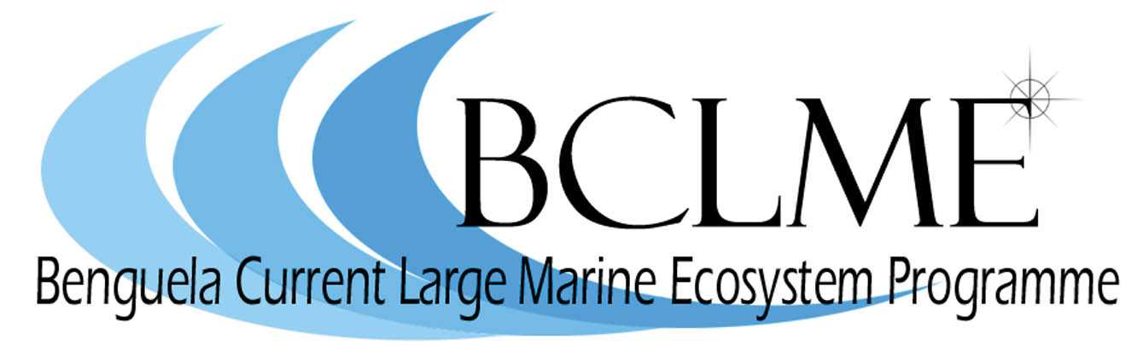

BCLME Programme extended until March 2008

The Benguela Current Large Marine Ecosystem (BCLME) Programme has been extremely successful in capturing vital knowledge and information necessary for the development of an integrated, ecosystem-based and cooperative management approach. The Programme has made significant advances in capacity building and training. Most importantly the BCLME Programme has created an environment of trust and partnership between Angola, Namibia and South Africa at the scientific and middle management levels.
However, owing to the time taken to establish the operating structures of the BCLME Programme, there are still a number of activities that need to be completed to fulfil the aims and objectives of the Programme which was originally scheduled to finish in March 2007. As a result, the Steering Committee and the GEF Implementing Agency (UNDP) have decided to extend the lifetime of the BCLME Programme for another 12 months (at no additional cost to GEF) until the end of March 2008.

A new GEF project for the Benguela region

The partner countries of the BCLME are proposing a new UNDP/GEF Project entitled Implementation of the Benguela Current LME action programme for restoring depleted fisheries and reducing coastal resources degradation.
This new project will focus on regional management. It has two major thrusts:
- supporting the institutional development of the newly established Benguela Current Commission through capacity building;
- supporting the implementation of key governance mechanisms such as an Ecosystem Approach to fisheries management (EAF) and the management of transboundary fish stocks.
A GEF Project Identification Form (PIF) has been submitted and approved for this new project, which now enters the GEF Pipeline.
The development of the new Project Document is currently underway. The development phase is supported by a local project development coordinator, Mr Nico Willemse, and a project development specialist, Dr David Vousden. Two consulting firms are also involved in synthesising information for the development of the Project Document. Integrated Environmental Consultants Namibia (IECN) is preparing a stakeholders participation plan and FEIKE Management Services is undertaking a BCLME policy and governance review. The preparation of a training and capacity building strategic plan for the new phase has been contracted to BENEFIT.
A stakeholder workshop will be held in Windhoek on 9 to 10 May 2007. One of the main objectives of the workshop will be to agree on the aims and outcomes of the new project. The consultations with stakeholders will ultimately lead to the development of a draft Project Document which will be submitted to GEF in August 2007.
It is expected that grant funding to develop this new project will be released shortly. Once the full Project Document is approved by the GEF, it is expected that up to US$5.0 million (R35 million) will be available to implement the next stage in the cooperative management of the Benguela

The Benguela Current Commission

Government ministers responsible for the fisheries, environment, minerals and petroleum sectors in Angola, Namibia and South Africa have now signed an Interim Agreement that will lead to the establishment of a Benguela Current Commission (BCC).
The BCC is a formal institutional structure that will help Angola, Namibia and South Africa to implement an “ecosystem approach” to managing the BCLME. This means that, instead of managing living and non-living marine resources at the national level, the three countries will work together to tackle transboundary environmental issues such as pollution, the management of shared fish stocks and the coordination of regional efforts to mitigate the impacts of marine mining and oil and gas production on the environment.
The formal structure of the BCC, including a Management Board, will be established in the next few months. The BCC will ultimately make recommendations to the three countries on research and management issues relating to the sustainable utilisation, conservation and protection of the BCLME. It will be informed by an Ecosystem Advisory Committee which will supply countries with the best available information concerning the implementation of the ecosystem approach to management.

