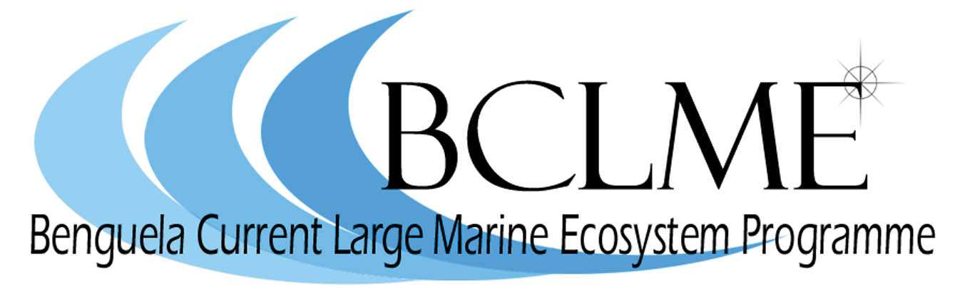

Media Release
The release by the global NGOs, WWF and Birdlife South Africa, of a report on the impact of longline fishing, highlights the challenges faced by Angola, Namibia and South Africa as they strive to better manage the Benguela Current Large Marine Ecosystem (BCLME).
The BCLME stretches up the west coast of South Africa and Namibia to Cabinda, the northern-most province of Angola.
The BCLME Programme, a regional project that is supported by the Global Environment Facility through the United Nations Development Programme, initiated and funded the WWF/Birdlife by-catch assessment.
“This report draws attention to the fact that fishing has a major impact on the BCLME,” says Dr Michael O’Toole, chief technical advisor to the BCLME Programme.
“It underlines the need for Angola, Namibia and South Africa to work together to reduce the ecosystem impacts of fishing.”
The Benguela Current Commission (BCC), provides an ideal forum for the three countries to collectively address the catch of seabirds, turtles and sharks by the longline fisheries of the region, says Dr O’Toole.
The BCC is a formal institution that will help Angola, Namibia and South Africa to utilise the marine and coastal resources of the BCLME in a sustainable way. It is the first commission of its kind in the world and lays the groundwork for the three countries to introduce an “ecosystem approach” to managing the BCLME. This means that, instead of managing living and non-living resources at the national level, the countries will work together to tackle problems that affect the marine environment. These problems include pollution, the management of shared fish stocks and the mitigation of the impacts that marine diamond mining and oil and gas production have on the BCLME.
Seabirds, turtles and sharks are all good examples of shared marine resources. They are all top ocean predators that migrate over large distances; many traverse the length and breadth of the BCLME and their incredible journeys regularly bring them into contact with the regional fishing industry. If they’re not caught off Namibia, these predators have a good chance of being caught in Angola or South Africa, or on the high seas.
“By working together, through the BCC, to address the impact that longline fishing has on these predators, Angola, Namibia and South Africa have a unique opportunity to contribute to global conservation efforts,” says Dr O’Toole.

The formal structure of the BCC, including a Management Board, will be established in the next few months. The BCC will ultimately make recommendations to the three countries on research and management issues relating to the sustainable utilisation, conservation and protection of the BCLME. It will be informed by an Ecosystem Advisory Committee which will supply countries with the best available information concerning the implementation of the ecosystem approach to management.

Issued by the Benguela Current Large Marine Ecosystem Programme
13 June 2007

For further information: Dr Michael O’Toole
Tel: (061) 246 948 or 081 129 0830

