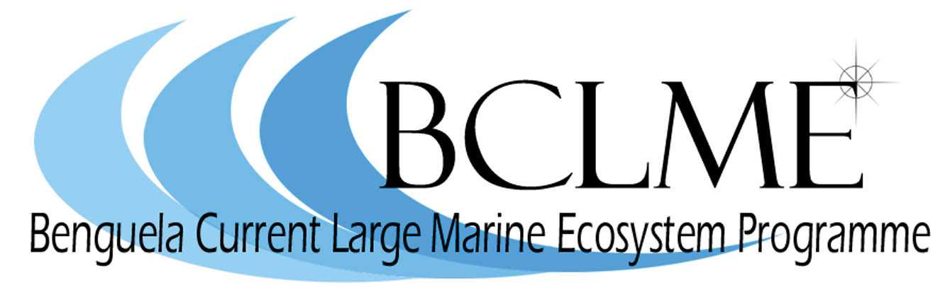
Media Release

It is a well known fact that commercially important fish resources fluctuate markedly in the Benguela region, but is it possible to forecast years of boom and bust for the fishing industry? This is one of the questions that will be deliberated by some of the world’s top marine scientists who meet in Cape Town from 8 to 11 November to take part in the International Workshop on Forecasting and Data Assimilation in the Benguela and Comparable Systems.
The Workshop is hosted by the Benguela Current Large Marine Ecosystem Programme, a regional initiative that aims to improve the capabilities of Angola, Namibia and South Africa to manage the marine resources of the Benguela Current in a sustainable and integrated way.
It will be opened by Horst Kleinschmidt, deputy director general in the Department of Environmental Affairs and tourism and head of the South African fisheries department.
The BCLME Programme is staging the workshop with seven other sponsors in an effort to improve the capacity of scientists in the three countries to forecast changes in the Benguela ecosystem. Such changes lead to variations in the abundance and distribution of important fish stocks such as pilchards and hake, and may also influence the occurrence of harmful algal blooms and low oxygen water events.
In the southern Benguela, harmful algal blooms – which are more commonly referred to as “red tides” - can have a devastating effect on marine resources such as rock lobster which wash ashore in massive quantities when the blooms decay and sea water becomes oxygen depleted. At present, harmful algal blooms are monitored in an effort to pre-empt marine mortalities and ensure safe seafood consumption, but the development of an early warning system would allow for more effective mitigation measures.
Low oxygen water events are another common environmental occurrence in the Benguela. These events are considered to be one of the key environmental factors governing the commercial viability of fisheries, especially off Namibia where low oxygen water events caused catastrophic mortalities of hake in 1994 and 2000. The ability to predict the occurrence of these natural events is one of the key challenges facing the scientists at the Cape Town workshop.
The impacts that climate change is having on the highly variable Benguela ecosystem is also on the scientists’ agenda, as Dr Mick O’Toole, chief technical advisor of the BCLME Programme explains:
“Many countries are making plans for dramatic changes in the environment, fluctuations in natural resources and other environmental pressures. This workshop is concerned with studying what we know about the Benguela, how this is changing over time, and establishing early warning systems for environmental change.”
Approximately 100 of the world’s leading marine scientists have been invited to participate in the workshop. The scientists will travel to Cape Town from Europe, Canada and the USA, South America and a number of African countries, including Angola, Namibia and Ghana.
The main output of the workshop will be a peer-reviewed book on forecasting in the Benguela. It is anticipated that the book will become a definitive text on what scientists know about the Benguela upwelling system and what measures need to be implemented in order to manage future changes in the system.
The workshop will take place at the Breakwater Lodge at the V&A Waterfront. It will be opened at 9am on Monday 8 November by Horst Kleinschmidt.
The workshop sponsors are:
- Benguela Current Large Marine Ecosystem (BCLME) Programme
- Benguela Environment Fisheries Training Interactions Programme (BENEFIT)
- University of Cape Town
- Department of Environmental Affairs and Tourism
- Council for Scientific and Industrial Research (CSIR)
- Inter-governmental Oceanographic Commission (IOC)
- International Association for the Physical Sciences of the Oceans (IAPSO)
- International Union of Geodesy and Geophysics (IUGG)
- Scientific Committee for Oceanic Research (SCOR)
Issued by the Benguela Current Large Marine Ecosystem Programme
1 November 2004
For further information: Dr Michael O’Toole - Chief Technical Advisor
Tel: +264 (0) 61 246948 or + 264 (0)81 1290830
e-mail: otoole@bclme.un.na
Claire Attwood – Media Consultant
083 290 7995 or cattwood@mweb.co.za

