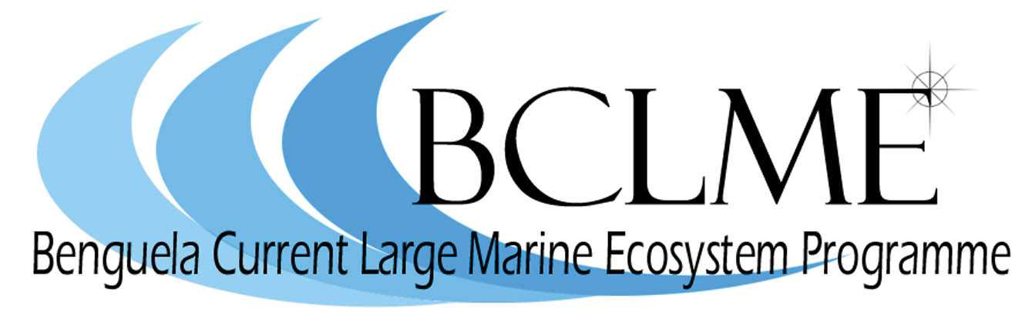
Media Release

Dr Moses Maurihungirire has been appointed as the director of the BCLME Programme’s Activity Centre for Marine Living Resources in Swakopmund, Namibia.
Dr Maurihungirire, who holds a doctoral degree in Marine and Estuarine Environmental Sciences from the University of Maryland in the USA, joins the BCLME Programme from the Ministry of Fisheries and Marine Living Resources where he held the position of deputy director responsible for inland fisheries and research administration.
He replaces Dr Hashali Hamukuaya who has taken up the position of executive secretary of the South East Atlantic Fisheries Organisation (SEAFO) in Walvis Bay.
The BCLME (Benguela Current Large Marine Ecosystem) Programme is a regional initiative that aims to improve the capabilities of Angola, Namibia and South Africa to manage the marine resources of the Benguela Current in a sustainable and integrated way. The BCLME Programme is supported by the Global Environment Facility (GEF) and implemented by the United Nations Development Programme (UNDP).
As director of the Activity Centre for Marine Living Resources, Dr Maurihungirire will be responsible for managing one of the BCLME Programme’s key interventions; that is, how best to manage fish stocks that are shared by two or more countries of the BCLME region. There is increasing scientific evidence to suggest that stocks of deepwater hake are shared between Namibia and South Africa, and to a lesser extent, Angola. Pilchard and horse mackerel stocks are shared between Angola and Namibia, as are red crabs and bronze whaler sharks. Big eye, yellowfin and longfin tunas are also shared by the three countries of the BCLME, both in their respective exclusive economic zones and on the high seas.
Dr Maurihungirire has a strong interest in transboundary resource management issues and is looking forward to playing a central role in the development and implementation of management plans for shared resources.
Dr Maurihungirire will also contribute substantially to the establishment of an Interim Benguela Current Commission (IBCC) which will be set up by the three countries of the Benguela region within the next two years. The IBCC is seen as a precursor to a permanent Benguela Current Commission which would provide Angola, Namibia and South Africa with a formal framework for managing the marine resources of the Benguela region in a cooperative manner.
Dr Maurihungirire will take up his position with the BCLME Programme on 10 May 2005.

Issued by the Benguela Current Large Marine Ecosystem Programme
3 May 2005
For further information: Dr Michael O’Toole - Chief Technical Advisor
Tel: +264 (0) 61 246948 or + 264 (0)81 1290830
e-mail: otoole@bclme.un.na
Claire Attwood – Media Consultant
083 290 7995 or cattwood@mweb.co.za

