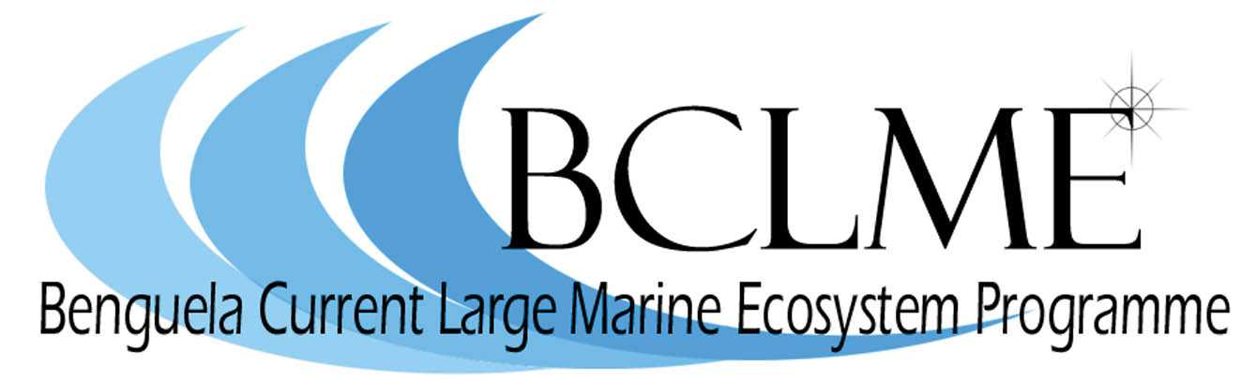
Media Release

Skiboats for environmental monitoring
The Benguela Current Large Marine Ecosystem (BCLME) Programme has purchased two 5.5m glass fibre skiboats to assist scientists in Namibia and Angola to monitor the marine environment.
The Namibian ski-boat, Noctiluca, was launched by the Minister of Fisheries and Marine Resources, Dr Abraham Iyambo and UNDP Resident Representative, Simon Nhongo, at a ceremony that took place in Swakopmund in February.
Noctiluca is a microscopic dinoflagellate (a type of plankton) that gives off bioluminescence at night.
Noctiluca was built by Z-Craft boat builders in Empangeni, South Africa. It is powered by a Yamaha 90 hp outboard motor and was supplied with a heavy duty trailer which will allow it to be launched at Swakopmund and Walvis Bay.
The boat is equipped with fish hatches, fishing rod racks as well as brackets for storing SCUBA apparatus.
Noctiluca will largely be used for monitoring of water quality, the benthos (seabed), harmful algal blooms (red tides), pollution and near-shore fisheries. It may also be used for training purposes and to build capacity in fisheries and environmental research.
“As its name implies the boat will be used mainly for red tide sampling - to routinely sample the inshore waters and complement the shore-based monitoring we do for aquaculture,” says Bronwen Currie of the National Marine Research and Information Centre (NATMIRC).
“It will be especially useful when we have a visible bloom beyond the surf zone.”
NATMIRC scientists will use Noctiluca to carry out other water quality tests – to check for bacterial or chemical pollution and to monitor sulphide events. These are natural events that can be harmful to fish and other living organisms.
Sampling will be carried out using a Niskin bottle over the side. Plankton net samples may also be taken over the side of Noctiluca.
The facilities for storing diving equipment will enable researchers to conduct underwater research and to maintain scientific equipment which is moored to the ocean floor.
As part of the package, a two- to three-day training course in the operation and maintenance of the ski-boat will be presented to key staff of NatMIRC by Z-Craft.
A boat which is identical to Noctiluca has been delivered to the Angolan fisheries research institute in Luanda. The vessel will also be used by Angolan scientists to monitor the marine environment.
Photographs
- Noctiluca on the slipway at Swakopmund.
- Namibia’s Minister of Fisheries and Marine Resources, Dr Abraham Iyambo, toasts the launch of Noctiluca with Simon Nhongo, United Nations Development Programme (UNDP) Resident Representative in Namibia.
- Dr Mick O’Toole, Chief Technical Advisor of the BCLME Programme with Dr Abraham Iyambo and Simon Nhongo.
- Dr Abraham Iyambo prepares to go to sea. He is pictured with Namibian researcher, Bronwen Currie.
- Noctiluca is launched.
- Dr Iyambo returns to dry land.

Issued by the Benguela Current Large Marine Ecosystem Programme
24 March 2006
For further information: Claire Attwood – Media Consultant
083 290 7995 or cattwood@mweb.co.za

