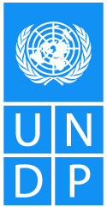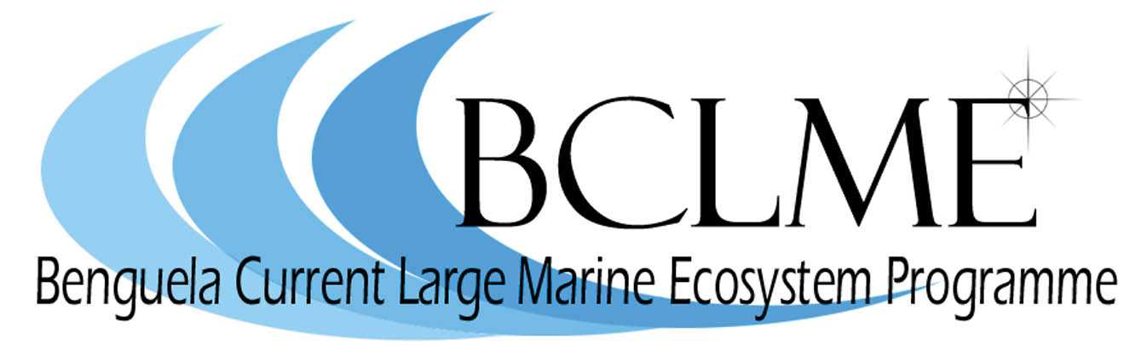

Media Release

The ministers responsible for the management of marine fisheries in Angola, Namibia and South Africa will come together in Cape Town today, 29 August 2006, to signify their support for the establishment of a Benguela Current Commission.

The Benguela Current Commission is a formal institutional structure that will help the three countries of the region to utilise the marine and coastal resources of the Benguela Current Large Marine Ecosystem (BCLME) in a sustainable and integrated way.

The establishment of the Benguela Current Commission represents an important step in a decade-long process of building trust and cooperation between the three countries of the BCLME. Marine scientists from Angola, Namibia and South Africa have been working together since 1995 when they began to share knowledge and understanding of the Benguela Current ecosystem through the regional fisheries science programme BENEFIT (Benguela Environment Fisheries Training Interactions Programme). More recently, scientists and fisheries managers have been working together through the BCLME Programme, a collaborative initiative that is supported by the Global Environment Facility (GEF) through the United Nations Development Programme (UNDP).

The Benguela Current Commission is the first commission of its kind in the world. It will lay the groundwork for the three countries to collectively manage trans-boundary environmental issues such as pollution, shared fish stocks and regional efforts to mitigate the impacts of marine mining and oil and gas production on the environment.

Members of the media are invited to attend the signing ceremony which will be jointly hosted by Angola’s Deputy Minister of Fisheries Pedro João, Namibia’s Minister of Fisheries and Marine Resources, Dr Abraham Iyambo, South Africa’s Minister of Environmental Affairs and Tourism, Marthinus van Schalkwyk, and Ad Melkert, Associate Administrator of the United Nations Development Programme.

The ceremony will take place at the Two Oceans Aquarium at the Victoria & Alfred Waterfront in Cape Town, starting at 19h30.

Issued by the Benguela Current Large Marine Ecosystem Programme
29 August 2006

For further information: Claire Attwood
Tel: (021) 788-5453 or 083 290 7995

