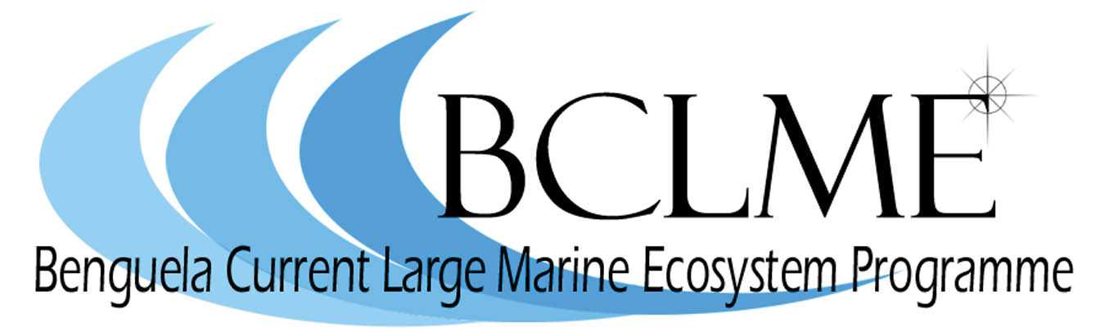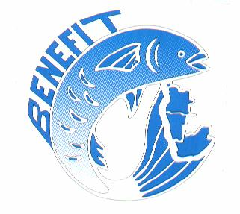
Media Release

South Africa, Namibia and Angola benefit from German co-operation
Students of oceanography are gaining valuable insights into the mechanics of the highly variable Benguela Current Large Marine Ecosystem, thanks to a co-operative research programme that is being conducted from the deck of the German research vessel, Alexander v. Humboldt.
The Alexander v. Humboldt has been operating off the coast of Namibia and Angola since December 2003 and on April 28 the vessel will stop in Cape Town to conduct a student demonstration cruise. Thereafter, the Alexander v. Humboldt will set sail for Walvis Bay with several South African scientists and students on board. On this leg of the six-month long voyage, scientists will sample a variety of marine organisms between Cape Town and the Orange River mouth. This is part of a longer-term study which aims to identify regions of benthic biodiversity along South African shores.
Over 100 scientists from eight German institutions and nine regional scientific institutions - including fisheries departments and universities – are participating in the six-month voyage of the RV Alexander v. Humboldt which is being funded by a number of international and regional institutions and organisations.
These are the German ministry of education for the state of Mecklenburg Vorpommern, the federal ministry of Science and Technology in Germany, the Max Planck Institute for Marine Microbiology, the University of Hamburg and the Baltic Sea Research Institute. Local funders are the co-operative scientific programme, BENEFIT, and the regional Benguela Current Large Marine Ecosystem (BCLME) Programme.
BENEFIT (the Benguela Environment Fisheries Interaction and Training Programme) is a regional partnership between Namibia, Angola and South Africa which focuses on research into the major shared fish resources of the three countries and the profound influence that environmental variability has on the productivity and distribution of these stocks. It has a strong training component and receives generous funding from the Norwegian development agency NORAD and the German agency for technical cooperation, GTZ.
The BCLME Programme is a joint initiative between the three countries in the Benguela region to manage and utilise the resources of the Benguela Current Large Marine Ecosystem in a sustainable and integrated manner. It is funded by the Global Environment Facility (GEF), through the United Nations Development Programme (UNDP).
The scienfitic focus of the Alexander v. Humboldt’s voyage is environmental and ecological issues that were identified by researchers from South Africa, Namibia and Angola. The primary aims of the expedition may be summarised under four topics:
- Understanding the role of oceanographic zones in the reproduction of important fish species;
- The causes of hydrogen sulphide and sulphur eruptions and their impacts on living marine resources;
- Predicting the possible impacts of global climate change on the Benguela Current Large Marine Ecosystem;
- On-the-job training, data collection for masters and doctoral students, technical training and presentation of equipment for possible use on the new Angolan research vessel Tombwa.
Post-cruise activities, such as scientific workshops, are planned to include data evaluation, reports and manuscripts.
Media representatives are invited to attend a casual reception on board the RV Alexander v. Humboldt on 29 April 2004. The ship will be berthed in Cape Town harbour at a berth that is yet to be confirmed.

Issued by the Benguela Current Large Marine Ecosystem (BCLME) Programme
23 April 2004
For further information: Claire Attwood
Tel: (021) 788 3500 or 083 290 7995

