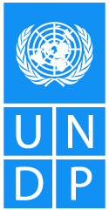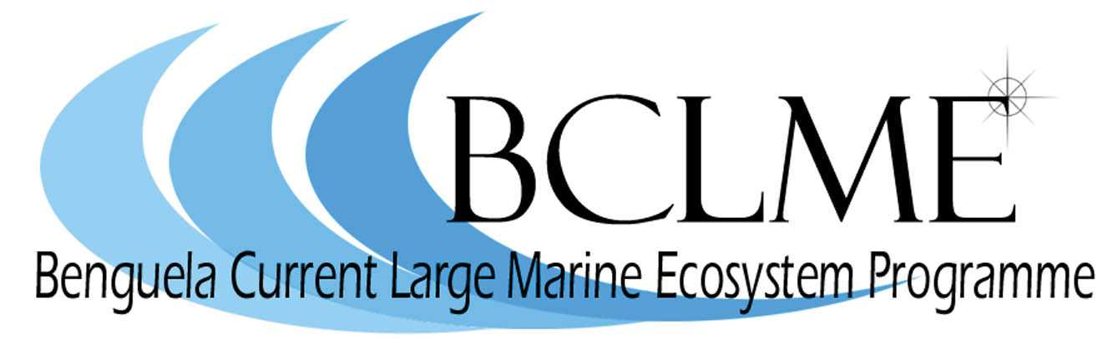
Media Release

Genetic analysis is just one of a range of tools that scientists from Namibia and South Africa will employ over the next two years in a bid to ascertain with reasonable certainty whether the two countries share a single stock of deep-water hake (Merluccius paradoxus).
The decision to intensify genetic studies of deep water hake stocks was taken at a three-day stock assessment workshop that brought South African and Namibian scientists together in Cape Town last week.
The scientists were meeting for the first time to discuss the possibility of working more closely on the management of valuable fisheries resources such as hake.
The workshop concluded that, while there is evidence to suggest that South Africa and Namibia do not share stocks of shallow water hake (M. capensis), the situation with deep water hake (M. paradoxus) is less certain.
Further research is warranted because, if the stock is shared by the two countries, over fishing in one country could affect catches in the other.
“The possibility that the stocks are shared should be taken seriously by both countries,” concluded Dr Tony Smith, one of three international experts in fisheries stock assessment who were invited to the workshop to provide advice and to steer the discussions.
Although scientists have studied hake for more than 50 years, their research has tended to focus on the assessment of biomass (stock size), rather than the movement of hake in the Benguela ecosystem. The new interest in hake movement has been initiated by the Benguela Current Large Marine Ecosystem (BCLME) Programme, a project that aims to improve the management of the Benguela ecosystem by strengthening ties between South Africa, Namibia and Angola.
One of the mandates of the BCLME Programme is to look at ways of managing fish stocks like hake and horse mackerel that might straddle the national borders of the three countries.
“Scientists in the Benguela region need to look to new scientific techniques, such as genetic analysis, to help them to determine whether deep water hake stocks are, in fact, shared by South Africa and Namibia,” explains Dr Mick O’Toole, chief technical advisor of the BCLME Programme.
“This is one of the most important research questions in the region.”
In the next two years, the BCLME Programme will be converted into a Benguela Current Commission which will provide a formal platform for the three countries of the Benguela to engage on subjects such as the sharing of fish stocks. It will also facilitate the improved management of the human impacts on the marine environment of the Benguela, for example the extraction of oil, gas and diamonds.

Issued by the Benguela Current Large Marine Ecosystem Programme
15 May 2006
For further information: Claire Attwood – Media Consultant
083 290 7995 or cattwood@mweb.co.za

