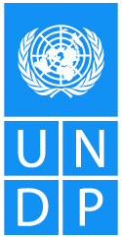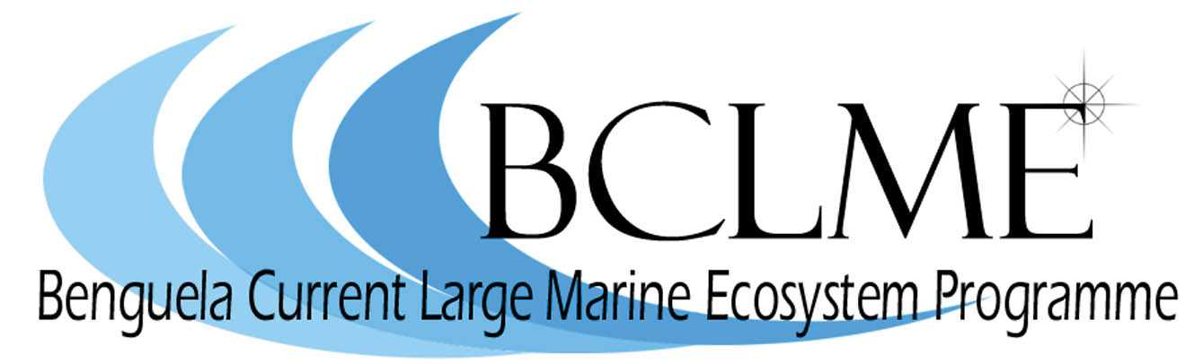
Media Release

Fisheries scientists and members of the fishing industries and governments of South Africa and Namibia are scheduled to meet in Cape Town from 9 to 11 May to discuss the potential for managing deep water hake (Merluccius paradoxus) as a shared stock.
Hake is a vitally important fishery in both countries, providing employment for thousands of people and generating valuable export revenue.
The three-day workshop represents an important first step towards the two countries working more closely on the management of valuable fisheries resources such as hake.
It is being organised by the Benguela Current Large Marine Ecosystem (BCLME) Programme, an initiative between Angola, Namibia and South Africa that aims to improve the management of the Benguela ecosystem.
One of the mandates of the BCLME Programme is to look at ways of managing fish stocks, like hake and horse mackerel, that straddle the national borders of the three countries.
“Scientists are not yet certain whether deep water hake is, in fact, a shared stock,” explains Dr Mick O’Toole, chief technical advisor of the BCLME Programme.
“This workshop is a first step towards accertaining to what degree the hake stock is shared and identifying ways in which the two countries can cooperate in the future to manage shared resources.”
Scientists from South Africa and Namibia have already participated in transboundary surveys of hake which were undertaken from the deck of the Nowegian research ship, Dr Fridtjof Nansen. The data gathered on these cruises has led scientists to formulate two hypotheses concerning the distribution, migration and abundance of M. Paradoxus in Namibian waters.
The first hypothesis suggests that M. Paradoxus breeds almost exclusively in South African waters and migrates over the border into Namibia. The second hypothesis postulates that M. Paradoxus may spawn in Namibia but the main source of juveniles is still south of the Orange River.
Further research is warranted because, if the stock is proved to be shared by the two countries, over fishing in one country could affect catches in the other.
Three highly respected international experts in fisheries stock assessment have been invited to attend this week’s workshop to provide advice and valuable inputs into the discussions. There will be a report back session for senior management of the fisheries departments of both countries at the end of the workshop.
In the next two years, the BCLME Programme will be converted into a Benguela Current Commission which will provide a formal platform for the three countries of the Benguela to engage on subjects such as the sharing of fish stocks. It will also facilitate the improved management of the human impacts on the marine environment of the Benguela, for example the extraction of oil, gas and diamonds.

Issued by the Benguela Current Large Marine Ecosystem Programme
7 May 2006
For further information: Claire Attwood – Media Consultant
083 290 7995 or cattwood@mweb.co.za

