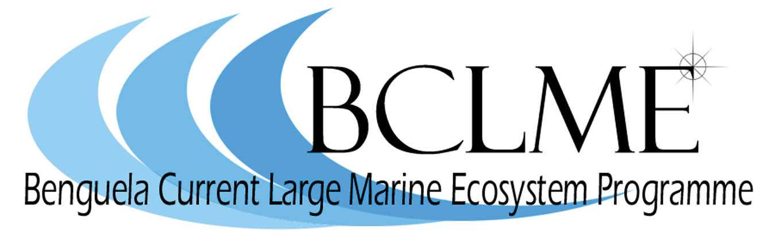

Media Release

The meeting and mixing of the Benguela and Agulhas currents off the southern tip of Africa will come under the spotlight this week when oceanographers and fisheries scientists meet in Cape Town.
The scientists will attend the Southern Boundary Workshop which is being hosted by the BCLME Programme, an initiative by South Africa, Namibia and Angola to manage and utilise the resources of the Benguela Current Large Marine Ecosystem (BCLME) in a sustainable and integrated manner.
Delegates at the workshop will review recent advances in understanding the influence that environmental processes have on the southern boundary of the BCLME. The boundary area is generally accepted as being in the vicinity of the Agulhas retroflection area which lies south of Africa.
It is here that several important fish species, such as hake, pilchards and south coast rock lobster are fished commercially.
Over the past five or six years, significant shifts in the distribution of marine resources have caused scientists to look more closely at this region. For instance, a dramatic eastward shift in the pilchard resource has been well documented. Whereas pilchards were traditionally fished off the west coast of South Africa, catches taken off Mossel Bay have leapt up from 2110 tons to 121 536 tons in five years.
Other species have also shown an eastward movement. Most notable has been the shift of west coast rock lobster from the traditional fishing grounds on the west coast to the southeast coast. Seabird biologists have also documented changes in the breeding patterns of several seabirds, including Cape gannet, crowned cormorant and hartlaub’s gull.
These observations have led scientists to question whether a “regime shift” is taking place in the BCLME. They suggest that climate change, or at least climate variability, may be behind the eastward movement of pilchards and other species.
The Southern Boundary workshop will provide the scientific community with an opportunity to examine the changes that have taken place in the southern part of the BCLME over the past five or six years.
“It is essential that the state of knowledge and understanding of this part of the ecosystem should be re-examined within the context of the greater Benguela ecosystem and its management,” says Dr Mick O’Toole, chief technical advisor of the BCLME Programme.
The workshop will also provide the scientific community with an opportunity to build links with the Agulhas Somali Large Marine Ecosystem Programme, an initiative that will pull together the efforts of several east African nations in addressing the most pressing environmental challenges facing the east coast of southern Africa.
The Southern Boundary workshop starts on Wednesday 3 May at 08h30 at the Breakwater Lodge, V&A Waterfront. It finishes on Friday 5 May.

Issued by the Benguela Current Large Marine Ecosystem Programme
2 May 2006
For further information: Claire Attwood – Media Consultant
083 290 7995 or cattwood@mweb.co.za

