BCLME Project LMR/CF/03/02

An Assessment of the State of Commercial Fisheries Catch Data in the BCLME Region

24th May 2004
Richard Aukland, Consultant
Chris Ninnes, Consultant

Contents
Contents 2
Acknowledgments 4
Executive Summary 5
Table of Figures 5
Acronyms 5
1 Introduction 5
1.1 Regional Fisheries Management 5
1.2 International Instruments 5
1.3 The Need for Fisheries Data 5
1.4 The Need for Fisheries Data Management 5
1.5 Data Verification and Validation 5
1.6 International Data Standards 5
2 Background 5
2.1 Commercially Important Regionally Shared Stocks 5
2.2 Review of previous technical evaluations of regional data management systems 5
2.3 FAO recommendations for best practices in Regional Fisheries Management of shared fish stocks, including information requirements. 5
3 Mission Activities 5
3.1 South African Hakes 5
3.2 South African Sardine and Anchovy 5
3.3 South African Kingklip and Monkfish 5
3.4 South African Snoek 5
3.5 Namibian Hake 5
3.6 Namibian Monk 5
3.7 Namibian Horse Mackerel 5
3.8 Namibian Pilchard 5
3.9 Namibian Linefish 5
3.10 Namibian Red Crab 5
3.11 Management of Fisheries Logsheet Data in Namibia 5
3.12 Angolan Red Crab 5
3.13 Angolan Pilchard 5
3.14 Angolan Horse Mackerel and Demersal Trawl 5
3.15 Angolan Research Data 5
3.16 Historic data in Angola 5
3.17 Future Directions in Fisheries Data Collection and Management in Angola 5
3.18 Artisanal Fisheries Data Collection in Angola 5
4 Discussion and Recommendations 5
4.1 General Issues In Data Management 5
4.2 Identifying potential scenarios appropriate for regional shared stock management 5
4.3 Appropriate methods for the exchange of information given potential scenarios for shared stock management. 5
4.4 The extent to which existing catch data meets the information requirements of potential regional shared stock management scenarios. 5
4.5 If regional standardisation of data or collection methods is necessary in order for inter comparability, then propose recommended procedures. 5
4.6 The reliability and appropriateness of catch data management systems for the purposes of regional management of shared stocks. 5
4.7 Recommend remedial action to improve catch data management systems where they fail to meet requirements. 5
Annex I. United Nations Fish Stock Agreement (Annex 1). 5
Annex II. Institutes Visited and People Met 5
Annex III. Data Flow Diagrams 5
Annex IV. References 5

Acknowledgments
Many thanks to all the staff members at the Institutes visited during the development of this report, whose kind and helpful approach made for a productive and enjoyable visit given the limited time available.

Special thanks go to the staff of the BENEFIT Secretariat for their assistance in planning and logistics.

Executive Summary
The SADC Protocol on Fisheries and the FAO Code of Conduct for Responsible Fisheries, of which all three BCLME member states are signatories establish obligations for the exchange of timely and appropriate information necessary for the effective management of transboundary stocks. For many of the commercially important stocks there is already cooperation and exchange of information for research but as yet no joint management procedures and exchange of management related information.

The need for fisheries data and its role in fisheries management is introduced, with emphasis given to commercial catch data and biological indicators. The economic and scientific benefits of an effective Data Collection and Management strategy are illustrated. Data validation and verification processes are examined and the benefits of using database systems outlined. A summary of international fisheries data standards is provided.

Results of preliminary background tasks are provided. This includes the identification and prioritisation of commercially important shared stocks of the Benguela and a review of available reports on data management systems in the BCLME region. Also, the FAO’s recommended existing conditions necessary for regional data sharing are given, along with a guiding description of the basic fishery data types that are necessary for shared stock management (according to the UN Fish Stocks Agreement).

For each of the prioritised shared stocks in each country, an analysis of the data flow and processing of commercial catch and research data is illustrated using data flow diagrams. Known and discovered problems in the data collection and management strategy are noted and the fitness for purpose of the information systems used is discussed. Where documentation was available or information provided, a high level inventory of available data types is provided for the prioritised stocks.

General issues common to all institutes that reduce the accessibility and reuse of data include inadequate documentation and the low priority assigned to data management practices. This situation is acerbated due to the high staff turnover rates. Recommendations are provided that will encourage best practices in data husbandry.

A three-stage framework for the development of fisheries data exchange within the context of regional shared management is proposed, starting with a system independent of any political process and moving towards a Secretariat with bilateral commissions providing support for exchange of data as part of a political process. Based on FAO recommendations, the experience of other fisheries bodies and acknowledging characteristics of the region, a practical method for the exchange of information is given. The process considers data reporting responsibility, usage policies, schedules for data submission and possible reporting formats and data exchange media. A case study (ICCAT) is presented for comparison.

The success of current fisheries management given existing problems with information systems is noted and it is argued that the uncertainty associated with transboundary effects will reduce likely successes of future management. It is further argued that the main cause of this uncertainty is the limited understanding of the impacts of environmental change and the incorporation of environmental data into management decision-making.

It is advised that standardised data collection procedures are not a prerequisite for shared management and that standardisation of data for purposes of inter comparability should be developed through scientific working groups.

The reliability and appropriateness of the data systems of the three countries is assessed generally and in turn. The establishment of a regional metadata directory and dedicated data managers in each country is advised. Finally, for each of the BCLME member states, recommendations to be considered during the development and maintenance of existing and planned information systems are given.

Table of Figures
Figure 1. The Role Of Data In Fisheries Management 5
Figure 2 South African Hake. Data sources, pathways, processing and storage of commercial catch and fishery independent research data 5
Figure 3 South African Pelagics. Data sources, pathways, processing and storage of commercial catch and fishery independent research data 5
Figure 4 Namibian Hake. Data sources, pathways, processing and storage of commercial catch and fishery independent research data. 5
Figure 5.Namibian Horse Mackerel. Data sources, pathways, processing and storage of commercial catch and fishery independent research data. 5
Figure 6 Namibian Pelagics. Data sources, pathways, processing and storage of commercial catch and fishery independent research data. 5
Figure 7 Angolan Crab. Data sources, pathways, processing and storage of commercial catch and fishery independent research data. 5
Figure 8 Angolan Pelagics. Data sources, pathways, processing and storage of commercial catch and fishery independent research data. 5

Acronyms
ASCII American Standard Code for Information Interchange
ASPM Age Structured Production Model
BCLME Benguela Current Large Marine Ecosystem
BENEFIT Benguela Environment Fisheries Interaction and Training Programme
CCAMLR Commission on the Conservation of Antarctic Marine Living Resources
CCRF Code of Conduct for Responsible Fisheries
CCSBT Commission for the Conservation of Southern Bluefin Tuna
CPUE Catch per Unit Effort
CSIRO Commonwealth Scientific and Industrial Research Organisation
CSR Cruise Summary Reports
CWP Coordinated Working Party
DBMS Database Management System
DIF Directory Interchange Format
DIF (Ang) Departamento de Informação dos Fisheries
DFD Data Flow Diagram
DNP Direcção Nacional das Pescas
EEZ Exclusive Economic Zone
EU European Union
FAO Food and Agricultural Organisation of the United Nations
FAO-FIDI Fisheries Division of the FAO
FIGIS Fisheries Global Information System
FIMS Fisheries Information Management System
GCMD Global Change Master Directory
GLM Generalised Linear Model
GUI Graphical User Interface
HTTP Hypertext Transfer Protocol
IATTC Inter-American Tropical Tuna Commission
ICCAT International Commission for the Conservation of Atlantic Tunas
ICES International Council for the Exploration of the Sea
ICSEAF International Commission for the Southeast Atlantic Fisheries
IIM Instituto de Investigação Marinha
IOC International Oceanographic Commission
IODE International Oceanographic Data and Information Exchange
IPA Instituto de Pesca Artisanal
ISSCFG International Standard Statistical Classification of Fishing Gear
ISSCFV International Standard Statistical Classification of Fishing Vessels
MARAM Marine Resource Assessment and Management Group
MATT Metadata Authoring Tool
MCM Marine and Coastal Management
MCS Monitoring, Control and Surveillance
MEDI Marine Environmental Data Interchange
MFMR Ministry of Fisheries and Marine Resources
MS Microsoft
NAN-SIS Nansen Survey Information System
NatMIRC National Marine Information and Research Centre
NMLS National Marine Linefish System
NORAD Norwegian Agency for Development Cooperation
OMP Operational Management Plan
PIMS Pelagic Information Systems
QBE Query By Example
RFB Regional Fisheries Body
RFIS Regional Fisheries Information Systems
RFMO Regional Fisheries Management Authority
SADC Southern African Development Community
SCRS Sub-Committee on Research and Statistics
SEAFO South East Atlantic Fisheries Organisation
SQL Standard Query Language
SSL Secure Sockets Layer
TAC Total Allowable Catch
UN United Nations
UNCLOS United Nations Convention on the Law of the Sea
UNFSA United Nations Fish Stocks Agreement
VPA Virtual Population Analysis
WAN Wide Area Network
XML eXtensible Mark-up Language

Introduction

Regional Fisheries Management
The Benguela Current Ecosystem can be loosely considered as covering the continental shelf between the Angola-Benguela frontal zone in northern Namibia/southern Angola and the Agulhas retroflection area, typically between 36 and 37˚S (Shannon and O’Toole 1998). Consequently it covers the West Coast of South Africa, the entire Namibian coast, and southern Angola. Rich in pelagic and demersal fish populations supported by plankton production driven by intense coastal upwelling, total fish catches in the south-east Atlantic climbed rapidly during the 1950s and 1960s, with the development of hake, sardine, anchovy, horse mackerel and sardinella fisheries. Total annual catches peaked at over 3 million tonnes in 1968, but subsequently declined to a level of around 2 million tonnes in the 1970s. It is believed that subsequent declines have been due primarily to overfishing, although some of the major fluctuations have probably been influenced to a greater or lesser extent by the large-scale environmental perturbations that have occurred periodically in the system during this period (Shannon and O’Toole 1998).

The Southern African Development Community (SADC) Protocol on Fisheries includes numerous specific provisions in support of shared stocks management in the SADC region. There are a number of international management organisations (ICCAT, CCSBT, CCAMLR) with jurisdiction over tunas and southern ocean resources caught by BCLME coastal states, and many of the states concerned are members of these organisations. A Regional Fisheries Management Organisations (RFMO), SEAFO is being set up in consultation with the BCLME coastal states for the management of high-seas stocks in the region, with jurisdiction over those which extend into the EEZs of the coastal states.

However, there are currently no local arrangements between SADC states for the management of shared stocks within their EEZs, and consequently there are none that are managed cooperatively. Catch data submitted to FAO, and additional information provided in the RFIS report (Penny et al 2003) indicate that a number of the important trawled and purse-seined resources (including hakes, horse-mackerel, sardine and anchovy) on the southern African west coast are shared, or may be shared on occasion.

Caddy (1997) made a conservative estimate that between 1,000 to 1,500 transboundary fishery resources exist and furthermore that in relation to global catch, the number of such resources under effective cooperative resource management regimes is very modest. The UN Fish Stocks agreement provides definitions for both transboundary and straddling stocks as:

Transboundary Stocks
“…the same stock or stocks of associated species occur within the exclusive economic zones of two or more coastal States…”

Straddling Stocks
“…the same stock or stocks of associated species occur both within the exclusive economic zone and in an area beyond and adjacent to the zone…”

However, there is no such legal definition ‘shared stocks’ in the UN FSA or UNCLOS. An often-cited definition when referring to transboundary stocks that do not extend to the high seas is provided by Caddy (1997).

Shared Stocks
“A group of commercially exploitable organisms distributed over, or migrating across a maritime boundary between two or more national jurisdictions, whose exploitation can only be managed effectively by cooperation between the States concerned, but where emigration to or immigration from other jurisdictions need not be taken into account.”

For the purposes of this report, considering that the terms of reference focus on those stocks shared within the EEZs of the BCLME countries the term ‘shared stocks’ will be referring to transboundary stocks as defined above and not the Caddy (1997) definition of shared stocks.

Given that a case for regional management of transboundary stocks does exists, Gulland (1980) identifies at least two levels of cooperation that exist between participating states. The first level comprises of cooperation in research alone, without reference to coordinated management programs. This has already been achieved for many of the commercially important stocks under consideration in this report through the activities of the BENEFIT and BCLME research programmes. Gulland indicates that first level cooperation is relatively easy to achieve, as all parties will benefit from improved information and data. However, as has been experienced through the BENEFIT programme, genuine open sharing of scientific data is often difficult to achieve unless data ownership issues are fully addressed and resolved initially.

International Instruments

The Code of Conduct for Responsible Fisheries
The Code of Conduct for Responsible Fisheries (CCRF) is a voluntary code, adopted on 31 October 1995 by the FAO Conference providing a framework for national and international efforts to ensure sustainable exploitation of aquatic living resources in harmony with the environment. All three of the BCLME member states are signatories to the CCRF. The following articles in the code are of particular relevance for the use of information in the management of shared stocks of the Benguela;
Article 7.4.4
States should ensure that timely, complete and reliable statistics on catch and fishing effort are collected and maintained in accordance with applicable international standards and practices and in sufficient detail to allow sound statistical analysis. Such data should be updated regularly and verified through an appropriate system. States should compile and disseminate such data in a manner consistent with any applicable confidentiality requirements.
Article 7.4.6
States should compile fishery-related and other supporting scientific data relating to fish stocks covered by subregional or regional fisheries management organizations or arrangements in an internationally agreed format and provide them in a timely manner to the organization or arrangement. In cases of stocks which occur in the jurisdiction of more than one State and for which there is no such organization or arrangement, the States concerned should agree on a mechanism for cooperation to compile and exchange such data.
Article 7.4.7
Subregional or regional fisheries management organizations or arrangements should compile data and make them available, in a manner consistent with any applicable confidentiality requirements, in a timely manner and in an agreed format to all members of these organizations and other interested parties in accordance with agreed procedures.
Article 12.4
States should collect reliable and accurate data which are required to assess the status of fisheries and ecosystems, including data on by-catch, discards and waste. Where appropriate, this data should be provided, at an appropriate time and level of aggregation, to relevant States and subregional, regional and global fisheries organizations.

The United Nations Fish Stock Agreement
The United Nations Fish Stock Agreement (UNFSA) is an extension to the United Nations Convention on the Law Of The Sea (UNCLOS, 1982) relating to the conservation and management of straddling fish stocks and highly migratory fish stocks. It should be noted that the stocks under consideration in this report are transboundary and not highly migratory or straddling as defined above. However the UNFSA provides a good starting point for the principles of collection and exchange of data. Article 14, Collection and provision of information and cooperation in scientific research and Annex I of the agreement (standard requirements for the collection and sharing of data) contain the following guidelines;

Article 14 Collection and provision of information and cooperation in scientific research
1. States shall ensure that fishing vessels flying their flag provide such information as may be necessary in order to fulfil their obligations under this Agreement. To this end, States shall in accordance with Annex I (See Annex 1 of this report):
(a) collect and exchange scientific, technical and statistical data with respect to fisheries for straddling fish stocks and highly migratory fish stocks;
(b) ensure that data are collected in sufficient detail to facilitate effective stock assessment and are provided in a timely manner to fulfil the requirements of subregional or regional fisheries management organizations or arrangements; and
(c) take appropriate measures to verify the accuracy of such data.

2. States shall cooperate, either directly or through subregional or regional fisheries management organizations or arrangements:
(a) to agree on the specification of data and the format in which they are to be provided to such organizations or arrangements, taking into account the nature of the stocks and the fisheries for those stocks; and
(b) to develop and share analytical techniques and stock assessment methodologies to improve measures for the conservation and management of straddling fish stocks and highly migratory fish stocks.

SADC Protocol on Fisheries
Within the sector of fisheries SADC is guided by the SADC Protocol on Fisheries, which was signed by SADC heads of state and governments in August 2001. The objective of the Protocol is to promote the responsible use of the living aquatic to enhance food security and human health, safeguard the livelihood systems of fishing communities, generate economic opportunities for nationals in the region and to ensure that future generations benefit from these resources. Among the issues addressed are: management of shared resources, law enforcement, access agreements, high seas fishing, artisanal fisheries, aquaculture, protection of the environment, human resources development, trade and investment, science and technology and information exchange. The Protocol on Fisheries fully recognises the obligations placed on the region as a result of the development of international policy covering development and the role that fisheries should play in achieving these development objectives.

The Protocol on Fisheries is a significant policy development that provides a coherent and comprehensive framework for regional fisheries policy. The Protocol is built around poverty eradication objectives and is consistent with all the international fisheries conventions, instruments and agreements, and the International Code of Conduct for Responsible Fisheries provides a guiding structure for its content. It provides a basis for translating into action in the SADC region the commitments on international fisheries made strongly by the UK and other countries at the World Summit on Sustainable Development (WSSD) in Johannesburg 2002. It is also consistent with the approach taken by DFID in partnership with FAO in West Africa, which is also based on the regional implementation of the International Code of Conduct for Responsible Fisheries.

The Need for Fisheries Data
The collection of fisheries and associated data is often a routine and laborious task. Such is the distance between policy and data collection that it is easy to forget that this data underpins and drives the whole fisheries management framework. The role of data in fisheries management is outlined in the figure below. Fisheries policy at the highest level is driven by decisions that aim to best utilise the fishery resource for purposes of contribution to food security and the economy, whilst minimising the impact of exploitation on the resource and its environment. Policy is further defined into periodically reviewed goals and management objectives that monitor the success of policy implementation.

In order to assess the management performance, operational targets such as reference points can be set. Reference points are usually used to guide the fisheries manager in setting and adjusting the management measures and provide a guideline as to the state of the resource. Examples of target reference points (a desirable state of the resource) include F_{max}, F_{0.1} , F_{med} and F_{MSY}. Conversely Limit Reference points refer to a state that should be avoided and indicate action must be taken. B_{loss}, M_{BAL}, and F_{crash} are common limit reference points. In accordance with the precautionary approach, F_{0.1} and F_{MSY} are often now used more cautiously as Limit Reference points. It should be noted that indicators also exist for social and economic reference points but these are beyond the scope of this report.
Figure 1. The Role Of Data In Fisheries Management
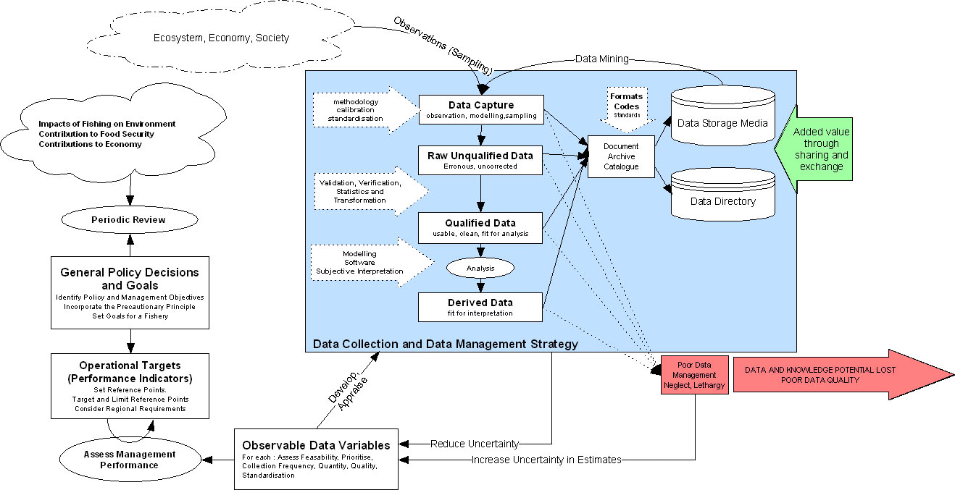
Once policy and management objectives are defined with their relative reference points, appropriate performance indicators are identified, as are the variables that are needed for their estimation. The data variables selected are observable and derived from observations in the field obtained through sampling schemes etc. The most important factor in selecting variables is the:
- Feasibility of their collection considering the fisheries operational activities.
- Number of variables which can realistically be collected
- Number of indicators which a variable can be used for (e.g. Catch and Effort have many uses)
- Frequency of collection necessary to be robust
- Expected data quality and quantity that can be obtained
- Issues of standardisation.

Depending on the indicators being supported, the following information domains are recognised (FAO 1999);
- Fishery and Operations
- Biology and Environmental
- Economic and Financial
- Sociocultural

Commercial catch data variables such as catch, discards and landings come from the fishery and operations domain. Other variables used in assessing stock size and structure such as CPUE, recruitment, age, sex, maturity, size and behaviour belong to the biology domain.

Biological performance indicators of an exploited stock are often based on results from fish stock assessment. Stock assessments can provide estimates of stock size, fishing mortalities, yield-per-recruit, spawners per recruit and other indicators. These indicators require reference points for their interpretation, also obtained from stock assessment methods. Depending on the extent of data available, FAO Cadima (2003) outlines levels of increasingly sophisticated analysis that can be performed to assess the stocks:
Table 1. Data requirements for differing levels of analysis, based on Cadima 2003.
Model | Data Requirements | Comments
Various Simple Methods | Little Information | Estimation of Biomass and Potential Yield
Production Models | Annual Catches  Annual Abundance Index e.g. Catch Per Effort (CPUE) or Biomass Estimate | Data should span several years and contain good contrast in effort and biomass. Allows projections of Yield and Catch per Effort
Structural Models  e.g. Yield & Biomass per Recruit  Virtual Population Analysis (VPA) | Commercial Catches  Fishing Effort or CPUE  Biological distribution of catch by species, length, ages etc  Growth Rate, Mortality, Age/Size at Recruitment, Gear Selectivity, Maturity | Data must be available over several years  Performs Historical Analysis.  Projections with different scenarios.

While the TOR for this report focus on the utility of resource based catch data systems in the region and it should be noted that effective management will also require the monitoring of social and economic variables as well.

The Need for Fisheries Data Management
Following the identification of performance indicators and variables, the implementation phase begins with the development of a strategy, the definition of data collection mechanisms and the means to maintain it (Evans and Grainger 2003). The role of the Data Collection and Management Strategy in achieving Fisheries Policy is illustrated in Figure 1.
Commercial Fisheries Catch Data are generated through measurement, observation and sampling of the resource. Fisheries research and monitoring may also generate data indirectly through mathematical modelling or data mining techniques, both of which extract information from existing and often extensive data sets, thereby reusing data for a purpose beyond its initial intention.

Following capture, the resultant data is considered to be "raw data" in that it may contain errors introduced by equipment malfunction, poor instrumentation calibration, bias or errors on behalf of a human observer. Raw data generally requires some type of processing or quality control before it is ready to be analysed. For commercial catch data, often captured on log sheets this quality control often occurs as the data is entered into a data management system, typically taking the form of validation procedures such as double punching, database constraints and batch processing checks (see Section 1.5, Data Verification and Validation for more details).

Following successful validation and any associated processing, data can be considered fit for purposes of analysis. Such analysis could be simple database queries that calculate total catches by sea area or species. Alternatively analysis could involve the calculation of acoustically derived biomass indices. This derived data, fit for interpretation is our observable view of the resource (or ecosystem or society depending on the data domain which was sampled) and therefore our indicator against which we assess management performance.

The level of uncertainty associated with the derived variable is dependent not only on the design of the sampling strategy but all the processes of validation and analysis which act on it. It is therefore important that the integrity of the original sampling design is not lost through poor data husbandry practices or inappropriate analysis.

The reuse of fisheries and fisheries-related data both improves the return on investments in data collection and also reduces uncertainty in the indicators used for assessing fisheries management. This latter point is of fundamental significance because with reduced uncertainty the precautionary approach allows harvesting closer to the target or limit reference points. Therefore greater economic and social returns are earned through increased exploitation at a lower risk of over exploitation (Evans and Grainger 2003).

‘States shall be more cautious when information is uncertain, unreliable or inadequate’
(UN 1995)

Fisheries and fisheries-related data are unlikely to be reused effectively in the absence of enforced and supported data management practices. Often data management is given a low priority in scientific projects and typically data is not archived and documented and its usability restricted to a small group (or even a single user) who know the data well. As time passes and staff change roles it is very likely that data will be lost (Aukland 2002). This is particularly concerning as the effective management of fisheries requires indicators derived from time series of data, especially when the resource’s ecosystem is subject to medium term environmental anomalies such as the Benguela Nino.

Data Verification and Validation
The quantity and quality of the data collected has a direct influence on the quality of the management that can be exercised. Quality control through the verification or validation of data is essential to ensure that it is accurate, complete and gives a true indication of the values under consideration.

Data quality control is applied at several points in the data capture and management process. Proper training of monitoring staff is essential for reliable observations and the sampling methodologies used must be statistically sound for data gathered to be of significant worth in subsequent analysis. Other quality procedures include the verification of the data prior to submissions into the database and the integrated features of data management system that ensure that the integrity of the information is maintained.

Examples of methods that can be used to verify data being captured include:
- checking logbooks against landings data.
- sampling catches for species composition to verify landings data.
- production statistics (e.g. processed fish) and similar sources of information
- inspecting data collection methods by statistical staff
- observer schemes;

In order to maintain the integrity and longevity of data collected for purposes of fisheries management it is essential that data are managed within an information system designed for such purposes. Ideally this should be a Database Management System (DBMS) that has been specifically designed to meet the data management requirements of the fisheries data collection framework and the information needs of scientific assessment, management decision making and policy monitoring. Most DBMS contain many or all of the following design features for ensuring the integrity of information and therefore a minimal number of data anomalies;
- Normalisation. This is the logical breakdown of information to its lowest common denominator. Without normalisation a system cannot be extended to incorporate new information needs.
- Entity Integrity, Primary keys and Foreign Keys. These define unique identifiers for records and are a way of tracking information.
- Referential Integrity Constraints. These ensure that the deletion of a “parent-record” will result in the deletion of “child-records”, preventing orphaned data.
- Implementation of Business Rules. Business rules define logic rules specific to the system being modelled and prevent the insertion of erroneous data, e.g. negative catches.
- Authentication and Authorisation. These processes ensure a person is who they say they are and prevents them from accidentally or intentionally changing data that they should not have access to.
Other techniques used to validate fisheries data include the location of erroneous spatial data through visual mapping checks and the double punching of important data to increase confidence in the data. It should be noted however that strictly speaking the former is a method of implementing a business rules and the latter is a verification check for human error.

Unfortunately most database systems have rarely been designed or implemented with such rigor. Their design has often evolved in an ad hoc way such that each design change challenges these basic premises. Therefore to harness the power of databases the system should be designed in accordance to best practices by an experienced database designer. A poorly designed database will exhibit ‘anomalies’, or inconsistencies in the database. Such inconsistencies include the appearance of nonsense values in related records when entering data, data being deleted when not expected and problems updating a single field without changing many other fields. It is not uncommon in large private sector organisations where full information audits have been carried out, to discover 15 to 20 percent of data may be erroneous or otherwise unusable, leading to problems such as inconsistently represented data, duplicate data and missing data.

International Data Standards
The successful regional management of commercially important shared stocks of the Benguela will require cooperation between management authorities of the different member states. The task of cooperative management is made easier and more effective if the different partners in the cooperative management all collect data according to common definitions, classifications and methodologies and in a pre-agreed, standardized format, enabling all data to be combined and compared as required.

The FAO (1997) advise that the collection of data in a standardized manner will require that the cooperating partners meet periodically to agree on the data requirements, the methods to collect the data, the amount of data to be collected and to review the sample design within each independent jurisdiction. Given clear reference to the Code of Conduct in the terms of reference, it is important for the BCLME to be aware of FAO standards developed in support of statistical systems guided by these instruments (Code of Conduct, UN Fish Stocks Agreement, SADC Fisheries Protocol). This includes internationally recognised definitions, classifications and codes, which the FAO recommends be used where possible and appropriate.

The FAO co-operates with regional fisheries bodies through the Co-ordinating Working Party on Fishery Statistics (CWP), which has recommended standard classifications for fisheries data types including;
- The International Standard Statistical Classification of Fishery Vessels (ISSCFV)
- The International Standard Statistical Classification of Fishing Gear (ISSCFG)
- The Harmonised Commodity Description and Coding System (Customs Co-operation Council, 1992)
- Common Names and Scientific Names of Commercial Species (FAO-FIDI) which is updated annually. When codes are not available, the scientific names should be used.

The above classifications and other standards are documented in the handbook of Fishery Statistical Standards, available online from http://www.fao.org/fi. In addition to the fisheries data standards defined by CWP, the Committee for International Oceanographic Data Exchange (IODE) of the International Oceanographic Commission (IOC) define standards for the assimilation and management and exchange of oceanographic data. Further information is available from http://www.iode.org.

FAO have also developed a Fisheries Global Information System, which allows contributing partners to submit information about fisheries management frameworks and their performance. FIGIS is browser based and uses XML to compile information. Ultimately FIGIS will provide a more timely report of the State of the Worlds’ Fish Stocks. The system does provide a standard that the region should aim to comply with, as it would enable regional compliance with international obligation relating to the exchange and availability of fisheries information. It will also provide a standard that would also promote transparency of national management frameworks that can only assist with the development of shared stocks management.

Background
In order to evaluate the status of commercial fish catch data and identify gaps in data management systems as specified in the project objectives, it was necessary to undertake several preliminary studies. These included prioritising stocks to ensure work focuses on shared species of most commercial importance, reviewing the status of existing knowledge on data management systems in the region and identifying FAO recommendations of information requirements for shared stock management.

Commercially Important Regionally Shared Stocks
In order to define the scope of the study it is necessary to first try and identify which of the BCLME region’s stocks are transboundary in nature. A recent RFIS study (Penny et al, 2003) identified and prioritised the stocks of the SADC coastal states in terms of a regional management need. The table below outlines those stocks from the Benguela Current ecosystem which were rated at least of ‘low to medium need’. Note that the table only includes transboundary stocks and not those considered highly migratory or straddling and whose management falls within the remit of established RFMOs, e.g. SEAFO.
Table 2 Adapted from Penny et al 2003. Identification and prioritisation of stocks considered to be shared between two or more BCLME coastal states.
States sharing stock | Stock | Assigned Priority | Suitability/Need for Shared Management
Angola  Namibia | Sardine | Medium to High | Shared to some extent between Namibia and Angola.  The degree of overlap is variable and usually low.  Strong need for research cooperation (joint surveys and assessment, recruit monitoring) and co-operation in management, although probably not shared TACs.
Angola  Namibia | Red Crab | High | Shared stock, with spawning migration of adult females from Namibia to Angola.  Benefits from cooperative research or exchange of results, and sharing of management experiences.  Shared TACs possibly necessary.
Namibia  South Africa | Hakes | High | Basis of important trawl and demersal longline fisheries in both countries.  Recruitment and migration studies suggest that there is probably a single stock of both M.capensis and M. paradoxus on the west coast, and that the M.paradoxus stock in Namibia is recruited from South Africa.  There is a forthcoming BCLME survey dedicated to studying the movement of paradoxus.  Need for joint monitoring and shared management, possibly through shared TACs.
Namibia  South Africa | Kingklip  &  Monkfish | Moderate. | By catch species in hake fishery, although there is a directed fishery for monkfish in Namibia.  Potential for increased importance if directed monkfish fishery developed by South Africa.  Circumstantial evidence that the distribution of both species extends across the Namibian/South African boundary, although the extent of transboundary interactions is unknown.  Some joint management will result from joint management of the Namibian and South African hake fisheries.  Need joint or compatible monitoring of catch rates to determine whether species-specific regional management is needed.
 | Snoek | Moderate | Considered to constitute a single stock, perhaps separated into different components seasonally, or inter-annually, with substantial interchange at times. Migratory, with evidence of migrations between South Africa and Namibia. Comparable monitoring of catch rates and recruitment variability in both countries required.
 | Sardine | Low to Moderate | Dependent on degree of interchange across Lüderitz upwelling cell.  Requirement for research to address this question.
 | Anchovy | Low at present  Moderate if  Namibian  fishery recovers to former levels. | Similar to sardine.  Evidence of northward interchange across Lüderitz cell in anomalous years stronger than for sardine, but fishery less important in Namibia

Review of previous technical evaluations of regional data management systems
The consultant was able to obtain the following reports
- Jónas Blöndal Report on Namibia’s fisheries information system, December 2000
- Evaluation of the Fisheries Information Management System, Bull Systems Review, September 1998
- Evaluation of Information Systems at MFMR, Rune Espelid and Gunnar Haaland under the NORAD Fisheries Assistance Programme September 1998
- Support to the Fisheries Information Management System (FIMS) Namibia. Final Report, Graeme Morris 2003.
- A Proposal to BENEFIT, Making Effective Use of the Data Resource through the Incorporation of Data Management practices into BENEFIT activities, RFIS Project 2002
Given that document four above reports on work initiated by the first three studies, documents one to three are covered in the review commentary on document four.

A Proposal to BENEFIT, Making Effective Use of the Data Resource through the Incorporation of Data Management practices into BENEFIT activities, RFIS Project 2002
This report draws attention to the lack of disciplined data management among research scientists in the region, citing examples of where data has been lost. Reasons for data loss are given as poor documentation and lack of data management systems which is encompassed by high staff turnover and the low priority assigned to data management by scientists. In addition to being a significant waste of initial resources, when data is lost, the added value of information resources is reduced when they are poorly documented and inaccessible. The report proposes that BENEFIT adopt a data policy that, if adhered to will encourage data management practices through;
- Metadata. Metadata is ‘information about data’ not the actual data itself. Metadata is used to describe a dataset; the people involved, the format/media/location of the data, the data quality, the parameters represented by the data, how to get the data etc. It was proposed that BENEFIT projects are documented using MATT, a metadata authoring tool developed through the RFIS project to document data and provide an online directory of information resources.
- Cruise Summary Reports (CSR) the proposal recommends that all BENEFIT cruises are documented using the ICES CSR standard, which once submitted to ICES are available over the internet, allowing participating scientists to identify data collected on the cruise and the custodians of that data.
- Centralisation. The proposal recommends that data from cruises be centralized at the Secretariat on CD and made available on request.
- Project Level Data Management. The proposal recommends that data management issues should be addressed at the project level, decentralising data management responsibility given the low level of data management staff in the region. It advises this is done through the submission of a data management plan must be submitted at the project proposal stage addressing key data management issues and their implementation (e.g. Metadata and data documentation, data quality, technical issues, dissemination, longevity and final archiving of data)

The ideas presented in the proposal are not new and are practiced in Marine Institutions around the globe (e.g. CSIRO Australia). Marine Science has however been slow on the implementation of data management policies when compared to other disciplines such as the biomedical sciences. Regardless, the proposal, whilst accepted is not adhered to or properly implemented. This is partly because of disregard for the adopted procedure within the scientific community, lack of enforcement of the measures agreed in the data policies and also due to sustainability issues related to the metadata system. This is addressed further in the recommendations.

Support to the Fisheries Information Management System (FIMS) Namibia. Final Report, Graeme Morris 2003. & Supporting Documents
This is a final report of the FAO assisted re-launch of the DFID funded Namibian Fisheries Information Management System (FIMS). FIMS is a large MS SQL 2000 database operating on Windows NT platform with a GUI developed through PowerBuilder. A relaunch of the system was necessary due to several problems and lack of confidence in the system as a result of a major system crash in 1998 considered to have been the result of commissioning without adequate testing.

A FAO consultant was commissioned to improve the functionality of FIMS by implementing modifications through the use of external consultants, reviewing user needs and revising the system as appropriate, introducing verification procedures, advise on IT staff training, organizing FIMS workshops, developing user manuals and planning long term system development and maintenance strategies. The relaunch project was considered successful when measured against its terms of reference. A message that is reoccurring throughout the report is that the challenges related to FIMS are not only technical but very much process oriented. For example, a FIMS help desk system is established so that users’ concerns are addressed in a timely and professional manner by a properly resourced IT support network. Without such a process, confidence in the system will be lost.

Much technical documentation was produced to create a framework for current and future FIMS related working practices and activities. This documentation was considered for this report and is considered to be extensive and sufficient for purposes of system maintenance. FIMS is a very large and complex software system that will require a team of knowledgeable and dedicated staff to maintain it. For example FIMS has over 130 separate database tables compared to the Access databases at NatMIRC that generally contain 2 or 3 tables.

Whilst the relaunch was largely successful and FIMS is used widely throughout MFMR, it is not used at NatMIRC who are responsible for the capture of the logsheets and therefore important catch and effort information that is necessary for stock assessment. This is discussed further in the recommendations.

FAO recommendations for best practices in Regional Fisheries Management of shared fish stocks, including information requirements.
The successful management of the transboundary stocks in the Benguela will require a degree of regional co-ordination and data sharing. It will certainly be necessary to collate fishery data collected by different national programmes. According to the FAO (1999), such integration is feasible under the following conditions.

- All contributing national standards and classifications share a common regional or inter-regional set of statistical standards (usually at a high level of aggregation), and that each national database is equipped with the necessary logical linkages for reporting data at that commonly used level.
- All estimated data (such as totals on catch and fishing effort) are recorded in compatible computer media and utilise the same exchange formats.
- Automated procedures are in place to speed up the integration process and generate (with minimum or no manual intervention) a regional or inter-regional statistical database capable of performing typical reporting functions
- National data are compiled from the raw data so that the national statistics can be further aggregated to international requirements in terms of variables, data stratification, and standards.

The FAO (1999) advise that in most cases data collected at national level can be used as the source for data compilation, and simple extraction and aggregation of national data at an international level will be sufficient. In the case that the resolution requested internationally is finer than that normally used at the national level, regional agencies must make every effort to ensure that their data requirements are well understood. In return, those in charge of collecting statistics at the national level should be well aware of the obligation to provide these data in the form required by regional agencies. (FAO 1999)

The data requirements for management of the BCLME’s transboundary stocks have not yet been defined. However, some guidance is provided by the UNFSA Annex1 which specifies the following data types;

Basic Fishery Data
- time series of catch and effort statistics by fleet;
- total catch in number, nominal weight, or both, by species (both target and non-target) as is appropriate to each fishery;
- discard statistics, including estimates where necessary, reported as number or nominal weight by species, as is appropriate to each fishery;
- effort statistics appropriate to each fishing method;
- fishing location, date and time fished and other statistics on fishing operations as appropriate
- composition of the catch according to length, weight and sex;
- other biological information supporting stock assessments such as information on age, growth, recruitment, distribution and stock identity; and
- other relevant research, including surveys of abundance, biomass surveys, hydro-acoustic surveys, research on environmental factors affecting stock abundance, and oceanographic and ecological studies.

Vessel Data and Information
- vessel identification, flag and port of registry;
- vessel type;
- vessel specifications (e.g. material of construction, date built, registered length, gross registered
- tonnage, power of main engines, hold capacity and catch storage methods);
- fishing gear description (e.g. types, gear specifications and quantity);
- navigation and position fixing aids;
- communication equipment and international radio call sign; and
- crew size.

The annex further states that “States should ensure that data are collected from vessels flying their flag on fishing activities according to operational characteristics of each fishing method (e.g. each individual tow for trawl, each set for long-line and purse seine, each school fished for pole-and-line and each day fished for troll) and in sufficient detail to facilitate effective stock assessment”. This suggests that a fundamental obligation of flag states is to ensure that catch and effort (i.e. logsheet) data, and possibly other information, such as size composition data collected through observer programmes, are recorded at an operational level.

Mission Activities
The consultant undertook field visits to fisheries management related institutes in the BCLME region during the period 25th March 2004 to April 2nd 2004. See Annex II for a list of institutions visited and people met. Specific activities were defined as consultations with Fisheries Management Authorities to;
- Determine current processes and information flows, problems and challenges relating to use of information for commercially important shared stocks.
- High-level documentation (specifications: completeness, limitations, quality and other parameters) of the fitness for purpose of catch data for commercially important shared stocks.
- High-level inventory of any issues relating to physical data storage methods used – database software, physical hardware, communications links etc.
- Obtain copies of any relevant reports and documents pertaining to data management in the region.
- Comparison of specifications of data management practices in the three countries and regional programmes.
Before proceeding, the identification and prioritisation of the shared stocks to be studied was achieved with the aid of an RFIS report (Penny et al 2003) to develop an initial list, see Section 2.1 which was extended to include horse mackerel as a result of Trachurus trachurus capensis being found in Angola during recent surveys. Mission activities are documented in the following sections by country and species where appropriate. In Angola there was a common process and therefore some documentation is aggregated.

South African Hakes

Management Controls
Global TAC (166 000 tons in 2002) for west and south coasts.

Stock Assessment
Development of the 2002 TAC consisted of three components; a west coast age-aggregated species-aggregated Fox-form of the surplus-production model (with an f0.75 harvesting strategy), a south coast disaggregated model and ad hoc procedures accounting for a portion of the M.paradoxus stock on the south coast. The models use commercial CPUE data (standardized using a GLM) and fisheries independent survey data. The latter are increasingly important in the move towards species disaggregated models as they provide the only source of species-disaggregated abundance indices. The Fox age-aggregated production model was chosen over age structured production models due to its simplicity and associated efficiency in computation time (Geromont et al 1999).

Data Sources
Long time series of CPUE from commercial trawl data. Fishery Independent Trawl Survey Indices

Data Flow and Processing (Hake, Monk, Kingklip)
A data flow diagram (DFD) showing the principal data sources, pathways, processing and storage of commercial catch data and fishery independent research data for the demersal fishery is shown in Fig 2, Annex III.

Primary catch data is assimilated at sea onto Trawl Fishing Logs, completed by skippers for each haul as specified in the conditions of the fishing permit. The log captures details of vessel owner, rights holder, sailing details and gear types used. Data on effort and catch by species and processing type is captured at a finer scale for Wet Fish vessels (by drag) than for freezer vessels (per day).

Aggregated data on catch is captured through discharge (landings) sheets by species and processing type. Landing sheets are completed at port by factory managers or by monitors who will sign (verify) the logbook. All logbooks and observer data are sent to MCM where they are given a visual validation by MCM staff to check for any non-trivial errors that may not be caught by the data punching system. Data is then punched into the MCM Sybase system by data typists.

Reports on catches produced from the database are sent to firms in the industry to verify quota allocations, whose feedback on catches assigned to them acts as a further level of cross validation. Landings data from the system is also extracted for stock assessment purposes. Individual drag information is used for purposes of standardization of CPUE series by GLM techniques.

There are two notable problems with the system. The first, which is largely solved, was a consequence of the Y2K (Year 2000) bug. The now obsolete legacy system used COBOL on a mainframe and was found not to be Y2K compliant. A decision was made to port the system to a client-server based Sybase database whilst taking advantage of the redesign to add additional functionality. The added complexity coupled with a restructuring of the IT department caused a prolonged delay resulting in a large data entry backlog. In addition, the use of non-experienced data entry staff meant that data was being entered into the system without the visual pre validation. At the time of writing the backlog has been reduced substantially and 2003 data is being entered. It is suspected however that some problems may remain with data in the system where it has not been fully validated.

Secondly, performing SQL queries on the system is not authorised for scientific staff due to the importance of the catch data for computing levies. Data can only be accessed through pre-generated reports that do not always meet the requirements of the user, or by requests made to the IT section.

Inventory of Principal Data
Parameters | Availability | Comment
Fishing Capacity
Gross Tonnage | Available
Engine Power | Available
Age of Vessel | Available
Fishing Effort
Fuel Consumption | Available | Captured on Logsheets
Effort By Technique | Available | Captured on Logsheets
Catches and Landings
Total catches | Available by 20min grid block and by landing date
Total landings | Available by 20min grid block and landing date
Total Discards | Available | Discard information collected by Observers
Conversion Factors | Available
Fishery Independent Methods
Bottom Trawl Survey | See Biomass Survey
Larval Survey | NA
Biomass Survey | 2 Annual West Coast surveys from 1984-90, one thereafter. Plans are to reinstate west coast survey. | Undertaken in conjunction with Namibia
Spawning Survey | NA | Undertaken in conjunction with Namibia
Recruitment Survey | NA | Undertaken in conjunction with Namibia
Biological Sampling
Length composition of Catch | Available | Was collected at landings, now Collected by Observers
Age composition of Catch | Historical Only | MCM 5-6 years behind on ageing programme
Discard length composition | Available | Collected by Observers
Other Biological
Length Growth Curves | Available | Biological Data Collected during biomass surveys
Weight Growth Curves | Available | Biological Data Collected during biomass surveys
Maturity at Age/Length | Available | Biological Data Collected during biomass surveys
Fecundity at Age/Length | Available | Biological Data Collected during biomass surveys
Sex Ratio | Available | Biological Data Collected during biomass surveys

South African Sardine and Anchovy

Management Controls
Multispecies management of sardine and anchovy is necessary because mixed shoaling of juvenile anchovy and sardine results in sardine by-catch caught in the anchovy fishery. A sardine-anchovy trade-off allows sustained harvesting of both species according to a pre agreed OMP. TACs are set in two stages during the year. In the second stage anchovy TAC and sardine TAB are adjusted on the recruitment estimates of the winter survey. Industry constraints are also taken into account

Stock Assessment
The OMP currently in use is aimed at managing the sardine and anchovy fisheries together and interactively in such a way as to optimise the sardine catches.

Assessment models been developed jointly between staff at MCM and MARAM. Maximum likelihood estimation is used for the South African pilchard assessment. Survey estimates of spawning biomass and recruitment strength, and of the precision of these estimates, are used together with (in the case of sardine) estimates of the population age structure from commercial data and information on age structure of the adult stock from surveys.

A new OMP for 2004 is under development, incorporating new target strength expressions, accounting for saturation of the old EK400 echo sounder and sampling design modifications.

Data Sources
MCM has been responsible for the collection and primary analysis of all data input to the models. Data used by the model includes commercial catch at age data (>21 year time series), survey abundance of adult (>17 year time series) and juvenile (>15 years) and adult age structure (>13 years)

Data Flow and Processing
A DFD showing the principal data sources, pathways, processing and storage of commercial catch data and fishery independent research data is shown in Figure 3 of Annex III. There are currently four separate sources of fishery dependant catch related data. Vessel skippers are required to fill in daily reports of estimates of catch by species and location for each purse seine set in during the day. This data is treated cautiously by Pelagic Section as generally forms are filled in at the end of the day from memory and therefore may not be very accurate. Given that fishing activities tend to be in aggregated it is thought any error in reporting of location is limited.

In 2001 a scientific observer programme was introduced. Currently observer coverage is low (7% during full season, higher during sub-season) with the short-term aim of 15% and longer-term aim of 100% coverage. Observers record length frequency, estimated catch weight by species and fishing location for each set. It is estimated that perhaps 10,000 to 50,000 tonnes of juvenile sardine may be discarded per annum. Discarding of sardine occurs primarily to avoid reaching the sardine by-catch quota set for the anchovy fishery and also to not exceed catch quantities requested by processing factories. The extent of discarding is the greatest source of uncertainty in the accuracy of catch data. It is difficult for all but the most astute observer to identify genuine discarding events as the catch is often discarded before being brought onto deck by releasing the purse seine rope. As the programme progresses, the increase in numbers and skills of observers will help to reduce this uncertainty.

Onshore Scale Monitors are fed regular samples (approximately every 30 minutes) from the vessel hold for all vessel landings (100% coverage) and report species composition and weight of the catch. It is possible that some catch under reporting may occur for sardine if offloading of sardine occurs during time periods that are not being sampled. Under reporting may also occur if smaller boats, without pumps do not offload at designated landing sites. Scale monitors are provided and trained by an external company, Capricorn Fishing.

In order to monitor the effectiveness of the Scale Monitor sampling system an MCM study is underway to verify samplings of landings. MCM field staff randomly sample vessel holds at landing in order to build up an independent picture of species composition and length frequency. Field Staff record species composition, length frequency and otoliths (for catch at age studies).

There are two storage locations for primary data collection. Skipper log sheets and detailed information from MCM field staff are returned to the field office and punched over the WAN into the Pelagic Database at MCM. Data collected by the Scale Monitors and Observers is returned to MCM Pelagic Section via an Access database from Capricorn Fishing.

Fisheries independent data is collected through three annual research surveys: the prerecruit survey in late summer, the winter recruit survey and the summer biomass survey. The winter and summer surveys provide estimates of anchovy and sardine stock size. In addition to collecting acoustic biomass estimates, much data is collected on condition factor, maturity, ageing etc. See below for more details

A new OMP for 2004 is under development for Sardine and Anchovy that will reduce past uncertainties associated with target strength expressions (past surveys used the expression for North Atlantic Herring, Clupea harengus), signal ‘capping’ problems associated with previous equipment and issues of signal attenuation caused by dense shoaling schools.

Inventory of Principal Data
Parameters | Availability | Comment
Fishing Capacity
Gross Tonnage | Available
Engine Power | Available
Age of Vessel | Available
Fishing Effort
Fuel Consumption | Historical Only | No longer collected. Not needed for assessment purposes
Effort By Technique | Sets are recorded to at least day basis and are geographically disaggregated by 10 min intervals
Catches and Landings
Total catches | Collected as weight by species. Geographically disaggregated.
Total landings | Collected as weight by species. Geographically disaggregated.  Some data back to 1950
Total Discards | Not Available | Discard monitoring is a problem. Large scale dumping suspected.
Conversion Factors | NA | Fish landed whole
Fishery Independent Methods
Bottom Trawl Survey | N/A
Larval Survey | Pre-recruit surveys 91-2002 | Weak stock-recruit relationship
Biomass Survey | Summer spawner biomass. 20 year time series | Acoustic Surveys initiated in 1983, 1984 first reliable data. Trawls targeted pilchard from ’91 (to reduce CV).
Spawning Survey | Summer spawner biomass. 20 year time series
Recruitment Survey | Winter recruit survey.
Biological Sampling
Length composition of Catch | Available
Age composition of Catch | Historical Only | MCM 5-6 years behind on ageing programme
Discard length composition | Not Available | Illegal Dumping
Other Biological |  | Older data sets (50’s-60’s) also exist in literature
Length Growth Curves | Can be derived from data | Currently not used
Weight Growth Curves
Maturity at Age/Length |  | Poor knowledge for sardine, good for Anchovy. New Egg Production Method scheduled to start for sardine, to give biomass estimate from egg count. Performed for anchovy during 83-mid 90’s.
Fecundity at Age/Length
Sex Ratio
Migration | Tagging Data (1957-65), Genetics (1985)

South African Kingklip and Monkfish

Management Controls
There is no directed fishery for this species in South Africa. Monkfish (average 6000 tons 1992-1999) and Kingklip (3000 tons 1992-99) catches are regarded as a by-catch of the Hake trawl fishery and therefore essentially unrestricted. Current catches of monk by-catch in the hake trawl fishery preclude the allocation of separate TACs for a directed monkfish fishery.

Data Sources
Time series of catch data for Kingklip and monk are taken from the MCM demersal database.

South African Snoek

Management Controls
Snoek is caught both as a by catch of the demersal hake trawl fishery and from a directed handline fishery, with catches from both in the region of 8000 tons. The multi-species line fishery, of which snoek is the commercially most important species is input controlled through access licences. The line fishery is divided into three sub sectors based on historical activities; hand line hake, hand line tuna and traditional line fish, the later being the most significant for snoek. The number of licences for the fishery has recently been cut from 2600 to 450 in order to best sustain the other species taken by this fishery, whose stocks are in a critical state. To retain the resources for those who are economically dependant on line fish, a permit for the fishery excludes the holder from participating in other fisheries; limiting the opportunities for their licences to become consolidated. Given the importance of the fishery for local economies, there is the possibility that economic modelling may be incorporated into future management procedures.

Stock Assessment
Due to a lack of both biological and fisheries data original level of protection afforded to linefish species depended largely on subjective perceptions of its vulnerability to exploitation, rather than on quantitative evaluations. Stock assessments conducted since the mid 1990s have revealed that, with the exception of snoek and yellowtail, most commercially exploited traditional line fishes appear to have been depleted to dangerously low levels. The Linefish Management Protocol (LMP) developed in 1999 now defines regulations based on clearly stated objectives and quantifiable reference points. The protocol requires management plans for all line fish species, with stock status evaluated using biologically based stock assessments and analysis of historical trends in catch and effort data. Snoek stock assessment is performed using Yield per Recruit analysis and analysis of historical trends in catch and effort data.

Data Sources
The National Marine Line Fish System (NMLS) of MCM has data time series from 1985. Plans are underway to collect high quality CPUE data through a new observer programme for purposes of stock assessment. A tender notice will be put out this for fiscal year 2004/5.

Data Flow and Processing
Research studies into the line fishery starting in 1983 stimulated the development of the National Marine Linefish System in 1985. The principal source of data for the system are mandatory monthly submissions of daily activities completed by vessel skippers and sent to MCM where data is punched into the NMLS. This includes information on the number of crew, the date of fishing and the area of operation (position of fishing), species caught and mass of species caught.

The NMLS, developed in Sybase is used to generate reports and extract data for the purposes of assessment. There are a few recognised sources of error for the data in NMLS. It is known that fisherman frequently accidentally report catch in mass as catch in numbers. It is also suspected that there is a bias in the fisherman’s estimate of catch, and this bias is dependent on current management procedures. A sampling programme conducted by MCM estimated that there was between 50-70% under reporting. Regardless, the NMLS data follows the trends in the resource fairly well. Data however, are not accurate enough to be used for purposes of stock assessment. Currently stock assessment is based on estimates of yield per recruit because of the limitations on the current data set.

This fiscal year an observer programme to monitor landings at the 18-20 sites will be going out for national open tender. The long-term aim of the programme is to record high quality catch and effort information for stock assessment.

As is the case within other South African fisheries, ageing studies are seriously backlogged and accurate age-length keys for use in Yield per Recruit stock assessment are not available.

Namibian Hake

Management Controls
Input controls used include ban on fishing within 200m isobath. Output control is through a TAC. TAC was based on an operational management procedure (OMP).

Stock Assessment
The model used in the OMP integrates all available current and historic data on: catches, catch at age and commercial and survey CPUE to estimate the state of the stock. The OMP is based on generalisations of a constant catch proportion harvesting strategy coupled to an age-structured production model (ASPM). Currently data for both hake species (Merluccius capensis and M. paradoxus) are combined for the purposes of assessment and management. There is an intention to move towards disaggregated management of the two hake species. However this will require the presence of skilled observers on board all vessels to assist in species identification.
The OMP developed appears to be reasonably robust over a fairly wide range of robustness test scenarios considered. Recommendations on the management of hake are made with a greater emphasis on biological recovery of the resource, while at the same time trying to secure high annual catches, to enable the industry to develop to its full potential in the longer term.

Data Sources
For the OMP, two data points are needed annually to determine the total allowable catch for that fishing year viz. the index of total biomass estimated from the annual swept-area survey in January of the same year and the standardized commercial catch-per-trawling hours (CPUE) for the previous year.

Data Flow and Processing
A DFD showing the principal data sources, pathways, processing and storage of commercial catch data and fishery independent research data for the demersal fishery is shown in Figure 4, Annex III.

Commercial Data
Daily Logsheets issued by the inspectorate to demersal freezer trawlers, demersal wet fish trawlers and demersal long-liners capture information concerning;
- Identifiers (Licence No., IRCS, Captain, Trip No and Date),
- Activity Type,
- Climate (Wind, Sea),
- Gear Type
- Operations and Catch (For each Trawl : Start and Stop Positions, Trawl Time, Trawl Depth, Sea Depth, Trawling Speed and Bearing, Target Catch and Discards)
- Daily Product (Product by Code and Weight)
Note that the hake catches are recorded for both species combined and therefore cannot be reliably disaggregated. The completion of logsheets is monitored by observers who also collected length frequency and biological information depending on their level of training. (see observer data collection).

Log sheets are returned to the inspectorate at offloading who then forward the logsheet information to NatMIRC. During harbour offloading or transhipment, the process is recorded by inspectorate staff onto landings sheets which are double punched into FIMS to ensure data correctness. Note that the landings data is aggregated for the trip and cannot therefore be used for purposes of calculating CPUE and is therefore not detailed enough for purposes of stock assessment. It is used by the Ministry for purposes of calculating quota levies.

At NatMIRC the log sheets are given a visual inspection by scientist first and then punched into an Access DB known as the demersal database. Visual inspection often identifies completion errors such as;
- Catches recorded in section on form reserved for daily product.
- Missing depth information. This has potential importance in species identification.

Data is no longer punched into FIMS due to a lack of confidence in the system resulting from the loss of data caused by a severe system crash in 1998. Note that the consultant was not permitted access to the demersal database without written permission from the Permanent Secretary. Furthermore the custodian of the database was not available for a meeting. However, from consultation with users of the data the following information is known about the database;
- It is suspected that the database does not capture all the fields on the logsheets
- The database does not properly validate data on data entry. It took three weeks to clean the data for purposes of stock assessment.
- The database does not properly enforce referential integrity such that records can become orphaned or duplicated.
- The database is not properly backed up; there have been occasions on which the data has had to be repunched due to loss of data.
- Users of the data have not been able to obtain data in a timely manner. It can take several months to obtain data from the system.

Data is extracted from the database using a series of standard QBE queries. SQL skills are necessary to ensure that newly developed queries are performing correctly.

Historic catch and effort data for the period 92-96 were captured on an old Sun Microsystems based system. Unfortunately due to a hard disk failure and lack of back up much detailed information was lost from the system and consequently only monthly aggregated data is available. All data from 97 onwards are available in the MS Access system. ICSEAF data prior to independence is not available in electronic format but is available in aggregated format from the library. There is still a large amount of detailed commercial catch and effort data located in the former Soviet Union (See electronic metadata records submitted with this report)

Research Data
Swept area biomass surveys were performed two or three times annually between 90-96 then annually from 97 onwards. Data from surveys is managed within NAN-SIS. NAN-SIS is a Survey Information System for logging, editing and analysis of trawl catch data and length frequency data used onboard R.V. Fridtjof Nansen and therefore commonly used to hold Namibian, Angolan and BENEFIT research data. Swept-area calculations (mean densities) can be made for groups of data for the purposes of biomass estimation. NAN-SIS uses mnemonic species codes rather than those adopted by FAO and is often cited as a problem for those familiar with FAO species codes. NANSIS is programmed in the database language TAS and runs under DOS. Since most users are more familiar with the windows environment it takes a long time to learn how to navigate within NAN-SIS.

Inventory of Principal Data
 | Availability | Comment
Fishing Capacity
Gross Tonnage | Available as a list, either from NatMIRC representative or from within FIMS
Engine Power
Age of Vessel
Fishing Effort
Fuel Consumption | Not available
Effort By Technique | Available from logsheets. | Data not in FIMS. Data available from demersal database (MS Access).
Catches and Landings
Total catches | Available from Demersal database. Not in FIMS | Historic ICSEAF from 1964  ICSEAF CPUE: 1965-1980  Namibian CPUE: 1992-2004
Total landings | Available in FIMS
Total Discards | Available from Logsheets
Conversion Factors | Available
Fishery Independent Methods
Bottom Trawl Survey | Available from NAN-SIS  Available Excel | (summer): 1990-2004  (winter): 1990, 1992-1996  Spanish surveys: 1983-1990
Biological Sampling
Length composition of Catch | Available in RESDAT observer database
Age composition of Catch |  | 1978-independence ICSEAF hard copy  Namibian fishery: 1997-2002  Research Surveys
Discard length composition | Available in RESDAT database
Other Biological
Length Growth Curves | Available | 1978-independence ICSEAF hard copy  Research Surveys
Weight Growth Curves | Available | 1978-independence ICSEAF hard copy  Research Surveys and Observer data
Maturity at Age/Length | Available | From research surveys and some observers
Fecundity at Age/Length | Available | From research surveys and some observers
Sex Ratio | Available | From research surveys and some observers

Namibian Monk

Management Controls
Namibian monkfish forms part of a two-species fishery with two separate but overlapping fishery interest groups. The first group is the monkfish and sole fishery that targets monkfish with a by-catch of sole and hake and the second group, the hake fishery that catches on average 30% of the total annual monkfish landings as a by-catch.

Monkfish catches are controlled by a quota management system, limited entry licensing for the monkfish and sole directed fleet and by-catch levies for the hake directed fleet. By-catches of monkfish by the hake directed fishery make management of the monkfish resource slightly more challenging since this has to be accounted for against the determined TAC even though it is not known. By-catch is estimated from previous years by-catch figures.

Stock Assessment
Age-structured production models tuned by biomass estimates from 4 research surveys are used to predict the future of the stock for various exploitation levels

Data Sources and Data Management Systems supporting Management Strategy
Input data for the assessment of the state of the monkfish stock is obtained from commercial catch rates and landing figures as well as from biomass surveys that have been conducted on Monk directed surveys annually since 2000. Prior to 2000 Monkfish data was collected during Hake surveys. However, these did not give accurate enough data for the management of Monk through a TAC that was introduced at the end 2000.

Data Flow and Processing
Commercial Data
The flow and processing of commercial catch and landings data for Monkfish is the same as for the Hake.

Research Data
Catch and biological information gathered from Monk directed swept area surveys has been entered into an Access Database since 2001 because the NAN-SIS system proved too complicated to use. Prior to 2001 all data is in the NAN-SIS system as part of the Hake dedicated survey database.

Inventory of Principal Data
 | Availability | Comment
Fishing Capacity
Gross Tonnage | Available as a list, either from NatMIRC representative or from within FIMS
Engine Power
Age of Vessel
Fishing Effort
Fuel Consumption | Not available
Effort By Technique | Available from logsheets. | Data not in FIMS. Data available from demersal database (MS Access).
Catches and Landings
Total catches | Available from Demersal database. Not in FIMS | Back to 98 on Logsheets (good quality) . Little from 97.  Data prior to this only available in aggregate form. (ICSEAF and Sun System Data)
Total landings | Available in FIMS | 97-2004.  Data prior to this only available in aggregate form. (ICSEAF and Sun System Data)
Total Discards | Available from Logsheets | 97-2004  Data prior to this only available in aggregate form.
Conversion Factors | Products either whole or tailed. One conversion factor. Available
Fishery Independent Methods
Bottom Trawl Survey | Access 2001-present, NAN-SIS 2000  Available NAN-SIS | Monk directed surveys only from 2000.  See Hake inventory for hake directed surveys.
Biological Sampling
Length composition of Catch | Available in RESDAT observer database | Insufficient Length Frequency data coverage by observers. Data also often poor.  1978-independence ICSEAF hard copy.  Research Surveys
Age composition of Catch | Not available for present  See | Not available for present commercial  1978-independence ICSEAF hard copy  Research Surveys for present
Discard length composition | Available in RESDAT database | From observers 97-present
Other Biological
Length Growth Curves | Available | Research Surveys  1978-independence ICSEAF hard copy
Weight Growth Curves | Available | 1978-independence ICSEAF hard copy  Research Surveys and Observer data
Maturity at Age/Length | Available | From research surveys and some observers
Fecundity at Age/Length | Available | From research surveys and some observers
Sex Ratio | Available | From research surveys and some observers

Namibian Horse Mackerel

Management Controls
The Horse Mackerel, Trachurus trachurus capensis is exploited by two fleets, a mid-water trawl fleet harvesting mainly adults and a purse-seine fleet targeting mainly the juvenile component of the stock. Horse Mackerel is managed through a TAC.
Size restrictions are enforced such that vessels should leave an area if catching excess juveniles. By-catch restrictions are enforced to control the amount of hake and pilchard by-catch taken by the fishery. Vessels are required to leave the fishing area if by catch of these species exceeds 5%.

Stock Assessment
The stock is assessed using an Age Structured Production Model (ASPM) which takes into account the two separate fisheries. The model combines all the available data on Namibian Horse Mackerel (except the survey data) and reflects the history of the stock since its exploitation.

Data Sources and Data Management Systems supporting Management Strategy
The ASPM uses annual CPUE in tonnes per hour for the period 1991 to 2002. Other data used includes total landings since 1961 for both fleets and catch at length data. Catch at length data is converted to catch at age data using a single age-length key determined in 1996. Maturity and weight at age assumed constant over the years. Model input parameters include Natural Mortality (m) and a steepness parameter related to spawning potential, h.

Data Flow and Processing
A DFD showing the principal data sources, pathways, processing and storage of commercial catch data and fishery independent research data for the Horse Mackerel is shown in Figure 5 Annex III

Commercial Data
For the flow of catches of Horse mackerel data through the pelagic fishery see the pilchard section of this report.
Mid-water trawl logsheets issued by the inspectorate are filled in daily by skippers at sea. Trawl by trawl logs record the following data (typical MFMR logsheet)
- Identifiers (Licence No., IRCS, Captain, Trip No and Date),
- Activity Type,
- Climate (Wind, Sea),
- Gear Type
- Operations and Catch (For each Trawl : Start and Stop Positions, Trawl Time, Trawl Depth, Sea Depth, Trawling Speed and Bearing, Target Catch and Discards)
- Daily Product (Product by Code and Weight)

Sometimes an inspector is on board to verify the information. Logsheets are returned to NatMIRC upon landing and are given a preliminary screening by scientists for errors. Typically there are errors associated with species codes. Letters are written to the industry to verify any problems with the logsheets. Logsheet data are then punched by scientists into the MS Access (version 97) Pelagic Information Management System (PIMS). PIMS was developed as a temporary storage system in 1997 whilst staff were waiting for FIMS to become operational. A brief inspection o f the database noted the following problems;
- The database does not capture a significant portion of the log sheet. The following fields are captured: Date, Licence, Trawl Start Position, Trawl Duration, Catch of Horse mackerel, Aggregated By Catch. The aggregated By-catch makes By-catch studies difficult.
- There is no double punching or data entry validation checking on the data fields, i.e. it is easy to enter nonsensical information.
- There are no data integrity constraints enforced between any of the tables in the system. This makes it easy for records to become duplicated or orphaned.
- Erroneous data was visible within the system
- There was no authorisation enforced on the database.
Therefore PIMS does not utilise any of the features that are inherent in a database system for ensuring the integrity of the data. PIMS is functionally the same as a spreadsheet. It is highly probable that the system contains large amounts of erroneous data. There are plans to upgrade PIMS to capture more data and enhance data integrity.

Research Data
Dedicated horse mackerel acoustic surveys have been undertaken in February annually since 1999. Prior to this horse mackerel was surveyed opportunistically during pilchard surveys. Acoustic data is available electronically from 2000, captured using echoview. Biological sampling data are managed within excel spreadsheets and more recently an MS Access system being developed in the pelagic system.

Inventory of Principal Data (Mid-Water Trawl)
NOTE: Juvenile horse mackerel is caught by the pelagic fleet. See the sardine data inventory for information on pelagic data.
Parameters | Availability | Comment
Fishing Capacity
Gross Tonnage | Available from NatMIRC on paper form, FIMS electronically
Engine Power | Available from NatMIRC on paper form, FIMS electronically
Age of Vessel | Available from NatMIRC on paper form, FIMS electronically
Fishing Effort
Effort By Technique | Effort Data available from logsheets. Haul by Haul from 97.
Catches and Landings
Total catches | Logsheet data back to 97 in PIMS. Not in FIMS | Daily aggregated data available from 90-96. In Excel format.
Total landings | In FIMS | Summary of annual landings from ICSEAF period (61-90)
Total Discards | Available on logsheet but aggregated in database therefore studies not possible.
Conversion Factors | Most Horse Mackerel processed as fishmeal. Conversion factor last updated 97
Fishery Independent Methods
Biomass Survey | Feb Acoustic Survey. | From 1999 dedicated Horse mackerel survey. Prior to this as part of pelagic framework.
Biological Sampling
Length composition of Catch | Since Oct 96 by observers | Historic ICSEAF summaries available as hard copy 1978-independence
Age composition of Catch | Not much from commercial. Mainly obtained from Research Surveys | ICSEAF summary format as hard copy. 1978-independance
Discard length composition | Available from observer programme
Other Biological
Length Growth Curves | Available from research and observer programmes | 1980-89 Excel Spreadsheets
Weight Growth Curves | Available from research programmes | 1980-89 Excel Spreadsheets
Maturity at Age/Length | Available from research programmes. Soon to be observers | 1980-89 Excel Spreadsheets
Fecundity at Age/Length | Available from research programmes
Sex Ratio | Available from research programmes and observer | 1980-89 Excel Spreadsheets

Namibian Pilchard

Management Controls
An OMP for Namibian pilchard is currently under development that will incorporate both biological and industry considerations. The current TAC is set at 20,000 tonnes.

Stock Assessment
The new OMP is based on a simplified age structured model that uses survey estimates and commercial catch data as inputs. Historically the TAC has been set at approximately 18% of the survey biomass estimate as defined at the end of the previous fishing season. Adjustments are made to the TAC if surveys during the season indicate unusually high or low recruitment, growth or mortality.

Data Sources and Data Management Systems supporting Management Strategy
Since 1990 hydro-acoustic surveys have been used to estimate the biomass of pilchard in Namibian waters. Usually two surveys annually.

Data Flow and Processing
A DFD showing the principal data sources, pathways, processing and storage of commercial catch data and fishery independent research data for the Namibian Pilchard is shown in Figure 6, Annex III.

Commercial Data
The captain completes a logbook for each set of the seine which is returned to the inspectorate on return to port. Information contained within the logsheet is similar to that for other MFMR logsheets, with obvious differences for the use of the purse-seine instead of a trawl.

At landing an inspector fills in an ‘A’ form which verifies the landed catch against the log sheets. Form ‘A’ contains landed weight of pilchard and horse mackerel, by-catch (anchovy), vessel name, licence and inspector details of the inspector completing the form. The landings A Form, the logsheets and a ‘bin’ sample for every 500kg of fish landed are returned to NatMIRC, whilst the landings information is punched into FIMS by the inspectorate. At NatMIRC the bin samples are used to fill in biological forms that contain information concerning gonad weight, gutted weight, sex, maturity stage, otoliths.

All landings sheets (A-form), logsheets and biological data are punched into the Pelagic Database developed by two former NatMIRC scientists. A brief look at the database noted the following features;
- Referential integrity is at least partially enforced between tables
- Some data validation rules are enforced to restrict input of erroneous data
- The database appeared well designed.
During periods of low workload historic data is entered into the system to lengthen the time series which extends back to ‘97. The plan is to enter data back to ‘92. Data are given visual validation before being punched. Following punching, data are checked regularly for outliers using data plots and routine queries.

The staff in the pelagic section do not have faith in the reliability of FIMS and therefore choose not to use it. However, they do verify the total catch obtained from the logsheets by cross-referencing with the landings total recorded in FIMS. Rather than access FIMS directly this is done by telephone to MFMR.

Research Data
There are two annual acoustic surveys performed for purposes of assessing pilchard and anchovy. Due to low pilchard biomass, current surveys are performed with assistance of industry scouting vessels in locating fish. However survey design is considered to be compatible with previous design. Acoustic data collected is maintained within the pelagic section on CDs for more recent surveys and (since 1999) and paper formats prior to this. Length, weight and biological data sampled are all maintained on a variety of excel spreadsheets located within the pelagic section at NatMIRC.
The collection and management of commercial and research data has a fragmented history within MFMR, with a variety of media and formats used to store and manage the data. This is very apparent when studying various inventories of information resources within the pelagic section. That such inventories exist is to be merited and shows that the section is organised. However the following concerns are notable;
- Inventories are not sufficiently detailed to allow an independent to properly assess the fitness or usefulness of the data.
- Inventories are not maintained and therefore data may no longer be in the place or format indicated
- Inventories are not in a standardised format. This makes them confusing and difficult to interpret.
- There is a wide variety of different formats and media used to store information within the pelagic section. According to the inventory some of this data is on ‘stiffy’ disks or various PC hard disks. These storage systems are not immutable and will without doubt fail or become obsolete in time.
- The above factors coupled with high staff turn over place much of the data within the section at high risk.

Inventory of Principal Data
The inventory below was established from various sources including photocopied reports, information gathered from meetings and working group reports. It should be noted that the level of detail and aggregation across these sources varied and was sometimes contradictory. The information below should be considered as an outline only, for more detailed documentation see Namwadi 2002, Boyer 1999, Purchase 1986
Parameters | Availability | Comment
Fishing Capacity
Gross Tonnage | Available | Paper format from NatMIRC, electronic from FIMS
Engine Power | Available | Paper format from NatMIRC, electronic from FIMS
Age of Vessel | Available | Paper format from NatMIRC, electronic from FIMS
Fishing Effort
Effort By Technique | Days at Sea available from Trip details (landings) | Not known if available electronically. Would be from FIMS.
Catches and Landings
Total catches | Available from logsheets from 1997  1993-1997  1984-1992 | MS Access ‘Pelagic Database’ and spreadsheets  Excel spreadsheets extracted from Sun System  Excel spreadsheets extracted from MV2000 system. Unreliable prior to ‘90
Total landings | Available from 1972-present  Monthly aggregation 1991-2003  Yearly aggregation 1971-2003  Per degree latitude 1982-2003 | MS Access ‘’Pelagic Database’ Back to 97  Excel Spreadsheets beforehand
Total Discards | Unknown
Conversion Factors | Whole fish landed
Fishery Independent Methods
Spawning Survey | Annually since 1990. Survey in Mar/Apr. Acoustic Biomass Assessment. | Available in excel spreadsheets within NatMIRC. Acoustic raw data paper form pre 99, electronic since 99
Recruitment Survey | Annually since 1990. Survey in Oct/Nov Acoustic Biomass Assessment. | Available in excel spreadsheets within NatMIRC. Acoustic raw data paper form pre 99, electronic since 99
Biological Sampling
Length composition of Catch | From observer programme | 1989-1995 various formats ASCII, EXCEL, ACCESS
Age composition of Catch | Weight at age data available back to 1966  Otoliths being collected but not yet analysed. | Spreadsheet format
Discard length composition
Other Biological
Length Growth Curves | Can be calculated from survey samples | In Excel Spreadsheets, MS Access database under development.  Also 1989-1995 various formats ASCII, EXCEL, ACCESS
Length-Weight | Can be calculated from survey samples
Maturity at Age/Length | Collected on surveys
Sex Ratio | Collected on surveys

Namibian Linefish

Management Controls
There are currently no controls implemented for the management of Namibian linefish.

Data Flow and Processing, Inventory of Principal Data
The custodian of the data set was not available for the consultation and no other documentation of the data set was available

Namibian Red Crab

Management Controls
The Namibian Red Crab resource is managed using a TAC. Input controls include a limit on minimum size and prohibition of fishing inside the 400m isobath.

Stock Assessment
Assessment of the Namibian part of the deep-sea red crab stock for 2003 was performed using a modified Delury model.

Data Sources and data Management
A time series of catch and effort data available between 1980 and 2002 is used for the stock assessment. The model uses carapace width size, catch and effort and indices of recruits and fully recruits. Input data is separated into males and females and run separately for sexes.

Data Flow and Processing, Inventory of Principal Data
The custodian of the data set was not available for the consultation and no other documentation of the data set was available.

Management of Fisheries Logsheet Data in Namibia
Namibia is unique in that it is the only one of the three BCLME countries where management of logsheet data does not occur within a centralised system. Instead a range of MS Access databases are used which have been reviewed in the previous sections. The Namibian FIMS system (See section X) was developed to include a module for management of logsheet data but due to problems with its implementation and subsequent loss of data, FIMS has not been used for managing logsheet data since 1998. A relaunch project of FIMS in 2003 unveiled minor technical problems with logbook data entry towards the end of the project and subsequently FIMS is still not used in NatMIRC and is very unlikely to be without renewed efforts.

However, the consultant considers that the problems with FIMS uptake in NatMIRC are not entirely technical. There is a negative attitude towards FIMS amongst the NatMIRC staff. There is still a general lack of awareness of FIMS, for example it was necessary to have FIMS installed before it could be demonstrated to the consultant. Even if FIMS was as robust as is possible for any complex system, it is questionable if the NatMIRC staff are sufficiently committed to FIMS to wish to see teething problems solved. It is equally important that the supporting software maintenance team ensure any reported problems are resolved. Currently it is much easier to keep punching data into the bespoke MS Access systems.

Angolan Red Crab

Management Controls
The Angolan Red Crab resource is managed through input controls including a restriction on effort, prohibition of fishing between the 200m-500m isobaths and a minimum size limit.
Output controls include a TAC and limitations on the Crab by-catch associated with the Prawn fishery.

Stock Assessment
Assessment of the resource in Angola is performed using a production model based on CPUE data from the monthly catch reports for both the targeted crab fishery and by-catch from the shrimp fishery (daily reports). Estimates of natural mortality from a number of different sources are used as inputs.

Data Sources and Data Management
Monthly aggregated catch reports from the directed crab fishery and daily by-catch information from the shrimp fishery are currently obtained. To date only one Japanese vessel is catching the resource in the directed crab fishery. This occurs largely in the southern region from Benguela to Namibia. The non-directed fishery occurs in the northern regions.

Data Flow and Processing
A DFD showing the principal data sources, pathways, processing and storage of commercial catch data and fishery independent research data for the Angolan Crab is shown in Figure 7 Annex III.

Data on commercial catches of Red Crab comes from two sources; monthly logsheets (Captura Mensal) completed by the sole directed crab vessel (the Carangola 1) and daily logsheets (Diario de Pesca) completed by vessels in the shrimp fishery. The Carangola 1 lands her catch in Walvis Bay but is inspected in Namibe before leaving Angolan waters

Captura Mensal
These forms are used to capture catch information for the Crab, Demersal, Horse Mackerel and Pelagic fisheries and includes;
- Vessel Name and Company
- Gear Type, Province Fished, Fuel Consumption
- Catch in Weight by Species
- Number of Boxes by Species
- Days at Sea, Hours fishing
- Port of landing
The Captura Mensal is sent to the local field office (e.g. Namibe) from where it is sent to the DNP (Direcção Nacional das Pescas) and punched into a SQL Server database on the DNP network. Information in this database is used for purposes of managing quotas and issuing licences. Photocopies of the Captura Mensal are sent to IIM (Instituto de Investigação Marinha) where they are punched into an MS Access database by the IIM Data Center. Logsheet data are used by IIM for purposes of research, stock assessment and therefore providing scientific advice to DNP.
A small, knowledgeable and committed team runs the data centre at IIM. They manage two fisheries databases and environmental data. They are well equipped, with adequate PCs, a server and a network. All machines on the network have Internet access with actual speeds (as opposed to possible speeds) estimated in region of 5-10kbps. It would not be unreasonable to send files of 2-3MB over such a connection. The data centre is supported through the Nansen programme.

The MS Access database at IIM housing the Captura Mensal is confusingly known as the ‘DNP Database’ because of the data source. It was developed with assistance from the University of Algarve in 1997. The consultant was given a brief demonstration of the database. The following features were noted;
- The database appeared neat, tidy and well designed
- Referential integrity was enforced between the tables to prevent orphaned records and duplication.
- Authentication was required to Log on to the system
- Many validation rules were in place to prevent erroneous input of data.
- All databases in the data centre are routinely backed up.
- The data was quickly accessible through a set of and clear queries.

With regards to the characteristics of the information it was noted that;
- the reliability of the initial data received on the Captura Mensal is questioned, particularly the quality of the effort data as the number of traps used is not always defined.
- The Captura Mensal are not received in good time from the industry. For example, logsheets for the Carangola 1 are outstanding for 2003/4

Diario de Pesca
These daily logsheets are used by vessels in the demersal Shrimp fishery. The data are sent direct to IIM rather than via DNP. 22 EU and national vessels report their daily fishing activities using this logsheet as part of their licence agreement. The Diario de Pesca is more detailed than the Captura Mensal, capturing information at individual trawl level and include data on latitude, longitude, depth, duration, catch by species. The forms also capture company and vessel information.

At IIM this data is entered into a separate, but equally effective MS Access system ‘Diario de Pesca’. A separate Access database utility ‘Fish Mapper’ has been developed to validate the latitude and longitude positions provided on the Diario de Pesca in order to validate them before data entry. It is thought that some of the data provided by the EU vessels is of poor quality and not reliable due to lack of monitoring by observers and inspectors. At DNP this data is entered into a SQL Server system.

Research Data
Joint BENEFIT surveys were performed for red crab off Angola and Namibia in 2001 and 2002. Biological data from the surveys is stored in Excel spreadsheets within the data centre. Prior to this there were a small number of crab assessment surveys which terminated in 1998.

Inventory of Principal Data
Parameters | Availability | Comment
Fishing Capacity
Gross Tonnage | Available from IIM Datacenter or DNP
Engine Power | Available from IIM Datacenter or DNP
Age of Vessel | Available from IIM Datacenter or DNP
Fishing Effort
Fuel Consumption | Available
Effort By Technique | Available but questionable for Crab trap data
Catches and Landings
Total catches | Monthly catch data from 86-2002. Note – two crab vessels were fishing in 1986. | Logsheets not provided in timely manner to DN P  Some gaps in data  Data from 97captured in Access database
Total landings
Total Discards
Conversion Factors | Available. | Incorrect raising factor used by industry between 86-97
Fishery Inde pendent Methods
Biomass Survey | Series of 3 surveys before 1998 when they stopped. In 2000/2001 joint surveys undertaken with Namibia through BENEFIT.
Biological Sampling
Length composition of Catch | Not available | Soon available through observer programme
Age composition of Catch | Not available
Discard length composition | Not available
Other Biological
Length Growth Curves | From research surveys
Age Growth Curves | From research surveys
Weight Growth Curves | From research surveys
Maturity at Age/Length | From research surveys
Fecundity at Age/Length | From research surveys
Sex Ratio | From research surveys

Angolan Pilchard
The pilchard fishery in Angola is currently closed. There used to be a small fishery south of Tombwa that collapsed soon after fishing started. Historical data is available for the time series of the Captura Mensal (back to 1998). See Section 3.12 for a discussion of Captura Mensal. See Figure 7, Appendix III for a data flow diagram.

Angolan Horse Mackerel and Demersal Trawl
The mid-water trawl fishery is currently closed for horse mackerel. Horse mackerel may only be caught through the purse-seine fishery. Aggregated catch data captured with the Captura Mensal is available for Horse Mackerel (M.cunene and M.capensis) and Hake for the time periods ’95-2004 and ‘97-2004 (respectively). See Section 3.12 for discussion of Captura Mensal. See Figure 7, Appendix III for a data flow diagram.

Angolan Research Data
Research surveys undertaken aboard the Dr Fridtjof Nansen are undertaken twice annually. There is a demersal survey in March/April and a pelagic survey in July-August. Biological Data are collected for all the target species. Biomass estimation and length frequency data from the research cruises are stored in the NAN-SIS database and biological information within spreadsheets. All data are available from within the data centre.

In 2002 a pilot project for collecting length frequency data at landings sites in Benguela, Namibe and Luanda was started for demersal and pelagic species. Unfortunately there are many gaps in the data due to logistical problems. The data that was collected is available from the IIM data centre.

Historic data in Angola
It is known that some historic data exists in Portugal, Cuba and the USSR. Some information on the latter is contained in the electronic metadata records submitted with this report.

Future Directions in Fisheries Data Collection and Management in Angola
Through the SADC MCS project Angola are entering a new phase in fisheries data collection. New logbooks have been developed and have recently started to be issued. They are similar in design to the Diario de Pesca, capturing positional and haul-by-haul information compared to the spatially and temporally aggregated Captura Mensal. In tandem with the development of the new standard logsheet is a new MS SQLServer database (Sistema BASEDNP) developed by a private company for DNP.

The MCS programme is also introducing a new observer programme scheduled to start in the coming months with the foreign fleet before extending to the national fleet. Currently observers are being trained to collect catch and species data. This will be used to independently verify the data on the logsheets thereby giving improved confidence in the data. At a later stage biological sampling will also be introduced. To support the data management requirements of the programme a new database is under development.

Artisanal Fisheries Data Collection in Angola
Artisanal fisheries in Luanda also catch shared stock species although in much smaller quantities than the industrial sector. The only management controls are restrictions on the use of more destructive beach seines. The Instituto de Pesca Artisanal (IPA) in Luanda is responsible for the monitoring of the artisanal sector in Angola. Catch monitoring is performed through sampling at main landing sites of which there are 55 in total. For each sample the species, weight, effort (number of boats at sea per day) are captured and returned to IPA. At landing sites where no samples are taken information is known on effort (number of boats at sea per day) and total catch. The total catch for these sites is then broken down into species using species proportions from nearby sampling sites.

Data is available from 1996 and stored in FAO’s ArtFish system. Typically data is aggregated by month, Province and Species. Local knowledge is necessary to interpret common names, which are assigned to different species depending on the province in question. The total catches in the Namibe province for the possible shared species for 2002 and 2003 are given below.
Table 3. Catches for Namibe province 2002, 2003
Species | 2002 Catch (kg) | 2003 Catch (kg)
Red Crab | 133,952 | 121,160
Hake | 178,141 | 31,266
Pilchard | 675,673 | 766,864
Horse Mackerel | 8,770,345 | 5,437,970

Discussion and Recommendations
This section consolidates findings outlined in the main body of this report. Discussion is structured according to the outputs outlined in the terms of reference for this report. Where necessary, specific recommendations are made at the end of each section. To prevent duplication the following two outputs have been combined;
- Recommend corrective action or alternative approaches where data fails to meet requirements of potential shared stock management scenarios
- Reliability and appropriateness of catch data management systems for the purposes of regional management of shared stocks
An additional section, ‘General Issues in Data Management’ has been included to highlight important cross cutting issues.

General Issues In Data Management
Fisheries data and related information is expensive to collect. The users of fisheries data are often not the producers or the custodians of fisheries data and consequently are dependant on others for both access to the data and descriptions of the dataset contents and quality. However, little attention is given in the region to ensuring the information resource generated by a project is well documented and readily available for others to add to its value. Many data sets within regional institutes are often undocumented, discreet entities in various spreadsheets, databases or even loose-leaf files distributed across different computers or filing cabinets. This situation is acerbated due to the high staff turnover rates. It is highly probable that many data sets are unknown and unused resources at risk of being lost as their curators retire or take up employment elsewhere. The current apparent lack of focus on data management costs the region financially and provides an unnecessary legacy for future Southern African scientists.

Recommendations
It is recommended that the BCLME programme encourage best practice in data husbandry throughout the region by requiring that:
- A data management plan is submitted with all projects
- All data generated through the programme is fully documented and safely archived to promote longevity
- Metadata be written for datasets created through the programme and published to a data directory. A possible data directory is the MATT system developed through the RFIS programme for the region. The IODE’s MEDI system for oceanographic data may be an alternative. Other systems include NASA’s GCMD system.
- If the region wished to be progressive in natural resource data management they could require that scientific publications not be accepted without an accompanying accessible (with possible constraints), fully documented and archived data set.

Identifying potential scenarios appropriate for regional shared stock management
The development of regional management frameworks for shared stocks has often comprised of two distinct and parallel processes. The first process to start is typically the exchange of data within a scientific environment, as a natural consequence of regional research programmes such as those carried out by BENEFIT. The second process is initiated when some form of political mandate for shared stock management has been given. These steps are further outlined below:

a) Exchange of fisheries and associated data independent of any political process.
This builds confidence amongst scientists in data derived from other institutions. It will also assist in identifying requirements for data documentation standards, reporting formats and levels of aggregation that are achievable for the different BCLME countries.

In order to be successful such exchange mechanisms must be sensitive to data policies that exist within the region that have evolved through concerns over data ownership. South Africa has adopted a data policy, Angola has a draft data policy and Namibia has identified a requirement for the development of a data policy. If the data exchange process is successful and the collective gains in sharing data become apparent through increased fisheries knowledge, this level of cooperation will remove some of the barriers concerning data ownership as data becomes seen as a joint resource.

b) Scientific exchange sanctioned by political process.
The exchanges discussed above often occur without official mandate. Added impetus to the exchange process is given when there is recognised political support for this. This does not infer that shared stock management is a stated goal at this point, or that a regional fisheries body has been established. Rather it is a process whereby these issues can be exploded with formal political sanction.

c) Political process for the exchange of fisheries data
Given a regional agreement that there is a clearly identified need for shared stocks management, the political process proper would commence with an exploration of the requirements for shared stocks management.

The requirements stage would define what more needs to be done at a national and regional level in order for the effective management of shared stocks to be achieved. What is actually done will depend on the respective willingness of BCLME countries to give up some level of independent national decision-making.

There are many examples of how the above process becomes codified with the mandate of an operational RFB. Such examples may provide a template to follow where appropriate, given the identified requirements. Given that the shared stock issues of the Benguela region are essentially bilateral, many of the decision-making checks and balances (e.g. how votes are cast and consensus is gained) needed within RFB’s such as ICCAT, IOC, CCAMLR are not really needed. Consequently a Secretariat with a relatively simple role with two bilateral commissions (RSA-NAM and NAM-ANG) would probably meet the requirements. Each Commission could have its own largely independent scientific resources, to assess species specific issues. There will however, be a need for scientists with a cross-cutting mandate to ensure that appropriate appreciation is given to the impact of environmental perturbations on the ecosystem and fisheries.

The development of a Benguela Current Commission could form the regional umbrella beneath which a RFB could function. Much of the institutional complexity of the BCC will be determined by the complexity of the management tasks imposed by the other sectors (mining, oil, gas etc). In its simplest form the BCC could provide Secretariat services for all sectors and the RFB would be composed only of the two bilateral scientific commissions.

The Secretariat will need to provide administrative and technical support in the form of database skill and timely co-ordination of data exchange programmes for the RFB. Given that the expense of this support will be borne by the national governments, it will be important to keep the functions of the Secretariat minimal and this requirement extends to the technical resources available for implementing data exchange and management.

However, whilst noting the requirement to establish an effective but limited Secretariat function, it may be more appropriate to consider the RFB also hosting this role. The role and function of the BCC would then focus on cross-sectoral issues and the supporting political processes to take appropriate decisions.

Appropriate methods for the exchange of information given potential scenarios for shared stock management.
Timely reporting of fisheries data to fisheries bodies is necessary for the provision of appropriate management advice. The experience from existing RFB’s e.g. IATTC (Swan, 2000) is that the provision of statistics by member countries is a real problem and acts as a major bottleneck. Contributing factors that influence the timely exchange and reporting of fishery information include:
- Agreement of the criteria used to allocate responsibility for data reporting
- Agreement on a framework for data reporting (including schedules and communication protocols)
- Agreement on a common format for data reporting and information exchange.
However, even with the above procedures in place, their implementation can be uneven. Reasons for this (Swan, 2000) are cited as;
- The political commitment of member states to supply data
- The capacity of members to supply data.
Note that the capacity of members also extends to include the capacity of their information systems to manage the required data and the ability to extract the data into a common format in a timely manner. Therefore timely reporting will rely to a large extent on the efficiency and structure of national data collection systems.

Any method for the exchange of information between states must address the following;

a) Fishery data reporting responsibility
These are outlined in the UNFSA and further defined to remove ambiguities relating to access agreements, joint ventures and charter arrangements at the Eighteenth Session of the CWP. However, given that the fisheries under consideration are all within the EEZ the division of reporting responsibility is simply allocated to the member states South Africa, Namibia and Angola.

b) Schedules for Data Submission
The nature of the data to be collected and the management advice to be given will largely dictate the reporting schedules. Reporting schedules must be clearly defined and provide sufficient time for the collation of data by member states. Designated points of contact in each country who are responsible for the timely and accurate submission of data will also be necessary. This is particularly important for solving discrepancies in the data between the contact points and the Secretariat.

c) Data Reporting Formats and Exchange Media
A range of potential reporting formats exist including;
- No predefined format. Data could be exchanged without any agreed standardised format. If data is sufficiently documented (e.g. with accompanying metadata description) then it is possible for an independent to understand and use the data.
- Traditional e.g. STATLANT forms on paper media. STATLANT A forms are used by FAO for reporting annual nominal catches. STATLANT B forms provide more detailed effort by month, vessel size and area, with associated catch by species.
- Proprietary electronic formats. Commercial software e.g. MS Excel, MS Access is used by many RFO’s (e.g. ICCAT, CCAMLR ) for purposes of designing electronic forms for electronic or paper (printed) submission of fisheries data. Information in electronic form is obviously more readily useable. Electronic submission requires access to PCs, and ideally the Internet.
- Non-proprietary formats. Human and machine-readable data formats such as CSV and the open standards based XML provide implementation independent solutions to formatting and exchanging data. XML is a widely and increasingly used format for data exchange on the internet and is used extensively within the FAO’s FIGIS system. Information exchanged in this manner often occurs via a web interface using a secure transfer protocol (e.g. SSL) as is typically seen in many data intensive web applications.

Whichever reporting format is used it must be designed such that it is extensible, i.e. can adapt to incorporate future needs. The exchange of data is clearly facilitated if internet access is available, as is the case for the BCLME countries. The internet enables exchange of information via email and browser based form submissions via the world-wide web.

Case Study: International Commission for the Conservation of Atlantic Tunas (ICCAT)
The International Commission for the Conservation of Atlantic Tunas is responsible for the conservation of tunas and tuna-like species (about 30 species in total) in the Atlantic Ocean and adjacent seas. The Commission's work requires the collection and analysis of statistical information relative to current conditions and trends of the fishery resources in the Convention area.

The Sub-Committee on Research and Statistics (SCRS) is responsible for developing and recommending to the Commission all policy and procedures for the collection, compilation, analysis and dissemination of fishery statistics. It is the SCRS' task to assure that the Commission has available at all times the most complete and current statistics concerning fishing activities in the Convention area as well as biological information on the stocks that are fished. Among other activities the committee also carries out stock assessments and advises the Commission on the need for specific conservation and management measures.

All member states are required to submit their tuna and shark fisheries data in the ICCAT format adopted by the SCRS, either manually or electronically. Well-designed Excel forms containing full instructions, examples and pull-down lists to facilitate completion and maintain data integrity can be downloaded from the ICCAT web site. The basic types of data compiled by ICCAT are known as "Task I" and "Task II":

Task I:
Nominal annual catch by species, region, gear, flag, and where possible, separated between EEZ and High Seas. In general, responsibility for reporting catch and landings data rests on flag states.
Task II: Catch and fishing effort statistics for each species by small area (1x1 degree squares for most gears), gear, flag, and month. Task II data also include actual size frequencies of samples measured for each species by small area, gear, flag and month.

All data is required to reach the ICCAT Secretariat before a deadline when it is compiled into appropriate formats and provided to SCRS scientists in advance of the stock assessment workshop. The process is outlined in the figure below.

Figure 9. The data exchange process implemented by ICCAT.
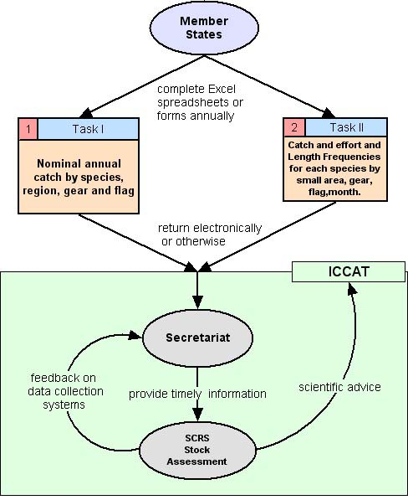

Options for the Benguela Region
The exact mechanism for exchange or submission of data will be dependant on the following characteristics of the fisheries management authority responsible for the shared stocks of the Benguela;
- The organisational structure.
- The exact information needs of the organisation.
- The capacity of the organisation and funds available

A possible scenario is the establishment of a Secretariat with data management staff and plentiful resources. Given this situation the outsourced development of a web-based data collection system to meet the information needs of the organisation would be a possible solution.

A more realistic and technically proven approach is recommended given the likely financial and personnel constraints. This would involve adopting a simplified version of the ICCAT model;
- Proprietary software (MS Excel or MS Access) be used to develop fully documented data collection forms with guidance notes. The use of standard FAO Species, Vessel and Gear Codes is recommended, along with pull-down lists and data range checking in order to maintain data integrity. Such electronic forms should also be printable.
- Points of contact established in member states responsible for the completion and return of data forms to the Secretariat in a timely and accurate manner.
- Data made available to stock assessment scientists in a consistent format, thereby reducing time wasting and erroneous interpretation.

This approach is more robust given that the information needs of the fisheries management organisation will change steadily, particularly in the early stages. Development of the data collection forms and a database in which to manage the resultant data will require a member of staff with tertiary level skills in information science. The exact data requirements will be driven by a needs analysis as the regional management framework evolves.

Given political problems experience by other regional and subregional fisheries bodies, the issues of data ownership and national data policies must be addressed when developing regional data exchange procedures. Furthermore agreements must be established regarding the usage of data submitted to the Secretariat.

Recommendations
- Data exchange should be facilitated through a central point (e.g. a Secretariat) with national contact points established in member states who are responsible for the timely submission of data. Data should be submitted using electronic forms (e.g. MS Excel or MS Access) developed such that they are well documented, use FAO descriptors and enforce data integrity.
- A data manager/coordinator with a tertiary level qualification in information science should be responsible for the collation, management and dissemination of fisheries data.
- A usage policy, developed in consideration with national data policies should be established for data submitted to the Secretariat.

The extent to which existing catch data meets the information requirements of potential regional shared stock management scenarios.
The existing information systems in the three countries all have to a greater or lesser extent, problems relating to effectiveness and efficiency as highlighted in the main body of this report. Despite these problems, and considering the importance of reliable and timely information for decision-making, fisheries management appears to be functioning moderately well for most shared commercial species.

Currently no provisions are made in either stock assessment or management decision making for the incorporation of uncertainty associated with transboundary effects on shared resources. Given that transboundary effects maybe significant then the continued presence of these uncertainties will reduce the likely success of future management.

The argument for shared stock management is strongest for the smaller stock such as red crab and linefish which (in the case of red crab and snoek) are known to undertake transboundary migrations. However, existing information for the principal demersal and pelagic resources suggests that the Luderitz upwelling cell and the Angolan-Benguela front keep the stocks largely separate. This is not true in all instances and during environmental anomalies, and to a lesser extent seasonally, the stocks exhibit mingling and may require more active shared stock mechanisms for effective management. An example of this was seen when depleted “Namibian” pilchard resources were found in southern Angolan waters and unrestricted fishing (some of it by Namibian vessels) further fished down an overfished resource.

The differing extent of transboundary interactions for different stocks implies that shared stock management frameworks should be developed on a stock-by-stock case. Significant fluctuations for certain shared stocks are well documented for the Benguela but the extent that fishing pressure is driving those changes (as opposed to decadal and inter-decadal shifts in environmental conditions) is unclear. Much of the work of the BCLME and BENEFIT programmes is to address this uncertainty by promoting the incorporation of environmental and fisheries data in analyses. The observed fluctuations are also unlikely caused because inappropriate management was implemented because of a paucity of fisheries information, but rather because exploitation continued despite there being a good body of information. While new research findings may well increase the need for shared management approaches if stock interactions are shown to occur more widely than currently believed or because changing environmental conditions promote such mingling. However, it is argued here, that the main cause of uncertainty for future shared stock management is the limited understanding of the impacts of environmental change and the current limited incorporation of environmental data into management decision-making.

While benefits will be gained by improving the range and quality of fisheries information available for stock assessments, more significant reductions in reducing uncertainty for future fisheries management will likely be derived by being able to better predict the impact of environmental perturbations.

Using the framework proposed in Section 4.2, scientific exchanges could move forward (supported by BENEFIT/BCLME funding) for crab and other prioritised stocks. For hake, horse mackerel, and pilchard exchanges should be initiated that explore what environmental data is needed to support better management decision making, how it should be used and what management measures should be triggered and when. The more formalised steps could follow as appropriate.

Data Requirements
The data collection system and data management systems in the region are all different in their spatial and temporal aggregation of data stocks, formats used, levels of quality, level of documentation and completeness. There are also differences across species within countries, and across fisheries within species. Given this huge diversity in approach it is very difficult, and probably undesirable to identify individual areas for improvement. Where current data collection problems and systems create incompatibilities these are better accommodated within existing approaches, albeit perhaps with increased uncertainties.

There is an overarching recognised need within the region for improved age-length keys for purposes of population structure inputs into stock assessment models. However, such data is not a prerequisite to establishing or at least initiating the mechanisms required for shared management, and for the purposes of priority stocks (e.g. crab) there is sufficient existing data to move forward with exchange of population parameter estimates and trends. By comparing and contrasting data sets, their quality and fitness for purpose to a level of detail suitable for assessment, recommendations will emerge regarding changes needed to data collection programmes.

A summary of the data sets available in the three countries is provided below in the table below. More details are available in the main report mission activities section;
Table 4. Summary of the data sets available in the three countries
 | South Africa | Namibia | Angola
Catch and effort time series | Long time series 25+ years | Long time series 25+ years | Shorter time series - 1997
Catch in number, weight or both | 1yr (and decreasing) backlog in data entry. Not all data in system validated. Sybase | Landings in FIMS.  Logsheets in Access/Excel from 1997.. | Available from 1997 (95 for horse mackerel). MS Access/SQL Server
Discard statistics | Not collected. Dumping suspected in pelagic fishery | Collected by observers | Not collected. By Catch stats only
Effort statistics | 1yr (and decreasing) backlog in data entry. Not all data in system validated. | Logsheets in Access/Excel from 1997 | Available from 1997 (95 for horse mackerel). Low spatial (province name) and temporal (1 month) resolution
Fishing location, date and time | Good spatial and temporal resolution | Good spatial and temporal resolution | Low spatial (province name) and temporal (1 month) resolution
Length, weight and sex composition of catches | Sampling undertaken and data available | Sampling undertaken and data available | Pilot project 2002. Otherwise research data only. New programme starting.
Age, growth, recruitment | Ageing data backlog 5-6 years. Recruitment from research surveys and studies | Ageing data backlog Recruitment from research surveys and studies | Not available from catches. Research only.
Surveys | Survey time series available for key species | Survey time series available for key species | Survey time series for key species
Vessel Details | Available | Available | Available

If regional standardisation of data or collection methods is necessary in order for inter comparability, then propose recommended procedures.
Procedures such as GLM-based standardisation of CPUE time series data are frequently used within the region in stock assessment. Such standardisation procedures do not imply standard data collection methods. Exact methods used for standardisation of data should be determined through working groups after gaining detailed insight into the potential biases in data sets resulting as a consequence of data not being collected on the basis of a balanced design.

The standardised aggregation of data would be expensive given that it may involve a change in existing data collection systems. Furthermore, it is not a necessary prerequisite for the movement towards shared management. It is very likely that data is already available at sufficient level of detail and aggregation and therefore any changes should be based on the result of sound statistical analysis through working groups.

Recommendations
1. Standardisation of data does not imply the need for standardisation of collection procedures, although this would undoubtedly be desirable. Methods for standardising data before inter comparability such as standardisation of CPUE data should be developed through scientific working groups.

The reliability and appropriateness of catch data management systems for the purposes of regional management of shared stocks.
The need for improved discipline in data management within the region is the priority concern affecting the reliability and appropriateness of the region’s information systems. This limited study has only been able to provide an outline of the available data sets and is not able o seriously address the reliability of individual datasets, databases and document the full extent of their fitness for purpose.

Using the documentation and references in this report as a starting point, and the knowledge of the data managers at Angola and Namibia it would be an extremely worthwhile exercise to undertake an inventory and document the exact contents of data management systems and their fitness for purpose, prioritising by shared stocks.

To document this inventory will require the adoption of metadata standards. The metadata format commonly adopted for fisheries and related information is based on NASA’s DIF format as adopted by the GCMD, IODE, CSIRO and the MATT system developed through the RFIS project. This format is suitable for fisheries and environmental data. The MATT system has been customised for regional needs but will require ongoing maintenance to be sustainable. An alternative is to organise for a customised BCLME portal to the online system of the GCMD/IODE; although the benefit that this system has over MATT would need to be clearly established given the momentum that the uptake of MATT has established.

South Africa is currently planning a migration of her resource based fisheries information system from a Sybase system to an Oracle system. It is important firstly that the return on the large investment for this system is justified, given that the existing system has yet to be fully implemented and is still undergoing work. This will provide a good opportunity for incorporating much reporting functionality and resolving access restrictions that are currently cited as problems with the existing system. Appropriate lesson learning from the development of Namibia’s FIMS should be utilised.

Additionally, the fishery management framework in South Africa is becoming increasingly complex and is demanding new indicators and variables to assess management performance. A revamped ‘management’ oriented information system is also required at a national level. Such an approach would have an additional advantage as it could spearhead the development of management driven information systems. Their wider uptake in the context of regional shared stock management will be required at some point in the future. Their development should be informed by both the development process undertaken in the design of FAO’s FIGIS and the potential need of the region to contribute information to this global system.

There are two noteworthy points concerning the reliability and appropriateness of catch data systems in Angola. Firstly the systems at IIM can be considered reliable in terms of stability and reporting ability. This is in part due to the work of the data management team through NORAD support and also because of the relatively simple nature of the data (often monthly aggregate) collected compared to Namibia and South Africa. There are concerns over obtaining timely information from Japanese vessels, which should be followed up with ship’s agents to improve timeliness.

Secondly, the Angolan MCS programme, which is introducing verification of catch data through an observer programme, will instil confidence in data which is suspected to be of poor quality. New logsheets are also being introduced to address the lack of spatial and temporal detail. A new information system is being developed for DNP to support these improvements. The new system is an enterprise scale MS SQLServer system and will therefore come with added complexity and new challenges in fisheries data management for Angola. The future reliability of the system will depend on managing this complexity whilst meeting reporting requirements. It is important that the system is properly implemented before the MCS programme finishes, to avoid experiences similar to the Namibian FIMS.

Recommendations
- The reporting facilities of the current information system in South Africa be reviewed and improved if necessary and better access be provided for scientists to access information in the system.
- The development of a reliable system in Angola is important for future regional stock management. It may be appropriate if not already undertaken for some lesson learning between Angola and Namibia concerning the development of fisheries information systems. Support should be given to ensure the management and maintenance of the systems after the MCS programme is finished.
- Both South Africa and Angola could benefit from experience gained in the development of similar systems designed and implemented for other fisheries institutions of similar complexity. This experience perhaps gained through appropriate international support to the design process, should also provide guidance on the regional and international reporting requirements of such systems.
- The exact contents of data management systems and their fitness for purpose be documented using a metadata standard, prioritising by shared stocks.

Recommend remedial action to improve catch data management systems where they fail to meet requirements.
It is unfortunate that the FIMS re-launch did not leave the ground at NatMIRC. It is essential for the integrity, longevity and accessibility of Namibian logsheet data that it is managed within a well-designed DBMS. Given that FIMS meets the information requirements of the log-sheets quite well whilst also providing a mechanism for data integrity; it should be the obvious choice of data repository. Without FIMS data losses will continue and data integrity remain poor. The successful uptake of FIMS at NatMIRC is only possible with a full commitment from scientists and IT staff alike in a ‘there’s no-going back’ environment. It is far easier and more comfortable for all but the users of the data to remain at status quo. It is recommended that a migration of all existing data from the MS Access systems into FIMS be the first step. Following this it may be necessary to run both systems in parallel before switching over entirely and removing the MS Access systems when there is satisfaction with FIMS. Success is more likely if the process is driven from within and therefore a NatMIRC staff member would ideally ‘champion’ the process and be rewarded if successful.

It will still be possible to perform analysis of catch data and integrate fisheries with other data outside of FIMS using spreadsheets and other software through the use of exported data. This will be a prerequisite for the uptake of FIMS at NatMIRC where scientists must be able to extract data in ASCII or similar format for reuse. Therefore given a standardised set of reporting requirements for regional fisheries management it will be a straightforward process to develop queries to extract the necessary data from FIMS in an appropriate format and level of aggregation.

Dedicated Data Managers
In the event that data continues to be manages outside of FIMS, it will be necessary to have single dedicated data manager at NatMIRC who is responsible for the maintenance and supply of all data. The data manager will be able to act as a contact point for external consultants and other users of the data. The data manager will have a tertiary level qualification in information systems and not partake in cruises.

Angola has an effective data management team who are able to provide the roles of data management, system maintenance and data dissemination.

South Africa has an assigned data manager who acts as a contact point for access to fisheries, data inventory and other data. However, his role has been extended to include other time consuming roles not related to data management. Consequently, users of South African data find the lack of a full time dedicated data manager restricts accessibility and reliability of the data.

Recommendations
- That the uptake of FIMS at NatMIRC should be promoted once again. The first step should involve a migration of existing data sets to FIMS, followed by a period of parallel usage of the systems before finally making a complete move. For best chances of success, NatMIRC should drive the process.
- Ideally all three countries should have a dedicated data manager who acts as a contact point for users of fisheries and related data. Their role would be to manage a data inventory, provide timely access to data when appropriate and ensure that custodians of data sets (including IT sections) maintain the integrity of the data. Where appropriate and no sustainable alternative exists, they can provide advice and assistance in the design of bespoke information systems. Ideally qualified to tertiary level in information science, they should be comfortable with technologies such as relational design, SQL etc.
  - Such a role already exists in Angola.
  - In Namibia there is an acute shortage of a dedicated data manager given the state of logsheet information systems. Using FIMS will reduce this need but not eliminate it.
  - More time should be allocated to the Data Manager role in South Africa.

Annex I. United Nations Fish Stock Agreement (Annex 1 thereof).
STANDARD REQUIREMENTS FOR THE COLLECTION AND SHARING OF DATA
Article 1 General principles
1. The timely collection, compilation and analysis of data are fundamental to the effective conservation and management of straddling fish stocks and highly migratory fish stocks. To this end, data from fisheries for these stocks on the high seas and those in areas under national jurisdiction are required and should be collected and compiled in such a way as to enable statistically meaningful analysis for the purposes of fishery resource conservation and management. These data include catch and fishing effort statistics and other fishery-related information, such as vessel-related and other data for standardizing fishing effort. Data collected should also include information on non-target and associated or dependent species. All data should be verified to ensure accuracy. Confidentiality of non-aggregated data shall be maintained. The dissemination of such data shall be subject to the terms on which they have been provided.

2. Assistance, including training as well as financial and technical assistance, shall be provided to developing States in order to build capacity in the field of conservation and management of living marine resources. Assistance should focus on enhancing capacity to implement data collection and verification, observer programmes, data analysis and research projects supporting stock assessments. The fullest possible involvement of developing State scientists and managers in conservation and management of straddling fish stocks and highly migratory fish stocks should be promoted.

Article 2 Principles of data collection, compilation and exchange
The following general principles should be considered in defining the parameters for collection, compilation and exchange of data from fishing operations for straddling fish stocks and highly migratory fish stocks:

(a) States should ensure that data are collected from vessels flying their flag on fishing activities according to the operational characteristics of each fishing method (e.g., each individual tow for trawl, each set for long-line and purse-seine, each school fished for pole-and-line and each day fished for troll) and in sufficient detail to facilitate effective stock assessment;

(b) States should ensure that fishery data are verified through an appropriate system;

(c) States should compile fishery-related and other supporting scientific data and provide them in an agreed format and in a timely manner to the relevant subregional or regional fisheries management organization or arrangement where one exists. Otherwise, States should cooperate to exchange data either directly or through such other cooperative mechanisms as may be agreed among them;

(d) States should agree, within the framework of subregional or regional fisheries management organizations or arrangements, or otherwise, on the specification of data and the format in which they are to be provided, in accordance with this Annex and taking into account the nature of the stocks and the fisheries for those stocks in the region. Such organizations or arrangements should request non-members or non-participants to provide data concerning relevant fishing activities by vessels flying their flag;

(e) such organizations or arrangements shall compile data and make them available in a timely manner and in an agreed format to all interested States under the terms and conditions established by the organization or arrangement; and

(f) scientists of the flag State and from the relevant subregional or regional fisheries management organization or arrangement should analyse the data separately or jointly, as appropriate.

Article 3 Basic fishery data
1. States shall collect and make available to the relevant subregional or regional fisheries management organization or arrangement the following types of data in sufficient detail to facilitate effective stock assessment in accordance with agreed procedures:

(a) time series of catch and effort statistics by fishery and fleet;

(b) total catch in number, nominal weight, or both, by species (both target and non-target) as is appropriate to each fishery. [Nominal weight is defined by the Food and Agriculture Organization of the United Nations as the live-weight equivalent of the landings];

(c) discard statistics, including estimates where necessary, reported as number or nominal weight by species, as is appropriate to each fishery;

(d) effort statistics appropriate to each fishing method; and

(e) fishing location, date and time fished and other statistics on fishing operations as appropriate.

2. States shall also collect where appropriate and provide to the relevant subregional or regional fisheries management organization or arrangement information to support stock assessment, including:

(a) composition of the catch according to length, weight and sex;

(b) other biological information supporting stock assessments, such as information on age, growth, recruitment, distribution and stock identity; and

(c) other relevant research, including surveys of abundance, biomass surveys, hydro-acoustic surveys, research on environmental factors affecting stock abundance, and oceanographic and ecological studies.

Article 4
Vessel data and information

1. States should collect the following types of vessel-related data for standardizing fleet composition and vessel fishing power and for converting between different measures of effort in the analysis of catch and effort data:

(a) vessel identification, flag and port of registry;

(b) vessel type;

(c) vessel specifications (e.g., material of construction, date built, registered length, gross registered tonnage, power of main engines, hold capacity and catch storage methods); and

(d) fishing gear description (e.g., types, gear specifications and quantity).

2. The flag State will collect the following information:

(a) navigation and position fixing aids;

(b) communication equipment and international radio call sign; and

(c) crew size.

Article 5 Reporting
A State shall ensure that vessels flying its flag send to its national fisheries administration and, where agreed, to the relevant subregional or regional fisheries management organization or arrangement, logbook data on catch and effort, including data on fishing operations on the high seas, at sufficiently frequent intervals to meet national requirements and regional and international obligations. Such data shall be transmitted, where necessary, by radio, telex, facsimile or satellite transmission or by other means.

Article 6 Data verification
States or, as appropriate, subregional or regional fisheries management organizations or arrangements should establish mechanisms for verifying fishery data, such as:

(a) position verification through vessel monitoring systems;
(b) scientific observer programmes to monitor catch, effort, catch composition (target and non-target) and other details of fishing operations;
(c) vessel trip, landing and transshipment reports; and
(d) port sampling.

Article 7 Data exchange
1. Data collected by flag States must be shared with other flag States and relevant coastal States through appropriate subregional or regional fisheries management organizations or arrangements. Such organizations or arrangements shall compile data and make them available in a timely manner and in an agreed format to all interested States under the terms and conditions established by the organization or arrangement, while maintaining confidentiality of non-aggregated data, and should, to the extent feasible, develop database systems which provide efficient access to data.

2. At the global level, collection and dissemination of data should be effected through the Food and Agriculture Organization of the United Nations. Where a subregional or regional fisheries management organization or arrangement does not exist, that organization may also do the same at the subregional or regional level by arrangement with the States concerned.

Annex II. Institutes Visited and People Met
Institute | People Met
Marine and Coastal Management,  Private Bag X2,  Rogge Bay 8012,  Cape Town, | Johann Augustyn
 | Rob Leslie
 | Carl van der Lingen
 | Sharon du Plessis
 | Jan van der Westhuizen
 | Chris Wilke
Marine Resource Assessment and Management (MARAM),  Department of Mathematics and Applied Mathematics,  University of Cape Town,  Private Bag  Rondebosch 7701,  South Africa | Anabela Brandao
 | Eva Plaganyi
 | Susan Johnston
National Marine Information and Research Center,  Strand Street,  P.O. Box 912 ,  Swakopmund,  Namibia | Hannes Holtzhausen
 | Titus Illende
 | Angie Kanandjembo
 | Carola Kirschner
 | Anja Kreiner
 | Heinrich Lesch
 | Theopolina Namwadi
 | Peter Schneider
Ministry of Fisheries & Marine Resources,  Brendan Simbwaye Square, Block C,  C/O Uhland & Goethe Street,  Private Bag 133355,  Windhoek  Namibia | Lucia Haufiku
 | Paul Nichols
Instituto de Investigação Marinha  P. O. Box 2601  Luanda  Angola | Paulo Brincas
 | Azviedo Domingues
 | Guilherme
 | Nkosi Luyeye
Direcção Nacional das Pescas  Luanda  Angola | Julia Ferreria
Direcção Nacional das Pescas  Luanda  Angola | Florian (EU MCS Project)
Instituto de Pesca Artisanal  Luanda  Angola | Duarte Augustyn

Annex III. Data Flow Diagrams
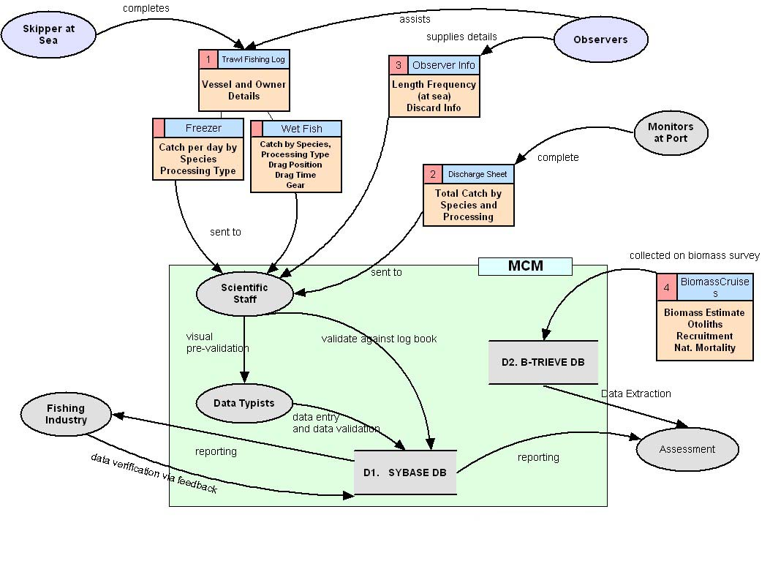
Figure 2 South African Hake. Data sources, pathways, processing and storage of commercial catch and fishery independent research data
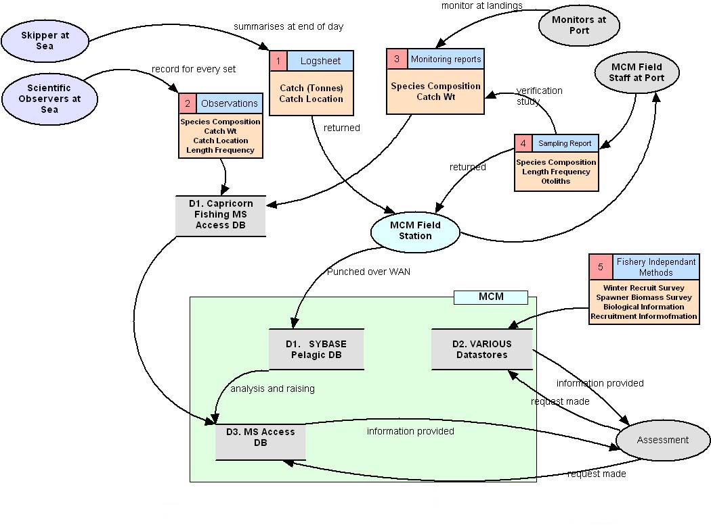
Figure 3 South African Pelagics. Data sources, pathways, processing and storage of commercial catch and fishery independent research data
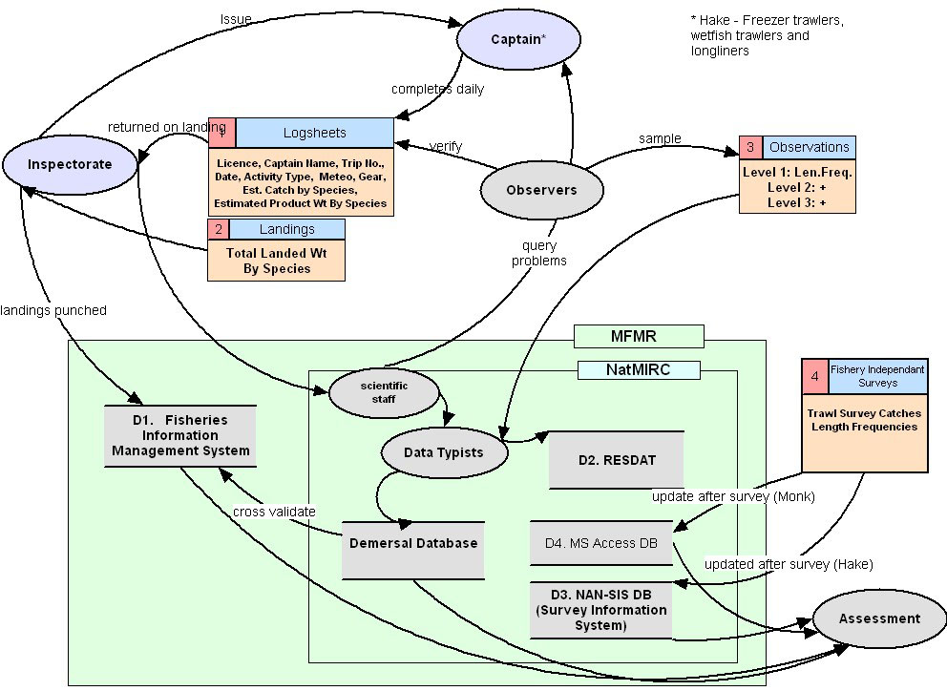
Figure 4 Namibian Hake. Data sources, pathways, processing and storage of commercial catch and fishery independent research data.
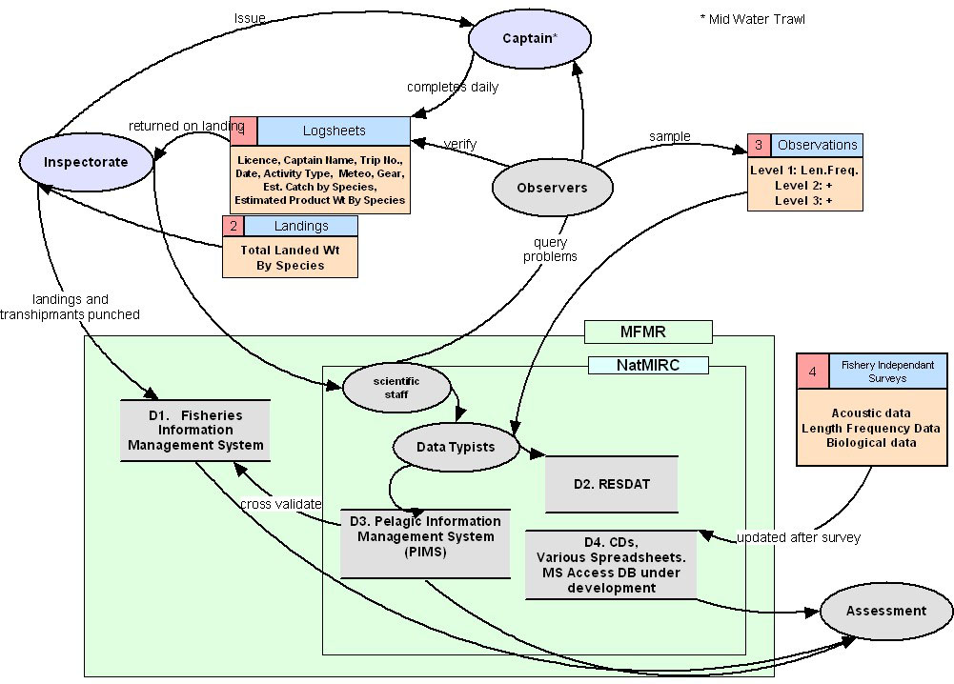
Figure 5.Namibian Horse Mackerel. Data sources, pathways, processing and storage of commercial catch and fishery independent research data.
Figure 6 Namibian Pelagics. Data sources, pathways, processing and storage of commercial catch and fishery independent research data.
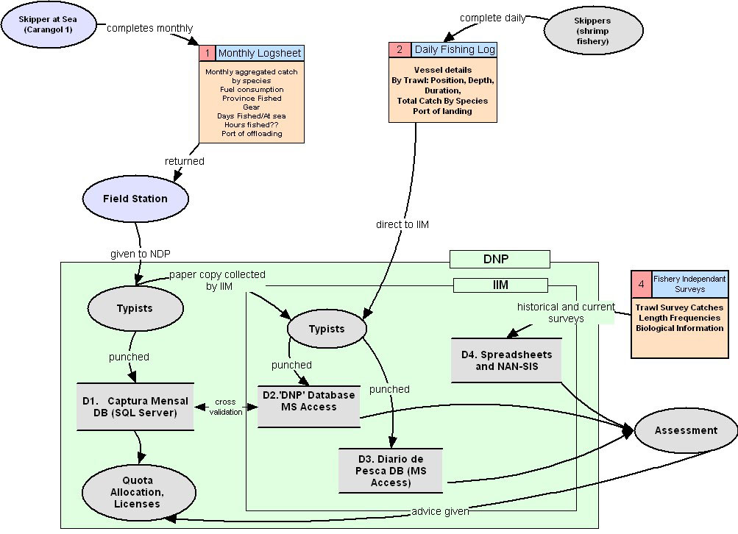
Figure 7 Angolan Crab. Data sources, pathways, processing and storage of commercial catch and fishery independent research data.
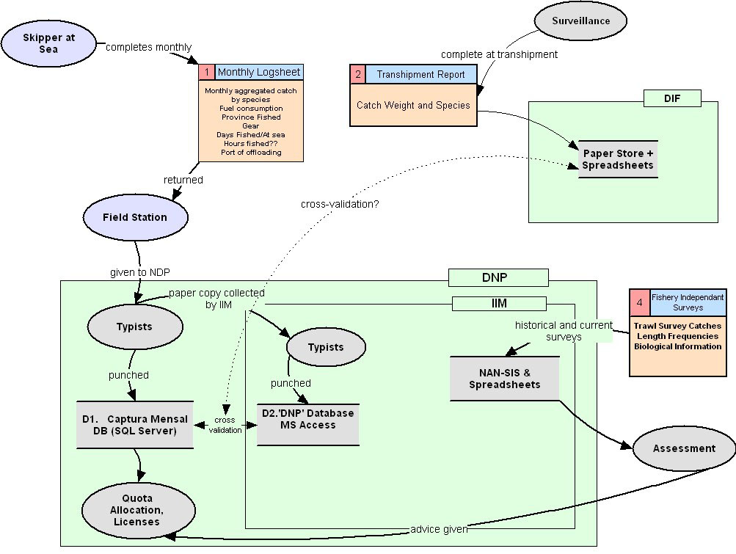
Figure 8 Angola Pelagic & Demersal. Data sources, pathways, processing and storage of commercial catch and fishery independent research data.

Annex IV. References
Aukland, R. A Proposal to BENEFIT, Making Effective Use of the Data Resource through the Incorporation of Data Management practices into BENEFIT activities, BENEFIT document BEN/2002/04/MAC/02, RFIS Project 2002.

Boyer, H. Data available – Small Pelagics. Internal Memorandum. Ministry of Fisheries and Marine Resources 1999.

Caddy, John F. 1997. Establishing A Consultative Mechanism or Arrangement for Managing Shared Stocks Within the Jurisdiction of Contiguous States, in D. Hancock (ed.), Taking Stock: Defining and Managing Shared Resources, Australian Society for Fish Biology and Aquatic Resource Management Association of Australasia Joint Workshop Proceedings, Darwin, NT, 15-16 June 1997, Sydney, Australian Society for Fish Biology: 81-123.

Cadima, E.L. Fish Stock Assessment. FAO Fisheries Technical Paper 393, Rome 2003.

Evans, D and Grainger, R. Gathering Data for Resource Monitoring and Resource Management. Chapter 5 In Handbook of Fish Biology and Fisheries (Volume II), Blackwell Publishing 2003.

FAO Technical Guidelines for Responsible Fisheries 4. Fisheries Management. FAO, Rome, 1997.

FAO. Guidelines for the Routine Collection of Capture Fisheries Data. FAO Fisheries Technical Paper 382. Rome, 1999

Gulland, John A. 1980. Some Problems of the Management of Shared Stocks, FAO Fisheries Technical Paper No. 206, Rome.

Namwadi, T.M. Pelagic Commercial catch and biological data. PWG/HM/03/02. NatMIRC, 2002

PENNY, A.I., I. Hampton, R.P. van der Elst, A.D. Wood, H.J. Boyer, S. Fennessy and T.G. Andrew, Requirements for development of Effective cooperative arrangements for the management of shared fish stocks in the SADC region, prepared by Envirofish Africa (Pty) Ltd March 2003

Purchase, L. Towards the BOSRM, Biological Oceanographic and Scientific Research Module for the Namibian FIMS, 1996

SHANNON, L.V. and M.J. O’TOOLE 1998 – An overview of the Benguela ecosystem. Collected papers, First Regional Workshop, Benguela Current Large Marine Ecosystem (BCLME) Programme, UNDP, Cape Town, South Africa, 22-24 July 1998: 20pp.

Swan, J. Regional Fisheries Bodies and Governance: Issues, Actions and Future Directions, FAO, Rome 2000

