¹ Introduction

Introduction
Classification
External Characteristics
Chemical composition of body

Khazar (Caspian) is the name of a tribe that once ruled in the north of the Caspian Sea in the north of the Caucasus Mountains. A group of them later moved southwest to the Karimi sub-island to the north of the Red Sea where they formed the Khazaran country. The Caspian Sea, which covers a surface area of 3733000 km², is the largest lake in the world shared by the five Caspian littoral states; The Islamic Republic of Iran, Azerbaijan, The Russian Federation, Kazakhstan and Turkmenistan (figure 1). This sea is home to about 115 fish species and sub species some of which are commercially important including the five unique sturgeon species such as the beluga sturgeon (Huso huso), the Persian sturgeon (Acipenser persicus), the Russian sturgeon (Acipenser gueldenstaedtii), the ship sturgeon (Acipenser nudiventris) and the stellate sturgeon (Acipenser stellatus) as well as the bony fishes such as the Kutum (Rutilus frissi kutum), mullets, breams, carps, barbus, salmons, and kilka fish.
Rutilus frissi kutum is the most important bony fish inhabiting the Caspian Sea and is a very popular species among fishers, coastal dwellers and the people in Iran as well as in other Caspian littoral states for its high nutritive value and for its rich and good tasting meat. This species has a life span of 9-10 years in the Caspian Sea and it is caught between early October and the end of March every year. There are two spawning migrations, winter and spring, and so two forms or stocks of this species in the Iranian waters of the Caspian Sea.
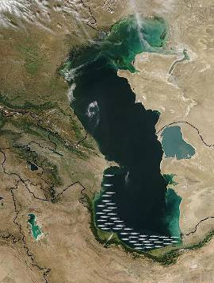

Fig. 1 The Caspian Sea and the schematic distribution of Rutilus frissi kutum
Classification
Order: Cypriniformes
Family: Cyprinidae
Genus: Rutilus
Species: Rutilus frissi kutum
Persian name: Mahi Sefid
English name: Kutum
Russian name: Kutuma

External Characteristics
The kutum normally has a laterally compressed fusiform body. The dorsal surface dark in color, lateral sides silvery white and the ventral surface is white in color. This species has five sets of fins including two pectoral fins, two ventral or pelvic fins, one dorsal fin, one anal fin and one caudal fin (homocercal) (figure 2). The fin formula is as follows:
D III 9; A III 10; L.1. 53 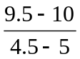 62; G.r.8-12
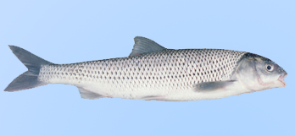

Fig. 2 Rutilus frissi kutum
This species is characterized by having pharyngeal teeth in one row usually 6-5, sometimes 5-5 or 6-6. Mouth is subterminal with a protractile snout and barbels are absent. Scales are moderate in size and cycloid. The body depth is equal to or less than head length and anal fin is longer than its height.
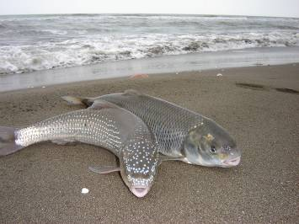
This species attains a maximum length of 71 cm and a maximum weight of 4 kg. The mean length and weight of this species is 45 cm and 1100 kg, respectively. It has a pair of lateral lines that run on the two sides of the body from the operculum up to the tip of the caudal fin. Epithelial tubercles are found on the top of the head and on the sides of the body in males during the spawning season (figure 3). Tubercles are white in contrast to the dark head and make it look like a wedding dress (Abbasi et al., 1999).

Fig. 3 Epithelial tubercles on male Rutilus frissi kutum in the river
Eyes used to see objects at close distance and play a significant role in finding food items feeding and in finding routes. There are two nostrils on the two sides of the snout located in front of the eyes. A skin fold inside the nostril divides each nostril into two parts. The floor of the nose cavity is covered with olfactory epithelium. While swimming water enters the body from the anterior part of the nose and leaves the body from the posterior part of the nose thus stimulating the olfactory cells.
Ears are internal and are connected to the swim bladder by Weberian ossicles for sound transmission. This species has a relatively strong sense of hearing (17-700 HZ). Swim bladder in kutum has two parts, the posterior part is elongated or pointed and is connected to the foregut or oesophagus by pneumatic ducts (Weber, 1991).
Chemical composition of body
The chemical composition of kutum varies from one individual to another and depends on sex, weight, age, feed intake and time of sampling. However the principal constituents may be divided into the categories shown in Table 1.
Table 1 Principal composition (percentage) of kutum fillet
Protein | Lipid | Wet | Ash
18-20 | 4-6 | 74-76 | 1-2

² Biology

Natural Feeding
Natural Reproduction

Natural feeding
This species is an omnivore. However unlike other omnivores it has a limited food supply, due to its short digestive tract. In the early stages it feeds on phytoplankton and zooplankton as well as on insect larvae, but during later stages and after migrating to the sea this species mainly feeds on bivalves (Table 2). The digestive tract in this species includes the mouth, alimentary canal, anterior gut, posterior gut and anus. This species lacks a true stomach.
Table 2 Main natural foods of Rutilus frissi kutum
Benthos | Zooplankton | Phytoplankton
Chironomidae | Protozoa |  | -Ankistrodesmus | Cynophyta
Diptera | -Difflugia |  | -Selenastrum | -Merismopedia
Nematoda | -Centropyuis |  | -Scenedesmus | -Microcystis
Insect larvae | -Marituja |  | -Volvox | -Lyngbya
Odonata | -lionotus |  | -Chlamydomonas | -Anabaena
Cerastoderma lamarcki | -Arcella |  | -Spirogyra | -Rophidiopsis
Abra ovata | Rotatoria |  | -Ulotriv | -Nostoc
Mytilaster lineatus | -Lepadella |  | -Pandorina | -Phormidium
Dreissena polymorpha | -Pompholyu |  | -Dictiosphaerium | -Gomphosphaerium
Hypanis sp. | -Philodina |  | -Oedogonium | -Anabaenopsis
Annelida | -Keratella |  | -Cladophora | -Oscillatoria
Nereis diversicolor | -Brachionus |  | -Schroderia | -Aphanizomenon
Hypaniola kawalewskii | -Asplanchna |  | -Actinastrum | -Spirulina
Hypania invalida | -Monostyla |  | Bacillariophyta | -Chrococcus
Balanus sp. | -Synchaeta |  | -Cyclotella | -Gloeotrichia
 | -Philodina |  | -Melosira | Euglenphyta
 | -Rotaria |  | -Stephanodiscus | -Euglena
 | -Anareapsis |  | -Synedra | -Phacus
 | -Polyarthra |  | -Navicala | -Lepocinclis
 | Copepoda |  | - Fragilaria | -Trachaelomonas
 | -Cyclops |  | - Tabellaria | Pyrrhophyta
 | -Diaptomus |  | -Asterionella | -Ceratium
 | -N.Cyclops |  | - Nitzschia | -Glenodinium
 | Cladocera |  | - Gyrosigma | -Gymnodinium
 | -Daphnia |  | - Gomphonema | -Predinium
 | -Moina |  | - Diatoma | Chrysophyta
 |  |  | -Denticula | -Synura
 |  |  | Cryptophyta | -Dinobryon
 |  |  | -Mallomonas | -Chlorella
 |  |  | -Crytomonas | -Pediastrum

Natural Reproduction
R. frissi kutum is among the species which exhibits high fecundity. The absolute fecundity in this species ranges from 19718 to 147696 eggs with a mean value of 74774 eggs. The mean value for number of eggs per gram eggs is 272 eggs. The eggs are yellow to golden yellow and sometimes pistachio green in color and their diameter varies from 1.2-1.9 mm. Mature males weigh between 400 g to 2.100 kg, while mature females weight between 500 g to 3.300 kg. Males attain sexual maturity between 2-3 years and females become sexually mature between 3-4 years. The ratio of males to females in rivers during natural reproduction differs and usually varies between 3.2:1 to 6.6:1.
Depending on the spawning migration (autumn or spring), males and females ready for spawning enter the Anzali Lagoon and rivers in the southern shores of the Caspian Sea in autumn or in spring and spawn on submerged aquatic plants or on pebbly bottoms (figure 4). The stage of sexual maturity, water and air temperature, water flow, water clarity, dissolved oxygen and coastal processes in the sea are the main factors that determine the entrance of these fish into the rivers on the spawning migration.
On reaching sexual maturity and entering the river, male and female spawners undergo morphological variations. Males become conical and possess white tubercles on their head and on the sides of their body. Females have a smooth body surface with a soft, swollen abdomen which is laterally symmetrical. Each female is flanked by two males at spawning in shallow water. Stimulated by males, the females sharply rub their lower abdomen and pectoral area on the gravel bottom, males and females convulse, and eggs are shed. Males release their sperms simultaneously on the eggs and fertilization occurs. The eggs absorb water and become swollen after the entry of the sperm into the micropyle and cell division begins. The eggs are adhesive at this stage and stick to pebbles and plants on the bottom of the spawning ground. They remain in this state for 14 to 16 days during which the embryo grows and develops in the egg after which the cell membrane ruptures and the larvae emerge.
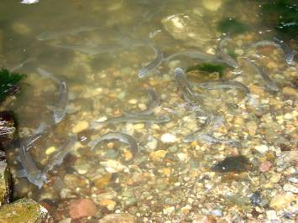

Fig. 4 Natural spawning of kutum on pebbly bottoms in river
Incubation of eggs lasts for 9-10 days under normal conditions. Larvae feed on yolk sac reserves for 4-5 days and then begin to feed on various planktons in rivers and lagoons where they develop into fingerlings and attain a body weight of a few grams. Once osmoregulation in fry is developed, they migrate towards the sea where they remain until they attain sexual maturity.

³ Ecology

Habitat and distribution of Rutilus frissi kutum in the Caspian Sea
Migration and Population Diversity
The autumn form of Rutilus frissi kutum
The spring form of Rutilus frissi kutum
Rutilus frissi kutum growth in the Caspian Sea

Habitat and distribution of Rutilus frissi kutum in the Caspian Sea
Rutilus frissi kutum is mainly distributed in the south and southwest coast of the Caspian Sea and is considered an economically valuable species in the region extending from the Atrek River located in the Caucasus region (western coasts of the central Caspian region) up to the southern coasts of Turkmenistan. This species rarely occurs in other regions of the Caspian Sea including the north Caspian and the Volga River and there has been no official report on the migration of this species to these regions. Highest abundance and catch figures for this species in the past years are found in the regions between the Kura River in Azerbaijan and the Sepidrud River in Iran. However following the mass release of kutum fingerlings throughout the Iranian shores of the Caspian Sea in the past 25 years has caused a considerable difference in the distribution of this species and their numbers in the coasts of the Mazandaran and Golestan Provinces have increased significantly. Variations in kutum abundance are associated with variations in season and temperature. In early winter because of colder temperatures in the coastal waters of the Gilan Province as compared to that in the Mazandaran Province this species migrates to the warmer eastern parts, moving away from the coast and migrating to the deeper regions of the sea. However in late February, as spring approaches this species gets ready for its spawning run and they are found in larger numbers in the coastal regions reaching a peak in late March. Today the Anzali Lagoon in Iran and the Ghazel Aghaj Lagoon in Azerbaijan that were considered the main spawning grounds for kutum in the past have lost their significance and are no more able to support kutum spawning. Most of the rivers in the Iranian coasts of the Caspian Sea were used in the past for the natural spawning of kutum, but at present only the a few rivers including Chalusrud, Lemir, Shalmanrud, Khoshkud, Sefidrud, Shirrud and Babolsar are used as the main spawning grounds for the spring migration and for the artificial breeding of this species in the Iranian coasts of the Caspian Sea. Apart from the rivers in the Iranian coasts, the Atrek, Samur and Kura Rivers in the Caucasus region are also spawning grounds for kutum. However spawning migrations of this species to these regions have declined drastically because of polluted coasts, over fishing of spawners and the absence of artificial breeding and rehabilitation of stocks through the release of fingerlings.
Rutilus frissi kutum spends the remaining period of spring and summer feeding and growing in the shallow coasts of the Caspian Sea where there is an abundance of benthic fauna.
In late summer when the water temperature is very high and the epilimniom extends to the depth of 30 m, these fish leave the shallow coastal regions and move to deeper layers close to the thermocline only to return to the shallow coastal regions (<20 m) during the autumn circulation for feeding. In autumn this species migrates in shoals along the coastline from the west to the east or vise versa. Such migrations are totally dependant on atmospheric conditions and sea currents caused by wind.
During late autumn and early winter when surface layers become cold and during thermal stratification, kutum species gradually abandon the shallow coastal regions and move to deeper regions so that when winter sets in this species is rarely found in the shallow regions particularly between mid December and late January. Kutum spends the winter in deeper regions of the sea bottom which sometimes even exceed 100 m. Feeding activity in this species is low in winter. Between late January and early February when climatic conditions are favorable, the spring forms of this species start moving towards the coastal regions of the sea and resume feeding to store energy in the form of lipids and prepare for their spawning migration to rivers and lagoons. The main spawning migration in the rivers and Anzali Lagoon occurs in mid March and lasts until mid May depending on water temperature, sea processes and ecological conditions.

Migration and Population Diversity
Kutum feeds and grows in the sea and enters freshwater bodies such as the Anzali Lagoon and rivers leading to the Caspian Sea to spawn after it attains sexual maturity. According to Derzavin and Berg (1934) this species possesses two migratory forms and populations; the autumn form and the spring form.

The autumn form of Rutilus frissi kutum
In late September, when conditions are favorable, the autumn form of this species usually begins its migration to the Anzali Lagoon through the navigation canal. Male fish run before females. Spawners migrate towards rivers leading to the lagoon the principal rivers being Siyahdarvishan, Pasikhan, Masouleh and under suitable hydrological conditions to the Pirbazar River. These fish overwinter in the Anzali Lagoon particularly in the deeper regions of the central and western parts of the lagoon and enter rivers with emergent or submerged aquatic plants when temperature increases in the end of winter. Eggs are deposited on these plants which makes this form of kutum as being phytophylus.
During the spawning season two to three males usually provoke each female fish and eggs and sperm are released simultaneously into the water and fertilization occurs. Fertilized eggs adhere to aquatic plants and embryonic development takes place in an oxygen rich environment. Larvae emerge from the eggs after about two weeks and begin to swim freely. Very few larvae stand a chance to grow and migrate into the sea because of the presence of several predators in the Anzali Lagoon. Unsuitable ecological conditions in this lagoon that is sometimes associated with serious oxygen depletion which sometimes reaches zero also result in the mortality of a large number of larvae.
After spawning, kutum of the autumn form migrate back into the sea in late winter and early spring where they resume active feeding in order to compensate for the lost energy. With regard to the extensive food resources found in the Anzali lagoon, Kutum larvae produced in this lagoon show better growth as compared to that in the spring form. These larvae begin to migrate to the sea after 25-35 days when they have reached a weight of 2-3 g and complete their development feeding on various natural food items in the shallow regions of the Caspian Sea.

The spring form of Rutilus frissi kutum
The main population of R. frissi kutum in the Caspian Sea is the spring population, which comprises more than 98% of the stocks of this species in the Caspian Sea. The spring form of this species moves from the deeper parts towards the coastal regions after the thermal circulation in spring when the water temperature becomes almost uniform at the surface and depths of the Caspian Sea. Fishes that have not reached sexual maturity remain in the coastal regions in late winter and early spring to feed and grow, while mature fishes migrate into the rivers.
Several factors influence the entry of R. frissi kutum into the Sepidrud River for natural reproduction, which include water temperature, sea processes, water flow, Secchi disk depth and dissolved oxygen concentration. Spawners usually migrate into rivers where they spent their early ontogeny (from egg to migration to the sea). Locating the native river is usually
On entering the river through the estuary the spring form of
R. frissi kutum moves upstream depositing their eggs 500-800 m from the estuary on stony and gravel bottoms and are thus called lithophylus fish.
The spring form of R. frissi kutum is in the end of IV stage of sexual maturity when it enters the river and attains complete sexual maturity and is ready for spawning when it reaches the spawning ground. Spawning begins when temperature is 8 ºC and reaches a peak at 13-15 ºC (Berg, 1965).
Male fish run before females. In the river each female is flanked by 3-4 male fish. Stimulated by males, the females sharply rub their lower abdomen and pectoral area on the gravel bottom, males and females convulse, and eggs are shed in clear water rich in oxygen. Males release their sperms simultaneously on the eggs and fertilization occurs. Fertilized eggs are adhesive in nature and stick to stones.
Female fish choose clear and shallow waters for spawning and sometimes the dorsal fin and backs of the fish protrude from the water. The female spawner changes its mate and chooses a new mate several times during spawning.
Spawning is so intense that males and females injured through contact with the gravel stream bed and depleted of their energy are easily caught by fishermen in the river. Spawners that are able to reach the sea after spawning resume active feeding to recompense for the spent energy.
Fertilized eggs swell up on absorbing water and are adhesive sticking to the stony bottom until the larvae hatch in 16 days at 14-16 °C. The larvae begin to swim freely when the yolk sac is almost absorbed. Fry in the spring form of kutum normally remain in the river for 30-45 days before they enter the sea (Khanipour, 1984).

Rutilus frissi kutum growth in the Caspian Sea
Several factors influence growth in kutum such as hereditary characteristics, food reserves, environmental factors, pollution etc.
Investigations carried out indicate that growth in this species in the recent years has decreased drastically as compared to that in the past whereby length and weight increases in terms of age have decreased gradually. This can be mainly attributed to artificial breeding and restocking programs carried out every year by the Iranian Fisheries Organization. Over fishing and the elimination of larger individuals of this species by the use of inappropriate fishing gear have also contributed to this situation. Considering that there is no selection involved in choosing male and female spawners for artificial breeding programs, the gene bank of this species is gradually shifting. Growth variations in kutum for different years have been compared (Table 3).

Table 3 Comparison of length (cm) in Rutilus frissi kutum caught in beach seine in the Iranian coasts of the Caspian Sea
Year class | 1 | 2 | 3 | 4 | 5 | 6 | 7 | 8
1972-73 | 24.6 | 37.3 | 42.2 | 49.9 | 52.7 | 58.5
1992-93 | 25.9 | 32.5 | 37.2 | 43.3 | 48.8 | 52.3 | 55.5 | 56.0
1996-97 | 23.2 | 28.8 | 33.5 | 41.1 | 44.8 | 48.2 | 50.7 | 51.7
2004-05 | 20.5 | 27.4 | 33 | 37.5 | 41.9 | 46.3 | 49.7 | 53.8

Mean length in three year old adult kutum was 42.2 cm during 1971-72, whereas that in 2004-2005 was recorded as 33 cm. Such decreasing trends were observed in almost all year classes in the fish caught in different years. Mean length and weight recorded in kutum specimens caught in the Iranian coastline of the Caspian Sea in 1991 through 2003 also show declining trends which could be related to restocking of this species through artificial breeding and also to the failure in natural reproduction in this species.
Thus providing the required conditions for natural spawning in rivers that this species migrates to and/or the semi-natural breeding of kutum in earthen ponds where the selection of breeders is allowed even if only of a small size is stressed more than before (Khanipour, 2005).

⁴ Fishing

Fishing history in the Iranian waters of the Caspian Sea
Stock status and catch of kutum in Iranian Waters of the Caspian Sea
Catch methods for Rutilus frissi kutum
Marine fixed gillnets
Beach seine
Two sheet drift net

Fishing history in the Iranian waters of the Caspian Sea
Catch and utilization of fishes in the Caspian Sea has been practiced by the coastal dwellers and mainly by the Russians since the long past. No documented data is available on fishery and fishing in the Caspian Sea following the Arab era and right up to the tenth century. The first records were found in a book by Abolghasen Ben Hoghal from Baghdad in 919 year. This book traces a map of the Caspian Sea showing the outlines of Gilan and Tabarastan. The writer describes the people of this region to have bridged eyebrows and hot temperament and rice, fish and garlic to be their staple diet.
When Al-Buye a fisherman from Gilan became the ruler (903-1026 years) with the expansion of their territories up to Iraq, fisheries and fishing in the Iranian regions of the Caspian Sea also flourished.
During the Safavi Dynasty fur, leather, linen, cotton material, iron, copper and metal and glass handicrafts as well as paper for stationery and weapons were imported to Iran from Russia through the Caspian Sea, Anzali Lagoon and Volga River in exchange for sturgeon, perch and kutum fish.
When Fath Ali Qajar was defeated by the Russian army in 1862 and when the Treaty of Turkman was signed, Nakhjavan, Shirvan and Baku were separated from Iran and fishing permits in the Caspian Sea were handed over to the Tsar government. Based on a treaty signed in 1840 the Russian fishermen in Gilan paid the ruling government 39720 Rails in return for 101112 sturgeon fish and 281800 kg caviar harvested in the Caspian Sea.
During the reign of Mohammad Shah Qajar, the government of Mirza Aghasi under the pressure of the Tsar government handed over the fishing permits for sturgeons and bony fishes in the Caspian Sea to Haj Ebrahim Daryabeghi in return for 140000 Rails annually. The fact that 40000 Rails alone of this amount was the annual rent for the Sepidrud River throws light on the significant catches of different species such as kutum, perch, barbus and sturgeons.
During his rule in 1886, Mirza Taghi Khan annulled this contract on the pretext that the rent was not paid and handed over the fishing permits to an Iranian named Vali Beig for an annual rent of 250000 Rails. In 1914 Haj Mirza Hossein Khan Sepah Salar rented the fishing permits in the Caspian Sea and the Anzali Lagoon entirely from the Shah only to hand it over to a Russian merchant named Stefan Martinovich Lianazov after four months for an annual rent of 500000 Rails. In 1893 Lianazov extended the contract on the fishing permits for fishes in the Caspian Sea for another 25 years.
After the death of Stefan Martinovich Lianazov in 1935, his son Georgi took over and extended the contract for a further 25 years. This contract was stable for a long time during which Lianazov the son attempted to build very extensive installations including fishing vessels with cold storage, fish salting and smoking units, store rooms, fishing net construction workshops, office buildings and the production of electricity in Astara, Bandar Anzali, Kiyahshahr, and Turkman. About 4200 people were employed in the fishery establishment of which about 3000 were Russian nationals. During this period Lianazov made very good profits by over exploiting fishery stocks in the Caspian Sea as well as in the Anzali Lagoon.
In 1948, Lianazov rented out the fishing permits for bony fishes in rivers and in the sea to General Mansour for 220000 Rails and to other fishers for 800000 Rails on condition that all the total perch catch is handed over to him free of cost.
After the victory of the revolution and following the establishment of the Soviet Union in Russia, the Lianazov contract was annulled and a joint fishing company of Iran and Russia was established that was issued a fishing permit for a period of 25 years. The invasion of Bandar Anzali and the confiscation of the property of Fisheries by the Jungle Movement of Mirza Koochek Khan were among the other events of that time.
On 1 February 1952, the contract for the Iran-Russia joint fishing company was annulled and Fisheries was nationalized by
Dr. Mosadegh. In 1953 the constitutional law for the Iranian Fisheries Company was proposed and approved.
After the nationalization of the Iranian Fisheries Company this company merged with the Ministry of Finance and in 1967 with the establishment of the Ministry of Natural Resources, the Iranian Fisheries Company became affiliated to this Ministry. In 1973 with the demolition of the Ministry of Natural Resources it was brought under the Ministry of Agriculture and in 1987, by the order of the Leader of the Islamic Republic of Iran it was officially detached from the Ministry of Agriculture and affiliated to the Ministry of Jehad Sazendaghi. In 2000 when the Ministry of Agriculture and the Ministry of Jehad Sazendagi merged together the Iranian Fisheries Company became affiliated to the Ministry of Jehad Agriculture and in 2005 it was transformed into the Iranian Fisheries Organization.
At the time when fishing permits in the rivers and Caspian Sea were under the control of Lianazov, sturgeons were caught mainly in the Caspian Sea using cotton gillnets and bony fish w ere caught in rivers using ‘Shil”.
At the time of establishment of the Iran-Russia joint fishing company bony fish catch particularly kutum catch was conducted in 40 cooperative societies in the coastal provinces of Gilan and Mazandaran using waiting nets. Since 1979 gillnets made of nylon were used to catch kutum in addition to beach seine. However when large numbers of juvenile and premature adults of sturgeon were caught as bycatch in gillnets used for kutum catch thus causing harm to sturgeon stocks in the Caspian Sea the use of these nets in the Caspian Sea was banned since 1997. At present catch of bony fishes and kutum in the Caspian Sea is carried out only by 150 cooperative societies using beach seine (figure 5).

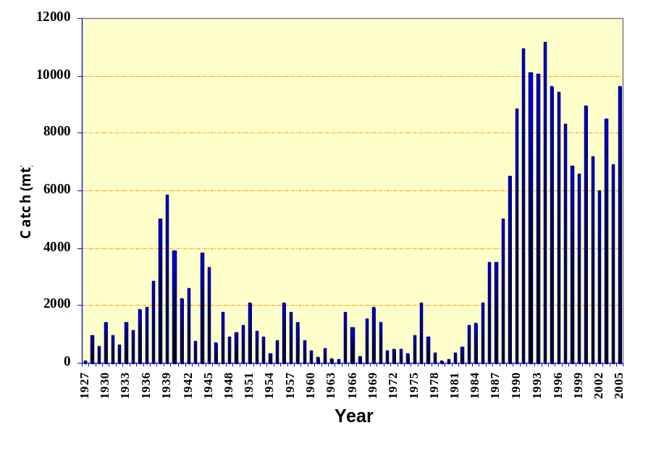
Fig. 5 Variations in Rutilus frissi kutum catch in the Caspian Sea

Stock status and catch of kutum in Iranian Waters of the Caspian Sea
Rutilus frissi kutum is the most important bony fish species for fishers in terms of catch numbers and selling price. This species now comprises more than 60% of the total bony fish catch in the Iranian shores of the Caspian Sea, whereas in 1931 it constituted only about 16% of the recorded catch. Changes that occurred in the decades that followed destroyed the stocks of some species and decreased species diversity of the fishes caught. Highest catch figures in the past decades was 5854 tons in 1939 following which figures for kutum catches showed decreasing trends as a result of over fishing and loss of natural spawning grounds for this species in rivers and the Anzali Lagoon caused by sand removal and the entry of agricultural, domestic and industrial sewage into this water body and also the lowering of the Caspian Sea level. This continued until the 1980s when kutum catch figures reached its lowest level (Ghani Nejad et al., 1998). It was then that the Iranian Fisheries Organization decided to restore the depleted stocks of this species in the Caspian Sea. The rehabilitation program for kutum which started in 1982 with the release of fingerlings of the spring form of this species into rivers, has significantly affected kutum stocks. Decrease in Caspian Sea level during the 50s, 60s and 70s and the adverse effects of food production this on and decrease in the surface area of the coastal wetlands greatly affected the decline in kutum stocks and drop in their catch figures. The decrease in Caspian Sea level which commenced from 1950 led to a drastic decline in stocks and decrease in the catch figures for commercially valuable species including representatives of the Cyprinidae family particularly kutum as well as perch of the Caspian Sea (Kuliev, 1997).
In 1990 about 154.3 million kutum fingerlings weighing 1-2 g were released into the rivers entering the Caspian Sea. In the past 23 years the Iranian Fisheries Organization has released a total of 2.46 million kutum fingerlings into rivers which has greatly influenced the rehabilitation of kutum stocks and has increased kutum catch by several times. Kutum catch showed increasing trends from 1983 through 1994 after which it declined slightly. Apart from the mass release of kutum fingerlings, rise in Caspian Sea level during the past decade as well as the increase in catch efforts for kutum during the period 1983 to 1994 have also played a significant role in increasing kutum stocks whereby the number of beach seine fishing cooperative societies increased from 53 to 91 and the number of fishers engaged in this type of fishing reached from 4596 fishers to 7290 fishers. However increase in catch efforts for kutum also led to the over exploitation of kutum stocks which exceeded the maximum sustainable yield (MSY) for this species thus resulting in the drop in kutum catch figures from 1995 through 1999.
The quantitative and qualitative release of kutum fingerlings during the recent years have shown great fluctuations whereby the mean weight for kutum fingerlings released dropped from 1.56 g in 1992 to 0.7 g in 1998. This accelerated the drop of kutum catch during 1997 to 2000 and kutum catch decreased from 9435 tons in 1996 to 6583 tons in 1999. Decrease in weight of kutum fingerlings resulted in lowering survival coefficient and thus decreased kutum catch. Survival percentage of fingerlings in the first years of their life greatly depends on their weight at the time of their release into the sea (Steiger, 1989) and by increasing fingerling weight at time of release will result in higher fishery return coefficients (Kasimov, 1996).
On comparison of data obtained for number of fingerlings released, mean weight of fingerlings released and fishery return coefficients it is evident that lower mean weight of fingerlings released belongs to generations which show higher numbers of fingerlings released and also lower mean weight of fingerling release resulted in lower fishery return coefficient. Increase in mean weight of fingerlings released led to increasing trends in fishery return coefficient (Ghani Nejad et al. 2000).
The approximate estimation of fishery return coefficient for kutum fingerlings released during 1986 through 1994 without taking into account the contribution of natural reproduction in the kutum catch, ranged from 7.6 to 16.6%.
At present the annual release of more than 150 million kutum fingerlings plays a vital role in the rehabilitation of kutum stocks. A major percentage of kutum stocks in the Caspian Sea are produced from the release of kutum fingerlings (figure 6). Kutum populations produced from artificial breeding programs have gradually dominated the Caspian Sea.
It is evident from figure 6 that kutum stocks in the Caspian Sea for the past 20 years are produced from artificial breeding and restocking of kutum fingerlings. Data available also shows that natural reproduction of this species has decreased during this period which will gradually lead to lowering the quality and number of fingerlings produced. Loss of genetic stocks and the gradual depletion of the gene bank are parameters of great concern in the long run. Decrease in growth rate, mean length and fecundity and increase in the number of abnormal larvae will become evident through a process of 25 to 40 years (Pourkazemi, 2000).
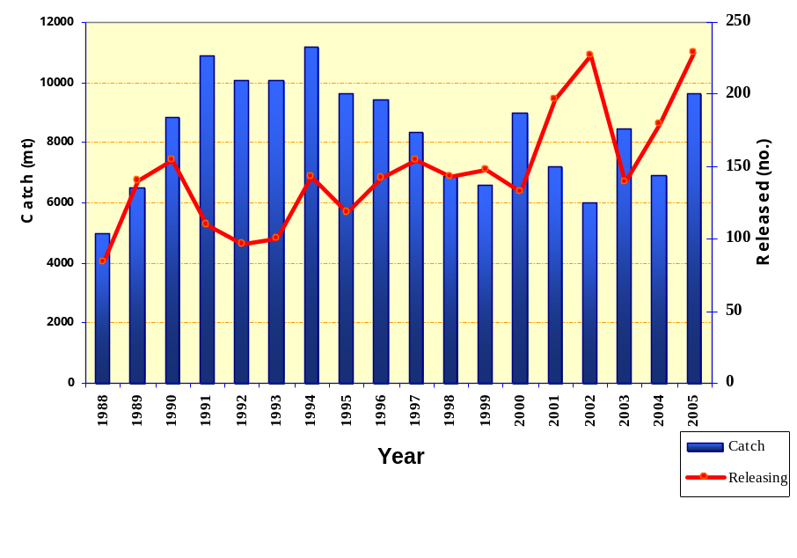
Fig. 6 Rutilus frissi kutum catch and fingerling release in the Iranian coastline of the Caspian Sea during 1972-2004

Catch methods for Rutilus frissi kutum
Kutum catch in the Iranian of waters of the Caspian Sea is carried out by 1200 official fishers using the following methods:
- Marine fixed gillnets
- Beach seine
- Two sheet drift nets

Marine fixed gillnets
This fishing gear is considered to be a passive fishing gear and was commonly used in the Caspian Sea from 1979 through 1997. Fishers engaged in kutum fishing used gillnets that were 18-21 m long and 6-8 m wide made of monofilament or multifilament nylon with a mesh size of 40-50 mm and a hanging ratio of 50% (figure 7).
In this method about 10-20 series of fixed gillnets are fixed in the migratory route of kutum at 5 to 40 m depths, perpendicular to the coastline using wooden fixers or sand bags. In shallow regions these nets occupy the entire water column from the surface to the bottom but in deeper regions they are found either in the surface or in mid waters.
The nets are either colorless or white or sometimes light blue and are non visible to the fish because of their large mesh size and small diameter of the thread used. Fish run into gillnets in their migratory route and get trapped in the nets at the head region (operculum) or body (maximum body diameter at dorsal fin region).
Fishers set up these nets in the sea for a relatively long time (a few days to a few months) and pull the nets up in boats every morning to remove the kutum caught in the nets. A large number of sturgeons were also caught as bycatch in these nets and were suffocated to death while struggling to get free. Therefore based on scientific investigations carried out by the Iranian Fisheries Organization this fishing gear was considered destructive and banned. In this method of fishing, fish detectors such as sonar or eco sounders are not used.
At present this method of catch is used illegally by non registered fishers in the Caspian Sea.

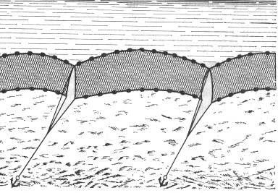

Fig 7 Fixed gillnets used for Rutilus frissi kutum

Beach seine
Beach seine nets are considered as semi active fishing gears. Beach seine nets are used by 15 fishing cooperative societies in the Gilan, Mazandaran and Golestan Provinces located in the south Caspian Sea coastline from 2 October to 31 March every year to catch kutum and other migratory species such as mullets, perch, carps, salmon etc. About 80 to 100 fishers are employed at each cooperative society. Beach seine nets are 1100-1400 m in length and the width of the nets varies from 12 m at the upper part to 24 m at the bag. Nets are made of nylon and are white r light blue in color with a mesh size varying from 33 mm at the bag to 45 mm at the upper part. The nets are made of multifilament knotted threads with a double knot on the left and a hanging ratio of 60% at the bag part and 50% in the upper part of the net.
Beach seine nets are spread out by a fishing vessel in a semi circle from the coastline around a school of fish. The nets are dropped up to a depth of 30 m reaching from the water surface to the bottom. The floating line of the net lies on the water surface and the lead line lies on the sea bed. The nets are then pulled ashore by two tractors equipped with winch. The mesh size at the upper part of the net is large enough to allow small and non standard sized fish escape from the net while the larger and standard sized fish are directed towards the bag of the net. In this method of catch fish are swept by the net towards the shore without getting trapped in the mesh (mesh size in beach seine is smaller than that in gillnet) (figure 8).
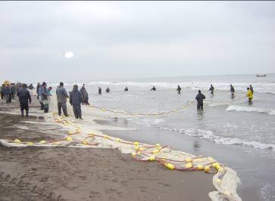

Fig. 8 Beach seine used to catch Rutilus frissi kutum

Each fishing operation lasts for 2-3 h and is repeated 3 or 4 times a day without a break. No fish detecting device such as sonar or eco sounder is used in this method of fishing.

Two sheet drift net
Two sheet drift nets are considered active fishing gears and are only used in the channel that links the Caspian Sea to the Anzali Lagoon and also in the lower parts of this lagoon (figure 9).
Two sheet drift nets used by fishers to catch kutum (usually the autumn form of this species) are 25-30 m in length and 3-4 m in width. The mesh size of the first sheet is 50 mm and that of the second sheet is 40 mm. The net is made of monofilament nylon knotted thread with a double left knot and hanging ratio of 50%.
At the time of migration of kutum from the Caspian Sea to the Anzali Lagoon these nets are set up in the migratory route of these fish across the channel in the form of a semi circle so that the floats remain on the water surface and the weights lie above the bottom of the channel. Fishers position themselves by the nets waiting for the fish to be caught. When water flows from the lagoon towards the sea, fish that come in contact with the net either get entangled in the net or get trapped by their gills (Khanipour, 2003).

Fishing operation using this type of net is carried out 8-10 times each day and each operation lasts for 30-60 min.
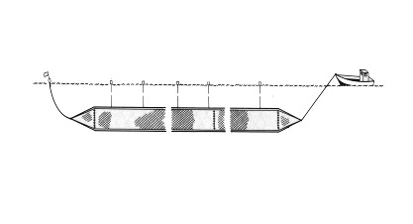
Fish caught in the nets are immediately removed from the nets and transferred to the boats. No kind of fish detecting device such as sonar or eco sounders are used in this method of fishing.

Fig. 9 Two sheet drift net used to catch Rutilus frissi kutum

Apart from the above mentioned methods of fishing, kutum is also caught in the Anzali Lagoon and rivers as recreational fishing and using traditional methods of fishing such as pole and line and cast nets.

⁵ Artificial Breeding

Artificial breeding in Rutilus frissi kutum Artificial breeding in the spring form of Rutilus frissi kutum  Catch of spawners  Artificial breeding in the spring form spawners  Incubation of fertilized eggs  Artificial breeding in the autumn form of Rutilus frissi kutum Significance of restocking | Artificial breeding and rearing in the autumn form of kutum  Catch and maintenance of spawners Confinement in floating cages in the Anzali Lagoon  Confinement in earthen ponds Artificial breeding in spawners  Larval rearing  Release of fingerlings

Artificial breeding in the spring form of Rutilus frissi kutum
Artificial breeding programs with Rutilus frissi kutum were first considered when kutum catches in the Caspian Sea declined in the 60s and 70s as a result of over fishing, loss of natural spawning grounds and environmental pollution. Artificial breeding in kutum was experimented by Faridpak for the first time in 1961 in several rivers in the south Caspian Sea basin including Shalmanrud and Shafarud. Following the drastic decline in kutum stocks in 1980-81 when kutum catches reached less than 500 tons per year, the need for artificial breeding program in this species was emphasized more than before. Experts at the Gilan Fisheries Research Center attempted to develop the biotechnique involved in the artificial breeding of the spring form of this species and released the fingerlings produced from such programs into the rivers entering the Caspian Sea. Since then artificial breeding and the release of kutum fingerlings were included in annual activities of the Iranian Fisheries Organization. This led to the gradual increase in kutum catches whereby kutum catch figures in some years soared up to above 90 thousand tons per year.
Artificial breeding in the spring form of Rutilus frissi kutum includes the following stages:

Catch of spawners
When conditions for spawning are favorable the spring form of R. frissi kutum migrates from the sea to the river and releases its eggs when it reaches suitable spawning grounds. However with regard to the loss of suitable spawning grounds in rivers, artificial breeding was experimented as a measure to combat the loss of this valuable species. Adults are caught as they enter rivers on the spawning migration by blocking the river with wooden tripods barriers called ‘shil’ that are set up at short distances of about 500-800 m from the river estuary (figure 10). Spawners collect behind this wooden barrier and are caught easily using beach seine or cast nets without incurring the least stress and injury (figure 11).
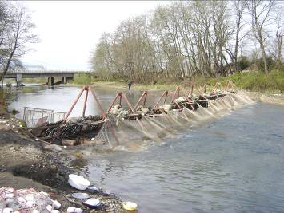

Fig. 10 Wooden barriers or ‘shil’ set up in the river to catch kutum spawners
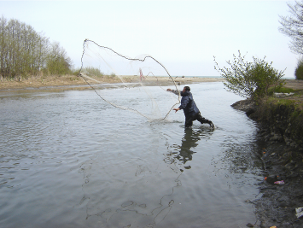

Fig. 11 Kutum spawners caught in the Sefidrud River using cast nets

Artificial breeding in spring form spawners
When caught in the rivers male and female spawners both possess the required conditions for spawning. Ripe eggs are stripped from females without injecting hormones. Female spawners are first dried with a cloth and stripped by gently squeezing the abdomen towards the tail and the eggs that flow easily are collected in dry plastic bowls or basin. Then the males are similarly stripped for milt which is collected over the eggs in the same container (figure 12). The contents are mixed immediately with a feather until fertilization occurs. After a few minutes water is added to the contents until the eggs begin to swell. Eggs are rinsed several times with clean water to washing out superfluous sperm and to remove the sticky protein on their surface (figure 13). It is to be noted that washing of eggs in all stages is done using clear water from the river. Fertilization rate in kutum is high and is usually above 95%.

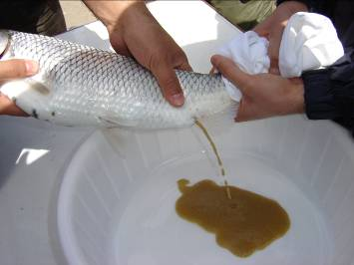

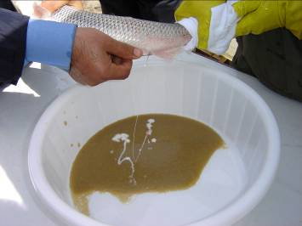

Fig. 12 Removal of eggs and sperms from spawners
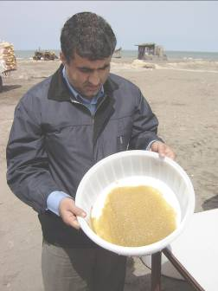

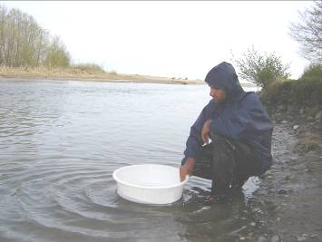

Fig. 13 Fertilization and rinsing eggs
Incubation of fertilized eggs
Fertilized eggs are placed in running river water in Seth Green incubator jars. These incubators are made up of a netted bottom and water enters the incubator from the bottom. The water flow in the incubators prevents the eggs from sticking together or to the bottom of the incubator and thus prevents mortality of eggs. Water flow into the incubators is regulated in a way that the eggs neither stick together nor are washed away with the water (figure 14). About 2 kg of eggs can be incubated in each incubator. Once the first larva emerges from the eggs, all the eggs are transferred from the incubator to plastic tubs so that they hatch out of the eggs. The larvae are then transported to rearing farms.
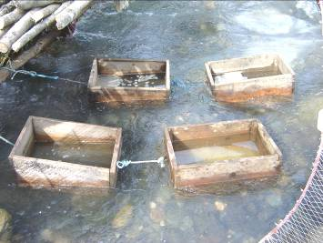

Fig. 14 Incubation of eggs in Seth Green incubators in rivers

A few days after incubation, owing to the relatively high mortality of eggs in Seth Green incubators, the developing embryo are transferred to glass incubators call ‘Veis’ set up in hatcheries to complete their incubation. Veis incubators are 8 l conical glass containers that are set on iron stands. Water flows in from the bottom of these incubators and flows out at the upper wider end of the incubators. This keeps the eggs moving in the incubators, provides aeration to the eggs and prevents the accumulation of eggs over each other and thus prevents their mortality (figure 15).
Water flow into Veis incubators is regulated so that eggs do not collect over each other and also do not flow out of the incubator from the top. Another advantage of using Veis incubator jars is that mortality rate of eggs is low. In most cases hatching percentage is above 90%. About 1 kg eggs is transferred to each incubator jar.
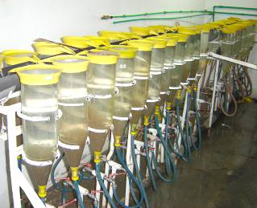

Fig. 15 Incubation of eggs in Veis incubators in hatcheries
Incubation period for eggs differs and lasts for about 8-10 days at 15-17 ºC. Incubation period is seldom more than six days and the longest is about 20 days.
Larvae that hatch out of the eggs leave the incubator from the upper part of the incubator and are directed through a pipe made of PVC to a larger incubator called zoug which are very similar to the Veis incubators except that they are larger and hold about 200 l of water. Zougs are made of polyethylene or fiber glass and are mounted on an iron stand. Larvae are maintained in Zougs for about 4-5 days until the complete absorption of yolk sac and larvae begin to swim freely. Larvae are fed with a mixture of powdered milk and egg yolk in this stage until they are ready to be transferred to earthen rearing ponds.

Artificial breeding in the autumn form of Rutilus frissi kutum

Significance of restocking
The autumn form of R. frissi kutum migrates to the Anzali Lagoon and rivers entering the Caspian Sea in the middle of autumn and deposits its eggs on suitable spawning grounds. These fish remain in the Anzali Lagoon until they attain complete sexual maturity. However, because of over fishing, water pollution and habitat alteration, natural reproduction is not successfully accomplished in most of them and the wild populations of this species are in imminent danger of extinction. To save the endangered populations of this species, experts from the Gilan Fisheries Research Center began research to determine the biotechnique for breeding and rearing of the spring form of kutum. Such activities were further developed by the Iranian Fisheries Organization and at present more than 150 million fingerlings of the spring form of kutum are produced through artificial breeding and released into the sea. However no scientific measures have been taken to address rehabilitation of stocks of the autumn form of kutum. Considering the significance of the conservation of this species the artificial breeding of the autumn form of R. frissi kutum was proposed was implemented at the Inland Water Aquaculture Research Center funded by the Iranian Fisheries Research Organization (IFRO) and the Caspian Environment Programme affiliated to the United Nation Development Programme (UNDP) in 2005-06. The main objectives of this study were:

- Preserve and conserve genetic diversity of different races of Rutilus frissi kutum and combat the extinction of stocks of the autumn form of this species.
- Artificially breed the autumn form of Rutilus frissi kutum for the rehabilitation of stocks and the increase in the productivity of the Caspian Sea
- Develop the biotechnique for artificial breeding in the autumn form of this species and present it to the Iranian Fisheries Organization for rehabilitation of stocks
- Improve the economy of the Iranian Fisheries and income of fishers in the south Caspian Sea coastline

Artificial breeding and rearing in the autumn form of kutum
The biotechnique for the autumn form of kutum is a little different from that of the spring form in that the spawners of the autumn form have not reached complete sexual maturity at the time of catch in autumn and are maintained under suitable conditions before they are ready to spawn. Artificial breeding in the autumn form includes the following stages:

Catch and maintenance of spawners
Two sheet drift nets (figure 16), purse seine (figure 17) and fyke net (figure 18) are among the different fishing gear used to catch kutum spawners however two sheet drift nets are regarded an extremely efficient fishing gear. Considering the population decline in the autumn form of kutum in the recent years, and limited number of spawners that enter the Anzali Lagoon, spawners were caught in their migratory route as they enter the Anzali Lagoon in the water channel linking the sea to the lagoon.

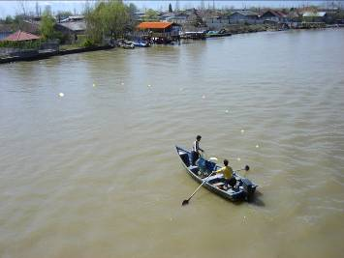

Fig. 16 Two sheet drift net set up at the starting point of the Anzali Lagoon to catch spawners of the autumn form of kutum
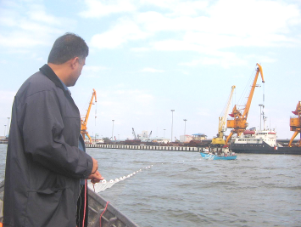

Fig. 17 Purse seine set up at the starting point of the Anzali Lagoon to catch spawners of the autumn form of kutum

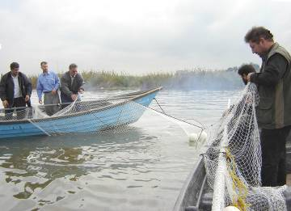

Fig. 18 Fyke nets set up at the starting point of the Anzali Lagoon to catch spawners of the autumn form of kutum

Spawners that enter the Anzali Lagoon in autumn remain in the deep regions of the lagoon until February to attain sexual maturity. Spawners that are caught in autumn for artificial breeding programs are maintained under two different conditions and survival rate and sexual maturity of spawners under the two conditions was compared.

Confinement in floating cages in the Anzali Lagoon
Floating cages with a dimension of 4 x 4 x 2 m are used to maintain kutum spawners. Cages are constructed of a metal frame and nylon netting with a mesh size of 20 and 25 mm and are positioned in the Anzali Lagoon in open areas which are suitable regarding water circulation, depth, bottom substrate, dissolved oxygen, pH and in areas which are free of pollution (figure 19). About 24 spawners in the ratio of 2 females to 1 male are introduced into each of the cages (figure 20). Feeding, sexual maturity and hygienic state of spawners are controlled during their confinement in cages.
To avoid stress and injury to the spawners, they are transported to the floating cages in special boats called 'aquarium boats' designed at the Inland Water Aquaculture Research Center (figure 21). Accommodation for experts guarding the cages was provided in a research vessel positioned at the site of the floating cages.

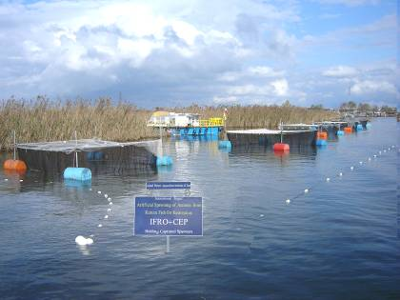

Fig. 19 Site where floating cages are positioned in the Anzali Lagoon
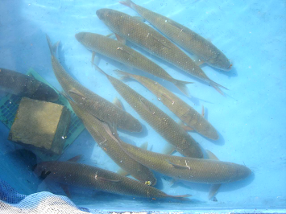

Fig. 20 Spawners of the autumn form of Rutilus frissi kutum caught in the Anzali Lagoon

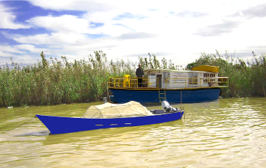

Fig. 21 Research vessel used for accommodation of experts guarding the cages and the aquarium boats used to transport spawners (designed by Khanipour, 2005)

Confinement in earthen ponds
Some of the fish caught in the Anzali Lagoon are immediately transferred to earthen ponds under suitable conditions of aeration. Males and females are stocked together in one pond and sometimes the two sexes are separated from each other and stocked in separate ponds (figure 22). This is done to assess the stage of sexual maturity in the spawners confined in cages and in earthen ponds.
It was evident from results obtained that kutum spawners of the autumn form attained complete sexual maturity under both conditions of confinement and semi-natural spawning occurred in male and female spawners confined together. It is worthy to note that some of the spawners that were confined in concrete ponds also attained sexual maturity and underwent semi natural spawning.
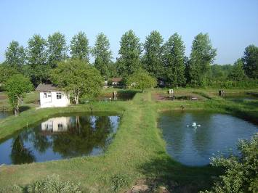

Fig. 22 Maintenance of spawners in earthen ponds at the
Sepidrud Fishery Research Center
Artificial breeding in spawners
When spawners approach sexual maturity so by spawning time in January, they are transferred from the floating cages set up in the Anzali Lagoon and confined to earthen ponds at the hatcheries until they attain complete sexual maturity. Males are kept separated from female spawners. All spawners are induced to spawn through hormone therapy in late February depending on the water temperature. Males are injected 2-3 mg kg⁻¹ body weight and females are injected 4-5 mg kg⁻¹ body weight of pituitary extract (figure 23). Spawners respond to hormone therapy within 10-12 h after injection and eggs and milt are stripped using a dry method of spawning (figure 24). Fertilization rates of above 95% were achieved at this stage. Fertilized eggs of the autumn form of kutum were rinsed with well water for about 1-1.5 h to remove the sticky protein on their surface and then placed in Weis incubators at a rate of one kilogram eggs per incubator (8 l) (figure 25). Incubation period varies from 7-10 days at 14-16 °C. On hatching larvae are held in Zougs for 5-7 days and fed milk and egg yolk after absorption of yolk sac (figures 26, 27). The larvae are then transferred to earthen ponds where they feed on natural food (plankton and benthic organisms) as well as formulated diets (figure 28).

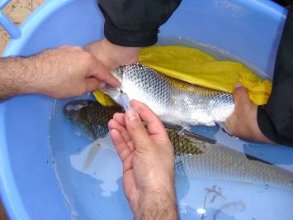

Fig. 23 Hormone therapy in spawners

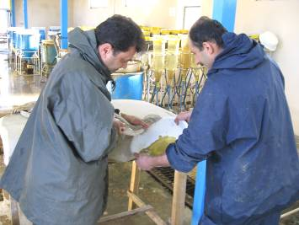

Fig. 24 Artificial breeding and production of fertilized eggs

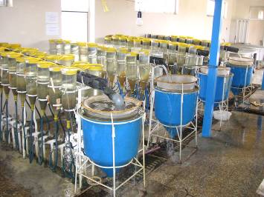

Fig. 25 Incubation of eggs until emergence of larvae
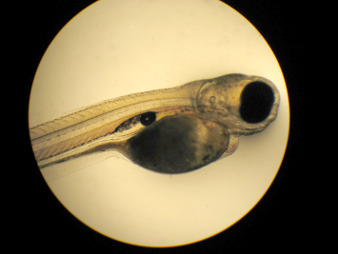

Fig. 26 Larvae with yolk sac during incubation

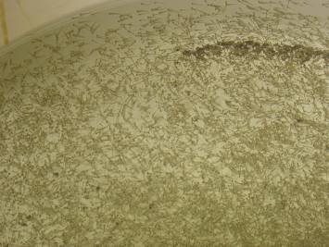

Fig. 27 Larvae after yolk sac absorption ready to be stocked in earthen ponds

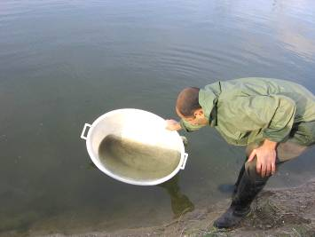

Fig. 28 Larvae after yolk sac absorption ready to be stocked in earthen ponds
Larval rearing
Prior to stocking larvae, earthen ponds are ploughed and treated with lime at a rate of 1 ton hac⁻¹ and then fertilized with animal manure at a rate of 1.5 tons hac⁻¹. Larvae are reared in extensive culture, stocked in earthen ponds at a density of 1 to 4 million larvae hac-1, and fed formulated micro pellets containing 40% protein for a period of three months (figure 29). Water exchange, liming and mechanical aeration is applied to provide suitable conditions of rearing (figure 30) . Larvae are initially fed powdered diets three times a day (morning, afternoon and evening) up to satiation and weaned to paste diets on reaching the fingerling stage. Rearing ponds are sometimes treated with lime to control the population of planktons. Rearing period normally lasts for three months during which fingerlings reach 1-2 g in weight. Growth rate in fingerlings however depends on their stocking density and the conditions in the maintenance ponds. When the initial stocking density of larvae in earthen ponds is low (<one million larvae per hectare) and water quality is good the increase in weight in fingerlings is high so that some of the fingerlings may even reach a weight of >5 g. Survival rate of larvae in this period is above 85%.

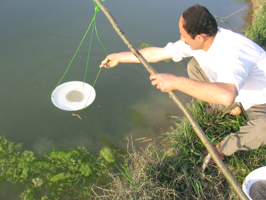

Fig. 29 Feeding larvae and fingerlings with formulated diets

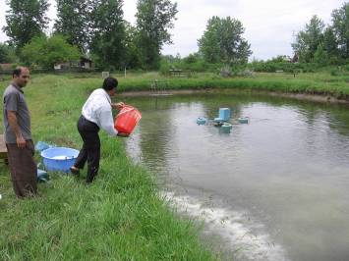

Fig. 30 Liming earthen ponds during the rearing period
Release of fingerlings
Fingerlings produced through artificial breeding are released into the water bodies from which their parents were caught after they reach a body weight of above 1 to 2 g (figure 31). Spawners of the autumn form of kutum are caught in the Anzali Lagoon, and the offspring produced from these spawners are released into the Anzali lagoon and rivers of this lagoon (figure 32). The fingerlings spend sometime in the lagoon to feed and migrate to the Caspian Sea once osmoregulation is achieved and remain there until they attain sexual maturity. In the present study more than two million kutum fingerlings of the autumn form produced through artificial breeding were reared to 2 g and released into the Anzali Lagoon. The artificial breeding of the autumn form of kutum has progressively been included in the annual rehabilitation activities of the Iranian Fisheries Research Organization to combat the extinction of kutum stocks, to conserve the gene bank in the autumn form of kutum, to rehabilitate stocks and increase catch figures for the autumn form of this species and ultimately improve fisheries economy in the region. Survival rate of kutum fingerlings in this stage was greater than 75%.

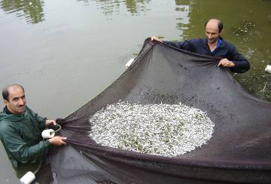

Fig. 31 Catch of the autumn form of Rutilus frissi kutum for release into the Anzali Lagoon

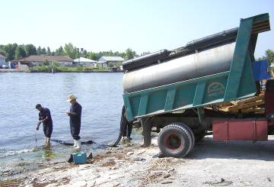

Fig. 32 Release of kutum fingerlings into the Anzali Lagoon

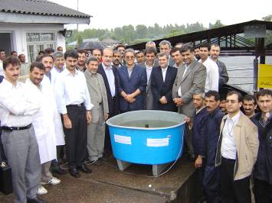

Fig. 33 Authorities and experts present at the first release of the autumn form of Rutilus frissi kutum into the Anzali Lagoon

⁶ Stages of embryogenesis

Fertilization and embryogenesis in Rutilus frissi kutum

The different stages involved in the embryogenesis of kutum are:
- Early embryonic stage
This stage begins with fertilization of eggs and continues up to organogenesis
- Larval or transitional embryonic stage
This stage begins with organogenesis and the fish attains its true form at the end of this stage. Thus in fishes which undergo metamorphosis, this stage ends with the completion of metamorphosis.
- Post embryonic stage
Growth and development involves a series of sequential changes into juvenile, mature, adult and senescent (Lagler et al., 1964).

Fertilization and embryogenesis in Rutilus frissi kutum
Fertilization in fish begins when the sperm penetrates the egg and involves several reactions the most important of which is the cortical reaction. The egg membrane in fish is known as chorion or shell. Almost all fish eggs have an opening called the micropyle which lies in the vitelline membrane inner to the chorion. Once fertilization occurs the discharged contents of the cortical granules and cortical alveoli block the opening of the micropyle. It is for this reason that polyspermy occurs very rarely in fish. On absorbing water the outer membrane of the fertilized eggs harden and become adhesive.
Cell division in fertilized kutum eggs involves the following stages:

Stage 1 (unfertilized and fertilized eggs)
Unfertilized eggs are bright yellow in color with a diameter of about 2 mm and weigh about 0.0261 g. In fertilized eggs, the effective contact of the egg with the fertilizing spermatozoan is followed by the formation of a narrow perivitelline space and the liberation of the eggs from its connection with the chorion or shell. In fish due to contraction the superficial layer of the egg loses distinct contours and glycogen globules that are formed migrate together with colloid in the perivitelline space to form the perivitelline fluid.
Stage 2 (one hour after fertilization)
The perivitelline space widens and the rudiments of protoplasm called the germinal disk or cap is formed in the animal region.
Stage 3 (2-2.5 h after fertilization)
I cleavage division in kutum eggs occurs at 14-16 °C.

Stage 4 (4-4.5 h after fertilization or four celled stage)
II cleavage division occurs and four blastomeres are formed on the surface of the yolk.

Stage 5 (6-6.5 h after fertilization)
III and IV cleavage occurs and 8-16 blastomeres are formed.

Stage 6 (8-8.5 h after fertilization)
This stage begins with formation of the morula when cell borders slowly become indistinct and the cells begin to form two layers. The perioplast occupies the major part of the embryo.

Stage 7 (10-14 h after fertilization)
This stage is known as the early blastula stage and in kutum it is characterized by the appearance of the distinct and cap like blastodisc. At the end of this stage half of the yolk is still not covered by the blastula.

Stage 8 (14-18 h after fertilization)
This stage is known as late blastula where the cavity of blastula increases in size and its boundary is clearly distinct from the yolk. About half the yolk is covered in this stage.
Stage 9 (20-30 h after fertilization)
This stage is called gastrulation and is characterized by the extension of the blastoderm on the egg surface. The blastoderm covers much more than half of the egg surface at this stage which is the beginning of the formation of the germ ring. A part of the germ ring surrounds the region of large cellular heavily pigmented material of the eggs vegetal hemisphere, which is not yet covered by the outer cell sheet, called yolk plug. As epiboly progresses the animal material moves over the yolk plug.

Stage 10 (30-48 h after fertilization)
This is the beginning of neurulation when the material of germ layers divides into the rudiments of individual systems of organs. In this stage a solid keel becomes more distinct in the head region, the blastopore begins to close and loses its communication with the outside, the cells at the optic vesicule become dense, the embryo becomes considerably elongated, the tail region undergoes marked changes and the tail rudiment becomes visible. By the end of neurulation the neural tube begins to elongate and divides into the three primary brain vesicles: the forebrain, midbrain and hindbrain.

Stage 11 (67-72 h after fertilization)
This stage is characterized by the process of organogenesis. The body shape of the embryo changes and the rudiment of the posterior body regions is separated. Parts of the brain form. Rudiments of the olfactory sacs, eyes and membranous labyrinths appear.

Stage 12 (84-96 h after fertilization [3.5-4 days])
The brain vesicles develop and the further and the different pats of the brain begin to take form. The eye lens increases in size and fills a large part of the optic cap. With the progress in the pericardial cavity the head rises above the yolk sac. The rudiment of the posterior body region shows rapid growth and separates from the yolk sac. The embryo becomes heavily pigmented.

Stage 13 (120-128 h after fertilization [5-5.5 days])
Melanophores increase on the surface of the yolk and the first pigments appear in the center of the lens. The auditory vesicles become more distinct, the different parts of the brain are completely formed, rudiments of the pectoral fins become clearly defined on the two sides of the body and the other fins are also taking form. The liver is developed but the embryo still cannot move. Apart from the network of vessels in the yolk sac, the dorsal aorta carrying blood from the head to the tail runs under the notochord and passes into the caudal fin.

Stage 14 (144-150 h after fertilization [6-6.5 days embryo])
The embryo shows irregular movement and is known as the stalked stage. Tail is elongated, fins are developed and the spinal cord is visible in the tail region. Blood vessels collect at the caudal fin rays, aorta is distinct and blood circulation is complete.

Stage 15 (168-178 h after fertilization [7-7.5 days embryo])
Head still does not project over the surface of the yolk sac, embryo is capable of forward movement and can be seen with the naked eye, caudal fin is more developed, blood circulation in the pectoral fin is visible and blood seen in the heart.

Stage 16 (192-205 h after fertilization [8-8.5 days embryo])
Eggs almost ready to hatch, eyes in embryo completely black in color and fins more developed. Differentiation of internal ear and appearance of branchial arch are characteristic features of this stage. Heart is filled with blood. Some of the embryos are liberated from their membranes. The embryo at this stage is called the eyed egg.

Stage 17 (216 -225h after fertilization [9-9.5 days embryo])
All eggs hatch and larvae emerge from the chorion membrane. Hatching depends on water temperature and has been recorded as between 9-9.5 days at 14-16 °C. Movement of the first larvae that hatches out influences the hatching of other eggs.

Stage 18 (240 h after fertilization [10 days larvae])
Pectoral, dorsal and caudal fins increase in size and the vascular network in these fins develops. Tail becomes longer and is turned slightly upwards. Yolk sac grows smaller and semi circular canals are seen in the auditory vesicles. Larvae retain a certain amount of yolk and are slightly bent.

Stage 19 (288 h after fertilization [12 days larvae])
Yolk sac diminishes in size but larvae are still bent. Blood becomes redder and blood vessels become more extensive. Swim bladder still not filled completely with air and mouth appears as a small triangular depression. Larvae still feed on yolk sac contents and are capable of swimming to the water surface.

Stage 20 (336 h after fertilization [14 days larvae])
Swim bladder filled with air and larvae swim more effectively. Organs develop. Movement of fins and operculum become more coordinated. Yolk sac is not completely absorbed.

Stage 21 (384 h after fertilization [16 days larvae])
Yolk sac is completely absorbed and larvae begin active feeding. All organs except the reproduction system are fully formed.

Stage 22 (432-480 h after fertilization [18-20 days larvae])
Larvae swim actively. Pigmentation on the dorsal surface increases. Jaws can be moved and are markedly developed for active feeding.

Stage 23 (480-600 h after fertilization [20-25 days larvae])
Swim bladder completely filled with air and larvae is capable of swimming to any distance. Respiration is totally carried out by the gills and olfactory and optical lobes completely developed.

Stage 24 (600-720 h after fertilization [25-30 days larvae])
Larvae are remarkably elongated. Caudal fin rays fully developed and larvae reach a length of 8-9 cm. Internal organs are more developed and pigmentation on dorsal surface, fin rays and inside the body becomes more distinct.
Ultimately the fully developed larvae are stocked in fertilized pond where they begin to feed on live food.
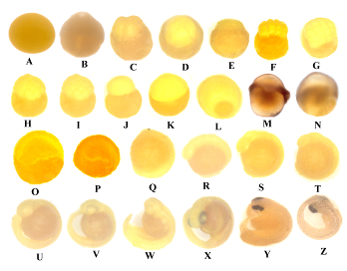

Fig. 34 Different stages in the development of embryo from fertilization up to the emergence of larvae (coutsey of Haghighi, 2006)
⁷ Handling and Marketing

Handling
Decreasing escape time and mortality of kutum in fishing nets
Washing
Removal of entrails and secondary washing
Transport of fish under cooling conditions
Fish transportation on crushed ice or ice flakes
Transportation in Cold Sea Water (CSW) Tanks
Marketing fresh kutum

About 10 thousand tons of kutum is caught annually in the Iranian coasts of the Caspian Sea, which is marketed fresh and/or processed in the domestic markets.

Handling
To assure quality of the product and to prevent it from spoilage it is necessary to bear the following instructions in mind while handling kutum that is marketed fresh.

Decreasing escape time and mortality of kutum in fishing nets
The following principles of handling should be kept in mind while marketing kutum fresh in order to preserve the quality of kutum meat and to prevent the fish from decaying. Kutum meat has a better flavor and taste when escape time is decreased and the fish dies sooner in the net. Mortality in kutum results from the accumulation of a large amount of lactic acid and other non-oxidized compounds produced from metabolism in blood and fish muscle and the paralysis of the nervous system which causes the meat to turn black and also speeds up fish decay. Thus the sooner the fish are taken out of water and killed the higher is the quality of meat marketed (Khanipour, 2004).
Industrial fishing methods usually apply a weak electric current to kill the fish. However because the fish dies in water it is not considered suitable for consumption by Moslems for religious reasons and other methods of fishing are used such as cutting the caudal fin and draining the blood from the fish, creating an incision at the gill rays and draining the blood, inserting a sharp object like a knife into the fish brain, inserting a thin wire into the spinal cord of the fish or hitting the fish on the back of its head with a hammer which can cause immediate death of the fish.

Washing
The fish caught are washed with freshwater to remove the mud and other contaminants from the body surface. Because of the presence of various bacteria and different kinds of chemical pollutants and residues of petroleum hydrocarbons in the coastal fishing regions, transport of fish mixed with sand and mud increases the body temperature and spoilage in fish. Investigations conducted show that washing the fish and removing the mucous and contaminants from the body surface with a nylon brush preserves fish quality and increases shelf life of fish by at least 30% (Khanipour, 2004).

Removal of entrails and secondary washing
After death, the autolysis of muscle tissues and internal organs takes place by the strong secretions of acids and digesting enzymes in the digestive system of the fish which lowers the quality of the fish especially in case of transport with no cooling system.
To maintain the quality of fish meat and retard the process of spoilage it is recommended to remove the fish entrails including the liver by slitting open the abdomen from the anus right up to the operculum and to rinse the fish with freshwater.

Transport of fish under cooling conditions
It is known that factors like the physical condition of the fish at death, and the temperature at which it is kept after death, can markedly affect the time a fish takes to go into, and pass through, rigor mortis, microbial spoilage and autolysis. It is for this reason that if fish are caught in summer and/or if the fish is to be transported for long distances it is better to transport the fish with cooling system.
Fish can be transported on ice or in Cold Sea Water Tanks (CSW).

Fish transportation on crushed ice or ice flakes
The amount of ice required to chill fish depends on several factors which include water and air temperature at time of fish landing, size and amount of fish, chemical composition of the fish, type of ice used, type of containers used, storage time, degree of exhaustion before death and temperature at which it is kept.
Investigations carried out show that in autumn and winter depending on the water and air temperature and the body temperature of the fish about 25-30% of body weight ice is required whereas in spring and summer we require about 75-100% of body weight ice to transport fish.
Chilling the fish immediately after landing will prolong or delay rigor mortis and thus delay microbial degradation. In order to maintain good quality of fresh fish during transportation, fish boxes made of suitable materials should be used. It is important that the boxes be made of insulating material with lids.
Powdered ice has a higher surface area and is very effective in cooling the body temperature of fish and is thus preferred to flaked ice. It is recommended to cover the bottom of the box with a layer of ice and then pack the fish in the box in layers separated from each other with a layer of ice. Fish can be stored in this condition for 2-3 days.

Transportation in Cold Sea Water (CSW) tanks
These tanks are designed in different capacities to transport fish and are very effective as they are impervious. About 40% of the tank is filled with fresh seawater or flaked ice and the remaining 60% is filled with fish. When placed in chilled water the body temperature of the fish decreases in a very short time. Fish chilled in this way can be transported for 6-8 days without affecting the quality of the fish. It is to be noted that fish should not be chilled for longer than 10-12 days and fish preserved in this way should ether be eaten or processed.

Marketing fresh kutum
With the beginning of the kutum catch season more than 70% of the catch is marketed fresh in the coastal markets and in Tehran directly by the purse seine cooperative societies (figure 35, 36) without undergoing any kind of processing and the remaining catch is processed using different methods such as freezing, salting and smoking before being distributed.

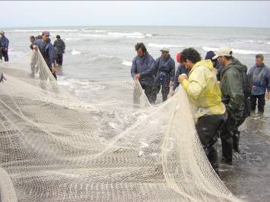

Fig. 35 Kutum catch at the purse seine cooperative societies
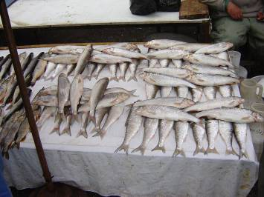

Fig. 36 Marketing fresh kutum in the local fish markets

⁸ Processing

Freezing kutum | Wet salting
Quick freezing in freezing air blast tunnels | Semi dry salting
Quick freezing in Plate freezers | Smoking kutum
Cold storage of Rutilus frissi kutum | Cold-smoking of kutum
Salting kutum | Hot-smoking of kutum
Dry salting

A large proportion of the kutum catch is marketed fresh in Tehran, Gilan, Mazandaran and Golestan Provinces. Considering that kutum catch exceeds its consumption, a small proportion of the catch is processed by adding flavor and taste to increase shelf life. The most important methods of processing kutum are:

Freezing kutum
Freezing is one of the most common methods for preserving kutum for prolonged periods without causing major changes in size, shape, texture and flavor.
Freezing is a physical phenomenon in which the body fluids; free as well as water inside the cells of living tissues freezes to form ice crystals under the very low temperatures of storage. Freezing prevents the partial or complete deterioration of food by microorganisms and enzymes. Microorganisms stop multiplying -10 °C and microbial enzymatic activity in the fish body declines sharply when the body temperature drops to less than -1 °C however certain enzymes particularly lipase remain active under such conditions.
Freezing is effective in preserving quality of the fish only if the product is handled in such a way that its quality is kept near its peak freshness and is not able to compensate for the degradation in quality before freezing. Careful handling of fish assures higher quality of product during freezing or in other methods of processing.
It is to be noted that whatever the conditions of handling and quick freezing, frozen fish product will not regain its initial quality. The main objective of freezing is to increase shelf life and to facilitate extensive distribution of fish. Frozen fish can be normally stored for 6-12 months in cold storage. For best quality thawed fish should be consumed immediately and/or used as raw material in other processing methods such as canning, preparing surimi products, salting, smoking and drying.
Different methods are used to freeze kutum, however the most commonly used methods are slow freezing (freezing in chilled units and freezing in chilled salted solution) and the quick freeze (freezing in tunnels or plate freezers).
Kutum is frozen whole with the entrails removed, with skin, or it is cut in two halves with the skin removed, or in the form of fillet. Slow freezing involves chemical changes in the body and degradation in quality of frozen kutum in cold storage and so this method is not usually used for kutum. Kutum is usually preserved whole with entrails removed in tunnel freezers. The shorter the freezing process and the storage time the higher is the quality of the frozen fish. Freezing process is affected by several factors the most important of which are the initial temperature of the fish, cooling power of the freezer, freezing system, volume of fish to be frozen, chemical composition of fish, form of the product (whole or fillet) and the circulation of cold air in the freezing tunnels.
Fish normally freezes at -4 °C. So when water inside the cells of the fish freezes rapidly it forms minute crystals of ice. The period of time when the temperature of the deeper layers of the fish decreases from zero to -4 °C is considered a very critical period when the maximum number of ice crystals are formed. Under ideal conditions of freezing this period lasts for less than 30 min and may take as long as 2 h.

Quick freezing in freezing air blast tunnels
Freezing tunnels are designed so that the air flows horizontally and vertically. Kutum are washed immediately after catch to remove any contaminants on the body. They are then gutted and washed again and placed on the trays and are loaded on special trolleys and transferred to the freezer tunnels.
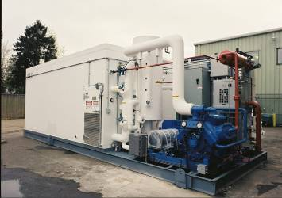
Freezing capacity depends on the power of the condensing unit's electric motor and about 3-5 tons of fish can be frozen in the freezing tunnels in one batch. Once the trolleys carrying the trays of fish are loaded in the tunnel freezer, the tunnel door is closed and the chill air blast begins to flow from the upper layers and the fish freezes in about 2-5 h. The maximum freezing temperature in the tunnel freezers is -40 to -45 °C and the ideal air flow in the tunnels is 3-5 m/sec. When the freezing rate increases, the moisture lost from fish during freezing results in desiccation, however operating the freezer below the design value increases freezing time and adversely affects product quality. The trolleys should be loaded in the tunnel freezer to avoid any empty spaces so that the air blast has no alternative but to flow over the fish and not flow between the shelves or trays loaded. This is an extremely important feature of a tunnel air blast freezer (figure 37).

Fig. 37 Freezing fish in a air blast freezer tunnel
Quick freezing in Plate freezers
Plate freezers are the most modern type of freezers which is very fast on a small scale and is generally used to freeze small fish in small volumes or to freeze fish pellets.
Plate freezers are of two types; the horizontal (figure 38) and the vertical which have 12 plates constructed from extruded sections of aluminium alloy arranged 10-15 cm apart so as to allow the refrigerant (liquid nitrogen or feroin gas).
Fishes are gutted and washed and placed directly on the plates or packed in polyethylene bags. The plates of the freezer are closed by means of a hydraulically operated piston to make contact with the surface of the product.
Fish are in direct contact with the freezer plates from above and below and freeze in the shortest freezing time. The loading capacity of plate freezers differs and about 500-600 kg of fish can be frozen in each batch. At chilling temperatures of -40 to -50 °C the freezing time for 5 tons of fish is 2-3 h. Whatever the method of quick freezing used the temperature of the frozen fish in the deepest regions of the product should be about -20 °C.

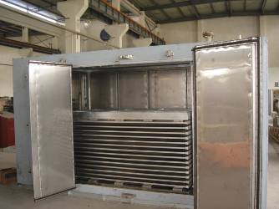

Fig. 38 Freezing fish in plate freezers

Cold storage
Frozen fish once removed from the freezer should be immediately transferred to cold storage. The quality of freezing which involves rate of freezing, freezing time, type of loading, management of cold storage, type of packaging and chemical composition of the product plays a vital role in preserving the quality of the frozen product during cold storage. The most common problems in frozen seafood products are development of off flavors due to the oxidation of tissue lipids (fat rancidity), denaturation of proteins, dehydration which is caused by moisture loss and freezer burn (toughening of the tissue texture). To protect frozen kutum against these problems follow the methods given below:
- Glaze the fish which involves forming a thin coating of ice on the product. After glazing fish should be tightly wrapped with freezer paper or aluminum foil for added protection of both the glaze and the product.
- Decrease storage time and so that it does not exceed 6 months.
- Store fish at temperatures between -18 and -20 °C and avoid fluctuations in storage temperature
- Place the frozen fish in the freezer to allow for uniform flow of chilled air over the product
- Maintain good hygiene at the cold storage premises

Salting kutum
Preservation of kutum achieved by salting is done with the main objective of increasing shelf life by decreasing water activity. Salt acts almost like a magnet, which removes water from inside of the fish and at the same time migrates towards the inside of the meat where it inhibits the growth of bacteria (except halophilic bacteria) and the secretion of enzymes while adding taste and flavor to the fish. The quality of salted kutum depends on the method of salting, type, quality brine and temperature of brine, form of fish for salting (whole, gutted, cut into two pieces or fillet) and strength of the brine
(figure 39).
Considering that salt penetrates flesh of the fish very slowly, it is possible for certain microorganisms to remain active in the fish which can result in the spoilage of some parts of the fish. When brining in such conditions it is a good idea to cut the fish in two pieces with the entrails removed to assure salt contact with all the parts of the fish particularly the inner parts of the fish. Other than salting kutum flesh, salting kutum roe is also practiced in the north of Iran. This product which is called ‘ashpal shoor’ has a great demand.
There are three common ways of salting fish:
- Dry Salting
- Wet Salting
- Semi Dry Salting

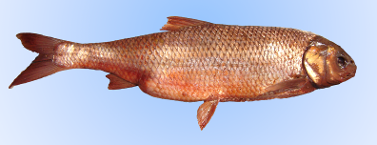

Fig. 39 Salted Rutilus frissi kutum

Dry Salting
When dry salting kutum it is advisable to use gutted fish cut in two pieces. Take fresh, refrigerated or frozen fish that has been thawed completely, remove the entrails and was the inside o the fish to remove any traces of the remaining organs such as kidneys. Powdered salt is used because it penetrates faster into the fish flesh. Then place the fish in wooden or plastic containers that drain well allowing the brine to flow away from the fish and not remain trapped in the bottom. Place one layer of salt at the bottom of the container and then pack the fish in layers to avoid any empty space in the container separated by a layer of salt. For gutted fish it is advisable to cover the inner parts of the fish and the gills completely with salt to control development of bacteria and stop enzyme secretions. Cover the last layer of fish with a thick layer of salt to exclude air and avoid heat exchange. Put a weight on top of that to compress the fish and force out the brine.
Dry salting is usually carried out at room temperature. Salt migrates gradually towards the inside of the fish and removes water from inside of the fish which drains out of the containers. Dry salting which depends on the shape of the fish, fat content of the fish, temperature of the environment and amount of salt used, usually takes 10-14 days. Fish salted in this method can be stored for a maximum period of 3 months at room temperature or for one year refrigeration.
To speed up the drying process and decrease the water content of fish the fish in the containers are rearranged so that the moisture content is uniformly distributed and the fish is salted evenly. Normally at the end of the dry salting process salt content in kutum is 12-15 %.
Dry salted fish may develop slime on their body surface, become putty and develop pink. At very high temperatures and moisture content bacterial growth may be so rapid that the fish become spoiled before they absorb enough salt. Certain bacteria are capable of developing in low salt content (6-10%) and spoil the fish faster. The fish becomes slimy and sticky on the surface and develops an unpleasant odor. To prevent this temperature and moisture content of the salting medium should be as low as possible and the salt penetration should be speeded up by using pure, small grained salt and by rearranging the fish in the container.
Sometimes salted fish become putty in the deeper parts of the fish and on the inner walls of the abdomen. This happens when the inner parts of the fish are not covered with salt and salt penetration to the inner parts of the fish is weak and slow. This results in the development of bacteria which cause the fish to become putty and sometimes unsuitable for eating.
To prevent salted kutum from becoming putty, care should be taken to salt the fish thoroughly including the inner parts of the fish. Use enough amount of pure salt depending upon the temperature, the salt used and the condition of the fish. The containers should be placed in warm and dry conditions.
When the salt content in the fish rises and reaches above 15% it supports the growth and development of certain bacteria especially the halophilic bacteria. The origin of these bacteria is brine which is reused a number of times. Significant amounts of organic material are introduced and the bacterial load of the brine becomes extremely high. These bacteria proliferate and spread to the entire product making it soft and giving it an obnoxious odor. This can be corrected by exchanging the salt used and using salt containing halophilic bacteria and/or by heating the salt.
Dun which is the formation of brown spots is a common defect of salt fermented fish which is the result of spoilage by osmophilic moulds. These spots appear when the fish are sliced. These spots are formed by halophilic mould clusters which are capable of growing when salt content exceeds 10-15%. This condition can be prevented by maintaining good hygiene in the premises and/or by dipping the fish in sorbic acid before salting.

Wet Salting
In the wet salting process the fish are salted in brine liquor that seeps from the salted fish. This process differs from the dry salting in that the fish lose less moisture and so fish salted in brine liquor look exactly like fresh fish and also fish are uniformly wet and are salted in a shorter time. A saturated salt solution (36 g salt in 100 cc water) is used as brine solution. The salt solution is boiled and then cooled to dissolve the salt faster and to remove any impurities. The circulating system for brine solution is preferred to the static system because the concentration of the brine solution remains uniform in all parts of the salting container. Fresh or freeze-thawed kutum to be salted in brine solution is cut open, eviscerated and washed thoroughly. The cleaned fish are packed in layers in wooden or polyethylene airtight containers with a lid and the saturated brine solution is poured over the fish so that they are completely immersed in the brine and an even distribution of the salt inside the fish. Place a weight on the fish to prevent the fish from floating on the brine solution. Then put the lid on the container and keep aside for 10-12 days. The salt diffuses into the fish tissues, but at the same time water moves by osmosis from the fish at a high speed into the surrounding brine. This occurs until the salt concentration in the fish tissue reaches equilibrium with that of the surrounding brine.
In wet salting the fish show a salt content of 8-10 % at the end of the brine salting process. The rate of salt penetration and brine salting period depends upon the following factors; chemical composition of the fish, specific surface and shape of the fish body, concentration and temperature of the brine, salting method (circulating or static), chemical composition and the fineness of the salt used.
Depending on the strength of the brine solution used there are three methods of curing:
- Light cure is characterized by a salt absorption of 6%.
- Medium cure which is characterized by 10-14% salt absorption.
- Heavy cure where the fish absorbs 20-26% salt and increases in weight.

When the brine concentration is low, 10-15%, fish absorbed water and gained weight and when it was more than 40%, water was extracted from the fish leading to denaturation of proteins.

Semi Dry Salting
Mixed salting is a method by which the fish is salted consecutively in brine and with crystalline salt. After eviscerating and washing the fish are dredged in fine salt (including the inside of the fish and the gills) and packed in the salting containers. Then fill the whole container with concentrated brine solution and closed with a lid. The advantage of this method is that the powdered salt added to the fish prevents the diluting of the brine solution with fish fluids. This method speeds up salt penetration decreases salting process.

Smoking Kutum
Smoking has been a commonly used technique for the preservation of kutum that gives the fish a specific and pleasant flavor and taste. A number of wood smoke compounds are antioxidants and act as preservatives to the fish for short periods of storage.
There are two general methods of smoking: the traditional method and the commercial method. The traditional method of smoking fish is by exposing it to the smoke from burning or smoldering plant materials, most often wood or smoke produced by burning saw dust which is mainly taken from deciduous tree wood such as chestnut, walnut, oak, chicory, maple, birch, beech, or alder. Antimicrobials in wood smoke include formaldehydes, aldehydes ketones, formic acid, acetic acid, alcohols and phenols greatly influence the quality of smoking as well as the flavor of the product. Some of these compounds are toxic to people as well, and may have health.
Adding sawdust of deciduous tree wood to the heating source is preferred to wood of broad leaved trees or wood chunks which produce more smoke and increase the level of 3 and 4 benzoperone which are known to be carcinogenic.
The moisture content of the wood used for smoking is also an important factor. The moisture content of the wood used for smoking should be <50% and the moisture content of the smoking environment should be <70% so that the fish does not turn bitter and develop a bad color. Smoked fish are yellow or have an amber-colored translucent flesh (figure 40).

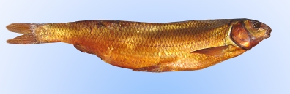

Fig. 40 Smoked Rutilus frissi kutum

There are two methods of smoking fish:
- Cold-smoking
- Hot smoking

Cold-smoking
The maximum temperature for cold-smoking is 40 ºC and smoking time is extended to a maximum of 5 days. Generally the fish is held close to room temperatures as it is smoked. Since no cooking takes place, the interior texture of the food generally isn't affected. However due to the long smoking period, the moisture content of the fish reaches 48-50%. Cold-smoking has traditionally frequently been combined with salt curing. Salted fish with 5-8% salt content in their meat are used. Cold–smoked fish have lost enough moisture, are heavily salted and are long-smoked and could keep without refrigeration for weeks or months. Cold-smoked kutum require further cooking before consumption and are usually fried, steam cooked or barbecued. Fish that have been handled carelessly or stored under improper conditions will not produce a satisfactory finished product after smoking. In cold-smoking the brined fish are carefully rinsed under cold running water to remove salt crystals on the body and the salt penetration in the fish tissue reaches 5-8%. When the salt content is high (>12%) the smoked product is very salty and when salt content is low (<3%) the storage time for smoked kutum decreases.

The brined fish are then left hanging over a source of smoke in a smokehouse to dry and smoke effectively. Smoke produced by burning sawdust should freely circulate between the fish before it adheres to the outer surface of the fish (figure 41).

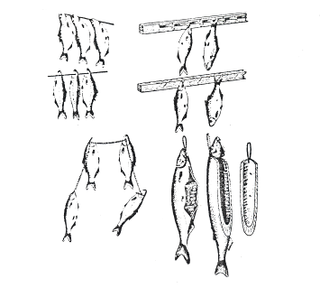

Fig. 41 Whole fish hung on hooks and over butchers twine

Smoking is done in two stages; first is drying and then smoking and the second is directly smoking. In the first stage, the fish is dried in special chambers or in smokehouses using air flow without smoking. This should take about 3 hours at 30 °C. If smoking is begun while the fish are still moist, the time required is longer, the color will not be as desirable, the fish will not have as good a surface, and will steam and soften in smoking. For the second stage, the dried fish are kept hanging in the smokehouse and the smoke flow is regulated. The fish are left to smoke from 12 h to a maximum of 5 days.
Smoking period for kutum in the cold-smoking method depends on the density of the smoke, moisture content, chemical composition and size of the fish.
Smoked fish must be allowed to cool to at least room temperature and packed in polyethylene bags for prolonged storage.

Hot smoking
Hot smoking kutum means curing fish by smoking at a temperature of above 80°C for a period of less than 8 h. In this process the fish gets a smoked flavor and smell and does not require further cooking before consumption. Hot smoked fish shows a moisture content of 60-70% and the salt absorption in the finished product is 1.5-3%. Hot smoked fish must be stored in cold storage or in a freezer. If stored in a refrigerator it has a reduced shelf life and should be consumed within a week. Hot smoked fish has a high market demand because it is lightly salted, very succulent and can be consumed directly without further cooking.
To hot smoke the fish first split the fish by cutting through the rib bones along the length of one side of the backbone and remove the entrails. Wash body cavity with running cold water to remove all traces of blood and kidney. Then brine the fish in a light brine solution for 18-24 h until the salt absorption reaches 2-3%. Remove the fish from the brine solution and rinse in cold running water to remove salt crystals. Then hang the brined fish on hooks or on a butchers twine in the smokehouse.
Hot-smoking involves three stages. In the first stage the fish is dried in drying chambers or in the smokehouse without smoke for 3-4 h at 60-70 °C. In the second stage the temperature is raised to 100-140 °C for an additional 60 min so that the protein will be coagulated and parts of the fish will be cooked. In the final stage the temperature is lowered to 10-80 °C and the density of the smoke is also lowered. Fish are left in this condition for 3-4 h when they develop a golden yellow and a pleasant smell and flavor of smoke (figure 42).
The fish are then removed from the smokehouse and are cooled immediately to prevent further loss of moisture and packed using the modified atmosphere packing (MAP) method.
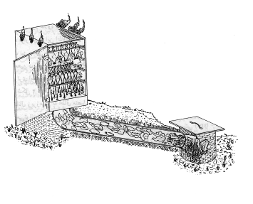

Fig. 42 Smoking Rutilus frissi kutum

Fig. 43. Golden Rutilus frissi kutum caught in purse seine nets by the Isargaran Fishing Cooperative

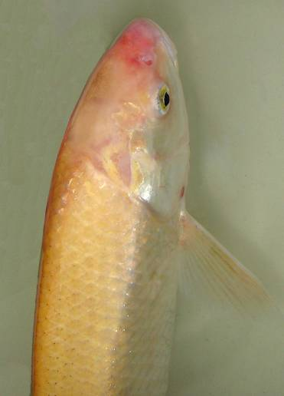

⁹ References

Abbasi, K., A. Valipour, D. Talebi Haghighi, A. Sarpanah and S. Nezami, 1999. Atlas of Fishes in Iran (Inland waters of Gilan). Gilan Fisheries Research Center, Bandar Anzali. 113 pp.
Armit, F., 1975. Social democracy in the Iranian Constitution. Payam Publishers, Tehran, Iran.
Ashraf, A. 1980. Historical restrictions in the growth of capitalism in the Gajar Period. Zamineh Tehran Publishers, Tehran.
Balachandran, K.K., 2001. Postharvest technology of fish and fish products. Daya Publishing House. Delhi. 440 pp.
Behzadi, S., 1991. Growth and development of embryo in Rutilus frissi kutum. M.Sc. thesis report. Islamic Azad University, North Tehran Branch, Tehran. 140 pp.
Berg, L.S., 1948. Freshwater fishes of USSR and adjacent countries. Volume 1, 2, 3. Trudy Institute Aced. Nack USSR. 8: 783-858. Translated to English in 1962. 1510 pp.
Danesh Khosh Asl, A. and M. Shakurian, 1993. Monoculture of Rutilus frissi kutum and polyculture with Chinese carp. Gilan Fisheries Research Center. Bandar Anzali, 30 pp.
Emadi, H., 1977. Rutilus frissi kutum: its past and present status in the northern waters of Iran. Gilan Fisheries Research Center. Bandar Anzali. 15 pp.
Fakhraei, A., 1973. Gilan during the constitutional movement. Handbook Publications, Tehran.
Fallahi et al., 1987. Effects of Oscillaria sp. on larval rearing in Rutilus frissi kutum. Inland water Aquaculture Research Center, Bandar Anzali. 123 pp.
Hall, G.M., 1997. Fish Processing Technology. Blackie Academic & Professional. 292 pp.
Johnston, W.A., F.J. Nicholson, A. Roger and G.D. Stroud, 1994. Freezing and refrigerated storage in fisheries. FAO Fisheries Technical Paper. 143 pp.
Kanel, J., Translated to Persian by Rastgooye Fahim, 2004. Quality Control in Fish. Iranian Fisheries Research Organization, Tehran. 359 pp.
Kazanchev, E.N., 1981. Fishes of the Caspian Sea and its drainage basin. Translated by Shariati, A., 1992. Iranian Fisheries Organization Publication, Tehran, Iran. 171 pp.
Kazanchev, E.N., 1984. Fishes of the Caspian Sea. Volume One. Translated by Y. Adeli, 1992. Gilan Fisheries Research Center. Bandar Anzali. 54 pp.
Kazanchev, E.N., 1984. Fishes of the Caspian Sea. Volume One. Translated by Y. Adeli, 1994. Gilan Fisheries Research Center. Bandar Anzali. 93 pp
Kazerooni Monfared, M., 1988. Breeding normatives in Rutilus frissi kutum in the south Caspian Sea basin. Breeding and Rearing Department of the Iranian Fisheries, Tehran. 38 pp.
Keshavarz K., 1984. Iranian History from ancient times up to 18th century. Translated from Russian to Persian. Payam Publishers, Tehran, Iran.
Khanipour, A.A., 1989. Limnological study (in terms of migration of Rutilus frissi kutum) of the Polrud and Khoshkrud Rivers Tehran University, College of Natural Resources, Karaj. 152 pp.
Khaval, A., 1999. Migration in Rutilus frissi kutum to the Sepidrud River. Breeding and Rearing Department of the Iranian Fisheries, Tehran. 12 pp.
Nikolskii, G.V., 1954. Special Ichthyology. (English Edition) 1961. 538 pp.
Parvaneh, S.A., 1994. Polyploidy in kutum and grass carp. Gilan Fisheries Research Center. Bandar Anzali, 38 pp.
Razavi Sayad, B., 1993. Identifying races in Rutilus frissi kutum using electrophoresis of blood serum protein. M.Sc. thesis report. Islamic Azad University, North Tehran Branch, Tehran. 115 pp.
Razavi Sayad, B., 1995. Rutilus frissi kutum. Iranian Fisheries Research and Training Organization, Tehran, 165 pp.
Razavi Shirazi, H., 2001. Technology of Seafood. Naghshi Mohreh Publishers. 292 pp.
Razavi Shirazi, H.,1994. Technology of seafood. Shilane Company, Tehran. 400 pp.
Report on Breeding in Rutilus frissi kutum., 1971. Iranian Fisheries Organization. Institute of Fishery Science and Industry, Bandar Anzali. 30 pp.
Rezaikhah Nargesi, M.R., 1995. Rearing kutum fingerlings using soybean extract and animal manure. M.Sc. thesis report. Tehran University, College of Natural Resources, Karaj, 133 pp.
Saeedi, A.A., 2003. Qualitative and quantitative study of Rutilus frissi kutum breeding in the Shirud and Tajen Rivers. Caspian Sea Ecology Research Center. 70 pp.
Sainsbury, J.C., 1996. Commercial fishing methods (Third editing). Fishing News Books. 359 pp.
Shahul Hameed, M. & M.R. Boopendranath, 2000. Modern fishing gear technology. Daya Publishing House. Delhi. 186 pp.
Sobhani Sani, M., 1998. Comparitive study of breeding biotechnique in Rutilus frissi kutum in rivers in the southwest Caspian Sea basin. Shahid Ansari Fish Breeding and Rearing Center, Rasht. 20 pp.
Sreekrishna, Y. and L. Shenoy, 2000. Fishing gear and craft technology. Indian Council of Agriculture Research, New Delhi. 341 pp.
Talebi Haghighi, D., 2006. Larval rearing in Rutilus frissi kutum with formulated diets. Inland water Aquaculture Research Center, Bandar Anzali. 185 pp.
Valipour, A. and A. Khanipour, 2006. Artificial breeding in autumn form of Rutilus frissi kutum. Inland water Aquaculture Research Center, Bandar Anzali. 40 pp.
Valipour, A. and D. Talebi Haghighi, 1999. Fishing gears and harvests of commercial fish in the Anzali Lagoon. Gilan Fisheries Research Center. Bandar Anzali. 124 pp.
Waterman, J.J., 1987. Freezing fish at Sea. A history. HMSO Bookshop. 80 pp.
Zarin Kamar, H., 1996. Feeding physiology and feeding habits in Rutilus frissi kutum in the Bandar Anzali region. Islamic Azad University, North Tehran Branch, Tehran. 164 pp.

