Transboundary Diagnostic Analysis

Climate Change and Vulnerability Assessment Report for the Caspian Basin

Prof. Gennady N. PANIN (Institute of Water Problems, RAS), panin@aqua.laser.ru

April 2007

Contents

1. Analysis of climate change 3

1.1 Historical trends over the past 50 years in the Caspian basin 3

1.2 Current and future regional manifestations of global climate change. 8

1.3 Prognostic analysis of climate change trends for the coming 30 years in the near Caspian Basin 21

2. Potential environmental impacts of climate change in the near Caspian basin. 37

2.1 Impacts on hydrological flow of major contributing rivers (Volga, Kura, Terek) 37

2.2 Impacts on ecosystems (desertification, deforestation) and biodiversity. 43

3. Adaptive measures to reduce the adverse effect of climate change on the ecosystems and the economy in the basin. 44

3.1 Review of measures already undertaken 45

3.2 Recommendations of further measures 46

3.3 Proposals on management solutions with respect to uncertainty of Caspian water level fluctuation 47

4. General summary and conclusion 50

5. References 56

Annex 1: Glossary of terms 60

Annex 2: Abbreviations and acronyms 63

1. Analysis of climate change

1.1 Historical trends over the past 50 years in the Caspian basin
The Caspian Sea being the largest inner sea and, thus, considered to be a lake, has its surface level below the level of the World Ocean and unites quite a big watershed areas of such deliberate rivers as Volga, Ural, Kura, Tereck and etc., and has no connection with the World Ocean. Having its level below the one of the World Ocean and the evaporation area the largest among the all inner lakes on Earth, the Caspian Sea apparently earlier than other areas has reacted on the global climate change. Therefore investigation of the Caspian Sea turns out to be extraordinarily important for the climate changes analysis and prediction.
Investigation of the formation and redistribution of water resources on the Earth's surface is getting more important as recently some catastrophic changes occurred in water resources of some regions, including the Caspian Sea region (Figure 1).

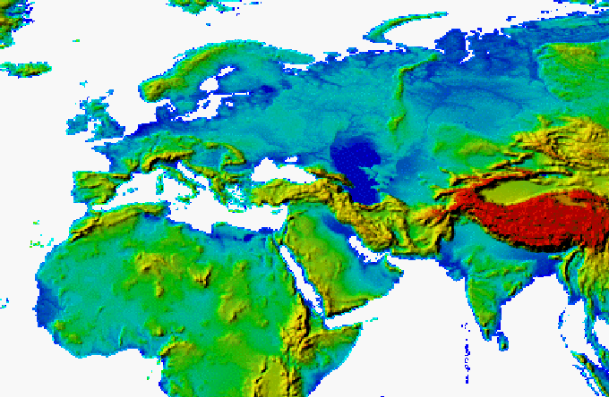
Figure 1. Topographical map of the Caspian Sea region.

The sea level rise, which started in 1977 has already led to a number of adverse consequences (Figure 2).

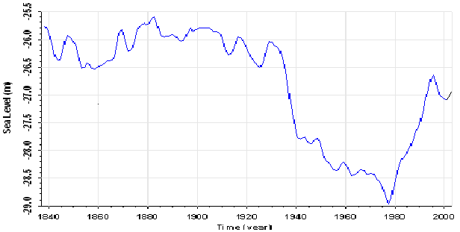
Figure 2. Annual levels of the Caspian Sea measured in the Baku post.

A reliable foresight of the Caspian Sea level behavior is very important as applied and fundamental problem, and its solution is impossible without an adequate description and diagnosis of the causes of the water balance components variations that occurred in the last decades.
The perennial level variations of the Caspian Sea and components of its water balance are investigated on the basis of the different approaches. But still the physical mechanism generating the long-term directed level changes of the Caspian is not understood. Researches of Golitsyn and Panin [1989], Panin et al. [1991, 2003, 2005] testify to the climatic nature of modern level variations, and also water and heat balance of the Caspian Sea. Our investigations have shown that present Caspian Sea level changes to 90% should be explained by corresponding changes of the water balance components or of the climate change (see Figure 3).

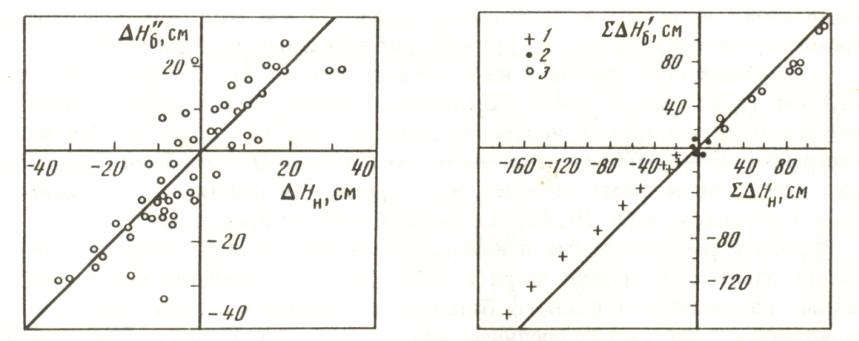 (a) (b)
Figure 3. Dependence (a) between actual (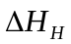) and calculated from the equation of water balance (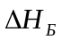) values of change of a level of the Caspian Sea; dependence (b) between the current sums actual (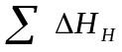) and calculated from the equation of water balance (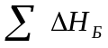) during the periods, 1930-1939 - (1), 1962-1970 - (2), 1978-1986 - (3).

Globalization of information enables the identification of the majority of anomalies in hydro-meteorological characteristics of any significance that appear in different regions. The question arises of whether these are local synoptic phenomena or a manifestation of a steady tendency toward climate changes? For the discursive understanding of the objectives and results of this study, it is essential to clarify the terms employed. A great number of different definitions of climate, which, as a rule, are too specialized, can be met in the scientific literature. In the authors' opinion, the most exact physical-mathematical formulation of the problem of climate, as a problem of statistical hydrodynamics of the atmosphere in its interaction with the underlying surface, was given by Monin, Shishkov [1979]: "Climate is the statistical ensemble of states through which the ocean-land-atmosphere system passes during time periods of several decades". Now the weather should be understood as an instantaneous state of this system in a given point. This state can be characterized by a set of values of hydro-meteorological characteristics. When using such definition of the climate, one should take into account the fact that the climate system does not remain in a static state but rotates around the Earth’s axis. An important point is that, according to astronomic data, the modules of the angular rotation speed of the atmosphere, the lower part of which is a component of the climate system, and the Earth, the outer surface of which is another part of the same system, are not identical.
The hydro-meteorological characteristics have a continuous spectrum of variations. The types of variations commonly distinguished include micrometeorological variations from fractions of a second to a few minutes, meso-meteorological variations from minutes to hours, synoptic variations from hours to weeks, climatic variations from a month to several decades, variations at a scale of centuries, and variations corresponding to glacial periods. In this case, it is necessary to distinguish the periodic oscillations of hydro-meteorological characteristics due to their diurnal and annual variations and evaluate the indices of anomalous and extreme character of climate in accordance with [Gruza and Ran'kova]. WMO recommends using a period of 30 years with a step of more than a month as a standard period for the assessment of variations in the hydro-meteorological characteristics for the present-day or current climate. In this study, we consider the period of 1961-1990 [Gruza, G.V. and Ran'kova]. With such approach, the answer to the question formulated above requires the spatial and temporal significance of the anomalies observed in the hydro-meteorological characteristics to be determined.
This problem gains particular importance in the context of the necessary forecast of the redistribution of water resources on the Earth's surface and the environmental situation in different regions in the nearest decades.
Studying the present-day state of the climate system requires the examination of sets of independent thermodynamic and hydrodynamic characteristics of its components (atmosphere, hydrosphere, terrain) averaged over the time and space.
The studies carried out earlier [Golitsyn et al., 1990, 2004, Panin et al., 1991, 1994, 2005, Panin and Dzuba, 2006] show that the present-day variations in the Caspian Sea level are related, through the evaporation from the sea surface, with the long-term variations in the wind regime, rather than with variations in the temperatures of boundary layers.
The regime of the Caspian Sea is an integral characteristic of the hydro-meteorological processes that take place in the catchment areas of rivers, such as the Volga, the Ural, the Kura, and the Terek, while the combination of these processes determines the climate in a considerable part of the European Russia.
Analysis [Budyko et al., 1981, Panin et al., 1991, 1994] of calculated monthly and annual values of evaporation from the Caspian Sea surface and the data of evaporameters located in different parts of the Caspian Basin testify to the presence of a statistically significant (at a 95%-level) linear trend in evaporation series. The trend averages to-86 mm/10 yr, or about 8% of the annual norm of evaporation from the sea surface. Results of the joint analysis of variations in the Caspian Sea evaporation and sea level over a long period show a high coherence of these processes during the period of the current sea level rise. Therefore, the question arises: what physical processes caused the decrease of evaporation in the Caspian Sea region over more than 30 years?
The intensity of interaction between the underlying surface and the atmosphere, including the process of evaporation, is controlled by the thermal, moisture, and dynamic characteristics of boundary layers. To establish the reasons for the trends in the rate of evaporation from the Caspian Sea a comprehensive analysis of variations in the hydro-meteorological characteristics (the air temperature, water surface temperature, air absolute humidity, and the magnitude of wind speed vector) in 1960-1990 at coastal and insular stations within the Caspian Sea and stations in the sea catchment area was made. No statistically significant linear trends were recognized in local variations of the air and water temperatures and air absolute humidity. These variations can be reliably described by models of autoregression of the first order, the average values of parameters of regression being 0.3-0.4, 0.4-0.5, and 0.25-0.35, of the air and water temperatures and the air absolute humidity respectively. In this case, the predictability of changes in the above hydro-meteorological characteristics of the Caspian Sea region is rather low (as a rule, the limit of predictability does not exceed 1-2 time steps). The relative errors of the forecast with the one-step term vary from 0.7 to 0.9 and more.
At the same time, statistically significant (at a 99% level) trends in the long term variations of the wind speed vector magnitude were found at most coastal and insular stations within the Caspian Sea and at stations in the sea catchment area.
A general tendency towards a decrease in the mean annual wind speed was observed in the studied region during 1960-1990. The average trend is about -0.3 to -0.4 (m/s)/10 yr, or 10% of the annual norm of the wind speed magnitude. The correlation analysis of the long-term variations of the wind speed magnitude and the rate of evaporation in the Caspian Sea region give a close cause-and-effect correlation between these processes [Panin et al., 1991, 1994]. The behavior of anomalies of the above parameters in 1960-1990 is as follows. Prior to 1972, positive anomalies of evaporation prevailed; after 1972, its negative anomalies were predominant. The temporal course of anomalies of the wind speed magnitude appeared to precede the respective course of evaporation, leading it by 2-3 years.
Note that tendencies towards a decrease in the mean annual and mean monthly modules of wind speed in the 1950s-1970s in the central part of European Russia [Antonevich and Litvyakova, 1979], Baltic region and Kazakhstan [Shkolyar, 1980] and in the region east of the Sea of Azov [Luts, 2001] have been recognized [Meshcherskaya et al. 2004] revealed a negative trend in long-term series of wind speed modules (from 1936 to 2000) at stations in the basins of the Volga and Ural. In [Panin et al., 1991, 1994, 2005, Panin and Dzuba, 2006], a statistically significant negative linear trend was recognized in the long-term variations of mean annual and mean monthly wind speed modules at a height of 10 m. This trend averaged to 0.4 m/s per 10 years at stations on the coast and islands of the Caspian Sea. However, analysis of the long-term variations in mean monthly and mean annual values of wind speed modules is necessary but not sufficient for understanding the causes of changes in the rates of interaction between the underlying surface and the atmosphere, including evaporation. The obtained results do not give a complete description of real regularities in long-term variations of the surface wind speed, since the matter of analysis was the scalar value of wind speed module arithmetically averaged over 240 or 2880 observation times. However, the wind speed measured at a weather station is a vector variable, the time-averaging of which will give a different result. Therefore, the description of long-term variations in wind speed with a given direction with its rightful averaging as a scalar value over time periods commonly used in meteorology, appears to be more sound and promising approach to the analysis of the causes and consequences of the current changes in climate characteristics. Panin et al., [1994] describe the basic regularities in long-term variations of the wind speed, regarded as a vector variable, based on the analysis of mean monthly values of its module in different directions at five stations on the eastern coast of the middle and southern Caspian Sea, and show that a steady and statistically significant decline in the speed of the ground wind (as a rule, in the zonal directions with the highest frequency) has been occurring over more than three recent decades.
Panin and Dzuba [2006] study the parameters of long-term variations in wind speed vector in the Caspian Basin (see Figure 4).

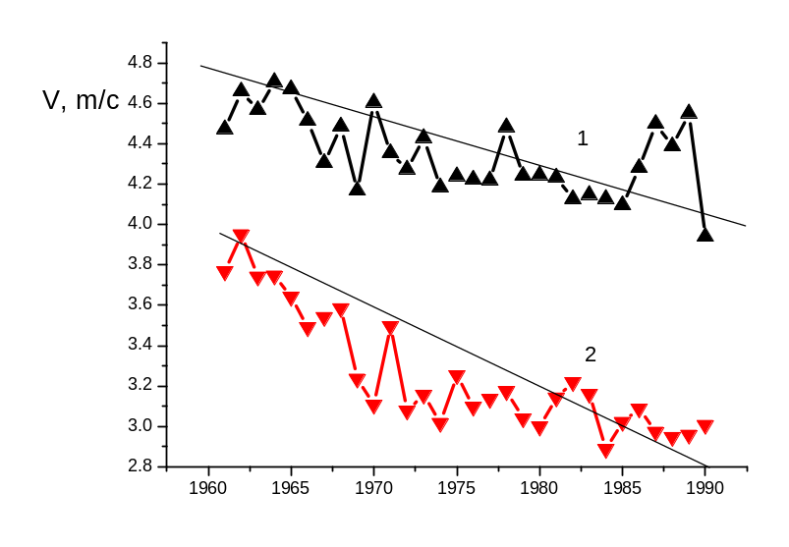
Figure 4. Long-term variations in mean annual modules of surface wind speed. (1) At the coastal and island stations of the Caspian Sea (2) along the Kola Peninsula-the Caspian Sea section.

First of all, a test was conducted regarding the authors' hypothesis that the mean annual modules of the surface wind decreased during past decades not only at the onshore and island stations of the Caspian Sea, but also in its catchment area, where the climate depends on the rate and trajectory of air mass transport. Analysis of five stations of the catchment area and over 13 stations of the Caspian Sea established a statistically significant decline in the mean annual wind speed module in more than 30 past years both at stations of the European Russia and at stations onshore and on islands of the Caspian Sea. The negative linear trend in 100 years averaged about 4 m/s for stations at the Murmansk-Syzran section and 3 m/s at onshore and island stations of the Caspian Sea. It should be mentioned that a positive trend was recorded in the air temperature and atmospheric precipitation.
Winds of zonal directions predominate at onshore and island stations in the Caspian Sea, especially in autumn and winter, when their modules are largest. These winds also feature maximum values of statistically significant negative linear trends. These trends amount to -7, -8, and -10 m/s per 100 years for stations of the northern, middle, and southern Caspian Sea, respectively.
Note that all five characteristics of the surface wind speed considered here show wider variations over wind directions than over seasons.
Thus, a statistically significant decrease was found to take place during more than three past decades in the speed of surface winds with most frequent zonal directions and largest modules in the area from Kola Peninsula to the eastern and southern coasts of the Caspian Sea. The occurrence frequency of winds of zonal rhumbs somewhat decreases.
The obtained results show that the surface air circulation experienced considerable alteration in the Caspian Basin. The presence of directional long-term changes in the parameters of vector velocity of air motion in the interaction layer prevents the present-day climate in the area examined from being considered as stationary.

1.2 Current and future regional manifestations of global climate change.
On the global climate warming backdrop occur regional changes for identification of which on the territory of Azerbaijan Republic have been used 100 years observations data of the 16 representational for the region meteorological stations.
Trend analyses results shows that for 100 years’ period ambient temperature on country territory increased on 0.5-0.6 ⁰С. During 1961-1990 the warming degree was 0.3-0.6 ⁰С.
In general warming affected on all natural areas of the country. Maximum warming observes in Big Caucasus, Kura-Araz lowland (0.5-0.65⁰С) and minimum on Small Caucasus Mountains and in coastal areas of the Caspian Sea (0.14-0.2⁰С).
Falls annual sums’ dynamics more than of secular passage of Baku station shows that for approximately last 50 years the quantity of the falls increased. Trend analyses results shows if 1881-1997 years annual fall quantity in general increased on 21% then in 1971-1997 years reduction was only 12%.
For evaluation further climate change on Azerbaijan territory by MSEI recommendation national experts used ОSА models: GISS, CCCM, UKMO, GFDL-3, GFDL-T. As the climatic base has been used real meteorological data of 16 stations for period from 1961 to 1990 years. In accordance with these models by doubling СО₂ concentration in atmosphere, expected increase of average annual temperature till the end of further century will be 4.11-5.82 ⁰ С.
By doubling СО₂ concentration using UKMO and GISS models expects increase of the annual falls on 4-12% and by CCCM and GFDL-T models reduction on 1-1.9% and using GFDL-3 model we observe minor spatial change of falls. Winter falls are increasing by all models, and summer falls are reducing on 23-62%, except GISS model by what summer falls increase on 17-40%.
Due to the absence of the unique estimates against of the climate change impact on water level increase and future development of coastal areas in the survey chiefly adduced scenario but not specific forecasts. From the other site, absences of the basis scenarios that simulate sea level fluctuation substantially complicate climate change impact analyses.
As you know, climate change has a significant role in the Caspian Sea level fluctuation. We can estimate this by sea water balance and variability change value of outlet basin’s hydrological conditions. So, by 46 meteorological stations’ data located in Caspian basin has been identified that during the last transgression (1978-1996) the fall quantity were on 40-60mm (8-10%) more than in previous periods and accordingly streamflow flowing into the sea also increased on 10-11%. Besides, in 90s years economical crisis in the Caspian Sea countries also facilitate to the decrease of consumptive use of river waters.
There are many forecasts on the Caspian Sea level change. Many scientist of Russia, Azerbaijan and different countries conduct survey for forecasting the Caspian Sea level, i.e. basically try to elaborate long term climate change forecast in the basin. However these attempts didn’t give the expected results, i.e. climate forecast is one of the most complicated and pending problems of the modern science.
In the majority of the modern elaborations the main conclusion of the researches coincide in that the high humidity in the Caspian Sea basin will remain and the sea level fluctuate in the frame from -26.0 to -25.0 m abs.
Various researches’ work analyses and level data for 1830-1996 years allow making conclusion that for potential estimation of the climate change impact on the coastal areas of the Caspian Sea it is necessary to orientate on the sea level raise till -25.0m (analogous raise has been observed in 1882). Such evaluation corresponds to the stochastic forecasts results of R.K.Klige, B.N. Malinin and to the forecasts of Geography Institute of the National Science Academy of Azerbaijan Republic.
Here is the Caspian Sea level forecast table (m. abs) with reference to the various authors:

Table 1.0 the Caspian Sea level forecasts

Author |  |  | Year
Author | 2010 | 2015 | 2020 | 2025 | 2030 | 2040 | 2050
Geography Institute of NSA of Azerbaijan* and BSU hydrometeorology department | -26,6 | -26,4 | -26,4 | -25,2 | -25,8 | -27,8 | -27,9
B.N.Malinin^{*1} | -25,6 | -25,5 | -25,3 | -25,2
I.A.Shiklomanov^{*2} | -28,8 | -28,5 | -28,0
R.K.Klige^{*3} | -25,2 | -25,5 | -24,9 | -24,8

Note: * Forecast has been prepared based on solar-terrestrial relationships by applying extrapolation method; the given evidences have 50% of supportability
^{*1} Forecast executed based on climatic method
^{*2} Water table estimate on climate change scenario with accounting.
^{*3} Probabilistic prediction with 50% of supportability.

The most part of the Kazakhstan’s Caspian Sea region is located in arid and semi-arid zones, which are considerably vulnerable to climate change. The climate is continental, with wide variations throughout the region. In the north average January temperature is minus 10-11 °C and July average is about 25 °C (Table 1.1); in the south the averages are minus 3-7 °C and 26-27 °C correspondingly.
Table 1.1 Air Surface Temperatures (Celsius degree) for the Kazakhstan’s Caspian Sea region for the 53-year average 1950-2003
Station | Month |  |  |  | Annual
Station | January | April | July | October | Annual
Taypak | -10.7 | 9.6 | 25.3 | 7.2 | 7.1
Zhalpaktal | -10.3 | 9.3 | 24.4 | 6.7 | 6.9
Urda | -8.6 | 10.2 | 24.8 | 7.9 | 8.2
Atyrau | -8.0 | 11.0 | 26.1 | 8.6 | 9.1
Fort-Shevchenko | -1.7 | 11.3 | 25.8 | 12.6 | 11.8
Ganyushkino | -6.2 | 10.7 | 25.3 | 8.9 | 9.5
Tushibek* | -3.6 | 11.8 | 26.5 | 10.8 | 11.2
Beyneu | -7.2 | 11.7 | 27.7 | 9.2 | 10.1
Uil | -11.8 | 8.9 | 24.6 | 6.4 | 6.4
* - data since 1955

In the north annual precipitation reaches 200-270 mm (Table 1.2), and less than 100 mm in the desert areas in the south. Strong winds are typical for most part of Caspian Sea region.
Table 1.2 Total Precipitation (mm) for the Kazakhstan’s Caspian Sea region for the 53-year average 1950-2003
Station | Month |  |  |  | Annual
Station | January | April | July | October | Annual
Taypak | 16 | 19 | 16 | 21 | 208
Zhalpaktal | 22 | 18 | 24 | 29 | 266
Urda | 21 | 22 | 23 | 25 | 265
Atyrau | 13 | 13 | 16 | 16 | 175
Fort-Shevchenko | 6 | 15 | 12 | 11 | 123
Ganyushkino | 12 | 21 | 19 | 13 | 177
Tushibek* | 10 | 21 | 12 | 12 | 85
Beyneu | 10 | 18 | 15 | 14 | 148
Uil | 19 | 20 | 23 | 28 | 252
* - data since 1976

Redistribution of precipitation and increase of frequency and intensity of droughts on the background of air temperature increase will entail negative consequences particularly in agriculture and water management of the country. Climate change can also have negative influence on human health.
Meteorological observations at some stations of Kazakhstan started more than 50 years ago, that has allowed to estimate regional climate change over this period.
Surface air temperature. The tendency of increase of average seasonal and annual air temperatures was observed during last centenary period in Caspian Sea region (Table 1.3). Maximal warming occurs in the winter period (0.5-1.3 °C /10 years). Over the region mean annual surface temperature rose by about 0.2-0.4 °C /10 years over the region for the period 1950-2003.

Table 1.3 Linear Trend Coefficients for Air Surface Temperatures (°C/10years) for the Kazakhstan’s Caspian Sea region for the Period 1950-2003
Station |  | Month |  |  |  | Annual
 |  | January | April | July | October | Annual
 |  | A | A | A | A | A
Taypak |  | 1.1 | 0.2 | 0. 2 | 0.3 | 0.3
Zhalpaktal |  | 1.3 | 0.5 | 0.3 | 0.4 | 0.4
Urda |  | 1.0 | 0. 2 | 0.2 | 0.2 | 0.3
Atyrau |  | 0.9 | 0.2 | 0.3 | 0.3 | 0.4
Fort-Shevchenko |  | 0.5 | 0.1 | 0.2 | 0.1 | 0.2
Ganyushkino |  | 0.8 | 0.2 | 0.1 | 0.2 | 0.2
Tushibek* |  | 03 | 0.1 | 0.2 | 0.2 | 0.1
Beyneu |  | 0.7 | 0.2 | 0.2 | 0.1 | 0.4
Uil |  | 0.8 | 0.1 | 0.1 | 0.2 | 0.2
* - data since 1955

Precipitation. A slight negative trend of the annual and autumn total precipitation for the period 1950-2003 was observed at the most meteorological station in the Caspian Sea region of Kazakhstan (Table 1.4). To the contrary a slight increase in winter, spring, and summer rainfall was observed.

Table 1.4 Linear Trend Coefficients for Total Precipitation (mm/10 years) for the Kazakhstan’s Caspian Sea region for the Period 1950-2003
Station | Month |  |  |  | Annual
Station | January | April | July | October | Annual
Taypak | 0.1 | 1.8 | -0.7 | -2.3 | -6.5
Zhalpaktal | 0.6 | 0.9 | 0.1 | 0.1 | -5.0
Urda | 1.3 | 1.9 | 1.4 | -0.7 | 10.3
Atyrau | -1.0 | 1.8 | -3.2 | -0.03 | -3.3
Fort-Shevchenko | 0.2 | 2.5 | -0.7 | -0.4 | -4.8
Ganyushkino | -2.6 | 5.4 | 1.4 | -0.3 | -10.1
Tushibek* | 1.1 | -2.6 | 2.0 | 1.9 | 10.7
Beyneu | -0.11 | -0.19 | -0.14 | -0.28 | -1.23
Uil | 0.01 | 0.21 | 0.09 | -0.24 | -0.46
* - data since 1976

Such regime of rainfall on the background of significant temperature rise is an evidence of increase in climate aridness over the most part of Caspian Sea region in Kazakhstan.

Projections of climate change in the Caspian region
The results presented in this chapter are based on simulations made with global climate models. Climate change simulations are assessed for the period 1990 to 2030 and are based on the P50 scenarios – i.e., median of the SRES scenarios (IPCC Special Report on Emission Scenarios, see the Box below) for projected changes in greenhouse gas concentrations and sulphate aerosol loadings (direct effect). A few Atmosphere-Ocean General Circulation Model (AOGCM) simulations include the effects of ozone and/or indirect effects of aerosols. Most integrations do not include the less dominant or less well understood forcings such as land-use changes, mineral dust, black carbon, etc. No AOGCM simulations include estimates of future changes in solar forcing or in volcanic aerosol concentrations.
Box: The Emissions Scenarios of the Special Report on Emissions Scenarios (SRES)
A1. The A1 storyline and scenario family describe a future world of very rapid economic growth, global population that peaks in mid-century and declines thereafter, and the rapid introduction of new and more efficient technologies. Major underlying themes are convergence among regions, capacity building and increased cultural and social interactions, with a substantial reduction in regional differences in per capita income. The A1 scenario family develops into three groups that describe alternative directions of technological change in the energy system. The three A1 groups are distinguished by their technological emphasis: fossil intensive (A1FI), non-fossil energy sources (A1T), or a balance across all sources (A1B) (where balanced is defined as not relying too heavily on one particular energy source, on the assumption that similar improvement rates apply to all energy supply and end use technologies).
A2. The A2 storyline and scenario family describe a very heterogeneous world. The underlying theme is self-reliance and preservation of local identities. Fertility patterns across regions converge very slowly, which results in continuously increasing population. Economic development is primarily regionally oriented and per capita economic growth and technological changes are more fragmented and slower than in other storylines.
B1. The B1 storyline and scenario family describe a convergent world with the same global population, that peaks in mid-century and declines thereafter, as in the A1 storyline, but with rapid change in economic structures toward a service and information economy, with reductions in material intensity and the introduction of clean and resource-efficient technologies. The emphasis is on global solutions to economic, social and environmental sustainability, including improved equity, but without additional climate initiatives.
B2. The B2 storyline and scenario family describe a world in which the emphasis is on local solutions to economic, social and environmental sustainability. It is a world with continuously increasing global population, at a rate lower than A2, intermediate levels of economic development, and less rapid and more diverse technological change than in the B1 and A1 storylines. While the scenario is also oriented towards environmental protection and social equity, it focuses on local and regional levels.

There are many more AOGCM projections of future climate available than was the case for the IPCC Second Assessment Report (IPCC, 1996) (hereafter SAR). Some indication of uncertainty in the projections can be obtained by comparing the responses among models. The range and ensemble standard deviation are used as a measure of uncertainty in modeled response. The simulations are a combination of a forced climate change component together with internally generated natural variability. A number of modelling groups have produced ensembles of simulations where the projected forcing is the same but where variations in initial conditions result in different evolutions of the natural variability. Averaging these integrations preserves the forced climate change signal while averaging out the natural variability noise, and so gives a better estimate of the models’ projected climate change.
AOGCMs can only be integrated for a limited number of scenarios due to computational expense. Therefore, a simple climate model is used here for the projections of climate change for the next century. The simple model is tuned to simulate the response found in several of the AOGCMs used here. The forcings for the simple model are based on the radiative forcing estimates, and are slightly different to the forcings used by the AOGCMs. The indirect aerosol forcing is scaled assuming a value of 0.8 Wm2 for 1990. Using the IS92 scenarios, the SAR gives a range for the global mean temperature change for 2100, relative to 1990, of 1 to 3.5°C. The estimated range for the six final illustrative SRES scenarios using updated methods is 1.4 to 5.6°C. The range for the full set of SRES scenarios is 1.4 to 5.8°C. The more recent results are generally obtained from models with improved parametrizations (e.g., better land-surface process schemes).
A more relevant measure of transient climate change is the transient climate response (TCR). It is defined as the globally averaged surface air temperature change for AOGCMs at the time of CO2 doubling in 1%/yr CO2 increase experiments. The TCR combines elements of model sensitivity and factors that affect response (e.g., ocean heat uptake). It provides a useful measure for understanding climate system response and allows direct comparison of global coupled models. The range of TCR for current AOGCMs is 1.1 to 3.1°C with an average of 1.8°C. The 1%/yr CO2 increase represents the changes in radiative forcing due to all greenhouse gases, hence this is a higher rate than is projected for CO2 alone. This increase of radiative forcing lies on the high side of the SRES scenarios (note also that CO2 doubles around mid-21st century in most of the scenarios). However these experiments are valuable for promoting the understanding of differences in the model responses.
The median of the SRES scenario(P50) has been integrated with five AOGCM by using the MAGICC/SCENGEN software. MAGICC (Model for the Assessment of Greenhouse-gas Induced Climate Change) is a set of coupled gas-cycle, climate and ice-melt models that allows the user to determine the global-mean temperature and sea-level consequences of user-specified greenhouse gas and sulphur dioxide emissions. MAGICC is designed for two main purposes:
- to compare the implications of a 'policy' emissions scenario with a 'reference' scenario in order to see how effective a specified emissions control policy is relative to a baseline 'no climate policy' case.
- to determine the sensitivity of results to model parameter changes. This may be done by comparing results for a given emissions scenario for a user-specified set of parameters with those for a default set of parameter values.
MAGICC generates a set of interface files for SCENGEN which contain a number of global warming curves for the period 1961-2100. SCENGEN uses these global warming values to scale the AOGCM patterns of climate change. Exactly which of these curves is used in a given climate change scenario creation depends on the user selections.
SCENGEN uses the scaling method of Santer et al. (1990) to produce spatial patterns of change from an extensive data base of atmosphere/ocean GCM (AOGCM) data. The scaling method is based on the separation of the global-mean and spatial-pattern components of future climate change, and the further separation of the latter into greenhouse-gas and aerosol components. Spatial patterns in the data base are ‘normalized’ and expressed as changes per 1ºC change in global-mean temperature. These normalized greenhouse-gas and aerosol components are appropriately weighted, added, and scaled up to the global-mean temperature defined by MAGICC for a given year, emissions scenario and set of climate model parameters. For the SCENGEN scaling component, the user can select from a number of different AOGCMs for the patterns of greenhouse-gas-induced climate. For the aerosol component there is currently only a single set of model results (from Michael Schlesinger). In the SCENGEN, all model data are from the Climate Model Intercomparison Project (control-run data, and data from perturbation experiments with 1% compound increasing CO₂ concentrations – see Covey et al., 2003). Data from 17 models are included.
The model ensemble mean temperature and precipitation changes were calculated for Caspian Sea region. The model ensemble includes the СERF98 Model (CERFACS Centre), the CSI296 Model (Australia), the ECH498 Model (the Max-Planck-Institute for Meteorology, Hamburg, Germany), the CSM_98 Model (NCAR, USA), and the HAD300 Model (UK Met. Office's Unified Model).
Results. The average annual mean temperature response from five AOGCMs using the SRES P50 forcing (Table 2.1) for the 30-year average 2016 to 2045 relative to 1961 to 1990 is 1.5 °C with a range of 1.4 to 1.7°C. The regionally averaged winter and spring surface air temperature increase compared to 1961 with 1990 is 1.6°C with a range of 1.2 to 1.9°C, while increase of summer surface air temperature amounts to 1.5°C with a range of 1.3 to 1.6°C. The values for autumn for the 2030 (the middle of 2016 to 2045) are 1.3°C with a range of 1.2 to 1.6°C, these values are lower than for other seasons.

Table 1.5 Changes in air surface temperature (Celsius degree) for the 30-year average 2016 to 2045 relative to 1961 to 1990 for Caspian Sea region in Kazakhstan

 | Season
 | Spring | Summer | Autumn | Winter | Annual
Average | 1.5 | 1.6 | 1.5 | 1.3 | 1.6
Maximum | 1.6 | 1.8 | 1.6 | 1.6 | 1.9
Minimum | 1.4 | 1.3 | 1.3 | 1.3 | 1.2

The average annual total precipitation response using the SRES P50 forcing (Table 2.2) for the 30-year average 2016 to 2045 compared with 1961 to 1990 is an increase of 2.0% with a range of 0.7 to 3.3%. For winter season it amounts to an increase of 4.3% with a range of 3.6 to 5.9%. The lower precipitation increase values are 1.9% with a range of -1.0 to 5.4% which were observed in spring. The regionally averaged summer total precipitation increase compared to 1961 with 1990 is 5.4% with a range of -12.8 to 44.9%, while increase in autumn total precipitation amounts to 3.7% with a range of  -3.9 to 9.3%.

Table 1.6 Changes in total precipitation (%) for the 30-year average 2016 to 2045 relative to 1961 to 1990 for Caspian Sea region in Kazakhstan

 | Season
 | Spring | Summer | Autumn | Winter | Annual
Average | 1.9 | 5.1 | 3.7 | 4.3 | 2.0
Maximum | 5.4 | 44.9 | 9.3 | 5.9 | 3.3
Minimum | -0.9 | -12.8 | -3.9 | 3.6 | 0.7

For reference the mean change and the range in global average surface air temperature (SAT) for the 1961 to 1990 average to the mid-21st century (2021 to 2050) for SRES is 1.1°C with a range from 0.5 to 1.4°C, and for the SRES marker scenario B2, the mean is 1.2°C with a range from 0.5 to 1.7°C. For the end of the 21st century (2071 to 2100), for the SRES marker scenario A2, the global average SAT change from AOGCMs compared with 1961 to 1990 is 3.0°C and the range is 1.3 to 4.5°C, and for B2 the mean SAT change is 2.2°C and the range is 0.9 to 3.4°C.
The Kazakh Research Institute for Environment Monitoring and Climate (KazNIIMOSK) has developed a water balance model for the calculation of sea water levels. The model allows determination of the sea level on the basis of river water inflow, water consumption changes in the basin, evaporation, precipitation and sea water runoff to the Kara Bogaz Gol gulf. The calculated values of the Caspian Sea level form the basis for the design of hydrotechnical constructions, industrial enterprises and other economic development projects in the coastal zone. This issue is of a great importance because using incorrect water level values for design will often necessitate large additional expenditures.
Investigations and calculations carried out have shown that under present climate conditions and with a water consumption in Caspian Sea basin equal to 40 - 45 km³/year, the sea level may reach the minus 26 m level with an 1% probability (once in 100 years) and the minus 25 m level with an 0.1% probability (once in 1000 years). They also have shown that if water consumption in the Caspian Sea basin would be absent the sea level would be 1.5-1.6 m above the current level.

The data analysis of average air temperatures over Turkmenistan for the period of 65 years stated that for the period 1931-1995 the tendency towards increase of average seasonal and annual air temperatures was observed.
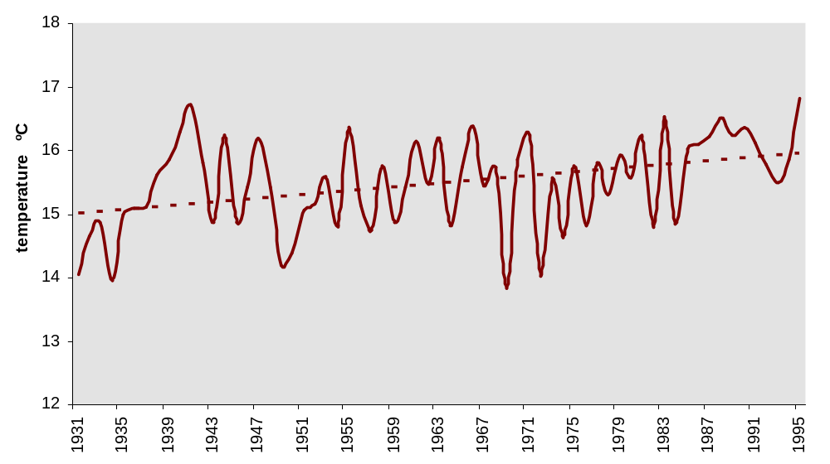
Figure 5 Time and linear trend of average annual air temperatures over the territory of Turkmenistan for 1931-1995

As stated in the Initial national communication on climate change, for the period 1931-1995 over the territory of Turkmenistan average precipitations were slightly yearly increased, among the four seasons the winter period was notable for increase.
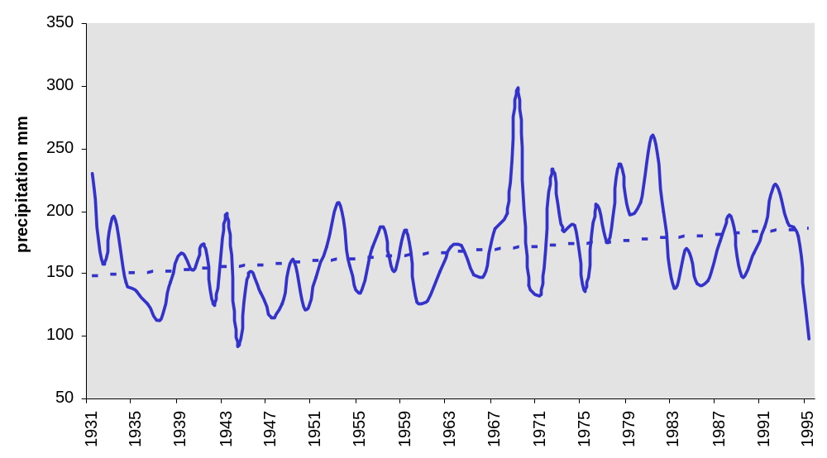
Figure 6 Time trend of average annual precipitations over the territory of Turkmenistan for 1931-1995

According to conclusions of the Initial national communication on climate change, air temperatures were raised by 0.1 - 0.2°С over the territory of Turkmenistan for all year seasons. Atmospheric precipitations were increased, among the seasons the winter period was notable for the highest precipitations.
Expected climate change Under the Initial national communication specific climate change scenarios over the territory of Turkmenistan were decided by the IPCC methodology based on outputs of the following general atmosphere and ocean circulation models (GCM):
- GISS Model - the balanced model of the Goddard Institute of Space Studies, USA;
- CCC Model - the balanced model of the Canadian Climate Center;
- UK89 Model - the balanced model of the United Kingdom Meteorological Agency;
- GFDL Model - the balanced model of the Geophysical Fluid Dynamics Laboratory, University of Princeton, USA;
- GFDL-T Model - the unbalanced model of the Geophysical Fluid Dynamics Laboratory, University of Princeton, USA.
By the five models a number of numerical experiments assuming the current and doubling carbonic gas concentration level were conducted for 12 year months. Data on the actual climate for 1961-1990 were used for the models. To verify the current climate reproduction of the models outputs were compared with calculated results of climate modeling, assuming the carbonic concentration 1хСО₂ or the current carbonic gas concentration (data on the actual climate). To study climate changes over the territory of Turkmenistan 17 stations evenly disseminated at the territory and covering diverse climatic regions were selected. 6 stations are located in Balkan velayat.
Under all scenarios understated amounts as compared with the current climate was specified. The best results of air temperatures were received under the UK89 model (the temperature is understated, but even during a year).
The most scenarios showed overestimated precipitation amounts in comparison with the current climate. Comparing results the GFDL model provided with the actual picture of precipitation distributions.
Results of all scenarios, which used to research main climatic parameters in Turkmenistan, helped to draw the following conclusions:
- A maximal warming is noted by the scenario under the CCC model. Under the scenario an average annual air temperature will increase by 6.1°С assuming CO₂ doubling, and precipitations will decrease by 15%. According to output data of the model a maximal air temperature growth will be during the winter period, and a significant precipitation raise - during the spring period;
- A minimal warming is noted by the scenario of the GDFL model. Under the scenario an average annual temperature will increase by 4.2°С, an average annual precipitation will not changed (0.0%);
- The other scripts showed the average annual air temperature raise by 4.6 - 5.5°С and the precipitation amount decrease by 17 - 56%;
- Seasonal fluctuations of average air temperatures are the following: a maximal air temperature increase under the scenario of the ССС model is observed during the winter period, under the UK89 model - during the summer period, under the GISS model - during the autumn period, under the GFDL-T model - during the winter period, and under the GFDL model - during the summer period.

Table 1.7 Average annual air temperature (T) and annual precipitations (R) changes over the territory of Turkmenistan
GCM model | ΔТ,°С | ΔR,%
GISS | 4.6 | -56
GFDL | 4.2 | 0.0
UK89 | 5.5 | -17
CCC | 6.1 | -15
GFDL – T | 4.8 | -4.4

The analysis of actual climate reproduction errors by the GCM models concluded, that the UK89 model is the most acceptable for climate modeling (air temperature and precipitation modeling) of Turkmenistan. Using outputs of the model, the analysis of future climate changes by all velayats of the country was carried out.
For Balkan velayat the climate parameters were calculated for the stations Turkmenbashi, Chagyl, Balkanabat, Esenguly, Etrek and Serdar. The model showed the air temperature increase by 3.3-6.4^{о}С during a year, the maximal increase is in the summer months and the minimal increase in January.
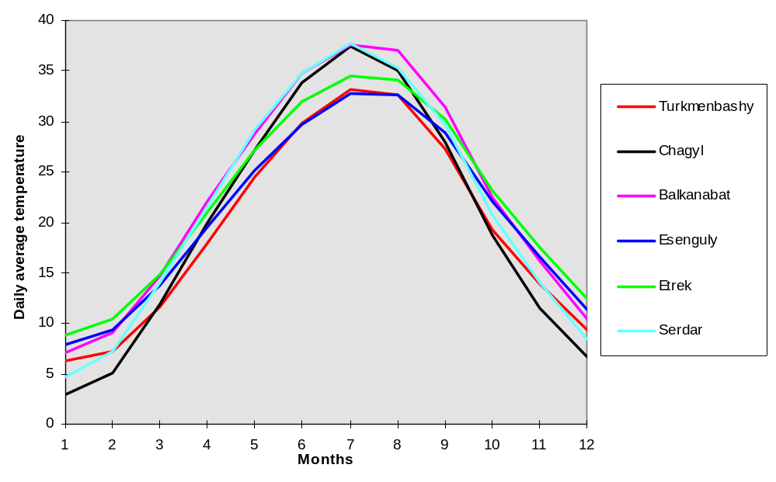
Figure 7 Temperature scenarios under the UK89 model assuming CO₂ doubling

Simulated precipitations decreases and increases for the velayat are uneven, but a maximal precipitation raise was calculated for May, and significant decrease - for November. It should be to note that for all velayats in the beginning of the spring (February, March, April) a precipitation decrease was predicted.
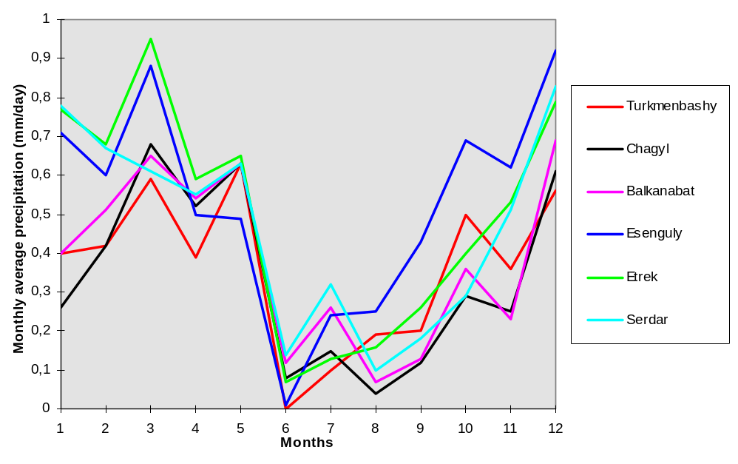
Figure 8 Precipitation scenarios under the UK89 model assuming CO₂ doubling

Iran. Synoptic data of 5 coastal cities (Babolsar, Raamsar, Gorgan, Rasht, and Anzli) have been analyzed by the Excel software in order to study these changes in sea level.
Babolsar: Precipitations are showing the rate of rainfall has noticeable fluctuations in recent 6 years relative to many years average. In warm season six year average have not noticeable difference relative to normal. But in fall season shows noticeable increase. The most increase occurs in Nov. at cold season. The temperature graph is showing that no noticeable difference between six year average and normal existed. Only a bit increase is apparent. In precipitation trend observed some increase.

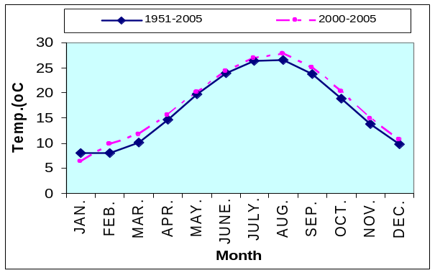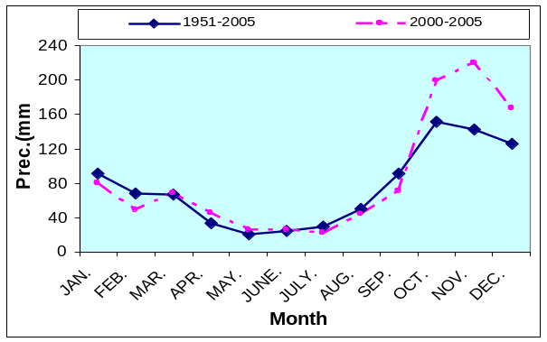

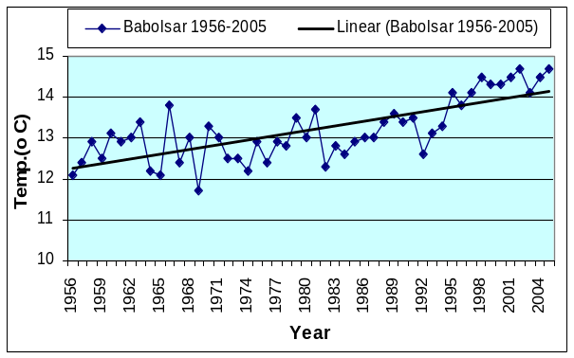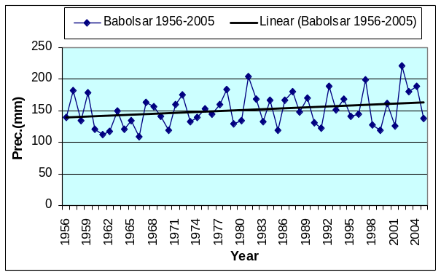
Figure 9 Comparison of parameters by normal amounts in Babolsar

Raamsar: With regard to precipitation graph it is seen that in summer six year average decreased relative to normal and in other months increased. Most decrease happened in Aug. and Sep. The temperature graphs show small increase of temperature in all of months except Sep. and the most rate of increase was in Jan. Graphs show that temperature increase is more in winter relative to other seasons. In precipitation graph decrease is seen.

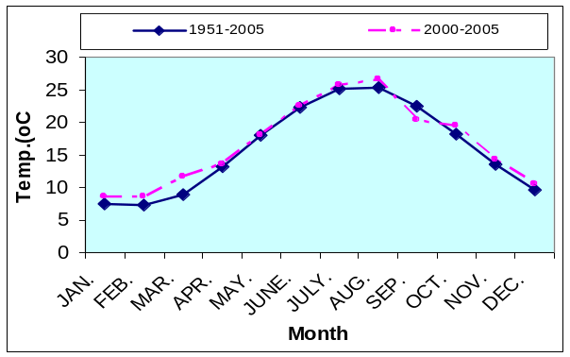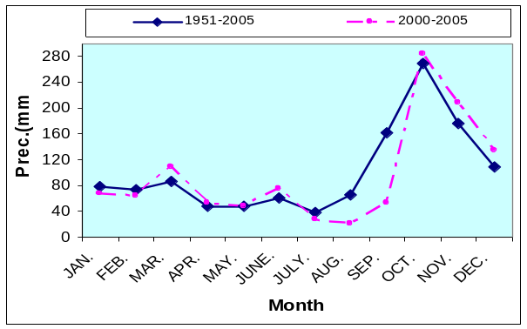
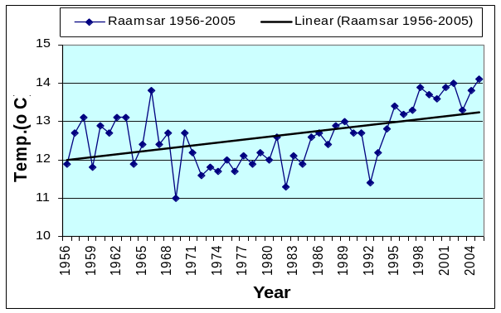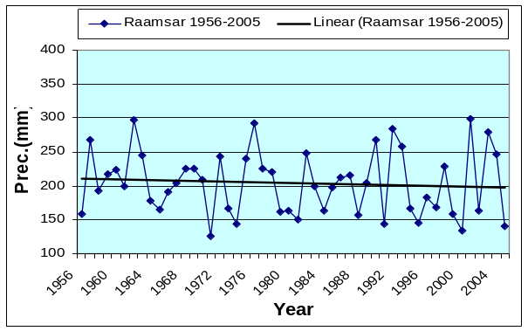
Figure 10 Comparisons of parameters by normal amounts in Raamsar

Rasht: Precipitation records show that in all months the rate of precipitation has been increased except in Jan., Jul., and Oct. Temperature records show that it have been increased in all months except in Jun. in which it was at normal. In cool season the most increase has occurred in Feb. and it was more in cold season relative to warm season. Precipitation trend have no noticeable differences but only a bit increase.

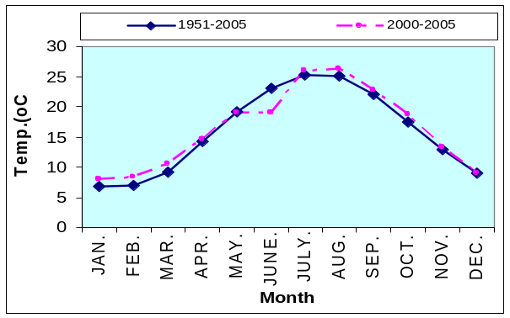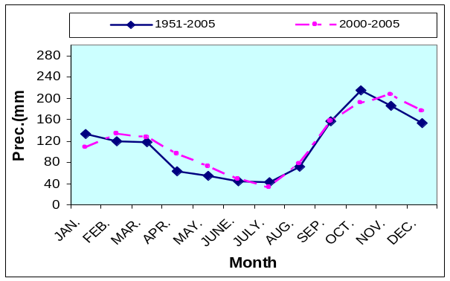
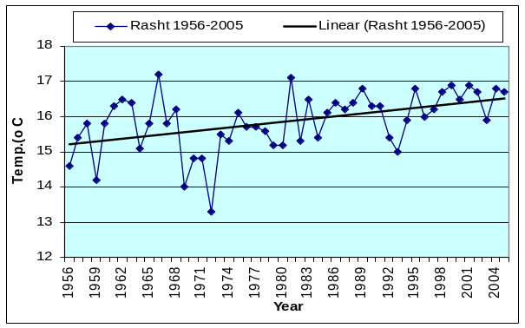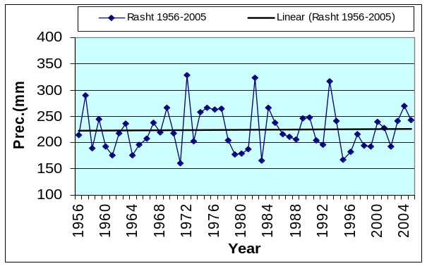
Figure 11 Comparisons of parameters by normal amounts in Rasht
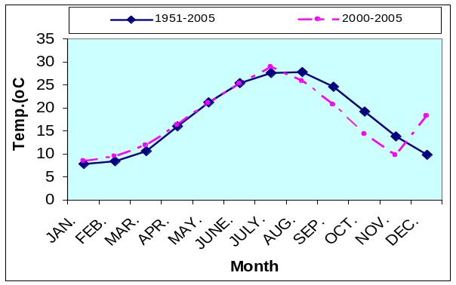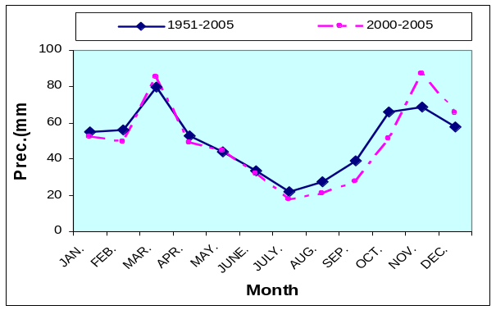
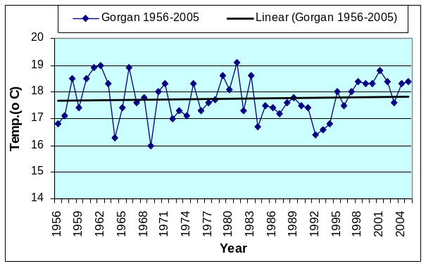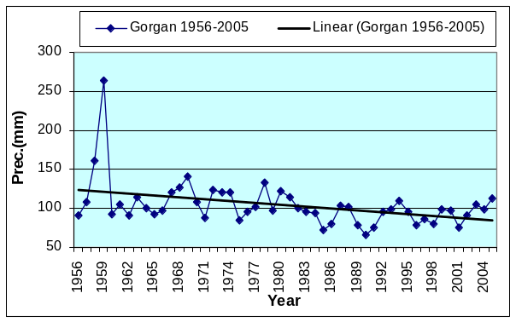
Figure 12 Comparisons of parameters by normal amounts in Gorgan
Gorgan: Precipitation graph show that six month average has been decreased in most of months relative to normal and it was more decreased in Oct. Precipitation decrease in warm season was more than cold season. Temperature graph shows that its six year average is less than normal rate for four months and in other months is a little more than normal rate. Graph of precipitation has decreasing trend.

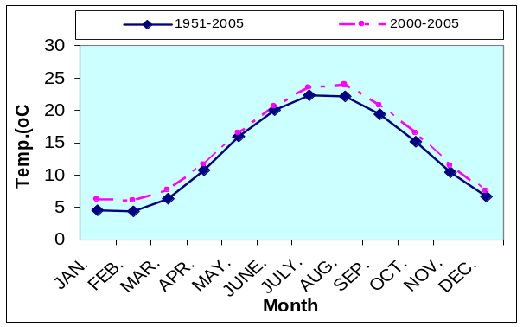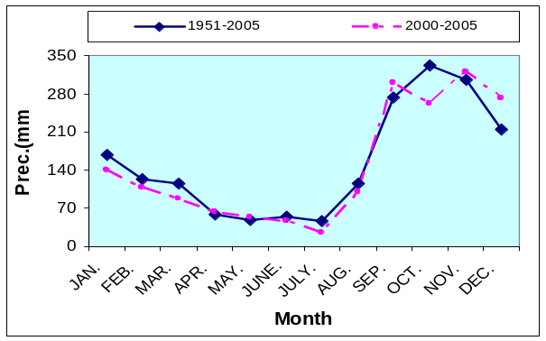
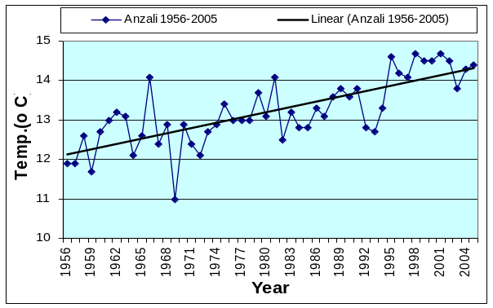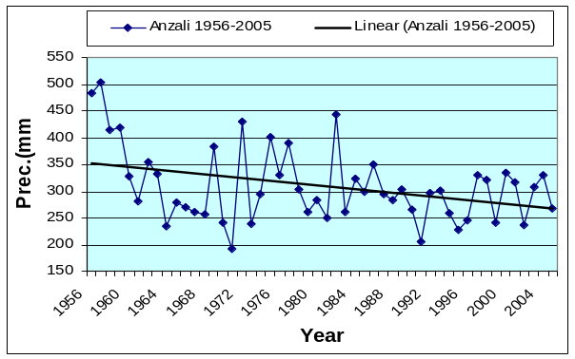
Figure 13 Comparisons of parameters by normal amounts in Anzali
Anzali: Study of precipitation graphs shows that six year average of rainfall has decreased in all seasons and months except in Sep., Nov., and Dec. and the most decrease has occurred in Oct. Rate of precipitation was less than normal in cold season except in Nov. and Dec. But in warm season it was temporarily decreased or increased. Temperature graph showing that six year average was increased very little in all months relative to normal; the most increase was in Feb. Precipitation graph shows decreasing trend.
Notation to atmospheric systems acting in north of Iran during cold and warm seasons shows that rainfall and evaporation fluctuation can be regarded as most important reason for water level fluctuation in Caspian Sea.

1.3 Prognostic analysis of climate change trends for the coming 30 years in the near Caspian Basin
The top-priority question is understanding of the sea level changes causes and possibility of its long-term fluctuations prediction. Fluctuations of the Caspian Sea level, in its turn, are also a point of interest as an index of a regional climate change, which is connected with its global change. The report evidently demonstrates that present changes of the Caspian Sea level are caused by certain variance of the water balance components and mainly by the river runoff and visible evaporation. That is, to our opinion, the point for the choice of method of the long-term Caspian fluctuations prediction.
Different approaches have been used to forecast long-term variations of the Caspian Sea level and water balance components. In most cases, the hypothesis of the climate stability within the last decades was assumed. These studies used linear and nonlinear stochastic models with either discrete or continuous time, physical models of interaction between the inner dynamics and the outer medium noise, and other methods. However, successful forecast that explain long-term directional changes (tendencies) in the Caspian Sea level is still absent. Efforts to estimate the Caspian Sea level in the nearest future made by Budyko et al. [1988] cannot be considered fully successful. Decrease in the Caspian Sea level was predicted by Ratkovich [1994], contrary to that, of Golitsyn et al.[1998] (where a similar approach is used) the sea level was supposed to rise up to 2010. The sea level in 2000 has been expected to be -28.0 [Ratkovich, 1994] and from -27.0 to -26.0 m abs. [Golitsyn et al., 1998], actually, it was -27.1 m abs (see Figure 1).
Our analysis of a wide spectrum of publications on the subject of the sea level fluctuations made it possible to specify three main groups of methods.
- Methods based on use of correlation connections between the sea level fluctuations on one hand and meteorological, geophysical or heliophysical processes on the other. Prognosis in this case is accomplished when it is possible to reveal temporal shift between the sea level (or components of the water or heat balance of the sea) and the predictor (process which is fit for connection). This group could also include the works on research of the future Caspian Sea level changes using the method of paleoanalogies and the works studying connections between sea level and the Sun activity characteristics (e.g. with the Wolf numbers) or neotechtonics. Those approaches do not exclude the necessarily for a forecasting of accounting the increasing influence of human economic activity on the Caspian level regime.
In spite of some or other connections being evident, their mechanism and theoretical side of the question still seem to be unclear. Dependences between the sea level and the atmosphere circulation characteristics also not always give an opportunity to make prognoses for a perspective. At the same time it should be noted that in most of the works of the above group the prognosed sea level changes coincided with reality for certain time intervals, i.e. predictions are often successful. But periods of quite close connecting of the average Caspian level magnitudes with, for instance, corresponding indexes of the solar activity or atmospheric circulation indexes are followed by periods when such connection is broken, changes its sign or is absent at all. Actually in spite of quite representative number of publications it is still difficult to expect success in predicting moving this way of research. Lower we will make certain that change of the sea level and its water balance components depend on quite a number of factors, i.e. multifactorial processes for prognosing are often connected with just one predictor (though it is quite possible to receive a high correlation between the analyzed processes at some separate sectors of the curves).
Among the various climate patterns of the northern hemisphere near the Atlantic sector extensively studied is North Atlantic Oscillation (NAO). The influence of NAO on the Euro-Mediterranean region in winter is well known [Hurrell, 1995; Marshall et al., 2001]. Paz et al. [2003] alternatively identify a North-Africa-West Asia (NAWA) sea-level pressure pattern, which they directly associate with the inter-annual climate variability and change in the Eastern Mediterranean. An alternative pattern known as the North Sea Caspian Pattern (NCP) based on mid-troposphere geo-potential height difference between the North Sea and Caspian Sea regions has been proposed by Kutiel and Benaroch [2002], and has been previously referred to as the East Atlantic/Western Russian (EA/WR) pattern by Barnston and Livezey [1987]. Both of the above patterns characterize the motions of mid-troposphere jet-stream over Europe, and therefore represent eastward extension of the NAO pattern originating in the Atlantic sector.
Correlations between NCP and surface atmosphere variables have been calculated for the 42 years window of the available data [Murat Gunduz and Emin Ozsoy, 2005].
Remarkable correlation is found between the NCP index and sensible, latent and net heat fluxes, specific humidity and air temperature in the Balkans, Middle East and the Caucasus regions.
Sensible and latent heat fluxes correlate negatively around the eastern Mediterranean, Black and Caspian Seas region, with significant values over the Aegean and eastern Black Sea and positive correlation over the western Mediterranean. Specific humidity and air temperature show similar behavior, with high negative correlation in a wide region encompassing the eastern Mediterranean, Black and Caspian Seas. Precipitation shows a clear contrast between negative correlation over continental Europe including western Anatolia, and positive correlation in the Asian region including Aral and Caspian Sea areas.
Based on data of Murat Gunduz and Emin Ozsoy [2005] analysis of marine and atmospheric surface variables, the important atmospheric climate pattern affecting the entire Euro-Asian Mediterranean region, and especially the Eastern Mediterranean and Black Sea, appears to be the North Sea Caspian Pattern. While the NAO has been attributed a stronger role in influencing the climates on both seaboards of the Atlantic Ocean and especially Europe on its downstream, its influence appears more confined in the western Mediterranean, while the NCP better accounts for the climatic variability of the Eastern Mediterranean, Black and Caspian Seas region.
Forecasting methods connected with use of the Earth rotation angular velocity change as predictor seem to be quite perspective [Sidorenkov, 1996, Panin et al, 1994, Panin, Dzuba, 2006)]. Changes of the rotation angular velocity might take place due to redistribution of mass on the Earth and in the atmosphere in time. Being a reflection of some or other mass redistribution the angular velocity could be considered as an integral index of changes of main processes going on the Earth. At least sharply definite changes of 1978 and 1996, when the certain Caspian level changes took place, are clearly seen on a curve of the astronomical day duration change [Sidorenkov, 2004].

PRINCIPAL FEATURES OF REARRANGEMENT OF THE SURFACE ATMOSPHERIC CIRCULATION IN THE CASPIAN SEA REGION. Here, it is supposed to develop investigations of temporal variability of local hydro-meteorological characteristics and of their possible connection with global climate changes.
Let us write the system of two equations:

 (1)
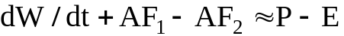 (2)

Equation (1) characterizes the water balance of the closed water body. Equation (2) characterizes the region water balance, including the water body itself and its basin [Rasmusson, 1977]. In equations: RF- river run-off, GF - underground run-off, W- moisture content of atmosphere above the basin, 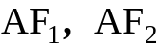 - horizontal moisture fluxes.
Let us assume, as in the case of the Caspian Sea , and also that the river run-off is determined mainly by the difference of precipitation and evaporation of the water catchment area 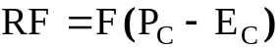. Equation (1) it could be rewritten as:

(3)
At 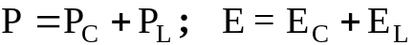 equation (3) it could be rewritten in form:

 (4)

Comparing equations (2) and (4) we find that the water level change may be determined from:

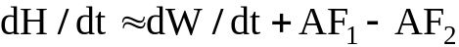 (5)

From (5), in particular, it follows that the water level change essentially depends on horizontal transfer of the air mass, and the direction of its transport.
Thus, as we have shown, the above analysis in combination with the trend of wind velocity value, gives us a basis to assume the possibility of the certain trends existence and wind direction changes in the environments of the Caspian Sea. Clarifying of these circumstances is the primary task of new investigations to find out the causes of the Caspian basin evaporation, precipitation and sea level changes.
The investigations of Panin et al. (2005) allowed to diagnose the formation and development of steady directional changes in the intensity processes of interaction between the underlying surface and the atmosphere (including evaporation) in the Caspian Sea region during nearly the 20-year period of the sea level rise. It is found that the global climate nonstationarity manifested itself in the Caspian Sea region during the last decades in the essential rearrangement of the surface atmosphere circulation. In the region as a whole, a tendency towards a decrease in the wind speed in the surface layer of the atmosphere is observed. Against this background, trends in the mean monthly wind speed vary with wind direction and season. A steady, statistically significant trend towards a decrease in the speed magnitude of the winds of zonal directions is found. The above results show that in the studied region a steady, statistically significant decrease is observed in the speed of surface winds of meridional directions, which speed is about 20% higher than the speed of winds of other directions. This trend is mainly observed in the seasons (autumn, winter), when the intensity of interaction between the water surface and the atmosphere is maximal. This rearrangement of the atmospheric dynamics in the interaction layer is the physical basis for the formation and development of present tendencies in the rate of interaction between the atmosphere and the underlying surface and, as a consequence, in the Caspian Sea water regime.
The geophysical factors are related to the properties of the Earth as a planet. Some of these factors affect the climate system as a whole, while other act at the regional level. These factors include the size and mass of the planet, its own gravitational and magnetic fields, internal heat sources, the properties of land surface that determine its interaction with the atmosphere, and the angular rotation speed of the Earth. The vector of angular rotation speed of the Earth, which determines the coordinates of poles and the duration of day can be measured instrumentally and calculated from astronomic data. Series of parameters of the Earth's angular rotation vector are available with a half-year step [Sidorenkov, 2004]. These data show the long-term variations of the rotation speed module to feature relatively long (about 35 years) period of directional changes (Figure 14).

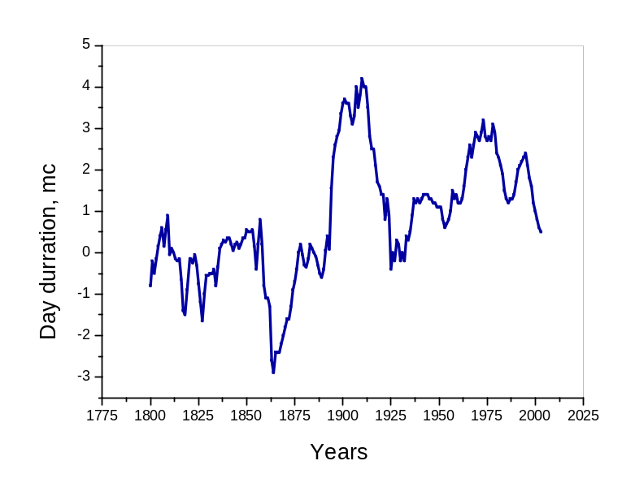
Figure 14. The Earth's angular rotation vector is available with a half-year step [Sidorenkov, 2004]

The calculations and analysis of data on long-term variations in climate system parameters suggest a significant effect of global water exchange processes on the vector of the Earth's angular rotation speed at a scale of an order of decades. Thus, we can conclude that directional changes took place in the recent decades in two major climate-forming factors - CO2 concentration in the atmosphere and the Earth's angular rotational speed. The estimate of the contribution of these factors to the present days and anticipated climate changes is indefinite. However, the effect of these factors is physically sound and confirmed by observational data.

2. Second group of forecasting combines stochastic and dynamically-stochastic models, the essence of which is the probable description of the sea level fluctuations based on understanding of generating climatic and hydrological factors as the stochastic processes. Stochastic water body model is usually considered as mathematical model of the water level fluctuations in a reservoir interpreted as a hydrological system with two income processes- river inflow and visible evaporation from the water surface. Modeling of those characteristics rows allows to study the sea level variability in natural conditions of the hydrological regime forming as well as under its different irregularities. Linear dynamically-stochastic model is widely acknowledged for description of the Caspian sea level fluctuations (supposition of the linear dependence of the sea surface area on its level, what in case of the Caspian Sea is accomplished according to A.V.Frolov [2003] with sufficient approximation).
Not less important assumption for that models class is hypothesis about stationary of the river inflow and visible evaporation, though bringing to strongly unstationary realization of the sea level fluctuation. Stated should be that the determinant for the predicted conditional mathematical expectation for the sea level is admission of some or other average water balance magnitudes relationship.
Long-term prognosis of the Caspian Sea level fluctuations should be based on prediction of the main sea water balance components: summary river flow, subsoil flow, visible evaporation from the sea surface, irretrievable losses from the water flow into the sea. Stochastic character of the long-term fluctuations of the sea-water balance components presumes only probabilistic estimation of the sea level regime parameters for perspective, and these estimations should be considered as tentative.
Presented considerations reinforce the need of studying of a few scenarios of the perspective Caspian Sea water balance and corresponding estimations of the sea level fluctuations parameters. Calculations [Golitsyn et al., 1998] demonstrate that to 2010 year the level fluctuations will most probably happen with the interval -27 -25 m. It should be thought realized that such a scenario has an extreme character and in the nearest time there will be no confirmation of considerable climate change in the Caspian Sea basin, there is quite a probability of turning to another variant based on hypothesis of absence of noticeable climate change during the accounted period. In this case reduction of the sea level is very likely to happen even in the nearest years. Even for the full-water scenario of the Caspian water balance it looks very unlikely that the sea level will exceed the marks of -25 m. during the nearest decades.
Results of the Caspian level regime calculation for the long-term perspective (20-30 years) should be reconsidered regarding the actual situation and trend of the sea level change and climate parameters determining the sea water balance formation and also the consequences of anthropogenic activity around the sea basin. By that prediction of the level fluctuations it turns out to adaptive character considering actual and defined perspective changes of the natural and anthropogenic processes forming the level regime.
Probably the nature of the Caspian sea level change is too complicated to solve the problem of its variability prediction within the frames of the linear dynamically-stochastic model. At the same time we should mention that the followers of stochastic modeling seem to feel rather critical towards the first group of publications (though they motivate this criticism rather logically).
Use of some or other nonlinear formation mechanism according to dependence of the sea surface area on its level (for example, thermo- physical mechanism of the nonlinearity forming due to dependence of evaporation on the sea level) complicates solving the problem of the application goals though widens the frames of the dynamically-stochastic modeling.
As a whole it should be pointed out that stochastic methods of the Caspian level change prediction have a stronger theoretical basement than methods of the first group, but the probabilistic form of received prognosis, when a wide range of probable fluctuations of the prognostic period of the level positions is assigned, complicates its practical use.

- Principally new ways for the long-term Caspian level change forecasting become possible with the use of the big climatic models, which are being actively developed during a last decade due to solvation of problem of the global and regional climate changes. With that modeling of the Caspian level fluctuation changes of a regional basin climate are considered according to the global climate change.
Global modeling studies of the Caspian Sea level (CSL) response to climatic forcing are reported by Mokhov et al. [2003], Arpe et al. [2000], Arpe and Roeckner [1999], and Golitsyn et al. [1995]. Golitsyn et al. [1995] evaluated the performance of thirteen General Circulation Models (GCMs) participating in the Atmospheric Model Intercomparison Project (AMIP) in simulating the water balance of the Caspian Sea basin for the period 1979–88. They found that, although all models overestimated the changes in CSL, the higher resolution ones performed better and were able to simulate the seasonal hydrological cycle of the basin and the steady rise in the CSL during the analysis period. Golitsyn et al. [1995] concluded that the accurate simulation of the net water balance over the Caspian Sea basin critically depends on the resolution of the GCM and on the proper representation of the sea surface and sea basin physiographic in the model.
Using results from future GHG scenario experiments performed with the MPI-ECHAM4 AOGCM, Arpe and Roeckner [1999] analyzed changes in the hydrological cycle over several basins, including the one of the Caspian Sea. They estimated a rise in CSL because of increased runoff from the Volga basin resulting from a change in the winter circulation bringing more precipitation over the region.

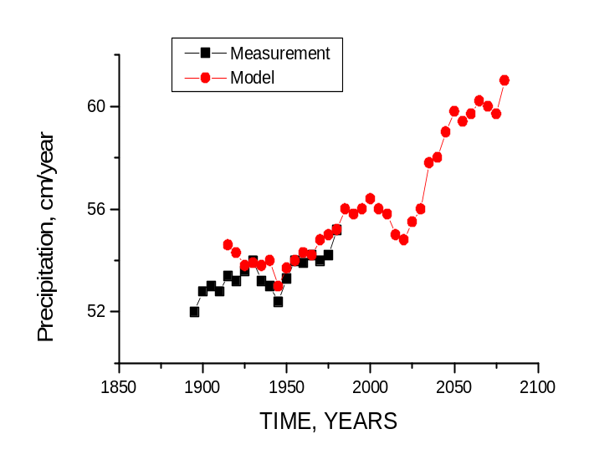
Figure 15,a. The Caspian Sea precipitation forecast [Arpe and Roeckner, 1999]

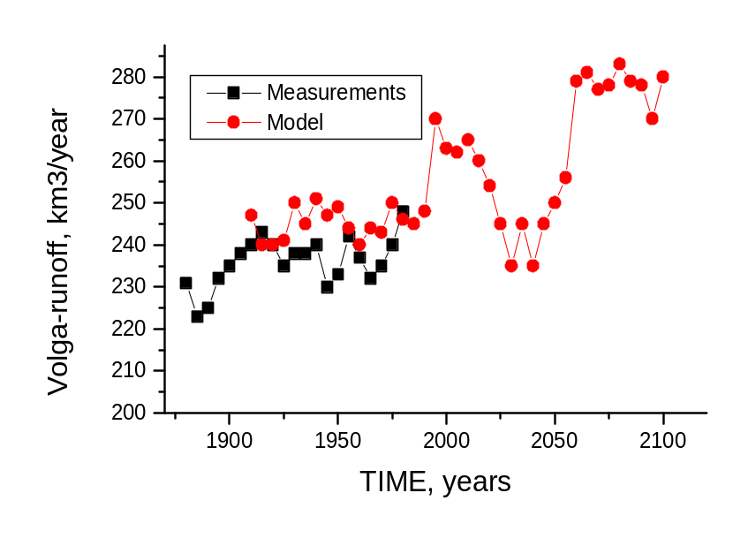
Figure 15,b. The Volga runoff into the Caspian Sea forecast [Arpe and Roeckner, 1999]

However, the authors were careful to note that the robustness of their results was limited by the relatively coarse resolution of the model (2.5 horizontal grid resolution) and the fact that the Caspian Sea was not represented at this resolution. Similarly, using 21st century simulations from global climate models, Mokhov et al. [2003] found increases in winter precipitation over northern Eurasia including the Volga and Caspian basins.
Here we present an analysis of the climate and hydrologic budget of the Caspian Sea basin simulated by a sub-set of the latest global climate change simulations performed by modeling groups worldwide as a contribution to the fourth assessment report of the Intergovernmental Panel on Climate Change (IPCC). The purpose of Elguindi and Giorgi [2005, 2006] is to assess possible changes in CSL for the 21st century under different greenhouse gas (GHG) emission scenarios (the IPCC A1b and A2).
Annual CSL changes (CSL) are calculated from the equation

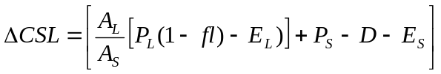 (6)
where 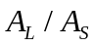 is the ratio of the land basin size to the sea size (equal to 6.365), P and P are the precipitation rates over the land and sea, respectively, and E and E are the evaporation rates over the land and sea, respectively. The only discharge out of the sea, D, is into the Kara-Bogaz Gol bay.
The parameter fl measures the fraction of total land basin precipitation PL that is lost by processes different from soil evaporation (and runoff) which are not represented by the model (actual river water evaporation, evaporation of water in pools, groundwater storage, etc). The value of fl is unknown, but estimates available in the literature are of the order of up to 10% [see Elguindi and Giorgi, 2006].
Figure 6 presents the simulated CSL change during the 21st century for the A2 and A1b scenarios, respectively. The majority of models predict a steady decreasing trend in the CSL under both scenarios, with no period of stabilization or recovery. By the end of the 21st century the simulated CSL ranges from -20 to -45 mbsl in both scenarios. Only two models predict an increase in the sea level, the CNRM-CM3 (A2 and A1b) and the CSIRO-MK3 (A2 only). The CNRM-CM3, which predicts about a 5 meter sea level increase, has the largest negative evaporation bias over the sea (-30%), indicating that the ocean scheme in this model tends to evaporate too little over the Caspian Sea. Also the CSIRO-MK3 model, which predicts a slight rise, has a negative evaporation bias over the sea. The largest decrease in CSL by the end of the 21st century is simulated by the MIROC3 model, up to about 20 m. This large CSL response is due to a large increase in evaporation over the basin.

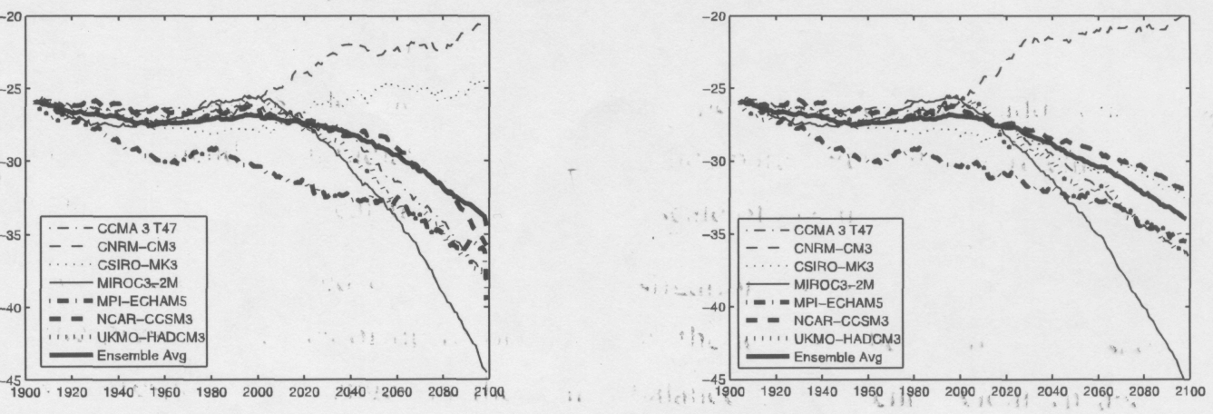
Figure 16. Simulated Caspian Sea level (mbsl) from the 21st century using IPCC A2 (left) and A1b (right) scenario emissions.

The forecasted CSL drop of Elguindi and Giorgi [2006] found in study is contrary to what has been previously by Arpe and Roeckner [1999]. This is mainly because the increase in evaporation over the sea was not previously accounted.
Evaporation over the sea is a very important component of the basin water budget [Panin, 1987, Golitysn, 1995], and for the ensemble average it comprises over 40% of the total evaporation-transpiration contribution to CSL change. Differences in how evaporation is parameterized in the models can have a significant effect on projected changes in the CSL.
The previous investigations [Golitsyn, Panin, 1989] have shown that changes in the water-balance components account for only 90% of the current sea-level variations of the Caspian Sea. There may be a number of factors that induce the indicated imbalance, but we supposed that it could have been caused by an insufficiently correct calculation of the evaporation from the shallow northern Caspian. An overview of the methods of calculation of evaporation and the heat and energy exchange has demonstrated that the state-of-the-art models of the heat and mass exchange between a basin and the atmosphere do not take into account the small-scale interaction between the shallows and the atmosphere. The point is that waves in shallow water are steeper than in the open and deep-water parts of the sea and break earlier (at lower wind speeds). These peculiarities must lead to an increase in the aerodynamic roughness of the water surface and, consequently, to a more intense turbulent exchange of momentum, heat, and moisture. It is possibly due to these conditions that the Kara-Bogaz Gol, after it became isolated from the Caspian in 1980, was drying up almost twice more rapidly than expected. The overview has also shown that a reliable method of estimation of the evaporation and heat exchange of shallow lakes and coastal areas does not exist so far. Investigations have been carried out both experimentally and theoretically.
We now consider the new estimates of the role of the depth in evaporation from the northern Caspian, but first we present a brief analysis of the wind and wave regime of this region [Panin et al., 2006]. The data from the Caspian Sea experiment has allowed us to account for the influence of the basin depth on evaporation, heat exchange and the friction velocity intensities in a final form:

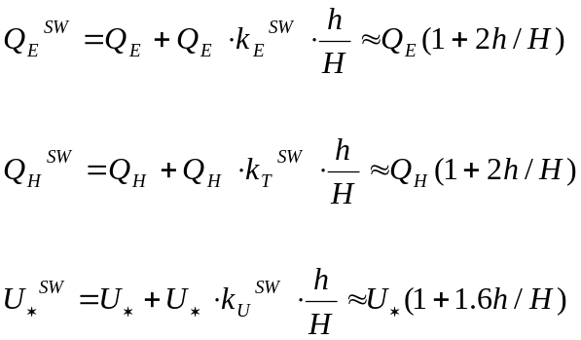 (7)

In (7) 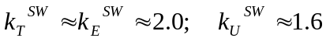 - empirical coefficient, h: the root mean-square waves height of the lake at the measuring point, - the depth of the lake, 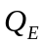, 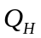 and  the evaporation, heat exchange and friction velocity of deep water, 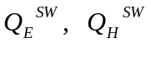 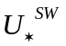 - evaporation, heat exchange and friction velocity of shallow water.
If the wave height 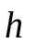data are absent, then an empirical relationship [Davidan et al, 1985] could be used 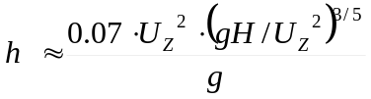, where 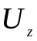- wind speed on the height 10m, - gravity acceleration.
While the formulation of this dependence still needs to be refined, it allows us to account for the influence of the basin depth on the evaporation and heat exchange intensities with an error rate of about 25% from the calculated value.
A new parameterization of evaporation and friction velocity from shallow water surfaces under different wind velocities (Fig. 17, 18) has been recognized on the basis of the theoretical and experimental analyses performed on the intensive energy-heat-mass exchange between deep and shallow sea/lake surfaces and the atmosphere (see Eq. 7).

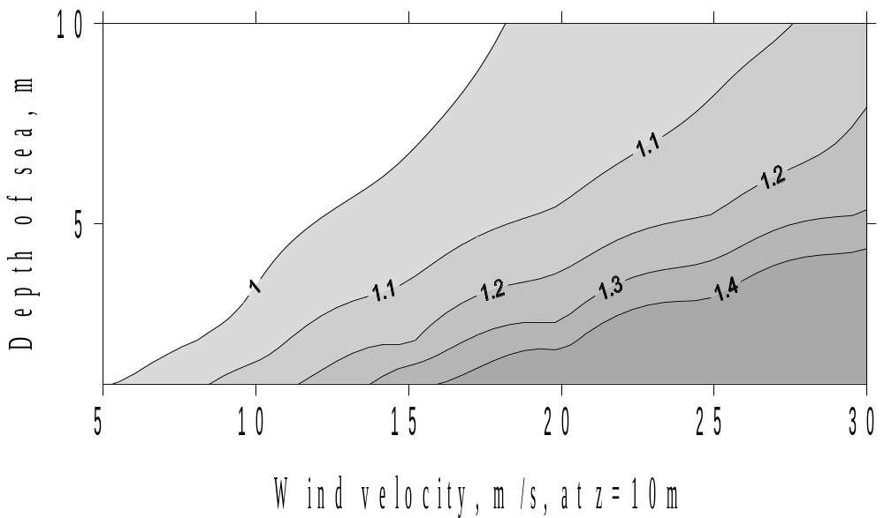
Figure 17: Intensification of the friction velocity of the shallow sea.

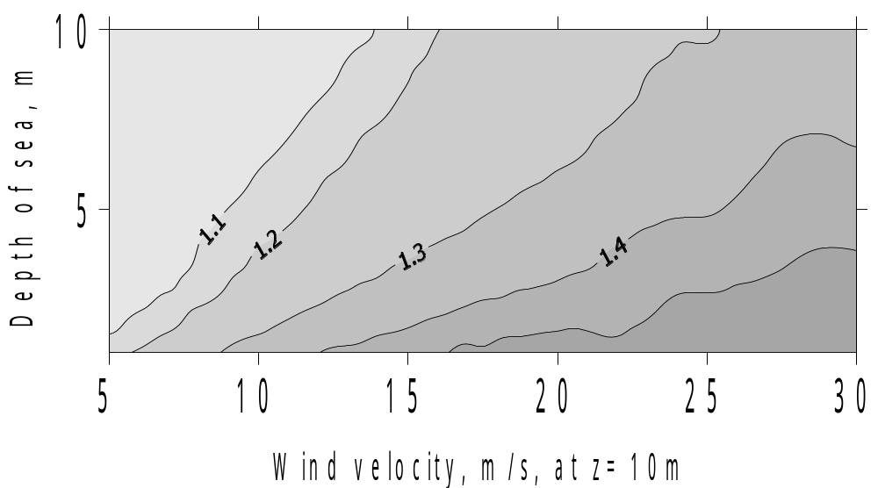
Figure 18 Intensification of the evaporation and sensible heat exchange of the shallow sea.

According to Figures 17 and 18, in natural conditions (within the range of actual wind velocities) evaporation and friction velocity from shallow waters theoretically might exceed by more than 1.5 times its usual magnitudes for deep waters.
Following our model for the evaluation of the shallow waters` effect, we should have statistical information on the wind velocity changes and on the shallow waters` areas, as well as their depth.

The largest impact on the intensification of evaporation in the northern Caspian, as was noted above, may come from a storm wind. The severest storm occurred there in November 1952. It was caused by a steady south-east wind of long duration (four days). The wind speed during the storm attained 34 m/s.
The frequency of wind speeds (without regard for direction) indicates that strong winds (above 15 m/s) account for 3% of cases. At the same time, the number of days in a year with winds over 15 m/s, e.g., at Fort Shevchenko, may be as large as 40 to 70 days.
According to the Skriptunov data wind speeds do not exceed 5 m/s in 55% of cases. This means that it is important to take into account the shallow-water effect in 45% of cases. As the wind speed increases, the duration of its action decreases.
In the northern Caspian, waves can reach the maximum development possible in shallow basins, with breaking of all high and medium waves, which may cause a considerable intensification of the evaporation and heat exchange in this region. As the Northern Caspian has shallow depths, the waves rapidly become steady when the wind arises. Wave parameters have a weak dependence on wind directions. The waves are characterized by a high steepness, which in a fully developed sea may reach a limiting value of 1/7.
Regarding the wave-regime features and wave-growth conditions, the northern Caspian can be divided into two areas, the eastern and western ones. The eastern area is very shallow, with maximum depths of 8 m in its central part. The western area resembles an open bay on the side of the middle Caspian, with a shallow estuarine zone of the Volga River in the northern part.
In the northern Caspian, the frequency of waves is closely related to the frequency of winds. Easterly winds prevail throughout the year, especially in winter months. Their frequency is about 30% in winter and 10% in June and July. The southeasterly wind is characterized by the same annual cycle of frequency. This is probably linked to the effect of the Siberian High, which reaches the maximum development in winter and nearly disappears in summer. Westerly, northwesterly, and northerly winds have a higher frequency of occurrence in summer months (June and July). The frequency of northeasterly winds varies within narrow limits throughout the year except for December, when it is minimal (8.4%). Southerly and southwesterly winds occur rarely. Calms are most frequent in the summer months and in the early fall (July, August, September, and October).
The intensification of evaporation and heat exchange in this region may also be caused by storm surges. The vast shallows of the northern Caspian, small bottom and dry-land slopes, configuration of the shoreline, and intense wind activity are favorable for the development of considerable storm surges.
We now turn to the corresponding estimates for the northern Caspian. In accordance with our model, to estimate the shallow-water effect, it is necessary to have statistical information about wind speed and frequency and information about depths and areas. Examples of the calculation of evaporation intensification for the northern Caspian are given in Figures. 19a and 19b for winds of 10 and 20 m/s, respectively.

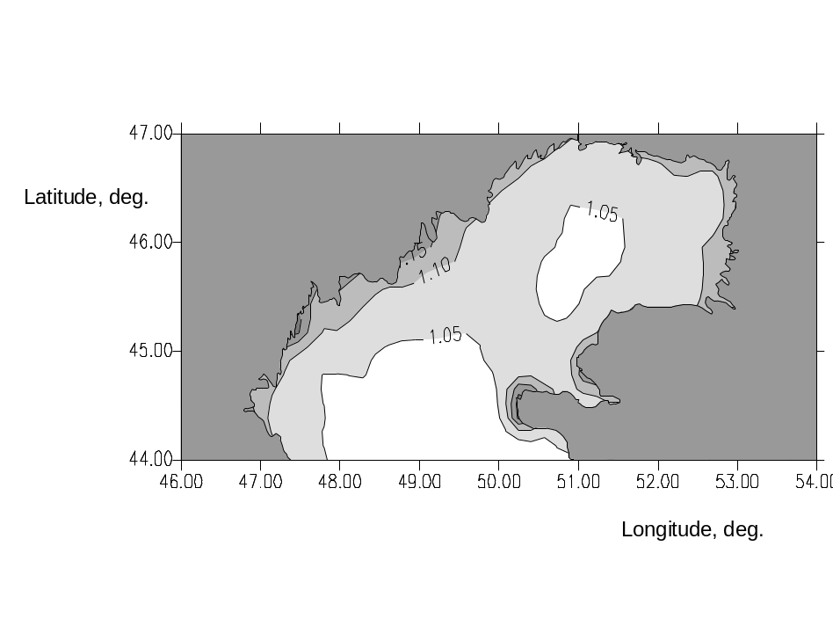
Figure. 19a. Results from model calculation of evaporation intensification in the northern Caspian at 10 m/s.

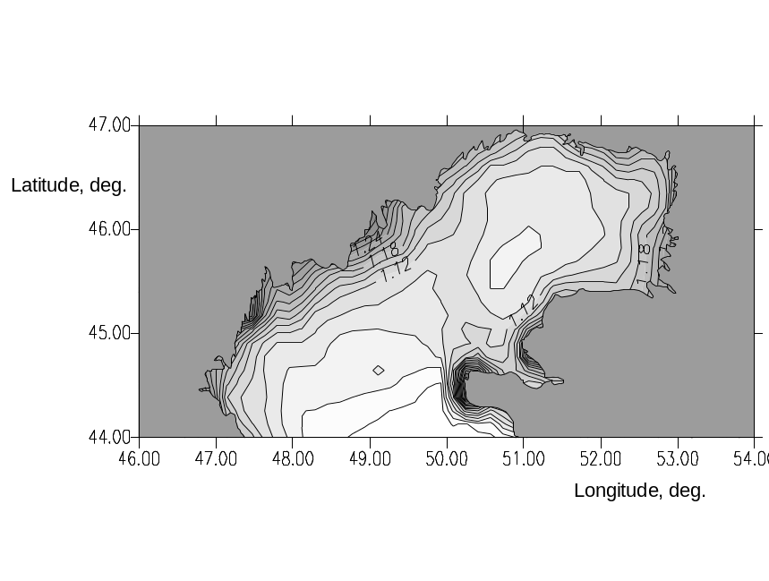
Figure. 19b. Results from model calculation of evaporation intensification in the northern Caspian at 20 m/s.

Our estimates show that evaporation in the coastal northern Caspian increases by 15 % at wind speeds of 10 m/s and by 30% at 20 m/s. In the deeper middle part of the northern Caspian, the evaporation intensification due to consideration for the sea depth is 5 and 10%, respectively.
The inter-annual variation of the evaporation from the surface of the northern Caspian differs greatly from that obtained earlier [Panin, 1987]. The annual mean evaporation from the northern Caspian made up 114.9 cm, or 14 cm higher than that calculated in our model without considering shallows [Panin et al., 2006].
Thus, it may be concluded that the proposed model of the heat and moisture exchange of shallow and coastal water areas with the atmosphere provides the opportunity to refine characteristics of the air-sea interaction on the basis of standard hydro-meteorological information. To design and test the model, direct measurements of turbulent momentum, heat, and moisture fluxes and of surface-wave characteristics were used. Data were obtained in deep and shallow areas of the open sea and in its coastal zones. The new model makes it possible to estimate the direct influence of the depth of a basin on the energy and mass exchange, both in the open sea and in the coastal zones.
It may be stated that the results obtained a point to a substantial omission in investigating the nature of the water body-atmosphere interaction. An overview of the method of calculations of the evaporation and heat- energy exchange has shown that the up-to-date models of heat and mass exchange between a body of water and the atmosphere do not take into account the features of the small-scale interaction between shallow waters and the atmosphere. Waves in shallow zones are steeper than in the open and deep sea and break earlier (at lower wind speeds). All this leads to an increase in the aerodynamic roughness of the water surface and, consequently, to a more intense turbulent exchange of momentum, heat, and moisture. The overview has also shown that there is still no reliable method of estimation of evaporation and heat exchange in shallow lakes and sea coastal zones.
Overall, our theoretical generalizations and experimental investigation of the role of the basin depth in the intensification of evaporation, heat exchange, and water-surface friction and first estimates of the role of this factor in the evaporation from the northern Caspian strongly suggest that the new model is universal. On the one hand, the results indicate a significant influence of the basin depth on the intensity of energy exchange in natural conditions. On the other hand, the examples presented illustrate a good agreement of the model calculations with experimental data. In real conditions, with the use of direct data on the depth, area, and wind frequency, the correction for the shallow-water effect gives an increase in the resultant evaporation from the northern Caspian above 10%.
The features of the spatial variability of the Caspian Sea evaporation also suggest that there may be an external forcing of the formation of surface currents, which was disregarded earlier in the simulation of currents. This forcing is caused by heterogeneous evaporation (intense evaporation in spring and in the first half of summer in the northern and southern parts of the Caspian leads to a level difference between the middle Caspian and these parts) and may exert significant influence on the water circulation in the entire sea. It might be expected that this circulation, which is intensified in spring and in the first half of summer because of the intense evaporation from the shallow northern Caspian, is seasonal in character. In the fall and early winter, the evaporation field becomes homogeneous in space, and quite a different picture in the field of currents might be expected. Evidently, similar currents can be simulated within the framework of a three-dimensional thermo-hydrodynamic model (for example, the hydrodynamic inland sea model (HISM)). The HISM is a coupled model of three-dimensional thermo-hydrodynamic processes of the sea, the model of the interaction between the boundary layers of the atmosphere and the sea, and the sea-ice thermo-hydrodynamic model.

The given results illustrate that use of climatic models opens new possibilities for estimation of regional components of the Caspian water balance and, correspondingly, for obtaining the sea level fluctuation estimations prediction. This approach to the problem of the Caspian level changes prediction is rather laborious method though quite promising.
The estimates of possible climate changes in the current century made with the use of numerical models of general atmospheric and oceanic circulation, which yield a linear or logarithmic dependence between changes in air temperature and the concentrations of greenhouse gases in the atmosphere can be essentially modified if the formation mechanism of climate changes connected with Earth rotation (rotation mechanism) is accounted for in the models.

About role of rotation mechanism for forecasting of the global and regional climate changes in the 21-st century.
It is evident that the atmosphere pressure gradient between the polar and tropical latitudes changing in dependence of the rotation regime should also manifest itself in the atmosphere dynamic change as well as in meteorological characteristics change. Empiric data prove that amount of clouds above the Earth surface is being changed according antiphase with the atmosphere pressure, while the absorbed radiation- in antiphase with the cloudness and in phase with the atmosphere pressure [Dzuba, Panin 2007].
The system planet albedo depends quite considerably on the clouds. Dependence of cloudness on the radiation balance of the underlying surface and the climate system could be opposite by sign due to relation of the clouds albedo to the different underlying surfaces’ albedo.
With increasing of the Earth rotation the atmosphere pressure lowers down and cloudness grows in the polar and moderate latitudes. During winters the underlying surface of these latitudes is mostly conditioned as either the ocean water surface or the snow surface. The snow albedo (average 0,8) significantly exceeds albedo of the clouds’ upper surface (average 0,4), therefore the system’s albedo considerably increases. By that the quantity of the absorbed atmosphere radiation grows. This brings to the increase of the air temperature at the Earth surface. The ocean albedo (average 0,1) is smaller than the cloud’s albedo. Therefore the system’s albedo above oceans slightly grows. Though this is highly compensated by saving of the heat transmitted by the ocean to the atmosphere and saved by clouds (reduce of effective radiation). Consequently air temperature above the ocean is also increasing. During warm periods of the year in polar areas above the snow covered underlying surfaces the mechanism of the air temperature increase stays the same but goes on less intensely. Above the ocean the air temperature growth also goes slower due to decrease of the heat transmitted by the ocean to the atmosphere. In moderate latitudes during warm periods of the year the land albedo comes to become almost similar to that of the clouds’, therefore the summary system’s albedo changes insignificantly. But there exists the greenhouse effect reducing effective radiation of the underlying surface which acts at the same time as the air heater. The long-wave system’s radiation into the space decreases and the air temperature grows. Above the oceans in moderate latitudes there are not observed the real significant directed temperature changes during the summer.
In the tropical zone by the Earth rotation acceleration appear the growth of the atmosphere pressure and reduce of the cloudness. The system’s albedo reduces as the clouds’ albedo is higher than albedo of the underlying surface being mainly the ocean surface. Simultaneously grows the absorbed radiation. As a result, an unimportant air temperature growth is registered during the whole of the year.
Thus, increase of the Earth rotation speed brings to the air temperature growth at all the latitudes, especially during the cold times of the year at polar zones.

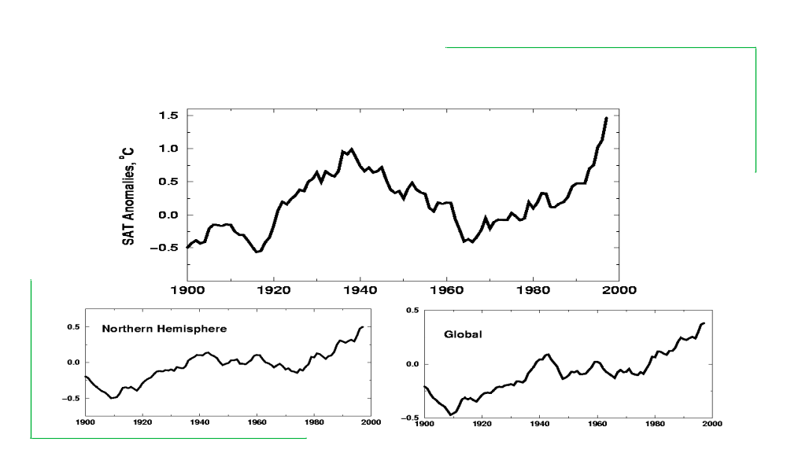

Figure 20. Annual anomalies of the near-surface air temperature (NSAT) in the Arctic ( 60C of N.L.- 90C of N.L.), the Northern Hemisphere and wholly on the Earth (Global).

By the Earth rotation speed slowing down the atmosphere pressure at the polar and moderate latitudes grows and the cloudness reduces. In winters above the snow covered underlying surfaces the system’s planetary albedo significantly grows, simultaneously the long-waved radiation into the space increases. The air temperature goes lower. Above the oceans, despite the system’s albedo decrease, there also takes place the air temperature drop due to significant increase of the long-waved radiation into the space. During the warm period of the year the loss of heat by the climate system, though less intense than in winter, takes place.
In the tropical zone by the Earth rotation slowing down the atmosphere pressure decrease and the cloudness’ increase takes place. The system’s albedo grows, what is partly compensated by reduce of the system’s long-waved radiation into the space. The air temperature goes down but not essentially.
Described physical mechanism of the climate system’s radiation response to the rotation factor is confirmed by empirical data. Figure 21 presents correspondence of the long-term changes of the Earth rotation speed and the averaged meanings of the air temperature.

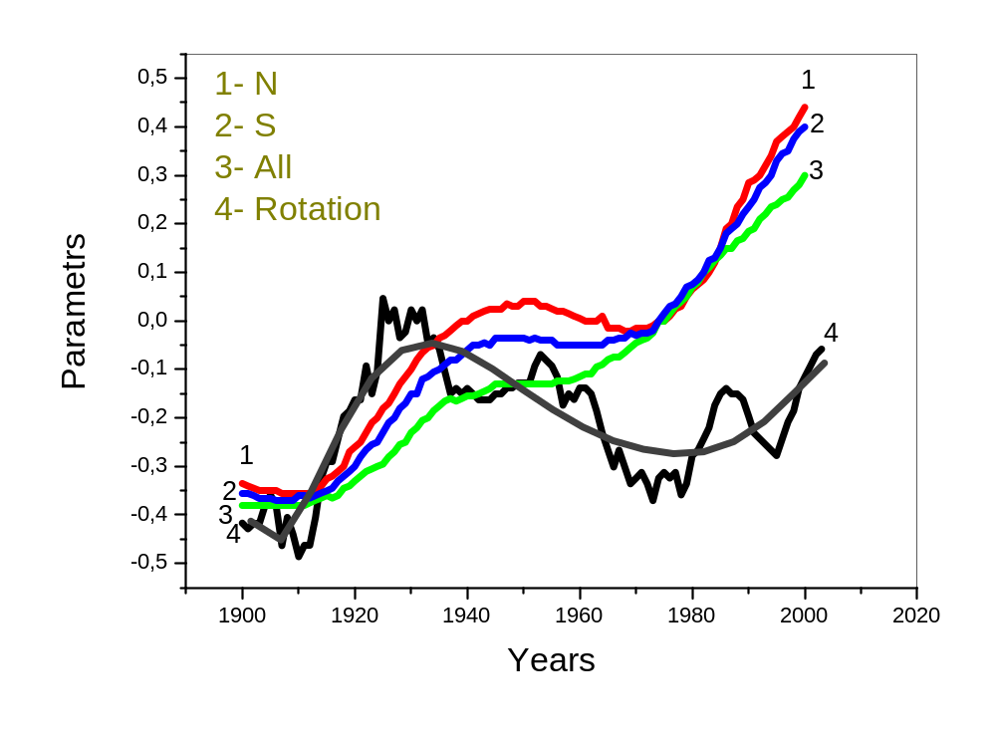

Figure 21. Changes of the average air temperature meanings: 1- Northern Hemisphere; 2 – Southern Hemisphere; 3 – Global; 4 – the Earth rotation speed.

Changes of normalized anomalies of the angular Earth rotation velocity and anomalies of the Northern Hemisphere the NSAT go on by the same phase with correlation coefficient between their average-decade meanings 0,81 0,06. The weaker correlation of the Southern Hemisphere’s and the global NSAT with the Earth rotation changes is explained by the fact that portion of the land in the Northern Hemisphere is equal to 39.3%, in Southern - 19,1% and globally - 29,2%. Correspondingly the snow-covered area during winter in the Northern Hemisphere is approximately by two times larger than in the Southern. Correlation coefficient of the Earth rotation speed changes and the air temperature of the zone 85 – 30 N.H. comes to 0,93 0,03 [Rudjaev, 1984].
This way correspondence of the climate warming periods in the XX-th century to periods of the Earth rotation acceleration, and a period of 1940-ies to 1970-ies when the growth of the global temperature was not marked to a period of the Earth rotation speed slowing down, has a physical basis and is confirmed by the observation data. The rotation effect acts either jointly with that of the greenhouse (by the Earth rotation acceleration), or compensates the last one (by the Earth rotation slowing down). Input of the rotation effect into the NSAT trend during the certain period of coinciding the changes of the Earth rotation angular velocity (appr. 35 years) comes approximately to 0,25 C for the Northern Hemisphere, 0,12 C for the Southern and 0,16 C for the globally averaged temperature.

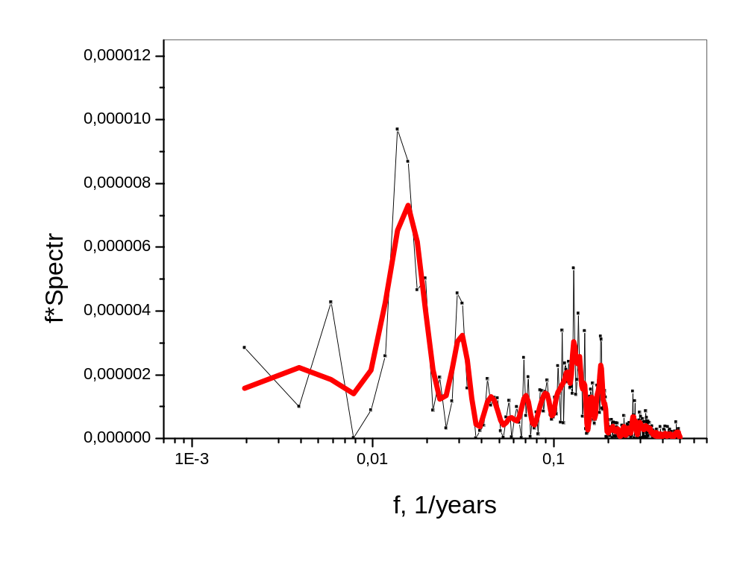
Figure 22. Spectrum of the astronomical day duration change [data of Sidorenkov, 2004]

Most sensitive to the rotation disturbances are zones of moderate and high latitudes in winter.
Composition of “the greenhouse“ and “the rotation” effects looks adequate for description of the climate system present regime. During 1910-1940 there was marked the Earth rotation acceleration, the greenhouse and rotation effects were one-way directed, the NSAT increase was observed. During the second half of the 1940-ies up to mid 1970-ies the slowing down of the Earth rotation has been marked, the CO - effect was compensated by the rotation effect, what brought to the noticeable reduce of the temperature growth in the Southern Hemisphere, to some cooling in the Northern Hemisphere and the absence of trend in changing of the globally averaged temperature. During the last three decades and till now the growth of the greenhouse gases concentration and acceleration of the Earth rotation affect the climate system in the same direction. Growth of the air temperature at the underlying surface becomes more intense. Correspondingly the other climate characteristics are being changed. Anomality indices and the climate extremity are growing. Difference of the course of the temperature averaged by hemispheres and the global one are explained by relationship of the areas covered by seas, lands and snows, determining values of the underlying surface albedo, planetary albedo and the effective radiation.
According to multi-model evaluations used by AMIP for the scenario of the greenhouse gases B concentration increase (concentration of CO ,CH, NO will increase by 2100 comparing to 1990 by 1,76; 1,75; 1,18 times correspondingly) the growth of the global near-land air temperature will come to 1,3 C to the middle of XXI-st century and to 2,1 C to 2080 [Meleshko, Golitsyn, Govorkova, 2004]. Variability of the Earth rotation angular velocity’s irregularity is correcting the obtained estimations by the following way. In the first half of XXI (appr.2010-2045) the rotation factor will compensate the greenhouse effect. Therefore the air temperature growth till the middle of the 2040-ies will come to 0,7 C (- 0,3 C- rotational component, + 1,0 C- greenhouse component). During the following approximately 35 years (2045- beginning 2080-ies) the disturbance effect of both factors will be similarly directed. As a result the global near-land temperature will increase approximately by 1,1 C (+0,3 C- rotation component, 0,8 C- greenhouse component). Summary growth of the globally-averaged near-land temperature will come to approximately 2,1 C. At that the growth of anomality and climate extremity will be observed. During the following more than three decades (after 2080-ies) the air temperature growth will slow down again.
Represented estimations are only preliminary. But they show that calculations of possible climate changes in the current century with the use of numeric models of the general atmosphere and ocean circulation, which gives the linear or logarithmic dependence (see Figure 23) between the air temperature changes and changes of the greenhouse gases concentration in atmosphere, could be considerably corrected by accounting the Earth rotation angular velocity irregularity.

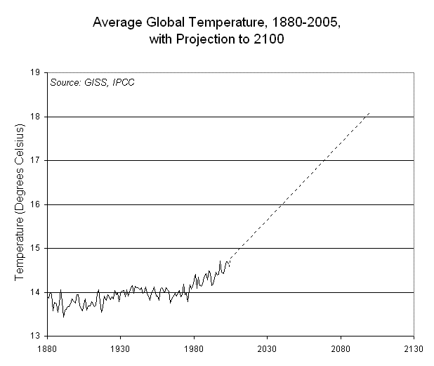

Figure 23 Forecast of change of global temperature in XXI-st century.

It is evident that the joint use of the greenhouse and rotation components for prediction of the Caspian Sea level changes in the XXI-st century should produce new, more realistic results. This work is still to be done but some preliminary evaluations are possible. During the first half of XXI (appr. 2045) the rotation factor will compensate the greenhouse effect. Therefore growth of the water level is rather unlikely before the middle of the XXI-st century. During the next approximately 35 years (2045- till beginning of 2080-ies) the disturbance effect of both factors will be similarly oriented and in this period the new rise of the water level even more significant than during 1977-1996 could be expected.

2. Potential environmental impacts of climate change in the near Caspian basin.

2.1 Impacts on hydrological flow of major contributing rivers (Volga, Kura, Terek)
Water surface flow into the sea results from income of the Volga, Ural, Terek, Sulak, Samur, Kura, small Caucasus rivers and those of the Iran coast. Below the short hydrological and hydroeconomic characteristic of the main Caspian basin rivers is given.
The Volga. Water catchment area comes to 1380.000 km² (about 40% of the whole Caspian basin catchment) and defines the main portion of the surface income into the sea, coming up to 82% of its total volume. The Volga water flow regime is well enough studied by observations being regularly done since 1890 at different points: Volgograd, Dubrovka station and the Verhneye Lebezhye village. Magnitude of the Volga flow is changed within quite wide a range depending on the climate conditions. Its lowest values have been observed in 1977 and 1937, respectively 148 and 161 km ³; when the biggest in 1926 and 1990 correspondingly 382 and 356 km ³, i.e. variability range comes to 234 km ³. Average magnitude of the Volga flow during the period of instrumental observations is 243 km ³. The interannual distribution of the Volga natural flow is irregular- 30% of the annual water amount goes normally within the three months of spring and only about 11% - during winter (December-March).
Presently the Volga flow is regulated within the annual cycle by the storage reservoir of the Volzhsko-Kamsky Casckade with the present summary useful capacity of about 109 km ³. Reservoirs accumulate part of the spring flow, thus enlarging and smoothing the mean water flow.
The Kura. That is the second river of the Caspian basin as to its volume and its levels have been observed since the end of the 80-ies of the XIX century. But the flow observation data for its lower course (river station:Sabirabad- 240 km from estuary and Salyany- 85 km from estury) are available only starting the 1930.
The flow of this river should be better considered according observation data from the Salyany station. Regarding the fact that below the Sabirabad station the Kura- river has no tributaries and in this sector it runs among arid steppes (Mugan, Salyany and Shirvan), it could be concluded that the measured flows by the Salyany are most representative as they account the water flow off for irrigation and evaporation losses. Considering the available directed data by accounting the flow coming through the Kura into the sea, it is accepted that diversions and losses of the flow lower Sabirabad is in average 1 km ³.
The Kura basin is the area of the ancient irrigational agriculture. Full resources of the river flow in the basin are estimated as average of 26 km³ annually, but the water diversion for farming purposes plays significant role in the water balance since the old times. To date the irrigated area in the Caspian basin comes to about 1,5 million hectare. Total amount of irretrievable water flow for agricultural purposes, including losses due to evaporation from reservoirs, comes to 13-14 km ³ during the year. In 1953 the Mingechaur water storage reservoir (useful capacity of 8,3 km ³) aimed for the long-term water flow regulation was put into operation on the Kura-river in a point of its outlet from the mountains. By the end of 1970 the Soviet-Iranian hydro-control structure “Araz” on the Araz-river with the reservoir of useful capacity of 1,15 km ³, also being able to some flow regulation, started to operate. In 1982 above Mingechaur there was constructed the Shemkirskaya GES (Hydro-electro station) with the effective capacity of 2,7 km ³ and in 2001- the Enikendskoye of 2,5 km ³ capacity.
The average annual flow of the Kura-river in its pre estuarial portion could be estimated as 18 km ³ or 6% of the total amount of all the rivers flowing into the Caspian Sea. Most fully-watered years among all the observed were 1940 (25 km ³) and 1915 (24 km ³), and the lowest: 1918 (11 km ³) and 1930 (13 km ³). The water level of the Kura-river was lower than the sanitary norm during the summer periods of 1999- 2000, though the following three years the full-water periods are observed.
The Ural. The watershed area is 231000 km ³. Monthly magnitudes of the Ural flow volume could be most precisely characterized by observation data from the village Topoly located at 200 km from the estuary. The average annual flow here equals to 9,2 km ³. Variability of the annual flow is very high. Within the period of direct observations at this site (from 1932) the annual flow volumes vary from 20,5 km ³ (1948) to 2,9 km ³ (1937), when the variations range within the frames of the whole long-term period is even bigger: from 24,5 km ³ (1914) up to 2,2 km ³ (1890). Mostly the water comes during the three spring months (poor-waters years- about 70%, rich-waters years- up to 80% of the annual income). During the four winter months (December-March) only 7% of the total annual flow comes in.
According to the generalized data the average flow volume of the Ural-river is 10,2 km ³, or 4% of the Volga flow.
Terek. Natural water resources are formed mainly in the mountainous zone of the basin and are estimated as 11,5 km ³/yaer. Watershed area is 43200 km ³. The Terek flow in its lower course is being observed in points: Stepnoye (165 km from estuary) and Karagalinsky (108 km from estuary). Total irretrievable flow losses in the Terek delta are estimated as about 2 km ³.
Average annual flow of Terek at the point Karagalinsky during the whole observational period is estimated as 9,0 km ³, i.e. about 35 of the surface flow of all the rivers. At that the average flow during first 25 years of observation is 10 kmз and all the following- 7,8 km ³. Most full-watered was the year of 1944 with the flow of 12 km ³. The lowest watered during the first half of the long-term period was 1913 with the flow of 8,0 km ³, and the second- 1955 with the flow 6,1 km ³.
Sulak and Samur are starting in the area of perpetual snow and glaciers. Their summary annual flow into the sea is 8,1 km ³, i.e. less than 3% of the surface flow.
Summary average long-term water resources of small rivers of the Caspian west coast is 80-85 m ³/sec or 2,6 km ³/year; the flow into the sea is estimated as 1,6 km ³ and this is accepted to be similar for all the years of the accounting period.
Rivers of the Iranian part. According to Remizova [1964] the summary flow into the Caspian Sea is 14 km ³ in a year.
Flow of the different rivers is sometimes asynchronous. Thus, during the poor-water 1937 the Volga flow was minimal and came to 73,4% of total surface flow, at the same time the flow of the Kura and Terek was maximal and came to 10,3% and 4,9% correspondingly. In comparatively rich-water 1955 the relative role of the Volga flow was the largest (87,4) and the flow volume of the Terek and Kura was characterized by minimal meanings (3,75 and 1,7%). The flow of Samur and Sulak was also minor.
Most evident asynchronous fluctuations of the flow are observed between the rivers of the European and the Asian groups. Inside those the flow fluctuations are mostly synchronous.
Figure 24 presents diagram of income of the summary water flow into the sea. As to update according to a number of observations for 1880-2001 the estimations are the following: the average flow 290 km ³/year [Frolov 2003], variation coefficient C = 0.16, autocorrelation coefficient R= 0.4, maximal magnitude 436 km ³/year (1926), minimal- 181 km ³/year (1975).

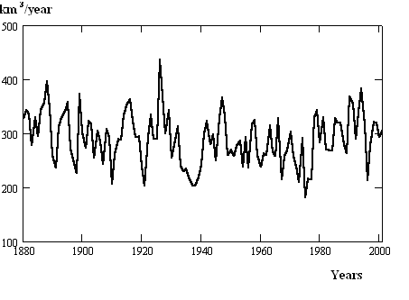
Figure 24. Summary river flow into the Caspian Sea during 1880-2001 [Frolov 2003].

Influence of anthropogenic factors on the water resources of the sea.
Solution of this problem is complicated by the fact that up today the hydrology so far is not supplied by the scientifically based recommendations for considering of the mankind activity influence as on the areas of the river flow (agricultural, forestry, irrigation), also on the drainage subsoil waters. The reason of that is complication of the problem, insufficient study of all the phenomena, heterogeneity and inadequate equivalence of available data, poor research of the whole complex of the studied factors.
Relatively thorough data about the anthropogenic influence on the rivers flow within the Caspian Sea basin is available for the period of 1940-1990. This time is characterized by the directed decrease of the sea level and significant influence on the rivers flow. Below, we will consider influence of the rivers input into the Caspian irretrievable losses, related to water reservoirs, ponds and irrigation.
Influence of the water reservoirs. Starting from the 30-es in the Caspian area there was constructed a number of reservoirs in order to regulate the rivers flow for transport, energetic and irrigation purposes. Influence of the hydro-engineering constructing on the water resources of the Caspian during the period of 1937-1969 could be understood by the works of Korenistov [1975] and Shiklomanov [1989]. Reduction of the rivers flow into the sea due to hydro-engineering contructing during the above period according to Korenistov is 201 km ³. As to Shiklomanov [1989] decrease of the Volga flow during the period of 1951-1990 comes to 63,7 km ³, what is considerably less that by Korenistov [1975].
Generalizing all the available data it could be said that the summary loss for evaporation from the reservoirs’ surface is approximately the following:1965- 100 km ³, 1970- 200 km ³, 1980- 350 km ³, 1990- 450 km ³. Summarizing these meanings with the whole volume of the Caspian basin reservoirs (185 km ³) we receive the amount of 635 km ³. That is the actual loss of the river flow related to the building up of reservoirs and its averaged annual amount comes to 11,5 km ³, what is equal approximately to 2,5 m of the water layer on the Caspian Sea surface.
Influence of ponds. The flow losses related to the ponds constructing are insignificant comparing to those of the water reservoirs. Ponds could be divided into two groups: 1) Ponds whose capacity is wholly used for economical reasons during the year; and 2) Pond with “the dead” capacity.
Water volume accumulated by ponds whose capacity is used in full could be included into accounting in a form of the annual losses. For ponds with the dead capacity the annually worked out portion is taken into account. For ponds fed by constant tributaries the annual outlay could exceed its volume. Water losses for the pond’s farming considering the return water came to 1965 to approximately 8 km ³, 1970- 20 kmз, 1980- 40 km ³, 1990- 60 km ³.
Influence of irrigation. Irrigation in the Caspian basin area is carried out as well in the arid part, as in regions with quite essential precipitation.
When counting the expenditure for irrigation, considered are only the areas actually irrigated, what makes up usually in average about 70% of the areas supplied with the irrigation system. It should be pointed that the catchment area is not changed proportionally to the increase of the irrigated areas. This statement is confirmed by the data on the irrigated soils and the summary water takeoff. For instance, despite the growth of irrigated areas, the water catchment in Azerbaidjan came to 4-5 km ³ in 1950, as well as in 1960.
It would be also wrong to suppose that the rivers flow into the Caspian will decrease by the amount of water, taken away for irrigation. Due to inadequate irrigative systems’ technique far from all the water taken away from the supply sources reaches the field. Irretrievable takeoff from the river flow for the agricultural purposes in the Volga-river basin makes up to 3 km ³ in a year. Takeoff from the rivers flow in the Kura-river and the Ural-river basins comes to 4,5 and 1 km ³ respectively.
According to quite approximate accounting total amount of irretrievable losses for irrigation in the Caspian basin made up to 1956-approximately 40 km ³, 1970- 100 km ³, 1980- 350 km ³ and 1990- appr. 450 km ³.
Calculations show that the summary irrevocable water losses in the Caspian basin due to irrigation made up in 1960- approximately 2,5 km ³, 1970- 40 km ³, 1980- 80 km ³, and in 190- 100 km ³.
During last years, beginning from the mid 80-es the development rates of irrigational and other activities has been reduced. Reasoning from this fact we could accept the data of 1980 for a year of 1990 with a certain fault. Summarizing that way, we obtain that without the anthropogenic influence on the river flow, the sea level in 1990 would be by 284,3 cm higher than the actually measured at that time. But theses estimations were done ignoring the accounting of the water return into the sea basin. According to approximate estimations the 30% of the ejected water comes back to the sea basin, what will reduce the above calculated value by approximately 1,0 m. This means that the sea level would be presently by 2 m higher than the actually measured (Figure 25).

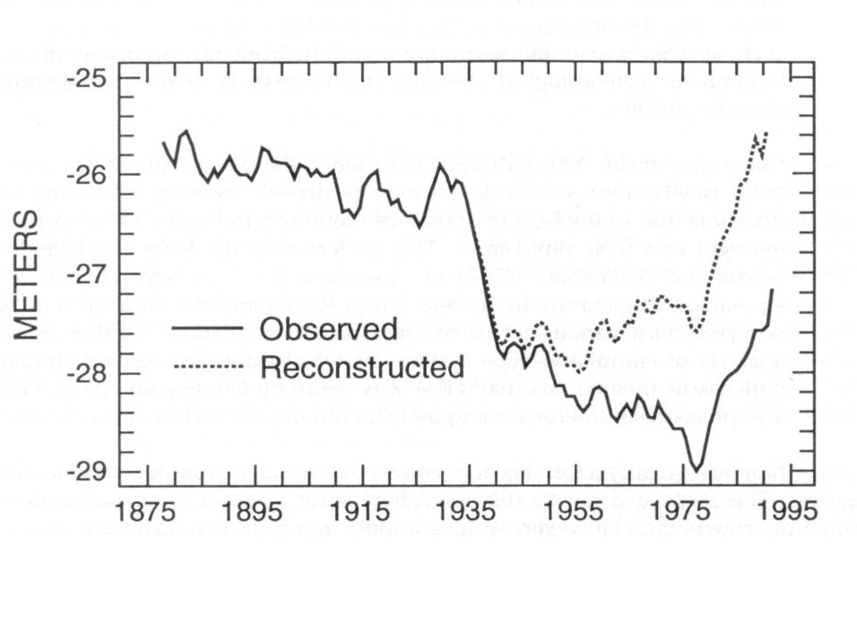
Figure 25. Observed and reconstructed the Caspian Sea level.

Influence of the oil products floods for evaporation. On the Caspian Sea there happen the oil outflows whose influence on evaporation should be also considered. Well known is the fact that the oil film in a first turn suppresses the short and sharp waves on a water surface. According experimental data and our model calculations, namely the short and sharp waves are responsible for intensification of the shallow waters evaporation. Therefore it should be definitely approved that intensification of evaporation will be totally suppressed and the value of evaporation would be understated. Answering the question of the oil outflows influence on evaporation and heat exchange of the whole water area is still open. For receiving of numerical estimations it is necessary on one hand to have complete information about the oil outflow, on the other- to be able to evaluate influence of the oil film on the general energy-mass exchange going on the boundary air-water.
To solve these problems the special experiments were carried out at the Caspian scientific-research station of the Geography Institute of The Azerbaijan Acad. of Science (Abakarov et. al.1983) and in laboratory (Panin, 1985).
Analysis of the received data illustrated that in evaporation basins the value of the temperature drop between the oiled water and the clear one depends on the oil film thickness. But this relation is not incontestable as the temperature excess also depends on the summary radiation, heat-exchange, evaporation and other factors. Excess of the temperature ∆T considerably depends on the time period gone since the oil outflow. Analysis of the available data shows that, depending on the time, the temperature excess ∆T increases during 4-5 days, and then it gradually reduces. Start of ∆T increase is connected with heterogeneity of the oil distribution on the water surface. At the beginning the oil-free sections of the water surface have a form of small round spots, which by course of time turn to the form of ellipse. Later, these ellipses are being stretched along the big axe and vanish. The oil film covers the whole water surface by continuous layer. This leads to the sharp evaporation reduce and the surface temperature increase. Following goes the ∆T decrease what is connected with the ageing of the oil film, which is partly evaporated, partly sediment. The process is finished by smoothing of the surface temperature of clear and polluted waters.
Results of the given experiments showed that the main reason of the water temperature increase by the polluted surface is the sharp decrease of the evaporation process intensity. Dependence of ΔЕ=Е_{В} - Е_{Н} (where Е_{В} and Е_{Н} - velocities of evaporation of the clear water and the oil-polluted water correspondingly) from ∆T =T_{Н}-T_{В}. has been analyzed Determined is that ΔЕ increases almost linearly in dependence on ∆T. By increasing of ∆T, ΔЕ is increased, by increasing thickness of d, Е_{Н} decreases and ∆T increases. Dependence of normalized meanings Е_{Н}/Е on the normalized time 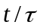 (Panin et al, 2005) evidence the certain universality of dependence of evaporation through the oil-products film on the film thickness and the time. Such dependence allows to evaluate the effect of the oil-products film influence on evaporation by condition of availability of information about its distribution around the water basin.
Systematical air photography of the Caspian Sea surface accomplished by the San-Petersburg division of GOIN illustrated that about 1500 km² of the sea surface is constantly covered by the oil film. Evidently this value is very small comparing to the total area of the Caspian Sea. But still this factor can not be ignored and its scale has a trend of growing.
Analyses accomplished by us in this area showed that if one of the anthropogenic factors (water diversion) considerably reduces the water income part of the Caspian Sea water balance, the other (influence of the oil film on evaporation)- though not significantly- enlarges it. Input of this effect is so far not precisely defined, - it could be only marked that it does not exceed a few percent.

2.2 Impacts on ecosystems (desertification, deforestation) and biodiversity.
At present, the rich living resources of the Caspian Sea appear to be under permanent decline. The origins of the observed environmental changes can often be traced back to natural and human factors of regional dimension [Glantz and Zonn, 1997]. The effects in some cases are far extending and linking the fate of the Caspian Sea with distant parts of the globe. Hydro-meteorological processes leading to erratic changes in sea-level link the Caspian Sea to global and regional climates.
The socio-economic situation of the region adds quite an urgency to the need for pooling of scarce resources together, and creating either fresh or sustained initiatives for developing appropriate strategic plans to counter the mounting environmental crisis. On the other hand, sustainable development of the region can only be achieved if management strategies relying on modern tools are put into effect. Modern observing systems serving monitoring and forecasting activities should supplement the current initiatives for rational management of the Caspian basin.
If taken in full consideration, these recommendations would have led to appropriate action to address and solve environmental problems of the Caspian Sea. Actually if society fails to address these questions in time with appropriate means, the problems will continue to increase and become more difficult to being solved. Human influence on the Caspian Sea appears to accelerate the degradation and increase the eventual feedbacks on society.
Abrupt changes in sea-level, responding to climatic fluctuations in hydrological regimes of the Caspian Seas have been recorded throughout the well known history. Attempts to forecast the sea level have consistently failed, because of a poor understanding of the water cycle in the extensive catchment basin. The desiccation of the neighboring Aral Sea represents the worst environmental decline that the earth has experienced in its recent history, driven by regional climate changes, as well as human influence. Yet, sea-level change is only an overall indicator that integrates a serial changes that affect not only the resources of these enclosed seas, but also the surrounding lands and people. There are large uncertainties with respect to regional global change response and interactions with the neighboring Euro-Mediterranean, Siberian, Indian Ocean, and Central Asian climates [Bengtsson 1998; Arpe and Roeckner, 1999, Arpe et al., 2000].
The least obvious and poorly understood mechanism that affects the Caspian Sea is the observed changes in the ventilation of its deep waters, which in its turn determines the biochemical regime [Kosarev and Yablonskaya, 1994; Dumont, 1998]. Recent analyses of the available data indicate dramatic changes in stratification and nutrient regimes in the periods before and after the sea level minimum in 1977. Vertical overturns induced by sea level associated buoyancy changes can shift the entire ecosystem to alternative states, as documented by historical data of insufficient length. Further investigations are necessary for the joint utilizing of observations and modeling.
Increased levels of nutrients arriving from a large catchment area threaten to irreversibly damage the already fragile ecosystem of the Caspian Sea and its entire mosaic of coastal wetlands through eutrophication processes. Fish and caviar production has been on the decline and some fish of economic value have already become extinct [Dumont, 1995]. The annual catch of commercial fish (excluding Sprat and fish caught in Iran) decreased to about 80,000 tons in the early 1990’s from the 400,000 tons reported in the 1930’s.
In general, the rate of loss of marine biodiversity has been very high in the last decades. Populations of the Caspian Seal, endemic to the region, have decreased from an estimated one million in the early 19th century, to about 300.000 in 1986, going only to decline further. In 1996-1997, weakening of the population resulted in mass mortality along the Azerbeijan coast [Eybatov, 1997].
The introduction of the comb jelly Mnemiopsis from Black Sea is a serious current problem that could greatly alter the Caspian ecosystem. Monitoring programs in Azerbaijan and Iran clearly show the zooplankton to be the worst affected component of the ecosystem (A. E. Kıdeyş, S. Bagheri, A. Roohi, unpublished data). The biodiversity of coastal zooplankton has decreased from about 40 species to only 6-10 species by 2001, also reflected on higher trophic levels. Pelagic landing figures indicate about 50 % reduction in Iran and Azerbaijan kilka catch [Kıdeyş et al. 2001a,b; Kıdeyş and Moghim, 2002], with similar values presented for Russian fishery. Lower pregnancy, higher mortality and consequent decrease in endemic Caspian Seal populations have been linked with these changes [Shiganova et al. 2001]. Unfortunately, recent data [Bagheri et al. 2002] suggest Mnemiopsis has not reached its maximum level in the Caspian Sea, implying further decreases in fish catches.
The most significant anthropogenic effects in the Caspian Sea are those related to the extraction of hydrocarbons, industry and agriculture. The loss of oil during normal extraction, refining and transport amounts to about 2% of the total volume, capable to pollute large areas. Oil fields have created virtual dead zones in the northern and eastern Caspian shelf zones. Further development of oil fields serving an estimated reserve of 10¹⁰ tons, compared to the presently exploited 2x10⁹ tons is expected to have much greater impacts on the ecosystem. However, the additional threat, considering the enclosed geometry of the sea, is the accidental release of oil that could be much larger in quantity, and create accumulative effects over long periods. Beaches and coastal ecosystems are stressed or destroyed. Oil in the sea is toxic to aquatic life, and directly affects habitants. Oil films disturb exchange processes at the sea surface, and therefore can affect air-sea interaction and transfer of gases.
River inputs, agricultural, industrial and municipal discharges, and risks of toxic and radioactive contamination originating from polluted lands as a result of sea-level rise are other sources of pollution. Sites with toxic and nuclear waste dumps along the coasts of the Caspian Sea can potentially be influenced by changes in sea level.
Various hydrological surveys have been carried out by the national agencies of riparian states, and in some cases organized by the Caspian Environment Program (CEP).

3. Adaptive measures to reduce the adverse effect of climate change on the ecosystems and the economy in the basin.
Environmental problems of the Caspian Sea and its coastal zone originate from the whole extensive economical development in littoral states. Long-term natural changes (like water level fluctuation and climate change) are making the background, and nowadays-critical socio-economical problems (like transition period, economic depression, conflicts, transnational companies intervention) are redoubling the tension.
Environmental impact on society could be conventionally devided into two groups – direct and indirect. Direct effects are presented, for instance, by the losses of biological resources that have a monetary value. Thus, the damages from sturgeon population degradation could be calculated as decrease in trade. This category may also include compensation costs (for example, hatcheries construction).
Indirect effects are presented by the ecosystem’s losses of self-purification abilities, balance disturbance and gradual transformation to a new state. The social impact is loss of landscapes aesthetic value, discomfort for people’s livelihood and so forth (which is designated by term “ecological services”). Furthermore, the chain of losses leads, as a rule, back to direct economic losses (tourist sector, etc.). In the last years marine environment contamination led, for example, to the repeated closing of beaches and recreation zones in a number of populated areas. The seals’ mass death in spring 2000 and insufficient and misleading information about the reasons for this phenomenon led to great financial losses in the tourist sector in all Caspian countries.
Most of the environmental damages are beyond economic calculations. Particularly, the absence of economical methods for evaluation of biodiversity and ecological services leads to the fact that the planning organs of the Caspian countries give preference to the development of the extractive industries and agro-industry instead of to bio-resource sustainable use, tourism and recreation. Following is a description of the major Caspian environmental problems.
- As it follows from above-stated, the technogenic threats and risks are not connected with the profit of each country, obtained from the Caspian bioresource. For instance, the current system of sturgeon quotas determination assumes the damage from oil extraction, power station building, poaching, river and sea pollution are equal for all countries. This does not correspond to the truth and does not stimulate efficient measures to correct the situation.
- Most damaging factors for the sea environmental and biological resources are the natural habitats’ degradation (including chemical pollution), excessive exploitation and the invasion of alien species. Mass diseases are the secondary factor by scale and by nature, caused by the three above named.
- Sea contamination is mostly caused by the quality of inflowing river water. A low rate of industrial and agricultural growth in the Volga basin assumes that the river water quality will not become worse, and short-time emergency discharges will be smoothed out by artificial reservoirs.
- Quite the contrary, sea pollution by oil extraction will increase in a few years, starting from Northern Caspian with gradual spreading to the Middle and Southern Caspian along the western shore. The only possible way to restrain this process is the legislative limitation of oil extraction. But this way which is highly improbable.
- The possibility of Caspian ecosystems’ restoration depends mostly on preconcerted actions of the Caspian states. Until now, there have been many “environmental” solutions and plans without any systems and criteria to monitor their results. Such situation creates advantages for all economic subjects acting by the Caspian Sea, including state owned, private and transnational corporations.

3.1 Review of measures already undertaken

To such measures could be related lists of the main observations carried out in the coastal countries, which could be used in preparing of the future adaptive actions.

- a review of the present environmental state of the Caspian Region, problems, their impacts and possible remedies (on the basis of the CEP TDA),
- identification and monitoring of the relative roles of natural variability and anthropogenic factors of change,
- identification and monitoring of the roles of nutrient and water fluxes, sedimentation, coastal processes, possible deep water overturns, eutrophication processes and invasive species such as ctenophore Mnemiopsis on the expected changes in the Caspian Sea ecosystem,
- evaluation of related databases on physical and biogeochemical variables and adverse human activities.

3.2 Recommendations of further measures
In the coastal Caspian countries a process of changing the marine and estuary systems located in those territories goes on, and that causes a threat for their steady development, human health and safety, as well as for the ability of marine ecosystems to maintaining the products and services.
Changes causing preoccupations are the growing dangers for the coastal habitants of the flooding, erosion, distribution of diseases, loss of dwellings, exhausting of the living resources, harmful blooming of algae, mass dying of marine mammals and birds.
As these changes and their causes and consequences often go beyond the limits of the national borders, adoption of the international agreements and conventions according to which the regular observations of the marine, coastal and terrain systems should be provided on local, regional and global scales, is necessary.
Establishment of the international observation system will allow to obtain the necessary data and information for receiving the possible reliable picture of the joint influence of both: the natural and anthropogenic processes at coastal, marine and estuary zones.
Data received by the international observation system will allow to evaluate the real state of the coastal marine and estuary systems, make the update prediction of the extreme weather effects, climate changes and human activities results, to develop (based on ecosystems) approaches to regulating and smoothing of the human activity and natural variability on the social-economical systems, what secures the health and wealth of the population.

The following science and technology components must be reviewed:
- Operational satellite derived data on physical climate variables (sea surface temperature, altimetry, coastline detection, surface wind and waves, sea ice, SAR, solar radiation and dust, land use patterns, desertification) and on ecosystem variables (ocean colour, chlorophyll and pigments, primary production, sedimentation) will be obtained and analyzed from new satellite images and relevant gridded digital data.
- In-situ near-real-time oceanographic and meteorological data will be obtained by a network of sea level gauges, river gauging stations, meteorological stations, vessels of opportunity, surface drifting buoys, profiling buoys and digitally transmitted for near real time acquisition.
- Other observational data will include monitoring stations (for assessing biodiversity of key components, temporal and spatial distribution of Mnemiopsis as well as other key species belonging to phyto, zooplankton), basin wide oceanographic surveys, coastal transects, environmental baseline surveys done by the oil companies. An attempt should be made to record macro-elements in situ (such as Mnemiopsis) by real-time video techniques.
- Contaminant data from various sources (rivers, industries, domestic wastes, atmosphere, etc.) based on archived and measurement station data are important to evaluate their role in adverse effects on the health of the Caspian Sea.
- Hardware and software for data collection, storage, processing and presentation (radio and satellite links, computers, distributed data bases, Internet, GIS).
- Modeling and data assimilation with physical near-real-time models (circulation model, storm surge model, ice models, air sea interaction, transport model, air pollution model) will be used to monitor and forecast the physical state of the Caspian Sea.
- Coupled physical, biological and chemical models (nutrient cycling, light utilization, plankton), fish population dynamics models, should be used for predicting the human made and natural effects on the biogeochemical cycles and production.
- Physical climate models (regional atmospheric circulation models, coupled ocean atmospheric models, Earth rotation models, dust transport models) will be used for forecasting the regional climate including the sea level and water cycles in the Caspian Sea Region.
- Techniques for biological control of invasive species (e.g. Mnemiopsis ) will be evaluated for restoration of the ecosystem.

Further measures will allow:
- define the data needs and methodologies to predict short term (storm surges) and long term (secular and inter-decadal) sea level changes in the Caspian Sea and their socio- economic impacts on the coastal region, oil and gas platforms,
- describe the necessary data and methodologies to preserve and restore the Caspian Sea eco-system, including its biodiversity and endemic species,
- recommend a system that will provide the most economically efficient way to obtain and distribute data and data products to meet a wide range of objectives without duplication of the observations,
- recommend appropriate modeling and forecasting programs developed already by the Caspian coastal states,
- develop the information basis for balanced exploitation of marine resources.

3.3 Proposals on management solutions with respect to uncertainty of Caspian water level fluctuation

There are quite few proposals for solution of the management of the Caspian Sea level fluctuations and all of those are based on stabilization or change of the sea water balance components. Regulation of evaporation and the atmosphere precipitation over large water areas appears so far to be not possible (excluding parts of shallow water), therefore decision of the problem seems likely to be solvable by regulation of the river flow and the flow into the Kara-Bogaz-Gol bay. The river flow is already mostly regulated. Thus, presently resolution of the management problem of the Caspian Sea water level fluctuations could be decided by cutting off the shallow waters and regulating of the flow into the Kara-Bogaz-Gol.
We could present some valuations.
Cutting of the sea shallow waters. According to one version cutting off the North Caspian shallow waters dependence of the sea surface area on its level comes to the look (linear form of the sea surface area dependence on the level is suggested):

F=a+bh, (8)

where a= 286.000 km², b= 2.000 km²/m, level h is measured relatively to the mark- 28,5 m. [Ratkowich, 1976]. Supposed that parameters of the constraining process are not changed then relation of the Caspian level dispersion after cutting off the shallow waters to the corresponding dispersion prior to the cutting, according to results of Frolov [1985] is equal to:

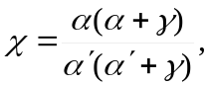 (9)

where = 0.03, 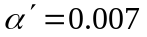- inertial parameters of the Caspian Sea before and after the shallow waters cutting. In other words, the Caspian level dispersion increases approximately by 4.5 times.
Increase of the fluctuations level dispersion by the significant change of the sea morphometrical characteristics should be considered, for instance, when constructing dams, protecting the economical objects from the sea flooding. Thus, the length of dams protecting the Tengiz oil and gas deposit field from the sea flooding comes to the amount of approximately 150 km, the coastal area cutoff by this dam could be approximately estimated as 1000-1500 km². Change of morphometric characteristics of the sea caused by the cutting off the coastal lands of low inclination, as well as cutting off the shallow waters, brings to the increase of the coasts’ slope grades and consequently to the dispersion increase of the water level fluctuations in the sea.
At least, theoretically, under some conditions the effectiveness of the coast-protecting objects constructing could become absolutely abolished.
Growth of the sea fluctuations dispersion by the significant change of the sea morphological characteristics should be also considered for accomplishing of the probabilistic accounting of the long-term level regime for a perspective.
Expected in the nearest decades increase of the atmosphere temperature according to interpreting of a number of specialists will bring to a change of the present relationship between the elements of the Caspian Sea water balance. Supposing the possibility of adjustment of the climate quasi-stationarity hypothesis (i.e. its relative stability for temporal intervals of few years’ decades), we could try to estimate parameters of the Caspian Sea level regime with reference to new climatic conditions.
Velichko et. al. [1988] came to conclusion that increase of the average atmosphere temperature by 1°C will bring to forming climatic conditions in the area of the Caspian Sea similar to those of the Holocene optimum. Researchers received estimations of average magnitudes of the Caspian water balance components as applied to these conditions and the corresponding average level of the sea. Regarding the fact that under condition of one and the same average sea level its long-term fluctuation regime might be considerably different as to its deviation range, burst characteristics and so on, it seems quite helpful to receive estimations of those characteristics for the expected conditions. Evaluations accomplished by A.V.Frolov [2003] based on the data of Velichko et. al. [1988] showed that according to climatic conditions similar to the period of the Holocene optimum the inter-annual fluctuations should be characterized by dispersion increased by about 20 % as compared to the present regime.

Regulating role of the flow coming into the Kara-Bogaz-Gol bay. Dependence of the water flow-out from the Caspian Sea to the Kara-Bogaz-Gol bay on the sea level is precisely looking nonlinear. But when the sea level deviates lightly this dependence could be used in a linear form. Golitsyn and Panin [1989] suggested the empirical dependence:

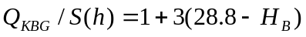, (10)

where Q_{KBG}/S(h) - annual flow-off from sea into the bay in cm., H_{B} - average sea level as the Baku tide-gauge in m.

As it is known the Kara-Bogaz-Gol stait was blocked by the dead dam in 1980, what resulted in the absolute stopping of the sea water flow into the bay and brought to its intense drying. Up to the year of 1984 the bay’s area of 9,5 thousand km.² decreased up to the 0,3-0,4 thousand km.². In September 1984 the regulated structure with the projected channel capacity of 66 m³/s. has been switched into operation. During 1980-1986 about 70 kmз of the water flow-out into the bay was kept and that is 18,5 cm of the height [Golitsyn and Panin, 1989].
In June 1992 the dead dam has been ruined and beginning with summer 1993 the average amount of the water flow by the bay comes to 940 m³/s what considerably stabilizes the sea level fluctuations. Destroying a dam, connecting the sea and the bay exerted quite considerable damping influence on the present rise, what should be definitely considered as a positive effect. One should mind that saving a present state of flow off into a bay provides conditions for lowing of the Caspian level even concerning the full water sea balance.
It also seems quite interesting to estimate the influence of one or another regime of flow off to the bay on the Caspian level during the period of its raise, e.g. 1978-1997. Figure 26 gives the level graphs showing different regimes of flow off into the bay [Frolov 2003].

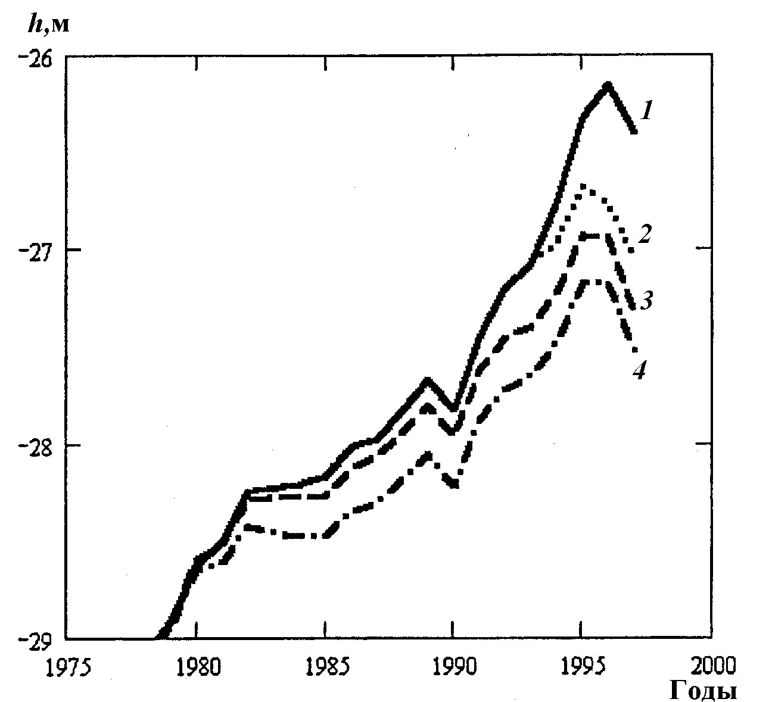

Figure 26. Fluctuations of the Caspian Sea level during the period 1978-1997, 1 - under absence of the flow off into the Kara-Bogaz-Gol, 2 - observed level marks, 3 - by the regime of the flow off during 1946-1980, 4 - by the flow regime supposedly being formed after the dam’s destroy.

From the Figure 26 it follows - first: evident effectiveness of renewal of the flow off relatively to the rise of the sea level- by the cut of bay the rise would have been by about 0,5 m more than the observed one. Regarding the fact that economic losses exponentially depend on the level [Ragozin 1996] it could be supposed that breaking of the dam in the Kara-Bogaz-Gol bay allowed the Caspian countries to avoid additional losses to as a minimum hundreds of billion dollars. Second: considerable difference between the curves 2 and 4 directly points to the increase of the flowing off into the bay regulating function after the strait’s washout.
The given results allow to return back to the idea of building up the regulating structure in the strait, connecting the sea and the Kara-Bogaz-Gol bay. Supposedly such a structure could satisfy the interests of all the Caspian countries, as it would permit (according the observations) to make effective regulating influence on the Caspian Sea level fluctuations.

4. General summary and conclusion

It looks quite sure that nowadays the Caspian region and first of all the sea itself go through serious trials. That displays the degradation of the environmental ecology, decline in human health and life conditions, decrease of the certain commercial fish types population including sturgeon, reduction of the sea biodiversity. Ecological problems of the Caspian Sea and its coasts come out to be a consequence of the whole history of the extensive economic development of the region’s countries. The situation is worsened by the long-term natural changes (secular variations of the sea level, climate change) as well as by the social-economic problems of present days (economical crises, regional conflicts, growth of the oil production). Destruction of the coastal landscapes and infrastructures caused by the present sea level changes brought to additional pollution of the water medium by the oil petrochemicals.
But still the top-priority question is understanding of the sea level changes causes and possibility of its long-term fluctuations prediction. Fluctuations of the Caspian Sea level, in its turn, are also a point of interest as an index of a regional climate change, which is connected with its global change. The report evidently demonstrates that present changes of the Caspian Sea level are caused by certain variance of the water balance components and mainly by the river runoff and visible evaporation. That is, to our opinion, the point for the choice of method of the long-term Caspian fluctuations prediction. Our analysis of a wide spectrum of publications on the subject of the sea level fluctuations made it possible to specify two main groups of methods.
1). First group of forecasting combines stochastic and dynamically-stochastic models, the essence of which is the probable description of the sea level fluctuations based on understanding of generating climatic and hydrological factors as the stochastic processes. Stochastic water body model is usually considered as mathematical model of the water level fluctuations in a reservoir interpreted as a hydrological system with two income processes: river inflow and visible evaporation from the water surface. Modeling of those characteristics rows allows to study the sea level variability in natural conditions of the hydrological regime forming as well as under its different irregularities.
Stochastic character of the long-term fluctuations of the sea water balance components presumes only probabilistic estimation of the sea level regime parameters for perspective, and these estimations should be considered as tentative.
Presented considerations reinforce the need for study of a few scenarios of the perspective Caspian Sea water balance and corresponding estimations of the sea level fluctuations parameters. Calculations [Golitsyn et al., 1998] demonstrate that by 2010 year the level fluctuations will most probably happen with the interval -27 -25 m. It should be thought realized that such a scenario has an extreme character and, if in the nearest time there will be no confirmation of considerable climate change in the Caspian Sea basin, there is quite a probability of turning to another variant, based on hypothesis of absence of noticeable climate change during the accounted period. In this case reduction of the sea level is very likely to happen even in the nearest years. Even for the full-water scenario of the Caspian water balance it looks very unlikely that the sea level will exceed the mark of -25 m. during the nearest decades.
Results of the Caspian level regime calculation for the long-term perspective (20-30 years) should be reconsidered regarding the actual situation and trend of the sea level change and climate parameters determining the sea water balance formation and also the consequences of anthropogenic activity around the sea basin. By that, prediction of the level fluctuations turns out to adaptive character considering actual and defined perspective changes of the natural and anthropogenic processes forming the level regime.

2). Principally new ways for the long-term Caspian level change forecasting become possible with the use of the big climatic models, which are being actively developed during the last decade due to solving of problem of the global and regional climate changes. This way modeling of the Caspian level fluctuation changes of a regional Caspian basin climate are considered according to the global climate change.
In numerical experiments of the general atmospheric circulation models a proper reproduction of the water balance (catchment areas of the Volga, Ural-Siberian and the Far East rivers) components is already achieved.
Global modeling studies of the Caspian Sea level (CSL) response to climatic forcings are reported by Mokhov et al. [2003], Arpe et al. [2000], Arpe and Roeckner [1999], and Golitsyn et al. [1995]. Golitsyn et al. [1995] evaluated the performance of thirteen General Circulation Models (GCMs) participating in the Atmospheric Model Intercomparison Project (AMIP) in simulating the water balance of the Caspian Sea basin for the period 1979–88. They found that, although all models overestimated the changes in CSL, the higher resolution ones performed better and were able to simulate the seasonal hydrological cycle of the basin and the steady rise in the CSL during the analysis period. Golitsyn et al. [1995] concluded that the accurate simulation of the net water balance over the Caspian Sea basin critically depends on the resolution of the GCM and on the proper representation of the sea surface and sea basin physiographic in the model.
Using results from future GHG scenario experiments performed with the MPI-ECHAM4 AOGCM, Arpe and Roeckner [1999] analyzed changes in the hydrological cycle over several basins, including the Caspian Sea’s. They estimated a rise in CSL because of increased runoff from the Volga basin resulting from a change in the winter circulation bringing more precipitation over the region. Similarly, using 21st century simulations from global climate models, Mokhov et al. [2003] found increases in winter precipitation over northern Eurasia including the Volga and Caspian basins.
Here we present a new analysis of the climate and hydrologic budget of the Caspian Sea basin simulated by a sub-set of the latest global climate change simulations performed by modeling groups worldwide as a contribution to the fourth assessment report of the Intergovernmental Panel on Climate Change (IPCC). The purpose of Elguindi and Giorgi [2005, 2006] is to assess possible changes in CSL for the XXI-st century under different greenhouse gas (GHG) emission scenarios (the IPCC A1b and A2).
The majority of models predict a steady decreasing trend in the CSL under both scenarios, with no period of stabilization or recovery. Only two models predict an increase in the sea level, the CNRM-CM3 (A2 and A1b) and the CSIRO-MK3 (A2 only). The largest decrease in CSL by the end of the XXI-st century is simulated by the MIROC3 model. This large CSL response is due to a large increase in evaporation over the basin.
The forecasted CSL drop of Elguindi and Giorgi [2006] found in study is contrary to what has been previously by Arpe and Roeckner [1999]. This is mainly because the increase in evaporation over the sea was not previously accounted.
Environmental problems of the Caspian Sea and its coastal zone originate from the whole extensive economical development in littoral states. Long-term natural changes (like water level fluctuation and climate change) are making the background, and nowadays-critical socio-economical problems (like transition period, economic depression, conflicts, transnational companies intervention) are redoubling the tension.
Environmental impact on society could be conventionally broken down into two groups – direct and indirect. Direct effects are presented, for instance, by the losses of biological resources that have a monetary value. Thus, the damages from sturgeon population degradation could be calculated as decrease in trade. This category may also include compensation costs (for example, hatcheries construction).
Indirect effects are presented by the ecosystem’s losses of self-purification abilities, balance disturbance and gradual transformation to a new state. The social impact is loss of landscapes aesthetic value, discomfort for people’s livelihood and so forth (which is designated by term “ecological services”). Furthermore, the chain of losses leads, as a rule, back to direct economic losses (tourist sector, etc.).
The report also shows that main ecological problems of present days the Caspian Sea region are connected with pollution of the water and air media including also “biological pollution” in a form of new invaders into the sea. From all types of pollutants the most global and probably most inconvertible is immigration (purposeful or accidental) of a new animal and plant species. Main concern is caused by appearance of a new ctenophore “Mnemiopsis” and what worries even more is a wish of some specialists to suppress this invader with the help of some new introductions. In spite of actuality of ecological problems in certain regions of the Caspian Sea, the basin as a whole still stays yet rather clean. Now it is quite a time to make responsible decisions and actions for the Caspian ecosystems protection from irrational use and direct or indirect destruction as a result of a human activity. We like to hope that the Caspian countries, instead of the burdensome development of the extractive industries, will eventually turn over to sustainable development of the Caspian region and, in the first turn,- the Caspian Sea.
The main result of the social-economic analysis of the Caspian countries is a significant poverty and unemployment of the native rural population. Oil-gas exploitation turning out to be the most important industry in all the five states is still almost not privatized and its benefits are totally concentrated in hands of the authorities.
Most of the environmental damages are beyond economic calculations. Particularly, the absence of methods of economic evaluation of biodiversity and ecological services leads to the fact that the planning organs of the Caspian countries give preference to the development of the extractive industries and agro-industry instead of the bio-resource sustainable use, tourism and recreation.
Solution of many problems of the Caspian Sea often goes beyond the national borders, therefore it is necessary to base international agreements and conventions aimed to carry out regular observations on the marine, coastal and terrain systems on the local, regional and global scales. Creation of the international observation system will allow to collect the necessary data and information to illustrate reliably the joint influence of natural and anthropogenic processes in coastal, marine and estuary zones.
Now it is quite a time to make responsible decisions and actions for the Caspian ecosystems protection from irrational use and direct or indirect destruction as a result of a human activity. We like to hope that the Caspian countries, instead of the burdensome development of the extractive industries, will eventually turn over to sustainable development of the Caspian region and, in the first turn - the Caspian Sea.

Tasks of the Caspian Sea level prediction.
1. Note here, that the estimates of possible climate changes in the current century made with the use of numerical models of general atmospheric and oceanic circulation, which yield only a linear or logarithmic dependence between changes in air temperature and the concentrations of greenhouse gases in the atmosphere can be essentially modified if the formation mechanism of climate changes connected with the Earth rotation (rotation mechanism) will be accounted for in the new models.
Most sensitive to the rotation disturbances are zones of moderate and high latitudes in winter.
Composition of “the greenhouse“ and “the rotation” effects looks adequate for description of the climate system present regime. During 1910-1940 there was marked the Earth rotation acceleration, the greenhouse and rotation effects were one-way directed, the NSAT increase was observed. During the second half of the 1940-ies up to mid 1970-ies the slowing down of the Earth rotation has been marked, the CO- effect was compensated by the rotation effect, what brought to the noticeable reduce of the temperature growth in the Southern Hemisphere, to some cooling in the Northern Hemisphere and the absence of trend in changing of the globally averaged temperature. During the last three decades and till now the growth of the greenhouse gases concentration and acceleration of the Earth rotation affect the climate system in the same direction. Growth of the air temperature at the underlying surface becomes more intense. Correspondingly the other climate characteristics are being changed. Anomality indices and the climate extremity are growing. Difference of the course of the temperature averaged by hemispheres and the global one are explained by relationship of the areas covered by seas, lands and snows, determining values of the underlying surface albedo, planetary albedo and the effective radiation.
Variability of the Earth rotation angular velocity’s irregularity is correcting the obtained estimations by the following way. In the first half of XXI (appr.2010-2045) the rotation factor will compensate the greenhouse effect. Therefore the air temperature growth till the middle of the 2040-ies will come to 0,7 C (- 0,3 C- rotational component, + 1,0 C- greenhouse component). During the following approximately 35 years (2045- beginning 2080-ies) the disturbance effect of both factors will be similarly directed. As a result the global near-land temperature will increase approximately by 1,1 C (+0,3 C- rotation component, 0,8 C- greenhouse component). Summary growth of the globally-averaged near-land temperature will come to approximately 2,1 C. At that the growth of anomality and climate extremity will be observed. During the following more than three decades (after 2080-ies) the air temperature growth will slow down again.
Represented estimations are only preliminary. But they show that calculations of possible climate changes in the current century with the use of numeric models of the general atmosphere and ocean circulation, which gives the linear or logarithmic dependence between the air temperature changes and changes of the greenhouse gases concentration in atmosphere, could be considerably corrected by accounting the Earth rotation angular velocity irregularity.
It is evident that the joint use of the greenhouse and rotation components for prediction of the Caspian Sea level changes in the XXI-st century should produce new, more realistic results. This work is still to be done but some preliminary evaluations are possible. During the first half of XXI (appr. 2045) the rotation factor will compensate the greenhouse effect. Therefore, growth of the water level is rather unlikely before the middle of the XXI-st century. During the next approximately 35 years (2045- till beginning of 2080-ies) the disturbance effect of both factors will be similarly oriented and in this period the new rise of the water level even more significant than during 1977-1996 could be expected.
The given results illustrate that use of climatic models with combination of the greenhouse and the rotation effects opens new possibilities for estimation of regional components of the Caspian water balance and, correspondently, for obtaining prediction of the sea level fluctuation estimations. This approach to the problem of the Caspian level changes prediction is rather laborious method though quite promising.

2. The task of the magnitude specification of all the shallow sea aquatoria looks not the less important.
Evaporation over the sea is a very important component of the basin water budget [Panin, 1987, Golitysn, 1995], and for the ensemble average it comprises over 40% of the total evaporation-transpiration contribution to CSL change. Differences in how evaporation is parameterized in the models can have a significant effect on projected changes in the CSL.
An overview of the methods for calculation of evaporation and the heat/energy exchange has demonstrated that the state-of-the-art models of the heat and mass exchange between a basin and the atmosphere do not take into account the small-scale interaction between the shallows and the atmosphere. The point is that waves in shallow water are steeper, than in the open and deep-water parts of the sea, and break earlier (at lower wind speeds). These peculiarities must lead to an increase in the aerodynamic roughness of the water surface and, consequently, to a more intense turbulent exchange of momentum, heat, and moisture.
It is possibly due to these conditions that the Kara-Bogaz Gol, after it became isolated from the Caspian in 1980, was drying up almost twice more rapidly than expected. The overview has also shown that a reliable method for estimation of the evaporation and heat exchange of shallow lakes and coastal areas does not exist so far.
For proper evaluation of the shallow waters` effect, we should have statistical information on the wind velocity changes and on the shallow waters` areas, as well as their depth. All this points out that the most of attention in new projects should be focused on research of evaporation from the Caspian Sea surface.

3. Along with that it is still advisable to continue works on agreement of the observational data of the sea surface level fluctuations accomplished by remote, as well as by the ground-based measurements. Not the last place should be also taken by agreement of the observational data of the sea level in different countries and at different stations. Data given on Fig.27 demonstrate that differences of such measurements could exceed 0,5 m.

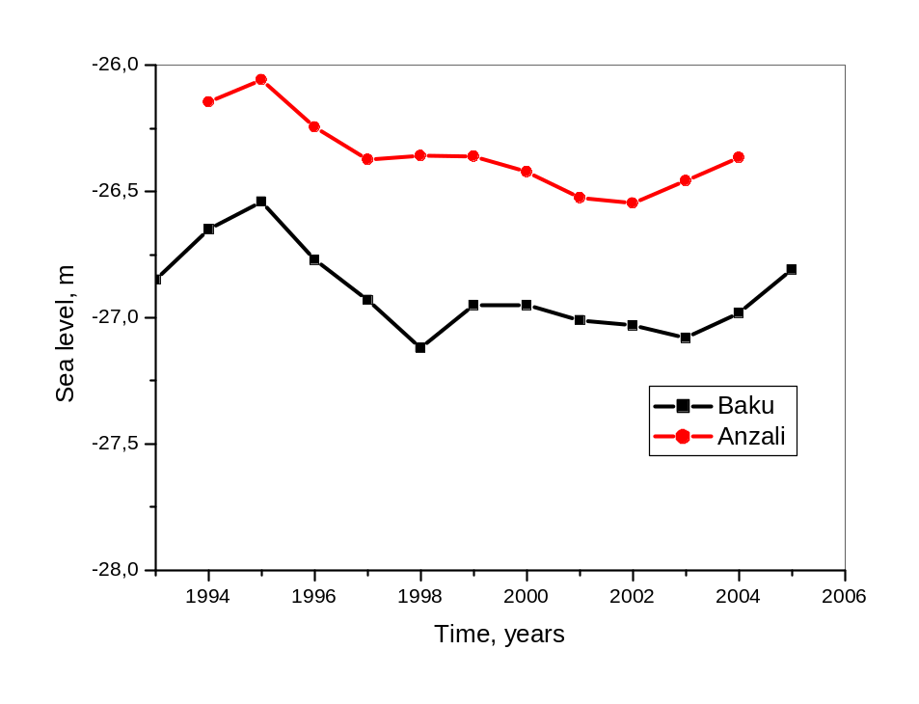
Figure 27 Annual levels of the Caspian Sea measured in the Baku and Anzali post.

4. Not less important task - to estimate influence of the water salinity on intensity of evaporation. This task is especially actual for reservoirs which salinity varies in time (for example, salinity of Aral Sea for last decades has grown more than ten times).

Adaptation measures
From the past experience of the thirties, a significant change in the Caspian Sea level as projected by these current state-of-art AOGCMs can be potentially devastating socio-economically and environmentally for the surrounding region. Keeping in mind the uncertainties related to the simulation of climate change at the regional scale, our results do indicate that the Caspian Sea basin may be particularly vulnerable to anthropogenically induced climatic change if no adaptation measures are taken.
There are quite few proposals for solution of the management of the Caspian Sea level fluctuations and all of those are based on stabilization or change of the sea water balance components. Regulation of evaporation and the atmosphere precipitation over large water areas appears so far to be not possible (excluding parts of shallow water), therefore decision of the problem seems likely to be solvable by regulation of the river flow and the flow into the Kara-Bogaz-Gol bay. The river flow is already mostly regulated. Thus, presently resolution of the management problem of the Caspian Sea water level fluctuations could be decided by cutting off the shallow waters and regulating of the flow into the Kara-Bogaz-Gol. Will represent some evaluations.
Cutting of the sea shallow waters. Supposed that parameters of the constraining process are not changed, then relation of the Caspian level dispersion after cutting off the shallow waters to the corresponding dispersion prior to the cutting, according to results of Frolov [1985] increases approximately in 4 - 5 times.
Increase of the fluctuations level dispersion by the significant change of the sea morphometrical characteristics should be considered, for instance, when constructing dams, protecting the economical objects from the sea flooding. Change of morphometric characteristics of the sea caused by the cutting off the coastal lands of low inclination, as well as cutting off the shallow waters, brings to the increase of the coasts’ slope grades and consequently to the dispersion increase of the water level fluctuations in the sea.
At least, theoretically, under some conditions the effectiveness of the coast-protecting objects constructing could become absolutely abolished.
Growth of the sea fluctuations dispersion by the significant change of the sea morphological characteristics should be also considered for accomplishing of the probabilistic accounting of the long-term level regime for a perspective.
Regulating role of the flow coming into the Kara-Bogaz-Gol bay. Dependence of the water flow-out from the Caspian Sea to the Kara-Bogaz-Gol bay on the sea level is precisely looking nonlinear. But when the sea level deviates lightly this dependence could be used in a linear form. Golitsyn and Panin [1989] suggested the empirical dependence:, where Q_{KBG}/S(h) - annual flow-off from sea into the bay in cm., H_{B} - average sea level as the Baku tide-gauge in m.
It also seems quite interesting to estimate the influence of one or another regime of flow off to the bay on the Caspian level during the period of its raise, e.g. 1978-1997. Frolov [2003] gives the level graphs showing different regimes of flow off into the bay. From the [Frolov 2003] it follows - first: evident effectiveness of renewal of the flow off relatively to the rise of the sea level- by the cut bay the rise would have been by about 0,5 m more than the observed. Regarding the fact that economic losses exponentially depend on the level [Ragozin 1996] it could be supposed that breaking of the dam in the Kara-Bogaz-Gol bay allowed the Caspian countries to avoid additional losses. Second: shows to the increase of the flowing off into the bay regulating function after the strait’s washout.
The given results allow to be back to the idea of building up the regulating structure in the strait, connecting the sea and the Kara-Bogaz-Gol bay. Supposedly such a structure could satisfy the interests of all the Caspian countries, as it would permit (according the observations) to make effective regulating influence on the Caspian Sea level fluctuations.

5. References
Adam, J. C., and D. P. Lettenmaier (2003), Adjustment of global gridded precipitation for systematic bias, J. Geophys. Res., 108(D9), 4257, doi:10.1029/2002JD002499.
Antonevich, V.D. and Litvyakova, L.A., Specific Features of Time Series of Wind Speed, Tr. Gl. Geofiz. Obs. im. A.I. Voeikova, 1979, no. 425, pp. 42--46.
Arpe, K. and E. Roeckner (1999). Simulation of the hydrological cycle over Europe: Model validation and impacts of increasing greenhouse gases, Advances in Water Resources, 23, 105-119.
Arpe, K., L. Bengtsson, G. S. Golitsyn, I. I. Mokhov, V. A. Semenov and P. V. Sporyshev (2000). Connection between Caspian Sea level Variability and ENSO, Geophys. Res. Lett., 27, 2693-2696.
Bagheri S., J. Sabkara and A. E. Kıdeyş (2002). Mnemiopsis dynamics in the Guilan region of Iran (southern Caspian Sea) in 2001-2002. First National Mnemiopsis Meeting. Sari, Iran, 19-20 June 2002.
Barnston, A. G., and R. E. Livezey (1987), Classification, seasonality and persistence of low-frequency atmospheric circulation patterns, Mon. Weather Rev., 115, 1083– 1126.
Bartzokas, A., L. C. Lolis, and D. A. Metaxas (2003), The 850 hPa relative vorticity centers of action for winter precipitation in the Greek area, Int. J. Climatol., 23, 813– 828.
Bengtsson, L. (1998), Climate modelling and prediction, Achievements and challenges, WMO/IOC/ICSU Conference On The WCRP Climate Variability And Predictability Study (CLIVAR), UNESCO, Paris, 2-4 December 1998.
Brunetti, M., M. Maugeri, and T. Nanni (2002), Atmospheric circulation and precipitation in Italy for the last 50 years, Int. J. Climatol., 22, 1455–1471.
Budyko, M.I., N. A. Efimova, V. V. Lobanov (1988) Future Level of the Caspian Sea, Meteorol. Gidrol., N. 5, 86-94.
Budyko M.I., Byutner, E.K., Vinnikov K.Ya et al., Anthropogenic Changes in Global Climate, Meteorol. Gidrol., 1981, no. 8, pp. 5--14.
Coppola, E., and F. Giorgi (2005), Climate change in tropical regions from high resolution time slice AGCM experiments, Q. J. R. Meteorol. Soc., 131, 3123– 3145.
Corte-Real, J., B. Qian, and H. Xu (1998), Regional climate change in Portugal: Precipitation variability associated with large-scale atmospheric circulation, Int. J. Climatol., 18, 619–635.
Dumont, H.J. (1995). Ecocide in the Caspian Sea. Nature, 377, 673-674.
Dumont, H. J. (1998). The Caspian lake: History, Biota, Structure and Function, Limnol. Oceanogr., 43, 44-52.
Dzuba, A.V. and Klige, R.K., Present-Day Variations in Surface-Water Temperature, Ice Conditions, and the Level of the World Ocean, in Kolebaniya urovnya morya. Rezul'taty issledovanii po mezhdunarodnym geofizicheskim proektam (Sea Level Variations. Results of Studies in International Geophysical Projects), Moscow: Radio i Svyaz', 1982, pp. 102-107.
Dzuba, A.V., Osipov, A.G., and Panin, G.N., Regularities in the Time and Space Variations in Hydrometeorological Characteristics that Control Heat Exchange between the Caspian Sea and the Atmosphere, Vodn. Resur., 1990, N 5, pp. 17-32.
Dymnikov, V.P., Volodin, E.M., Galin, V.Ya., et al., Sensitivity of Climate System to Small External Impacts, Meteorol. Gidrol., 2004, N 4, pp. 77-92.
Elguindi, N., and F. Giorgi (2006), Projected changes in the Caspian Sea level for the 21st century based on the latest AOGCM simulations, Geoph. Res. Letter, V. 33, L08706.
Eybatov T. M. (1997). Caspian Seal Mortality in Azerbaijan. In: Studies on the Present Status of Marine Biological Resources of the Caspian Sea, Bioresources Network Meeting, Bordeaux, November 1997 (eds. H. Dumont, S. Wilson, B. Wazniewicz), pp 95-100.
Eshel, G., and B. F. Farrell (2000), Mechanisms of eastern Mediterranean rainfall variability, J. Atmos. Sci., 57, 339–351.
Hurrell, J. W. (1995), Decadal trends in the North Atlantic Oscillation: Regional temperatures and precipitation, Science, 269, 676– 679.
Josey, S. A. (2003), Changes in the heat and freshwater forcing of the eastern Mediterranean and their influence on deep water formation, J. Geophys. Res., 108(C7), 3237, doi:10.1029/2003JC001778.
Glantz, M. H. and I. S. Zonn (1997). The Scientific, Environmental and Political Issues in the Circum-Caspian Region, NATO ASI Series, 2, Environment - vol. 29, Kluwer Academic Publishers, Dordrecht.
Golitysn, G. (1995), The Caspian sea level as a problem of diagnosis and prognosis of the regional climate change, Izv. Russ. Acad. Sci. Atmos. Oceanic Phys., 31, 366– 372.
Golitsyn G.S., G. N. Panin (1989): On Water Balance and the Present Variations in the Caspian Sea Level, Meteorol. Gidrol., 1989, N. 1, 57-64.
Golitsyn, G., V. Meleshko, A. Meshcherskaya, I. Mokhov, T. Pavlova, V. Galin, and A. Senatorsky (1995), GCM simulation of water balance over Caspian Sea and its watershed, in Proceedings of the first International AMIP Scientific Conference, WMO/TD 732, pp. 15– 19, World Meteorol. Org., Geneva.
Golitsyn, G.S., Dzyuba, A.V., Osipov A.T., and Panin G.N., Regional Climate Changes and Their Manifestations in the Current Rise in the Caspian Sea Level, Dokl. Akad. Nauk SSSR, 1990, vol. 313, no. 5, pp. 1224--1227.
Golitsyn, G.S., Efimova, L.K., Mokhov, I.I., et al., Long-Period Changes in the Regime of Temperature and Precipitation in St. Petersburg Based on Empirical Data and Model Estimates of Regional Changes in the Past and the Future, Meteorol. Gidrol., 2004, N8, pp. 5-17.
Golitsyn, G.S., D.Ya. Ratkovich, M. I. Fortus, A. V. Frolov (1998): On the Present Rise in the Caspian Sea Level, Vodn. Resur., 1998, vol. 25, N. 2, 133-145.
Gruza, G.V. and Ran'kova, E.Ya., Identification of Climate Changes: The State, Variations, and Extreme Character of Climate, Meteorol. Gidrol., 2004, N4, pp. 50-66.
Ibrayev, R. A., E. Özsoy, A. S. Sarkisyan, C. Schrum and H. I. Sur (1999). Three-dimensional Circulation and Ice Modelling of the Caspian Sea: Sensitivity of Deep Water Ventilation to Climatic Changes, MEDCOAST-EMECS Joint Conference, Antalya, Turkey, November, 1999.
Ibraev, R. A., E. Özsoy, A. S. Sarkisyan and H. İ. Sur (2000). Seasonal Variability of the Caspian Sea Dynamics: Barotropic Motions Driven by Climatic Wind Stress and River Discharge, in: Oceanic Fronts and Related Phenomena}, Proceedings of the Konstantin Fedorov International Memorial Symposium, St. Petersburg, International Oceanographic Commission Workshop Report No. 159, UNESCO, pp. 212-217.
Ibrayev, R. A., E. Özsoy, A. S. Sarkisyan and H. I. Sur (2001). Seasonal Variability of the Caspian Sea Circulation Driven by Climatic Wind Stress and River Discharge (submitted to J. Phys. Oceanogr.).
Kıdeyş, A. E., S. Ghasemi, D. Ghninejad, A. Roohi and S, Bagheri (2001a). Strategy for Combatting Mnemiopsis in the Caspian Waters of Iran. A report prepared for the Caspian Environment Programme, Baku, Azerbaijan, Final Report, July 2001.
Kıdeyş, A. E., F. M. Jafarov, Z. Kuliyev and T. Zarbalieva (2001b). Monitoring Mnemiopsis in the Caspian Waters of Azerbaijan. A report prepared for the Caspian Environment Programme, Baku, Azerbaijan, Final Report, August 2001.
Kıdeyş, A. E. and M. Moghim (2002). Distribution of the Alien Ctenophore Mnemiopsis leidyi in the Caspian Sea in August 2001. Marine Biology (accepted).
Kondrat'ev, K.Ya., Uncertainties in Observational Data and Numerical Modeling of Climate, Meteorol. Gidrol., 2004, N 4, pp. 93-119.
Luts, N.V., Long-Term Variations in Wind Speed in the Area East of the Sea of Azov, Meteorol. Gidrol., 2001, N 2, pp. 98-102.
Kosarev, A. N. and E. A. Yablonskaya (1994). The Caspian Sea, Backhuys Publishers, Haague, 259 pp.
Kutiel, H., and Y. Benaroch (2002), North Sea-Caspian Pattern (NCP)—An upper level atmospheric teleconnection affecting the eastern Mediterranean: Identification and definition, Theor. Appl. Climatol., 71, 17– 28.
Kutiel, H., P. Maheras, M. Tu¨rke, and S. Paz (2002), North Sea-Caspian Pattern (NCP)—An upper level atmospheric teleconnection affecting the eastern Mediterranean: Implication on the regional climate, Theor. Appl. Climatol., 72, 173– 192.
Lascaratos, A., W. Roether, K. Nittis, and B. Klein (1999), Recent changes in deep water formation and spreading in the Mediterranean Sea: A review, Prog. Oceanogr., 44(1–3), 5– 36.
Malanotte-Rizzoli, P. (Ed.) (2004), White paper on Mediterranean climate variability and predictability: Positioning MedCLIVAR as coordinated scientific activities under CLIVAR umbrella, report, Eur. Sci. Fed., Strasbourg, France.
Marshall, J., Y. Kushnir, D. Battisti, P. Chang, A. Czaja, R. Dickson, M. McCartney, R. Saravanan, and M. Visbeck (2001), North Atlantic Climate Variability: Phenomena, impacts and mechanisms, Int. J. Climatol., 21, 1863– 1898.
Meleshko, V.P., Golitsyn, G.S., Govorkova, V.A., et al., Possible Anthropogenic Changes in Climate of Russia in the XXI Century, Meteorol. Gidrol., 2004, no. 4, pp. 38--49.
Meshcherskaya, A.V., Getman, I.F., Borisenko, M.M., and Shevkunova, E.I., Monitoring Wind Speed on the Volga and Ural Watershed in the XX Century, Meteorol. Gidrol., 2004, N 3, pp. 83--97.
Miller, A. R. (1974), Deep convection in Aegean Sea, in Processus de formation des eaux oceaniques profondes, en particulier en Mediterranee Occidentale, Colloq. Int. Cent. Natl. Rech. Sci., 215, 155–163.
Monin, A.S. and Shishkov, Yu.A., Istoriya klimata (History of Climate), Leningrad: Gidrometeoizdat, 1979.
Mokhov, I.I., Demchenko, P.F., Eliseev, A.V., et al., Assessment of Global and Regional Climate Changes in the XIX--XXI Centuries Based on the Model of IAP RAS with Allowance Made for Anthropogenic Impacts, Izv. Akad. Nauk, Fiz. Atmos. Okeana, 2002, vol. 38, N 5, pp. 629--642.
Mokhov, I. I., V. A. Semenov, and V. C. Khon (2003), Estimates of possible regional hydrologic regime changes in the 21st century based on global climate models, Izv. Russ. Acad. Sci. Atmos. Oceanic Phys., 39, 130–144.
Mokhov, I. I., A. V. Eliseev, and P. F. Demchenko (2005), Climate changes and their assessment based on the IAP RAS global model simulations, Dokl. Acad. Sci. USSR, Earth Sci. Ser., 402, 591– 595.
Monabe, S. and Stouffer, R., Sensitivity of a Global Climate Model to an Increase of CO Concentration in the Atmosphere, J. Geophs. Res., 1980, vol. 85, N 10, pp. 5529-5554.
Ozsoy, E. (1999), Sensitivity to global change in temperature Euro-Asian Seas (The Mediterranean, Black Sea and Caspian Sea): A Review, in The Eastern Mediterranean as a Laboratory Basin for the Assessment of Contrasting Ecosystems, NATO Sci. Ser. 2, vol. 51, edited by P. Malanotte-Rizzoli and V. N. Eremeev, pp. 281– 300, Springer, New York.
Ozsoy, E. (2001). A Review of Caspian Sea Environment, Climate Variability and Air-Sea Interaction, Planetary Emergencies Meeting, Workshop on Environmental Pollution in the Caspian Sea, Erice, Italy, August 2001.
Panin, G.N. 1985, Heat and Mass Exchange between a Body of Water and the Atmosphere in Natural Conditions (Nauka, Moscow) [in Russian].
Panin G.N (1987): Evaporation and Heat Exchange of the Caspian Sea, Moscow: Nauka, 89 pp.
Panin G.N (1999): Progress in Studying Evaporation from the Caspian Sea Surface, Vodn. Resur., vol. 26, N. 6, 643-651.
Panin G.N. and Dzyuba A.V. Current Variations in the Wind Speed Vector and the Rate of Evaporation from the Caspian Sea Surface Vodn. Resur., 2003, vol. 30, N 2, pp. 198-203. [Water Resources (Engl. Transl.), vol. 30, N 2, pp. 177-185].
Panin G.N., Dzyuba, A.V., and Osipov, A.G., On Possible Causes of Changes in Evaporation for Recent Decades in the Caspian Sea Region, Vodn. Resur., 1991, N 3, pp. 5--17.
Panin G.N., Dzyuba, A.V., and Osipov, A.G., 1994, Regional Changes in the Processes of Interaction Between Continental Water and the Atmosphere as a Manifestation of Global Climate Variations, in Vody sushi: problemy i resheniya (Continental Waters: Problems and Solutions), Moscow: IVP RAN, pp. 112-144.
Panin G.N, Mamedov R., Mitrofanov I.V. 2005, Present state of the Caspian Sea, Moscow: Nauka, 356 pp.
Panin G.N., A. E. Nasonov , Th. Foken, H. Lohse, 2006, On the parametrisation of evaporation and sensible heat exchange for a shallow lakes, Theor. Appl. Climat., V. 85, N. 3-4, 123-129.
Panin G.N., A. E. Nasonov , Th. Foken, 2006, Evaporation and sensible heat exchange between atmosphere and lakes, Izv. Russ. Acad. Sci. Atmos. Oceanic Phys., 42, N 3, 367-383.
Panin G.N., Dzyuba, A.V 2006, Variations in Wind Direction and Speed from Arctic to the Caspian Sea as a Manifestation of Modern Climate Changes, Water Res., 33, N6, 1-17.
Panin G.N. 2007, Caspian Sea level fluctuations as consequence of regional climatic change in the book GLOBAL CHANGE: Enough Water for all? Eds. J. Lozán, H. Graßl, P. Hupfer, L. Menzel & Chr. Schönwiese, 216-219.
Paz, S., Y. M. Tourre, and S. Planton (2003), North Africa-West Asia (NAWA) sea-level pressure patterns and their linkages with the eastern Mediterranean (EM) climate, Geophys. Res. Lett., 30(19), 1999, doi:10.1029/2003GL017862.
Preisendorfer, R. (1988), Principal Component Analysis in Meteorology and Oceanography, Elsevier, New York.
Ratkovich D.Ya., 1994, Probabilistic Prediction of the Level Regime in Inland Water Bodies, Vody sushi: problemy i resheniya (Continental Waters: Problems and Solutions), Moscow: Inst. Water Problems, 145-178.
Rasmusson E.M., 1977, Hydrological Applications of Atmospheric Vapor Flux Analysis, WMO. Rep. 1.
Rodionov, S. N. 1994, Global and Regional Climate Interaction: The Caspian Sea Experience, Water Sci. Technol. Libr., vol. 11, Elsevier, New York.
Roether, W., B. B. Manca, B. Klein, D. Bregant, D. Georgopoulos, V. Beitzel, V. Kovacevich, and A. Lucchetta (1996), Recent changes in eastern Mediterranean deep waters, Science, 271, 333– 335.
Rudyaev, F.I., The Earth's Rotation Velocity and Tendencies in Climate Change, Dokl. Akad. Nauk, 1998, vol. 357, N 6, pp. 823-825 [Dokl. (Engl. Transl.), vol. 357, N 6, pp. 1407-1409].
Samuel, S. L., K. Haines, S. A. Josey, and P. G. Myers (1998), Response of the Mediterranean Sea thermohaline circulation to observed changes in the winter wind stress field in the period 1980– 93, J. Geophys. Res., 104(C3), 5191– 5210.
Shkolyar, L.F., On the Problem of Decrease in Wind Speed in Recent Decades, Tr. Gl. Geofiz. Obs. im. A.I. Voeikova, 1980, N 435, pp. 96-98.
Shiganova T. A, A. M. Kamakin, O. P. Zhukova, V. B. Ushivtzev, A. B. Dulimov, and E. I. Musayeva (2001). The invader into the Caspian Sea Ctenophore Mnemiopsis and its initial effect on the pelagic ecosystem. Oceanology 41: 517-524.
Sidorenkov, N.S., Irregularities in Earth Rotation as Possible Characteristics of Global Water Exchange, in Kolebaniya urovnya morei i okeanov za 15000 let (Variations in the Levels of Seas and Oceans for 15 000 Years), Moscow: Nauka, 1982, pp. 85-93.
Sidorenkov, N.S., Physics of Mean Annual Zonal Atmospheric Crculation, Tr. Gidrometeorol. Tsentra, 1991, N 316, pp. 3-18.
Sidorenkov, N.S. and Svirenko, P.I., Long-Term Variations in Atmospheric Circulation and Climate Variations in the First Natural Synoptic Region, Tr. Gidrometeorol. Tsentra, 1991, N 316, pp. 93-105.
Stratford, K., and K. Haines (2001), Modelling changes in Mediterranean thermohaline circulation 1987–1995, J. Mar. Syst., 33, 51–62.
Venegas, S. A. (2001), Statistical methods for signal detection in climate, Rep. 2, Danish Cent. for Earth Syst. Sci., Copenhagen.
Xoplaki, E., J. Luterbacher, R. Burkard, I. Patrikas, and P. Maheras (2000), Connection between the large-scale 500 hPa geopotential height fields and precipitation over Greece during wintertime, Clim. Res., 14, 129–146.

Annex 1: Glossary of terms
Anthropogenic
Resulting from or produced by human beings.
Atmosphere
The gaseous envelop surrounding the Earth. The dry atmosphere consists almost entirely of nitrogen (78.1% volume mixing ratio) and oxygen (20.9% volume mixing ratio), together with a number of trace gases, such as argon (0.93% volume mixing ratio), helium, and radiatively active greenhouse gases such as carbon dioxide (0.035% volume mixing ratio) and ozone. In addition, the atmosphere contains water vapor, whose amount is highly variable but typically 1% volume mixing ratio. The atmosphere also contains clouds and aerosols.
Basin
The drainage area of a stream, river, or lake.
Biodiversity
The numbers and relative abundances of different genes (genetic diversity), species, and ecosystems (communities) in a particular area.
Biota
All living organisms of an area; the flora and fauna considered as a unit.
Carbon cycle
The term used to describe the flow of carbon (in various forms such as as carbon dioxide) through the atmosphere, ocean, terrestrial biosphere, and lithosphere.
Catchment
An area that collects and drains rainwater.
Climate
Climate in a narrow sense is usually defined as the “average weather” or more rigorously as the statistical description in terms of the mean and variability of relevant quantities over a period of time ranging from months to thousands or millions of years. The classical period is 30 years, as defined by the World Meteorological Organization (WMO). These relevant quantities are most often surface variables such as temperature, precipitation, and wind. Climate in a wider sense is the state, including a statistical description, of the climate system.
Climate change
Climate change refers to a statistically significant variation in either the mean state of the climate or in its variability, persisting for an extended period (typically decades or longer). Climate change may be due to natural internal processes or external forcing, or to persistent anthropogenic changes in the composition of the atmosphere or in land use. Note that the United Nations Framework Convention on Climate Change (UNFCCC), in its Article 1, defines “climate change” as: “a change of climate which is attributed directly or indirectly to human activity that alters the composition of the global atmosphere and which is in addition to natural climate variability observed over comparable time periods.” The UNFCCC thus makes a distinction between “climate change” attributable to human activities altering the atmospheric composition, and “climate variability” attributable to natural causes. See also climate variability.
Climate prediction
A climate prediction or climate forecast is the result of an attempt to produce a most likely description or estimate of the actual evolution of the climate in the future (e.g., at seasonal, interannual, or long-term time-scales). See also climate projection and climate (change) scenario.
Climate system
The climate system is the highly complex system consisting of five major components: the atmosphere, the hydrosphere, the cryosphere, the land surface and the biosphere, and the interactions between them. The climate system evolves in time under the influence of its own internal dynamics and because of external forcings such as volcanic eruptions, solar variations, and human-induced forcings such as the changing composition of the atmosphere and land-use change.
Climate variability
Climate variability refers to variations in the mean state and other statistics (such as standard deviations, the occurrence of extremes, etc.) of the climate on all temporal and spatial scales beyond that of individual weather events. Variability may be due to natural internal processes within the climate system (internal variability), or to variations in natural or anthropogenic external forcing (external variability). See also climate change.
Desert
An ecosystem with less than 100 mm precipitation per year.
Ecosystem
A system of interacting living organisms together with their physical environment. The boundaries of what could be called an ecosystem are somewhat arbitrary, depending on the focus of interest or study. Thus, the extent of an ecosystem may range from very small spatial scales to, ultimately, the entire Earth.
El Niño Southern Oscillation (ENSO)
El Niño, in its original sense, is a warmwater current that periodically flows along the coast of Ecuador and Peru, disrupting the local fishery. This oceanic event is associated with a fluctuation of the intertropical surface pressure pattern and circulation in the Indian and Pacific Oceans, called the Southern Oscillation. This coupled atmosphere-ocean phenomenon is collectively known as El Niño Southern Oscillation, or ENSO. During an El Niño event, the prevailing trade winds weaken and the equatorial countercurrent strengthens, causing warm surface waters in the Indonesian area to flow eastward to overlie the cold waters of the Peru current. This event has great impact on the wind, sea surface temperature, and precipitation patterns in the tropical Pacific. It has climatic effects throughout the Pacific region and in many other parts of the world. The opposite of an El Niño event is called La Niña.
Energy balance
Averaged over the globe and over longer time periods, the energy budget of the climate system must be in balance. Because the climate system derives all its energy from the Sun, this balance implies that, globally, the amount of incoming solar radiation must on average be equal to the sum of the outgoing reflected solar radiation and the outgoing infrared radiation emitted by the climate system. A perturbation of this global radiation balance, be it human-induced or natural, is called radiative forcing.
Eutrophication
The process by which a body of water (often shallow) becomes (either naturally or by pollution) rich in dissolved nutrients with a seasonal deficiency in dissolved oxygen.
Evaporation
The process by which a liquid becomes a gas.
Evapotranspiration
The combined process of evaporation from the Earth’s surface and transpiration from vegetation.
General Circulation Model (GCM)
See climate model.
Global surface temperature
The global surface temperature is the area-weighted global average of (i) the sea surface temperature over the oceans (i.e., the sub-surface bulk temperature in the first few meters of the ocean), and (ii) the surface air temperature over land at 2 m above the ground.
Greenhouse effect
Greenhouse gases effectively absorb infrared radiation, emitted by the Earth’s surface, by the atmosphere itself due to the same gases, and by clouds. Atmospheric radiation is emitted to all sides, including downward to the Earth’s surface. Thus greenhouse gases trap heat within the surface-troposphere system. This is called the “natural greenhouse effect.” Atmospheric radiation is strongly coupled to the temperature of the level at which it is emitted. In the troposphere, the temperature generally decreases with height. Effectively, infrared radiation emitted to space originates from an altitude with a temperature of, on average, -19°C, in balance with the net incoming solar radiation, whereas the Earth’s surface is kept at a much higher temperature of, on average, +14°C. An increase in the concentration of greenhouse gases leads to an increased infrared opacity of the atmosphere, and therefore to an effective radiation into space from a higher altitude at a lower temperature. This causes a radiative forcing, an imbalance that can only be compensated for by an increase of the temperature of the surface-troposphere system. This is the “enhanced greenhouse effect.”
Greenhouse gas
Greenhouse gases are those gaseous constituents of the atmosphere, both natural and anthropogenic, that absorb and emit radiation at specific wavelengths within the spectrum of infrared radiation emitted by the Earth’s surface, the atmosphere, and clouds. This property causes the greenhouse effect. Water vapor (H2O), carbon dioxide (CO2), nitrous oxide (N2O), methane (CH4), and ozone (O3) are the primary greenhouse gases in the Earth’s atmosphere. Moreover there are a number of entirely human-made greenhouse gases in the atmosphere, such as the halocarbons and other chlorine- and bromine-containing substances, dealt with under the Montreal Protocol. Besides CO2, N2O, and CH4, the Kyoto Protocol deals with the greenhouse gases sulfur hexafluoride (SF6), hydrofluorocarbons (HFCs), and perfluorocarbons (PFCs).
La Niña
See El Niño Southern Oscillation.
Land use
The total of arrangements, activities, and inputs undertaken in a certain land cover type (a set of human actions). The social and economic purposes for which land is managed (e.g., grazing, timber extraction, and conservation).
Land-use change
A change in the use or management of land by humans, which may lead to a change in land cover. Land cover and land-use change may have an impact on the albedo, evapotranspiration, sources, and sinks of greenhouse gases, or other properties of the climate system, and may thus have an impact on climate, locally or globally.
Mean Sea Level (MSL)
Mean Sea Level is normally defined as the average relative sea level over a period, such as a month or a year, long enough to average out transients such as waves. See also sea-level rise.
Non-linearity
A process is called “non-linear” when there is no simple proportional relation between cause and effect. The climate system contains many such non-linear processes, resulting in a system with a potentially very complex behavior. Such complexity may lead to rapid climate change.
North Atlantic Oscillation (NAO)
The North Atlantic Oscillation consists of opposing variations of barometric pressure near Iceland and near the Azores. On average, a westerly current, between the Icelandic low pressure area and the Azores high pressure area, carries cyclones with their associated frontal systems towards Europe. However, the pressure difference between Iceland and the Azores fluctuates on time scales of days to decades, and can be reversed at times. It is the dominant mode of winter climate variability in the North Atlantic region, ranging from central North America to Europe.
Parameterization
In climate models, this term refers to the technique of representing processes, that cannot be explicitly resolved at the spatial or temporal resolution of the model (sub-grid scale processes), by relationships between the area- or time-averaged effect of such sub-grid-scale processes and the larger scale flow.
Photosynthesis
The process by which plants take carbon dioxide (CO2) from the air (or bicarbonate in water) to build carbohydrates, releasing oxygen (O2) in the process. There are several pathways of photosynthesis with different responses to atmospheric CO2 concentrations. See also carbon dioxide fertilization.
Phytoplankton
The plant forms of plankton (e.g., diatoms). Phytoplankton are the dominant plants in the sea, and are the bast of the entire marine food web. These single-celled organisms are the principal agents for photosynthetic carbon fixation in the ocean. See also zooplankton.
Plankton
Aquatic organisms that drift or swim weakly. See also phytoplankton and zooplankton.
Runoff
That part of precipitation that does not evaporate. In some countries, runoff implies surface runoff only.
Sea-level rise
An increase in the mean level of the ocean. Eustatic sea-level rise is a change in global average sea level brought about by an alteration to the volume of the world ocean. Relative sea level rise occurs where there is a net increase in the level of the ocean relative to local land movements. Climate modelers largely concentrate on estimating eustatic sea-level change. Impact researchers focus on relative sea-level change.
Socio-economic potential
The socio-economic potential represents the level of greenhouse gas mitigation that would be approached by overcoming social and cultural obstacles to the use of technologies that are costeffective. See also economic potential, market potential, and technology potential.
Thermohaline circulation
Large-scale density-driven circulation in the ocean, caused by differences in temperature and salinity. In the North Atlantic, the thermohaline circulation consists of warm surface water flowing northward and cold deepwater flowing southward, resulting in a net poleward transport of heat. The surface water sinks in highly restricted sinking regions located in high latitudes.
Zooplankton
The animal forms of plankton. They consume phytoplankton or other zooplankton. See also phytoplankton.

Annex 2: Abbreviations and acronyms
AGCM Atmosphere General Circulation Model
AMIP Atmospheric Model Intercomparison Project
AOGCM Atmosphere-Ocean General Circulation Model
CSL Caspian Sea level
HISM Hydrodynamic inland sea model
GHG greenhouse gas
GWP global warming potential
IPCC Intergovernmental Panel on Climate Change
NAO North Atlantic Oscillation
NCP North Sea Caspian Pattern
OGCM Ocean General Circulation Model
SCM Simple Climate Model
UN United Nations
UNFCCC United Nations Framework Convention on Climate Change
WMO World Meteorological Organization

Chemical symbols
CH4 Methane
CO Carbon monoxide
CO2 Carbon dioxide
N2O nitrous oxide
NOx nitrogen oxides
O3 Ozone
PFC perfluorocarbon
SF6 sulfur hexafluoride
SO2 sulfur dioxide
SOx sulfur oxides

