International Project “Caspian Environment Programme”
UNDP/GEF Project “Implementation of Convention and Action Plan on Caspian Sea Environment Protection – Phase II”
United Nations Office for Project Services (UNOPS)
State Oceanographic Institute of Federal Service on Hydrometeorology and Monitoring of Environment (SOI)
Caspian Marine Research Center of Federal Service on Hydrometeorology and Monitoring of Environment (CaspMNIC)
Institute of Water Problems at Russian Academy of Sciences (IWP)
Center for International Projects (CIP)

GENERAL REPORT ON PROJECT No. RER03G31 (00034997)
“STUDY AND REVIEW FOR DETERMINATION
OF MAJOR POLLUTANTS FLOW
FROM THE VOLGA CASCADE”

Moscow, 2006

Synopsis

Analysis of published information and archive data on contents of the main persistent toxic substances (PTS) over the recent 10 years in water and bottom sediments in the Lower Volga at a distance of 200 km from the Caspian Sea was carried out. Results of research conducted within a framework of the State Monitoring Programme on Roshydromet network stations in the upper and central parts of the Volga delta as well as scientific expeditionary works of State Oceanographic Institute of Roshydromet and Institute of Water Problems at Russian Academy of Sciences were used. Based on analysis results, textual and graphic description of timing dynamics and spatial distribution of pollutants in water and bottom sediments in the Lower Volga and its delta as well as estuarial seashore shallow zone was prepared. Zoning was carried out and multi-annual data on hydrological regime in the delta and estuarial seashore shallow zone were summarized to justify estimations of pollutants discharge by the Volga flow into the Caspian Sea. Assessment of multi-annual variations and average multi-annual volumes of water and sediment discharges in the Volga delta was implemented based on data of network hydrological surveys as well as by monthly intervals over the recent 10 yeas.

Based on data of Roshydromet monitoring system on monthly and quarterly water and sediment discharges, pollutant contents in water as well as published data on distribution of water flow in the Volga delta, the estimation of discharges of water, suspended solids and pollutants in different parts of the Volga delta and its sea border was carried out and averaged by quarters for the recent 10 years.

Expeditionary research of bottom sediments pollution in the Volga delta and estuarial seashore shallow zone was conducted. All 37 samples collected were subject to laser granulometric analysis and determination of content of total organic carbon, and 5 samples – to comprehensive chemical analysis (metals, aliphatic and polyaromatic hydrocarbons, chlorinated pesticides and polychlorbiphenyls).

Comparison of published, archive and expeditionary data by the level of pollution of bottom sediments in the Volga delta was carried out. Gaps in knowledge concerning water dynamics and process of pollutants evolution in the Volga delta were revealed and major tasks for future scientific research in the area proposed.

Abbreviations

ACPP | Astrakhan Cellulose Paperboard Plant
ACHME | Astrakhan Center on Hydrometeorology and Monitoring of Environment
APC | Astrakhan Production Complex
BOD | biochemical oxygen demand
bs | bottom sediments
CaspMNIC | Caspian Marine Research Center of Federal Service on Hydrometeorology and Monitoring of Environment
CEP | Caspian Environment Programme
CIP | Center for International Projects
CRTC | Caspian Regional Thematic Center
DDD | dichlordiphenyldichloroethane
DDE | dichlordiphenyldichloroethylene
DDT | dichlordiphenyltrichloroethane
DSL | delta seashore line
GEF | Global Environment Facility
GEMS | Global Environment Monitoring System
HCH | hexachlorocyclohexane
hs | hydrometric site
IAEA | International Atomic Energy Agency
IWP | Institute of Water Problems at Russian Academy of Sciences
MAC | maximum allowed concentration
PAH | polyaromatic hydrocarbons
PC | permissible concentration for bottom sediments (“Netherlands lists”)
PHs | petroleum hydrocarbons
PTS | persistent toxic substances
Roshydromet | Federal Service on Hydrometeorology and Monitoring of Environment
SAP | Strategic Action Programme for the Caspian Sea
SOI | State Oceanographic Institute of Federal Service on Hydrometeorology and Monitoring of Environment
TDA | Transboundary Diagnostic Analysis
UNDP | United Nations Development Programme
UNOPS | United Nations Office for Project Services
VCC | Volga-Caspian Canal

TABLE OF CONTENTS

Introduction

Chapter 1 Hydrologo-morphological characteristics and zoning of the Volga delta
  - Morphology and hydrography of the Volga delta
  - Morphology and hydrography of estuarial seashore shallow zone
of the Volga river
  - Zoning of delta and estuarial seashore shallow zone of the Volga river
  - Texture of bottom soils

Chapter 2 Flows of water and suspended sediments in the Volga delta
2.1 Multi-annual and seasonal variations of water flow
2.2 Multi-annual and seasonal variations of suspended sediments flow
2.3 Water and suspended sediments flows in 1995-2004

Chapter 3 Water pollution in the delta and estuarial seashore shallow zone

3.1 Water pollution in the Volga delta according to data of operating
observations of Roshydromet in 1995-2004
3.1.1 Petroleum hydrocarbons
3.1.2 Phenols
3.1.3 Detergents
3.1.4 Heavy metals
3.1.5 Pesticides

3.2 Pollution of the Volga delta water according to data of SOI and IWP
expeditionary research
3.2.1 Petroleum hydrocarbons
3.2.2 Phenols
3.2.3 Detergents
3.2.4 Pesticides
3.2.5 Heavy metals

Chapter 4 Pollution of suspended solids and bottom sediments in the delta and
estuarial seashore shallow zone
4.1 Pollution of suspended solids with metals
4.2 Pollution of bottom sediments
4.2.1 Petroleum hydrocarbons
4.2.2. Pesticides
4.2.3 Heavy metals

Chapter 5 Pollutants flow in the Volga delta

Chapter 6 Results of the expedition in the Volga delta in 2005
6.1 Field sampling of bottom sediments
6.2 Methods of sample analysis
6.2.1 Granulometric analysis
6.2.2 Preparation of bottom sediments samples for chemical analysis
6.2.3 Total organic carbon
6.2.4 Chemical analysis of heavy metal contents in 5 samples
6.2.5 Total content of aliphatic and polyaromatic petroleum hydrocarbons
6.2.6 Fractional composition of aliphatic petroleum hydrocarbons
6.2.7 Fractional composition of polyaromatic hydrocarbons, chlorinated pesticides and polychlorbiphenyls

6. 3 Results of bottom sediment samples processing
6.3.1 Granulometric composition
6.3.2 Content of total organic carbon
6.3.3 Selection of samples for further chemical analysis
6.3.4 Content of heavy metals
6.3.5 Content of organic pollutants

Conclusions

Annexes

Annex 1 – “Extract from the State Reports on Environment Condition in the Russian Federation”

Annex 2 – Tables:
Table 3.1 Data on of standard network stations of observations over pollution of water in pre-estuarial part and delta of the Volga River
Table 3.2 Affiliation of permanent stations for observations over chemical composition of water with various areas of pre-estuarial part and delta of the Volga River
Table 3.3 Number of measurements on permanent observation stations grouped by pollutants, areas and quarters for 1995-2004
Table 3.4 Description of methods of chemical analysis of pollutants in water
Table 3.5 Outline of statistical analysis of observation data on contents of pollutants in river water on observation stations of Roshydromet for 1995-2004
Table 3.6 Number of water samples from different areas of the Volga delta in which petroleum hydrocarbon concentration was determined during SOI expeditions in 1993-2002
Table 3.7 Maximum allowed concentrations of individual pollutants in marine and fluvial waters
Table 3.8 Number of pollutant detections in bottom sediments selected during SOI expeditions in 1993-2002
Table 4.1 Permissible concentration levels (PC) of pollutants in bottom sediments of water bodies in accordance with Netherlands standards – “Netherlands lists” (Neue Niederlandische Liste. Altlasten Spektrum 3/95)

Introduction

Pollution of marine environment is considered as a main factor threatening the conservation of biological diversity and destroying habitats of aquatic bioresources in the Caspian basin. Traditionally, the major sources of anthropogenic pollution of the Caspian Sea are waters of entering rivers first of all the Volga flow. However, purifying capacity of the Volga delta and settling of pollutants arriving with fresh water in a zone of mixture of fluvial and marine waters in the Northern Caspian mitigate significantly negative consequences of such impact. At the same time, the problem of assessing the actual contribution of the Volga delta in current processes related to reduction of transit of persistent pollutants into the Caspian Sea is still urgent.
The most available official sources of aggregate information on the Lower Volga environment condition are the Sate Reports on Environment Condition in the Russian Federation [1]. Data of State Reports for 1991-2004 (Annex 1) is an evidence of heterogeneity and contradictions of information available as well as of general trend to stabilization and reduction of pollution in the Lower Volga. At that, there are no data on bottom sediments and characteristics of water quality in the lower delta.
The State Reports were used in Russian thematic reports for the international project “Caspian Environment Programme” (CEP) and materials of the Caspian Regional Thematic Center (CRTC) on pollution control. Thus, along with data of Transboundary Diagnostic Analysis (TDA) [9] they served as a basis for development of Strategic Action Programme for the Caspian Sea (SAP) [8].
In particular, in the National Report “Problems of environment condition in the Caspian Region” it is noted that “the major volume of pollutants constituting about 90 % of total discharge comes with river flow into the Caspian Sea…. Concentrations of pollutants in river estuaries often exceed allowed concentrations significantly. Discharge of pollutants is of permanent character changing not much from year to year and from season to season”. According to the Report, such hydrologo-morphological features of the Volga delta as overgrowing and weak dynamics activity created peculiar hydrochemical and hydrobiological filters. Much more organic matter is transported and produced in the delta and front delta of the Volga River than brought into the Northern Caspian. At that, pollutants produced in the Astrakhan oblast and arriving with sewage constitute only a little part of pollutant mass transiting with Volga flow through the oblast area.
The National Report “Condition and conservation of biological and landscape diversity in the Caspian Region” [6, 7] states that “anthropogenic pollution causes toxicity of water and the whole ecosystem in the Volga delta. However, toxicity is a biological parameter and its value at the same level of pollution varies multiple depending on ecosystem condition”.
In SAP it is noted that «data on the overall environmental quality of the Caspian are generally not systematic or comprehensive”, and potential threats are determined in particular as «contaminants sequestered in the major impoundments” on rivers of the Caspian Sea basin [8]. At that, materials from TDA did not confirm a wide-spread opinion that Volga is the main sources of the Caspian pollution [8, 9].
Regardless of the evident complexity to obtain reliable assessment of pollutants discharge entering the Caspian Sea through the Volga delta such assessments are necessary for achieving the real progress in marine environment management. This corresponds completely to the Framework Convention for the Protection of the Marine Environment of the Caspian Sea and requires a special attention in development of ecological monitoring in accordance with the National Caspian Action Plan of the Russian Federation (NCAP) [3].
In order to update knowledge and justify assessment of flow of major persistent toxicants (PT) from the Lower Volga into the Caspian Sea within “D2” activity of CEP-SAP UNDP/GEF Project “Review study for determination of flux of major contaminants from the Volga cascade” was implemented. In accordance with project objectives in this report the following is presented:
- Assessment of major pollutant contents in water and bottom sediments in typical periods of annual regime of flow in the Volga delta (to 200 km from its estuary) and on its seashore line based on published and available archive data;
- Assessment of major pollutants flux brought by the Volga flow into the Caspian;
- Results of chemical analysis of samples of bottom sediments in delta and estuarial seashore shallow zone of Volga taken during expedition in 2005;
- Comparison of results obtained from archive estimated assessments with expeditionary data.

Assessment of pollution level in the Volga delta as well as flows of pollutants entering the Northern Caspian is based on information from observation network of Roshydromet about flows of water, sediments and by standard stations for control of pollutants. At the same time, the Volga delta is not provided with a network of regular observations sufficiently for the task implementation. Therefore, the most important information for assessments and interpretations is provided by materials obtained during research cruises. In particular, such research takes into account the fact that most factors and processes impacting self-purification of aquatic systems to some extent are regulated by biota. Effectiveness of self-purification processes increases in aquatic ecosystems of delta having “barrier” character. The role of macrophytes of the lower and front delta is essential for “ecosystem self-purification” processes and transit of pollutants into the Northern Caspian [2]. However, a number of anthropogenic pollutants including persistent toxicants affect extremely negatively the effectiveness of biological constituent of “self-purification” [4].
Peculiarities mentioned above determined the composition of the project executors. The following organizations participated in preparation and assessment of pollutants transported with the Volga flow to the seashore line of the Volga delta: State Oceanographic Institute of Roshydromet (SOI), Institute of Water Problems at the Russian Academy of Sciences (IWP), Center for International Projects (CIP) and Caspian Marine Research Center of Roshydromet (CaspMNIC), Astrakhan). Sampling of bottom sediments on typical sites of the Volga delta and their laboratory analysis was made by SOI.
All works for the project were carried out in accordance with detailed Plan agreed with CEP Coordination Unit, and informative reports were submitted once in two months. Efficient coordination of the project activity was maintained including agreement of plans for expeditionary works in the Volga delta and laboratory processing of samples obtained.
The report was edited by A.N. Korshenko, V.F. Polonski and V.A. Markov.
In preparation of the report participated: V.A. Markov and B.N. Morozov (CIP); A.N. Korshenko, L.P. Ostroumova, V.F. Polonski and A.V. Syroeshkin (SOI); V.F. Brekhovskikh and V.D. Kazmiruk (IWP); S.K. Monakhov (CaspMNIC). Translation: E. Yuldasheva.

References cited in “Introduction”:
- State Reports on Environment Condition in the Russian Federation in 1991-2004 (prepared: for 1991 – by Administration of the President of the Russian Federation and Ministry of Ecology and Natural Resources of the Russian Federation; for 1992 – by the Ministry of Environment Protection and Natural Resources of the Russian Federation; for 1993-1999 – by the State Committee on Environment Protection of the Russian Federation; for 2000-2004 – by the Ministry of Natural Resources of the Russian Federation), M., 1992-2005.
- Overgrowing water courses and water bodies: Dynamic processes of bottom sediment development. Kazmiruk V.D., Kazmiruk T.N., Brekhovskikh V.F. M., Nauka, 2004, 310 p.
- National Caspian Action Plan of the Russian Federation in the field of nature use and environment protection. Draft, M., CEP, 2003.
- Ostroumov S.A. Pollution, self-purification and rehabilitation of aquatic ecosystems. M., MAKC-Press, 2005.
- Problems of the environment condition in the Caspian Region. National Report of the Russian Federation. UNDP, GEF, State Committee on Environment Protection and Hydrometeorology of the Russian Federation. M., 1998.
- Present condition and factors determining biological and landscape diversity of the Volga-Caspian Region of Russia. Abdurakhmanov G.M., Karpyuk M.I., Morozov B.N., Puzachenko Yu.G. M., Nauka, 2002, 416 p., 33 ill.
- Condition and conservation of biological and landscape diversity of the Caspian Region. National Report of the Russian Federation. CEP, CRTC on Biodiversity Conservation. M., 2000.
- Strategic Action Programme for the Caspian Sea. CEP, 2003.
- Technical description and environmental quality objectives. Transboundary Diagnostic Analysis of the Caspian Sea. CEP, Baku, Azerbaijan, 2002.

Chapter 1 HYDROLOGO-MORPHOLOGICAL CHARACTERISTICS
AND ZONING OF THE VOLGA DELTA

The Volga delta is one of the largest in the world. According to the recent assessment [1], at present its area constitutes approximately 14000 km² comprising of 9000 km² of the delta as such, about 4000 km² of western sub-steppe ilmens (lakes) and about 1000 km² of eastern sub-steppe ilmens. The delta apex locates at a distance of 50 km above the city of Astrakhan at the point where the Buzan arm branches off the Volga River. The delta extension from its apex to mouths of watercourses on the delta seashore line (DSL) constitutes from 115 to 165 km. The length of DSL is 175 km. DSL means a border between terrestrial part of the delta and estuarial seashore corresponding to average annual water discharge in the delta apex of 90% provision (about 6000 m³/s). Eastern border of the delta as such without sub-steppe ilmens lies along the left bank of the Buzan arm, then downstream along the river watercourses of Akhtuba – Bereket – Kigach – Sharonova with outlet to DSL [2]. Western border of the delta lies along the right bank of the Bakhtemir arm up to DSL (Figure 1.1). Essential peculiarity of water regime in the Volga delta is its systematic coverage with flood water.
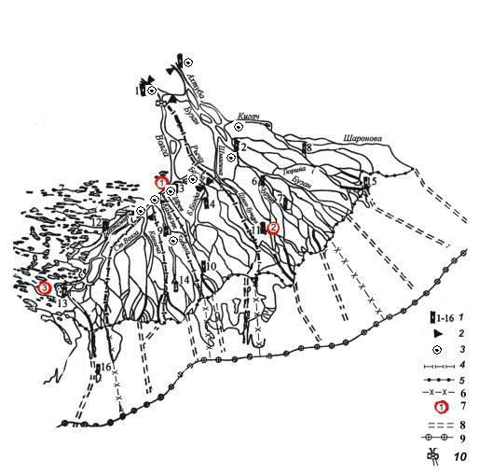
Figure 1.1 Outline of the Volga delta:
1 – permanent hydrological stations (station No. 1 – Verkhneye Lebyazhye village, station No. 3 – Astrakhan, station No. 13 – Olya village); 2 – hydrometric sites on the main watercourses distributors of flow; 3- standard stations of sampling for pollution by ACHME; 4 – borders of arterial waterway systems in the Volga delta (border of the Buzan arm system lies on the water divider dam and represents a border between eastern and western parts of the delta); 5 – the Volga delta seashore line; 6 – sector borders of estuarial seashore shallow zone of Volga; 7 – meteorological stations (MS): 1- MS of Astrakhan, 2- MS of Zelenga, 3 – MS of Liman, 8 - arterial waterway canals in the seashore shallow zone, 9 – southern border of the seashore shallow zone, 10 – water divider .

DSL adjoins the large estuarial seashore shallow zone covering the area of about 10000 km². At the present background level of the Caspian Sea of -27 m BC (Baltic System of height marks), the depths in this zone are from 0.5-1 m near DSL to 2-2.5 m in front of the sea slope where depth increases up to 4 m. Extension of the zone from DSL to sea slope constitutes 35-50 km.

1.1 Morphology and hydrography of the Volga delta

The present delta of the Volga River represents a plain slightly inclining to sea with height marks around -20 m BS in the delta apex and about -26.5 m BS at its sea line which in recent decades until 1991 (i.e. at sea level below 27.3 m BS) was practically stable with respect to both layout and height marks. In 1991 due to the rise of the Caspian Sea level a graduate flooding of delta and shifting of sea line towards the land had started with increase of its height marks. In recent years the background level of the Caspian Sea has stabilized at marks close to -27 m BS.
Watercourses in delta are represented by large arterial waterways, smaller arms, canals and banks (estuarial waterways concentrating flows of arms and canals running in the estuarial seashore). Along many waterways there are watercourse embankments of sand and clay sand soils and as a rule overgrown with tree vegetation. On the estuarial seashore some delta watercourses continue their way as natural underwater canals or dredged navigation of fish-passing canals.

1.2 Morphology and hydrography of estuarial seashore shallow zone of Volga

Estuarial seashore shallow zone of Volga is very important for spawning and feeding of sturgeon juveniles. Processes occurring here affect significantly the dynamics of flows of water, sediments and pollutants, distribution of biogenic and pollutants in the Northern Caspian.
Over 70 % of this area is covered with growth of higher aquatic flora during vegetation period.
Shallow pre-estuarial part of the estuarial seashore (seashore shallow zone) with 35-50 km extension from north to south and depths up to 1.5-2.5 (at sea level of -27 BS) represents a wide platform slightly inclining to sea. This is a submerged part of the delta developed during a period of the lower sea level. In this shallow area, flat flow of the Volga water runs slowly southward.
Flat relief of the seashore shallow zone is complicated by natural underwater canals and artificially dredged navigation and fish-pass canals as well as soil disposals along the canals. Natural underwater canals are usually a continuation of large delta watercourses on the seashore and represent slight decline of bottom relief stretching along the delta flow current to marine sand-bar. The length of underwater canals sometimes reaches dozens of kilometers and their width is from 200 m to several kilometers. Usually, underwater canals are separated from each other by underwater spits stretching towards the sea. Total number of artificial canals stretching through the shallow seashore zone is 28 of which 3 canals are navigational, 8 canals are main arterial waterways and 17 are supplementary (entrance) fish-pass canals. Navigation canals are the Volga-Caspian Canal with length of 86 km on the seashore and average depth of 5 m, the Belinski canal (42 km length, average depth about 4 m) and Laganski canal (30 km, not connected with delta). The main arterial fish-pass waterways include (from west to east): Gandurinski (54 km length), Kirovski (34 km), Bardyninski (35 km), Tishkivski (65 km), Karaiski (35 km), Obzhorovski (80 km), Igolkinski (65 km), Ganushkinski (50 km).
Total length of canals is about 1000 km.
Arterial waterways consist usually of pre-delta and marine parts. Pre-delta part represents a cleared, deepened on microbar and straightened channel in the mouth of delta waterway, and marine part is a purely artificial cut through the whole seashore shallow zone from DSL to the sea slope of estuarial sand-bar. In general, entrance fish-pass canals are continuation of the large delta waterways. Entrance fish-pass canals are not directly connected with the sea and run from the delta watercourses to arterial waterways. Before the period of present sea level rise, pre-delta parts of canals were well formed by above-water banks overgrown with higher vegetation and on the site approximately 15-20 km away from DSL represented developed natural channels. At sea level rise, the above-water banks were mainly submerged and at present are washed out.
Major peculiarity of the seashore shallow zone hydrography is its significant dependence on the height of the Caspian Sea level. At changing of the sea level in a rather narrow range (from -26.0 to -29.0 m BS) the present estuarial seashore shallow zone may turn into either sea water area or overgrown running area practically not affected by sea.
From the seaside the seashore shallow zone is bounded by submerged bar of fine-grained sand and broken shells. At any sea level (from -30 m d higher) the marine estuarial bar holds its location although its depth changes.

1.3 Zoning of delta and estuarial seashore shallow zone of the Volga River

Delta of the Volga may be divided into three zones from its apex to DSL.
The upper delta zone (with extension of about 60 km along the current) with lower border along the line from the city of Astrakhan to Krasnyi Yar settlement is the most ancient with average area marks higher than -23.5 m BS. It is characterized by relatively simple channel network. Central zone with 40-60 km extension stretches southward from the upper zone to the line of the Olya village – Karalat village – Zelenga village – Bolshoi Mogoi village – Kotyaevka village, close to the site of former sea slope near DSL developed in XVIII at high sea level (about -24…-25 m BS). This zone is characterized by a network of well developed large watercourses. The lower (coastal) zone of 20-40 km ion stretches from the central zone southward to DSL. It was formed mainly in XIX-XX during a period when short rise of the sea level started to decline. For this zone, typical features are significant fragmentation of channel network, alternation of watercourse branching and junction parts, active redistribution of their flows. Further on right up to depth slope at relict DSL (present marine estuarial bar) with marks of -28…-30 m BS, semi-submerged and submerged parts of the Volga cone outlet stretches where relict relief forms of combine with present. Under current condition this zone plays a role of estuarial shallow seashore. DSL serves as a border between terrestrial part of the Volga delta and shallow pre-delta zone of the estuarial seashore. As a result of significant fluctuations of the sea level and interannual and seasonal changes of the river flow this border may shift within dozens of meters to several kilometers. DSL is cut and overgrown with higher vegetation so strongly that on some sites it is impossible to determine its clear “shore” line.
In latitude direction the Volga delta is subdivided into two large parts – western and eastern. Below is the zoning plan of the Volga estuary (Figure 1.2). Several simplifications were made at its preparation (western sub-steppe ilmens were excluded; borders separating districts from each other were straightened in order to reduce bend points).

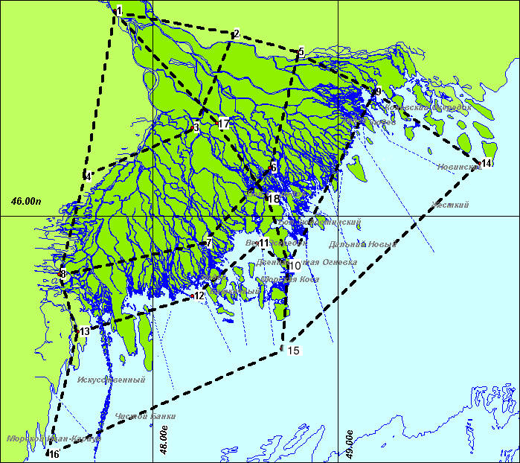
Figure 1.2 Zoning plan of the Volga delta

DSL and estuarial seashore shallow zone are additionally subdivided into 5 sectors out of which 3 belong to the western part of delta and 2 – to its eastern part (Figure 1.3).
Table 1.1 shows coordinates of bend points of dividing lines between various structural elements of the delta and estuarial seashore shallow zone of Volga. That allowed grouping of data on pollutants selected at monitoring stations by those elements.

Table 1.1
Coordinates of points determining borders between sectors of delta
and estuarial seashore shallow zone of Volga

Point | Longitude | Latitude | Point | Longitude | Latitude
1 | 47^{о}48´ | 46^{о}46´ | 13 | 47^{о}36´ | 45^{о}34´
2 | 48^{о}26´ | 46^{о}41´ | 14 | 49^{о}46´ | 46^{о}12´
3 | 48^{о}13´ | 46^{о}20´ | 15 | 48^{о}42´ | 45^{о}30´
4 | 47^{о}38´ | 46^{о}09´ | 16 | 47^{о}26´ | 45^{о}06´
5 | 48^{о}47´ | 46^{о}37´ | 17 | 48^{о}21´ | 46^{о}21´
6 | 48^{о}38´ | 46^{о}11´ | 18 | 48^{о}37´ | 46^{о}04´
7 | 48^{о}17´ | 45^{о}54´ | 19 | 47^{о}47´ | 45^{о}36´
8 | 47^{о}30´ | 45^{о}47´ | 20 | 47^{о}56´ | 45^{о}15´
9 | 49^{о}12´ | 46^{о}28´ | 21 | 48^{о}20´ | 45^{о}45´
10 | 48^{о}44´ | 45^{о}49´ | 22 | 48^{о}28´ | 45^{о}25´
11 | 48^{о}34´ | 45^{о}54´ | 23 | 49^{о}0´ | 46^{о}13´
12 | 48^{о}13´ | 45^{о}42´ | 24 | 49^{о}20´ | 45^{о}55´

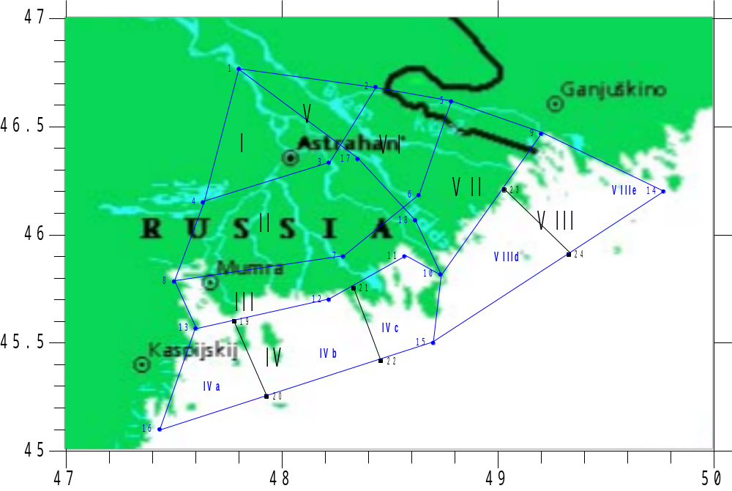
Figure 1.3 Detailed zoning plan of delta and estuarial seashore shallow zone of Volga

1.4 Texture of bottom soils

Upper part of the Volga estuary is affected by regimes of water discharges from the Volgograd storage reservoir. Water current velocity in the riverbed until the Volga delta apex often exceeds 1 m/s at riverbed depth of 10-15 m. The riverbed is composed mainly of dust sand sometimes with inclusion of lens and layers of hardly eroding clay. In bottom sediments fractions smaller than 0.25 mm prevail constituting 60%.
Decrease of water current velocity on the estuarial part of the river down to 0.3-0.5 m/s, flood wave spreading and as a result settling of a part of suspended solids are determining factors of fractional composition formation of bottom sediments in the Volga delta. The share of particles smaller than 0.25 mm in arms and canals of delta increases to 76 % among which fractions of 0.1-0.25 mm prevail (45 %).
Estuarial seashore shallow zone represents a buffer zone between the river and sea. Gradual reduction of current velocities from DSL to sea slope is typical. In period of low water the average current velocities on river bar sites are equal to 0.30 m/s, in canals – 0.55 m/s, in cuts – 0.11 m/s, underwater canals – 0.16 m/s, pits – 0.05 m/s, in growth of higher aquatic vegetation – 0.02 m/s, in canals between islands and curtains of aquatic vegetation – 0.15 m/s, in rear parts of islands – 0.00 m/s, marine bar slope – 0.02 m/s [3].
According to data of drilling conducted in different times starting from 1929, the basis of front delta terrace is composed of ancient Khvalyn deposits. They are covered with younger soils of both fluvial and marine origin often not connected with present sedimentation processes. Capacity of present sedimentation is determined by amplitude of ancient relief changes. The latter sometimes has outlets on day surface forming submerged shoals and islands [4, 5, 6].
Insufficient study of geology of the Volga estuarial seashore shallow zone does not allow to compose a detailed plan of spatial distribution of bottom soils however analysis of published sources and our data allow to produce their general characteristics.
Regardless of various origins, ancient and present deposits have similar granulometric composition (Table 1.3). Sampling was implemented evenly on the whole territory of shallow seashore. The depth of non-cohesive soil sampling was 0-0.39 m, cohesive soil – 1.6-3.0 m.
The upper layer of front-delta soils have seasonal and multi-annual dynamics caused by environmental changes. Before the Volga flow regulation sediments appearing on day surface were represented mainly by dust sands.
Fine sands occurred more rarely and were connected to well running sites, for instance, to underwater canals. Fractions of 0.1-1.0 mm size prevail often in fine sands of shallow zone reaching almost 90 % at good grading of material.
After flow regulation the qualitative changes took place in sedimentation process toward increase of percentage ratio of fine fractions. Intensive formation of silt soils have started.
At present, silts of size from 1 to 20 cm occupy the upper layer of sediments in almost all area of the shallow seashore, and are absent only near the Volga-Caspian Canal and developed flow courses. According to results of shallow drilling along the canals at depth of 1-2 m from seashore bottom surface there are mainly medium and heavy loamy soils. During canal construction those layers were opened and compose a bed for the latter. On some canal sites fine-grained silted sand and Khvalyn clay are deposited. VCC stays outside a common system; its bed is composed of fine-grained sand.

Table 1.3
Granulometric composition of main types of surface bottom sediments in the estuarial seashore shallow zone of Volga, %

Fractions, mm |  |  |  |  | Soil type
>1.0 | 1.0-0.1 | 0.1-0.05 | 0.05-0.01 | <0.01 | Soil type
shell traces | 1.0 | 29.0 | 26.3 | 43.7 | Silt
0 | 0.4 | 33.4 | 26.6 | 39.6 | Silt
0 | 1.7 | 46.7 | 24.3 | 27.3 | Silted sand
0 | 0.3 | 36.0 | 40.0 | 23.7 | Silted sand
0 | 1.5 | 24.5 | 3.3 | 0.7 | Dust sand
(4.4) shell | 15.9 | 79.9 | 2.7 | 1.5 | Dust sand
0 | 4.8 | 92.6 | 1.4 | 1.2 | Dust sand
(0.2) shell | 5.6 | 88.5 | 3.1 | 2.8 | Dust sand
(2.5) shell | 29.0 | 66.0 | 1.9 | 3.1 | Dust sand
(1.1) shell | 74.0 | 23.4 | 0.4 | 2.2 | Fine sand
0 | 0.3 | 84.0 | 10.0 | 5.7 | Clay sand
0 | 0.2 | 82.2 | 10.2 | 7.4 | Clay sand
0 | 10.5 | 72.8 | 13.5 | 3.2 | Clay sand
0 | 0.1 | 82.7 | 14.0 | 3.2 | Clay sand
0 | 30.0 | 38.0 | 12.0 | 20.0 | Loamy sand
0 | 17.0 | 53.0 | 6.0 | 24.0 | Loamy sand
0 | 30.0 | 38.0 | 8.0 | 24.0 | Light loam
0 | 4.2 | 31.8 | 24.0 | 40.0 | Light loam
0 | 10.6 | 39.4 | 26.0 | 14.0 | Medium loam
0 | 3.4 | 32.6 | 24.0 | 40.0 | Medium loam
0 | 20.0 | 16.0 | 32.0 | 32.0 | Heavy loam
0 | 30.0 | 59.0 | 14.0 | 24.0 | Heavy loam
0 | 10.0 | 30.0 | 20.0 | 40.0 | Clay

Chapter 2 Flows of water and suspended sediments
in the Volga delta

2.1 Multi-annual and seasonal variations of water flow

Water flow entering the delta apex of the Volga River (Q_{c}) consists of three constituents: 1) the Volga River flow (measured at hydrometric site (hs) of the Verkhneye Lebyazhye village); 2) Akhtuba river flow (continuation of hs of the Verkhneye Lebyazhye village); 3) the Volga-Akhtuba floodplain flow (continuation of hs of the Verkhneye Lebyazhye village). The flow of Akhtuba and Volga-Akhtuba floodplain is characterized by significant inconstancy and varies in a wide range from 10-15% of flow in the Volga delta apex at the highest water level during flood to zero flow in period of low water.
Main patterns of multi-annual changes of water flow are well observed on difference-integral curves of its annual volumes in the Volga delta apex (Figure 2.1). In the analysis, data were use on the flow observed (Q_{fo}) from 1940 to 2004 where anthropogenic changes were taken into account, and on rehabilitated natural flow of Volga (Q_{fr}) in the delta apex. Over a period from 1881 to 1940 the average monthly and annual flow in the Volga delta apex was calculated in relation with the average monthly water discharge near the Dubrovka village [1]. In some years with lack of observations near the Dubrovka villages or near Verkhneye Lebyazhye village the average monthly water flow in the delta apex was restored by its relations with average monthly levels near Astrakhan. It is assumed that from 1881 to 1939 data on the observed and rehabilitated natural flows coincide. Rehabilitated flow from 1940 to 2004 was calculated considering data of the State Hydrological Institute on total anthropogenic losses of flow [2, 3, 4]. The rate of rehabilitated natural flow of Volga for 1881-2004 constitutes 8050 m³/s. Joint analysis of difference-integral curves of rehabilitated and observed flows allowed revealing the relative role of climatic and anthropogenic factor in multi-annual variations of flow.
Using a difference-integral curve of rehabilitated natural flow, periods of the highest water were distinguished: 1923 - 1929 (Q_{fr} = 9450 m³/s), 1978 - 2004 (Q_{fr} = 8870 m³/s and Q_{fo} = 8500 m³/s), and period of the lowest water: 1930-1940 (Q_{fr} = 6180 m³/s), 1971-1977 (Q_{fr}=6850 m³/s and Q_{fo}=6320 m³/s). At present, considering 2005, a period of higher water in the Volga River goes on.
In general trends of the Volga flow changes for 1881-2004 both by data on observed flow and by data of rehabilitated natural flow coincide (Figure 2.1). Therefore it may be concluded that climate factor plays a dominating role in multi-annual variations of the Volga discharge regardless of significant anthropogenic withdrawal of flow started in the second half of XX century.
Analysis of multi-annual fluctuations of total flow of Volga in its delta apex, taking into account the data on hydro engineering constructions in the Volga River basin and pattern of anthropogenic intra-annual redistribution of flow, allowed distinguishing several typical periods. A period from 1881 to 1955 is called a period of natural flow regime. In that period two sub-periods are distinguished – natural (undisturbed) flow regime in 1881-1940 and low-disturbed flow regime in 1941-1955. The period of 1956-1960 is a period of filling in large storage reservoirs. During that time large storage reservoirs of the Volga-Kama cascade of 100 km³ total capacity were put into operation which started functioning as powerful regulator of water regime in the Lower Volga. By 1961 the main volume of storage reservoir of the Volga power station located at a distance 450 km from the Volga delta apex was filled in. Since that time the flow regime in delta repeats the pattern of water discharges into the lower reach of dam of the Volga power station. The period from 1961 to date is called a period of regulated flow regime (Table 2.1).

i
Σ (К_{i}-1)/Сv
1
-30
-25
-20
-15
-10
-5
0
5
10
1880
1900
1920
1940
1960
1980
2000
Rehabilitated flow
Observed flow

Figure 2.1 Difference-integral curves of rehabilitated (Q_{fr}) and observed (Q_{fo}) annual flow in the delta apex of the Volga River for 1881-2004.
К_{i} – modular ratio equal to ratio of water flow of i-th year to average for period rehabilitated flow; Cv – variation ratio of annual flow.

Table 2.1
Characteristics of periods of the Volga flow regimes in its delta apex

Periods |  |  | Reason of regime change
№ | Years | Name | Reason of regime change
I | 1881−1955 | Period of natural flow regime | –
Ia | 1881−1940 | Sub-period of undisturbed flow regime | –
Ib | 1941−1955 | Sub-period of low- disturbed flow regime | Regulation of flow by storage reservoirs in the Upper Volga: Ivankovskoye, Uglichskoye, Sheksninskoye, Rybinskoye.  Flow withdrawal 5.6 km³/year on average.
II | 1956−1960 | Period of filling in large storage reservoirs | Filling in storage reservoirs: Gorkovskoye (1955-1957), Kuibyshevskoye (1955-1957), Kama (1954-1956), Volgograd (1958-1960).  Flow withdrawal 17 km³/year on average.
III | 1961−to date | Period of regulated flow regime | Regulation of the Volga flow by storage reservoirs of the Volga-Kama cascade.  Flow withdrawal:  1961-1980 –18.1 km³/year on average;  1981-1990 –14.6 km³/year on average;  1991-2004 –10.0 km³/year on average.

Until 1955, total reduction of flow in the Volga basin as a result of economic activity did not exceed 7.3 km³/year, and in period of 1940-1955 it was 5.6 km³/year on average or 2.2 % of normal flow in the delta apex. In 1956-1960 the flow withdrawal including for filling in storage reservoirs averaged 17 km³/year (6.7 % of rate) having reached its maximum of 26 km³ in 1960 (10.2 % of rate). In period of regulated regime, anthropogenic withdrawal of flow averaged 13 km³/year (5.1 % of rate), and maximum withdrawal of flow in the Volga River basin was noted in 1983 amounting to 27 km³/year.
In period of regulated flow regime in 1961-2004 water consumption in the Volga basin was in direct relation with development of social and economic processes in the country. According to the recent assessments implemented using data of the State Water Cadastre, actual losses of flow in the Volga basin in 1961-2004 showed a trend to decline. Regulation of flow caused significant intra-annual redistribution of flow in the Volga delta and first of all changes of main characteristics of spring-summer flood, the most important natural factor determining to a great extent the condition and development of the Volga River estuary as a whole (Figure 2.2).
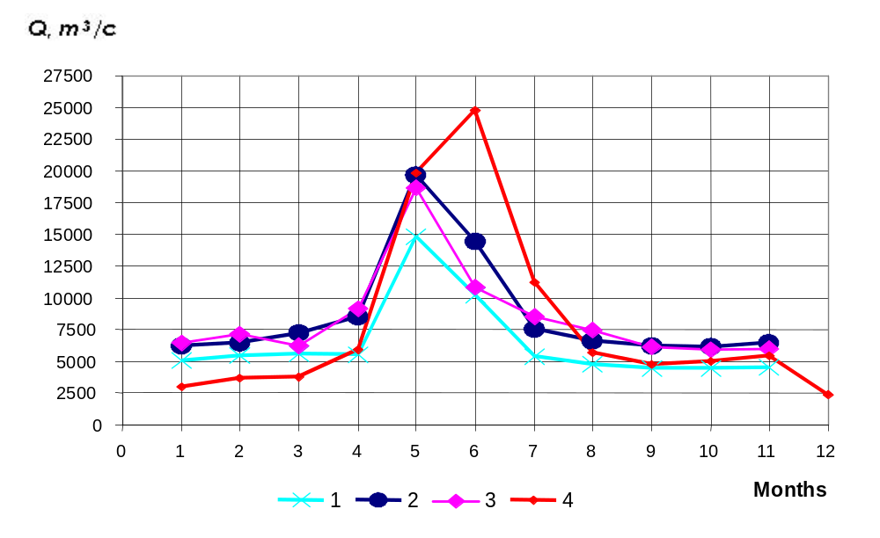

Figure 2.2 Intra-annual distribution of water flow in the Volga delta apex in typical periods (Averaged water discharges by months for periods: 1 –1971-1977; 2 – 1978-2004; 3 – 2004; 4 –1941-1955)

Below characteristics of observed flow in the Volga estuary for the period of regulated flow in 1961-2004 are considered in detail. Starting from 1961 three typical phases can be distinguished by water content volumes:
1) 1961-1970 with water content close to average – average annual total water discharge in the delta apex Qa = 7410 m³/s. Observed flow of water in the Volga delta apex for that period averaged 92 % of natural flow rate of 1881-2004, rehabilitated flow – 99 %.
2) 1971-1977 – with lower water content (low-water phase) – Qa – 6320 m³/s. Observed flow of water in the Volga delta apex for the period of lower water content averaged 78 % of natural flow rate of 1881-2004, rehabilitated flow – 85 %.
3) 1978-2004 – with higher water content (high-water phase) – Qa = 8500 m³/s. Observed flow of water in the Volga delta apex for the period of higher water content averaged 106 % of natural flow rate of 1881-2004, rehabilitated flow – 110 %.
Under natural conditions, minimum discharges in winder period of low water were observed in January, average monthly water discharge in January in 1941-1955 was Qa=2860 m³/s. Maximum discharge at the highest flood was noted in June, average monthly discharges in June Qa=24300 m³/s, minimum discharges in summer-autumn low water periods – in September, average monthly discharge in September Qa= 4830 m³/s. During period of regulated flow intra-annual distribution of the Volga flow changed significantly (Table 2.2).

Table 2.2
Intra-annual distribution of total water flow in the Volga delta apex in various periods
(km³ and % of annual flow)

Years | Flow volumes by seasons, km³/% |  |  | Annual flow volume, km³/% | Flood period
Years | IV-VI | VII-XI | XII-III | Annual flow volume, km³/% | Flow volume, km³ | Duration, days
1881-1955 | 127/52 | 86.9/35 | 32.1/13 | 246/100 | - | -
1941-1955 | 133/53 | 85.3/34 | 33.2/13 | 251/100 | 150 | 116
1956-1960 | 117/44 | 95.4/36 | 51.9/20 | 264/100 | 116 | 98
1961-2004 | 105/42 | 79.4/32 | 64.8/26 | 250/100 | 90 | 74
1961-1970 | 105/45 | 70.8/30 | 58.2/25 | 234/100 | 98 | 80
1971-1977 | 80/40 | 62.6/31 | 56.4/28 | 199/100 | 68 | 62
1978-2004 | 111/42 | 87.0/33 | 69.3/26 | 268/100 | 100 | 74

In spring-summer period (IV-VI) the flow volume reduced by 10 %, maximum water discharge at the highest flood in 1961-2005 is observed in May, average May water discharge constitutes 18500m³/s. From period of 1941-1955 to period of 1961-2004, the average starting date of flood shifted from April 11 under natural conditions to April 19 under regulated flow conditions. The date of the highest flood shifted respectively from May 4 to May 21, the end of flood – from July 29 to July 3. Flow volume during summer-autumn low-water period (VII-XI) reduced to some extent (from 35% to 32%) as a result of reduction of flood duration and volume. The share of the Volga flow in period of winter low water (XII-III) increased practically by two times – from 13% to 26% causing winter flooding that did not occur before as well as frequent ice blocking and jams.

2.2 Multi-annual and seasonal variations of suspended sediments flow

Regular observations over sediment flows in the Volga delta apex on the main riverbed are conducted since 1950. They characterize mainly new conditions of sediment flow formation on the upper border of the estuary. During several decades after the regulation of flow, in contrast to water flow, sediment flow and turbidity reduced by two-three times in the Volga estuary even under conditions of higher water content (Figure 2.3). Accumulation of fluvial sediments in a cascade of the Volga storage reservoirs and rehabilitation of sediments flow below the Volgograd storage reservoir changed the natural flow pattern as a result of directed mass exchange in a flow-bed system.
In 1950-1955, 12.8 million tonnes of suspended solids per year entered the delta through the main bed of Volga. During filling in large storage reservoirs (1956-1960) that amount reduced down to 11.6 million tones per year. The largest decrease of suspended solids flow happened in 1961-1970 and 1971-1977 down to 7.2 and 4.6 million tones per year respectively. Some increase in flow of suspended solids starting in 1978 coincides with the beginning of a phase of higher water content in the Volga River and respective activation of river sediments washing out by water flow. Over a period of 1978-1991, 8.9 million tones of suspended solids per year on average entered the delta, at average water turbidity 33 g/m³. In 1992-2004 regardless of the higher water flow practically equal to flow of 1978-1991, the average flow of sediments constituted 5.9 million tones per yea, while average turbidity reduced down to 22 g/m³.

0
50
100
150
200
250
300
350
400
450
500
1950
1955
1960
1965
1970
1975
1980
85
1990
95
2000
Years
0
1000
2000
3000
4000
5000
6000
7000
8000
R, kg/s Q, m³/s
1
2
3
Figure 2.3 Multi-annual variations of water discharge (Q), sediments flow (R)
and turbidity (r) in the apex of the Volga estuary in 1950-2004

0
500
1000
1500
2000
2500
0
1
2
3
4
5
6
7
8
9
10
11
12
Years
1
2
3
4
5
6

Figure 2.4 Intra-annual distribution of sediments flow in the Volga delta apex for typical periods (averaged discharges of suspended sediments by months for periods: 1 - 1950-1955; 2 - 1956-1960; 3 - 1961-1970; 4 - 1971-1977; 5 - 1978-1991; 6 - 1992-2004)

As a result of regulation of the Volga River flow the ratio of sediments during flood reduced fro 80 % to 60 %. Regulation of the Volga flow led to changes of average monthly discharges of sediments. They reduced in flood and increased in winter and summer-autumn periods of low water (Figure 2.4). The flow of sediments drawn by the Volga River is practically not studied. This is caused by the lack of reliable metering equipment.

2.3 Water and suspended sediments flows in 1995-2004

For the period of 1995-2004, data on Roshydromet standard observations of water and sediments discharges in the Volga delta apex by hydrometric sites (hs) were collected: 1) the main riverbed of Volga – the Verkhneye Lebyazhye village; 2) Akhtuba river – continuation of hs of the Verkhneye Lebyazhye village; 3) the Volga-Akhtuba floodplain – continuation of hs of the Verkhneye Lebyazhye village; 4) the Buzan arm – near source. Based on data collected 7 work tables were created including data on average monthly and annual discharges of water and sediments by those sites for 1995-2004. In those tables water discharges are assessed by all 4 sites and sediment discharge by sites 1, 2, and 4. In site 3 sediment discharges are not measured however it is known that their share in total annual sediment discharge into the delta apex is negligibly small (less than 1 %).
Based on work tables the total water flow entering the delta was calculated and inserted in the summary table as a sum of flow on sites 1, 2 and 3 (Table 2.3). For further estimate of pollutants entering the delta apex data on averaged monthly and annual water discharges in 1995-2004 on sites 1 and 2 were also used.
Distribution of water flow into the eastern part (as a sum of flow on sites 2, 3 and 4) and western part (as difference of total water flow entering the delta and flow in its eastern part) of delta was estimated. Tables were drawn up including data on average monthly and annual water discharges entering the western and eastern parts of delta for 1995-2004 (Tables 2.4 and 2.5).
Electronic chart of division of water flows entering the estuarial seashore shallow zone of Volga was drawn up by 5 sectors – 3 in the western part of delta and 2 in the eastern part (Figure 1.3). Using the author’s data from monograph [5], dependences for estimate of water flow distribution by indicated 5 sectors were prepared and approximated electronically as functions of value of total water flow entering the Volga delta. By means of these dependences distribution of flows of water, sediments and pollutants entering the estuarial seashore shallow zone of Volga were estimated by 5 sectors (Tables 2.6 – 2.10).
For calculation of pollutant flows in the eastern part of the Volga delta (see Chapter 5) additional division of total water flow entering this part of delta by water flow in the Buzan arm system including the flow of the Volga-Akhtuba floodplain and by flow of the Kigach canal (continuation of the Akhtuba River). It was needed in order to have a possibility to calculate pollutants of various geneses from the Buzan arm and Akhtuba River separately.
Total flow of suspended sediments entering the delta was calculated as a sum of flow on sites 1 and 2 (Table 2.11).
Distribution of suspended sediment flow into the eastern part (as a sum of flow on sites 2 and 4) and western part (as difference of total flow entering the delta and flow on site 4) of delta was estimated. Tables were drawn up including data on average monthly and annual suspended sediment discharges entering the western and eastern parts of delta for 1995-2004 (Tables 2.12 and 2.13).

Table 2.3
Total monthly and annual water discharges in the Volga delta apex for 1995-2004

Years | Average water discharges by months and per year, m³/s |  |  |  |  |  |  |  |  |  |  |  |  | Annual flow volume, km³
Years | I | II | III | IV | V | VI | VII | VIII | IX | X | XI | XII | year | Annual flow volume, km³
1995 | 6871 | 6986 | 7759 | 12936 | 27398 | 13565 | 6746 | 6336 | 6080 | 4845 | 3950 | 4359 | 8986 | 283
1996 | 4784 | 5485 | 4213 | 5107 | 11992 | 6485 | 4802 | 5140 | 5150 | 5081 | 4643 | 4523 | 5617 | 178
1997 | 4675 | 4873 | 4707 | 5093 | 19009 | 17664 | 7637 | 6533 | 5541 | 4985 | 6060 | 5452 | 7686 | 242
1998 | 5396 | 6030 | 6785 | 7703 | 17916 | 21406 | 7784 | 6910 | 7652 | 6719 | 7099 | 7403 | 9067 | 286
1999 | 6980 | 8092 | 9734 | 12148 | 22606 | 14889 | 6810 | 6962 | 6420 | 5467 | 4904 | 6182 | 9266 | 292
2000 | 4452 | 4580 | 5003 | 7261 | 21849 | 13466 | 7899 | 6229 | 6290 | 5993 | 5570 | 5393 | 7832 | 248
2001 | 5461 | 6596 | 8066 | 8707 | 22727 | 18300 | 7555 | 5974 | 6144 | 5433 | 5491 | 6467 | 8910 | 281
2002 | 6033 | 6702 | 6180 | 8958 | 20725 | 16147 | 7656 | 5818 | 5463 | 5012 | 5001 | 5721 | 8285 | 261
2003 | 6641 | 6573 | 6366 | 8081 | 18046 | 12562 | 6941 | 6298 | 5822 | 5814 | 5802 | 6063 | 7917 | 250
2004 | 6456 | 7119 | 6219 | 9164 | 18651 | 10844 | 8562 | 7489 | 6165 | 5939 | 5988 | 6619 | 8268 | 261
Average | 5775 | 6304 | 6503 | 8516 | 20092 | 14533 | 7239 | 6369 | 6073 | 5529 | 5451 | 5818 | 8183 | 258
Quarter |  |  | 6194 |  |  | 14380 |  |  | 6560 |  |  | 5599

Table 2.4
Total monthly and annual water discharges into the western part of the Volga delta in 1995-2004

Years | Average water discharges by months and per year, m³/s |  |  |  |  |  |  |  |  |  |  |  |  | Annual flow volume, km³
Years | I | II | III | IV | V | VI | VII | VIII | IX | X | XI | XII | year | Annual flow volume, km³
1995 | 4040 | 3950 | 4950 | 8110 | 15880 | 8530 | 4210 | 3950 | 3780 | 2940 | 2320 | 2760 | 5452 | 172
1996 | 3330 | 3690 | 2580 | 3150 | 7230 | 4100 | 3000 | 3250 | 3260 | 3210 | 2880 | 2810 | 3541 | 112
1997 | 3220 | 3350 | 3020 | 3220 | 11170 | 10730 | 5000 | 4260 | 3560 | 3160 | 3930 | 3540 | 4847 | 153
1998 | 3510 | 3870 | 4270 | 5040 | 11080 | 12870 | 4950 | 4410 | 4870 | 4270 | 4530 | 4660 | 5694 | 180
1999 | 4440 | 5120 | 6150 | 7690 | 13550 | 9220 | 4390 | 4480 | 4110 | 3450 | 3080 | 3950 | 5803 | 183
2000 | 2830 | 2840 | 3140 | 4430 | 13390 | 8380 | 5050 | 3980 | 4030 | 3840 | 3570 | 3450 | 4911 | 155
1901 | 3480 | 4050 | 5180 | 5560 | 13290 | 11400 | 4920 | 3850 | 3970 | 3490 | 3530 | 4090 | 5568 | 176
2002 | 3600 | 4090 | 3990 | 5850 | 12940 | 10290 | 5020 | 3770 | 3530 | 3220 | 3210 | 3750 | 5272 | 166
2003 | 4300 | 4120 | 4080 | 5340 | 10890 | 8020 | 4560 | 4120 | 3810 | 3810 | 3800 | 3980 | 5069 | 160
2004 | 3960 | 4610 | 4050 | 5810 | 11270 | 6980 | 5670 | 4950 | 4070 | 3910 | 3950 | 4410 | 5303 | 167
Average | 3671 | 3969 | 4141 | 5420 | 12069 | 9052 | 4677 | 4102 | 3899 | 3530 | 3480 | 3740 | 5146 | 162
Quarter |  |  | 3927 |  |  | 8847 |  |  | 4226 |  |  | 3583

Table 2.5
Total monthly and annual water discharges into the eastern part of the Volga delta in 1995-2004

Years | Average water discharges by months and per year, m³/s |  |  |  |  |  |  |  |  |  |  |  |  | Annual flow volume, km³
Years | I | II | III | IV | V | VI | VII | VIII | IX | X | XI | XII | year | Annual flow volume, km³
1995 | 2831 | 3036 | 2809 | 4826 | 11518 | 5035 | 2536 | 2386 | 2300 | 1905 | 1630 | 1599 | 3534 | 111
1996 | 1454 | 1795 | 1633 | 1957 | 4762 | 2385 | 1802 | 1890 | 1890 | 1871 | 1763 | 1713 | 2076 | 66
1997 | 1455 | 1523 | 1687 | 1873 | 7839 | 6934 | 2637 | 2273 | 1981 | 1825 | 2130 | 1912 | 2839 | 90
1998 | 1886 | 2160 | 2515 | 2663 | 6836 | 8536 | 2834 | 2500 | 2782 | 2449 | 2569 | 2743 | 3373 | 106
1999 | 2540 | 2972 | 3584 | 4458 | 9056 | 5669 | 2420 | 2482 | 2310 | 2017 | 1824 | 2232 | 3464 | 109
2000 | 1622 | 1740 | 1863 | 2831 | 8459 | 5086 | 2849 | 2249 | 2260 | 2153 | 2000 | 1943 | 2921 | 92
1901 | 1981 | 2546 | 2886 | 3147 | 9437 | 6900 | 2635 | 2124 | 2174 | 1943 | 1961 | 2377 | 3343 | 105
2002 | 2433 | 2612 | 2190 | 3108 | 7785 | 5857 | 2636 | 2048 | 1933 | 1792 | 1791 | 1971 | 3013 | 95
2003 | 2341 | 2453 | 2286 | 2741 | 7156 | 4542 | 2381 | 2178 | 2012 | 2004 | 2002 | 2083 | 2848 | 90
2004 | 2496 | 2509 | 2169 | 3354 | 7381 | 3864 | 2892 | 2539 | 2095 | 2029 | 2038 | 2209 | 2964 | 94
Average | 2104 | 2335 | 2362 | 3096 | 8023 | 5481 | 2562 | 2267 | 2174 | 1999 | 1971 | 2078 | 3038 | 96
Quarter |  |  | 2267 |  |  | 5533 |  |  | 2334 |  |  | 2016

Table 2.6
Total monthly and annual water discharges on DSL of western part of the Volga delta
(section IVa) in 1995-2004

Years | Average water discharges by months and per year, m³/s
Years | I |  | II | III | IV |  | V | VI | VII | VIII | IX | X | XI | XII | year
1995 | 2190 | 2136 |  | 2632 |  | 3910 | 6806 | 4072 | 2289 | 2167 | 2086 | 1670 | 1347 | 1586 | 2826
1996 | 1894 | 2064 |  | 1488 |  | 1778 | 3542 | 2242 | 1706 | 1833 | 1838 | 1813 | 1644 | 1608 | 1975
1997 | 1836 | 1901 |  | 1721 |  | 1818 | 4978 | 4848 | 2666 | 2327 | 1989 | 1789 | 2170 | 1982 | 2581
1998 | 1968 | 2138 |  | 2319 |  | 2683 | 4993 | 5626 | 2631 | 2389 | 2595 | 2323 | 2443 | 2497 | 2947
1999 | 2401 | 2703 |  | 3141 |  | 3757 | 5881 | 4315 | 2383 | 2424 | 2251 | 1931 | 1747 | 2175 | 2991
2000 | 1623 | 1623 |  | 1777 |  | 2381 | 5836 | 4006 | 2677 | 2189 | 2213 | 2123 | 1993 | 1934 | 2607
2001 | 1948 | 2209 |  | 2736 |  | 2898 | 5764 | 5116 | 2628 | 2130 | 2188 | 1955 | 1975 | 2237 | 2890
2002 | 1989 | 2226 |  | 2197 |  | 3034 | 5683 | 4734 | 2675 | 2093 | 1976 | 1822 | 1816 | 2086 | 2772
2003 | 2343 | 2248 |  | 2237 |  | 2820 | 4900 | 3891 | 2468 | 2262 | 2115 | 2115 | 2110 | 2197 | 2686
2004 | 2167 | 2485 |  | 2228 |  | 3001 | 5040 | 3490 | 2965 | 2647 | 2242 | 2165 | 2184 | 2404 | 2790
Average | 2036 |  | 2173 | 2248 | 2808 |  | 5342 | 4234 | 2509 | 2246 | 2149 | 1970 | 1943 | 2071 | 2707
Quarter |  |  |  | 2152 |  |  |  | 4128 |  |  | 2301 |  |  | 1995

Table 2.7
Total monthly and annual water discharges on DSL of western part of the Volga delta
(section IVb) in 1995-2004

Years | Average water discharges by months and per year, m³/s
Years | I |  | II | III | IV | V | VI | VII | VIII | IX | X | XI | XII | year
1995 | 1441 | 1412 |  | 1791 | 3096 | 6235 | 3270 | 1499 | 1397 | 1330 | 1010 | 781 | 938 | 2005
1996 | 1143 | 1284 |  | 874 | 1088 | 2741 | 1453 | 1030 | 1123 | 1127 | 1108 | 985 | 959 | 1235
1997 | 1102 | 1152 |  | 1035 | 1112 | 4363 | 4181 | 1805 | 1511 | 1240 | 1089 | 1383 | 1231 | 1751
1998 | 1219 | 1361 |  | 1521 | 1822 | 4320 | 5038 | 1791 | 1574 | 1759 | 1520 | 1622 | 1677 | 2096
1999 | 1587 | 1861 |  | 2282 | 2919 | 5306 | 3559 | 1565 | 1601 | 1455 | 1200 | 1059 | 1393 | 2141
2000 | 964 | 970 |  | 1082 | 1590 | 5242 | 3210 | 1830 | 1404 | 1424 | 1349 | 1245 | 1199 | 1778
2001 | 1211 | 1438 |  | 1882 | 2038 | 5204 | 4448 | 1774 | 1352 | 1399 | 1213 | 1229 | 1449 | 2046
2002 | 1266 | 1455 |  | 1407 | 2151 | 5063 | 3992 | 1813 | 1320 | 1228 | 1110 | 1106 | 1311 | 1921
2003 | 1528 | 1463 |  | 1443 | 1941 | 4247 | 3054 | 1629 | 1456 | 1335 | 1334 | 1331 | 1400 | 1838
2004 | 1403 | 1651 |  | 1429 | 2141 | 4400 | 2620 | 2074 | 1783 | 1435 | 1373 | 1388 | 1567 | 1932
Average | 1286 |  | 1405 | 1475 | 1990 | 4712 | 3482 | 1681 | 1452 | 1373 | 1231 | 1213 | 1312 | 1874
Quarter |  |  |  | 1389 |  |  | 3395 |  |  | 1502 |  |  | 1252

Table 2.8
Total monthly and annual water discharges on DSL of western part of the Volga delta
(section IVc) in 1995-2004

Years | Average water discharges by months and per year, m³/s
Years | I | II | III | IV | V | VI | VII | VIII | IX | X | XI | XII | year
1995 | 409 | 402 | 527 | 1103 | 2839 | 1189 | 423 | 386 | 364 | 260 | 192 | 236 | 621
1996 | 293 | 341 | 218 | 284 | 947 | 405 | 265 | 294 | 295 | 289 | 251 | 243 | 330
1997 | 281 | 297 | 264 | 290 | 1829 | 1701 | 529 | 422 | 331 | 282 | 378 | 327 | 514
1998 | 323 | 371 | 430 | 535 | 1768 | 2207 | 528 | 447 | 516 | 428 | 464 | 486 | 651
1999 | 452 | 556 | 727 | 1014 | 2363 | 1346 | 442 | 456 | 404 | 319 | 274 | 383 | 670
2000 | 243 | 246 | 281 | 459 | 2312 | 1163 | 542 | 387 | 393 | 367 | 332 | 317 | 525
2001 | 321 | 403 | 562 | 624 | 2322 | 1836 | 518 | 368 | 384 | 322 | 327 | 403 | 632
2002 | 345 | 409 | 386 | 665 | 2194 | 1563 | 532 | 357 | 326 | 288 | 287 | 352 | 578
2003 | 429 | 409 | 400 | 579 | 1743 | 1075 | 463 | 402 | 360 | 360 | 359 | 383 | 545
2004 | 390 | 473 | 393 | 668 | 1831 | 870 | 631 | 519 | 394 | 373 | 378 | 439 | 581
Average | 349 | 391 | 419 | 622 | 2015 | 1335 | 487 | 404 | 377 | 329 | 324 | 357 | 565
Quarter |  |  | 386 |  |  | 1324 |  |  | 423 |  |  | 337

Table 2.9
Total monthly and annual water discharges on DSL of eastern part of the Volga delta
(section VIIId) in 1995-2004

Years | Average water discharges by months and per year, m³/s
Years | I | II | III | IV | V | VI | VII | VIII | IX | X | XI | XII | year
1995 | 2055 | 2201 | 2018 | 3338 | 8009 | 3474 | 1844 | 1744 | 1687 | 1424 | 1237 | 1205 | 2508
1996 | 1087 | 1328 | 1234 | 1456 | 3308 | 1740 | 1348 | 1406 | 1405 | 1393 | 1322 | 1287 | 1533
1997 | 1091 | 1138 | 1263 | 1394 | 5372 | 4751 | 1897 | 1657 | 1464 | 1361 | 1563 | 1415 | 2041
1998 | 1397 | 1586 | 1828 | 1914 | 4684 | 5867 | 2035 | 1814 | 2001 | 1781 | 1859 | 1978 | 2391
1999 | 1841 | 2127 | 2527 | 3094 | 6238 | 3896 | 1758 | 1800 | 1687 | 1493 | 1361 | 1635 | 2452
2000 | 1220 | 1306 | 1389 | 2045 | 5818 | 3510 | 2044 | 1647 | 1653 | 1581 | 1478 | 1440 | 2097
2001 | 1466 | 1855 | 2066 | 2239 | 6502 | 4727 | 1897 | 1560 | 1593 | 1439 | 1451 | 1734 | 2374
2002 | 1786 | 1900 | 1604 | 2206 | 5345 | 4017 | 1896 | 1508 | 1430 | 1336 | 1335 | 1453 | 2152
2003 | 1704 | 1787 | 1670 | 1962 | 4903 | 3147 | 1727 | 1592 | 1481 | 1476 | 1475 | 1528 | 2043
2004 | 1821 | 1816 | 1588 | 2376 | 5057 | 2702 | 2060 | 1829 | 1534 | 1491 | 1496 | 1609 | 2118
Average | 1547 | 1704 | 1719 | 2202 | 5524 | 3783 | 1851 | 1656 | 1594 | 1477 | 1458 | 1528 | 2171
Quarter |  |  | 1657 |  |  | 3836 |  |  | 1700 |  |  | 1488

Table 2.10
Total monthly and annual water discharges on DSL of eastern part of the Volga delta
(section VIIIe) in 1995-2004

Years | Average water discharges by months and per year, m³/s
Years | I | II | III | IV | V | VI | VII | VIII | IX | X | XI | XII | year
1995 | 776 | 835 | 791 | 1488 | 3509 | 1561 | 692 | 642 | 613 | 481 | 393 | 394 | 1026
1996 | 366 | 467 | 399 | 501 | 1454 | 645 | 455 | 484 | 484 | 478 | 441 | 426 | 543
1997 | 365 | 385 | 423 | 479 | 2467 | 2183 | 740 | 616 | 517 | 464 | 567 | 497 | 798
1998 | 489 | 575 | 687 | 749 | 2153 | 2669 | 799 | 686 | 781 | 668 | 709 | 765 | 981
1999 | 699 | 845 | 1057 | 1364 | 2818 | 1773 | 662 | 682 | 624 | 524 | 462 | 597 | 1012
2000 | 402 | 434 | 474 | 786 | 2641 | 1576 | 805 | 603 | 607 | 572 | 522 | 504 | 824
2001 | 515 | 691 | 820 | 908 | 2935 | 2173 | 738 | 564 | 581 | 504 | 510 | 643 | 969
2002 | 647 | 712 | 586 | 902 | 2440 | 1840 | 740 | 540 | 502 | 456 | 456 | 518 | 861
2003 | 637 | 666 | 616 | 779 | 2253 | 1396 | 654 | 585 | 531 | 529 | 528 | 555 | 806
2004 | 675 | 693 | 581 | 978 | 2323 | 1162 | 832 | 710 | 560 | 538 | 541 | 600 | 846
Average | 557 | 630 | 644 | 893 | 2499 | 1698 | 712 | 611 | 580 | 522 | 513 | 550 | 867
Quarter |  |  | 610 |  |  | 1697 |  |  | 634 |  |  | 528

Table 2.11
Total monthly and annual suspended sediment discharges in the Volga delta apex (sediment discharge of the Volga River near the V. Lebyazhye village + sediment discharge of the Akhtuba River) in 1995-2004

Years | Average sediment discharge per months and per year, kg/s
Years | I | II | III | IV | V | VI | VII | VIII | IX | X | XI | XII | year
1995 | 69 | 87 | 314 | 629 | 1026 | 390 | 202 | 131 | 111 | 120 | 120 | 27 | 269
1996 | 79 | 102 | 77 | 100 | 430 | 122 | 90 | 84 | 100 | 130 | 96 | 77 | 124
1997 | 21 | 39 | 41 | 26 | 715 | 968 | 112 | 202 | 171 | 63 | 111 | 111 | 215
1998 | 59 | 52 | 98 | 54 | 1220 | 869 | 69 | 37 | 70 | 37 | 96 | 69 | 228
1999 | 88 | 71 | 100 | 259 | 926 | 616 | 182 | 71 | 35 | 46 | 46 | 39 | 207
2000 | 14 | 15 | 42 | 314 | 507 | 767 | 64 | 51 | 19 | 20 | 32 | 42 | 157
2001 | 13 | 31 | 33 | 42 | 492 | 370 | 183 | 24 | 33 | 45 | 49 | 23 | 112
2002 | 19 | 15 | 15 | 164 | 585 | 346 | 102 | 71 | 30 | 15 | 12 | 14 | 116
2003 | 25 | 23 | 55 | 38 | 799 | 361 | 87 | 87 | 94 | 53 | 26 | 20 | 139
2004 | 40 | 29 | 38 | 295 | 729 | 362 | 68 | 45 | 42 | 44 | 54 | 29 | 148
Average | 43 | 46 | 81 | 192 | 743 | 517 | 116 | 80 | 71 | 57 | 64 | 45 | 171,3

Table 2.12
Total monthly and annual suspended sediment discharges into the western part of the Volga delta (total discharge minus discharge into eastern part) in 1995-2004

Years | Average sediment discharge per months and per year, kg/s
Years | I |  | II |  | III |  | IV |  | V |  | VI |  | VII |  | VIII |  | IX |  | X |  | XI |  | XII |  | year
1995 |  | 39 |  | 47 |  | 200 |  | 380 |  | 590 |  | 230 |  | 123 |  | 78 |  | 68 |  | 70 |  | 69 |  | 16 |  | 159
1996 |  | 66 |  | 78 |  | 57 |  | 70 |  | 230 |  | 89 |  | 67 |  | 67 |  | 71 |  | 89 |  | 67 |  | 60 |  | 84
1997 |  | 14 |  | 25 |  | 25 |  | 15 |  | 380 |  | 550 |  | 67 |  | 124 |  | 101 |  | 37 |  | 63 |  | 67 |  | 122
1998 |  | 37 |  | 32 |  | 59 |  | 33 |  | 740 |  | 520 |  | 42 |  | 23 |  | 42 |  | 22 |  | 58 |  | 42 |  | 138
1999 |  | 42 |  | 34 |  | 48 |  | 120 |  | 430 |  | 300 |  | 92 |  | 35 |  | 17 |  | 22 |  | 22 |  | 19 |  | 98
2000 |  | 8 |  | 7 |  | 22 |  | 150 |  | 260 |  | 420 |  | 35 |  | 28 |  | 11 |  | 10 |  | 17 |  | 23 |  | 83
2001 |  | 8 |  | 18 |  | 27 |  | -2 |  | 90 |  | 130 |  | 156 |  | -2 |  | 25 |  | 37 |  | 42 |  | 14 |  | 45
2002 |  | 11 |  | 9 |  | 9 |  | 102 |  | 350 |  | 210 |  | 64 |  | 43 |  | 18 |  | 9 |  | 8 |  | 9 |  | 70
2003 |  | 16 |  | 14 |  | 33 |  | 24 |  | 460 |  | 220 |  | 54 |  | 54 |  | 59 |  | 33 |  | 16 |  | 12 |  | 83
2004 |  | 19 |  | 14 |  | 20 |  | 140 |  | 340 |  | 190 |  | 36 |  | 24 |  | 23 |  | 23 |  | 29 |  | 16 |  | 73
Average | 26 |  | 28 |  | 50 |  | 103 |  | 387 |  | 286 |  | 74 |  | 47 |  | 43 |  | 35 |  | 39 |  | 28 |  | 95.6

Table 2.13
Total monthly and annual suspended sediment discharges into the eastern part of the Volga delta (sediment discharge of the Buzan arm + sediment discharge of the Akhtuba River) in 1995-2004

Years | Average sediment discharge per months and per year, kg/s
Years | I |  | II |  | III |  | IV |  | V |  | VI |  | VII |  | VIII |  | IX |  | X |  | XI |  | XII |  | year
1995 |  | 30 |  | 40 |  | 114 |  | 249 |  | 436 |  | 160 |  | 79 |  | 53 |  | 43 |  | 50 |  | 51 |  | 11 |  | 110
1996 |  | 13 |  | 24 |  | 20 |  | 30 |  | 200 |  | 33 |  | 23 |  | 17 |  | 29 |  | 41 |  | 29 |  | 17 |  | 40
1997 |  | 8 |  | 14 |  | 16 |  | 11 |  | 335 |  | 418 |  | 45 |  | 78 |  | 70 |  | 26 |  | 48 |  | 44 |  | 93
1998 |  | 22 |  | 20 |  | 39 |  | 21 |  | 480 |  | 349 |  | 27 |  | 14 |  | 28 |  | 15 |  | 38 |  | 27 |  | 90
1999 |  | 46 |  | 37 |  | 52 |  | 139 |  | 496 |  | 316 |  | 90 |  | 36 |  | 18 |  | 24 |  | 24 |  | 20 |  | 108
2000 |  | 6 |  | 8 |  | 20 |  | 164 |  | 247 |  | 347 |  | 29 |  | 23 |  | 8 |  | 10 |  | 15 |  | 19 |  | 75
2001 |  | 6 |  | 13 |  | 5 |  | 44 |  | 402 |  | 240 |  | 27 |  | 26 |  | 9 |  | 8 |  | 7 |  | 10 |  | 66
2002 |  | 8 |  | 6 |  | 6 |  | 62 |  | 235 |  | 136 |  | 38 |  | 28 |  | 12 |  | 6 |  | 5 |  | 5 |  | 46
2003 |  | 10 |  | 9 |  | 22 |  | 14 |  | 339 |  | 141 |  | 33 |  | 33 |  | 35 |  | 20 |  | 10 |  | 8 |  | 56
2004 |  | 21 |  | 15 |  | 18 |  | 155 |  | 389 |  | 172 |  | 32 |  | 21 |  | 19 |  | 21 |  | 25 |  | 13 |  | 75
Average | 17 |  | 19 |  | 31 |  | 89 |  | 356 |  | 231 |  | 42 |  | 33 |  | 27 |  | 22 |  | 25 |  | 17 |  | 75.8

References sited in Chapter 2:

- Baidin S.S. Flow and levels of the Volga delta. M., Hydrometeoizdat, 1962, 387 p.
- Shiklomanov I.A. Anthropogenic variations of river water contents. L., Hydrometeoizdat, 1979, 302 p.
- Shiklomanov I.A. Impact of economic activity on the river flow. L., Hydrometeoizdat, 1989, 334 p.
- State Water Cadastre. Resources of surface and underground waters, their use and quality (annual issue). L., 1981-2004.
- The Volga estuary: hydrologo-morphological processes, regime of pollutants and impact of fluctuations of level of the Caspian Sea. Editors: V.F. Polonski, V.N. Mikhailov and S.V. Kiryanov. М., GEOS, 1998, 278 p.

Chapter 3 Water pollution in the delta and estuarial seashore shallow zone

3.1. Water pollution in the Volga delta according to data of operating observations of Roshydromet in 1995-2004

The task of this work part was to characterize spatial and timing variability of pollutants concentration in water in the Volga delta.
Operating observations over pollution of land surface water implemented by operational departments of Roshydromet serve as a main source of information about pollution of water bodies on the Russian territory. In the Lower Volga including the area from the Volga power station dam to the delta apex (further called as “pre-estuarial area”) and delta as such from its apex to seashore line, observations over pollution of land surface water are conducted on 11 stations (Annex, Table 3.1). During the period under consideration observations over fluvial water were implemented mostly nearby Astrakhan. On other stations they were relatively rare. Basic observation data from different stations were compiled in files in accordance with the accepted zoning of the Volga delta. (Chapter 1, Figure 1.2).
Affiliation of stations to various areas is shown in Annex, Table 3.2. It should be noted that in the lower zone of the Volga delta there are no stations for observation over water pollution. Compiled data arrays are shown in Annex, Table 3.3. In the same Annex there is information about controlled indices of fluvial water pollution. Methods of chemical analysis applied are described briefly in Annex, Table 3.4.
Statistical analysis of summarized data arrays was dome according to the outline shown in Annex, Table 3.5. It should be noted that when the quantity of values was less than five in such cases calculations were not made. When there was large amount of data then both multi-annual (1995-2004) and annual analysis of data arrays was made.
Quarterly data were analyzed for assessment of seasonal variability. At that, peculiarities of hydrological regime in the Lower Volga were taken into consideration, and accordingly 1 quarter may be considered as winter period of low water, 2 quarter – flood, 3 quarter – summer period of low water and 4 quarter is an autumn period of low water. Analysis of spatial and timing variability of dissolved pollutants content in water of the Volga delta was made for each pollution index separately.

3.1.1. Petroleum hydrocarbons
In this section data of water samples analysis implemented using the spectrophotometric analysis method. This method allows determination of organic substance concentration by presence of СН₂ groups which is traditionally called “petroleum (oil) hydrocarbons” within monitoring programmes. In precise terms the oil origin of this substance should be proved using chromatography especially in cases of exceeding MAC.
During 1995-2004 the average concentration of petroleum hydrocarbons (PHs) in Lower Volga water was 0.20 mg/l. In the Akhtuba River as well as in the eastern part of the upper zone of delta (Kigach canal) the average concentration of PHs in water constituted 0.16 mg/l (the Kigach canal feeds mainly on water form the Akhtuba River). In the delta apex as well as in canals in upper and central zone fed on water from the Volga River the average concentration of PHs in water was 0.21 mg/l. Only in the western part some increase of TPH concentrations in water up to 0.23 mg/l was reported. Thus, PHs concentration in the Volga River water and delta canals fed by Volga is higher than that in the Akhtuba River and canals fed by Akhtuba. Taking this into account together with peculiarities of water flow distribution between western and eastern parts of delta it is possible to assume that the main discharge of petroleum hydrocarbons is concentrated in the western section of the delta seashore line.
The pattern of inter-annual variability of PHs concentration in water of the Volga delta may be characterized by results of observations implemented in its apex (Figure 3.1). In general higher concentrations of PHs in water in 1995-1999 may be noted in comparison with the next 5-year period. At that, the highest values were reported in the middle of observation period in 2000.

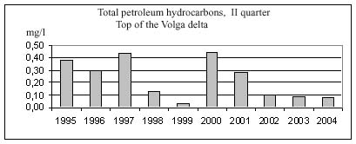
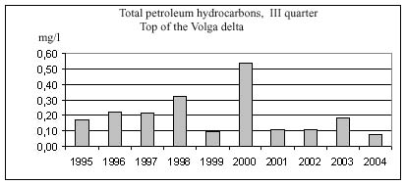
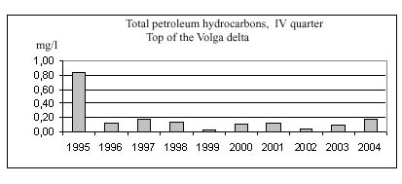
Figure 3.1 Inter-annual variability of PHs concentration (mg/l) in water by observation data of Roshydromet implemented in the Volga delta apex

Both seasonal and spatial variability of PHs concentration in the Volga delta water is significant (Figure 3.2). The major peculiarity of seasonal variability is reduction of PHs in late summer and significant increase during autumn period of low water (4th quarter) observed practically in all areas of the Volga delta. Spatial variability is less vivid than timing variability. The exclusion is the evident reduction of PHs concentration in main watercourses in the western part of delta from upper zone of delta toward its seashore line in autumn low-water period
eastern part

0.00
0.10
0.20
0.30
0.40
0.50
0.60
V
II
VI
VII
mg/l

western part  0.00  0.10  0.20  0.30  0.40  0.50  0.60  I  II  III  IV  mg/l | I quarter
western part  0.00  0.10  0.20  0.30  0.40  0.50  0.60  I  II  III  IV  mg/l  western part  0.00  0.10  0.20  0.30  0.40  0.50  0.60  I  II  III  IV  mg/l | II quarter | eastern part  0.00  0.10  0.20  0.30  0.40  0.50  0.60  V  II  VI  VII  mg/l
 | III quarter | eastern part  0.00  0.10  0.20  0.30  0.40  0.50  0.60  V  II  VI  VII  mg/l
western part  0.00  0.10  0.20  0.30  0.40  0.50  0.60  I  II  III  IV  mg/l  l  eastern part  0.00  0.10  0.20  0.30  0.40  0.50  0.60  V  II  VI  VII  mg/l | IV quarter

Figure 3.2 Seasonal and spatial variability of PHs concentration in water of pre-estuarial part and delta of Volga according to data of observations implemented on Roshydromet stations in 1995-2004
Notes: 1). Roman numerals here show elements of pre-estuarial part and delta of Volga: I – pre-estuarial part, Volga River; II - delta apex; III – upper zone of the western part of delta (corresponds to the area I in Figure 1.3); IV – central zone of the western part of delta (corresponds to the area II in Figure 1.3); V – pre-estuarial part of the Akhtuba River; VI – upper zone of the eastern part of delta (corresponds to the area V in Figure. 1.3); VII – central zone of the eastern part of delta (corresponds to the area VI in Figure 1.3).
2). Similar marking is used in further figures of this section.

3.1.2 Phenols
During 1995-2004 the average concentration of phenols in water of the Volga delta constituted 0.004 mg/l. Its values were almost similar which denotes conservative features of these substances. Their content in water does not depend on natural and anthropogenic conditions varying widely in different area of the Volga delta.
Pattern of inter-annual variability of phenol concentrations in water in the Volga delta apex indicates reduction of the content level over the recent years in all observation seasons (Figure 3.3). Maximum average quarterly values were observed in 1997 and 1999, and before that edge there was some increase in values observed and after it – decline.

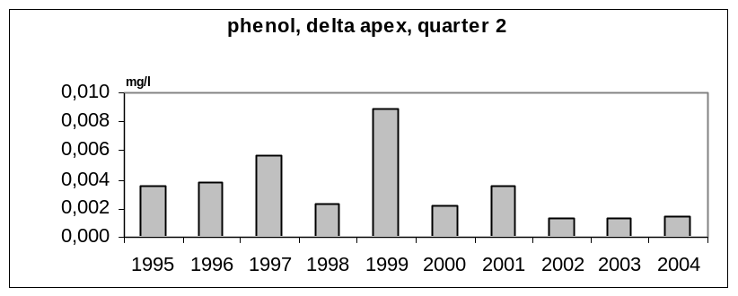
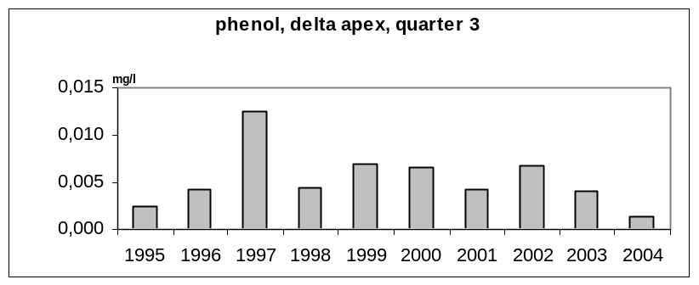
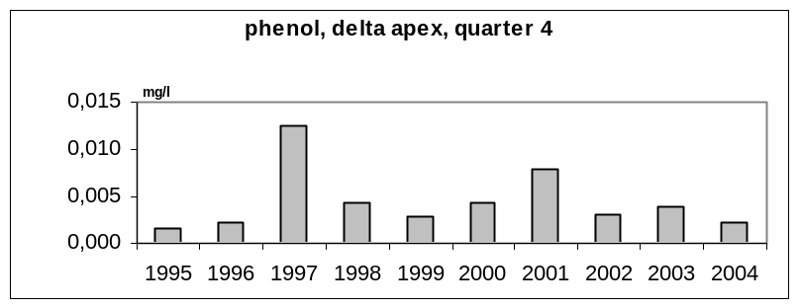

Figure 3.3 Inter-annual variations of phenol concentrations (mg/l) in water in the Volga delta apex according to observation data of Roshydromet

Based on diagrams presented in the figure the conclusion is that major peculiarity of seasonal variability of phenol concentrations in water of the Volga delta is increase in phenol content in summer period of low water (quarter 3) observed practically in all areas of the Volga delta (Figure 3.4). Spatial variability is expressed insignificantly.
western part
0.000
0.002
0.004
0.006
0.008
0.010
I
II
III
IV
mg/l
eastern part
0.000
0.002
0.004
0.006
0.008
0.010
V
II
VI
VII

mg/l

 | Quarter I
western part  0.000  0.002  0.004  0.006  0.008  0.010  I  II  III  IV  mg/l | Quarter II | eastern part  0.000  0.002  0.004  0.006  0.008  0.010  V  II  VI  VII  mg/l
western part  0.000  0.002  0.004  0.006  0.008  0.010  I  II  III  IV  mg/l | Quarter III | eastern part  0.000  0.002  0.004  0.006  0.008  0.010  V  II  VI  VII  mg/l
western part  0.000  0.002  0.004  0.006  0.008  0.010  I  II  III  IV  mg/l | Quarter IV | eastern part  0.000  0.002  0.004  0.006  0.008  0.010  V  II  VI  VII  mg/l

Figure 3.4 Seasonal and spatial variability of phenol concentrations (mg/l) in water of pre-estuarial area and delta of Volga according to data of observations conducted on Roshydromet stations in 1995-2004

3.1.3. Detergents
In 1995-2004 the average concentration of detergents in water of the Volga delta constituted 0.03 mg/l. In most areas the average concentration of detergents in water also amounted to 0.03 mg/l. It was some higher only in the Akhtuba River (0.04 mg/l) and lower to some extent in the eastern part of the upper zone of delta (0.02 mg/l). Inter-annual variability of concentration of detergents was not researched due to lack of measurements to compile annual data arrays.
Major peculiarity of seasonal variability of concentration of detergents in the Volga delta water is increase of their content during flood (quarter 2) and decline during the next seasons of a year. The lowest values are observed in winter period of low water (quarter 1). In the eastern part of the Volga delta the highest concentration of detergents in water is usually observed in the central zone and the lowest in the upper zone. In the western part of the Volga delta during first half of the year the concentration detergents in the central zone and in the delta apex are the same. In summer low-water period the concentration detergents declines from the apex downstream to the central zone and in autumn low-water period it on the contrary increases.

3.1.4 Heavy metals
Iron. In 1995-2004 the average concentration of dissolved iron in water of the Volga delta constituted 0.19 mg/l. Lower than that value the iron concentration was only in the Akhtuba River as well as in the western part of the upper zone of delta where it amounted to 0.17 mg/l. The highest average value (0.20 mg/l) was reported in the eastern part of the central zone of delta. Increase in iron concentration is observed in water of the Kigach canal in comparison with the Akhtuba River that feeds the Kigach canal. Also increase in iron concentration is noted in watercourses of the central zone in comparison with watercourses of the upper zone of delta.
The pattern of inter-annual variability of dissolved iron concentration in water of the Volga delta is given due to lack of measurements to compile annual data arrays.
Major peculiarity of seasonal variability is reduction of iron concentration in water in winter period of low-water (quarter 1) observed in most areas of the Volga delta (Figure 3.6). Spatial variability is expressed insignificantly but its following features may be noted: a) higher iron concentration in watercourses in the eastern part in comparison with watercourses in the western part of delta; b) during flood (quarter 2) the highest iron concentration in water is observed in the central zone of delta and during next periods of low water in summer and autumn the areas with higher iron concentration shift toward the Volga delta apex.
western part
0.00
0.05
0.10
0.15
0.20
0.25
0.30
I
II
III
IV
mg/l

eastern part
0.00
0.05
0.10
0.15
0.20
0.25
0.30
V
II
VI
VII
mg/l

 | Quarter I
western part  0.00  0.05  0.10  0.15  0.20  0.25  0.30  I  II  III  IV  mg/l | Quarter II | eastern part  0.00  0.05  0.10  0.15  0.20  0.25  0.30  V  II  VI  VII  mg/l
western part  0.00  0.05  0.10  0.15  0.20  0.25  0.30  I  II  III  IV  mg/l | Quarter III | eastern part  0.00  0.05  0.10  0.15  0.20  0.25  0.30  V  II  VI  VII  mg/l
western part  0.00  0.05  0.10  0.15  0.20  0.25  0.30  I  II  III  IV  mg/l | Quarter IV | eastern part  0.00  0.05  0.10  0.15  0.20  0.25  0.30  V  II  VI  VII  mg/l

Figure 3.6 Seasonal and spatial variability of iron concentration (mg/l) in water of pre-estuarial part and delta of Volga according to data of observations implemented on Roshydromet stations in 1995-2004

Zinc. In 1995-2004 the average concentration of dissolved zinc in the Volga delta water constituted 36.9 mkg/l. The highest positive deviation of zinc concentration value average for the area from the value average for the entire delta of Volga was reported in the Akhtuba River where the concentration constituted 40.7 mkg/l. Close to the average value was concentration of zinc in water in the delta apex while in the upper zone it declined down to 34.6 mkg/l and in the central zone it increased again up to 37.4 mkg/l. Differences in zinc content in water between western and eastern parts of delta were not observed.
The pattern of inter-annual variability of zinc concentration in water in the Volga delta may be considered on a basis of data of observations conducted in its apex (Figure 3.7). In 1995-1999 zinc content in water changed randomly. In 2000 and 2001 low concentration of zinc in water was observed. Then the rapid increase of zinc concentration happened in 2002 and steady decline during the following two years.

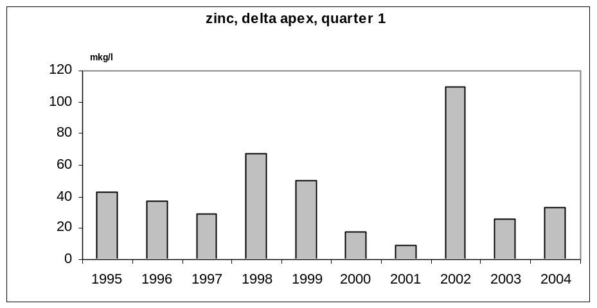
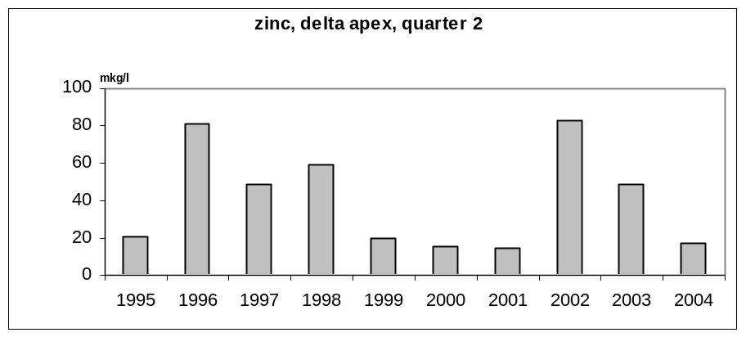
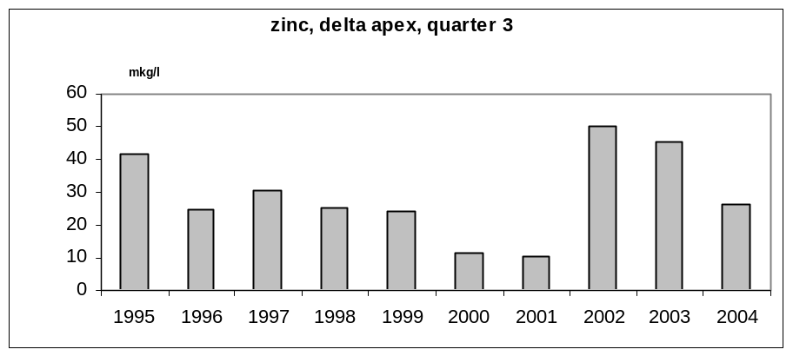
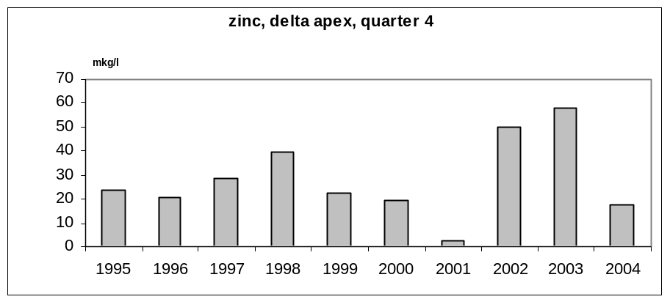
Figure 3.7 Inter-annual variations of zinc concentration (mkg/l) in water in the Volga delta apex according to observation data of Roshydromet

Major peculiarity of seasonal variability of zinc concentration in the Volga delta water is its increase in winter period of low-water (quarter 1) observed in most areas of the Volga delta (Figure 3.8). Spatial distribution is expressed insignificantly, however higher concentration of zinc may be noted in water of central zone of delta in winter low-water period (quarter 1) and shifting of zone with higher concentrations to the delta apex during the following seasons of the year.

western part  0  10  20  30  40  50  60  I  II  III  IV  mkg/l | Quarter I | eastern part  0  10  20  30  40  50  60  V  II  VI  VII  mkg/l
western part  0  10  20  30  40  50  60  I  II  III  IV  mkg/l | Quarter II | eastern part  0  10  20  30  40  50  60  V  II  VI  VII  mkg/l
western part  0  10  20  30  40  50  60  I  II  III  IV  mkg/l | Quarter III | eastern part  0  10  20  30  40  50  60  V  II  VI  VII  mkg/l
western part  0  10  20  30  40  50  60  I  II  III  IV  mkg/l | Quarter IV | eastern part  0  10  20  30  40  50  60  V  II  VI  VII  mkg/l

Figure 3.8 Seasonal and spatial variability of zinc concentration (mkg/l) in water of pre-estuarial part and delta of Volga according to data of observations implemented on Roshydromet stations in 1995-2004

Copper. In 1995-2004 the average concentration of dissolved copper in water in the Volga delta constituted 5.97 mkg/l. The highest positive deviation of copper concentration value average for the area from the value average for the entire delta of Volga was recorded in the delta apex where the concentration constituted 6.56 mkg/l. Close to the average value was concentration of copper in water in the Akhtuba River. The lowest concentrations of copper in water were reported in the eastern part, and in the central zone the copper concentration was 5.04 mkg/l. In the western part of delta copper concentration in water was in general higher than that in the eastern part but lower than in the delta apex. Thus, for instance, in the upper zone it constituted 6.30 mkg/l.
Based on data of multi-annual observations over copper concentration in water in the Volga delta apex in 1995-2004, rare but rather essential surges of copper content in water occurred in some years which was especially typical for winter periods of low water and floods (Figure 3.9). The most remarkable increase in copper concentration was observed from summer low water period in 2001 until flood in 2002. Attention is paid to the declining trend of copper concentration in water in 1995-2000 and some increase in 2004. The pattern of inter-annual variability indicates the “volley” entrance of copper into the river in the Upper and Central parts of the Volga basin.

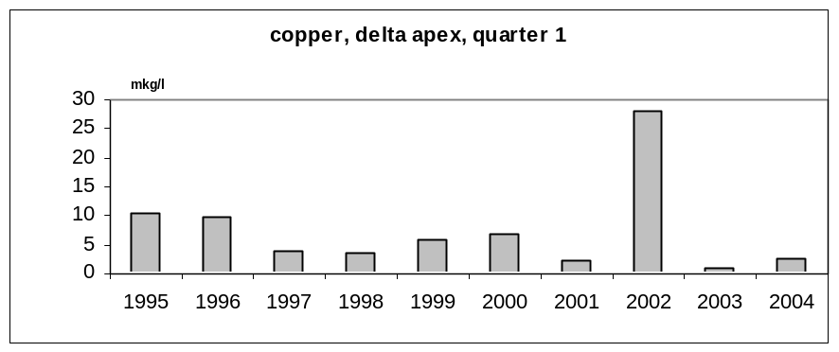
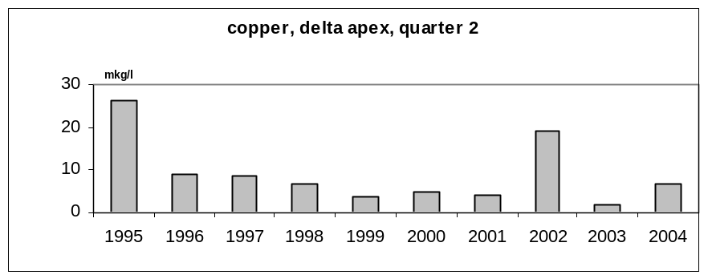
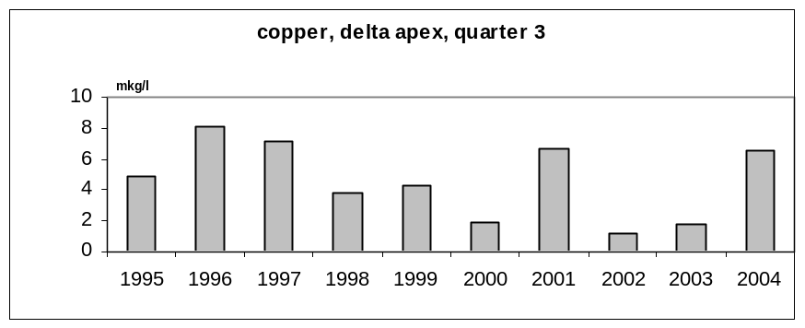
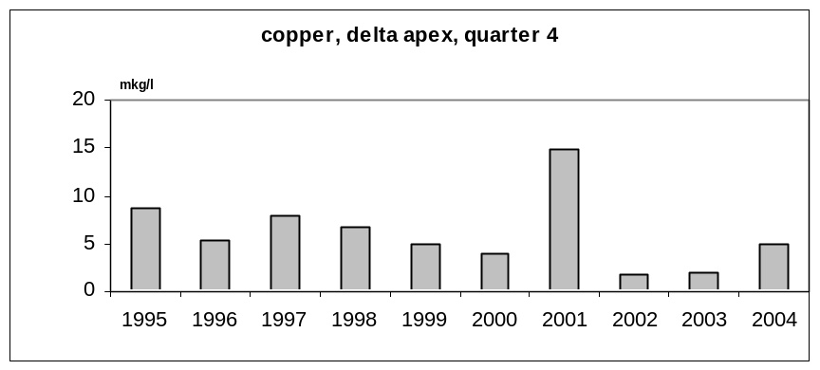

Figure 3.9 Inter-annual variations of copper concentration (mkg/l) in water in the Volga delta apex according to observation data of Roshydromet

Major peculiarity of seasonal variability of copper concentration in water in the Volga delta is its increase during flood in quarter 2 and the evident decline in summer period of low-water in quarter 3 (Figure 3.10). Spatial heterogeneity is apparent in relative decrease in copper concentration in water in the central zone of delta.

western part  0.0  2.0  4.0  6.0  8.0  10.0  I  II  III  IV  mkg/l | Quarter I  eastern part  0.0  2.0  4.0  6.0  8.0  10.0  V  II  VI  VII  mkg/l
western part  0.0  2.0  4.0  6.0  8.0  10.0  I  II  III  IV  mkg/l | Quarter II | eastern part  0.0  2.0  4.0  6.0  8.0  10.0  V  II  VI  VII  mkg/l
western part  0.0  2.0  4.0  6.0  8.0  10.0  I  II  III  IV  mkg/l | Quarter III | eastern part  0.0  2.0  4.0  6.0  8.0  10.0  V  II  VI  VII  mkg/l
western part  0.0  2.0  4.0  6.0  8.0  10.0  I  II  III  IV  mkg/l | Quarter IV | eastern part  0.0  2.0  4.0  6.0  8.0  10.0  V  II  VI  VII  mkg/l
Figure 3.10 Seasonal and spatial variability of copper concentration (mkg/l) in water of pre-estuarial part and delta of Volga according to data of observations implemented on Roshydromet stations in 1995-2004

Manganese. Due to lack of data it is impossible to characterize in full the spatial and timing variability of manganese concentration in water in the Volga delta. The information presented in Figure 3.11 allows considering some of its features. Thus, based on observation data on the Akhtuba River covering all seasons the average manganese concentration in water there constitutes 1.91 mkg/l. The highest manganese concentration (4.46 mkg/l) in water in the Akhtuba River was reported in winter low-water period and the minimum concentration amounting to 0.74 mkg/l was observed in summer period of low-water. During flood the decline in manganese concentration was noted in water in the western part of the central zone in comparison with the delta apex.
western part  0.0  1.0  2.0  3.0  4.0  5.0  I  II  III  IV  mkg/l  western part  0.0  1.0  2.0  3.0  4.0  5.0  I  II  III  IV  mkg/l | Quarter I | eastern part  0.0  1.0  2.0  3.0  4.0  5.0  V  II  VI  VII  mkg/l
 | Quarter II | eastern part  0.0  1.0  2.0  3.0  4.0  5.0  V  II  VI  VII  mkg/l
western part  0.0  1.0  2.0  3.0  4.0  5.0  I  II  III  IV  mkg/l | Quarter III |  | eastern part  0.0  1.0  2.0  3.0  4.0  5.0  V  II  VI  VII  mkg/l
western part  0.0  1.0  2.0  3.0  4.0  5.0  I  II  III  IV  mkg/l | Quarter IV |  | eastern part  0.0  1.0  2.0  3.0  4.0  5.0  V  II  VI  VII  mkg/l

Figure 3.11 Seasonal and spatial variability of manganese concentration (mkg/l) in water of pre-estuarial part and delta of Volga according to data of observations implemented on Roshydromet stations in 1995-2004

Nickel. Due to lack of data it is impossible to characterize in full the spatial and timing variability of nickel concentration in water in the Volga delta. The information presented in Figure 3.12 allows considering some of its features. Thus, based on observation data on the Akhtuba River which cover all seasons the average nickel concentration in water thereconstitutes 6.52 mkg/l. The highest nickel concentration (9.25 mkg/l) in water in the Akhtuba River was reported in winter low-water period and the minimum concentration amounting to 3.33 mkg/l was observed in autumn low-water period. In summer and autumn low-water periods the decline in nickel concentration was noted in water in the western part of the central zone in comparison with the delta apex.

western part  0.0  2.0  4.0  6.0  8.0  10.0  I  II  III  IV  mkg/l | Quarter I | eastern part  0.0  2.0  4.0  6.0  8.0  10.0  V  II  VI  VII  mkg/
western part  0.0  2.0  4.0  6.0  8.0  10.0  I  II  III  IV  mkg/ | Quarter II | eastern part  0.0  2.0  4.0  6.0  8.0  10.0  V  II  VI  VII  mkg/
western part  0.0  2.0  4.0  6.0  8.0  10.0  I  II  III  IV  mkg/ | Quarter III | eastern part  0.0  2.0  4.0  6.0  8.0  10.0  V  II  VI  VII  mkg/
western part  0,0  2,0  4,0  6,0  8.0  10.0  I  II  III  IV  mkg/ | Quarter IV | eastern part  0.0  2.0  4.0  6.0  8.0  10.0  V  II  VI  VII  mkg/
Figure 3.12 Seasonal and spatial variability of nickel concentration (mkg/l) in water of pre-estuarial part and delta of Volga according to data of observations implemented on Roshydromet stations in 1995-2004

Chrome. Due to lack of data it is impossible to characterize in full the spatial and timing variability of chrome concentration in water in the Volga delta. The information presented in Figure 3.13 allows considering some of its features.
Thus, based on observation data on the Akhtuba River which cover all seasons of the year the average chrome concentration in water thereconstitutes 1.07 mkg/l. The highest chrome concentration (1.65 mkg/l) in water in the Akhtuba River was reported in winter low-water period and the minimum amounting to 0.72 mkg/l was observed in autumn low-water period. In flood and summer low-water periods the decline in chrome concentration was noted in water in the western part of the central zone in comparison with the delta apex.

western part  0.0  0.5  1.0  1.5  2.0  I  II  III  IV  mkg/l | Quarter I | eastern part  0.0  0.5  1.0  1.5  2.0  V  II  VI  VII  mkg/l
western part  0.0  0.5  1.0  1.5  2.0  I  II  III  IV  mkg/l  western part  0.0  0.5  1.0  1.5  20  I  II  III  IV  mkg/l | Quarter II | eastern part  0.0  0.5  1.0  1.5  2.0  V  II  VI  VII  mkg/l
 | Quarter III | eastern part  0.0  0.5  1.0  1.5  2.0  V  II  VI  VII  mkg/l  eastern part  0.0  0.5  1.0  1.5  2.0  V  II  VI  VII  mkg/l
western part  0.0  0.5  1.0  1.5  2.0  I  II  III  IV  mkg/l | Quarter IV
Figure 3.13 Seasonal and spatial variability of chrome concentration (mkg/l) in water of pre-estuarial part and delta of Volga according to data of observations implemented on Roshydromet stations in 1995-2004

Cobalt. Lack of data does not allow implementation of full characteristics of the spatial and timing variability of cobalt concentration in water in the Volga delta. Results of observations covering all seasons of the year carried out on the Akhtuba River allow revealing some of its features. The average cobalt concentration in water thereconstitutes 2.48 mkg/l (Figure 3.14). The highest cobalt concentration (4.09 mkg/l) in water in the Akhtuba River was reported in winter low-water period and the minimum amounting to 0.90 mkg/l was observed during flood. In summer low-water period the decline in cobalt concentration was noted n water in the western part of the central zone in comparison with the delta apex.
western part  0.0  1.0  2.0  3.0  4.0  5.0  I  II  III  IV  mkg/l |  |  | Quarter I  eastern part  0.0  1.0  2.0  3.0  4.0  5.0  V  II  VI  VII  mkg/l
western part  0.0  1.0  2.0  3.0  4.0  5.0  I  II  III  IV  mkg/l |  |  | Quarter II  eastern part  0.0  1.0  2.0  3.0  4.0  5.0  V  II  VI  VII  mkg/l
western part  0.0  1.0  2.0  3.0  4.0  5.0  I  II  III  IV  mkg/l |  | Quarter III |  |  | eastern part  0.0  1.0  2.0  3.0  4.0  5.0  V  II  VI  VII  mkg/l
western part  0,0  1,0  2,0  3,0  4,0  5,0  I  II  III  IV  mkg/l | Quarter IV |  |  | eastern part  0,0  1,0  2,0  3,0  4,0  5,0  V  II  VI  VII  mkg/l

Figure 3.14 Seasonal and spatial variability of cobalt concentration (mkg/l) in water of pre-estuarial part and delta of Volga according to data of observations implemented on Roshydromet stations in 1995-2004
Lead. Due to lack of data it is impossible to characterize in full the spatial and timing variability of lead concentration in the Volga delta water. The information presented in Figure 3.15 allows considering some of its features.
Thus, based on observation data on the Akhtuba River which cover all seasons of the year the average lead concentration in water thereconstitutes 1.96 mkg/l. The highest lead concentration (2.56 mkg/l) in the Akhtuba River water was reported during flood and the minimum amounting to 1.21 mkg/l was observed in autumn period of low water. During flood the increase in lead concentration was noted in water in the western part of the central zone in comparison with the delta apex.

western part  0.0  0.5  1.0  1.5  2.0  2.5  3.0  I  II  III  IV  mkg/l | Quarter I  eastern part  0.0  0.5  1.0  1.5  2.0  2.5  3.0  V  II  VI  VII  mkg/l
western part  0.0  0.5  1.0  1.5  2.0  2.5  3.0  I  II  III  IV  mkg/l | Quarter II | eastern part  0.0  0.5  1.0  1.5  2.0  2.5  3.0  V  II  VI  VII  mkg/l
western part  0.0  0.5  1.0  1.5  2.0  2.5  3.0  I  II  III  IV  mkg/l | Quarter III | eastern part  0.0  0.5  1.0  1.5  2.0  2.5  3.0  V  II  VI  VII  mkg/l
western part  0.0  0.5  1.0  1.5  2.0  2.5  3.0  I  II  III  IV  mkg/l | Quarter IV | eastern part  0.0  0.5  1.0  1.5  2.0  2.5  3.0  V  II  VI  VII  mkg/l
Figure 3.15 Seasonal and spatial variability of lead concentration (mkg/l) in water of pre-estuarial part and delta of Volga according to data of observations implemented on Roshydromet stations in 1995-2004

Cadmium. Due to lack of data it is impossible to characterize in full the spatial and timing variability of cadmium concentration in the Volga delta water. The information presented in Figure 3.16 allows considering some of its features. Thus, based on observation data on the Akhtuba River which cover all seasons of the year the average cadmium concentration in water thereconstitutes 0.60 mkg/l. The highest cadmium concentration (0.73 mkg/l) in the Akhtuba River water was reported during winter period of low water and the minimum amounting to 0.37 mkg/l was observed in flood. During summer low-water period the decrease in cadmium concentration was noted in water in the western part of the central zone in comparison with the delta apex.
western part  0.0  0.2  0.4  0.6  0.8  1.0  I  II  III  IV  mkg/l |  |  | Quarter I  eastern part  0.0  0.2  0.4  0.6  0.8  1.0  V  II  VI  VII  mkg/l
western part  0.0  0.2  0.4  0.6  0.8  1.0  I  II  III  IV  mkg/l |  | Quarter II |  |  | eastern part  0.0  0.2  0.4  0.6  0.8  1.0  V  II  VI  VII  mkg/l
western part  0.0  0.2  0.4  0.6  0.8  1.0  I  II  III  IV  mkg/l | Quarter III |  |  | eastern part  0.0  0.2  0.4  0.6  0.8  1.0  V  II  VI  VII  mkg/l
western part  0.0  0.2  0.4  0.6  0.8  1.0  I  II  III  IV  mkg/l | Quarter IV |  |  | eastern part  0.0  0.2  0.4  0.6  0.8  1.0  V  II  VI  VII  mkg/l
Figure 3.16 Seasonal and spatial variability of cadmium concentration (mkg/l) in water of pre-estuarial part and delta of Volga according to data of observations implemented on Roshydromet stations in 1995-2004

Mercury. Due to lack of data it is impossible to characterize in full the spatial and timing variability of mercury concentration in the Volga delta water. The information presented in Figure 3.17 allows considering some of its features. Thus, based on data of observations implemented in the western part of delta which cover all seasons of the year the average mercury concentration in water thereconstitutes 0.05 mkg/l. The highest mercury concentration (0.08-0.09 mkg/l) in the western part of delta during flood and the minimum amounting to 0.02-0.03 mkg/l was observed in autumn period of low water. During both flood and summer period of low water the significant increase in mercury concentration was noted in water in the western part of the central zone in comparison with the delta apex.
western part  0.00  0.02  0.04  0.06  0.08  0.10  I  II  III  IV  mkg/l | Quarter I  eastern part  0.00  0.02  0.04  0.06  0.08  0.10  V  II  VI  VII  mkg/l
western part  0.00  0.02  0.04  0.06  0.08  0.10  I  II  III  IV  mkg/l | Quarter II | eastern part  0.00  0.02  0.04  0.06  0.08  0.10  V  II  VI  VII  mkg/l
western part  0.00  0.02  0.04  0.06  0.08  0.10  I  II  III  IV  mkg/l | Quarter III | eastern part  0.00  0.02  0.04  0.06  0.08  0.10  V  II  VI  VII  mkg/l
western part  0.00  0.02  0.04  0.06  0.08  0.10  I  II  III  IV  mkg/l | Quarter IV | eastern part  0.00  0.02  0.04  0.06  0.08  0.10  V  II  VI  VII  mkg/l
Figure 3.17 Seasonal and spatial variability of mercury concentration (mkg/l) in water of pre-estuarial part and delta of Volga according to data of observations implemented on Roshydromet stations in 1995-2004

3.1.5 Pesticides
α-HCH. In 1995-2004 in watercourse in the Volga delta 444 samplings were implemented to measure α-HCH concentration in water. Its presence was reported only in samples taken during flood in the western part of the upper zone of delta where the average concentration of α-HCH constituted 0.1 ng/l. Due to that the analysis of spatial and timing variability and assessment of flow were not implemented. It should be noted that according to observation data of Roshydromet in 1983-1986 the average α-ГХЦГ concentration in water in the Volga delta apex constituted 3 ng/l, and in 1990 unusually high concentration was recorded amounting to 55 ng/l [2]. Thus, during the recent decade the significant decrease in discharge of α-HCH in water was noted.
γ-HCH. In 1995-2004 the average γ-HCH concentration in the Volga delta water constituted 0.4 ng/l. In the Akhtuba River, in apex and western part of the upper zone of delta the average γ-HCH concentration constituted 0.3 ng/l; in the western part of the central zone it was equal to 0.2 ng/l. In the eastern part of the central zone of delta the average γ-HCH concentration was relatively high and constituted 0.7 ng/l. Patterns of seasonal variability of γ-HCH concentration in water in various areas differ significantly from each other (Figure 3.18). In the Akhtuba River and eastern part of delta the highest γ-HCH concentration in water is observed in winter low-water period while during flood it rapidly reduces. In the apex and western part of delta, on the contrary, the highest γ-HCH in water is observed during flood with its minimum in winter period of low water. The exclusion is the western part of the upper zone of delta where seasonal dynamics of γ-HCH concentration in water is similar to that of eastern part of delta.
western part  0  0  0.0  0.2  0.4  0.6  0.8  1.0  1.2  I  II  III  IV  ng/l | Quarter I | eastern part  0  0.0  0.2  0.4  0.6  0.8  1.0  1.2  V  II  VI  VII  ng/l
western part  0.0  0.2  0.4  0.6  0.8  1.0  1.2  I  II  III  IV  ng/l | Quarter II | eastern part  0  0.0  0.2  0.4  0.6  0.8  1.0  1.2  V  II  VI  VII  ng/l
western part  0.0  0.2  0.4  0.6  0.8  1.0  1.2  I  II  III  IV  ng/l | Quarter III | eastern part  0  0.0  0.2  0.4  0.6  0.8  1.0  1.2  V  II  VI  VII  ng/l
western part  0  0.0  0.2  0.4  0.6  0.8  1.0  1.2  I  II  III  IV  ng/l | Quarter IV | eastern part  0  0.0  0.2  0.4  0.6  0.8  1.0  1.2  V  II  VI  VII  ng/l
Figure 3.18 Seasonal and spatial variability of γ-HCH concentration (ng/l) in water of pre-estuarial part and delta of Volga according to data of observations implemented on Roshydromet stations in 1995-2004

DDT. In 1995-2004 the average concentration of DDT in the Volga delta water constituted 0.7 ng/l. In the Akhtuba River, apex and eastern part of the central zone of delta the average DDT concentration constituted 0.7-0.8 ng/l. In the western part of the upper zone of delta it was equal to 1.0 ng/l. Relatively low average concentration of DDT was observed in the western part of the central zone of delta where it constituted 0.3 ng/l.
The pattern of inter-annual variability of DDT concentration in the Volga delta water is not described due to lack of measurements for compiling annual data arrays. Information about seasonal and spatial variability of DDT concentration in the Lower Volga water is presented in Figure 3.19. Based on diagrams shown in the figure the conclusion is that patterns of seasonal variability of DDT concentration in water in various delta areas differ significantly from each other. In the Akhtuba River and eastern part of delta the highest DDT concentration like also γ-HCH concentration is observed in winter period of low-water. In the delta apex the highest DDT concentration is reported in summer low-water period and in the western part of delta – during flood.
 | Quarter I
western part  0  0  0  1  2  3  4  I  II  III  IV  ng/l |  | eastern part  0  0  1  2  3  4  V  II  VI  VII  ng/l

 | Quarter II
western part  0  1  2  3  4  I  II  III  IV  ng/l |  | eastern part  0  0  1  2  3  4  V  II  VI  VII  ng/l

 | Quarter III
western part  0  1  2  3  4  I  II  III  IV  ng/l |  | eastern part  0  0  1  2  3  4  V  II  VI  VII  ng/l

western part  0  0  0  0  1  2  3  4  I  II  III  IV  ng/l | Quarter IV | eastern part  0  0  0  0  1  2  3  4  V  II  VI  VII  ng/l

Figure 3.19 Seasonal and spatial variability of DDT concentration (ng/l) in water of pre-estuarial part and delta of Volga according to data of observations implemented on Roshydromet stations in 1995-2004

DDE. In 1995-2004 the average DDE concentration in the Volga delta water constituted 0.11 ng/l (data on the Volga River in the Volga-Akhtuba floodplain area and along the eastern part of the upper zone of the Volga delta were not used in calculation of the average concentration due to lack of sampling). In the central part of delta DDE concentration in water constituted 0.10 ng/l. Upstream the river it increased up to 0.25 ng/l in the western part of the upper zone and 0.15 ng/l in the delta apex. The lowest average value equal to 0.5 ng/l was recorded in the Akhtuba River.
The pattern of inter-annual variability of DDE concentration in the Volga delta water is not described due to lack of measurements for compiling annual data arrays. Major feature of seasonal variability of DDE concentration in water is its increase in winter low-water period (Figure 3.20). In summer and autumn periods of low-water the average DDE concentration in water was as a rule lower than determination limit of chemical analysis method applied. Regarding spatial variability, the highest DDE concentrations were usually observed in the delta apex (winter low-water period) or in the western part of the upper zone (flood).

western part  0.0  0.2  0.4  0.6  0.8  I  II  III  IV  ng/l | Quarter I | eastern part  0.0  0.2  0.4  0.6  0.8  V  II  VI  VII  ng/l

western part  0  0.0  0.2  0.4  0.6  0.8  I  II  III  IV  ng/l | Quarter II | eastern part  0  0  0  0  0.0  0.2  0.4  0.6  0.8  V  II  VI  VII  ng/l
western part  0  0  0  0  0.0  0.2  0.4  0.6  0.8  I  II  III  IV  ng/l | Quarter III | eastern part  0  0  0.0  0.2  0.4  0.6  0.8  V  II  VI  VII  ng/l

western part  0  0  0  0,0  0,2  0,4  0,6  0,8  I  II  III  IV  ng/l | Quarter IV | eastern part  0  0  0  0,0  0,2  0,4  0,6  0,8  V  II  VI  VII  ng/l

Figure 3.20 Seasonal and spatial variability of DDE concentration (ng/l) in water of pre-estuarial part and delta of Volga according to data of observations implemented on Roshydromet stations in 1995-2004

Hence, according to data of operative observations conducted in 1995-2004 on Roshydromet stations in the pre-estuarial part and deltas of Volga the level of average concentrations of dissolved pollutants in water constituted: for chlorinated pesticides - tenth of nanogram per liter of water; for mercury – hundredth of microgram; for cadmium – tenth of microgram; for metals Cu, Mn, Ni, Cr, Co, Pb – units of micrograms; for zinc – the first tens of micrograms; for iron – the first two hundreds of micrograms; for phenols – the thousandth of milligram; for detergents – hundredth of milligram; for petroleum hydrocarbons – tenth of milligram (Table 3.1).
The highest concentration of pollutants is usually observed in winter period of low water and the minimal in summer or autumn low-water periods. As a rule, the spatial variability is expressed less than seasonal. Patterns of spatial and timing variability of various pollutants differ from each other which indicate their different migration ways in watercourses in the Volga delta.

Table 3.1
Spatial and timing variability of pollutant concentrations in the Volga delta water according to data of observations conducted on Roshydromet stations in 1995-2004

Pollutant,  unit | Concentration
Pollutant,  unit | Average for the entire area | Maximal average |  |  |  | Minimal average
Pollutant,  unit | Average for the entire area | By areas |  | By seasons |  | By areas |  | By seasons
Pollutant,  unit | Average for the entire area | Concen  traion | Area** | Concen  traion | Quarter | Concen  traion | Area ** | Concen  traion | Quarter
PH, mg/l | 0.20 | 0.23 | VI (CZep) | 0.27 | IV | 0.16 | V (UZep) | 0.14 | III
Phenols, mg/l | 0.004 | = |  | 0.005 | III | = |  | 0.004 | I. II. IV
Detergents, mg/l | 0.03 | 0.04 | Akhtuba | 0.04 | II | 0.02 | V (UZep) | 0.02 | I. IV
Iron, mkg/l | 190 | 200 | VI (CZep) | 200 | II. IV | 170 | Akhtuba | 160 | I. III
Zinc, mkg/l | 36.9 | 40.7 | Akhtuba | 39.9 | I | 34.6 | V (UZep) | 32.3 | IV
Copper, mkg/l | 6.0 | 6.6 | DA | 8.1 | II | 5.0 | VI (CZep) | 3.9 | III
Manganese, mkg/l | 1.9* | – | – | 4.5* | I | – | – | 0.8* | III
Nickel, mkg/l | 6.5* | – | – | 9.3* | I | – | – | 3.3* | IV
Chrome, mkg/l | 1.1* | – | – | 1.7* | I | – | – | 0.7* | IV
Cobalt, mkg/l | 2.5* | – | – | 4.1* | I | – | – | 0.8* | II
Lead, mkg/l | 2.0* | – | – | 2.6* | III | – | – | 1.2* | IV
Cadmium, mkg/l | 0.6* | – | – | 0.7* | I | – | – | 0.4* | II
Mercury, mkg/l | 0.05* | – | – | 0.07* | II | – | – | 0.02* | IV
gamma-HCH, ng/l | 0.4 | 0.7 | VI (CZep) | 0.5 | I | 0.2 | II (CZwp) | 0.2 | IV
DDT, ng/l | 0.7 | 1.0 | I (UZwp) | 1.4 | I | 0.3 | II (CZwp) | 0.0 | IV
DDE, ng/l | 0.1 | 0.3 | I (UZwp) | 0.3 | I | 0.0 | Akhtuba | 0.0 | IV

Note 1) sign “=” means that concentration in all areas is equal; 2) sign “–“ indicates the lack of data for assessment of spatial variability; 3) * for assessment of average concentration and seasonal variability the data on one area only were used ; 4) DA – delta apex; UZ – upper zone of delta; CZ – central zone of delta; ep – eastern part; wp – western part; 5) ** - Roman numeral means the number of area in accordance with Figure 1.3.

3.2. Pollution of the Volga delta water according to data of SOI and IWP expeditionary research

3.2.1. Petroleum hydrocarbons
During expeditions conducted by SOI in 1993-2002 for investigation of pollution level of water and bottom sediments in the Volga delta and shallow area of the Northern Caspian 71 samples of fluvial water were selected and analyzed in order to determine the content of petroleum hydrocarbons (Annex, Table 3.6). The work was implemented during three summer months and only in 2000 the expedition was carried out in October.
The average PH concentration for all years constituted 0.039 mg/l (0.8 MAC, Annex, Table 3.7). Maximum value was 0.18 mg/l (3.6 MAC) that was recorded in late June 2001 at the beginning of marine part of the Volga-Caspian Canal. Although seasonal dynamics cannot be identified based on data obtained the attention should be paid to essentially higher average values of PH content in June and July (0.063 and 0.060 mg/l respectively) than they were in August and October (0.014 and 0.020 mg/l).
Pollution with petroleum hydrocarbons in all areas of the Volga delta was approximately at the same level (Figure 1.3, Table 3.2). Concentration higher than for the entire delta was on sites in its western part near the very apex (section I) as well as close to the delta seashore line and the estuarial seashore zone (sections III and IV). The eastern part of delta in general was cleaner.

Table 3.2
Average concentration of petroleum hydrocarbons (mg/l) in water in various areas of the Volga delta according to results of SOI expeditions in 1993-2002

Delta area | June | July | August | October | Average
I | 0.120 | 0.140 | 0.020 |  | 0.093
II |  |  | 0.030 |  | 0.030
III | 0.067 | 0.040 | 0.020 |  | 0.043
IV | 0.081 | 0.105 | 0.011 | 0.023 | 0.055
VI |  | 0.043 | 0.015 |  | 0.029
VII | 0.052 |  | 0 |  | 0.026
VIII | 0.044 | 0.058 | 0.010 | 0.012 | 0.031
Average | 0.063 | 0.060 | 0.014 | 0.020

According to data of IWP for 1990-2003, the content of petroleum hydrocarbons in water of the Volga main course varied widely. In 1990 the average PH concentration was at the level of 6 MAC, the following year its decline occurred down to 1 MAC. Similar level of pollution with petroleum hydrocarbons (3 MAC) was reported in 1992 and 1993. In 1995 and 1996 the average annual PH content in river water did not exceed 1 MAC. Maximum concentration amounting to 70 MAC was observed near the Verkhneye Lebyazhye village in April 28-30, 2000.
Observations showed that the main amount of PH arrives with surface run-off. Water samples from the near-surface layer are more contaminated with PH than near-bottom samples.
The water entering the Astrakhan oblast changes as it runs under the influence of various factors. Self-purification of water occurs as a result of sorption processes and absorption by hydrobionts. Shipping, impact of oil-loading plants and outflows of petroleum hydrocarbons cause deterioration of water quality. As a consequence river sites are identified contaminated more or less with petroleum hydrocarbons. For example, in 1991 on the site near the Chernyi Yar settlement the decrease in PH content was noted down to 1 MAC, then during the following years some increase took place and then another decrease to 1 MAC in 1995; maximum concentrations at that time were 1.5 MAC in July 1994 and September 1995.
On the site located downstream nearby the Tsagan-Aman village variations of PH content in water were similar; however in 1993 the increase of average annual concentration up to 4 MAC was noted caused by local pollution of water area. Later the maximum concentrations constituted 3 MAC in June 1994 and March 1995.
On the site near the Verkhneye Lebyazhye village the dynamics of PH content variations over the period under consideration is similar to PH variation pattern on sites upstream. Maximum concentrations in 1994 and 1995 were in April and constituted 3 and 6 MAC respectively.
High level pf PH content was recorded on the site near the Ilyinka village in 1991 and 1993. In 1994, maximum PH concentrations were observed in July in surface layer in the middle of the river (15 MAC) and in August on river surface at the right and left banks (5 MAC). In 1995-2002 the maximum content of petroleum products (3 MAC) was noted in May near the Astrakhan Cellulose Paperboard Plant (ACPP) and near the Ilyinka village.
Economic activity of the Akhtubinsk town and Astrakhan Gas Industrial Complex impacts the content of petroleum hydrocarbons. Regardless of the fact that upper parts of the river are characterized by low PH content, in the water area near Akhtubinsk the increased of PH up to 2 MAC was observed which in turn affected the sites downstream.
The content of petroleum products in the Volga delta water is impacted by emergency conditions related to the oil spills, discharges of water not treated properly from treatment plants, intensive shipping and secondary pollution. Complicated system of sources of petroleum hydrocarbons entering the Volga water causes irregular and often unpredictable level of their concentrations. Both timing dynamics of pH distribution by years and seasons and their spatial distribution have complicated character. Nevertheless, a trend to decline in petroleum products is observed in the Volga delta. The change of pollution pattern resulted mainly from the overall economic decline and related decrease of shipping operations and navigation as a whole, reduction of industrial and agricultural waste discharges.
Attention should be paid to significant scatter of assessments of PH concentrations in the Volga delta water obtained from various sources. Data of IWP reports in general significantly higher levels of water pollution with PH, especially maximum values are remarkable: 70 MAC according to data of IWP and 3.6 MAC were revealed by SOI expedition. At that, differences in average annual values are less evident and in some years are practically the same at the level lower than 1 MAC. Apart from the natural difference in methods of sampling and sample processing applied the possible explanation may be the high “spottiness” of petroleum pollution. Local by space “spots’ of PH moving fast along the river course may be noted during expeditionary sampling and be a reason of extremely high pollution assessments but also may be not noticed. In the latter case more or less stable background of water area will be recorded formed due to continuous effective reasons such as biological decay of organic matter, waste and storm water discharges from cities and enterprises, permanent oil extraction and processing plants. In order to match the time scales of local pollution “spots” moving and the sampling interval it is necessary to envisage additional resources for recording these “spots”, for instance automatic sensors, laser scanning of water surface, etc.

3.2.2 Phenols
According to data of IWP in 1990-2002 the average concentration of volatile phenols (phenol, cresols, xylenols) in the Volga water varied within 103 MAC. Their content in water running from the Volgograd storage reservoir decreased constantly. In 1990-1992 phenol content level in all river sites constituted about 3 MAC. Since 1993 concentration of volatile phenols decreased in all water courses and its value did not exceed maximum allowed concentration values.
Near the Astrakhan Production Complex (APC) the level of phenol concentration is impacted by untreated water discharged from treatment plants. In river site near ACPP in 1994-2002 phenol concentration decreased down to minimum content and downstream from APC in the river site near the Ilyinka village it fixed at the level of 0.5 MAC. In the Akhtuba River over the entire period under consideration the average annual phenol concentrations did not exceed 0.001 mg/l (1 MAC). According to SOI data in October 2000 in the Belinski canalnear the 7th Ognyevka settlement (section VIII – estuarial seashore shallow zone of the eastern part of delta) phenol concentration both on surface and in bottom layer constituted 0.003 mg/l (3 MAC).
Considering the seasonal variations of phenol content in the Volga water its maximum is obvious in August-September. This relates to processes of biochemical decay and transformation of organic matters developing more intensively at higher temperature. Increase in phenol concentration due to decay of organic matter accumulated during summer period indicates to a great extent their natural origin.
Chlorinating of phenol-containing water during water preparation and treatment leads to creation of chlorophenols which toxicity is much higher that that of simple phenols volatile with steam. Even at concentration of 1 mkg/l chlorophenols give unpleasant taste and smell to water. According to data of SOI expedition in 1993-1996 chlorophenol concentration was determined in 44 water samples (Annex, Table 3.6). The average and maximum concentration of 3-chlorophenol 0.0006 and 0.0020 mg/l respectively; 2,4-dichlorophenol – 0.0011 and 0.0018 mg/l; 2,4,6-trichlorophenol – 0.0015 and 0.0050 mg/l; pentachlorophenol – 0.0006 and 0.0017 mg/l; 2- nitrophenol – 0.0002 and 0.0015 mg/l; 4- nitrophenol – 0.0017 and 0.0348 mg/l (35 MAC for phenol). In general all concentrations of phenol derivations were within the range from fractions to units of MAC for phenol (0.001 mg/l). The exclusion was the value recorded in the Kirovski canal near the Bukhtovyie islands (section IV) in June 1993 where extremely high value of 4- nitrophenol content in water amounting to 0.0348 mg/l was recorded. In other samples of the same expedition this phenol derivation was not revealed and in other years its concentration did not exceed 0.0021 mg/l. It should be noted that the maximum content of 2- nitrophenol amounting to 0.0015 mg/l was also recorded in that sample.
In the western part of delta the average concentrations of phenol derivations constituted: section III – 0.0014 mg/l; section IV – 0.0014 mg/l. In the eastern part of delta they were: section VI – 0.0007 mg/l; VII – 0.0016 mg/l; VIII – 0.0005 mg/l. Hence, based on data studied it is impossible to identify zones with higher concentrations of phenol derivations in the Volga delta. At the same time like in the case with petroleum hydrocarbons it may well be the appearance of local “spots” moving fast downstream the river. In order to fix such “spots” of high concentration of pollutants it is necessary to use the continuous recording technology and further point selection of samples as required.

3.2.3. Detergents
The major amount of detergents is distributed in the near-surface layer therefore samples selected from the near-surface layer are usually more enriched with detergents than from the near-bottom layer. Uneven distribution of detergents in river sites was noted in various seasons of the year. In 1994 maximum concentrations of detergents were observed on the bordersite near the Ushakovka village in May and July and constituted 0.102 mg/l (1 MAC) и 0.210 mg/l (2 MAC) respectively. During the same period increased water pollution with detergents was noted on the river sites near ACPP and Ilyinka village. In 1995 near the Ushakovka village concentration of detergents in April reached 0.122 mg/l. However that increase did not impact the content of those substances in other river sites where concentration of detergents did not exceed MAC. In 1996 in the main river sites of Volga the highest concentration of detergents was 0.09 mg/l. Over the recent years there were no cases of exceeding MAC in the Akhtuba River from the town of Akhtubinsk to the Seitovka village. In the Buzan river in 1995 content of detergents constituted 0.08 mg/l.
During SOI expedition in October 2000 detergents amounting to 0,038 mg/l were detected at the beginning of marine part of the Volga-Caspian Canal near the Iskusstvennyi island.

3.2.4 Pesticides
Pesticides of DDT group. During expeditions conducted by SOI within the Volga delta and in the shallow seashore area concentrations of DDT< DDE and DDD were detected on 34 stations in 1993-1996 (Annex, Table 3.6). Samples in various years were selected in all delta areas excluding sections I, II and V located in the apex and western part of delta (Figure 1.3).
The average concentration of DDT in the delta water constituted 1.58 ng/l, ДДЕ – 0,13 ng/l, ДДД – 0,19 ng/l. High value of the average DDT concentration depends to a great extent on maximum value of 34.8 ng/l (3.5 MAC) recorded in June 30, 1994 in the Olya port area in the Bakhtemir arm. Together with DDT in that sample the increased values of all pesticides of DDD group were detected (DDE – 2.6 ng/l, DDD – 3.6 ng/l) and HCH (α-HCH – 1.1 ng/l, γ-HCH – 9.7 ng/l).
Without taking into account that one extreme value all other DDT concentrations are within a narrow range from 0 to 4.1 ng/l, and the average value is 0.58 ng/l. Without considering maximums in that very sample DDE values are within 0 to 0.31 ng/l (average – 0.06 ng/l), and DDD – from 0 to 0.32 ng/l (average – 0.08 ng/l).
Most of all samples (12) were taken in section III. The average concentration of DDT there constituted 0.49 ng/l, DDE – 0.08 ng/l, DDD – 0.11 ng/l.
In section VI near the Zelenga village (Bushma arm in the eastern part of delta) samples were taken only in 1996 and the average value of DDT concentration in water was high – 3.82 ng/l, DDE – 0.03 ng/l, DDD – 0.17 ng/l.
In section VII located closer to the sea in the eastern part of the Volga delta (the beginning of the Igolkinski and Balinski canals) samples were selected only in 1993-1994. The average concentration of DDT constituted 0.45 ng/l, DDE – 0.04 ng/l, DDD – 0.11 ng/l.
On the very eastern part of the shallow estuary (section VIIIe) two samples ewere taken in 1993-1994 in the Igolkinski canal. Content of pesticides in water in general corresponded ti the values in the delta seashore line at the beginning of canals (section VIIc). The avergage concentration of DDT constituted 0.26 ng/l, DDE – 0.03 ng/l, DDD – 0,04 ng/l.
Some westward in section VIIId (the beginning of Belinski and Karaiski canals, the 7th and 12 th Ognyevka, hunting center and others) 7 samples were selected in 1993-1996. The average concentration of DDT constituted 0.19 ng/l, DDE – 0.01 ng/l, DDD – 0.02 ng/l.
In the western part of the shallow seashore (section IV) the average value of DDT was equal to 0.30 ng/l, DDE – 0.09 ng/l, DDD – 0,07 ng/l. Differences between the western and eastern parts of that area (section IVa – VCC, pass to section IIIa and the Iskusstvennyi island, and section IVb – the Kirovski canal, Bukhtovyie islands) were rather significant: the average concentration of DDT constituted 0.20 and 0.83 ng/l, DDE – 0.06 and 0.21 ng/l, DDD – 0.02 and 0.32 ng/l respectively. However, it should be taken into account that in the eastern part only one sample was taken in 1994 while in the western part there were 5 samples selected in 1995-1996. Such a small number of samples processed do not allow determination of differences between the Volga delta areas with confidence.
Concentration of DDT group pesticides was calculated only for three summer months. Small number of sampling did not allow identification of seasonal variations of pesticide concentrations. Also inter-annual dynamics was not revealed.

Pesticides of HCH group. In the Volga delta and shallow seashore areas the concentration values of α-HCH and γ-HCH were determined on 34 stations during SOI expeditions in 1993-1996 (Annex, Table 3.6). Samples in various years were selected in all delta areas excluding sections I, II and V located in the apex and western part of delta.
The average concentration of α-HCH in the delta water constituted 0.14 ng/l, γ-HCH – 0.32 ng/l. Maximum concentrations of α-HCH and γ-HCH constituted 1.1 ng/l and 9.7 ng/l respectively and were recorded in June 1994 in the Olya port area in the Bakhtemir arm.
Increased concentrations of pesticides were noted in the western part of delta: section II – 1.1 and 9.7 ng/l for α-HCH and γ-HCH respectively; section III – 0.13 and 0.005 ng/l; section IV – 0.18 and 0.07 ng/l.
In the eastern part of delta in section VI in July 1996 concentration of α-HCH on two stations was 0.12 and 0.22 ng/l, there also the content of γ-HCH was 0 and 0.06 ng/l. In section VII on the delta seashore line samples were taken only in 1993 and 1994; concentration of α-HCH varied from 0 to 0.12 ng/l; γ-HCH – from 0 to 0.06 ng/l. On the shallow seashore of the eastern part of delta (section VIII) values ranged within 0 and 0.17 ng/l, however high values were noted only at the beginning of observations. In later years the values did not exceed 0.02 ng/l. In the same section γ-HCH was never revealed, their content in water was outside the determination limits of the method of analysis applied.

3.2.5 Heavy metals
According to SOI data the distribution of iron ions in the main course of Volga in the Astrakhan oblast id characterized by increase in their concentration on river sites downstream in comparison with the upper border of delta. On the river parts from Chernyi Yar to Tsagan Aman the content of iron is two times more in comparison with the upper site. In the APC water area that impact is leveled but iron concentration still remains higher by several MAC than in the incoming water.
Distribution dynamics of iron ions in the Volga water in 1990-2002 allow the conclusion on maximum level of this metal content for all river sites in 1991. By 1996 pollution of the Volga River with iron became stable and constituted 2-3 MAC. Seasonal changes of iron content in the incoming water and in APC water are related to flood. Maximum concentrations were noted in March and June. Period of low water is characterized by minimum concentration values which relates to the decrease in volume of pollutants discharged from the Volgograd storage reservoir, intensification of sorption processes and absorption of iron by hydrobionts.
The average annual concentration of copper in the incoming water in 1990-2002 varies from 4 to 10 MAC. In recent years the increase in copper content is observed in the main course of the Volga River. The distribution pattern of copper ions by years on the river sites downstream is in general similar to their distribution on the border site near the Ushakovka village. However, on the overall stable background of 5-6 MAC some cases of increase in copper content were noted. For example, in the ACPP area in 1995 its content reached 9 MAC and in a sample taken from the near-bottom layer at the Kamennyi Yar village in 1996 it was 15 MAC. Pollution of the Akhtuba River with copper compounds is by 1-2 MAC lower than in the Volga River. By 1995 on all river sites from the town of Akhtubinsk to the Seitovka village that value constituted 4 MAC.
Zinc compounds enter the Astrakhan oblast with water from the Volgograd storage reservoir in amount some higher than maximum allowed values – 1.5 MAC on average. Seasonal character of zinc entrance is evident. During flood the concentration of zinc compounds is by 2-3 times higher than the average content of this element. The average annual level of the Volga water pollution with zinc over the recent years remains within 10-20 mkg/g (1-2 MAC) which is some lower than the average multi-annual assessment amounting to 37 mkg/l determined on a basis of multi-annual data of Roshydromet. Maximum values of zinc concentration were noted in April 1995 in the Akhtuba River amounting to 93 mkg/l and in the Buzan River – 104 mkg/l. In 1996 samples mostly polluted with zinc were selected in June near the Kamennyi Yar settlement with concentration of 3.5 MAC.
In watercourses in the Astrakhan oblast lead concentration is usually lower than standards determined. Nevertheless, recently the increase in lead ions is noted. Small but stable increase in comparison with the pollution level of the incoming water was reported in the main course of the Volga River and in delta water ways. Thus in 1996, lead concentration in the incoming water constituted 1.4 mkg/l while in the area near ACPP it was 20 mkg/l.
The average manganese concentration in watercourses in the Astrakhan oblast varies within 10-20 mkg/l depending on observation season, time and place of sampling. Those values exceed approximately by 5-10 times the average assessments of Roshydromet. Manganese concentration may vary in a wide range from 1 to 950 mkg/l (95 MAC). Seasonal variation character of manganese concentration is obvious. Thus in 1996, before the flood in all samples taken in the area from the Ushakovka village to Verkhneye Lebyazhie village the concentration of manganese ions did not exceed 2 mkg/l (0.2 MAC). After the flood started the water pollution with manganese increased and constituted 1 MAC. In June the exceed of maximum allowed values by 3 times was recorded (30 mkg/l)/ During the summer-autumn period of low water the content of manganese was fixed at the level of 5 mkg/l. As the main form of manganese ions migration is a suspended form, and during flood the increase in content of suspended substance occurs, so the manganese concentration increases respectively. That is especially typical for the Akhtuba River in the area near Akhtubinsk where the maximum concentrations of manganese ions were recorded.

Chapter 4 Pollution of suspended solids and bottom sediments in the delta and estuarial seashore shallow zone

Entrance of pollutants from water into bottom sediments is caused mainly by three processes: 1) diffusion of water into stratum of soils composing the bottom; 2) direct sorption of pollutants; 3) sedimentation of suspended solids sorbing pollutants. Bottom sediments on sites with low current accumulate significant amount of pollutants and in some places may transform into a peculiar storage. Observation results show that soils composing of predominantly fine-dispersed silt particles of organic origin posses the highest sorption feature. In most cases 50 % of silt bottom sediments (sand silt, grey silt, peaty silt, macrophyte sediments) are presented by fine-dispersed particles of size less than 50 mcm.
Research of pollution of bottom sediments and suspended solids in water in the Lower Volga was implemented during expeditionary works conducted by IWP in summer-autumn 1997-2002 (Figure 4.1). In the main course of the Volga River and delta arms on every river site there were 2-5 measuring stations. In the Akhtuba River, the Volga delta (except for the Bakhtemir River) and in estuarial seashore shallow zone, measurements and sampling were carried out on some stations located in typical areas close to sources of pollution or in natural complexes representing integral characteristics of hydrologo-morphological and ecological peculiarities of the site. Analysis of samples was implemented in analytical laboratories of Caspian Fisheries Research Institute (KaspNIRKh, Astrakhan) and Institute of Oceanology after P.P. Shirshov.

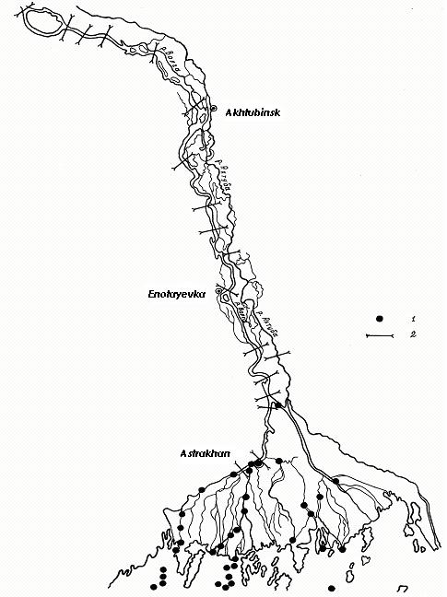
Figure 4.1 Layout of location of sampling stations (1) and river sites (2)

4.1. Pollution of suspended solids with metals
Research conducted by IWP in 1997 showed that significant amount of heavy metals in water in the Lower Volga is transported on suspended solids. Composition of suspended solids included the highest quantity of Fe and Al (Table 4.1). Elements which are not indicated in the table were observed in trace quantity in suspended solids. Content of Al was homogeneous in the entire part of the river with exclusion of upper zone nearby Volgograd. Similar distribution was typical also for Fe, Mn and to lesser extent for Pb. Concentration of Co, Ni, Cu, Zn and Mo on suspended solids was approximately the same on the entire investigated length of the river. Concentration of Co was the lowest and its distribution on the entire river length was characterized by the highest homogeneity. Content of suspended solids as such in water increased downstream starting from Volgograd. Similar situation was observed also in the delta watercourses below Astrakhan.
Table 4.1
Concentration (mcg/l) of metals in suspended solids in the Lower Volga water in 1997

Location of sampling | Date of sampling | С_{ss,} mg/l | Al | Mn | Fe | Co | Ni | Cu | Zn | Mo | Cd | Pb
V. Lebyazhye village (2986 km) | 18.09 | 10.8 | 145.3 | 16.1 | 275.4 | 6.4 | 7.2 | 8.6 | 6.6 | 8.4 | 1.93 | 15.2
Seroglazovka village (2935 km) | 19.09 | 14.4 | 152.1 | 18.2 | 337.8 | 7.7 | 6.9 | 9.1 | 8.3 | 7.8 | 1.85 | 15.2
Enotayevka village (Arbuznyi Yar, 2884 km) | 20.09 | 11.2 | 129.3 | 15.4 | 254.6 | 6.3 | 6.9 | 9.3 | 8.2 | 8.7 | 2.1 | 18.8
Tsagan Aman village (2830 km) | 20.09 | 8.1 | 143.1 | 17.9 | 235.5 | 6.5 | 7.3 | 8.8 | 7.1 | 7.8 | 1.96 | 19.4
Solyenoye Zaimishche village (2763 km) | 20.09 | 14.5 | 129.7 | 18 | 305.6 | 7.6 | 7.7 | 8.6 | 10.4 | 7.6 | 2.08 | 21
Voloviy Island (2705 km) | 22.09 | 1.7 | 20.1 | 6.5 | 22 | 5 | 7.1 | 10.2 | 8.9 | 7.9 | 1.83 | 6
Kamennyi Yar village (2660 km) | 23.09 | 7.2 | 68 | 10.1 | 124.5 | 5.2 | 7 | 9.7 | 6.2 | 7.8 | 1.76 | 10.3
Ushakovka village (2617 km) | 23.09 | 5 | 74.3 | 6.9 | 115 | 5 | 7 | 9.8 | 6.6 | 7.9 | 1.88 | 7
Svetlyi Yar village (2597 km) | 24.09 | 9.1 | 82.9 | 10.1 | 153.5 | 6.2 | 7.2 | 10.1 | 11.2 | 6.8 | 1.82 | 15.8
Tatianka village (2580 km) | 24.09 | 2.7 | 59.8 | 5.7 | 66.5 | 4.8 | 7.1 | 9.7 | 6.2 | 7.4 | 1.88 | 6
Volgograd (2545 km) | 24.09 | 2 | 39.5 | 5.2 | 49.8 | 5.1 | 7.8 | 10 | 6.6 | 7.7 | 1.92 | 5.9
V. Lebyazhye village (2986  km) | 04.10 | 26.8 | 147.1 | 22.8 | 465.4 | 8.7 | 6.7 | 8.4 | 3.1 | 8.1 | 2.17 | 16.3
Enotayevka settlement (Arbuznyi Yar, 2884 km) | 05.10 | 10.8 | 148.5 | 15.8 | 284.6 | 7 | 6.9 | 9.2 | 6.1 | 7.5 | 1.95 | 6.2
Voloviy Island (2705 km) | 05.10 | 4.5 | 60.2 | 6.4 | 88.2 | 5.1 | 7.5 | 9.2 | 5.5 | 7.8 | 1.88 | 8.8
Ushakovka village (2617 km) | 26.09 | 2.5 | 47.6 | 4.8 | 64.7 | 4.4 | 7.1 | 9.7 | 7.6 | 7.6 | 1.93 | 8.8

Pastukhova fishing site (source of Buzan river) | 29.09 | 10.9 | 165.4 | 16.6 | 303.2 | 7.2 | 7.2 | 8.7 | 5.9 | 7.6 | 1.99 | 10.6
Durnovski island (30 km above Astrakhan) | 29.09 | 8.8 | 102.6 | 8.6 | 163.4 | 5.5 | 6.8 | 9.5 | 6.3 | 7.9 | 1.79 | 7.2
Source of Kizan River (buoy No. 43) | 06.10 | 7.7 | 155.7 | 10.8 | 241.6 | 5.9 | 6.9 | 9.4 | 6.4 | 6.7 | 2.05 | 8.6
Bakhtemir arm (4th Ognyevka) | 07.10 | 14.9 | 185.7 | 6.7 | 402.7 | 8.6 | 7 | 8.9 | 7.7 | 8.7 | 2.05 | 11.8
Bakhtemir arm (9th Ognyevka) | 07.10 | 8.5 | 170.9 | 10.6 | 246.2 | 7.4 | 7.6 | 8.2 | 6.8 | 8 | 2.02 | 8.3
Volga at upper part of Ilyinski island | 07.10 | 7.9 | 127.8 | 12.5 | 221.2 | 6.6 | 7.5 | 8.8 | 8.2 | 6.6 | 1.88 | 12.1
Kizan river at upper part of Ilyinski island | 07.10 | 6.4 | 115.2 | 9.3 | 177.6 | 6.4 | 6.9 | 9.5 | 8 | 7.7 | 2.07 | 9.8
Mouth of Kizan river | 04.10 | 11.3 | 129.9 | 13.8 | 240.9 | 6.4 | 7.3 | 8.8 | 4.8 | 7.2 | 1.75 | 3.8
Rytyi bank (Verkhnekalinovski settlement) | 05.10 | 12.6 | 160.7 | 14.1 | 329 | 7.2 | 6.7 | 8.9 | 5.3 | 8.5 | 2.17 | 5.9
Joint of Kulaginski, Rytyi and Nikitinski banks | 05.10 | 15.6 | 176.5 | 17 | 404.2 | 8.4 | 6.7 | 8.8 | 5.9 | 7.7 | 2.26 | 8.2
Rytyi bank (1 km below summer cottages) | 06.10 | 17.7 | 188.9 | 19 | 466.7 | 8.9 | 6.6 | 8.4 | 5.8 | 8.5 | 2.21 | 4.4
Kirovski bank (mouth into Kamenskaya Yama) | 08.10 | 17.9 | 165.5 | 17.8 | 419.9 | 9.2 | 6.7 | 8.7 | 5.3 | 8.1 | 1.99 | 5.1
Mouth of Kamenskaya Yama (kultuk at Kirovski canal) | 08.10 | 7.8 | 154.6 | 12.4 | 242.9 | 5.9 | 7.3 | 8.6 | 5.1 | 7.5 | 1.94 | 5.5

Comparison of the researched concentrations of heavy metals in water and suspended solids showed that they were mainly concentrated in suspended solids (Table 4.2). The share of copper absorbed in suspended solids varies from 45.6 % up to 95.2% averaging at 76.5 % for the entire researched part of Volga. For cadmium those values were significantly higher and constituted 85 %, 97 % and 89.6 % respectively. For lead the range of those values was wider (from 28 to 100 %, making 80.5 on average %). The major part of manganese was also detected in a form bound with suspended solids – all values were within 57-100 % making 85.4% on average. The only exclusion was distribution of zinc between dissolved and suspended forms in water of the Lower Volga. The most part of this metal was detected in dissolved form. On solids suspended in water adsorption of zinc was determined from 6.7 % to 51.6 % making only 21.8 % on average.
Distribution of dissolved and suspended forms of heavy metals along the river length differs. Concentration of Сu, Zn and Pb in suspended form was practically constant on the entire researched river part while dissolved forms of these metals show sharp increases on some parts. For example, the even concentration distribution of suspended lead is in contrast with the sharp increase of dissolved lead concentration in the middle of the river part between Volgograd and Astrakhan.

Table 4.2
Percentage of metal contents in dissolved and absorbed in suspended solids forms in the Lower Volga water in autumn 1997

Location of sampling | Zn |  | Cu |  | Mn |  | Cd |  | Pb
Location of sampling | water | suspended solids | water | suspended solids | water | suspended solids | water | suspended solids | water | suspended solids
V. Lebyazhye village (2986 km) | 83.3 | 16.7 | 5.5 | 94.5 | 11 | 89 | 10.6 | 89.4 | 0 | 100
Seroglazovka village (2935 km) | 83.5 | 16.5 | 9.9 | 90.1 | 12 | 88 | 13.1 | 86.9 | 14.1 | 85.9
Enotayevka village (Arbuznyi Yar, 2884 km) | 78.8 | 21.2 | 17.7 | 82.3 | 6 | 94 | 11 | 89 | 5.1 | 94.9
Tsagan Aman village (2830 km) | 92.3 | 7.7 | 36.2 | 63.8 | 14.4 | 85.6 | 10.5 | 89.5 | 72 | 28
Solyenoye Zaimishche village (2763 km) | 73.6 | 26.4 | 5.5 | 94.5 | 10 | 90 | 10 | 90 | 0 | 100
Voloviy Island (2705 km) | 78.5 | 21.5 | 46.9 | 53.1 | 13.4 | 86.6 | 12.8 | 87.2 | 0 | 100
Kamennyi Yar village (2660 km) | 81.9 | 18.1 | 34 | 66 | 23 | 77 | 15 | 85 | 25.4 | 74.6
Ushakovka village (2617 km) | 81.7 | 18.3 | 4.8 | 95.2 | 22.5 | 77.5 | 13 | 87 | 17.6 | 82.4
Svetlyi Yar village (2597 km) | 60.9 | 39.1 | 16.5 | 83.5 | 9 | 91 | 11 | 89 | 8.7 | 91.3
Tatianka village (2580 km) | 92.5 | 7.5 | 9.3 | 90.7 | 34.5 | 65.5 | 11 | 89 | 14.3 | 85.7
Volgograd (2545 km) | 75.6 | 24.4 | 28.6 | 71.4 | 27.8 | 72.2 | 11.5 | 88.5 | 29.8 | 70.2
V. Lebyazhye village (2986 km) | 92.4 | 7.6 | 5.6 | 94.4 | 0 | 85 | 9.6 | 90.4 | 0 | 100
Enotayevka settlement (Arbuznyi Yar, 2884 km) | 85.7 | 14.3 | 14 | 86 | 15 | 75 | 11.4 | 88.6 | 24.4 | 75.6
Voloviy Island (2705 km) | 77.6 | 22.4 | 37.4 | 62.6 | 24 | 96.5 | 8.3 | 91.7 | 33.8 | 66.2
Ushakovka village (2617 km) | 75.2 | 24.8 | 29.2 | 70.8 | 13.5 | 86.5 | 10.7 | 89.3 | 18.5 | 81.5
Pastukhova fishing site (source of Buzan river) | 77.2 | 22.8 | 25.6 | 74.4 | 10.8 | 89.2 | 8.7 | 91.3 | 12.4 | 87.6
Durnovski island (30 km above Astrakhan) | 78.6 | 21.4 | 17.4 | 82.6 | 19 | 81 | 10 | 90 | 17.2 | 82.8
Source of Kizan River (buoy No. 43) | 88.6 | 11.4 | 29.8 | 70.2 | 27 | 73 | 9 | 91 | 18.9 | 81.1
Bakhtemir arm (4th Ognyevka) | 93.1 | 6.9 | 36.5 | 63.5 | 29.5 | 70.5 | 7.2 | 92.8 | 11.3 | 88.7
Bakhtemir arm (9th Ognyevka) | 78.3 | 21.7 | 46.1 | 53.9 | 0 | 100 | 12.2 | 87.8 | 15.3 | 84.7
Volga at upper part of Ilyinski island | 73.7 | 26.3 | 54.4 | 45.6 | 39 | 61 | 12.5 | 87.5 | 11.2 | 88.8
Kizan river at upper part of Ilyinski island | 48.4 | 51.6 | 24 | 76 | 43 | 57 | 7.2 | 92.8 | 13.3 | 86.7
Mouth of Kizan river | 64.5 | 35.5 | 14.6 | 85.4 | 0 | 100 | 12.5 | 87.5 | 34.5 | 65.5
Rytyi bank (Verkhnekalinovski settlement) | 93.3 | 6.7 | 14.4 | 85.6 | 0 | 100 | 10.7 | 89.3 | 7.8 | 92.2
Joint of Kulaginski, Rytyi and Nikitinski banks | 73.1 | 26.9 | 5.4 | 94.6 | 0 | 100 | 9 | 91 | 23.4 | 76.6
Rytyi bank (1 km below summer cottages) | 78.4 | 21.6 | 19.2 | 80.8 | 0 | 100 | 9 | 91 | 36.2 | 63.8
Kirovski bank (mouth into Kamenskaya Yama) | 71.2 | 29.8 | 22.3 | 77.7 | 0 | 100 | 10 | 90 | 28.2 | 71.8
Mouth of Kamenskaya Yama (kultuk at Kirovski canal) | 59.5 | 40.5 | 48.2 | 51.8 | 0 | 100 | 9 | 97 | 52.2 | 47.8

It is difficult to determine the impact of Astrakhan on variations of pollutant concentrations in delta watercourses. It is known that annual discharge of Fe, Мn and Рb from three large treatment plants constitute 93, 18 and 12 tonnes respectively. Conversion of this amount to substance discharge per second and assuming that average annual water discharge in the river constitutes 4000 m³/s (Bakhtemir arm) results in concentrations of the above indicated microelements equal to 0.75, 0.15 and 0.1 mcg/l respectively. This is much lower than real values, at least by an order.
Analysis of metal concentrations averaged by the river part of Volgograd-Astrakhan and delta watercourses revealed a trend to decline as regards to Cu, Zn and Рb in suspended form. This reduction f a share of suspended form of metals contradicts to data of expedition of IWP conducted in 1988. In that period, concentration of these three metals in water of delta increased in suspended solids and the share of Pb in suspended form was almost two times lower than in dissolved form.
Research implemented by IWP in 1999 focused on investigation of processes of metal transportation and accumulation in watercourses in the Volga delta in contrast to detailed investigations of the main riverbed in 1997 and 1998. In 1998 and 1999, expeditionary works were conducted only in autumn low-water period. In 1999 high concentrations of suspended solids averaging at 18.2 mcg/l were noted in water of delta watercourses. Concentrations of metals averaged for the entire observation area constituted: Mn – 55.4 mcg/l, Fe – 380 mcg/l, Ni – 10.6 mcg/l, Сu – 8.7 mcg/l, Zn – 4.2 mcg/l, Рb – 1.9 mcg/l. In comparison with 1998 the content of suspended forms of manganese, copper and nickel in general increased, iron and lead decreased and zinc remained at the same level. Series of metals descending in their concentrations in suspended solids is as follows: Fe>Мn>Ni>Cu>Zn>Pb.
In order to determine seasonal dynamics the research into heavy metal contents in suspended solids in the Volga River nearby Astrakhan was implemented in 1998 and 1999. In 1998 sampling of water was carried out in flood, as well as in winter and summer-autumn periods of low water. The highest amount of suspended solids was noted during flood in May, while the lowest was observed in winter. In 1998 about 94 % of zinc was transported during the entire year in a dissolved form (Table 4.3). The share of suspended forms of copper increased after flood from trace quantity to 50 %. Other metals during the whole year as a rule migrated in a suspended form. However, in 1999 another situation was observed. Flood in 1999 was higher and longer (77 days against 63 days in 1998), and water flow in quarter II constituted 126.4 km³ (in 1998 it was 120.6 km³). Water discharge during flood period in 1999 averaged at 18787 m^{З}/s (17654 m^{З}/s in 1998).
Maximum discharges in 1999 and 1998 reached 26100 and 26000 m^{З}/s respectively. In that period the share of suspended forms of zinc increased significantly and in April it even exceeded to some extent the share of dissolved forms (Table 4.4). At the same time the share of dissolved forms of manganese increased while in other seasons it migrated as suspended. Both forms of copper and lead during the entire year of 1999 were approximately of the same quantity.

Table 4.3
Seasonal dynamics of ratio of suspended and dissolved forms of heavy metals in water of the Volga River nearby Astrakhan in 1998

Month | Zn, % |  | Cu, % |  | Mn, % |  | Сd, % |  | Рb, %
Month | water | suspended solids | water | suspended solids | water | suspended solids | water | suspended solids | water | suspended solids
January | 100 | trace | 100 | trace | 34.6 | 65.4 | 100 | trace | 100 | trace
May | 95.2 | 4.8 | 95.3 | 4.7 | 16.9 | 83.1 | 5.2 | 94.8 | 16.2 | 93.8
June | 99.6 | 0.4 | 40.1 | 59.9 | 15.8 | 84.2 | 8.6 | 91.4 | 0 | 100
July | 88.6 | 11.4 | 57.8 | 42.2 | 11.7 | 88.3 | 4.0 | 96.0 | 0 | 100
September | 85.1 | 14.9 | 45.8 | 54.2 | 6.1 | 93.9 | 10.0 | 90.0 | 0 | 100
Average | 93.7 | 6.3 | 67.8 | 32.2 | 17 | 83.0 | 25.6 | 74.4 | 23.2 | 76.8

Table 4.4
Seasonal dynamics of ratio of suspended and dissolved forms of heavy metals in water of the Volga River nearby Astrakhan in 1999

Month | Zn, % |  | Cu, % |  | Mn, % |  | Pb, %
Month | water | suspended solids | water | suspended solids | water | suspended solids | water | suspended solids
March | 92 | 8 | 9 | 41 | 8 | 72 | 1 | 9
April | 45 | 55 | 9 | 71 | 3 | 67 | 5 | 55
May | 89 | 11 | 6 | 44 | 1 | 59 | 2 | 38
June | 86 | 14 | 6 | 54 | 4 | 96 | 2 | 48
July | 96 | 4 | 3 | 37 | 3 | 57 | 4 | 36
August | 94 | 6 | 1 | 49 | 8 | 92 | 2 | 18
September | 93 | 7 | 4 | 66 | 0 | 90 | 0 | 50

Annual content dynamics of suspended forms of Fe and Mn in the Volga water near Astrakhan corresponds to content of suspended solids (s.s.) in water with two peaks – in April-May (flood period) and July (Figure 4.2). Other microelements do not show such a pattern. Analysis of absolute values of metal contents in suspended solids reveals that in winter suspended forms are detected only for iron and manganese while other metals exist in trace quantity. During flood (April-May) the highest amount of suspended solids runs into the Volga River. However, the increased concentrations of heavy metals in suspended solids are observed not only during flood but also in summer-autumn period of low water (June-September). One of the reasons is probably absorption of metals by phytoplankton and as a consequence the summer period of mass development of phytoplankton is followed by reduction of content of heavy metals in water and their increase in suspended solids.

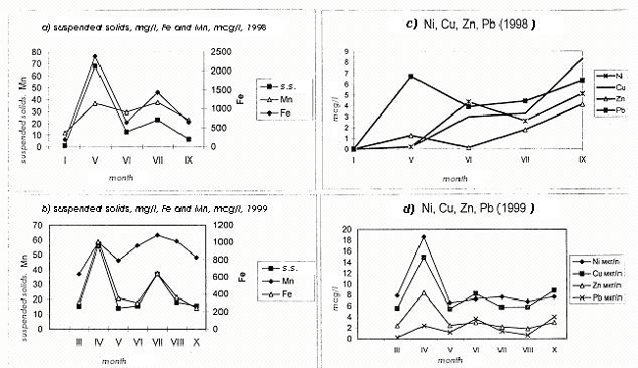
Figure 4.2 Seasonal distribution of suspended forms of heavy metals in the Volga water near Astrakhan, mcg/l

Hence, inter-annual and seasonal variability is significant with regard to both content of two forms of metals and their correlation depending on external conditions. Content of heavy metals depends to a great extent on water flow in the Volga River and amount of suspended solids as well as production processes.
In the estuarial seashore shallow zone of Volga higher aquatic vegetation plays an important role in dynamics of suspended solids. Vegetation resists significantly to movement of water and reduces water exchange by 10-100 times contributing to settling of suspended solids. Suspended solids settle and accumulate not only on the bottom but also on leaves and stems of plants. Sparganium simplex merely is able to retain up to 10 % of annual solid discharge of the Volga. Growth of submerged plants Ceratophyllum demersum and Najas minor retain fine-dispersed particles and generate silt best of all. Heavy metals accumulated on surface and tissue of plants during vegetation period settle down on the bottom after the vegetation dying. The content of heavy metals in vegetation growth is higher in comparison with bottom sediments in canals in the seashore shallow zone of Volga: Mn – by 1.8-2.3 times, Co – 1.4, Ni – 1.4, Cu – 1.5-1.6, Zn – 1.7-1.8, Pb – 1.4. Change of Fe content is much more complicated and does not show obvious regularity. Content of Cr, Mo, Cd and Sn in growth and on sites free from vegetation differs insignificantly.

4.2 Pollution of bottom sediments
Composition and features of bottom sediments determine their role in a water body – participation in secondary pollution of water (ability of soils to supply organic matter, phosphate ions, ammonium, iron, manganese, silicon and others into water) and water self-purification (ability of soils to purify water from phenols and naphthols through physical and chemical bonding, absorb many detergents, sorb heavy metal ions, accumulate biogenic elements, etc.). For different types of bottom sediments in the Lower Volga the average value of their specific gravity varies from 2.46-2.65 g/cm³ (sand medium and fine dispersed) to 1.8 g/cm³ (silt). Losses at burning constitute 0.8-3.0 % (sand), 3.3-9.5 % (silt sand), 15-22.5 % (silt). Content of organic carbon in sand is 0.075-0.21 %, in silt sand – 0.30-1.00 %, in silt – 1.10-2.50 %.

4.2.1 Petroleum hydrocarbons
During expeditionary research conducted by SOI from 1993 to 2002, 67 bottom samples were taken for determination of their petroleum hydrocarbon contents. Samples in various years were taken in all sections of the delta excluding sections I and V located in the delta apex.
Average concentration of petroleum hydrocarbons in bottom sediments in delta constituted 15.5mcg/g (Table 4.5). In different years average values per survey varied from 9.2 to 39.9 mcg/g. The most polluted bottom sediments were in 1993 and the following years their average values varied within 9.2-15.3 mcg/g.
Table 4.5
Concentration of pollutants in bottom sediments in the Volga delta according to results of expeditionary research conducted by SOI in 1993-2002

Section | 1993 | 1994 |  | 1995 | 1996 |  |  | 2002 | 1993 | 1994 | 1995 | 1996 | 2002
Section | Iron, mcg/g |  |  |  |  |  |  |  | Petroleum hydrocarbons, mcg/g  PC = 50 mcg/g
II |  |  |  |  |  |  |  |  |  | 0 |  |  | 39
III |  |  |  |  |  |  |  |  | 52.67 | 34 | 16.72 | 6.35 | 10
IV |  |  |  |  |  |  |  |  | 39 | 6.25 | 9.767 | 8.5 | 22
VI |  |  |  |  |  |  |  |  |  | 0 | 38.15 |  | 7
VII |  |  |  |  |  |  |  |  | 23 |  |  |  | 2
VIII |  |  | 1560 |  |  | 1500 |  |  | 20 | 14.44 | 11.34 | 11.1 | 8
Average |  |  | 1560 |  |  | 1500 |  |  | 39.86 | 11.81 | 15.29 | 9.225 | 13.29
Section | Copper, mcg/g  PC = 35 mcg/g |  |  |  |  |  |  |  | DDT, ng/g  PC for total:  DDT, DDE, DDD = 2.5 ng/g
II |  |  |  |  |  |  | 56
III | 20.8 | 14.3 | 13.05 |  |  | 14.43 | 71.5 |  | 7.2 | 23.4 |  | 10.9
IV | 2.4 | 11.9 | 14.8 |  |  | 14.69 | 63 |  | 20.9 | 8 | 3.8 | 3.98
VI |  |  | 2.68 |  |  |  | 59
VII | 6.8 |  |  |  |  |  | 74
VIII | 1.5 | 6.516 | 8.443 |  |  | 8.038 | 52.25 |  | 2.3 | 5.667 |  | 6.567
Average | 6.78 | 8.61 | 10.44 |  |  | 11.68 | 62.36 |  | 10.13 | 7.6 | 3.8 | 6.916

Section | Manganese, mcg/g |  |  |  |  | DDE, ng/g
II |  |  |  |  | 794.5
III |  |  |  |  | 1004 | 1 | 2.2 |  | 0.65
IV |  |  |  |  | 336.5 | 3.2 | 0.55 | 0.163 | 0
VI |  |  |  |  | 821.8
VII |  |  |  |  | 1048
VIII |  |  | 1399 | 1200 | 868.4 | 1 | 0.233 |  | 0.707
Average |  |  | 1399 | 1200 | 797.3 | 1.733 | 0.464 | 0.163 | 0.554
Section | Nickel, mcg/g  PC = 35 mcg/g |  |  |  |  | DDD, ng/g
II |  |  |  |  | 52.8
III | 18.9 | 0.9 | 626.7 |  | 55.48 | 1.4 | 11 |  | 0.8
IV | 272.1 | 0.7 | 533.8 |  | 31.6 | 2 | 3.375 | 0.4 | 0
VI |  |  | 174.4 |  | 56.2
VII | 600 |  |  |  | 67.4
VIII | 40.8 | 1.833 | 307.9 |  | 36.85 | 0.6 | 1.644 |  | 1.72
Average | 240.8 | 1.42 | 452.4 |  | 45.75 | 1.333 | 2.807 | 0.4 | 1.192
Section | Lead, mcg/g  PC = 85 mcg/g |  |  |  |  | а-HCH, ng/g
II |  |  |  |  | 4.2
III | 5.2 | 1.02 | 1.502 | 2.385 | 3.975 | 0.09 | 0 |  | 0.18
IV | 1.25 | 0.965 | 2.372 | 2.348 | 2.2 | 1.9 | 0 | 0.888 | 0
VI |  |  | 2.935 |  | 3.8
VII | 0.8 |  |  |  | 5.2
VIII | 1.2 | 1.424 | 1.334 | 1.605 | 1.15 | 0 | 0.178 |  | 1.093
Average | 1.94 | 1.264 | 1.877 | 2.085 | 2.879 | 0.663 | 0.114 | 0.888 | 0.692
Section | Cadmium, mcg/g  PC = 0,8 mcg/g |  |  |  |  | γ-HCH (lindane), ng/g  PC = 0,05 ng/g
II |  |  |  |  | 0
III | 0.28 | 0.32 | 0.101 | 0.156 | 0.02 | 5.4 | 0 |  | 4.15
IV | 0.01 | 0.36 | 0.153 | 0.136 | 0 | 14.2 | 0.3 | 0.925 | 0
VI |  |  | 0.029 |  | 0
VII | 0.04 |  |  |  | 0.04
VIII | 0.01 | 0.473 | 0.036 | 0.036 | 0.01 | 0 | 0.778 |  | 1.167
Average | 0.07 | 0.43 | 0.082 | 0.096 | 0.011 | 6.533 | 0.586 | 0.925 | 1.53
Note: In titles of each parameter there is Permissible Concentration (PC) for pollutants as it is set for bottom sediments of water bodies in Netherlands (“Netherlands lists”, Neue Niederlandische Liste. Altlasten Spektrum 3/95, Annex, Table 4.1).

On average, the highest pollution of bottom sediments with petroleum hydrocarbons was noted in the western part of delta (section III) – 21.9 mcg/g. There also at the beginning of the Tishkovski canal in 1993 the maximum value of 84 mcg/g was reported for the whole observation period. That concentration is by 1.7 times higher than allowed concentration determined by “Netherlands lists” for bottom sediments.
Also rather high values were typical in general for the western part of shallow zone of DSL (section IV), where average value constituted 13.5 mcg/g with maximum up to 58 mcg/g in 1993 and 2002.
In the eastern part of shallow zone (section VIII) average concentration of petroleum hydrocarbons also constituted 12.3 mcg/g, however, maximum content of petroleum hydrocarbons in soils was higher – 76 mcg/g in June 1994 in the middle of the Belinski canal.
In other parts of the Volga delta average concentrations of petroleum hydrocarbons in bottom sediments over the research period were also within 13-19 mcg/g but there were only few observations (Annex, Table 3.8).
According to data of IWP, accumulation of petroleum hydrocarbons in bottom sediments in areas under consideration was noted in all samples studied and was characterized by the following values: 0.005 mg/g – 0.074 mg/g of dry soil at average value 0.034 mg/g. Increased values were noted mainly in summer and autumn. Soils mostly polluted with petroleum hydrocarbons were observed in the Akhtuba River (0.046 mg/g) and Buzan arm (0.030 mg/g).

4.2.2 Pesticides
According to data of expeditionary survey conducted by SOI in 1993-1996, average concentration of α-HCH in bottom sediments in the Volga delta constituted 0.408 ng/g (Table 4.5). Maximum value amounted to 3.45 ng/g and was reported in August 1995 in estuarial seashore shallow zone at the very beginning of marine part of the Volga-Caspian canal. Due to that value the western part of the estuarial seashore (section IV) appeared on average the mostly polluted part of the delta (1.9 ng/g). In general, identified and non-zero values of α-HCH concentrations in bottom sediments were very high and exceeded significantly allowed concentrations determined by “Netherlands lists”. At the same time, out of 26 samples of bottom sediments studied in 17 samples α-HCH was not revealed, i.e. its concentration was beyond the detection limit of the analysis method applied (Annex, Table 3.8).
Average concentration of γ-HCH (lindane) in bottom sediments in the Volga delta constituted 1.506 ng/g (Table 4.5) and its maximum reached 14.2 ng/g in June 1993 in the Kirovski canal near the Bukhtovyye islands. That is very high value which exceeds allowed concentration (0.05 ng/g) by almost 284 times. Other values were usually within a narrow range from 1 to 5 ng/g and in 16 samples out of 26 those pesticides were not revealed at all.
According to data of IWP, survey conducted in 1995-1996 showed the existence of pesticides in bottom sediments (Figures 4.3 and 4.4) [Integrated assessment of hydrochemical …, 1996]. In the Akhtuba River, HCH content level was minimal before flood (0.0104 ng/g). During flood its concentration increased almost by 6 times and after flood and in autumn the amount of pesticides in soil practically did not change. In Buzan arm, HCH content increases in summer (0.206 ng/g) and decreases in autumn down to the initial level. Uneven pollution of bottom sediments with pesticides in different points of the Volga delta indicates the probability of their mosaic spatial distribution. Also intra-annual seasonal variability of pesticides content in bottom sediments in the Lower Volga is observed.

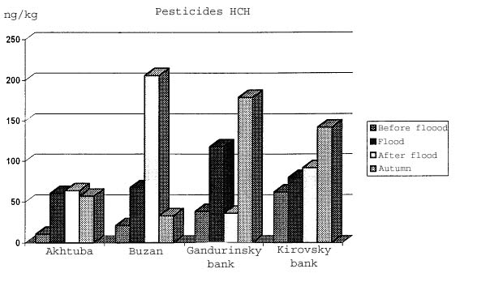
Figure 4.3 Content of pesticides of HCH group (ng/kg) in bottom sediments of the Volga delta in various seasons in 1995-1996

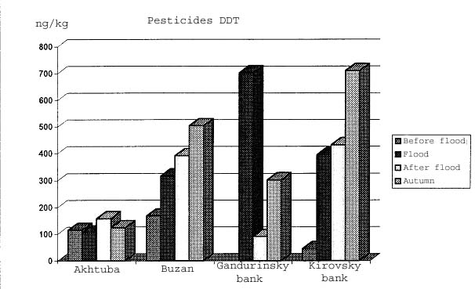

Figure 4.4 Content of pesticides of DDT group (ng/kg) in bottom sediments of the Volga delta in various seasons in 1995-1996

4.2.3 Heavy metals
Systematic observations over the content of heavy metals in bottom sediments in the Lower Volga are not conducted. In various periods sporadic observations were implemented by Astrakhan Research and Design Institute of Gas Industry jointly with Rostov State University (1982-1988), Institute of Water Problems of Russian Academy of Sciences jointly with Department on Protection of Water Resources of the Caspian Sea and Caspian Fisheries Research Institute (1991, 1997-2005), Geological Institute of Russian Academy of Sciences (1994, 1995), Moscow State University jointly with Astrakhan Biosphere Nature Reserve (1994-1998), Caspian Fisheries Research Institute (1993, 1995, 1996), State Oceanographic Institute (1993-1996, 2002, Table 4.5).
Analysis of timing and spatial variability of heavy metal contents in bottom sediments in the Lower Volga shows significant unevenness of their distribution in the area. Even on one river site the heavy metal contents in bottom sediments may differ by an order. For instance, on the site near the Seroglazka settlement in September 1998 on station located at a distance of 70 m from the left bank of the river the content of ZN was equal to 69.4 mcg/g; at a distance of 200 m from the left bank its content decreased to 7.2 mcg/g and then again increased up to 66.1 mcg/g on the station located at a distance of 80 m from the right bank. In 1997 the content of heavy metals on the same station was more even (Figure 4.4).

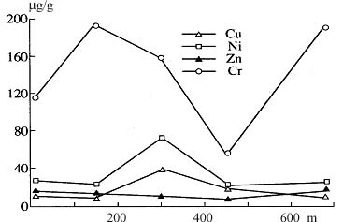
Figure 4.5 Content of heavy metals in bottom sediments by river profile on the site near the Solyenoye Zaimishche village in 1997. Distance on river width is calculate from the right bank.

Heterogeneity of distribution of heavy metal content in bottom sediments is various. In the riverbed part of Volga distribution of Zn content is stably heterogeneous with variation coefficients equal to 1.14 in 1997 and 0.65 in 1998. For Mn and Cd, high values of variation coefficient resulted from low concentrations of those metals in bottom sediments; on many stations they were detected at the level of trace quantity. The most heterogeneous is distribution of Cd content. In different parts of the Lower Volga variation coefficient for Cd varies within 0.07-0.15.

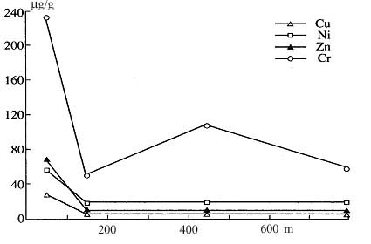
Figure 4.6 Content of heavy metals in bottom sediments by river profile on the site near the Tsagan-Aman village in 1997. Distance on river width is calculated from the right bank

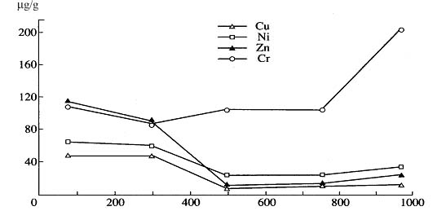
Figure 4.7 Content of heavy metals in bottom sediments by river profile on the site near the Seroglazka village in 1997. Distance on river width is calculated from the right bank

Along the river length on some of its parts many microelements in bottom sediments were distributed rather evenly in 1997 (Figure 4.8).

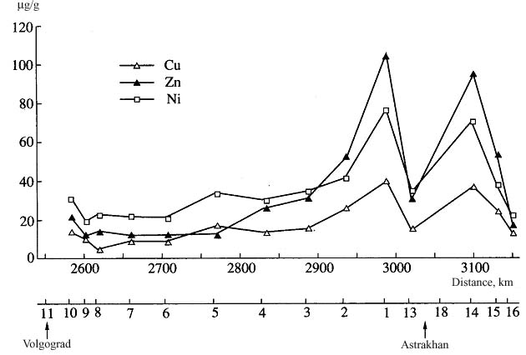
Figure 4.8 Distribution of heavy metal concentrations in bottom sediments lengthwise the Volga riverbed in autumn 1997

The major factors determining the process rate of accumulation of heavy metals in bottom sediments are peculiarities of granulometric composition in every specific point as well as of hydrodynamic processes and morphometry of the river. Due to high turbulent activity on the Volga channel line, the content of most heavy metals excluding Mo and Cd is usually lower there than on the riversides. In bottom sediments of the watercourses in the Volga delta accumulation of heavy metals goes on with higher or lower intensity excluding molybdenum and cadmium. The most probable cause of heavy metal accumulation in bottom sediments of the delta watercourses is the decrease in hydrodynamic activity resulted from the Volga River splitting into different arms. Data related to the latter were grouped by downstream flows: 1 – main riverbed of Volga from the Svetlyi Yar village to delta apex near the Nizhnelebyazhye village; 2 – VCC, as a continuation of the main riverbed of Volga within delta; 3 – the Buzan arm, waterway of the 1st order intaking the flow running through the watercourses of the Volga-Akhtuba floodplain; 4 – the Akhtuba arm, low-water course, strongly eutrophicated, with low current; 5 – the Kizan arm, waterway of the 1st order and its continuation in the delta; 6 – the Bolda arm and its continuation as delta banks (Table 4.5).

Table 4.5
Ratio (in %) of heavy metal concentrations in bottom sediments in the main riverbed and delta watercourses of the Volga River

Waterways | Mn | Fe | Cr | Co | Ni | Cu | Zn | Mo | Cd | Pb
Volga main riverbed | 100 | 100 | 100 | 100 | 100 | 100 | 100 | 100 | 100 | 100
VCC | 129 | 116 | 101 | 117 | 108 | 117 | 125 | 81 | 91 | 189
Buzan arm | 149 | 142 | 106 | 144 | 123 | 122 | 146 | 77 | 92 | 192
Akhtuba arm | 110 | 98 | 129 | 86 | 96 | 87 | 93 | 96 | 101 | 99
Kizan arm | 160 | 121 | 109 | 132 | 119 | 124 | 145 | 69 | 86 | 191
Bolda arm | 176 | 152 | 81 | 140 | 122 | 137 | 156 | 64 | 87 | 210

The Buzan and Akhtuba arms may be distinguished for their contrast. The highest concentrations of practically all metals were observed in the first one and the lowest in the second excluding molybdenum, cadmium and chrome that were obviously accumulated in bottom sediments. Emphasis should be made on high degree of similarity in heavy metal concentration values in the western arms of the Volga delta and in its main riverbed. Eastern arms of the delta (Buzan, Bolda) are distinguished by high concentrations of heavy metals in comparison with western arms. In general, such elements as lead, manganese, iron, cobalt, zinc and copper are accumulated to a great extent in bottom sediments of watercourses in the Volga delta.
Analysis of individual strata of bottom sediment columns selected on various sites in the Lower Volga does not allow making unequivocal conclusion about accumulation or wash-out of heavy metals over the multi-annual period, although in most cases the lower strata were polluted stronger than upper strata regardless of the fractional composition of bottom sediments. Such distribution may be a consequence of both penetration and accumulation of heavy metals in deeper layers as well as depositing of polluted strata by cleaner ones.
Correlation analysis revealed the existence of persistent relations between metal concentration in bottom sediments and their fractional composition. In the main riverbed of Volga, concentrations of Fe, Co, Ni and Cu have significant continuous positive relation with the part of small particles of size 0.001-0.005 mm, correlation coefficient r = 0.76-0.79. For Cd and especially for Mo, correlation relations are negative almost with all the rest metals and part of small fractions in bottom sediments. In general for all metals in bottom sediments of the main riverbed of Volga it is possible to say about the existence of significant relations with fractional composition of bottom sediments.
Calculation of correlation relations using summarized data not only on the main riverbed but on the entire researched part of Volga showed less significant dependences. The highest positive correlation coefficients were revealed between Mn and Zn concentrations and part of particles of size ranged within 0.25-0.50 mm (r = 0.62-0.67), Fe and Ni with particles of size within 0.001-0.005 mm (r = 0.64-0.65) and negative relation of Mo with particles less than 0.05 mm (r = -0.65).
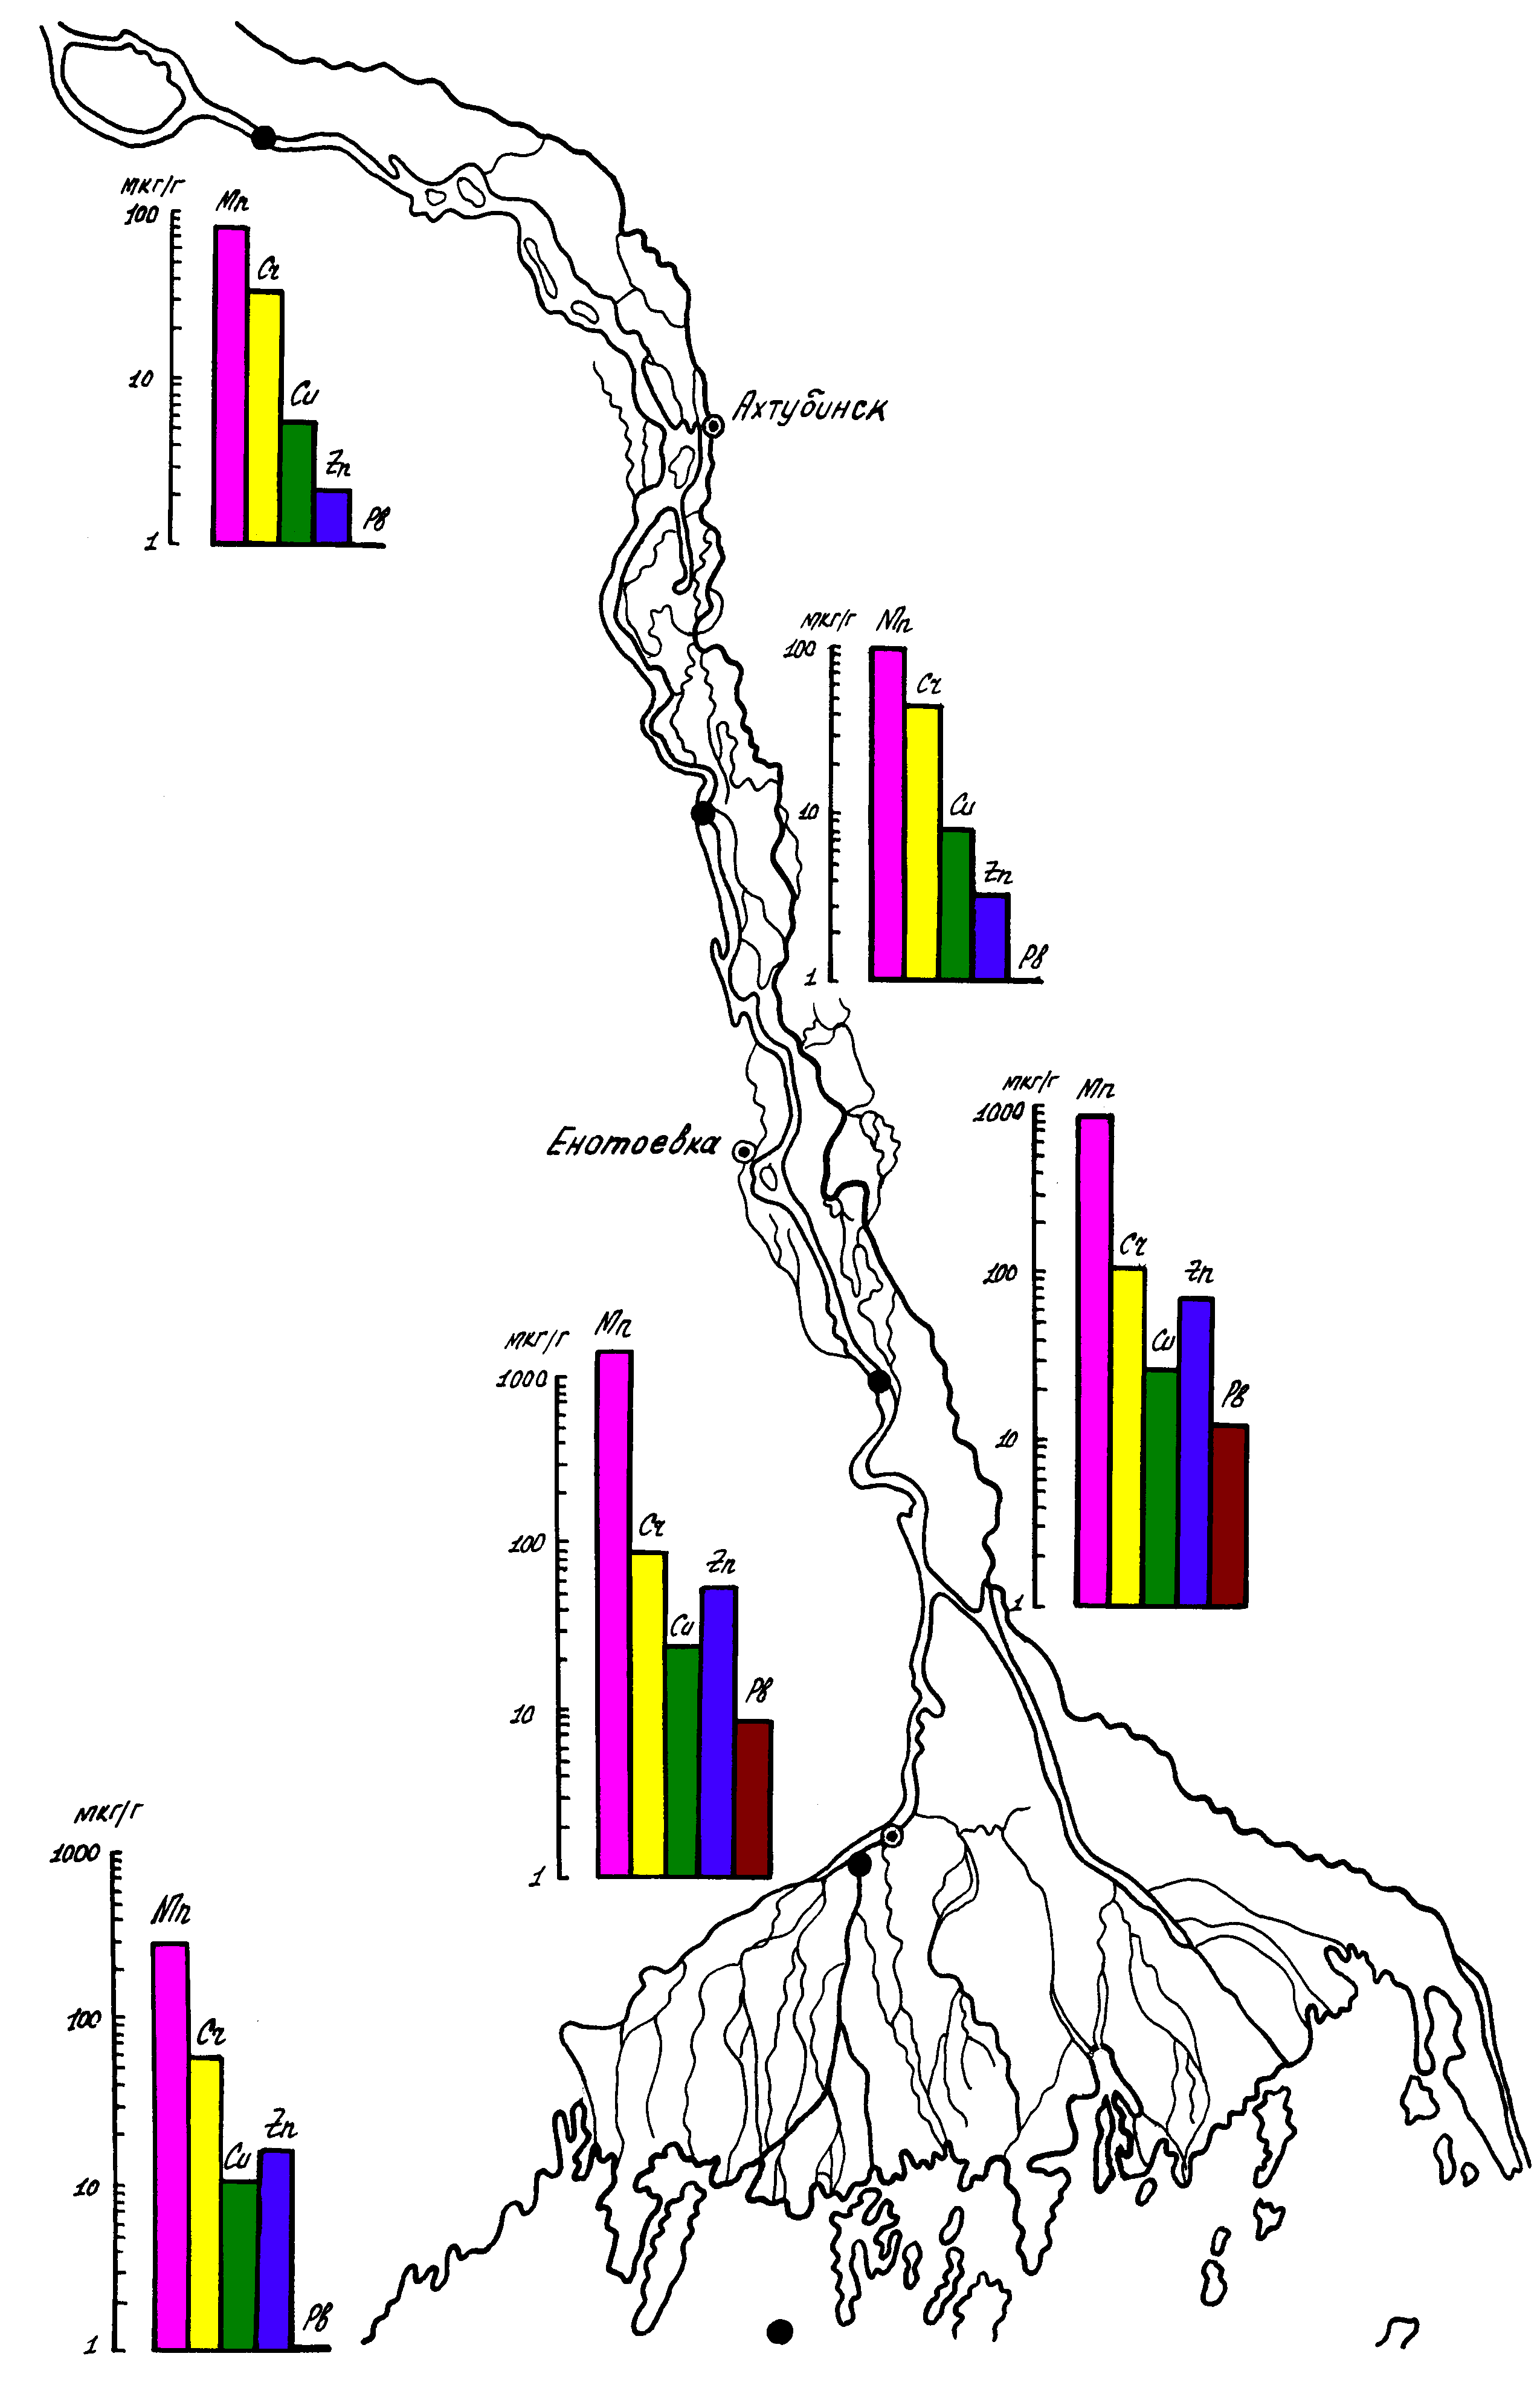

Fig. 4.9. Content of heavy metals in bottom sediments of the Lower Volga River in September 1998 (points indicate sample stations).

Chapter 5 Pollutant flows in the Volga delta

Estimation of flows of pollutants dissolved in water of the Volga River delta was made based on data on water flow distribution for the period of 1995-2004 (see Chapter 2, Section 2.3, Tables 2.3 – 2.10) and results of analysis of observation data on concentrations of pollutants in water on standard network stations of Roshydromet (see Chapter 3, Section 3.1, Tables 3.2 – 3.5). Due to limited amount of data on pollutants the calculation of their flows in different parts of delta was made with averaging by quarters. Calculation of pollutant flows (P_{i}) was made according to formula:

P_{i} = C_{i} W_{i ,}
where W_{i} is water flow, C_{i} – average concentration of pollutants in water in i-part of delta.

Pollutant flows in the upper zone of delta are sum up of the Volga River flows on hydrometric site (hs) of Verkhneye Lebyazhye (delta apex) where both water discharges (taking into account the Volga-Akhtuba floodplain) and pollutant concentrations are determined, as well as the Akhtuba River flows where water discharges are determined sequential to the Verkhneye Lebyazhye hs (Dosang station) and pollutant concentrations are determined at the Selitrennoye and Aksaraisk settlements. Amount of data on pollutants at those points allow to calculate only their averaged flows for 1995-2004 (Tables 5.1, 5.2). Distribution of pollutant flows of the Volga River on the Verkhneye Lebyazhye hs between the western and eastern parts of delta is assumed proportional to distribution of the water flow between the Volga course below the delta apex and Buzan arm (Tables 5.3, 5.4). Concentrations and flows of pollutants into the delta from the Volga-Akhtuba floodplain are not determined. Considering the small portion of floodplain water discharge, the flow of pollutants from it can be neglected.
Analysis of data available on some pollutants (petroleum hydrocarbons, phenols, copper, zinc) in the western part of delta allowed to calculate their flows not only for 1995-2004 on average as for other pollutants (Tables 5.5, 5.6) but also separately by those years (Tables 5.7 – 5.12). Comparison of results of averaging the pollutant flows as arithmetic mean of annual values with flows estimated by average values of water flows and pollutant concentrations for the period of 1995-2004 showed that divergences in different quarters for various pollutants by absolute value are as follows: for petroleum hydrocarbons - from 2 to 19 %, for phenols - from 9 to 30 %, for zinc - from 1 to 15 %, for copper - from 1 to 17 %.
The nearest to DSL standard network stations for observation of pollutants (Figure 1.2, Table 3.2) are located in the northern part of section II (central zone of western part of delta). Therefore, total pollutant flows on DSL are taken, as a first approximation, equal to total pollutant flows in the central zone of the western part of delta. Average pollutant flows for the period of 1995-2004 in sections IVa, IVb, IVc (Tables 5.13 – 5.15) are assumed as proportional to distribution of water flow in these sections.
Amount of data on pollutants on observation stations in the eastern part of delta allow to calculate only average flow values for 1995-2004 for all pollutants. Observation stations for pollutants in this part of delta are located in section V close to the border between the upper and central zones of the eastern part of delta. Calculation of pollutant flows on the border between the upper and central zones of this part of delta was made separately for systems of the Buzan arm and Kigach canal (continuation of Akhtuba) in order to take into account various genesis of pollutants in these flows (Tables 5.16, 5.17). Total pollutant flows on DSL of the eastern part of delta are taken as a first approximation equal to total pollutant flows on the border between the upper and central zones of this part of delta. Pollutant flows in section VIIId are taken as proportional to the share of water flow in it and pollutant concentrations at the Krasnyi Yar settlement (Table 5.18). Pollutant flows in section VIIIe are sum up of flows coming from the Buzan arm system (Table 5.19) and flows from the Kigach canal system (Table 5.20). Total pollutant flows on DSL of Volga by 5 sites in the lower zones of the western and eastern parts are shown in Table 5.21. In cases when there was no observation data for some quarters of a year, pollutants flows were taken proportional to their share in annual water flow. As observations of some characteristics of pollutants in the eastern part of delta were not conducted, their flows were estimated through the flows in the western part of delta multiplied by ratio of water flow in those parts. As a result, average annual flows of pollutants in the western and eastern parts of delta were calculated as well as total annual flows on DSL (Table 5.21).
It is possible to assess the order of some flows of pollutants on suspended substance using tables from Chapter 4 (Tables 4.2 – 4.4). Transformation of pollutant flows in the estuarial seashore shallow zone of Volga is not studied. Theoretically these flows there should decrease especially at settling of sediments in the DSL area.

Table 5.1
Pollutant flows in the Volga delta apex

Name of pollutants | Apex of the Volga River delta – Verkhneye Lebyazhye hs |  |  |  |  |  |  |  | Totally pollutants,  thousand tonnes
Name of pollutants | 1 quarter  (water discharge 6084 m³/s) |  | 2 quarter  (water discharge 13738 m³/s) |  | 3 quarter  (water discharge 6478 m³/s) |  | 4 quarter  (water discharge 5561 m³/s) |  | Totally pollutants,  thousand tonnes
Name of pollutants | concentration, mg/l | pollutant flow,  thousand tonnes | concentration, mg/l | pollutant flow,  thousand tonnes | concentration, mg/l | pollutant flow,  thousand tonnes | concentration, mg/l | pollutant flow,  thousand tonnes | Totally pollutants,  thousand tonnes
Oil hydrocarbons | 0.230000 | 11.0 | 0.240000 | 25.9 | 0.100000 | 5.1 | 0.270000 | 11.8 | 53.8
SSAS | 0.020000 | 0.96 | 0.035000 | 3.78 | 0.290000 | 1.48 | 0.017000 | 0.74 | 6.96
Phenol | 0.003000 | 0.14 | 0.004000 | 0.43 | 0.005000 | 0.26 | 0.003000 | 0.13 | 0.96
Zinc | 0.033520 | 1.60 | 0.037830 | 4.09 | 0.037850 | 1.93 | 0.035190 | 1.54 | 9.16
Copper | 0.007290 | 0.35 | 0.008720 | 0.94 | 0.005430 | 0.28 | 0.006420 | 0.28 | 1.85
Chrome | - | - | 0.001550 | 0.17 | 0.001010 | 0.05 | - | - | 0.22
Lead | - | - | 0.001210 | 0.13 | 0.002080 | 0.11 | - | - | 0.24
Cobalt | - | - | 0.000990 | 0.11 | 0.001750 | 0.09 | - | - | 0.20
Cadmium | - | - | 0.000290 | 0.03 | 0.000720 | 0.04 | - | - | 0.07
Manganese | - | - | 0.001720 | 0.19 | 0.000880 | 0.04 | - | - | 0.23
Iron | 0.140000 | 6.7 | 0.180000 | 19.4 | 0.200000 | 10.2 | 0.230000 | 10.1 | 46.4
Nickel | - | - | 0.004550 | 0.49 | 0.007630 | 0.39 | 0.006190 | 0.27 | 1.15
Mercury | - | - | 0.00004 | 0.0043 | 0.00004 | 0.0020 | 0.000020- | 0.0009 | 0.0072
DDE | 0.0000006 | 0.000027 | 0 | 0 | 0 | 0 | 0 | 0 | 0.000027
DDT | 0 | 0 | 0.000001 | 0.000091 | 0.0000018 | 0.000092 | 0 | 0 | 0.000183
а-HCH | 0 | 0 | 0 | 0 | 0 | 0 | 0 | 0 | 0
γ-HCH | 0 | 0 | 0.0000007 | 0.000070 | 0.0000002 | 0.000012 | 0.0000001 | 0.000006 | 0.000088

Table 5.2
Pollutant flows in the upper zone of the eastern part of the Volga delta from the Akhtuba River

Name of pollutants | Eastern part of delta, Akhtuba river - continuation of the Verkhneye Lebyazhye hs (Dosang station) |  |  |  |  |  |  |  | Totally pollutants,  thousand tonnes
Name of pollutants | 1 quarter  (water discharge 110 m³/s) |  | 2 quarter  (water discharge 515 m³/s) |  | 3 quarter  (water discharge 81 m³/s) |  | 4 quarter  (water discharge 38 m³/s) |  | Totally pollutants,  thousand tonnes
Name of pollutants | concentration, mg/l | pollutant flow,  thousand tonnes | concentration, mg/l | pollutant flow,  thousand tonnes | concentration, mg/l | pollutant flow,  thousand tonnes | concentration, mg/l | pollutant flow,  thousand tonnes | Totally pollutants,  thousand tonnes
Oil hydrocarbons | 0.18000 | 0.156 | 0.16000 | 0.647 | 0.13000 | 0.083 | 0.18000 | 0.054 | 0.940
SSAS | 0.02700 | 0.023 | 0.04700 | 0.190 | 0.03000 | 0.019 | 0.03400 | 0.010 | 0.243
Phenol | 0.00300 | 0.003 | 0.00300 | 0.012 | 0.00700 | 0.004 | 0.00400 | 0.001 | 0.020
Zinc | 0.03755 | 0.033 | 0.04786 | 0.194 | 0.04638 | 0.029 | 0.03087 | 0.009 | 0.265
Copper | 0.00800 | 0.007 | 0.00823 | 0.033 | 0.00452 | 0.003 | 0.00537 | 0.002 | 0.045
Chrome | 0.00165 | 0.0014 | 0.00111 | 0.0045 | 0.00079 | 0.0005 | 0.00072 | 0.0002 | 0.0066
Lead | 0.00249 | 0.0022 | 0.00156 | 0.0063 | 0.00256 | 0.0016 | 0.00121 | 0.0004 | 0.0105
Cobalt | 0.00409 | 0.0035 | 0.00090 | 0.0036 | 0.00149 | 0.0009 | 0.00343 | 0.0010 | 0.0091
Cadmium | 0.00073 | 0.0006 | 0.00037 | 0.0015 | 0.00062 | 0.0004 | 0.00066 | 0.0002 | 0.0027
Manganese | 0.00446 | 0.0039 | 0.00147 | 0.0059 | 0.00074 | 0.0005 | 0.00098 | 0.0003 | 0.0106
Iron | 0.14000 | 0.121 | 0.21000 | 0.85 | 0.13000 | 0.083 | 0.18000 | 0.054 | 1.107
Nickel | 0.00925 | 0.0080 | 0.00611 | 0.0247 | 0.00738 | 0.0047 | 0.00333 | 0.0010 | 0.0384
Mercury | - | - | - | - | - | - | - | - | -
DDE | 0.00000015 | 0.0000001 | 0 | 0 | 0 | 0 | 0 | 0 | 0.0000001
DDT | 0.000003 | 0.0000027 | 0.00000006 | 0.0000002 | 0 | 0 | 0 | 0 | 0.0000029
а-HCH | 0 | 0 | 0 | 0 | 0 | 0 | 0 | 0 | 0
γ-HCH | 0.0000008 | 0.0000007 | 0.0000002 | 0.0000009 | 0 | 0 | 0 | 0 | 0.0000016

Table 5.3
Pollutant flows in the apex of the eastern part of the Volga delta

Name of pollutants | Apex of the eastern part of delta – concentration of pollutants by Verkhneye Lebyazhye point |  |  |  |  |  |  |  | Totally pollutants,  thousand tonnes
Name of pollutants | 1 quarter  (water discharge 2157 m³/s) |  | 2 quarter  (water discharge 4891 m³/s) |  | 3 quarter  (water discharge 2253 m³/s) |  | 4 quarter  (water discharge 1978 m³/s) |  | Totally pollutants,  thousand tonnes
Name of pollutants | concentration, mg/l | pollutant flow,  thousand tonnes | concentration, mg/l | pollutant flow,  thousand tonnes | concentration, mg/l | pollutant flow,  thousand tonnes | concentration, mg/l | pollutant flow,  thousand tonnes | Totally pollutants,  thousand tonnes
Oil hydrocarbons | 0.230000 | 3.9 | 0.240000 | 9.2 | 0.100000 | 1.8 | 0.270000 | 4.2 | 19.1
SSAS | 0.020000 | 0.34 | 0.035000 | 1.35 | 0.0290000 | 0.51 | 0.017000 | 0.26 | 2.46
Phenol | 0.003000 | 0.05 | 0.004000 | 0.15 | 0.005000 | 0.09 | 0.003000 | 0.05 | 0.34
Zinc | 0.033520 | 0.57 | 0.037830 | 1.45 | 0.037850 | 0.67 | 0.035190 | 0.55 | 3.24
Copper | 0.007290 | 0.12 | 0.008720 | 0.34 | 0.005430 | 0.10 | 0.006420 | 0.10 | 0.66
Chrome | - | - | 0.001550 | 0.060 | 0.001010 | 0.018 | - | - | 0.078
Lead | - | - | 0.001210 | 0.046 | 0.002080 | 0.037 | - | - | 0.083
Cobalt | - | - | 0.000990 | 0.038 | 0.001750 | 0.031 | - | - | 0.069
Cadmium | - | - | 0.000290 | 0.011 | 0.000720 | 0.013 | - | - | 0.024
Manganese | - | - | 0.001720 | 0.066 | 0.000880 | 0.016 | - | - | 0.082
Iron | 0.140000 | 2.37 | 0.180000 | 6.92 | 0.200000 | 3.54 | 0.230000 | 3.58 | 16.42
Nickel | - | - | 0.004550 | 0.17 | 0.007630 | 0.14 | 0.006190 | 0.10 | 0.41
Mercury | - | - | 0.00004 | 0.002 | 0.00004 | 0.001 | 0.00002 | 0.0003 | 0.0033
DDE | 0.0000006 | 0.0000097 | 0 | 0 | 0 | 0 | 0 | 0 | 0.0000097
DDT | 0 | 0 | 0.000001 | 0.000032 | 0.0000018 | 0.000032 | 0 | 0 | 0.000064
а-HCH | 0 | 0 | 0 | 0 | 0 | 0 | 0 | 0 | 0
γ-HCH | 0 | 0 | 0.0000007 | 0.000025 | 0.0000002 | 0.000004 | 0.0000001 | 0.000002 | 0.000031

Table 5.4
Pollutant flows in the apex of the western part of the Volga delta

Name of pollutants | Apex of the western part of delta – concentration of pollutants by Verkhneye Lebyazhye point |  |  |  |  |  |  |  | Totally pollutants,  thousand tonnes
Name of pollutants | 1 quarter  (water discharge 3927 m³/s) |  | 2 quarter  (water discharge 8847 m³/s) |  | 3 quarter  (water discharge 4226 m³/s) |  | 4 quarter  (water discharge 3583 m³/s) |  | Totally pollutants,  thousand tonnes
Name of pollutants | concentration, mg/l | pollutant flow,  thousand tonnes | concentration, mg/l | pollutant flow,  thousand tonnes | concentration, mg/l | pollutant flow,  thousand tonnes | concentration, mg/l | pollutant flow,  thousand tonnes | Totally pollutants,  thousand tonnes
Oil hydrocarbons | 0.230000 | 7.1 | 0.240 | 16.7 | 0.100 | 3.3 | 0.270000 | 7.6 | 34.7
SSAS | 0.020000 | 0.62 | 0.035 | 2.43 | 0.0290 | 0.96 | 0.017000 | 0.48 | 4.49
Phenol | 0.003000 | 0.09 | 0.004 | 0.28 | 0.005 | 0.17 | 0.003000 | 0.08 | 0.62
Zinc | 0.033520 | 1.04 | 0.038 | 2.63 | 0.038 | 1.26 | 0.035190 | 0.99 | 5.92
Copper | 0.007290 | 0.22 | 0.009 | 0.61 | 0.005 | 0.18 | 0.006420 | 0.18 | 1.19
Chrome | - | - | 0.002 | 0.11 | 0.001 | 0.03 | - | - | 0.14
Lead | - | - | 0.001 | 0.08 | 0.002 | 0.07 | - | - | 0.15
Cobalt | - | - | 0.001 | 0.07 | 0.002 | 0.06 | - | - | 0.13
Cadmium | - | - | 0.000 | 0.020 | 0.001 | 0.024 | - | - | 0.044
Manganese | - | - | 0.002 | 0.12 | 0.001 | 0.03 | - | - | 0.15
Iron | 0.140000 | 4.32 | 0.180 | 12.52 | 0.200 | 6.65 | 0.230000 | 6.48 | 29.97
Nickel | - | - | 0.005 | 0.32 | 0.008 | 0.25 | 0.006190 | 0.17 | 0.74
Mercury | - | - | 0.00004 | 0.028 | 0.00004 | 0.001 | 0.00002 | 0.0006 | 0.030
DDE | 0.0000006 | 0.000018 | 0 | 0 | 0 | 0 | 0 | 0 | 0.000018
DDT | 0 | 0 | 0.000001 | 0.000058 | 0.0000018 | 0.000060 | 0 | 0 | 0.00012
а-HCH | 0 | 0 | 0 | 0 | 0 | 0 | 0 | 0 | 0
γ-HCH | 0 | 0 | 0.0000007 | 0.000070 | 0.0000002 | 0.000008 | 0.0000001 | 0.000004 | 0.000082

Table 5.5
Pollutant flows in the upper zone of the western part of the Volga delta

Name of pollutants |  |  |  |  |  |  |  |  | Totally pollutants,  thousand tonnes
Name of pollutants | 1 quarter  (water discharge 3927 m³/s) |  | 2 quarter  (water discharge 8847 m³/s) |  | 3 quarter  (water discharge 4226 m³/s) |  | 4 quarter  (water discharge 3583 m³/s) |  | Totally pollutants,  thousand tonnes
Name of pollutants | concentration, mg/l | pollutant flow,  thousand tonnes | concentration, mg/l | pollutant flow,  thousand tonnes | concentration, mg/l | pollutant flow,  thousand tonnes | concentration, mg/l | pollutant flow,  thousand tonnes | Totally pollutants,  thousand tonnes
Oil hydrocarbons | 0.24000 | 7.41 | 0.23000 | 16.00 | 0.20000 | 6.64 | 0.15000 | 4.23 | 34.28
SSAS | 0.02000 | 0.62 | 0.03600 | 2.50 | 0.02200 | 0.73 | 0.02600 | 0.73 | 4.59
Phenol | 0.00300 | 0.09 | 0.00400 | 0.28 | 0.00500 | 0.17 | 0.00400 | 0.11 | 0.65
Zinc | 0.04345 | 1.34 | 0.03653 | 2.54 | 0.02982 | 0.99 | 0.02900 | 0.82 | 5.69
Copper | 0.00779 | 0.24 | 0.00788 | 0.55 | 0.00395 | 0.13 | 0.00568 | 0.16 | 1.08
Chrome | - | - | 0.00176 | 0.12 | - | - | - | - | 0.12
Lead | - | - | 0.00299 | 0.21 | - | - | - | - | 0.21
Cobalt | - | - | 0.00020 | 0.01 | - | - | - | - | 0.01
Cadmium | - | - | 0.00008 | 0.01 | - | - | - | - | 0.01
Manganese | - | - | 0.00057 | 0.04 | - | - | - | - | 0.04
Iron | 0.13000 | 4.01 | 0.16000 | 11.13 | 0.20000 | 6.65 | 0.19000 | 5.35 | 27.14
Nickel | - | - | 0.00383 | 0.27 | - | - | - | - | 0.27
Mercury | 0.00003 | 0.0009 | 0.00008 | 0.0056 | 0.00006 | 0.0020 | 0.00003 | 0.0008 | 0.0093
DDE | 0.0000002 | 0.000006 | 0.0000008 | 0.000055 | 0 | 0 | 0 | 0 | 0.000061
DDT | 0.0000015 | 0.000046 | 0.0000019 | 0.000135 | 0.0000005 | 0.000016 | 0 | 0 | 0.000196
а-HCH | 0.0000000 | 0.000000 | 0.0000001 | 0.000006 | 0 | 0 | 0 | 0 | 0.000006
γ-HCH | 0.0000008 | 0.000025 | 0.0000001 | 0.000010 | 0.0000001 | 0.000003 | 0 | 0 | 0.000038

Table 5.6
Pollutant flows in the central zone of the western part of the Volga delta

Name of pollutants |  |  |  |  |  |  |  |  | Totally pollutants,  thousand tonnes
Name of pollutants | 1 quarter  (water discharge 3927 m³/s) |  | 2 quarter  (water discharge 8847 m³/s) |  | 3 quarter  (water discharge 4226 m³/s) |  | 4 quarter  (water discharge 3583 m³/s) |  | Totally pollutants,  thousand tonnes
Name of pollutants | concentration, mg/l | pollutant flow,  thousand tonnes | concentration, mg/l | pollutant flow,  thousand tonnes | concentration, mg/l | pollutant flow,  thousand tonnes | concentration, mg/l | pollutant flow,  thousand tonnes | Totally pollutants,  thousand tonnes
Oil hydrocarbons | 0.24000 | 7.41 | 0.23000 | 16.00 | 0.16000 | 5.32 | 0.30000 | 8.45 | 37.18
SSAS | 0.02000 | 0.62 | 0.03400 | 2.36 | 0.02000 | 0.67 | 0.02500 | 0.70 | 4.35
Phenol | 0.00300 | 0.09 | 0.00400 | 0.28 | 0.00500 | 0.17 | 0.00500 | 0.14 | 0.68
Zinc | 0.04658 | 1.44 | 0.03694 | 2.57 | 0.03460 | 1.15 | 0.03022 | 0.85 | 6.01
Copper | 0.00675 | 0.21 | 0.00829 | 0.58 | 0.00491 | 0.16 | 0.00656 | 0.18 | 1.13
Chrome | - | - | 0.00081 | 0.056 | 0.00081 | 0.027 | 0.00036 | 0.010 | 0.093
Lead | - | - | 0.00189 | 0.13 | 0.00197 | 0.07 | 0.00085 | 0.02 | 0.22
Cobalt | - | - | 0.00103 | 0.072 | 0.00155 | 0.051 | 0.00118 | 0.033 | 0.156
Cadmium | - | - | 0.00028 | 0.020 | 0.00350 | 0.116 | 0.00065 | 0.018 | 0.154
Manganese | - | - | 0.00112 | 0.08 | 0.00062 | 0.02 | 0.00138 | 0.04 | 0.14
Iron | 0.15000 | 4.63 | 0.22000 | 15.31 | 0.18000 | 5.98 | 0.20000 | 5.64 | 31.56
Nickel | - | - | 0.00498 | 0.35 | 0.00741 | 0.25 | 0.00561 | 0.16 | 0.75
Mercury | 0.00003 | 0.0009 | 0.00009 | 0.0063 | 0.00006 | 0.0020 | 0.00002 | 0.0006 | 0.0097
DDE | 0.0000002 | 0.0000062 | 0.0000003 | 0.0000174 | 0 | 0 | 0 | 0 | 0.0000236
DDT | 0 | 0 | 0.0000006 | 0.000042 | 0.0000004 | 0.000014 | 0 | 0 | 0.000056
а-HCH | 0 | 0 | 0 | 0 | 0 | 0 | 0 | 0 | 0
γ-HCH | 0 | 0 | 0.0000002 | 0.000013 | 0.0000003 | 0.000010 | 0.00000015 | 0.000004 | 0.000027

Table 5.7
Petroleum hydrocarbon flows in the western part of the Volga delta by years
Years | Upper zone of the western part of delta |  |  |  |  |  |  |  |  | Central zone of the western part of delta
Years | 2 quarter |  |  | 3 quarter |  |  | 4 quarter |  |  | 2 quarter |  |  | 3 quarter
Years | water discharge, m³/s | concentra-tion,  mg/l | pollutant flow,  thousand tonnes | water discharge, m³/s | concentra-tion,  mg/l | pollutant flow,  thousand tonnes | water discharge, m³/s | concentra-tion,  mg/l | pollutant flow,  thousand tonnes | water discharge, m³/s | concentra-tion,  mg/l | pollutant flow,  thousand tonnes | water discharge, m³/s | concentra-tion,  mg/l | pollutant flow,  thousand tonnes
1995 | 10840 | 0.38 | 32.6 | 3980 | 0.17 | 5.4 | 2673 | 0.84 | 17.7 | 10840 | 0.24 | 20.1 | 3980 | 0.07 | 2.2
1996 | 4827 | 0.3 | 11.4 | 3170 | 0.22 | 5.5 | 2967 | 0.12 | 2.8 | 4827 | 0.4 | 15.2 | 3170 | 0.19 | 4.7
1997 | 8373 | 0.44 | 29.0 | 4273 | 0.21 | 7.1 | 3543 | 0.18 | 5.0 | 8373 | 0.23 | 15.1 | 4273 | 0.22 | 7.4
1998 | 9663 | 0.13 | 9.9 | 4743 | 0.32 | 11.9 | 4487 | 0.14 | 4.9 | 9663 | 0.25 | 19.0 | 4743 | 0.27 | 10.1
1999 | 10153 | 0.03 | 2.4 | 4327 | 0.1 | 3.4 | 3493 | 0.03 | 0.8 | 10153 | 0.02 | 1.6 | 4327 | 0.09 | 3.1
2000 | 8733 | 0.44 | 30.2 | 4353 | 0.54 | 18.5 | 3620 | 0.11 | 3.1 | 8733 | 0.33 | 22.7 | 4353 | 0.38 | 13.0
2001 | 10083 | 0.28 | 22.2 | 4247 | 0.11 | 3.7 | 3703 | 0.12 | 3.5 | 10083 | 0.26 | 20.6 | 4247 | 0.09 | 3.0
2002 | 9693 | 0.10 | 7.6 | 4107 | 0.11 | 3.6 | 3393 | 0.04 | 1.1 | 9693 | 0.08 | 6.1 | 4107 | 0.14 | 4.5
2003 | 8083 | 0.09 | 5.7 | 4163 | 0.19 | 6.2 | 3863 | 0.1 | 3.0 | 8083 | 0.09 | 5.7 | 4163 | 0.2 | 6.5
2004 | 8020 | 0.09 | 5.7 | 4897 | 0.08 | 3.1 | 4090 | 0.18 | 5.8 | 8020 | 0.13 | 8.2 | 4897 | 0.05 | 1.9
average by yeas | 8847 | 0.29 | 15.7 | 4226 | 0.21 | 6.8 | 3583 | 0.19 | 4.8 | 8847 | 0.20 | 13.4 | 4226 | 0.17 | 5.6
data average for the period | 8847 | 0.23 | 16.0 | 4226 | 0.2 | 6.6 | 3583.3 | 0.15 | 4.2 | 8847 | 0.23 | 16.0 | 4226 | 0.16 | 5.3
differnece | 0.00 | 0.06 | -0.3 | 0.00 | 0.01 | 0.2 | 0.00 | 0.04 | 0.6 | 0.00 | -0.03 | -2.6 | 0.00 | 0.01 | 0.3
% of average by years |  |  | -2 |  |  | 3 |  |  | 12 |  |  | -19 |  |  | 5

Table 5.8
Phenol flows in the western part of the Volga delta by years
Years | Upper zone of the western part of delta |  |  |  |  |  |  |  |  | Central zone of the western part of delta
Years | 2 quarter |  |  | 3 quarter |  |  | 4 quarter |  |  | 2 quarter |  |  | 3 quarter
Years | water discharge, m³/s | concentra-tion,  mg/l | pollutant flow,  thousand tonnes | water discharge, m³/s | concentra-tion,  mg/l | pollutant flow,  thousand tonnes | water discharge, m³/s | concentra-tion,  mg/l | pollutant flow,  thousand tonnes | water discharge, m³/s | concentra-tion,  mg/l | pollutant flow,  thousand tonnes | water discharge, m³/s | concentra-tion,  mg/l | pollutant flow,  thousand tonnes
1995 | 10840 | 0.0040 | 0.3 | 3980 | 0.003 | 0.09 | 2673 | 0.002 | 0.04 | 10840 | 0.0030 | 0.26 | 3980 | 0.002 | 0.06
1996 | 4827 | 0.0040 | 0.2 | 3170 | 0.004 | 0.10 | 2967 | 0.002 | 0.05 | 4827 | 0.0070 | 0.27 | 3170 | 0.003 | 0.07
1997 | 8373 | 0.0060 | 0.4 | 4273 | 0.012 | 0.40 | 3543 | 0.013 | 0.36 | 8373 | 0.0030 | 0.20 | 4273 | 0.014 | 0.47
1998 | 9663 | 0.0020 | 0.2 | 4743 | 0.005 | 0.19 | 4487 | 0.004 | 0.14 | 9663 | 0.0030 | 0.23 | 4743 | 0.003 | 0.11
1999 | 10153 | 0.0090 | 0.7 | 4327 | 0.007 | 0.24 | 3493 | 0.003 | 0.08 | 10153 | 0.0080 | 0.64 | 4327 | 0.007 | 0.24
2000 | 8733 | 0.0020 | 0.1 | 4353 | 0.007 | 0.24 | 3620 | 0.004 | 0.11 | 8733 | 0.0020 | 0.14 | 4353 | 0.007 | 0.24
2001 | 10083 | 0.0040 | 0.3 | 4247 | 0.004 | 0.13 | 3703 | 0.008 | 0.23 | 10083 | 0.0020 | 0.16 | 4247 | 0.008 | 0.27
2002 | 9693 | 0.0001 | 0.0 | 4107 | 0.007 | 0.23 | 3393 | 0.003 | 0.08 | 9693 | 0.0010 | 0.08 | 4107 | 0.008 | 0.26
2003 | 8083 | 0.0010 | 0.1 | 4163 | 0.004 | 0.13 | 3863 | 0.004 | 0.12 | 8083 | 0.0010 | 0.06 | 4163 | 0.003 | 0.10
2004 | 8020 | 0.0020 | 0.1 | 4897 | 0.002 | 0.08 | 4090 | 0.001 | 0.03 | 8020 | 0.0020 | 0.13 | 0 | 0.001 | 0.00
average by yeas | 8847 | 0.003 | 0.24 | 4226 | 0.006 | 0.18 | 3583 | 0.00440 | 0.13 | 8847 | 0.0032 | 0.21 | 3736 | 0.01 | 0.18
data average for the period | 8847 | 0.004 | 0.28 | 4226 | 0.005 | 0.17 | 3583 | 0.00400 | 0.11 | 8847 | 0.004 | 0.28 | 4226 | 0.005 | 0.17
differnece | 0.00 | -0.001 | -0.04 | 0.00 | 0 | 0.01 | 0.33 | 0.0004 | 0.02 | 0 | 0.00 | -0.07 | -489.67 | 0.00 | 0.01
% of average by years |  |  | -17 |  |  | 6 |  |  | 15 |  |  | -33 |  |  | 6

Table 5.9
Zinc flows in the western part of the Volga delta by years
Years | Upper zone of the western part of delta
Years | 1 quarter |  |  | 2 quarter |  |  | 3 quarter |  |  | 4 quarter
Years | water discharge, m³/s | concentra-tion,  mg/l | pollutant flow,  thousand tonnes | water discharge, m³/s | concentra-tion,  mg/l | pollutant flow,  thousand tonnes | water discharge, m³/s | concentra-tion,  mg/l | pollutant flow,  thousand tonnes | water discharge, m³/s | concentra-tion,  mg/l | pollutant flow,  thousand tonnes
1995 | 4313 | 0.04305 | 1.5 | 10840 | 0.0210 | 1.8 | 3980 | 0.0415 | 1.30 | 2673 | 0.02356 | 0.50
1996 | 3200 | 0.03725 | 0.9 | 4827 | 0.0810 | 3.1 | 3170 | 0.0249 | 0.62 | 2967 | 0.02067 | 0.48
1997 | 3197 | 0.02883 | 0.7 | 8373 | 0.0489 | 3.2 | 4273 | 0.0306 | 1.03 | 3543 | 0.02875 | 0.80
1998 | 3883 | 0.06747 | 2.1 | 9663 | 0.0591 | 4.5 | 4743 | 0.0255 | 0.95 | 4487 | 0.03964 | 1.40
1999 | 5237 | 0.05045 | 2.1 | 10153 | 0.0203 | 1.6 | 4327 | 0.0241 | 0.82 | 3493 | 0.02238 | 0.61
2000 | 2937 | 0.01800 | 0.4 | 8733 | 0.0155 | 1.1 | 4353 | 0.0118 | 0.40 | 3620 | 0.01959 | 0.56
2001 | 4237 | 0.00872 | 0.3 | 10083 | 0.0150 | 1.2 | 4247 | 0.0105 | 0.35 | 3703 | 0.00225 | 0.07
2002 | 3893 | 0.10932 | 3.3 | 9693 | 0.0824 | 6.3 | 4107 | 0.0497 | 1.61 | 3393 | 0.04969 | 1.33
2003 | 4167 | 0.02567 | 0.8 | 8083 | 0.0487 | 3.1 | 4163 | 0.0451 | 1.47 | 3863 | 0.05760 | 1.75
2004 | 4207 | 0.03315 | 1.1 | 8020 | 0.0174 | 1.1 | 4897 | 0.0265 | 1.02 | 4090 | 0.01788 | 0.57
average by yeas | 3927 | 0.04219 | 1.32 | 8847 | 0.04093 | 2.7 | 4226 | 0.02903 | 0.96 | 3583 | 0.02820 | 0.81
data average for the period | 3927 | 0.04345 | 1.34 | 8847 | 0.03653 | 2.5 | 4226 | 0.02982 | 0.99 | 3583.3 | 0.02900 | 0.82
differnece | 0 | -0.00126 | -0.02 | 0 | 0.00440 | 0.2 | 0 | -0.00079 | -0.03 | 0 | -0.00080 | -0.01
% of average by years |  |  | -2 |  |  | 7 |  |  | -3 |  |  | -1

Table 5.10
Zinc flows in the western part of the Volga delta by years

Years | Central zone of the western part of delta
Years | 2 quarter |  |  | 3 quarter |  |  | 4 quarter
Years | water discharge, m³/s | concentra-tion,  mg/l | pollutant flow,  thousand tonnes | water discharge, m³/s | concentra-tion,  mg/l | pollutant flow,  thousand tonnes | water discharge, m³/s | concentra-tion,  mg/l | pollutant flow,  thousand tonnes
1995 | 10840 | 0.02220 | 1.89 | 3980 | 0.05824 | 1.82 | 2673 | 0.04250 | 0.89
1996 | 4827 | 0.03608 | 1.37 | 3170 | 0.02732 | 0.68 | 2967 | 0.01594 | 0.37
1997 | 8373 | 0.03578 | 2.36 | 4273 | 0.03218 | 1.08 | 3543 | 0.02400 | 0.67
1998 | 9663 | 0.04771 | 3.62 | 4743 | 0.03736 | 1.39 | 4487 | 0.04000 | 1.41
1999 | 10153 | 0.02182 | 1.74 | 4327 | 0.02304 | 0.78 | 3493 | 0.02288 | 0.63
2000 | 8733 | 0.01285 | 0.88 | 4353 | 0.01218 | 0.42 | 3620 | 0.02420 | 0.69
2001 | 10083 | 0.01404 | 1.11 | 4247 | 0.00977 | 0.33 | 3703 | 0.00187 | 0.05
2002 | 9693 | 0.15360 | 11.71 | 4107 | 0.03535 | 1.14 | 3393 | 0.04157 | 1.11
2003 | 8083 | 0.07306 | 4.64 | 4163 | 0.08974 | 2.94 | 3863 | 0.06013 | 1.83
2004 | 8020 | 0.01630 | 1.03 | 4897 | 0.01871 | 0.72 | 4090 | 0.02823 | 0.91
average by yeas | 8847 | 0.04334 | 3.04 | 4226 | 0.03439 | 1.13 | 3583 | 0.03013 | 0.86
data average for the period | 8847 | 0.03694 | 2.57 | 4226 | 0.03460 | 1.15 | 3583 | 0.03022 | 0.85
differnece | 0 | 0.01 | 0.47 | 0 | -0.0002 | -0.02 | 0.00 | -0.00009 | 0.01
% of average by years |  |  | 15 |  |  | -2 |  |  | 1

Table 5.11
Copper flows in the western part of the Volga delta by years

Years | Upper zone of the western part of delta
Years | 1 quarter |  |  | 2 quarter |  |  | 3 quarter |  |  | 4 quarter
Years | water discharge, m³/s | concentra-tion,  mg/l | pollutant flow,  thousand tonnes | water discharge, m³/s | concentra-tion,  mg/l | pollutant flow,  thousand tonnes | water discharge, m³/s | concentra-tion,  mg/l | pollutant flow,  thousand tonnes | water discharge, m³/s | concentra-tion,  mg/l | pollutant flow,  thousand tonnes
1995 | 4313 | 0.01043 | 0.4 | 10840 | 0.0261 | 2.2 | 3980 | 0.004930 | 0.15 | 2673 | 0.00867 | 0.18
1996 | 3200 | 0.00975 | 0.2 | 4827 | 0.0090 | 0.3 | 3170 | 0.008070 | 0.20 | 2967 | 0.00544 | 0.13
1997 | 3197 | 0.004 | 0.1 | 8373 | 0.0086 | 0.6 | 4273 | 0.007180 | 0.24 | 3543 | 0.00794 | 0.22
1998 | 3883 | 0.00368 | 0.1 | 9663 | 0.0068 | 0.5 | 4743 | 0.003080 | 0.11 | 4487 | 0.00664 | 0.23
1999 | 5237 | 0.00508 | 0.2 | 10153 | 0.0039 | 0.3 | 4327 | 0.004250 | 0.14 | 3493 | 0.00500 | 0.14
2000 | 2937 | 0.00268 | 0.1 | 8733 | 0.0048 | 0.3 | 4353 | 0.001860 | 0.06 | 3620 | 0.00403 | 0.11
2001 | 4237 | 0.00223 | 0.1 | 10083 | 0.0040 | 0.3 | 4247 | 0.006640 | 0.22 | 3703 | 0.01480 | 0.43
2002 | 3893 | 0.02819 | 0.9 | 9693 | 0.0193 | 1.5 | 4107 | 0.001220 | 0.04 | 3393 | 0.00187 | 0.05
2003 | 4167 | 0.00102 | 0.0 | 8083 | 0.0020 | 0.1 | 4163 | 0.001820 | 0.06 | 3863 | 0.00191 | 0.06
2004 | 4207 | 0.00265 | 0.1 | 8020 | 0.0068 | 0.4 | 4897 | 0.006510 | 0.25 | 4090 | 0.00490 | 0.16
average by yeas | 3927 | 0.0070 | 0.21 | 8847 | 0.00913 | 0.66 | 4226 | 0.00456 | 0.15 | 3583 | 0.00612 | 0.17
data average for the period | 3927 | 0.0078 | 0.24 | 8847 | 0.00788 | 0.55 | 4226 | 0.00395 | 0.13 | 3583.3 | 0.00568 | 0.16
differnece | 0 | 0.0008 | -0.03 | 0.00 | 0.00 | 0.11 | 0.00 | 0.00 | 0.02 | 0 | 0.00044 | 0.01
% of average by years |  |  | -14 |  |  | 17 |  |  | 13 |  |  | 6

Table 5.12
Copper flows in the western part of the Volga delta by years
Years | Central zone of the western part of delta
Years | 2 quarter |  |  | 3 quarter |  |  | 4 quarter
Years | water discharge, m³/s | concentra-tion,  mg/l | pollutant flow,  thousand tonnes | water discharge, m³/s | concentra-tion,  mg/l | pollutant flow,  thousand tonnes | water discharge, m³/s | concentra-tion,  mg/l | pollutant flow,  thousand tonnes
1995 | 10840 | 0.01652 | 1.4 | 3980 | 0.00981 | 0.3 | 2673 | 0.00889 | 0.19
1996 | 4827 | 0.00892 | 0.3 | 3170 | 0.00756 | 0.2 | 2967 | 0.00550 | 0.13
1997 | 8373 | 0.00433 | 0.3 | 4273 | 0.00647 | 0.2 | 3543 | 0.00900 | 0.25
1998 | 9663 | 0.00775 | 0.6 | 4743 | 0.00455 | 0.2 | 4487 | 0.00520 | 0.18
1999 | 10153 | 0.00459 | 0.4 | 4327 | 0.00446 | 0.2 | 3493 | 0.00506 | 0.14
2000 | 8733 | 0.00463 | 0.3 | 4353 | 0.00118 | 0.0 | 3620 | 0.00644 | 0.18
2001 | 10083 | 0.00450 | 0.4 | 4247 | 0.00604 | 0.2 | 3703 | 0.01667 | 0.49
2002 | 9693 | 0.03033 | 2.3 | 4107 | 0.00104 | 0.0 | 3393 | 0.00179 | 0.05
2003 | 8083 | 0.00183 | 0.1 | 4163 | 0.00213 | 0.1 | 3863 | 0.00244 | 0.07
2004 | 8020 | 0.00500 | 0.3 | 4897 | 0.00410 | 0.2 | 4090 | 0.00446 | 0.14
average by yeas | 8847 | 0.00884 | 0.64 | 4226 | 0.00473 | 0.15 | 3583 | 0.00655 | 0.182
data average for the period | 8847 | 0.00829 | 0.58 | 4226 | 0.00491 | 0.16 | 3583 | 0.00656 | 0.185
differnece | 0 | 0.00055 | 0.06 | 0 | -0.00018 | -0.01 | 0 | -0.00001 | -0.003
% of average by years |  |  | 9 |  |  | -7 |  |  | -2

Table 5.13
Pollutant flows on DSL of the western part of the Volga delta by sections

Name of pollutants | Western part of delta - section IV a |  |  |  |  |  |  |  | Totally pollutants,  thousand tonnes
Name of pollutants | 1 quarter  (water discharge 2152 m³/s) |  | 2 quarter  (water discharge 4128 m³/s) |  | 3 quarter  (water discharge 2301 m³/s) |  | 4 quarter  (water discharge 1995 m³/s) |  | Totally pollutants,  thousand tonnes
Name of pollutants | concentration, mg/l | pollutant flow,  thousand tonnes | concentration, mg/l | pollutant flow,  thousand tonnes | concentration, mg/l | pollutant flow,  thousand tonnes | concentration, mg/l | pollutant flow,  thousand tonnes | Totally pollutants,  thousand tonnes
Oil hydrocarbons | 0.24000 | 4.06 | 0.23000 | 7.465 | 0.16000 | 2.895 | 0.30000 | 4.706 | 19.1
SSAS | 0.0200 | 0.34 | 0.03400 | 1.104 | 0.02000 | 0.362 | 0.02500 | 0.392 | 2.2
Phenol | 0.00300 | 0.05 | 0.00400 | 0.130 | 0.00500 | 0.090 | 0.00500 | 0.078 | 0.35
Zinc | 0.04658 | 0.79 | 0.03694 | 1.199 | 0.03460 | 0.626 | 0.03022 | 0.474 | 3.1
Copper | 0.00675 | 0.11 | 0.00829 | 0.269 | 0.00491 | 0.089 | 0.00656 | 0.103 | 0.58
Chrome | - | - | 0.00081 | 0.026 | 0.00081 | 0.015 | 0.00036 | 0.006 | -
Lead | - | - | 0.00189 | 0.061 | 0.00197 | 0.036 | 0.00085 | 0.013 | -
Cobalt | - | - | 0.00103 | 0.033 | 0.00155 | 0.028 | 0.00118 | 0.019 | -
Cadmium | - | - | 0.00028 | 0.009 | 0.00350 | 0.063 | 0.00065 | 0.010 | -
Manganese | - | - | 0.00112 | 0.036 | 0.00062 | 0.011 | 0.00138 | 0.022 | -
Iron | 0.15000 | 2.54 | 0.22000 | 7.140 | 0.18000 | 3.256 | 0.20000 | 3.137 | 16.1
Nickel | - | - | 0.00498 | 0.162 | 0.00741 | 0.134 | 0.00561 | 0.088 | 0.38-
Mercury | 0.00003 | 0.0005 | 0.00009 | 0.0029 | 0.00006 | 0.0011 | 0.00002 | 0.0003 | 0.0048
DDE | 0.0000002 | 0.000003 | 0.0000003 | 0.000008 | 0 | 0 | 0 | 0 | 0.000011
DDT | 0 | 0 | 0.0000006 | 0.000020 | 0.0000004 | 0.000007 | 0 | 0 | 0.000027
а-HCH | 0 | 0 | 0 | 0 | 0 | 0 | 0 | 0 | 0
γ-HCH | 0 | 0 | 0.0000002 | 0.0000062 | 0.0000003 | 0.0000052 | 0.00000015 | 0.0000024 | 0.000014

Table 5.14
Pollutant flows on DSL of the western part of the Volga delta by sections

Name of pollutants | Western part of delta - section IVb |  |  |  |  |  |  |  | Totally pollutants,  thousand tonnes
Name of pollutants | 1 quarter  (water discharge 1389 m³/s) |  | 2 quarter  (water discharge 3395 m³/s) |  | 3 quarter  (water discharge 1502 m³/s) |  | 4 quarter  (water discharge 1252 m³/s) |  | Totally pollutants,  thousand tonnes
Name of pollutants | concentration, mg/l | pollutant flow,  thousand tonnes | concentration, mg/l | pollutant flow,  thousand tonnes | concentration, mg/l | pollutant flow,  thousand tonnes | concentration, mg/l | pollutant flow,  thousand tonnes | Totally pollutants,  thousand tonnes
Oil hydrocarbons | 0.24000 | 2.62 | 0.23000 | 6.14 | 0.16000 | 1.89 | 0.30000 | 2.95 | 13.6
SSAS | 0.0200 | 0.218 | 0.03400 | 0.908 | 0.02000 | 0.236 | 0.02500 | 0.246 | 1.61
Phenol | 0.00300 | 0.03 | 0.00400 | 0.11 | 0.00500 | 0.06 | 0.00500 | 0.05 | 0.25
Zinc | 0.04658 | 0.509 | 0.03694 | 0.986 | 0.03460 | 0.409 | 0.03022 | 0.297 | 2.20
Copper | 0.00675 | 0.074 | 0.00829 | 0.221 | 0.00491 | 0.058 | 0.00656 | 0.065 | 0.42
Chrome | - | - | 0.00081 | 0.022 | 0.00081 | 0.010 | 0.00036 | 0.004 | 0.03
Lead | - | - | 0.00189 | 0.050 | 0.00197 | 0.023 | 0.00085 | 0.008 | 0.08
Cobalt | - | - | 0.00103 | 0.027 | 0.00155 | 0.018 | 0.00118 | 0.012 | 0.057
Cadmium | - | - | 0.00028 | 0.075 | 0.00350 | 0.041 | 0.00065 | 0.0064 | 0.018
Manganese | - | - | 0.00112 | 0.030 | 0.00062 | 0.007 | 0.00138 | 0.014 | 0.05
Iron | 0.15000 | 1.64 | 0.22000 | 5.87 | 0.18000 | 2.13 | 0.20000 | 1.97 | 11.6
Nickel | - | - | 0.00498 | 0.133 | 0.00741 | 0.088 | 0.00561 | 0.055 | 0.28
Mercury | 0.00003 | 0.0003 | 0.00009 | 0.0024 | 0.00006 | 0.0007 | 0.00002 | 0.0002 | 0.0036
DDE | 0.0000002 | 0.0000022 | 0.0000003 | 0.0000067 | 0 | 0 | 0 | 0 | 0.000009
DDT | 0 | 0 | 0.0000006 | 0.000016 | 0.0000004 | 0.000005 | 0 | 0 | 0.000021
а-HCH | 0 | 0 | 0 | 0 | 0 | 0 | 0 | 0 | 0
γ-HCH | 0 | 0 | 0.0000002 | 0.0000051 | 0.0000003 | 0.0000034 | 0.00000015 | 0.0000015 | 0.000010

Table 5.15
Pollutant flows on DSL of the western part of the Volga delta by sections

Name of pollutants | Western part of delta - section IVc |  |  |  |  |  |  |  | Totally pollutants,  thousand tonnes
Name of pollutants | 1 quarter  (water discharge 386 m³/s) |  | 2 quarter  (water discharge 1324 m³/s) |  | 3 quarter  (water discharge 423 m³/s) |  | 4 quarter  (water discharge 337 m³/s) |  | Totally pollutants,  thousand tonnes
Name of pollutants | concentration, mg/l | pollutant flow,  thousand tonnes | concentration, mg/l | pollutant flow,  thousand tonnes | concentration, mg/l | pollutant flow,  thousand tonnes | concentration, mg/l | pollutant flow,  thousand tonnes | Totally pollutants,  thousand tonnes
Oil hydrocarbons | 0,24000 | 0,73 | 0,23000 | 2,394 | 0,16000 | 0,532 | 0,30000 | 0,795 | 4,4
SSAS | 0,0200 | 0,06 | 0,03400 | 0,354 | 0,02000 | 0,067 | 0,02500 | 0,066 | 0,55
Phenol | 0,00300 | 0,01 | 0,00400 | 0,042 | 0,00500 | 0,017 | 0,00500 | 0,013 | 0,08
Zinc | 0,04658 | 0,14 | 0,03694 | 0,385 | 0,03460 | 0,115 | 0,03022 | 0,080 | 0,72
Copper | 0,00675 | 0,02 | 0,00829 | 0,086 | 0,00491 | 0,016 | 0,00656 | 0,017 | 0,14
Chrome | - | - | 0,00081 | 0,008 | 0,00081 | 0,003 | 0,00036 | 0,001 | 0,012
Lead | - | - | 0,00189 | 0,020 | 0,00197 | 0,007 | 0,00085 | 0,002 | 0,028
Cobalt | - | - | 0,00103 | 0,011 | 0,00155 | 0,005 | 0,00118 | 0,003 | 0,019
Cadmium | - | - | 0,00028 | 0,0029 | 0,00350 | 0,0012 | 0,00065 | 0,0017 | 0,0058
Manganese | - | - | 0,00112 | 0,0117 | 0,00062 | 0,0021 | 0,00138 | 0,0037 | 0,017
Iron | 0,15000 | 0,46 | 0,22000 | 2,290 | 0,18000 | 0,599 | 0,20000 | 0,530 | 3,9
Nickel | - | - | 0,00498 | 0,052 | 0,00741 | 0,025 | 0,00561 | 0,015 | 0,091
Mercury | 0,00003 | 0,0001 | 0,00009 | 0,0009 | 0,00006 | 0,0002 | 0,00002 | 0,0001 | 0,0013
DDE | 0,0000002 | 0,0000006 | 0,0000003 | 0,0000026 | 0 | 0 | 0 | 0 | 0,0000032
DDT | 0 | 0 | 0,0000006 | 0,0000063 | 0,00000041 | 0,0000014 | 0 | 0 | 0,0000077
а-HCH | 0 | 0 | 0 | 0 | 0 | 0 | 0 | 0 | 0
γ-HCH | 0 | 0 | 0,0000002 | 0,0000020 | 0,00000029 | 0,0000010 | 0,00000015 | 0,0000004 | 0,0000033

Table 5.16
Pollutant flows in the eastern part of the Volga delta

Name of pollutants | Central zone of the eastern part of delta – Buzan arm, pollutant concentrations by the Krasnyi Yar point |  |  |  |  |  |  |  | Totally pollutants,  thousand tonnes
Name of pollutants | 1 quarter  (water discharge 2123 m³/s) |  | 2 quarter  (water discharge 5153 m³/s) |  | 3 quarter  (water discharge 2186 m³/s) |  | 4 quarter  (water discharge 1888 m³/s) |  | Totally pollutants,  thousand tonnes
Name of pollutants | concentration, mg/l | pollutant flow,  thousand tonnes | concentration, mg/l | pollutant flow,  thousand tonnes | concentration, mg/l | pollutant flow,  thousand tonnes | concentration, mg/l | pollutant flow,  thousand tonnes | Totally pollutants,  thousand tonnes
Oil hydrocarbons | 0.19000 | 3.17 | 0.24000 | 9.60 | 0.14000 | 2.39 | 0.25000 | 3.69 | 18.9
SSAS | 0.01400 | 0.23 | 0.05800 | 2.32 | 0.02700 | 0.46 | 0.02800 | 0.41 | 3.42
Phenol | 0.00300 | 0.05 | 0.00400 | 0.16 | 0.00500 | 0.09 | 0.00500 | 0.07 | 0.37
Zinc | 0.05695 | 0.94 | 0.03074 | 1.23 | 0.03059 | 0.52 | 0.03213 | 0.47 | 3.16
Copper | 0.00673 | 0.11 | 0.00545 | 0.22 | 0.00469 | 0.08 | 0.00473 | 0.07 | 0.48
Chrome | - | - | - | - | - | - | - | - | -
Lead | - | - | - | - | - | - | - | - | -
Cobalt | - | - | - | - | - | - | - | - | -
Cadmium | - | - | - | - | - | - | - | - | -
Manganese | - | - | - | - | - | - | - | - | -
Iron | 0.15000 | 2.49 | 0.25000 | 10.00 | 0.17000 | 2.90 | 0.19000 | 2.80 | 18.2
Nickel | - | - | - | - | - | - | - | - | -
Mercury | - | - | - | - | - | - | - | - | -
DDE | 0.00000025 | 0.0000041 | 0 | 0 | 0.00000008 | 0.0000014 | 0 | 0 | 0.0000055
DDT | 0.0000025 | 0.000004 | 0.0000004 | 0.000015 | 0.00000041 | 0.000007 | 0 | 0 | 0.000064
а-HCH | 0 | 0 | 0 | 0 | 0 | 0 | 0 | 0 | 0
γ-HCH | 0.0000011 | 0.000019 | 0.0000004 | 0.00002 | 0.00000067 | 0.000012 | 0.0000007 | 0.000010 | 0.000056

Table 5.17
Pollutant flows in the eastern part of the Volga delta

Name of pollutants | Central zone of the eastern part of delta – Kigach canal, pollutant concentrations by Podchalyk point |  |  |  |  |  |  |  | Totally pollutants,  thousand tonnes
Name of pollutants | 1 quarter  (water discharge 159 m³/s) |  | 2 quarter  (water discharge 445 m³/s) |  | 3 quarter  (water discharge 164 m³/s) |  | 4 quarter  (water discharge 141 m³/s) |  | Totally pollutants,  thousand tonnes
Name of pollutants | concentration, mg/l | pollutant flow,  thousand tonnes | concentration, mg/l | pollutant flow,  thousand tonnes | concentration, mg/l | pollutant flow,  thousand tonnes | concentration, mg/l | pollutant flow,  thousand tonnes | Totally pollutants,  thousand tonnes
Oil hydrocarbons | 0.14000 | 0.18 | 0.15000 | 0.52 | 0.10000 | 0.13 | 0.23000 | 0.25 | 1.08
SSAS | 0.01600 | 0.02 | 0.03100 | 0.11 | 0.01900 | 0.02 | 0.02300 | 0.03 | 0.18
Phenol | 0.00210 | 0.0026 | 0.00300 | 0.0105 | 0.00500 | 0.0064 | 0.00400 | 0.0044 | 0.024
Zinc | 0.02809 | 0.035 | 0.04579 | 0.160 | 0.03463 | 0.045 | 0.02981 | 0.033 | 0.273
Copper | 0.00618 | 0.008 | 0.00993 | 0.035 | 0.00426 | 0.005 | 0.00589 | 0.007 | 0.055
Chrome | - | - | - | - | - | - | - | - | -
Lead | - | - | - | - | - | - | - | - | -
Cobalt | - | - | - | - | - | - | - | - | -
Cadmium | - | - | - | - | - | - | - | - | -
Manganese | - | - | - | - | - | - | - | - | -
Iron | 0.20000 | 0.25 | 0.18000 | 0.63 | 0.14000 | 0.18 | 0.23000 | 0.25 | 1.31
Nickel | - | - | - | - | - | - | - | - | -
Mercury | - | - | - | - | - | - | - | - | -
DDE | 0.00000025 | 0.00000031 | 0 | 0 | 0.00000008 | 0.00000010 | 0 | 0 | 0.00000042
DDT | 0.0000025 | 0.0000031 | 0.00000038 | 0.0000013 | 0.00000027 | 0.00000035 | 0 | 0 | 0.0000048
а-HCH | 0 | 0 | 0 | 0 | 0 | 0 | 0 | 0 | 0
γ-HCH | 0.00000113 | 0.00000141 | 0.00000038 | 0.00000133 | 0.00000067 | 0.00000086 | 0 | 0 | 0.0000036

Table 5.18
Pollutant flows on DSL of the eastern part of the Volga delta

Name of pollutants | Eastern part of delta – section VIIId - Buzan arm system, pollutant concentrations by the Krasnyi Yar point |  |  |  |  |  |  |  | Totally pollutants,  thousand tonnes
Name of pollutants | 1 quarter  (water discharge 1657 m³/s) |  | 2 quarter  (water discharge 3836 m³/s) |  | 3 quarter  (water discharge 1700 m³/s) |  | 4 quarter  (water discharge 1488 m³/s) |  | Totally pollutants,  thousand tonnes
Name of pollutants | concentration, mg/l | pollutant flow,  thousand tonnes | concentration, mg/l | pollutant flow,  thousand tonnes | concentration, mg/l | pollutant flow,  thousand tonnes | concentration, mg/l | pollutant flow,  thousand tonnes | Totally pollutants,  thousand tonnes
Oil hydrocarbons | 0.19000 | 2.48 | 0.24000 | 7.24 | 0.14000 | 1.87 | 0.25000 | 2.92 | 14.51
SSAS | 0.014000 | 0.18 | 0.05800 | 1.75 | 0.02700 | 0.36 | 0.02800 | 0.33 | 2.62
Phenol | 0.00300 | 0.04 | 0.00400 | 0.12 | 0.00500 | 0.07 | 0.00500 | 0.06 | 0.29
Zinc | 0.05695 | 0.742 | 0.03074 | 0.927 | 0.03059 | 0.409 | 0.03213 | 0.376 | 2.45
Copper | 0.00673 | 0.088 | 0.00545 | 0.164 | 0.00469 | 0.063 | 0.00473 | 0.055 | 0.37
Chrome | - | - | - | - | - | - | - | - | -
Lead | - | - | - | - | - | - | - | - | -
Cobalt | - | - | - | - | - | - | - | - | -
Cadmium | - | - | - | - | - | - | - | - | -
Manganese | - | - | - | - | - | - | - | - | -
Iron | 0.15000 | 1.95 | 0.25000 | 7.54 | 0.17000 | 2.27 | 0.19000 | 2.22 | 13.98
Nickel | - | - | - | - | - | - | - | - | -
Mercury
DDE | 0.00000025 | 0.0000033 | 0 | 0 | 0.00000008 | 0.0000011 | 0 | 0 | 0.0000043
DDT | 0.0000025 | 0.000033 | 0.00000038 | 0.000011 | 0.00000027 | 0.000006 | 0 | 0 | 0.000050
а-HCH | 0 | 0 | 0 | 0 | 0 | 0 | 0 | 0 | 0
γ-HCH | 0.0000011 | 0.000015 | 0.00000038 | 0.000011 | 0.00000067 | 0.000009 | 0.00000071 | 0.000008 | 0.000043

Table 5.19
Pollutant flows on DSL of the eastern part of the Volga delta

Name of pollutants | Eastern part of delta – section VIIIe - Buzan arm system, pollutant concentrations by the Krasnyi Yar point |  |  |  |  |  |  |  | Totally pollutants,  thousand tonnes
Name of pollutants | 1 quarter  (water discharge 451 m³/s) |  | 2 quarter  (water discharge 1252 m³/s) |  | 3 quarter  (water discharge 470 m³/s) |  | 4 quarter  (water discharge 387 m³/s) |  | Totally pollutants,  thousand tonnes
Name of pollutants | concentration, mg/l | pollutant flow,  thousand tonnes | concentration, mg/l | pollutant flow,  thousand tonnes | concentration, mg/l | pollutant flow,  thousand tonnes | concentration, mg/l | pollutant flow,  thousand tonnes | Totally pollutants,  thousand tonnes
Oil hydrocarbons | 0.19000 | 0.67 | 0.24000 | 2.36 | 0.14000 | 0.52 | 0.25000 | 0.76 | 4.31
SSAS | 0.01400 | 0.05 | 0.05800 | 0.57 | 0.02700 | 0.10 | 0.02800 | 0.09 | 0.81
Phenol | 0.00300 | 0.011 | 0.00400 | 0.039 | 0.00500 | 0.018 | 0.00500 | 0.015 | 0.08
Zinc | 0.05695 | 0.20 | 0.03074 | 0.30 | 0.03059 | 0.11 | 0.03213 | 0.10 | 0.71
Copper | 0.00673 | 0.024 | 0.00545 | 0.054 | 0.00469 | 0.017 | 0.00473 | 0.014 | 0.11
Chrome | - | - | - | - | - | - | - | - | -
Lead | - | - | - | - | - | - | - | - | -
Cobalt | - | - | - | - | - | - | - | - | -
Cadmium | - | - | - | - | - | - | - | - | -
Manganese | - | - | - | - | - | - | - | - | -
Iron | 0.15000 | 0.53 | 0.25000 | 2.46 | 0.17000 | 0.63 | 0.19000 | 0.58 | 4.20
Nickel | - | - | - | - | - | - | - | - | -
Mercury | - | - | - | - | - | - | - | - | -
DDE | 0.00000025 | 0.0000009 | 0 | 0 | 0.00000008 | 0.0000003 | 0 | 0 | 0.0000012
DDT | 0.0000025 | 0.0000092 | 0.00000038 | 0.0000039 | 0.00000027 | 0.0000010 | 0 | 0 | 0.000014
а-HCH | 0 | 0 | 0 | 0 | 0 | 0 | 0 | 0 | 0
γ-HCH | 0.0000011 | 0.0000040 | 0.00000038 | 0.0000037 | 0.00000067 | 0.0000025 | 0.00000071 | 0.0000022 | 0.000012

Table 5.20
Pollutant flows on DSL of the eastern part of the Volga delta

Name of pollutants | Eastern part of delta – section VIIIe – Kigach canal, pollutant concentrations by Podchalyk point |  |  |  |  |  |  |  | Totally pollutants,  thousand tonnes
Name of pollutants | 1 quarter  (water discharge 159 m³/s) |  | 2 quarter  (water discharge 445 m³/s) |  | 3 quarter  (water discharge 164 m³/s) |  | 4 quarter  (water discharge 141 m³/s) |  | Totally pollutants,  thousand tonnes
Name of pollutants | concentration, mg/l | pollutant flow,  thousand tonnes | concentration, mg/l | pollutant flow,  thousand tonnes | concentration, mg/l | pollutant flow,  thousand tonnes | concentration, mg/l | pollutant flow,  thousand tonnes | Totally pollutants,  thousand tonnes
Oil hydrocarbons | 0.14000 | 0.18 | 0.15000 | 0.52 | 0.10000 | 0.13 | 0.23000 | 0.25 | 1.08
SSAS | 0.01600 | 0.02 | 0.03100 | 0.11 | 0.01900 | 0.02 | 0.02300 | 0.03 | 0.18
Phenol | 0.00210 | 0.0026 | 0.00300 | 0.0105 | 0.00500 | 0.0064 | 0.00400 | 0.0044 | 0.024
Zinc | 0.02809 | 0.035 | 0.04579 | 0.160 | 0.03463 | 0.045 | 0.02981 | 0.033 | 0.273
Copper | 0.00618 | 0.008 | 0.00993 | 0.035 | 0.00426 | 0.005 | 0.00589 | 0.007 | 0.055
Chrome | - | - | - | - | - | - | - | - | -
Lead | - | - | - | - | - | - | - | - | -
Cobalt | - | - | - | - | - | - | - | - | -
Cadmium | - | - | - | - | - | - | - | - | -
Manganese | - | - | - | - | - | - | - | - | -
Iron | 0.20000 | 0.25 | 0.18000 | 0.63 | 0.14000 | 0.18 | 0.23000 | 0.25 | 1.31
Nickel | - | - | - | - | - | - | - | - | -
Mercury | - | - | - | - | - | - | - | - | -
DDE | 0.00000025 | 0.00000031 | 0 | 0 | 0.00000008 | 0.00000010 | 0 | 0 | 0.00000042
DDT | 0.0000025 | 0.0000031 | 0.00000038 | 0.0000013 | 0.00000027 | 0.00000035 | 0 | 0 | 0.0000048
а-HCH | 0 | 0 | 0 | 0 | 0 | 0 | 0 | 0 | 0
γ-HCH | 0.0000011 | 0.0000014 | 0.00000038 | 0.0000013 | 0.00000067 | 0.0000009 | 0.00000071 | 0.0000008 | 0.0000044

Table 5.21
Pollutant flows on the delta seashore line of Volga
Pollutant | Annual pollutant flow in the apex of western part of delta, thousand tones | Western part of delta |  |  |  | Annual pollutant flow in the apex of eastern part of delta and Akhtuba river, thousand tones | Eastern part of delta |  |  | Transformation coefficient of pollutant flow on DSL * |  | Annual pollutant flow on DSL of Volga, thousand tonnes
Pollutant |  | Annual pollutant flow, thousand tonnes |  |  |  |  | Annual pollutant flow, thousand tonnes |  |  |  |  | Annual pollutant flow on DSL of Volga, thousand tonnes
Pollutant |  | section IVa | section  IVb | section  IVc | total on DSL |  | section VIIIe | section VIIId | total on DSL | from western part of the Volga delta | from eastern part of the Volga delta | Annual pollutant flow on DSL of Volga, thousand tonnes
Petroleum hydrocvarbons | 34.725 | 19.126 | 13.603 | 4.450 | 37.179 | 20.039 | 5.398 | 14.510 | 19.908 | 1.1 | 1.0 | 57.086
Detergents | 4.495 | 2.196 | 1.608 | 0.547 | 4.352 | 2.70 | 1.02 | 2.62 | 3.64 | 1.8 | 1.35 | 7.956
Phenol | 0.622 | 0.349 | 0.248 | 0.081 | 0.678 | 0.360 | 0.108 | 0.285 | 0.393 | 1.1 | 1.1 | 1.071
Zinc | 5.915 | 3.087 | 2.201 | 0.721 | 6.009 | 3.506 | 0.988 | 2.454 | 3.442 | 1.0 | 1.0 | 9.451
Copper | 1.193 | 0.575 | 0.418 | 0.140 | 1.133 | 0.700 | 0.164 | 0.370 | 0.534 | 0.9 | 0.8 | 1.667
Chrome** | 0.223 | 0.058 | 0.043 | 0.015 | 0.117 | 0.129 | 0.020 | 0.049 | 0.069 | 0.5 | 0.5 | 0.186
Lead** | 0.241 | 0.138 | 0.103 | 0.036 | 0.276 | 0.142 | 0.047 | 0.116 | 0.163 | 1.1 | 1.1 | 0.439
Cobalt** | 0.200 | 0.100 | 0.072 | 0.024 | 0.195 | 0.118 | 0.033 | 0.082 | 0.115 | 1.0 | 1.0 | 0.311
Cadmium** | 0.069 | 0.032 | 0.023 | 0.023 | 0.077 | 0.040 | 0.013 | 0.032 | 0.045 | 1.1 | 1.1 | 0.122
Manganese** | 0.234 | 0.087 | 0.064 | 0.022 | 0.172 | 0.140 | 0.029 | 0.072 | 0.101 | 0.7 | 0.7 | 0.273
Iron | 29.968 | 16.072 | 11.605 | 3.874 | 31.551 | 17.523 | 5.514 | 13.989 | 19.504 | 1.1 | 1.1 | 51.054
Nickel** | 0.920 | 0.480 | 0.345 | 0.114 | 0.938 | 0.541 | 0.160 | 0.394 | 0.554 | 1.0 | 1.0 | 1.492
Mercury** | 0.006 | 0.005 | 0.004 | 0.001 | 0.0097 | 0.003 | 0.002 | 0.004 | 0.0057 | 1.7 | 1.7 | 0.0154
DDE | 0.000018 | 0.000011 | 0.000009 | 0.000003 | 0.0000236 | 0.000010 | 0.0000016 | 0.0000043 | 0.0000059 | 1.3 | 0.6 | 0.000029
DDT | 0.000119 | 0.000027 | 0.000021 | 0.000008 | 0.000056 | 0.000067 | 0.000018 | 0.000050 | 0.000068 | 0.5 | 0.6 | 0.000124
α-HCH | 0 | 0 | 0 | 0 | 0 | 0 | 0 | 0 | 0 | - | - | 0
γ-HCH | 0.000082 | 0.000014 | 0.000010 | 0.000003 | 0.0000271 | 0.000033 | 0.000016 | 0.000043 | 0.0000594 | 0.3 | 1.8 | 0.000087

* Transformation coefficient of pollutant flow on DSL is a ratio of pollutant flow on DSL to pollutant flow in delta apex.
** Pollutants for which data concerning eastern part of the Volga delta are absent – calculation of their flows was made by means of flows in the western part of delta multiplied by ratio of water flow in these parts.
Results of estimation of pollutant flows on DSL (Table 5.21) taking into account their comparison with flows for later periods (for those pollutants on which data were available concerning their flows for later periods [1]) allow making the following conclusions:
1). Average annual flow of petroleum hydrocarbons on DSL in period of 1995-2004 constituted 57.1 thousand tonnes including 37.2 thousand tonnes in the western part of delta and 19.9 thousand tonnes in the eastern part. According to data [1] the average petroleum hydrocarbon flow in the delta apex in 1977-1993 constituted 71.6 thousand tonnes. In 1995-2004 it was equal to 53.8 thousand tonnes. Thus, in recent ten years the average annual flow of petroleum hydrocarbons reduced by 31 % in comparison with previous period.
2). Average annual flow of detergents on DSL in period of 1995-2004 constituted 7.95 thousand tonnes including 4.35 thousand tonnes in the western part of delta and 3.60 thousand tonnes in the eastern part. According to data [1] the average flow of detergents in the delta apex in 1977-1993 constituted 5.29 thousand tonnes. In 1995-2004 it was equal to 6.96 thousand tonnes. Thus, in recent ten years the average annual flow of detergents increased by 32 % in comparison with previous period.
3). Average annual flow of phenols on DSL in period of 1995-2004 constituted 1.071 thousand tonnes including 0.678 thousand tonnes in the western part of delta and 0.393 thousand tonnes in the eastern part. According to data [1] the average phenol flow in the delta apex in 1977-1993 constituted 0.70 thousand tonnes. In 1995-2004 it was equal to 0.982 thousand tonnes. Thus, in recent ten years the average annual flow of phenols increased by 31 % in comparison with previous period.
4). Average annual flow of zinc on DSL in period of 1995-2004 constituted 9.45 thousand tonnes including 6.01 thousand tonnes in the western part of delta and 3.44 thousand tonnes in the eastern part. According to data [1] the average zinc flow in the delta apex in 1977-1993 constituted 4.97 thousand tonnes. In 1995-2004 it was equal to 9.42 thousand tonnes. Thus, in recent ten years the average annual zinc flow increased by almost two times in comparison with previous period.
5). Average annual flow of copper on DSL in period of 1995-2004 constituted 1.667 thousand tonnes including 1.133 thousand tonnes in the western part of delta and 0.534 thousand tonnes in the eastern part. According to data [1] the average copper flow in the delta apex in 1977-1993 constituted 2.19 thousand tonnes. In 1995-2004 it was equal to 1.893 thousand tonnes. Thus, in recent ten years the average annual copper flow decreased by 16 % in comparison with previous period.
6). Average annual flow of chrome on DSL in period of 1995-2004 constituted 186 tonnes including 117 tonnes in the western part of delta and 69 tonnes in the eastern part.
7). Average annual flow of lead on DSL in period of 1995-2004 constituted 439 tonnes including 276 tonnes in the western part of delta and 163 tonnes in the eastern part.
8). Average annual flow of cobalt on DSL in period of 1995-2004 constituted 311 tonnes including 195 tonnes in the western part of delta and 115 tonnes in the eastern part.
9). Average annual flow of cadmium on DSL in period of 1995-2004 constituted 122 tonnes including 77 tonnes in the western part of delta and 45 tonnes in the eastern part.
10). Average annual flow of manganese on DSL in period of 1995-2004 constituted 273 tonnes including 172 tonnes in the western part of delta and 101 tonnes in the eastern part.
11). Average annual flow of iron on DSL in period of 1995-2004 constituted 51.05 thousand tonnes including 31.55 thousand tonnes in the western part of delta and 19.50 thousand tonnes in the eastern part.
12). Average annual flow of nickel on DSL in period of 1995-2004 constituted 1492 tonnes including 938 tonnes in the western part of delta and 554 tonnes in the eastern part.
13). Average annual flow of mercury on DSL in period of 1995-2004 constituted 15.4 tonnes including 9.7 tonnes in the western part of delta and 5.7 tonnes in the eastern part.
14). Average annual flow of DDE on DSL in period of 1995-2004 constituted 0.029 tonnes including 0.0236 tonnes in the western part of delta and 0.0059 tonnes in the eastern part. According to data [1] the average DDE flow in the delta apex in 1983-1986 constituted 1.32 tonnes. In 1995-2004 it was equal to 0.027 tonnes. Thus, in recent ten years DDE flow decreased significantly (by 50 times) in the apex of the Volga delta in comparison with previous period.
15). Average annual flow of DDT on DSL in period of 1995-2004 constituted 0.124 tonnes including 0.056 tonnes in the western part of delta and 0.068 tonnes in the eastern part. According to data [1] the average DDT flow in the delta apex in 1983-1990 constituted 3.71 tonnes. In 1995-2004 it was equal to 0.186 tonnes. Thus, in recent ten years DDT flow decreased significantly (by twenty times) in the apex of the Volga delta in comparison with previous period.
16). Average annual flow of α-HCH on DSL was not calculated as this sunstance was not found within the deterction level.
17). Average annual flow of γ-HCH on DSL in period of 1995-2004 constituted 0.087 tonnes including 0.027 tonnes in the western part of delta and 0.06 tonnes in the eastern part. According to data [1] the average γ-HCH flow in the delta apex in 1983-1986 constituted 1.26 tonnes. In 1995-2004 it was equal to 0.115 tonnes. Thus, in recent ten years γ-HCH flow decreased significantly (by ten times) in the apex of the Volga delta in comparison with previous period.
Thus, it was determined that flows of pollutants from the Volga River into the Caspian Sea vary within the range from tens of kilograms (pesticides) to tens of thousands tonnes (petroleum hydrocarbons). During flood period as a rule 40-50 % of flow occur. The western part usually receives 60-70 % of flow. Exclusion is pesticides which main flow comes into the eastern part of delta. At present, flows of most pollutants are significantly lower than in the period of 1978-1993. Pesticides flow reduced particularly.
This assessment is of an approximate character. For more precise assessment of pollutant flux into the Caspian Sea it is necessary to organize operating observations on DSL and in estuarial seashore shallow zone of the Volga River. It is necessary to elaborate methods for assessment of pollutant flows on suspended substance. In addition further research into patterns of pollutant migration in the Lower Volga ecosystem is needed as without such works it is impossible to obtain correct appraisal of its pollution level and self-purification potential.

References sited in Chapter 5:
1. Estuary of Volga: hydrologo-morphological processes, regime of pollutants and impact of fluctuations of the Caspian Sea level. Editors: V.F. Polonski, V.N. Mikhailov, S.V. Kiryanov. M., GEOS, 1998, 278 p.

Chapter 6 RESULTS OF THE EXPEDITION IN THE VOLGA DELTA in 2005

6.1. Field sampling of bottom sediments

During field sampling the reconnaissance of respective water bodies was implemented in order to specify features of sampling sites in areas located as shown in the principle layout (Figure 6.1).

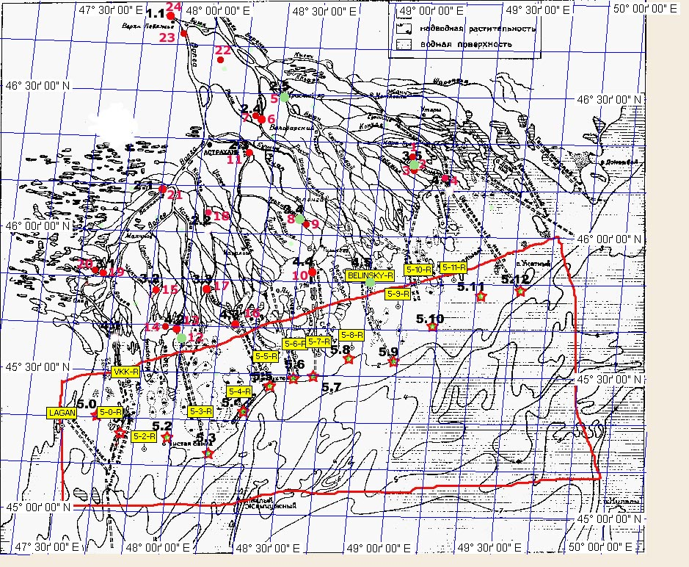
Figure 6.1 Location of stations for bottom sediment sampling
Note: Red circles are sampling stations of the delta team. Figures in yellow frame and corresponding starlets with dots are sampling stations of the sea team. Green circles denote 5 stations from which bottom sediment samples were subject to comprehensive chemical analysis.

Delta team. The group executed sampling of bottom sediments at stations located in the Volga delta and near the delta seashore line in estuarial shallow zone. During reconnaissance survey of water bodies in the areas of preliminary planned sampling stations the sites with fine (silt-like) sediments were determined accessible for cars and boats. As a rule, such sites are located close to banks of waterways and during low-water periods their depth stays within 1 m. Deeper depths were on the estuarial shallow seashore reaching 1.5-2 m. Sampling sites in the delta are affiliated to specific areas in water bodies; on the topographic map they are identified by neighboring settlements and bridges. Sampling sites in the estuarial seashore are identified by geographical coordinates. The result of reconnaissance of water bodies was that bottom sediment samples were taken on 24 sites in water bodies of different types (Figure 6.1, Table 6.1).
Table 6.1
Description of sampling sites of expedition implemented by SOI in the Volga delta
in 24.08-08.09.2005

Station No. | Sample No. | Water body name | Date | Time | Site coordinates |  | Depth, m | Comments
 |  |  |  |  | latitude | longitude | Depth, m
1 | 1 | Ostovaja anabranch, Reserve cordon No.3, Obzhorovski part | 27.08.05 | 12⁰⁰ | 46º20.0’ | 48º58.6’ | 0.5 | at the left bank
2 | 2 | Objorovo anabranch, Reserve cordon No.1, Obzhorovski part | 27.08.05 | 16³⁰ | 46º18.2’ | 48º58.9’ | 0.5 | at the right bank
3 | 2а | Dried floodplain of the Objorovo anabranch, Reserve cordon No.1, Obzhorovski part | 28.08.05 | 17⁰⁰ | 46º18.1’ | 48º58.9’ | 0 | on the right bank of Objorovo anabranch
4 | 3 | Objorovskiy canal opposite the end of the canal right edge | 28.08.05 | 13⁰⁰ | 46º15.0’ | 49º8.0’ | 0.5 | at the left bank
5 | 4 | Buzan arm 1 km downstream the Krasnyi Yar town | 29.08.05 | 12⁰⁰ | 46º30.4’ | 48º21.4’ | 0.5 | at the right bank
6 | 6 | Belyi Ilmen arm, 1 km downstream the Belyi Ilmen village | 29.08.05 | 14³⁰ | 46º25.3’ | 48º15.6’ | 0.5 | at the right bank of the Belyi Ilmen arm
7 | 5 | Lake in floodplain of Beliy Ilmen arm, 100 m above the bridge near the Belyi Ilmen village | 29.08.05 | 16⁰⁰ | 46º26.5’ | 48º14.6’ | 0.5 | on the right bank of the Beliy Ilmen arm
8 | 7 | Trekhizbinka canal, 200 m above Reserve cordon No. 2, Trekhizbinski part | 30.08.05 | 13⁰⁰ | 46º3.8’ | 48º30.8’ | 0.5 | At Reserve cordon No.2, Trekhizbinski part
9 | 9 | Dried floodplain, Trekhizbenka canal at cordon No. 2 | 30.08.05 | 14⁰⁰ | 46º3.5’ | 48º30.9’ | 2.2 | Reserve cordon No.2, Trekhizbinski part
10 | 8 | Area of sedimentation in the shallow zone westward the Tishkovski canal | 31.08.05 | 12³⁰ | 45º54.3’ | 48º34.5’ | 0.7 | Estuarial shallow seashore westward the Tishkovski canal
11 | 10 | Bolda arm eastward the Nachalovo vollage | 01.09.05 | 14³⁰ | 46º21.0’ | 48º13.0’ | 0.5 | at the right bank
12 | 14 | Gandurinskiy canal opposite the end of the canal left edge | 02.09. 05 | 14⁰⁰ | 45º37.7’ | 48º1.0’ | 1.5 | at the right bank
13 | 15 | Babushkinskiy canal, shallow sand-bar in a zone of intensive sedimentation | 02.09.05 | 16⁰⁰ | 45º40.8’ | 47º58.5’ | 0.5 | at the left bank
14 | 16 | Seashore at the delta sea line westward the Babushkinski canal | 02.09.05 | 17⁰⁰ | 45º40.9’ | 47º56.2’ | 1.4 | shallow estuarial seashore
15 | 17 | Bistraja anabranch, Reserve cordon No. 3, Damchik settlement | 03.09.05 | 11⁰⁰ | 45º47.5’ | 47º53.4’ | 1.5 | at the right bank
16 | 11 | Kirovskiy canal, outlet to Kamenskaya Yama | 04.09.05 | 14⁰⁰ | 45º41.4’ | 48º16.6’ | 2.0 | in Kamenskaya Yama
17 | 12 | Kizan arm, Nikitinskiy Bank, 200 m above the Nikitinski Bank source | 04.09.05 | 17⁰⁰ | 45º49.8’ | 48º6.9’ | 0.5 | at the left bank
18 | 13 | Kizan arm, at the southern end of the Kamyzyak town | 04.09.05 | 19⁰⁰ | 46º5.9’ | 48º4.0’ | 0.5 | at the left bank
19 | 18 | Bakhtemir arm, Fedorovka village | 05.09.05 | 12³⁰ | 45º51.8’ | 47º38.2’ | 0.5 | at the right bank
20 | 23 | Three Yerika anabranch, 100 m below the bridge near Fedorovka village | 05.09.05 | 14⁰⁰ | 45º52.2’ | 47º35.5’ | 0.5 | at the right bank
21 | 19 | Bakhtemir arm, Krasnye Barrikady village | 05.09.05 | 16³⁰ | 46º12.3’ | 47º53.4’ | 0.5 | at the right bank
22 | 22 | Yesaul anabranch, Talnikovyi settlement | 06.09.05 | 11³⁰ | 46º38.6’ | 48º3.2’ | 0.5 | at the left bank
23 | 20 | Volga course, 200 m above the water divider dam | 07.09.05 | 12⁰⁰ | 46º42.5’ | 47º51.1’ | 0.5 | at the right bank
24 | 21 | The Volga river at the delta apex, 500 m above the Verkhneye Lebyazhye village | 07.09.05 | 14⁰⁰ | 46º45.5’ | 47º48.1’ | 0.5 | at the right bank

Marine team. The work was carried out in the estuarial seashore shallow zone of the Volga River (Table 6.2).

Table 6.2
The list of real sampling stations
№ | Station No. | Date | Time | Coordinates |  | Depth, m
 |  |  |  | Latitude | Longitude | Depth, m
1 | VCC | 28.08.05 | 13⁰⁰-13²⁰ | 45º27.010’ | 47º46.174’ | 2.0
2 | 5.0-*(R) | 28.08.05 | 15⁴⁵-16¹⁰ | 45º18.423’ | 47º43.201’ | 1.4
3 | 5.2.-R | 28.08.05 | 20⁰⁵-20³⁰ | 45º13.396’ | 47º53.159’ | 2.1
4 | 5.3-R | 29.08.05 | 09¹⁵-09⁴⁰ | 45º19.012’ | 48º07.831’ | 2.0
5 | 5.4-R | 29.08.05 | 11⁵⁰-12¹⁵ | 45º23.512’ | 48º17.854’ | 1.4
6 | 5.5-R | 29.08.05 | 15¹⁵-15²⁵ | 45º31.198’ | 48º24.108’ | 1.3
7 | 5.6-R | 29.08.05 | 17⁰⁵-17²⁵ | 45º34.042’ | 48º31.777’ | 1.65
8 | 5.7-R | 29.08.05 | 18³⁰-18⁵⁰ | 45º34.571’ | 48º38.225’ | 1.5
9 | 5.8-R | 30.08.05 | 06²⁰-06⁴⁰ | 45º36.092’ | 48º47.020’ | 2.2
10 | Belinskiy-R | 30.08.05 | 10³⁰-10⁵⁴ | 45º48.880’ | 48º50.558’ | 2.3
11 | 5.9-R | 30.08.05 | 13¹⁵-13³⁵ | 45º45.111’ | 48º58.760’ | 2.1
12 | 5.10-R | 30.08.05 | 15⁰⁰-15¹⁵ | 45º50.346’ | 49º03.784’ | 2.3
13 | 5.11-R | 30.08.05 | 16⁵⁰-17¹⁰ | 45º50.863’ | 49º13.515’ | 2.2
14 | Lagan-R | 31.08.05 | 15⁵⁰-16¹⁰ | 45º17.815’ | 47º30.021’ | 2.25

6.2. Methods of sample analysis

6.2.1 Granulometric analysis
Granulometric analysis of bottom sediment samples was carried out through two methods. The first one is sieving analysis using geology sieves with mesh size of 2 mm and 0.25 mm. The second one is the laser diffraction method (LALLS).
Samples of frozen (to -20ºC) bottom sediments before preparation were dried to constant weight at temperature not higher than 35-45ºC and then carefully reduced to fragments and sifted through geological sieve with mesh size of 0.25 mm. The samples sifted through 250-mcm sieves were analyzed by low-angle dispersion meter. Repeatability of measuring the numerical and mass distribution (size spectra) was verified at thrice-repeated selection of sample mass (≈0.2 g). The bottom samples were preliminary prepared through the method described above (Figure 6.2, A). That way the granulometric composition of aleuric and pelitic fractions is analyzed.
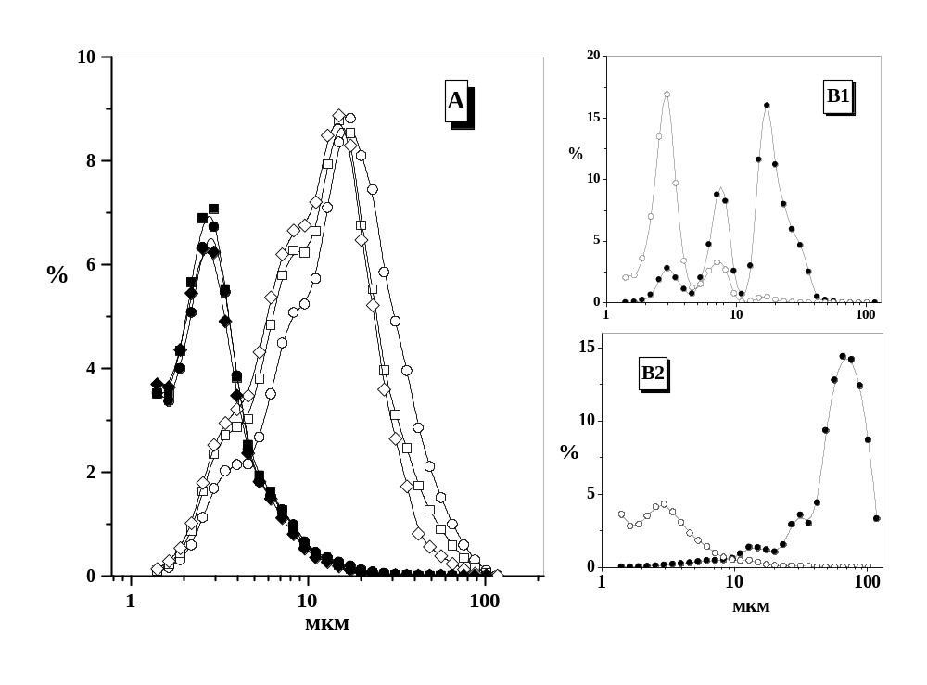
Figure 6.2 Typing of size spectra (granulometric analysis) of bottom sediments according to data of laser low-angle diffraction
А – example of the repeatability of measuring. В1 – example of the size specter of sandy silt. В2 – example of the size spectra of silty sand.

Size spectra of suspension of bottom sediments in distill water were conducted through diffraction of laser light on laser low-angle dispersion meter (diffraction detector of particle size – “particle sizer”) «Malvern 3600 Ec». The dependence v_{i}=f(r_{i}), (where v_{i} is mass part of size group r_{i}.) was used for analysis of distribution of disperse phase (www.malvern.co.uk, GOST R 8. 606-2004, GOST ISO 14644-1-2002, Certificate on approval of measuring means GB.E.27.002.A No.11341). Suspension of bottom sediments was prepared directly in the cell of low-angle particle sizer «Malvern 3600 Ec». The principle of low-angle dispersion meter is as follows: low-power He-Ne laser radiates monochromic light (λ_{max}= 633 nm), which goes through experimental cell. The diffraction picture focuses on multi-element photoelectric detector through Fourier lens. The detector is directly connected with a computer executing comprehensive processing of data starting from integrating the set of diffraction pictures reflecting the momentary size distribution of particles. In the experimental sample all particles go through the lighted zone as a result of continuous mixing. Two types of dependences were used for analysis of dispersion phase: n_{i}=f(r_{i}) and v_{i}=f(r_{i}), where n_{i} and v_{i} are size and mass part of size group r_{i}. The method sensitivity depends on section area and varies within 300 particles per sample (at length ≈0.5 mm and average width ≈70 mcm) to ≈10⁴ particles per sample (average linear size < 1 mcm). The average relative error for detection of maximum of size spectra does not exceed 10% (at confidence probability of 0.95).

6.2.2. Preparation of bottom sediments samples for chemical analysis
Bottom sediments frozen to -20 ⁰C were defreezed and dried to constant weight. Drying was done in desiccator at temperature not higher than 35 ⁰C. in order to prevent fritting of samples. Before the analytical preparation the samples were carefully reduced to fragments and sifted through geological sieves with mesh size of 0.25 mm (steel sieves are used for analysis of organic substance, and inert polypropylene sieve made by “Bioblock” company are used for elemental analysis). All chemical analysis was carried out on five parallel samples if no other methods are mentioned in the text.

6.2.3. Total organic carbon
Total organic carbon (%) in the samples of bottom sediments was defined by method of automatic titration of pH. Aliquot of the bottom sediments were burned in tubular furnace, then in the stream of especially pure О₂. Formed СО₂ left with О₂ stream in the electrochemical cell and was absorbed by solution of KCL, SrCl₂ x 6H₂O and H₃PO₄ in distilled water. The catalyst at burning was Co₃O₄. Saccharose 42.24% was used as the standard. Total organic carbon (%) in the samples of bottom sediments was defined by АN-7229 analyzer. The analysis was carried out at 500⁰С. If siderite was in the samples, the analysis was carried out after removing the siderite by 10% HCl. Temperature of the siderite decomposition was 450⁰С. There was no impurity of siderite in the samples. Other carbons do not stir the analysis. The average relative error for detection was no more than 15% (confidence probability is 0.95).

6.2.4. Chemical analysis of heavy metal contents in 5 samples
During the preparation of bottom sediment samples for elementary analysis heavy metal contents 0.1 g of dried bottom sediments were incubated with mix of acids (HCl, HNO₃, HF - 6 ml) during 1 day in teflon bombs. Sample mineralization was carried out under pressure in microwave MDS2000 under the following conditions: 2 min. 20 sec. - at 80% power, 5 min. - at 100% power. Three parallel samples were analyzed in each experiment [1].
The microelement concentrations were determined using spectrometer «SpectrAA-800» with electrotermic atomization and Zeeman effect according to manufacturer’s (“Varian” Inc) and international calibration standards. One-element lamps with hollow cathode (“Varian” Inc) were used as radiation source. Current in a lamp for Ni, Cu, Hg, Cd was 4.0 mA, for Al, As – 10 mА; for Mn, Zn – 5.0 mА; for Сr, V, Pb – 7.0 mА, for Co, Sn – 7 mA. Width of the monochromator split was 0.5 nm (for measurement of Al, Ni, Cu, Zn, Hg), 0.2 nm (for measurement of Сr, Fe, Mn, V, Co, Sn) and 1.0 mm (for measurement Cd, Pb, As). Correction mode of baseline and hot injection (80^{о}С) were used. The following wavelengths and modificators were used: for Al - λ=256.8 nm, Mg(NO₃)₂; Ni - λ=232.0 nm, Mg(NO₃)₂; Cr - λ=429,0 nm, Mg(NO₃)₂; Mn - λ=403,1 nm, Mg(NO₃)₂; Fe - λ=386,0 nm, Mg(NO₃)₂; Cu - λ=327.4 nm, Pd(NO₃)₂; Zn - λ=307.6 nm, Mg(NO₃)₂. As - λ=193.7 nm, Pd(NO₃)₂+Mg(NO₃)₂; Sn - λ=286.3 nm, Mg(NO₃)₂ + NH₄H₂PO₄; V - λ=318.5 nm; Co - λ=242.5 nm, Pd(NO₃)₂; Сd - λ=228.8 nm, Pd(NO₃)₂+Mg(NO₃)₂+NH₄H₂PO₄; Pb - λ=283.3 nm, Pd(NO₃)₂+Mg(NO₃)₂+NH₄H₂PO₄.
Mercury was analyzed the following way: 4 ml of HNO₃ and 2 ml of H₂SO₄ was added to sample mass of 0.5 g. After 1 hour incubation the mix was heated at 90^{о}С during 3 hours. Then mix was cooled and 1 ml of 10% solution of K₂Cr₂O₇ added. Mercury concentration was measured using the method of cool steam - CVAAS (atomic-absorption spectrometer «SpectrAA-800»). Relative standard deviation was no more than 20% with probability level of 0.95. Composition of the reference sample for elemental analysis is shown in Table 6.3.

Table 6.3
Concentration of elements in the reference sample of bottom sediment IAEA-405
(IAEA, Service of analytical control of quality)
Element | Concentration,  mcg/g (dry weight) | 95 % probability level,  mcg/ g (dry weight)
As | 23.6 | 22.9 - 24.3
Cd | 0.73 | 0.68 - 0.78
Co | 13.7 | 13.0 -14.4
Cr | 84 | 80-88
Cu | 47.7 | 46.5 - 48.9
Fe | 37400 | 36700 - 38100
Hg | 0.81 | 0.77 - 0.85
Li | 72 | 65-79
Mg | 12300 | 11400- 13200
Mn | 495 | 484 - 506
Ni | 32.5 | 31.1 - 33.9
Pb | 74.8 | 72.6 - 77.0
Sb | 1.81 | 1.62 - 2.00
Se | 0.44 | 0.32 - 0.56
Sn | 7.6 | 6.3 - 8.9
V | 95 | 90 -100
Zn | 279 | 272-286
Me-Hg | 0.00549 | 0.00496 - 0.00602
Al | 77900 | 72700 - 83100
Br | 85 | 60 -110
Cs | 12.5 | 10.4 -14.6
Eu | 1.25 | 0.89 -1.61
Hf | 5.80 | 4.93 - 6.67
K | 24900 | 17700 - 32100
La | 40.4 | 33.1 - 47.7
Lu | 0.468 | 0.283 - 0.653
Sc | 13.52 | 11.53 -15.51
Sm | 6.86 | 6.50 - 7.22
Sr | 118 | 104 -132
Tb | 0.93 | 0.50 -1.36
Th | 14.3 | 12.2 -16.4
U | 3.01 | 1.86 - 4.16
Yb | 3.04 | 2.19 - 3.89

6.2.5 Total content of aliphatic and polyaromatic petroleum hydrocarbons
Determination of petroleum hydrocarbons in bottom sediments was carried out according to the guidelines RD 52.10.556-95 [2] using IR-spectroscopy and UV-spectrofluorometry with insignificant modifications. Results presented are the average value received from 3-5 results of parallel measurements. Relative standard deviation did not exceed 20% at probability level of 0.95 A sample of about 20-35 g of natural moisture was introduced into rotary tube, then 15 ml of acetone was added, mixed well and centrifuged at speed of 1500 r/min during 5 min until the absolute stratification of solid and liquid phases. Acetone layer was decanted in a flask. The procedure was repeated once more. Then 15 ml of methylene chloride was added to the sample and a procedure of homogenization, rotation and decant was repeated three times. Combined extract was dried with sodium sulphate, and then evaporated until dry in natural condition. Treated sediment sample ass dried and weighted. After that 15 ml of carbon tetrachloride was added to dried extract, and then it was subjected to chromatographic column filled with Al₂O₃. The content of nonpolar hydrocarbons was determined by absorption intensity in IR-area in the range of 2700-3100 cm⁻¹ on IR-spectrophotometer SP-1100 Pye Unicam (max absorption – 2926 cm⁻¹).
To measure UV-area of spectra the treated extract was dried and solved in hexane. The fluorescence measurement was made on the spectrofluorometer FP-550 Jasco at λ_{ex}= 310 nm and λ_{em}= 360 nm. Crude oil ‘Ekofisk’ or Simard’s mixture was used as an equivalent. Determination limit constituted IR – 5 μg/g in the first variant and UV – 0.5 μg/g.

6.2.6 Fractional composition of aliphatic petroleum hydrocarbons
Analysis of fractional composition of petroleum hydrocarbons was implemented using the method of capillary gas-liquid chromatography [4]. Sample prepared for determination of hydrocarbon content was steamed in 1000 times through IR- spectrophotometry. 1 mcl was added in chromatograph. Chromatograph conditions were as follows: quartz capillary column Ultra-1 with graft methanesiliconic phase of 25 m length and 0.25 mm diameter. Gas-carrier was hydrogen, thermostat programming temperature – 80^{о}С - 4^{о}/min - 300^{о}С, pressure at the column inlet was 0.8 bar. Detector was flame-ionization. Example of determination of relative content of n-alkane, prystane, phytane and phthalic acid ether is shown in Figure 6.3. Examples of chromatograms are shown in Figure 6.4. Crude oil and individual substances of n-alcaline row were used as equivalents. Relative standard deviation did not exceed 20% at confidence probability of 0.95. Determination limit in the sample preparation method constitutes for the compound С_{n} – 0.002 mcg/g of dry bottom sediments.

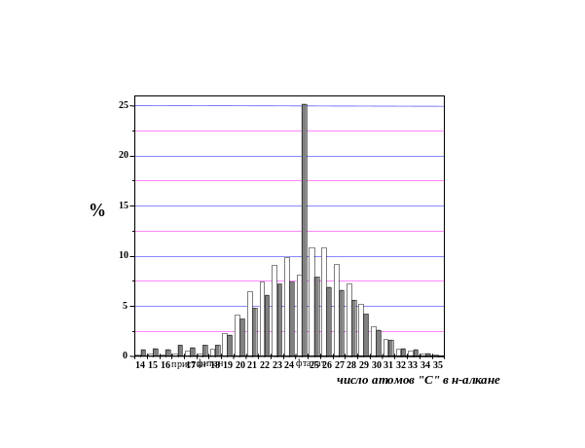
Figure 6.3 Example of determination of relative content of n-alkane, prystane, phytane and phthalic acid ether

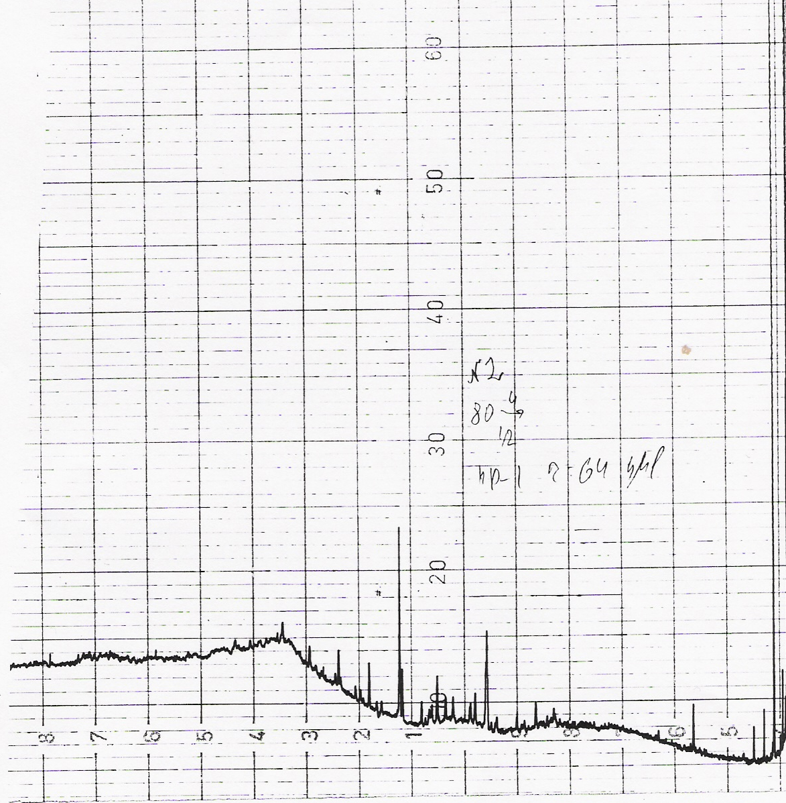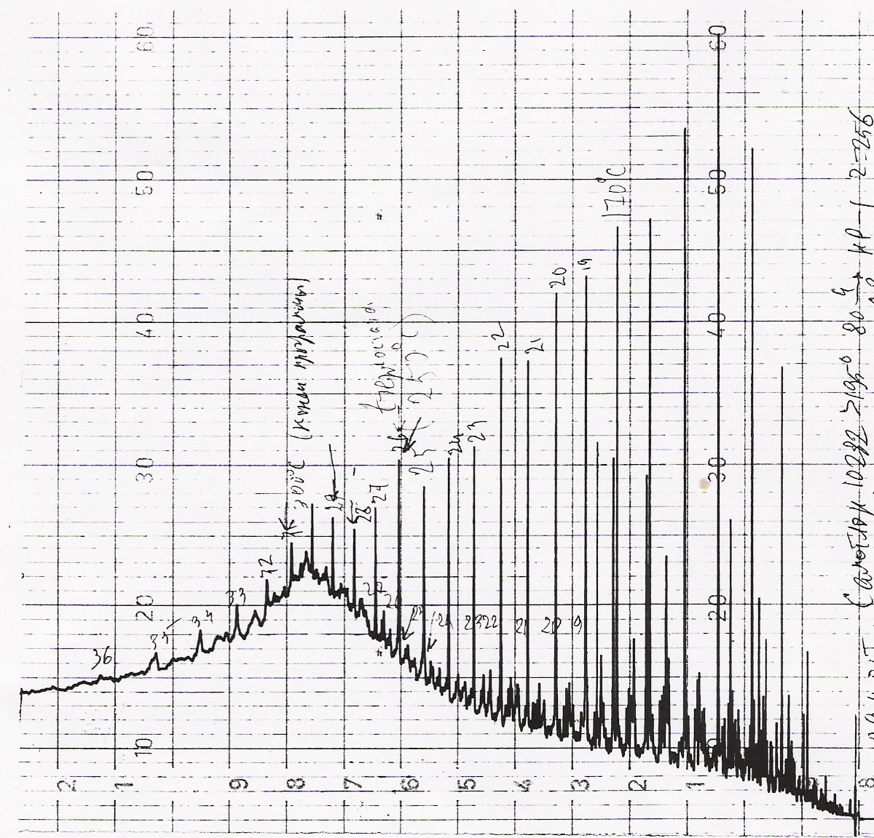
Figure 6.4 Examples of chromatograms of sample No.2 (Table 6.1) and oil equivalent

6.2.7 Fractional composition of polyaromatic hydrocarbons, chlorinated pesticides and polychlorbiphenyls
Sample mass (about 150 g) was selected for analysis of bottom sediment composition and revealing polyaromatic hydrocarbons. 50 ml of dissolvent - methylene chloride - was added to samples. Samples were mixed carefully and put into ultrasonic bath for 20-30 minutes. Then the extract obtained poured out and repeated the exctraction using 30 ml of dissolvent. Then solutions were combined and steamed in helium current at room temperature to 500 mcl.
Analysis of composition of extracts received was implemented using the method of chromate-mass-spectrometry (CMS). Analysis was carried out on gas chromatograph, model 6890 of “Helwett Packard” Company (USA) with mass-selective detector of model 5973 of “Helwett Packard” Company (USA) in a regime of ionization by electron impact.
Separation of substances was implemented in helium current at speed of 40 cm/s on column НР-5МS of “Helwett Packard” Company (USA) with diameter of 0.25 mm, layer width in static phase 0.25 mcm, length 30 m. Injector temperature was 250⁰С. Injector regime “Splitless”, without current division. Volume of sample introduced was 1 mcl. Temperature on the column: isotherm 40⁰С during 1 minute and then the programmed heating at speed of 25⁰С/min to 320⁰С with further exposition during 10 minutes. Temperature of the source was 150⁰С and interface 250⁰С.
Mass spectra of substances separated were recorded within the range of 29-800 а.е.m. Composition analysis was carried out through comparison of mass-spectra obtained with library spectral data (Mass-Spectra Library NIST 98 and Wiley) and standard mass-spectra. Content of polyaromatic hydrocarbons, chlorinated pesticides and polychlorbiphenyls in reference sample is shown in Tables6.4 and 6.5 respectively. Example of chromatograms and decoding of sample compositions based on mass-spectra library is shown in Figure 6.5.

Table 6.4
Petroleum hydrocarbon content in reference sample of bottom sediments
BS-1/OC (IIAEA, MEL).

Analyte | Units | Concentration | Standard deviation
Total Aliphatics | μg/g | 110 | ± 5.0
Resolved Aliphatics | μg/g | 10 | ± 0.53
Unresolved Aliphatics | μg/g | 99 | ± 4.3
n- С₁₇ | ng/g | 120 | ± 4.5
Pristane | ng/g | 120 | ± 4.5
n-C₁₈ | ng/g | 58 | ± 1.8
Phytane | ng/g | 110 | ± 4.5
∑ Alkanes (C₁₄-C₃₄) | μg/g | 3.6 | ± 0.19
Total Aromatics | μg/g | 18 | ± 0.84
Resolved Aromatics | μg/g | 3.2 | ± 0.15
Unresolved Aromatics | μg/g | 13 | ± 0.84
Naphthalene | ng/g | 30 | ± 1.5
1-Methylnaphthalene | ng/g | 29 | ± 1.9
2-Methylnaphthalene | ng/g | 38 | ± 2.4
2, 6-Dimethylnaphthalene | ng/g | 19 | ± 0.84
Biphenyl | ng/g | 7.3 | ± 1.2
Acenaphthylene | ng/g | 2.5 | ± 0.33
Acenaphthene | ng/g | 2.3 | ± 0.089
Fluorene | ng/g | 8.5 | ± 0.69
Phenanthrene | ng/g | 40 | ± 1.2
Anthracene | ng/g | 3.2 | ± 0.53
2-Methylphenanthrene | ng/g | 17 | ± 0.71
1-Methylphenanthrene | ng/g | 24 | ± 1.4
Fluoranthene | ng/g | 51 | ± 2.2
Pyrene | ng/g | 60 | ± 3.0
1-Methylpyrene | ng/g | 4.3 | ± 0.2
Benz[a]anthracene | ng/g | 13 | ± 0.55
Chrysene | ng/g | 45 | ± 1.9
Benzo[b]fluoranthene | ng/g | 44 | ± 2.4
Benzo[k]fluoranthene | ng/g | 32 | ± 3.9
Benzo[e]pyrene | ng/g | 37 | ± 1.9
Benzo[a]pyrene | ng/g | 31 | ± 1.9
Perylene | ng/g | 69 | ± 4.2
Indeno[l,2,3-cd]pyrene | ng/g | 43 | ± 2.1
Dibenz[a,h]anthracene | ng/g | 12 | ± 0.45
Benzo[ghi]perylene | ng/g | 39 | ± 1.1
Dibenzo Thiophene | ng/g | 5.1 | ± 0.25
1-Methyldibenzo Thiophene | ng/g | 2.1 | ± 0.11
4-Methyldibenzo Thiophene | ng/g | 6.3 | ± 0.43
UVF, Chrysene equivalent | μg/g | 23 | ± 2.5
UVF, ROPME Oil equivalent | μg/g | 200 | ± 21

Table 6.5
Content of chlorinated pesticides and polychlorbiphenyls
in reference sample of bottom sediments BS-1/OC (IAEA, MEL)

Analyte | Units | Concentration | Standard deviation
HCB | pg/g | 820 | ±13
Lindane | pg/g | 130 | ±5.5
α-HCH | pg/g | 260 | ±18
β-HCH | pg/g | 370 | ±18
pp' DDE (4,4') | pg/g | 2 700 | ±55
pp' DDD (4,4") | pg/g | 18 000 | ±1100
pp' DDT (4,4') | pg/g | 5 000 | ±320
DDMU | pg/g | 1400 | ±100
op DDE (2,4') | pg/g | 150 | ±19
op DDD (2,4') | pg/g | 2 100 | ±110
op DDT (2,4') | pg/g | 180 | ±25
Heptachlor | pg/g | 4.2 | ±0.45
Aldrin | pg/g | < 2
Dieldrin | pg/g | 19 | ±1.2
Endrin | pg/g | < 5
Aroclor 1254 | pg/g | 7 800 | ±45
Aroclor 1260 | pg/g | 3 900 | ±110
PCB No 18 | pg/g | 290 | ±15
PCB No 28 | pg/g | 200 | ±11
PCB No 31 | pg/g | 180 | ±7.1
PCB No 44 | pg/g | 320 | ±24
PCB No 49 | pg/g | 300 | ±40
PCB No 52 | pg/g | 500 | ±8.9
PCB No 87 | pg/g | 250 | ±7.1
PCB No 101 | pg/g | 620 | ±8.9
PCB No 105 | pg/g | 140 | ± 15
PCB No 118 | pg/g | 350 | ±7.1
PCB No 128 | pg/g | 86 | ± 9.4
PCB No 138 | pg/g | 650 | ±17
PCB No 149 | pg/g | 480 | ±15
PCB No 153 | pg/g | 650 | ±17
PCB No 170 | pg/g | 230 | ±11
PCB No 174 | pg/g | 180 | ±7.1
PCB No 177 | pg/g | 100 | ±3.1
PCB No 180 | pg/g | 450 | ±16
PCB No 183 | pg/g | 100 | ±4.5
PCB No 187 | pg/g | 2S0 | ±16
PCB No 194 | pg/g | 84 | ±4.1
PCB No 201 | pg/g | 22 | ±0.84

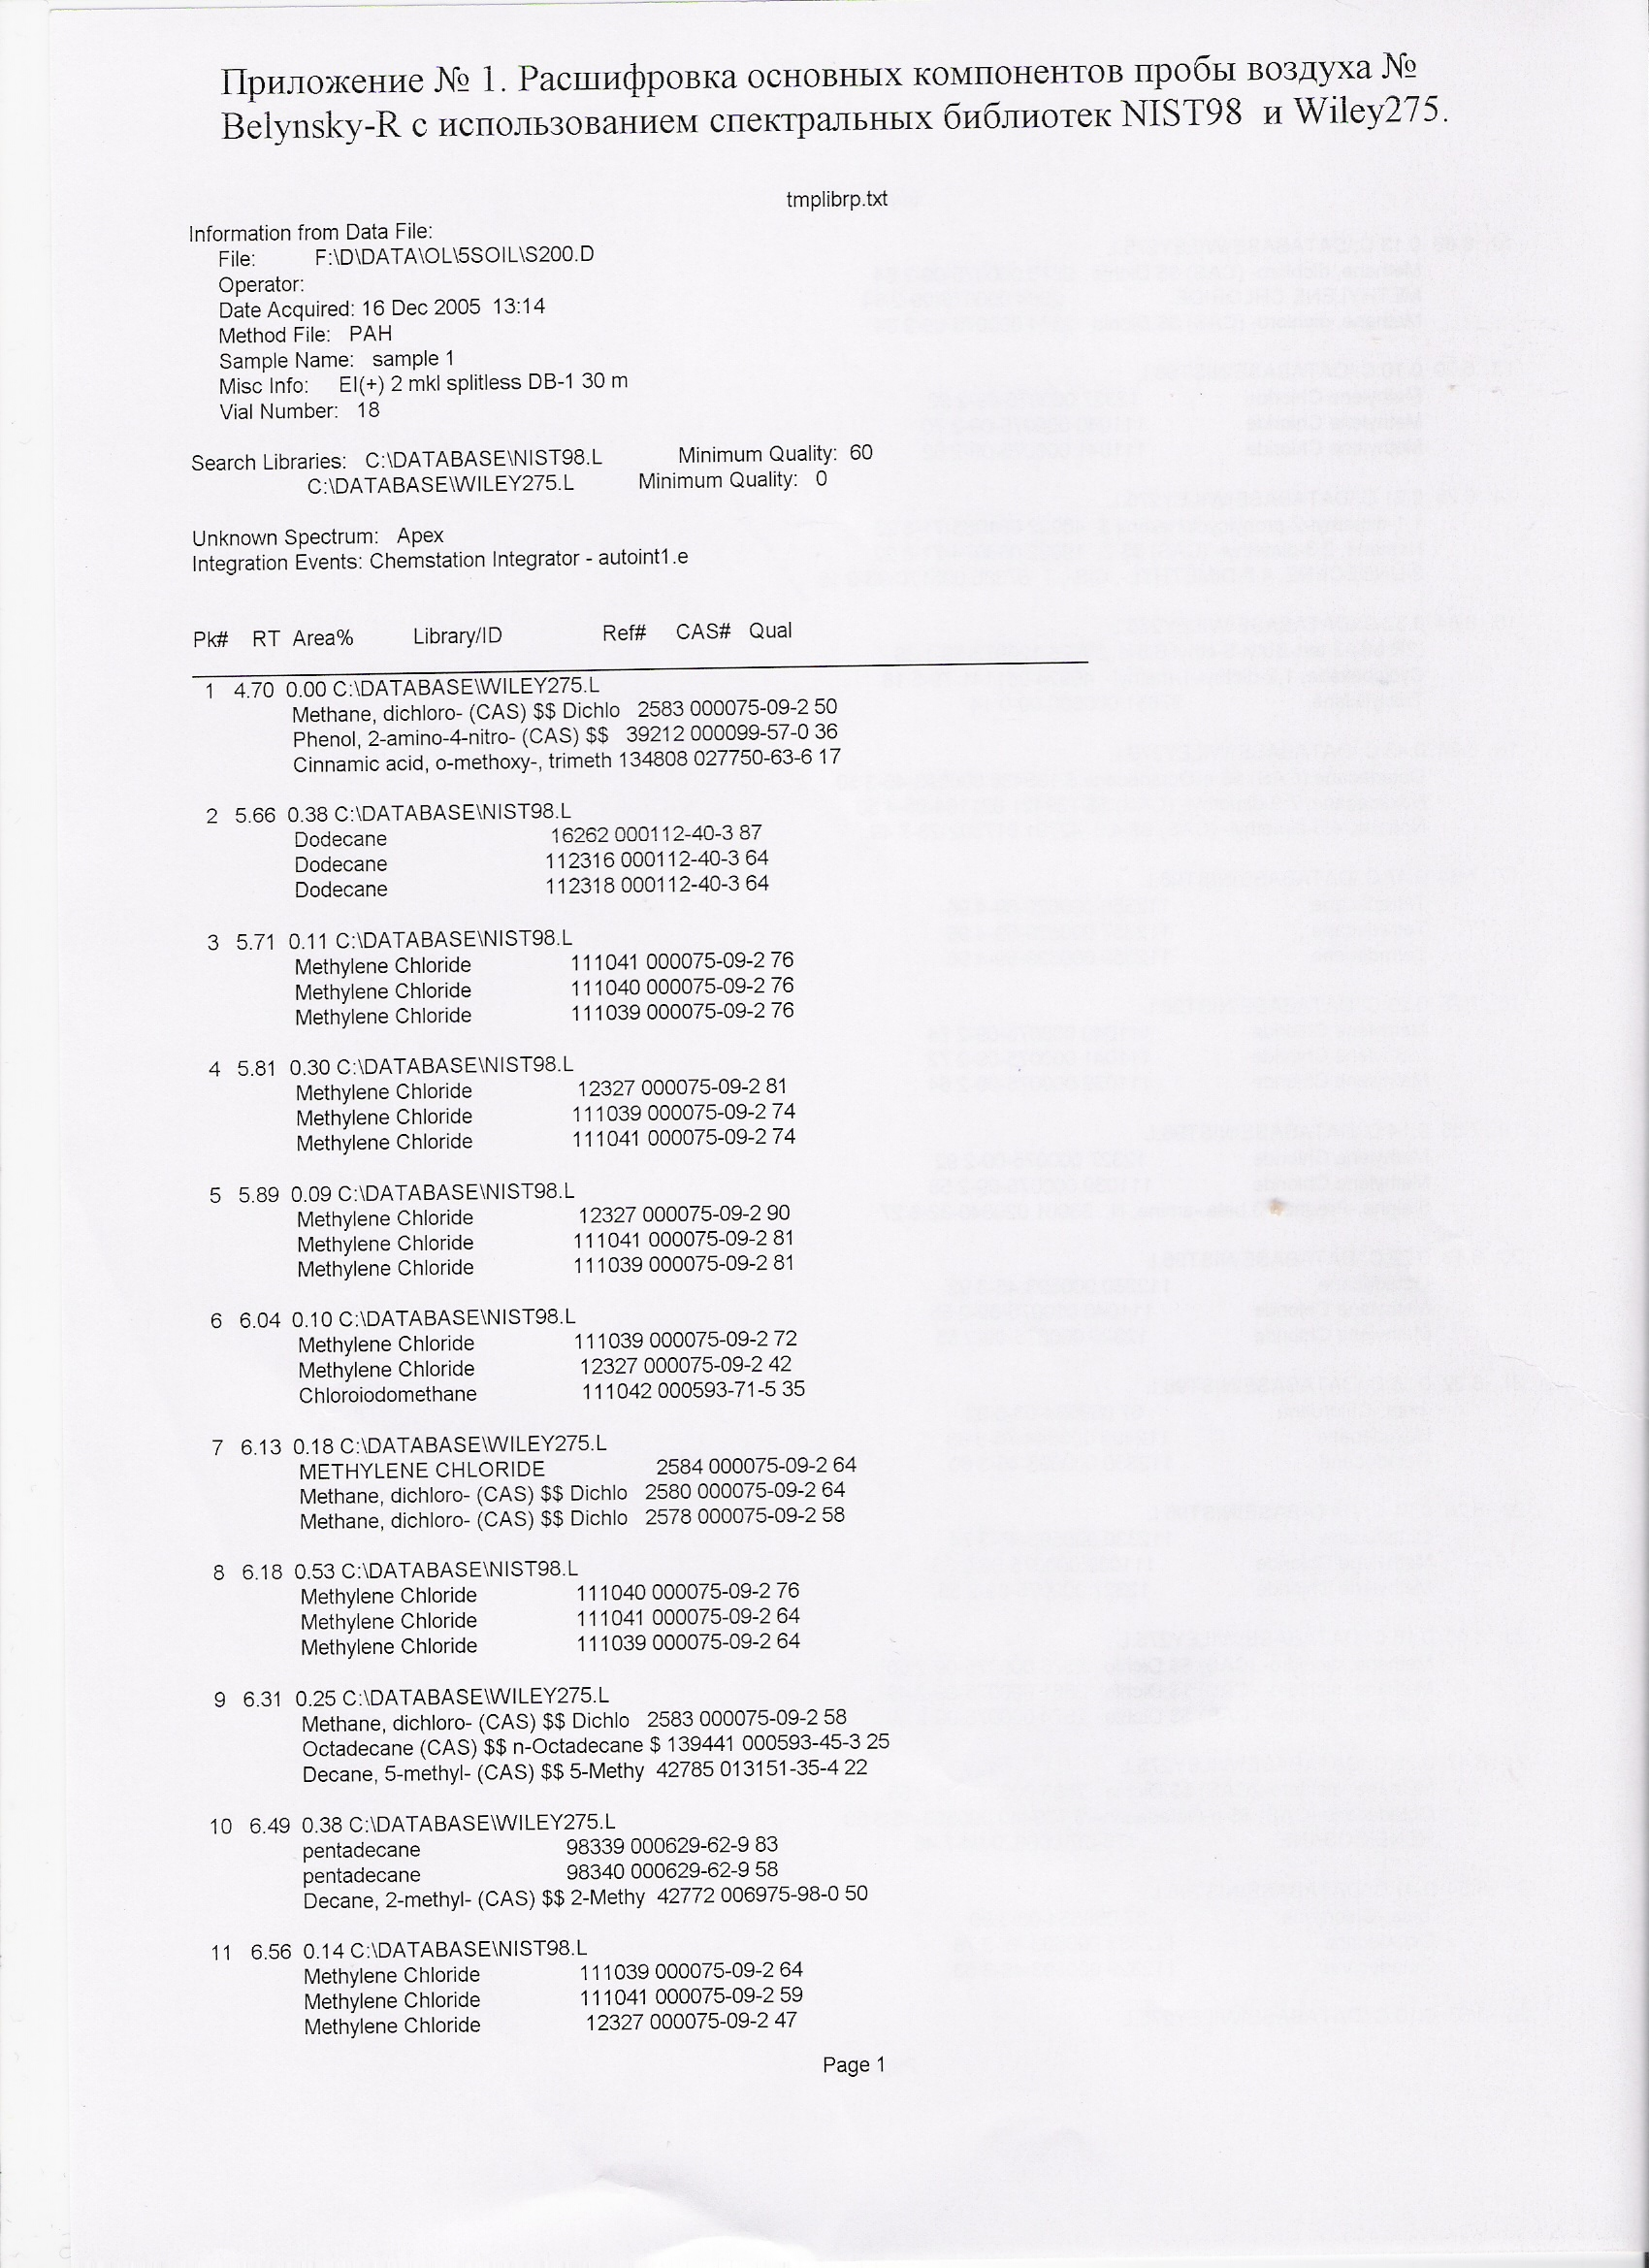

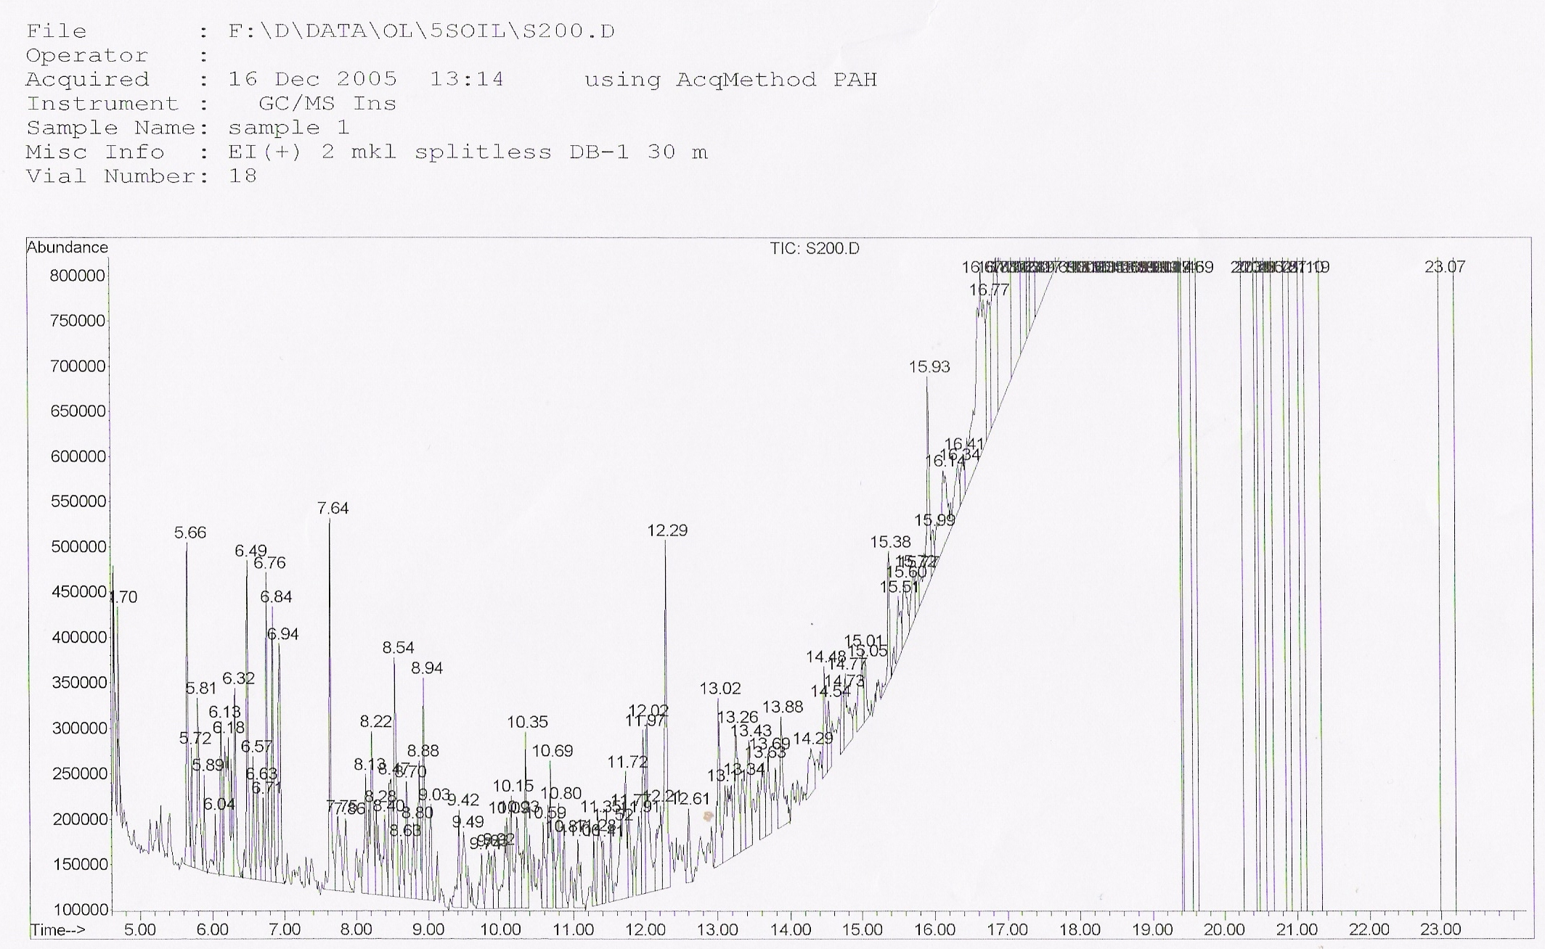

Figure 6.5 Example of chromatogram and decoding of sample composition based on the library of mass-spectra NIST 98 and Wiley

6.3. Results of bottom sediment samples processing
6.3.1 Granulometric composition
Figure 6.6 below shows size spectra of sediments from 0.002 mm to 0.25 mm.
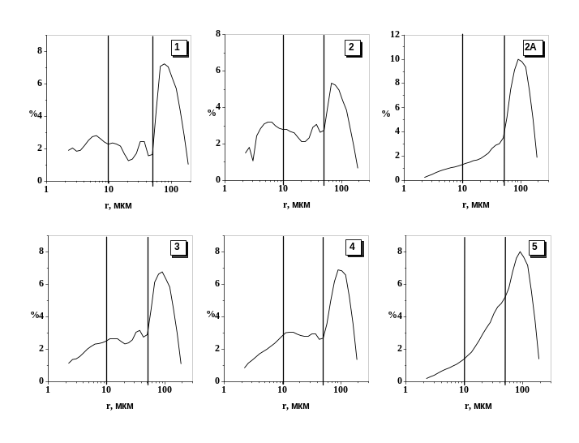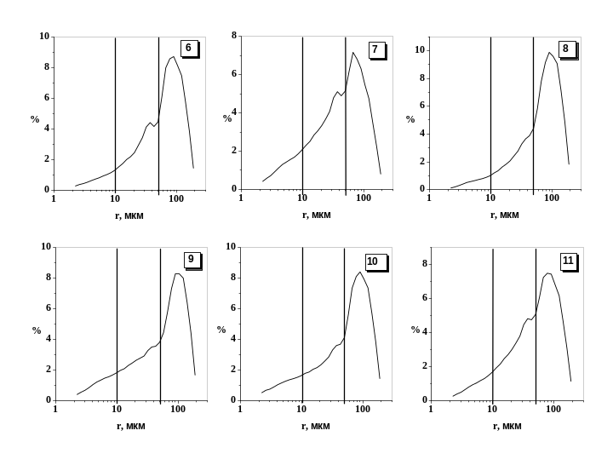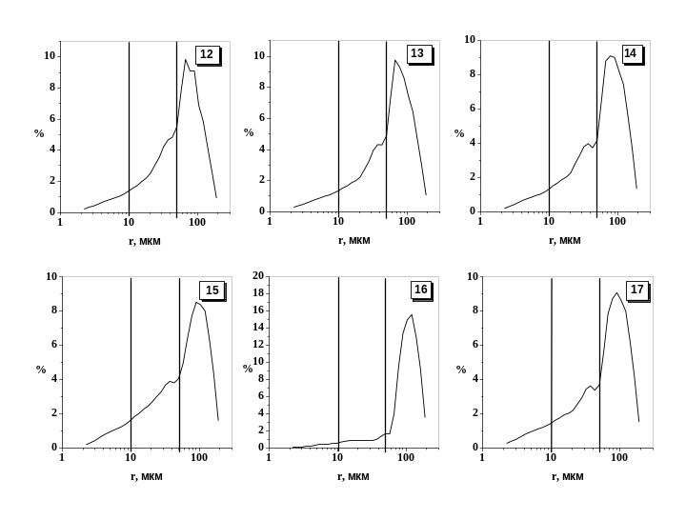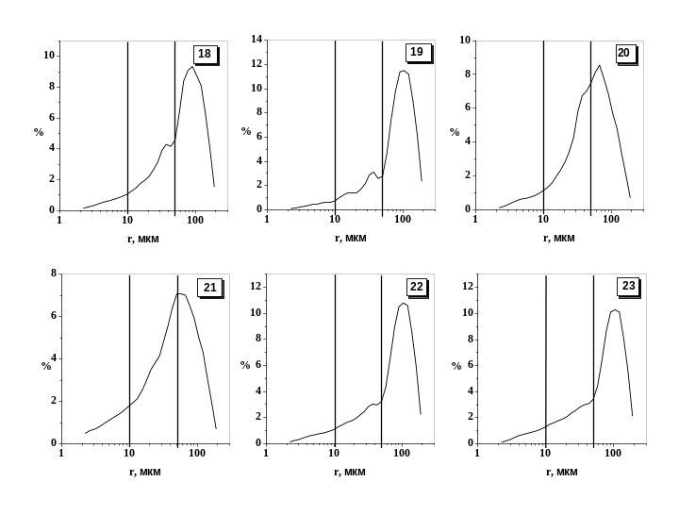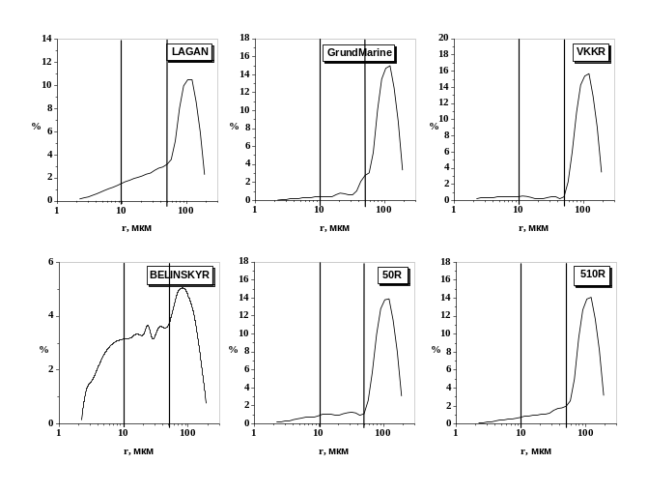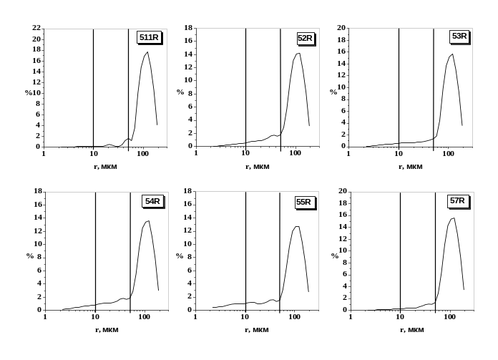
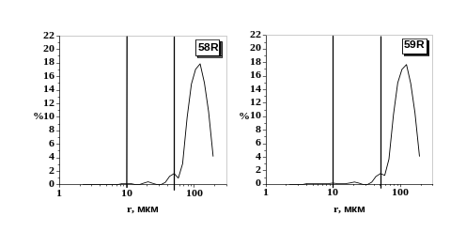
Figure 6.6 Mass size spectra of bottom sediments of the Volga delta. Number of sample is indicated in the right upper part (see Tables 6.1 and 6.2)

Table 6.6
Simplified table of granulometric composition of samples

No. of station (according to Figure 6.1) | No. of  sample (according to Tables 6.1 and 6.2) | 2 mm - 200 mcm, %  (g/g) | 200 mcm – 63 mcm, %  (g/ g) | < 63 mcm, %  (g/g)
1 | 1 | 1.3 | 33.3 | 65.4
2 | 2 | 0.8 | 23.1 | 76.1
3 | 2а | 2.3 | 49.7 | 47.9
4 | 3 | 1.4 | 32.9 | 65.7
5 | 4 | 1.1 | 30.6 | 68.3
6 | 6 | 2.0 | 41.9 | 56.1
7 | 5 | 2.1 | 39.3 | 58.6
8 | 7 | 0.9 | 29.0 | 70.1
9 | 9 | 2.7 | 41.8 | 55.5
10 | 8 | 2.6 | 48.9 | 48.5
11 | 10 | 3.0 | 39.8 | 57.2
12 | 14 | 2.2 | 35.4 | 62.4
13 | 15 | 2.4 | 42.6 | 55.0
14 | 16 | 4.2 | 75.2 | 20.6
15 | 17 | 1.9 | 44.6 | 53.5
16 | 11 | 0.9 | 36.0 | 63.1
17 | 12 | 0.9 | 36.8 | 62.3
18 | 13 | 1.3 | 39.3 | 59.4
19 | 18 | 1.5 | 45.8 | 52.7
20 | 23 | 2.8 | 52.2 | 45.0
21 | 19 | 3.3 | 58.3 | 38.4
22 | 22 | 2.7 | 55.7 | 42.6
23 | 20 | 1.2 | 30.2 | 68.6
24 | 21 | 2.1 | 30.5 | 67.4
VCC | VCC | 4.2 | 77.6 | 18.1
5.0-*(R) | 5.0-*(R) | 5.2 | 68.0 | 26.8
5.2.-R | 5.2.-R | 4.6 | 70.1 | 25.3
5.3-R | 5.3-R | 4.2 | 76.1 | 19.7
5.4-R | 5.4-R | 2.7 | 68.5 | 28.8
5.5-R | 5.5-R | 2.7 | 64.9 | 32.4
5.6-R | 5.6-R | 3.8 | 74.3 | 21.9
5.7-R | 5.7-R | 4.3 | 77.6 | 18.1
5.8-R | 5.8-R | 5.5 | 84.6 | 9.9
Belinsky-R | Belinsky-R | 0.7 | 24.3 | 75.0
5.9-R | 5.9-R | 3.5 | 86.2 | 10.3
5.10-R | 5.10-R | 4.8 | 68.7 | 26.5
5.11-R | 5.11-R | 4.3 | 84.7 | 10.9
Lagan-R | Lagan-R | 2.5 | 53.3 | 44.2

6.3.2. Content of total organic carbon

Table 6.7
Content of organic hydrocvarbon (%) in samples of bottom sediments
in the Volga delta in August-September 2005

No. of station (according to Figure 6.1) | No. of the sample (according to Tables 6.1 and 6.2) | С org., %
1 | 1 | 0.67
2 | 2 | 0.54
3 | 2а | 3.72
4 | 3 | 1.07
5 | 4 | 0.91
6 | 5 | 3.84
7 | 6 | 0.47
8 | 7 | 1.6
9 | 8 | 1.39
10 | 9 | 2.7
11 | 10 | 0.38
12 | 11 | 1.17
13 | 12 | 0.51
14 | 13 | 0.71
15 | 14 | 0.84
16 | 15 | 0.92
17 | 16 | 0.47
18 | 17 | 0.88
19 | 18 | 0.76
20 | 19 | 0.42
21 | 20 | 0.84
22 | 21 | 0.59
23 | 22 | 2.77
24 | 23 | 2.5
VCC | VCC | 0.17
5.0-*(R) | 5.0-х | 0.31
5.2.-R | 5.2-R | 0.26
5.3-R | 5.3-R | 0.24
5.4-R | 5.4-R | 0.42
5.5-R | 5.5-R | 0.26
5.6-R | 5.6-R | 0.47
5.7-R | 5.7-R | 0.34
5.8-R | 5.8-R | 0.16
Belinsky-R | Belinsky-R | 1.8
5.9-R | 5.9-R | 0.09
5.10-R | 5.10-R | 0.31
5.11-R | 5.11-R | 0.11
Lagan-R | Lagan-R | 0.5

6.3.3 Selection of samples for further chemical analysis
Stations with highly dispersed bottom sediments were selected for further analysis (with the highest content of pelitis fractions). Among them were three samples – No. 2, 7 and Belinsky R (Figure 6.6, Table 6.6). Two more samples, No. 4 and No. 14, were additionally selected both for their disperse index and geographical representativeness. Finally 5 samples were selected from the delta apex, a zone with the highest sedimentation and the delta seashore line (No. of station – its location, No. of sample): Belinskiy canal (Belinsky-R), 2 – Objorovskiy anabranch, the right bank (2), 8 – Trekhizbenka anabranch, the right bank (7), 5 – Buzan arm (below the Krashyi Yar village (4), 12 – Gandurinskiy canal (at the right bank edge) (14).

6.3.4 Content of heavy metals

Table 6.8.
Content of heavy metals and other elements (mcg/g of dried weight) in bottom sediments of the Volga Delta in August-September 2005

Element | No. of the sample
Element | 4 | 2 | 14 | 7 | Belinsky-R
Hg | 0.025 | 0.044 | 0.036 | 0.068 | 0.078
Sn | 1.05 | 1.63 | 1.47 | 1.86 | 1.81
As | 4.1 | 4.6 | 5.0 | 2.7 | 5.7
Cr | 52 | 67 | 211 | 94 | 75
Mn | 225 | 304 | 427 | 302 | 306
Zn | 41 | 52 | 97 | 90 | 61
V | 47 | 60 | 85 | 77 | 62
Li | 64 | 97 | 176 | 140 | 69
Co | 9.4 | 11.4 | 15.4 | 16.6 | 13.4
Cd | 0.13 | 0.16 | 0.31 | 0.37 | 0.23
Ag | 0.17 | 0.19 | 0.31 | 0.26 | 0.34
Pb | 5.4 | 7.3 | 12.2 | 9.7 | 7.7
Ni | 37 | 46 | 156 | 70 | 53
Cu | 10.0 | 13.1 | 31.6 | 20.9 | 18.3
Fe | 11200 | 14400 | 22500 | 23000 | 16200
Al | 26700 | 32600 | 69600 | 45900 | 33600
Ba | 448 | 551 | 819 | 548 | 449
Ca | 10253 | 12220 | 16378 | 12422 | 17501

6.3.5. Content of organic pollutants
Most organic pollutants were not found in 5 samples of sediments from the Volga Delta (Table 6.9). This fact is in a good agreement with data of SOI, VNIIgeosystems and RC “Arctic Monitoring” regarding investigations of the upper (1 cm) layer of bottom sediments in the Volga delta during 2000-2004.

Table 6.9
Content of saturated petroleum hydrocarbons in five samples from the Volga delta
(mcg/ g dried weight) for total aliphatic petroleum hydrocarbons,
and ng/g dried weight for individual n-alkans)

Parameter | No. of samples
Parameter | 4 | 2 | 14 | 7 | Belinsky-R
Total aliphatic | 30 | 6 | 22 | 62 | 12
Resolved aliphatics petroleum hydrocarbons | 0 | 0 | 0 | 0 | 0
Unresolved aliphatics petroleum hydrocarbons | 30 | 6 | 22 | 62 | 12
n-C14-C34  n-C12  n-C13  n-C14  n-C15  n-C16  n-C17  n-C18  n-C19  n-C20  n-C21  n-C22  n-C23  n-C24  n-C25  n-C26  n-C27  n-C28  n-C29  n-C30  n-C31  n-C32  n-C33  n-C34  n-C35  n-C36  Pristane  Phytane  Squalane | n.d.  n.d.  n.d.  n.d.  n.d.  n.d.  n.d.  n.d.  n.d.  n.d.  n.d.  n.d.  n.d.  n.d.  n.d.  n.d.  n.d.  n.d.  n.d.  n.d.  n.d.  n.d.  n.d.  n.d.  n.d.  n.d.  n.d.  n.d.  n.d. | n.d.  n.d.  n.d.  n.d.  n.d.  n.d.  n.d.  n.d.  n.d.  n.d.  n.d.  n.d.  n.d.  n.d.  n.d.  n.d.  n.d.  n.d.  n.d.  n.d.  n.d.  n.d.  n.d.  n.d.  n.d.  n.d.  n.d.  n.d.  n.d. | n.d.  n.d.  n.d.  n.d.  n.d.  n.d.  n.d.  n.d.  n.d.  n.d.  n.d.  n.d.  n.d.  n.d.  n.d.  n.d.  n.d.  n.d.  n.d.  n.d.  n.d.  n.d.  n.d.  n.d.  n.d.  n.d.  n.d.  n.d.  n.d. | n.d.  n.d.  n.d.  n.d.  n.d.  n.d.  n.d.  n.d.  n.d.  n.d.  n.d.  n.d.  n.d.  n.d.  n.d.  n.d.  n.d.  n.d.  n.d.  n.d.  n.d.  n.d.  n.d.  n.d.  n.d.  n.d.  n.d.  n.d.  n.d. | n.d.  n.d.  n.d.  n.d.  n.d.  n.d.  n.d.  n.d.  n.d.  n.d.  n.d.  n.d.  n.d.  n.d.  n.d.  n.d.  n.d.  n.d.  n.d.  n.d.  n.d.  n.d.  n.d.  n.d.  n.d.  n.d.  n.d.  n.d.  n.d.
Note. Determination limit for individual n-alkans is 2 ng per g of dried weight (ρ=95%),
“n.d.” - not detectable (the concentration is less than the determination limit).

There were not peaks in the zones of elution of n-alkans and izoprenans on the chromatogram (see Figure 6.4). There were non-identified peaks of nonpolar compounds (most likely of biogenic origin) in the area of elution of n-С₁₆ - n-С₂₂ (287⁰С - 371⁰С) and n-С₃₉ - n-С₃₆ (447⁰С-504⁰С).

Table 6.10
The concentrations of polyaromatic petroleum hydrocarbons
in five samples from the Volga delta

Parameter | Samples
Parameter | 4 | 2 | 14 | 7 | Belinsky-R
Total aromatic | 0.1 | 2.4 | 0.5 | 20.0 | 1.1
Naphthalene  Cl-naphthalenes  C2-naphthalenes  C3-naphthalenes  Acenaphthylene  Acenaphthene  Fluorene  Cl-fluorenes  Dibenzothiophene  Phenanthrene  Anthracene  Cl-dibenzothiophenes  C2-dibenzothiophenes  C3-dibenzothiophenes  C4-dibenzothiophenes  Cl-phenanthrenes  C2-phenanthrenes  C3-phenanthrenes  Retene  C4-phenanthrenes  Fluoranthene  Pyrene  Cl-pyrenes  Benzo (c) phenanthrene  Benz (a) anthracene  Chrysene  Cl-chrysenes  C2-chrysenes  Benzo (b) fluoranthene  Benzo (k) fluoranthene  Benzo (a) fluoranthene  Benzo (e) pyrene  Benzo (a) pyrene  Perylene  Indeno [l,2,3-c,d] pyrene  Benzo [g,h,i] perylene  Dibenz [a,h] anthracene | n.d.  n.d.  n.d.  n.d.  n.d.  n.d.  n.d.  n.d.  n.d.  n.d.  n.d.  n.d.  n.d.  n.d.  n.d.  n.d.  n.d.  n.d.  n.d.  n.d.  n.d.  n.d.  n.d.  n.d.  n.d.  n.d.  n.d.  n.d.  n.d.  n.d.  n.d.  n.d.  n.d.  n.d.  n.d.  n.d.  n.d. | n.d.  n.d.  n.d.  n.d.  n.d.  n.d.  n.d.  n.d.  n.d.  n.d.  n.d.  n.d.  n.d.  n.d.  n.d.  n.d.  n.d.  n.d.  n.d.  n.d.  n.d.  0.86  n.d.  n.d.  n.d.  1.4  n.d.  n.d.  n.d.  n.d.  n.d.  n.d.  n.d.  n.d.  n.d.  n.d.  n.d. | n.d.  n.d.  n.d.  n.d.  n.d.  n.d.  n.d.  n.d.  n.d.  n.d.  n.d.  n.d.  n.d.  n.d.  n.d.  n.d.  n.d.  n.d.  n.d.  n.d.  n.d.  n.d.  n.d.  n.d.  n.d.  n.d.  n.d.  n.d.  n.d.  n.d.  n.d.  n.d.  n.d.  n.d.  n.d.  n.d.  n.d. | n.d.  n.d.  n.d.  n.d.  n.d.  n.d.  n.d.  n.d.  n.d.  n.d.  n.d.  n.d.  n.d.  n.d.  n.d.  n.d.  n.d.  n.d.  n.d.  n.d.  n.d.  6.0  n.d.  n.d.  4.38  6.1  n.d.  n.d.  n.d.  10.9  н.о.  н.о.  6.5  н.о.  6.2  24.0  6.3 | n.d.  n.d.  n.d.  n.d.  n.d.  n.d.  n.d.  n.d.  n.d.  n.d.  n.d.  n.d.  n.d.  n.d.  n.d.  n.d.  n.d.  n.d.  n.d.  n.d.  n.d.  0.38  n.d.  n.d.  n.d.  n.d.  n.d.  n.d.  n.d.  n.d.  n.d.  n.d.  n.d.  n.d.  n.d.  n.d.  n.d.

Notes: Determination limit for detection of individual fractions – 0.2-0.4 ng/g of dried weight (ρ=95%),
“n.d.” - not detectable (the concentration is less than the determination limit).

Table 6.11
Content of chlorinated pesticides in five samples from Volga delta (ng/g of dried weight)

Parameter | Samples
Parameter | 4 | 2 | 14 | 7 | Belnsky-R
HCB  α-HCH  β-HCH  Lindane  5 HCH  pp’ DDE  pp' DDD  pp' DDT  DDMU  op DDE  op DDD  op DDT  Cis Chlordane  Trans Chlordane  Trans Nonachlor  Heptachlor  Aldrin  Dieldrin  Endrin  Heptachlor epoxide  Methoxychlor  Alpha Endosulfan  Beta Endosulfan  Endosulfan sulfate  Aroclor 1254  Aroclor 1260 | n.d.  n.d.  n.d.  n.d.  n.d.  n.d.  n.d.  n.d.  n.d.  n.d.  n.d.  n.d.  n.d.  n.d.  n.d.  n.d.  n.d.  n.d.  n.d.  n.d.  n.d.  n.d.  n.d.  n.d.  n.d.  n.d. | n.d.  n.d.  n.d.  n.d.  n.d.  n.d.  n.d.  n.d.  n.d.  n.d.  n.d.  n.d.  n.d.  n.d.  n.d.  n.d.  n.d.  n.d.  n.d.  n.d.  n.d.  n.d.  n.d.  n.d.  n.d.  n.d. | n.d.  n.d.  n.d.  n.d.  n.d.  n.d.  n.d.  n.d.  n.d.  n.d.  n.d.  n.d.  n.d.  n.d.  n.d.  n.d.  n.d.  n.d.  n.d.  n.d.  n.d.  n.d.  n.d.  n.d.  n.d.  n.d. | n.d.  n.d.  n.d.  n.d.  n.d.  n.d.  n.d.  n.d.  n.d.  n.d.  n.d.  n.d.  n.d.  n.d.  n.d.  n.d.  n.d.  n.d.  n.d.  n.d.  n.d.  n.d.  n.d.  n.d.  n.d.  n.d. | n.d.  n.d.  n.d.  n.d.  n.d.  n.d.  n.d.  n.d.  n.d.  n.d.  n.d.  n.d.  n.d.  n.d.  n.d.  n.d.  n.d.  n.d.  n.d.  n.d.  n.d.  n.d.  n.d.  n.d.  n.d.  n.d.
Note: Determination limit is 20-40 ng/g of dried weight (ρ=95%) except for heptachlor, aldrin, dieldrin, endrin (2-4 ng/g of dried weight (ρ=95%) “n.d.” - not detectable (the concentration is less than the determination limit).

Table 6.12
The concentrations of polychlorbiphenyls (PCB) in five samples from Volga delta
(ng/g of dried weight)
Parameter | Samples
Parameter | 4 | 2 | 14 | 7 | Belinsky-R
∑ PCBs | n.d. | n.d. | n.d. | n.d. | n.d.
PCB 8 | n.d. | n.d. | n.d. | n.d. | n.d.
PCB 18 | n.d. | n.d. | n.d. | n.d. | n.d.
PCB 28 | n.d. | n.d. | n.d. | n.d. | n.d.
PCB 31 | n.d. | n.d. | n.d. | n.d. | n.d.
PCB 44 | n.d. | n.d. | n.d. | n.d. | n.d.
PCB 49 | n.d. | n.d. | n.d. | n.d. | n.d.
PCB 52 | n.d. | n.d. | n.d. | n.d. | n.d.
PCB 66/95 | n.d. | n.d. | n.d. | n.d. | n.d.
PCB 87 | n.d. | n.d. | n.d. | n.d. | n.d.
PCB 97 | n.d. | n.d. | n.d. | n.d. | n.d.
PCB 101 | n.d. | n.d. | n.d. | n.d. | n.d.
PCB 105 | n.d. | n.d. | n.d. | n.d. | n.d.
PCB 110/7 | n.d. | n.d. | n.d. | n.d. | n.d.
PCB 118 | n.d. | n.d. | n.d. | n.d. | n.d.
PCB 126 | n.d. | n.d. | n.d. | n.d. | n.d.
PCB 128 | n.d. | n.d. | n.d. | n.d. | n.d.
PCB 138 | n.d. | n.d. | n.d. | n.d. | n.d.
PCB 149 | n.d. | n.d. | n.d. | n.d. | n.d.
PCB 153 | n.d. | n.d. | n.d. | n.d. | n.d.
PCB 156 | n.d. | n.d. | n.d. | n.d. | n.d.
PCB 169 | n.d. | n.d. | n.d. | n.d. | n.d.
PCB 170 | n.d. | n.d. | n.d. | n.d. | n.d.
PCB 174 | n.d. | n.d. | n.d. | n.d. | n.d.
PCB 177 | n.d. | n.d. | n.d. | n.d. | n.d.
PCB 180 | n.d. | n.d. | n.d. | n.d. | n.d.
PCB 183 | n.d. | n.d. | n.d. | n.d. | n.d.
PCB 187 | n.d. | n.d. | n.d. | n.d. | n.d.
PCB 189 | n.d. | n.d. | n.d. | n.d. | n.d.
PCB 194 | n.d. | n.d. | n.d. | n.d. | n.d.
PCB 195 | n.d. | n.d. | n.d. | n.d. | n.d.
PCB 201 | n.d. | n.d. | n.d. | n.d. | n.d.
PCB 206 | n.d. | n.d. | n.d. | n.d. | n.d.
PCB 209 | n.d. | n.d. | n.d. | n.d. | n.d.
Note: Determination limit is 10-40 ng/g of dried weight (ρ=95%),
“n.d.” - not detectable (the concentration is less than the determination limit).

References sited in Chapter 6:
1. Coquery M., Villeneuve J.P. Final report on the Split Sampling Exercises and Quality Assurance Activities. EU Project Number ENVRUS9602. - Amsterdam: ICWS, 2001, 51 р.
2. Determination of pollutants in marine bottom sediment samples suspended matter. Edited by Oradovskii S.G., M., Roshydromet, 1996, 50 p.
3. Methodical guidelines on determination of pollutants in marine bottom sediment samples suspended matter. Edited by Oradovskii S.G., M., Hydrometeoizdat, 1979, 40 p.
4. Gordadze G. N. Analysis of organic matter of rock, oil and condensates. Geology of oil and gas. 1994, No.9., 49 p.

Conclusions

1. Assessment of the Volga delta pollution and estimate of pollutants flow

Analysis of published and archive data collected and processed in accordance with Terms of Reference of the Project allowed to make the following conclusions concerning assessment of the Volga delta pollution and estimate the flow of major pollutants transported through the Lower Volga and its delta.
According to data collected during operational observations in 1995-2004 on stations of Roshydromet on the pre-estuarial site and in the Volga delta the level of average concentrations of pollutants dissolved in water constituted: for chlorinated pesticides - tenth parts of nanogram per liter of water; for mercury – hundredth parts of microgram; for cadmium – tenth parts of microgram; for metals Cu, Mn, Ni, Cr, Co, Pb – units of micrograms; for zinc – first tens of micrograms; for iron – first two hundreds of micrograms; for phenols – thousandth of milligram; for detergents – hundredth of milligram; for petroleum hydrocarbons – tenth of milligram (Table 3.1).
The highest concentration of pollutants in water was usually observed in winter period of low water and the lowest – in summer or autumn period of low water. As a rule, spatial variability is expressed less than timing variability (seasonal and inter-annual). Various pollutants differ from each other by the pattern of spatial and timing variability which indicates different ways of their migration in water courses of the Lower Volga.
Consideration of water flow distribution by water courses of the Volga delta and by sections of estuarial seashore shallow zone allowed to specify the assessment of dissolved pollutants flow into the sea much more accurately.
Estimate made using Excel program allowed to reconsider earlier results obtained on assessment of pollutants flow in the Volga delta in 1980-s. Assessment of pollutants flow made in this paper is of approximate character due to the lack of continuous observations in the lower part of delta and estuarial seashore shallow zone of Volga. For assessment of flows on the delta seashore line, data of observations in its central and upper parts was used.
The estimated flow of dissolved pollutants from the Volga River into the Caspian Sea (as a first approximation, equal to discharge into estuarial seashore shallow zone of Volga) varies within the limit from tens of kilograms (pesticides) to tens of thousand tonnes (petroleum hydrocarbons). As a rule, 40-50% of pollutant discharge occurs during flood period. Western part of the delta receives 60-70% of flow. The exclusion is pesticides as their main part of flow runs into eastern part of the delta. At present, the flow of most pollutants into the sea is significantly lower than that in 1978-1993. Pesticides discharge reduced particularly.
Pollutants flow in the Volga delta develops mainly in the upper part of the basin. According to estimates made on a basis of data of observations conducted by Roshydromet, contribution of pre-estuarial part and delta of Volga in this flow does not exceed 10%. Major part was noted only for γ-hexachlorocyclohexane. For some pollutants (detergents, DDT, most metals) reduction of their concentration in water down to 30-40% was noted in the central part of the delta as respects to its apex.
The annual average flow of pollutants in the apex and on the Volga delta seashore line (DSL) is shown in the Table below.

Pollutants | Unit | Delta apex |  | DSL, 1995-2004
Pollutants | Unit | 1977-1993 | 1995-2004 | Total | including:
 |  |  |  |  | Western part | Eastern part
Petroleum hydrocarbons | thousand tonnes | 71.65 | 54.80 | 57.10 | 37.2 | 19.9
Detergents | thousand tonnes | 5.29 | 6.96 | 7.95 | 4.35 | 3.60
Phenols | thousand tonnes | 0.70 | 0.98 | 1.07 | 0.68 | 0.39
Iron | thousand tonnes |  |  | 51.05 | 31.55 | 19.50
Zinc | thousand tonnes | 4.97 | 9.42 | 9.45 | 6.01 | 3.44
Copper | thousand tonnes | 2.19 | 1.89 | 1.66 | 1.13 | 0.53
Nickel | thousand tonnes |  |  | 1.49 | 0.94 | 0.55
Lead | tonne |  |  | 439 | 276 | 163
Cobalt | tonne |  |  | 311 | 195 | 115
Manganese | tonne |  |  | 273 | 172 | 101
Chrome | tonne |  |  | 186 | 117 | 69
Cadmium | tonne |  |  | 122 | 77 | 45
Mercury | tonne |  |  | 15.4 | 9.7 | 5.7
DDT | kg | 3710 | 186 | 94 | 56 | 38
DDE | kg | 1320 | 27 | 29.5 | 23.6 | 5.9
Alfa-HCH | kg | - | nd | 5 | nd | 5
Gamma- HCH 1983-1986 | kg | 1026 | 115 | 87 | 27 | 60
Note: For calculation of pollutant flows for DSL, their concentrations in the central part of delta were used.

Analysis of results of expeditionary work conducted by Roshydromet, SOI and IWP over the recent 15 years aimed at research into spatial and timing distribution of persistent toxicants in the Volga delta and estuarial seashore shallow zone allowed the following conclusions:
1. Water quality in the Lower Volga depends on both entrance of pollutants from the Volgograd storage reservoir and local sources.
2. Over the recent decade a stable trend to reduction of contents of petroleum hydrocarbons and pesticides in water was noted. For instance the HCH and DDT flows decreased by dozens of times.
3. Changes in concentration of major metals in water over the period under consideration does not have a clear trend and depend on a number of factors of both global (the river water flow, season, etc.) and local character (local pollution hot spots near large sources of pollutants). Dynamics of heavy metal concentrations depends in the first instance on natural processes.
4. Concentrations of dissolved mercury in the Volga delta water are high and during flooding reach 8-9 MAC in the western part of the delta.
5. Significant part of heavy metals is transported adsorbed in suspended substances (up to 73-89 %). Exclusion is Zn (the share of its suspended form is about 22 %). In different seasons the amount of metals transported on suspended substances varies widely. For instance, amount of copper transported on suspended substances during a year changed from 37 to 71%.
6. High level of pollution of bottom sediments by heavy metals is observed on the site of the Volga main riverbed below the Seroglazka settlement. As a rule, metals accumulate in silt and clay sediment fractions in places with low hydrodynamic activity of water course. Main processes of heavy metal concentrations take place in delta water courses and estuarial seashore shallow zone, especially in organic silt in growth of higher aquatic vegetation.

2. Comparison of published data and results of expedition in 2005

Heavy metals
Chrome. Out of five samples of bottom sediments selected in August-September 2005 in the Volga delta which were analyzed to determine their heavy metal concentrations in four samples the level of chrome varied within 52 and 94 mcg/g. And only in one sample taken at the right edge of the Gandurinski canal its concentration reached high level – 211 mcg/g. Research implemented earlier by IWP showed that chrome content in bottom sediments was about 120 mcg/g on average and its maximum constituted 200 mcg/g. Maximum values exceeded the level of permissible concentrations in “Netherlands lists” (100 mcg/g) approximately by two times (further in the text “permissible concentrations of pollutants in bottom sediments of water bodies – “Netherlands lists” are shown as PC. See Table 4.1 in Annex). During expeditions conducted by SOI chrome in bottom sediments was not determined. Thus, published and expeditionary results coincided significantly and confirmed the high degree of heterogeneity of this metal distribution in sediments in the Volga delta.
Nickel. Nickel distribution was similar to that of chrome. In four samples the nickel concentration varied from 37 to 70 mcg/g and only in a sample taken in Gandurinski canal its concentration reached 156 mcg/g. According to previous research conducted by SOI the average value was about 30 mcg/g, and maximum – about 80 mcg/g (PC – 35 mcg/g). During expeditions conducted by SOI, along with relatively low values from 1 to 60 mcg/g, extremely high values were noted repeatedly reaching 600-627 mcg/g (Table 4.5). At that, maximum levels of nickel concentrations were noted both in western (districts III and IV) and in eastern (districts VII and VIII) parts of the delta. Timing variability of nickel concentration in bottom sediments was also extremely high. Thus, average concentration in 1995 constituted record high value of 452 mcg/g, and in 2002 it was ten times lower – 45.8 mcg/g. Preliminary results of the expedition of 2005 confirmed significant spatial and timing variability of nickel distribution in bottom sediments. In total, they does not exceed values reported earlier.
Copper. The range of copper concentration changes in 2005 was within 10 and 32 mcg/g which is very close to values obtained by IWP earlier – about 20 mcg/g on average and about 40 mcg/g maximum (PC – 35 mcg/g). According to expeditionary works conducted by SOI the average copper concentration in the 1990-s changed within 7-12 mcg/g, while in some years its maximum reached 21-28 mcg/g (Table 4.5). However in 2002 it increased rapidly (average – 62 mcg/g, maximum – 92 mcg/g). Results of 2005 are much more closer by level to data of the 1990-s. This allows to suppose either the presence of very high level of precipitation pollution in 2002 happened due to unknown reason and exceeding PC almost by two times, or systematic error in the method of chemical analysis.
Zinc. Significant differences between various surveys were noted concerning the level of zinc in bottom sediments. In samples taken in 2005 the range was 41-97 mcg/g, however during previous expeditions conducted by IWP the average value was about 10 mcg/g while maximum was only 20 mcg/g. At that, PC constitutes 140 mcg/g. During expeditions of SOI zinc in bottom sediments was not determined.
Iron. In samples taken in 2005 iron concentration varied from 11000 to 23000 mcg/g. During SOI expeditions concentration of this element was determined only two times and was lower approximately by ten times.
Manganese. In samples taken in 2005 manganese concentration varied from 225 to 427 mcg/g constituting 313 mcg/g on average. During SOI expeditions the average annual values changed within 797-1399 mcg/g with maximum 1780 mcg/g in Tishkovski canal. According to data of IWP in September 1998 in the Volga course and its delta manganese concentration was at the level of 800-1100 mcg/g and in estuarial seashore shallow zone it constituted about 300 mcg/g (Figure 4.9). Hence, data of expedition of 2005 and previous research does not coincide to a great extent but data are insignificant to make correct comparison.
Lead. In samples taken in 2005 lead concentration varied from 5.4 до 12.2 mcg/g constituting 8.5 mcg/g on average. According to data of IWP in September 1998 in the Volga course and its delta lead concentration was at the level of 8-10 mcg/g while in estuarial seashore shallow zone it constituted about 1 mcg/g (Figure 4.9). According to results of SOI expeditions the average annual concentrations varied in a narrow range from 1.26 to 2.88 mcg/g, and its maximum reached the level of 5.9 mcg/g in August 2002 at the start point of the Volga-Caspian Canal. Results of all research are rather close and significantly lower than PC (85 mcg/g).
Cadmium. According to results of processing 5 samples in 2005 cadmium concentration varied within 0.13-0.37 mcg/g constituting 0.24 mcg/g on average. During SOI expeditions the average value in different years varied from 0.01 to 0.43 mcg/g and maximum reached 1.03 mcg/g in the shallow seashore area in Karaiski canal which is only a little higher than PC (0.8 mcg/g). In general pollution of bottom sediments in the Volga delta may be considered insignificant.
Regarding other elements (mercury, tin, arsenic, vanadium, lithium, cobalt, silver, aluminum, barium, calcium) results of expedition of 2005 cannot be compared with previous ones due to the absence of data.

Petroleum hydrocarbons
Results of processing five samples of bottom sediments taken in the Volga delta in late summer of 2005 showed the presence of saturated petroleum hydrocarbons in a very insignificant quantity. The range of total quantity of aliphatic hydrocarbons constituted 6-62 ng/g of dry bottom sediments (dry BS). However independent hydrocarbons with a number of carbon atoms from 12 to 36 were not revealed, i.e. their concentration in sediments was lower than the limit of revealing individual n-alkanes – 2 ng/g of dry BS.
Content of polyaromatic petroleum hydrocarbons in five samples from the Volga delta varied from 0.1 to 20.0 mcg/g of dry BS. Among aromatic hydrocarbons small concentration were noted for benzoperylen (24 ng/g).
According to data of expeditionary works conducted by SOI, the total average annual quantity of petroleum hydrocarbons including not only aliphatic hydrocarbons but also aromatic hydrocarbons and a number of other agents constituted 9.23 – 39.9 mcg/g (9230 – 39900 ng/g). Regarding aliphatic hydrocarbons those values are higher by more than 2 orders than the results of 2005 but concerning the total content of hydrocarbons they are very close. It is obvious that distribution of individual groups of hydrocarbons in bottom sediments in the Volga delta is extremely heterogeneous. It should be marked that in all expeditions the concentration of hydrocarbons did not exceed PC (50 mcg/g).

Chlorinated pesticides
Results of processing of five samples of bottom sediments taken in late summer 2005 in the Volga delta allow to assume the presence of chlorinated organic compounds in very low concentrations which does not exceed detection level of the chemical analysis method used: detection level for 24 compounds – 20-40 pg/g of dry BS, for heptachlor, aldrin, dieldrin, endrin - 2-4 pg/g of dry BS (Table 6.11).
According to data of expeditionary works conducted by SOI in the 1990-s, average annual concentration of DDT in bottom sediments constituted 3.8-10.1 ng/g; DDE – 0.16-1.73 ng/g; DDD – 0.40-2.81 ng/g; α-НСН – 0.11-0.89 ng/g; γ-НСН – 0.59-6.53 ng/g (Table 4.5). Concentration of all pesticides at the beginning of the decade was higher than at the end. PC for sum of DDT, DDD and DDE constitutes 2.50 ng/g; for γ- HCH (lindane) – 0.05 ng/g.
Hence, the absence of chlorinated pesticides in bottom sediments in summer 2005 may be considered either as a result of their elimination from the Volga delta ecosystem during the recent decade or low detection level of the analysis method used in 2005 which for lindane, for instance, almost corresponds to PC.

Polychlorbiphenyls
Out of 34 polychlorbiphenyl congeners which were being determined in the Volga delta in August-September 2005 none of compounds was revealed. Detection limit of the applied method of analysis constituted 10-40 pg/g of dry BS. PC for the sum of 6 polychlorbiphenyls is set at the level of 20000 pg/g. Such significant difference between detection limit and PC allow supposing either complete absence of polychlorbiphenyls in bottom sediments in the Volga delta or methodic error at implementation of chemical analysis of samples.

3. Recommendations on further research in the Lower Volga

The project work allowed to determine major gaps in knowledge about functioning of ecosystem of the Volga delta and estuarial seashore shallow zone as well as dynamics of pollutants in water and bottom sediments in the area of research. This allows developing some directions of further investigations which could give an answer to existing questions on the water body condition. Part of them envisages large scale research while another is aimed at coverage of more particular questions and details. List of problems below was composed following the geographical principle – from upstream to downstream the Volga.
1. Investigation of a role of the storage reservoirs system on the Volga with respect to accumulation and transformation of pollutants entering with Volga flow
It is necessary to assess the flow of pollutants settling in bottom sediments of storage reservoir and being washed out into the main river course during flood period and water discharges. Investigation of a core in storage reservoir on the site of active sedimentation and without significant re-settling of sediments would allow monitoring the timing dynamics of pollutants accumulation over a period of several decades. It is necessary to study conditions of transition of metals from sediments into water column and time of decomposition of organic pollutants. These investigations are beyond the geographical scope of CEP international project agreed with countries.
2. Research into mechanism of organic pollutants transportation in the Lower Volga in dissolved and suspended forms
Investigations implemented within this project showed significant absorption degree of almost all metals on suspended solids. It is necessary to carry out a large scale research on organic pollutants which level of relation with suspended substance should be still higher. It may be expected that results to be obtained would allow objective appraisal of the existing technology of monitoring the water of river and estuarial seashore.
3. Assessment of impact degree of pollutants entering from local sources in the Volga delta based on annual data of the authorized state bodies with respect to intensity and amounts of pollutants discharged with industrial and communal waste water
Results obtained during implementation of the project allow assuming that most of pollutants enter from the upper parts of the river in comparison with their sources in lower parts and delta of Volga. However without appraisal of flow of organic pollutants on suspended solids and detailed consideration of a seasonal factor (especially transportation of pollutants during flood) it is difficult for the time being to assess the exact correlation between their transit and entrance from local sources.
4. Determination of background concentrations of heavy metals for delta and estuarial seashore shallow zone of Volga
Results of research showed that timing and spatial dynamics of heavy metal concentrations depends first of all on natural processes. The task is to reveal anthropogenic impact concentrated probably in the very local by space areas with severe pollution, against the background of great variability of natural pattern. Determination of regional background concentrations of heavy metals in the water and in the bottom sediments would allow considering them in determination of indices of aquatic environment pollution and would assist in adequate appraisal of pollution level of bottom sediments.
5. Implementation of special investigation of aquatic environment pollution with inorganic and organic forms of mercury
Particularly important object of research is methylmercury and processes of its accumulation in bottom sediments and bottom organisms-filtrators.
6. Investigation of composition variability of suspended solids, bottom sediments and their pollution in different phases of water regime in the Lower Volga (raise, peak and fall of flood, discharges, summer-autumn and winter low water)
With rise of water discharge and flow velocity its saturation with suspended substances and flushed solids of bottom sediments increases, and upon decrease of its intensity these solids “enriched” with pollutants fall down on the bottom. At time-dependent regime of water flows typical for pre-estuarial area and Volga delta, multiple exchange of solids between water column and bottom of a watercourse take place. At that, fractional composition of suspended solids and bottom sediments changes along with the amount of pollutants on them. In delta and estuarial seashore shallow zone those processes have essential spatial differences. Without appropriate investigations there is no possibility to obtain reliable assessment of timing and spatial variability of pollution of suspended solids and bottom sediments in the Volga estuary and magnitude of their integral flow running through the delta.
As the above mentioned processes cause serious but not enough investigated impact on ecological state of delta, the results of proposed research will be in demand for development of management plans for the hydrological regimes of the major impounded rivers in the Caspian basin with respect to the Lower Volga envisaged by SAP for the Caspian Sea (EQO II, Target 4.4) and for implementation of recommendations stated in the National Caspian Action Plan of the Russian Federation in the field of nature use and environment protection (NCAP) – “to provide for rational water discharges for fisheries in the Lower Volga”.
6.1. As a component of the indicated research it seems advisable to implement the following: Investigation of composition, condition and features of bottom sediments in estuarial seashore shallow zone and interfluvial areas flooded in spring in the Volga delta as accumulator of pollutants running with Volga flow and potential source of secondary pollution of the Caspian Sea
Data obtained within this project denote a possibility of significant dynamics of fine- disperse fraction of bottom sediments in the estuarial seashore shallow zone at least within the major watercourses and canals. It is still unclear what the share of pollutants settling in the delta outside the major watercourses and seashore shallow zone (in canals and beyond their bounds) is with respect to the share of pollutants carried out to sea.
7. Investigation of a role of higher aquatic vegetation in retention of pollutants in delta and estuarial seashore shallow zone of Volga as a result of direct absorption of pollutants or deceleration of current velocity and settling down suspended substances
More than 70 % of the lower delta area and estuarial seashore shallow zone of Volga is overgrown with higher aquatic vegetation which impacts diversely the dynamics of transportation of water mass and bottom sediments. Vegetation shows mechanical resistance to water movements and thus contributes to settling solids suspended in water and their accumulation. Moreover, vegetation accumulates (sorbs) various substances on leaves and stems and also adsorbs them during the process of exchange with environment. The amount of biogenic elements, metals and other pollutants accumulated by vegetation may be estimated by tens and hundreds of thousand tonnes. After dying of vegetation these substances may come back into water or deposit in bottom sediments. Therefore, investigation of a role of higher aquatic vegetation in transformation of pollutants in the Lower Volga is one of the priority tasks in further research.
8. Investigation of a role of geochemical barrier in a mixture zone of fluvial and marine waters with respect to accumulation, transformation and depositing of pollutants arriving with Volga flow
Special investigations are needed in the front zone aimed at studying the dynamics of formation and settling of suspended substances as main carriers of pollutants.

Annexes

Annex 1 - “Extract from the State Reports on environment condition in the Russian Federation” Data on pollution of Volgograd storage reservoir,
Lower Volga, and Volga delta in 1991-2004

Storage reservoir | Lower Volga | Additional information
1991
N/A | In recent years due to development of the Astrakhan Gas Condensate Industrial Complex, pollution of surface water in this area is increasing especially of waters from rivers with small discharges – Akhtuba, Bereket, Kigach. | Storage reservoirs on the Volga river are polluted with phenols (1-3 MAC), copper compounds, ammonia and nitrite nitrogen, petroleum products.  Northern Caspian area is referred to regions with very critical ecological situation.
1992
Pollution of Saratov and Volgograd storage reservoirs leads to appearance of heavy metal residues in fish. | N/A | Water from the Volga system of reservoirs is characterized by increased content of phenols (2-5 MAC), petroleum products (3-10 MAC) and copper compounds (5-6 MAC). Below the city of Nizhniy Novgorod nitrogen compounds, methanol, cyanides, zinc were reported.
1993
N/A | Content of pollutants (phenols, petroleum products, copper compounds and zinc) increased up to 5-12 MAC in the estuarial part of the Volga in the area near Astrakhan.  Ecological condition of significant land areas in the Astrakhan oblast is poor. | As annually 2.5 cubic kilometers of untreated sewage are discharged into the Volga basin and 7 cubic kilometers of conditionally treated sewage in the Northern Caspian the water area adjacent to the Volga estuary is mostly polluted as well as other areas where pollutants are carried by currents.  Due to pollution of the Volga delta and Northern Caspian and mainly due to poaching, sturgeon catches continue decreasing rapidly.
1994
N/A | N/A | Section 13 (ecologically adverse regions) data on Volgograd storage reservoir, Lower Volga in the Astrakhan oblast and delta is not available.
1995
N/A | N/A | In comparison with 1994, reduction of major pollutants discharge (into the Volga basin) is observed. …entrance of such specific agents as benzol, vanadium, dichlorethane, radonids, hydroquinone, silver is noted... Typical pollutants of the Volga basin – petroleum products, iron and copper compounds, easily oxidizable organic matters… Water pollution level in the Volga storage reservoirs during a number of years is still rather high; water quality is assessed in a wide range from “polluted” to “extremely dirty”. Major pollutants in storage reservoirs – petroleum products, phenols, iron compounds, formaldehyde as well as easily oxidizable organic matters.  Essential contribution into pollution of the Volga delta is made by agricultural enterprises… Significant ecological tension in the Volga delta and Northern Caspian is caused by … oil tanker shipping operations (and oil loading plants in Astrakhan).
1996
Water in the Volgograd storage reservoir was characterized as 3-d grade of quality and assessed mainly as “polluted”. | Water in the Lower Volga was characterized as 3-d grade of quality and assessed mainly as “polluted” and near several settlements (Verkhneye Lebyazhye village, Astrakhan city) – as “dirty”. | Significant ecological tension in the Volga delta… is caused by the fact that in the Astrakhan port there are oil-loading plants and … volumes of (transit) tanker transportation of oil and oil products are increasing.
1997
N/A | N/A | Water pollution level in the Volga storage reservoirs during a number of years is still rather high; water quality is assessed from “polluted” to “extremely dirty”. Major pollutants– oil products, phenols, iron and copper compounds, formaldehyde as well as easily oxidizable organic matters. … Practically, in all storage reservoirs the quality of water in bottom layer is as a minimum one grade lower than that in the surface layer.
1998
Water in the Volgograd storage reservoir was characterized as 3-d grade of quality and assessed mainly as “polluted”. | Water in the Lower Volga was characterized as 3-d grade of quality and assessed mainly as “polluted” and near several settlements (Verkhneye Lebyazhye village, Astrakhan city) – as “dirty”. | Regardless of the trend to reduction of total amount of pollutants discharge with sewage the pollution level (of Volga) in general remains steadily at the level of previous years.
1999
Water in the Volgograd storage reservoir was assessed mainly as “polluted”. | Water in the Lower Volga was assessed mainly as “polluted” and near several settlements (Verkhneye Lebyazhye village, Astrakhan city) – as “dirty”. | Typical pollutants of the Volga river during a number of years include oil products, copper compounds, easily oxidizable matters (by BOD₅), for which recurrence of cases of exceeding MAC varied accordingly in different years within 60-75; 78-85; 52-58% of total number of water samples selected. Comprehensive assessment of water quality … shows that annually the river water quality changed by pollution level from “polluted” to “dirty”.
2000
Water in the Volgograd storage reservoir was assessed mainly as “polluted”. | Downstream the river at the Verkhneye Lebyazhye village the water quality … deteriorated (to “dirty”). | For more than 60% of river sites the Volga water quality corresponded to the grade “polluted” and for the rest – “dirty”.  Negative impact on water quality in the Lower Volga was caused by sewage discharged by Communal Services of Astrakhan as well as by waste water from Gas Condensate Industrial Complex…Significant ecological tension in the Volga delta is caused also by existence of oil-loading plants in the port of Astrakhan.
2001
Water in the Volgograd storage reservoir was assessed mainly as “low polluted” and “polluted”. | Downstream the river at the Verkhneye Lebyazhye village the water quality deteriorated (“dirty”) as in the previous years.  On the Astrakhan oblast territory… the water quality deteriorates… to “polluted” and “dirty”. The highest level of water pollution near Astrakhan: oil products up to 25-31 MAC, copper compounds up to 24-39 MAC, phenols to 9-18 MAC. | Pollution of the Volga river water remains at the same level...  Significant ecological tension in the Volga delta is caused also by existence of oil-loading plants in the port of Astrakhan.
2002
Water in the Volgograd storage reservoir was assessed mainly as “low polluted”. | Downstream the river at the Verkhneye Lebyazhye village the water quality deteriorated (as in the previous years is was assessed as “dirty”).  The highest concentrations of pollutants were noted in water of Akhtuba arm (phenols – 31 MAC), Kamyzyak arm (phenols – 47 MAC); in the river site near Astrakhan (copper compounds – 60 MAC, zinc – 165 MAC, mercury – 8 MAC). On the same site the highest concentrations of oil products constituted 21-26 MAC, copper compounds – 24-39 MAC. | Distribution of the Volga river sites and its storage reservoirs by grades of water quality during many years is practically the same. Most river sites are assessed as “polluted:, up to 22% of river sites – as “dirty”.  Sewage from Communal Services of Astrakhan as well as waste water from Astrakhan Gas Condensate Industrial Complex put the Volga-Akhtuba floodplain on the verge f ecological disaster.  Significant ecological tension in the Volga delta is caused also by existence of oil-loading plants in the port of Astrakhan.
2003
N/A | On the Astrakhan oblast territory the Volga water quality deteriorated in comparison with Volgograd oblast: the Volga water was characterized as “polluted” and “dirty”, and its arms – as “dirty”.  In general, during hydrobiological monitoring of the Volga-Akhtuba floodplain … surface water quality is assessed as transitional from “low polluted” to “medium polluted”. …Toxicological situation in that part of the Caspian Sea was relatively favorable for hydrobionts. | In 2003 the water in the Volga river and its storage reservoirs was assessed as “rather polluted” in 30% of river sites, “very polluted” in 49%, “dirty” – in 21%. Ecological tension in the Volga-Akhtuba floodplain and Volga delta is caused by sewage discharged by Communal Services of Astrakhan and waste water from Astrakhan Gas Condensate Industrial Complex and complicated by presence of oil-loading plants in the Port of Astrakhan.  Ecologo-toxicological situation in the Lower Volga and its delta was characterized by stabilization of indices of oil, phenol, detergent pollution and contents of such metals as cadmium, nickel and cobalt. The most adverse situation was observed on water courses of Belinski bank and in the Volga within the city precincts. Water in the Volga-Caspian Canal has high level of oil pollution.
2004
N/A | On the territory of the Astrakhan oblast, in comparison with the Volgograd oblast, water quality became worsen and near Astrakhan changed into “dirty”.  The Volga arms were characterized by high level of water pollution, and its quality on 11 river sites was assessed as “polluted”, on 7 river sites as “dirty”. | Sewage from Communal Services of Astrakhan as well as waste water from Astrakhan Gas Condensate Industrial Complex put the Volga-Akhtuba floodplain on the verge f ecological disaster.  Significant ecological tension in the Volga delta is caused also by existence of oil-loading plants in the port of Astrakhan.

Annex 2. Tables

Table 3.1 Data on standard network stations of observations over pollution of water in pre-estuarial part and delta of the Volga River

Water course name | Observation station name | Coordinates of observation station |  | Opening date of observation station | latitude, tenth part | Depth
Water course name | Observation station name | latitude | longitude | Opening date of observation station | latitude, tenth part | Depth
Volga River | Tsagan Aman village | 47°30´ | 46°44´ | 1969 | 0.8 | 0.5
Volga River | Tsagan Aman village | 47°30´ | 46°44´ | 1969 | 0.5 | 0.5
Volga River | Tsagan Aman village | 47°30´ | 46°44´ | 1969 | 0.5 | 14.5
Volga River | Verkhneye Lebyazhye village | 46°45´ | 47°48´ | 1968 | 0.8 | 0.5
Volga River | Verkhneye Lebyazhye village | 46°45´ | 47°48´ | 1968 | 0.5 | 0.5
Volga River | Verkhneye Lebyazhye village | 46°45´ | 47°48´ | 1968 | 0.5 | 14
Volga River | Astrakhan, ACPP | 46°25´ | 48°00´ | 1968 | 0.8 | 0.5
Volga River | Astrakhan, ACPP | 46°25´ | 48°00´ | 1968 | 0.5 | 0.5
Volga River | Astrakhan, ACPP | 46°25´ | 48°00´ | 1968 | 0.5 | 12.5
Volga River | Astrakhan, POS | 46°16´ | 47°57´ | 1986 | 0.5 | 0.5
Volga River | Astrakhan, POS | 46°16´ | 47°57´ | 1986 | 0.5 | 9
Volga River | Astrakhan, Ilyinka | 46°12´ | 47°55´ | 1972 | 0.8 | 0.5
Volga River | Astrakhan, Ilyinka | 46°12´ | 47°55´ | 1972 | 0.5 | 0.5
Volga River | Astrakhan, Ilyinka | 46°12´ | 47°55´ | 1972 | 0.5 | 5
Volga River | Astrakhan, Ilyinka | 46°12´ | 47°55´ | 1972 | 0.5 | 10
Volga River | Astrakhan, Ilyinka | 46°12´ | 47°55´ | 1972 | 0.2 | 0.5
Akhtuba arm | Seliternoye urban village | 47°08´ | 47°28´ | 1988 | 0.5 | 0.5
Akhtuba arm | Aksaraiski settlement | 46°47´ | 47°58´ | 1983 | 0.5 | 0.5
Kigach canal | Podchalyk village | 46°38´ | 48°17´ | 1986 | 0.5 | 0.5
Buzan arm | Krasnyi Yar village | 46°32´ | 48°21´ | 1969 | 0.5 | 0.5
Buzan arm | Krasnyi Yar village | 46°32´ | 48°21´ | 1969 | 0.5 | 7.5
Krivaya Bolda arm | Krivaya Bolda arm | 46°22´ | 48°10´ | 1980 | 0.5 | 0.5
Krivaya Bolda arm | Krivaya Bolda arm | 46°22´ | 48°10´ | 1980 | 0.5 | 8
Kamyzyak arm | Kamyzyak towm | 46°07´ | 48°04´ | 1984 | 0.5 | 0.5
Kamyzyak arm | Kamyzyak town | 46°07´ | 48°04´ | 1984 | 0.5 | 7.5

Table 3.2 Affiliation of permanent stations of observations over chemical composition of water with various areas of pre-estuarial part and delta of the Volga River

Water course name | Observation station name | Coordinates of observation station |  | Area
Water course name | Observation station name | latitude | longitude | Area
Volga River | Tsagan Aman village | 4730 | 4644 | Pre-estuarial part, Volga River
Akhtuba arm | Seliternoye urban village | 4708 | 4728 | Pre-estuarial part, Akhtuba River
Akhtuba arm | Aksaraiski settlement | 4647 | 4758 | Pre-estuarial part, Akhtuba River
Volga River | Verkhneye Lebyazhye village | 4645 | 4748 | Delta apex
Volga River | Astrakhan | 4625 | 4800 | Upper zone, western part of delta
Volga River | Astrakhan | 4616 | 4757 | Upper zone, western part of delta
Krivaya Bolda arm | Krivaya Bolda arm | 4622 | 4810 | Upper zone, western part of delta
Volga River | Ilyinka settlement | 4612 | 4755 | Central zone, western part of delta
Kamyzyak arm | Kamyzyak town | 4607 | 4804 | Central zone, western part of delta
Buzan arm | Krasnyi Yar village | 4632 | 4821 | Border between upper and central zones of eastern part of delta
Kamyzyak canal | Podchalyk village | 4638 | 4817

Table 3.3 Number of measurements on permanent observation stations grouped by pollutants, areas and quarters for 1995-2004

ЗВ | Pre-estuarial part |  |  |  |  |  |  |  | Delta
ЗВ |  |  |  |  |  |  |  |  | Apex |  |  |  | Upper zone |  |  |  |  |  |  |  | Central zone
ЗВ | Volga River |  |  |  | Akhtuba River |  |  |  |  |  |  |  | West |  |  |  | East |  |  |  | West |  |  |  | East
ЗВ | 1 qu | 2 qu | 3 qu | 4 qu | 1 qu | 2 qu | 3 qu | 4 qu | 1 qu | 2 qu | 3 qu | 4 qu | 1 qu | 2 qu | 3 qu | 4 qu | 1 qu | 2 qu | 3 qu | 4 qu | 1 qu | 2 qu | 3 qu | 4 qu | 1 qu | 2 qu | 3 qu | 4 qu
Detergents | 2 | 4 | 13 | 5 | 20 | 40 | 33 | 21 | 11 | 30 | 23 | 16 | 28 | 93 | 77 | 56 | 10 | 19 | 15 | 12 | 19 | 92 | 75 | 55 | 10 | 30 | 20 | 16
Oil | 5 | 4 | 14 | 9 | 43 | 59 | 54 | 60 | 19 | 45 | 43 | 32 | 126 | 190 | 200 | 161 | 22 | 29 | 27 | 26 | 80 | 190 | 180 | 133 | 22 | 42 | 38 | 31
Phenols | 5 | 4 | 14 | 7 | 44 | 59 | 54 | 56 | 21 | 46 | 42 | 31 | 138 | 207 | 227 | 168 | 22 | 29 | 27 | 27 | 81 | 196 | 186 | 135 | 22 | 42 | 37 | 30
Zinc | 6 | 4 | 13 | 6 | 44 | 59 | 55 | 54 | 21 | 47 | 41 | 31 | 289 | 438 | 446 | 370 | 22 | 29 | 27 | 27 | 108 | 223 | 202 | 152 | 22 | 42 | 37 | 30
Copper | 6 | 4 | 13 | 6 | 44 | 60 | 54 | 54 | 21 | 46 | 42 | 31 | 291 | 438 | 447 | 370 | 22 | 29 | 27 | 27 | 106 | 223 | 202 | 153 | 22 | 42 | 36 | 30
Iron | 2 | 1 | 14 | 6 | 16 | 38 | 37 | 19 | 9 | 28 | 26 | 13 | 25 | 94 | 94 | 48 | 8 | 18 | 18 | 10 | 17 | 93 | 87 | 51 | 8 | 27 | 23 | 13
Nickel | 0 | 0 | 2 | 0 | 8 | 19 | 15 | 8 | 4 | 13 | 8 | 5 | 1 | 12 | 0 | 0 | 0 | 1 | 0 | 0 | 3 | 20 | 12 | 9 | 0 | 4 | 0 | 0
total chrome | 0 | 0 | 2 | 0 | 8 | 19 | 15 | 8 | 4 | 13 | 9 | 4 | 1 | 12 | 0 | 0 | 0 | 1 | 0 | 0 | 3 | 20 | 12 | 9 | 0 | 4 | 0 | 0
Lead | 0 | 0 | 1 | 0 | 8 | 19 | 15 | 8 | 4 | 13 | 7 | 4 | 1 | 12 | 0 | 0 | 0 | 1 | 0 | 0 | 3 | 20 | 11 | 9 | 0 | 4 | 0 | 0
Cobalt | 0 | 0 | 1 | 0 | 8 | 19 | 15 | 8 | 4 | 13 | 7 | 4 | 0 | 13 | 0 | 0 | 0 | 1 | 0 | 0 | 3 | 20 | 11 | 9 | 0 | 4 | 0 | 0
Cadmium | 0 | 0 | 2 | 0 | 8 | 19 | 15 | 8 | 4 | 13 | 8 | 4 | 1 | 12 | 0 | 0 | 0 | 1 | 0 | 0 | 3 | 20 | 12 | 9 | 0 | 4 | 0 | 0
manganese | 0 | 0 | 1 | 0 | 8 | 19 | 15 | 8 | 4 | 13 | 7 | 4 | 1 | 12 | 0 | 0 | 0 | 1 | 0 | 0 | 3 | 21 | 10 | 9 | 0 | 4 | 0 | 0
Mercury | 0 | 0 | 2 | 0 | 0 | 4 | 0 | 0 | 4 | 13 | 9 | 5 | 14 | 54 | 32 | 16 | 0 | 0 | 0 | 0 | 7 | 44 | 32 | 18 | 0 | 4 | 0 | 0
а-HCH | 2 | 3 | 5 | 0 | 14 | 18 | 15 | 6 | 9 | 23 | 13 | 7 | 21 | 52 | 34 | 17 | 4 | 5 | 1 | 0 | 14 | 69 | 35 | 26 | 8 | 24 | 12 | 7
у-HCH | 2 | 3 | 6 | 0 | 14 | 18 | 15 | 6 | 9 | 23 | 13 | 7 | 21 | 51 | 34 | 17 | 4 | 5 | 1 | 0 | 14 | 69 | 35 | 26 | 8 | 24 | 12 | 7
DDT | 2 | 3 | 6 | 0 | 13 | 18 | 13 | 6 | 9 | 25 | 11 | 7 | 21 | 52 | 34 | 17 | 4 | 5 | 1 | 0 | 15 | 69 | 37 | 26 | 8 | 24 | 12 | 7
DDE | 2 | 3 | 6 | 0 | 13 | 18 | 13 | 6 | 7 | 25 | 13 | 7 | 21 | 52 | 34 | 17 | 4 | 5 | 1 | 0 | 15 | 69 | 37 | 26 | 8 | 24 | 12 | 7

Table 3.4 Description of methods of chemical analysis of pollutants in water

Ingredient | Method | Directive document,  No. , title | Instrumentation | Standard | Unit | Range of concentrations measured | Characteristics of error components |  |  | Characteristics of error  Δс
 |  |  |  |  |  |  | Sporadic  О  σ (Δ) | Systematic  Δс
 |  | RD.52.24.353-95. Recommendations. Sampling of surface water of land and treated sewage
Practical manual.
GEMS /WATER-UNEP
/WHO/UNESCO/WMO PROGRAM GLOBAL WATER MONITORING AND QUALITY ASSESSMENT –
Chapter I-VII).
 |  | RD.52.10.556-95. Guidelines. Determination of pollutants in samples of bottom sediments and suspended solids. Federal Service on Hydrometeorology and Monitoring of Environment. М. 1966
petroleum hydrocarbons | IR | RD.52.24.476-95. Guidelines. MM of mass concentration of oil products in water using IR- photometric method. | Oil concentration meter КN-2 | GSO7248-96 oil products in carbon tetrachloride 50mg\cm³ | mg dm³ | 0.04 - 0.08  0.08-2.0 | 0.01  0.01+ 0.08*C | 0.09*C  0.09*C |  | 0.01+0.19*C  0.01+0.19*C
phenol | Eph | RD.52.24.480-95. Guidelines. MM of mass concentration of total volatile phenols in water using extraction- photometric method without distillation | KFK-3 | GSO7101-94  phenol 29.71% of molar fraction | mg dm³ | 2.0 - 15.0  15.0-25.0 | 0.2 + 0.03*С  0.2 + 0.03*С | 0.1 + 0.08*С  1.3 |  | 0.4+ 0.09*С  1.1 +0.05*С
iron | АА | RD.52.24.377-95. Guidelines. MM of mass concentration of metals (Al,Ag,Ba,Be,Cd,Co,Cr,Cu,Fe,Mn,Mo,Ni,Pb,V,Zn) in surface land-based water using method of atomic absorption with direct electrothermal atomization of samples | Atomic absorptive spectrophotometer “Kvant-Z-ETA” with Zeeman correction and electrothermal atomization | GSO7330-96  Metal ions, g\l: Fe-0.99, Cd-0.500, Mn-0.495, Cu-1.00,  Ni-2.00,  Pb-1.00,  Zn-0.500, АО, chrome, 1mg\cm³ (certificate, VNIIM after Mendeleyev)  GSO5216-90 barium, 1mg\cm³ | mcg dm³ | 6 - 250 | 1+ 0.08*C | 1+ 0.06*C |  | 2+ 0.16*C
cadmium | Same | Same | Same |  | mcg dm³ | 0.12 - 2.00 | 0.02+ 0.04*С | 0.02+ 0.02*С |  | 0.04+ 0.08*С
manganese | Same | Same | Same |  | mcg dm³ | 0.45 - 15.0 | 0.1+ 0.05*С | 0.1+ 0.03*С |  | 0.2+ 0.10*С
copper | Same | Same | Same |  | mcg dm³ | 0.65 – 30.0 | 0.1+ 0.08*С | 0.1+ 0.05*С |  | 0.2+0.16*С
nickel | Same | Same | Same |  | mcg dm³ | 4.05 - 65.0 | 0.8+ 0.05*С | 0.5+ 0.03*С |  | 1.6+0.10*С
lead | Same | Same | Same |  | mcg dm³ | 2.0 - 30.0 | 0.4+ 0.05*С | 0.2+ 0.04*С |  | 0.8+0.10*С
chrome | Same | Same | Same |  | mcg dm³ | 0.5 - 30.0 | 0.1+ 0.09*С | 0.07*С |  | 0.3+0.18*С
zinc | Same | Same | Same |  | mcg dm³ | 2.5 - 20.0 | 0.4+ 0.07*С | 0.5+ 0.03*С |  | 0.8+0.14*С
mercury | АА | RD.52.24.479-95. Guidelines. MM of mass concentration of mercury in water using method of atomic absorption in cold steam | -«»- mercury hydride generator  GRG-106 | АО, mercury, 1mg/cm³  (certificate, VNIIM after Mendeleyev) | mcg dm³ | 0.020-0.100 | 0.17*С | 0.25*С |  | 0.43*С
alfa-HCH | GCh | RD 52.24.412-95.  Guidelines. MM of mass concentration of  Of 2 Ohexachloro-benzene, alfa-, beta- and gamma-HCH, dicophole, dihydroheptachlor,  4,4'-DDT, 4,4'-DDE, 4,4'-DDD, trifluraline in water using gas chromatography method | Gas chromatograph  Tsvet-500М |  | mcg dm³ | 0.0020-0.0500 | 4*10⁻⁴ + 0.087*C | 3*10⁻⁴ + 0.069*C |  | 8*10⁻⁴ + 0.17*C
gamma-HCH | Same | same | same |  | mcg dm³ | 0.0020-0.0500 | 4*10⁻⁴+ 0.090*C |  | 3*10⁻⁴+ 0.072*C |  | 8*10⁻⁴+ 0.18*C
4,4'-DDE | Same | same | same |  | mcg dm³ | 0.0050-0.150 | 0.001+  0.047*C |  | 8*10⁻⁴+ 0.037*C |  | 0.002+  0.093*C
4,4'-DDT | Same | same | same |  | mcg dm³ | 0.020-0.500 | 0.005+  0.048*C |  | 0.004+  0.038*C |  | 0.010+  0.096*C

Abbreviations: IR - infrared method; EPh – electrophotometric method; АА - atomic absorptive method; GCh – gas chromatography; MM –method of measuring; С – ingredient concentration; VNIIM after Mendeleyev – All-Russian Research Institute on Meteorology after D. I. Mendeleyev

Table 3.5 Outline of statistical analysis of observation data on contents of pollutants in river water
on observation stations of Roshydromet for 1995-2004

Amount of summary  data array  (number of measurements) | Statistical parameters determined
Amount of summary  data array  (number of measurements) | Average value | Maximum value | Minimum value | Median | Asymmetry coefficient | Standard deviation | Correlation coefficient of pollutant concentration to water discharges | Moving correlation coefficient (window width, n=17) of arrays ranged by water discharges
Analysis of summary data array for 1995-2004
<5 | Calculations were not made
5-9
10-19
20-150
Analysis of annual summary data arrays for 1995-2004
150-250
> 250

Note: results of correlation analysis are not considered in this paper.

Table 3.6 Number of water samples from different areas of the Volga delta in which petroleum hydrocarbon concentration was determined during SOI expeditions in 1993-2002

Areas | Petroleum hydrocarbons (PHs)
Areas | 1993 | 1994 | 1995 | 1996 | 2000 | 2001 | 2002
I |  |  |  |  |  | 2 | 1
II |  |  |  |  |  |  | 1
III | 4 | 4 | 2 | 2 | 1 | 3 | 4
IV |  | 2 | 1 | 2 | 6 | 2 | 3
VI |  |  | 2 | 2 |  | 1 | 1
VII | 2 | 2 |  |  |  |  | 1
VIII | 3 | 3 | 3 | 3 | 3 | 1 | 4
Total for the period | 9 | 11 | 8 | 9 | 10 | 9 | 15

Areas |  | Chlorophenols (3- chlorophenol,  2,4-di chlorophenol, 2,4,6-trichlorophenol, pentachlorophenol, 2- nitrophenol, 4- nitrophenol)
 |  | 1993 |  | 1994 |  | 1995 |  | 1996 | 2000 |  | 2001 |  | 2002
I
II
III | 4 |  | 4 |  | 5 |  | 5
IV | 1 |  | 3 |  | 1 |  | 1
VI |  |  |  |  | 2 |  | 2
VII | 2 |  | 2
VIII | 3 |  | 3 |  | 3 |  | 3
Total for the period | 10 |  | 12 |  | 11 |  | 11

Areas | DDT group (DDT, DDE, DDD)
Areas | 1993 | 1994 | 1995 | 1996 | 2000 | 2001 | 2002
I
II |  | 1
III | 3 | 4 |  | 5
IV |  | 1 | 4 | 1
VI |  |  |  | 2
VII | 2 | 2
VIII | 3 | 3 |  | 3
Total for the period | 8 | 11 | 4 | 11

Areas |  | HCH group (α-HCH and γ-HCH)
 |  | 1993 |  | 1994 |  | 1995 |  | 1996 |  | 2000 |  | 2001 |  | 2002
I
II |  |  | 1
III | 3 |  | 4 |  |  |  | 5
IV |  |  | 1 |  | 4 |  | 1
VI |  |  |  |  |  |  | 2
VII | 2 |  | 2
VIII | 3 |  | 3 |  |  |  | 3
Total for the period | 8 |  | 11 |  | 4 |  | 11

Table 3.7 Maximum allowed concentrations (MAC) of pollutants in marine and fluvial water
Ingredient | Number* | Designation | MAC, mg/l | mcg/l | ng/l
Ammonia | 50 | NH₃ nH₂O | for fresh water – 0.05 | 50
Ammonium-ion | 51 | NH₄⁺ | 2.9 at 13-34 ‰  0.5 at < 13 ‰ | 2900  500
Nitrate - anion | 672 | NO₃₋ | for fresh water – 40.0 | 40000
Nitrate - anion | 678 | NO₂₋ | for fresh water – 0.08 | 80
Phosphates | 1054 | PO₄ | 0.05 oligotrophic water;  0.15 mesotrophic;  0.2 eutrophic | 50  150  200
Iron | 367 | Fe | 0.05;  for fresh water – 0.1 | 50  100
Cadmium | 418 | Cd | 0.01  for fresh water – 0.005 | 10  5
Cobalt | 455 | Co | 0,005  for fresh water – 0.01 | 5  10
Manganese bivalent | 559 | Mn²⁺ | 0.05  for fresh water – 0.01 | 50  10
Copper | 564 | Cu | 0.005;  for fresh water – 0.001 | 5  1
Molybdenum | 618 | Мо | -  for fresh water – 0.001 | -  1
Arsenic | 632 | As | 0.01  for fresh water – 0.05 | 10  50
Nickel | 671 | Ni | 0.01  for fresh water – 0,01 | 10  10
Mercury | 832 | Hg | 0.0001;  for fresh water – 0.00001 | 0.1  0.01
Lead | 839 | Pb | 0.01  for fresh water – 0.006 | 10  6
Chrome trivalent | 1113 | Cr³⁺ | -  for fresh water – 0.07 | -  70
Chrome hexavalent | 1114 | Cr⁶⁺ | -  for fresh water – 0.02 | -  20
Zinc | 1137 | Zn | 0.05  for fresh water – 0.01 | 50  10
Detergents |  | Detergents | 0.1 | 100
Phenols |  | Phenols | phenol – 0.001;  for derivations – higher | 1.0
2,4,6-trichlorphenol |  | 2,4,6-trichloro-phenol | 0.0001 | 0.1
Chlorinated pesticides (COP) and polychlorbiphenyls (PCB) |  | DDT, DDD, DDE, α-HCH, β-HCH,  δ-HCH, γ-HCH (lindane),  Chlorobiphenyls | None  (conditionally – 0.00001) | 0.01 | 10
Petroleum products (hydrocarbons) |  | Petroleum  hydrocarbons | 0.05 | 50

Total indices
Dissolved oxygen | Page 8 | Dissolved oxygen (O₂) | In iced period - not less than 4.0;  In summer period – not less than
Suspended solids | Page 8 | Suspended solids | 0.25
Supplements: 1) * - substance number in List of MAC (“List of fisheries standards: maximum allowed concentrations (MAC) and approximately safe impact levels (ASIL) of hazardous substances for water of important for fisheries water bodies”, approved by Order of N.A. Ermakov, the Chairman of the State Committee for Fisheries of the Russian Federation, No. 96 of April 28 1999. М., VNIRO Publisher, 1999.
2) Definition of MAC: “MAC is a maximum concentration level of hazardous substance at which a water body does not suffer from consequences decreasing its fisheries value. Experimentally MAC is determined by the most sensitive link of trophic chain of water body (MAC List).

Table 3.8 Number of pollutant detections in bottom sediments selected during SOI expeditions in 1993-2002

Section | 1993 | 1994 | 1995 | 1996 | 2002 | 1993 | 1994 | 1995 | 1996 | 2002
Section | Petroleum hydrocarbons |  |  |  |  | DDT
II |  | 1 |  |  | 1
III | 3 | 1 | 5 | 2 | 4 | 1 | 1 |  | 1
IV | 2 | 4 | 6 | 5 | 3 | 1 | 4 | 4 | 1
VI |  | 1 | 2 |  | 1
VII | 1 |  |  |  | 1
VIII | 1 | 9 | 5 | 5 | 4 | 1 | 9 |  | 3
Total | 7 | 16 | 18 | 12 | 14 | 3 | 14 | 4 | 5
Section | DDE |  |  |  |  | DDD
II
III | 1 | 1 |  | 1 |  | 1 | 1 |  | 1
IV | 1 | 4 | 4 | 1 |  | 1 | 4 | 4 | 1
VI
VII
VIII | 1 | 9 |  | 3 |  | 1 | 9 |  | 3
Total | 3 | 14 | 4 | 5 |  | 3 | 14 | 4 | 5
Section | α-HCH |  |  |  |  | γ-HCH
II
III | 1 | 1 |  | 1 |  | 1 | 1 |  | 1
IV | 1 | 4 | 4 | 1 |  | 1 | 4 | 4 | 1
VI
VII
VIII | 1 | 9 |  | 3 |  | 1 | 9 |  | 3
Total | 3 | 14 | 4 | 5 |  | 3 | 14 | 4 | 5

Table 4.1 Permissible concentration levels (PC) of pollutants in bottom sediments of water bodies in accordance with Netherlands standards – “Netherlands lists” (Neue Niederlandische Liste. Altlasten Spektrum 3/95)

Pollutants | PC | Pollutants | PC
Cadmium, mcg/g | 0,8 | Sum of 10 PAH, ng/g | 1000
Mercury, mcg/g | 0,3 | Benzapilene, ng/g | 25
Copper, mcg/g | 35 | Benzol, ng/g | 50
Nickel, mcg/g | 35 | Toluol, ng/g | 50
Lead, mcg/g | 85 | Xylol, ng/g | 50
Zinc, mcg/g | 140 | Ethylbenzene, ng/g | 50
Chrome, mcg/g | 100 | Sum of DDT, DDD and DDE, ng/g | 2,5
Arsenic, mcg/g | 29 | γ-HCH, lindane, ng/g | 0,05
Cobalt, mcg/g | 20 | Sum of 6 PCB, ng/g | 20
Molybdenum, mcg/g | 10 | Chlorbenzenes, ng/g | -
Tin, mcg/g | 20 | Chlorphenols, ng/g | -
Barium, mcg/g | 200 | Petroleum hydrocarbons, mcg/g | 50

