CASPIAN ENVIRONMENT PROGRAMME

Monitoring study of Beroe ovata and Mnemiopsis leidyi
in the Southern Caspian
Summer-Autumn 2005

WORKPLAN

September 2005
Content
Background 3
1. Objectives 3
2. Scope of the work 4
2.1. The area and sampling stations 4
2.2. Methodology for identification of Beroe ovata and Mnemiopsis leidyi 6
2.2.1. Methodology for identification of Beroe ovata 6
2.2.2. Methodology for identification of Mnemiopsis leidyi. 9
2.3. Methodology for ML sampling and measurements 11
2.3.1. Required equipment 11
2.3.2. Sampling 11
2.3.3. Measurements of ML 11
2.3.4. Calculations of ML biomass and abundance 12
2.3.5. Other gelatinous organisms 13
2.3.6. Recommended basic parameters to be measured in course of monitoring 13
2.4. Needed Vessels and Equipment 13
2.5. Duration and the schedule 13
2.6. Data management and sharing 14
2.7. Training 14
2.8. Participants 15
2.9. Coordination 17
3. Data and information interpretation and Presentation of the result 18
4. Literature. 18
Annex A. MNEMIOPSIS MONITORING DATA SHEET 19

Background
The Caspian Environment Programme (CEP) represents a partnership between the five littoral states, Azerbaijan, Islamic Republic of Iran, Kazakhstan, Russian Federation and Turkmenistan, and the International Partners, the EU, UNDP, UNEP, and the World Bank. The overall goal of the CEP is to promote the sustainable development and management of the Caspian environment in order to obtain the optimal long-term benefits for the human population of the region. Sustainable human development and management will protect human health, maintain ecological integrity and support the region's economic and environmental viability for future generations. The first phase was conducted from 1998 and continued by extending of the programme into the phase-II.
During the first phase of the Caspian Environment Programme (CEP), one of the priority areas of work was alien invasive species and their impact on the biodiversity of Caspian Sea. Particular attention was paid to the ctenophore species, Mnemiopsis leidyi (ML), which has become invasive in the Caspian in recent times. Several studies of ML in the Caspian confirmed that it has negative impacts on the Caspian ecosystem and fisheries.
As a mitigation measure to control and reduce the negative impacts of ML, it has been proposed to introduce another ctenophore, Beroe ovata (BO), which feed exclusively on ML. This is based on experiences from the Black Sea, where studies have indicated that the accidental introduction of BO significantly reduced the number of ML and in turn its negative impacts.
Based on these studies and data of experiments performed in the Caspian Sea water on possibilities BO lives in the Caspian Sea water and control population of ML, the CEP Steering Committee Meeting in November 2004 requested the CEP/PCU to compile all existing information related to ML and BO and submit it to all the five Caspian countries for their review and with the view to facilitate a regional consensus on the introduction of BO, giving the countries a period of 3 months to review the information and make the decision. This information was provided to the countries in January 2005.
At the second meeting of the Biodiversity and Invasive Species Regional Advisory Group (BISRAG) in Almaty, Kazakhstan, in April 2005, some countries still were not able to make a decision regarding the introduction of BO. Instead, it was agreed to undertake a one-season monitoring study of important portal areas of the Southern Caspian with the aim to clarify whether BO already occurs in the Caspian as it is expected to be arriving with ballast water along the same routes as ML. This could at the same time also encourage the Caspian countries to continue to implement monitoring of ML and BO in the future.

Objectives
The major objectives of this study are summarized as follows:
- to investigate possible presence of BO in the Caspian Sea, particularly in Southern Caspian
- to set up regional programme for monitoring of ML and BO in the Southern Caspian in coastal waters of Azerbaijan, I.R. Iran and Turkmenistan

Scope of the work
The scope of the work comprises a series of sampling along fixed transects done monthly in all 3 countries in predefined periods using the same methodology.
  - The area and sampling stations
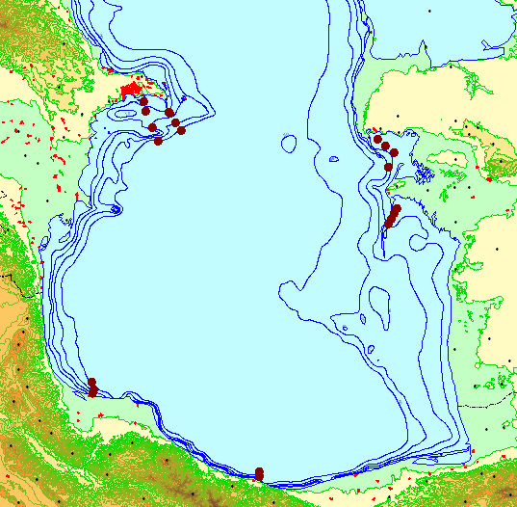
Figure 1. Map of sampling sites
Transects and stations
Azerbaijan
Transect | Station | Latitude | Longitude | Depth
Shakhov Shoal | 1 | 40°12'00" | 50°23'00" | 5
Shakhov Shoal | 2 | 40°11'20" | 50°24'10" | 10
Shakhov Shoal | 3 | 40°05'50" | 50°28'10" | 20
Shakhov Shoal | 4 | 40°01'00" | 50°32'40" | 50
Makarov Bank | 1 | 40°18'00" | 50°04'00" | 5
Makarov Bank | 2 | 40°12'00" | 50°06'00" | 10
Makarov Bank | 3 | 40°03'00" | 50°11'00" | 20
Makarov Bank | 4 | 39°55'00" | 50°15'00" | 50
Sampling will be done along 2 transects in Southern direction from sites Shakhov Shoal and Makarov Bank on stations with sea depth 5, 10, 20 and 50m. Sampling sites are situated in shallow coastal zones with predominance of fine sediments with clayey and sandy silt on the bottom. The bottom nearby Makarov bank is more hard and covered with intact and broken shells. Bottom relief in the Northern part of sampling area is gently sloping, flat and without overfalls, but in Southern part relief has variable profile due bottom irregularity with sharp hollows and slopes around Makarov bank, which is a mud volcano (still active). Sampling will be done from board of Research Vessel Alif Hajiev or its motorboat in shallow areas. In case of necessity another small vessels can be arranged for carrying out this work.

I.R. Iran
Transect | Station | Latitude | Longitude | Depth
Anzali | 1 | 37°29'00" | 49°29'31" | 5
Anzali | 2 | 37°29'20" | 49°28'59" | 10
Anzali | 3 | 37°30'30" | 49°29'43" | 20
Anzali | 4 | 37°35'07" | 49°28'37" | 50
Noshahr | 1 | 36°40'50" | 51°29'50" | 5
Noshahr | 2 | 36°40'51" | 51°29'58" | 10
Noshahr | 3 | 36°41'30" | 51°29'47" | 20
Noshahr | 4 | 36°43'44" | 51°30'14" | 50

Turkmenistan
Transect | Station | Provisional coordinates
Transect | Station | Latitude | Longitude | Depth
Bay of Turkmenbashi | 1 | 39°55'00" | 53^{о}00'00" | 6
Bay of Turkmenbashi | 2 | 39°51'00" | 53^{о}06'00" | 6
Bay of Turkmenbashi | 3 | 39°47'00" | 53^{о}12'00" | 6
Bay of Turkmenbashi | 4 | 39°38'00" | 53^{о}09'00" | 12
Alaja-Ogurchinskiy | 1 | 39°18'00" | 53°18'00" | 5
Alaja-Ogurchinskiy | 2 | 39°13'00" | 53°15'00" | 10
Alaja-Ogurchinskiy | 3 | 39°09'00" | 53°12'60" | 10
Alaja-Ogurchinskiy | 4 | 39°05'00" | 53°10'36" | 10
Sampling sites are situated in portal areas of Bay of Turkmenbashi and Bay of Turkmen (from Southern Cheleken Shoal to Ogurchinskiy Island). Maximum station depth is 20 m.
  - Methodology for identification of Beroe ovata and Mnemiopsis leidyi

Methodology for identification of Beroe ovata
According to their morphology the representatives of Beroidae are the simplest ctenophores. The body is mitten-shaped, wider at the oral end and not tapered at the aboral end; with a ratio of length to width (l/n) of 1.1-1.2. Lateral compression of the body marked. Young specimens are wider at the oral and aboral ends of the body.
Beroe ovata has a wide-flaring mouth (Figure 2, Figure 3, Figure 4) which enables the animal to obtain food without depending on tentacles to capture prey.
These ctenophores generally have a pink colour (Figure 3), with largest adults colored more intensely with a brown tinge. The size of large specimens in the Black Sea is from 81 to a maximum of 162 mm with mean 40-70 mm (Figure 2, Figure 3).
The mouth opening is wide and the ectodermal portion of the stomach (stomodeum) is voluminous. The polar- plate surrounding the sense organ at the aboral pole is fringed with a row branched papillae. There are ciliated areas upon the walls of the stomodeum near the mouth. The axial funnel-tube which extends upward to the sense-organ, is deeply cleft so that 2 lateral vessels extend upward to the 2 apical excretion-pores on the sides of the pole-plate; 8 meridional canals and 2 paragastal canals. The meridional canals lie under the 8 rows of ciliary combs (Fig 1); the 2 paragastal canals extend down the middle of the broad sides of the animal and 8 meridian canals may be placed in communication one with another by means an anostomosing network of side branches, thus establish a circum oral canal system, which are characteristic for Beroe ovata. While studying live Black Sea ctenophores, it was found that both sides the lateral tubes of the meridional canals can anostomose with each other and with the paragastral canals, which do not have own diverticulas. In accordance with these features the new ctenophore of the Black Sea was considered to have originated from the Atlantic northern American coast.
Beroe ovata is remarkably phosphorescent. The seat of the phosphorescence is confined to the rows of locomotive flappers. In the sea while ctenophore swimming the green light along meridional canals emitted from the eight phosphorescent ambulacums is clearly visible.
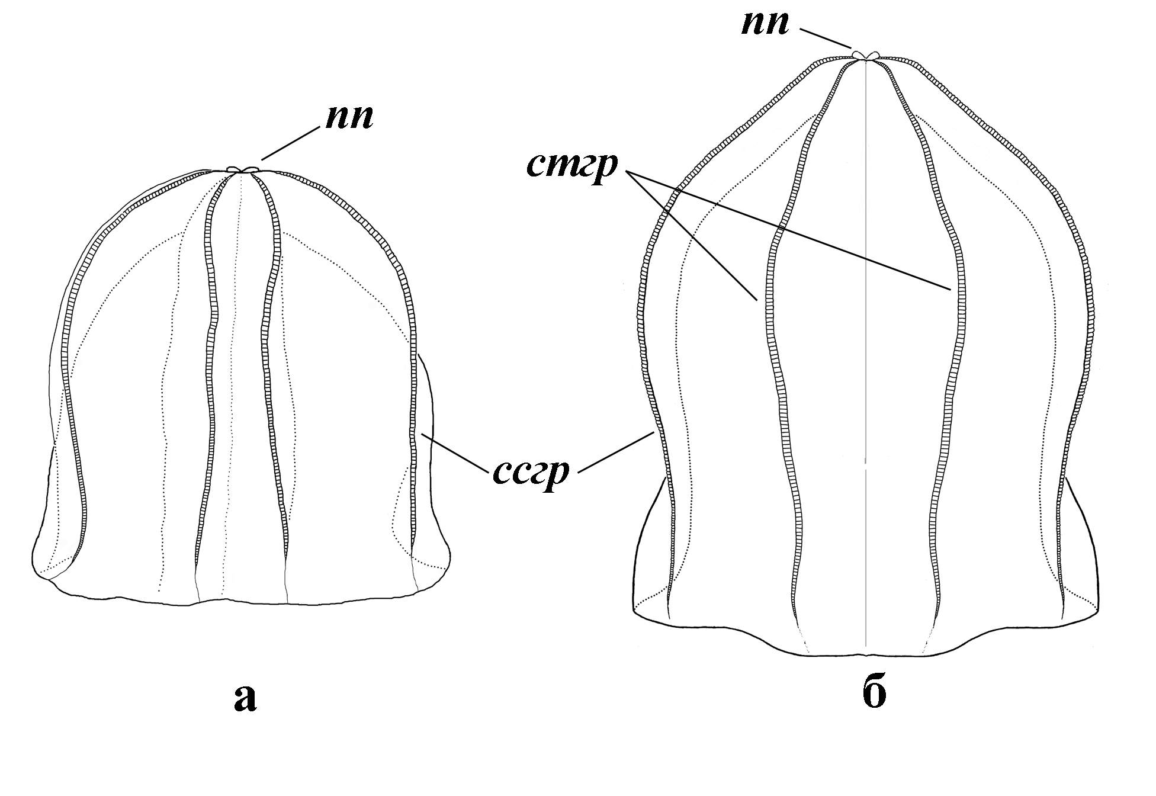
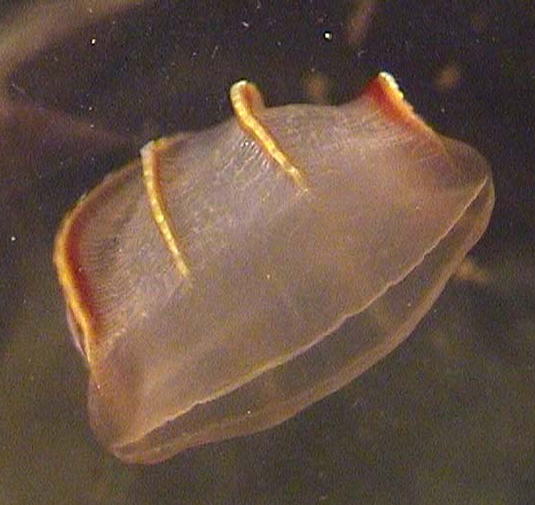
Figure 2. Morphology of adult Beroe ovata (after Seravin, Shiganova, Luppova, 2000) a - with round shape of aboral part, б - a little conic shape of aboral part
nn - polar pores; cmгр –subtenticularal cilia row, ccгз - subsaggital cilia row
Figure 3. Adult individual of Beroe ovata (photo of T. Shiganova)
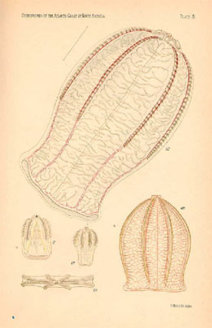
Figure 4.Representative of Beroidae
Figure 5. Ovae (1-4), embrio and larva of Beroe Ovata (most photos were made by scientists of Ecological Institute of Caspian Sea, Sari, Iran)
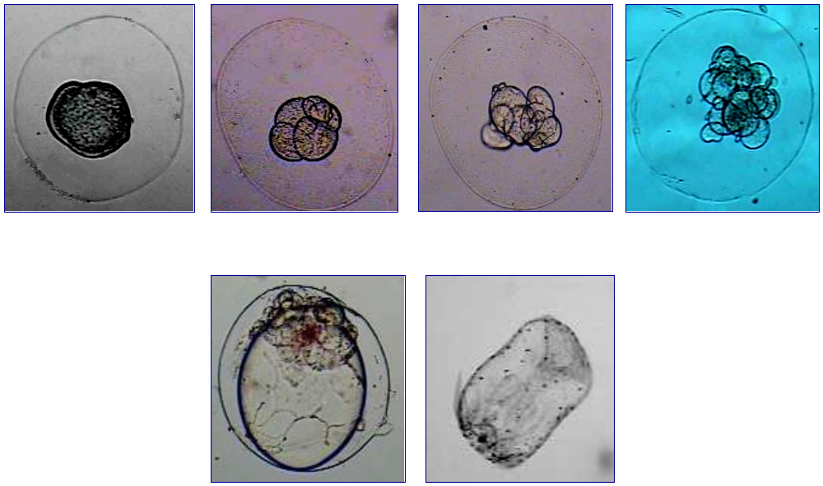
Beroe ovata is a hermaphrodite with gonads situated along meridional canals.The freshly spawned egg (size 0.8-1.0 mm) surrounded by a reflective meshwork (Figure 5), which disappears in the first hour after shedding, while a thick gelatinous layer swells around the egg. The egg pronuclear remains in the cortex below the polar bodies. The unfertilized egg has a glass-like appearance.

Methodology for identification of Mnemiopsis leidyi.
Descriptions and pictures of Mnemiopsis leidyi from the Caspian Sea are given for comparison with Beroe ovata.
Mnemiopsis leidyi is the lobate ctenophore from the class Tentaculata, order Lobata, family Mnemiidae Esch. It has two large and motive oral lobes (Figure 6, Figure 7).
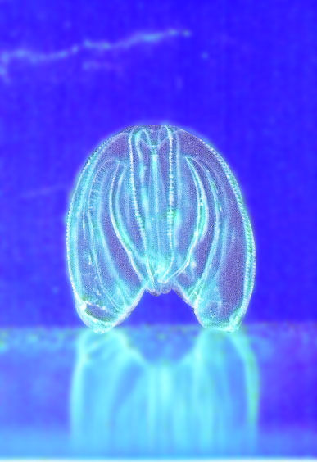
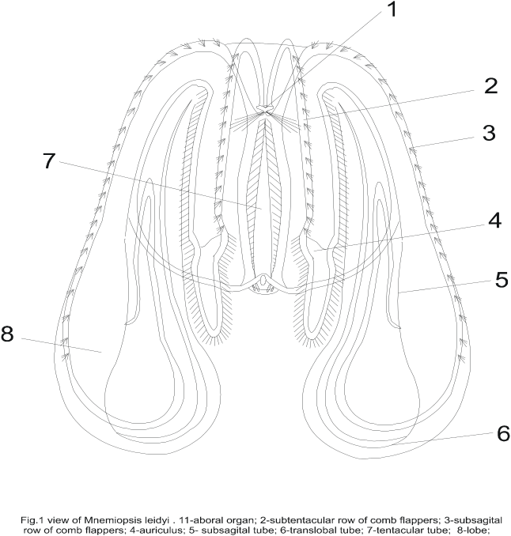Figure 6. View of Mnemiopsis leidyi 1- aboral organ; 2- subtentacular row of comb flappers; 3- substagital row of comb flappers; 4- auriculus; 5- subsagital tube; 6- translobal tube; 7- tentacular tube; 8- lobe (drawing of T. Shiganova, Shiganova, 2000)
Figure 7. View of Mnemiopsis leidyi (Photo of T. Shiganova, A. Kamakin)
ML has two oral lobies, which derivative of the ctenophore body (spherosome). Four smaller lobes –auricules are situated under the principal two oral lobes. The oral lappets carry tentacular rings. Its central part is situated above the lips of the mouth crevice. Both «lips» are extremely contractible. Some specimens of this ctenophore collected in the Black Sea have small papillae on their body surface, same as had been described from American waters.
Ctenophore ML has also 8 meridional canals. Subsagital and subtentacular canals are situated in pairs. After every couple of subsugital canals follows a couple of subtentacular canals (Figure 6, Figure 7).
The mean length of Caspian Mnemiopsis with lobes, estimated for the whole Caspian in July is 14.9 ± 3.1 mm, mean wet weight 0.97 ± 0.32 mg while the maximal size recorded was 65 mm with lobes, maximal wet weight 7.2 mg. This is considerably below the range recorded in the Black Sea in summer, in July (mean length 60.6 ± 39 mm, mean weight 15.1 ± 14.2) and maximal length 137 mm, weight 35 mg and largest individual was found 180 mm in early August in the southern Black Sea (Shiganova et al., 2004).
Mnemiopsis leidyi is remarkably phosphorescent. In the sea while ctenophore swimming the blue light along meridional canals emitted from the eight phosphorescent ambulacums is often visible.
ML is also hermaphrodite. Ovae of M.leidyi are smaller in size, have diameter 0.2-0.3 mm, and even small larva has tentacles (Figure 8)
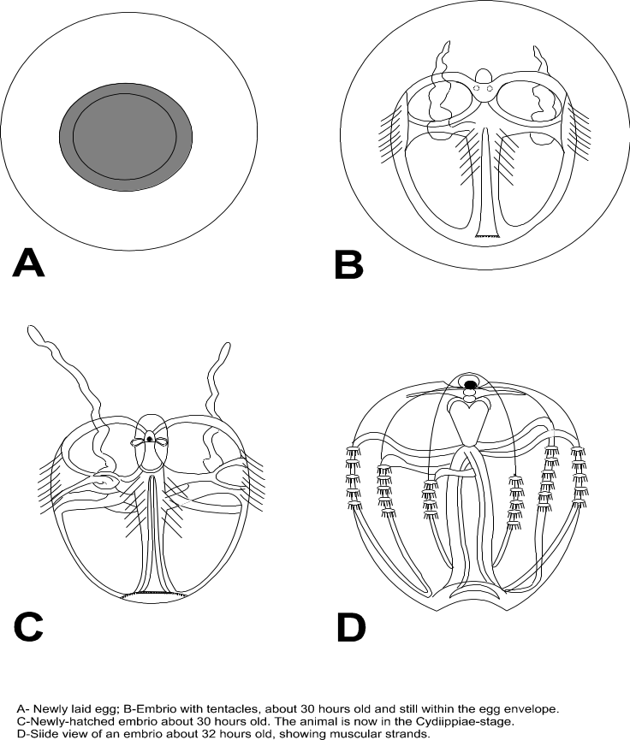
Figure 8. Development of Mnemiopsis leidyi, A- newly laid egg; B- embrio with tentacles, about 30 hours old and still within the egg envelope; C- newly hatched embrio about 30 hours old, the animal is now in the Cydiippiae stage; D- Side view of an embrio about 32 hours old, showing muscular strands (drawing T.Shiganova, Shiganova,2000)
  - Methodology for ML sampling and measurements

Required equipment
- Plankton net, 500 micron mesh size
- Jars with volume 1-5 liters
- Petri dishes
- Ruler
- Beakers, 10-25-50-100ml to measure displacement volume

Sampling
At every station, ctenophore will be sampled using 500 micron net (diameter 50 cm opening mouth suitable for BO and ML). Samples will be collected by vertical towing from the bottom to the surface for all stations, except the deepest stations. The depth of sampling should be measured with correction for angle of haul. At the deepest stations, two layers will be sampled: (1) one sample from depth interval 50 (100)-20 m (it is best to use closing deviser, to close net on the way back at the depth 20m); and (2) one sample from depth interval 0-20 m.
If CTD-probe is available on the board of the vessel it is best to use depths in accordance to vertical stratification: above seasonal thermocline (from the low layer of thermocline to the surface) and below thermocline (from 100 or 50 m up to low boundary of thermocline).

Measurements of ML
Since fixation of gelatinous organisms is problematic, measurements should be done as soon as possible after sampling. (But small size individuals might be fixed by 2% of formaldehyde or 2% glutaraldehyde. Even adult Beroe individuals can be fixed by 2% glutaraldehyde.) After the net is taken on board, its content should be placed into jar. Then the sample should be examined for availability of any unusual gelatinous animals, if any of them found, they should be separated and placed in jar or aquarium with Caspian Sea water.
If there are <50 individuals in the sample; all ML should be sorted out to size groups on Petri dish using a ruler. At least 10 individuals of each size group should be measured with lobes (total length) to obtain mean length for each size group. Number of individuals in each size group should be counted and entered into table, as it is shown in example. In addition sub-sample after removing ctenophores for measurements should be examined under magnifying glass or binocular microscope for examination of smallest individuals and ovae.
In addition during cruise at least 10 ind. of each size group should be measured for displacement volume, to obtain wet weight of Mnemiopsis leidyi. If you don’t have opportunity to measure displacement volume, you can use equation, given below for Caspian Mnemiopsis leidyi.

Length Group (mm) | ML number | ML length measurements | BO number
Ovae
0-5 | 20
6-10 | 10
11-15 | 5
16-20 | 3
21-25 | 2
And so on
Note: detail format of data sheets will be presented in further section.
If number of individuals in sample is numerous (> 50 individuals), a sub-sampling should be collected: ML sample should be suspended in known volume (e.g. 1 l) of seawater and sub-sample of a smaller volume should be taken with the help of a beaker (e.g. 100 ml). Then sub-sample should be processed according to the above described method, and result (ML numbers) should be magnified per ratio between sample and sub-sample volume (10 in our example).

Calculations of ML biomass and abundance
Abundance sp/sample is calculated as sum of number of individuals in each size group.
Abundance sp/m² is calculated with the following formula:
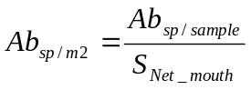, where 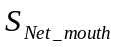 is square of Net mouth
Abundance sp/m³ is calculated with the following formula:
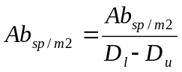, where:
D_{l} and D_{u} are Lower and Upper Sampling Depth correspondingly.
ML Biomass for every size group is calculated with the following formula:
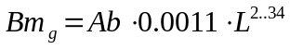, where:
L is an average length for size group is estimated from measured individuals.

Biomass (g/sample) is calculated as sum of biomasses of all size groups. Biomass (g/m²) and Biomass (g/m³) are calculated in the same way as corresponding Abundances.
Some investigators use coefficient for the filtering efficiency of the net, whilst some others not but it should be mentioned in method of calculation.

Other gelatinous organisms
In case of discovery of any unknown gelatinous organisms, if possible one should take their photograph, measure, draw and describe them and try to preserve them in 2% buffered formaldehyde or glutaraldehyde.

Recommended basic parameters to be measured in course of monitoring
Nonliving parameters
- Station’s depth
- Wind speed and direction
- Degree of roughness
- Temperature (preferably at all depths or at least in the surface waters).
- Salinity (preferably at all depths or at least in the surface waters).
- Transparency (Secchi disk depth).
- Nutrients and oxygen samples from selected depths down to the sea bottom.

Biological parameters
- Phytoplankton samples from standard depths (2 liter of seawater from depths of 0, 10, 25, 50 m).
- Mesozooplankton (including ichthyoplankton if possible) samples (using a vertical net (with mesh size 180-200 micron) tow from 100 m to the surface for deep stations and from the bottom to the surface for shallow stations). The most optimal net for zooplankton sampling is a Judey net and an ichthyoplankton net which are available in the most Institutes of Caspian countries with mesh size equal to 125, 180 or 200 micron for a Judey net.

  - Needed Vessels and Equipment
The recommended vessel for such kind of monitoring is a small research vessel or fishing-boat which is able to work in the sea up to depth 100m and equipped with winch for sampling with plankton net. On the other hand, sampling can be done with using a motorboat on transects in shallow areas situated close to the coast. Selection of optimal type of vessel is under responsibility of research teams in each country and is reported in the countries work plans.
Beside equipment necessary for implementation of the methodology describe in 2.1.3 every research team has needs in other specific equipment to conduct study, such as GPS, photo-camera for taking pictures of species - candidates of being BO, magnifying glass, waterproof closes and so on. Detailed list of this equipment is presented in national work plans.
  - Duration and the schedule
The monitoring study of ML and BO will be carried out during 4 months starting in August 2005 and finishing in November 2005. The first half of sampling period overlaps with peak of ML abundance in the Caspian.
The first sampling will be done between 22 and 25 of August.
The second sampling will be done between 18 and 22 of September.
The third sampling will be done between 18 and 22 of October.
The 4th sampling will be done between 18 and 22 of November.

  - Data management and sharing
All results of ML measurements should be entered into hard (printed) copy of MNEMIOPSIS MONITORING DATA SHEET, presented in Annex A. Upon completing the monthly survey data should be transferred into electronic form and sent to CEP PCU for storing in the CEP Mnemiopsis Database. Upon finishing the study Database copy will be made available to every country research team. Collected data will be used for preparation of the final report.
  - Training
Training is essentially needed to ensure that the same sampling methodology is properly used in all 3 countries, which in turn will ensure compatibility of obtained data and results. The Iranian Fisheries Research Institute (IFRO) is implementing ML monitoring programme during last 4 years and has a great experience in sampling methodology. It was agreed on the Coordination meeting, held in Tehran 27-28 July 2005, that IFRO specialists will provide training for scientists from 2 other participating countries. Training will include on board practices in the sea. Proposed place and time for training: port Anzali, Iran, 15th of August 2005.
It is much possible that sampling in different countries will be done with different types of vessels and may be even with different equipment, so it is necessary to have joint meeting after 2nd sampling term to discuss achievements, problems etc, and harmonize methodology. Exact dates of the meeting will be specified later on.

  - Participants
Research teams of each of 3 Southern Caspian countries are presented in the following tables.
Research team of Azerbaijan
No | Name | Role in team | Organization | Position | Contact details
1 | Mehman Akhundov | Team leader | Azerbaijan Fishery Institute | Director | E-mail: azfiri@azeurotel.com  m.akhundov@azeurotel.com  Tel./Fax: (99412) 496 3037;  Tel.: (99412) 496 2280
2 | Tamara Zarbalieva | Researcher | Azerbaijan Fishery Institute | Deputy director | E-mail: azfiri@azeurotel.com  Tel./Fax: (99412) 496 3037;  Tel.: (99412) 496 2280
3 | Kheimat Gasanov | Researcher | Azerbaijan Fishery Institute | Scientist | E-mail: azfiri@azeurotel.com  Tel./Fax: (99412) 496 3037;  Tel.: (99412) 496 2280

Iran
No | Name | Role in team | Organization | Position | Contact details
1 | Hossein Negarestan | Team leader | Iranian Fisheries Research Organization (IFRO) | Head Division of Marine Ecology of Caspian Sea | Address: No. 297, West Fatemi St., Tehran, Iran  Phone: +98 (21) 6945143  Fax: +98 (21) 6420732  Email: hosseinnegarestan@yahoo.com
2 | Abolghasem Roohi | Member of team | Ecological Institute of Caspian Sea | Comb jelly researcher | E-mail: roohi_ark@yahoo.com

Research team of Turkmenitan
No | Name | Role in team | Organization | Position | Contact details
1 | Berdi Berdiev | Team Leader | Khazar State Reserve | Head of protection | Тел.8-(993)-00243- 2-23-18
2 | Viktoria Nazarenko | Hydro-biologist | The Regional Environmental Centre for Central Asia (REC CA) | National Coordinator | Тел. 8-(993)-0066-32-51-16,  E-mail: VNazarenko@carec.kz,  rifus@online.tm
3 | Sergey Gaponchik | engineer | HNGO “RIF” | Head of “Aquaculture” Centre | Тел.8-(993)- 00243-2-02-86
4 | Ruslan Boyko | technician | TPNZ | Operator | Тел.8-(993)-00243-1-42-97

  - Coordination
Scientific coordinator of this study has been selected at the Coordination Meeting held in Tehran, I.R. Iran, 27-28 August 2005. The meeting recommended to engage an International Adviser for this study. Engagement has been done by CEP PCU, which contacted possible candidates at the first half of August, 2005.
Coordinators
No | Name | Role | Organization | Position | Contact details
1 | Dr. Hossein Negarestan | Scientific Coordinator | Iranian Fisheries Research Organization (IFRO) | Head Division of Marine Ecology of Caspian Sea | Address: No. 297, West Fatemi St., Tehran, Iran  Phone: +98 (21) 6945143  Fax: +98 (21) 6420732  Email: hosseinnegarestan@yahoo.com
2 | Dr. Tamara Shiganova | International Adviser | P.P.Shirshov Institute of Oceanology of Russian Academy of Sciences (SIO RAS) | Senior Scientist, Laboratory of pelagic ecosystem functioning | Address: 117997 Moscow, 36 Nakhimovsky prospekt, Russia  Tel.: +7 (095) 1292327  Fax: +7 (095) 1245983  e-mails: shiganov@sio.rssi.ru; shiganova_tamara@list.ru
Scientific coordinator will be responsible for the preparation of work plan, consulting of participants regarding methodology of sampling, providing help in identification of BO, interpretation of data and information and preparation of final report.
International Adviser will prepare detailed guideline for monitoring with assistance of Scientific Coordinator and provide evaluation for research and for final report.

Data and information interpretation and Presentation of the result
Every research team must present detailed report on fulfilled work in one week upon finishing the last survey. These reports will be incorporated into the final report of Monitoring study of Beroe Ovata and Mnemiopsis Leydii in the Southern Caspian.
All data obtained in framework of this study will be accumulated in CEP PCU and provided to Scientific Coordinator for analysis and interpretation. Scientific Coordinator in consultancy with research team leaders will compile final report. Report should be ready at the beginning of December in order to be presented on the upcoming Steering Committee Meeting. International Adviser will provide evaluation for the final report

Literature.
Seravin L.N., Shiganova Т.А., Luppova N.E. A hisory of study ctenophore Beroe ovata (Ctenophora, Atentaculata, Beroida) and some specific features of its Black Sea representative. Zool.Jour. 2002 . Т. 81. № 10.P.1193-1201.
Shiganova, T.A., 2000. Certain Results of Studying Biology of Invader M. leidyi (A.Agassiz) in the Black Sea, Grebnevik Mnemiopsis leidyi (A.Agassiz) v Azovskom i Chernom moryakh i posledstviya ego vseleniya (Comb Jelly Mnemiopsis leidyi (A.Agassiz) in the Sea of Azov and Black Sea and Consequences of Its Settling), Volovik, S.P., Ed., Rostov-na-Donu,: 33-75.
Shiganova T.A.,Dumont H.,Sokolsky A.F., Kamakin A. M., Tinenkova D. & Kurasheva E. K. 2004. Population dynamics of Mnemiopsis leidyi in the Caspian Sea, and effects on the Caspian ecosystem. Edc. Dumont, H., T. Shiganova & U. Niermann – The Ctenophore Mnemiopsis leidyi in the Ponto-Caspian and other aquatic invasions - NATO ASI Series, 2. Environment-. Kluwer Academic Publishers: 71-111

- MNEMIOPSIS MONITORING DATA SHEET
MNEMIOPSIS MONITORING DATA SHEET
Sample No
Transect
Station:
Date
Time
Lower Depth (m):
Upper Depth (m)
Net mesh size
Net diameter
T(1m)
S(1m)
pH(opt)
DO(opt)
 | Length (mm) | Number in haul | Length (mm) | Number in haul | Length (mm) | Number in haul | Length (mm) | Number in haul | Length (mm) | Number in haul
 | 0-5 |  | 0-5 |  | 0-5 |  | 0-5 |  | 0-5
 | 6-10 |  | 6-10 |  | 6-10 |  | 6-10 |  | 6-10
 | 11-15 |  | 11-15 |  | 11-15 |  | 11-15 |  | 11-15
 | 16-20 |  | 16-20 |  | 16-20 |  | 16-20 |  | 16-20
 | 21-25 |  | 21-25 |  | 21-25 |  | 21-25 |  | 21-25
 | 26-30 |  | 26-30 |  | 26-30 |  | 26-30 |  | 26-30
 | 31-35 |  | 31-35 |  | 31-35 |  | 31-35 |  | 31-35
 | 36-40 |  | 36-40 |  | 36-40 |  | 36-40 |  | 36-40
 | 41-45 |  | 41-45 |  | 41-45 |  | 41-45 |  | 41-45
 | 46-50 |  | 46-50 |  | 46-50 |  | 46-50 |  | 46-50
 | 51-55 |  | 51-55 |  | 51-55 |  | 51-55 |  | 51-55
 | 56-60 |  | 56-60 |  | 56-60 |  | 56-60 |  | 56-60
 | 51-55 |  | 51-55 |  | 51-55 |  | 51-55 |  | 51-55
 | 56-60 |  | 56-60 |  | 56-60 |  | 56-60 |  | 56-60
Comments:

