INTERNATIONAL MARITIME ORGANIZATION

MISSION REPORT

Ballast Water Sampling, Training and Monitoring Workshop:
Caspian Region

BAKU, AZERBAIJAN

(10-11 November 2005)

prepared by Stephen Gollasch

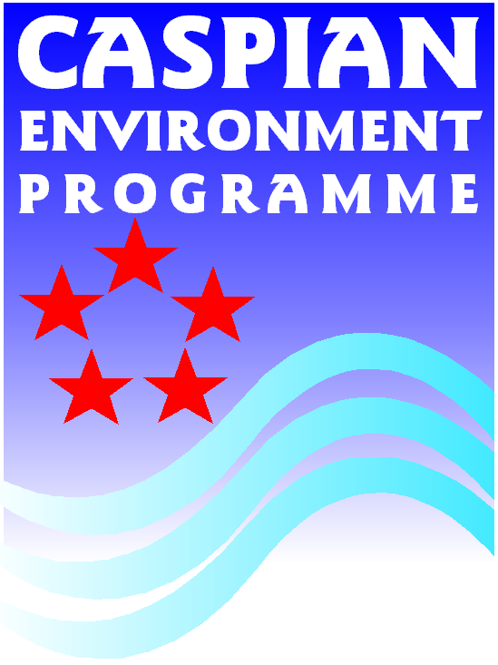

INTERNATIONAL MARITIME ORGANIZATION

SUMMARY SHEET

Title of the workshop: Assessment of the extent of aquatic species transfer through ships ballast water; IMO-UNOPS Project on Ballast Water Sampling and Monitoring in the Caspian Region

Host: Caspian Environmental Programme (CEP)

Venue and date: Baku, Azerbaijan, 10-11 November 2005

Type: Regional

Organized by: IMO Supported by: CEP

Participants: The workshop was attended by 19 participants from 5 countries.

_________________________________________________________________________
Summary

The objectives of this workshop included conducting a (classroom and onboard) training session on ballast water sampling and preparing an initial ballast water sampling and monitoring programme for the Caspian Sea. The sampling session focussed on the selection of the ship(s) to be sampled, pre-sampling communications, occupational health and safety aspects, sample labelling, storage and handling. Overall, the workshop achieved its stated objectives. Key to the workshop success was the onboard familiarisation with problems encountered in ballast water sampling and the lively discussions at the end of each session as well as the overall discussion at the end of the workshop when drafting the initial ballast water sampling and monitoring programme for the Caspian Sea. It was recommended that a follow-up initiative should be carried out by involving additional stakeholders. This may be done on both, national and regional level. The chosen approach for the monitoring programme needs to be developed further to reach a greater level of detail. However, it is believed that these initial discussions resulted in a very helpful concept how to approach ballast water sampling and monitoring in the Caspian Sea.
__________________________________________________________________________
Key words: regional cooperation, ballast water, sampling, monitoring

Report ref.:

Co-ordinator:

1 Introduction

Ballast water has been identified as a major vector for the unintentional introduction of non-indigenous biota. Several ship sampling studies were carried out in the past to estimate the importance of this transport vector for biological invasions (e.g. Gollasch 1996, Dodgshun & Handley 1997, Sutton et al. 1998, Gollasch et al. 2002, Hamer 2003, Patil 2003, Raaymakers 2003).

Experience has shown that sampling ships´ ballast water is a challenge. For biological analysis carried out to assess the variety of organisms arriving in ballast (qualitative analysis) several sampling methods have been developed. However, these techniques are not considered adequate when planning to sample ships for compliance with the ballast water discharge standard as set forth in the IMO Ballast Water Management Convention (quantitative approach).

According to the IMO Guideline on Ballast Water Sampling, still under development of Marine Environment Protection Committee, large amounts of water need to be sampled to assess compliance of ships with Standards as set forth in the Convention.

Regulation D-2 of the Ballast Water Management Convention (the Convention) stipulates that ships meeting the requirements of the Convention shall discharge:
- less than 10 viable organisms per cubic meter greater than or equal to 50 micrometers in minimum dimension, and
- less than 10 viable organisms per millilitre less than 50 micrometers in minimum dimension and greater than or equal to 10 micrometers in minimum dimension, and
- less than the following concentrations of indicator microbes, as a human health standard:
- Toxigenic Vibrio cholerae (serotypes O1 and O139) with less than 1 Colony Forming Unit (cfu) per 100 millilitres or less than 1 cfu per 1 gramme (wet weight) of zooplankton samples,
- Escherichia coli less than 250 cfu per 100 millilitres, and
- Intestinal Enterococci less than 100 cfu per 100 millilitres.

Especially to document the number of organisms above 50 microns is challenging as less than 10 organisms per cubic meter of discharged ballast water are acceptable. As a result more than 1,000 liters of water need to be sampled – and this needs to be carried out multiple times, as more than one sampling point, several samples and various sampling occasions may be required.

In April 2003, the 1st International Workshop on Guidelines and Standards for Ballast Water Sampling was held in Rio de Janeiro, Brazil (Raaymakers, 2003). The key findings of the workshop included:
- Health and safety should be given a major consideration before and during all sampling occasions as ports and ships are sometimes dangerous places to sample. The sampling team needs to be trained and informed of safety practices and it is advised to carry a comprehensive first aid kit. For safety reasons a sampling team should consist of at least two persons.
- No mater what the purpose of the ballast water sampling programme is, practicality is a key issue.
- Samplings have to be rapid not delaying the vessel schedule.
- Because of the complex design of ballast water tanks and ships and the associated sampling difficulties, sampling representatively is a challenge. Samples need to representatively reflect the biota in a ballast tank, but also the whole ship.
- Previous studies have shown that access to ballast tanks for sampling via opened manholes is preferred. Sampling via manholes is the most direct access to ballast water resulting in the most accurate assessment on biota in the ballast tank. As manholes might not be available on all ships or may not be opened due to e.g. overlaying cargo, the sampling team should be prepared to sample via other sampling access points, e.g. sounding pipes and ballast water discharge pipe.
- When sampling via manholes nets should be employed as scientific studies have shown that nets provide more representative results of biota in the tank. When using nets cone nets are more efficient than standard nets and short nets should be used as these are less likely to become stuck in tanks. Further nets with a filtering cod-end are preferred.
Phytoplankton studies have shown that pumps reveal a more representative picture of cells numbers and (cone-)nets for diversity. In zooplankton trials (cone-)nets proved to be the best tools to sample for individuals.
- Knowing that the distribution of biota in ballast tanks is patchy a minimum amount of water needs to be sampled. Sampling programmes targeting zooplankton at least 1000 l of water should be sampled. It is recommended to use plankton nets with a maximum meshsize of 50 micron to enable the catchment of most zooplankton organisms.
For phytoplankton sampling the water volume to be sampled should not be less than 50 l. The meshsize of the net should not be larger than 10 microns.
- Rather than favouring one method it is recommended to take a flexible approach and have available a toolbox of sampling methods. This tool box should include sampling gear to be employed via manholes, sounding pipes and in-line sampling. Sampling methods need to be selected according to configuration and access of ballast tanks, ship type and also purpose of the study.
Larger organisms may also be sampled by the use of different collecting methods, such as light traps or baited traps.

Conclusions from of this GloBallast workshop were discussed at the Baku workshop in detail.

2 Objectives

Within the framework of IMO-UNOPS Collaboration Project for Caspian Environmental Programme TC-0093 (Caspian Ballast Water Management Project), a hands-on training session on ballast water sampling techniques on board ships followed by a workshop to develop a sampling and monitoring programme to assess the extent of aquatic species transfer through ships’ ballast water (and sediments) was held in Baku (Azerbaijan) from 10 to 11 November 2005.

The terms of reference for this mission were:

- Three days home based preparation to develop the training materials (i.e. time schedules, programme outline, handouts, etc.) and a draft monitoring programme to be used as a starting point for the workshop (to be distributed in advance to the participants).
- Four days mission to Baku, Azerbaijan, to organise and conduct the training session and workshop in cooperation with the representatives of CEP and the Azerbaijan authorities who will facilitate access onboard a ship for the practical part of the training. The consultant was expected to liase in advance with relevant authorities to agree on the logistics of the onboard training.
- Two days to review and incorporate comments by the participants to the workshop and prepare the sampling and monitoring programme together with a set of recommendations for a long term monitoring strategy.
- Two days home based mission report writing.

3 Venue, dates, roles and participants

The workshop was held at the Government Building, 40 Uzeir Hadjibeyov St. (the former CEP PCU office), Baku, Azerbaijan on November 10th and 11th 2005.

The event was organized under IMO-CEP interagency agreement with the IMO consultant being responsible for the preparation of background information and a draft ballast water sampling and monitoring programme and the CEP being responsible for organizational matters and providing relevant facilities. The host, Dr. Bakhtiyar Muradov, arranged for laboratory access to analyse the ballast water samples taken and Capt. Vamik Ragimov organized the practical ballast water sampling exercise on M/V Kara Karayev, a roro carrier.

In total 19 participants from 5 countries attended the workshop (Fig. 1), i.e. Azerbaijan, Iran, Kazakhstan, Russian Federation and Turkmenistan. Two participants represented the Caspian Sea Programme Coordination Unit. Seven participants represented governments and nine represented universities and other scientific institutes. The full list of participants with contact details is attached as annex I.

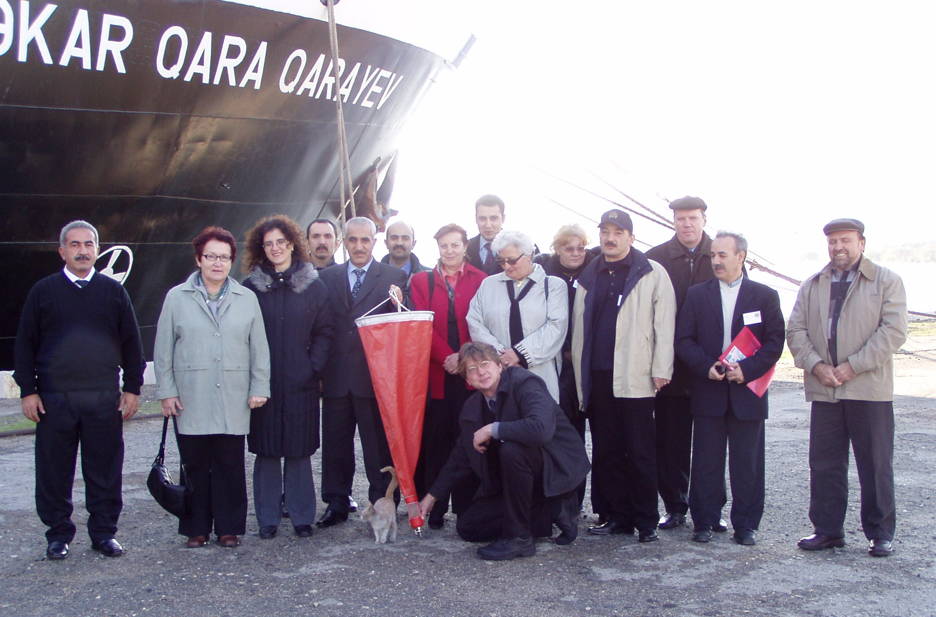
Fig. 1. Participants at the Baku Ballast Water Sampling and Monitoring Workshop in front of the samples roro carrier M/V Kara Karayev in the Port of Baku. Photo: courtesy of Boris Geldyyev, Centre for Remote Sesnsing and GIS, Almaty, Kazakhstan.
4 Activities and proceedings

4.1 Pre-mission assignments

The following documents were provided in electronic format well in advance to familiarize the participants with background information on problems encountered in ballast water sampling and on relevant paragraphs in the Convention as well as the IMO Guideline on Ballast Water Sampling (in prep.). The presentations were prepared in advance as a Term of Reference of the consultant (annexes V & VI):

- Summary of the report of the GloBallast Ballast Water Sampling Workshop (1st International Workshop on Guidelines and Standards for Ballast Water Sampling, Rio de Janeiro, Brazil).
- Presentation on German ballast water sampling techniques, i.e. results of one of the most recent comprehensive ship sampling programmes, carried out in German ports.
- Presentation on an inventory of ballast water sampling studies (prepared for GloBallast). Comparison of world-wide ballast water sampling techniques including reference to relevant paragraphs in the Convention as well as the IMO Guideline on Ballast Water Sampling (in prep.).
- Presentation entitled "More than 1,000 aquatic invaders in European Seas".
- Aspects to consider when developing a draft ballast water monitoring programme.

After arrival in Baku, the consultant contacted the Azerbaidjan State Maritime Administration, i.e. Capt. Vamik Ragimov, to support the arrangement for the practical onboard ballast water sampling exercise in advance of the workshop. The vessel was visited and a meeting was held onboard involving the captain on duty, Capt. Shanbazi Samir. Further, the onboard facilities were tested by taking one ballast water sample. Thereafter, the consultant met Dr. Bakhtiyar Muradov (CEP Manager Liason officer) at the Baku Government Building to discuss the suggested meeting agenda, arrange the technical meeting set-up and to evaluate the facilities for sample analysis.

4.2 Opening session

The meeting was opened at 9.15 am on November 10th with the host Dr. Bakhtiyar Muradov, Mr. R. Sattarzade (Ministry of Environment and Natural Resources, Azerbaijan) and the consultant welcoming the participants. The objectives of the workshop were outlined. The participants expressed their special interest in ballast water sampling and the need for guidance to develop a monitoring programme. The agenda was reviewed and adopted (annex IV).

4.3 Description of the proceedings

The two-day workshop took the form of several sessions with plenary discussions at the end of each session. All oral statements were translated by interpreters. A practical training session was held (a) classroom demonstration of various sampling gear and (b) onboard the ro/ro vessel M/V Kara Karayev in the Port of Baku including a hands-on familiarisation of all participants with the use of the sampling gear. The onboard session was carried out on the afternoon of Thursday, November 10th 2005.

On day one several presentations were given by the consultant to update the audience on recent findings in invasion biology (including information on the Caspian Sea situation) and ballast water sampling in general. A follow up presentation referred to the standards relevant to ballast water sampling as set forth in the Convention and the IMO Guideline for Ballast Water Sampling, currently being developed. Abstracts of these presentations are annexed to this report (annex VI).

Before lunch various ballast water sampling equipments were presented in a class room exercise. After lunch the roro vessel M/V Kara Karayev was visited for an onboard ballast water sampling exercise. The workshop attendees were split in two groups and the sampling was undertaken with both groups consecutively at the sampling access point in the engine room. The new German ballast water sampling equipment was employed to sample ballast water at the ships´ ballast water pump. Other sampling gear could not be employed as other sampling access points, such as opened manholes, could not be provided.

In the morning of the second day the samples taken on the vessel were analysed at a laboratory of the Environmental Monitoring Department in Baku. Due to time constraints and limited facilities, the sample was only analysed for larger zooplankton organisms. All participants were made familiar with the analytical methods, which are in-line with the guidance provided in the IMO Ballast Water Sampling Guideline, currently in preparation.

The majority of the second day of the workshop was spent on detailed discussions on a possible scenario for a ballast water sampling and monitoring programme – which was based also upon the discussions from the previous day. The participants commented and provided recommendations on the draft sampling and monitoring programme prepared by the consultant (see annex VII). At the end of the second day a brief discussion was held also on potential ballast water management options, considering the unique situation in the Caspian Sea (see section 8 & 9 of this report).

5 Assessment and anticipated outcome

The workshop participants comprised of a very diverse group of experts with different knowledge on biological invasions and ballast water sampling. However, all participants were very well prepared to address ballast water sampling and monitoring issues. Various stakeholders, governments and research institutes including experts from the shipping and port sectors were represented at the meeting allowing for detailed discussions reflecting different perspectives. The participants never boarded a vessel before to take ballast water samples and for some attendees it was the first time to visit a ships´ engine room (where the sampling was carried out).

The anticipated outcome included:
- Workshop Report (this document) containing abstracts of all presentations, recommendations and conclusions drawn from the discussions at the workshop,
- An onboard practical training exercise and workshop,
- An initial sampling and monitoring programme addressing recommendations for a long-term ballast water monitoring strategy (see annex VII), and
- Trained experts on ballast water sampling from all Caspian Sea countries attending the workshop.

6 Closing session

The meeting was closed on Friday, November 11th 2005 at 6.15 pm. The participants felt that the workshop achieved the objectives especially as they never entered a vessel before to sample ballast water. Also the classroom demonstration of sampling gear was highlighted as it became clear that without the installation of an appropriate sampling point onboard, a very flexible approach needs to be taken for ballast water sampling.

It was noted that all new species arriving in the Caspian Sea have a potential to negatively impact the environment or economy of the region. All ships from outside the Caspian are potentially carrying "unwanted" species, i.e. each single vessel may introduce a new species. However, not all ships arriving can be sampled, highlighting the need for risk assessment to target those ships which regularly travel outside the Caspian Sea to regions with matching climate and salinity conditions.

The closing statement was made by Mr. Lev Neretin on behalf of CEP. He acknowledged the success of the training event and informed the workshop participants about ongoing CEP activities related to invasive species introductions into the Caspian Sea with ships ballast water, including legislation. He stressed that the main goal of the event was to discuss the ballast water sampling and monitoring and to provide training of the pilot monitoring team. The brief discussions on ballast water management were also very fruitful, but should be addressed during the next meetings of the Regional Project Task Force in greater detail. However, together with IMO, CEP will bring recommendations from this workshop to the attention of the Regional Project Task Force. Finally, CEP can provide a list of taxonomists with expertise in the identification of aquatic species in the Caspian countries as recommended by the participants.

7 Achievements and conclusions

7.1 Following an initial consideration of the draft ballast water sampling and monitoring programme the participants conclude that further co-operation in the region is needed to approve a final sampling and monitoring strategy.

7.2 It was further recommended that this report should be made available to various affected stakeholders in the region to broaden the acceptance of the findings of the workshop attendees.

7.3 The workshop participants also conclude that the report on the GloBallast Ballast Water Sampling Workshop in Brazil (Raaymakers, 2003), is a key document to consider, especially on technical issues, such as sampling techniques, selection of the ship(s) to be sampled, pre-sampling communications, occupational health and safety aspects, sample labelling, storage and handling etc.

The activities related to the two main objectives of the mission are reported in detail in the following sections.

8 Training on ballast water sampling methodologies and techniques

8.1 Training material

Training material, such as the documentation of biological invasions into the Caspian Sea, information on traditional and new ballast water sampling gear, was circulated prior the meeting. These background information were considered as most useful to update the audience on the current situation, especially as many participants were not familiar with biological invasions and/or sampling of ballast water.

The opportunity to test the newly designed ballast water sampling gear and its easy handling was appreciated by the participants. This positive evaluation is especially based on the time efficient application of the device and, most importantly, its accuracy when sampling ballast water.

8.2 Classroom demonstration

During the classroom presentation, a set of sampling techniques were evaluated in a practicality test. The sampling gear considered included "traditional" methods, i.e. a standard plankton net and a net with cone-shaped opening (Fig. 2), and a newly designed sampling device (Fig 3). It was clearly demonstrated that a flexible approach needs to be taken when planning onboard ballast water sampling studies, as different sampling access points may be available.

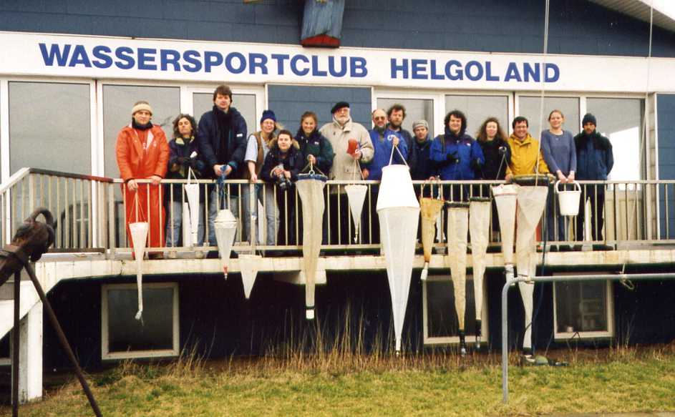
Fig. 2 Various plankton nets used in previous ballast water sampling studies.

The most suitable sampling gear may be selected according to the sampling access point available onboard and the objectives of the sampling programme. It should, however, be noted that the sampling access point which will likely reveal the most accurate sampling results, i.e. in the ballast water discharge line, may not be available. The participants agreed that in these cases, an alternative sampling approach may be selected rather than leaving the vessel without any sample. The flexible approach may be achieved by the development of a tool box which includes sampling gear to be employed via more than one sampling access point (e.g. manholes, sounding pipes and in-line). These initial sampling kit recommendations were resulted from the GloBallast Ballast Water Sampling Workshop in Rio de Janeiro.

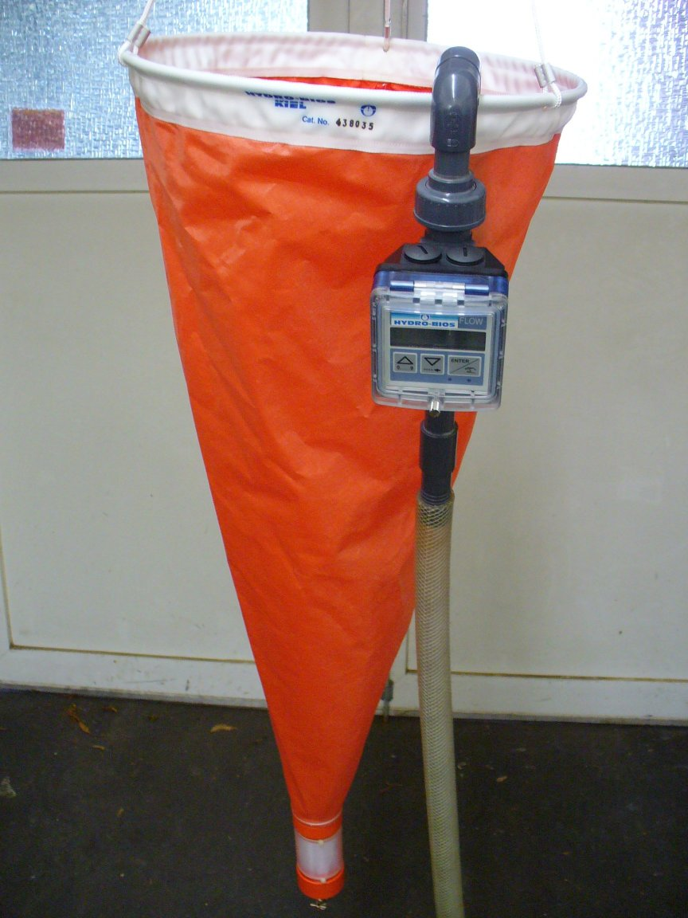
Fig. 3 The newly designed ballast water sampling device (for details see also the abstract of the relevant presentation attached as annex VI).

8.3 Onboard demonstration

The onboard sampling trip clearly showed the problems a sampling team may face during its work. This was of special interest to all participants as they had never boarded a vessel for sampling before (Fig. 4).

Sampling difficulties experienced on existing ships indicate the need for the availability of an appropriate sampling point design to allow for representative samples of the biota in the discharge line of the vessel (compliance control sampling).

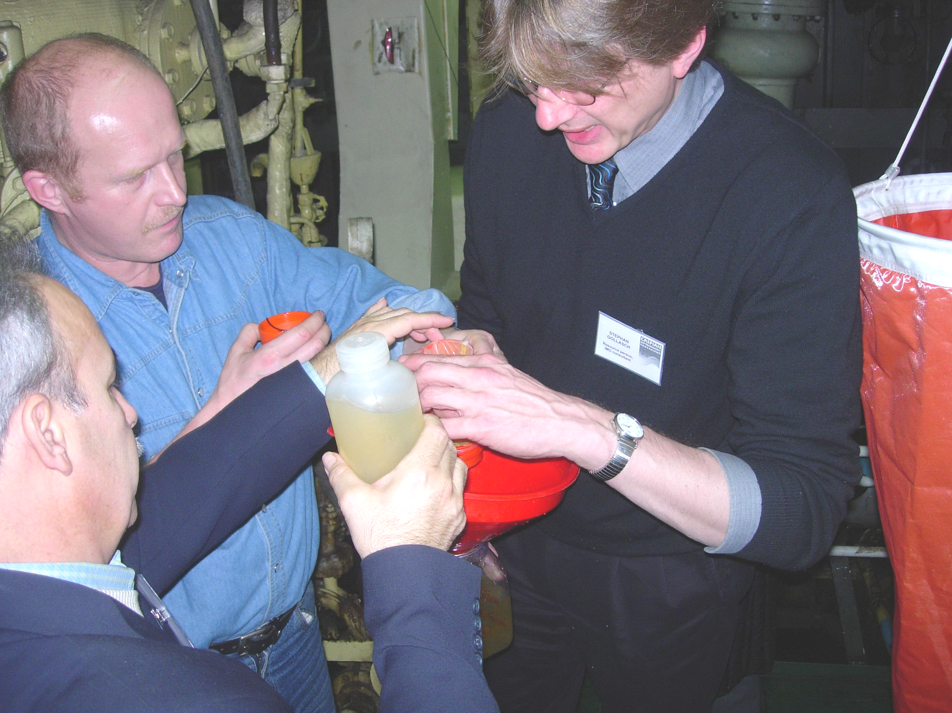
Fig. 4. Demonstration of sampling gear and sample processing in the engine room of roro carrier M/V Kara Karayev in the Port of Baku. Photo courtesy of Abolghasem Roohi, Ecological Academy of the Caspian Sea, Sari, Iran.
8.4 Sample analysis in the laboratory

The ballast water sample taken onboard M/V Kara Karayev was analysed in the Caspian Complex Environmental Monitoring Department. Samples were concentrated by using a sieve with an identical meshsize as the filtering sieve of the sampling device used onboard.

Due to time constraints and limited facilities, the ballast water sample was only analysed for larger zooplankton organisms by using a stereo microscope. All participants were made familiar with the analytical methods, which are in-line with the guidance provided in the IMO Ballast Water Sampling Guideline, currently in preparation.

A Bogorov tray was used as counting chamber for zooplankton organisms. To allow for greater accuracy, especially when analysing samples onboard a ship, newly designed trays were presented to the attendees (Fig. 5).

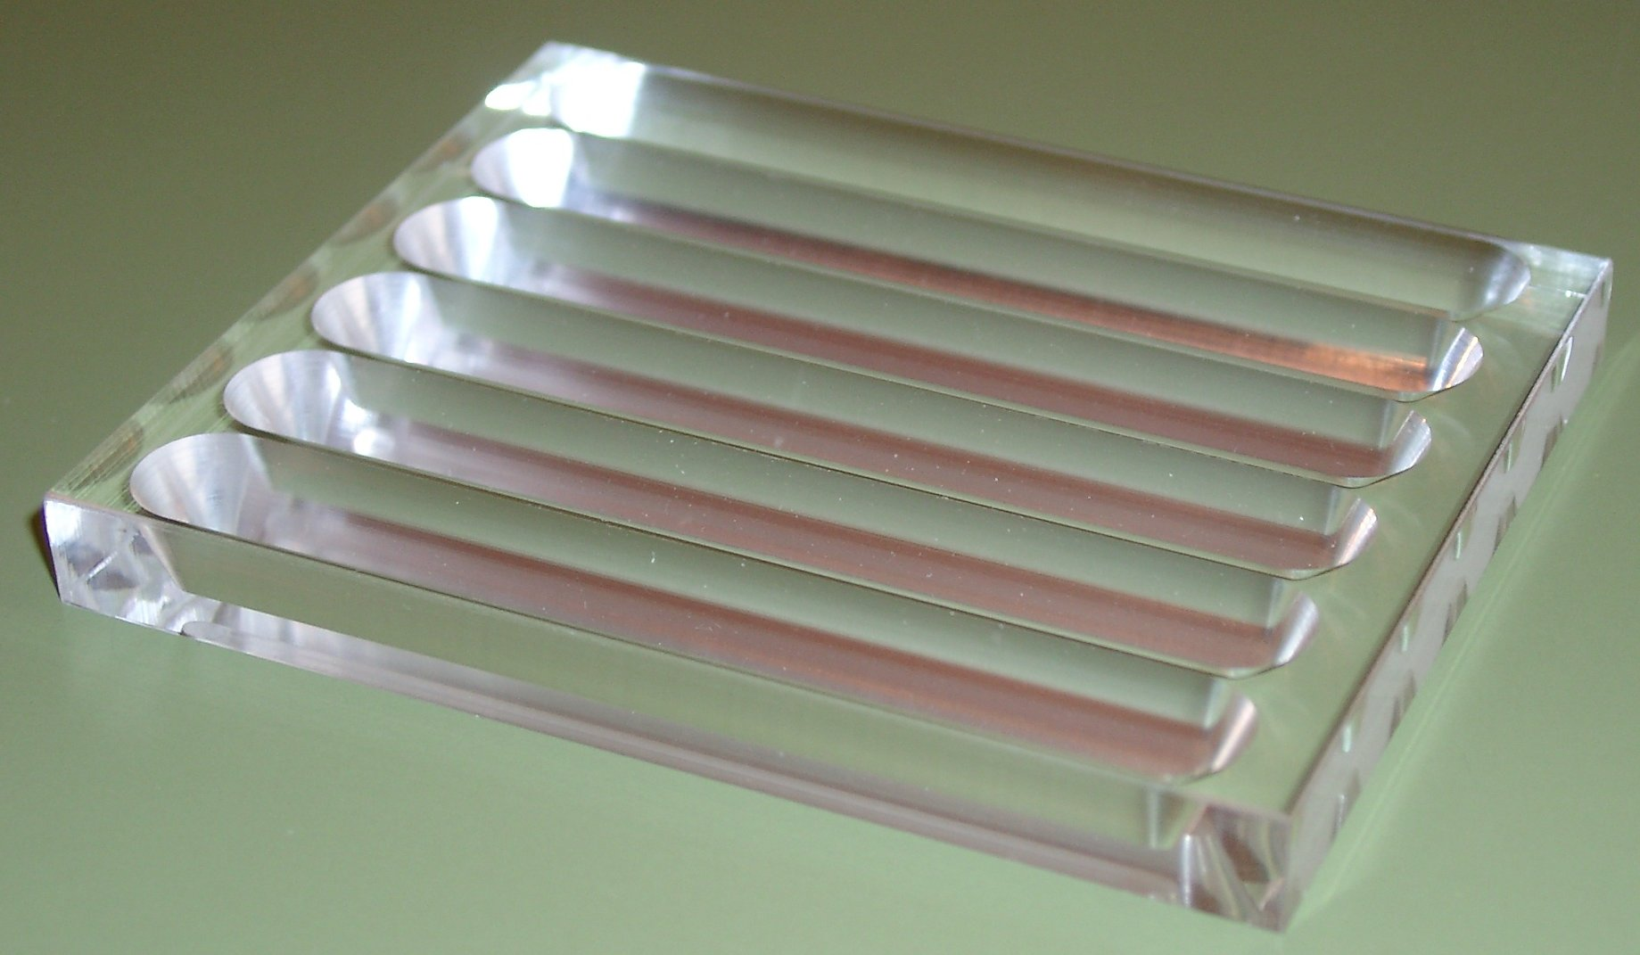 | 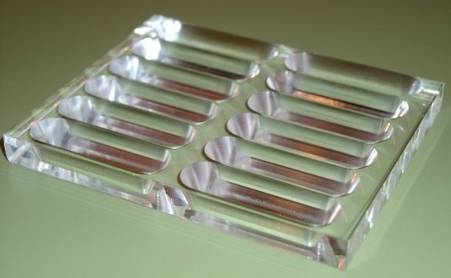 | 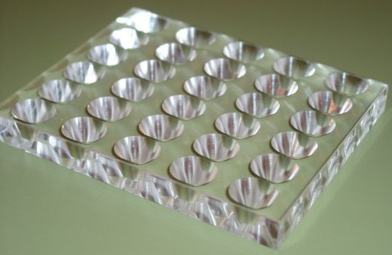
Fig. 5. Newly designed zooplankton counting chambers.

8.5 Ballast water sampling techniques

The first ballast water tank was sampled for biota in the 1970s (Medcof 1975). Since than several shipping studies have been undertaken world-wide. Most studies focussed on qualitative sampling, i.e. the diversity of organisms being present in ballast tanks.

Because of the complex design of ballast water tanks and ships and the associated sampling difficulties it is a challenge to gather a representative sample which reflects all biota in a ballast tank, but also the whole ship.

The objectives of the monitoring programme will largely influence the sampling technique to choose. Sampling for academic research may use all sampling access points and sampling gear available. When sampling for risk assessment the prime interest is to quantify the risk of unmanaged ballast water discharge, i.e. to document the presence of unwanted, potentially harmful aquatic species in the ballast tank. For this purpose the most advanced method to reveal an accurate figure of the variety of species needs to be applied. For compliance control however, with the exception of bacteria, the individual species present in the water is not of importance as the standard is quantitative according to size classes of organisms.

Other method selection criteria are the taxonomic groups a ship sampling programme targets: Phytoplankton studies have shown that pumps reveal a more representative number of individuals but (cone-)nets deliver a more representative number of species. In zooplankton trials (cone-)nets proved to be the best tools to sample for organism density (Sutton et al. 1998, Gollasch et al. 2003).

8.5.1 Manhole sampling

Previous studies have shown that access to ballast tanks for sampling via opened manholes is preferred to sampling via sounding pipes (Sutton et al. 1998, Gollasch et al. 2003). As manholes might not be available on all ships or may not be opened due to e.g. overlaying cargo, the sampling team should be prepared to sample via other sampling access points. However, sounding pipe sampling likely reveals a less accurate figure and should therefore only be used if no other sampling access point is available.

When sampling via manholes nets should be employed as scientific studies have shown that nets provide more representative results of biota in the tank. When using nets, nets with a cone-shaped opening are more efficient than standard nets and further short nets should be used as these are less likely to become stuck in tanks. Nets with a filtering cod-end are preferred.

Several methods were assessed during the GloBallast Ballast Water Sampling Workshop in Brazil and a ”tool box” of ship sampling techniques was suggested. However, full recovery of organisms in ballast tanks may remain impossible, indicating that results of ballast water sampling studies may well underestimate the actual number of biota.

8.5.2 In-line sampling

To proof compliance with the standards as set forth in the Convention, discharge line sampling may be the only option as the Convention reads “ships shall not discharge…”. This wording implies that the water being discharged needs to be sampled. Samples from the tank, e.g. via manholes, i.e. point source samples of a certain part of the tank where sampling access is given, will likely deliver a biased result as organisms are not equally distributed in the tank. For the same reason it is not recommended to samples certain water layers of the tank during discharge (e.g. when 80, 50 and 10% of the tank volume is emptied), but to sample during the entire discharge time of the ballast water.

The workshop participants took note of the newly developed German ballast water sampling tool, which may be operated to take samples from the discharge line, and consider to use this in compliance control sampling initiatives (Fig. 3).

A possible scenario for ballast water monitoring was also discussed and is attached to this report as annex VII.

9 Aspects to consider when planning a ballast water monitoring programme

Various issues need to be considered when planning to carry out a ballast water monitoring programme. No matter what the purpose of the sampling programme is, practicality is a key issue. Sampling of ballast water has to be rapid not delaying the vessel schedule. This includes the availability of sampling access points as well as the duration of the sampling itself. Sampling teams may consider to sample the vessel on the roads or to bring a sampling team onboard with the pilot prior arrival in the port.

Regional cooperation to deal with the ballast water problem is a key feature. This approach will result in mutual benefit for all Caspian Sea countries and will allow to spend the financial resources more efficiently.

The Caspian Sea situation

Shipping in the Caspian Sea is clearly dominated by inner-Sea transport, i.e. annually the number of ships arriving from outside the Caspian Sea is estimated as 300 to 400 vessels only. In 2004 approx. 80 ships arrived from outside the Caspian Sea in Baku, i.e. from various regions (mostly from Europe and North Africa – a few from Asia and other regions), via the Black Sea / Sea of Azov. The second shipping route connecting the Caspian Sea with other seas is from the Baltic Sea. This shipping route connects the easternmost Baltic with the Caspian Sea and this route is of particular concern as both ends show similar salinities, a key issue in species survival after release. However, the shipping pattern on this route is largely unknown, i.e. with today’s knowledge it cannot be quantified how many ships use this route and the volume of ballast water discharged in the Caspian Sea originating from the Baltic is largely unknown.

The maximum ships´ capacity to allow for passage through the Volga-Don-Canal is approx. 3,000 DWT. As this shipping route is on Russian territory, a special permission is needed for passage – and most vessels are operated under Russian flag.

Almost all ships arriving from the outside the Caspian Sea need to pass through the Volga-Don-Canal system. Additional shipping access routes to the Caspian Sea include:
- the Volga-Baltic waterway, which links the Caspian Basin (Volga River) with the Baltic Basin (Gulf of Finland-Neva River – Lake Ladoga - Lake Onega-canals-upper Volga), and
- the White Sea - Baltic Canal (Belomoro-Baltyisky Canal) which links the White Sea with the Baltic basin via a canal connecting the White Sea and Lake Onega. After passing this canal and Lake Onega, ships from the White Sea use canals of the Volga-Baltic system, linking Lake Onega with upper Volga.

However, as various shipping connections exist, ballast water management approaches in the Caspian Sea shipping should be part of a concerted ballast water management in the triangle Black/Azov-Baltic-Caspian Seas.

During the discussions particular interest was expressed to aspects relating to ballast water sampling for:
- general scientific research,
- risk assessment and hazard analysis,
- compliance control with the Convention, and
- ballast water treatment options.

The workshop participants, in general, agreed with most of the findings of the GloBallast report and view this report as a very comprehensive document which should be considered when drafting the Caspian Sea ballast water monitoring approach further. One additional comment refers to genetic studies for taxonomic analysis as outlined in the GloBallast report and it is believed that this approach cannot be taken in the Caspian region due to the lack of relevant resources.

Another general concern was raised regarding the permission to sample ships. It is quite doubtful that researchers get permission to sample ships. A political decision needs to be taken to support researchers to get access to take samples onboard. Alternatively port state control teams may be asked to sample ships.

The group prepared an initial sampling manual which is attached to this report as annex VII.

In addition the following questions were addressed in greater detail:

(i) Inner Caspian shipping

Inner Caspian shipping is not of prime interest for sampling as (introduced and native) species are distributed by natural means, i.e. by water currents, in the region. For the same reason, secondary spread of introduced species is also considered to be of minor importance. As a result ballast water monitoring and also management, including ballast water exchange, is not an issue of key importance for inner Caspian shipping.

However, certain Caspian countries have already ballast water regulations in place, e.g. since August 2005 in Turkmenistan unexchanged ballast water cannot be discharged. Here, sampling may be carried out to assess whether or not the ballast water was exchanged.

Recommendations

According to the view of the participants, inner Caspian shipping may be excluded from ballast water sampling programmes.

Considering the different shipping connections to the Caspian Sea, ballast water management approaches in Caspian Sea shipping should be part of a concerted ballast water management in the triangle Black/Azov-Baltic-Caspian Seas.

It was stated that any ballast water management approach in the region should start with developing an information system to provide basic information on which management options may be appropriate (i.e. ballast water exchange or treatment).

(ii) Biological surveys in port areas

It is recommended to carry out comprehensive biological surveys in each Caspian port, with an emphasis on ports which receive vessels from outside the Caspian Sea. This is of particular interest to document whether or not target organisms are already introduced (e.g. Beroe ovata). Beroe is of particular interest as it is considered as biocontrol option for the earlier introduced comb jelly Mnemiopsis leidyi. However, legislators are reluctant to intentionally introduce the species. First findings of this species may allow to convince relevant authorities to grant permission to introduce Beroe to reduce the negative impacts on Mnemiopsis.

Initial port sampling studies were already carried out in Iran (2 ports), Azerbaijan (1 port) and Turkmenistan (2 ports) and samples are currently being worked out. So far, Beroe was not found, but it is believed that the species will be found in the near future and therefore port sampling initiatives should continue to search for Beroe. This initial port sampling programme will come to an end in December 2005.

Regular monitoring programmes in the Caspian exist and also include ports/port regions. However, the level of detail and sampling frequency varies. Since the arrival of Mnemiopsis in 2000 six transects were sampled monthly (until 2003) and since seasonal sampling occurs for zooplankton, phytoplankton, water parameters and also benthos organisms to document the invasion pattern of Mnemiopsis and its impact on native species.

New invaders are first reported to national authorities and thereafter all Caspian states are formally informed by means of the CEP communications and meetings. Suggested eradication measures are also communicated. In case more individuals of the species of concern are found a joint concerted action should address eradication efforts.

Recommendations

The participants felt that:
- port sampling studies are an efficient tool also to document new invaders,
- it should be considered to also use SCUBA diving for port sampling,
- port sampling programmes should include plankton, fouling and benthos organisms,
- a coordinated approach on sampling techniques, sampling frequency should be aimed for, and
- port sampling should be continued.

(iii) Scope of the planned ballast water monitoring programme

Ballast water monitoring may – at best – be carried out in two consecutive phases. In phase one "traditional" sampling gear may be used during initial scientific studies, whereas the workshop participants recommend to make use of the newly designed ballast water sampling gear (see above) during phase two (e.g. in compliance control activities) as here greater accuracy is essential.

Sampling for awareness raising is of minor importance as previously introduced species, such as Mnemiopsis leidyi, have already prompted relevant awareness.

Recommendations

Phase one of a ballast water monitoring programme may focus on:
- scientific research, i.e. which organisms arrive with ships ballast water in the Caspian Sea, and
- risk assessment, i.e. document the presence of target species of concern.

The objectives of Phase two may include:
- verification of ballast water management and ballast water treatment systems efficiency, and
- compliance monitoring with ballast water regulations in place.

(iv) Duration of the ballast water monitoring programme

The participants discussed in detail the duration of such a ballast water monitoring programme. It was concluded that long-term monitoring is preferred.

Recommendations

Although long-term monitoring measures are preferred, it was also noted that in some instances short-term actions may be successful. This in particular refers to eradication programmes, which may however be part of a long-term programme.

For ballast water sampling a long-term continuous monitoring programme is needed, as:
- shipping pattern may change over time resulting in ballast water to arrive from new regions,
- target species identification is an ongoing process. New species introductions in ballast water source regions need to be evaluated for their capabilities to become established in the Caspian Sea, and
- species already found to be invasive in the Caspian Sea need to be monitored to document their impact over time.

(v) Development of sampling standards

Ballast water sampling standards are needed to enable a comparison of results undertaken in different countries and/or within various stakeholders. Standards should aim for the best and most efficient sampling technique and at the same time need to be internationally accepted and operable by all Caspian countries. These standards should address:
- the sampling approach per ship (i.e. number of tanks to be sampled), and
- sampling access points.

Recommendations

There is a clear need to prepare a detailed sampling protocol including photo documentation of sampling gear and sample analysis. Standards for data storage and handling, mesh sizes, volumes etc. should - at best - follow the Ballast Water Sampling Guideline currently in preparation by IMO.

When undertaking sampling for compliance monitoring, representativeness is of crucial importance. Therefore the most efficient methods should be used, i.e. sampling the ballast water discharge line by using nets which enable to sample large amounts of water (see also annexes VI & VII).

(vi) Database and information exchange

It was agreed to aim for the implementation of a regional information system including a database on ships ballast water history. When developing this, the IMO Ballast Water Reporting Form should be considered for the application of this purpose. To guarantee for a proper facilitation, a regional ballast water documentation centre may be launched.

Further, it was strongly recommended to build up a network of taxonomists considering the expertise in all Caspian Sea countries with the aim to ease the sampling analysis. Also, these experts may be approached for student training.

It may also be considered to develop a database of already introduced species in the Caspian Sea. This database may further include the detailed description of target species not being introduced into the Caspian Sea. Here, the focus should not be laid on the Baltic and Black Seas, but on all ballast water donor regions.

Recommendations

Training and familiarization is key – and therefore the participants believe that one focal point and an alternate expert on ship sampling and taxonomy should be identified in each Caspian country. The existing CEP database on aquatic scientists and experts working in related scientific fields is currently updated. The participants recommend to refer to the problems of biological invasions, ballast water, regulatory instruments etc. in the updated version of the database to ease the spread of information and to increase awareness on biological invasions.

To proove the presence of non-native species in ballast water, a specialised regional inspection service centre should be established.

A database of ship compliance with ballast water discharge standards (i.e. results from ship sampling) and management records should be established for use by port state control to guide the ship selection process for sampling.

10 Conclusions and recommendations

In the beginning of the workshop the bilingual structure of the CEP was referred to. It was also recommended that, for future meetings, key documents, such as abstracts and overheads of presentation, should be translated and made available in English and Russian to allow for a timely meeting progress. At best, all documents should be available in these languages.

It was recommended that a follow-up initiative should be carried out by involving additional stakeholders (see below). This may be done on both, a national and regional level.

10.1 Ballast Water Sampling

An initial sampling programme is planned with the aim to test the suggested ballast water sampling gear. The newly developed ballast water sampling method which is particularly useful to test compliance with the standards in the Convention may only be used after the Convention entered into force. Until than, traditional sampling gear, such as nets and pumps, may be employed.

The workshop attendees also agreed to follow the guidance of the IMO Ballast Water Sampling Guideline for compliance control which is currently in preparation by IMO. This in particular refers to the water volume to be sampled, number of samples, mesh sizes of sieves etc. These technical details should at best be identical in any sampling initiative in the Caspian Sea to allow for maximum comparison of sampling results.

To allow for optimal comparison of sampling results it may also be considered to standardise the sampling point design when sampling ballast water from the ships´ discharge line. The participants suggest that this issue should be addressed during the preparation of the IMO Ballast Water Sampling Guideline.

10.2 Ballast Water Management

The participants felt that this workshop was an useful step in achieving the ultimate goal to address the ballast water problem in the region. Further, a holistic ballast water management programme in the Caspian region should be developed. As a first step, ballast water sampling and monitoring will provide insights on the dimension of "risky" ballast water, i.e. ballast water containing species of concern, to arrive in the Caspian Sea. However, once this is documented, a management approach needs to be developed with the aim to minimize the problem of species invasion.

Almost all ships arriving from the outside the Caspian Sea need to pass through the Volga-Don-Canal system. Additional shipping access routes to the Caspian Sea include:
- the Volga-Baltic waterway, which links the Caspian Basin (Volga River) with the Baltic Basin (Gulf of Finland-Neva River – Lake Ladoga - Lake Onega-canals-upper Volga), and
- the White Sea - Baltic Canal (Belomoro-Baltyisky Canal) which links the White Sea with the Baltic basin via a canal connecting the White Sea and Lake Onega. After passing this canal and Lake Onega, ships from the White Sea use canals of the Volga-Baltic system, linking Lake Onega with upper Volga.

Several ships enter the Caspian Basin from the Baltic via the Neva River-Lake Ladoga-Lake Onega-canals-upper Volga, but probably this number is much less than the number of ships from the Black/Azov Seas to the Caspian Sea via Volga-Don canal. The lack of detailed shipping pattern information indicates the need for a regional shipping information centre.

As various shipping connections exist, ballast water management approaches in the Caspian Sea shipping should be part of a concerted ballast water management in the triangle Black/Azov-Baltic-Caspian Seas.

It was stated that any ballast water management approach in the region should start with developing an information system to provide basic information on which other management options may be appropriate. The Russian delegation considers this as a priority issue.

The workshop participants agreed that vessels originating from the outside of the Caspian Sea are of prime concern to introduce non-native species. As a result a comparably low number of ships need to be dealt with (see above). One suggestion expressed at the workshop is that these vessels may treat or exchange their ballast water prior having left the Black (Azov) and Baltic Seas before the entrance of the water-ways connecting it to the Caspian Sea. This is especially valid when ballast water exchange is carried out as once the ship enters the Caspian Sea no area for ballast water exchange can be identified (see also chapter 9(i) above). It may also be considered to build a ballast water reception facility for land-based water treatment at the entrance to the Caspian Sea or at major Caspian Sea ports.

A possible scenario may be to sample ships when entering these shipping corridors after they have carried out ballast water management measures, analyse the sample prior the ship enters the Caspian Sea, i.e. while the ship is in the water-way, and document whether or not critical species are onboard. In case "unwanted" species are found, it may be recommended that these ships need to discharge the ballast water to a land-based reception facility when reaching the Caspian Sea. With this approach the discharge of "critical" ballast water into the Caspian Sea may be avoided. However, it is not clear whether or not this scenario can be put into action.

To plan for appropriate reception facilities more shipping data are needed, i.e. the number of ships arriving with ballast water to be managed, the amount of ballast water to be dealt with per year, etc. Further, a plan should be developed how to treat the water received by the (land-based) reception facility.

10.3 Résumé

Although ballast water mediated species introductions were of key importance for this workshop it was also discussed to consider ballast tank sediments and hull fouling as important introduction vector and also to address other vectors of species invasions, such as imports of living organisms for aquaculture purposes.

Following the precautionary principle ("prevention is better than cure") the participants felt that new invasions of non-indigenous species should be minimized. Eradication of already introduced aquatic species may not be possible at all. This is particularly true for the Caspian Sea due to its enclosed location without open access to any other seas or oceans. Therefore a ballast water management approach is needed and it may also be considered to establish ballast water reception (and treatment) facilities at the entrance into the Caspian Sea.

It is further recommended to consider launching a regional working group under the umbrella of the Teheran Convention to address biological invasions and to e.g. agree on international standards for sampling and allow for proper coordination to avoid duplication of efforts. This group may also develop joint management strategies and/or eradication efforts on already introduced species, such as the comb jelly Mnemiopsis leidyi. In addition this group may suggest applicable, i.e. biologically and cost effective, treatment options for ballast water (and tank sediments). It was stated that a special risk assessment study on species introductions with hull fouling is needed. Possible treatment scenarios for vessel hull fouling should also be evaluated.

Last but not least, it was stated that biological invasions are a bi-directional phenomenon and the Caspian Sea should therefore not only be considered as a recipient region, but also as donor source of species to e.g. Black and Baltic Seas.

The participants suggest that the recommendations of this workshop (see also Annex VII) may be considered by the regional advisory group for biodiversity and invasive species of CEP at its next meeting in April 2006.

11 Follow - up action

It is suggested to hold another workshop on this issue with a much larger number of participants also involving additional stakeholders. This workshop may be seen as part of an awareness campaign, and may also include experts from neighbouring states not bordering the Caspian Sea to allow for a wider regional approach and to take advantage of the experts knowledge in such countries. It may also be considered to invite representatives from other regional sea areas, where ballast water management is already addressed, e.g. ICES, HELCOM, OSPAR and the Mediterranean Sea. It was suggested that the expertise of these working groups may result in a harmonised approach on:
- ballast water sampling and monitoring,
- monitoring initiatives in ports (port sampling programme),
- ballast water management, and
- development of an early warning (monitoring and information) system.

The chosen approach for the ballast water monitoring programme needs to be developed further to reach a greater level of detail. However, it is believed that this initial discussion resulted in a very helpful concept how to approach ballast water sampling and monitoring.

An additional regional training course may be planned after the first ships have been sampled and should involve those who will eventually sample ships and/or will undertake port sampling programmes. The terms of reference of a follow-up workshop may include:
- share the experiences from first sampling events,
- familiarize all Caspian countries planning to sample ships,
- update the suggested sampling programme according to the further development of the IMO Ballast Water Sampling Guideline – and to apply modifications as they fit into the scope of the Caspian Sea Ballast Water Monitoring Programme,
- development of a standard method to analyse the samples,
- address the need for a ballast water management approach, including risk assessment, target species lists and port sampling programmes.

The participants felt that a follow-up workshop should be arranged for 2006 – after the first ships were sampled.

12 Acknowledgements

This workshop on ballast water sampling and monitoring was funded jointly by CEP and IMO. The workshop was hosted by CEP. Thanks are expressed to the two interpreters and all participants without whom the workshop would not have been a success.

The efforts of the following persons deserve particular attention and special thanks: Capt. Vamik Ragimov, Republic of Azerbaijan State Maritime Administration, for his assistance locating a vessel in the Port of Baku for the practical training session on November 10th 2005 onboard M/V Kara Karayev, Latifa Husseynova and Arif Azimov for arranging laboratory facilities to analyse the ballast water sample and Dr. Bakhtiyar Muradov for organizational support. Thanks are expressed to Capt. Shanbazi Samir for making the vessel and its crew available for sampling. Last, but not least, the participants thank the Government of the City of Baku and the Azerbaijan State Maritime Administration for their tremendous hospitality.
13 Annexes

I List of participants and their contacting addresses including e-mail address

II List of lecturers and subjects covered

III List of acronyms used in the report

IV Workshop programme

V Pre-workshop assignments

VI Synopsis of lectures

VII A possible scenario for a ballast water sampling and monitoring programme in the Caspian Sea

14 References

Dodgshun, T. & Handley, S. 1997 Sampling ships´ ballast water. A practical manual. Cawthron Report No. 418. 58 pp.
Gollasch, S. 1996 Untersuchungen des Arteintrages durch den internationalen Schiffsverkehr unter besonderer Berücksichtigung nichtheimischer Arten. Diss., Univ. Hamburg; Verlag Dr. Kovac, Hamburg, 314 pp. [in German]
Gollasch, S., Macdonald, E., Belson, S., Botnen, H., Christensen, J., Hamer, J., Houvenaghel, G., Jelmert, A., Lucas, I., Masson, D., McCollin, T., Olenin, S., Persson, A., Wallentinus, I., Wetsteyn, B. & Wittling, T. (2002): Life in Ballast Tanks. 217-231 pp. In: Leppäkoski, E., Gollasch, S. & Olenin, S. (eds.): Invasive Aquatic Species of Europe: Distribution, Impacts and Management. KLUWER Academic Publishers, Dordrecht, The Netherlands. 583 pp.
Gollasch, S., Rosenthal, H., Botnen, H., Crncevic, M., Gilbert, M., Hamer, J., Hülsmann, N., Mauro, C., McCann, L., Minchin, D., Öztürk, B., Robertson, M., Sutton, C. & M. C. Villac (2003): Species richness and invasion vectors: Sampling techniques and biases. Biological Invasions 5, 365-377
Hamer, J. P. 2003 Sampling ballast sediments and other challenges. 1st International Workshop on Guidelines and Standards for Ballast Water Sampling. Rio de Janeiro, Brazil, 7-11 April 2003. 7 pp.
Medcof, J. C. 1975 Living marine animals in a ships' ballast water. Proc. Natl. Shellfish Ass., 65, 54-55 pp.
Patil, J. 2003 Development of genetic probes for detection of pest species in ballast water. 1st International Workshop on Guidelines and Standards for Ballast Water Sampling. Rio de Janeiro, Brazil, 7-11 April 2003. 12 pp.
Raaymakers, S. 2003. 1st International Workshop on Guidelines and Standards forBallast Water Sampling. Rio de Janeiro, Brazil, April 7th – 11th 2003. Workshop Report. GloBallast Monograph Series No. 9, IMO London, 19 pp. (plus various appendices)
Sutton, C., Murphy, K., Martin, R.B. & Hewitt, C.L. 1998 A review and evaluation of ballast water sampling protocols. Centre for Research on Introduced Marine Pests (CRIMP). Technical Report No. 18. 113 pp.
Annex I List of participants and their contacting addresses including e-mail address (participants were listed by country and in alphabetical order of their last names).
NAME | JOB TITLE,  ORGANIZATION | ADDRESS | CONTACT DETAILS
REPUBLIC OF AZERBAIJAN
Ceyhun HASANOV | Caspian Complex Environmental Monitoring Department;  PRAG Member | 3, Khudu Mamedov Str.  1123 Baku  Azerbaijan | Tel: +994 12 471 8329  Fax: +994 12 479 4443  Email: jaka1@box.az
Neymat HASANOV | Azerbaijan Fisheries Research Institute | 16, Demivchizadeh Str.  1008 Baku  Azerbaijan | Tel: +994 12 496 2280  Fax: +994 12 496 3037  Email: azfiri@azeurotel.com
Latifa HUSSEYNOVA | Head of Caspian Complex Environmental Monitoring Department, PRAG Member | 3, Khudu Mamedov Str.  1123 Baku  Azerbaijan | Tel: +994 12 471 3901  Fax: +994 12 479 4443  Email: Caspian@bakinter.net
Shahlar MAMMEDOV | Head of State Maritime Inspection, State Maritime Administration | 8, R. Zorge Str.  1010 Baku  Azerbaijan | Tel: +994 12 498 7822  Fax: +994 12 498 7813  Email: shm@ardda.org
Vamik RAGIMOV | Master Mariner, Head of Maritime Security Department, Azerbaijan State Maritime Administration | 8, R. Zorge Str.  1010 Baku  Azerbaijan | Tel: +994 12 498 78 22  Fax: +994 12 498 78 13  Email: v_ragimov@ardda.org  marsec@ardda.org
Rasim Sattarzade | The State Committee of Azerbaijan Republic on Ecology and Nature, Utilization Control, NFP Representative | 50 Moscow Avenue  370001 Baku  Azerbaijan | Tel: +994 12 498 23 46  Fax: +994 12 92 59 07  Email: rsattarzade@azdata.net
Tamara ZARBALIYEVA | Azerbaijan Fisheries Research Institute | 16, Demivchizadeh Str.  1008 Baku  Azerbaijan | Tel: +994 12 496 2280  Fax: +994 12 496 3037  Email: azfiri@azeurotel.com
ISLAMIC REPUBLIC OF IRAN
Seyed Mohammad Reza FATEMI | Senior Advisor  Marine Environment Bureau, Department of the Environment | Pardisan Natural Park  PO Box 15155-5655  Tehran  Iran | Tel: +982 12 209 8526  Email: rezafatemi@mydatak.com
Abolghasem ROOHI | Head of Biodiversity Group  Ecological Academy of the Caspian Sea | Mazardaran  Khzarabat boolvar  Sari  Iran | Tel: +981 51 346 2496  Fax: +981 51 346 2495  Email: roohi_ark@yahoo.com
REPUBLIC OF KAZAKHSTAN
Boris GELDYYEV | Candidate of Science, Head of Centre for Remote Sesnsing and GIS, Terra Ltd. | Office 26  Maulenova 133  Almaty 050022  Kazakhstan | Tel: +7 3272 72 0685  Fax: +7 3272 72 6210  Email: terra@mail.online.kz
Natalya OGAR | Doctor of Science, Professor at the Centre for Remote Sesnsing and GIS, Terra Ltd. | Office 26  Maulenova 133  Almaty 050022  Kazakhstan | Tel: +7 3272 72 0685  Fax: 7 3272 72 6210  Email: terra@mail.online.kz
RUSSIAN FEDERATION
Alexander KIRYANOV | Port Control Inspectorate Manager, Transport Ministry of the Russian Federation, Russian Maritime Administration, Astrakhan Port Authority | 31, Captain Krasnov  414016 Astrakhan  Russian Federation | Tel: +7 8512 58 5711  Fax: +7 8512 58 5712  Email: psc@astranet.ru
Vadim PANOV | Senior Scientist  Zoological institute of Russian Academy of Science | Universitetskaya nab. 1  199034 St. Petersburg  Russian Federation | Tel: +7 812 32 33 140  Fax: +7 812 32 82 941  Email: rbic@zin.ru
TURKMENISTAN
Viktoriya NAZARENKO | Hydrobiologist, Protection Department of Khazar State Reserve | Bahry-Xazar, 42a  Turkmenbashi  Turkmenistan | Tel: +993 006 632 5116  Fax: +993 243 20 286  Email: rifus@online.tm
Vladimir SALNIKOV | Ichthyologist, Leading Scientific Collaborator, Institute of Deserts, Ministry of Nature Protection | Bitarap Turkmenistan Str. 15  Ashgabat  Turkmenistan | Tel: +993 12 39 0488  Fax: +993 12 35 3716  Email: salnikov@online.tm
CASPIAN ENVIRONMENTAL PROGRAMME COORDINATION UNIT
Bakhtiyar MURADOV | Regional Liaison Officer, Caspian Environment Programme | Government Building, Room 108, 3rd Entrance,  40, Uzeir Hajibayev St., 1000 Baku  Azerbaidjan | Tel: +994 12 497 1785  Fax: +994 12 497 1786  Email: bmuradov@caspian.in-baku.com
Lev NERETIN | CEP- SAP Biodiversity Expert, Caspian Environment Programme Coordination Unit | 63 Golestan Alley, Valiasr Avenue,  1966733413 Tehran  Iran | Tel: +982 12 204 2285  +982 12 204 2935  +982 122 05 9574  Fax: +982 122 05 1850  Email: lev.neretin@undp.org
Agip KCO, Kazakhstan North Caspian Operating Company NV
Gulsim MUTYSHEVA | Ecology Coordinator of Agip KCO | 1, K. Smagulov Str., Chagala Centre  060002 Atyrau  Republic of Kazakhstan | Tel: +31 70 341 3372  Fax: +31 70 341 3238  Email: g.mutysheva@agipkco.com
Representative of International Maritime Organization
Stephan GOLLASCH | GoConsult,  Senior scientist | Bahrenfelder. Str. 73 a  22765 Hamburg  Germany | Tel: +49 40 390 54 60  Fax: +49 40 360 309 4767  Email: sgollasch@aol.com
Annex II List of lecturers and subjects covered

The following presentations were given at the workshop:

- Highlights from the GloBallast Ballast Water Sampling Workshop (1st International Workshop on Guidelines and Standards for Ballast Water Sampling, Rio de Janeiro, Brazil). Presentation given by Stephan Gollasch.
- Summary of German ballast water sampling techniques, i.e. results of one the most recent comprehensive ship sampling programmes, carried out in German ports. Presentation given by Stephan Gollasch.
- An inventory of ballast water sampling studies (prepared for GloBallast). Comparison of world-wide ballast water sampling techniques including reference to relevant paragraphs in the Convention as well as the IMO Guideline on Ballast Water Sampling (in prep.). Presentation given by Stephan Gollasch.
- Summary on introduced species in Europe entitled "More than 1,000 aquatic invaders in European Seas". Presentation given by Stephan Gollasch.
- Advantages of the newly developed ballast water sampling device. Presentation given by Stephan Gollasch.

Annex III List of acronyms used in the report.

CEP Caspian Sea Environmental Programme
IMO International Maritime Organization
MEPC Marine Environment Protection Committee
Annex IV Workshop programme

Assessment of the extent of aquatic species transfer through ships ballast water
IMO-UNOPS Project on Ballast Water Sampling and Monitoring in the Caspian Region

Baku (Azerbaijan), 10-11 November 2005

Agenda

Thursday, November 10th 2005 (Day 1)

9.15 am Session 1

- Housekeeping issues
- Introduction of participants
- Opening talk, workshop objectives, terms of reference
- Review and adoption of the agenda
- Presentation on species movements with ballast water in general and reference to the Caspian Sea situation: "More than 1,000 aquatic invaders in European Seas". Presentation given by Stephan Gollasch.
- Presentation on German ballast water sampling techniques, i.e. results of one the most recent comprehensive ship sampling programmes, carried out in German ports. The presentation included a detailed description on a newly developed ballast water sampling device. Presentation given by Stephan Gollasch.

10.45 – 11.15 am coffee break

- Presentation on an inventory of ballast water sampling studies (prepared for GloBallast). Comparison of world-wide ballast water sampling techniques including reference to relevant paragraphs in the IMO Ballast Water Management Convention as well as the IMO Guideline on Ballast Water Sampling (in prep.). Presentation given by Stephan Gollasch.
- Report of the GloBallast Ballast Water Sampling Workshop (1st International Workshop on Guidelines and Standards for Ballast Water Sampling, Rio de Janeiro, Brazil). Presentation given by Stephan Gollasch.
- Classroom demonstration of sampling gear
- Planning the sampling trip

1.00 – 2.15 pm lunch break

2.15 pm Session 2

- Sampling trip
  - Transportation to port
  - Forming of two groups
    - Ballast water sampling with group 1
    - Ballast water sampling with group 2
- Photo of workshop attendees in the port
- Transportation to meeting venue
- Summing up

4.00 – 4.20 coffee break

- Preparation of Day 2, initial discussion and questions on ballast water monitoring

5.30 pm End of Day 1

Friday, November 11th 2005

9.00 am Session 3

- Transportation to the ballast water sample analysing laboratory
- Demonstration of sample analysis in the lab

11.00 am coffee break

- Transportation to meeting venue
- Summary of ballast water sampling options
- Discussions on ballast water monitoring programme

1.15 – 2.30 lunch break

2.30 pm Session 4

- Discussions on ballast water monitoring programme (continued)
- Initial comments on ballast water management options in the Caspian Sea

- Recommendations

- Summing up

6.15 pm End of workshop
Annex V Pre workshop assignments

The following documents were provided in electronical format well in advance to familiarize the participants with background information on problems encountered in ballast water sampling and on relevant paragraphs in the IMO Ballast Water Management Convention as well as the IMO Guideline on Ballast Water Sampling (in preparation). The presentations were prepared in advance as a Term of Reference of the consultant:

- The report of the GloBallast Ballast Water Sampling Workshop (1st International Workshop on Guidelines and Standards for Ballast Water Sampling, Rio de Janeiro, Brazil).
- Presentation on German ballast water sampling techniques, i.e. results of one the most recent comprehensive ship sampling programmes, carried out in German ports.
- Presentation on an inventory of ballast water sampling studies (prepared for GloBallast). Comparison of world-wide ballast water sampling techniques including reference to relevant paragraphs in the IMO Ballast Water Management Convention as well as the IMO Guideline on Ballast Water Sampling (in prep.)
- Presentation entitled "More than 1,000 aquatic invaders in European Seas"
- Advantages of the newly developed ballast water sampling device
- A draft ballast water sampling and monitoring programme

Annex VI Synopsis of lectures

1 Highlights from the GloBallast Ballast Water Sampling Workshop (1st International Workshop on Guidelines and Standards for Ballast Water Sampling, Rio de Janeiro, Brazil).

Stephan Gollasch

The 1st International Workshop on Guidelines and Standards for Ballast Water Sampling was held in Rio de Janeiro, Brazil in April 2003, to:
- review sampling activities undertaken by various entities around the world,
- initiate greater global coordination and cooperation on this issue,
- review the various ballast water sampling guidelines and standards that are currently available,
- provide practical training to the delegates from the GloBallast Pilot Countries, and
- provide recommendations to feed into global and regional project funding proposals.

The one week workshop took the form of a series of plenary sessions during the first two days. A practical sampling exercise was carried out onboard a Brazilian Navy ship on day three. All attendees considered the outcomes of the Thursday and Friday sub-group sessions and other recommendations of the meeting at a final session at the end of the meeting.

Ballast water sampling standards are needed to enable a comparison of results undertaken in different countries and/or within various stakeholders. Standards need to be internationally accepted and operable by all countries.

Despite best sampling efforts, full recovery of organisms in ballast tanks may remain impossible, indicating that results of ballast water sampling studies may well underestimate the actual number of biota.

Sampling ballast water of world-wide origin results in a "global" study of plankton. Therefore the taxonomic determination of species is a challenge. Selected taxa such as early larval stages of bivalves and gastropods may require the use of an electron microscope for taxonomic identification. However, determination to species level might not be possible at all.

It was concluded that this workshop delivered essential recommendations for the use of ballast water sampling techniques. The recommendations were based on practical sampling trials during the workshop and working group discussions. However, there was consensus that similar workshops are needed to compare the biological efficiency of certain sampling techniques.

Other key findings of the workshop were already presented above.

2 Summary of German ballast water sampling techniques

Stephan Gollasch

During the study "Introduction of Non-Indigenous Organisms into the North Sea and Baltic Sea: Investigations on the Potential Ecological Impact through Ship Traffic" carried out from March 1992 through August 1996 in total 186 ships were sampled in German ports (132 ballast water samples). The vessels investigated were selected according to vessel type and route. This talk focuses on ballast water sampling. In addition to ballast water tank sediments (see further below) and the ship hulls (not reported here) were sampled.
A total of 8,219 l ballast water were collected, corresponding to an average of 62,3 l per sample. The abiotic parameters temperature, salinity, pH value, and oxygen content were measured aboard immediately after sampling. Organisms were found in 97 ballast water samples.

Flora The main phytoplankton groups in ballast water samples were diatoms (95 species) with Chlorophyceae (18 species), and dinoflagellates (8 species) as dominant groups. A maximum of 110.000 unicellular algae were recorded from 1 l of ballast water. A total of 11 non-indigenous phytoplankton species were recorded. The majority were diatoms (8 species) including genera Alexandrium and Gonyaulax which are known for toxin production.

Fauna The total number of zooplankton taxa determined from all ballast water samples was 98. Copepoda (52 species) and Rotatoria (10 species) were the dominant groups. The maximum number of species per sample was 12. With increasing age of ballast water (time period spent in the tank), the number of species and specimens decreased. On average 1 zooplankton organism was recorded per 1 l of sampled ballast water. Non-indigenous species were recorded in 37 ballast water samples.

It was concluded that every vessel from overseas is a potential carrier of organisms in sufficient numbers to establish a founder population in German waters. Since even a single introduced non-indigenous species may cause severe damage, it is essentially needed to develop preventive measures.

3 An inventory of ballast water sampling studies (prepared for GloBallast). Comparison of world-wide ballast water sampling techniques

Stephan Gollasch

During a European Union Concerted Action study on species introductions, an intercalibration workshop on ship ballast water sampling techniques considered various phytoplankton and zooplankton sampling methods. For the first time, all the techniques presently in use world-wide were compared using a plankton tower as a model ballast tank spiked with the brine shrimp and oyster larvae while phytoplankton samples were taken simultaneously in the field (Helgoland Harbour, Germany).

Three cone shaped and eleven non-cone shaped plankton nets of different sizes and designs were employed. Net lengths varied from 50 - 300 cm, diameters 9.7 - 50 cm and mesh sizes 10 - 100 µm. Three pumps, a Ruttner sampler and a bucket previously used in ballast water sampling studies were also compared. This first assessment indicates that for sampling ballast water a wide range of techniques may be needed. Each method showed different results in efficiency and it is unlikely that any of the methods will sample all taxa. Although several methods proved to be valid elements of a hypothetical “tool box” of effective ship sampling techniques. The Ruttner water sampler and the pump P30 provide suitable means for the quantitative phytoplankton sampling, whereas other pumps prevailed during the qualitative trial. Pump P15 and cone shaped nets were the best methods used for quantitative zooplankton sampling. It is recommended that a further exercise involving a wider range of taxa be examined in a larger series of mesocosms.

4 More than 1,000 aquatic invaders in European Seas

Stephan Gollasch

At least 1,032 non-indigenous aquatic species have been found in European coastal and adjacent waters. Regions considered in this overview range from European Arctic waters in the North to the southern Mediterranean Sea and Irish waters in western Europe to the Black Sea. Most introduced species were first recorded since 1950s. More than 600 introduced taxa (from unicellular algae to vertebrates) occur in self-sustaining populations with the dominating taxonomic group being zoobenthos organisms. Introduction vectors are predominantly shipping (ballast water and hull fouling) and species movements for aquaculture or stocking purposes.

5 Advantages of the newly developed ballast water sampling device

Stephan Gollasch

A new sampling device, developed by Hydrobios, one of the leading manufacturers of scientific sampling gear in Germany, allows for accurate and time efficient ballast water sampling. This sampling approach likely delivers a more representative sample of organism density when being discharged from a ship for compliance control with the standards as set forth in the IMO Ballast Water Management Convention.

This device consists of a flexible sampling bag with a filtering cod-end both being especially designed for this purpose. This cod-end has filtering panels and can be unscrewed from the sampling bag. An integrated flow-meter allows for accuracy to document the filtered volume of water.

Advantages of the Sampling Device

- The sampling device can be hung to the ceiling, i.e. does not need a stand to be operated which is unlikely to be available on ships or is difficult to install in e.g. the ships engine room.
- Its light weight eases transportation to and within the ship in case various sampling points need to be sampled consecutively.
- The sampling bag can be folded, i.e. it is easier to carry which is especially an advantage when using narrow stairs in ships engine rooms – or when sampling needs to be undertaken in densely packed cargo rooms (e.g. on car carriers).
- The device is completely independent from the ships operation (other than ballast water operations), i.e. does not require power supply etc.
- Cleaning of the non-stick bag can easily be done by rinsing with water.
- The filtering cod-end can be unscrewed and after cleaning of the bag the unit is ready for use immediately, i.e. several samples may be taken in a short period of time by simply sealing one cod-end and screwing on another cod-end. Sealed used cod-ends may be placed in a special water tight container. Alternatively the filtering sieve of the cod-end may be replaced with a new sieve after each sampling occasion and put into the sample container. This also eases the cleaning of the sieve to avoid organism contamination with future samples. As a result samples can be carried to the analysing laboratory without any further processing onboard, such as sieving at the sampling location etc. The filter sieve replacement is a matter of minutes allows the use of only one cod-end for multiple samplings.
- The integrated flow-meter enables a precise measurement of the water volume filtered.
- Compared to buckets a bigger water volume can be filtered as the device collects and filters the water at the same time. The limiting factor is the concentration of organism and particular matter in the water. In case the organism and particle concentration in the water is low, sampling can be "endless" when the time for filling the bag equals to the time needed for water filtration through the cod-end.
- It works time efficient, i.e. up to 2.5 tonnes of ballast water were sampled in less than 30 minutes.
- Discharge of filtered water after sampling may be carried out either by dumping it in the bilge water system.
- In case sampling is undertaken in areas where water spillage cannot be tolerated, the spillage can be minimised by directing the water with a hose to a sink – or by placing a bucket underneath the device which may be emptied as requested. In case the treatment system uses backwash-lines to discharge filter backwash material, this backwash line may also be used to discharge the filtered water.
- In case the sampling procedure takes a lengthy time, organism survival may be impaired by the long sampling time. To allow optimal organism survival, the tap of the cod-end may be opened every 10 minutes to extract sampled organisms (subsample). By doing so organism exposure to air is minimised. Organisms in all subsamples should be counted.

All these advantages will result in an efficient, timely and accurate sampling of ballast water. In addition due to the time efficient application, the number of samples or replicates taken by the sampling crew may be increased without any extra working hours.
Annex VII A possible scenario for a ballast water sampling and monitoring programme in the Caspian Sea

Foreword

The participants agreed to use the following ballast water sampling and monitoring protocol, which is based on practical sampling experience on M/V Kara Karayev, findings of the GloBallast Workshop on ballast water sampling (Raaymakers 2003) and the presentations and discussions at the workshop.

The workshop participants, in general, agree with most of the findings of this GloBallast report and view this report as a very comprehensive document which may be considered when drafting the Caspian Sea ballast water monitoring approach further. One additional comment refers to the genetic studies for taxonomic analysis and it is believed that this approach cannot be taken in the Caspian region due to the lack of relevant resources. Another general concern was raised regarding the permission to sample ships. It is quite doubtful that researchers get permission to sample ships. A political decision needs to be taken to support researchers to get access to take samples onboard. Alternatively port state control teams may be asked to sample ships.

It was also stated that the Ballast Water Sampling Guideline, currently in development at IMO, needs to be considered when completed to ensure that the Caspian sampling study is in line with IMO standards.

Introduction

Various issues need to be considered when planning to carry out a ballast water monitoring programme. No matter what the purpose of the ballast water sampling programme is, practicality is a key issue. Ballast water sampling has to be rapid, i.e. not delaying the vessel operation or schedule. This includes the preparation of sampling access points as well as the duration of the sampling itself. Sampling teams may also consider to sample vessels on the roads or to bring a sampling team onboard with the pilot prior arrival in the port.

The workshop participants agreed that vessels originating from the outside of the Caspian Sea are of prime concern to introduce non-native species. As a result a comparably low number of ships need to be dealt with. Almost all ships arriving from the outside the Caspian Sea need to pass through the Volga-Don-Canal system. Additional shipping access routes to the Caspian Sea include:
- the Volga-Baltic waterway, which links the Caspian Basin (Volga River) with the Baltic Basin (Gulf of Finland-Neva River – Lake Ladoga - Lake Onega-canals-upper Volga), and
- the White Sea - Baltic Canal (Belomoro-Baltyisky Canal) which links the White Sea with the Baltic basin via a canal connecting the White Sea and Lake Onega. After passing this canal and Lake Onega, ships from the White Sea use canals of the Volga-Baltic system, linking Lake Onega with upper Volga.

However, a very low number of ships use this canal system. As a result ballast water management in Caspian Sea shipping should be part of the concerted ballast water management in the triangle Black/Azov-Baltic-Caspian. Regarding ballast water management approaches it was stated to start with developing an information system to provide basic information on which other management options may be appropriate. The Russian delegation considers this as a priority issue. Possible ballast water management scenarios are outlined in the body of this report.

The participants discussed in detail the duration of such as ballast water monitoring programme. Although long-term monitoring measures are preferred, it was also noted that in some instances short-term actions may be successful. This in particular refers to short-term eradication programmes, which may also be part of a long-term monitoring programme. However, for ballast water sampling a long-term continuous monitoring programme is needed, as:
- shipping pattern may change over time resulting in ballast water to arrive from new regions,
- target species identification is an ongoing process. New species introductions in ballast water source regions need regularly to be evaluated for their capabilities to become established in the Caspian Sea, and
- species already found to be invasive in the Caspian Sea need to be monitored to document their impact over time.

Development of sampling standards

Ballast water sampling standards are needed to enable a comparison of results undertaken in different countries and/or within various stakeholders. Standards should aim for the best and most efficient sampling technique and at the same time need to be internationally accepted and operable by all Caspian countries.

The workshop participants also felt that the sampling and monitoring programme should, wherever possible, follow the advice and standards as outlined in the IMO Ballast Water Sampling Guideline. Once this guideline is approved, this draft ballast water sampling and monitoring programme needs to be revisited for consistency reasons.

Draft ballast water sampling and monitoring programme in the Caspian Sea

1 Selection of vessels

Ships to be sampled should be selected according to the origin of the ballast water onboard. Inner-Caspian shipping is not of prime interest for sampling as (introduced and native) species are distributed by natural means in the region, i.e. by water currents. Secondary spread of species is also considered to be of minor importance. As a result ballast water monitoring is not an issue for ships solely operated in inner Caspian shipping.

Therefore, ships which carry ballast water originating outside the Caspian Sea should be targeted. Although the number of ships entering the Caspian Sea is limited it will be impossible to sample all incoming vessels. It is recommended to select those ships for sampling with ballast water onboard from areas with matching climate regime and salinity conditions, both being key factors in species survival after ballast water discharge. To document the origin of the ballast water onboard, the IMO Ballast Water Reporting Form should be considered for the application of this purpose. To guarantee for a proper facilitation, a regional ballast water documentation centre may be launched.

1.1 Purpose of the sampling

Ballast water sampling may be carried out for various purposes, including:
- scientific research, i.e. which organisms arrive with ships ballast water in the Caspian Sea,
- risk assessment, i.e. document the presence of target species of concern,
- verification of ballast water management and ballast water treatment systems efficiency, and
- compliance monitoring with ballast water regulations in place.

Another reason for undertaking ship sampling is awareness raising. However, sampling for awareness raising is believed to be of minor importance in the Caspian Sea as previously introduced species, such as Mnemiopsis leidyi, have already prompted relevant awareness.

For the Caspian Sea sampling programme it is suggested to start with an initial scientific study to document which organisms arrive with ships ballast water in the Caspian Sea (qualitative study). At a later stage, once the initial sampling programme revealed its first results, verification of ballast water management measures, ballast water treatment systems efficiency and compliance monitoring with ballast water regulations in place (quantitative studies) may become into focus and may also require the adjustment of the sampling technique.

For the initial research study "traditional" sampling gear may be used, whereas the workshop participants recommend to make use of the newly designed ballast water sampling gear (see above) during follow up programmes where greater accuracy is essential. For initial sampling, when using traditional sampling gear, it was recommended to use standard plankton sampling gear as formerly developed in Caspian countries. However, to allow for comparison of results, the meshsizes used for phyto- and zooplankton needs to be standardised. For follow up programmes, it was agreed to use the newly developed German sampling gear (see below) to allow for time efficient and accurate samplings.

2 Sampling techniques

Because of the complex design of ballast water tanks and ships and the associated sampling difficulties it is a challenge to gather a representative sample which reflects all biota in a ballast tank, but also the whole ship.

The objectives of the monitoring programme will largely influence the sampling technique to choose. Sampling for academic research may use all sampling access points and sampling gear available. When sampling for risk assessment the prime interest is to quantify the risk of unmanaged ballast water discharge, i.e. document the presence of unwanted, potentially harmful aquatic species in the ballast tank. For this purpose the most advanced qualitative method to reveal an accurate figure of the variety of species needs to be applied. For compliance control however, with the exception of bacteria, the individual species present in the water is not of importance as the standard is quantitative according to size classes of organisms. Also, when undertaking sampling for compliance monitoring, representativeness is of crucial importance. Therefore the most efficient quantitative methods as outlined below should be used.

Due to its limitations to reveal representative results, sampling of ballast tanks via sounding or air pipes is not recommended. Scientific trials have shown that these sampling access points do not reveal accurate estimates of organism density, i.e. sampling may provide an underestimate of the number of organisms which may result in a false positive in some cases. As a result sounding or air pipe samples reveal an inaccurate figure of the biota present in the ballast water.

Sampling via manholes and in the discharge line of the ships´ ballast water system may deliver the most accurate figures on species content in the water. Sampling access via manholes may be used for scientific trials, but is not recommended for compliance control with standards as set forth in the IMO Convention, as the Convention reads “ships shall not discharge…”. This wording implies that the water being discharged needs to be sampled (see below).

Other method selecting criteria are the taxonomic groups a ship sampling programme targets:
- phytoplankton studies have shown that pumps reveal a more representative picture of cells numbers and (cone-)nets for diversity, and
- zooplankton trials (cone-)nets proved to be the best tools to sample for individuals (Sutton et al. 1998, Gollasch et al. 2003.).

2.1 Manhole sampling

Previous studies have shown that access to ballast tanks for sampling via opened manholes is preferred rather than sampling via sounding pipes (Sutton et al. 1998, Gollasch et al. 2003). As manholes might not be available on all ships or may not be opened due to e.g. overlaying cargo, the sampling team should be prepared to sample via other sampling access points. However, sounding pipe sampling likely reveals a less accurate figure and should therefore only be used if no other sampling access point is available.

When sampling via manholes nets should be employed as scientific studies have shown that nets provide more representative results of biota in the tank. When using nets, nets with a cone-shaped opening are more efficient than standard nets and further short nets should be used as these are less likely to become stuck in tanks. Further nets with a filtering cod-end are preferred as they are easier to operate.

When employing plankton nets the sample should be taken in a vertical net haul from the deepest sampling point accessible in the tank by using
- a 50 micrometers (in diagonal dimension) plankton net (vertical net haul) to sample organisms greater than or equal to 50 micrometers. In case the sample needs to be concentrated by using a mesh, the mesh size should be equal to or smaller than 50 micrometers (in diagonal dimension);
- a 10 micrometers (in diagonal dimension) plankton net (vertical net haul) to sample organisms less than 50 micrometers and greater than or equal to 10 micrometers. In case the sample needs to be concentrated by using a mesh, the mesh size should be equal to or smaller than 10 micrometers (in diagonal dimension); and

All plankton nets should be lowered to the maximum depth inside the ballast tank and retrieved at a speed of approx. 0.5 m/s. Multiple vertical net hauls may be needed to meet the required sample volume (see below).

Larger organisms may also be sampled by the use of different collecting methods, such as light traps or baited traps, which may be lowered to the bottom of the tank. However, full recovery of organisms in ballast tanks may remain impossible, indicating that results of ballast water sampling studies may well underestimate the actual number of biota.

When sampling for bacteria a sterile sampling bottle to collect water for analysis of microbes of at least three different depths.

2.2 In-line sampling

Sampling points for in-line sampling should be fitted to the ships ballast water piping system in a straight, i.e. vertical or horizontal, section after the ballast water pump. As per today, no standardised sampling point design is suggested, but this matter will likely be addressed in the IMO Ballast Water Sampling Guideline. It should be noted that the required water volumes to be sampled to proof compliance with the standards of the IMO Ballast Water Management Convention may result in the installation of two in-line sampling points, i.e. one for larger organisms (minimum sample volume 1,000 litres) and another for smaller organisms (minimum sample volume 10 litres).

To prove compliance with the standards as set forth in the IMO Ballast Water Management Convention, discharge line sampling may be the only option as the Convention reads “ships shall not discharge…”. This wording implies that the water being discharged needs to be sampled. Samples from the tank, e.g. via manholes, i.e. point source samples of a certain part of the tank where sampling access is given, will likely deliver a biased result as organisms are not equally distributed in the tank. For the same reason it is not recommended to samples certain water layers of the tank during discharge (e.g. when 80, 50 and 10% of the tank volume is emptied), but to sample during the entire discharge time of the ballast water.

2.2.1 Organisms above 50 micrometers (in diagonal dimension)

To allow for a most accurate sample, sampling should be undertaken during the entire discharge time. Otherwise (sampling of certain layers of water during discharge, e.g. when 80, 50 and 10% of the tank volume is emptied), organisms concentrated in other water layers may be missed.

The participants of this workshop took note of the newly developed German ballast water sampling tool which will allow such samplings and consider to use this in compliance control sampling initiatives (see below).

2.2.2 Organisms smaller than 50 micrometers and above 10 micrometers (in diagonal dimension)

At best, and for the same reason as outlined above, samples should be taken over the entire discharge period of the tank. The smaller water volume to be sampled (see below) may require the installation of a second in-line sampling point with a smaller water flow.

2.2.3 Bacteria

When sampling for bacteria a sterile sampling bottle to collect water for analysis of microbes should be used. Samples should be taken during the discharge of the ballast water at least at three different times, e.g. when 80, 50 and 10% of the tank volume is emptied.

3 Sample volumes

3.1 Scientific studies

The workshop participants noted that as larger the water volume sampled is, the higher is the chance to take a representative sample. Therefore, in minimum 1000 litres of water should be sampled for larger organisms and in minimum 10 litres for smaller organisms. If samples need to be concentrated the sieve meshsize for larger organisms should be no grater than 50 micometres in diagonal dimension and for smaller organisms no greater than 10 micrometres in diagonal dimension. In case bacteria need to be assessed 500 ml of water may be sampled.

3.2 Compliance control sampling

The participants agree with the sample volume limits as provided in the IMO Ballast Water Sampling Guideline (in prep.):
- For organisms greater than or equal to 50 micrometres or more in minimum dimension, samples of at least one cubic metre should be collected. If samples are concentrated for enumeration the samples should be concentrated using a sieve no greater than 50 micrometres mesh in diagonal dimension.
- For organisms greater than or equal to 10 micrometres and less than 50 micrometres in minimum dimension, samples of at least one litre should be collected. If samples are concentrated for enumeration the samples should be concentrated using a sieve no greater than 10 micrometres mesh in diagonal dimension.
- For the evaluation of bacteria a sample of at least 500 millilitres should be taken.

4 Sample labelling, handling and recording

Standards for sample labelling, handling and storage etc. should - at best - follow the Ballast Water Sampling Guideline currently in preparation by IMO.

5 Sample analysis

The samples should be analysed as soon as possible after sampling, and analysed live within 6 hours or treated in such a way to ensure that proper analysis can be performed. During transport the samples should be stored in a dark cooling bag to avoid rapid temperature changes until analysis. In case longer sample transport times are needed the use of pre-frozen cooling bags may be considered.

5.1 Larger plankton (>= 50 micrometer)

Microscopic evaluation. Organisms greater than or equal to 50 micrometers should be counted under magnifications of at least 25x. Analysis of living organisms may be assessed by documenting movements of organisms. Analysis of living organisms in preserved samples may be evaluated by use of a vital stain.

5.2 Smaller plankton (< 50 micrometer and >= 10 micrometer)

Microscopic evaluation. Samples for organisms less than 50 micrometers and greater than or equal to 10 micrometers should be placed in a settlement chamber overnight. Intact phytoplankton and other protist cells (i.e. undamaged cells are supposed to be living) should be counted by using magnifications of at least 100x and an inverted microscope. Analysis of living organisms in preserved samples may be evaluated by use of a vital stain.

5.3 Bacteria

Microbial samples should be cultured for analysis of living organisms by using standard techniques according to taxa under consideration.

Several bacterial growth media may need to be used. Use of multiple types of media enables the measurement of the response of different portions of the bacterial taxa present in the samples. It should however be noted that less than 5% of the known marine bacteria can be cultured with today’s technologies.

6 Sampling equipment cleaning

After each sampling trial is completed, all sampling equipment should be cleaned by using warm freshwater. The sampling gear should also be inspected prior new sampling events to avoid contamination of organisms from the previous sampling occasion.

7 Recommended sampling scenario when using the newly developed German ballast water sampling device

The following paragraphs suggest a suitable four step sampling scenario when using the newly developed German ballast water sampling device (Fig. 3 in the body of this report). It should be noted that this device and procedure is especially recommended for compliance control with the standards as set forth in the IMO Ballast Water Management Convention, i.e. to document the number of larger organisms (above 50 micrometres in minimum dimension; more than 1,000 litres of water need to be sampled). Sampling for smaller organisms and bacteria requires a much smaller volume of water (see IMO Ballast Water Sampling Guideline). Here it is recommended to extract the water volume and filter the water for phytoplankton analysis onboard by using a sieve with a meshsize of 10 micrometers (minimum dimension). Bacteriological samples should not be concentrated.

This zooplankton sampling device may either be connected to a sampling point in the ships´ ballast water discharge line or a pump may be used to pump up the water from a ballast tank. In any case, the water flow should be between 10 and 200 litres a minute to allow for best accuracy of the flow meter. More details of this sampling device are outlined in the abstract of the relevant presentation above.

Step 1 Preparation of sampling
- Clean sampling gear (hoses, sampling bag, cod-end, flow-meter).
- Properly fix filtering panels to cod-end.
- Hang the sampling bag to the ceiling in a suitable location.
- Fix cod-end to sampling bag and close the cod-end water tap.
- Fix the flow-meter to the sampling bag.
- Check battery charge level of flow meter.
- Connect the sampling pipe from the ballast water discharge line of the treatment system or ship to the flow-meter.

Step 2 Sampling
- Start the water supply and make sure that no water spillage occurs prior the sampling bag, i.e. check hose connections and position of flow-meter.
- To allow for best accuracy of flow-meter measurements make sure that no air bubbles occur in the supply water.
- Water filtered through the cod-end should either be dumped (onboard in the bilge water system) or collected and discharged.
- Collect one 10 litre bucket with filtered water by placing it underneath the cod-end (see below).
- Stop sampling (a) when the flow-meter indicates the required volume of water to be sampled or (b) when the ballast tank is emptied.
- Empty 10 litre bucket (see above) into the sampling bag to clean surface of the bag.
- Wait until water level in bag is below the screw ring fitting of cod-end.
- Use wash bottle to clean surface of the sampling bag a second time.
- Unscrew cod-end when water level in cod-end is below screw ring fitting.

Step 3 Transport of samples
- Place the sealed cod-end in water tight container – or empty water of cod-end into a container and remove the sieve from the cod-end and place this also in the sample container. Clean cod-end into sample container afterwards.
- In case samples cannot be analysed immediately add water to sample carrying container to ensure that organisms collected do not suffer from exposition to air which my compromise organisms survival (IMO standards refer to living organisms).

Step 4 Sample Analysis

- At the analysing land-based or shipboard laboratory use a wash bottle to remove organism from cod-end filtering panels.
- Empty cod-end by opening the water tap.
- Remove cod-end filtering panels.
- Clean panel again to ensure that all organisms are collected.
- For zooplankton analysis use a stereo microscope and a Bogorov chamber to count organisms. Further details are outlined in the IMO Ballast Water Sampling Guideline.
- In case samples need to be analysed onboard when the ship is at sea, ship movements may result in difficulties. Here, use the newly designed counting chamber.

Most ships arrive with cargo. A ship of this size may carry a few tonnes of ballast water only. However, in biological invasions it is not the volume of water what matters – it is the environmental match of source and donor regions. Even limited amounts of ballast water being discharge pose an enormous risk.
Approx. 300 to 400 vessels call for Caspian ports annually which are operated on shipping routes outside the Caspian Sea.
This approach is in line with a recent version of the IMO Ballast Water Sampling Guideline.
Preserved zooplankton samples shall be transferred to 70 percent ethanol solutions to prevent inhalation of formalin fumes during sample counting.

