IMO / UNOPS / CEP PROJECT
Study on ship-borne transfer of invasive species to and from the Caspian Sea

Draft Report

Assessment of Shipping Traffic and Ballast Water Movements to and from Caspian Sea, and preliminary appraisal of possible Ballast Water Management Options

Prepared for the
International Maritime Organization
by Robert Hilliard, Perth (Australia)
with information and advice from
Oleg Kazansky, Astrakhan (Russian Federation)

5 November 2006

Reference: IMO TC/0093-03-2290 Level 3, 20 Terrace Road
Project: IMO RER/03/G31 (00034997) East Perth, WA 6004
Report No.: RH/AUS/BSCS01.0/201006 Australia
Tel: +61 8 9326 0246
Mob: +61 427 855 485
Fax: +61 8 9326 0296
robert_hilliard@urscorp.com

Opinions expressed in this document are not necessarily those of IMO, UNOPS or CEP.

EXECUTIVE SUMMARY

Under the framework of the Caspian Environment Project (CEP), an Inter-Agency Agreement (IAA) has been signed between the International Maritime Organization (IMO) and the United Nations Office for Project Services (UNOPS) to carry out a study on traffic of ship-borne invasive species to and from the Caspian Sea (CS), including a pre-feasibility study on practicable management measures for controlling this ship-mediated traffic of invasive species (the Study).

Part of the Study has been to assess the shipping traffic and associated BW movements to and from the CS during the summer of 2006. This activity was coordinated by the IMO and undertaken by a local (Astrakhan-based) shipping expert and an international BW management consultant, working in close consultation with each other and pertinent Russian Federation (RF) maritime authorities. The main goal was to use this information to help identify potential BW management options in terms of their ability to offer effective and affordable measures for ships using the Black Sea – CS waterway (BS-CS waterway). The Study found that far more BW is moved across the BS-CS waterway than along the ‘North-South’ route between the Baltic Sea and CS.

For assessing BW management options, it is important to recognise that the 1670 km long BS-CS waterway contains both open-water and channel sectors which have differing physical characteristics and artificial features that affect navigation and, on occasion, ballasting needs. The waterway includes two long, dredged approach channels (i.e. the Azov-Don Sea Canal and the Volga-Caspian Channel, as well as the Volga-Don Shipping Canal (VDSC) and associated Tsymlyanskoye Water Reservoir (TWR). The 2080 km² TWR is the dammed section of the Don River. It plays a key role by feeding water to maintain navigable levels in both the Lower Don and the VDSC, as well as providing a 161 km stretch of open, exposed fairway that is subject to strong winds and steep seas which small ships must negotiate when heading to or from the VDSC.

Tasks undertaken for the activity included developing and distributing bilingual Ballast Water Record Forms (BWRFs) and guidance to ships undertaking east-west and west-east transits. 88 BWRFs returned by 30 September 2006 were used for the report analysis together with existing geographical and statistical information on this waterway.

It was assumed that ship-based trade from and to the Caspian region will continue to grow and internationalise, with a continuing dominance of ‘westward’ exports of dry and liquid bulk products, plus a lesser but by no means decreasing eastward movement of goods, containerised freight and special cargos (including heavy equipment for petroleum field developments).

The preliminary appraisal of BW management options has showed the following:

(a) a land-based BW reception and treatment facility, using standard water industry methods, would provide a cost effective solution if based at a port that can be conveniently accessed by all vessels entering the Lower Don. Costs will depend on the availability and price of riverside land, and the number and spacing of suitable existing wharves (and/or moorings) that are fitted to enable simultaneous servicing of two or three vessels. The advantages of linking the reception facility to regularly used bunkering and vessel service/supply points deserves close attention.

(b) Option (a) would be less useful for the more modern (and typically larger) River-Sea vessels that undertake international ‘direct’ voyages to and between European ports. These ships tend to have more ballast tanks (particularly the double bottom/double skin types) so would be more expensive to connect to shore. To ensure compliance with future BWM Convention requirements, the operators of these ships will probably prefer to equip them with a shipboard system that has small dimensions and power requirements.

Recommendation:

It is recommended that the maritime and environment agencies conduct a detailed review of the report and consolidate their views on its findings.

It is further recommended to organize a regional workshop with the participation of experts from the CEP maritime administrations and other relevant authorities to facilitate a common understanding of the report and discuss its conclusions and recommendations. Such a workshop would also help provide clarifications and corrections, as and where necessary, to the assumptions and outputs of this desk-top based activity.

Since the report forms the first step of a roadmap for developing and implementing a suitable ballast water management strategy for the Caspian region, this workshop would also provide a timely and effective way for CEP States to agree on the next steps and how these will be best achieved. In this respect participants nominated to attend the workshop should be given the authority to agree in principle on the future actions needed to address the problem of ship-borne transfer of invasive species to and from the Caspian region.

TECHNICAL SUMMARY

REPORT Background, Objectives AND SCOPE

Under the framework of the Caspian Environment Project (CEP), an Inter-Agency Agreement (IAA) has been signed between the International Maritime Organization (IMO) and the United Nations Office for Project Services (UNOPS) to carry out a study on traffic of ship-borne invasive species to and from the Caspian Sea, including a pre-feasibility study on practicable management measures for controlling this traffic of invasive species (the Study).

At the regional inception meeting held in Baku (Azerbaijan) in September 2005, a Regional Task Force (RTF) was formed consisting of government representatives of the five Caspian States (i.e. Azerbaijan, Iran, Kazakhstan, Russian Federation and Turkmenistan). A subsequent activity of the Study has been to assess the shipping traffic and associated BW movements to and from the Caspian Sea (CS).

These activities were arranged by the IMO, and undertaken by a local (Astrakhan) shipping expert and an international BW management consultant, working in close consultation with each other, and pertinent Russian Federation (RF) maritime authorities during the summer of 2006, and it is the subject of this report. The main purpose has been to provide information to help identify practicable BW management options, and to evaluate these on the basis of potential effectiveness, affordability and potential compliance with the IMO International Convention on the Control and Management of Ships’ Ballast Water and Sediments (the Convention). This report therefore:
(a) describes the tasks that were undertaken to identify present BW movements and the various inland waterway and shipping factors that influence them,
(b) uses the results and outputs from these tasks to identify potential BW management options (including a preliminary ranking of land-based reception and promising shipboard treatment methods based that can comply ), and
(c) presents a set of conclusions and recommendations for review by the RTF.

To help identify and evaluate practicable BW management options, the study assessed the:
• Depths and navigational features of each sector of the entire Azov Sea – Astrakhan Roads waterway, including the source/s, wave regimes, turbidity, temperature and winter ice characteristics of their waters.
• Age, design characteristics and trading patterns of the various ship types that move BW along the waterway (>18 different vessel types submitted BWRFs with a 1966 - 2006 age range);
• Principal BW sources and destinations, including where, why and when ballasting operations are made en route between the Sea of Azov/Lower Don (SoA), and the Lower Volga / Astrakhan Roads (AR; north Caspian Sea);
• Historic and projected patterns of aquatic bioinvasions to and from the CS, including the salinity-related and biodiversity reasons for the dominance of ship-mediated eastward invasions via the decreasing salinity gradient from the Mediterranean to the Azov Sea and Don River.
• Implications of the BW Convention to both RF and foreign-flagged ‘River-Sea’ ships trading between European and Caspian ports, after an assumed entry to force of its BW management requirements between 2009-2016, plus RF’s accession to the World Trade Organisation (WTO).
• Land-based reception versus promising shipboard BW treatment options that may provide effective and affordable measures to prevent aquatic species transfers.

It is important to recognise this report is based on a desk-top review that is not intended to provide an ‘executable’ BW management strategy for ships using the BS-CS waterway. Rather, it provides the first step on the pathway to such a strategy by identifying key features of the waterway and the ships that use it, future compliance aspects of the Convention, and potentially practicable and cost-effective BW management options. Since the Convention is several years from coming into force, it is inevitable that BW treatment technologies (BWT) and their associated requirements and regulations will become refined during this period.

SUMMARY REVIEW OF THE INLAND WATERWAYS TO THE Caspian Sea

Ships move to and from the CS via the Unified Deep Waterway System (UDWS) of the RF. The UDWS provides ~3.5 m navigable depths that connect the CS with the Black Sea via the Volgo-Don Waterway (VDW), and with the Baltic Sea via the Volgo-Baltic Waterway (VBW). The VDW and VBW share the same southern route along the Lower Volga (LV) and Volgo-Caspian Canal (VCC). The VCC is dredged to provide a navigation channel through the Volga Delta mouth to the Astrakhan Roads [AR], which are located in the northern CS.

In terms of present and projected shipping activity and BW movements to and from the CS, the VDW is by far the more important connection than the VBW, a fact confirmed by activities undertaken for this report.

- The following page shows the main sectors and regional ports of the complete, 160 kilometre (km) long Black Sea – Caspian Sea waterway.

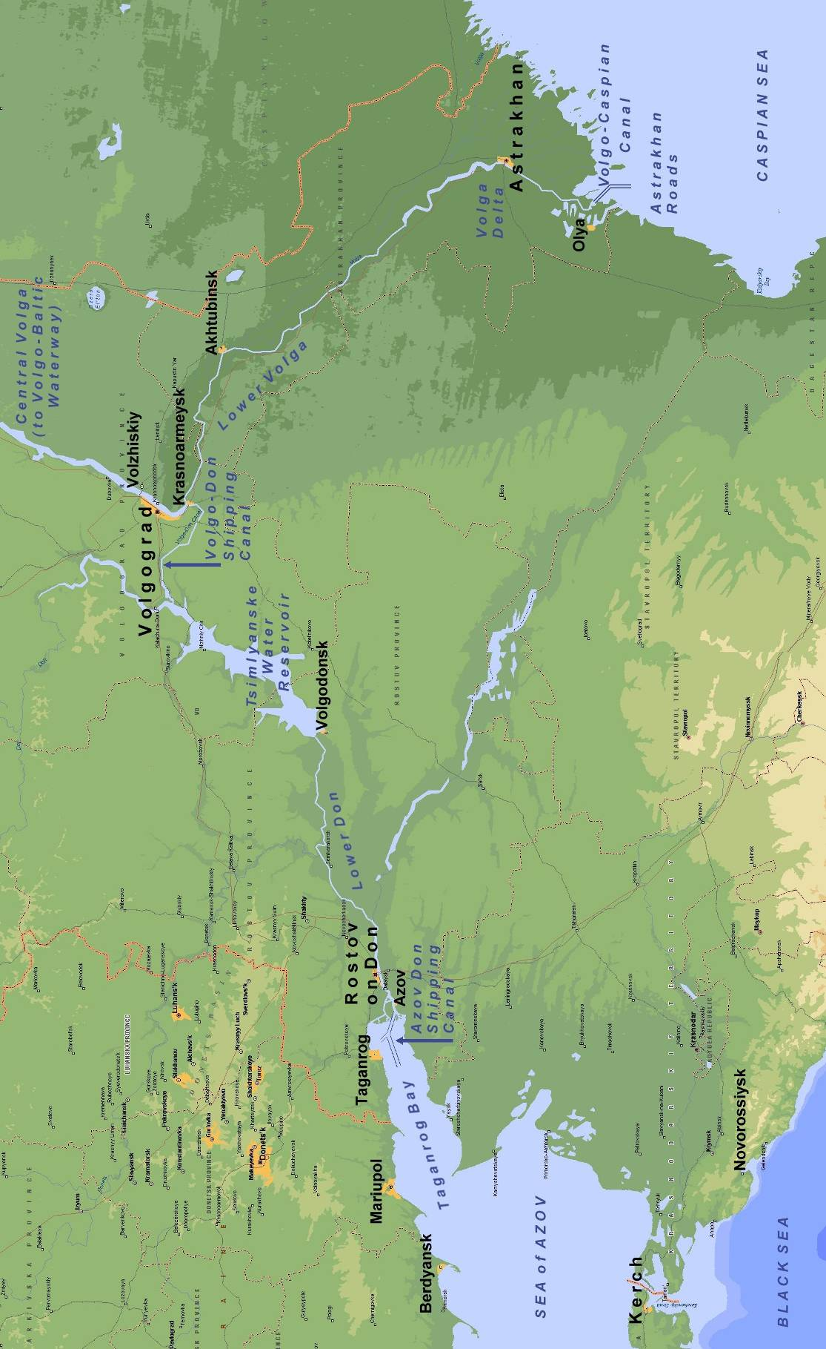

As shown in the figure on the previous page, ships transiting the waterway from the Mediterranean/Black Sea to the CS will along the following sectors:
- Sea of Azov (SoA): the shallow sea that connects the Black Sea to the Don River mouth via the Bay of Taganrog;
- Azov-Don Sea Canal (ADSC): a dredged channel giving navigable access to the Don River;
- Lower Don (LD): the western sector of the Volga-Don Waterway (VDW);
- Tsymlyanskoye Water Reservoir (TWR): the large artificial lake which forms a key central part of the VDW in terms of water level control and its navigational characteristics;
- Volgo-Don Shipping Canal (VDSC): the canal that connects the Don and Volga Rivers;
- Lower Volga (LV): this extends from Volgograd to Astrakhan and the Volga Delta; and the
- Volgo-Caspian Canal (VCC) – the shipping channel enabling navigation through the Delta mouth and adjacent shallow sector of the northern CS to the Astrakhan (Outer) Roads (AR).

The VDW closes during the winter freeze (late November - early April), but ice-hardened tugs are used to escort vessels along the VDW in spring and late autumn, and ice breakers are used to maintain a more year-round navigation between the BS and the Ports of Azov and Rostov-on-Don, and between Astrakhan and the CS. These and other relevant navigation features, physical characteristics and biological aspects of the complete BS–CS waterway were reviewed to identify:
- Where, why and when ballasting operations are usually undertaken; and
- What features along the route may prevent or reduce the effectiveness of particular BW management options, including particular treatment methods.
In terms of BW management options, Section 3 of the report identifies the following significant features of the BS-CS Waterway:
(W1) Susceptibility of CS to further ship-mediated bioinvasion: The CS remains susceptible to aquatic species that become adapted to (or are native) to low salinity environments in the Black Sea region. Species that invade and adapt to the BS spread, including into the SoA. Those that can complete their entire lifecycle in freshwater can colonise Taganrog Bay and the Lower Don. Thus the principal BW pathway of concern remains, for the projected future, from west to east, via the Sea of Azov/Lower Don and the VDW. In terms of ‘donating’ species, the CS is part of the Ponto-Caspian with species that have invaded the Baltic region.
(W2) Locks between the LD-TWR form the boundary between BS and CS catchments: The TWR provides the main supply of water which maintains levels in the VDSC before subsequently entering the Lower Volga at the canal’s junction near Volgograd. The locks between the Lower Don and TWR (near Volgodonsk) therefore form the barrier that inhibits self-spread of freshwater-tolerant species from the SoA/Lower Don into the Volga catchment (and thence to the northern CS). To prevent ballast-mediated transfer of unwanted fresh- or brackish-tolerant species to LV and CS from or beyond the BS, only managed BW should be allowed to be carried past these locks, i.e. BW that is ≥95% deepwater exchanged or preferably treated, including tank sediments.
(W3) Weather and wind-wave conditions on the Tsymlyanskoye Water Reservoir (TWR): The large TWR forms the middle sector of the VDW where strong winds and relatively high wind-waves can lead to undue (and unsafe) propeller emersion, reduced steering and windage problems to river vessels that are transiting partly loaded or in light ballast. Vessel control can be maintained by temporarily adding more BW, but its mixing with any untreated BW (including un-pumpable water or sediment) then subsequent discharge (to negotiate locks and other waterway features of the VDSC and LV provides a pathway for freshwater tolerant species.
(W4) Uniform Brackish-Freshwater Salinity Regime: There is little difference in the low salinity regimes that are present in the BS, CS and their respective approaches to the VDW (i.e. the SoA/ADSC/LD and the AR/VCC/LV). This precludes the use of freshwater ballast as a method for killing euryhaline biota (organisms tolerant to brackish waters). However it raises the possibility of using brine to kill ballasted biota that is adapted and/or acclimated to low salinity regimes. For example, rapidly increasing BW salinity from 1-10 PSU levels to 35-40 PSU produces a massive osmotic shock (OS), and has been viewed as a possible method for treating BW.
(W5) Shallow but unprotected approaches to the VDW: Both the western (SoA) and eastern (CS/AR) approaches to the BS-CS waterway involve long traverses across relatively shallow (<10 m) yet unprotected seaways with gradually shoaling ground. These approaches are frequently exposed to strong winds and relatively steep wind-wave conditions, i.e. in both the Bay of Taganrog and in the Astrakhan (Outer) Roads (AR). Undertaking ballasting operations, such as lightening up or exchanging in preparation for the transit, can be difficult, incomplete or readily abandoned as it is important for ships to minimise windage and maintain adequate vessel control (propulsion, steerage and stability) - particularly when particular courses must be held to safely approach then enter the narrow ADSC and VCC dredged channels. The biological effectiveness of exchanging BW in these shallow approach areas is very limited, in terms of removing unwanted biota.
(W6) Shallow water depths and high turbidity: Shallow depths (= small underkeel clearances) and high turbidity levels occur throughout the approaches and much of the of the BS-CS waterway, as a result of wind-waves, spring floods and associated silt shoals and bank. These can be expected to regularly enhance sediment uptake and accumulation within ballast tanks - particularly in peak turbidity periods of rough weather and throughout the spring flood period . High levels of suspended sediments in the BW flow presents a challenge to treatment methods that rely on compact mechanical filtration, membrane filtration (RO) and/or ultraviolet (UV) units. If the organic content of the suspended sediments is high, the heavily turbid flow will also have a high chemical oxidant demand (COD) that can reduce the efficacy of treatments that use active oxidising substances (i.e. doses of chemical oxidants added to BW by direct injection or via electrolysis).
(W7) Low levels of halide ions (Cl⁻, Br⁻, I⁻): The low salinity and virtually freshwater regimes in the SoA, ADSC, LD, VDW, LV, VCC and AR prevent efficient use of BW treatment systems that use electrolysis to produce OBr’, OCl’ and associated active substances. The peculiar ionic content of the CS (relatively low Na⁺ Cl⁻ content versus very high SO₄²⁻ [25% of total], Ca²⁺ and CO₃²⁻ content; e.g. Jazdzewski & Konopacka 2002) may also adversely influence the generation of appropriate levels of electrolytic products, by-products or long-lived residuals.
(W8) Seasonal ice formation / ice clearance: At the start and end of the winter freeze, ice breakers and tugs escort convoys of ships through the VDW. The springtime and autumn ‘rush’ of shipping activity also leads to ship ‘clusters’. Seasonal occurrence of groups of ships has design implications for any land-based BW reception/treatment facility.

SUMMARY OF SHIPPING ACTIVITY AND BW MOVEMENT ANALYSIS

Present and projected shipping trade and BW movements, together with ship types and their ballasting requirements which conduct these activities, are reviewed in Section 4 of the report

‘River-Sea’ classed ships are purpose built for trading on protected coastal and short sea routes as well as inland waterways, and have dual displacement tonnages and ballasting capacities for undertaking voyages at sea drafts (3.5-4.5 m) or UDWS drafts (<3.6 m). The present River-Sea trading fleet includes a range of general cargo ships (dry bulk, break-bulk, mixed bulk/container and some reefer types), tankers (product oil, chemical, vegetable oil), and a few oil-bulk-ore ships (OBOs). There are several classes that pertain to the maximum distance from land and nearest port of refuge a particular vessel may operate when undertaking a short-sea passage.

Section 4 shows that shipping trade and associated BW movements to and from the Caspian region continues to reflect the dominance of westward exports of liquid and dry bulk products, with smaller but by no means decreasing eastward movement of goods, containerised freight and special cargos (including heavy equipment for petroleum field developments). From a review of April-September 2006 shipping records and BW data, Section 4 identified the following features of the fleet and its ballasting operations that pertain to the choice of practicable BW management options:

River-Sea Shipping Features and Trading Patterns
(S1) The present ‘fleet’ that moves BW on the BS-CS waterway is a mix of ship types which have a wide range of designs and build dates, i.e. from the 1960s to modern double-skinned vessels. The more modern tankers and mixed freight cargo ships appear to be making an increasing proportion of international ‘direct voyages’ to and between European ports, particularly in winter so as to escape the 3-4 month lay-up period.
(S2) A large proportion of the present fleet are >25 year old ships facing the end of their commercial life. Many of the older vessels also appear unsuited for upgrade for international direct route trade, so their operators may understandably be unwilling to pay for retrofits of BW treatment equipment for ships with a potentially limited lifespan on ‘domestic’ SoA – VDW or VBW routes. On the other hand, since many of the older ships have relatively fewer BW tanks and generally smaller ballasting needs (<1500 m³) than their modern counterparts, their internal layouts may be amenable to affordable modifications that enable BW discharge/uptake to a reception/treatment facility via a standard over-deck coupling.
(S3) The more modern River-Sea ship types have 8-16 ballast tanks and ballasting requirements well above 1500 m³ (particularly the tankers). Many are designed, equipped and suited to international trade between ice-free ports in winter. These younger vessels will need to comply with future BW Convention requirements if needing to discharge BW in European ports and waterways that have no BW reception facilities (pertinent requirements of the BW Convention are addressed in Section 4.1).
(S4) Irrespective of vessel age and type, space is probably a premium on all River-Sea ships owing to the UDWS constraints on their draft and other dimensions. Limited space / convenient compartments for retrofitting treatment units, additional power generation, pumps and pipework pose problems for BW treatment systems that use bulky and/or power hungry units (space/power requirements and other features of BW treatment technologies are also addressed in Section 4).
(S5) There appear to be many capable shipyards on the Volga specialising in River-Sea vessel construction, modification, conversion and maintenance. Some should be well positioned to provide reliable advice and cost estimates for reticulating ballast tanks in the various ship types to enable BW discharges to shore, and/or for retrofitting onboard BW treatment systems. Ship or fleet managers will also be a source of valuable advice.

Present patterns of BW Movements and Ballasting Operations
(S6) Most BW is being moved east to the CS owing to present (and projected) trade that is skewed towards substantial liquid and some dry bulk exports from the Caspian region. Far less BW is moved from the CS, either westward to the SoA/Black Sea or northward to St Petersburg and the Baltic. The minor amounts of BW being moved south from the Baltic region to the CS are unlikely to rise unless bottlenecks on the central/upper Volga system are removed by a major improvement program (Appendix B).
(S7) There has been no methodical ballast tank sampling/analysis program to identify sources of BW / sediments, check claims of reported exchanges, or provide data allowing the effectiveness of present BW exchange requirements to be assessed.
(S8) There are several reasons why present BW exchange requirements in the approaches to the ADSC (SoA), VDSC (LD) and VCC (AR) are probably ineffectual in reducing the risk of species transfers: (i) the SoA, LD and N CS are not free of native or introduced organisms; (ii) frequent strong winds and short steep seas in the SoA and N CS inhibit exchange attempts; (iii) not all ships follow the requirement (owners do not want ships to delay to ensure a ≥95% exchange); (iv) high sediment entrainment is likely; and (v) un-pumpable BW and sediment (and hence organisms) will remain in the tanks even if complete exchanges are made.
(S9) BOB vessels occasionally conduct temporary ballasting operations in the TWR and other sectors of the VDW to maintain adequate vessel control and/or for other navigational purposes (4 of 41 eastbound BOB vessels reported one). The percentage of transits involving a ballasting operation within the VDW is probably >10%, given that not all ships necessarily logged or reported such operations during the recent BWRF campaign.
(S10) It is impractical to expect (and unsafe to require) all ships not to make any draft adjustment in the VDSC or TWR when coping with rough wind-wave conditions (as reported in some BWRFs). There are probably other circumstances/locations east of the TWR that can require a ballasting adjustment.
(S11) To prevent BW-mediated transfers of extraneous organisms and substances between the Lower Don (BS catchment) and the Lower Volga (CS catchment), the most eeffective measure is to prevent ships carrying unmanaged BW past the locks at the head of the Lower Don (Volgodonsk) into the TWR or beyond (refer [W2] in Section 3.5).

SUMMARY APPRAISAL OF PRACTICABLE BW MANAGEMENT OPTIONS

Section 5 of the report examines aspects of the IMO International Convention for the Control and Management of Ships' Ballast Water and Sediments 2004 (the Convention) that will influence the choice of BW management options, before addressing the relevant features and requirements of the land-based BW reception option and potential alternative BW treatment (BWT) options. Section 5 concludes with an appraisal and a preliminary ranking exercise to help determine if land-based BW reception will merit a more in-depth and detailed consideration. Salient findings of Section 5 are as follows:
(B1) The Convention will pertain to future BW management by any River-Sea ship that undertakes international trade to and between European ports as well as the BS-CS waterway, and it is expected to enter into force on 1 January 2009 (relevant aspects of the Convention are summarized in Section 5.1).
(B2) The Convention recognizes the use of land-based BW reception facilities, as this option may be commercially attractive to trading vessels that are dedicated to particular long term routes and ports, and which have predictable and well defined ballasting/deballasting cycles. Discharges into the aquatic environment of BW treated at a reception facility will need to meet a performance standard (details are now available in Guideline #5 of the Convention).
(B3) A land-based reception facility on the BS-CS waterway should be an economically attractive management option if there will be a sufficient number of ships with no capacity for onboard BW treatment for at least 15-20 years, and if the facility is designed to minimise ‘queuing’ and hence avoid undue delays. There would need to be a regulation requiring all such ships to use the facility, and a payment scheme to ensure all users contribute a fair share towards the costs of operating the facility.
(B4) A reception facility may not provide an attractive long-term option to vessels that only occasionally use the BS-CS waterway, and trade elsewhere for much of the year. Owners or operators of these ships may prefer to install an onboard BWT system when the BW management requirements of the Convention come into force.
(B5) Therefore a key step in determining the value of building a reception facility on the BS-CS waterway will be to consult with ship owners and operators to estimate how many existing ships (plus those built before 1 January 2009) will remain frequently dedicated to ‘domestic’ trade along the BS-CS waterway until 2020-2025. If old ships become phased out quickly and others become fitted with onboard BWT systems, then a relatively short operational time-frame (10-15 years) will increase the capital component of the total facility investment.
(B6) The most biologically effective location for the facility is a convenient, frequently visited port on the Lower Don, such as Azov or Rostov-on-Don. Placing the facility near the mouth of the Lower Don assumes that eastbound ships that replace their unmanaged BW have no subsequent need to take up (then discharge) additional BW until after entering the TWR. Alternative facility locations, such as on the Volga River at Krasnoarmeysk, Akhtubinsk or Astrakhan, would require ships not to discharge any unmanaged BW during their whole voyage along the BS-CS waterway. This appears impractical, as present data indicate that some 10% (or more) of eastbound ballasted ships make temporary draft adjustments involving BW uptake/discharge.
(B7) The present overall average number of ballasted eastbound and westbound ships is, on average, about 32 per month (= close to 1 per day). Typical volumes per ship are between 500 and 2300 tonnes, with the present average near ~1700 tonnes.
(B8) Sequential tank discharges at a facility would therefore take between 2-10 hours to complete if normal small ship deballasting rates are used (200-500 m³/hour). The additional time required to deliver ‘clean’ water to the empty tanks will depend on the ability of a ship to receive and distribute this water to the tanks that were initially emptied (i.e. during the period when its remaining tanks are being emptied).
(B9) An ability to deliver ‘clean’ water to a ship well before the end of its discharge of unmanaged BW would almost halve the total servicing time, thereby helping to avoid undue delays. If this is not possible (e.g. because of loading stresses to the hull or lack of the additional shipboard pipework for distributing this water to the empty tanks), then the total empty/refill time will be double the typical emptying time (i.e. to between 4 and 20 hours).
(B10) A facility that not only receives BW but delivers treated (or otherwise ‘clean’) water must be equipped with additional pumping, storage tank and piping infrastructure to avoid cross-contamination. The clean ‘delivery’ water can be treated BW (received from previous ships), and/or local river water if treated and stored at the facility. Alternatively, the ‘clean’ water could be sourced directly from an uncontaminated groundwater supply, if a suitably large source is available close to the port.
(B11) The need for ice-breaker or tug escorted ‘ice caravans’ in late autumn and spring means that the facility may need to handle the simultaneous arrival of 3-4 ships wishing to replace unmanaged BW before continuing their voyage. To avoid undue ‘queuing’ delays when 2, 3 or more ballasted ships arrive close to each other, the facility will need to provide multiple reception points at the port. Candidate locations would include frequently-used bunkering points, service wharves, service jetties and/or moorings used for port control inspections, customs and quarantine clearance.
(B12) Few ships have the capability to pump their BW to a shore-side facility at practical flow rates. Ships wishing to use the facility will need to be retrofitted with pipework and booster or larger BW pump/s to allow BW in all tanks to be discharged to the land connection, via a standardised coupling on the main or weather deck.
(B13) The faster that unmanaged BW can be pumped out and replaced by treated BW, the shorter the total delay to the voyage. A conceptual vessel retrofit design will need to lift BW vertically from the lowermost ballast tank to the main or weather deck at a suitably fast rate. For River Sea ships, this would involve a height of 5-7 m and a rate of 250-500 tonnes per hour, depending on the tank layout, moulded height and BW capacity of each specific ship type.
(B13) Consideration will need to be given to fitting tank eductor pumps, and/or making other improvements to maximise the ships’ ability to pump out as much BW and sediment as practicably as possible from each tank. If design work shows that significant quantities of un-pumpable BW and tank sediment cannot be removed despite good retrofit designs, then the facility could add a biocide to its clean ‘delivery’ water, so as to kill any organisms that remain in the tanks. This option will increase the facility’s operational cost, and the biocide will need to be an approved type that avoids tank corrosion risks or forming long-lived toxic residuals.
(B16) The following infrastructure will be needed for any onshore BW reception facility:
(1) Equipping a sufficient number of wharf and/or mooring points with the standard coupling, pump, reliable power and dedicated mains for piping water to and from the plant.
(2) Procuring sufficient land for the plant, including BW reception storage tanks large enough to handle peak BW inflows that would otherwise overwhelm the capacity of the plant (i.e. when two or more ships are discharging at the same or overlapping time). A tank storage volume of >6000 tonnes would also permit the facility to receive BW for 2-4 days during plant maintenance, overhaul or unexpected shut-down.
(3) A treatment plant that has sufficient capacity to treat the projected mean volume of BW discharged per day (potentially >2000 tonnes depending on projected increases in East-West trade), plus storage tank/s large enough to ensure uninterrupted deliveries of treated water (or filtered clean groundwater).
(4) Installation of an outfall (or a groundwater injection point) for discharging excess treated water. The potential salinity of the treated water may prevent its value and delivery into an existing irrigation or industrial recycling scheme via a link-main.
(5) Access to a suitable land-fill site for the burial of used filter media, filter cake or other forms of tank sediment and sludge that are generated at the plant.
(B17) Standard water industry treatment methods could be used, such as coarse pre-filters then fine filter units that use filter bed media followed by conventional secondary treatment to kill pathogenic bacteria, viruses and other microbes (e.g. UV, ozonation or chemical dosing). An existing public sewage treatment plant (STP) may be capable of an expansion/adaptation for treating the BW, providing that saline BW (>8 PSU) is not delivered in large ‘pulses’ (this would be incompatible with the freshwater bacteria that are used in the biological units of typical STPs).
(B18) Cost estimates, in terms of an overall cost per metric tonne of received BW, depend on land purchase costs (this varies markedly from port to port), as well as vessel retrofitting costs. The latter will vary between ships depending on the number and layout of their BW tanks, their existing pipework and pumping capacity, the specific design parameters of their type/class, and the timing, country, specific location and demand for vessel retrofits (i.e. number of vessels to be fitted per month or per year).
(B19) Following review of the present status of technologies for alternative shipboard BW management, a preliminary appraisal was made to compare the practicality of the land-based reception option versus possible shipboard BWT options. The onboard BWT technologies examined were filtration, ultraviolet light, dosing by ‘active substances’, de-oxygenation, hydrodynamic cavitation, osmotic shock and thermal treatment. The appraisal used a simple, semi-quantitative scoring method to score and preliminary rank the various BW management options.
(B20) Each BW management option, whether by land-based reception or particular onboard BWT method or combination of methods, inevitably presents inherent advantages and limitations associated with its particular technology/s. What can be fitted on one ship to provide a satisfactory, reliable system may pose intractable problems and issues on another ship and/or trading route. The following assumptions were used to help evaluate and score which BW management options presently appear potentially more practical, cost-effective and ecologically acceptable than others for use by River Sea ships that trade through the BS-CS waterway:
- Space/s in the motor room and near the BW pumps will be cramped and small.
- There will also be space and weight limitations for storing BWT consumables.
- Availability and stability of 3 phase power from existing generator/s may be limited.
- BW pump/s are not located in double bottoms or other inaccessible compartments
- Ballast tank surfaces and pipework may have limited corrosion protection.
- Sediment accumulations in BW tanks are removed manually, typically at slipping.
- BW uptake/discharges will be 200-500 m³/hour and volumes will be 500 – 2500 m³.
- Ballast tank numbers (4-18) will be highest in modern ships, particularly in tankers.
- Few, if any, crew will be available for BWT system monitoring and maintenance.
- Many shallow sectors, berths and cargo transfer sites are turbid with silty floors.
- Small underkeel clearances are frequent.
- Low salinity waters from the SoA to the CS have low Cl⁻, Br⁻ and I⁻ ionic strengths.
- Water temperatures range from ~0ºC (spring) to +25ºC (late summer/early autumn).
- Sectors and reservoirs of the BS-CS waterway provide industrial, agricultural, urban and ecologically important sources of water, so a high value is placed on waterway water quality.

(B21) The basic ‘pros and cons’ of the land-based reception facility versus those of the various onboard BWT technologies were scored using a simple matrix of 13 important operational features and factors (refer Table 5-3 in the main report for details). A simple scoring scheme was applied to each of the 13 factors, as follows
0 = Very difficult / very disadvantageous for small ships on the BS-CS waterway.
1 = Moderately practical / moderately suited to small ships using the BS-CS waterway.
2 = No substantial difficulties or disadvantages for small ships using the waterway.

All factors were treated with equal weight, and all scores were summed to provide an overall ‘first-pass’ score and preliminary ranking. Thus no factor was scored using higher values owing to its perceived relative importance when compared to other factors (more sophisticated scoring would need specific manufacturer information for particular BWT units, but these are not yet commercially available).
(B22) The ‘first-pass’ appraisal allowed a preliminary ranking. The output (table below) confirmed that the reception facility option merits further and more detailed analysis. Since it is inevitable that onboard BWT technologies will continue to improve, the preliminary ranking should not be used to guide, or support, any strategic decision regarding what types of alternative onboard BWT system may be most suited for particular River-Sea ships. Such decisions cannot be taken until approved BWT units appear on the market with manufacturer specifications and recommendations, and should also involve advice from ship designers, Classification societies and shipyards.

Summary Outcome of the Preliminary Ranking Exercise
BW Management Option | % of Maximum Score | Preliminary Ranking
Land-based reception facility | 88.5% | 1
Injection of a non-oxidising biocide | 84.6% | 2
Cavitation / shear force mixing | 80.8% | 3
Mechanical screen or disc filters | 80.8% | 3
Medium pressure UV units | 80.8% | 3
Deoxygenating systems | 73.1% | 6
Injection of an oxidising biocide | 73.1% | 6
Chlorine dioxide | 69.2% | 8
High Pressure UV units | 65.4% | 9
Osmotic shock by salinisation | 65.4% | 9
Thermal treatment | 57.7% | 11
Filtration by hydrocyclones | 53.8% | 12
Multiple low pressure UV units | 53.8% | 12
Ozonation systems | 50.0% | 14
Ultra-filtration systems | 50.0% | 14
Electrolysis units + brine injection | 42.3% | 16

TECHNICAL Summary Conclusions
The study assumed that ship-based trade from and to the Caspian region will continue to grow and internationalise, with a continuing dominance of ‘westward’ exports of dry and liquid bulk products, plus a lesser but by no means decreasing eastward movement of goods, containerised freight and special cargos (including heavy equipment for petroleum field developments). On this basis, the following conclusions and recommendations can be drawn:
(1) The principal BW pathway of concern will remain, for the projected future, West to East.
(2) Species that invade and adapt to the BS spread, including into the SoA. Those that can complete their entire lifecycle in freshwater can colonise most of the SoA, including Taganrog Bay and the Lower Don.
(3) The locks between the Lower Don and TWR provide a barrier against the natural spread of introduced (and native) species from the BS, SoA and Don catchment to the Volga catchment (and hence to the CS) via the TWR pumping station that feeds the VDSC.
(4) Effective BW measures therefore need to prevent ships carrying unmanaged BW past the head of the Lower Don into the TWR, Volga and beyond.
(5) BW exchanges undertaken in the SoA (or in the North CS/AR) will remain relatively ineffectual for several reasons.
(6) It is impractical to expect (and unsafe to require) all ships not to make a draft adjustment in the TWR when coping with rough wind-wave conditions (as reported in some BWRFs). There are other sectors/circumstances east of the TWR that may also require a temporary ballasting operation to adjust draft or trim.
(7) Any land-based BW reception/treatment facility used by ships which have no onboard treatment ability therefore needs to be at Azov or Rostov-on-Don, and not at Astrakhan.
(8) The ‘fleet’ presently contains a mix of ship types, with a small (<15%) but increasing proportion making international ‘direct voyages’ to and between a range of European ports, particularly in winter. Ships engaged on this trade (typically the younger vessels) will need to comply with BW Convention requirements in ports or waterways that have no land based reception facility.
(9) A large proportion of the present fleet are >25 year old ships facing the end of their commercial life. Most appear unsuited to upgrade for international direct route trade, and their operators may also be unwilling to pay for expensive modifications to enable shipboard treatment for trading along the more ‘domestic’ SoA – AR routes.
(10) A land-based facility at Azov or Rostov-on-Don that services ships restricted to the SoA-AR routes may therefore be attractive and cost effective - if this trade remains substantial for >10-15 years. The cost of reticulating a vessel to enable convenient onshore discharge varies with the number of ballast tanks (from 4 to 14 depending particular River-Sea vessel type). Price estimates from previous studies examining the cost of reticulating ocean-going container ships and bulk carriers for onshore BW discharge do not provide a reliable guide for extrapolating to River-Sea vessels for several reasons.
(11) Irrespective of vessel age, type and number of ballast tanks, space is probably a premium on all River-Sea ships owing to constraints on their draft and other dimensions. Limited space / convenient compartments for retrofitting treatment units, additional power generation, pumps and pipework may pose problems for technologies requiring bulky or power hungry units (e.g. advanced oxidation, hydrocyclones or de-oxygenation systems)
(12) Selection of workable shipboard treatment systems also need to account for:
- high levels of turbid water and entrained sediment due to the shallow waterways, dredged channels, river flood waters and small under-keel clearances (a challenge to filtration/UV-based systems);
- low salinities and cold water temperatures (constrain electrolysis or heating methods).
(13) Preliminary ranking of BW management options has showed the following
(a) a land-based BW reception and treatment facility, using filter-bed media and other standard water industry methods, would provide a cost effective solution if based at a port that can be conveniently accessed by all vessels entering the Lower Don. Costs will depend on the availability and price of riverside land, and the number and spacing of suitable existing wharves (and/or moorings) that are fitted to enable simultaneous servicing of two or three vessels. The advantages of linking the reception facility to regularly used bunkering and vessel service/supply points deserves close attention.
(b) Option (a) would be less useful for the more modern (and typically larger) River-Sea ships that undertake international ‘direct’ voyages to and between European ports. These ships tend to have more ballast tanks (particularly the double bottom/double skin types) so would be more expensive to reticulate. To ensure conformance with future BW Convention requirements, the operators of these ships will probably prefer to equip them with an onboard system that has small dimensions and power requirements. Of the various technologies under current R&D, those that inject approved active substance/s into the BW stream deserve close monitoring and attention. Of the various sediment-reduction systems, auto-cleaning screen filters presently appear the most promising for application on River-Sea ships, owing to their small power need, compactness, modular form and ability to be fitted vertically, horizontally or other angles.

TECHNICAL SUMMARY Recommendations
(1) The draft report should be read in full by CEP maritime and environment agencies, and a workshop needs to be held to facilitate the review, understanding and discussion of its findings. Such a workshop would also undoubtedly help provide clarifications and corrections, as and where necessary, to the inputs, assumptions or outputs of this desk-top based activity. Since the study forms the first step of the pathway to developing and implementing a suitable BW management strategy, this workshop would also provide a timely and very effective way for CEP States to agree on the next steps and how these will be best achieved.
(2) To determine projected life and hence value of the land-based option, advice and opinion need to be solicited from major operators and builders of River-Sea vessels, and/or their association/s or collective representatives. There are many capable shipyards along the RF waterways specialising in River-Sea vessel construction, modification and maintenance, and some of these would be well positioned to provide estimates for reticulating ballast tanks to enable discharge to shore.
(3) Trade projections also need to be sought for the planned or expected trend in River-Sea trade – particularly its rate of internationalisation versus the number of ships engaged in SoA – AR trade.
(4) For the more modern ships with international trading profiles, a ‘watching-brief’ on simple injection systems that dose an approved active substance, possibly coupled with an auto-cleaning screen filter unit, deserves to be maintained, and the operators, designers and builders of these ships should be solicited for their views and opinions.

ExECUTIVE AND TECHNICAL SUMMARIES (i - xviii)
1. INTRODUCTION 1
1.1 Background 1
1.2 Objectives and Tasks 1
1.3 Report Scope and Structure 2
2. Glossary of terms and acronyms 4
2.1 Terminology 4
2.2 List of Acronyms 5
3. description of THE WATERWAY TO THE CASPIAN SEA 7
3.1 Overview and Administration 7
3.2 Black Sea – Caspian Sea Waterway 9
3.3 Navigational Features of the BS-CS Waterway 10
3.3.1 Sea Of Azov (SoA) 10
3.3.2 Azov-Don Sea Canal (ADSC) 10
3.3.3 Volga-Don Waterway (VDW) 11
3.3.3.1 Vdw Overview 11
3.3.3.2 Lower Don (LD) 12
3.3.3.3 Tsymlyanskoye Water Reservoir (TWR) 12
3.3.3.4 Volgo-Don Shipping Canal (VDSC) 14
3.3.4 Lower Volga (LV) 14
3.3.5 Volgo-Caspian Canal (VCC) 16
3.3.6 Astrakhan Roads (AR) 16
3.4 Caspian Sea (Cs) 17
3.4.1 Physical Features of the CS 17
3.4.2 Biological And Aquatic Invasion Features of the CS 18
3.5 Waterway Features influencing BW Management Options 20
4. SHIPPING ACTIVITY AND BALLAST WATER MOVEMENTS 22
4.1 Overview of Present Waterway Trade and Ship Types 22
4.2 Collation Of Shipping Activity and BW Movement Data 28
4.3 Current Bw Management Requirements And Practice 29
4.4 Shipping Activity and Estimated BW Movements from April to September 2006 31
4.5 Ballasting Activity Along the BS-CS Waterway 34
4.6 Summary of Key Shipping and BW Movement Features 38
5. APPRAISAL OF PRACTICABLE BW MANAGEMENT OPTIONS 40
5.1 Future Requirements Of The International Convention 40
5.1.1 Convention Overview And Implications To River-Sea Ships 40
5.1.2 Convention Guidelines 41
5.1.3 Replacement Of Mandatory Bw Exchange 41
5.1.4 Discharge Performance Standard 43
5.1.5 Reception Facilities, Treatment Technology Approvals and Prototypes 43
5.2 Land-Based Bw Reception/Treatment Option 44
5.2.1 Conclusions From Previous Studies on Port-Based BW Reception 44
5.2.2 Operational Requirements for BW Reception on the BS-CS Waterway 45
5.2.3 Specific Components Required for the Reception Facility 47
5.3 Appraisal of Promising Shipboard Options 49
5.3.1 Progress and Choice of Onboard BW Treatment Technologies 49
5.3.2 Filtration 50
5.3.3 Irradiation Doses of Ultraviolet Light (Uv) 51
5.3.4 Dosing with ‘Active Substances’ 51
5.3.5 Hydrodynamic Cavitation 52
5.3.6 Deoxygenation 52
5.3.7 Salinity Shock 52
5.3.8 Thermal Treatment 53
5.4 Preliminary Ranking of the BW Management Options 53
6. SUMMARY CONCLUSIONS AND RECOMMENDATIONS 57
6.1 Conclusions 57
6.2 Recommendations 60
7. REFERENCES 61
8. LIMITATIONS OF REPORT 66

LIST OF TABLES
Table 3-1 Principal Dimensions of the Lower Volga Waterway 15
Table 4-1 Specifications of recently built River-Sea trading ships 22
Table 4-2 Shipping activity on the BS-CS waterway, including % of ballasted vessels 31
Table 4-3 Shipping activity on the VBW, including % of ballasted vessels 32
Table 4-4 Summary of estimated BW movement to and from the Caspian region 33
Table 4-5 Vessel types that submitted completed BWRF by 30 Sept. 2006 35
Table 4-6 Summary of reported BW movements on eastbound voyages 36
Table 4-7 Summary of reported BW movements on westbound voyages 37
Table 5-1 Guidelines G1-G14 of the Convention 41
Table 5-2 Phased replacement of BW Exchange by BW Treatment during 2009-2016 42
Table 5-3 Promising BW treatment technologies ranked in order of apparent suitability 55
Table 5-4 Summary outcome of the preliminary ranking exercise 56

LIST OF FIGURES
Figure 3-1 Waterways of the Unified Deep Water System that connect the Caspian Sea to the Black Sea, Moscow and the Baltic Sea 8
Figure 3-2 Canal-mediated bioinvasions of Ponto-Caspian aquatic species 19
Figure 4-1 Distribution of build dates for general cargo ships and tankers 34

LIST OF PLATES
Plate 1 River-Sea mixed cargo ship Rusich-4 built 2002/3 23
Plate 2 River-Sea mixed cargo ship Palmali Voyager at completion in 2004 23
Plate 3 River-Sea tanker Armada Trader in Marmara Sea, June 2004 24
Plate 4 River-Sea tanker Nizhniy Novgorod passing the Bosporus in 2005 24
Plate 5 River-Sea MEG tanker Roskem-1 (converted in 2004) 24
Plate 6 River-Sea cargo ship Amur 2531 in the Thames River Estuary in 2001 25
Plate 7 Volzhskiy-24 carrying logs near Rostov-on-Don 25
Plate 8 VolgoBalt 202 - example of another numerous but aging Soviet-era type 26
Plate 9 Examples of the large (OT type) and medium (Rechnoy type) pusher tugs 26

LIST OF APPENDICES
Appendix A Description of the Black Sea-Caspian Sea waterway (Local Knowledge Report)
Appendix B Development of the Inland Waterway Development and its River Fleet
Appendix C Bilingual Ballast Water Record Form (BWRF) and Guidance Documents
Appendix D Details of Vessels that submitted Completed Ballast Water Record Forms
Appendix E Summary Account of Promising Ballast Water Treatment Methods

INTRODUCTION

BACKGROUND

Under the framework of the Caspian Environment Project (CEP), an Inter-Agency Agreement (IAA) has been signed between the International Maritime Organization (IMO) and the United Nations Office for Project Services (UNOPS) to carry out a study on traffic of ship-borne invasive species to and from the Caspian Sea, including a pre-feasibility study on practicable management measures for controlling this traffic of invasive species (this report).

Under the Study framework, a regional inception meeting was held in Baku, Azerbaijan, during 8-9 September 2005, in which a Regional Task Force (RTF) was formed consisting of government representatives of the five Caspian States (i.e. Azerbaijan, Iran, Kazakhstan, Russia and Turkmenistan). The RTF will act in an advisory capacity to the Project. The Baku meeting also agreed to nominate a Task Force National Coordinator (TFNC) for each country, who will liaise with key national institutions, pertinent specialists and relevant industries to facilitate the Study.

A subsequent activity has been to assess the shipping traffic and associated BW movements in the region, and use this information to provide an appraisal of potential BW management options. Under the IAA framework, the IMO therefore commissioned two consultants to collaboratively work on (a) collecting and analysing shipping and BW data from ships trading to and from the Caspian Sea (using tailor-made BW reporting forms, guidance document (including developing a time schedule for these data collation activities), and (b) using these data to help provide a preliminary appraisal of BW management options.

The consulting activities were undertaken by a local (Astrakhan) shipping expert and an international BW management consultant, working in close consultation with the IMO, pertinent Russian Federation maritime transport authorities between April and October 2006, and is the subject of this report.

ACTIVITY OBJECTIVES AND TASKS

The objectives and outputs of the international consultant during the April-October 2006 activity have been to:
- Assist the local (Astrakhan) shipping expert in collecting and interpreting the data regarding shipping traffic and BW movements in the region;
- Identify options for BW management to prevent the transfer of aquatic invasive species to and from the Caspian region; and
- Provide a report (this document) to the CEP beneficiary countries that assesses the amount of BW being moved to and from the Caspian Sea, and identifies BW management options that can prevent the transfer of harmful aquatic invasive species by these BW movements..
The tasks undertaken to achieve these objectives and outputs have been as follows:
- Developing a time schedule for conducting the activity and preparing a regional workshop to discuss the findings and agree on a regional strategy to address the BW problem.
- Developing a user-friendly ballast water reporting form to be used on board river ships.
- Developing a guidance document for conducting the assessment on board ships trading between the Black Sea and the Caspian.
- Developing a spreadsheet to consolidate the data provided by the river ship captains during the survey conducted by relevant RF authorities..
- Assisting the local consultant and IMO with:
- advice on collating and consolidating the BW data obtained from ships.
- reviewing the data and providing inputs as appropriate.
- preparing a report on shipping traffic and BW movements in the region.
- providing inputs to possible BW management options.
- preparing materials for the workshop.
- provide recommendations and suggestions for conducting the workshop.
- Preparing and submitting a report to IMO on the activities undertaken, containing the above materials that were developed and used during the activity as well as the results, conclusions and recommendations.

REPORT SCOPE AND STRUCTURE

Section 2 provides a Glossary of the terms and acronyms used in this report.

Section 3 provides a summary of the Black Sea - Caspian Sea (BS-CS) waterway, borrowing heavily from the detailed local knowledge report which is presented in full in Appendix A. It concludes with a list of key features influencing ballasting operations and their management.

Section 4 describes the types of ship that are presently moving BW to and from the CS, before describing the methods and results of the shipping activity and BW movement study undertaken during the summer of 2006. Section 4 also refers to:
- a brief history of the Inland Waterways and associated Russian River Fleet (Appendix B);
- shipping activity and BW movements along the Volgo-Baltic Waterway in 2006;
- the BW Record Form (BWRF) and guidance documents used for the activity (Appendix C);
- the list of vessels that submitted completed BWRFs by 30 September 2006 (Appendix D).

Section 4 concludes with a review of current BW management requirements and apparent practises along the BW-CS waterway, and lists pertinent features of the River-Sea vessel classes, including their present and projected voyage patterns and associated ballasting requirements that are relevant to identifying practicable future BW Management options.

Section 5 commences with a brief review of relevant aspects of the International Convention on the Control and Management of Ships’ Ballast Water and Sediments (the Convention), as pertaining to the likely future BW management requirements of cargo ships that voyage across and beyond the waterways of the RF after the Convention comes into force.

Section 5 then presents an appraisal of possible BW management options, drawing on an account of promising BW treatment methods presented in Appendix E, plus previous studies on the pros and cons of land-based BW reception facilities. Section 5 concludes with a short- list of promising BW treatment methods that presently appear suited to the particular features of River-Sea vessels, including their present and projected trading routes and associated ballasting patterns.

Section 6 provides a summary list of the main points and conclusions reached in the previous report Sections 2-5, plus a list of recommended actions and activities for review and discussion by representatives of the five CEP countries at the workshop planned to be held in Astrakhan in November 2006. For the purposes of this workshop, Section 6:
- summarises the present pattern of likely aquatic species transfers via ships’ ballast water and ballast tank sediments into and out of Caspian Sea;
- lists the most potentially most practicable ways and means of controlling these transfers with respect to present and projected shipping activity; and
- provides a preliminary ranking of these options and other recommendations, for the purpose of facilitating the development of a regional proposal and ‘roadmap’ for implementing and progressing the actions and activities agreed at the Astrakhan workshop.

Section 7 lists the references cited in the report main text and its Appendices A-E, while the limitations of this report are outlined in Section 8.

This report was prepared by Robert Hilliard, based on briefings from the IMO plus advice and materials from Oleg Kazansky (Astrakhan shipping expert). Dr Hilliard is based in Australia and has undertaken several collaborative national and international BW management studies, risk assessments and appraisals of shipboard and land-based treatment methods since 1992. He was senior co-contributor to the Port of Oakland and Californian Association of Ports Authorities cost-benefit studies of potential shipboard and land-based BW treatment methods (Dames & Moore 1999, URS/Dames & Moore 2000) and was a member of the Technical Steering Committee of the Australian Ballast Water Treatment Consortium between 2001-2004 (ABWTC 2004). Dr Hilliard was also a senior contributor to the BW Risk Assessment project of the GEF/UNDP/IMO’s ‘GloBallast’ Programme, which included shipping and BW movements to and from the Port of Odessa (Alexandrov et al 2004).

Glossary of terms and acronyms

TERMINOLOGY

Air Draft | Height of a vessel (in metres) from the waterline to its highest point, usually its mast top (see Draft).
Declared (water) level | Water level for which a certain water volume is guaranteed within particular sector/s. Can be altered during or between years according to the replenishment status of water reservoirs and changing needs of other users.
Design (water) level | Minimum water level achieved by the dimensions of the waterway within a predicted or nominated range of wind-speed, river flow and/or reservoir discharge rates (micro-tides are discounted).
Downstream pool | Stretch of water adjacent to the backwater construction and located downstream from a hydro-engineering control dam.
Draft | Distance from the waterline to a vessel’s lowest point, usually the aft part of the keel if normally trimmed (see Under keel clearance).
Erik | Shallow arm between two deeper river reaches (anabranch), such as in the Volga system and its pre-Caspian basin.
Euryhaline | capable of acclimating or adapting to a wide range of salinities; the opposite of stenohaline. Euryhaline organisms are most common in estuaries and tide pools where salinity alters regularly. Also includes species with a migratory life cycle between rivers and the sea (salmon, trout, eels).
Girlo | Arm or branch of a river delta, including its underwater riverbed overlain by seawater. Used mainly in the Azov-Black Sea area.
In ballast / ballasted | Condition of a vessel whenever it has some pumpable ballast water onboard to maintain its stability, trim, steerage and/or propulsion, or sometimes to reduce its Air Draft.
Khutor | Landowner farmstead or croft – small to medium size hamlets and villages typically found in the Southern region.
Kilometre (km)  locations along  Inland Waterways | Kilometre locations in Inland Waterway maps and regulations of the Unified Deep Water System (UDWS) of the European Part of the Russian Federation are counted upwards from the Southern River Port of Moscow. Kilometre values have no comma to denote thousands, and use a conventional point to denote decimal fractions.
Low flood plain | Lower region of the river plain regularly flooded during periods of high water.
Low flood plain bank | Bank of the river channel adjacent to the low flood plain.
River shoal | Shallow and relatively stable formation of riverbed deposits that divides adjacent stretches of deeper river channel.
Stanitsa | Large village mainly in the Cossacks areas of the Southern region.
stenohaline | tolerates only a narrow salinity range. (most fresh and marine biota are stenohaline; i.e. they will die in sea or freshwater respectively).
Under keel clearance | Distance between the deepest point of a vessel’s keel and the river bed or seafloor. Clearances of 0.3 m and 0.5 m are typical minimum safe clearances for inland waterways and sheltered seaways respectively, but may be more depending on channel floor characteristics and local navigation regulations.
Upstream pool | Stretch of water adjacent to the backwater construction and located upstream from a hydro-engineering control dam.
Volozhka | Local term used in the Volga basin to denote a river arm or branch.
Water head | Water pressure magnitude produced by the difference between the levels of the upstream and downstream pools of a hydraulic control dams or other hydro-engineering complex.
Zero Datum (Kronstadt hydrometric staff) | The average multiyear level of the Baltic Sea measured at Kronstadt provides the Zero Datum that is used to reference all water depths in the reservoirs, rivers, lakes and seas of the Russian Federation.

List of Acronyms

ADSC | Azov-Don Sea Canal (part of the VDW)
AR | Astrakhan Roads
BOB | Ballast on board (ships with pumpable BW onboard)
BS | Black Sea
BW | Ballast water(s)
BWRF | Ballast water recording form
BWT | Ballast water treatment
CEP | Caspian Environment Programme
cm | centimetre(s)
cm/h | centimetres per hour
CS | Caspian Sea
DWT | Deadweight tonnage (total weight of cargo, fuel and stores a ship can carry, and usually 4-10% more than its payload tonnage of cargo).
E | East, Eastern
GT | Gross tonnes (a measure of a ship’s internal volume available for cargo, stores and passengers, not a measure of mass. There is no set relationship between GT and either displacement or deadweight tonnage [DWT])..
HE | Hydro-engineering / Hydro-electric
IMO | International Maritime Organization
IWW | Inland Waterways of the Russian Federation
Kh | Khutor (farmstead / crofts - see Terminology)
km | Kilometre(s)
km/h | kilometres per hour
knot | 1 nautical mile per hour (= 1.852 km per hour)
LD | Lower Don
LV | Lower Volga
m | metre/s
m/s | metres per second
µm | micron/s (micrometer/s)
N | North, Northern
NE | Northeast, North-Eastern
nm | nanometer/s
NM | Nautical mile/s (1 NM = 1.852 km)
NOBOB | “No (pumpable) Ballast (water + sediment) On Board”
NW | Northwest, North-Western
OS | osmotic shock
PCO | Port Control Officer
PSU | Practical Salinity Units (= conductivity ratio of seawater to a standard potassium chloride (KCl) solution. While mg/L (ppt) values are usually close to PSU (both indicate ocean salinity), PSU recognises that the salt composition (ion ratios) differs between oceans and seas, including the Baltic, Caspian, Black and Mediterranean Seas.)
RoD | Port of Rostov-on-Don
RF | Russian Federation
RO | Reverse Osmosis (membrane ultra-filtration)
S | South, Southern
SoA | Sea of Azov
SE | Southeast, South-Eastern
Sq.km / km² | Square kilometre(s)
sta | Stanitsa (large village, see Terminology)
stl | Settlement
SW | Southwest, South-Western
tn | town
TWR | Tsymlyanskoye Water Reservoir (part of the VDW)
UKC | under keel clearance
UV | Ultraviolet light
VCC | Volgo-Caspian Canal (part of the VDW)
VDSC | Volgo-Don Shipping Canal (part of the VDW)
VDW | Volgo-Don Waterway
W | West, Western

description of THE WATERWAY TO THE CASPIAN SEA

Overview AND ADMINISTRATION

There are over 100 000 km of inland waterways (IWW) across the Russian Federation (RF), although today these are not used fully or equally among the different regions and river basins (e.g. Kormyshov 2005, Isaeva 2006; see also Appendices A and B).

Present-day IWW navigation is concentrated in two sectors of the Unified Deep Water System (UDWS) in the European part of the RF. The main arteries of the UDWS are the Volga, Don, Kama and Neva Rivers, while the Volgo-Don, Volgo-Baltic and Moscow Canals provide the main connections between these systems (Figure 3-1). The UDWS is part of the European Agreement on Main Inland Waterways of International Importance.

The UDWS covers some 6500 km of waterway where navigable depths of 3.3 - 3.6 m allow passages by vessels carrying 1000-3000 tonnes of cargo (typical), and potentially up to 5000 tonnes of cargo on certain sectors. Recent cargo movements through the RF’s river ports are reported to have exceeded 200 million tonnes per year, a value representing some 40-50% of their existing handling capacity (Kormyshov 2005).

Apart from the Volgo-Don Waterway (VDW) which has connected the Caspian Sea (CS) to the Black Sea (BS) since 1952, the UDWS includes the Volgo-Baltic Waterway (VBW) that was opened in 1964. The VBW forms part of the ‘North-South corridor’, which has been recognised as a significant future trade route between South Asia, the Gulf region and North Europe by RF, IR Iran, Oman and India in 2000 (e.g. Slynko et al 2002, Kormyshov 2005).

As transport services became privatised during the 1990s, the RF government has reduced its IWW role to regulatory, supervision and maintenance functions. Present State control of the IWW has a three-layer structure. The Ministry of Transport develops policy and lays down the legislative basis, while the Federal Agency of Merchant Marine and Inland Shipping, together with its local branches, administer State property and navigational services to river transport needs. Day-to-day navigational control and supervision rests with the Federal Service for Supervision in the Field of Transport.

Navigation within the IWW falls under the requirements of The Sailing Regulations for the Inland Waterways of the Russian Federation. Shipping and navigation in RF maritime waters and ports are regulated by The General Regulations for Sailing and Berthing in the Maritime Ports of the Russian Federation and the Approaches thereto.

Local requirements and specific navigational needs for particular IWW areas are addressed by local sailing regulations. In the case of the VDW, these are The Sailing Regulations for the Don Basin and The Sailing Regulations for the Volga Basin. Notices to Mariners are issued by the Information Division of the Inland Waterways of the Volga Basin (Nizhniy Novgorod).

Local navigational rules and maritime advisories are also issued under Port by-laws. For the VDW these comprise The By-Laws of the Maritime Port of Azov, The By-Laws of the Port of Rostov-on-Don, and The By-Laws of the Maritime Merchant Ports of Astrakhan and Olya. Guidelines and instructional documents for specific issues such as re-fuelling and sewage management are provided by other agencies such as the Specialised Maritime Inspectorate and Port Sanitary Division.

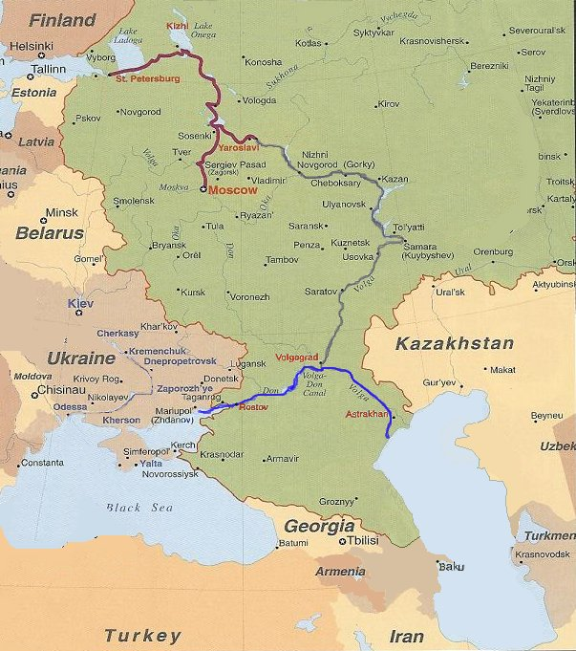

Figure 3-1: Waterways of the Unified Deep Water System (UDWS) that connect the Caspian Sea to the Black Sea, Moscow and the Baltic Sea.

Blue: Volgo-Don Waterway
Grey: Central and Upper Volga Waterway
Red: Volgo-Baltic Waterway and Moscow Canal

BLACK SEA – CASPIAN SEA WATERWAY

The waterway connecting the Mediterranean and Black Sea (BS) to the Caspian Sea (CS) is approximately 1670 km long, and consists of the following sections (see Figure in Summary):
- Sea of Azov (SoA) – the NE part of the Black Sea leading to the Don River mouth
- Azov-Don Sea Canal (ADSC) – the shipping channel providing access to the Don River
- Lower Don (LD) – the western sector of the Volga-Don Waterway (VDW)
- Tsymlyanskoye Water Reservoir (TWR) – a key central part of the VDW
- Volgo-Don Shipping Canal (VDSC) – the canal that links the Don and Volga Rivers
- Lower Volga (LV) – the lower Volga extends from Volgograd past Astrakhan to the Delta.
- Volgo-Caspian Canal (VCC) – the shipping channel enabling navigation through the Volga Delta and adjacent shallow sector of the northern CS to the Astrakhan (Outer) Roads (AR).

The VDW is seasonally closed to navigation during the winter freeze (November - early April) but more year-round navigation is usually available from the Black Sea through the SoA to the Ports of Azov and RoD, and from the Caspian Sea to Astrakhan, by the use of RF ice breakers. Low or medium power ice breakers are used to form temporary channels and lead convoys (‘ice caravans’) during mild to moderate winters but not in severe winters. Full details of the climate, geography, hydrology, navigational and wildlife features of the various sectors of the BS-CS are described in Appendix A (Local Knowledge Report).

The principal ports that have key infrastructure and regulatory roles are Azov, Rostov-on-Don (RoD) and Astrakhan (Figure 3-1). Together with the Ports of Kalach and Volgodonsk they provide pilotage, bunkering, watering, provisioning, waste reception and tugboat services. Ship repair works are at RoD, Volgograd, Kalach and Ust-Donetsk. All these ports play key roles in vessel refuelling, supplies, maintenance and repair, as well as providing onshore and vessel-based port reception services for ship wastes including garbage, sewage, old lubricants and oily bilge waters. The small Port of Olya on the Lower Volga is not a major service port but can arrange for ship’s garbage and oily water reception if given sufficient prior notice.

For vessels lacking masters with local navigational knowledge and experience in accordance with The Sailing Directions for the Don Basin, a pilot is required from the Port of Azov (3168 km) to lock #1 of the VDSC (2588 km). Pilotage is compulsory for any vessel that is:
• rated with a cargo capacity that exceeds 5,500 tonnes;
• engaged in towing or pushing unusual cargos or objects;
• carrying explosive or poisonous substances; or is
• foreign-flagged (including CIS).

NAVIGATIONAL FEATURES OF THE BS-CS WATERWAY

Sea of Azov (SoA)

The shallow SoA occupies 38000 km² and stretches 195 nautical miles (NM) from the Arabatskaya Strelka Spit to the Don River estuary. Offshore depths are typically 10-13 m, reducing to less than 10 m inside the Bay of Taganrog. The elongate Taganrog Bay extends NE for almost 75 NM to the Don River mouth, with depths gradually decreasing to <5 m then less than <3 m at its head. The principal ports of the SoA are Taganrog, Temryuk, Kavkaz, Eisk, Kerch, Berdyansk and Mariupol.

Tidal flows are minimal (several cm only) and totally overshadowed by wind-induced surges in water level. NE to E winds prevail throughout most of the year, with the exception of the June-August summer period when SW to W winds become common. The wind-induced water level fluctuations are most frequent in autumn and winter during periods of strong NE-E winds, with some of the largest and most sudden occurring inside Taganrog Bay.

Sea surface temperatures (SSTs) range from <0°C in January-February to 22-25°C in summer (a time when the inshore shallows can reach 32°C). SSTs decline rapidly from mid-August, reaching 6-10°C by November. Sea surface salinities (SSSs) are very low, but have been rising following the regulation of the Don and Kuban Rivers and associated water diversions for industry and agriculture. SSSs in the SoA presently range from 10-14 ppt in the open water and central parts to 9-10 ppt at the mouth of Taganrog Bay, and to 1-2 ppt at the head of this Bay. Seasonal SSS fluctuations are generally small (~1 ppt changes) except in Taganrog Bay owing to the influence of the Don River.

SoA water clarity is relatively low owing to the mount of suspended silt and plankton, particularly in summer. Clarity in the open sea it is typically 2- 3 m in spring and autumn, falling to 1-2 m in both winter and summer. Suspended particle levels are highest and clarity lowest in the E part of Taganrog Bay (<1 m in spring, late summer/autumn). The water column often turns bright green from phytoplankton blooms (typically most intense in late summer), while brown suspended sediments prevail in winter.

Azov-Don Sea Canal (ADSC)

The ADSC is a 13 NM dredged channel that connects the fairway in Taganrog Bay with the main fairway through the Lower Don delta (the Peschanoye girlo). Present depths in the ADSC permit passages by vessels with a maximum 3.5 m draft.

Pilotage is compulsory, and passages are permitted when visibility is at least 2 NM and winds are less than 15 m/s (54 km/h). To ensure adequate under keel clearance (UKC), vessels with a draft of 3.0 m or more are restricted to a maximum speed of 6 knots, and to 8 knots if their draft is <3.0 m. There is also one section of the ADSC where all vessels must reduce their speed to 3 knots (between light buoys #32 and #52).
Vessels transiting the ADSC in ballast must move to the right edge of the canal when passing ships loaded to the maximum permissible draft, are provided the right of way when flying the ‘Vessel constrained by draft’ signal.

Volga-Don Waterway (VDW)

VDW Overview

The VDW is 596 km long and comprises the Lower Don (LD), the Tsymlyanskoye Water Reservoir (TWR) and the Volgo-Don Shipping Canal (VDSC). The VDW is a major water transport corridor used mostly by River-Sea class dry bulk cargo ships and tankers (see Section 4). Waters in the LD, TWR and VDSC are also used for irrigation and aquaculture.

From W to E, ports along the VDW are located at Azov, RoD, Ust-Donetskiy, Volgodonsk and Kalach. There are also 20 landing stages and wharfs (Appendix A). The average annual navigation period in the VDW is 232 days, with its duration principally controlled by the dates of ice formation and ice clearing in the Bereslavskoye water reservoir.
Fairway dimensions along the VDW lie in the following range:

- Minimum declared depth: 3.3 - 3.6 m (= guaranteed depth)
- Channel width: 38 - 100 m
- Radius of bends: 550 - 1000 m
- Minimum lock width: 17.8 m
- Minimum lock length: 145 m
- Maximum air draft: 14 m

Apart from the fixed lock dimensions and air draft restriction, annual updates to declared channel depths and widths are circulated in Notices to Navigators. Navigation is most influenced by the following features:

- Water level fluctuations in the upstream and downstream pools of the various hydro-engineering complexes.
- Local currents produced in and near locks when their chambers are filled and emptied.
- Foggy days.
- Periods of strong winds and high waves in the TWR.

Fogs during the April-October navigational period are most common in the pre-dam section of the TWR (6% of navigation time; ~15 days per year). The strongest storms and wind waves occur primarily in the SW part of the TWR in autumn, when 25-28 m/s wind speeds (90-100 km/h) can produce wave heights to 3.3 m. The most favourable navigation period are the summer months which have the highest number of clear and windless days.

Lower Don (LD)

The LD forms the 313 km long western part of the VDW, and its main ports are Azov (3168 km) and RoD (3___ km). The shallow LD delta that extends downstream of RoD occupies some 340 km² and has several arms and branches, including the Peschanoye, Svinoye and Kalancha girlos. Upstream of RoD, the single river channel has a variable width (120-1000 m) and depths are typically 6-8 m (but as much as 10-15 m in some stretches).

To maintain the declared (guaranteed) navigational depth, water flow is regulated between the Tsymlyanskiy hydro-engineering (HE) complex of the TWR (at the head of the LD) and a series of three control dams and single-chamber locks located downstream at the Nikolayevskiy HE complex (2931 km), the Konstantinovskiy HE complex (2974 km) and the Kochetovskiy HE complex (3005 km). Below Kochetovskiy the river is unregulated and the navigational depth is maintained by dredging. Fogs in the Lower Don are rare during late spring-summer (<1 day month) but increase during autumn to reach an average of ~11 days per month by November.

Seasonal changes in water level are small. In most years (60%) the spring flow is fully captured by the TWR then subsequently released over summer and autumn. Point discharges from the mouths of the two navigable tributaries located below the TWR (the Severskiy Donets River [2997 km] and Manych River [3085 km]), do not markedly affect LD water levels but can alter local shoaling patterns.

Water currents are generally low, normally less than 1 km/h in the estuary (below stanitsa Starocherkasskaya at 3105 km) and above 1.5 km/h in most reaches, reaching 3.5 km/h rate in some narrow or shoaling areas. The strongest currents (6-7 km/h) typically occur in spring below the Kochetovskiy HE complex.

Wind-induced water level fluctuations (surges) occur from the estuary mouth to RoD and occasionally as far as the Bagayevskiy settlement further upstream (3071 km). Periods of strong SW-W winds in summer can reverse the normal downstream delta current as far as Azov (3168 km), and cause water levels to build up by +2.5 m in the estuary, up to +1.8 m at RoD and +0.6 m at Bagayevskiy (3071 km). Wind-induced water level declines are typically largest (-2 m) during periods of continuous NE winds in October-November.

Ice on the Lower Don ranges from several days to 4 months depending on the severity of the winter freeze. Early winter ice drift normally commences in mid-December and lasts for 11-13 days. The spring break-up usually takes place in mid-March. Ice formations on the Lower Don river sometimes clear enabling renewed navigation for 10-20 day periods.

Tsymlyanskoye Water Reservoir (TWR)

The TWR lies between the LD and VDSC in the middle part of the VDW, and was brought into operation in 1952 (Section 3.3.3.4). The TWR was developed by damming the Don River at the stanitsa Tsymlyanskaya. It provides the major source of water for controlling water levels in both the LD and VDSC via the Tsymlyanskiy HE complex.

Vessels pass the Tsymlyanskiy HE complex via two single-chamber locks and their associated canals, i.e. the approach canal from the LD to lock #15, then a short canal between locks #15 and #14. Vessels approaching the complex from the TWR (i.e. travelling west from the Volga) can stop and take shelter at the avantport located in the upstream pool of lock #14. Earth walls have been built at this site to provide protection from the winds and waves that move across the extensive open waters of the TWR.

The TWR occupies 2081 km² when filled to its designed water level and has a maximum width of 30 km. The fairway across the TWR from Volgodonsk to the VDSC is 181 km. The main fairway crosses the Don floodplain from Volgodonsk to 2752 km, then follows the submerged riverbed of the old Don River from 2752 km to lock #13 (entrance of the VDSC).

The TWR experiences moderately cold winters but hot dry summers (maximum air temperatures in July attain 40°C). Frequent strong winds and associated steep wind-waves frequently interfere with TWR navigation. Calms are rare and gale force winds can persist for several days, with the longest storms typically occurring in the SW part.

Wind speeds are frequently 10 m/s or more (>36 km/h) - both from E and W directions. Wind waves on the TWR reach their full height (>2.5 m) within 1.5-2 hours of strong persistent winds. These steep waves have heights to 3.3 m and relatively short periods (5.3 seconds).

The TWR contains various submerged tributaries, ravines and valleys that form large bays, some of which are used by ships for sheltering during storm periods. The main sheltering anchorages are at Zhukovskoye (2836 km), Krivskoye (2818 km), Nagavskoye (2810 km), and Ilmen-Suvorovskoye (2756 km).

Because the TWR is drained to supply the LD and VDSC over summer–autumn, water levels substantially decrease during the navigation period, forcing vessels to keep strictly to the old riverbed. Water levels also have short term fluctuations due to wind surging, particularly in the narrow upper section (from -0.9 m to +1.4 m during SW and NE winds respectively).

Prevailing currents are wind-induced except between Kalach-on-Don and the Rychkovskiy railway bridge, when flows can exceed 3 km/h when the Tsymlyanskiy HE complex is generating power. Flow under the Rychkovskiy bridge can reach 7.2 km/h when gale force NE winds (>72 km/h) coincide with a flood.

Ice formation in the TWR begins in eastern bays and shallows and gradually expands westward. Average duration of the ice-free navigation across the TWR is 241 days.

Volgo-Don Shipping Canal (VDSC)

The VDSC is a key component of the UDWS. Together with the TWR it was brought into operation in 1952 to permit uninterrupted shipping traffic between the Mediterranean-BS and the CS, Baltic Sea and White Sea (Figure 3-1).

The 92 km long VDSC connects the TWR (old Don River) from a point 10 km downstream from Kalach-on-Don, to the Volga River, at a point 47 km downstream from the Volgograd HE complex. Reservoir pools form almost 50% (45 km) of the total VDSC length.

The western and eastern sectors of the VDSC comprise inclined, locked sections that link its elevated central basin. From W to E the three sectors are the 45 km long Donskoy ‘declivity’, the 26 km ‘central divide’, and the 21 km long Volzhskiy ‘declivity’. Vessels must negotiate 13 single-chamber locks during their VDSC transit (i.e. from locks #13 to #1, going W to E).

The first 6-km of the Donskoy declivity (from the TWR to lock #13) is edged by dam walls. The Donskoy declivity has four locks (#13 - #10) and two water reservoirs: the Karpovskoye pool (between locks #12 and #11) and the Bereslavskoye pool (between locks #11 and #10).

The 26 km central dividing basin is located between locks #10 and #9. Its water level is 88 m above the Volga River and 38-43 m above the Don River, depending on the precise TWR level. For a distance of 17 km above lock #10 the central waterway runs through the Varvarovskoye reservoir. The next 9 km to lock #9 comprises an artificial recess where depths attain ~16 m. Water level in the central basin is maintained by three pumping stations which transfer water from the TWR. Local runoff provides a minor contribution.

The Volzhskiy declivity has nine almost equal locks (#9 to #1), with the section between locks #4 and #9 forming a series of small lake-like basins (1-2.5 km long; 0.5-1.3 km wide).

Under strong prevailing NE winds, wind wave heights in the Karpovskoye reservoir can reach 2.5 m, and up to 1.8 m and 1.5 m in the Varvarovskoye and Bereslavskoye reservoirs respectively. However unlike the exposed TWR, the number of strong wind/high wave days in the VDSC during April-October is low (6 days versus an average of 53 calm days over the same period). Fog mainly occurs in autumn (~18 days) but usually disappears by mid-day. VDSC water levels are highest in the spring and then are held stable over the summer-autumn period, until power generation arrangements are started that decrease the VDSC level during November.

Lower Volga (LV)

The 534 km long LV extends from the Volgograd HE complex and nearby Volzhskiy power plant, past the entrance to the VDSC (47 km downstream) and Astrakhan () to the Krasnye Barrikady settlement. The main LV ports are at Volzhskiy, Volgograd, Akhtubinsk and Astrakhan, while the largest landing stations are at Chyorniy Yar and Nikolskoye. Volgograd and Astrakhan provide the main fuel and lubrication bunkering points, as well as other provisioning, maintenance and waste reception services. Comprehensive ship repair services are available in many yards located at Volzhskiy, Krasnoarmeisk, Akhtubinsk and Astrakhan.

The LV experiences hot summers and cold winters. The average duration of ice-free navigation in the Volgograd region is 224 days, rising to 260 days close to Astrakhan. The most common winds are from the W and NW (12-15%) and from the E and SE (13-18%). Fogs are rare in summer and most frequent in autumn (2-4 days in October and 5-6 days in November).

The LV riverbed is unstable and sinuous, forming numerous branches (eriks). During low water periods the maximum width of the LV channel is 2.8 km and its minimum width is 300 m. The LV flood plain contains many islands that are dissected by channel arms called volozhkas. Both the LV and CS are below ocean sea level. Pilotage is compulsory unless vessel masters/navigators have appropriate documents confirming their knowledge of the LV in accordance with the Sailing Regulations for the Volga Basin.

During mid-April – June flood, the LV water level increases by ~8.0 m in the Volgograd area and by ~5 m in the Astrakhan area. The end of the spring flood is marked by a rapid, sharp decline in the water level, usually within 7-10 days and always by 20 days even in exceptional years. Daily water level fluctuations (up to 2.0 m) occur below the Volgograd HE complex due to the power generation needs of the Volzhskiy plant, and these are felt along the 85 km downstream pool that runs from the Volgograd dam to the Popovitskiye river shoals.

Compared to the VDW, the declared fairway dimensions of the LV alter less over time (the present soundings were taken in 2001). The main dimensions of the LV are summarised in Table 3-1 (see Appendix A for details). The most restrictive dimensions occur downstream of the VDSC at the Korshevitaya volozhka and Saralevskiye river shoals (2640-2661 km).

Table 3-1: Principal Dimensions of the Lower Volga Waterway
Fairway Sector | Length | Min. Depth | Breadth | Bend radius | Gauge station
Volgograd HE complex - Akhtubinsk  (2530 - 2724 km) | 194 km | 3.8 m | 100 m | 1200 m | Volgograd
(Approach channel to VDSC: 2577 km) | 4 km | 3.8 m | 60 m | 800 m | Volgograd
Akhtubinsk - Seroglazovka  (2724 - 2935 km) | 211 km | 3.8 m | 100 m | 1200 m | Chyorniy Yar
Seroglazovka – Rassvet  (2935 - 3013 km) | 78 km | 3.8 m | 100 m | 1200 m | Astrakhan
Rassvet – Astrakhan - Bertyul  (3013 – 3045 - 3063 km) | 50 km | 3.8 m | 150 m | 1200 m | Astrakhan

Maximum air draft along the LV is dictated by the lowest bridge which is at Astrakhan (3045 km; 18.1 m above design water level). The lowest power line crossing is near the Volgograd HE complex (2531 km; 22.7 m above maximum water level).

Volgo-Caspian Canal (VCC)

The VCC starts at the Krasniye Barrikady settlement and is the key 188 km waterway that connects the LV with the Astrakhan Roads (AR) in the northern CS. It has an 83 km delta section and a 105 km seaward section. The kilometre marks are counted upward in a seaward direction from Krasniye Barrikady.

Minimum depths along the VCC are maintained by dredging, and there is year-round navigation. Because of the VCC’s shallowness and numerous shoals, there is compulsory pilotage between the Port of Astrakhan and the AR.

The 83 km delta section has several bends as it follows the sinuous Bakhtemir arm, which is one of the longest and deepest arms in the delta. Minimum declared depth in this fairway is 4.8 m. There are many settlements along the Bakhtemir, including the small Port of Olya (45° 47’ N; 47° 32’ E), Fyodorovka, Trudfront, Sergievka, Yamnoye, Mayachnoye, Ikryanoye, Bakhtemir and finally Krasniye Barrikady.

The 105 km seaward part of the VCC is dredged through the very shallow N part of the CS, passing Iskusstvenniy Island and making four bends before ending at the AR. The width of the dredged seaward channel is 80 m and its minimum declared (guaranteed) depth is 3.3 m.

There are four bends in the seaward channel. Vessels heading N from the CS to Astrakhan enter the VCC at light buoys #1 and #2, then adopt a 355° heading for 27 NM (until 44° 55.5’ N; 47° 44.5’ E). Vessels then alter course to 347° for 10.1 NM until reaching parallel 45° 05.35’ N, where they turn to 13° for a further 18.7 NM. The final course alteration to 349° is made near Iskusstvenniy Island (45°24’N; 47°47’E), and this heading is kept for 18 NM until the entrance to the Bakhtemir arm.

The Port of Olya is on the E bank of the Bakhtemir arm, and it contains State Port Control Inspectorate, Coast Guard, Customs and Sanitary Division services. There are a range of privatised vessel service and suppliers, Total quayside length is 500 m and there are three berths dredged to 5.0 m. The Bakhtemir arm is 300-400 m wide near Olya but almost constant dredging is required to maintain the 100 m wide navigation channel.

Port facilities and equipment. Loading and discharging works are mechanised in the port. There are gantry cranes, frame cranes, lift trucks and trailers. Tug boats and launches are available for servicing the vessels. Small repairs of ship hulls, machinery and cordage can be carried out. Fuel and water bunkering is available.

Astrakhan Roads (AR)

The AR are located 40 NM S of the Volga Delta at 44° 40’ N; 48° 00’ E, and they occupy a large part of the NW portion of the CS. The S boundary is delimited by Parallel 44° 30’N.

Depth in the AR gradually shoals from 6-9 m in the S, to 5-6 m in the middle and 3-5 m in the N. The boundaries of the navigable AR vary according to wind surge affecting sea level height and the locations of shoals. The N boundary of the Roads shares the same Parallel that marks the entrance of the VCC (44° 40’ N), but this boundary has been slowly shifting southward as a result of seafloor shallowing from gradual sedimentation. The W side of the AR is delimited by the Tyulenya bank, and the E side is delimited by the Bolshaya Zhemchuzhnaya and Srednyaya Zhemchzhnaya banks.

The seafloor in the AR is not homogeneous, changing from sand and shell in the S and middle parts to silts, hard clay or mud and shell in the N part. Winds in the AR are most consistent and strongest from the E and SE, but storms in summer are rare. Gale-force winds are most frequent from the E-SE, but on occasion they can also occur from the W or NW. Periods of consistent NW winds generate a sea level decline in the AR by as much as 2.5 m. Fogs are most common in autumn. Ice usually covers the AR from the first half of December to the beginning of March, but this does not close navigation.

CASPIAN SEA (CS)

Physical Features of the CS

The CS has no natural connection with the World’s Oceans and therefore is technically not a Sea, but forms the largest lake in the world (630 x 175 NM). However the Caspian has been called a Sea since ancient times because of its considerable size, plus the depth range and salinity regimes in its central and southern regions.

The CS is often divided into three regions or parts (N, Middle, S) for descriptive, hydrological and geographical convenience. The N part extends to the line between Chechen Island and Cape Tyub-Karagan, while the Middle and S parts are divided by the line between the Lyebyezhiy Kamen and Cape Kuuli. Only the N part is addressed in this section (a figure and details for all parts are shown in Appendix A).

The N part annually freezes, beginning in November in the shallowest areas and normally well underway by the end of December. Maximum ice development occurs in February. Break-up beings in mid-March and the CS is clear of all ice by late April. Winter water temperatures in the N part remain close to -0.5°C, while the average summer maxima is close to 24°C (range 18-26°C). Warmer temperatures can occur along sheltered shoreline areas.

The N part is very shallow, having a mean depth of ~6 m (range 0-23 m). It has unique basin features dominated by river inputs that have formed its numerous shoals and banks (dominated by beds of soft shelly silts, particularly in the pro-delta areas). By contrast, the Middle and South parts of the CS contain deep (>700 m) depressions, have little river input, are warmer and more salty. and contain more sandy sediments in the shallow inshore areas.

The prevailing wind regime across both the inshore and offshore waters of the N part is from the E and SE (up to 60% of the time in some months). N-NW-W winds are the next common, blowing up to 30% of the time in some months. Overall average annual wind speeds in the N part are 3-6 m/s (11-22 km/h) and calms are uncommon.. Winds are typically strongest from October to May, with wind speeds above 15m/s (55 km/h) most common between March and May (3-4 days per month). Wind wave development in the N part is restricted by the shallow water effect, with 2-4 m wave heights present for 10-30 % of the time, depending on the particular month. Wave heights do not generally exceed 4 m, and maximal heights in the N part of the CS (8 m) are restricted to its deepest SW area.

Water level fluctuations in the CS occur on a day-by-day basis, a seasonal basis, and a decadal basis. Daily changes due to wind surges are largest in the shallow N part (3 - 4.5 m above mean water level [MWL]) and typically last for 10-12 h (occasionally 24 h and rarely 48 h). Seasonal changes to MWL are caused by spring river inflow (producing 0.3- 1.0 m increases in June-August) versus subsequent evaporation (levels decline below MWL in December-February). ‘Decadal’ fluctuations (>10 years) result from long term variations in rainfall patterns and diversion of freshwater inflow for irrigation and industrial schemes.

Sea surface salinities (SSS) in the N part vary from <0.05 PSU in the deltas to 13 PSU along its southern boundary, with average values lying between 5-10 PSU (salinity in the Middle and S parts of the CS is mostly 10-14 PSU). Salinity variations in the N part occur seasonally as a result of spring/summer river flows (1-2 PSU decline), and by wind-induced surges that cause more marked but short-term changes (as much as 5-8 PSU). Surge produced by E-SE winds generally increases PSU, while NW-N winds generally decrease PSU.

Turbidity in the shallow N part is consistently high, particularly near the Volga Delta (0.1 m transparency is common). Water clarity gradually extends to ~1 m only with substantially increased depth and distance from the delta and coastline. Water colour is often yellow-brown but changes to yellow-green (olive) or greenish during periods of phytoplankton growth between spring and autumn.

Biological and Aquatic Invasion Features of the CS

The ancient and modern wildlife, benthos and fishery resources of the CS have major ecosystem, conservation/heritage and economic values that merit protection (e.g. the kilka, shellfish and sturgeon fisheries and aquaculture).

However the CS remains highly susceptible to ship-mediated bioinvasions which, unlike oil, do not weather or can be cleaned-up by man or nature. Ongoing climate change, river regulation, nutrient inputs and sedimentation, plus invader trophic effects from recent bioinvasions, will continue to favour if not enhance the susceptibility of the CS to further invasion, particularly via the VDW (e.g. Gomoiu et al 2002, Aladin et al 2002).

The CS also has proven potential to export invasive Ponto-Caspian species to the Baltic region, since present evidence shows that the Baltic Sea, including the adjacent lagoon and waterways of north Europe, has been more susceptible to receiving invasive species that are native (or adapted) to the Ponto-Caspian region, than vice versa (Figure 3-2; see e.g. Bij de Vaate et al 2002, Jazdzewski & Konopacka 2002, Leppäkoski et al 2002, Nehring 2002, Ojaveer et al 2002, Slynko et al 2002).

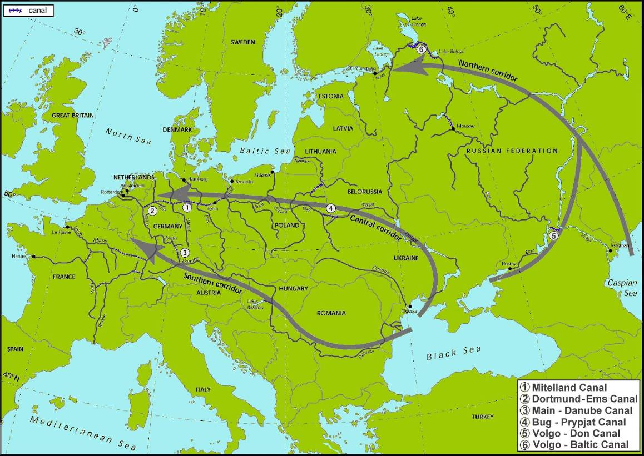

Figure 3-2: Canal-mediated bioinvasions of Ponto-Caspian aquatic species to Baltic and Western Europe regions (based on Bij de Vaate et al, 2002).

Therefore, current invasion research data indicate that, depending on future trends in shipping trade and associated BW movements versus the amount of effective BW management that is applied to these movements, the CS will remain prone to:
- being further invaded from the ‘west’ via the Black Sea salinity ‘transition’ zone and BW movements across the VDW;
- ‘donating’ further invasive species to the Baltic region via the Volgo-Baltic waterway.

In this context, complete (>95%) or incomplete (<95%) BW exchanges undertaken in the shallow waters of the northern CS will not be an effective measure to prevent northward (or westward) ballast -mediated species transfers.

These and other CS features that will influence the choice of affordable, practicable BW management options are addressed in the following concluding sub-section to Section 3.

WATERWAY FEATURES INFLUENCING BW MANAGEMENT OPTIONS

The purpose of Section 3 has been to provide a desk-top review and understanding of the main features of the BS-CS waterway, so as to help identify:
- Where, why and when ballasting operations are undertaken;
- What features along the BS-CS route may reduce or enhance the effectiveness of particular BW management and treatment technology options; and
- Which points along the BS-CS waterway can provide biologically effective as well as practicable sites for a BW reception/treatment facility.

With these questions in mind, the following features of the BS-CS Waterway are significant:
(W1) Susceptibility of CS to further ship-mediated bioinvasion: The CS remains susceptible to aquatic species that become adapted to (or are native) to low salinity environments in the Black Sea region. Species that invade and adapt to the BS spread, including into the SoA. Those that can complete their entire lifecycle in freshwater can colonise Taganrog Bay and the Lower Don. Thus the principal BW pathway of concern remains, for the projected future, from west to east, via the Sea of Azov/Lower Don and the VDW. In terms of ‘donating’ species, the CS is part of the Ponto-Caspian with species that have invaded the Baltic region.
(W2) Locks between the LD-TWR form the boundary between BS and CS catchments: The TWR provides the main supply of water which maintains levels in the VDSC before subsequently entering the Lower Volga at the canal’s junction near Volgograd. The locks between the Lower Don and TWR (near Volgodonsk) therefore form the barrier that inhibits self-spread of freshwater-tolerant species from the SoA/Lower Don into the Volga catchment (and thence to the northern CS). To prevent ballast-mediated transfer of unwanted fresh- or brackish-tolerant species to LV and CS from or beyond the BS, only managed BW should be allowed to be carried past these locks, i.e. BW that is ≥95% deepwater exchanged or preferably treated, including tank sediments.
(W3) Weather and wind-wave conditions on the Tsymlyanskoye Water Reservoir (TWR): The large TWR forms the middle sector of the VDW where strong winds and relatively high wind-waves can lead to undue (and unsafe) propeller emersion, reduced steering and windage problems to river vessels that are transiting partly loaded or in light ballast. Vessel control can be maintained by temporarily adding more BW, but its mixing with any untreated BW (including un-pumpable water or sediment) then subsequent discharge (to negotiate locks and other waterway features of the VDSC and LV provides a pathway for freshwater tolerant species.
(W4) Uniform Brackish-Freshwater Salinity Regime: There is little difference in the low salinity regimes that are present in the BS, CS and their respective approaches to the VDW (i.e. the SoA/ADSC/LD and the AR/VCC/LV). This precludes the use of freshwater ballast as a method for killing euryhaline biota (organisms tolerant to brackish waters). However it raises the possibility of using brine to kill ballasted biota that is adapted and/or acclimated to low salinity regimes. For example, rapidly increasing BW salinity from 1-10 PSU levels to 35-40 PSU produces massive osmotic shock (OS) (the pros and cons of salinity treatment are addressed in Section 5).
(W5) Shallow but unprotected approaches to the VDW: Both the western (SoA) and eastern (CS/AR) approaches to the BS-CS waterway involve long traverses across relatively shallow (<10 m) yet unprotected seaways with gradually shoaling ground. These approaches are frequently exposed to strong winds and relatively steep wind-wave conditions, i.e. in both the Bay of Taganrog and in the Astrakhan (Outer) Roads (AR). Undertaking ballasting operations, such as lightening up or exchanging in preparation for the transit, can be difficult, incomplete or readily abandoned as it is important for ships to minimise windage and maintain adequate vessel control (propulsion, steerage and stability) - particularly when particular courses must be held to safely approach then enter the narrow ADSC and VCC dredged channels. The biological effectiveness of exchanging BW in these shallow approach areas is very limited, in terms of removing unwanted biota.
(W6) Shallow water depths and high turbidity: Shallow depths (= small underkeel clearances) and high turbidity levels occur throughout the approaches and much of the of the BS-CS waterway, as a result of wind-waves, spring floods and associated silt shoals and bank. These can be expected to regularly enhance sediment uptake and accumulation within ballast tanks - particularly in peak turbidity periods of rough weather and throughout the spring flood period . High levels of suspended sediments in the BW flow presents a challenge to treatment methods that rely on compact mechanical filtration, membrane filtration (RO) and/or ultraviolet (UV) units. If the organic content of the suspended sediments is high, the heavily turbid flow will also have a high chemical oxidant demand (COD) that can reduce the efficacy of treatments that use active oxidising substances (i.e. doses of chemical oxidants added to BW by direct injection or via electrolysis).
(W7) Low levels of halide ions (Cl⁻, Br⁻, I⁻): The low salinity and virtually freshwater regimes in the SoA, ADSC, LD, VDW, LV, VCC and AR prevent efficient use of BW treatment systems that use electrolysis to produce OBr’, OCl’ and associated active substances. The peculiar ionic content of the CS (relatively low Na⁺ Cl⁻ content versus very high SO₄²⁻ [25% of total], Ca²⁺ and CO₃²⁻ content; e.g. Jazdzewski & Konopacka 2002) may also adversely influence the generation of appropriate levels of electrolytic products, by-products or long-lived residuals.
(W8) Seasonal ice formation / ice clearance: At the start and end of the winter freeze, ice breakers or tugs escort convoys of ships into or through the VDW. Any springtime or autumn ‘rush’ of shipping activity may also cause small ‘clusters’ of ships. The possible occurrence of groups of ships during spring or late autumn has design implications for any land-based BW reception/treatment facility.

SHIPPING ACTIVITY AND BALLAST WATER MOVEMENTS

OVERVIEW OF Present WATERWAY Trade and SHIP Types

This overview borrows from information in Appendix B, local knowledge materials and vessel details and photos maintained at the Russian Maritime Shipping Register (www.rs-head.spb.ru/en/index_en.htm) and on various ‘ship-finder’ databases (Lloyds Register, Fairplay, www.riverships.ru), and shipping company websites.

About 5500 km of the present 6300 km UDWS has minimum rated depths of ~3.5 m or more. The present trading fleet includes a range of ‘River-Sea’ classed general cargo ships (dry bulk, break-bulk, mixed bulk/container and some reefer types), tankers (product oil, chemical, vegetable oil), and a small number of oil-bulk-ore ships (OBOs).

River-Sea classed ships are purpose built for trading on protected coastal and short sea routes, with dual displacement tonnages and ballasting capacities for sailing at sea drafts (3.5-4.5 m) or UDWS drafts (<3.6 m). Hull dimensions and other specifications of modern River-Sea classed general cargo ships and tankers that are shown in Plates 1-3 are listed in Table 4-1.

Table 4-1: Specifications of recently built River-Sea trading ships (Plates 1-3)

Type  Specification | Rusich 1 - 6  ( P00101) Type | Heydar Aliyev / Palmali Voyager Type | Armada Leader /  Armada Trader Type
Type | Dry bulk / container | Dry bulk / container | Product tanker
Dates of Build | 2004-2006 | 2003-2006 | 2002-2006
Length overall (m) | 128.2 | 139.6 | 138.7
Maximum width (m) | 16.7 | 16.5 | 16.5
River/Sea drafts (m) | 3.6 / 4.34 | 3.6 / 4.6 | 3.6 / 4.3
River/Sea DWT (tonnes) | 3 855 / 5 485 | 3760 / 6 970 | 4 530 / 6 477
River/Sea BW capacities (m³) | ~2500* / 3778 | ~2500* / 3148 | ~2770* / 3465
Cargo capacity (m³) | 8 090 | 11 400 | 7 221 (6T); 7 471 total
Speed (knots) | 11.0 | 10.5 | 10.4
Accommodation/crew | 12/ | 14 / 9 | 12 / 9
Propulsion | Twin screw | Twin azimuth thrusters | Twin azimuth thrusters
Built | Navashino | Volgograd | Selah (Turkey)
Design | Vympel (Novgorod) | MEB (Odessa) | MEB (Odessa)
* River BW capacity estimated from 2006 BWRF records of same or similar vessels (Section 4.6)

Most trading vessels using the VDW in 2006 are River-Sea cargo ships and tankers of various types and age (see Plates 1-8 and Appendix B, which show examples of most ship types that submitted BWRFs in 2006). Most share similar basic dimensions to conform with IWW navigation, but the more modern types tend to have taller moulded depth (= higher ‘topside’) than Soviet-era designs and are more manoeuvrable. Vessels with River-Sea class designations (there are several types related to wave regime, distance from nearest coastline and port of refuge) are being designed, built and equipped to operate across European waterways, coastal waters and enclosed seas (Mediterranean, Caspian, Baltic etc), with guidance from the Russian Maritime Register of Shipping (http://www.rs-head.spb.ru/).

In the case of the Rusich and Palmali Voyager types (Plates 1,2), these were built at Navashino and Volgograd shipyards between 2003 and 2006 in collaboration with the RMRS (Class КМ(*) ЛУ1[1] II.А1) and represent contemporary double-side/double bottom mixed-cargo (dry bulk/container) types. Designed to handle timber, grain and other bulk cargo as well as TEU containers, they are among the largest cargo ships in the current fleet.

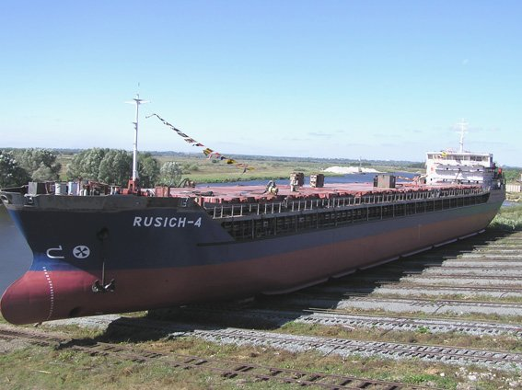

Plate 1: River-Sea mixed cargo ship Rusich-4 built 2002/3 and operated by the
Volga Shipping Company (photo: Volga Shipping Co)

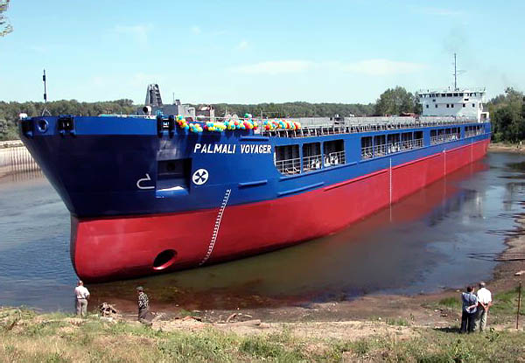

Plate 2: River-Sea mixed cargo ship Palmali Voyager at completion at Volgograd
in September 2004 (photo: Dmitriy Shalaev)

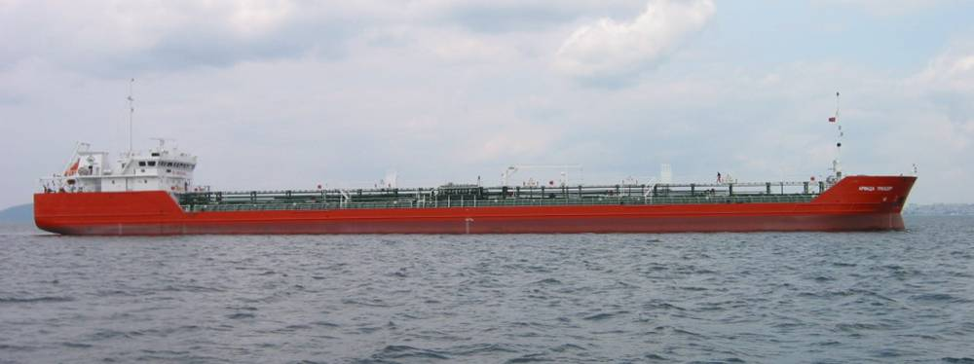

Plate 3: River-Sea tanker Armada Trader in Marmara Sea, June 2004 (Volvo photo)

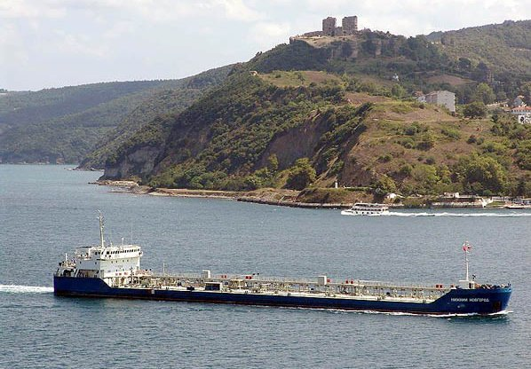

Plate 4: River-Sea tanker Nizhniy Novgorod at the Bosporus in 2005 (photo: Dmitriy Shalaev)

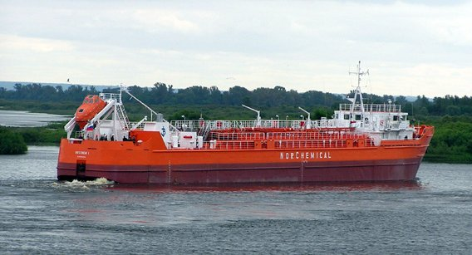

Plate 5: River-Sea MEG tanker Roskem-1 (converted in 2004; VSC photo)

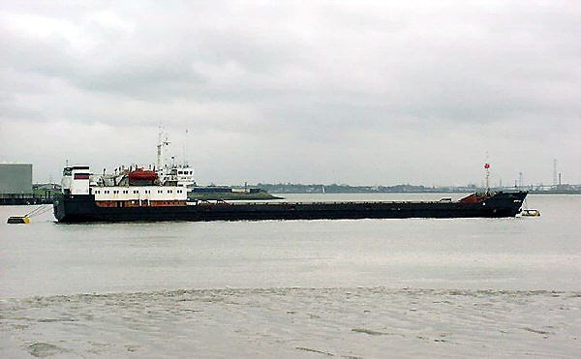

Plate 6: River-Sea cargo ship Amur 2531 (sister of1988/89 built Amur 2137 and Amur 2158 which submitted BWRFs) in the Thames River Estuary in 2001 (photo: Dimitry Shalaev)

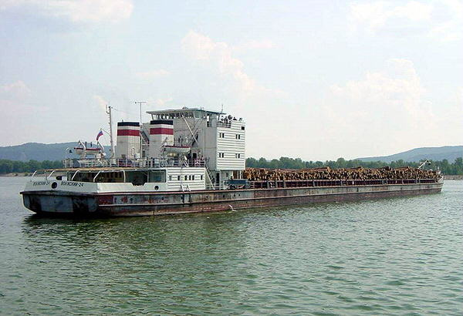

Plate 7: Volzhskiy-24 carrying logs near Rostov-on-Don - another example of one of the many Soviet-era ships built in the 1970s-1980s (see Appendix B) (photo: Dimitry Shalaev).

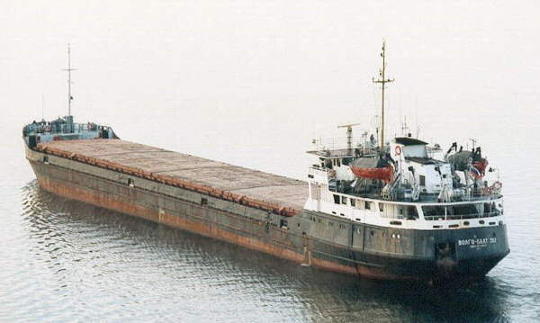

Plate 8: VolgoBalt 202 - example of another numerous but aging Soviet-era type in the IWW fleet that participated in the BW recording exercise of 2006 (photo: Dimitry Shalaev)

Apart from the trading ships there is a range of tugs (most of the pusher type; Plate 9), plus ice breakers, non self-propelled barges, dredges and numerous passenger ferries. The present passenger fleet is dominated by small displacement ferries and hydrofoils, plus some excursion/entertainment ships and other three- and four-decker liners, most of which service the Moscow – NW Russia – St. Petersburg cruising and tourism markets.

While the vast majority of passenger types do not require BW, the larger ships operating cruise services and the longer routes to the south of Moscow and Novgorod (e.g. Afanasiy Nikitin, Ivan Kulibin, Oktyabrskaya Revolutsia; Appendix B) may occasionally require trim adjustments to compensate for fuel usage, stores and small quantities of cargo. It is unclear how many of the three- or four-decker types have (or use) trim tanks which are externally or internally connected (i.e. for uptaking / discharging external river water or for transferring ‘internal’ water between tanks). Similarly, some of the ice breakers, dredges and larger types of pusher-tug may use trim tanks for achieving minor trim and draft adjustments.

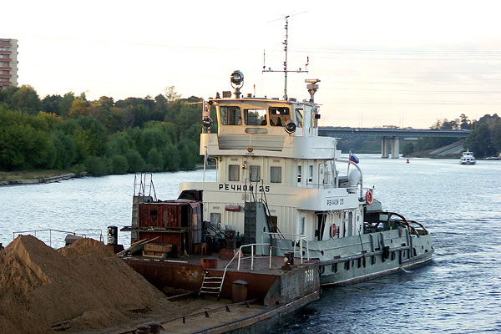
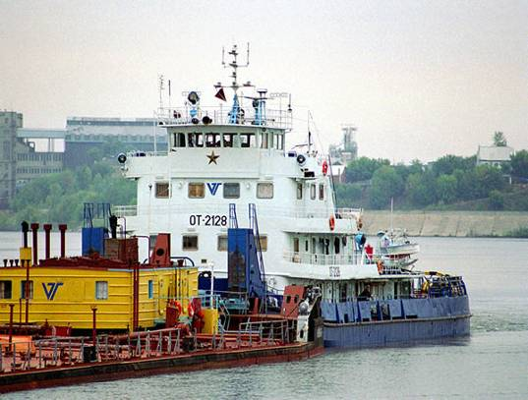

Plate 9: Examples of the numerous large (OT type) and medium (Rechnoy type) pusher tugs that manage dry and liquid cargo barges along the UDWS (photos: Dimitry Shalaev)
Assessing the possible role played by working vessels and the larger displacement passenger ships in moving BW and aquatic organisms to or from the CS is beyond the scope of the present study. However it is worth noting that most cruising routes and long distance passenger services are focussed on the St Petersburg, Moscow, Lake Ladoga and possibly the Upper and Central Volga regions (i.e. most use the Volgo-Baltic Waterway [VBW] and Moskva Canal, rather than operating to the VDW, Lower Don and Lower Volga).

Much of the existing fleet are Soviet-era vessels which are now 20-30 years old (Plates 5-8, see also Appendix B). Of the ~2200 registered units, approximately 50% are not in operation and/or are out of date (Appendix B). The more modern of the River-Sea types that meet international class rules, MARPOL regulations and SOLAS requirements etc, hold the prominent position. During the 1990s post-perestroika depression, most of the larger shipping entities avoided closure by using their best River-Sea vessels to provide non-stop services from RF river ports to European sea ports. Internationally-plying River-Sea ships are more expensive to maintain but are commercially attractive, as they can leave the UDWS to operate year round, thus avoiding the long winter freeze-up that stops domestically-oriented vessels. Following the post-1998 growth in international trade, the number and average size of the River-Sea vessels have been increasing, and they are reported to have carried over 30 million tons of cargo in 2004 (Kormishov 2005). On the other hand, it is also reported that nearly 75% of all domestic and international cargo transported on the IWW is being carried by the current operable RF cargo fleet, which is close to its full utilisation (Appendix B).

In summary, the present cargo fleet using the UDWS is moving towards more internationally-capable River-Sea classes that depart IWW in winter to obtain year-round trade. However much of the fleet consists of the 1960s-1980s types, now facing the end of their commercial life. Whether modern or old, trading ships built for the IWW are designed to maximise cargo-carrying capacity within the hull size and draft constraints imposed by the UDWS. Thus four features of the present (and near future) cargo fleet will influence BW management options:
(S-1) Age range: The wide range in vessel age (1960s-2006) and types will influence choices and decisions regarding type and cost of modifications for improved BW management.
(S-2) Size/location of ‘free’ space: The size of convenient internal spaces (i.e. in the motor room or other accessible compartments near ballasting pumps) may be limited - particularly in the more shallow-drafted older classes compared to sea-going vessels and modern River-Sea types that typically have taller moulded depth.
(S-3) Space premium: Irrespective of age, any space that is made available for increased electricity generation, pumps and pipework will command a relatively high premium in hulls that conform to the dimensions of the UDWS.
(S-4) Regular presence of small UKC: Compared to open sea routes, the shallow water depths in the UDWS, SoA, AR and northern CS can readily enhance the entrainment of suspended silts and mud when a ship ballasts during or after cargo unloading, when making trim/draft adjustments along a route, or when making a BW exchange requirement in the turbid shallow approaches to these waterways (Section 3; addressed further in Section 4.3).

Collation of Shipping Activity and BW Movement Data

A key objective of the activity has been to collate and review data on the present frequency and types of shipping activity that involve BW movements to and from the Caspian Sea (CS).

To facilitate this task, a bi-lingual BW Record Form (BWRF) was collaboratively developed by the IMO consultants for distributing to ships that visited Astrakhan on their way to or from ports in the Sea of Azov, Black Sea, Sea of Marmara or the Mediterranean via the VDW.

The BWRF was based on the IMO BWRF, which identifies the origin and ultimate destination of BW carried in each ballast tank and/or empty cargo compartment, plus the location of any BW exchange. To allow ships’ officers to conveniently record the type, volume and reason of any ballasting activity that was undertaken along the waterway for any purpose, the BWRF modified and expanded compared to the standard BWRF. As shown in Appendix C, the BWRF uses Russian local terms that are familiar to ships’ officers.

A guidance document, in the form a BWRF Information Sheet, was also developed and translated into Russian (Appendix C). This sheet explained the purpose of the BW recording exercise to ship’s officers, and how they should complete the BWRF and return it to the Port of Astrakhan after completing a transit (Appendix C shows the Russian and English versions).

To maximise understanding and accurate completions of the BWRFs, the BWRF and its guidance sheet were also distributed to shipping agents and shipping operators, some during specific briefing meetings and interviews at Astrakhan.

Delivery of the BWRF and guidance documents to vessels passing the Port of Astrakhan commenced in early August 2006 (this captured details of some voyages which had commenced in May/June 2006). With a few exceptions, all BWRFs that were returned to Astrakhan by 30 September 2006 were added to a database that was used for the analysis for this report (Section 4.6).

To help build the database quickly, a customised Excel file was developed for use at Astrakhan. The file contains a Data Entry Sheet which looks the same as a BWRF. The Excel file also contained a ‘Data Entry Macro’. This automatically copied all details entered for a particular ‘case’ (= voyage) into a separate Database Sheet, then automatically cleared the Data Entry Sheet, making it ready to receive new BWRF details for another case (voyage).

All BWRFs were checked during computer entry at Astrakhan, in an effort to detect and fix accidental mistakes and errors. Subsequent analysis of the collated BWRF data was undertaken during October 2006, using a copy of the Excel Database file.

Results of the analysis are presented in Section 4.6, following a description of present day BW management requirements and practises (Section 4.3) and an overview of BW movements to/from the Astrakhan and Caspian ports via the East/West (VDW) and North/South (VBW) route (Section 4.5).

Current BW Management Requirements and PractiCe

To ensure safe under keel clearance (UKC) and air draft, the design dimensions of the UDWS restrict vessel loaded drafts to about 3.5 m (depending on sector, season and precise water level). Present guaranteed water levels along the VDW (3.4 – 3.5 m) and in the shoaling prone sector of the VCC (3.3 m) cause passages to be made at less than full cargo capacity. Loaded vessels may also suffer delays in the ADSC and VCC sectors until favourable winds and surge-induced water levels return (Section 3).

All River-Sea vessels can achieve a ≤14 m air draft when their mast/s are lowered, even when ‘riding high’ in ballast. However there may be the odd occasion along a waterway when the air draft of a tall empty vessel needs to be reduced by BW intake (e.g. to pass a bridge under repairs, or a power line that is undergoing assembly, replacement or repair). In other words, it is unwise to absolutely discount the need for a vessel to make an air-draft adjustment.

When approaching the ADSC from the SoA, vessels in ballast are currently required to have completed a BW exchange no closer than 14 km from the ADSC entrance, as per the order of the Head of the State Control Division of the Azov Specialised Maritime Inspectorate (Appendix A). Similarly, when approaching the VCC from the CS, vessels in ballast are requested to complete their BW exchange along the Outer AR, in accordance with the By-Laws of the Maritime Merchant Ports of Astrakhan and Olya (Appendix A). The designated area for BW exchange in the AR terminates before the entrance to the VCC (44° 45’8 N; 47° 45’6 E). Vessels which are unable to exchange in the prescribed area are required to discharge it into an onshore reception facility or specialised vessel at the Port of Astrakhan.

BW exchanges made in the above regions follow the simple empty/refill method, in which each ballast tank (or ballast tank pair) is emptied then refilled in turn when the vessel is underway (anchoring exclusively for this purpose causes delays that are unacceptable to the ship owners; Appendix A). A complete exchange can be expected to take River-Sea vessels some 12-20 hours to complete, because a full BW uptake or discharge takes some 6-9 hours (depending on the size and condition of the pump/s, weather and other factors).

Because some un-pumpable ballast water remains in the bottom of each tank, the empty/refill method does not achieve a 100% exchange (the amount of this ‘dead’ water, together with sediment, is typically 1 to 1.5 tonnes per tank; Appendix A). Poor weather and/or difficult navigational conditions may further limit or prevent a BW exchange. Under these circumstances, captains may make a log book entry noting the problem that was experienced in the planned BW exchange area.

Log book records of cargo vessels transiting the BS-CS waterway are routinely checked by State Port Control Inspectorates (PCOs) to check if and where BW exchanges are made. However no physical checks of BW salinity, turbidity or biotic content are undertaken (Appendix A). Port Sanitary Inspectors have the authority to take BW samples to determine physical characteristics and bacteriological status, but this is done only if particular attention has been raised (e.g. unusual colour, a crew illness, a reported epidemic in previous port, etc).
The present west-oriented trade from the CS to BS/Mediterranean regions means that many vessels make eastward voyages with BW on board. Apart from oil products exported to SoA, BS or Mediterranean ports, this trade includes scrap metal from Turkmenbashy (Port of Krassnovodsk). Voyages made in ballast to the west are fewer. Some occur after a ship (or group of ships) have delivered heavy equipment and materials for an oil installation in the CS, and subsequently depart in ballast for their return transit to the Mediterranean/Black Sea.
Regular checks of ships’ documents (log book, ballast record books, etc) in RF ports indicate that BW operations along the LV and VDW are rarely performed by vessels using this route (Appendix A). In most cases empty vessels must carry BW throughout their voyage and, according to checks of ships’ documents, it is rare to see a note that a ballasting operation was undertaken for a navigational purpose (e.g. better stability, need to decrease air-draft, etc).
The log book entries also indicate that ships do not violate RF regulations concerning BW operations. However in private discussions that took place during the 2006 study in Astrakhan, some captains on the condition of confidentiality admitted they do not actually exchange BW in the specified areas (i.e. before entering the ADSC from SoA, or the VCC from AR). They also sometimes uptake or discharge certain amounts of BW while sailing in the LV or through the VDW for navigational purposes without registering this (Appendix A).
This indicates that actual BW uptake / discharge locations, volumes and original sources from different basins get mixed-up (also because of the un-pumpable quantity that remains in each tank after pumping out). Without regular laboratory analyses of tank samples made at the ports where vessels depart or arrive from the CS and SoA, it is not possible to be certain what source of BW or sediment is in a particular tank (Appendix A).
These and other aspects of BW management are addressed at the end of Section 4, following review of contemporary shipping activity, BW movements and ballasting operations, as collated from April-September 2006 Port records (Section 4.4) and the August September BWRF campaign (Section 4.5).

SHIPPING ACTIVITY AND ESTIMATED BW MOVEMENTS FROM 1 APRIL TO 30 SEPTEMBER 2006

To supplement the data from the August - September BWRF campaign, details of the ships using the VDW (to/from the Azov, Black, Mediterranean Seas) and the VBW (to/from the Baltic Sea; Figure 3-1) were collated from the Port of Astrakhan register of vessel arrival and departure records for the period 1 April to 30 September 2006. Ship, cargo and draft details etc enabled reasonable identification of those transits made by ships with ballast on board (‘BOB’) versus ships carrying cargo and no (pumpable) ballast on board (‘NOBOB’).

As shown in Table 4-2, records of the vessels making East/West transits along the VDW were grouped to show monthly movements by general cargo ships, tankers and other vessels (including OBOs but mostly tugs). In this table, the BOB vessels are shown as percentages of the numbers for each group. Table 4-3 provides similar details for ships making North/South transits along the VBW during the same period.

Table 4-2: Shipping activity on the BS-CS waterway, including % of ballasted vessels, from 1 April to 30 September 2006

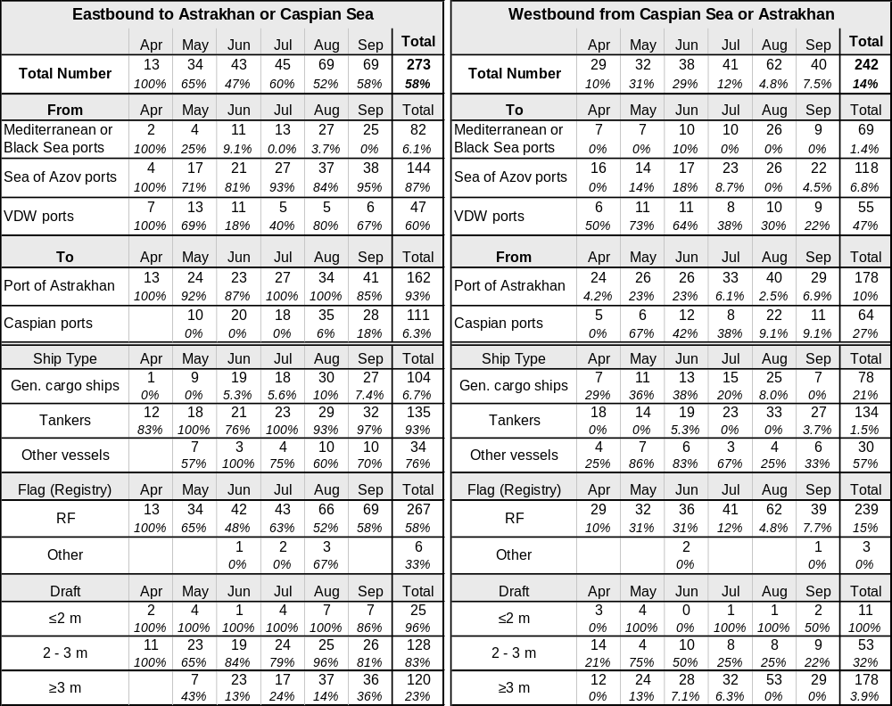

Table 4-2 shows that 58% of the 273 ships making eastbound transits to Astrakhan or CS ports were in ballast, with most having <3 m drafts. The large majority of BOB vessels were tankers departing ports in the Sea of Azov or Lower Don (93% of this ship type reported BOB). Westbound vessels were mostly laden with >3 m drafts. Only 14% of the 242 westbound transits were by BOB vessels, which were mostly general cargo ships (Table 4-2).

Table 4-3: Shipping activity on the Volgo-Baltic waterway, including % of ballasted vessels, from 1 April to 30 September 2006

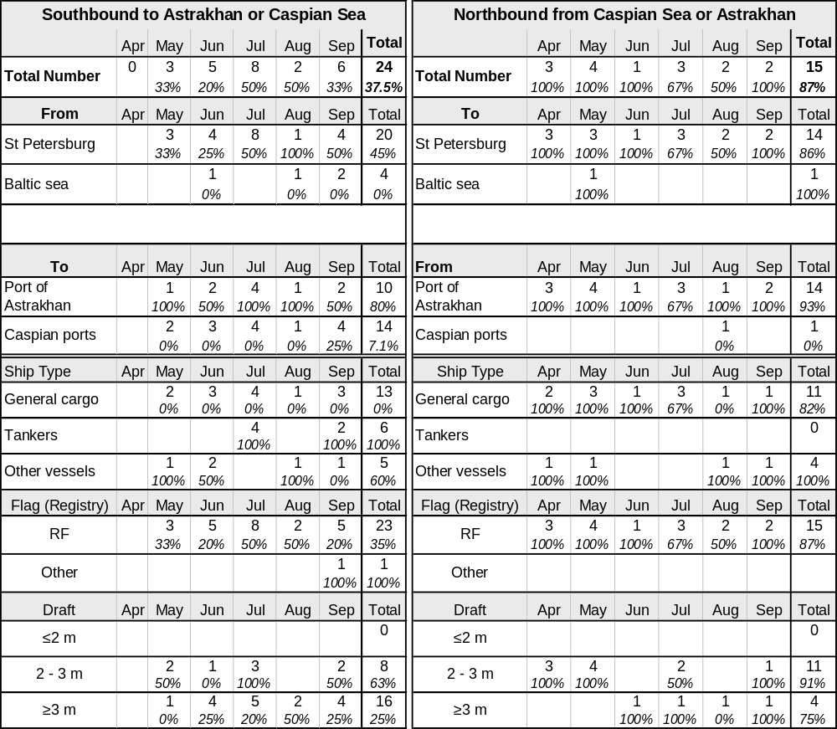

Table 4-3 shows shipping activity along the ‘North-South’ route that connects the CS with St Petersburg and other Baltic ports (Figure 3-1). Table 4-3 shows that only 24 southbound transits were recorded in April - September (10 to Astrakhan plus 14 to CS ports), while only 15 northbound transits were made (14 from Astrakhan and one from a CS port).

The pattern of North/South transits by BOB and NOBOB vessels was similar to the situation for the East/West transits. Thus most northbound voyages from Astrakhan or CS ports were made by ballasted ships (13 of the 15 = 87%), and most of these were general cargo ships (Table 4-3). Of the 24 southbound transits from St Petersburg (20) or other Baltic Sea ports (4), only 9 of these (38%) were made by BOB ships, including all 6 transits made by tankers (Table 4-3).
The 2006 shipping activity shown in Tables 4-2 and 4-3 indicates that tankers and OBOs are responsible for most BW that is moved E and S to Astrakhan or CS ports. If the average amount of BW carried by the tankers, OBO (other) and general cargo ships was 1947 tonnes, 580 tonnes and 1278 tonnes respectively (data from Section 4.6), then the total amount of BW carried eastward during April - September by the 125 tanker, 26 OBO and 7 cargo ship transits in ballast would have been 243 330 tonnes, 8 950 tonnes and 15 080 tonnes respectively. This amounts to some 267 360 tonnes for all 158 eastbound transits made by these BOB ships (= an overall average of ~1700 tonnes per ship).

The comparable figures for the southbound voyages from the Baltic were 6 BOB tankers, 3 BOB OBOs and zero BOB general cargo ships over the same period (Table 4-3). If these ships were carrying the same average quantities of BW as those on the VDW, then the southbound totals would be 11 680 tonnes for the 6 tankers and 1740 tonnes for the 3 OBOs. This amounts to 13 420 tonnes originating from St Petersburg or other Baltic ports.

The shipping records at Astrakhan, as interpreted in Tables 4-2 and 4-3, therefore indicate that for every 100 tonnes of BW carried to Astrakhan/Caspian ports by eastbound shipping in 2006, less than 5 tonnes arrived with southbound shipping from the Baltic (Table 4-4). Comparison between the westbound and northbound BOB shipping indicates that for every 100 tonnes of BW moved westward from Astrakhan/CS in 2006 (total ~34 200 tonnes), about 40 tonnes of BW went northward to the Baltic region (total ~13 800 tonnes) (Table 4-4).

Table 4-4: Summary of total estimated BW movements to and from the Caspian region from 1 April to 30 September 2006
Direction | To Caspian |  | From Caspian |  | Source or  Destination | % of
Direction | tonnes | % | tonnes | % | Source or  Destination | Total BW
Eastbound (VDW) | 267 360 | 95.2% | - | - | from SoA, BS, Med | 81.3%
Southbound (VBW) | 13 420 | 4.8% | - | - | from Baltic region | 4.1%
Westbound (VBW) | - | - | 34 200 | 71.2% | to SoA, BS, Med | 10.4%
Northbound (VBW) | - | - | 13 820 | 28.8% | to Baltic region | 4.2%
Total | 280 780 | 85.4% | 48 020 | 14.6% | 328 800 tonnes | 100%

Table 4-4 indicates that >95% of all BW moved to the Lower Volga / Caspian ports between April and September 2006 was carried on eastbound ships and sourced from the SoA, BS and Mediterranean.

Quantities of BW carried on the North/South routes were roughly equal in both directions (i.e. 13820 versus 13 420 tonnes respectively) but much smaller, i.e. some 8.3% of the estimated total tonnage of 328 800 tonnes (Table 4-4).

BALLASTING ACTIVITY ALONG THE BS-CS WATERWAY

During the BWRF campaign (Section 4.2), 88 reasonably complete BWRFs were returned to Astrakhan by 30 September 2006 (four others were insufficient and not added to the database). The 88 forms were submitted by 71 ships with dates of build from 1966 to 2005, and representing at least 12 types of cargo ship (mean age 24 years), 6 types of tanker (mean age 15 years) and one OBO type (age 20 years) (see Table 4-5; Figure 4-1; Appendix D).

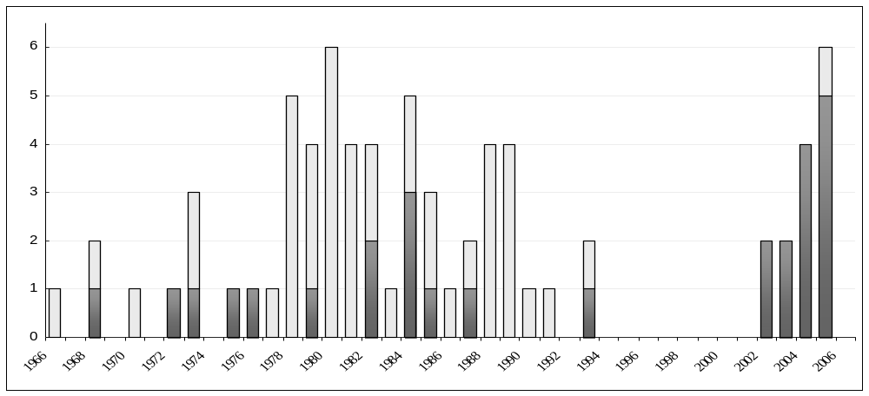
Number of Ships
Date of Build

Figure 4-1: Construction dates of the 45 general cargo ships (light) and 27 tankers (dark) that submitted BW information by 30 September 2006

Sixty-nine (69) of the BWRFs were received from ships undertaking eastbound voyages to Astrakhan or Caspian ports (Table 4-6). The other 19 BWRFs were from ships on westbound transits to ports in the Lower Don, SoA, Black Sea or beyond (Table 4-7). The BWRFs were checked, and in some cases corrections were made to remove typographical errors, spelling mistakes, illogical dates or misplaced BW entries from the database. Where possible, blank entries relating to key ballasting information for part of the voyage were filled by deducing values based on figures and comments provided elsewhere on the same form, and/or from BWRFs of ships of the same (sister ship) or similar type. An Excel file copy of the corrected database used for the analysis has been submitted separately to the IMO.

All 71 vessels that submitted BWRFs were registered at Russian ports (RF flagged) although in some cases the owning company was foreign (refer company list in Appendix D). Although the Azerbaijan State Caspian Shipping Company was contacted and provided with BWRFs, no completed BWRFs were received from their ships.

However faxed details for the one Azerbaijan-flagged ship that made an eastbound transit in August 2006 were received. These showed the 3353 DWT general cargo ship Nesimi (built 1973, type unidentified) had lifted 1493 tonnes of BW in the Black Sea on ~25 July, then passed Astrakhan on 6 August on its way to Baku where it arrived ~10 August. No information was supplied as to any en route ballasting operation. This single foreign-flagged ship was added to the List of Ships for completeness (Appendix D) but not added to the BW database.
Other ships of the same company used the VDW between April and August 2006 and few reported BOB (most had cargo). Azerbaijan vessels always make a temporary stop at Astrakhan, lying at anchor to be cleared by customs, coastguard and port control inspectors.

Table 4-5: Vessel types that sent completed BWRFs by 30 September 2006*

N | Ship Type | Vessel Design  Type / Class |  | Number of ships | Date of build |  | From Caspian |  | To Caspian
 |  |  |  |  |  |  | Without BW | With BW | Without BW |  | With  BW
1 | General cargo ships | Omskiy |  | 9 | 1978 - 1988 |  | 3 | 2 | 6
2 | General cargo ships | ST-1300 (Refrig.) |  | 5 | 1985 - 1989 |  |  | 1 | 2 |  | 2
3 | General cargo ships | Sormovskiy |  | 4 | 1973 - 1990 |  | 2 | 1 | 1
4 | General cargo ships | STK P326.1 |  | 4 | 1980 - 1988 |  | 3 |  | 4
5 | General cargo ships | Volgo-Balt 2-95A |  | 4 | 1970 - 1983 |  |  |  | 2 |  | 2
6 | General cargo ships | Volzhskiy 5074M |  | 3 | 1980 - 1990 |  | 2 |  | 3 |  | 1
7 | General cargo ships | Amur 92-040 |  | 2 | 1987 - 1989 |  |  |  | 2
8 | General cargo ships | Volgo-Don |  | 2 | 1980 - 1981 |  |  |  |  |  | 2
9 | General cargo ships | Ladoga 787 |  | 1 | 1989 |  |  |  |  |  | 3
10 | General cargo ships | Morskoy |  | 1 | 1968 |  |  |  |  |  | 1
11 | General cargo ships | Okskiy R97 |  | 1 | 1980 |  |  |  |  |  | 1
12 | General cargo ships | Vyg |  | 1 | 1993 |  |  |  |  |  | 1
13 | General cargo ships | Unidentified |  | 8 | 1966 - 2006 |  | 2 |  | 6 |  | 1
14 | Ore-Bulk-Oil | Nefterudovoz-55M |  | 1 | 1986 |  | 1 |  |  |  | 1
15 | Oil product and chemical tankers | Volgoneft |  | 8 | 1968 - 1983 |  | 1 |  |  |  | 10
16 | Oil product and chemical tankers | Lenaneft |  | 4 | 1982 - 1987 |  | 1 |  | 2 |  | 1
17 | Oil product and chemical tankers | 005RST01/6 |  | 6 | 2003 - 2006 |  |  |  |  |  | 6
18 | Oil product and chemical tankers | NNov P19614 |  | 1 | 2002 |  |  |  |  |  | 1
19 | Oil product and chemical tankers | RST14.03  (conv. ST-1321) |  | 1 | 2004  (1986) |  |  |  | 1
20 | Oil product and chemical tankers | Unidentified |  | 7 | 1981 - 2005 |  |  |  |  |  | 7
Total recorded voyages (88) |  |  |  |  |  |  | 15 | 4 | 29 |  | 40
Average Year of Build  (or major conversion) and BW Capacity (tonnes) |  |  | 45 General cargo ships |  | ~1986 DoB | BWC ~1394 |  | (Max. 3572*) |  | (Min. 509)
 |  |  | 26 Tankers + 1 OBO |  | ~1991 DoB | BWC ~2718 |  | (Max. 3812*) |  | (Min. 550)
* Summarised from the detailed list of vessel shown in Appendix D. Large maximum BW capacities shown at bottom of Table 4-4 reflect the additional ballasting /deeper draft requirements of River-Sea ships for open seaways. Actual amounts carried on the VDW and VBW by BOB vessels are less to ensure <3.5 m drafts (refer Tables 4-2 - 4-5).

Of the 69 BWRFs received from eastbound vessels, 40 were for transits made by general cargo ships and 29 were from transits by tankers and an OBO carrier. Of the 40 eastbound transits by dry cargo ship, 16 were BOB vessels that carried a total of 20 519 tonnes of BW (mean of 1282 tonnes per ballasted ship). Of the 29 BWRFs received from the eastbound tankers and OBO, these indicated 25 were in ballast and had moved a total of 49 827 tonnes of BW (mean of 1993 tonnes per ballasted ship). Recorded or deduced BW exchange locations were in the SoA, ADSC and/or Lower Don.
Table 4-6: Summary of reported BW movements on Eastbound Voyages

Direction | Departure port | Voyages in ballast | BW moved |  |  | En route BW operation |  | Destination ports of  intended BW discharge
Direction | Departure port | Voyages in ballast | Tonnes | Source/s |  | Exchange* | Navigation* | Destination ports of  intended BW discharge
Eastbound General Cargo Ships
From  SoA or Lower Don | Azov | 3 of 8 | 4860 |  | SoA | ADSC, LD | - | Astrakhan, Aktau, Baku
From  SoA or Lower Don | Mariupol | 2 of 5 | 1421 |  | SoA, LV | SoA, ADSC | - | Anzali; Atyrau
From  SoA or Lower Don | Rostov-on-Don | 1 of 3 | 1627 |  | LD | LD | - | Turkmenbashy
From  SoA or Lower Don | Berdyansk | 1 of 2 | 1598 |  | n/r | LD | - | Astrakhan
From  SoA or Lower Don | Eisk | 1 of 1 | 1168 |  | Eisk | ADSC | - | Astrakhan
From  SoA or Lower Don | Sub-Total | 8 of 19 | 10 670 |  | 10670 |  |  | 6 recipient ports
From  Black Sea | Odessa | 0 of 6 | - |  | - | - | - | -
From  Black Sea | Novorossiysk | 0 of 2 | - |  | - | - | - | -
From  Black Sea | Varna | 3 of 5 | 2958 |  | Varna | SoA, LD | - | Anzali, Baku, Astrakhan
From  Black Sea | Sub-total | 3 of 13 | 2958 |  | 2958 |  |  | 3 recipient ports
From  Sea of Marmara | Diliskelesi | 1 of 2 | 2000 |  | n/r | ADSC | - | Turkmenbashy
From  Sea of Marmara | Bandirma | 1 of 1 | 1009 |  | n/r | LD (2900) | - | Turkmenbashy
From  Sea of Marmara | Derince | 0 of 1 | - |  | - | - | - | -
From  Sea of Marmara | Herex | 0 of 1 | - |  | - | - | - | -
From  Sea of Marmara | Sub-total | 2 of 5 | 4900 |  | 2958 |  |  | 1 recipient port
From Mediterran  Sea | Nemrut (Aegn) | 1 of 1 | 851 |  | Nemrut | SoA | - | Astrakhan
From Mediterran  Sea | Psahna (Aegn) | 1 of 1 | 1920 |  | Psahna | Black Sea | Don lock (1) | Astrakhan
From Mediterran  Sea | Vibo-Valenta | 1 of 1 | 1107 |  | Vibo-V | LD | - | Aktau
From Mediterran  Sea | Sub-total | 3 of 3 | 3878 |  | 3878 |  |  | 2 recipient ports
Total for gen. cargo ships |  | 16 of 40 | 20 519 |  | 20 519 |  |  | 6 recipient ports
Eastbound Tankers and OBO
From  SoA or Lower Don | Azov | 6 of 7 | 14 652 |  | SoA, LD | ADSC, LD | RoD (2) | Astrakhan (5), Aktau
From  SoA or Lower Don | Berdyansk | 0 of 1 | - |  | - | - | - | -
From  SoA or Lower Don | Rostov-on-Don | 1 of 1 | 1100 |  | RoD | LD | - | Saratov (Volga),
From  SoA or Lower Don | Kavkaz | 6 of 6 | 12 183 |  | SoA | ADSC, LD | - | Astrakhan (4)
From  SoA or Lower Don | Sub-total | 13 of 15 | 27935 |  | 27935 |  |  | 3 ports
From  Black  Sea | Odessa (OBO) | 1 of 1 | 1160 |  | n/r | ADSC | - | Astrakhan
From  Black  Sea | Illyiochyovsk | 0 of 1 | - |  | - | - | - | -
From  Black  Sea | Kerch | 4 of 5 | 8762 |  | Kerch, SoA | ADSC, LD | TWR (3) | Astrakhan (2), Nikolaevsk, Turkmenbashy
From  Black  Sea | Kherson | 1 of 1 | 1500 |  | n/r |  | - | Nowshahr
From  Black  Sea | Sevastopol | 4 of 4 | 6324 |  | Sevast. | ADSC, LD | - | Aktau, Astrakhan, Turkmenbashy (2)
From  Black  Sea | Reni (Danube) | 1 of 1 | 1500 |  | n/r | ADSC |  | Astrakhan
From  Black  Sea | Sub-total | 11 of 13 | 19246 |  | 19246 |  |  | 5 ports
From Aegean S | Agio Theodori | 1 of 1 | 2646 |  | Agio Th. | ADSC | TWR (4) | Astrakhan
Total for tankers + OBO |  | 25 of 29 | 49 827 |  | 49 827 |  |  | 6 ports
EASTBOUND TOTAL |  | 41 of 69 | 70 346 |  | 70 346 | Mean = 1715 tonnes per ballasted ship |  | 9 ports
* Not all vessels indicated an exchange, few recorded any adjustment for a navigational purposes (4).
(1) Added BW at Don River 3175 km to reduce air draft and improve bow thruster use.
(2) Added ~700 tonnes at RoD to improve manoeuvrability and ensure subsequent bridge clearance.
(3) Added BW between VDSC 2578-2670 km to improve steering due to strong winds and bad weather.
(4) Added 832 tonnes at TWR 2628-2718 km to improve steering into locks and avoid power line.
Only designated BW tanks were used, i.e. no vessel recorded a ballasting operation involving a cargo tank or hold. BW exchange locations, as recorded or deduced from the BWRFs, were mostly in the Sea of Azov, the ADSC or the Lower Don. The BWRFs also indicated that ships occasionally undertake a ballasting operation along the VDW for navigational purposes, with four of the 41 transits recorded by all of the BOB ships reporting this type of operation (~10%). The 10% value should be regarded as a minimum since voluntary use of BWRFs does not always overcome the inertia or reluctance of vessel crews to report every ballasting activity (e.g. Alexandrov et al 2004).

Departure ports of the 41 eastbound BOB ships were mostly in the Sea of Azov and Lower Don (48%), with ports in the Black Sea, Marmara Sea and Mediterranean sharing the rest (Table 4-5). Destination ports where BW was intended to be discharged were Astrakhan (21) and Turkmenbashi (6), followed by Aktau (4), Anzali (2) and Baku (2) (Table 4-6).

In the case of the 19 BWRFs received from westbound ships, 16 were from general cargo ships, of which only 4 had BOB. BWRFs from 2 tankers and 1 OBO reported a NOBOB status. The total amount of BW carried by the 4 westbound BOB transits was 5041 tonnes (mean 1260 tonnes per ship), exchanges were in the AR or LV, and the destination ports were Bereslavka (VDC), Rostov-on-Don (LD), Berdyansk (SoA) and Mariupol (SoA) (Table 4-7).

Table 4-7: Summary of reported BW movements on Westbound Voyages

Direction | Departure port |  | Voyages in ballast | BW carried |  | En route BW operation |  |  | Destination ports of  intended BW discharge
Direction |  |  | Voyages in ballast | Tonnes | Source | Exchange |  | Navigation | Destination ports of  intended BW discharge
West-bound General Cargo Ships
RF |  | Astrakhan | 1 of 1 | 360 | Dep. port | Volga 3038km |  |  | Mariupol (SoA)
 |  | Makhach-Kala | 0 of 1 | - | - | - |  | - | -
Khazakstan |  | Aktau | 0 of 10 | - | - | - |  | - | -
 |  | Anzali | 1 of 2 | 1483 | Dep. port | AR |  |  | Bereslavka (Volga, VDC)
Turkmeni-stan |  | Turkmenbashi | 1 of 1 | 1598 |  | AR |  |  | Rostov-on-Don (LD)
Iran |  | Amirabad | 1 of 1 | 1600 | Dep. port | AR |  |  | Berdyansk (SoA)
Total for gen. cargo ships |  |  | 4 of 16 | 5041 | 5041 | - |  | - | 4 ports
West-bound Tankers and OBO
RF |  | Astrakhan | 0 of 2 | - | - | - | - |  | -
Iran |  | Turkmenbashi | 0 of 1 | - | - | - | - |  | -
Total for tankers + OBO |  |  | 0 of 3 | - | - | - | - |  | -
WESTBOUND TOTAL |  |  | 19 | 5041 | 5041 |  |  |  | 4 ports

SUMMARY OF KEY Shipping and BW MOVEMENT FEATURES

With respect to BW management options for the BS-CS waterway, key features of the ship types, trading patterns and associated ballasting operations can be summarised as follows:

River-Sea Shipping Features and Trading Patterns
(S1) The present ‘fleet’ that moves BW on the BS-CS waterway is a mix of ship types which have a wide range of designs and build dates, from the 1960s to modern double-skinned vessels. The more modern tankers and mixed freight cargo ships (~15%) appear to be making an increasing number of international ‘direct voyages’ to and between European ports, particularly in winter so as to escape the 3-4 month lay-up.
(S2) A large proportion of the present fleet are >25 year old ships facing the end of their commercial life. Many of the older vessels also appear unsuited for upgrade for international direct route trade, so their operators may understandably be unwilling to pay for retrofits of BW treatment equipment for ships with a potentially limited lifespan on ‘domestic’ SoA – VDW or VBW routes. On the other hand, since many of the older ships have relatively fewer BW tanks and generally smaller ballasting needs (<1500 m³) than their modern counterparts, their internal layouts may be amenable to affordable modifications that enable BW discharge/uptake to a reception/treatment facility via a standard over-deck coupling.
(S3) The more modern River-Sea ship types have 8-16 ballast tanks and ballasting requirements well above 1500 m³ (particularly the tankers). Many are designed, equipped and suited to international trade between ice-free ports in winter. These younger vessels will need to comply with future BW Convention requirements if needing to discharge BW in European ports and waterways that have no BW reception facilities (pertinent requirements of the BW Convention are addressed in Section 4.1).
(S4) Irrespective of vessel age and type, space is probably a premium on all River-Sea ships owing to the UDWS constraints on their draft and other dimensions. Limited space / convenient compartments for retrofitting treatment units, additional power generation, pumps and pipework pose problems for BW treatment systems that use bulky and/or power hungry units (space/power requirements and other features of BW treatment technologies are also addressed in Section 4).
(S5) There appear to be many capable shipyards on the Volga specialising in River-Sea vessel construction, modification, conversion and maintenance. Some should be well positioned to provide reliable advice and cost estimates for reticulating ballast tanks in the various ship types to enable BW discharges to shore, and/or for retrofitting onboard BW treatment systems. Ship or fleet managers will also be a source of valuable advice.

Present patterns of BW Movements and Ballasting Operations
(S6) Most BW is being moved east to the CS owing to present (and projected) trade that is skewed towards substantial liquid and some dry bulk exports from the Caspian region. Far less BW is moved from the CS, either westward to the SoA/Black Sea or northward to St Petersburg and the Baltic. The minor amounts of BW being moved south from the Baltic region to the CS are unlikely to rise unless bottlenecks on the central/upper Volga system are removed by a major improvement program (Appendix B).
(S7) There has been no methodical ballast tank sampling/analysis program to identify sources of BW / sediments, check claims of reported exchanges, or provide data allowing the effectiveness of present BW exchange requirements to be assessed.
(S8) There are several reasons why present BW exchange requirements in the approaches to the ADSC (SoA), VDSC (LD) and VCC (AR) are probably ineffectual in reducing the risk of species transfers: (i) the SoA, LD and N CS are not free of native or introduced organisms; (ii) frequent strong winds and short steep seas in the SoA and N CS inhibit exchange attempts; (iii) not all ships follow the requirement (owners do not want ships to delay to ensure a ≥95% exchange); (iv) high sediment entrainment is likely; and (v) un-pumpable BW and sediment (and hence organisms) will remain in the tanks even if complete exchanges are made.
(S9) BOB vessels occasionally conduct temporary ballasting operations in the TWR and other sectors of the VDW to maintain adequate vessel control and/or for other navigational purposes (4 of 41 eastbound BOB vessels reported one). The percentage of transits involving a ballasting operation within the VDW is probably >10%, given that not all ships necessarily logged or reported such operations during the recent BWRF campaign.
(S10) It is impractical to expect (and unsafe to require) all ships not to make any draft adjustment in the VDSC or TWR when coping with rough wind-wave conditions (as reported in some BWRFs). There are probably other circumstances/locations east of the TWR that can require a ballasting adjustment.
(S11) To prevent BW-mediated transfers of extraneous organisms and substances between the Lower Don (BS catchment) and the Lower Volga (CS catchment), the most effective measure is to prevent ships carrying unmanaged BW past the locks at the head of the Lower Don (Volgodonsk) into the TWR or beyond (see [W2] in Section 3.5).
(S12) A BW reception/treatment facility established at a frequent port of call on the Lower Don (e.g. Azov or Rostov-on-Don, therefore provides an attractive BW management option if it used by all ships that do not have any onboard BW treatment system. This facility should be capable of replenishing all BW carried on full or partly ballasted ships that are making an East or Westbound passage to or from ports on the Volga or beyond. The Astrakhan port records for April-September 2006 indicate that the number of Eastbound ships requiring this BW service would be about 26 per month, while the average number of Westbound ships would be close to 6 per month.

APPRAISAL OF PRACTICABLE BW MANAGEMENT OPTIONS

In this section, features of the International Convention for the Control and Management of Ships' Ballast Water and Sediments 2004 (the Convention) pertaining to future BW management by River-Sea ships are addressed first (Section 5.1). An examination of the land-based BW reception option is made in Section 5.2, followed by a review of progress in BW treatment (BWT) research and a summary assessment of the BWT technologies that have received most R&D attention (Section 5.3). Section 5.4 describes the simple score-based appraisal and ranking exercise that compared the features and requirements of the land and shipboard options, in terms of their predicted ability to provide practicable, safe, cost-effective and environmentally acceptable solutions to River-Sea ships that use the BS-CS waterway.

FUTURE Requirements Of The International Convention

Convention Overview and Implications to River-Sea Ships

The Convention is expected to enter into force on 1 January 2009, a step requiring its ratification by 35 countries representing 35% of the world’s registered tonnage. As with other countries and states in the Europe-Caspian region, the RF has already signalled its interest in the Convention and may become one of the 35 initially ratifying parties. Other CEP States plus European countries with River-Sea trade connections are also anticipated to become ratifying parties before or after January 2009 (e.g. Croatia, Finland, Germany, Greece, Italy, Netherlands, Poland, Romania, Slovenia, Sweden, Turkey, Ukraine).

An increasing number of ships in the River-Sea fleet have extended their trading patterns to a range of ports in the Mediterranean, Black Sea, Baltic Sea and North Sea in recent years (Section 4; Appendix B). Their owners and managers therefore need to consider the future requirements of the BW Convention, since after 2008 it is likely their vessels will not be permitted to discharge BW in the port or coastal waters of any ratifying country, unless these ships can demonstrate their BW has been managed in accordance with the Convention.

After entry into force, the Convention requires all ships larger than 400 GT to operate the following from 1 January 2009, if they are registered to, or visiting, a ratifying country and intending to discharge BW:
- a Ballast Water Management Plan specific to the ship and in line with Convention requirements and guidelines (including tank sediment removal and disposal);
- display an International Ballast Water Management Certificate, as obtained by a Ballast Water Survey and issued under the authority of the Administration that has registered the ship, which verifies that the ship’s BW Management Plan complies with the Convention;
- a Ballast Water Record Book - available for inspection by any party to the Convention;
- Ballast Water Management - either by BW exchange in deep water or a designated area, or by onboard treatment or discharge to a reception facility (the latter options replace BW exchange at a date between 2009-2016 depending on a ships’ build date and BW capacity);
- Ballast Sediment Management - involving operational, design and/or modification features that (a) limit sediment uptake, and (b) facilitate its disposal to an onshore reception facility (also starting between 2009-2016 depending on ship age and ballast capacity).

Convention Guidelines

The Convention has a set of Guidelines (G1-G14) to help ratifying parties, class societies and ship operators interpret and implement its requirements. The Guidelines are presently being approved by the IMO’s Marine Environment Protection Committee (MEPC). The topics and present status of the 14 Guidelines are shown in Table 5-1.

Table 5-1: Guidelines G1-G14 of the Convention

No. | Topic | Release Date
G 1 | Sediment Reception Facilities | MEPC 55 October 2006
G 2 | BW Sampling | Expected July 2007
G 3 | BW Management Equivalent Compliance | MEPC 53 July 2005
G 4 | BW Management and Development of BW Management Plans | MEPC 53 July 2005
G 5 | BW Reception Facilities | MEPC 55 October 2006
G 6 | BW Exchange | MEPC 53 July 2005
G 7 | BW Risk Assessment under Regulation A | Expected July 2007
G 8 | Approval of BW Management Systems | MEPC 55 July 2005
G 9 | Approval procedure for BW Management Systems that use Active Substances | MEPC 55 July 2005
G 10 | Approval and Oversight of Prototype BW Treatment Technology Programmes | MEPC 54 March 2006
G 11 | BW Exchange Design and Construction Standards | MEPC 55 October 2006
G 12 | Design and Construction to Facilitate Sediment Control on Ships | MEPC 55 October 2006
G 13 | Additional Measures including Emergency Situations | MEPC 55 October 2006
G 14 | Designation of Areas for BW Exchange | MEPC 55 October 2006

Some Guidelines are not yet perfected, and MEPC is presently keeping all Guidelines under review, to allow national Administrations and other shipping and maritime stakeholders to put forward suggestions for their improvement (ICBWM 2006).

Replacement of Mandatory BW Exchange

BW exchange will become a mandatory measure for all ships built before 2009 that are registered with (or visiting) ratifying countries, and intending to discharge BW from 1 January 2009. However the Convention regards BW exchange as an interim option, owing to widely-recognised ship safety, geographical/route constraints and biological effectiveness issues. A key biological issue is that BW exchange cannot eliminate all sediments from ballast tanks. The unflushed sediments, together with 1-2 tonnes of un-pumpable BW if the ‘empty-refill’ method is used, provide a re-oxygenated refuge for sediment-dwelling biota and microbes.

The Convention therefore requires BW exchange to be gradually replaced by onboard BW treatment or discharge to an approved reception facility. Table 5-2 shows how the date of the planned switch-over for particular ships depends on their date of build and total BW capacity.
Table 5-2: Phased replacement of BW Exchange by BW Treatment during 2009-2016
Ships built before 2009 with a total ballast water capacity of: | Phase-out Period / Requirement
 | 2008 | 2009 | 2010 | 2011 | 2012 | 2013 | 2014 | 2015 | 2016
<1500 m³ |  | Mandatory >95% BWE |  |  |  |  |  |  | BWT
1500 m³ - 5000 m³ |  | Mandatory >95% BWE |  |  |  |  | Mandatory BWT
>5000 m³ |  | Mandatory >95% BWE |  |  |  |  |  |  | BWT
Ships built after 1 January 2009 with a total ballast water capacity of: |  | Requirement
 |  | 2009 | 2010 | 2011 | 2012 | 2013 | 2014 | 2015 | 2016
<5000 m³ |  | Mandatory BWT
Ships built during 2009 - 2011 with a total ballast water capacity of: |  | Requirement
 |  | 2009 | 2010 | 2011 | 2012 | 2013 | 2014 | 2015 | 2016
>5000 m³ |  | Mandatory >95% BWE |  |  |  |  |  |  | BWT
Ships built after 1 January 2012 with a total ballast water capacity of: |  |  |  |  | Requirement
 |  |  |  |  | 2012 | 2013 | 2014 | 2015 | 2016
>5000 m³ |  |  |  |  | Mandatory BWT

BWE:: ≥95% BW exchange by the empty/refill or pumping-through method.
BWT: BW treatment by an approved system that meets the discharge performance criteria of Regulation D-2.

The phase-in dates listed in Table 5-2 remain subject to periodic MEPC reviews of the progress in the development, testing and approval of onboard BW treatment (BWT) systems that can meet the Convention’s BW discharge performance standard (Section 5.1.4). If adequate progress occurs, Table 5-2 shows that:
- River-Sea ships constructed² before 2009 with a total BW capacity above 1500 m³ (and <5000 m³) must start using an approved onboard BWT system (or BW reception facility) no later than after their first scheduled BW Management Survey after 1 January 2014.
- River-Sea ships constructed² before 2009 with a smaller BW capacity (below 1500 m³), must switch no later than after their first BW Management Survey after 1 January 2016;
- All River-Sea ships constructed² after 1 January 2009 must use BWT or a reception facility when they enter service.

The longer phase-in period provided to existing ships with relatively small BW capacities (<1500 m³) reflects the Convention’s view that the development of modular BWT systems will probably be evolutionary, and thus initially harder to achieve for:
- retrofitting to existing ships (compared to installing systems during ship construction);
- small ships, owing to their internal space constraints versus potentially bulky BWT units.

Discharge Performance Standard

Regulation D-2 of the BW Convention requires that the BW discharged from ships equipped with an approved BWT system must meet the following performance standard:
a. less than 10 viable organisms per cubic metre greater than or equal to 50 microns in minimum dimension (i.e. <10 viable >50 µm organisms per 1000 L);
b. less than 10 viable organisms per millilitre less than 50 micrometres in minimum dimension and greater than or equal to 10 micrometres in minimum dimension (i.e. <10 viable 10-50 µm organisms per 1 mL);
c. discharge of indicator microbes (as a human health standard), not to exceed the following:
(1) toxicogenic Vibrio cholerae (O1 and O139 strains): <1 colony forming unit (cfu) per 100 mL; or <1 cfu per gram of zooplankton sample (wet weight);
(2) Escherichia coli: < 250 cfu per 100 mL;
(3) intestinal Enterococci : <100 cfu per 100 mL.

Reception Facilities, Treatment Technology Approvals and Prototypes

The Convention allows for the use of land-based BW reception/treatment facilities, as this option may be commercially attractive to trading vessels that are dedicated to particular long term routes and ports with highly predictable and well defined ballasting/deballasting cycles. Discharges into the aquatic environment of BW treated at a reception facility will also need to meet the above performance standard (details are now available in Guideline 5; MEPC 55).

The Convention requires each ratifying country to ensure that adequate sediment reception facilities are available at ports and terminals where ballast tank cleaning and repair is permitted. The Convention also mandates that received sediments need to be disposed in a safe and environmentally responsible manner. Guidelines for Sediment Reception Facilities (G1) were also recently released at MEPC 55 (Table 5-1).

Because of concerns about the safety and environmental hazards of potentially harmful chemicals that could be used by some BWT systems, the process for their approval has been addressed by the Convention’s Regulation D-3(2) and its Guidelines (see Box E-3 in Appendix E for details on active substance approval). A key environmental concern was the potential for accumulation of long lived toxic chemical residuals (or their by-products) in the receiving environments of poorly-flushed harbours, estuaries, enclosed waterways or lakes.

Regulation D-4 of the Convention allows for ‘promising’ BWTs to be installed for shipboard tests and trials. Such installations must be approved by the relevant national Administration within an approvals framework established by the Convention. Guidelines for the prototype approval and oversight process (G10) were approved by MEPC 54 in March 2006.

Almost all studies have focussed on BWT for shipboard use, since port-based BW reception facilities can readily adopt conventional industrial treatment systems, and do not face the space, power, servicing and safety constraints that pose significant design challenges to shipboard BWT systems. The few studies that have been undertaken on the practicality and cost of port-based BWT facilities have concluded they do not provide an attractive management solution to most ships and their trading patterns (e.g. URS 2000, DNV 2003, 2005). The option of establishing a BW reception/treatment facility for River-Sea vessels using the BS-CS waterway is addressed in Section 5.2. This is followed by the potential suitability of onboard BWT methods for River-Sea ships in Section 5.3.

Land-Based BW RECEPTION/TREATMENT OPTION

Conclusions from Previous Studies on Port-based BW Reception

Several studies have investigated the feasibility of port-based BW reception facilities, particularly the specific requirements for handling ocean-going ships arriving at seaports in a full or part-ballasted condition to load cargo (e.g. AQIS 1993, URS 2000, DNV 2003, 2005). These studies concluded that port-based reception is generally an unattractive BW management option owing to:
- the problems and costs of installing not just the BW treatment plant but also a reticulation system enabling each cargo loading berth to receive BW and pump it to the plant (this is considerable for large ports that have many widely separated wharves and terminals).
- the expense of modifying every ship to enable over-deck coupling, particularly for ships that are not regular visitors to the port.
- the problem of servicing ships that wish to gravity discharge 5-20% of their BW from their topside and/or other tanks (typically in the port’s outer approaches before berthing, so as to avoid interruptions to cargo loading and/or ensure a safe UKC in the swing basin).
- the need for modified ships to use other management BW methods when visiting other ports where reception facilities are absent.
However it was also recognised that land-based BW reception might remain attractive for a situation where a large number of tankers are dedicated to a single trading route, particularly where the layout of the BW ‘receiving’ port is simple and a sufficiently large treatment facility that was built to treat oily BW pumped from unsegregated ballast tanks remains in an operational condition.

Operational Requirements for BW Reception on the BS-CS Waterway

Economic Justification

A land-based BW reception facility on the BS-CS waterway should be an economically attractive management option if there will be a sufficient number of ships with no capacity for onboard BW treatment for at least 15-20 years, and if the facility is designed to minimise ‘queuing’ and hence avoid undue delays. There would need to be a regulation requiring all such ships to use the facility, and a payment scheme to ensure all users contribute a fair share towards the costs of operating the facility.

The reception facility may not provide an attractive long-term option to vessels that only occasionally use the BS-CS waterway, and trade elsewhere for much of the year (i.e. to ports where no reception facilities will exist). Owners or operators of these ships may prefer to install an onboard BWT system when the BW management requirements of the Convention come into force (i.e. from 1 January 2009 for ships built after this date, and by 1 January 2016 for existing ships; refer Section 5.1.3).

Therefore a key step in determining the value of building a reception facility on the BS-CS waterway will be to consult with ship owners and operators to estimate how many existing ships (plus those built before 1 January 2009) will remain frequently dedicated to ‘domestic’ trade along the BS-CS waterway until 2020-2025, i.e. between RF ports in the SoA/Lower Don (plus Novorossiysk) and RF ports in the Volga and CS (Saratov, Astrakhan, Makhach-Kala), plus other Caspian State ports such as Aktau, Atyrau, Anzali, Baku, Turkmenbashi/Krassnovodsk (refer Section 4.5). If old ships become phased out quickly and others become fitted with onboard BWT systems, then a relatively short operational time-frame (10-15 years) will increase the capital component of the total investment.

Facility Location

The most biologically effective location for the facility has been identified as a convenient, frequently visited port on the Lower Don, such as Azov or Rostov-on-Don (Sections 3.5, 4.6). Placing the facility near the mouth of the Lower Don assumes that eastbound ships that replace unmanaged BW have no subsequent need to take up (then discharge) additional BW until after they have entered the TWR (i.e. no temporary ballasting operation during the initial voyage up the Lower Don, including the locks leading up to the TWR).

Alternative locations, such as on the Volga River at Krasnoarmeysk, Akhtubinsk or Astrakhan, would require ships not to discharge any unmanaged BW during their voyage along the BS-CS waterway. This appears impractical, as the BWRF data imply that some 10% (or more) of eastbound ballasted ships make temporary draft adjustments involving BW uptake/discharge (Sections 3).

Ability of Reception Facility to Avoid Undue Delays

From the analysis of the Astrakhan port records (Sections 4.4-4.6), the present overall average number of eastbound and westbound ships in ballast, and hence needing the facility would, on average, be about 32 per month (= almost 1 per day). Typical volumes per ship would be between 500 and 2300 tonnes, with the present average close to ~1700 tonnes (Section 4.4).

Sequential tank discharges would therefore take between 2-10 hours to complete if normal small ship deballasting rates are used (200-500 m³/hour), with the specific time for a particular ship depending on its deballasting rate and tonnage of BW carried. The additional time required to deliver ‘clean’ water to the empty tanks will depend on the ability of a ship to receive and distribute this water to tanks that were first emptied during the period when its remaining tanks are being emptied.

A facility that not only receives BW but is also required to supply ‘clean’ or treated BW must be equipped with additional pumping and piping infrastructure to avoid cross-contamination. The uncontaminated ‘delivery’ water can be BW received from previous ships, and/or local river water, that is treated and stored at the facility. Alternatively, the ‘clean’ water could be sourced directly from an uncontaminated groundwater supply, if a suitably large source of clean groundwater is available at the reception port.

The ability to deliver ‘clean’ water to a ship well before the end of receiving the last of its unmanaged BW can almost halve the total servicing time, thereby helping to avoid undue delays. If this is not possible (e.g. because of loading stresses to the hull or lack of the additional shipboard pipework for distributing this water to the empty tanks), then the total empty/refill time will be double the typical emptying time (i.e. to between 4 and 20 hours, with the precise time depending on the volume of BW carried by the visiting ship, its pump-out rate and the delivery / pump-in rate).

The need for ice-breaker or tug escorted ‘ice caravans’ in late autumn and spring means that the facility may need to handle the simultaneous arrival of 3-4 ships wishing to replace unmanaged BW before continuing their voyage.

To avoid undue ‘queuing’ delays when 2, 3 or more ballasted ships arrive close to each other, the facility will need to provide multiple reception points at the port. Candidate locations would include frequently-used bunkering points, service wharves, service jetties and/or moorings used for port control inspections, customs and quarantine clearance.

Specific Components Required for the Reception Facility

Modifications to Ships

Apart from tankers and other liquid bulk carriers, few ships have the capability to pump their BW to a shore-side facility at practical flow rates. Thus all ships wishing to use the facility will need to be retrofitted with pipework and pump/s to allow BW in all tanks to be discharged to the land connection, via a standardised coupling on the main or weather deck.

The faster that unmanaged BW can be pumped out and replaced by treated BW, the shorter the total delay to the voyage. As discussed in URS (2000), a conceptual vessel retrofit design needs to lift BW vertically from the lowermost ballast tank to the main or weather deck at a suitably fast rate. In the case of River Sea ships, this would involve a height of 5-7 m and a rate of 250-500 tonnes per hour, depending on the tank layout, moulded height and BW capacity of each ship type.

Before retrofitting a vessel, consideration should be given to fitting tank eductor pumps, and/or making other improvements to maximise the ability to pump out as much BW and sediment as practicably as possible from each tank. All proposed modifications and design details, including any replacement or booster pumps as well as new pipework, will need to receive class-approval. For these reasons vessel retrofitting may be best planned to occur when the vessel is slipped for its scheduled dry-dock maintenance and class inspection. Retro-fitting at vessel haul-out will be unavoidable for any ship type in the River-Sea fleet that has been fitted with submersible BW pump/s in the double bottom.

If design work shows that significant quantities of un-pumpable BW and tank sediment will not be able to be removed despite good retrofit designs, then an alternative is for the facility to add a biocide to its clean ‘delivery’ water, so as to kill any organisms that remain in the tanks. This option will increase the facility’s operational cost, and the biocide should be an approved type that avoids tank corrosion risks or forming long-lived toxic residuals (refer ‘Active Substances’ in Appendix E and Section 5.3.4).

BW Reception/Treatment Infrastructure

The following port-based infrastructure will be required for any onshore reception facility:
(1) Equipping enough wharf and/or mooring points with the matching standard coupling, pump, reliable power and dedicated mains for piping the unmanaged BW to the reception plant, and for receiving its clean water for delivering to the ship;
(2) Procuring sufficient land suitable for the treatment plant, including space for installing BW reception storage tanks that are large enough to handle peak BW inflows that would otherwise overwhelm the capacity of the plant (i.e. when two or more ships are discharging their BW during the same or overlapping time period). A tank storage volume of 6000 tonnes or more would also permit the facility to receive BW for 2-4 days during plant maintenance, overhaul or unexpected down-time periods;
(3) Constructing the treatment plant itself, with sufficient capacity to treat the projected mean volume of BW discharged per day (potentially >2000 tonnes depending on projected increases in East-West trade), plus storage tank/s large enough to ensure uninterrupted delivery of treated water (and/or filtered groundwater). Standard water industry treatment methods could be used, such as coarse pre-filters then fine filter units that use filter bed media to remove all ≥10 µm biota, followed by conventional secondary treatment to kill pathogenic bacteria, viruses and other microbes (e.g. by UV, ozonation or chemical dosing). An existing public sewage treatment plant (STP) may be expanded/adapted for treating the BW, providing that saline BW (>8 PSU) is not delivered in large ‘pulses’(this would be incompatible with the freshwater bacteria that are used in the biological unit of typical STPs ).
(4) Installation of an outfall (or a groundwater injection point) for discharging excess treated water. The potential salinity of the treated water would prevent its delivery via link-main into an existing irrigation or industrial co-share scheme.
(5) Access to a suitable land-fill site for the burial of used filter media, filter cake or other forms of tank sediment and sludge generated at the plant.

Cost estimates, in terms of an overall cost per metric tonne of received BW, were attempted by URS (2000) and DNV (2003), but these did not include land purchase costs (this varies markedly from port to port). Vessel retrofitting costs also do not convert well between ships, as these vary markedly between ships depending on:
- Number and layout of BW tanks.
- Existing pipework and pumping capacity.
- Ship type, size and specific design parameters.
- Timing, country and specific location of the retrofit.

Because of the small size and relatively simplicity of most River-Sea ships compared to ocean-going vessels, overall costs per tonne should be much smaller than those estimated by other studies (e.g. US$0.30 – to >US$1.50 per tonne; URS 2000, DNV 2003). The overall cost will reduce according to the numbers of ship that use the facility for 10, 15 or 20 years.

A preliminary appraisal which uses a simple semi-quantitative scoring method to compare and rank the practicality of a land-based BW reception option with shipboard BWT systems is shown in Section 5.4, following a review of the type and present R&D status of alternative onboard BWT options (Section 5.3).

Appraisal of Promising Shipboard Options

Progress and Choice of BW Treatment Technology for Ships

Commercial and institutional-based R&D projects, including land- and ship-based pilot trials and demonstrations, have examined various methods and combinations of systems since the early 1990s. Many have been conducted in Europe (Germany, Norway, Netherlands, Sweden, United Kingdom) and North America (Canada, United States), and a few in the Asia-Pacific region (Australia, China, Japan, Korea and New Zealand). Brief descriptions of promising BW treatment methods that have attracted significant R&D funding are given in Appendix E, and the following sub-sections assess these methods with respect to their likely suitability for retrofitting to existing River-Sea ships, or installing them during construction.

BW may be treated at the time of uptake, discharge, and/or when stored inside the ship. A key feature of the Convention’s D-2 Performance Standard is that it logically refers to BW quality at the time of discharge (Section 5.1.4). Thus any BWT applied only at uptake will fail the Standard if it does not prevent the survival, repair and/or regeneration of biota during the subsequent tank storage period (see Box E-2 of Appendix E).

In the case of the BS-CS waterway, the BWRFs received in August-September indicate that BW storage times are typically 7-17 days, within a range of 4-42 days. Both water and air temperatures along the waterway have very large ranges during the trading season, rising from spring night-time minima of ~0ºC (water) and below -5ºC (air) to summer daytime maxima that are >25ºC (water) and ~40ºC (air) on the Lower Volga. Thus BW tank conditions conducive to the regrowth of any plankton and bacteria surviving initial treatment, will vary markedly with season. An onboard BWT unit will also need to cope with a wide range of internal ship temperatures as well as the variable water temperatures.

BWT systems that can achieve the D-2 Performance Standard in a practical format that is safe for onboard use (see Appendix E), may use at least one of the following technologies:
- Filtration.
- Irradiation doses of ultraviolet light (UV).
- Chemical or electrolytic dosing to generate lethal but short-lived ‘active substances’.
- De-oxygenation by nitrogen or carbon dioxide gassing.
- Violent shear forces and other energies produced by hydrodynamic cavitation.
- Osmotic shock (OS) by rapid salinity change induced by dilution or brining methods.
- Thermal treatment.

Most BWT systems trialled to date have two or more components, such as filtration followed by dosing with UV or active substance/s (Appendix E). Filtration is generally regarded a useful initial treatment. By reducing the level of suspended sediments, organic particulate matter and the larger biota, fine filtration (<50 µm) reduces build-up of tank sediments as well as improving the efficacy of subsequent treatment/s. However filters can interfere with BW intake rates and some systems are bulky.

Each method, or combination of methods, will inevitably contain inherent advantages and limitations associated with its particular technology/s. What can be successfully fitted to one ship to provide a satisfactory, reliable system may pose intractable problems and issues for its fitting or operation on another, depending on differences in ship size and design, trading profile, ballasting requirements and voyage patterns.

The following summaries of the main types of BWT technologies are based on information in Appendix E, and they provide a preliminary assessment of their potential practicality for River-Sea ships. A preliminary appraisal which ranks the apparent practicality of the land-based BW reception option (Section 5.3) with the following onboard methods (by a simple semi-quantitative scoring method) is presented in Section 5.4.

Filtration

Filtration units are widely expected to be an important component in many BWT systems, either for essential primary treatment or as a useful ‘pre-treatment’ (water conditioning) to reduce sedimentation.

The most promising mechanical filter technology tested and trialled to date for shipboard use are automatic self-cleaning screen filters, with present woven-wire screen technologies approaching reliable, consistent seawater filtration to values close to 25 µm. Units are modular, have relatively small footprints and electrical power requirement, can be installed on any alignment, do not interrupt or compromise low pressure BW flow, and appear well suited for handling relatively slow BW uptake rates (50- 500 m³ per hour). Sediment and biota that accumulate on the screen are automatically back-flushed into the same location that provides the BW source.

Among the other filtration technologies, membrane ultra-filtration is the type used by Reverse Osmosis (RO) desalination units. Ultra-filtration can remove all organisms down to the bacterial level, and is a well proven technology already present on many ships. However it has several draw backs including high unit cost, high pre-filtering requirements (to prevent membrane damage) and limited water production rates versus unit size and power need. The latter constraints improve if the RO unit is treating brackish or near-fresh water.

Use of ‘over-size’ or multiple RO units has potential for any work vessel, landing craft or small livestock carrier, passenger ferry or passenger/Ro-Ro ship that has minor trim and ballasting requirements and does not require rapid tank filling. Any of these ship types that use onboard desalination to ensure an adequate supply of potable water, and trim water to compensate for fuel consumption, supplies and light cargos, could find ‘over-sizing’ of an RO system an attractive BW management option.

Irradiation Doses of Ultraviolet Light (UV)

R&D on the effectiveness of medium pressure UV lamps as a secondary component in BWT that deals with <20 µm organisms has kept this technology an attractive option (Appendix E).

In the context of River-Sea vessel requirements, UV has some weaknesses. These include potential space and power needs for the number of required UV units (including access to clean or replace their quartz tube and lamp respectively). If high levels of suspended fine particles (fine silts, clays or fine organic matter) remain in a filtered BW stream, the resultant transmission losses inside the UV chambers must be compensated by additional lamp power and/or number of chambers (Appendix E). The problem of multiple lamp, space and power need was particularly acute in the case of BWT prototypes that used low pressure UV lamps. Low-pressure ‘monochromatic’ lamps also suffer performance reductions when treating cold (<8ºC) or warm (>25ºC) water temperatures.

Fortunately, advances in the technology of medium-pressure ‘polychromatic‘ UV lamps have significantly improved the capabilities of UV for BWT. It is therefore worth maintaining a close watch on the ability of UV technologies to meet the special requirements of River-Sea shipping, particularly when definitive results from present UV R&D trials and testing programs become available.

Dosing with ‘Active Substances’

One of the most compelling attractions of biocidal substance/s is their ease of application for BWT treatment, by delivery systems already in use for other maritime and land-based water treatment purposes. To add a lethal but relatively short-lived substance, the dosing system may either inject a concentrated solution, meter a solid chemical or generate the substance/s by electrolysis (Appendix E). Units that draw upon a concentrated solution of biocide for injecting into the main ballasting line, can be controlled to add precise amounts during every BW uptake. Turbulent flow during the pumping period helps ensure adequate mixing of the biocide throughout the tank, including its eventual penetration into bottom sediments.

Because of the absence of saline or brackish waters along the entire waterway, methods using electrolysis to generate halide radicals (OCl⁻, HBrO⁻, etc) are severely disadvantaged. By contrast, an automatic injection system that doses from a stock solution of an approved biocide presents a potentially very attractive BWT technology for River-Sea ships for several reasons. These reasons include:
- Automatic injection systems are relatively small, simple, have minimal power requirements and can operate and self-monitor with minimal crew input or maintenance.
- Occasional replacement or replenishment of the stock solution tank can be arranged and supervised by a local service representative of the BWT provider.
- Frequent replenishment of the stock solution is not required for ships with small BW capacities. For example, if the approved dose rate is 2 mg/L and the stock solution is 10% [100 g/L], then a 2 tonne tank would provide sufficient stock to treat 50,000 tonnes of BW (i.e. 20 round-trip voyages for a ship that lifts 2,500 tonnes of BW per outward leg).

The potential disadvantages of active substances revolve around their possible hazards to the ship, crew and environment (Appendix E). In this context, active substances under present consideration for BWT treatment fall into two groups; non-oxidising and oxidising substances. Non-oxidising biocides such as Seakleen® and Acrolein have not been subjected to the levels of concern that have been expressed for oxidant biocides. The latter include hydroxyl radicals (OH⁻), hypochlorite (OCl⁻), the precursor chemicals of biocides such as chlorine dioxide (sulphuric acid and perchlorate), and the constituents of proprietary oxidants such as Peraclean® Ocean (Appendix E). By contrast, non-oxidizing biocides have limited propensity to react with compounds in the water column or corrode steel or coatings. Candidates for approval under the Convention guidelines are claimed to decay into non-toxic metabolisable residuals fairly rapidly (Appendix E).

Hydrodynamic cavitation

The violent pressure changes and very high energies induced via hydrodynamic cavitation (low pressure ‘boiling’ and collapse of microbubbles) help injure or destroy microorganisms that might otherwise survive exposure to UV or chemicals. The technology is generally regarded as an adjunct to other BW treatments, rather than a stand-alone method. Devices that use venturi or mechanical principals to induce cavitation are compact, but they can be very noisy and produce significant back pressures that require additional pumping and associated power demand. Relatively complex Norwegian systems involving a novel gas-pulse method plus a nitrogen generator for BW deoxygenation, are being trialled on a vehicles carrier and a bulk carrier. The number and size of components of this type of combination system will, however, restrict its ability to fit inside small ships with cramped available space.

Deoxygenation

Several multi-step BWT systems have been developed that involve a de-oxygenation step by nitrogen stripping or carbon dioxide gassing. The deoxygenation step is preceded by filtration and needs to be supplemented by a further treatment to kill the biota that can survive the low oxygen levels (particularly the bacterial pathogens of sewage origin). None developed to date are small enough to form a small, compact system that can be readily installed on small ships. Power requirements plus the need to treat anaerobic microbes should not be overlooked.

Salinity Shock

Salinisation or ‘brining’ methods induce osmotic shock (OS) by rapidly increasing BW tank salinities, a concept investigated by some BW management studies of shipping activity in the Great Lakes. rapidly increasing salinity by adding salt or brine to induce OS is theoretically a simple method for killing biota that is adapted or acclimated to low salinity and freshwater regimes (Section 3.6; Appendix E). However brine treatments raise a number of practical issues, including salt sourcing, cartage and delivery, the space required to store and deliver the relatively large dosing volumes, and the risk of increasing ballast tank and pipework corrosion rates. Moreover, equipping River-Sea ships with a salt dosing system will not allow these vessels to meet future international BW treatment performance requirements if they trade to or between international ports where salt-tolerant marine biota occur (i.e. the Mediterranean, North Sea, western Baltic region etc).

Thermal treatment

All aquatic biota and microbes can be killed if BW is ‘flash heated’ to 65-70ºC, and several systems have been put forward to achieve this during its uptake. Raising the tank temperatures to lower levels (34-36ºC) following ballasting requires much less energy and will kill all macrobiota. If maintained for several hours, such temperatures will also inactivate the tough resting cysts of toxic dinoflagellates. However a secondary treatment would be needed to kill surviving thermophilic bacteria and other pathogens.

The principal issues with thermal treatment centre on the increased use of fuel to achieve flash heating, and the problem of achieving and maintaining the lower temperatures for lengthy periods, particularly on cool water routes. The heating method is not considered attractive for these and other reasons, including the problem with finding and harnessing a sufficient amount waste heat to achieve adequate heating, plus concerns regarding increased corrosion rates and the potential for differential heating/cooling stresses to hull components, are outlined in Appendix E.

PRELIMiNARY RANKING OF THE BW MANAGEMENT OPTIONS

Each BW management option, whether by land-based reception or particular onboard BWT method or combination of methods, inevitably presents inherent advantages and limitations associated with its particular technology/s. What can be fitted on one ship to provide a satisfactory, reliable system may pose intractable problems and issues during its fitting or operation on another, depending on differences in ship size and design, cargo type, trading profile, ballasting rates and voyage pattern (Box E-3, Appendix E).

This section compares the basic land and shipboard management options by using a simple matrix to identify and score the overall advantages and disadvantages of each option, and use the total scores to provide a preliminary ranking. The matrix contains 16 features or factors for each BW management option, and the scoring was based on the following assumptions regarding the key features of River-Sea ships, their trading route and ballasting requirements (as identified in Sections 3 and 4):

- Available space/s in the motor room and/or near the BW pumps will be cramped and relatively small.
- There will be space and weight limitations for storing BWT consumables.
- Availability and stability of 3 phase power from existing generator/s may be limited.
- BW pump/s are not located in double bottoms or other inaccessible compartments
- Ballast tank surfaces and associated pipework may have limited corrosion protection, particularly on vessels that trade within the low salinity SoA-UDWS-AR regions.
- Sediment accumulations in BW tanks are removed manually, typically at slipping times.
- BW uptake and discharge rates are in the 200-500 m³/hour range.
- BW volumes requiring treatment are relatively small (500 – 2500 m³).
- Number of BW tanks is 4-18, with modern ships having the most (particularly the tankers).
- Availability of crew for BWT operation, monitoring or maintenance will be minimal.
- Many sectors, berths and cargo transfer sites are shallow with silty floors and turbid water.
- Small underkeel clearances are frequent.
- The low salinity waters from SoA to the N Caspian have low Cl⁻, Br⁻ and I⁻ ionic strengths.
- Water temperatures range from ~0ºC in spring to +25ºC in late summer/early autumn.
- Sectors and reservoirs of the BS-CS waterway provide sources of water that is abstracted for industrial, agricultural and/or urban needs, and a high ecological value is placed on the water quality of the waterway, for maintaining wildlife and commercial fishery resources.

The above assumptions were used to help evaluate and score which BW management options are likely to be potentially more practical, cost-effective and ecologically acceptable than others for use by River Sea ships that trade through the BS-CS waterway.

The basic ‘pros and cons’ of the land-based reception facility versus those of the various onboard BWT technologies were scored using a simple matrix of 13 important operational features and factors (see Table 4-8, next page).

The following scoring scheme was applied to each of the 13 factors listed in Table4-8:
0 = Very difficult / very disadvantageous for small ships on the BS-CS waterway.
1 = Moderately practical / moderately suited to small ships using the BS-CS waterway.
2 = No substantial difficulties or disadvantages for small ships using the BS-CS waterway.

All factors were treated with equal weight, and all scores were summed to provide an overall ‘first-pass’ score and preliminary ranking (i.e. no factor was scored using higher values owing to its perceived relative importance when compared to other factors).

A more sophisticated scoring system (in which factors are weighted) would need more specific manufacturer information for particular BWT units (BWT systems approved in accordance with the Convention’s requirements and guidelines are not yet commercially available).

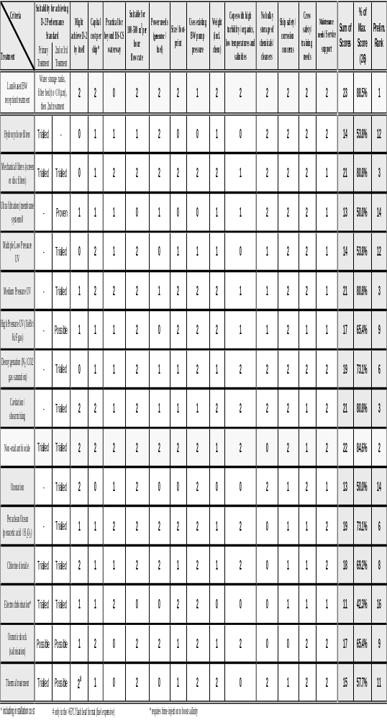
Table 5-3: Preliminary appraisal and ranking of BW treatment methods, by simple scoring of features appropriate for practical installation and operation on River-Sea trading vessels with 600-4000 m³ BW capacities

Total scores from the 13 factors listed in Table 5-3 indicate that the various BW management options can be preliminary ranked in the order shown in the summary Table 5-4.

Table 5-4: Summary Outcome of the Preliminary Ranking Exercise

BW Management Option | % of Maximum Score | Preliminary Ranking
Land-based reception facility | 88.5% | 1
Injection of a non-oxidising biocide  (such as SeaKleen®) | 84.6% | 2
Cavitation / shear force mixing | 80.8% | 3
Mechanical filters  (self-cleaning screen or disc filters) | 80.8% | 3
Medium pressure UV units | 80.8% | 3
Deoxygenation systems  (N₂ / CO2 gas saturation) | 73.1% | 6
Injection of an oxidising biocide  (such as Peraclean® Ocean) | 73.1% | 6
Chlorine dioxide | 69.2% | 8
High Pressure UV units  (XeBr / KrF gas) | 65.4% | 9
Osmotic shock by salinisation | 65.4% | 9
Thermal treatment | 57.7% | 11
Filtration by hydrocyclones | 53.8% | 12
Multiple low pressure UV units | 53.8% | 12
Ozonation systems | 50.0% | 14
Ultra-filtration systems  (membrane technology) | 50.0% | 14
Electrolysis units (with brine injection to provide enough salinity) | 42.3% | 16

The values in Tables 4-8 and 4-9 indicate that the land-based reception facility is worthy of further consideration, including a more detailed, thorough analysis. It must also be stressed that the preliminary ranking provides only a ‘first-pass’ prediction as to the relative potential suitability of the land and onboard management options and their associated ‘generic’ technologies. For example, it is inevitable that onboard BWT technologies will continue to be improved and advanced between now and 2009.

Thus the values in Tables 4-8 and 4-9 should not be used to help make, or support, any strategic decision regarding what type/s of alternative onboard BWT system will be most suitable for particular River-Sea ships. Such decisions cannot be taken or evaluated until approved BWT units have appeared on the market with detailed manufacturer specifications and recommendations. Their evaluation should also involve advice from relevant ship designers, Classification societies and shipyards.

SUMMARY CONCLUSIONS AND RECOMMENDATIONS

conclusions

This study has confirmed that most BW carried through the BS-CS waterway is sourced from ports in the Black Sea, Sea of Azov and Lower Don and most of this discharged, after variable and not particularly biologically effective BW exchange efforts, in ports in the Lower Volga or Caspian Sea.

Average quantities of BW per ballasted ship are in the 1,500-1800 tonne range, with range extending from ~550 to ~2500 tonnes. The shipping traffic is highly seasonal and ship clusters may occur at the start or end of the season owing to the use of ice-escorts.

The study also confirms that the CS remains more susceptible to receiving new invaders via the Black Sea route than ‘donating’ species to the Black Sea or beyond. The reverse holds true for the Baltic Sea (i.e. the CS has been ‘donating’ more native taxa to the Baltic than receiving species from this region), but the amount of BW moving along the north-south corridor and Volgo-Baltic waterway is small.

While Astrakhan may at first glance appear to be a very convenient point for receiving and treating unmanaged BW, ports on the Lower Don offer a much higher level of biological protection (= minimisation of bioinvasion risk). A key reason is that some 10% (or more) of ballasted eastbound ships appear to require ballasting adjustments at various points along the waterway, typically to temporarily improve vessel manoeuvrability, stability and/or draft clearance.

If vessels can be prevented from making ballasting adjustments along the BS-CS waterway, then the logic of providing a BW reception facility at Astrakhan (and/or converting any existing reception centres at Caspian Sea ports that receive oily BW from unsegregated tanks) markedly increases. However such a requirement may be impractical and potentially unreasonable, if not unsafe. One reason are the rough wind-wave conditions that can develop on the TWR, an expansive and relatively unsheltered waterbody that feeds the VDSC and hence is directly connected to the Lower Volga and CS.

The study identified from Port of Astrakhan records and a BWRF campaign that the number of ships using a BW reception facility would, on average be about 32 per month (i.e. close to 1 per days). To make sure the facility was used by all ships regardless of flag / port of registry, a set of regulations based on some form of existing or new legislative framework will be needed. These regulations could also form the basis of ensuring the charging system is fair and equitably applied.

The preliminary evaluation and score—based ranking of BW management options was undertaken based on the key features of the BS-CS waterway (Section 3), the present types of River Sea ship and their trading patterns and associated BW movements (Section 4), and the future requirements of the BW Convention and associated developments in BWT technologies (Section 5).

The results of this exercise support the view that a land-based reception facility appears to be a very viable BW management option – particularly for the numerous older classes of River-Sea ship that are unlikely to undertake international ‘direct voyages’ to and between non-RF ports in the Black Sea, Mediterranean, Baltic or North Sea regions. Modifications enabling these ships to discharge their unmanaged BW and associated sediment to a shore-based facility will need to include eductors and/or other pipework modifications to minimise the amount of ‘un-pumpable’ BW and sediment remaining in the ‘emptied’ tanks. An alternative would be for the land-based facility to add an approved biocide to the clean water it delivers to ships, in order to kill any organisms that remain in the un-pumped sediments or water of the tanks.

The conclusion that BW reception appears to represent a highly viable management option may not hold true for modern River-Sea ships, particularly those undertaking winter-season trade to and between European voyages, either now or in the future and particularly when the Convention enters into force (i.e. post 2009).

The more modern (post 1998) ships tend to have more ballast tanks (particularly the double bottom/double skin types) so would be more expensive to reticulate, and their operators may prefer to equip them with an onboard BWT system that has reasonably small dimensions and power requirements. Of the various technologies under current R&D, those that inject an approved active substance/s into the BW stream will deserve close monitoring and attention. In the case of sediment management, auto-cleaning screen filters presently appear the most promising for application on River-Sea ships, owing to their small power need, compactness, modular form and ability to be fitted vertically, horizontally or other angles.

The various key findings and conclusions drawn in this report can be summarised as follows:
(1) The principal BW pathway of concern will remain, for the projected future, West to East.
(2) Species that invade and adapt to the BS spread, including into the SoA. Those that can complete their entire lifecycle in freshwater can colonise most of the SoA, including Taganrog Bay and the Lower Don.
(3) The locks between the Lower Don and TWR provide a barrier against the natural spread of introduced (and native) species from the BS, SoA and Don catchment to the Volga catchment (and hence to the CS) via the TWR pumping station that feeds the VDSC.
(4) Effective BW measures therefore need to prevent ships carrying unmanaged BW past the head of the Lower Don into the TWR, Volga and beyond.
(5) BW exchanges undertaken in the SoA (or in the North CS/AR) appear relatively ineffectual for reasons addressed in Sections 3 and 4.
(6) It is impractical to expect (and unsafe to require) all ships not to make a draft adjustment in the TWR when coping with rough wind-wave conditions (as reported in some BWRFs). There are other sectors/circumstances east of the TWR that may also require a temporary ballasting operation to adjust draft or trim.
(7) Any land-based BW reception/treatment facility used by ships which have no onboard treatment ability therefore needs to be at Azov or Rostov-on-Don, and not at Astrakhan.
(8) The ‘fleet’ presently contains a mix of ship types, with a small (<15%) but increasing proportion making international ‘direct voyages’ to and between a range of European ports, particularly in winter. Ships engaged on this trade (typically the younger vessels) will need to comply with BW Convention requirements in ports or waterways that have no land based reception facility.
(9) A large proportion of the present fleet are >25 year old ships facing the end of their commercial life. Most appear unsuited to upgrade for international direct route trade, and their operators may also be unwilling to pay for expensive modifications to enable shipboard treatment for trading along the more ‘domestic’ SoA – AR routes.
(10) A land-based facility at Azov or Rostov-on-Don that services ships ‘restricted’ to the SoA-Volga-AR-CS routes may therefore be attractive and cost effective - if this trade remains substantial for >10-15 years. The cost of reticulating a vessel to enable convenient onshore discharge varies with the number of ballast tanks (from 4 to 14 depending particular River-Sea vessel type). Price estimates from previous studies examining the cost of reticulating ocean-going container ships and bulk carriers for onshore BW discharge do not provide a reliable guide for extrapolating to River-Sea vessels for several reasons.
(11) Irrespective of vessel age, type and number of ballast tanks, space is probably a premium on all River-Sea ships owing to constraints on their draft and other dimensions. Limited space / convenient compartments for retrofitting treatment units, additional power generation, pumps and pipework will pose problems for technologies requiring bulky or power hungry units (e.g. advanced oxidation systems, hydro-cyclones, de-oxygenation units using bulky components).
(12) Selection of workable shipboard treatment systems also need to account for:
- high levels of turbid water and entrained sediment due to the shallow waterways, dredged channels, river flood waters and small under-keel clearances (a challenge to filtration/UV-based systems);
- low salinities and cold water temperatures (constrain electrolysis or heating methods).
(13) Preliminary ranking of BW management options has showed the following
(a) a land-based BW reception and treatment facility, using filter-bed media and other standard water industry methods, may provide a cost effective, practical solution if based at a convenient port accessible to all vessels entering the Lower Don. Costs will depend on the availability and price of riverside land, and the number and spacing of suitable existing wharves (and/or moorings) that are fitted to enable simultaneous servicing of two or three vessels. The advantages of linking the reception facility to regularly used bunkering and vessel service/supply points deserves close attention.
(b) Option (a) would be less useful for the more modern (and typically larger) River-Sea ships that undertake international ‘direct’ voyages to and between European ports. These ships tend to have more ballast tanks (particularly the double bottom/double skin types) so would be more expensive to reticulate. To ensure conformance with future BW Convention requirements, the operators of these ships may prefer to equip them with an onboard system that has small dimensions and power requirements. Of the various technologies under current R&D, those that inject approved active substance/s into the BW stream deserve close monitoring and attention. Of the various sediment-reduction systems, auto-cleaning screen filters presently appear the most promising for application on River-Sea ships, owing to their small power need, compactness, modular form and ability to be fitted vertically, horizontally or other angles.

Recommendations

(1) This report should be read in full by CEP maritime and environment agencies, and a workshop needs to be held to facilitate the review, understanding and discussion of its findings. Such a workshop would also undoubtedly help provide clarifications and corrections, as and where necessary, to the inputs, assumptions or outputs of the desk-top components of this study. Since the study forms the first step of the pathway to developing and implementing a suitable BW management strategy, having a workshop would also provide a most effective and timely way for CEP States to agree on the next step/s and how these will be best achieved.
(2) To determine the projected life, usage patterns and hence value and cost of the land-based BW management option, advice and opinion need to be solicited from major operators and builders of River-Sea vessels, and/or their association/s or collective representatives. There are many capable shipyards along the RF waterways specialising in River-Sea vessel construction, modification and maintenance, and some of these would be well positioned to provide estimates for reticulating ballast tanks to enable discharge to shore.
(3) Trade projections also need to be sought for the planned or expected trends in River-Sea trade – particularly its rate of internationalisation versus the numbers, types and ages of ship presently engaged in SoA – AR trade.
(4) For the more modern ships with international trading profiles, a ‘watching-brief’ on simple injection systems that dose an approved active substance, possibly coupled with an auto-cleaning screen filter unit, deserves to be maintained, and the operators, designers and builders of these ships should be solicited for their views and opinions.

REFERENCES

ABWTC, 2004. Australian Pilot Project for the Treatment of Ships’ Ballast Water. Final Report of the Australian Ballast Water Treatment Consortium to the Department of the Environment and Heritage, produced by CRC Reef Research Centre and James Cook University (Townsville), June 2004 (34 pp).
Aladin NV, Plotinikov IS & AA Filippov, 2002. Invaders in the Caspian Sea. In: Invasive Aquatic Species of Europe: Distribution, Impacts and Management (Eds E Leppakoski, S Gollasch, S Olenin). Kluwer Academic Publishers, London (pp. 351-359).
Alexandrov B, Bashtannyy R, Clarke C, Hayes T, Hilliard R, Polglaze J, Rabotnyov V. & S Raaymakers, 2004. Ballast Water Risk Assessment, Port of Odessa, Ukraine, October 2003: Final Report. GloBallast Monograph Series No. 10. IMO London. (http://globallast.imo.org/index.asp?page=monograph.htm&menu=true).
AQIS, 1993. Ballast Water Treatment for the Removal of Marine Organisms. AQIS Ballast Water Research Series Report No. 1, June 1993. Australian Quarantine Inspection Service, Department of Agriculture, Forestry and Fisheries, Canberra, ACT.
ASMO Press, 2001. Transport of Russia Catalogue. Excerpts from: History of the Russian River Fleet (Vladimir Batsalyov, 1998). ASMO Press Publishing House, Mar'ino Business Center, 151 Lublinskaya Street, Moscow; www.goldbook.ru. (sourced September 2006 from http://analytics.ex.ru/cgi-in/txtnscr.pl?node=32&txt=517&lang=2&sh=1 ).
Bij de Vaate A, Jazdzewski K, Ketelaars HAM, Gollasch S & G Van der Velde, 2002. Geographical patterns in range extension of Ponto-Caspian macroinvertebrate species in Europe. Canadian Journal of Fishery and Aquatic Sciences 59: 1159–1174.
Cangelosi A, Knight I, Balcer M, Gao X, Huq A, McGreevy JA, McGregor B, Reid D, Sturtevant R & JT Carlton, 2001, ‘Great Lakes ballast technology demonstration project – biological effectiveness test program’. In: Proceedings of the First Ballast Water Treatment Symposium and Workshop, Global Ballast Water Management Program (GloBallast), London, UK, 26-30 March 2001.
CBMU, 2005. NuTech’s ozone-based BWT system. Canadian Board of Marine Underwriters Newsletter, July 2005. http://www.cbmu.com/downloads/IUMI%20Newsletter%20July%2005.pdf.
Cutler SJ, Cutler HG, Glinski J, Wright D, Dawson R & D Lauren, 2003. SeaKleen®, a Potential Product for Controlling Aquatic Pests in Ships’ Ballast Water. Proceedings of 2nd International Ballast Water Treatment R & D Symposium, IMO, London, July 2003.
DNV, 2003. Melkøya LNG Terminal: Alternative methods for ballast water management. DNV Technical Report No. 2002-1481. Det Norske Veritas, Oslo.
DNV, 2005. Technical Report: Ballast Water Scoping Study - Northwestern Europe. Report No. 2005-0638 by Det Norske Veritas to the UK Maritime and Coastguard Agency, November 2005.
Glosten-Herbert & Hyde Marine, 2002. Full-scale design studies of ballast water treatment systems. Report prepared for the Great Lakes Ballast Technology Demonstration Project by Glosten Associates, Inc. (Seattle, Washington), Herbert Engineering Corp. (Alameda, California) and Hyde Marine Inc.( Cleveland, Ohio).
Gomoiu et al 2002. The Black Sea – a recipient, donor and transit area for alien species. In: Invasive Aquatic Species of Europe: Distribution, Impacts and Management (Eds E Leppakoski, S Gollasch, S Olenin). Kluwer Academic Publishers, London (pp. 341-350).
Hallegraef GM, Valentine JP, Marshall JA & CJ Bolch, 1997. Temperature Tolerances of Toxic Dinoflagellate Cysts: Application to the Treatment of Ships’ Ballast Water. Aquatic Ecology 31(1), pp. 47-52.
Hi Tech Marine, 2001. Request for approval of two shipboard and land-based ballast water management methods. Hi Tech Marine International Pty Ltd, Cooma, NSW Australia. (http://www.htmarine.com.au/ ).
ICBWM, 2006. Proceedings of the 3rd International Conference on Ballast Water Management, Singapore 25-26 September 2006. Hosted by the Institute of Environmental Science and Engineering (IESE), Nanyang Technological University, Singapore.
Isaeva A, 2006. Russian River Fleet and Russian Water Routes – Are They Ready for the WTO? Interview by Olga Gorbunova, RZO Magazine 26 September 2006.. http://eng.rzd-partner.ru/interview/index.php?action=view&st=1159265423&id=0&PHPSESSID=ff1223eef66e1a06ecbc46324e0172c1
Japan, 2001. Harmful Aquatic Organisms in Ballast Water: Safety of Ballast Water Exchange at Sea. Submission to the Marine Environmental Protection Committee (MEPC), by Japan (MEPC 47/2/7).
Jazdzewski K & A Konopacka, 2002. Invasive Ponto-Caspian species in the waters of the Vistula and Oder Basins and southern Baltic Sea. In: Invasive Aquatic Species of Europe: Distribution, Impacts and Management (Eds E Leppakoski, S Gollasch, S Olenin). Kluwer Academic Publishers, London (pp. 384-398).
Kormyshov E, 2005. Pan-European cooperation towards a strong Inland Waterway Transport: On the Move. Session 1: Inland Waterway Market Development in a Pan-European Context. ECMT/UNECE/CCNR/DC Workshop, Paris, 22-23 September 2005. Intervention by Evgueni Kormyshov, Deputy Chief, Federal Agency for Merchant Marine and Inland Shipping (Russian Federation), Russian Market of Inland Water Transport. (http://www.cemt.org/online/Water05/Kormyshov.pdf ).
Leppäkoski E, Olenin S & S Gollasch, 2002. The Baltic Sea – a field laboratory for invasion biology. In: Invasive Aquatic Species of Europe: Distribution, Impacts and Management (Eds E Leppakoski, S Gollasch, S Olenin). Kluwer Academic Publishers, London (pp. 253-259).
Levachew S, 2006. International Eurasia Canal Project. Interview by Julia Alexeeva, RZO Magazine 1 Sep 2006. Stanislav Levachew, Eurasia Canal Project Board. http://eng.rzd-partner.ru/interview/index.php?action=view&st=1157116116&id=0&PHPSESSID=3c708613748392145acc3d986a931858
Mountfort DO, Dodgshun T, Gibbs W & B McCallin, 1999. Towards a feasible heat treatment system for ship’s ballast water. In: The Ballast Water Problem – Where to from Here? Proceedings of the National Workshop 5-6 May 1999, Brisbane. EcoPorts Monograph Series No. 19 (pp. 125-126), published by the Ports Corporation of Queensland (Brisbane).
Mountfort DO, Hay C, Taylor M, Buchanan S & W Gibbs, 1999. Heat treatment of ship’s ballast water: Development and application of a model based on laboratory studies. Journal of Marine Environmental Engineering 5: 193-266.
National Ballast Information Clearinghouse, 2002. Equivalent Reporting Program for vessels operating exclusively in the U.S. Exclusive Economic Zone (EEZ). http://invasions.si.edu/nbic/ .
Nehring S, 2002. Biological invasions into German waters: an evaluation of the importance of different human-mediated vectors for non-indigenous macrozoobenthic species. In: Invasive Aquatic Species of Europe: Distribution, Impacts and Management (Eds E Leppakoski, S Gollasch, S Olenin). Kluwer Academic Publishers, London (pp. 373-383).
NIOZ, 2005. Summary report of filtration trial results obtained at the Netherlands Institute. Unpublished report by NIOZ (Royal Netherlands Institute of Oceanographic Research, Texel Island) to ED Consulting (Australia), 7 July 2005 (15 pp).
Oemcke D, Parker N & Mountfort D, 2004. Effect of UV Irradiation on viability of microscale and resistant forms of marine organisms: Implications for the treatment of Ships’ Ballast Water. Journal of Marine Environmental Engineering 7: 153-172.
Oguma K, Katayama H & S Ohgaki, 2002. Photoreactivation of Escherichia coli after Low- and Medium-Pressure UV Disinfection Determined by an Endonuclease Sensitivite Site Assay. Applied & Environmental Microbiology 68 (12): 6029-6035.
Ojaveer H, Leppäkoski E, Olenin S & A Ricciardi, 2002. Ecological impact of Ponto-Caspian invaders in the Baltic Sea, European inland waters and the Great Lakes: An inter-ecosystem comparison. In: Invasive Aquatic Species of Europe: Distribution, Impacts and Management (Eds E Leppakoski, S Gollasch, S Olenin). Kluwer Academic Publishers, London (pp. 412-425).
Rigby G & AH Taylor, 2001. Ballast Water Treatment to Minimise the Risks of Introducing Nonindigenous Marine Organisms into Australian Ports. Ballast Water Report Series No. 13 published by the Department of Agriculture Fisheries and Forestry (Canberra), January 2001 (96 pp).
Rigby G, Taylor AH & G Hallegraeff, 2003. Does heat offer a superior ballast water treatment option? Paper presented by Reninna Pty Limited, University of Tasmania and Alan H Taylor & Associates (Australia) at the 2nd International Ballast Water Treatment R&D Symposium, IMO London 21-23 July 2003 (http://globallast.imo.org/monograph%2015%20RandD%20Symposium.pdf ).
Rigby GR & AH Taylor AH, 1994. Ocean exchange of ship’s ballast water to minimise the transfer of harmful marine organisms - a review of research work and recommendations for the use of different options. BHP Research Technical Report BHP/ENV/R/94/015. March 1994.
Rigby GR & GM Hallegraeff, 1994. The transfer and control of harmful marine organisms in shipping ballast water: behaviour of marine plankton and ballast water exchange on the MV “Iron Whyalla”. Journal of Marine Environmental Engineering 1: 91-110.
Rigby GR, Hallegraeff GM & CA Sutton, 1998. Novel ballast water heating and sampling trials on the BHP ship MV Iron Whyalla. Technical Report No.11, AQIS Ballast Water Research Series (Canberra), October 1998.
Rigby GR, Hallegraeff GM & CA Sutton, 1999. Novel ballast water heating technique offers cost-effective treatment to reduce the risk of global transport of harmful marine organisms. Marine Ecology Progress Series 191: 289-293.
Shalaev D, 2006. Photographs posted to www.riverships.ru photogallery by Dmitriy Shalaev. http://www.riverships.ru/english/albums/shalaev.shtml
Skjong R & E Dahle, 1997. Hazard identification - Ballast Water Exchange at Sea. IMO MEPC Document 41/9/2.
Skjong R & J Spouge, 2000. Hazards of ballast water exchange at sea for bulk carriers by SWIFT. London, IACS, 2000, International Association of Classification Societies (IACS), International Maritime Organisation, Document, MEPC 45/2/1.
Slynko YV, Korneva LG, Rivier IK, Papchenkov VG, Scherbina GH, Orlova MI & TW Therriault, 2002. The Caspian-Volga-Baltic Invasion Corridor. In: Invasive Aquatic Species of Europe: Distribution, Impacts and Management (Eds E Leppakoski, S Gollasch, S Olenin). Kluwer Academic Publishers, London (pp. 399-411).
Sobol Z, Wladyslaw K & W Bohdan, 1995. System for destruction of microorganisms occurring in ballast waters. Technical paper presented at MEPC 38, International Maritime Organization, London.
Stocks DT & M O’Reilly, 2003, Treatment of residual ballast water in the NOBOB ship using heat. Paper presented by BMT Fleet Technology Ltd and ESG International Inc, at the 2nd International Ballast Water Treatment R&D Symposium, IMO London, 21-23 July 2003 (http://globallast.imo.org/monograph%2015%20RandD%20Symposium.pdf)
Sutherland TF, Levings CD, Elliot CC & WW Hesse, 2001. ‘Effect of a ballast water treatment system on survivorship of natural populations of marine plankton’, Marine Ecology Progress Series 210,: 139-148.
Taylor, AH 1999, Heat treatment: what has the Iron Whyalla experiment told us? In: The Ballast Water Problem- Where to from Here? Proceedings of the National Workshop 5-6 May 1999, Brisbane. EcoPorts Monograph Series No. 19 (pp. 117-124), published by the Ports Corporation of Queensland (Brisbane).
Thornton GA, 2000. Ballast water decontamination using heat as a biocide. Paper presented at Sea Australia Conference, Sydney (1-3 February 2000).
Thornton GA, 2003. Use of heat for ballast water disinfection – the AquaTherm method. Paper presented by Hi Tech Marine Pty Ltd, Australia at the 2nd International Ballast Water Treatment R&D Symposium, IMO London 21-23 July 2003 (http://globallast.imo.org/monograph%2015%20RandD%20Symposium.pdf )
URS, 2000. Feasibility of Onshore Ballast Water Treatment at California Ports. Technica report prepared by URS and Dames & Moore for the California Association of Port Authorities, Sacramento, California.
Wright D, 2004. Use of Seakleen® as a treatment for Ballast Water. Report by University of Maryland Centre of Environmental Science to the Washington State Environmental Soundness Work Group, January 8, 2004. http://wdfw.wa.gov/fish/ballast/jan08_wright.pdf
Zimmer JL, Slawson RM & PM Huck, 2002. Potential repair of Escherichia coli DNA following exposure to UV radiation from both medium- and low-pressure UV sources used in drinking water treatment. Applied & Environmental Microbiology, 68(7): 3293-3299.
Zimmer JL, Slawson RM & PM Huck, 2003. Inactivation and potential repair of Cryptosporidium parvum following low- and medium-pressure ultraviolet irradiation. Water Research 37: 3517-3523.

LIMITATIONS OF REPORT

This report has been prepared for the use of the IMO and the associated CEP parties to the IMO/CEP/UNOPS Study. It is important to recognise this report is based on a preliminary desk-top review, and is not intended to provide an ‘executable’ BW management strategy for ships using the BS-CS waterway.

Rather, it provides a step on the pathway to developing such a strategy, by identifying key features of the waterway and the River-Sea ships which use it, by drawing attention to future compliance aspects of the Convention, and by identifying promising BW management options that are considered practicable, potentially cost-effective and likely to be capable of complying with the IMO Convention.

The Convention is still several years from coming into force, so it is inevitable that BW treatment technologies and their associated requirements and regulations will become refined during this period.

The review is based on the information that could be collated and assessed during the time it was prepared, and the sources of the information and methods used are outlined in this report. No independent verification of this information has been made beyond the agreed scope of work, so it is possible there are inaccuracies and/or omissions. Therefore no warranty can be given as to the veracity, accuracy or completeness of all of the information and advice included in this report, which was prepared in accordance with the scope of work and purposes outlined in the IMO Terms of Reference for project TC/0093-03-2290.

This report was prepared during October 2006 and is based on the information reviewed at the time of its preparation. While the author accepts responsibility for possible inaccuracies or omissions, any changes, new information or developments that may arise in the future are disclaimed.

This report should be read in full. No responsibility is accepted for use of any part of this report in any other context or for any other purpose or by unauthorised third parties. This report does not purport to give legal advice. Legal advice can only be given by qualified legal practitioners.

The inability of many ships worldwide to achieve even a 95% BW exchange in a consistent, safe fashion (in deep or shallow waters) is a key reason why the IMO’s International Convention of the Management of Ballast Water and Sediments (the BW Convention) has a timetable for phasing out this management method in favour of BW treatment by a shipboard or land-based system (Section 5).
Ship construction date: the date when either: (1) the keel has been laid, (2) construction identifiable with the specific ship has begun, (3) assembly has achieved at least 50 tonnes or 1% of the estimated total mass of all structural material (whichever is less); or (4) the ship is undergoing a ‘major conversion’. A major conversion is one which changes either (a) the BW capacity by 15% or more, (b) ship type, (c) its life by 10 years or more in the opinion of the Administration, or (d) its BW system other than in-kind component replacements.
If chemical dosing is used, this should use an approved ‘active substance’ (Section 5.3.4), or require monitoring to confirm that no long-lived toxic residuals are returned to ships in the treated water.
Many public STPs pump their treated water to industrial plants or irrigation schemes to provide a valuable supply of recycled freshwater. It is important the salinity of this water is kept <0.2 PSU.

