APPENDIX A

Description of the Black Sea – Caspian Sea
Waterway

Local Knowledge Report

IMO/CEP/UNOPS PROJECT

STUDY ON TRAFFIC OF SHIP-BORNE
INVASIVE SPECIES TO AND FROM
THE CASPIAN SEA

LOCAL KNOWLEDGE REPORT

OLEG KAZANSY, SHIPPING EXPERT
ASTRAKHAN, 2006
GENERAL PART

This part consists of two sections: The Definitions and Explanations and The List of Abbreviations. It was written and included into the Report with an exceptional purpose to make the reading and understanding of numerous terms and abbreviations scattered throughout the its contents easier and more convenient.

Definitions and Explanations

Design (water) level – the conventional level at which a certain water volume is guaranteed.

Downstream water pool – a stretch of water / water area adjacent to the backwater construction and located downstream from the dam of the hydro-engineering complex.

Erik – a shallow arm between two deeper river reaches. The term is mainly used in the Volga and pre-Caspian basins.

Girlo – an arm or a branch in the river delta or an underwater riverbed in the delta flooded by sea waters. The term in this meaning is mainly used in the Azov – Black Sea area.

Khutor – a separate farmstead of the landowner. At present it is a village of a small to medium size mainly in the Southern region; a croft, a hamlet.

Kilometres mentioned in connexion with the Inland Waterways – it is universally accepted in all the documents concerning the Unified Deep-Water System of the European Part of the Russian Federation (atlases, regulations, etc.) that the count-up of the kilometers in the Inland Waterways is made from the Southern River Port of Moscow. In this work the kilometres are always shown by four or figures without a comma after the figure denoting thousands and with the point before the figure denoting decimal meanings.

Low flood plain – the low part of the river plain flooded with water in the high water period.

Low flood plain – the bank of the riverbed adjacent to the low flood plain.

River shoal – a stable formation due to bottom-bed loads. It divides adjacent deeper river stretches.

Stanitsa – a large village mainly in the Southern region, in the areas inhabited by the Cossacks.

Upstream water pool – a stretch of water / water area adjacent to the backwater construction and located upstream from the dam of the hydro-engineering complex.

Volozhka – the local term denoting an arm or a branch used in the Volga basin.

Water head – the magnitude of the water pressure. The water head on the hydraulic constructions is equal to the difference of levels between the up- and downstream water pools.

Zero datum of the Kronstadt hydrometric staff – the average multiyear level of the depths of the Baltic Sea accepted as the reference actual zero point for the calculation of the depths in the aquatic areas of the seas, lakes, rivers and artificial water reservoirs of the Russian Federation.

LIST OF ABBREVIATIONS

ADSC (the) – the Azov-Don Sea Canal
AR (the) – the Astrakhan Roads
BW – ballast water(s)
cm – centimetre(s)
cm/h – centimetres per hour
CS (the) – the Caspian Sea
E – the East,. Eastern
e.g. – for example
etc. – and so on
i.e. – that is
IWW (the) – the Inland Waterways of the Russian Federation
kh - khutor
km – kilometre(s)
km/h – kilometres per hour
kn – knot(s)
LD (the) the Lower Don
LV (the) – the Lower Volga
m – metre(s)
m/s – metres per second
N – the North, Northern
NE – the North-East, North-Eastern
NW – the North-West, North-Western
NM – nautical mile(s)
PCO – Port Control Officer
p.o.v. – point of view
R-o-D – Rostov-on-Don (the city)
RF (the) – the Russian Federation
S – the South, Southern
SoA (the) – the Sea of Azov
SE – the South-East, South-Eastern
sq,km – square kilometre(s)
sta – stanitsa
stl - settlement
SW – the South-West, South-Western
tn – town
TWR (the) – the Tsymlyanskoye Water Reservoir
VCC (the) – the Volgo-Caspian Canal
VDSC (the) – the Volgo-Don Shipping Canal
viz. – that is
W – the West, Western
INTRODUCTORY PART
To make a voyage from the Mediterranean / Black Sea to the CS a vessel has to cover the overall distance of approximately 1,670 km. The whole way consists of several parts, viz. the SoA, the VDW, the LV and the VCC. The VDW in its turn consists of the LD, the TWR and the VDSC. In the present report each section of the way is looked at from the p.o.v. of its geographical, climatic, hydro-meteorological peculiarities, navigational conditions, distances, hydrographic, hydro-biological and some other details.
The report is not a comprehensive scientific description of the vast area mentioned nor it is a Pilot Book for navigational purposes. Its sole aim is to provide details of the local peculiarities which may help to reach the objectives set in the present Caspian Project on Ballast Waters.
With regard to the fact that the IWW of the RF may be less known to foreign specialists some definitions have been given in the General Part of the Report which refer not only to the local geographical notions but also to those accepted in the sphere of the river navigation. The List of Abbreviations given in the General Part comprises widely used abbreviations as well as those adopted specially for this work.
Sailing in the areas of the Russian maritime ports and the areas adjacent thereto is regulated by “The General Regulations for Sailing and Berthing in the Maritime Ports of the Russian Federation and the Approaches thereto”. For description of local specific details and requirements each maritime port issues its by-laws. For the area described those are “The By-Laws of the Maritime Port of Azov”, “The By-Laws of the Port of Rostov-on-Don” and “The By-Laws of the Maritime merchant Ports of Astrakhan and Olya”.
A considerable part of the voyage between the Black Sea and the CS is made through the IWW of the RF. Sailing through these waters one shall meet the requirements of “The Sailing Regulations for the Inland Waterways of the Russian Federation”. Local peculiarities and requirements for particular areas are described in the local sailing regulations. In the case under review those are “The Sailing Regulations for the Don Basin” and “The Sailing Regulations for the Volga Basin”.
Other documents – such as guidelines or instructions – issued by organs competent in particular aspects (e.g. Specialised Maritime Inspectorate, Port Sanitary Division, etc.) are also applicable. Cases when provisions of such documents are applied from the p.o.v. of the BW transfer are mentioned in the appropriate parts of this report.
Detailed description of the ports and port facilities located in the area under review is beyond the scope of this work. It is only found necessary to point out some certain details which have immediate concern to the BW operations. Ports of Azov, Rostov-on-Don and Astrakhan from / in which vessels depart / arrive to / from the SoA and the CS have quite developed infrastructure.
In these ports repairing works of various complexity may be carried out, virtually all kinds of supplies are available, and discharge of garbage, bilge/oily/sewage/ballast waters can be arranged. Garbage and waters may be discharged into both on-shore installations and specialised vessels.
Port of Olya also ensures garbage and oily/sewage waters reception. However the facilities of this developing port are not large yet and considerable repairing works are not carried out here. Specialised vessels are to be requested beforehand because they have to be called from Astrakhan.
Navigation in all the ports mentioned is year-round. Ice caravans in the freeze-up period are formed and conducted by ice breakers. In winter ice conditions garbage / waters discharging is only arranged into the on-shore installations.
When reviewing the question of BW transfer from the Mediterranean / Black Sea areas to the Caspian and backwards it is necessary to take into consideration the following aspects.
- According to the requirements of the applicable documents vessels on approaching the ADSC and the VCC from the SoA and the CS should change their ballast not closer than 14 km to the entrance into the ADSC and on the AR before the entrance into the VCC respectively. The ballast exchange is checked by the State Port Control Inspectorates. Besides, Sanitary Divisions in the ports take samples of the BW on board certain vessels to find out possible presence of harmful substances. But the actual fact of the BW exchange is checked by PCOs only according to the entries in the ships’ log books (Ballast Water Record Book, Oil Record Book, etc.). The sanitary inspectors take samples only on receiving some kind of special information, e.g. on water discharge violations or epidemic situation in the area the ship arrived from. Thus the regular physical control of the ballast water in the tanks and its analysis are not carried out.
- The time required for the complete BW discharge or uptake on board river-to-sea-going vessels varies from 6 to 12 hours depending on the type and working condition of their ballast pumps. Various circumstances (weather, navigational conditions, etc.) quite often make BW exchange while the vessel is under way complicated. Lying at anchor exclusively for this purpose is regarded by ship owners as unacceptable. Under such circumstances captains may make only formal entries into the log books about ballast operations in the areas specified without its actual exchange.
- Under the circumstances mentioned in item 2 ships’ captains will never carry out complicated schemes of ballast operations with the aim of mixing the unpumpable waters with the other ballast for its complete exchange. In the meantime some vessels making at present voyages in the area described carry on board 1.3 –1.5 tons of so-called “dead”, i.e. unpumpable BW. It goes without saying that the location of the uptake and the following discharge (uncertain time later) of this ballast mixed with other waters taken in other period and location cannot be accounted for.
- At present the maximum dimensions restrictions for sailing in the area under consideration allow to operate vessels with the draught of 3.4 – 3.5 m (depending on the season and the water level) and air draught of 14 m. For sailing in the area the vessels are loaded in such a way that they meet the draught requirement although their actual cargo may sometimes be less than their cargo capacity. All the river-to-sea-going vessels are within the air draught specified when their masts are lowered. That means that they may sail through the VDW as well as through other IWW without ballast operations, be the voyage in cargo or in ballast.
- Actual transit passage from the Mediterranean / Black Sea to the CS is only possible in the period since April till November when the navigation on the IWW stretch of the way is open. For the rest of the year the possibility of BW transfer into the Caspian basin from other area is totally excluded.

Hopefully all the peculiarities mentioned above as well as statistic data attached to this Report will be thoroughly examined by various specialists and appropriate decisions found for effective measures to implement BW control and management.
THE SEA OF AZOV
General information. The sea of Azov is located between the parallels 45*17’N and 47*17’N and meridians 34*49E and 39*18’E. It stretches from the Arabatskaya Strelka Spit up to the estuary of the Don river for 195 NM, and between the heads of the Bays of Temryuk and Belosaraisk for 97 NM. Its total area is 38,000 sq km. Offshore navigation in the SoA is not complicated because most of the dangers lie between the coastline and the 10 m depth curve. The exception is the Bay of Taganrog where the depths are below 10 m. Sailing close inshore is complicated not only by dangers but also by rather frequent water level fluctuations caused by surging. The latter are hazardous both for vessels under way and those lying anchored. While reviewing wind-driven currents it is necessary to bear in mind the following phenomenon. A current of one certain direction may keep for no longer than 24 hours even with durable and strong winds. The reason thereof is the high level surge and the inflicted thereby counter current. (A more detailed consideration of the currents in the SoA is given further on in the appropriate section).
The NE part of the SoA is the vast but shallow Bay of Taganrog. It stretches eastwards for almost 75 NM. Its shores are cut by several small and shallow bights limited by spits.
The SoA washes the shores of the Russian Federation and the Ukraine.
Depths, bottom relief and ground. The SoA is shallow. Maximum depth is 15 m. Depths offshore vary from 10 to 13 m. The maximum depth at the entrance to the Bay of Taganrog is 9.6 m. The depths in the Bay decrease from the entrance towards its head where they do not exceed 5 m.
The bottom of the sea is quite even except for some shoals appearing in the immediate vicinity of the spits. The ground is mainly soft. Along the shores the wide belts of sandy ground with admixtures of shells stretch. Rocky ground appears only by the S coast. The soft character of the ground is caused by intensive water-bed loads in the channels and fairways.
Ports and anchorages. The major ports in the SoA are Taganrog, Temryuk, Kavkaz, Eisk Kerch, Berdyansk and Mariupol. Quite large ports are Rostov-on-Don and Azov, which are situated in the aquatic area of the Lower Don.
Safely sheltered from winds and wave anchorages are not numerous. With the strong N winds lying at anchor is convenient in the bays situated along the N coast. But with the SW winds short but high waves arise in these bays causing severe pitching and rolling of the vessels. Sometimes vessels even lose their anchors because anchor cables break.
Sheltering from the S winds can be found the Bay of Temryuk as well as in the Kazantipskiy and Arabatskiy Bays. A relatively safe anchorage is located in the Bay of Taganrog.
In the Strait of Kerch lying at anchor is allowed only in the areas specially indicated as anchorages in the charts and navigational publications.
Winds. Almost all year round the NE and E winds prevail in the SoA area. Most vividly winds of these directions are expressed in the period since September till April when their summary repeatability is 30-60%. Apart from these repeatability of the SW and W winds increases in the period from June to August (about 50%).
The average monthly wind velocity in the annual run is 3 – 7 m/s, in the cold period it is larger than in the warm one. Calms are rare, their repeatability does not usually exceed 7% and only in certain spots it increases to 14%. The annual number of days with winds of 17 m/s and more varies from 21 to 38 . Winds of such velocity are more frequently observed from October to March. In winter winds with 17 m/s velocity are mainly of NE and E directions. They are known for considerable durability and usually embrace the whole sea area being accompanied by frosts and snow-storms. In summer winds of such velocity are observed with the passing of cold fronts. They usually appear as squalls and are accompanied by thunderstorms and showers.
Fogs. The annual number of days with fogs ranges from 30 to 55. The largest fogs repeatability is observed in the period since October till May. Offshore it attains 5 – 15% and inshore 4 to 10 days are the average monthly number. Since May to October it is not everywhere and not every year that fogs appear. In September the average number of foggy days is 1 – 3.
In the cold period fogs embracing the whole sea area or a considerable part of it are most frequent. They usually keep for 9 – 12 hours, but sometimes for several days. Vaporisation is observed in that period above the sea area clear of ice. In the warm period fogs appear in most cases at night or in the morning when the weather is calm and clear.
Cloudage and precipitation. The annual number of cloudy days varies within the range of 110 to 135. Most of such days are observed in the Bay of Taganrog. The largest average monthly number of cloudy days is usually in winter, in certain areas it attains 21. The average number of clear days in the same period is 1 – 2 a month. Clear days are mostly observed since July till September when their average monthly number is 10 – 15. In winter low veil clouds prevail everywhere, and in summer woolpack clouds are dominant. They are scattered over the shore in the daytime and disappear at night.
Precipitation is not evenly distributed throughout the area described. The largest amount of it is in the E part and in the Bay of Taganrog (about 500 mm per year). The smallest amount is in the W part (approximately 340 mm). In certain rainy years precipitation may be 3 – 4 times as much as the average, while in dry years 3 – 4 times less than the average amount. The largest monthly amount of precipitation is in summer (up to 60 mm) in other seasons it equals 20 – 40 mm.
Water level fluctuations and tides. The water level fluctuations in the SoA are caused by fluvial flowing, atmospheric precipitation, evaporation, wind (surging) and water exchange with the Black Sea. In the seasonal run of the sea level it is fluvial waters flowing, precipitation and evaporation that influence the fluctuations more. In the warm period the level is higher than in the cold one. The highest level is observed in June and it is 18 cm higher than the average annual level of several years standing. The minimum level is in November and it is 14 cm lower than the average annual level of several years standing. The average annual level of several years standing in the SoA is 30 cm lower than the zero datum of the Kronstadt hydrometric staff.
Surge-inflicted level fluctuations are most frequently observed in autumn and winter, which is explained by the cyclonic activity. These fluctuations are sometimes quite considerable. For example, cases were registered when at the low level of surge water was drawn from the coastline for more than 3 NM. At the high level of surge berths were flooded as well as the territory close to them, with the height of the berths being 2 m above the average sea level. The most considerable surging is observed in the Bay of Taganrog and the W part of the sea. The maximum magnitude of the surge in the vicinity of the port of Taganrog is 6 m, and the ports of Berdyansk, Kerch and Genichesk 4 m. The period of dangerously high level surge standing is in most cases not more than 12 hours, only in the port of Genichesk it may last for 48 hours.
In the SoA and the Strait of Kerch water level changes rapidly along the wind strengthening because of their shallowness: it is usually 6 – 10 cm/h at the high level surge and 4 – 8 cm/h at the low level surge. The seiches-inflicted fluctuations are also observed in the SoA. Their maximum magnitude (about 55 cm) is attained in the Bay of Taganrog. Flutuations due to tides and ebbs in the area described are not considerable: they do not exceed several cm and are totally overshadowed by the surging phenomena..
Sea Level Fluctuations (cm)

Location | Average level | Maximum level (year of observations) | Minimum level (year of observations) | Level fluctuations magnitude
Berdyansk  Genichesk  Eisk  Mariupol  Kerch  Primorcko-Akhtarsk  Taganrog  Temryuk | 461  471  462  462  472  467  458  472 | 551 (1941)  698 (1969)  615 (1960)  584 (1969)  534 (1970)  719 (1923)  710 (1970)  793 (1969) | 352 (1928)  287 (1969)  177 (1969)  342 (1949)  329 (1969)  276 (1921)  101 (1960)  371 (1956) | 199  411  438  242  205  443  609  422
Currents. In the SoA the currents mainly depend on the wind. The strongly changeable character of the currents is the consequence of the unstable wind regime, the shallowness of the sea and its comparatively small area. The dominant in the cold period are the NE and E winds, and in the warm one the SW and W winds. In the beginning period of the NE wind development the direction of the currents and the wind coincide in all the area of the sea. Then if the wind continues for a long time and high level surge appears at the Arabatskaya Strelka Spit two different schemes of currents are formed in the sea area. I fthe NE wind velocity is the same over the whole sea area or if it is higher in the N part the anti-clock-wise circulation is recorded in the W part of the sea. If the NE wind velocity in the S part of the SoA is higher than in the N part the clock-wise circulation is recorded in the N part.

Scheme of the Surface Currents with the Moderate NE and E Winds

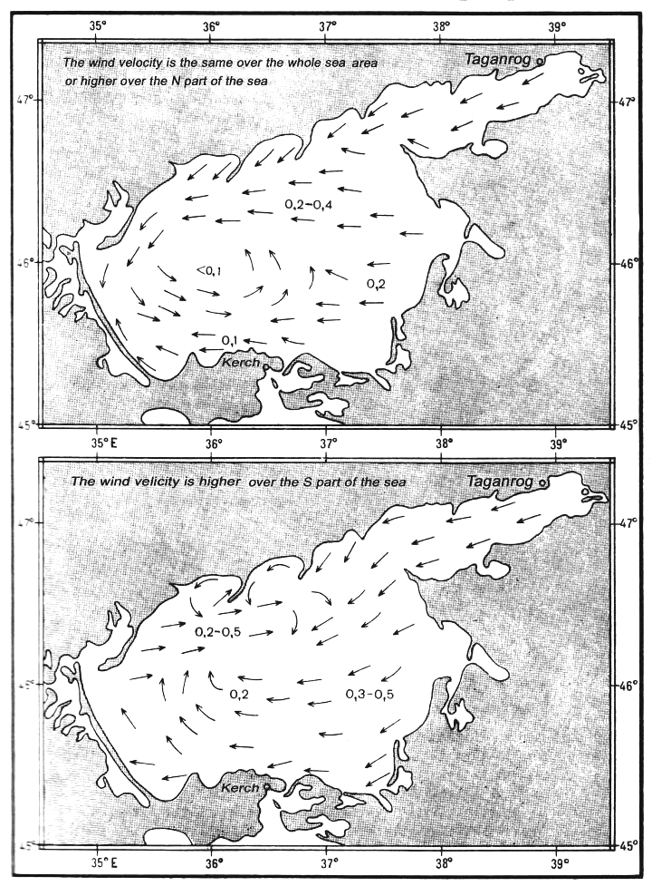
With the moderate SW winds blowing with the same velocity over the whole sea the high level surge is observed in the Bay of Taganrog. At the same time in the N part of the sea the wind-driven current is reduced and its direction changes to opposite due to a considerable difference between the water levels in the Bay of Taganrog and the W part of the sea. In the central part of the sea the anti-clock-wise circulation is registered. If the SW wind velocity in the N part of the sea is more than in the S part the clock-wise water circulation takes place in the central part.

Scheme of the Surface Currents with the Moderate SW and W Winds

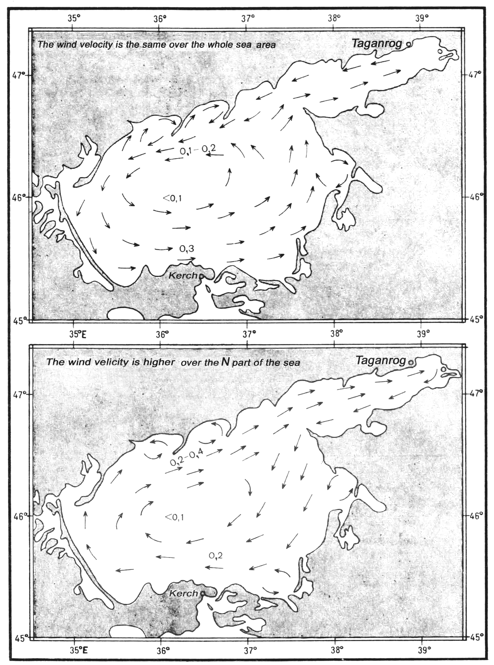
With weak and alternating winds the water circulation is disrupted and the currents become chaotic.
In the Strait of Kerch the current is usually directed from the SoA to the Black Sea. It is quite rare that the direction is opposite.
The prevailing current velocity in the SoA is 0.2 – 0.4 kn, the maximum one is 1.0 – 1.5 kn. In the period of strong and durable winds’ activity the currents’ velocity attains 2.5 kn. In the narrows of the Strait of Kerch the current velocity increases to 2.8 kn in case of the wind-inflicted high level surge.
Two tables are shown below which illustrate some aspects of the currents’ velocity in the SoA.

The velocity of the sea surface currents in the central part of the SoA
in the period of different wind direction; kn

Prevailing windspeed (m/s) | Wind direction
Prevailing windspeed (m/s) | N | NE | E | SE | S | SW | W | NW
5-10  10-15  15-20 | 0,2  0,6  1,3 | 0,4  0,9  1,8 | 0,4  0,8  1,7 | 0,2  0,5  1,2 | 0,2  0,6  1,1 | 0,3  0,8  1,5 | 0,3  0,8  1,6 | 0,2  0,7  1,2

The maximum registered current velocity on various stretches of the Strait of Kerch, kn

Stretch | Current
Stretch | From the SoA | From the Black Sea
Enikalskoye bend  Pevlovskoye bend | 2,4  2,4 | 2,8  2,0

The Currents’ repeatability on average is as follows: from the SoA 62%, from the Black Sea 38%.
Wave information. The wave regime in the SoA is conditioned by the area of the sea, its small depths and the indented character of the coastline. In the area described wave height of less than 1 m prevails (its repeatability attains 75%). The repeatability of the wave height of 1 – 2 m is 20 – 45% and of the wave height of 2 – 3 m is not more than 13%.
In the deepest central part of the sea the wave height does not exceed 3.5 m and only in quite rare cases it attains 4 m. In the most stormy months (December-March) the wave development is restricted by the ice.

Wave Heights Repeatability , %

Wave height (m) | December -February | May – March | June – August | September – November
<1  1-2  2-3  >3 | 36  46  13  5 | 45  41  11  3 | 75  21  3  1 | 47  39  10  4

Water temperature, salinity and density. The temperature of the sea surface layer is clearly chracterised by the annaul run. The lowest temperature is observed in January – February and in the major part of the sea it is 0*C or a little less. Only in the S part of the sea the positive water temperatures remain (1 – 3*C), although in severe winters it may decrease even here up to -0.3*C. Beginning with March the temperature quickly increases and in May it attains 18*C. In summer the temperature offshore is mainly 22 – 25*C and in the close inshore zone it reaches 32*C. Beginning with the second half of August its decrease is noticeable and in November it falls as low as 6 – 10*C. In the Strait of Kerch the water temperature in autumn – winter is usually 2 – 4*C higher than in the open sea. In summer months due to the water exchange between the SoA and the Black Sea the water temperature in the Strait is lower than close inshore.
The salinity of the sea surface area is inconsiderable. In recent years it became higher because of the regulated character of the Don and Kuban rivers’ flowing and at present it is 10 – 12 ppt; in the central part of the sea it attains 14 ppt. In the Bay of Taganrog the water salinity varies from 1 – 2 ppt in the head of the Bay to 9 – 10 ppt by the exit from it. In the Strait of Sivash the water salinity varies from 25 ppt in its N part to 180 ppt in the S.
The seasonal salinity fluctuations do not usually exceed 1 ppt; the most considerable they are in the Bay of Taganrog where the influence of the Don river flowing is quite strong.
The density of the sea surface layer is at its largest in December – March and equals 1.007 – 1.009 in the central part of the sea. In the coastal zone the water density in December – March equals 1.006 – 1.014, in June – August 1.001 – 1.007. In the Bay of Taganrog the water density in summer is 0.998. At present there is a tendency to the increase of the water density due to the increase of the water salinity.
Water transparency and colour. The relative water transparency in the SoA is quite inconsiderable in consequence of a large volume of suspended particles of silt and plankton. In the open sea it is on the average 2 – 3 m in spring and autumn and 1 – 2 m in winter and summer. The maximum water transparency of 5 – 8 m is sometimes observed in the S part of the sea close to the Strait of Kerch. The minimum transparency is registered in the E part of the Bay of Taganrog where it is less than 1 m both in spring and autumn.
Water colour. In the open sea it is usually bluish-green, close inshore as well as in the bays it is mainly green and brown. In the Bays of Taganrog and Temryuk the water is brownish-yellow. In summer bright green colour prevails because of the plankton development. In the windless weather in spring and autumn water is of a yellowish-green colour. In winter it is most often brown.
Hydro-biological information. In the SoA sparkling sea fluorescence (glow) is sometimes observed. It is caused by microscopic organisms. The intensity of this phenomenon is increased by the wave, ships’ moving, etc. It is especially intensive in the coastal areas.
Sea florification (blossoming) is caused by mass accumulation of plankton organisms in the sea surface layer. With florification (blossoming) the water transparency decreases and its colour changes. Most intensive it is in August.
Wood fretters. Small extent of salinity and comparatively low temperature in the cold annual seasons restrict the development of wood fretters in the SoA. The largest quantities of them are observed in the Strait of Kerch where they penetrate from the Black Sea. In the inshore zones the red-yellow beetle of nacerda (Nacerda melanura) lives. It inflicts much damage to the hydro-engineering constructions. The larvae of this beetle live in the wooden piles and other wooden parts of constructions.
Ice information. In the SoA ice is formed every year. In mild winters it is usually observed in small bights and coves well sheltered from winds, and does not complicate shipping. In moderate winters free navigation (i.e. sailing without ice convoys) usually breaks because of the ice and certain complications for even ice breakers of medium power are created. In severe winters the major part of the sea (and sometimes its whole area) is covered with ice impassable even for ice breakers of medium power. Alongside with ice formation ice campaign is declared in the SoA. In that period navigating in the sea is only allowed on permission of the ice breakers’ operations organisers. The average duration of ice convoys is 76 days, the shortest one is 22 days, the longest being 145 days. (see table showing the approximate duration of ice convoy periods between Kerch and Mariupol).

Approximate periods of ice caravans on the stretch from Kerch to Mariupol
depending on the type of the winter

Type of the winter | Periods of ice caravans
Type of the winter | Beginning | End
Most mild  Mild  Moderate  Severe  Most severe | 20 -30 / XII  20 -30 / XII  15 -25 / XII  10 -20 / XII  15 -25 / XI | 1-10 / III  20-30 / III  20-30 / III  1 -10 IV  10 -20 / IV
In moderate winters the first ice appears at end of November/start of December in the Bay of Taganrog. Usually stable motionless ice covers the Bay 7 – 10 days after the beginning of formation. At the same time drifting ice appears in the SW part of the SoA from where it is carried off into the Black Sea through the Strait of Kerch. A little later motionless ice is formed along the W, E and S coastlines. By that time the Bay of Taman is covered by stable ice. In the Strait of Kerch comparatively stable ice is formed by the end of January. The strongest development of ice is attained by the beginning of February. Its condition during the winter is influenced by weather. Strong winds break the ice, cause its hammocking, tear it from the shore and carry into the sea. Prevailing NE wind causes increasing ice accretion by the W and SW coasts of the SoA. The NE wind inflicts intensive ice drifting from the Bay of Taganrog which may cause damages to vessels. Along the Dolgaya Spit a large patch of clear water is formed, 30 – 35 NM wide. It may be used for navigating. In severe winds the patch’s breadth is not more than 15 NM.
In the SW part of the sea ice accretion occurs with the NE wind blowing. Along the Arabatskaya Strelka Spit ridges of hammocks are formed 2 – 3 m high, sometimes even 5 m high. Part of the ice is carried by the current into the Strait of Kerch. In the Strait of Kerch ice usually drifts to the S and SW. Drifting ice is observed in the strait as a rule since the end of November till the end of March.The highest probability of drifting ice (up to 70% in the Strait of Kerch and up to 90% in the Bay of Taman) is recorded from mid-January to the beginning of February. The SW and SE winds complicate ice conditions in the N of the sea. In the area of Byelosaraiskaya and Berdyanskaya Spits ridges of hammocks with the height of up to 3 m are formed.
The Bay of Sivash freezes up only in its N part and not every year. Ice formation is observed here when the water temperature is lower than in the SoA. By end of February, ice in the SoA gradually becomes deformed. Breaking and clearing of ice usually takes place in March, sometimes in the first half of April. As a rule the process begins in the S part of the sea and in the estuaries of the rivers. The table below shows some characteristics of ice period in the SoA
Maximum ice thickness and the number of days with ice
Sea area | Maximum ice thickness, cm |  | Number of days with ice
Sea area | in a severe winter | in a moderate winter | Number of days with ice
W part of the sea  N part of the sea  Bay of Taganrog  E part of the sea  Central part of the sea  S part of the sea  Strait of Kerch | 70  80  60-80  70  40  60  40-45 | 10-30  50  25-30  20  15-25  30  20-30 | 100  100  95-105  100  -  80  54

THE AZOV-DON SEA CANAL

The Azov-Don Sea Canal (hereinafter referred to as the ADMC) is dug through the shoal in the head of the Bay of Taganrog. It connects the fairways of the Bay of Taganrog and the Peschanoye girlo of the Lower Don. Tha ADSC consists of three bends the count-up whereof begins from the sea. The length of each bend is as follows: 1.1 NM; 6.7 NM; 5.2 NM; which makes its overall length 13 NM.
Only vessels with the draught of not more than 3.5 m are allowed to sail through the ADSC. The sailing is allowed the with wind velocity of not more than 15 m/s and visibility not less than 2 NM. The vessels proceeding through the Canal with the maximum permitted draught shall hoist the signal “vessel constrained by her draught”. Vessels whose draught is less shall keep out of her way by coming closer to the right edge of the Canal.
Vessels proceeding from the sea through the ADSC shall have changed their ballast before entering the Canal. According to the order of the Head of the State Control Division of the Azov Specialised Maritime Inspectorate the ballast waters shall be changed at a distance of not less than 14 km from the entrance into the ADSC.
The speed of the vessels whose draught is 3 m shall not exceed 6 NM; vessels with the draught of less than 3 m may proceed with the speed of not more than 8 kn. On the stretch between light buoys #32 and #52 the speed shall not be more than 3 kn.
Pilotage in the ADSC is obligatory.
\
NAVIGATIONAL AND HYDROGRAPHIC OUTLINE OF
THE VOLGO-DON WATERWAY

General information. The Volgo-Don Waterway (VDW) is 596 km long and comprises the Volgo-Don Shipping Canal, the Tsymlyanskoye Water Reservoir and the stretch of the Don river from the Tsymlyanskiy hydro-engineering complex to the estuary.
The VDSC is a 101-km-long canal and it was brought into operation in 1952. The Canal comprises 13 one-chamber navigational locks. The escarps of the Canal are strengthened with stones and concrete slabs. On bringing the VDSC into operation the Baltic, White and Caspian Seas became connected with the Mediterranean Sea, the Black Sea and the Sea of Azov by the Unified Deep-water System of the European part of the Russian Federation. Alongside with the VDSC the TWR was created in the middle part of the VDW. The navigational constructions of the Tsymlyanskiy hydro-engineering complex include two one-chamber locks and two canals: the first one connecting the locks, the other one being the approach canal from the Don river.
The stretch of Don river from the Tsymlyanskiy complex to the estuary is called the Lower Don (hereinafter referred to as the LD). There are three hydro-engineering complexes with one-chamber locks in the LD: Nikolayevskiy (2931 km), Konstantinovskiy (2974 km) and Kochetovskiy (3005km).
The Don River flows into Taganrog Bay of the Sea of Azov. In its estuary the river forms the delta with numerous arms and branches which are called girlos. The main fairway runs through the girlo Peschanoye. Two navigable tributaries flow into the Don downstream from the Tsymlyanskiy hydro-engineering complex: the Severskiy Donets (2997 km) and the Manych (3085 km).
The VDW is a major water transport main. Large numbers of passengers and cargoes are carried through it, considerable part whereof is done by river-to-sea types of vessels. The waters of the VDSC, the TWR and the LD are also used for irrigation and fish breeding. Ship steering in the VDW is seriously influenced by the water level fluctuations in the up- and downstream water pools, as well as the currents appearing resultant to the filling and discharging of the locks’ chambers. From the point of view of the hydro-meteorological conditions the TWR is the most unfavorable part for navigation. Strong winds and high waves are frequently observed in this water reservoir.
Hydro-meteorological information. The VDW run stretches in the zone of the continental climate. The most favourable for navigation are summer months as the most windless and clear. Foggy days during the navigational period are most frequent in the pre-dam area of the TWR. They take 6% of the navigation time, i.e. 15.3 days.
The maximum current velocity in the VDW is observed during the high water period in April – May. It attains 3.6 – 4.3 km/h in the area of the Rychkovskiy railway bridge, and with full gale force NE wind it may be as high as 7.2 km/h.
The average navigation period in the VDW is 232 days, its duration being limited by the early time of ice formation and late time of clearing from ice in the Bereslavskoye water reservoir. The average duration of freeze-up in the vicinity of Bereslavka settlement is 10-15 days larger than in the TWR and 7 days larger than in the area of the Kalach-on-Don town.
The most durable storms are observed primarily in autumn in the SW part of the TWR. Wind velocity during the storms attains 25-28 m/s.
The maximum wave height in the TWR is 3.3 m. Thus the TWR is the most dangerous part of the VDW as per hydro-meteorological conditions.
Fairway dimensions. The guaranteed dimensions along the VDW vary within the following range:
Depth: 3.3 – 3.6 m; breadth: 38 – 100 m; bending radius: 550 – 1,000 m. The fairway dimensions are annually updated in the navigational information issued in the form of Notices to Navigators. As per the height the dimensions are limited by bridges and power lines. The air draft of the vessels sailing in the VDW shall not exceed 14 m. The minimum breadth of locks chambers in the VDW is 17.77 m, the minimum length being 145 m.
Ports, quays, landing stages and roads (anchorages). Along the VDW the following ports are situated: Kalach, Volgodonsk, Ust-Donetskiy, Rostov-on-Don and Azov. The ports have berths equipped for cargo handling, passenger quays and anchorages for vessels of various categories. Besides, the VDW also comprises the following quays and landing stages: Ilyovka (2683 km), Pyatiizbyanskaya (2695 km), Nizhnechirskaya (2818 km), Krasnoyarskaya (2793 km), Krivskaya (2818 km), Zhukovskaya (2839 km), Romanovskaya (2883 km), Komyshvskaya (2905 km), Mariinskaya (2917 km), Nikolayevskaya (2936 km), Konstantinovskaya (2977 km), Kochetovskaya (3006 km), Semikarakorskaya (3011 km) Razdorskaya (3031 km), Melikhvskaya (3043 km), Manych (3068 km), Batayevskaya (3071 km), Arpachin (3092 km), Starocherkasskaya (3107 km), Aksai (3122 km).
Roads for vessels and towed caravans are situated in the areas of large settlements, approaches to locks and major cargo berths. Vessels shall stay at berths and anchorages in accordance with the requirements of “The Fire-Prevention Regulations for Ships Sailing in the Inland Waterways of the Russian Federagion “ and “The Sailing Regulations for the Don Basin”. According to these regulations vessels anchor at roads mooring to one another in so-called lines perpendicular to the banks. The distances between the lines and allowed number of vessels therein depend on the type of vessels and their dimensions.
Vessels servicing. In the ports of Kalach, Volgodonsk and Rostov-on-Don complex vessels servicing is organised. The servicing includes pilotage, fuel bunkering, water and provisions supplies, arrangements for bilge and sewage water discharging, providing tug boats for manoeuvring, etc.
Pilotage. “The Sailing Directions for the Don Basin” require of navigators the knowledge of the local navigational peculiarities. They also shall have all the navigational and hydro-meteorological information. Otherwise pilots are to be taken. For the stretch beginning from lock #1 of the VDSC (2588.6 km) to the port of Azov (3168.7 km) obligatory pilotage is required for the following vessels:
- sea going vessels and river-to-sea-going vessels with cargo capacity of 5,500 tonnes;
- vessels engaged in towing or pushing of special objects;
- vessels carrying explosive and poisonous substances;
- foreign-flagged vessels (including CIS).
Supplies. Fuel and lubrication oil bunkering as well as water supplies may be obtained in the ports of Kalach, Ust-Donetskiy and Rostov-on-Don.
Repairing works. Hulls, machinery and equipment of vessels may be repaired in the ports of Volgograd (the cove Krasnoarmeiskiy), Kalach, Rostov-on-Don, Ust-Donetsk. Medical service is also available in these ports.
Navigational and hydro-meteorological information. Navigational information comprises data on water levels, fairway dimensions, shifts in navigational aids locations, areas of special type vessels operating (such as dredging), etc. Navigational information is included into “Notices to Navigators” which are issued by the Information Division of the Specialised Enterprise “Inland Waterways of the Volga Basin” in Nizhniy Novgorod. These “Notices to Navigators” are issued for all the IWW of the Unified Deep-Water System of the European Part of the Russian Federation.
The local navigational information is included into Way Lists issued daily by the Don Section of Hydro-Engineering Complexes and Navigation. It is also broadcast in radio bulletins by the State Enterprise “Donrechsvyaz” (the Don River Communications) and the radio station “Volgodonsk”. Hydro-meteorological information comprises weather forecasts, gale and storm warnings, information on wave height and ice conditions. It is broadcast by the “Volgodonsk” radio station. Since 1997 navigational and hydro-meteorological information is also available in the navigational control stations at locks #1,13,14.

THE VOLGO-DON SHIPPING CANAL

The VDSC is a major hydraulic construction. It was brought into operation in 1952. The Canal begins 47 km downstream from the Volgograd hydro-engineering complex. It runs through the lowest parts of the interfluve and reaches the Don 10 km downstream from the town of Kalach-on-Don. The length of the Canal is 102 km, 45 km of which are a water reservoir.
The characteristic feature of the VDSC area is the undulated relief, which is formed as the result of the erosion of the gullies of the Volzhskiy and Donskoy declivities.
According to the relief of the area the Canal is divided into three sections: the Volzhskiy declivity, the divide basin and the Donskoy declivity.
The Volzhskiy declivity is 21 km long; it comprises nine locks with almost equal water head at each lock. From lock #1 to lock #4 the Canal is mainly located in the recess. The section of the VDSC between locks #4 and #9 forms lake-like basins, their length ranging from 1 to 2.5 km and breadth – from 0,5 to 1,3 km.
The 26-km-long divide basin is located between lock #9 and lock #10. It is 88 m above the Volga water level and 38 to 43 m above the Don level, depending on the Tsymlyanskoy water reservoir’s level. At the length of 9 km from lock #9 towards lock #10 the VDSC lies in the artificial recess, the depth whereof attains 16 m. For further 17 km the Canal’s line runs through the Varvarovskoye water reservoir. The water supply of the divide basin is ensured by three pumping stations which pump the water over from the Tsymlyanskoye water reservoir.The local flowing also adds a certain amount.
The Donskoy declivity is 45 km long and has four locks: #10, 11, 12, 13. Two water reservoirs are located in this declivity: Bereslavskoye (the downstream water pool of lock #10) and Karpovskoye (the downstream water pool of lock #12).The 6-km-long part of the Canal from lock #13 up to the entrance into the Tsymlyanskoy water reservoir is fenced with dams.
The bottom ground of the VDSC is clay, loam and sandy loam.
Wind and wave information. The prevailing NE winds induce waves, the direction whereof is transverse to the fairway in the Varvarovskoye and Bereslavskoye water reservoirs, and longitudinal to the fairway in the Karpovskoye water reservoir. With the wind velocity of up to 25 m/s waves attaining 2.5 m have been observed in the Karpovskoye water reservoir, the wave height in the Varvarovskoye and Bereslavskoye water reservoirs being 1.8 m and 1.5 m respectively. The number of days with strong winds and high waves does not exceed 6 during the navigation period; an average number of calm days at the same period amounts to 53.
Fogs and precipitation. Fogs in the VDSC area are mainly observed in autumn. There are usually about 18 foggy days during the navigation. The fogs normally appear at midnight or in early morning and keep till midday.
An average annual amount of precipitation varies from 319 mm in the SE to 367 in the NW. The largest amount of rainfall is in July (mainly showers).
Water level fluctuations. The following rounds are observed in the annual changes of the water level in the VDSC: the spring filling (or local flowing pass through), the summer – autumn stable status and the winter period. The filling of the water reservoirs is finished by the end of March, i.e. by the beginning of the navigation. After the filling the summer – autumn navigational period begins, which continues up to the end of November. The level of the water reservoirs is kept by sequential water pumping over from the Don. One month before the end of the navigation arrangements begin for level decreasing.
During the filling and emptying of the lock chambers waves appear in the approach channels. They induce local temporary currents the rate whereof attains 4 km/h. The possible magnitudes of the water level fluctuations amplitudes are given in the table below.

Water Level Fluctuations

Area | Possible WL fluctuat-  ions in basins (m) | Area | Possible water level fluctuations in basins  (m)
From lock #1 to lock #2 | 1,10 | Lock #9 upstream approach channel | 1,10
From lock #2 to lock #3 | 0,80 | Lock #10 upstream approach channel | 0,95
From lock #3 to lock #4 | 1,10 | Lock #10 downstream approach channel | 0,95
From lock #4 to lock #5 | 0,95 | Lock #11 upstream approach channel | 1,10
From lock #5 to lock #6 | 0,60 | From lock #11 to lock #12 | 1,10
From lock #6 to lock #7 | 0,60 | Lock #12 downstream approach channel | 1,05
From lock #7 to lock #8 | 0,80 | Lock #13 upstream approach channel | 0,90
From lock #8 to lock #9 | 0,95

Ice condition. The average duration of the navigation is 232 days, the minimum one is 198 days and the maximum is 268. Data on ice condition in the VDSC are given in the table below.

Ice Information on the VDSC

Ice reported | Date
Ice reported | early | average | late
Ice formation | 30.Х | 26.ХI | 8.I
Freeze – up | 31.X | 1.XII | 11.I
Spring ice drift | 12.III | 1.IV | 21.IV
Clearing from ice | 19.III | 10.IV | 23.IV

THE TSYMLYANSKOYE WATER RESERVOIR

The Tsymlyanskoye water reservoir was formed in 1952 by damming the Don river at the stanitsa Tsymlyanskaya. The length of the fairway in the water reservoir from the VDSC to the port of Volgodonsk is 181 km.
The water area at the designed water level is 2081 sq.km, the maximum breadth is about 30 km.
The right rivage of the water reservoir is high, partially steep and precipitous. The left bank is low and slanting (acclivitous), except for the section from the khutor Vesyoliy (2798 km) to stanitsa Zhukovskaya (2839 km). Acclivitous underwater slants (escarps) were formed as the result of intensive re-shaping of the steep banks. In the water reservoir there are many submerged estuaries, deep ravines and gullies, which form large bays. Part of these bays is used as shelters for vessels.
Sandstones forming the ground of the right rivage are changed by sands downstream from khutor Suvorovskiy (2754 km) and the clays in the head part of the water reservoir. The left bank ground is mainly loam.
The main fairway from lock #13 to 2752 km runs through the submerged riverbed of the Don; from 2752 km to the port of Volgodonsk it runs along the floodplain of the Don. Apart from the main fairway there also are minor fairways in the water reservoir. These are used as approaches to settlements and shelters.
Along the left rivage of the water reservoir there are the following shelters: Ilmen-Suvorovskoye (2756 km), Nagavskoye (2810 km), Krivskoye (2818 km) and Zhukovskoye (2836 km). These are used for both vessels and floats.
The TWR is connected with the Don by two locks: #14 and #15, and two canals, one of which is situated between these locks and the other is between lock #15 and the Don river.
The outer port (avantport) is situated in the upstream water pool of lock #14 which is sheltered from the waves of the Tsymlyanskoye water reservoir with dams made of earth.
Hydro-meteorological information. The climate in the area of the TWR is continental, droughty, with hot and dry summer and moderately cold winter. The average annual temperature in that area is about 8 degrees Centigrade above zero. The hottest period is in July when the maximum air temperature attains 40 degrees Centigrade.
Wind and wave information. Upon the whole the wind and wave situation in the Tsymlyanskoye water reservoir is not favourable for navigation. The calms are rather rare and the periods of gale force winds are quite long – up to 4 days. The storms of the greatest duration are observed in the SW part of the water reservoir. The winds attaining 10 m/s and more are mainly easterly or westerly.
The waves appear simultaneously with the wind and gather their full force within 1.5 – 2 hours. They are steep, their height attaining 2.5 – 3.0 m. The maximum wave height observed was 3.3 m. The average wave steepness is 1/12, the maximum is 1/8; the maximum wave propagation rate is 5.3 m/s.
The three following tables show various wind-and-wave characteristics in the Tsymlyanskoye water reservoir.
Table 1: Various velocity and direction wind frequency in the TWR

Observation point | Wind speed (m/s) | Wind repeatability, %
Observation point | Wind speed (m/s) | N | NE | E | SE | S | SW | W | NW
tn Kalach-on-Don | 0-5 | 8,2 | 6,6 | 9,6 | 11,6 | 8,6 | 8,0 | 11,3 | 17,4
 | 6-10 | 1,1 | 1,0 | 2,8 | 2,0 | 1,2 | 2,2 | 3,1 | 2,6
 | 11-15 | 0,1 | 0,1 | 0,2 | 0,1 | 0,1 | 0,3 | 0,2 | 0,3
 | 16-20 | 0,04 | 0,05 | 0,2 | 0,2 | 0,1 | 0,2 | 0,4 | 0,2
stl Nizhniy Chir | 0-5 | 6,9 | 11,9 | 13,7 | 8,9 | 7,8 | 9,9 | 12,8 | 9,2
 | 6-10 | 1,0 | 1,4 | 3,0 | 2,0 | 1,3 | 2,6 | 3,6 | 1,9
 | 11-15 | 0,03 | 0,1 | 0,2 | 0,12 | 0,03 | 0,3 | 0,5 | 0,1
 | 16-20 | 0,02 | - | 0,1 | 0,02 | 0,03 | 0,2 | 0,3 | 0,4
kh Krasnoyarskiy | 0-5 | 7,6 | 8,0 | 13,2 | 11,7 | 5,7 | 7,1 | 7,8 | 7,1
 | 6-10 | 2,3 | 1,9 | 5,8 | 4,5 | 1,8 | 3,9 | 5,4 | 4,2
 | 11-15 | 0,1 | 0,02 | 0,3 | 0,2 | 0,1 | 0,19 | 0,5 | 0,2
 | 16-20 | - | - | - | 0,02 | 0,03 | 0,1 | 0,1 | 0,04
tn Tsymlyansk | 0-5 | 7,4 | 16,5 | 12,4 | 6,6 | 3,6 | 7,6 | 12,1 | 7,0
 | 6-10 | 1,6 | 3,1 | 6,6 | 3,7 | 1,1 | 2,6 | 4,2 | 1,9
 | 11-15 | 0,03 | 0,1 | 0,4 | 0,1 | 0,1 | 0,2 | 0,4 | 0,1
 | 16-20 | - | 0,2 | 0,1 | 0,1 | 0,1 | 0,1 | 0,12 | 0,03

Table 2: Wind-induced wave heights on the main fairway

KM of the main  fairway | Wave height depending on wind velocity and direction
KM of the main  fairway | 10 m/s |  |  |  | 15 m/s |  |  |  | 20 m/s
KM of the main  fairway | N | E | S | W | N | E | S | W | N | E | S | W
2715 | 0,6 | 0,5 | 0,7 | 0,8 | 1,1 | 0,7 | 1,0 | 1,1 | 1,5 | 1,0 | 1,5 | 1,5
2740 | 0,9 | 1,1 | 0,8 | 0,7 | 0,3 | 1,3 | 1,2 | 1,0 | 1,6 | 1,7 | 1,6 | 1,3
2755 | 0,7 | 0,6 | 0,6 | 1,0 | 1,0 | 1,0 | 1,0 | 1,3 | 1,3 | 1,3 | 1,3 | 1,6
2780 | 0,9 | 0,7 | 1,2 | 1,2 | 1,4 | 1,1 | 1,6 | 1,5 | 1,9 | 1,6 | 2,0 | 1,8
2795 | 1,0 | 0,6 | 0,7 | 1,2 | 1,7 | 0,9 | 1,0 | 1,7 | 2,3 | 1,2 | 1,3 | 2,2
2815 | 0,9 | 0,4 | 0,5 | 1,0 | 1,3 | 0,6 | 0,7 | 1,4 | 1,7 | 0,9 | 0,9 | 1,8
2830 | 0,8 | 0,8 | 0,8 | 1,2 | 1,2 | 1,3 | 1,2 | 1,8 | 1,6 | 1,8 | 1,6 | 2,2
2850 | 1,0 | 1,1 | 0,8 | 1,0 | 1,3 | 1,6 | 1,2 | 1,4 | 1,7 | 2,1 | 1,6 | 1,8
2865 | 0,7 | 0,7 | 0,4 | 0,3 | 1,1 | 1,1 | 0,7 | 0,5 | 1,5 | 1,5 | 1,0 | 0,7

Table 3: Wave characteristics in gale and storm conditions

Observation point | Wind |  |  | Wave characteristics
Observation point | Direction | Velocity, m/s | Fetch,  km | Max.height,  m | Length,  m | Period,  s | Propagation rate, m/s
Lozhki | W | 12 | 21 | 1,2 | 13,7 | 3,4 | 4,3
Nizhniy Chir | NW | 13 | 18 | 2,1 | 21,0 | 4,2 | 5,0
Suvorovskiy | SW | 20 | 19 | 2,3 | 22,0 | 4,3 | 5,1
Krasnoyarskiy | W | 18 | 21 | 2,8 | 24,8 | 4,6 | 5,2
Krivskaya | W | 17 | 33 | 2,1 | 20,7 | 4,2 | 5,0
Zhukovskaya | N | 20 | 14 | 2,5 | 23,0 | 4,4 | 5,2
Primorskiy | W | 17 | 22 | 2,4 | 22,6 | 4,4 | 5,1
Tsymlyansk | E | 22 | 24 | 2,8 | 26,1 | 4,7 | 5,3
Fogs. Fogs are comparatively rare and not lasting. Most often they are observed in October and November. The average number of foggy days during the navigation period is 11.2, which is 4% of the period. The fog situation is illustrated by the following table.

Average number of foggy days during the navigation period

Observation point | Apr | May | Jun | Jul | Aug | Sep | Oct | Nov | Total
Kalach-on-Don (tn) | 1 | 0,2 | 0,2 | - | 0,1 | 0,3 | 2 | 5 | 8,8
Nizhniy Chir (stl) | 2 | 0,3 | 0,1 | 0,3 | 0,2 | 0,4 | 3 | 7 | 13,3
Krasnoyarskiy (kh) | 2 | 0,3 | - | 0,1 | 0,1 | 0,2 | 2 | 4 | 8,7
Tsymlyansk (tn) | 3 | 0,1 | 0,6 | 0,5 | 0,7 | 0,8 | 4 | 8 | 18,6
Water level fluctuations. The TWR is a water reservoir with the regulation of the flowing. The water rating (regime) in the Tsymlyanskoye water reservoir is characterised by considerable level decrease during the navigation period. It induces drying of the flooded plain rivage of the Don river. At such periods vessels sail strictly in the old riverbed. Low levels of water are observed not only by the end of navigation but in the spring period as well.
Water level fluctuations due to surging are also observed in the TWR. These happen at periods of continuous winds blowing in one direction. The maximum low level of surges attains 0.9 m, the maximum high level of the surge being 1.4 m. The greatest surges appear with durable SW and NE winds, which are longitudinal to the water reservoir. The most vivid surging phenomena are observed in the narrow upper part of the water reservoir , with the frequency of 28 – 29 days per month in the navigation period.
Apart from surging the seiches (standing waves) with the fluctuation amplitude of 4 – 5 cm are observed in the TWR. They are caused by the effect the wind exercises on the water surface, as well as by irregular work of the Tsymlyanskaya hydro-electric power station.
Current. The area from the town of Kalach-on-Don to the Rychkovskiy brodge is characterised by the flowing-induced current, the maximum rate whereof is as high as 3 – 3.6 km/h. Downstream from the Rychkovskiy bridge the prevailing type is the wind-induced current. The currents gather the maximum strength here with the longitudinal gale-force winds. Under the circumstances when the NE wind’s blowing with the force of 20 m/s or more coincides in time with the flood period the current rate in the vicinity of the Rychkovskiy bridge may attain 7.2 km/h. The current rate in the other areas under the same circumstances is 1.8 km/h.
Ice conditions. Ice formation in the TWR begins in the bays and shallows to the E, gradually expanding W. Ice destruction takes effect simultaneously down- and upstream. The average duration of the navigation for the Tsymlyanskoye water reservoir as the whole is 241 days.

Ice information in the TWR

Observation point | Date
Observation point | Ice formation |  |  | Freeze-up |  |  | Beginning of ice drift |  |  | Clearing from ice
Observation point | early | mean | late | early | mean | late | early | mean | late | early | mean | late
Kalach-on-Don | 8.XI | 26.XI | 8.I | 17.XI | 6.XII | 11.I | 5.III | 29.III | 16.IV | 15.II | 3.IV | 18.IV
Nizhniy  Chir (stl) | 4.XI | 27.XI | 10.I | 5.XI | 3.XII | 11.I | 12.III | 23.III | 21.IV | 16.III | 8.IV | 26.IV
Krasnoyarskiy (kh) | 4.XI | 30.XI | 12.I | 22.XI | 11.XII | 29.I | 20.II | 30.III | 20.IV | 26.II | 9.IV | 24.IV
THE LOWER DON

The flowing of the Don river in its 313-km-long section from the Tsymlyanskiy hydro engineering complex to the estuary is regulated. The guaranteed depths in this section are ensured by the water discharges from Tsymlysnskoye water reservoir made for navigational purposes.
Downstream from the Tsymlyanskiy hydro engineering complex, Nikolayevskiy hydro engineering complex is located (2931.4 km). The backwater of the Nikolayevskiy hydro engineering complex at the design level grade of 12.4 m extends to lock #15 (2872.3 km).
In 1982 the Konstantinovskiy hydro engineering complex was brought into operation. It is located on 2974.0 km. Its design level mark is 8.2 m and its backwater extends to the Nikolayevskiy hydro engineering complex.
On 3004.8 km there is the Kochetovskiy hydro engineering complex with a demountable dam as part of its main construction. In the period of high water with large water discharges vessels proceed through the dam’s sill with the trusses laid down.
The backwater of the Kochetovskiy hydro engineering complex at the design level of 5.1 m extends to the Konstantinovskiy hydro engineering complex.
Downstream from the Kochetovskiy hydro engineering complex the river is in an unregulated condition. The guaranteed depths in the area are ensured by dredging.
The Lower Don rivage is characterised by bluffs 3 to 7 metres high alternating with low flood plain banks. The right bank is usually higher than the left one. In the upstream part both banks are covered with woods which serve as a good shelter from strong winds. The banks in the area 60 to 80 km upstream from Rostov-on-Don are low and open.
The Don riverbed in some sections is divided into arms forming islands. The breadth of the riverbed varies from 120 km to 1,000 km. The depths in the area are 6 – 8 m attaining 10 – 15 m in some spots.
Downstream from Rostov-on-Don the Don delta begins. The area is 340 sq.km. It is characterised by a large number of arms and delta branches, the largest whereof are girlos Peschanoye, Svinoye and Kalancha branch.
Level fluctuations. The seasonal water level fluctuations in the Lower Don which are connected with the spring flowing increase are not considerable. Usually it is the Tsymlanskoye water reservoir that captures (retains) the whole spring flowing (60% of cases). Otherwise it discharges in the Lower Don during the high water period comparatively small amounts of water which do not make the plain flooded (25-30% of cases). And it is only in 10-15% of cases that there are large water discharges from the Tsymlanskoye water reservoir when spring water floods’ magnitude approaches the amounts which had been observed before the flowing became regulated.
With high floods in the river of Severskiy Donets, the amount of water flowing in into the Don river is 5 – 8 times as much as the water discharge in the Don proper. This phenomenon causes considerable re-shaping of the riverbed in the section further downstream. The water discharge in the river of Severskiy Donets in the low water period does not considerably influence the hydrological situation in the Lower Don.
Surging-induced level fluctuations are observed in the section from the settlement of Bagayevskiy (3071 km) to the estuary. With the wind direction being longitudinal to the river the larges surges are as follows: 0.6 m at the settlement of Bagayevskiy and 1.8 m in the area of Rostov-on-Don. High level surges sometimes cause the water level increase in the estuary of up to 2.5 m, particularly with strong winds blowing W and SW. In October and November the period of continuous NE winds comes when the surges induce water level decrease of up to 2 m.
Winds. During the annual period prevailing are the winds of E directions, the repeatability whereof is 30%. In June and July W winds blow in the Lower Don area with the repeatability of 20 – 33%. During the whole year wind velocity of 5 m/s is the most characteristic (55 – 80% repeatability); the repeatability of 6 – 8 m/s velocity is about 29%. Strong winds of 15 m/s or more are quite rare – about 3 per navigation period.
Fogs in the Lower Don area in the navigation period are rare. Since May till August there are not more than one foggy day per month. Only in November their number increases to 11.
Currents. During the navigation period the current rate in the river shoals of the Lower Don attains 2.4 – 3.5 km/h, in the river reaches it is not more than 1.5 km/h; downstream from stanitsa Starocherkasskaya (3105 km) it decreases to 1 km/h. The greatest current rate is observed in spring in the vicinity of the Kochetovskiy hydro engineering complex dam, where it attains 6 – 7 km/h. In the steep bends of the river gyrating currents may arise. In the Don delta temporary reverse currents appear which may extend somewhat upstream from the town of Azov (3168 km).
Ice information. Depending on meteorological situation the Lower Don may remain frozen for the period ranging from several days to 4 months. Autumn ice drift in the Lower Don is usually observed in mid-December. Its average duration is 11 – 13 days. However after the autumn ice drift and even after the local ice formation the Don river sometimes gets cleared of ice. In such circumstances navigation may be renewed and last for 10 – 20 days more.
The spring clearing of ice in the Lower Don usually begins from the Tsymlyanskiy hydro engineering complex in connexion with warmer temperature of the water coming from the Tsymlyanskoe water reservoir. The spring ice drift takes place in mid-March, its duration being 7 – 12 days.
Ice information on the Lower Don is given in the following table.

Ice information on the Lower Don

Observation point | Date
Observation point | Ice formation |  |  | Freeze-up |  |  | Beginning of Spring  Ice drift |  |  | Clearing of Iice
Observation point | early | mean | late | early | mean | late | early | mean | late | early | mean | late
Razdor-  skaya (sta) | 20.XI | 12.XII | 20.I | 27.XI | 23.XII | 5.II | 7.II | 12.III | 3.IV | 19.II | 20.III | 10.IV
R-o-D (city) | 21.XI | 19.XII | 20.I | 22.XI | 1.I | 6.II | 7.II | 7.III | 7.IV | 17.II | 19.III | 10.IV

THE LOWER VOLGA

This description includes the Lower Volga (hereinafter referred to as LV) stretch from the Volgograd hydro-engineering complex to the settlement of Krasnye Barrikady. Its length is 534 km. The Volga riverbed on this stretch is very unstable and curving, it forms numerous arms and branches locally called eriks. The maximum breadth of the riverbed at the low water level is 2.8 km, the minimum one is 300 m. The Volga fluvial plain is rich with islands which are cut through by the arms often called volozhkas. The islands and islets are covered with shrubs, bushes and trees. In the part under description the Volga flows through the pre-Caspian depression which is below the ocean level.
Hydro-meteorological information. The stretch of the Volga from the Volgograd hydro-engineering complex to the settlement of Krasnye Barrikady lies in the zone of the continental climate. Cold winters and hot summers are typical for this area. The warmest month is July, the average temperature whereof is 24.8*C. In winter the average monthly temperature is below 0*C. In January and February the frosts attain 38*C, while the average temperature in January is 6.9*C.
Winds. On the stretch under description dominant are the W and NW winds, the repeatability whereof is 12 – 15%, as well as the E and SE winds with the repeatability of 13 – 18%. More detailed information on winds is given in the table below.

Winds Information

Wind velocity (m/s) | Repeatability, %
Wind velocity (m/s) | N | NE | E | SE | S | SW | W | NW
 |  |  |  | Settlement of ChyorniyYar
0-5 | 10,4 | 10,5 | 10,8 | 15,2 | 6,7 | 8,3 | 10,2 | 12,2
5-10 | 1,0 | 1,3 | 1,7 | 2,0 | 0,8 | 2,0 | 2,8 | 2,7
11-17 | 0,06 | - | 0,2 | 0,14 | - | 0,3 | 0,4 | 0,3
 | City of Astrakhan
0-5 | 8,7 | 8,9 | 13,1 | 11,1 | 7,1 | 7,8 | 9,3 | 9,1
5-10 | 1,8 | 2,6 | 4,1 | 3,6 | 1,8 | 2 | 2,4 | 2,6
11-17 | 0,2 | 0,3 | 0,8 | 0,3 | 0,2 | 0,6 | 0,4 | -
17-24 | - | - | - | - | 0,04 | 0,1 | 0,05 | 0,04
Fogs. Fogs are most frequent in autumn: in October there are 2 – 4 foggy days, in November 5 – 6. In summer fogs are rare. Information on fogs during the navigation period (April – November) is shown in the following table.

Number of Foggy Days

Observation station | Number of foggy days
Observation station | April | May | June | Jul | Aug | Sep | Oct. | Nov. | Total in navigation
Chyorniy Yar | 1 | 0,2 | 0,1 | - | 0,2 | 0,5 | 2 | 5 | 9
Astrakhan | 1 | 0,5 | 0,2 | 0,2 | 0,5 | 2 | 4 | 6 | 14,4

Water level fluctuations. In the high floods period the increase of water level in the Volgograd area is 8.0 – 8.5 m and in the Astrakhan area it is 5.0 – 5.5 m. The duration of the spring floods is 1.5 – 2 months (usually from mid-April to the beginning of June). The floods’ decrease is sharp, as a rule it takes from 7 to 10 days. It is only in exceptional water-abounding years that it may last as long as 15-20 days.
In the downstream pool of the Volgograd hydro-engineering complex the daily water level fluctuations attain 2.0 m, they extend down the Volga from the dam of the Volgograd hydro-engineering complex to the Popovitskiye river shoals (approximately 85 km downstream).
Ice information. The average duration of the navigation in the Volgograd area is 224 days, in the area in the immediate vicinity upstream from Astrakhan is 260 days. Information on ice formation and clearing is given in the table below.

Dates of Ice Formation and Clearing from Ice

Observation station | Date of clearing from ice |  |  | Date of ice formation
Observation station | early | average | late | early | average | late
Settlement Chyorniy Yar | 5.III | 9.IV | 2.V | 16.XI | 14.XII | 21.I
City of Astrakhan | 1.III | 25.III | 18.IV | 22.XI | 15.XII | 21.I
Currents. Current velocity on the stretch from the Volgograd HE complex to Astrakhan varies rather slightly and depends mainly on the water level. The dependence is shown in the table below.

Current Velocity

Actual water level point relative to zero datum of the gauge station | Average current velocity on the stretches, km/h
 | Volgograd HE complex – Poppovitskiye shoals (gauge station Volgograd) | Poppovitskiye  Shoals – settlement Chyorniy Yar (gauge station Chyorniy Yar) | Settlement Chyorniy Yar – settlement Kopanovka (gauge station Chyorniy Yar) | Settlement Kopanovka – city of Astrakhan (gauge station Astrakhan)
-1,0 | - | - | - | 1,8
-0,5 | - | - | - | 2,0
0,0 | - | - | - | 2,3
0,5 | 3,5 | 3,5 | - | -
1,0 | 3,7 | 3,7 | 3,3 | 2,8
1,5 | 3,9 | 3,8 | 3,5 | 3,1
2,0 | 4,0 | 4,0 | 3,6 | 3,4
2,5 | 4,2 | 4,1 | 3,8 | 3,6
3,0 | 4,4 | 4,3 | 3,9 | 3,9
3,5 | 4,6 | 4,4 | 4,0 | 4,1
4,0 | 4,7 | 4,6 | 4,2 | -
4,5 | 4,9 | 4,7 | 4,3 | -
5,0 | 5,1 | 4,9 | 4,5 | -
5,5 | 5,2 | 5,0 | 4,6 | -
6,0 | 5,4 | 5,2 | 4,8 | -
6,5 | 5,6 | 5,3 | 4,9 | -
7,0 | 5,7 | 5,5 | 5,0 | -
7,5 | 5,9 | 5,6 | 5,2 | -
8,0 | 6,1 | 5,8 | 5,3 | -
Fairway dimensions. The guaranteed dimensions of the fairway in the Volga river (the latest soundings were taken in 2001), the marks of design level with reference to the actual zero point of the gauge stations’ flow-charts and its absolute heights relative to the zero datum of the Kronstadt hydrometric staff are shown in the following table.

Lower Volga Fairway Dimensions

Fairway Stretch  (km) | Length (km) | Min  Depth (m) | Min  Breadth (m) | Bend Radius (m) | Gauge station namr | Absolute height from Design level (m) | Design Level Mark relative to Zero Datum on Gauge Station flow-chart,  (cm) | Gauge Station Responsible Zone  (km)
Volgograd HE complex – Akhtubinsk  (2530-2724) | 194 | 3.80 | 100 | 1,200 | Volgograd | -11.40 | 0 | 2530-2724
Approach to VDSC | 4 | 3.80 | 60 | 800 | Volgograd | -11.40 | 0 | 2530-2724
Akhtubinsk –Seroglazovka  (2724-2935) | 211 | 3.80 | 100 | 1,200 | Chyorniy Yar | -19.06 | +40 | 2724-2935
Seroglazovka – Rassvet  (2935-3013) | 78 | 3.80 | 100 | 1,200 | Astrakhan | -25.69 | -231 | 2935-3063
Rassvet – Bertyul  (3013-3063) | 50 | 3.80 | 150 | 1,200 | Astrakhan | - 25.69 | -231 | 2935-3063

The fairway dimensions entered in the table are guaranteed at the design level.
At many spots the fairway is crossed by bridges and power lines. The minimum height of 18.1 m above the design level and 13.7 m above the calculated level is at the Astrakhan bridge located on 3045.1 km. The lowest power line is on 2530.9 km, the height whereof is 22.7 m above the maximum water level.
The most complicated from the navigational point of view are the Korshevitaya volozhka and Saralevskiye river shoals (2640.0-2661.0 km). The fairway dimensions there are quite close to those guaranteed.
In the downstream approach channel of the Volgograd hydro-engineering complex vessels steering is complicated by considerable daily and weekly water level fluctuations resultant from the operation of the Volzhskiy hydro-electric power station.
The locks of the Volgograd hydro-engineering complex are double-stepped with two parallel chambers. Vessels expect admittance to the locks at special anchorages. It is only with the locks’ senior controller’s permission that a vessel is allowed to enter the locks’ approach channels and berth to their mooring quays. Special alert is to be maintained during chambers’ filling and emptying on account of sharp water level fluctuations and strong gyrating and backrush currents in the locks’ chambers caused thereby.
Ports, landing stations and roads. On the stretch from the Volgograd hydro-engineering complex to the settlement of Krasnye Barrikady there are ports of Volzhskiy, Volgograd, Akhtubinsk and Astrakhan. The largest landing stations are Chyorniy Yar and Nikolskoye.
Vessels servicing. In the ports of Astrakhan and Volgograd complex vessels servicing is organised. It is carried out on requests from the ships or ships’ agents. Some of the services available are enumerated below.
Pilotage. In accordance with the Sailing Regulations for the Volga Basin the pilotage is obligatory for navigators without appropriate documents confirming their thorough knowledge of the trading area.
Supplies. Fuel and lubrication oil bunkering are available in the ports of Volgograd and Astrakhan as well as water, provision, equipment and spare parts supplies. Bilge, sewage and oily waters’ discharging into floating and on-shore installations can be arranged on request.
Repairing works. Wide range of repairing works are available at the numerous ship-repairing plants and yards of Volzhskiy, Krasnoarmeisk, Akhtubinsk and especially Astrakhan.
Navigational information. Navigational information comprises data on water levels, fairway dimensions, shifts in navigational aids’ locations, areas of operation of the vessels of special types (such as dredging), etc.
Navigational information is included into Notices to Navigators which are issued by the Information Division of the Specialised Enterprise “Inland Waterways of the Volga Basin” in Nizhniy Novgorod. These Notices to Navigators are issued for all the IWW of the Unified Deep-Water System of the European Part of the Russian Federation.
The local navigational information is included into Informational Bulletins issued daily by the Volgograd and Astrakhan Sections of Hydro-Engineering Complexes and Navigation. It is also broadcast in radio bulletins by the river radio stations and the radio centre of the Astrakhan Branch of the Federal State Unitary Enterprise “Rosmorport”.
Hydro-meteorological information comprises gale and storm warnings, water levels and depths forecasts, information on wave height and the latest data on ice conditions in the period of ice formation and freeze-up. It is broadcast by the same stations which broadcast navigational information.

ASTRAKHAN (OUTER) ROADS AND VOLGO-CASPIAN CANAL

The Astrakhan Roads (hereinafter referred to as the AR) is located (44*40’N; 48*00’E) 40 nautical miles to the S from the estuary of the Volga river. It is a vast aquatic area in the NW part of the Caspian Sea.
Boundaries. The boundaries of the AR are rather relative and depend on the condition of the sea level and the extent of this area’s shallowing due to sedimentation of the bottom-bed load. The N boundary of the Roads is the parallel serving as the beginning of the Volgo-Caspian Canal (hereinafter referred to as the VCC). Because of the area’s shallowing the N boundary is gradually shifting southwards. The parallel 44*30’N is considered to be the S boundary. The AR is limited from the W by the Tyulenya bank and from the E by the banks Bolshaya Zhemchuzhnaya and Srednyaya Zhemchzhnaya.
Depths and bottom ground. The depths of the AR are gradually decreasing from the S northwards. In the S part they attain 6-9 m, in the middle 5 – 6 m and in the N part 3 – 5 m. There are no banks at the AR, but to the W of it and in the approaches from the S and the E they are numerous. The depths above the banks are approximate because of the constant shallowing and the bottom relief changes in the N part of the Sea.
The bottom ground is not homogeneous: in its S and middle parts it consists of sand with shells, in the N part it is silt and hard mud with shells.
Hydro-meteorological information. Winds in the AR area mainly blow from the E and SE. Gale-force winds are frequent from the E and SE, but also possible from the W and NW. The most durable and stable are the SE storms. In summer storms are rare. Low level of the surge is observed in the AR with durable NW winds with the lowering of the level attaining 2.5 m.
Fogs are mostly observed in autumn.
The AR is usually covered with ice from the first half of December to the beginning of March.
The VCC is the main waterway connecting port of Astrakhan with the sea. The sea part of the Canal is dug through the shallow N part of the Caspian Sea. It runs past the Iskusstvenniy Island (45*24’N; 47*47’E) up to the entrance of the Volga arm called Bakhtemir, the latter beginning 18 NM to the NNW of the Iskusstvenniy Island. Further on the Canal stretches up to the settlement of Krasniye Barrikady. The overall length of the VCC is 101.5 NM (188 km). The kilometres are counted-up from the settlement of Krasniye Barrikady seawards. The length of the sea part is 56.5 NM (104.7 km) and of the river part is 45 NM (83.3 km).
The sea part consists of 4 bends, the first one beginning from the light buoys # 1 and 2 (the utmost S part). Its direction is 355*, its length is 27 NM. The second bend begins in the point 44*55,5’ N; 47*44,5’ E. Its direction is 347* and its length is 10.1 NM. The third bend begins at the parallel 45*05,35’ N, its direction and length being 13* and 18.7 NM accordingly. The forth bend begins at the Iskusstvenniy Island and runs in the direction of 349* up to the entrance of the Bakhtemir arm, its length is 18 NM. The breadth of the sea part is 80 m, the least depth is 3.3 m.
The river stretch runs through the curvy Bakhtemir arm and has several bends. The arm is one of the longest and deepest arms in the Volga delta.
The vessels navigate in the fairway which minimum depth is 4.8 m.
On the banks of the Bakhtemir arm there are many settlements, the major whereof are Olya, Fyodorovka, Trudfront, Sergievka, Yamnoye, Mayachnoye, Ikryanoye, Bakhtemir and Krasniye Barrikady.
The depths in the VCC are maintained by dredging. Because of the shallowness of the Canal and numerous shoals in its length the pilotage is obligatory for navigating on the whole stretch between the AR and the port of Astrakhan.
All the navigational information on the VCC including the depths in the Canal is available in the State Port Control Inspectorate of the Astrakhan Maritime Port Administration.
Port of Olya (45*47’ N; 47*32’ E) is situated on the right bank of the Bakhtemir arm. The navigation here – as well as in the port of Astrakhan – is year-round. There are three berths in the port, with the length of the quayside being 500 m. In the vicinity of Olya the Bakhtemir arm is 300-400 m wide. The banks are low. The width of the fairway is 100 m. Depths along the berths are 5.0 m. Dredging works are constantly carried out here. The bottom ground is mud and sand. In the port there are State Port Control Inspectorate, Coast Guard, Customs and Sanitary Division services.
Port facilities and equipment. Loading and discharging works are mechanised in the port. There are gantry cranes, frame cranes, lift trucks and trailers. Tug boats and launches are available for servicing the vessels. Small repairs of ship hulls, machinery and cordage can be carried out. Fuel and water bunkering is available. Radio communications are ensured by the radio centre of the Astrakhan Branch of the Federal State Unitary Enterprise “Rosmorport”.
According to the By-Laws for the Maritime Merchant Ports of Astrakhan and Olya vessels proceeding from the sea to the ports of Astrakhan and Olys shall change their ballast of sea water. The area for the change is the area of the AR but not closer to the entrance into the VCC (44*45’8 N; 47*45’6 E). The vessels which could not change the ballast in the area prescribed shall discharge it into the on-shore facilities or specialised vessels in the port of Astrakhan.

THE CASPIAN SEA

General information. The Caspian Sea presents the largest enclosed water reservoir without outflow in the world. The absence of natural connexion with the world ocean makes it a lake, but because of its considerable area and water salinity the Caspian has been called the sea since the ancient times.
The CS stretches from the N to the S for almost 630 NM and its average breadth is 175 NM. It lies between the parallels 47*02’N and 36*35’N and meridians 46*45’E and 54*46’E. The minimum breadth of the sea is 106 NM on the parallel 40*18’N.
The size of the CS depends on the changes of its level, which in its turn depends on the fluvial flowing. The whole area of the CS is divided into three parts: the N part, the middle part and the S part. The N part is considered to be the area located to the N of the line which connects the E extremity of the Chechen Island with the cape of Tyub-Karagan. The middle and S parts are divided by the line drawn from the sign of Lyebyezhiy Kamen (40*22’N; 50*22’E) to the Cape of Kuuli.
Navigating in the CS does not present difficulty except for the shallow N part and the areas close to the Bay of Baku as well as to the N and S of the Cheleken peninsula.
The shores of 5 states are washed by the CS: the Russian Federation, the Republic of Kazakhstan, the Republic of Azerbaijan, Turkmenistan and the Islamic Republic of Iran.
Depths, bottom relief and ground. The N part is very shallow and presents a kind of a separate basin sharply different from the other 2 parts. The average depth of the N part is about 6 m. The maximum depths of this part are on the border with the middle one and they do not exceed 20 – 23 m. The bottom is not even here. The bottom-bed loads from the fluvial flowing into the sea form a large number of shoals and banks.
The middle part is deep. It presents a hollow which is called the Derbent Depression (42*00’N; 50*00’E). The maximum depth of the middle part is 788 m. There are numerous shoals with depths of less than 20 m, but they stretch as a narrow lane along both the E and W coastlines.
The S part is the deepest one. There is a hollow 73 NM E from the Kura spit (39*00’N; 49*10’E), the maximum depth whereof is 1,025 m. This depth is also maximum for the CS as a whole. The area along the E shore is the deepest in this part of the sea. The W and E inshore waters are less deep, especially in the area of the Turkmen Bay and to the S from it.
The bottom in the S part offshore is even. Only mud hills scattered among the large depths serve as an exception. Close inshore there are many banks, especially along the W coastline.
The prevailing bottom ground in the CS is silt with admixtures of sand and shells. Silt sedimentations occupy vast deep-water hallows in the middle and S parts. Considerable sedimentations of soft silt are found in the pre-estuary areas, where they are formed by the fluvial bottom-bed loads.
Ports and anchorages. The main ports of the CS are Astrakhan, Baku, Aktau, Makhach-Kala, Krasnovodsk (Turkmenbashi) and Olya. Besides, there are some small ports, such as Bautino, Cheleken, Aladzha, Okarem and Kyanly. Along the Iranian coastline there are ports of Anzali, Nowshahr, Neka, Khazar, Amirabad.
Almost all the bays and bights in the CS are open to winds from the sea. But in some of them, e.g. in the Bay of Baku and the Bay of Krasnovodsk there are good anchorages.
Especially few are anchorages providing good shelter from the winds along the S coastline.
Repairing works and vessel supplies. Necessary repairing of the hull, cordage and machinery can be carried out in the ports of Astrakhan and Baku. Conditions for repairing works in Makhach-Kala, Aktau, Bautino, Krasnovodsk, Cheleken, Anzali and Nowshahr are limited.
Fuel and water bunkering as well as provisions supplies are available in each large port of the CS.
Winds. The wind regime of the CS is not homogeneous.
In the N part on high seas and in the inshore zone the E and SE winds prevail. Their summary repeatability reaches in some certain months up to 60%. Among winds of other directions the N, NW and W winds are not infrequent (the repeatability of each is up to 30%). The average wind velocity everywhere in the part described is 3 – 6 m/s, its maximum frequency is in the period since October to April.
Calms are rare, their repeatability is not higher than 10%.
Winds with 15m/s velocity are most often observed in the time span since March to May. In that period the average monthly number of days with strong winds is 3 – 4.
In the middle part both on high seas and along the W coastline the SE, E and NW winds prevail, the repeatability of which being 20 – 40%. In the area of Apsheron peninsula and the port of Baku N winds prevail (their repeatability is 30-50%) and since October to May the S winds as well (the repeatability being 15-25%). In most of the E coastline area the E winds are dominant. From September to May (20 – 50% repeatability) and since May till August – the NW and W winds (with the repeatability of 30 – 35% and 20 – 25% respectively).
The average monthly wind velocity is 5 – 7 m/s. The number of days with winds of 15 m/s and more is mainly 2 – 8, and this is mainly registered in the period from October to April. In the area of Apsheron peninsula strong storms with winds of 25 m/s velocity or more are possible. The durability of the storms is usually less than 12 hours.
In the S part the N winds prevail all year round. In the E coastline area the E and NE winds are dominant from October to February (20 – 50% and 20 – 30% repeatability respectively); since March till September the N and NW winds are dominant and their summary repeatability is 60%. In the S inshore area the W winds prevail in virtually all the seasons.
The average monthly wind velocity is 3 – 6 m/s. The calm repeatability varies from 3 to 14% and only in some spots off the E coast it attains 25% in September – April. In the S inshore area the calm repeatability is 20 – 40%.
The average monthly number of days with winds of 15 m/s and more does not as a rule exceed 5. Their durability is usually less than 12 hours.
Cloudage and precipitation. Within the daily run the maximum cloudage is usually registered in the morning, the minimum one in the daytime and in the evening.
In winter dense veil and shower clouds of the low level prevail. In summer high and medium anvil clouds are dominant.
Precipitation is not abundant. The average annual amount of it in general is not higher than 200 mm. But along the W coastline it is 400 mm, in SE it equals 670 mm and in SW it attains 1,700 mm.
Water level fluctuations. In the area of the CS – which is enclosed and without outflow – seasonal surges are observed. In the annual run of the CS level its maximum is recorded in the period since June till August, and the minimum since December till February. The magnitude of the seasonal fluctuations attains 0.3 – 0.4 m and in certain years 0.6 m. The most considerable fluctuations (up to 1m) are observed in the estuary area of the Volga river.
Water level fluctuations due to wind-induced surges are registered in the whole sea area, but most considerable they are in the N part in November and December. Under the influence of strong and durable winds the high level surge may attain 4.5 m and the low level surge 3 m as compared to the average water level.
The average duration of the surges is 10 – 12 hours, the longest one is 24 hours and in exceptional cases it attains 48 hours.
Currents in the CS are of a complicated character. In the shallow waters their direction mainly coincide with the direction of the dominant winds. In the deep water areas it diverts from the wind direction to the right for approximately 45*. In the N part of the sea the currents direction is unstable. Most often the water mass from the Volga river moves along the right coast southwards under the influence of the prevailing N winds. On the frontier line with the middle part of the sea this flood mixes with the constant current of the middle part running to the SE. The other part of the Volga river waters flows to the E where it mixes with the waters of the Ural river and form anti-clock-wise circulation. The average currents velocity is not big but with coincidence of the wind and current directions it equals 1.7 kn by the W coast and 0.7 kn by the E coast.
In the middle part the current arriving from the N part of the sea proceeds along the W coast to the SE. In the area of the Apsheron peninsula it is divided into two branches. The main of them goes round the Apsheron peninsula and moves on to the Iranian shore. The other one turns to the E, crosses the sea and mixes near the E coast with the flood going NW with the average velocity of 0.5 kn At the Mangyshlak peninsula the current diverts to the W and mixes with the current which moves along the W coastline to the S, thus forming cyclonic rotation in the middle part of the sea. The velocity of the current at the W coastline is 0.5-0.7 kn It is rather stable, but strong and durable winds can change its velocity and direction.
In the S part the current from the middle part of the sea goes round Zhiloy Island and proceeds to the SW and S. It forms in the area S to the Apsheron peninsula local anti-cyclonic circulation. By the Iranian shores the current gradually turns to the left. Yet, not reaching the E coast it turns to the N. To the S of Ogurchinskiy Island part of the current gradually diverts to the NW. As the result in the E half of the S part of the sea cyclonic water rotation forms. The average current velocity in the S part is about 0.5 kn, but with strong winds of the same direction as the current it may attain 2 kn.

Scheme of the Sea Surface Currents

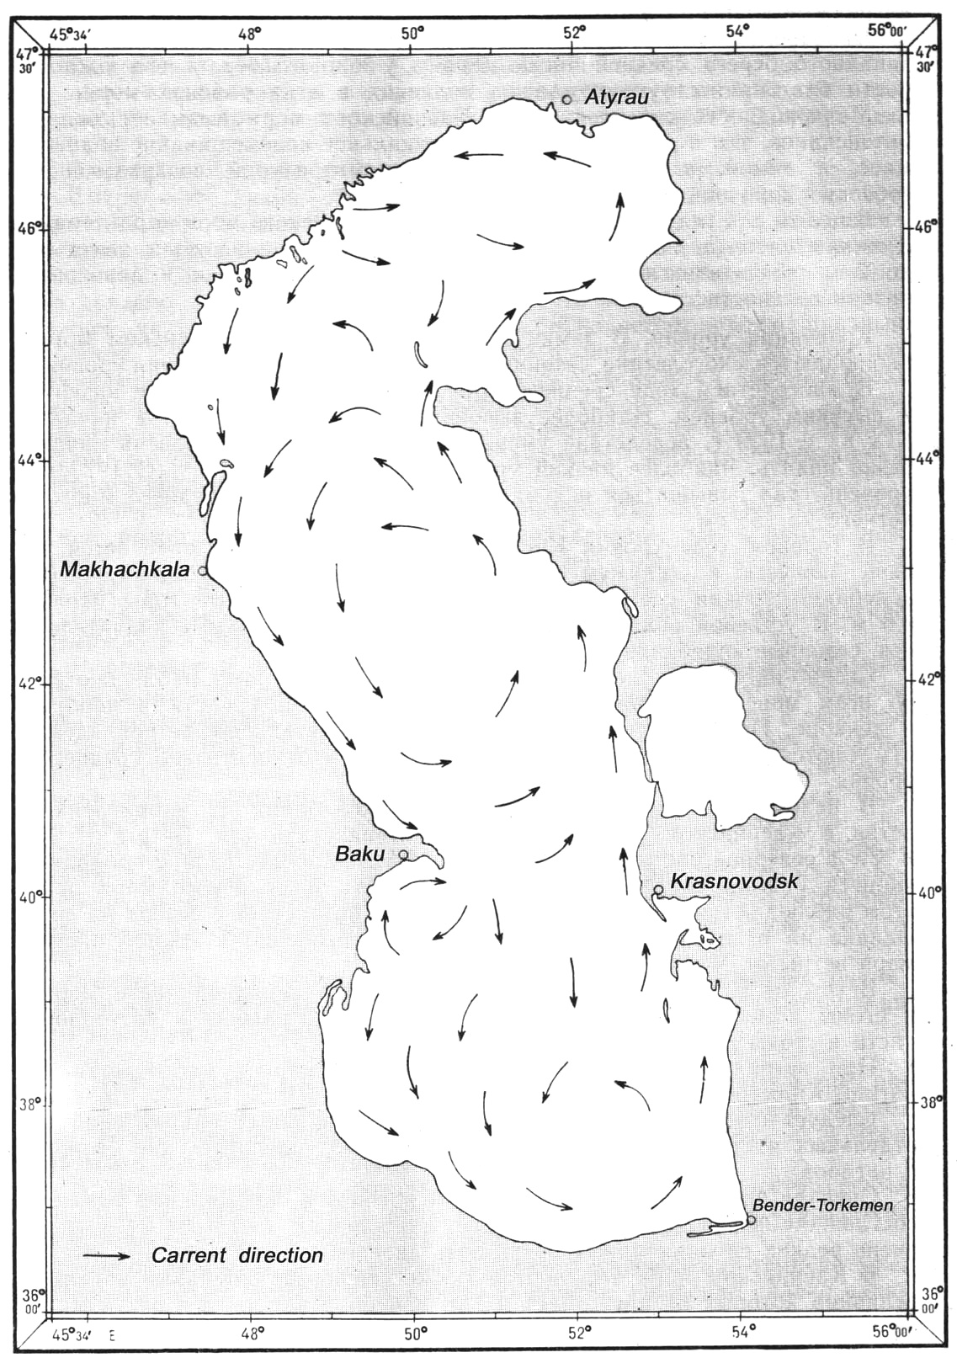
On the next page is presented the scheme of the parts the CS is traditionally divided into. Numbers 1, 2 and 3 in the scheme indicate the N, middle and S parts accordingly.

Scheme of the three parts that traditionally divides the Caspian Sea

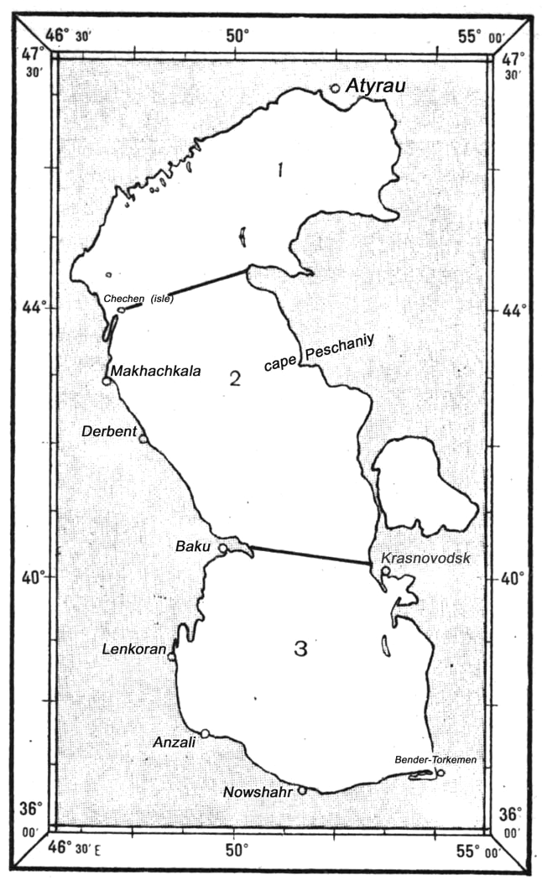

Wave information. The CS is rather turbulent, especially its middle and S parts. In the N part of the sea wave development is restricted by shallow waters as well as ice cover in the period since November till March. Wave height here does not exceed 4 m as a rule. It is only in rare cases in rather deep SW area of the N part that it may attain 8 m.
All year round the wave height of less than 2 m prevails in the CS, its repeatability varying from 65% to 90%. The repeatability of the waves 2 – 4 m high is 10-30%.
In the middle and S parts of the sea wave heights of 6 m and more may be observed all year round. Especially turbulent is the area of Neftyaniye Kamni Island and the area to the NW of it. Wave height may attain 12 m here.
Below the table is shown with information on the repeatability of the wave heights as per the sea areas indicated in the scheme of the sea areas.

Wave heights repeatability, %

Part | Wave height, m | December - February | March - May | June - August | September - November
1 | <1 | ice | 30 | 35 | 20
1 | 1-2 | ice | 45 | 44 | 46
1 | 2-3 | ice | 17 | 14 | 20
1 | 3-4 | ice | 4 | 4 | 9
1 | >=4 | ice | 4 | 3 | 5
2 | <1 | 25 | 35 | 38 | 25
2 | 1-2 | 45 | 44 | 40 | 45
2 | 2-3 | 20 | 14 | 14 | 20
2 | 3-4 | 6 | 4 | 8 | 6
2 | 4-6 | 4 | 3 | 0 | 3
2 | 6-10 | 0 | 0 | 0 | 1
2 | >=10 | 0 | 0 | - | 0
3 | <1 | 35 | 48 | 50 | 40
3 | 1-2 | 45 | 38 | 40 | 43
3 | 2-3 | 15 | 10 | 7 | 12
3 | 3-4 | 4 | 3 | 2 | 3
3 | 4-6 | 1 | 1 | 1 | 2
3 | 6-8 | 0 | 0 | 0 | 0
3 | >=8 | 0 | 0 | 0 | 0
Notice: Hyphen sign ( - ) means the absence of the phenomenon; zero ( 0 ) means its inconsiderable possibility.

The maximum calculated wave height on high seas with the hurricane winds of rare repeatability may reach 17 m. The prevailing wave period is 5 – 7 s.
High waves are observed almost everywhere with the N winds, and only in the NW area of the middle part of the CS they are registered with the winds from SE. In the area of Neftyanniye Kamni wave from the N is most often observed, and in the cold season of the year from the S as well.
In the open area of the middle and S parts of the sea strong swell from the N and NW is often observed, and in the N part the swell is from the S and SE.
Chop is often recorded in the CS.
Water temperature, salinity and density. The temperature of the sea surface layer is expressly characterised by the annual run. In winter it varies from 0*C in the N part of the sea to 14*C in its S part. Higher temperature in the E part as compared to the W part at the same latitude is clearly observed. This is caused by the motion of the warm waters from the S to the N of the sea along the E coast and the transfer of cold waters from the N southwards along the W coast. In summer the water temperatures in the N and S parts are virtually equal ranging from 18 to 26*C. A characteristic feature of temperature distribution in summer in the E half of the middle part is its sharp decrease towards the coastline. In June the temperature changes on approaching the shore are from 19*C offshore to 14*C inshore and in July – August from 24*C to 17*C respectively. In autumn the anomalous temperature decrease is less expressive.
The salinity of the sea surface area in its N part varies from 0.01 ppt in the rivers’ deltas to 13 ppt along the frontier line with the middle part. In the middle and S parts the salinity equals on the average 12 – 14 ppt, and at the W coastline of the S part 10 – 12 ppt. The largest extent of salinity is registered in the SE part of the sea as this area is least influenced by the sweet river water.
The seasonal changes of salinity are most vividly expressed in the N part of the sea where they attain 2 ppt. In the middle and S parts the salinity varies from season to season for not more than 0.2 ppt. In summer salinity is less than in winter.
In the proximity to the fluvial estuaries because of the wind-induced surges the short-term salinity changes to the extent of 5 – 8 ppt are possible. Thus the S winds increase salinity in the W half of the N part of the sea, while the W, NW and N winds decrease it. In the E half of the N part of the sea the W, NW and N winds cause loss of salinity, while the E, SE and S winds increase it. The largest salinity decrease is observed with the NW winds and the largest increase with the E and SE winds.
The density of the surface layer of the sea in its N part increases from the NW to SE, in its middle part from the W to E and in its S part from the SW to NE.
The maximum density is observed in winter: in the N part of the sea it is on the average 1.000 – 1.007; in its middle part 1.010 – 1.011; and in its S part 1.010 – 1.012. The minimum density (on the average it equals 0.998 – 1.006 in the N part; 1.007 – 1.009 in the middle part and 1.006 – 1.009 in the S part) is observed in summer. The largest density fluctuations occur in the areas of direct flowing from the rivers.
Water transparency and colour. Relative water transparency in the CS is not great because of the large amount of turbid fluvial waters. The lowest relative water transparency (0.1m) is observed in the area of the Volga delta. The greater the distance from the river estuaries the higher is the water transparency. In the middle part of the sea it attains 15 m offshore with about 1 m close inshore; and in the S part the figures are 17 m and 1 m respectively.
The water colour in the CS varies from bluish-green to yellowish-brown. In the N part in the high water period or during severe storms the water colour is yellowish-brown, in other periods it is green or yellowish-green. In the middle and S parts the water is green and in the coastal areas it is green or yellowish-green. In the vicinity of river estuaries the colour transforms from yellow to yellowish-brown.
Ice information. The N part of the CS (N to the parallel of 44*00’N) is annually covered with stable motionless ice . In the middle and S parts ice formation is sporadic and only in bays and harbours. In moderate winters the frontier line of the freeze-up area resembles an arc curved northwards and stretching from Chechen Island to the N extremity of Mangyshlak peninsula.
Ice formation usually begins in November in the shallow area of the N part. Closer to mid-December the NE part and shallow areas of the NW part are already covered with ice. The whole of the N part is frozen up in the end of December. Along the E coast of the middle part ice formation begins from the end of November in enclosed bights. Along the W coast the ice appears in the end of December or in the beginning of January. In the S part of the sea ice formation is possible only in rare and exceptionally severe winters. The following table shows the dates of ice formation.
Date of the First Appearance of Ice

Location | Number of years of observation | Number of years when ice appeared | Date of ice appearing
Location | Number of years of observation | Number of years when ice appeared | Early | Mean | Late
Astrakhan, port | 94 | 94 | 10.XI | 6.XII | 18.I
Atyrau, port | 38 | 38 | 29.X | 19.XI | 18.XII
Bekdash, bight | 33 | 11 | 15.XII | 9.I | 25.I
Derbent, town | 31 | 13 | 6.I | 21.I | 15.II
Izberg, bight | 25 | 11 | 23.XII | 22.I | 9.II
Iskusstvenniy, island | 26 | 26 | 26.X | 21.XI | 18.XII
Krasnovodsk, port | 32 | 17 | 7.XI | 3.XII | 4.I
Kulaly, Island (W coast) | 16 | 16 | 7.XI | 3.XII | 4.I
Kulaly, Island (E coast) | 29 | 29 | 9.XI | 10.XII | 29.I
Makhach-Kala, port | 32 | 23 | 1.XII | 10.I | 13.II
Peshnoy, peninsula | 38 | 39 | 18.X | 16.XI | 16.XII
Tuyleniy, Island | 35 | 35 | 5.XI | 8.XII | 3.I
Chistoy Banki, island | 18 | 18 | 18.X | 17.XI | 20.XII

Its maximum development the ice coverage attains in February. In the second half of March the ice becomes deformed and begins drifting. Its edge shifts to the N. In the second half of April the sea is usually entirely clear of ice.
The average ice edge positions in mild, moderate and severe winters are shown in the following scheme (next page).
Ice Edge Position

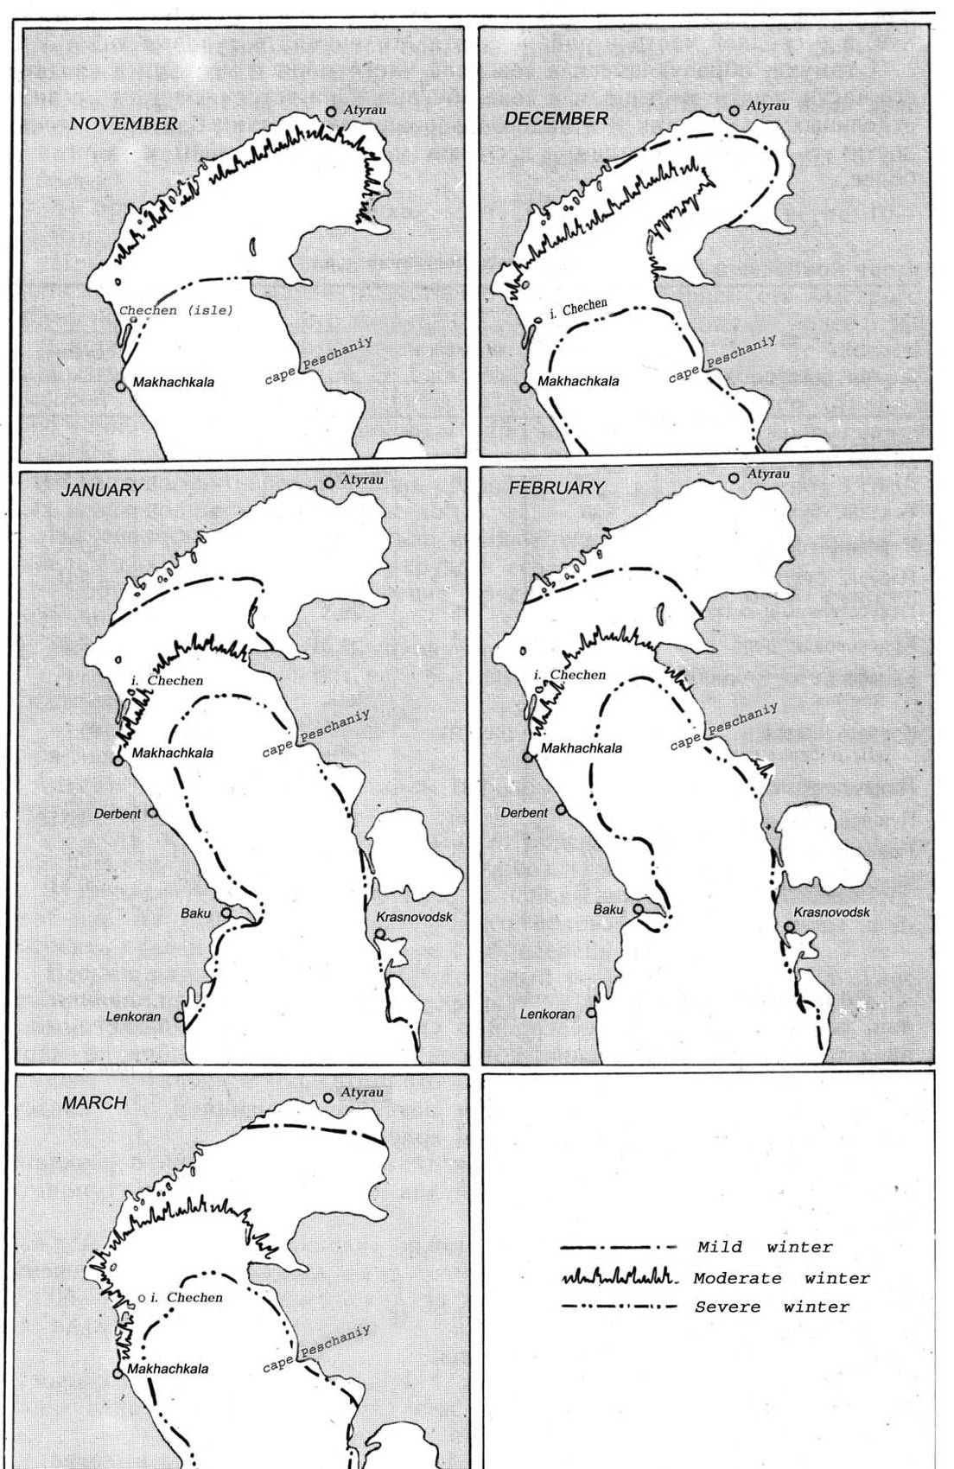

SUMMARY

The sea and IWW shipping traffic between the Mediterranean/Black Sea and the CS is of such a character that many vessels make voyages with BW on board. In most cases the BW is carried during so-called “ballast voyages” and, according to ships’ documents, it is a rare exception when ballast is taken on a loaded vessel for purely navigational purposes (better stability, necessity to decrease air-draft, etc). Ballast voyages are made mainly from some Caspian ports after transportation of equipment or constructions for oil production plants and installations there from the Mediterranean / Black Sea ports. There are variations though. For example, vessels carrying metal scrap from the port of Krasnovodsk (Turkmenbashy) or oily products from Astrakhan to the ports of the Sea of Azov, Black Sea or Mediterranean come back “in ballast”.
Checks of the ships’ documents (Log Book, Ballast Water Record Book, etc) which are regularly carried out in ports do not show violations of the regulations concerning BW operations. According to the log book entries, BW operations along the LV and VDW are quite rare for vessels going along the route under review.
Yet in private discussions which took place during the campaign, some captains on condition of confidentiality admitted that they do not actually change ballast in the areas specified (i.e. before entering the ADSC from SoA and the VCC from AR). They also sometimes uptake or discharge certain amounts of BW while sailing in the LV or through the VDW for navigational purposes without registering it.
As mentioned in the Introductory part of this Report, regular laboratory analysis of the BW is not carried out in the ports from which vessels depart into the CS and SoA, or where they arrive from these seas. This indicates that the actual BW uptake / discharge locations, volumes and original sources from different basins get mixed-up and unaccounted for.
With regard to the local conditions described in the Report, it seems reasonable to draw the following conclusions:
Under the circumstances mentioned above, BW-mediated transfer of extraneous substances and organisms which may be detrimental to the local aquatic fauna is quite possible, as well as potentially quick spread of these organisms throughout the area of their new habitat.

APPENDIX B

Summary History of Inland Waterway Development
and the Russian River Fleet

(adapted from ASMO and other sources)

The following summary is adapted mostly from Vladimir Batsalyov (in ASMO, 2001), with supplementary information from Kormyshov (2005), Isaeva (2006), Levachew (2006) and O. Kazansky (pers. comm.. 2006), plus information at http://www.riverships.ru/.

Beginnings

Five large European rivers (Volga, Dnieper, Kama, Don and Pechora) and four large Asian rivers (Yenisei, Ob, Amur and Lena) are the reason why Russian river ships have had a long and strategically important history that extends back to the 6-7th Centuries.

An account of the Great Merchant Route, written in circa 626, describes the difficult and often dangerous journey taken by Kiev merchants. from the Black Sea to the Baltic. Rowing up the Dnieper, they subsequently dragged their boats along the Western Dvina to the Lovat River, crossed the Ilmen Lake, sailed along the Volkhov River to Lake Ladoga and then finally entered the Neva River to reach the Baltic Sea.

However most river exploration and trade was conducted by the Novgorodians, who explored the rivers of the Northern Urals and Western Siberia (Northern Dvina, Mezen, Pechora, Vyatka, Kama), as well as pioneering the 3000 km Sukhona-Vychegda-Pechora-Arctic Ocean route. To the South, the Novgorodians trail-blazed routes as far as India via the Volga.

The Neva supported the largest and most important river fleet, with significant trade running upstream from Novgorod and Kotlin Island, passing the Ivanovskiye Rapids to reach Lake Ladoga, then down the Volkhov to Gostinnopolye. The Volga, which is Europe’s longest ‘north-south’ (meridinal) river, was reached by several portage routes. The most important access was the Lamsky Portage because this led to Moscow and the Ryazan Principality.

Influence of Ivan The Terrible

During the 16th Century the waterways around Moscow became the hub of Russian river trade, with passages from Moscow to the Sea of Azov taking just over a month. The river trade stimulated the unification of the lands and waterways around Moscow, then focussed Moscow’s attention to the Volga. The Kazan Khanate prevented free passage along the lower Volga until Ivan the Terrible conquered Kazan then Astrakhan, allowing Russian control and unification of the complete Volga system. This action stimulated trade to the Caspian Sea and Central Asia, driven by the use of large boats (strugs) that carried >250 tons of cargo along the Moskva, Oka then Volga rivers.

In 1553 a single British ship (the remnant of an ill-fated expedition to explore a possible Northern Sea Route to India) was blown into the White Sea by a storm, then entered the mouth of the Northern Dvina River. After entertaining the captain in Moscow, Ivan the Terrible saw the value of a foreign trade route through the White Sea basin, and therefore founded the town of Archangel at the mouth of the Northern Dvina. The new route along the Northern Dvina was subsequently serviced by long flat-bottom boats (doshchaniki and nasadki) and passenger barges.

By 1601 Yermak had opened up routes along the Chusovaya, Serebryanaya and Zheravlya rivers to reach the Tagil and Tura rivers in Siberia, with the trading post of Mangazeya established on the Taz River (a tributary of the Yenisei). By 1646 Vassily Poyarkov had ended a three year voyage to the Amur, covering 7,000 km and three portages to form a new waterway from the Volga and Kama to the Amur River via the Ket', Kas, Jenisei, Lena, Angara, Ilim, Muk and Kupa systems.

In the 1660s Moscow decided to build a road to the North-West by force, a task requiring a powerful military fleet that was assembled in the Volga basin (Dedinovo, Kolomenskoye district) on the decree of Tsar Alexei Mikhailovich. In 1668 the Dedinovo shipyards produced the "Oryol" (Eagle) plus a yacht, a large boat and two pulling boat (while Stepan Razin’s brigands were operating their own 80 ship fleet on the Volga).

Influence of Peter I

Tsar Peter I (Peter the Great) continued Russian Imperial interest in the river fleet, transforming Russia into a naval power with ships built in Kazan for the Caspian Sea, and built in Voronezh for the Sea of Azov (north-east Black Sea).

Peter I also studied the concept of connecting the Black Sea and Caspian Sea via the Don and Volga rivers. Although releasing Russia could not afford to build this link, he arranged the deepening of river-beds in several places. After founding St. Petersburg in 1703, Peter I turned his attention to connecting the Neva with the Moskva -Volga Rivers, a task completed in 1722 by M. Serdyukov via the Vyshny Volochek canal system.

During the 18th century, development of Russia’s river navigation and river ship designs was centred on the Volga, including the appearance of the rasshiva, a vessel purpose designed for navigating the numerous shoals and rapids of the Volga system. The rasshiva combined lightness with high carrying capacity, simple construction and durability, and could cover 80 km per day sailing down the river. It was dragged upstream back by barge haulers (over 600,000 in the Volga basin), while on the Oka River ships were dragged upstream with the help of horses.

Impact of Steam

The first steamboats were built in 1815, two at Kama – the town which eventually became the centre of the Russian steam navigation. Until 1843 most steamships on the Volga were kabestans (vessels that were also horse-drawn when going upstream). More powerful ships were developed following the opening of a regular steamship service by the ‘Along Volga’ Navigation Company.

The advent of steamships led to a rapid burst of river deepening and canal building projects during the middle to late 19th Century, the latter including the Berezino, Mari and Tikhvin systems, the Northern-Yekaterininsky canal and the Vindavsky waterway. The Sornovo shipyards built the first two-deck steamships with heated cabins and running water, and pioneered the development of cargo-passenger steamships, followed by purpose-built tankers and barges for oil transport.
By 1895 there were about 150,000 km of relatively navigable waterways and 2,539 steamships (200 of which were working in the Asian part of Russia), providing employment for 128,000 people. By 1901 there were approximately 400 ship-building centres along the banks of the Volga, Kama and Don Rivers. Together these yards produced nearly 4000 vessels per year, including the Izhorsky and Yepanchin yards. In 1903 the world's first motor ship, the bulk oil vessel Vandal, was built and launched at the Sornovo shipyards.

The first years of the 20th Century marked a ‘peak’ in Russian river traffic. Most of the river fleet belonged to private owners, but the government allocated very little money for maintaining the rivers in a navigable state. This was because Treasury also owned 66% of the competing railways. Thus many waterways were allowed to become shallow, and many lock systems gradually deteriorated. However navigable depths were maintained for the most important 10,000 km of waterway and Russia continued to outperform other countries in the number of steamship built. By 1913 the annual amount of cargo transported by the Russian river fleet (48 million tons) represented 29% of the country's entire freight turnover, and river steamships carried 11.2 million passengers in the same year.

Ups and Downs of the 20th Century

All shipping companies were nationalised in February 1918. The river fleet went into rapid decline until 1921, when Lenin was forced to launch a ship-repair programme to ensure adequate oil transport along the Volga and Lena systems. State steam-navigation lines were formed in 1923 and by 1924 total national river freight movements had recovered to 40% of the pre-1917 figure.

Between 1931 and 1933, the waterway connecting the White Sea and Baltic Sea was completed within 20 months, while the 128 km long Moskva - Volga ship canal was built in 4 years and 8 months. By 1940 the total length of working waterways had recovered to 102,000 km. During the Great Patriotic War (WWII) some 67,000 km of the waterways were equipped for night-time navigation, and the river fleet underwent a major modernisation program with new cargo ships exceeding the 500 tonne carrying capacity mark. Much damage occurred during 1941-1945, and post-war restoration and reconstruction was initially focussed on the White Sea - Baltic Sea Canal plus the locks near the Dnieper power station.

New ‘River-Sea’ vessel classes which could safely access foreign ports were introduced in 1949, and a period of river deepening began following the development of improved bucket dredging plant. Dozens of new man-made lakes and reservoirs appeared on the map, many forming part of the Unified Deep Water System (UDWS) that today incorporates the Volga-Baltic waterway, the Volga-Don canal, the White Sea-Baltic Sea canal and the Moskva (Moscow) canal.

On the other hand, steady improvements to Russia’s rail, road and air transport corridors have seen an overall decline in the share of the total freight and passenger movements carried by the river fleet, particularly in the post-Perestroika depression of the mid-1990s. Thus reported peaks of IWW cargo movements in the 1980s (>580 million tons for 1988) rapidly declined to some 100 million tons by 1996. Thus from the 29% of all cargo carried achieved in 1913, the percentage share by IWW had declined to 7% by 1955, steadied in 1970s-1980s, then declined to 4% by 1998.
Cargo movements gradually began increasing from 1999, reaching 136 million tons plus ~30 million passengers by 2004 (Kormishov 2005). Present figures still represent less than 5% of the total volume transported by all modes of transport in the RF. However several forecasts indicate a steady increase in the annual volume of transported cargo to as much as 230 million tons by 2010.

Present Day and Future Outlook

The total length of the present day UDWS is 6300 km, with 5500 km rated at 3.5 m depth or more. The present cargo fleet includes a range of River and River-Sea/Short-Sea classes of cargo ships and tankers in the 1,200 - 6,500 DWT range (including some methyl-ethylene glycol [MEG] tankers, oil-bulk-ore ships, refrigerated produce carriers as well as several types of dry bulk, general cargo and mixed bulk/container cargo ships). There are also a large number of tugs (mostly pusher types) and barges, plus ice breakers, dredges and numerous passenger ferries. The present passenger fleet is dominated by hydrofoil ferries plus various excursion/entertainment ships and some three and four-deckers which service long distance routes.

Much of the fleet comprises Soviet-era vessels, with average vessel age being 20-25 years old. Of the 2,200 registered units, up to 50% are not in operation and/or are out of date. The various ‘River-Sea’ vessel classes hold the prominent position. During the post-perestroika depression of the 1990s, most of the larger shipping entities managed to avoid closure by using these vessels to capture parts of the European trade that extends well beyond the IWW. River-sea vessels are commercially attractive as they can leave the IWW and operate all year, thus avoiding the 3 - 5 month winter freeze that stops the River classes.
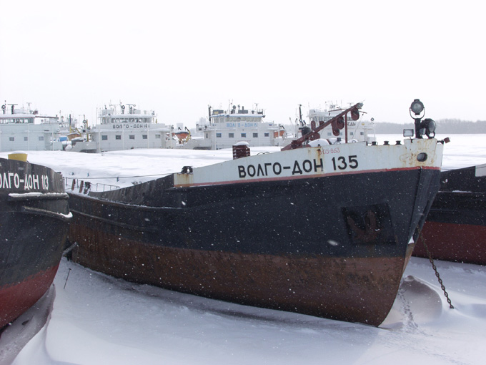

River class general cargo ships (Volga-Don types) over-wintering in 2005 near one of the
central Volga maintenance bases operated by the JS Volga Shipping Company.
With the post-1998 growth in international trade, the number of River-Sea vessels has been increasing (they are reported to have carried over 30 million tons of cargo in 2004; Kormishov 2005). On the other hand, with almost 75% of all domestic and international cargoes transported on the IWW being carried by RF companies, the operable RF-flagged cargo fleet has been close to full utilisation, a feature helping to stimulate investment in new River-Sea builds since ~2003.

While development of River-Sea shipping continues to be partly constrained by some key IWW bottlenecks, their international trade no longer experiences the types of maritime administration and safety difficulties that arose in the late 1990s / early 2000s, mostly from the lack of recognised Class data for these ships plus a number of equipment problems, all which have since been rectified (Kormishov 2005).

Isaeva (2006) has noted that although more up-to-date cargo and passenger vessels are needed, it has not been profitable to build many new vessels. While European carriers have similar problems (including high vessel amortization levels, vessels that don’t meet modern demands, HR problems and lack of investors), they have had better finance opportunities for fleet updates. However the RF has worked to improve investment situation and the number orders by RF companies for River-Sea vessels has been rising since ~2003.

A major part the RF River-Sea fleet is reported to be owned by four companies (Volgotanker Co., North-Western Shipping Co., Volga Shipping Co. and White Sea-Onega Shipping Co), and these firms are also reported to have carried the major portion of the river-sea international trade in 2004 (Kormishov 2005). Most of the large shipping companies have implemented plans and sought finance and investors to acquire / modernise River-Sea vessels with capacities to 6500 DWT , and a number have already been built by RF shipyards on the Volga as well as in other countries.

Economic development in the RF since 1996 has altered both the composition and direction of present cargo flows, which are now mostly westward to Rostov-on-Don/Black Sea in the southern sector (VDW), and northward to St. Petersburg / Baltic Sea in the northern sectors (VBW). The traffic has exposed bottlenecks along the VDW and VBW, particularly the shallow Gorodetsky lock section on the central Volga near Novgorod. If the water level situation caused by a problematic HE complex in this region is not resolved, it has been feared that the UDWS may become more permanently divided into ‘southern’ and ‘northern’ sectors (Kormyshov, 2005). Fixing the problem at Gorodets has been estimated to require some 15 billion Russian rubles – a major issue as all rivers, navigable waterways and hydraulic structures are state property.

River-sea transport in general has also suffered across Europe with respect to flexibility and speed of delivery, factors which heavily influence a shipper’s choice on the mode of transportation. Since future transport options need to be economical and environmentally friendly, the 2001 Pan-European Conference of Ministers of Transport (Rotterdam) adopted recommendations for promoting the inland water transport sector in Europe and unifying its rules. A key RF national initiative has been its Federal program entitled: “Government and Business Community Interaction in Shaping and Implementing the First Phase of the Russian Transport Development Strategy till 2010”.

This program has been tackling several issues such as improving the competitiveness of inland waterway transport, the impact of allowing foreign-flagged vessels into the IWW, waterway and facilities maintenance, improving investment and financial structures, and evolving ports into multi-modal transport nodes. RF’s accession negotiations with the World Trade Organization (WTO) have caused several analysts and commentators to examine the present status and future outlook of the UDWS and existing River-Sea fleet.

If the inner routes are opened to foreign vessels, there are fears their capacity will not be fully used, also causing a reduction in RF vessel loadings and general loss of competitiveness. There is already a partial openness of the RF waterways for international traffic, with foreign-flagged vessels permitted as far as the ports of Azov and Rostov (from the Black Sea), Astrakhan (from the Caspian Sea) and St. Petersburg (from the Baltic Sea). Some European ship-owners (principally Turkish such as Palmali Shipping) also obtained the right to fly the Russian flag by registering their company in the RF, and have subsequently moved freight between some RF ports as well as transiting the BS-CS Waterway.

Many sectors of the UDWS will need to be upgraded to ensure orderly safe navigation by foreign-flagged vessels following WTO accession. Currently the RF Government has set the Sea of Azov- VDW-Astrakhan route to be prepared by 2007, followed by completion of the St. Petersburg – Volga - Astrakhan route by 2010. Both projects require legislation revision and substantial financing to provide navigational aid improvements, new organisational structures, vessel servicing infrastructure and HR training.

Waterway maintenance and repair bills are rising and tariffs will need to be lifted, an issue involving discussions with key stakeholders including the Association of Shipping Companies and the Association of the Ports and Owners of the River Fleet. Most understand the need for such measures, otherwise the infrastructure may become dangerous and constrain vessel movements. Apart from de-bottlenecking, requirements include a new vessel traffic management service, reorganization of the river pilot service, upgrades to the vessel servicing infrastructure, and legislative adjustments (joint work under the UNECE framework has already achieved substantial progress, particularly on navigational rules and signals).

On 1 August 2006 Vladimir Putin, Russian President, signed the order to improve the situation of the IWW, and the measures are planned to start quickly (Isaeva 2006).

Examples of the ship types which contributed to the BW recording activity in 2006 are shown on the following pages, followed by a list and Table (B-1) of present-day and recent shipping companies.

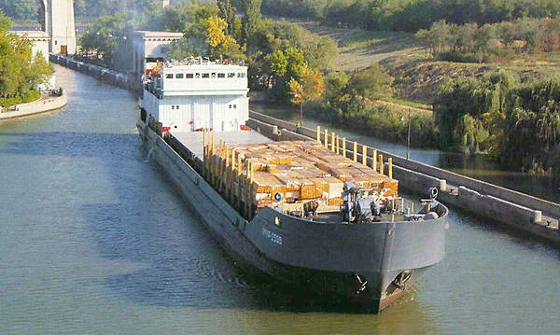
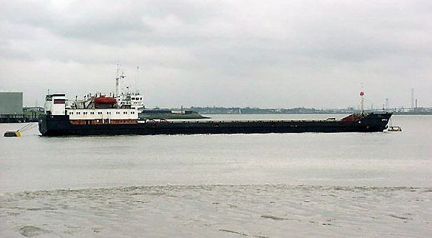

Amur-2508 on Volga Don Canal (VSC photo) Amur-2531 at Thames River 2001 (D.S.)

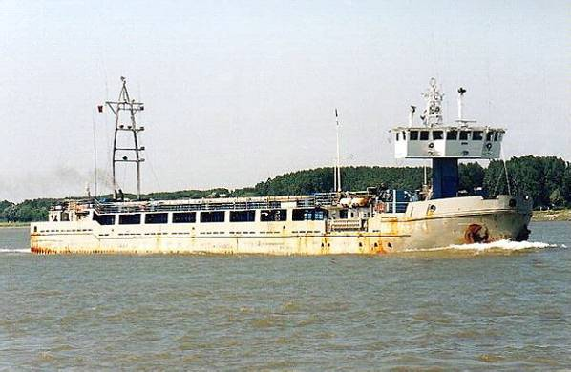
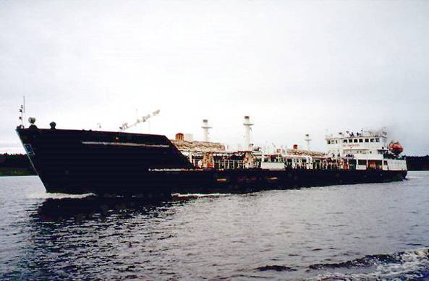

Ladoga-104 in the Netherlands, 1997 (D.S.) Lenaneft-2059 chem/products tanker (D.S.)
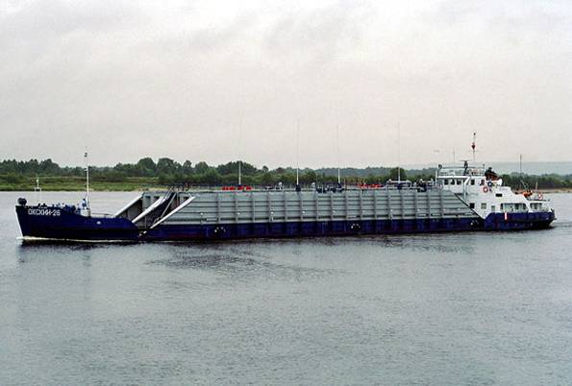
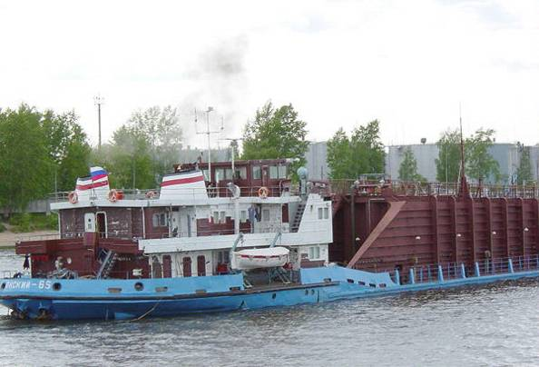

Okskiy-26 in 2004 (D.S. photo) Okskiy-65 near Yaroslavl (D.S. photo)
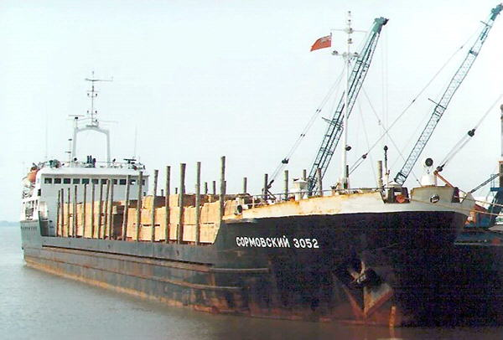
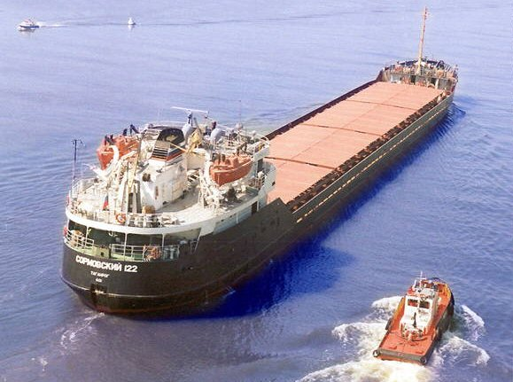

Sormovskiy-3052 in Goole, 2000 (D.S. photo) Sormovskiy-122 (North-Western SC)
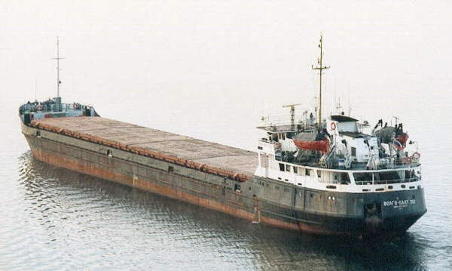
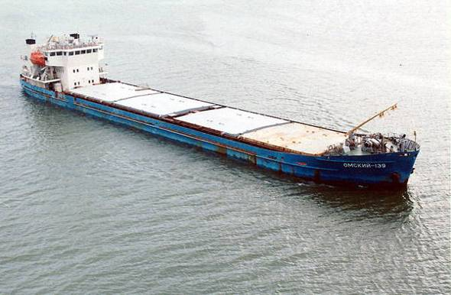

VolgoBalt-202 in the Finnish Gulf (D.S.)
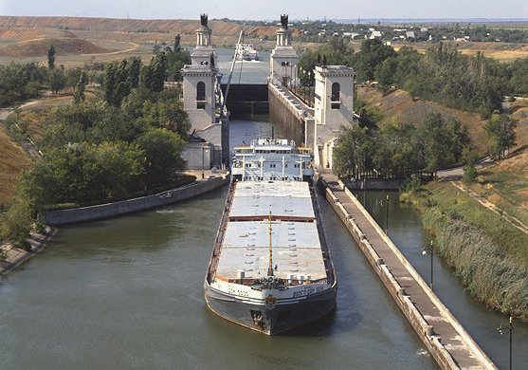
Omskiy 139 (photo: Dimitriy Shalaev)
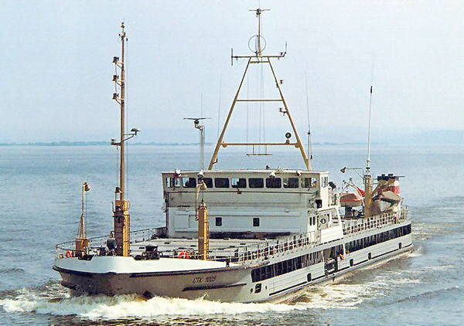
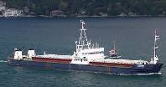

STK-1009 (inset: Haritina 2004) (PhotoIO) VolgoDon type on the Volgo-Don canal (VSC)
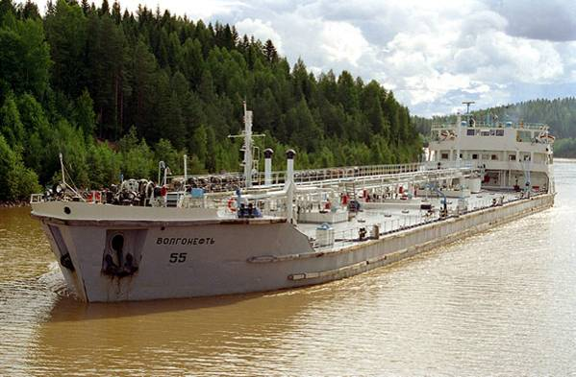
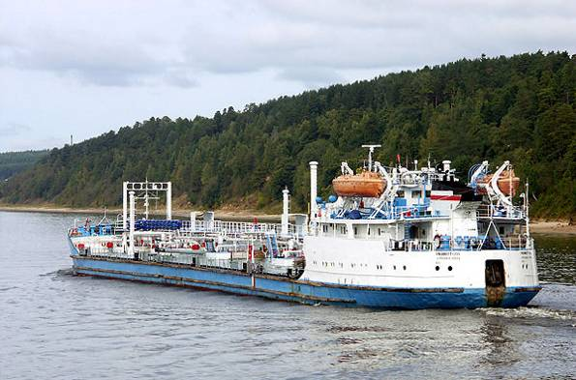

Volgoneft-255 on Volga below Rybinsk (D.S.) Volgoneft-55 on the Kovzha River (D.S.)
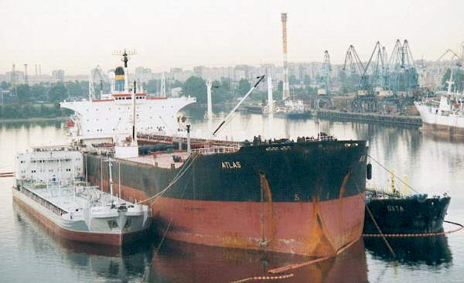
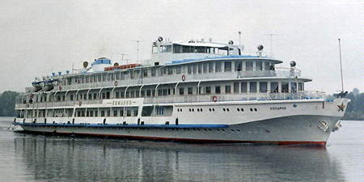

One of the four-deckers (Oktyabrskaya Revolyutsyya type) operating “Moscow-
Volgoflot and Volgoneft tankers loading Astrakhan” routes of the Volga Shipping Co.
to the M/T Atlas at St. Petersburg (no date). during the summer periods of 2003-2006
List of Shipping Companies providing IWW services
(http://www.riverships.ru/english/shipping.shtml )

Volgotanker Shipping Company
Historical operation area. Transportation of oil and oil products on Volga and other waterways of the United Inland Deepwater System of Russia, "river-sea" shipping in Europe.
Main home ports. Astrakhan, Samara, Yaroslavl, Ufa ("Bashvolgotanker").

Volga Shipping Company
Historical operation area. Passenger and cargo shipping on Volga and other waterways of the United Inland Deepwater System of Russia, "river-sea" shipping in Europe.
Home ports. Yaroslavl, Kostroma, Nizhniy Novgorod, Samara, Saratov, Volgograd, Astrakhan.

White Sea & Onega Shipping Company:
Historical operation area. Passenger and cargo shipping on Onega lake, White Sea- Balt canal, Volga-Balt waterway, "river-sea" shipping on Baltic, White, Azov and Black seas.
Main home ports. Petrozavodsk.

North-Western Shipping Company:
Historical operation area. Passenger and cargo shipping on Neva, Volga-Balt Waterway, River-Sea shipping in Europe, Ladoga and Onega lakes.
Main home ports. St. Petersburg, Cherepovets, Novgorod.

Belaya River Shipping Company
Historical operation area. Passenger and cargo shipping on Belaya, Kama, Volga.
Main home ports. Ufa.

Kama River Shipping Company
Historical operation area. Passenger and cargo shipping on Kama, Volga, "river-sea" shipping on Azov, Black and Mediterranean seas.
Main home ports. Perm, Chaykovskiy, Berezniki, Naberezhnye Chelny.

Kuban River Shipping Company
Historical operation area. Passenger/ cargo shipping on Kuban, "river-sea" shipping on Black Sea.
Main home ports. Temryuk, Krasnodar.

Lena United River Shipping Company
Historical operation area. Passenger and cargo shipping on Lena with tributaries, Yana, Indigirka, Kolyma, arctic "river-sea" shipping.
Main home ports. Osetrovo (Ust-Kut), Kirensk, Lensk, Olekminsk, Yakutsk, Tiksi.

Moscow River Shipping Company
Historical operation area. Passenger and cargo shipping on Moskva (Moscow river), Oka, Moscow-Volga canal, Upper Volga, Seliger, "river-sea" shipping on Azov, Black and Mediterranean seas.
Main home ports. Moscow, Tver, Ryazan, Kasimov, Murom, Uglich, Rybinsk.

Volga-Don Shipping Company
Historical operation area. Passenger and cargo shipping on Don, Volga-Don canal, Volga, "river-sea" shipping on Azov and Black seas.
Main home ports. Rostov-on-Don, Kalach-on-Don, Volgodonsk, Pavlovsk.

Western River Shipping Company
Historical operation area. Passenger and cargo shipping on the rivers of Kaliningrad Region (earlier including soviet baltic republics), "river-sea" shipping on Baltic sea.
Main home ports. Kaliningrad.

Table B-1: Shipping Companies presently or recently operating the ships that participated in the 2006 BWRF census.

Participating ships (N) | Present or Recent Shipping Company / Fleet Operator
5 | White Sea - Onega Shipping Co, St Petersburg
4 | Daf & Co Ltd., Pnomh Penh
4 | North-Western Shipping Co, St Petersburg
4 | Ob-Irtysh Shipping Co, Saint Petersburg
4 | JSC Volga Shipping Co , Taganrog
4 | Volgotanker, Astrakhan
3 | Moscow Shipping Co , Pnomh Penh
3 | Northern Shipping Co , Arkhangelsk
3 | Transpetro-Volga, Astrakhan
3 | Upper Lena Shipping Co (Norlat Shipping), St Petersburg / VD Ship Co
2 | Brothers Tanker Trading SA, Pnomh Penh
1 | Amur Shipping
1 | Caspian Shipping
1 | ex-Belaya Shipping Co (ST-1358)
1 | ex-North-Western Shipping Co, St Petersburg
1 | Kama Shipping Co, Taganrog
1 | Kirenskaya
1 | Navigator, St Petersburg;
1 | North Caspian Shipping
1 | Seferoglu Denizcilik, Valletta
1 | TOP Shipping & Trading (St Vincent & Grenadines)
1 | Vagna Shipping
1 | Volga-Don Shipping Co, Kingstown
1 | Western Shipping Co, Kaliningrad
1 | Yenisey / Ob-Irtysh Shipping Co (Blue Sprinter Shipping, Pnomh Penh)
19 | Unidentified companies

APPENDIX C

Bi-lingual Ballast Water Record Form (BWRF)
and Guidance Document

(used for recording Shipping Activity and BW movements along the Volgo-Don Waterway in summer of 2006)

ОПЕРАЦИИ С БАЛЛАСТНЫМИ ВОДАМИ - ФОРМА ЗАПИСЕЙ
Ballast Water OPERATIONS - ReCORD Form

Для судов, совершающих рейсы с проходом
по Волго-Донскому водному пути

For vessels making voyages which include
the Volgo-Don Waterway passage

- Данный бланк применяется для записи всех балластных операций при совершении рейса, включающего в себя проход по Волго-Донскому водному пути / Please use this form to record all ballasting operations during the voyage which includes the Volgo-Don Waterway passage.
- Заполните часть 1 в начале рейса. / Please complete Part 1 at the start of the voyage.
- На последующих страницах необходимо вести записи каждой балластной операции после захода на Волго-Донской водный путь / Use the subsequent pages to record every ballast operation after entering the Volgo-Don Waterway.
- По окончании рейса заполните последнюю часть, затем подайте (или передайте факсом или по э/почте) все заполненные страницы по следующему адресу: / At the end of the voyage, please complete last part then submit (or fax or e-mail) all completed pages to:
_______________________________________________________________________
О.Г.Казанскому, Заместителю капитана порта
по безопасности мореплавания ФГУ «АМП Астрахань»

Oleg G.Kazansky, Deputy Harbour Master,
FSI “Astrakhan Maritime Port Administration”
э/почта / e-mail okazans@narod.ru _______________ Факс /Fax: (8512) 58 57 12

Пояснения к последующим таблицам: / Explanations for the following tables:

* Такие как низкие мосты, мелкое озеро/ перекат/ порог шлюза / линии эл.передач и т.д
* e.g. low bridge / shallow lake / sand bar / lock gate sill / power lines, etc

. км = километр / km = kilometres м = метр / m = metres

** Коды, используемые для обозначения танков: Форпик=FP Ахтерпик=AP Двойное дно=DB Бортовой танк= SB , Бортовой подпалубный танк = WT,
Грузовой танк= CT, Грузовой трюм= CH, Другие танки= OT

** Use tank codes: Forepeak = FP, Aftpeak = AP, Double bottom = DB, Side-bottom = SB, Wing = WT Cargo tank = CT, Cargo hold = CH, Other tank = OT
- Данные судна / Vessel Information
Регистрационный номер:  Registration No: |  | Номер ИМО:  IMO number:  (if international vessel)
Название судна:  Name: | Позывной сигнал:  Call sign: | Тип судна:  Type: | Максимальный объем балласта, которое судно способно принять на борт( т):  Maximum Ballast Capacity (t):
Флаг:  Flag: | Дедвейт:  DWT (t): | Валовая вместимость:  GRT(t):
Количество балластных танков:  Number of dedicated ballast tanks: |  | Количество грузовых танков или трюмов, используемых для балласта:  No. of cargo tanks or holds used for ballast:
(т) = метрические тонны , (t) = metric tonnes

2 НАЧАЛО ПЛАВАНИЯ ПО ВОЛГО-ДОНСКОМУ ВОДНОМУ ПУТИ – МЕСТОПОЛОЖЕНИЕ, ОСАДКА И ИНФОРМАЦИЯ О НАЛИЧИИ БАЛЛАСТА
Start of Voyage – Location, Draft, Ballast Info
Дата (дд/мм/гг):  Date (dd/mm/yy): |  |  | Время (24 часа):  Time (24:00) : |  | Всего балласта на борту (т):  Total Ballast on board (t):
Осадка судна (в метрах): Vessel draft (metres) |  |  |  | Высота судна от ватерлинии (метры):  Vessel air draft (metres) :
Последний морской порт захода:  Last Sea Port of Call: |  |  |  | Порт назначения:  Entry Port:
Количество балластных танков, заполненных балластом:  No. of ballast tanks in ballast: |  |  |  | Количество грузовых танков/трюмов в балласте:  No. of cargo tanks/holds in ballast:
Местонахождение балласта  Source(s) of ballast |  | Место (места) приёма балласта:  Location(s) where ballast water was taken: |  |  |  | Дата приёма балласта (дд/мм/гг Date of uptake (dd/mm/yy):
№ танка/ов **
Tank No/s**
№ танка/ов **
Tank No/s**
№ танка/ов **
Tank No/s**
№ танка/ов **
Tank No/s**
№ танка/ов **
Tank No/s**
№ танка/ов **
Tank No/s**
№ танка/ов **
Tank No/s**
№ танка/ов **
Tank No/s**
№ танка/ов **
Tank No/s**
№ танка/ов **
Tank No/s**
№ танка/ов **
Tank No/s**
№ танка/ов **
Tank No/s**
3(a) Начало плавания по Волго-Донскому водному пути – местоположение, осадка и информация о наличии балласта
Start of Volgo-Don Waterway Passage – Location, Draft, Ballast Information
Дата (дд/мм/гг):  Date (dd/mm/yy): |  |  | Время (24 часа):  Time (24:00) : |  | Всего балласта на борту (т):  Total Ballast on board (t):
Осадка судна (в метрах): Vessel draft (metres): |  |  |  | Высота судна от ватерлинии (метры):  Vessel air draft (metres) :
Количество балластных танков, заполненных балластом:  No. of ballast tanks in ballast: |  |  |  | Количество грузовых танков/трюмов в балласте:  No. of cargo tanks/holds in ballast:
Местонахождение балласта  Source(s) of ballast |  | Место (места) приёма балласта:  Location(s) where ballast water was taken: |  |  |  | Дата приёма балласта (дд/мм/гг) :  Date of uptake (dd/mm/yy):
№ танка/ов **
Tank No/s**
№ танка/ов **
Tank No/s**
№ танка/ов **
Tank No/s**
№ танка/ов **
Tank No/s**
№ танка/ов **
Tank No/s**
№ танка/ов **
Tank No/s**
№ танка/ов **
Tank No/s**
№ танка/ов **
Tank No/s**
№ танка/ов **
Tank No/s**
№ танка/ов **
Tank No/s**
№ танка/ов **
Tank No/s**
№ танка/ов **
Tank No/s**
№ танка/ов **
Tank No/s**
№ танка/ов **
Tank No/s**
№ танка/ов **
Tank No/s**
№ танка/ов **
Tank No/s**
№ танка/ов **
Tank No/s**
№ танка/ов **
Tank No/s**
№ танка/ов **
Tank No/s**
№ танка/ов **
Tank No/s**

3(b) Плавание по Волго-Донскому водному пути – Записи балластных операций
Volgo-Don Waterway Passage – Record of Ballasting Operations

Дата (дд.мм.гг.)  Date (dd/mm/yy): |  |  |  | Время начала приёма  Start time (24:00): | Время окончания:  Finish time:
Место начала операции:  Location of Operation start: |  |  |  | Расстояние от входа в шлюз / подхода к препятствию и т.п. (км)  Distance from entrance into the lock / approach to the obstacle, etc. (km):
Цель операции
Reason (Purpose):
Тип препятствия *
Type of obstacle*:
Место окончания операции:  Location at operation finish: |  |  | Расстояние от входа в шлюз / подхода к препятствию и т.п. (км)  Distance from entrance into the lock / approach to the obstacle, etc. (km):
Балластная операция:  Ballast Operation: |  | Приём (T) или сброс(D) балласта  Discharge (D) or Uptake (T) | Объем сброшенного или принятого балласта (в тоннах)  Volume discharged or taken (metric tonnes)
№ танка/ов **
Tank No/s**
№ танка/ов **
Tank No/s**
№ танка/ов **
Tank No/s**
№ танка/ов **
Tank No/s**
№ танка/ов **
Tank No/s**
№ танка/ов **
Tank No/s**
№ танка/ов **
Tank No/s**
№ танка/ов **
Tank No/s**
№ танка/ов **
Tank No/s**
№ танка/ов **
Tank No/s**
№ танка/ов **
Tank No/s**
№ танка/ов **
Tank No/s**
№ танка/ов **
Tank No/s**
№ танка/ов **
Tank No/s**
№ танка/ов **
Tank No/s**
Количество балластных танков, заполненных балластом  No. of ballast tanks now with ballast: |  |  | Количество грузовых танков или трюмов, заполненных балластом  No. of cargo tanks or holds now with ballast:
Новая осадка судна:  New vessel draft (m): |  |  | Новая высота судна от ватерлинии:  New vessel air draft (m)
- Окончание плавания по Волго-Донскому водному пути – Сведения по приходу End of Volgo-Don Waterway passage - Destination Information

Осадка судна (метры):  Vessel draft (metres): |  |  | Высота судна от ватерлинии (в метрах)  Vessel air draft (metres) :
Место выхода их Волго-Донского водного пути:  Exit location: |  |  | Общее количество балласта на борту (т)  Total ballast on board (t):
Следующий порт захода  Next Port of Call (name): |  |  | Ожидаемая дата прибытия ( дд/мм/гг)  Expected arrival date: (dd/mm/yy)
Количество балласта, намеченного для сброса в следующем порту захода:
Total intended ballast discharge at Next Port of call (t):
Предполагаемые операции:  Predicted tank operation: |  | Сброс (D) или приём (T)  Discharge (D) or  Uptake (T) | Объем сброшенного или принятого балласта  (в тоннах)  Volume discharged or taken (metric tonnes)
№ танка/ов **
Tank No/s**
№ танка/ов **
Tank No/s**
№ танка/ов **
Tank No/s**
№ танка/ов **
Tank No/s**
№ танка/ов **
Tank No/s**
№ танка/ов **
Tank No/s**
№ танка/ов **
Tank No/s**
№ танка/ов **
Tank No/s**
№ танка/ов **
Tank No/s**
№ танка/ов **
Tank No/s**
№ танка/ов **
Tank No/s**
№ танка/ов **
Tank No/s**
№ танка/ов **
Tank No/s**
№ танка/ов **
Tank No/s**
№ танка/ов **
Tank No/s**
Волго-Донской водный путь

ОПЕРАЦИИ С БАЛЛАСТНЫМИ ВОДАМИ - ФОРМА ЗАПИСЕЙ

ИНФОРМАЦИОННЫЙ ЛИСТ (проект)
При поддержке и в сотрудничестве с Государственной морской аварийной и спасательно-координационной службой Российской Федерации (ГМСС, МТ РФ), Международная Морская Организация (IMO), Каспийская Экологическая Программа (КЭП) и_Департамент ООН по Обслуживанию проектов (UNOPS) инициировали исследование, целью которого являются:
- оценить роль перемещения в судовых балластных водах нежелательных и потенциально вредных морских биологических видов в Каспийское море и из него;
- обозначать и оценить практические мероприятия, которые могут уменьшить эти перемещения.
В связи с наличием в морской биоматерии (живые существа, обитающие в море) вредоносных организмов, планктона, хищников и переносчиков болезней существует насущная и неотложная потребность снизить уровень перемещение этой биоматерии, которая способна выживать в балластных танках. Если эти нежелательные организмы, перевезённые на судах, приживутся в Каспийском море, это может привести к ускоренному росту их популяции, что в свою очередь вызовет значительный экологический и экономический ущерб, например, уничтожение коммерческих запасов кильки и осетровых, вымирание от голода Каспийских тюленей.
Для достижения вышеупомянутых целей, одна из самых важных и критических задач проекта состоит в том, чтобы на основании предоставляемых капитанами данных обозначить места, где суда принимают и сбрасывают балластные воды в течение их рейса между черноморскими, средиземноморскими портами и портами Каспийского моря, а также – объёмы этих балластных вод.

Поэтому всем судам, которые перевозят откачиваемые и не откачиваемые балластные воды через Волго-Донской водный путь, в период с 10 августа до 1 октября 2006 года, требуется делать записи их операций с балластными водами, используя

ФОРМУ ДЛЯ ЗАПИСЕЙ ОПЕРАЦИЙ С БАЛЛАСТНЫМИ ВОДАМИ (ФормаBWRF, далее - Форма).
Форма была разработана с тем, чтобы помощникам капитана судна или старшему механику, можно было без затруднения делать запись каждой балластной операции для каждого танка (включая любой нефтяной танк / грузовой трюм, используемые для балласта). Каждая Форма должна быть предоставлена или отправлена факсом Заместителю Капитана порта Астрахани, для накопления статистической базы данных.
Поэтому важно делать записи происхождения (т.е. место приёма) и объема (в метрических тоннах или кубических метрах) балласта, который:
- перевозится в каждом танке, когда судно впервые входит на Волго-Донской водный путь;
- принимается (в т.ч. – дополнительно) или остаётся, в каждом танке после каждой балластной операции при движении по Волго-Донскому водному пути;
- перевозится в каждом танке, когда судно выходит из Волго-Донского водного пути.

Определённую важную информацию о судне также следует внести в Страницу 1 Формы. При этом необходимо пользоваться следующими обозначениями:
Даты: дд-мм-гг (10-07-06)
Количество балластной воды: метрические тонны (т) или кубические метры (м3)
Место приема балластной воды: Название порта и страна - для действий вне водного пути
Местоположение, километраж (по Атласу ЕГГС) или населенный пункт - для операций в границах водного пути
Осадка судна и высотный габарит: 3.1 метр (м)

Volga-Don Waterway
BALLAST WATER OPERATIONS - RECORD FORM

INFORMATION SHEET

With the support and cooperation of the Marine Pollution Control Salvage and Rescue Administration of the Russian Federation (MPCSA, Ministry of Transport), the International Maritime Organization (IMO), Caspian Environment Programme (CEP) and United Nations Office for Project Services (UNOPS) have initiated a joint study to:
- Assess the role of ships’ ballast water and sediments in transferring unwanted and potentially harmful marine species into and out of Caspian Sea; and
- Identify and evaluate practical management options that can reduce these transfers.

There is a strong and urgent need to reduce the transfer of marine life that can survive in ballast tanks, because this biota includes fouling pests, plankton predators and diseases. If accidentally introduced by ships, these unwanted organisms can undergo a rapid population explosion in Caspian Sea and cause considerable environmental and economic damage, such as destruction of commercial fish stocks (kilka, sturgeon) and starving of Caspian seals.

To achieve the above objectives, one of the most important and critical tasks is to identify – from data provided by ships’ Masters – the locations where ships need to uptake or discharge ballast water during their voyage between Mediterranean ports, Black Sea ports and Caspian Sea ports, and the volumes of this ballasted water.

Therefore all ships which carry pumpable or unpumpable ballast water through the Volga-Don Waterway during August - October 2006 are requested to record details of their ballast water and their ballasting operations using a Ballast Water Record Form (BWRF).

The BWRF has been designed to allow ship’s officer or chief engineer to conveniently record each ballasting operation for each tank (including any oil tank/cargo space used for ballast). Every BWRF will be submitted or faxed to the Deputy Harbour Master, Astrakhan, to accumulate the statistical database.

It is important to record origin (geographical location) and volume (metric tonnes or m³) of ballast that is:
i) carried in each tank when the ship enters the Sea of Azov or North Caspian Sea;
ii) added, discharged, or remains in each tank - for every ballasting operation conducted in the Sea of Azov, along the Volgo-Don waterway, or in the North Caspian Sea.

Information about the ship must also be entered on the BWRF. Please use the following units:
Dates: dd-mm-yy (e.g. 10-07-06)
Ballast water amount: metric tonnes (t) or cubic metres (m³)
Ballast water origin: Port name, country: for ballast taken outside Azov, VDW or N Caspian
Latitude/Longitude – for ballast taken in Sea of Azov or N Caspian Sea;
Official Kilometre Location (ref. Atlas of the Unified Deep Water System) or geographic station - for BW ops in Volgo-Don Waterway.
Draft and Air Draft: Metres (m)

APPENDIX D

Details of Vessels submitting Completed
Ballast Water Record Forms to 30 September 2006

List of Vessels submitting completed BWRFs (August–September 2006)

N | Vessel Name | IMO  No. | Port of  Registry | River-Sea Vessel Type* | DWT | Design  Type | Date of build | From Caspian |  | To Caspian
 |  |  |  |  |  |  |  | W/o BW | With BW | W/o BW | With BW
1 | Aleksey Afanasyev | 8033132 | St.Petersburg | RS - GC | 3243 | Sormovskiy | 1981 |  | 1
2 | Amur-2518 | 8721442 | Archangelsk | RS - GC | 2500 | Amur 92-040 | 1987 |  |  | 1
3 | Amur-2537 | 8842545 | Archangelsk | RS.GC | 2500 | Amur 92-040 | 1989 |  |  | 1
4 | Angarsk | 8957132 | Taganrog | RS.GC | 3100 | Omskiy | 1988 |  |  | 1
5 | Arsentiy | 7728132 | Taganrog | U.GC | 1263 | Unidentified | 1979 |  |  | 1
6 | Atria | 7867301 | Kaliningrad | U.GC | 3197 | Unidentified | 1978 |  |  | 1
7 | Avalon | 8857071 | Kaliningrad | RS.GC | 3060 | Omskiy | 1978 |  | 1
8 | Blue Sprinter | 7801910 | Astrakhan | RS.GC | 3162 | Volzhskiy 5074M | 1980 | 2 |  | 2
9 | Bratsk | 8888070 | Taganrog | RS.GC | 3031 | Omskiy | 1981 |  | 1 | 1
10 | Dmitriy Egorov | - | Moscow | RS.GC | 5231 | Volzhskiy 5074M | 1989 |  |  |  | 1
11 | Eksom-1 | 8858049 | Astrakhan | RSC.GC | 3060 | Omskiy | 1981 | 1
12 | Flestina-1 | 8811637 | Astrakhan | RS.GC | 1160 | STK P326.1 | 1988 |  |  | 1
13 | Flestina- 2 | 8521892 | Astrakhan | RS.GC | 1706 | STK P326.1 | 1985 | 2 |  | 1
14 | Flestina -5 | 8868537 | Astrakhan | RS.GC | 3391 | Sormovskiy | 1990 | 1
15 | Flestina -7 | 8883214 | Astrakhan | U.GC | 1260 | Unidentified | 1979 | 1 |  | 1
16 | Haritina | 8031419 | Taganrog | RS.GC | 1762 | STK P326.1 | 1980 |  |  | 1
17 | Kapitan Belodvortsev | 8883266 | St. Petersburg | RS.GC | 1209 | ST-1300 (Veg cr) | 1986 |  |  |  | 1
18 | Ladoga-107 | 8700072 | St. Petersburg | RS.GC | 2076 | Ladoga 787 | 1989 |  |  |  | 3
19 | Martunya | 8956578 | Taganrog | RS.GC | 2970 | Unidentified | 1988 |  |  | 1
20 | Megasam-1 | 8888848 | Astrakhan | U.GC | 2858 | Unidentified | 1991 |  |  | 1
21 | Nesimi* (fax details) | 7337672 | Baku | U.GC | 3353 | Unidentified | 1973 |  |  |  | 1*
22 | Okhotsk | 8887454 | Taganrog | RS.GC | 3030 | Omskiy | 1978 | 1
23 | Okskiy-70 | - | Moscow | R.GC | 1200 | Okskiy R97 | 1980 |  |  |  | 1
24 | Omskiy-14 | 8874914 | Taganrog | RS.GC | 3174 | Omskiy | 1980 |  |  | 1
25 | Onyx | 8943478 | Taganrog | U.GC | 3197 | Unidentified | 1982 |  |  | 1
26 | Petrozavodsk | 8933746 | St. Petersburg | RS.GC | 4178 | Volzhskiy 5074M | 1990 |  |  | 1
27 | Phobus | 8888094 | Taganrog | RS.GC | 2797 | Omskiy | 1981 |  |  | 1
28 | Samur-2 | 8869933 | Astrakhan | RS.GC | 1223 | ST-1300 (Veg cr) | 1989 |  |  |  | 1
29 | Samur-5 | 8869919 | Astrakhan | RS.GC | 1233 | ST-1300 (Veg cr) | 1988 |  | 1
30 | Seg | 9066045 | St. Petersburg | RS.GC | 2300 | Vyg | 1993 |  |  |  | 1
31 | Shuvalovo | 8862789 | Taganrog | RS.GC | 3165 | Volgo-Balt 2-95A | 1970 |  |  | 1
32 | Skif | 8862894 | Rostov-on-Don | RS.GC | 1673 | ST-1300 (Veg Cr) | 1985 |  |  | 1
33 | Sormovskiy- 49 | 8332784 | Kaliningrad | RS.GC | 3135 | Sormovskiy | 1984 | 1
34 | Svir-1 | 8866694 | St. Petersburg | RS.GC | 2797 | Omskiy | 1978 |  |  | 1
35 | Ulus Briz | 9327188 | Taganrog | U.GC | - | Unidentified | 2004 |  |  | 1
36 | Valeriy Godlevsky | 7329132 | Makhach-Kala | RS.GC | 3353 | Sormovskiy | 1973 |  |  | 1
37 | Vesta | 8881759 | Taganrog | U.GC | 2183 | Unidentified | 1966 | 1
38 | Vist | 6726553 | Astrakhan | RS.GC | 2157 | Morskoy | 1968 |  |  |  | 1
39 | Volgo-Balt-217 | 8230417 | Astrakhan | RS.GC | 3191 | Volgo-Balt 2-95A | 1979 |  |  | 1
40 | Volgo-Balt 238 | 8230522 | St. Petersburg | RS.GC | 3150 | Volgo-Balt 2-95A | 1982 |  |  |  | 1
41 | Volgo-Balt-246 | 8728050 | Archangelsk | RS.GC | 3171 | Volgo-Balt 2-95A | 1983 |  |  |  | 1
42 | Volgo-Don-236 | 0072526 | St. Petersburg | RS.GC | 3425 | Volgo-Don | 1981 |  |  |  | 1
43 | Volgo-Don-238 | 8899031 | St. Petersburg | RS.GC | 3530 | Volgo-Don | 1980 |  |  |  | 1
44 | Vuoksa | 8866709 | Taganrog | RS.GC | 2797 | Omskiy | 1978 | 1 |  | 1
45 | Zarya | 8422670 | Taganrog | RS.GC | 1706 | STK P326.1 | 1984 | 1 |  | 1
46 | Graf | 8726208 | Astrakhan | RS.OBO | 2871 | Nefterudovoz-55M | 1986 | 1 |  |  | 1
47 | Anna | 8711916 | Makhach-Kala | RS.C/POT | 3794 | Lenaneft | 1987 |  |  | 1
48 | Armada Trader | 9297199 | Taganrog | RS.C/POT | 4530 | 005RST01 | 2004 |  |  |  | 1
49 | Baku | 9377042 | Taganrog | RS.C/POT | 4530 | 005RST01 | 2006 |  |  |  | 1
50 | Borodino | 9313589 | St. Petersburg | RS.C/POT | 4530 | Unidentified | 2005 |  |  |  | 1
51 | Brothers-10 | 8935469 | St. Petersburg | RS.C/POT | 3135 | Lenaneft | 1984 | 1
52 | Brothers-12 | 8881371 | Taganrog | RS.C/POT | 3100 | Lenaneft | 1984 |  |  |  | 1
53 | Chingiz Mustafaev | 9354636 | Taganrog | RS.C/POT | 4530 | 005RST01 | 2005 |  |  |  | 1
54 | Dakhi Byuly Byuly | 9342657 | Taganrog | RS.C/POT | 4530 | 005RST01 | 2005 |  |  |  | 1
55 | Fariz Ismailkhanov | 9268344 | Taganrog | RS.C/POT | 4530 | 005RST01 | 2003 |  |  |  | 1
56 | GeneralHazi-Aslanov | 9333577 | Taganrog | RS.C/POT | 4530 | 005RST01 | ~2004 |  |  |  | 1
57 | Gurin | 8845523 | Makhach-Kala | RS.C/POT | 4000 | Unidentified | 1985 |  |  |  | 1
68 | Inzhener Nazarov | 8867155 | Astrakhan | RS.C/POT | 4190 | Volgoneft | 1968 |  |  |  | 1
59 | Kapitan Timofeev | 8729731 | Astrakhan | RS.C/POT | 4700 | Volgoneft | 1973 |  |  |  | 1
60 | Kostroma | 9300350 | St. Petersburg | RS.C/POT | 4700 | Unidentified | 2005 |  |  |  | 1
61 | Lenkaran | 9369617 | Taganrog | RS.C/POT | - | Unidentified | ~2004 |  |  |  | 2
62 | Mekhanik Udodov | 8230857 | Rostov-on-Don | RS.C/POT | - | Volgoneft | 1976 |  |  |  | 2
63 | Nizhniy Novgorod | 9278959 | St. Petersburg | RS.C/POT | 4530 | N-Nov P19614 | 2002 |  |  |  | 1
64 | Palflot-2 | 8952247 | Taganrog | RS.C/POT | 2858 | Lenaneft | 1982 |  |  | 1
65 | Palflot-3 | 8971059 | Taganrog | RS.C/POT | 2896 | Unidentified | 1981 |  |  |  | 1
66 | Riroil-2 | 9175200 | Taganrog | RS.C/POT | 4530 | Unidentified | 2002 |  |  |  | 1
67 | Roskem-2 | 8862935 | St. Petersburg | RS.C/POT | 1674 | RST14.03  (ST-1321) | 1986  (2004) |  |  | 1
68 | Samara Siti (City) | 8711966 | Astrakhan | RS.C/POT | 5872 | Volgoneft | 1993 | 1 |  |  | 1
69 | Tara-1 | 8960153 | Taganrog | RS.C/POT | 4190 | Volgoneft | 1982 |  |  |  | 1
70 | Volgoneft-104 | 8230613 | Rostov-on-Don | RS.C/POT | 4337 | Volgoneft | 1972 |  |  |  | 2
71 | Volgoneft-147 | 8892007 | Rostov-on-Don | RS.C/POT | 4337 | Volgoneft | 1979 |  |  |  | 1
72 | Volgoneft-247 | 8727991 | St. Petersburg | RS.C/POT | 4550 | Volgoneft | 1975 |  |  |  | 1
Total recorded voyages (88) |  |  |  |  |  |  |  | 15 | 4 | 29/  32 | 37
Mean DWT and Date of Build  (incl. major conversion) |  |  | General cargo ships |  | 2572 |  | ~1986 | 26 tankrs +OBO
 |  |  | C/POT tankers + OBO |  | 4063 |  | ~1991
RS = River-Sea RSC = RS. converted R = River OBO = Oil-Bulk Ore carrier
GC = General cargo ship C/POT = Chemical/Product oil tanker U = unidentified
List of Shipping Companies and associated Ship Management Companies
(ranked to according to number of ships submitting BWRFs)*

N | Shipping Company / Entity | Company Address / Managing Company Address
10 | Armada Trading Co Ltd (Valletta, Malta) (2) | Palmali Shipping Co. Ltd: Ebulula cad.Maya Siteleri No.1, L-Block Akatlar 34335, Istanbul, Turkey | 2
10 | Armada Trading-1 Co Ltd (Valletta, Malta) |  | 1
10 | Armada Trading-3 Co Ltd (Valletta, Malta) |  | 1
10 | Armada Trading-4 Co Ltd (Valletta, Malta) |  | 1
10 | Armada Trading-6 Co Ltd (Valletta, Malta) |  | 1
10 | Brothers Twelve Shipping Co. Ltd |  | 1
10 | IR Shipping Two Co. Ltd (Valletta, Malta) |  | 1
10 | Lenkaran Trading Co. Ltd |  | 1
10 | Tara Navigation Co. Ltd |  | 1
6 | Blue Sprinter Maritime Co. Ltd (Valletta, Malta) | Albros Shipping and Trading Ltd: Adnan Saycun Cad.Canak sok.Rifat bay, apt.4, D:51.Ulus, 80840, Istanbul, Turkey | 1
6 | Eksom 1 Maritime Co. Ltd |  | 1
6 | Megasam 1 Shipping Co. S.A. (Panama) |  | 1
6 | Samur 2 Maritime Co. Ltd (Valletta, Malta) |  | 1
6 | Samur 5 Shipping Company S.A (Panama) |  | 2
6 | Ulusland 1 Maritime Co. Ltd |  | 5
5 | Navigatory, St Petersburg | Navigatory: 195112 St.Petersburg, a/ya 324 | -
5 | KSS Shipping Ltd (Valletta, Malta) (3) | Navigatory: 195112 St.Petersburg, a/ya 324 | 6
5 | Navigatory Joint-Stock Company, Rostov On Don | Navigatory: 195112 St.Petersburg, a/ya 324 | 2
4 | Flestina Shipping Co. Ltd, Astrakhan (4) | KF Daf, 414024 Astrakhan, Privolzhskiy zaton, ulitsa Naberezhnaya 11/10 | 5
3 | Sea Trans-Service Corporation (BVI ) (3) | Kristall Marin, 344002 Rostov-on-Don, ulitsa Serafimovicha 79, office 34 | 4
3 | Transglobal Connection LLC (Arkansas, US) | Marship, 24482 Moskovskaya oblast, Zelenograd, Savelkinskiy proezd 4 | 2
3 | Oceanic Bay Investments Com.Corp (Panama) |  | 1
3 | Vuoksa Shipping Company |  | 1
3 | Northern River Shipping JSC, Arkangelsk (3) | NRiver Shipping Lines, 163061 Arkhangelsk, ulitsa Rozy Lyuksemburg 5 | 12
3 | Mardim Inc (Belize) (2) | Upper Lena Shipping Company (Norlat Shipping), St Petersburg | 5
3 | Upper Lena Shipping Company, St Petersburg | Upper Lena Shipping Company (Norlat Shipping), St Petersburg | -
3 | Volgo Oil Tanker Shipping JSC, Moscow (3) | Volgotanker AMS, Russia, 125375 Moscow, ulitsa Tverskaya 7 | 59
2 | Delta Streamline Ltd (Valletta, Malta) (2) | Blyu Veyv Shipping Ink.: 123557 Moscow, Presnenskiy Val 14 | 7
2 | Briz Co. Ltd (BVI) | Briz, 192286 St.Petersburg, Alpiyskiy pereulok 37, korpus 1, kvartira 43 | 3
2 | Walker Trading S.A. (Marshall Islands) |  | 2
2 | North-Western Shipping Co, St Petersburg (2) | NW Shipping Co, 190000 St.Petersburg, ulitsa Bolshaya Morskaya 37 | 34
2 | Onego Shipping Company, St Petersburg (2) | Onego Shipping Co, 185640 Petrozavodsk, ulitsa Rigachina 7 | 38
2 | Palmali Co. Ltd, Rostov-on-Don (2) | 344007 Rostov-on-Don, Budennovskiy prospekt 2, office 602 | 5
2 | Transpetro-Volga, Astrakhan (2) | Transpetro-Volga, Astrakhan | -
2 | Ugtrans Terminal Co Ltd (Limassol, Cyprus) (2) | Ugtrans, Limassol, Cyprus | 6
2 | V.F.Zagranperevozki Co Ltd, Moscow (2) | VF Zagranperevozki Co Ltd, 121099 Moscow, Novinskiy bulvar 3, str.1 | 22
1 | Astrakhan Shipping JSC, Astrakhan (1) | 414024 Astrakhan, Naberezhnaya Privolzhskogo zatona 13, korpus 2 | 2
1 | Azerbaydzhan Caspian Shipping Co (Baku) (1) | Azerbaydzhan, AZ1005 Baku, ulitsa Rasulzade 5 | 81
1 | Kama Shipping Company, Perm (1) | Kama Shipping Co,, 614600 Perm, GSP-204, ulitsa Ordzhonikidze 11 | 2
1 | Moscow Shipping Company, Kasimov (1) | Moscow Shipping Company, Kasimov | -
1 | Pallada Co Ltd, Petrozavodsk (1) | Pallada Co Ltd, 185005 Petrozavodsk, ulitsa Rigachina 7 | 7
1 | Persepolis Transportation Co. Ltd, Astrakhan (1) | Persepolis Trans Co Ltd, 14000 Astrakhan, ulitsa Bakinskaya 128/611 | 2
1 | Raylink Holding Ltd (BVI) (1) | Raylink, 125 Main Street, PO Box 144, Road Town, Tortola, BVI | 1
1 | Seg Shipping Co.Ltd (Limassol, Cyprus) (1) | Seg Shipping, 284, Arch. Makarios III Ave., PO Box 132, Limassol | 1
1 | Hope River Shipping Co Ltd (Cyprus) (1) | Shtil, 119121 Moscow, ulitsa Savvinskaya Naberezhnaya 5, office 93 | 1
1 | Brandex Group Ltd (BVI) (1) | Skal, 414000 Astrakhan, prospekt Guzhina 6, office 13 | 2
1 | Mcs Transport Ltd (London UK) (1) | Standard Shipping, 420133 Kazan, ulitsa Baumana, 26/14 | 1
1 | Svir Shipping Company (Panama) (1) | Top Floor, East 53street, Urbanizacion Obarrio, PO Box 7284, Panama 5 | 1
1 | Msrs Salmenia Shipping Co Ltd (Nicos, Cyprus) | Vizhn flot: 107140 Moscow, ulitsa Vasilyevskaya 4, korpus 3,4 | 1
1 | Volga Shipping Co, Nizhzniy Novogorod (1) | Volga Shipping Co, 603001 Nizhniy Novgorod, ploshchad Markina 15-a | 21
1 | Western Shipping Company, Kaliningrad (1) | Western Shipping Co, 236040 Kaliningrad, ulitsa Chernyakhovskogo 6 | 12
1 | Unidentifed (1) | - | -
*Shipping Company and Managing Company details from: http://www.rs-head.spb.ru/regbook/cd_eng/index.htm

APPENDIX E

Review of Ballast Water Treatment Methods

Overview

Evaluation of bW treatment technologies

Several global ‘screenings’ of promising BW treatment (BWT) technologies have been undertaken in recent years. These include reviews for MEPC 53 (MEPC 2005) and MEPC 55 (MEPC 2006), for the Australian Department of Agriculture, Forestry and Fisheries (ABWTG 2005), for the UK Maritime and Coastguard Agency (DNV 2005), and for the Royal Australian Navy (URS 2006).

These reviews have produced lists showing countries and companies / institutions engaged in BWT research and development (R&D)(Table E-1), and have assessed the trial or testing status of promising technologies. Information on recent R&D progress of particular BWTs was also presented at the 3rd International Conference on Ballast Water Management recently held in Singapore (ICBWM 2006).

Outputs from these activities show that BWTs which have received most R&D attention can be grouped into the following seven categories:
- Use of mechanical or centrifugal filtration as a primary treatment to remove biota and sediment.
- Use of ultraviolet light (UV) to kill or inactivate biota, as a secondary ‘sterilising’ treatment
- Chemical dosing (use of an ‘active substance’) to kill biota, as a primary, secondary or tertiary treatment (includes seawater electrolysis systems as well as generic or proprietary chemicals).
- Use of a de-oxygenation process (DEOX) to kill biota by hypoxia as a primary or secondary treatment (includes CO₂ generation and gassing systems that also reduce pH).
- Use of a venturi, pulse-generated or ultrasonic cavitation device to produce violent pressure changes (hydrodynamic cavitation) and associated microbubble formation/collapse (‘low temperature boiling’), as a primary or secondary treatment.
- Use of dilution/brining methods to kill biota by osmotic shock (OS), by diluting salty BW to freshwater, BW exchange, or brining of freshwater ballast) as a primary or secondary treatment.
- Use of heat as a primary or secondary treatment (includes steam for NOBOB vessels).

TECHNOLOGY COMBINATIONS

It is widely agreed that no single treatment method (or particular combination of methods) will provide the most practical and cost-effective system for achieving the performance standards of the BW Convention (Regulation D-2) for all ship types, voyage profiles and routes.

Most BWT systems trialled to date have two or three components that use a primary filtration step. Filtration is a useful primary treatment if it can reliably reduce suspended sediments, organic particles and large biota (>50 µm or less), therefore reducing the accumulation of ballast tank sediments, as well as improving the efficiency of subsequent BWT. Filtration is generally regarded as an attractive initial treatment to (a) enhance BWT effectiveness, reliability and equipment performance, and (b) reduce un-pumpable tank sedimentation that lowers cargo capacity, exacerbates corrosion rates and increases the need for (expensive) ballast tank cleaning. In the case of UV-based BWTs, efficient filtration is a critical primary requirement.

Table E-1: Examples of Institutions and Companies undertaking R&D on BWT
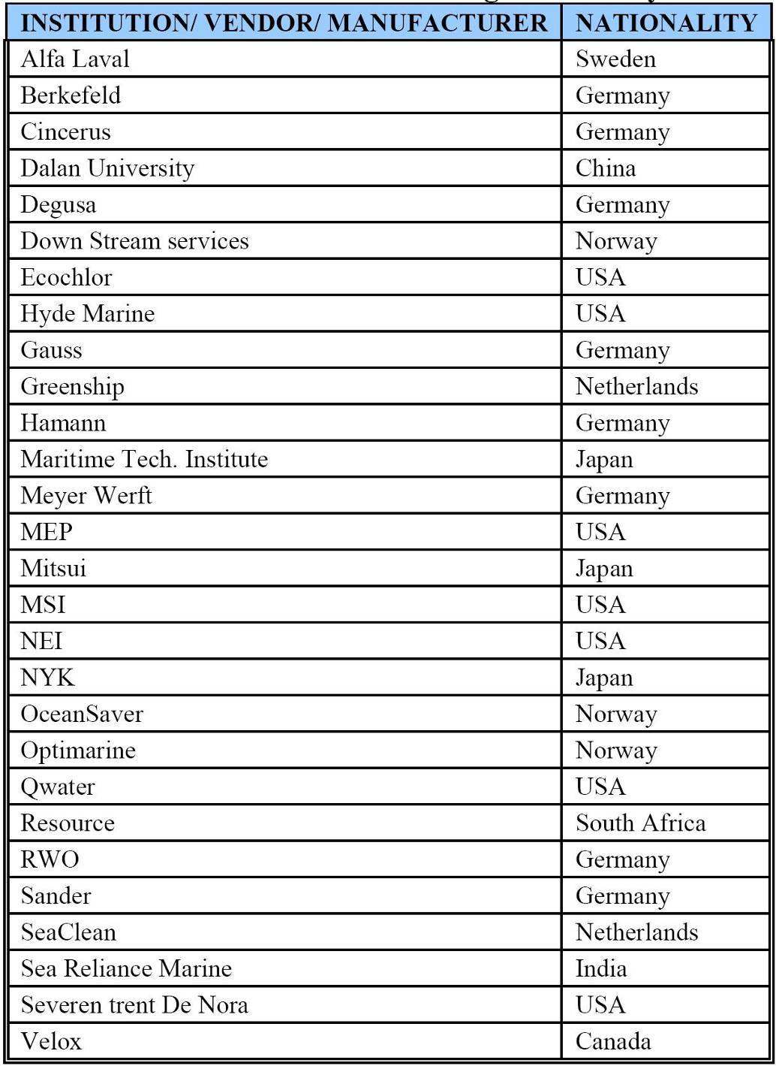

Reproduced from DNV (2005).
Development and trialling of combined systems that use primary filtration have secondary and/.or tertiary treatment steps consisting of:
- UV irradiation;
- Active substance dosing (using chemical oxidants or proprietary biocides);
- DEOX systems; and/or
- Hydrodynamic cavitation devices.

Some secondary treatments are being developed and trialled in combination. For example hydrodynamic cavitation followed by UV radiation, or UV radiation followed by ozonation to form an ‘Advanced Oxidation Process’ (AOP). Other investigated combinations include copper-silver (Cu/Ag) ionisation with seawater electrolysis or chlorine dosing. In all cases, the goal is to produce sufficiently long-lived ‘intermediate’ reactive radicals (e.g. the free hydroxyl ion OH⁻) to achieve adequate organism mortality/inactivation rates.

SHIP, CREW and ENVIRONMENT Safety

Choice and installation of BWT systems needs to be carefully planned and carried out in consultation with appropriate Class advice and input. Box E-1 highlights some of the issues that must be addressed to avoid compromising ship safety and BWT reliability.

Systems that produce aggressive oxidants and radicals require further biological assessment and corrosion testing studies to determine their potential to:
- cause unacceptable rates of corrosion to pipework, pumps, tank coatings and/or bare steel;
- produce long-lived toxic by-products that cause adverse ecosystem effects as a result of numerous BW discharges in busy port , coastal or inland waters;

Apart from the need to avoid discharges of long-lived harmful by-products or accelerate tank corrosion rates, there are health and safety (H&S) issues that some classification societies and ship managers have started to examine. The risk of accidental exposure to skin, eye or mucous membranes arises whenever a maintenance worker or crew member needs to handle or switch drums containing oxidising, corrosive or irritant chemicals. Exposure risks can be avoided by fully automated systems that do not require crew members to:
- Manually refill or change-over empty chemical drums, cartridges or containers;
- Manually connect/disconnect a container to the feed line of an ‘automatic’ dosing system; or
- Handle (move, unload) empty or damaged chemical containers.

To avoid undue environment, ship or crew safety risks, MEPC’s advisory GESAMP and Ballast Water Working Groups (BWWG), as well as ratifying parties, class Societies and ship operators, are using a cautious approach for assessing and approving BWT systems that require onboard storage/use of hazardous chemicals (e.g. sulphuric acid, sodium hypochlorite, sodium chlorate or hydrogen peroxide, used to generate free chlorine, OH⁻, chlorine dioxide). In the case of proprietary oxidants such as Peraclean® Ocean, its composition is 14.3% hydrogen peroxide, 15% peracetic acid and 26.5% acetic acid, all of which pose skin, eye and inhalation hazards if spilled (Section E4).

Box E-1: Installing / Retrofitting BWT systems

All components of a BWT system need to be positioned in the most suitable and secure sites available, preferably close to the main BW pump/s (which may need to be changed depending on the type of BWT system). Sites must have sufficient space for ease of service access and potential unit replacement, with vibration dampening provided as and where required. BWT systems designed to treat BW during the uptake phase have typically been installed in a loop format, but some ships will pose challenges to this configuration if the pipe/s emerging from the BW pump/s immediately pass through a bulkhead or enter the double bottom. Ships that use submerged ballast pumps (installed in the double bottom about midships), and BWT systems that re-treat BW during discharge, pose the greatest problems for a retrofit. Pipes that deliver and return the BW stream to and from the BWT system need to be correctly sized and drawn with the minimum of bends and other flow restrictions to avoid pressure losses, and selection of good quality, corrosion resistant pipework and ancillary materials is important. Installation of all electronic control, monitoring, metering and alarm equipment in motor rooms or pump compartments needs to account for power supply fluctuations / harmonic distortions, electrical interference, vibrations, high relative humidity and corrosive atmosphere, and potentially excessively cold and/or hot temperatures. Cargo pump rooms of tankers (where the BW pumps are often installed) are hazardous areas, with any electrical equipment and its installation needing to conform with relevant ignition suppression and pressurisation regulations and requirements.

The next sections outline treatment methods that have undergone reasonably comprehensive R&D since the 1990s. They are based mainly on information from ICBWM (2006) and URS (2006).

Filtration systems

Filtration units are expected to be an important component in many BWT systems, either for essential primary treatment or a useful ‘pre-treatment’ (water conditioning) to reduce sedimentation.

Most filter methods trialled to date are mechanical, i.e. cyclonic separators, disc filters, screen filters, cartridge filters and filter media beds. Cartridge filters and filter media beds provide reliable and exceptional organism removal ability (to below 4 µm and 10 µm respectively, but both systems will be large and likely to have recharge/replenishment requirements unsuited to the voyage logistics of small trading ships.

Non-mechanical forms of filtration include chemical coagulation/magnetic removal systems and membrane filtration (e.g. ultra-filtration using a reverse osmosis (RO) unit; reviewed in Section 6). In the case of chemical flocculation/magnetic filtration, one system has received limited research by Hitachi Limited (Japan). Data on performance and predicted unit size available to date (ICBWM 2006) indicate it will not be suitable for small ships.

The following mechanical filters each offer inherent advantages and disadvantages with respect to their use on small ships:

Cyclonic separators (‘hydrocyclones’): These use centrifugal force to separate particles or liquids with a specific gravity greater or smaller than water. They are widely used to separate water from oil and other different density liquids, and the technology has been trialled by several BWT projects (e.g. Glosten-Herbert & Hyde Marine, 2002). The technology is simple and relatively inexpensive (there are no moving parts apart from the pump), but pilot-scale and shipboard studies on commercially available separators have revealed minimal biological effectiveness (Sutherland et al. 2001; Cangelosi et al. 2001). The problem is that much suspended fine sediment and most plank tonic organisms are close to neutral buoyancy, so very large units are needed to achieve adequate centrifugation of high ballasting flow-rates. However smaller versions of the technology remain under active BWT development to facilitate the removal of coarse and fine sediments prior to follow-up BWT treatment, notably by the Germany-based Hamann AG group (as part its SEDNA filtration units) and by Greenship BV (Groningen, Netherlands).

Self-cleaning disc and screen filters: These units use compressed pads (discs) or fine wire mesh, and their compactness and performance progress is promising, particularly for small ships. Screen mesh units appear the most promising for small ships. They have also performed reliably and safely for over a decade on offshore oil and gas production platforms (to filter formation water for well re-injection). Disc filters contain sets of thick pads held firmly together inside a unit that provides an automatic back-washing system. Their disadvantages are the need to divert relatively large volumes of water to back-wash properly, and this takes some time to do so, thereby reducing treated flow capacity per unit volume of filter space compared with screen filters (= a significantly larger shipboard ‘footprint’ to achieve the same rate). As noted at ICBWM (2006), screen filter units developed for BWT are inherently smaller (Figure E-1), and may be mounted vertically, horizontally or at any angle.
Substantial R&D has led to advances in screen filter size and its ability to remove biota over the past five years, including auto-backwash units that filter reliably to 35 µm (a Japanese system) and to both 50 µm and 25 µm (an Israeli system) using self-supporting multi-weave screens of sintered ronel or 316L stainless steel. Development has also focussed on maximising the efficiency of the back-wash cycle to remove filter ‘cake’ without significantly interrupting BW uptake rates. The footprint of a screen system recently tested by the Royal Netherlands Institute of Oceanographic Research (NIOZ 2005) and presently undergoing further laboratory and seaborne trials is shown in Figure E-1.

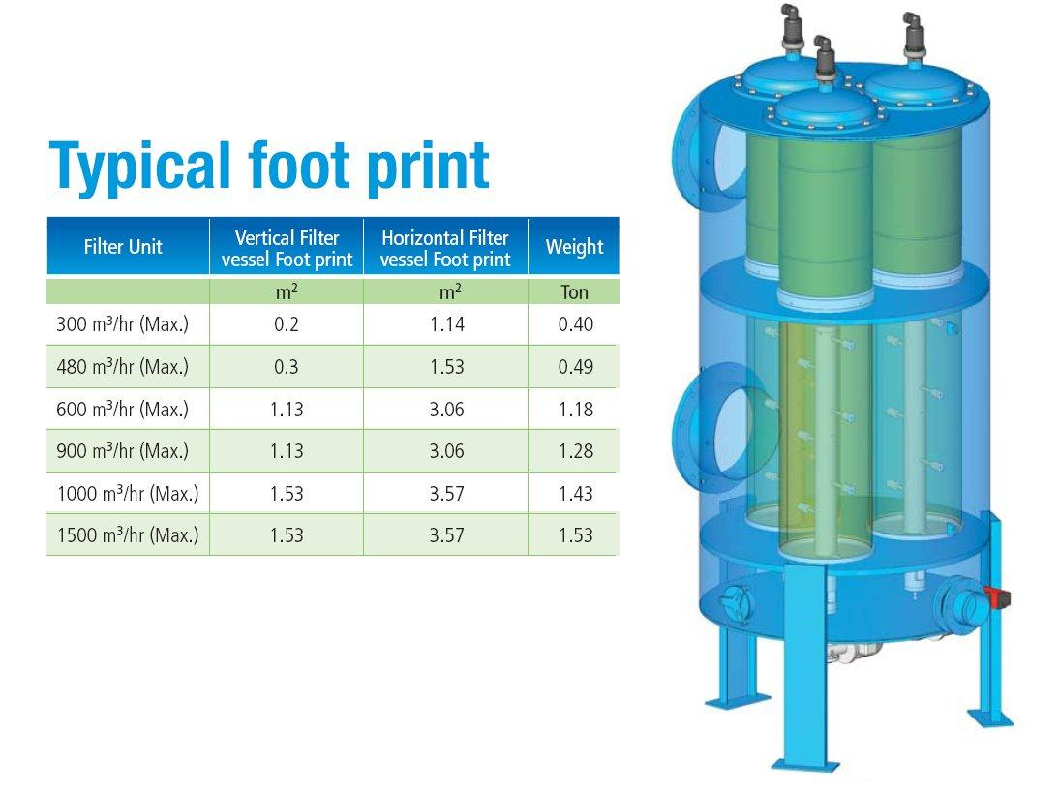

Figure E-1: Footprints of BW filter units being manufactured and trialled by BallastSafe from units tested at NIOZ (2005)

UltRaviolet treatment

The amount of photo-toxicity relates directly to the intensity and spectral distribution of received light. Within any water column, longer wavelengths (including visible >400 nm and UVA, 320-400 nm) penetrate more effectively than the shorter wavelengths of UVB (280-320 nm) and (UVC <280 nm). Water quality, particularly turbidity, heavily impacts the effectiveness of UV radiation.

Initial tests on the use of UV for BWT used low pressure UV tubes delivering 50-100 mJ/cm². These showed that self-regeneration of UV damaged microbes was common by 48 hours after treatment. Results also indicated that higher doses (60-120 mWs/cm²) delivered by practicable-size low pressure UV units may be effective for treating bacteria, the asexual (non-cyst) forms of microalgae and the motile forms of macroalgae, but would not kill/inactivate dinoflagellate cysts, larger protozoa or small metazoans that can pass through conventional filers (e.g. Oemcke et al. 2004; see Box E-2).

BOX E-2 : Features of UV radiation pertaining to BW Treatment
UV occupies the electromagnetic spectrum between visible light and X-rays. The 200-400 nm portion of the UV spectrum has a strong germicidal effect (peak effectiveness for single wave low pressure lamps is often quoted as 254 nm). DNA of microbes readily absorbs UV and in the process is destroyed by it. Maximum absorption occurs at both 200 nm and 265 nm and not 254 nm (which is the peak wavelength produced by Low Pressure lamps (LPL) and often wrongly claimed to be the optimal wavelength for killing microbes). In fact most absorption occurs at 200 nm in the Ribose and Phosphate ‘backbone’ molecules of DNA, and at 265 nm in the nucleotide bases (Adenine, Guanine, Cytosine, Thymine, plus Uracil in RNA). The most common molecules produced by UV damage are Thymine dimers. Formation of these dimers and other photo-products prevent the DNA from being able to replicate, thereby killing the microbes.
Apart from damaging DNA and RNA, UV also causes photochemical reactions to proteins, enzymes and other molecules. Peak absorption by proteins is ~280 nm, although peak absorption in the protein-peptide bond (-CONH-) is below 240 nm. Other biological molecules with unsaturated bonds can be susceptible to destruction by UV - examples include Coenzymes, hormones and electron carriers. Different types of microorganism have different specific sensitivity to UV light. Bacteria are much more sensitive than Fungi spores or Algae. Specific sensitivity is expressed by a ‘D10-value’, which is the UV dose that achieves a 90% reduction in the amount or number of the microorganism in question. In the case of the larger aquatic microorganisms (including Fungi, Protozoa and various unicellular Algae), the ability of UV to affect molecules other than DNA and RNA has stimulated BWT research. Thus although UV may be unable to penetrate as far as their DNA, sufficient doses of the correct peak wavelengths can still be lethal.
There are two main types of UV technology: (i) Mercury vapour LPLs that tend to have monochromatic UV output (e.g. a single wavelength at 254 nm), and (ii) Medium Pressure lamps (MPLs) that produce a polychromatic output between 185-400 nm. The UV dose is a combination of lamp power (UV intensity measured as mW/cm²), transmission loss and exposure time. Received UV intensity, multiplied by the exposure time, identifies the actual dose. The volume and flow rate of water requiring treatment determines the required exposure time inside a UV chamber, and therefore determine the optimal chamber dimensions and number. In practice, received UV intensity also depends heavily on the amount of UV-absorbing particles and compounds in the water flow. UV absorbance is measured by transmission loss (TL), which is the loss due to all absorbing components in the water flow (i.e. suspended organic materials, minerals, dissolved and undissolved iron and magnesium, etc). If the transmission loss is measured, then the UV intensity in the chamber/s can be adjusted, and chamber dimensions further optimised with respect to the flow rate/s.
The ability to repair and recover from UV damage (‘reactivation’) is common in most microbes that are regularly exposed to light in nature. Reactivation can occur in light (photo-repair) and darkness (dark repair). Photo-repair is carried out by the enzyme Photolyase, while dark repair is undertaken by a combination of over 12 enzymes. Both the light and dark repair enzymes require an energy source. In photo-repair the energy is visible light (300-500 nm), and in dark repair it is from nutrients inside the cell. The ability to repair depends on the type of UV damage and type of irradiated organism. Repair systems are not universal, and there are no reliable characters showing which species can/cannot repair themselves. Common E. coli strains contain ~20 photolyase enzymes, each repairing up to five Thymine dimers per minute (= 100 dimers per minute per cell). 1 mJ/cm² of UV produces 3000-4000 dimers (Oguma 2002), so this damage can be repaired in 30 minutes. However E. coli DNA is not capable of repair after irradiation by polychromatic MPL UV, which is very effective at causing permanent damage.
Compared to traditional mercury vapour low pressure lamps (LPL), medium pressure multiwave lamps (MPML) have a higher power consumption efficiency by producing polychromatic UV that ensures no self-repair by microbes, including unicellular algae, in the light or dark (Box E-2).

MPMLs produce UV over a broad wavelength and have been shown to cause permanent damage to non-pathogenic and pathogenic microbes such as E. coli and Cryptosporidium parvum (Oguma et al. 2002, Zimmer et al. 2002, 2003). By contrast, the more ‘monochromatic’ LPLs produce single or twin peaks of UV output, and many microorganisms can repair themselves after such exposure. Unlike LPLs that are optimal at around 20°C but deteriorate >25°C or <10°C, MPMLs are not influenced by water temperature and can handle large and rapid temperature fluctuations. Improvements to their stepless power supplies (electronic ‘ballasts’) have allowed production of units that more efficiently auto-compensate for variations in flow rate and UV transmissivity (Box E-2), requiring 10-20% less power than previous auto-control methods.

A significant factor of any UV system is fouling of the protective quartz sleeve surrounding the lamp, whether LPL or MPML. Suspended solids and minerals foul the sleeves and must be removed at regular intervals to ensure effective UV irradiation. Sleeve fouling is controlled by mechanical cleaning of the sleeves (with sliding O-rings or brush devices), and/or by chemical cleaning with a mild acid. If wiping or other mechanical cleaning is used alone, the sleeves will eventually need a chemical treatment from time to time. With closed-pipe systems, cleaning agents are injected into the UV chamber to enable internal cleaning without unit dissembly. Some manufacturers provide a combined automatic mechanical and chemical cleaning system. Wipers automatically move up and down the quartz sleeve periodically. At the same time, small volumes of an acidic cleaner are injected directly onto the sleeves to ensure removal of early deposits. Direct injection significantly reduces the volume of cleaner chemical required to be stored in the unit to keep the quartz sleeves clean. The weak acidity is not harmful to the environment or tank coatings owing to its subsequent dilution and seawater buffering capacity. However one manufacturer has moved away from sliding mechanical devices owing to the possibility of a gross mechanical failure (due to water flow constriction and pressure build-up when the slider is operating; ICBWM 2006).

The compact size and high energy output of MPMLs markedly reduces the size and number of the irradiation chambers and number of lamps. ‘In-line’ designs for BWT ensure minimal head-loss and a small footprint compared to conventional LPL or MPML systems. A programmable control module is used to manage auto-cleaning cycles, monitoring and auto-adjustment of power, transmission, flow rate fluctuations to maintain correct dosage, and automatic data logging.

Advanced in-line MPML systems are currently undergoing formal testing to determine what doses are needed to achieve the BW Convention discharge criteria (Regulation D-2), such as destruction of all biota that passes through a primary 25-35 um filter (including cysts), with no post-treatment auto-regeneration by dark repair inside the ballast tank or light repair after discharge. Predicted footprints and power requirements for these types of systems range from 0.4 x 0.8 m and 13 kW for ballasting rates to 120 m³/hour (plus ~0.3 m³ space for an electronic control cabinet that can be mounted on a bulkhead or stanchion. Larger units and higher power are needed for higher ballasting rates (e.g. 45 kW to treat a flow rate of 425 m³/hr).
Several water treatment manufacturers, including Severn Trent deNora and BersonsUV, remain actively engaged in BWT development that includes UV. Example filter/UV combinations include the Optimar system, which uses a ‘solids separation unit’ for the primary treatment (originally a hydro-cyclone but now a screen filter), and a UV ‘Microkill unit’, plus the vessel’s existing ballast pumps. Optimar systems with a pumping capacity of 200-500 m³/h have been installed on several cruise ships, feeder container carriers and a chemical tanker. Systems are being designed to remove larger biota and suspended material by filtration then kill/deactivate microorganism by UV when a ship is ballasting. The same system could repeat the treatment when a ship is deballasting, but this requires substantial additional pipework and pumping, with costs varying widely depending on vessel size, number of tanks, and the particular configuration of its tank locations, outlets and existing pumps.

Active substances

Active substances can be grouped into two classes – oxidants such as O₃, OH⁻, OCl⁻, HBrO⁻, ClO₂ etc, and non-oxidant generic or proprietary biocides such as glutaraldehyde or SeaKleen® (a quinone-based formulation). As described in Box E-3, active substances are subject to Convention testing requirements and approval guidelines, in order to ensure sufficient reliable information is obtained on their ability to avoid unacceptable environmental impact (e.g. discharge of treated BW containing long-lived toxic residuals or by-products such as trihalomethanes). In the case of oxidant-generating BWTs, testing is also focussing on the potential for stimulating corrosion effects to pipework, tanks and tank coatings. Most active substances are being trialled and evaluated as part of combination treatment systems, and examples are provided below:

Alfa Laval AB / Benrad Advanced Oxidation Technology (AOT): AOT is claimed to be highly efficient in eliminating bacteria and other microorganisms, as well as markedly reducing organic content of any ballast tank sediments, without the need to chemical substances that form toxic residuals. AOT is based on primary filtration followed by ozonation (O₃) combined multiwave UV, using catalysts. Organisms small enough to pass through the primary filter are killed by catalyst-stimulated hydroxyl radicals (OH⁻) that destroy their cell membranes. The Benrad system has been applied to both BW inflow and outflow to ensure D2 performance standards are met. Results from land-based trials with seawater suggest that removal/inactivation is ~96% efficient for zooplankton immediately after treatment, rising to 99.7% after 3-4 days tank storage. Results for phytoplankton indicate 93% immediately after treatment, rising to 99.5% after 3-4 days storage, while results for bacteria indicate 98% rising to 99.5% after the same period. The AOT system has been installed on the MS Don Quijote to trial a ballasting rate of 550 m³/hour. DNV (2005) considered that the onboard version is less likely to perform as efficiently as the land-based plant.

NuTech: Nutech O3 Inc. (US) has been trialling a BWT system that generates and injects ozone during the BW uptake phase. Trials have included onboard testing on British Petroleum crude oil tankers Tonsina (2001-2002) and, more recently, Prince William Sound. The system has also undergone laboratory testing at the University of Washington's Marrowstone research facility (Puget Sound) and at the La Que Center for Corrosion Technology (Wrightsville Beach, North

Box E-3: Approval process for Active Substances

During Convention development, concerns were raised over the possible accumulation of long lived toxic residuals (or their by-products), as a result of frequent discharges of BW containing by biocides or other harmful substances. Concerns were linked to the following:

• many ports receive considerable amounts of discharged ballast water on a daily basis.

• active substances such as free chlorine can readily interact with seawater and suspended organic matter to form persistent toxic organo-halogens.

• chemical handling, storage and delivery systems may pose ship safety and/or crew health issues.

An initial Guideline for approving active substances was approved at MEPC 52. This required the evaluation of a proposed substance to include an assessment of its potential to produce long lived residuals, by-products or end-products in ballast tanks and the ultimate receiving environments. A key factor is that use of an active substance must not pose a greater risk of harm than it prevents.

The Convention defines an ‘Active Substance’ as any substance or organism, including a virus or a fungus, that has a general or specific action on or against harmful aquatic organisms and pathogens. Regulation D-3(2) requires treatment systems which make use of one or more active substances to be approved by the IMO. Approvals are based on procedures developed on the IMO’s behalf by GESAMP’s Ballast Water Technical Group on Active Substances (established after MEPC 53). Regulation D-3(2) also requires a procedure for withdrawing the approval of a treatment system approved to use an active substance, with the continued use of the particular system to be prohibited one year after the approval withdrawal date.

The GESAMP group presented details on the methods and data requirements for the required approval and approval-withdrawal procedures for review at MEPC 54 (March 2006), and has continued assessing specific proposals for consideration at MEPC 55 (October 2006). The procedures cover the proposed manner of the application of the substance, a detailed evaluation with respect to environmental protection, human health and ship safety, and a protocol for withdrawing its approval. The procedures emphasise the need for the submitted data to come from laboratory tests that meet international best practise testing standards such as the OECD Guidelines.

In March 2006, MEPC 54 provided ‘basic approval’ enabling shipboard testing of two ballast water management systems that use active substances, after considering reports from the first session of the GESAMP’s Technical Group (January 2006). One is a system that uses the proprietary Peraclean Ocean® biocide. The other involved BW disinfection by an electrolysis system that generates a mixture of active oxidants, including free chlorine, hypobromous ions and hydroxyl radicals (ICBWM 2006). Several more substances will be considered for ‘basic approval’ by MEPC 55, including an ozonation system and another electrolytic system.

Carolina). Ozone introduced to seawater rapidly produces hypobromous ions and other radicals with effective biocidal properties. However ozone is very unstable and cannot be stored (it quickly decomposes to oxygen with a half life of 5.3 seconds). Ozone must therefore be generated when needed - typically by passing O₂-enriched air between high-voltage discharge gaps. Units are relatively complex and bulky, requiring compressed air for the oxygen separator system, a refridgerant system for the ozone generator, a stable power supply and regular maintenance. Ozone generation requires complex and relatively bulky equipment, and the installation cost for a 125,000 DWT crude oil carrier has been estimated at around ~$1.5 million (CBMU 2005).

Degussa AG: Degussa has promoted the active substance Peraclean® Ocean, a biocidal formulation based on peroxyacetic acid and hydrogen peroxide that is claimed to have high effectiveness on phytoplankton and zooplankton at low concentrations (~150 ppm). Because Peraclean® Ocean is chlorine-free, it reduces the risk of generating toxic, long lived halogenated residuals. ‘Unused’ Peraclean® is reported to rapidly decompose to water, acetic acid and oxygen (half-life ranges from 10 minutes to 24 hours depending on BW pH, temperature and salinity). No cost projections have been published but researchers estimate that approximately 150 liters of Peraclean® Ocean is sufficient for treating 1,000 tonnes of ballast water (Degussa 2005). Peraclean® Ocean has been trialled in a combined modular system developed by Hamann AG. This system injects the formulation during BW uptake, after the water has passed a Sedna filter unit. The latter includes hydrocyclones that can eliminate some of the larger organisms as well as reducing sediment uptake by 30-80% depending on the size and type of suspended particles (silica, calcitic, aragonitic and organic particles all have different specific gravities). A second ‘fine’ filter unit then removes particles and organisms to ~50 microns, which are backwashed and discharged during the ballasting phase. Remaining smaller organisms (microalge, cysts, nanoalgae, bacteria and viruses) are inactivated by a third step that comprises dosing with Peraclean Ocean®. The system has passed full scale land based testing and has achieved ‘basic approval’ from MEPC 54 enabling onboard testing and final Active Substance approval, possibly in late 2007.

MEP Marisan: Marine Environmental Partners (a private Florida-based company) has patented a BWT treatment system called ‘Marisan’. This is a multi-step combination system consisting of filtration, production of active substance ions via seawater electrolysis, then ‘advanced mixing’. As the BW enters the vessel it passes through a self-cleaning screen filter unit that removes organisms larger than 50 µm, with the screen sludge washed back into the source water at the time of uptake. Secondary treatment comprises oxidants generated from seawater electrolysis (principally hypobromous and hypobromite ions). The third step uses a proprietary ‘shear mix module’. This is used to maximise complete mixing of disinfecting agents with the ballast flow. The mixing action and subsequent tank residence time is claimed to eliminate any residual active substances prior to discharge. The system is monitored by a control box which monitors water flow, pressure, temperature, electrical voltage and current, leakage and internal component functions.

Vitamar SeaKleen®: Vitamar Inc (US) has developed SeaKleen®, a patented formulation of menadione (vitamin K3), which in small doses may be effective at killing most organisms entrained in BW. Menadione is an extracted plant product used in livestock and fish feed, skin care creams and mouthwashes. Seakleen® is not corrosive or requires any special handling or storage systems, as it is a formulation of a compound that occurs naturally in mammals, plants and fungi. SeaKleen® was trialled in 1997 – 2001, including onboard test on the USS Cape May in Baltimore harbor under guidance from University of Maryland researchers. Results indicated that doses of 0.2 – 1.0 mg/L are effective (Cutler et al 2003, Wright 2004). Test organisms included bivalve larvae, copepod crustaceans, larval fish, algae, dinoflagellates (including encysted forms) and plus E. coli and Vibrio fischeri bacteria. Experiments at the Great Lakes Research Laboratory indicated the presence of heavy sediment loads did not reduce SeaKleen® toxicity to amphipod crustaceans, probably due to the low affinity of SeaKleen® and similar compounds for suspended particulates. Bioassays have found no significant residual Seakleen® toxicity to three standard fish, crustacean and mollsc test species (Cyprinodon variegatus, Palaemonetes pugio and Mysidopsis Americana).
Shipboard studies indicated that summer conditions, require a Seakleen® dose of 2.0 mg/L to achieve a complete zooplankton kill. Cost predictions suggest that SeaKleen® may cost ~15 cents per tonne, with relatively low initial capital costs required for its injection system (Wright 2004).

Deoxygenation SYSTEMS

Several design, laboratory and pilot-scale studies on different types of deoxygenation have been conducted, including some recent ship trials. These include the Norwegian ‘OceanSaver’ system (this uses N₂ gas injection from a modified nitrogen-air stripper to achieve < 2 mg/L dissolved oxygen), and a CO₂ injection systems, including one that injects CO₂ / N₂ produced by a modified inert gas generator of the type used on product and chemical tankers (ICBWM 2006). DEOX systems can achieve rapid kill rates of all >50 um biota and 10-50 um plankton, but cannot kill most obligate or facultative anaerobic bacteria and viruses (i.e. further treatment is required).

In the case of the NEI (US) system, this uses a patented venturi-based stripping system to rapidly remove 95% of the dissolved oxygen (DO) from ballasted water. This is accomplished by mixing N₂/CO₂ from a modified inert gas generator through a parallel network of venturi injectors in the ballasting pipework. There are few moving parts and no upper limit to flow rate capacity. Venturi Oxygen Stripping™ was the winner of Intertanko’s 2004 Environmental Challenge.

An ongoing issue associated with all DEOX systems has been concern regarding the risk of accidentally enhancing tank and pipework corrosion rates via the action of heterotrophic bacteria and sulphate-reducing bacteria. These brown and black microbial biofilms can develop within layers of tank sediment and sludge, and cause corrosion issues when there are alternating hypoxic / oxic conditions, as can occur from regular ballasting / deballasting operations.

Some class societies and ship operators remain to be convinced that DEOX systems can avoid enhancing corrosion, particularly those that use CO₂ and/or which do not control O₂ levels in empty or part-emptied tanks. As with the proposed use of oxidising biocides, the corrosion worry from DEOX has helped stimulate several intense tank and tank coating corrosion testing programmes that are expected to yield results in late 2007 / early 2008 (ICBWM 2006). A key factor in the design and evaluation of these tests is the new 15 year IMO Performance Standard for the life of durable corrosion protection coatings for ships’ tanks and other internal compartments.

HydroDYNAMIC Cavitation

Use of cavitation systems to enhance secondary treatment or provide a tertiary treatment stage have been investigated in Australia (ABWTC 2004), Japan (ICBWM 2006) and Norway (ICBWM 2006). The principle of all hydrodynamic cavitation devices is to cause a very rapid drop in water pressure, which in turn changes the gaseous composition and vapour point of the water flow, causing ‘low temperature boiling’ via intense microbubble generation and bursting. This produces short-lived but extreme physical conditions that destroy or heavily damage microorganisms.

The Australian ‘MSC’ unit was manufactured in Sydney and used rotating turreted wheels to generate the abrupt changes in hydrodynamic pressure, the Japanese ‘special pipe’ device uses the venturi effect, while the Norwegian “C-3T” unit is part of the OceanSaver system (MetaFil AS, Norway) that releases compressed gas in a novel ‘gas pulse’ method. The pulses rapidly accelerate then decelerate water flow velocity, thereby violently reducing then increasing the internal pressure of the BW stream. The C-3T was purpose-designed to kill or inactivate all organisms that deoxygenation via the cavitation induced shear forces, shock waves and associated energies.

Backpressures associated with all cavitation methods are not amenable to the low pressure flows of ballasting pumps, and the Australian and Japanese units require significant pumping energy. The closed circuit Norwegian C-3T unit also requires some additional pumping to compensate for the backpressure (ICBWM 2006). The combination of the gas pulsing and injection of nitrogen rapidly displaces a significant proportion of the dissolved oxygen (DO) from the BW (down to ~2 mg/L). Kill rates achieved by the OceanSaver’s N₂ gassing and cavitation units have been investigated at both laboratory and onboard pilot scales (750 m³/hr).

Two pilot systems have been installed onboard a Wagenborg ro-ro/container feeder ship that operates in European waters and a FedNav bulk carrier that operates into the Great Lakes (ICBWM 2006). Results from these systems will support ongoing land-based development of the complete full scale system. The latter includes a primary filter unit (50 µm) and will be tested on land during 2006-2007. It is anticipated the OceanSaver system will be able to complete all BW Convention testing and approval requirements by early 2008 (ICBWM 2006).

OSMOTIC SHOCK BY Brining OR DILUTION

It is well known that virtually all marine biota can be killed by osmotic shock (OS) if they are subject to a rapid and precipitous decline in salinity (i.e. no gradual reduction enabling their potential to acclimate). Marine biota entrained in seawater ballast (25-36 PSU) can be killed if there is rapid freshwater dilution to 8-10 PSU or less, while brackish water biota (euryhaline organisms) can be killed if tank salinities are quickly reduced to <1 PSU. Similarly, fresh and brackish-water biota can be killed by OS if the PSU is rapidly raised to >15 PSU and >35 PSU respectively.

BRINING SYSTEMS

Rock salt or brine (concentrated salt solutions >20%) can be used to rapidly raise the salinity of freswahter (<1 PSU), brackish water (2-22 PSU) or seawater (~3.5% salt; ~35 PSU). Together with seawater exchange, these have been considered as a potential BW management option for vessels that carry fresh or low salinity ballast between ports in freshwater lakes, waterways or enclosed low-salinity seas (e.g. Great Lakes, Baltic Sea, Black Sea). Organisms entrained with fresh or salinity ballast can be killed by rapidly increasing ambient ion concentrations to induce OS.

The concept of adding salt to rapidly raise ballast tank salinities to >15 PSU (for freshwater biota) or >35 PSU (for brackish water biota) has been examined by Canadian/US researchers as a possible treatment option for vessels operating in the Great Lakes - Gulf of St Lawrence region, particularly for ‘NOBOB’ vessels (no pumpable ballast on board) entering the Great Lakes and intending to trade between ports before departing to the sea. It has been accepted that the concept, although simple in theory, poses a number of practical issues including:
- tank corrosion concerns for both NOBOB and more fully ballasted vessels;
- the costs of obtaining, distributing then dosing with rock salt / concentrated brine solutions;
- issues for vessel plumbing and/or onboard storage space requirements for onboard system, particularly for vessels with large BW capacities (e.g. 10,000-20,000 DWT ‘Laker’ class bulk carriers).

Although BW salinisation does not offer a practicable BW management option to the shipping activity and trading patterns of the Great Lakes, the concept appears not to have been examined for small ‘River’ or ‘River-Sea class vessels with relatively small ballasting requirements and trading profiles restricted waterway routes that connect different catchments and seas. However, even if rock salt or brine supplies were locally available and inexpensive to secure, a key issue remains ship owner concerns regarding the need to avoid enhancing ballast tank corrosion (particularly with river vessels that may have limited, if any, anti-corrosion coating systems applied to internal tanks).

BW DilutIon Systems

BW drawn from marine ports can be treated by dilution with freshwater to the point where the fall in osmotic pressure by 5-8 PSU and 2 PSU respectively kills all marine and estuarine biota by OS. However a secondary treatment is needed to kill any surviving bacteria and viruses (e.g. UV or chemical dosing).

The logical application of the dilution approach, which is suited to small maritime vessels with minor ballasting needs (trim tanks), is to use freshwater for ballasting purposes, either by onboard generation using a Reverse Osmosis (RO) unit, or relying on a shore-based supply.

RO technology is reliable and RO desalination units are used on many ship types and sizes to provide potable freshwater, including cruise liners, passenger ships, livestock carriers, long-distance Search & Rescue vessels, government patrol vessels and most warships. RO offers the potential to provide trim water (or dilute ballasted seawater), particularly if ‘oversize’ units providing adequate desalination capacity are installed (a variation of this concept is to divert treated effluent from onboard sewage treatment systems as the feed for trimming needs).

As an alternative to the space and cost requirements of installing and maintaining a treatment system dedicated only to BW management, using an RO unit to provide freshwater (or treat ballasted seawater) for the trimming requirements of small vessels offers the following advantages:
- RO is proven and widely available technology, with worldwide supply and service networks;
- Reliable maritime versions of RO units with a sterilising capacity are already present on many vessels;
- There are no hazardous chemicals or potentially harmful waste products;
- Avoiding the need to install a separate, dedicated BW treatment system makes stand-alone modular RO units attractive to small vessels with small ballasting capacities.
- Onboard monitoring, fleet maintenance and servicing routines for RO units may already be in place;
- Accumulation of sediment and the associated build-up of biofilms inside trim tanks can be totally avoided, minimising all mud loading and associated tank corrosion concerns and loss of cargo capacity issues.

However using RO systems for BWT has potential disadvantages. These include:
- Relatively slow production rates (so unsuited to cargo vessels with relatively large trim or ballasting requirements, and/or fast bulk cargo unloading rates that require fast BW intake).
- Susceptible to membrane problems and failure, if unused for long periods or maintenance is neglected (but this will also be true for many BWT systems).
- RO membranes have a heavy reliance for a ‘clean’ seawater feed, i.e. adequate pre-filtration is critical for any feedwater taken from polluted harbours, turbid estuaries, tidal creeks or deltas.
- Relatively high electrical power requirements.

Thus RO desalination units appear best suited for treating or providing trim water needs for small vessels that can avoid/delay intake of turbid or oily water from polluted ports and shallow turbid areas (which could otherwise overwhelm the pre-filtration unit).

Thermal treatment

Heating seawater as a BW management option received most attention during the 1990s as a result of Australian laboratory and shipboard research work sponsored by BHP Shipping and the Australian Quarantine Inspection Service. Development of heat treatment technologies for controlling zebra mussel invasions in the United States had commenced in the late 1980s and has contributed to the testing of BW heat treatment applications, including the use of steam to sterilise biofilms, sediments and unpumpable water in the ‘empty’ ballast tanks of NOBOB carriers entering the Great Lakes (e.g. Stocks & O’Reilly 2003).

However no studies appear to have been continued post ~2002, and no R&D work on ship- or land-based heating was presented at the recent 3rd ICBWM in Singapore (ICBWM 2006). Thus apart from the Canadian Great Lakes trials that used land-sourced steam for treating NOBOB carriers, Thornton (2000) proposed a complex and as yet untested system involving additional exchangers and a hold-over tank to achieve >65°C (achieving full sterilisation), while Sobol et al. (1995) proposed a system (un-trialled to date) that combines two conventional plate heat exchangers receiving hot water from the main engine cooling circuit with a steam generator to flash heat BW inflow to ~70°C.

A key issue has been the amount of heat required, since the energy needed to treat the large BW volumes taken aboard most merchant vessels poses economic and environmental issues with respect to increased fuel burning, greenhouse gas production and NO_{X}/SO_{X} concerns (e.g. Mountfort et al. 1999; Rigby & Taylor 2001).

The alternative to generating large quantities of energy to flash-heat water during ballasting, is to harness a ship’s ‘waste energy’ generated en route, in order to slowly raise its BW to 38-45°C for some 3-5 hours on a ‘tank-by-tank’ basis. This approach was evaluated by mostly Australian and New Zealand researchers in the 1990s (e.g. Hallegraeff et al. (1997), Hi Tech Marine (2001), Mountfort et al. (1998, 1999), Rigby & Hallegraeff (1994), Rigby et al. (1998, 1999, 2003), Rigby & Tayor (1994, 2001).

Harnessing waste heat can utilise the cooling circuit heat exchangers of the main engine, and/or stack-mounted heat exchangers or auxiliary steam generators that are fitted inside stacks to capture heat from hot exhaust gasses.

The land-based and shipboard trials showed that the vegetative (unprotected) stages of dinoflagellates may be killed by 30 minute exposures to temperatures as low as 35°C, but inactivation of the heat-resistant cyst stages (hypnozygotes) 3-5 hour exposures to >38°C. A short New Zealand program involving laboratory tests and two shipboard trials indicated that zooplankton, phytoplankton and dinoflagellate cysts could be killed or inactivated if BW is heated to 36ºC for 16 hours, but decreasing to only 10 minutes if heated to >46ºC (Mountfort et al. 1998, 1999).

The Australian and New Zealand shipboard trials indicated the ‘tank-by-tank gradual heating approach may be practicable only for vessels engaged on long (>10 day) voyages across tropical/subtropical regions. The key disadvantage is the need to install additional pipework and pumps to link every ballast tank to exchangers drawing from the main engine cooling circuit and/or stack gases (a substantial design challenge for any existing vessel that has widely-separated multiple tanks). Other issues include:
- Unlike >65ºC flash heating, gradual heating will not meet IMO Convention performance requirements (Regulation D-2) unless secondary treatment is provided.
- Lack of filtration invokes issues associated with sediment entrainment that gradually accumulates in tanks with repeated ballasting cycles.
- Insufficient voyage time to heat all tanks – particularly for cold water routes / winter seasons.
- Concerns that unpredictable stresses may be induced by thermal-expansion to hull structures and pipework connections as a result of regular differential heating / cooling patterns.
- Risk of thermally-accelerated corrosion rates requiring more frequent inspections and maintenance diligence.
- Securing adequate sources of waste heat, as modern ships maximise the use of exchangers and other flue-gas heat recovery systems to provide energy for auxiliary power generation and shipboard utilities.

