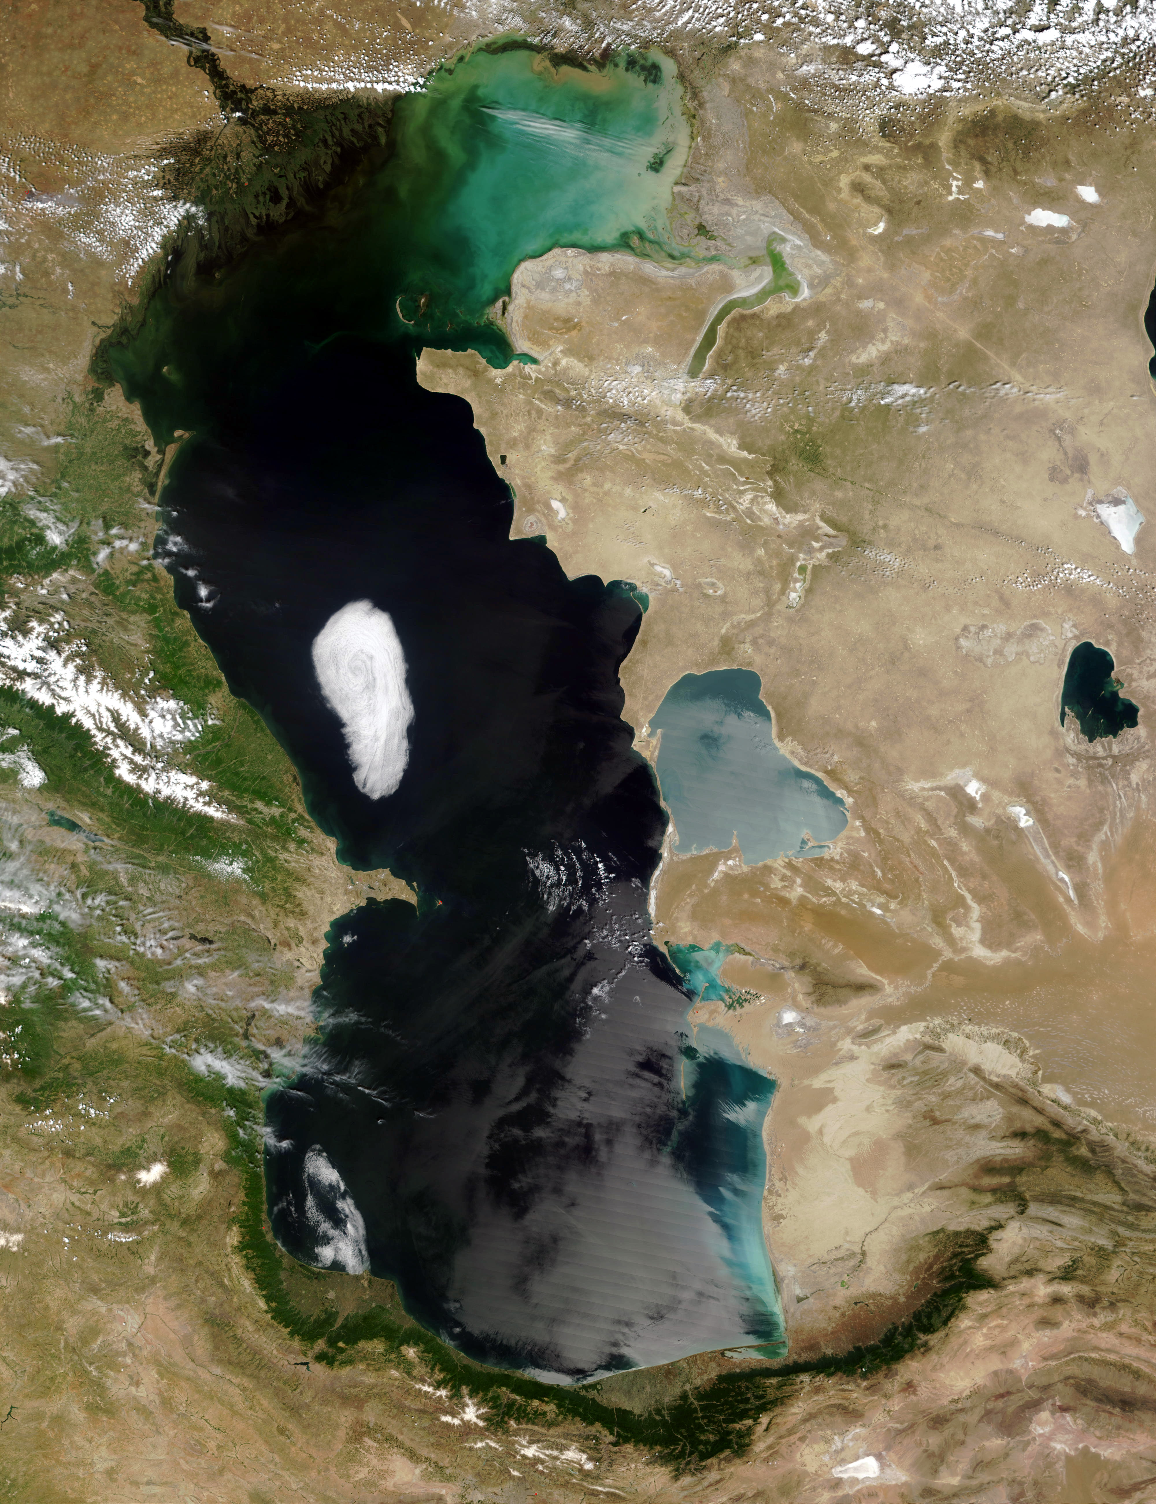
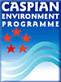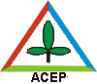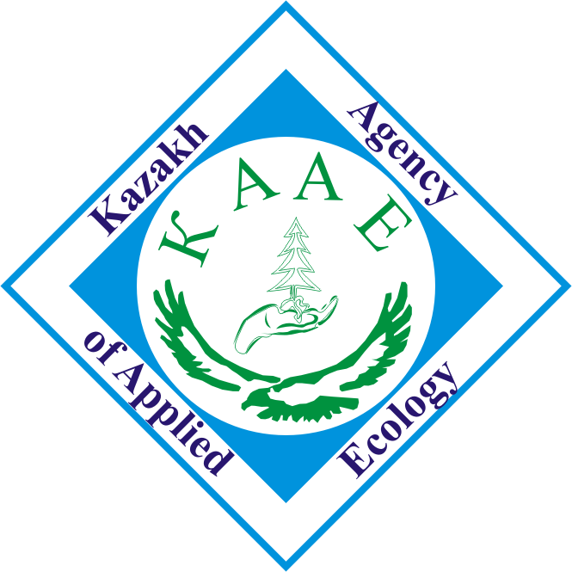
Caspian Environment Programme

CEP-SAP Project
Development of Caspian Coastal Sites Inventory (CCSI) and identification of areas of special importance and/or sensitivity within an ecosystem approach and framework
Ground-Truthing Report
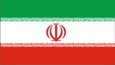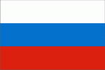
Almaty – Ashgabat – Baku – St. Petersburg –Tehran
2006

