3.3 Republic of Kazakhstan
3.3.1 Coastal systems and human impacts on them
The littoral zone of the Kazakhstan coast of the Caspian Sea is extremely dynamic; its form is constantly changing together with the sea level changes that can be very strong due of the surges. As a result, the morphology of the littoral zone varies from delta, “regenerated” and washed coasts to slightly sloping plains, coastal marine terraces, and rocky ledges.
The total length of Kazakhstan coastline in the Caspian Sea, except archipelagos and Kaydak Bay, is more than 2 500 thousand km. Deltas include about 300 km of the coastline, low currents of the Kigach River (eastern part of the Volga delta) occupies 160 km. The Ural delta occupies about 120 km, the Emba delta – about 20 km. About 1 500 thousand km of the North Caspian coast of Kazakhstan has dynamic coastline because of the sea level fluctuations, including zones of storm tide flood.
The Caspian coast of Kazakhstan is low from the Volga delta to Tyup-Karagan Peninsula, and high – farther to the south, in Mangistaus part, until the border with Turkmenistan. The coastline of the Northeastern Caspian Sea is extremely dynamic and changes with the sea level fluctuations. The northern coast of the Caspian Sea is formed mostly by delta deposits and deserted marine quaternary deposits periodically flooded by waves and surges.
Coastal infrastructure, consisting of civil, industrial, and agricultural objects, has been formed for a long time and is gradually improving. Besides built-up landscapes and oil fields, most important elements of manmade relief are line structures: road embankments and different canals. There are three most important aspects of human impact on the coastal ecosystems.
- Agricultural development, expressed in building of many hundreds of kilometres of irrigation canals. Canal network covers most part of the northern coast. This effect has taken place during the last 50 years. At present, most of the canals are under water. About 90% of all irrigation infrastructures are not used any more. Reed thickets have developed along the canals and formed habitats for numerous species of mammals and birds;
- Industrial development, mostly oil field development, which has taken place during the last 50 years, is the most dangerous kind of human impact because of its considerable chemical effect on the coastal ecosystems. Development of oil industry has stimulated the third type of effect on the coastal ecosystems – construction of protective works.
- Construction of protective works – dam-embankments, road-embankments. Their height varies from 2 to 4 m in different regions. Most of them were built during the last 25 years. Protective works, besides other functions, serve as the only possible transport communications during tidal seasons (April-May, October-December). In fact, all coastal oil fields are protected by dams.
Eastern part of the Volga delta is the largest accumulative form in Kazakhstan. This region stretches from the border of Russia and Kazakhstan to the east from Kigach branch and includes Novinskiy Nature Reserve. As well as the Russian part of the Volga delta, coastal part of the delta in Kazakhstan includes vast rush communities with areas of submerged rush and sedge. The delta has slightly prominent profile and is inclined towards the Caspian. The eastern part of the Volga delta, situated in Kazakhstan, is characterized by a complex system of branches with numerous islands with high edges formed by riverbed swells. Transition from the delta plain to coastal waters is gradual, through the zone with terrestrial-aquatic regime of periodical wind tide flooding and drying. Former irrigation channel goes along the coast from the eastern part of the delta.
A system of irrigation and drainage canals developed in 1940-1970 with the purpose of agricultural development of the Volga and Ural deltas during the period of sea level fall. At present, considerable part of these hydro-technical constructions is flooded. The flood was passive, and the submerged canals did not loose their form during 15-20 years. Main canals and their branches are distinctly seen as well as the banks of ground excavated during canal construction.
Area between the Volga and the Ural. From the delta edge the coast appears as a sandy marine plain, stretching to the east (for about 75 km). From the north this coastal plain is surrounded by the sandy bank Menteke. Hilly fixed sands stretch from the bank to the dry surface. During the wind tide, low areas between the hills are flooded. In other periods, aeolian processes are widely distributed in this sand massive. The territory is covered with herb-erkek, wormwood-erkek vegetation.
Father, towards the Ural delta, the coast is formed by avandelta deposits. This is the marine coastal lowland, made of clays and loams with serial coastal vegetation, rush and reed thickets on littoral meadow-marsh soils combined with primitive littoral soils. This sector of the coast is about 100 km long.
At the distance of 5-10 km from the coastline towards the sea, there is a belt of rush thickets, from 1 to 8 km wide. At the sea side of the rush zone, there are vast areas of submerged vegetation. The marine part of the region between two rivers has a plain gently sloping seabed.
Littoral part of the region between the Volga and the Ural Rivers has a dried up surface gently sloping to the sea. At the absolute marks of -25 m, there is a surface bend or banks of about 0.7 m high, which mark the border between early - and late-new-Caspian parts of the plain.
Drastic rise of the sea level in 1979-1995 caused the necessity of dam construction for protection of settlements and oil fields situated in the littoral zone. During this period, several protective works were built in Isatayskiy region where settlements and oil fields were in danger of flooding.
Latitudinal protruding dike 2 m high was built near Zhambay settlement for protection of population and agricultural lands. Earth-fill dams-roads 2 m high were also constructed for protection of functioning oil fields (Martyshy, Kamyshytovoye, etc.) from the wind tide and for communication between them.
The Ural River delta is smaller than the Volga delta but creates vast wetland with rush thickets of about 150 km long. Channels, creeks, and lakes divide the delta territory. In the Ural River mouth, rush communities continue into submerged vegetation. The Ural River delta is made of alluvial and sand-clay deposits. In some places, rush thickets stretch for 20 km.
In the talus train of the river, braided delta was formed, which corresponds to the coastline and different levels of the Caspian Sea. Littoral regions of the Ural River delta, formed during the talus train development of the Ural-Caspian channel (1932), and fish-pass channel (1965), are now flooded.
Head of the sea level stretches up the mouth area of the Ural River. Besides, the tidal waters penetrate to the river mouth and cause additional rise of the river level. As a result, the danger of water overflow and flood increases in the adjacent territories. Low relief forms in the Ural delta are periodically flooded during spring high water period. Near the town Atyrau, during the high water season, the beaches and areas adjacent to dams and road embankments are flooded first of all.
The system of irrigation and drainage channels built in 1940-1970 for the agricultural purposes is especially well developed in the eastern part of the Ural delta. A dense network of channels was organized here as a result of destruction of natural left branches deepening and displacement of the main river bed to the right.
Area between the Ural and the Emba. The coast from the Ural delta to the low current of the Emba is dried up, made of loams and sandy clays. This coast sector is about 90 km long. The coast represents a flat plain with numerous saline depressions slightly sloping towards the sea. This marine littoral lowland near the Ural delta has meadow-littoral soil with halophyte-grass and wormwood-saltwort vegetation and father to the Emba delta, with hyper-halophytic saltwort vegetation on the littoral solonchak areas. Shallow water area with minimum incline for the Caspian Sea is subjected to tidal processes and inhabited by saltwort communities.
The rush belt here is more dispersed, compared to the area between the Volga and the Ural. Rush massive is inherited from the previous habitats. Their structure depends on geo-morphological peculiarities formed in previous transgress and regress periods of the Caspian Sea. In fact, these rush communities in both areas are distributed in the zone of water level fluctuations. They do not stretch to the south from the water edge of 1977 – minimum level of the Caspian Sea before the last rise. This vast territory is formed in the period when sub-aerial regime changes to littoral-shallow water and, as well as the modern marginal stripe, is filled with diverse communities with rich species composition in every period of its development.
Drastic rise of the sea level in 1979-1995 caused the necessity of dam construction for protection of settlements and oil fields situated in the littoral zone. In this area of the coast, at the distance of 10-12 km from the coastline, there are several oil fields, protected by dams 2.5-3.0 m high and 8 m wide at the top. Dams separate industrial objects from the salt marshes connected with the sea. These salt marshes are also flooded in spring, being the part of natural drainage system of the rivers Sagiz and Emba, which cross the littoral plain.
The Emba-Prorva delta. Some years ago the Emba River delta was many kilometers away from the Caspian Sea but in 1995 the sea came close to it again. The Emba delta has weakly expressed structure with the total coastline length of about 20 km. The delta represents a system of floods and salt marsh-lake lowlands connected by narrow channels. The riverbed is divided into stretches and has no stable drainage. One part of the delta is turning into dried up seashore with traces of the former main channels.
From the Emba delta, the coast stretches to the south for about 90 km through the Tengiz region to the half-submerged salt marsh Mertvyy Kultyk. To the Komsomolets Bay, the coastal stripe stretches for 130 km. Most part of the coast consists of salt marsh and algae marsh. Littoral stripe of the plain, 10-15 km wide has definite terraced structure, reflecting stages of the Caspian Sea development. In some places, there are rush thickets in the sea at some distance from the coast. Dense thickets of rush, characteristic to the coastline to the west of the Emba delta, are not widely distributed here. Rush thickets develop on small flat islands (called “shalyga”), which consist of marine deposits, including shell rock and plant debris. Shalyga’s outline changes after every storm. In autumn, they create habitats for the Caspian seal. During the recent years, most of shalygas became submerged because of the sea level rise.
In the shallow littoral zone, shalygas, ridges, and shoals alternate with underwater meadows of Myriophyllum aquaticum and Potamogeton natans with 100% projective cover. Such densely overgrown areas alternate with sparse rush thickets at the stage of their formation and areas covered by submerged aquatic macrophytes. The land here is occupied by salt marshes, marshes with submerged rush and sedge in the littoral zone and halophytic vegetation in the areas with sub-aquatic regime.
Drastic rise of the sea level in 1979-1995 caused the necessity of large-scaled dam construction for protection of settlements and oil fields situated in the littoral zone. This eastern low coast of the Northern Caspian Sea, with minimum incline of the surface, was flooded most of all. Dozens kilometers of dams were constructed for oil field protection but some oil fields remain under water.
Before the dam construction, the primary marine plain was flooded during the wind tides from the water edge to the horizontal line -25 m. At present, this territory is subjected to activity of oil and gas complex. More than 20 oil fields are situated in the coastal stripe 50 km wide. Many of them have been exploited for more than 20 years. Oil fields situated close to the coastline (e.g., Tengiz, Teren-Uzyuk, Tazhigali, Zapadnaya Prorva), have protective dams and are connected by dam-roads.
Wind tides are most intensive in April-May and October-December and reach 1 m or, sometimes, 2 m in height. The length of flooded area can be about 200 km. Maximum registered width of the flooded area on the eastern coast is 30 km.
Some of the oil fields are situated close to the sea (Teren-Uzyuk, Tazhigali, Pustynnyy). The road, leading from Karaton to Teren-Uzyuk in its western part goes along the top of the dam. Teren-Uzyuk oilfield is separated from the sea by a protective dam 4 m high and 10 m wide. From this dam another dam-road leads to Pustynnyy oil field. This road was washed out and Pustynnyy oil field went under the sea. Other dam-roads are in reliable condition.
Asphalt motor road, going along the coast from Karaton to Tengiz and Prorva oilfields, is in good condition. In the west, the motor road is separated from the sea by a dam 3-3.5 m high. The sea went back from the dam on 1-2 km and comes close to the road only near Zapadnaya Prorva oil field. This oil field is surrounded by two dams. One dam is 5-6 km away from the sea and the other goes along the coastline. Improved motor road with easy approach to the sea goes along the dam. The western side of the dam is being washed out and an abrasion terrace 1.5 m high has been formed. Traces of maximum water up-rush are at the height of 2.5 m from the sea level, during the highest wind tide absolute mark of up-rush reached -25 m.
Komsomolets Bay separates the eastern coast of the North-Eastern Caspian Sea and Buzachi Peninsula. Here in the mouth of the bay, there is an archipelago of small rush or marsh islands. During wind tides, the bay is connected with Mertvyy Kultuk and Kaydak – vast primary solonchak plains. Their surface becomes a water area at the average sea level -26 m. At present, their deepest areas remain under water. Water enters these areas only during the strongest storms. Coastline here is very changeable. Relative irregularities of the seabed (up to 1.5 m) are formed by tidal currents. Part of the solonchak surface is drained plain.
Buzachi Peninsula along its northern coast has different types of littoral zone, including damp, marsh and dry solonchak. The surface of the peninsula is covered by aeolian sands and solonchaks, 10-15 m deep. Flooding, caused by the sea level rise, is entailed by the groundwater rise and water logging of littoral lowlands. On the northern coast of Buzachi Peninsula with 0.003-0.005 incline, a well defined sand-bar has been formed. This bar has a height of 1 m, length – 6 km, and separates a lagoon about 200 m wide. This territory belongs to Aktau-Buzachi Nature Reserve, which also includes the lowlands of Mangistau Bay.
Buzachi Peninsula has drained coast, in the west with steep underwater vault and lagoons separated by sandy-shell bars. Big Sor in the northwestern part of the peninsula was often connected to the sea. That is why, for the development of Kalamkas oil field there was built a dam (1981), 33 km long, which, however, did not save from the groundwater rise. Therefore, it was necessary to built ground embankments for boring and communication.
Protruding dyke, protecting the oil field goes along the northwestern coast of the peninsula. There is only one well-found drive from the dyke to the sea – on the technical water supply point. It is situated on the artificial island and is connected with the coast by the earth-fill dam. The construction can serve as a pier, because the sea in this point is about 3 m deep.
Tyupkaragan Peninsula has high shores, which are mostly steep, denudation, 150-190 m high in the north, 40-80 m high in the west and about 120 m high in the south. The zone of wave influence includes the lower part of the chinks, with accumulation of slide rocks. There are terraces and smooth benches as well as abrasion-accumulative systems with dead cliffs and sandy beaches.
The northern coast of Tyupkaragan Peninsula is a chink of calcareous plateau of about 100-200 m high above the sea level (the height increases from west to east). The western coast is abrasion- accumulative. Accumulative sandy-shell surface, 2 km wide, is formed under the chink plateau due to littoral dereliction.
Tyupkaragan chinks, more than 100 m high in some places, are crossed by erosion ravines, especially in the south and west. In the last case, there is a gentle slope to the settlements Fort-Shevchenko and Bautino. Here, in the region of Tyupkaragan Bay there is a Tyupkaragan spit – free accumulative coastal form of two-side nutrition. It stretches into the sea in sub-meridian direction for 6.5 km, has a width of 1.5 km and separates comfortable Bautino Bay, 5-10 m deep. Maximum relative height of the spit is 3.5 m (-24.5 m of absolute height). Its marine part is under the wave influence and forms coastal swells and abrasion depressions. On the eastern internal coast, longitudinal currents facilitate formation of small marshy lagoons.
Tyulen’i Islands are situated in the shallow zone to the west of Buzachi Peninsula and to the north of Tyupkaragan Peninsula. In the littoral zone of the islands dominant are rush communities. Small rush islands are situated eastwards between Tyulen’i Islands and Mangistaut Bay.
Mangyshlak and Ustyurt. Plateau Ustyurt forms a steep, nearly vertical chink, 230 m high at the border with Kaidak solonchak. Steeps and chinks of Ustyurt, Tyupkaragan and mountain Mangyshlak are examples of a peculiar complex relief. Their height is from 50 to 230 m with total average steepness of 45°. The higher part of the chinks, cutting the plate of limestone and marl, is nearly vertical (15-40 m). Lower, there is an odd ravine-landslide relief, or typical badlands, several hundreds meters wide. At the bottom of the chinks, there are beaches, abrasion terraces and accumulative coastal swells.
To the south of Tyupkaragan the height of coastal chinks is 40-50 m. In some places, they almost disappear and only on the coast of Kazakhskiy Bay their height again reaches 100-130 m. True abrasion shores with active cliff are present to the south of the settlement Kuryk, in the north of Kazakskiy Bay and along the Kenderli-Kayasan plateau. In other cases, between the coastline and the dead cliff there is a stripe of accumulative beaches and terraces. Lagoons are often formed on such accumulative coasts (between Aktau and Peschanyy Cape, Rakushechnyy Cape, Kenderli Bay). There are also areas of drained coast (to the east of Rakushechnyy Cape, eastern coast of Kenderli Bay). Construction of Kuryk port is going on in this area near the settlement of the same name. Ports Aktau and Bautino are also under reconstruction, new terminals, and mooring lines are being constructed here. New international cargo terminals are planned to be built at the airport, in 30 km to the north of Aktau.
Main types of the Caspian Sea coasts and human impacts on them are briefly described in the table 3.2.1; for designations refer to Sections 2.3 and 2.4).
Table 3.2.1 Main types of the Caspian Sea coasts and human impacts on them in Kazakhstan
Code | Coastal site type | Presence | Human impacts
HRC | Hard rock cliffed coasts | - | -
HRP | Hard rock coastal plains | - | -
SRC | Soft rock cliffed coasts | + | CH
SRP | Soft rock coastal plains | + | CH, CG, CT,
SKC | Skerry coasts | - | -
SGS | Shingle / sandy spits | + | -
SSB | Shingle / sandy beaches | + | CH
COD | Coastal dunes | + | CA
RRT | Reed & rush thickets | + | DF
MUF | Mud flats | - | -
WET | Wetlands | + | DF
SAM | Salt marshes | + | CA
OBA | Open bays | + | CF, DF
SCB | Semi-closed bays | + | CE, CF
LAG | Lagoons | + | CF, DF
COL | Coastal lakes | + | DF
RID | River deltas | + | CD, CF, CW, DB
EST | Estuaries | - | -
SOI | Solitary islands | + | CA
ARC | Archipelagos | + | -
ADM | Protective engineering structures / Dams | + | CD, CM, CN, CP
3.3.2 Novinskiy Reserve
Novinskiy State Zoological Reserve of republican significance (see Annex 2, Figures 3.3.1-3.3.4) was firstly organized by the resolution of Council of Ministers of Kazakh SSR on February 17, 1980, No. 69 on the square of 45 thousand hectares. After its liquidation, it was re-established by the regulation of RK Government of June 27, 2001, No. 877 with the status of Republican Reserve. The last document regulating the status of Novinskiy Reserve – Regulation of RK Government of July 19, 2005, No. 746 “Approval of the List of Protected Areas of Republican Significance” gives the reserve a status of category 4 according classification of IUCN. The reserve was situated on the territory of Kurmangazinskiy Region of Atyrau Province, on the islands in the Caspian Sea flooded by tidal waters. At present, after the sea level rise, the reserve is flooded by the seawater. In order to determine the real situation it is advisable to investigate the adjacent territories, which really have conditions for the concentration of valuable species of birds and mammals. As a reference, there has been chosen the area, situated in 30 km to the east of Ganyushkino settlement, in the region of the former Primorskiy Canal. The territory represents the eastern outline of Kigach River delta with meadow-marsh and flood-land soils, covered by reed and rush thickets and communities of serial littoral vegetation.
Flora and vegetation. Land adjacent to the area of Novinsky reserve represents an ecotone located between the extensive sand massif Menteke and seaside inter-fluvial plain. It is characterized by complicated spatial structure of vegetation and by ecologically contrasting ecotopes. The processes of hydrophitization, prairification and eutrophication are in progress due to sea level rise. Reed beds (Phragmites australis) are formed in shallow water area and along the coast during years of sea level rise. Communities composed by Aeluropus littoralis, Puccinellis giganthea, P. distans are widely spread in areas washed out by surges and with close groundwater occurrence. Shrub communities Nitraria schoberii are typical for sand dunes. Elevated sections of plain with littoral solonchaks are occupied by communities with Climacoptera crassa, Suaeda prostrata, Artemisia monigina, A. terrae-albae, Tamarix hispida, saltwort Kalidium capsicum and K. foliatum.
Solonchak depressions are occupied by communities with domination of Halocnemum strobilaceum, Kalidium foliatum, and K. caspicum. Field stratum of Suaeda altissima, S. acuminata, Climacoptera crassa, Salicornia europaea and Aeluropus littoralis is recorded in areas with close groundwater occurrence. Stratified structure of vegetation is typical for deep depressions. As far as humidification is decreased, alternating communities form ecological series, which include Typha angustifolia, T. latifolia, Phragmites australis, Aeluropus littoralis, Climacoptera crassa, Suaeda acuminate, Atriplex cana, Halimione verruciferа, Kalidium foliatum, and K. caspicum.
Six algae species and twenty-one species of higher plants have been recorded in reserve area and in adjacent areas. Currently, the reserve area is flooded. A row of trees, most likely ash-trees (Fraxinus pensylvanica) is recorded along the boat channel. The planted trees are died off because of the sea level rise. Vegetation of aquatic area (flooded Novinskiy reserve) with depths of 1.5-2.5 m is depleted. The following plants are encountered as dominants of some ecotopes and ingredients of other ecopotes: Potamogeton pectinatus, Lemna triculca, Myriophyllum spicatum, Ceratophyllum demersum, Vallisneria spiralis, Elodea cannadensis, Botrachium foeniculaceum, etc. At a depth of 2 m (closer to reed beds), the projective cover makes up 20-90%. The total projective cover of deeper ecotopes is 50-100%. Green algae from Vancheria genus are abundant in a number of ecotopes. Blue-green algae Lyngbya majuseula have high biomass less frequently. Diatom algae (Cymbella lanceolata, Synedra ulna, Cimatopleura soba, etc.) are the most representative among the fouling algae, green algae from Cosmarium genus are encountered less frequently.
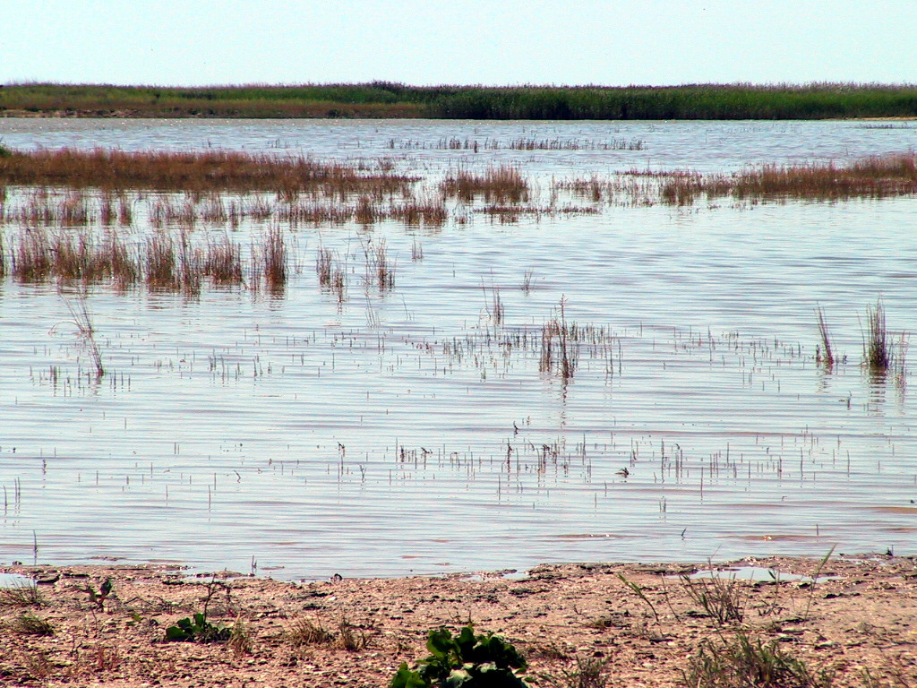
Figure 3.3.1 Communities of rush, reed and cattail in the Novinskiy Reserve
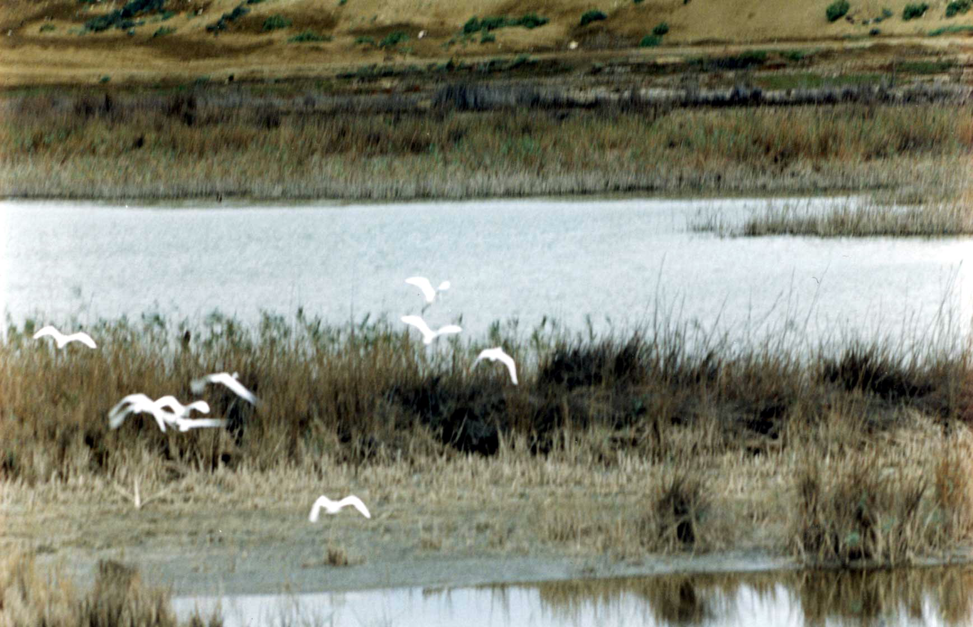
Figure 3.3.2 Egrets Egretta alba in the Novinskiy Reserve
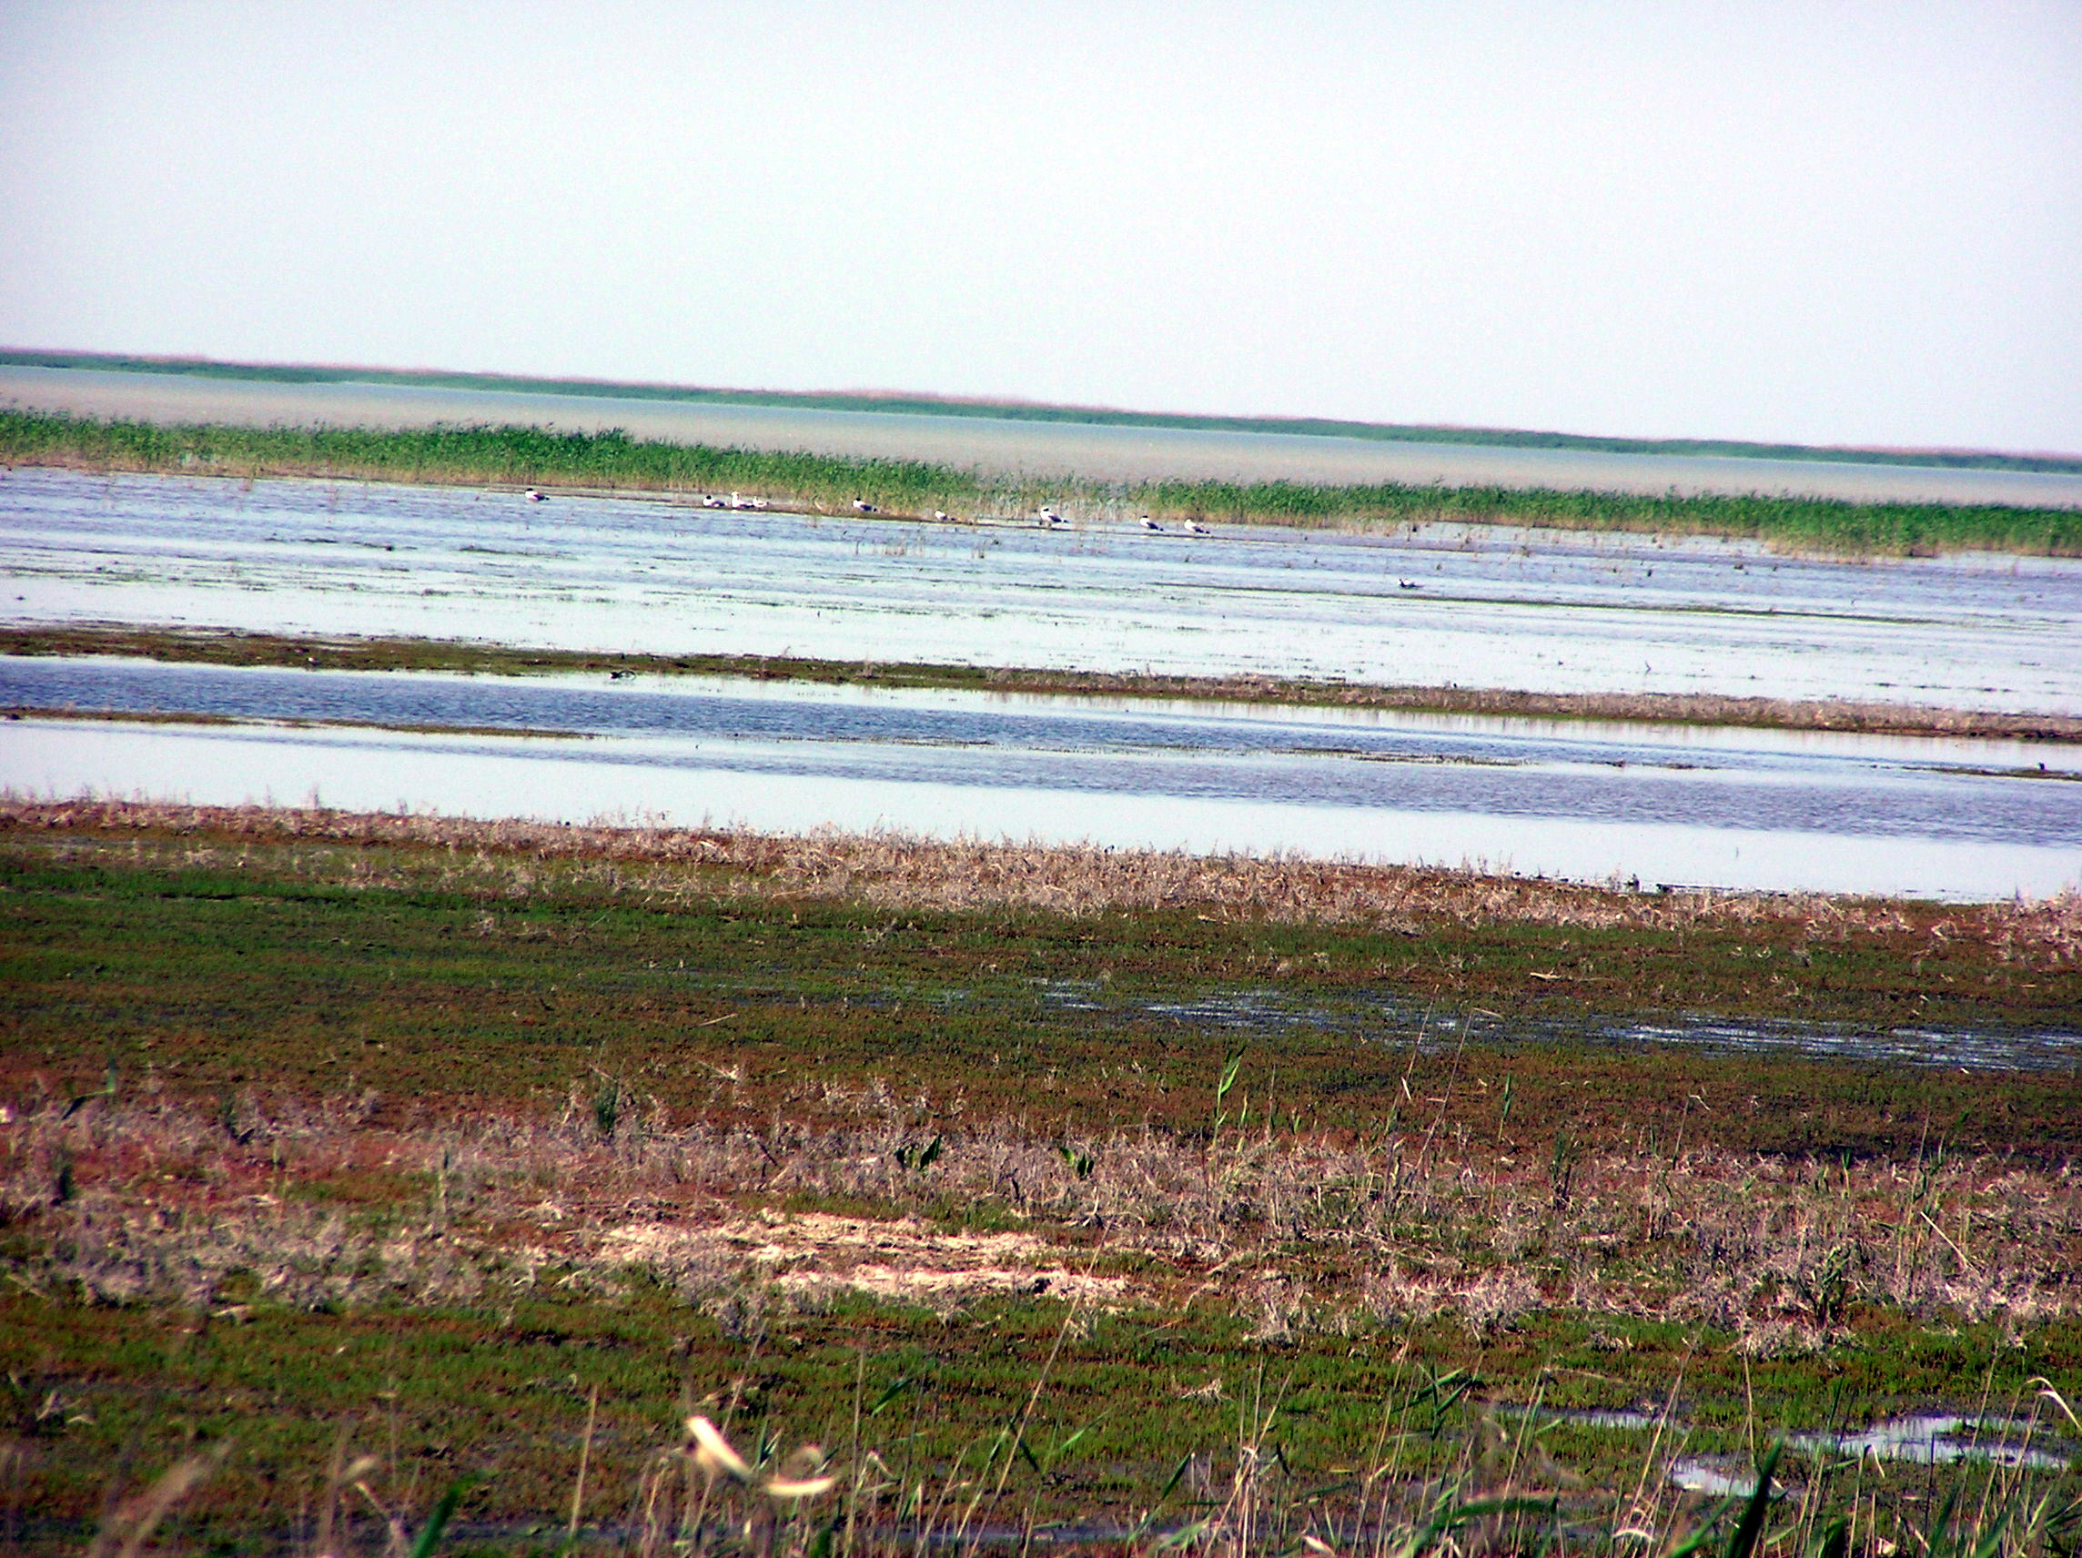
Figure 3.3.3 Gulls Larus ridibundus in the Novinskiy Reserve
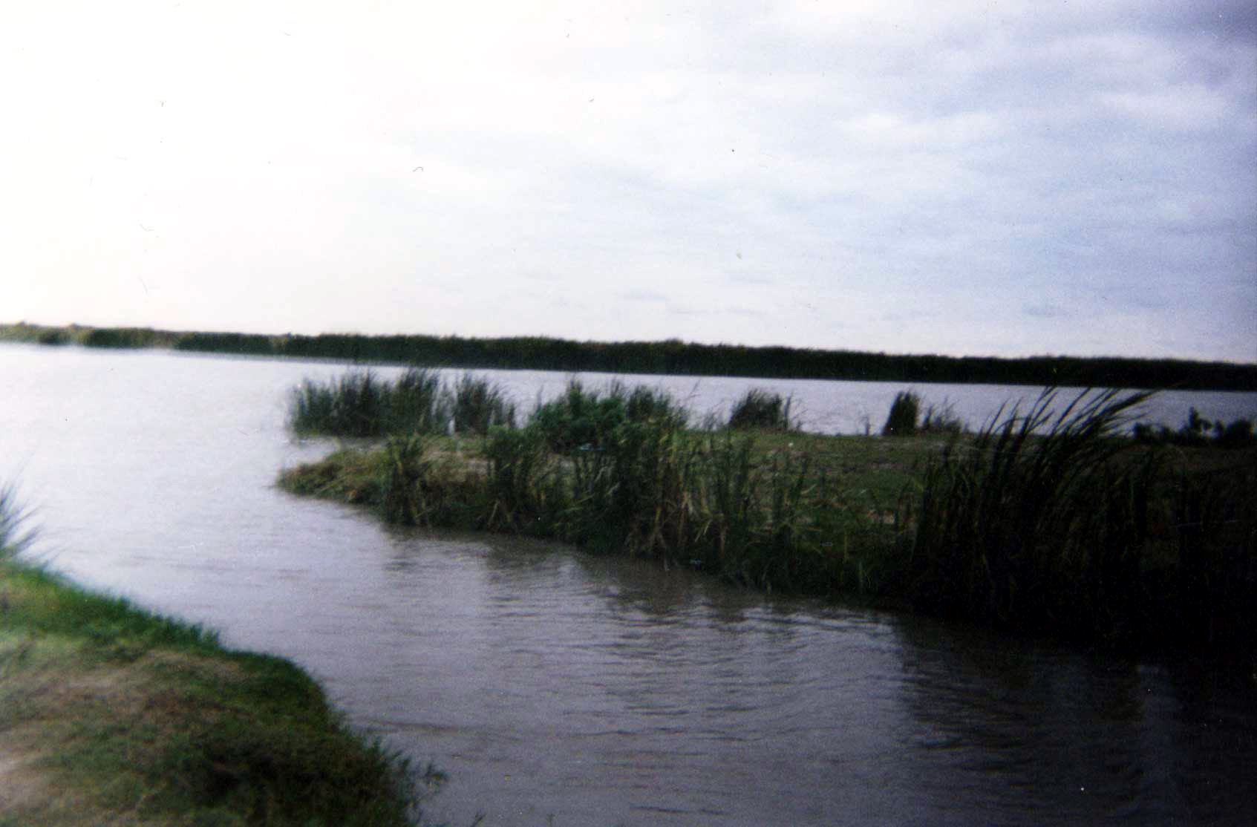
Figure 3.3.4 Cattail (Typha sp.) community in the Novinskiy Reserve
Aquatic area with depths of 0.5-0.6 m is rich in aero-aquatic vegetation. The following species predominate in communities: Phragmites australis, Typha angustifolia, T. lacksmanii, and Scirpus lacustris. Abundant mono-dominant communities of pondweed (P. pectinatus, P. macrocarpus) with 100% projective cover, horn weed communities with high proportion of Chara tomentosa are encountered in the area. Milfoil and milfoil-hornwort communities with 100% projective cover are frequently encountered. Valisneria spiralis, Salvinia natans, Botrachium foeniculaceum species are scarce in the encountered communities. Small communities with domination of Utricularia vulgaris, Hydrocharis morsus-ranae, Nymphoides peltatum, Aldrovandra vesiculosa, and other species are recorded around reed beds. Sparganium stoloniferum, Sciorpus lacustris, thick bushes of Carex pseudocyperus and Lycopus europaea are encountered on edges of reed beds. Butomus umbellatus is encountered less frequently.
Red Book of the Republic of Kazakhstan includes 4 vascular plant species inhabiting the Novinskiy Reserve site. These are:
- Nymphaea alba (3)
- Nelumbo nuciferum (3)
- Aldrovanda vesiculosa (2)
- Trapa natans (2)
Biodiversity of all plant species and rare and endangered plants is assessed a decreasing one.
Fauna of the site comprises 1 species of Cyclostomes, 39 species of fishes, 2 species of amphibians, 14 species of reptiles, 278 species of birds and 45 species of mammals (data on invertebrates are not available).
Species composition of fishes represents 8 orders, 11 families, and 39 species. Among them sturgeons number 5 species, herrings – 5 species, salmons – 2 species, carps – 11 species, cat-fishes – 1 species, silversides – 1 species, sticklebacks – 2 species, perches – 12 species.
Amphibians on the Caspian coast and adjoining territories are represented by 2 species – green toad and lake frog.
Reptiles of Novinskiy Reserve number 14 species that is 29% of all reptiles of Kazakhstan. In terrestrial communities, desert fauna is represented by lizards of the genus Phrynocephalus, Eremias and sand boa. Desert steppe group is represented by multicoloured Eremias and large whip snake. The rest 6 species (European pond terrapin, grass snake, chaser, mocassin, Orsini’s viper) have wide, often intrazonal distribution).
Birds of Novinskiy Reserve number 278 species. Among them, there are 110 nesting species, 76 wintering and 92 migratory species. Rush thickets is a nesting place for 2.5 thousand pairs of mute swans, 500 pairs of grey geese, more than 2 thousand pairs of mallard ducks, gadwalls, garganeys, about 1 thousand pairs of red-crested pochards and 5 thousand pairs of waders, more than 20 thousand pairs of gulls and terns, 500 pairs of cormorants and 10 thousand pairs of herons. In summer, it is a moulting place for 80 thousand mute swans and 100 thousand river ducks (Neruchev et al., 1995). Before the sea level rise, marine shoals of Volga-Ural region were not significant for birds’ nesting but were their habitats during moulting and migration. Numerous transgressions and regressions of the Caspian Sea lead to the considerable redistribution and fluctuations in number of birds. The most diverse is bird fauna of the Volga and Ural deltas, nesting places for about hundred of species. The nucleus of the bird fauna is formed by representatives of wetland complex (more than 40 species). Dominant representatives of the complex are warblers and terns. Numerous are great white and little egrets, great cormorant, night heron, glossy ibis, great grebe, great and little bitterns, moorhen, coot, red-crested pochard.
Sea level rise, land flooding and growth of rush and reed thickets lead to significant changes in terrestrial distribution of many shore birds. Besides increasing number of nesting ducks, swans, herons and appearance of new nesting species (purple gallinule, cattle egret), there was registered their distribution over newly flooded areas, closer to the modern coastline. At the same time, flooding of near-delta islands and sandy shoals lead to disappearance of nesting grounds for lake and common gulls, marine doves, Caspian, sandwich, gull-billed terns.
In the delta areas of the Volga and Ural Rivers there preserved some singular pairs of waders (oystercatcher, black-winged stilt, lapwing, redshank, and little ringed plover). The following species have disappeared from the nesting grounds: short-toed lark, shore lark, crested lark, great grey shrike and starling. Sometimes, in high places, along the roads and canals, among the vast water and rush-covered areas, there are registered nesting places of stone curlew, black-winged pratincole, blue-cheeked beeeater, lesser short-toed lark, sand martin.
Near-delta and adjacent shallow water areas are very important as places of summer moulting gathering of dabbling and sea ducks, grey geese and mute swans. In 1960-1970s, the main stop-over places for birds were reed and rush thickets (kultuk) and marine shoals but now more significant for dabbling ducks (mallards, pintails, gadwalls and teals), coots and mute swans are internal stretches (open water areas) of the Ural and Volga deltas.
Qualitative and quantitative composition of birds of Volga-Ural region changes in different seasons. The highest quantity of birds was registered during seasonal migrations (in spring - 240, in autumn -940 birds per 1 km of the route). Most numerous in springs are herons, gulls, and terns. Rather numerous are mute swans and dabbling ducks. In autumn, from late August until November, the number of waterfowls and shore birds is higher, than in other periods. Dominant in number are dabbling ducks (mallard, pintail, and teals), grey geese, shelducks, and gulls.
Mammals of the region are rather diverse and number 45 species. Among them, the most numerous in terrestrial communities are 4 species (fox, steppe polecat, saiga, Eversmann’s hamster). In coastal habitats numerous are raccoons, muskrats, wild boars and in the water area of the Caspian Sea –Caspian seals. Among rare mammals, marbled polecat occurs in terrestrial habitats. Endemic species – putorak, was included into the Red Book in 1978 and than excluded from it.
Red Books of IUCN and Republic of Kazakhstan includes 1 species of cyclostomes, 3 species of fishes, 1 species of reptiles, 32 species of birds and 1 species of mammals. They are represented by the following organisms:
Cyclostomes:
- Caspiomyzon wagneri - Caspian lamprey (2)
Fishes:
- Salmo trutta caspius - Caspian trout (1)
- Alosa kessleri volgensis - Volga shad (2)
- Stenodus leucichthys leucichthys - Caspian inconnu (4)
Reptiles:
- Coluber caspius (3)
Birds:
- Pelecanus onocrotalus - great white pelican (1)
- P. crispus - Dalmatian pelican (2-3)
- Ardeola ralloides - squacco heron (2)
- Bubulcus ibis - cattle egret (3)
- Egretta garzetta - little egret (3)
- Platalea leucorodia - spoonbill (2)
- Plegadis falcinellus - glossy ibis (2)
- Ciconia nigra - black stork (3)
- Phoenicopterus roseus - greater flamingo (2)
- Rufidrenta ruficollis - red-breasted goose (2)
- Cygnus cygnus - mute swan (2)
- Aythya nyroca – white-eyed pochard (3-5)
- Oxyura leucocephala - white-headed duck (1)
- Pandion haliaetus - osprey (1)
- Circaetus gallicus/ferox - short toed-eagle (2)
- Aquila rapax – steppe eagle (5)
- A. heliaca – eastern imperial eagle (3)
- A. chrysaetos - golden eagle (3)
- Haliaeetus albicilla - white-tailed eagle (2)
- Falco cherrug – saker falcon (1)
- F. peregrinus - peregrine falcon (1)
- Grus leucogeranus - Siberian white crane (0-1)
- Anthropoides virgo - demoiselle crane (5)
- Porphyrio porphyrio – purple gallinule (2)
- Otis tarda - great bustard (1-2)
- O. tetrax - little bustard (2-5)
- Chlamydotis undulata - houbara bustard (2-5)
- Chettusia gregaria – sociable plover (1)
- Larus ichthyaetus - great black-headed gull (2)
- Pterocles orientalis - black-bellied sand-grouse (3)
- Syrrhaptes paradoxus - Pallas’s sandgrouse (4)
- Bubo bubo - Eurasian eagle owl (2)
Mammals:
- Vormela peregusna - (3)
Biodiversity of both all animals and of animal species included into the Red Books is assessed as stable with exception of fishes, reptiles and mammals, which demonstrate decrease in composition and abundance.
It should be highlighted that Caspian coast is a home of most of rare birds of Kazakhstan – flamingo (about 50 thousand individuals), white pelican (about 2 thousand individuals), Dalmatian pelican (about 0.5 thousand individuals), little egret (about 1.5 thousand individuals), glossy ibis (about 0.6 thousand individuals). The largest in the area is the number of white-tailed eagle, which concentrate here for wintering (about 600 individuals).
Wetland ecosystems of Novinskiy Reserve are especially significant for the region because of extreme shallowness of the Northern Caspian Sea. Shallow areas with the depth of 1-1.5 m stretch for many kilometres towards the sea. Shallow areas, vast reed and rush thickets, and wetlands make this region the most productive in the Caspian Sea. However, this region is subjected to different natural changes and stresses, such as sea level fluctuations, floods, transportation of seabed sediments during storm surge, extreme temperatures, and ice cover in winter. In such dynamic environment, flora and fauna quickly adapts to changes and ecological stresses.
Presence of reed and rush thickets is the main peculiarity of these ecosystems. After the sea transgression, vast dike areas and former irrigation canals are flooded. Soil conditions facilitate formation of reed and rush thickets, which appeared here long before the sea level rise.
Inside the rush belt there are numerous shallow areas with sparse rush communities and floating and submerged vegetation, which serve for nesting of herons. Dense curtain reed thickets are quickly developing in the coastal delta areas. In contrast to the Ural River delta, formation of these thickets occurred because of their primary distribution in the coastal water area. Marine freshwater and brackish water ecosystems with the depth of 1-1.5 m are most important among aquatic ecosystems. Residual ecosystems of the former lowland reed-beds alternating with water areas take special place among the Volga delta ecosystems.
Terrestrial areas, which once had arid conditions, are now flooded and have sub-aerial damping regime. In such hydromorphic conditions, soils are at the stage of reformation. Corresponding changes occur in all parts of ecosystems, from entomological fauna to large mammals. Soil cover of the flooded territory transferred into seabed sediments. Coastal solonchak soils are now in hydromorphic marsh conditions. In such a way, new kind of wetland ecosystems is developing here, which a special has set of biotic components.
Novinskiy Reserve as well as the Ural River delta is very important region for waterfowls and shore birds. Millions of them migrate over these regions every year. They also are moulting places for mute swans, dabbling and sea ducks. These places are especially valuable as habitats of endangered species of birds included in the Red Book, which disappeared in other regions of Kazakhstan (little egret, cattle egret, squacco heron, glossy ibis, etc.). Besides, this region is the largest in Eurasia wintering place of white-tailed eagle. Birds densely inhabit coastal habitats of the Volga-Ural region during nesting period as well as in the period of seasonal migrations.
Human impacts. The Caspian Sea level rise favours development of hydrophytes vegetation in the region. The flooded land is transforming, being occupied by communities of higher aquatic plants and algae. The process of the sea level rise is unpredictable and has no time limit. So are the changes of vegetation. New ecosystems can be unstable in space and time and highly sensitive to any of the human impacts.
There are two types of human impact in the region – agriculture, oil and gas industry. Influence of agriculture is expressed in the presence of engineering constructions – exploited and mostly flooded irrigation canals. Besides, high content of biogenic elements, i.e., mineral forms of phosphorus and nitrogen, are registered in the region of the Volga flow off influence. However, this tendency has been going down during the recent years.
At present, oil pollution is registered in the seabed sediments and heavy metals - in the seawater of the region. Accumulation of carbohydrates in fish tissues (first of all in sturgeons and carps) is registered in the areas close to oil fields. Most likely, carbohydrates also pollute other components of ecosystems.
Besides this, activity of oil and gas complex is expressed in construction of protective dams along the marine borders of oil fields. In general, human impact on the ecosystems of the site is assessed as moderate. However, consideration must be given to the value of these ecosystems and their protection from chemical pollution.
3.3.3 Ural River Delta
Wetlands of the Ural River delta and adjacent areas of the Caspian Sea coast (see Annex 2, Figures 3.3.5-3.3.8) are important habitats, giving support to millions of waterfowls and shore birds during their nesting, moulting, migration, and wintering.
The site situated in Peshnoy Island within the modern Ural River delta is chosen as a reference point. Communication with the island occurs through the embankment road of unsatisfactory condition. In some places it is washed out and only 2 m wide. In the island, ground roads on loamy sand have medium traffic ability.
The Ural River alluvium influenced the origin and development of Peshnoy Island (once there was a group of islands at the lower level) but, in general, the island has marine origin and is formed under the influence of wind currents and roughness.
The island is located in 800 m to the east of the Ural-Caspian canal, through which the Ural River flows into the sea. Delta reed and rush thickets are widely developed around the island. The soils of the island are of meadow-marsh and marsh type.
The upper border of the Ural River mouth coincides with the top of the delta (lower Atyrau), marine border – goes along the coastal waters at the isobath of 3 m. Within these borders the square of the mouth area is 1500 km². The square of the river delta is – 600 km².
Flora and vegetation. Altogether, there are not less than 229 species of higher plants growing on the described territory (data on other plant species are not available). Vegetation of the Ural River delta is referred to several types:
Submerged herbaceous aquatic vegetation:
- Water areas:
  - Loose communities and singular individuals of eelgrass (Zostera marina);
  - Communities of eelgrass (Zostera marina) and pondweed (Potamogeton pectinatus) and Charophyte algae (Chara hispida, Chara polyacantha);
  - Combination of eelgrass communities (Zostera marina) and pondweed communities (Potamogeton pectinatus + Herbae aquaticae demersae).
- Sublittoral:
  - Dense high thickets of pondweed (Potamogeton pectinatus + Herbae aquaticae demersae);
  - Combination of middle height thickets of pondweed (Potamogeton pectinatus, P. perfoliatus, Myryophyllum spicatum, Ruppia marina), with participation of polysiphonia (Polysiphonia sertularioides);
  - Herb communities with domination of pondweed and ceratophyllum (Potamogeton pectinatus, P. perfoliatus, Ceratophyllum demersum, Myryophyllum spicatum, Najada marina).
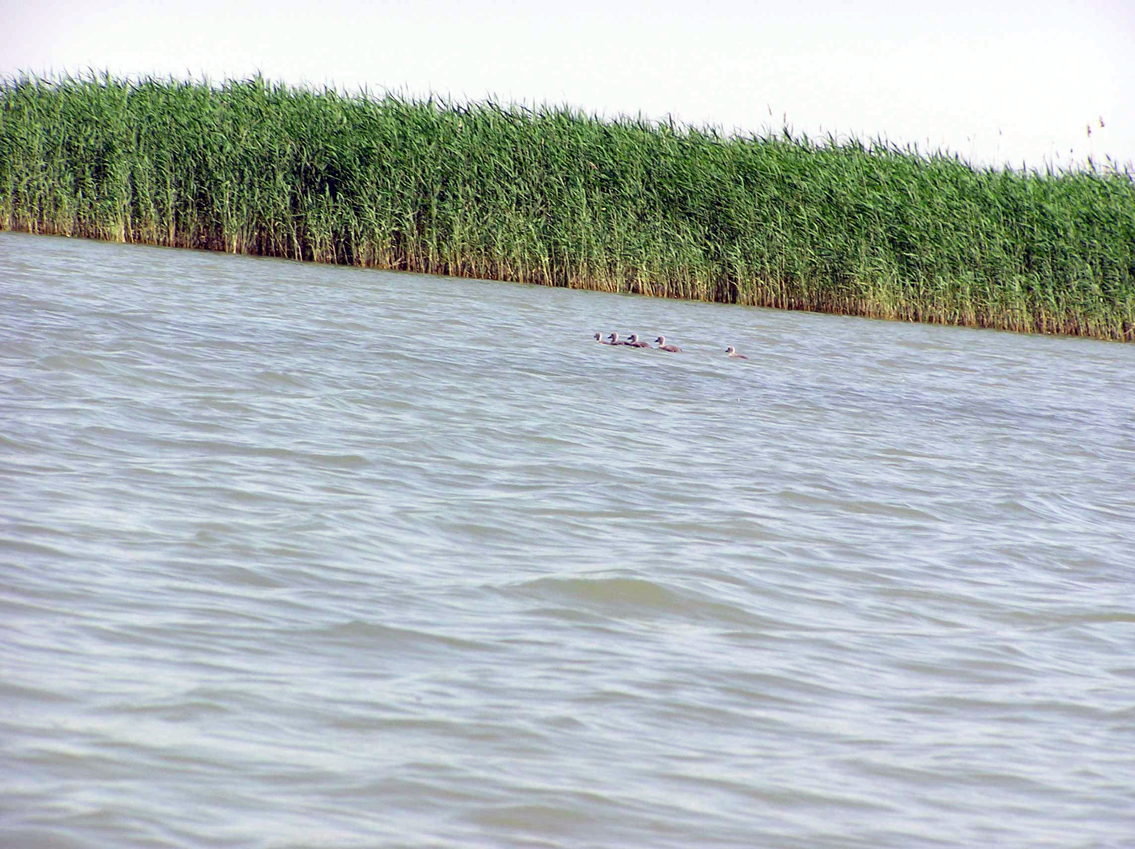
Figure 3.3.5 Dabbling ducks in the Ural River Delta
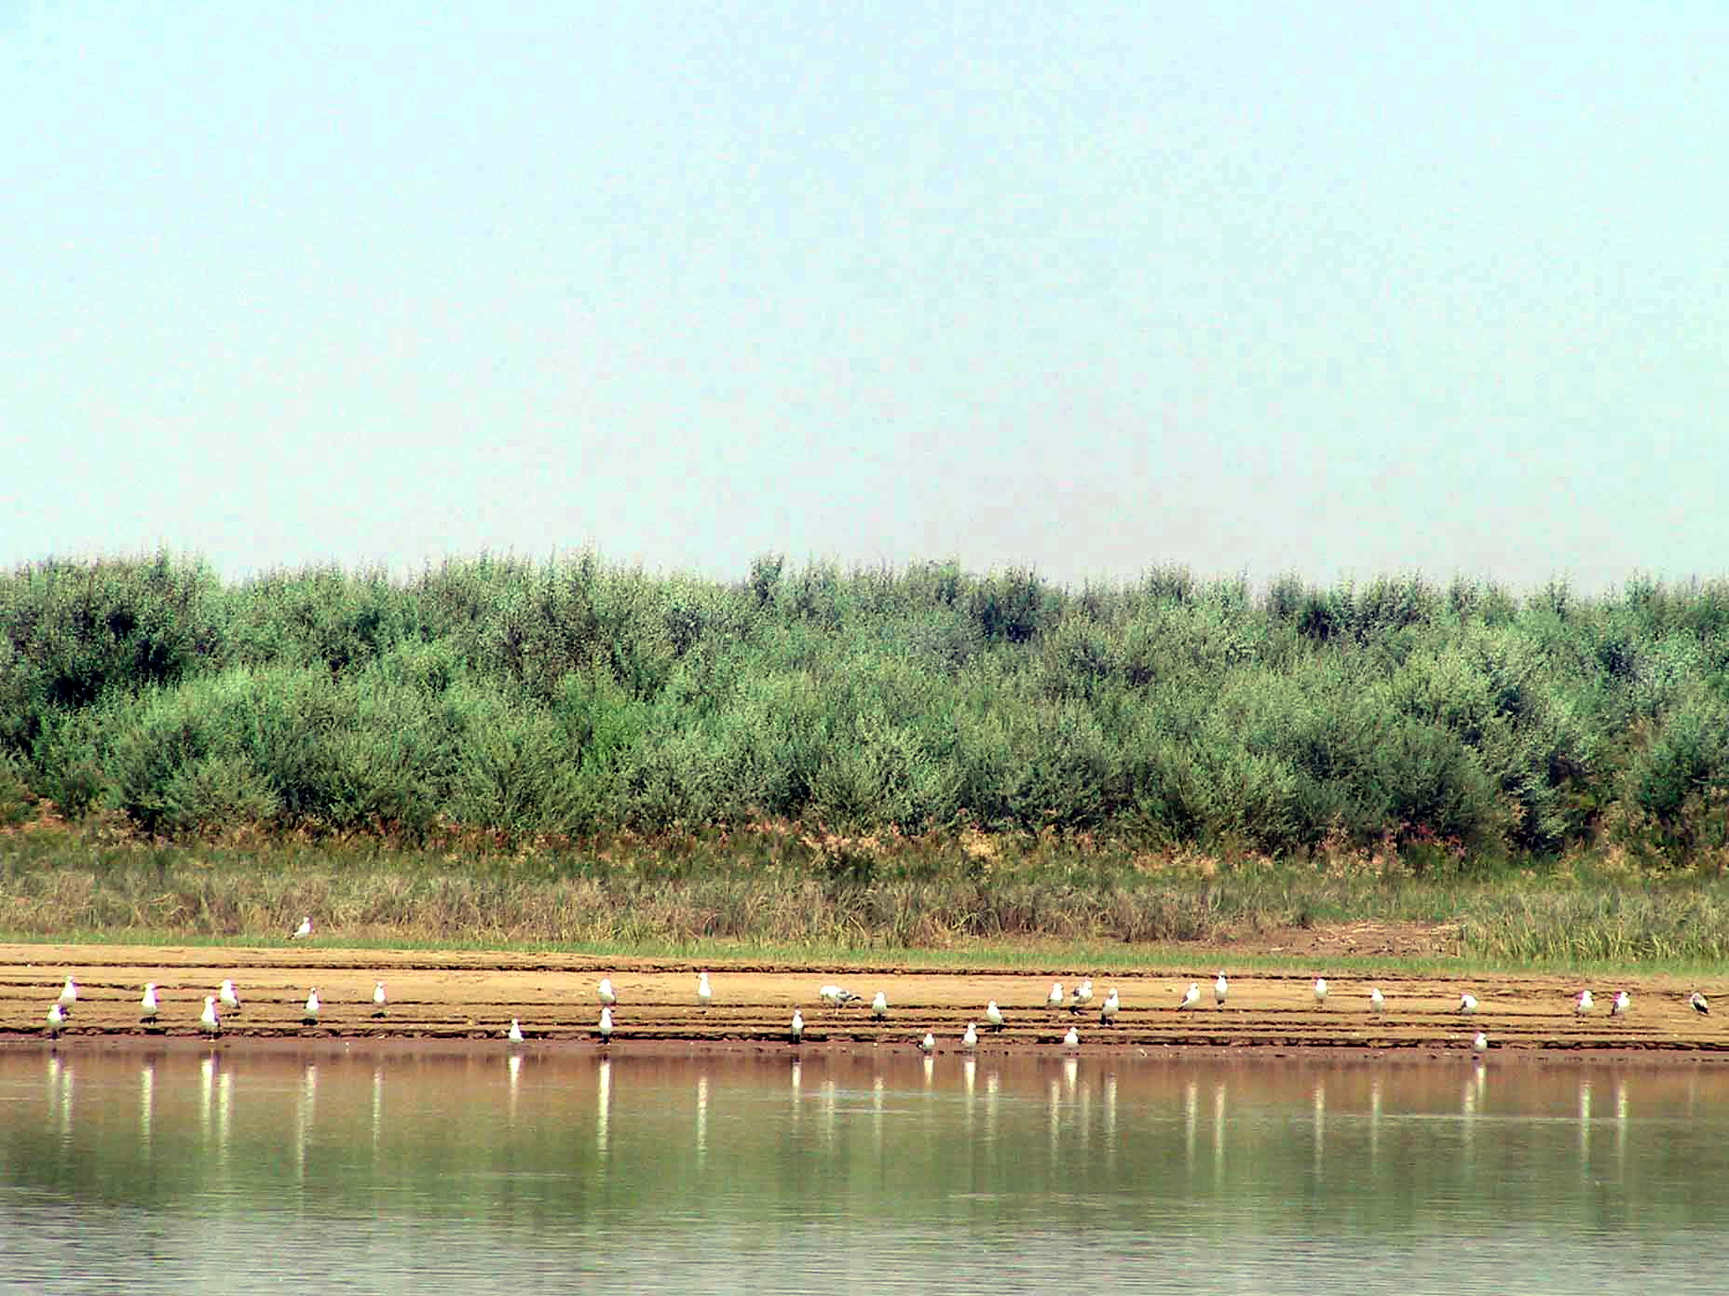
Figure 3.3.6 Gulls Larus argentatus in the Ural River Delta
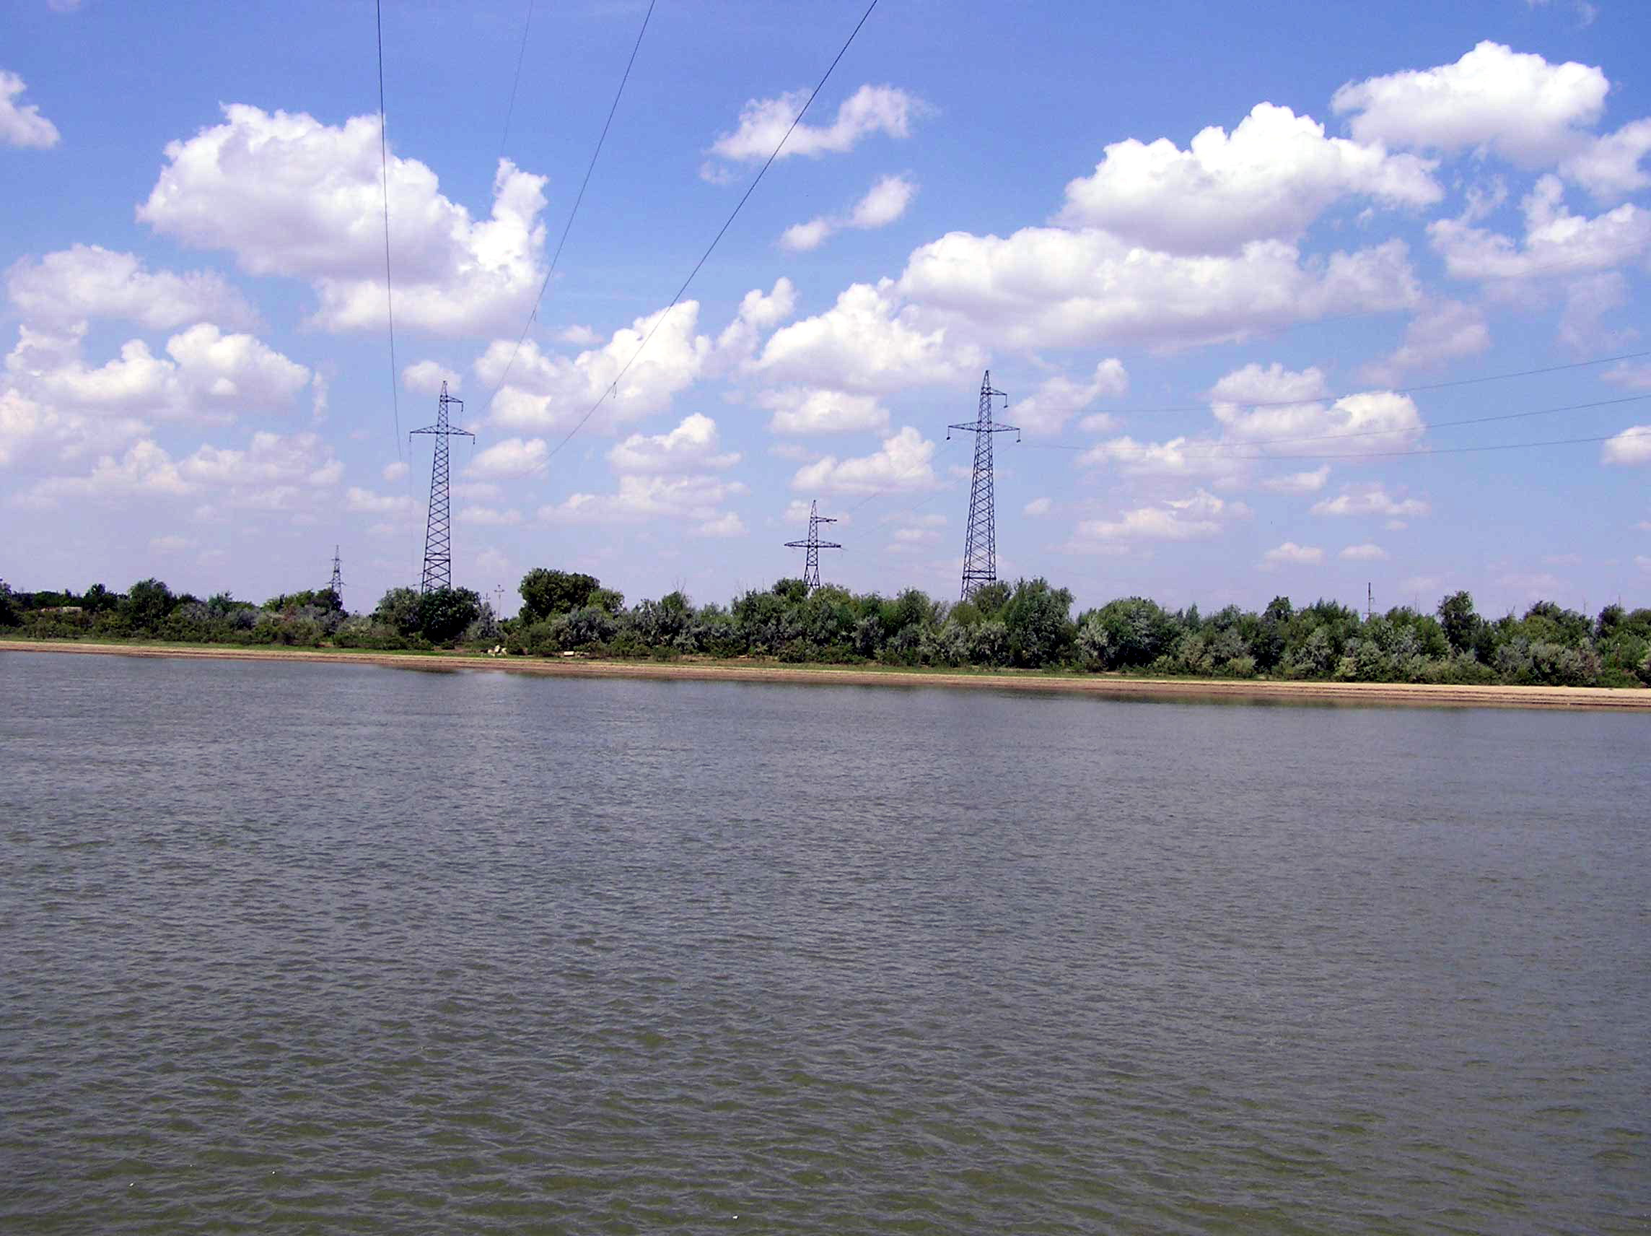
Figure 3.3.7 Left bank of the Ural River
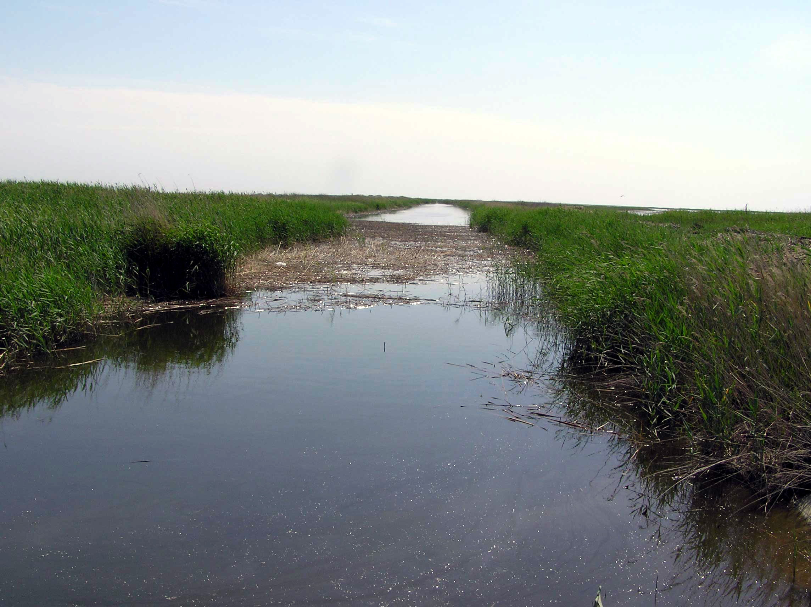
Figure 3.3.8 Reed bed along one of channels in the Ural River Delta
- Modern littoral (transitional zone):
  - Complex of developing communities of pondweed (Potamogeton pectinatus) and ceratophyllum (Ceratophyllum demersum) with participation of other aquatic plants (Herbae aquaticae demersae);
  - Loose pioneer communities of pondweed (Potamogeton pectinatus), ceratophyllum (Ceratophyllum demersum), myryophyllum (Myryophyllum spicatum), and najada (Najada marina);
  - Singular individuals of pondweed (Potamogeton pectinatus), ceratophyllum (Ceratophyllum demersum), najada (Najada marina).
Aerial-aquatic vegetation of transitional zone:
  - Combination of semisubmerged and terrestrial cane thickets (Phragmites australis) with submerged aquatic vegetation in the lower layer (Herbae aquaticae demersae) at the depth of 1.5 m with participation of willow (Salix caspica), and shorthear (Calamagrostis pseudophragmites) along the canal banks and land areas;
  - Cane thickets (Phragmites australis) combined with cattail (Thypha angustifolia, T. latifolia) with mixture of aquatic herbs (Herbae aquaticae mixtum) in the inner areas of bays and lagoons;
  - Young developing cane thickets at the depth of 1-1.5 m with submerged aquatic herbs in the lower layer (Phragmites australis - Herbae aquaticae demersae);
  - Cattail thickets (Thypha angustipholia, T. latifolia) with cane (Phragmites australis) and mixed aquatic herbs (Herbae aquaticae mixtum).
Terrestrial (shore) vegetation of the flooded area:
  - Combination of cane (Phragmites australis) and annual saltworm-halophyte-grass (Aeluropus littoralis, Puccinelia giganthea, Salicornia europaea, Suaeda prostrata) communities;
  - Developing communities of puccinelia (Puccinelia giganthea) and salicornia (Salicornia europaea) in place of dead sarsan communities (Halocnemum strobilaceum);
  - Transformed under human impact shrub communities (Nitraria shoberii, Tamarix ramosissima, Halostahys caspica, Kalidium caspica) with annual saltwort-herb layer (Vexibia alopecuroides, Climacoptera aralo-caspica, C. crassa, Chenopodium album) with singular individuals of oleaster (Elaeagnus oxycarpa) along the banks of the Ural River.
Red Book of the Republic of Kazakhstan includes 2 vascular plant species inhabiting the Ural River Delta. These are:
- Trapa natans (2) and
- Tulipa schrenkii (2)
Rare species occurring on the territory are:
- Vallisneria spiralis
- Salvinia natans
- Marsilea quadrifolia
- Utricularia vulgaris
Biodiversity of the vascular plant species is assessed as an increasing one, while abundance of rare and endangered plants is assessed as decreasing.
Fauna of the site comprises 820 species of invertebrates, 1 species of cyclostomes, 98 species of fishes, 2 species of amphibians, 20 species of reptiles, 292 species of birds and 48 species of mammals.
Insects registered in the Ural River delta number 820 species, representing 61 family, and 15 orders. The basis of the insect fauna is formed by representatives of dragon-flies (Lestidae, Coenagrionidae, Aeschnidae, Libellulidae), mantises (Mantidae), homopterans (Cicadellidae, Aphidinea), bugs (Corixidae, Nepidae, Miridae, Lygaeidae), orthopterans (Acrididae, Gryllidae, Tettigoniidae), beetles (Dytiscidae, Carabidae, Staphylinidae, Coccinelidae, Scarabaeidae, Elateridae, Tenebrionidae, Chrysomelidae, Curculionidae), butterflies (Geometridae, Noctuidae, Pyralidae, Pieridae, Lycaenidae), hymenopterans (Ichneumonidae, Braconidae, Sphecidae, Eumenidae, Formicidae), and dipterans (Culicidae, Chironomidae, Asilidae, Bombyllidae, Muscidae, Syrphidae, Ephydridae).
Fishes in the Ural River delta and mouth area can be met in the number of 99 species and 13 subspecies from 18 families (Kazancheyev, 1981; Kasymov, 1987; Prorection…, 1994).
Most important for the preservation of biodiversity of the Ural River basin (and in commercial respect) are sturgeons (5 species) and carps (33 species). For the majority of river and semi-anadrom fishes inhabiting in the Ural River, the Ural delta is a feeding, reproduction and fattening area. Production of big amount of biogenic elements creates rich forage reserve in the Ural River mouth. During the feeding migration, many river and sea fish species (herring, grey mullet, and goby) can appear in this area.
Among sea fishes, the most diverse are herrings (18 species and subspecies) and gobies (41 species and subspecies).
Mouth area of the Ural River is important as a transitional zone, where young fishes of many valuable and rare anadrom and semi-anadrom species adapt to marine environment.
Birds in the Ural River delta are registered in number of 292 species. These number of species includes representatives of divers (Gaviiformes, Podicipediformes), pelicans (Pelicaniformes), storks (Ciconiiformes), flamingos (Phoenicopteriformes), geese (Anseriformes), falcons (Falconiformes), cranes (Gruiformes), plovers (Charadriiformes), pigeons (Columbiformes), cuckoo birds (Cuculiformes), owls (Strigiformes), goatsuckers (Caprimulgiformes), martins (Apodiformes), (Coraciiformes) and sparrows (Passeriformes).
While the number of nesting little white egrets, glossy ibises, and pygmy cormorant is relatively high, the number of cattle egrets and spoonbills is still very low. During the last decade, environmental changes and formation of new large nesting and feeding areas lead to the growth of number of rare and endangered species. The number of nesting glossy ibises, pygmy cormorants, and Dalmatian pelicans considerably increased. At the same time, some species of this group - squacco heron, spoonbill, purple gallinule, decreased in number and there are no data about their nesting in the region.
Mammals of the Ural River delta and adjacent territories number 48 species of the 7 orders. Among them, there are orders of insectivorous mammals (Lagomorpha), predators (Carnivora), even-toed mammals (Artiodactyla), and pinniped mammals (Pennipedia). The most numerous are muskrats, house mice, tamarisk gerbilles, raccoon dogs, foxes, wolves, badgers, and wild boars.
Aquatic mammals are represented by one species from the order Pennipedia – Caspian seal. Its number within the considered area is relatively low. The animals visit the site for feeding.
Muskrat represent semi-aquatic mammals. These rodents occupy running and ditch water reservoirs with the reserve of forage plants along the banks, and reed and rush thickets in the coastal zone. Number of muskrat families, registered during field research, varied from 0.25 to 1 (0.32 in average) per hectare, and number of animals – from 1 to 6 (in average 2.3 per hectare).
The rest of the species are terrestrial mammals, inhabiting different ecosystems – cane thickets of the coastal zone (on land), forests and shrub thickets of the coastal zone, dry-steppe, steppe-desert, desert, desert hyper-halophyte, halophyte-semi-shrub ecosystems, man made ecosystems, agricultural ecosystems, etc.
Red Books of IUCN and Republic of Kazakhstan includes 24 species of invertebrates recorded at the site, 1 species of cyclostomes, 3 species of fishes, 2 species of reptiles, 16 species of birds and 2 species of mammals. The following organisms represent them:
Invertebrates:
- Ischnura aralenais (3)
- Calopteryx virgo (2)
- Anах imperator (2)
- Bolivaria brachyptera (2)
- Saga pedo (2)
- Onconotus servillei (2)
- Ceraeocercus fuscipermis (3)
- Porphyrophora polonica (3)
- Callisthenes reticulates (3)
- Lucanus cervus (2)
- Dorcus parallelopipedus (0)
- Bolboceras armiger (0)
- Cnemisus rufescen (4)
- Haplosoma ordinatum (4)
- Chilocorus bipustulatus (2)
- Stethorus punctillum (2)
- Scolia maculate (2)
- Scolia hirta (2)
- Hoplitis fulva (2)
- Zerynthia polyxena (2)
- Microzegris pyrothoe (2)
- Aricia chinensis myrmecias (3)
- Scolitantides bavius (2)
- Philotes panope (1)
Cyclostomes:
- Caspiomyzon wagneri - Caspian lamprey (2)
Fishes:
- Salmo trutta caspius - Caspian trout (1)
- Alosa kessleri volgensis - Volga shad (2)
- Stenodus leucichthys leucichthys - Caspian inconnu (4)
Reptiles:
- Elaphe quatuorlineata - four-lined snake (4)
- Coluber caspius - Caspian whip snake (3)
Birds:
- Pelecanus onocrotalus - great white pelican (1)
- P. crispus - Dalmatian pelican (2)
- Phalacrocorax pygmaeus – pygmy cormorant (2-5)
- Egretta garzetta - little egret (3)
- Ardeola ralloides - squacco heron (2)
- Platalea leucorodia - spoonbill (2)
- Plegadis falcinellus - glossy ibis (2)
- Cygnus cygnus - mute swan (2)
- Oxyura leucocephala - white-headed duck (1)
- Aquila rapax – steppe eagle (5)
- Haliaeetus albicilla - white-tailed eagle (2-5)
- Otis tarda - great bustard (1-2)
- O. tetrax - little bustard (2-5)
- Chlamydotis undulata - houbara bustard (2-5)
- Porphyrio porphyrio – purple gallinule (2)
- Larus ichthyaetus - great black-headed gull (2)
Mammals:
- Eptesicus bobrinskoi – Bobrinski's serotine (3)
- Vormela peregusna - marbled polecat (3)
Biodiversity of majority of the animal groups (fishes, reptiles, birds, and mammals) is assessed as a decreasing one, while some of them (invertebrates, cyclostomes, and amphibians) demonstrate stability.
Wetland ecosystems of the Ural River delta and adjacent Caspian coast are most important in Eurasia areas, which support millions of waterfowls and shore birds during their nesting, moulting, seasonal migration, and wintering. There are several types of ecosystems in the region, which differ in main physical and chemical parameters and components. Coastal ecosystems are characterized by presence of cane and reed thickets with communities of arboreal-shrub vegetation along the delta branches of the Ural River. River freshwater ecosystems are characterized by running and stagnant regime. Of this type is the Ural River bed (Ural-Caspian canal) with channels, connected with the sea, and separated from the sea “blind” old riverbeds with weal current and boggy regime. Island ecosystems have reed and rush thickets with colonies of one of the abundant bird species – great black headed gull.
The Ural River delta, unlike the multi-branched Volga delta, has only two large functioning branches. Besides the main riverbed, the permanent flow occurs through the canals Shamanozek and Yaitskiy. In the northern part of the delta, considerable areas of herb-grass meadows are used for haymaking and cattle pasturage. The banked areas of the northern delta, once used for agriculture, where water collects during spring floods, serve as spawning places for fish (first of all, for sazan). Because of transgression, large banked areas are constantly or periodically flooded and now overgrown with reed and cane.
Cane thickets have also formed until the marine edge of the delta, occupy the area to the east of Peshnoy Peninsula (more than 8 thousand hectares), and to the west of Jaitskiy canal (more than 10 thousand hectares). Inside the thickets, there are several old riverbeds with communities of cane and submerged aquatic vegetation, which serve for nesting of herons. Curtain thickets of cane are quickly forming in the mouth coastal waters. Unlike in the Volga delta, their formation occurred because of land flood and not because of their distribution in the coastal waters.
According the criteria of Ramsar Convention, the wetland can have international significance, if it supports the existence of not less than 20 000 waterfowls. The site of the Ural delta has great significance for preservation of migrant birds, so the territory corresponds to the criteria of Ramsar Convention and can be recommended for PA creation.
Human impact over ecosystems in the Ural River basin leads to the decrease of quantity and quality of river waters entering the delta. From the other side, growing influence over delta from the sea (sea level rise, wind tides, pollution due to the oilfield development) also changes the chemical regime of water in the Ural River delta. All these factors endanger the existence of many animals, first, rare species. The most serious factor, which endangers the biodiversity of the Ural delta fauna, is the sea level rise and subsequent flooding of coastal areas. On the adjacent to delta territories, it led to the flooding of deserted oil wells, so in some places the oil pollution became stronger. The most risky areas are sites of broken productive oil wells and sites of productive wells, prepared for exploitation but dormant until the beginning of production. Besides these, there are oil wells, dormant at the stage of boring because they did not reach the productive horizon.
Most dangerous are the broken oil wells with gas emission, including hydrogen sulphide and other oil products. Dangerous also are productive oil wells under pressure and oil wells dormant for more than 15-20 years. In many of them under the influence of aggressive environment (marine water and ice), casing pipes became worthless and can cause emergency at every moment and cause irreplaceable damage to environment. High concentrations of chlorine-containing pesticides and herbicides are also registered in the regions of former irrigation agriculture in the Ural River delta with the dense network of irrigation canals. Flooding of these territories caused distribution of these chemicals over the adjoining areas of the coast, where their high concentrations are registered in the seabed sediments and water.
Active oil industry expansion in the adjoining regions of the Eastern Caspian Sea shelf is another negative factor for vital functions of sturgeons and seals. It has disturbing man-caused and chemical effect. Main components of this effect are physical presence of people, mechanical damage of seabed during construction of pipelines, dumping and building of production islands, pollution of environment by oil products, phenols, heavy metals, etc.
Misguided economical activity on the Ural River is accompanied by gravel dumping of the seabed, placing of concrete slabs on the seabed, etc. This worsens the conditions of natural spawning because sturgeons do not reach their original spawning grounds and lay their spawn on the artificial dense substrates where the spawn dies in unfavourable conditions. At the main fish industry objects “Malaya Damba” and “Nizhnyaya Dambinskaya” situated here, about 80% of the Ural River catch volume is produced. The main wintering pits of fishes are situated here – “Nizhnyaya Dambinskaya” and “Bolshaya Ganyushkinskaya”. Spawning of semi-anadrom fishes occurs along the zone of aquatic vegetation of the river and in the flood land. Delta channels and main riverbed of the Yaik canal serve as ways of spawning and seasonal migrations of sturgeons and other fishes. About 70% of sturgeons, migrating to spawning and wintering places enter the Ural River through the Zolotoy channel of the Ural River from the sea. The young sturgeons migrate back to the sea through the same way.
However, human impact can be positive. Rather important for biodiversity conservation is an artificial water body situated in the Ural River delta to the west of Atyrau. There are 21 species of birds, including 4 key species (Dalmatian pelican, glossy ibis, white-headed duck and great black-headed gull). Besides, this is the only nesting place of white-headed duck and one endemic species (black-winged pratincole).
3.3.4 Komsomolets Bay
Komsomolets Bay (see Annex 2, Figures 3.3.9-3.3.12) refers to the State Protected Area in the northern part of the Caspian Sea, which was created by the Resolution of the Council of Ministers of the Kazakh SSR of April 30, 1974, No. 252 “On the declaration of a protected area in the northern part of the Caspian Sea”. Komsomolets Bay is a unique large shallow bay, a place of concentration of flamingo and other Red Book species. The “Spacing scheme of the RK PA until 2030” designed by ECOPROJECT in 2001, suggests organization of Tasurpinskiy Refuge as a perspective PA for Atyrau and Mangistau provinces, which will include some sites of Komsomolets Bay and Mertvyy Kultuk Bay.
The bay separates the eastern coast of North-Eastern Caspian Sea and Buzachi Peninsula. During recent years, the bay water area became a place of active exploring and production of oil. That is why, it is important to intensify control and monitoring over this area of the Caspian Sea.
The site situated in 30 km to the south-west of Sarykamys has been chosen as a reference point. The territory represents littoral lowland with halophyte vegetation on salt marsh. There are some small cane and marshy islands in the mouth of the bay.
Flora of the Komsomolets Bay area numbers about 70 species of higher plants from 15 families and 52 genera (data on other plant species are not available). The highest species diversity have the families Chenopodiaceae (31 species), Gramineae (9 species), Asteraceae (8 species) and Brassicaceae (5 species). Fabaceae and Polygonaceae are represented by 3 species each, Cyperaceae, Boraginaceae and Plumbaginaceae – by 2 species and families Ephedraceae, Liliaceae, Zygophyllaceae, Iridaceae, Frankeniaceae and Tamaricaceae – by 1 species.
Vegetation of the region refers to north-turanic type, subzone of northern deserts and is a part of Caspian province (Rachkovskaya, 1995). Desert type of vegetation of the region is characterized by domination of xerophillic and halophillic sub-shrub annual saltworts. In general, the coastal zone is covered by halophyte vegetation because salinity is the main adaptogenic environmental factor. The most common species here is sarsazan (Halocnemum strobilaceum), and annual saltworts and glasswort (Salicornia europaea).
Vegetation of halophyte deserts is formed by juicy saltworts: Petrosimonia oppositifolia, P. glaucescens, P. triandra, Halimocnemis sclerosperma, H. villosa, Climacoptera crassa, C. lanata, C. brachiata, Salsola foliosa, S. nitraria, Suaeda acuminate, S. confuse, S. altissima, creating mono-dominant and mixed communities.
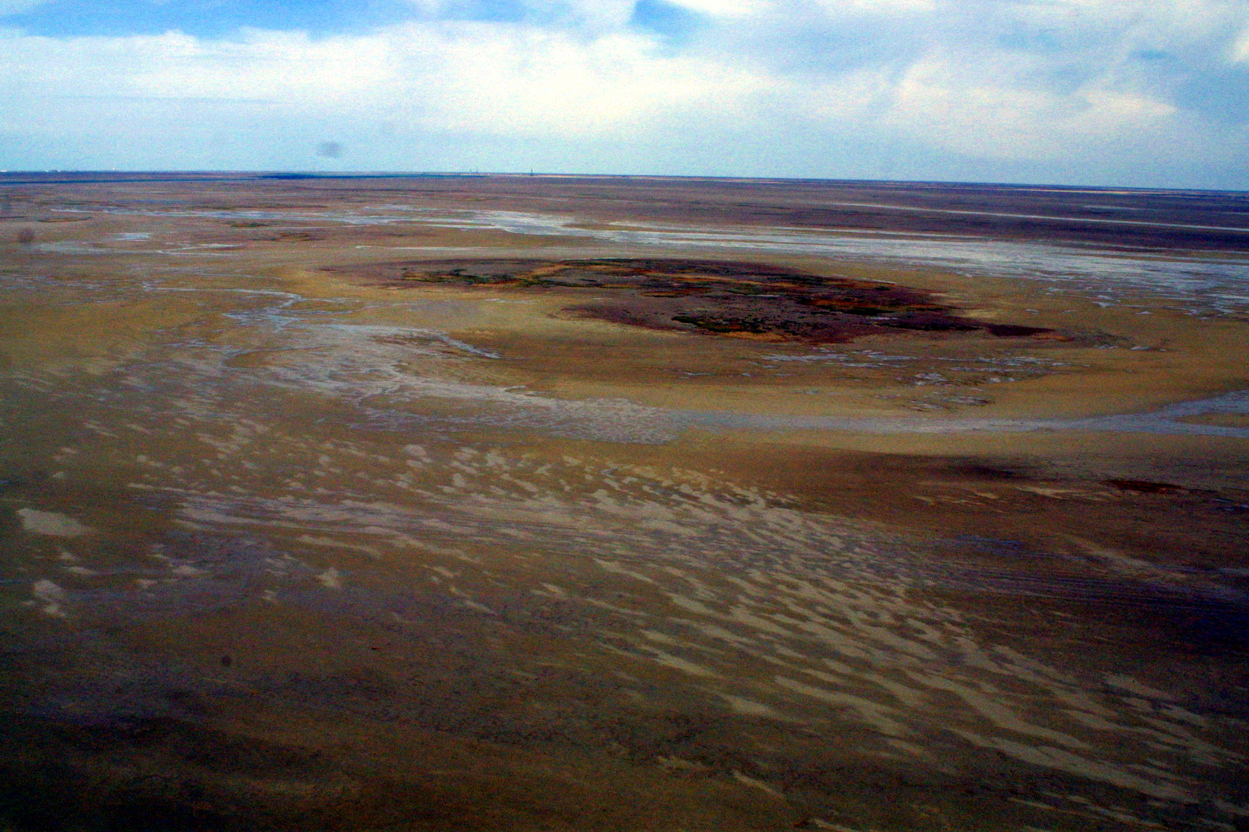
Figure 3.3.9 Air view on the Komsomolets Bay
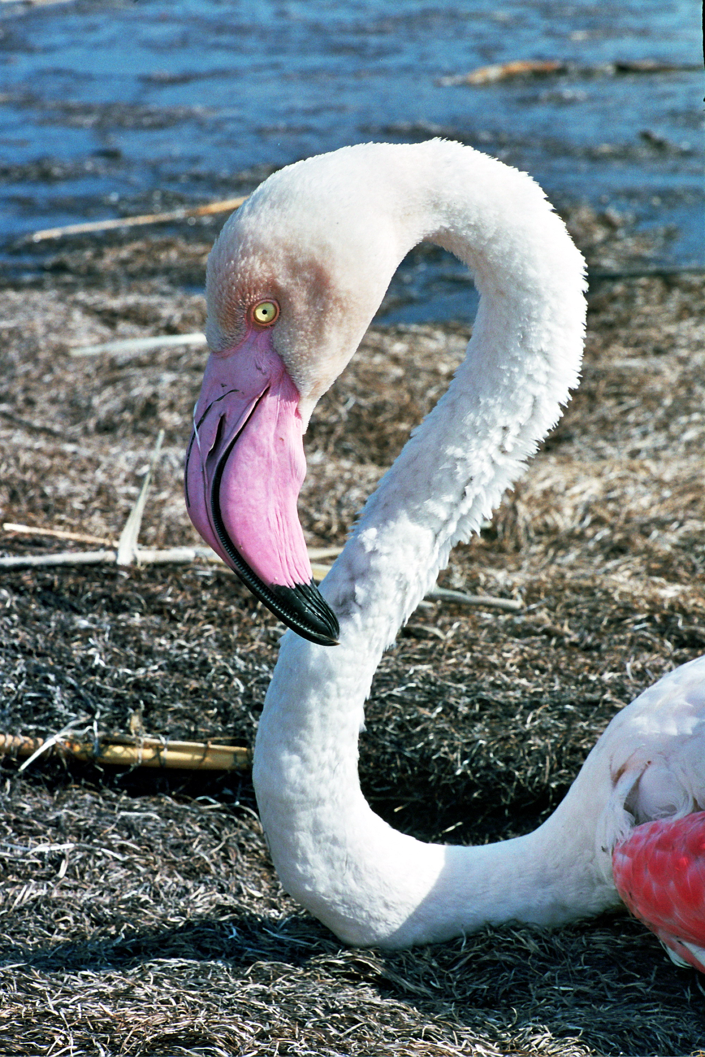
Figure 3.3.10 Greater flamingo on the coast of the Komsomolets Bay
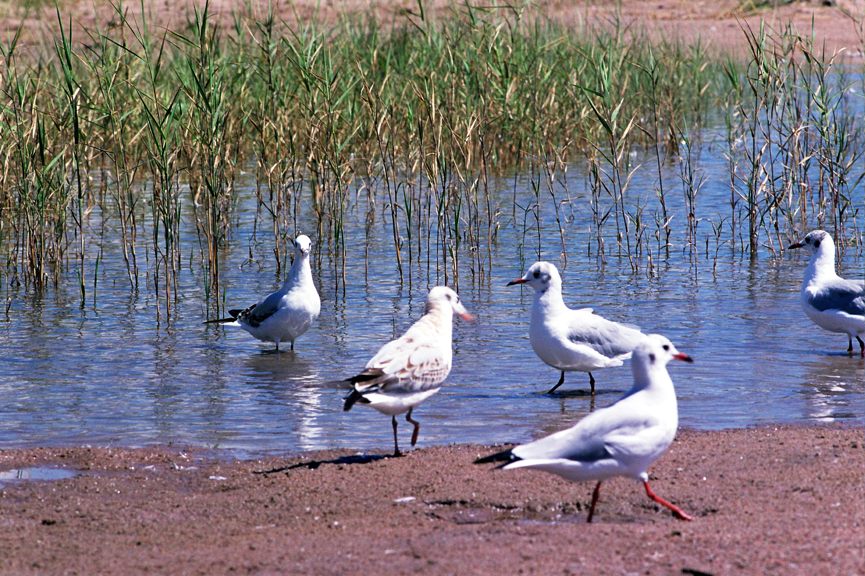
Figure 3.3.11 Gulls Larus argentatus in the coastal zone of the Komsomolets Bay
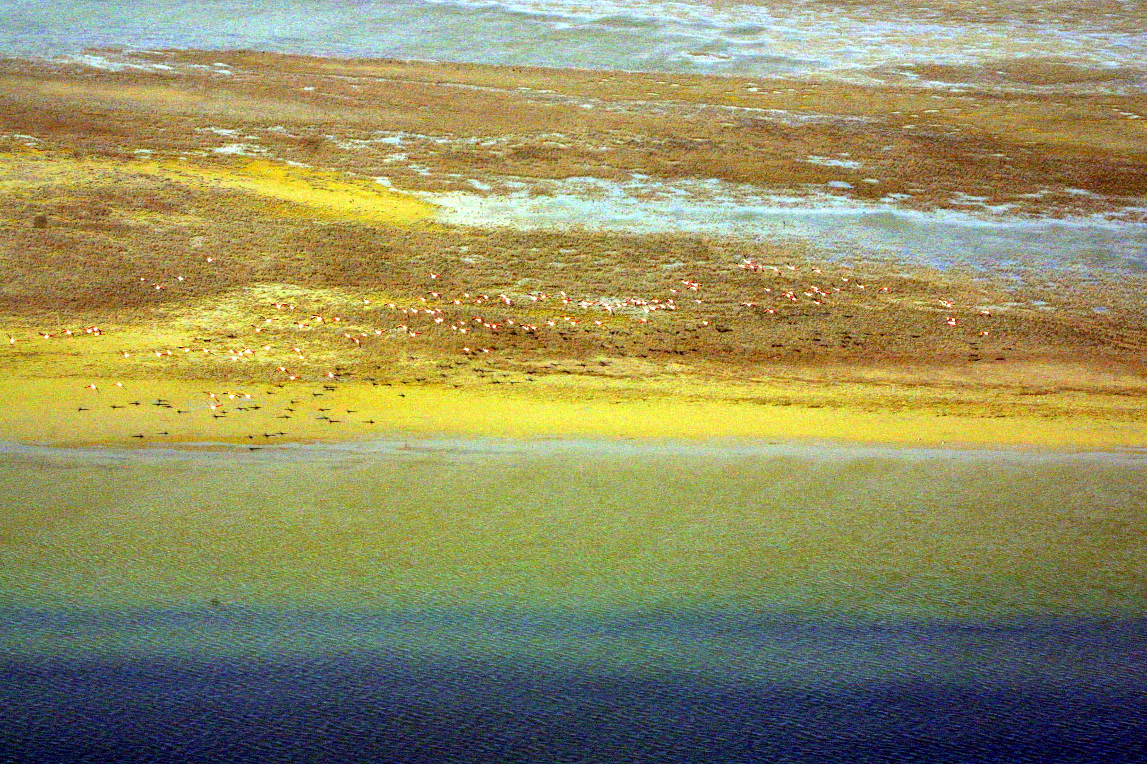
Figure 3.3.12 Air view on the flocks of Phoenicopterus roseus on the coast of the Komsomolets Bay
All these plants can grow only on soils with cellular moisture coming close to the soil surface. Root system of these saltworts is superficial. All of them are resistant to short floods with marine water. During long flood, they die but soon recover from seeds passing phonologic stages from shoots to seeds in 30-40 days. In some years, at favourable conditions, there are 3 or 2 generations of these plants but not repeating the previous ones. Projective cover of the soil varies in wide range from 30 to 100%, but more often, it comprises 40-50%. The height of saltworts varies from 3-5 cm to 30 cm, and in some years – to 40-60 cm.
Besides saltworts there is a small number of ephemers: Anisantha, A. tectotum, Lepidium perfoliatum, Limonium gmelinii and L. sufruticosum, Anabasis aphylla, and singular bushes of Tamarix ramosissima.
The herbage of glasswort communities is very poor. Mostly it consists of monodominant communities of Salicornia europaea with sporadic participation of other halophytes: sarsazan (Halocnemum strobilaceum), Climacoptera, Petrosimonia, kermek (Limonium gmelinii and L. sufruticosum). Farther from the salt marshes, as the salt concentration decreases, the abundance of concomitant species grows. In such a way, together with the glasswort communities, there appear glasswort-saltwort and glasswort-kermek communities. Glasswort rather easy survives flood. It develops better in salt marshes but can grow well under temporary floodwater. It is oppressed during long flood. The alkali-grass (Puccinella dolichlepis) grows on salt marsh soils in sarsazan (Halocnemum strobilaceum) and saltwort (Salsola spp.) communities and has a small area. Sometimes, among sarsazan and saltwort vegetation you can meet single bushes of tamarisk (Tamarix ramosissima) – a representative of tugay flora. On the described territory, tamarisk bushes are in rather poor condition and not higher than 0.8-1.2 m.
On high sandy relief elements, you can meet zhuzgun (Calligonum aphyllum) and teresken (Eurotia ceratoides). Rather abundant are ephemers and ephemeroids. These are represented by thick-stemmed sedge Carex pachystylis), bulbous bluegrass (Poa bulbosa), and cheat grass brome (Anisantha tectotum). When the herbage is trampled down on the sands there appear ebelek (Ceratocarpus utriculosus) and other weeds, such as Heliotropium dasycarpum, Corispermum aralo-caspicum, Salsola paulseni and Ephedra distachya.
Sagebrushes on the sands are represented by Artemisia terrae-alba, rarely A. lercheana astrachanica and A. arenaria. The main types of plant communities on sands are sagebrush-erkek-ephemeral, erkek-sagebrush, sagebrush-ephemeral and ebelek communities.
Some valuable medicinal plants grow on the territory – ephedra (Ephedra distachya) and itisigek (Anabasis aphylla).
Species included in the Red Book of the Republic of Kazakhstan in the Komsomolets Bay area are not recorded.
Biodiversity of vascular plant species is assessed a decreasing one.
Fauna of the site comprises 39 species of fishes, 1 species of amphibians, 18 species of reptiles, 223 species of birds and 35 species of mammals (data on invertebrates are not available).
Fish fauna in the areas of the Caspian Sea, adjacent to Komsomolets Bay is represented by 9 orders, 10 families and 39 species and subspecies of fishes. Among them there are sturgeons (4 species), herrings (5 species), pikes (1 species), carps (12 species), catfishes (1 species), silversides (1 species), grey mullets (2 species), pipefishes (1 species), sticklebacks and perches (11 species and sub-species); Impact…, 1994; Assessment…, 1996; Baseline…, 1996). Fish fauna of the region is formed by typically marine species, such as herrings, sticklebacks, pipefishes, grey mullets, silverbacks and gobies.
Amphibians are represented by a background species. Green toad (Bufo viridis) is widely distributed in the desert part of the territory near temporary water reservoirs. Representatives of this species can survive during unfavourable dry periods in the holes of great sanderling.
Reptiles are represented by 18 species from 6 families. The basis of the reptile fauna is formed by desert complex of 10 species. These are leopard tortoise, Caspian gecko, grey gecko, lizards (Phrynocephalus helioscopus and Ph. mystaceus), steppe agama (Agama sanguinolenta), eremias (Eremias velox), sand boa (Eryx miliaris) and arrow-snake (Psammophis lineolatus). Other species (water grass snake, four-lined snake, rat snake, and moccasin) have wide intrazonal distribution. Such heterogeneity of reptile fauna is caused by the sea level fluctuations and peculiarities of ecosystems on plain and seaside territories (Neruchev et al., 1995).
Avifauna of the region is divided into four categories according the character of birds’ occurrence – migrant birds, nesting birds, settled birds, and wintering birds. During migration, birds can number 223 species, which is about one half of the whole avifauna of Kazakhstan. Most of nesting and settled birds are distributed along the coast of the Komsomolets Bay. Their most important habitat is littoral part of the bay, small salty lakes and salt marshes, situated inside the bay. These are stopover places for greater flamingo. This rare and endangered species is the only representative of the genus in Kazakhstan fauna. In the north-eastern part of the Caspian Sea, during the period of 1976-1982, there were registered from 1.5 to 15 thousand birds. In summer and autumn, in the shallow areas of the Komsomolets Bay and salt marshes Myortvyy Kultuk and Kaydak, there were registered 300-500 individuals of flamingo.
The role of the described region in preservation of birds’ biodiversity is very important as a stopover place for numerous migrant rare and endangered species of birds. Coastal zone is a habitat of protected and Red Book species of birds. Many species stay here at the end of summer during their flight preparations. Some species nest and feed their young. One-half of the rare birds of Kazakhstan are connected with aquatic environment.
Fauna of mammals of the considered territory refers to Aral-Caspian northern desert zoogeographical province with well-expressed desert features. Peculiar climate, relief, saline soils, and dispersed vegetation determine poor species composition of settled representatives of terrestrial vertebrates: mammals are represented only by 35 species. Rather divers are predatory mammals (8 species). Most of them are objects of hunting (wolf, fox, corsac, weasel, steppe polecat). Abundant in this group is wolf, fox, steppe polecat, and in coastal zone and water area of the Caspian Sea – Caspian seal.
Environs of the Komsomolets Bay are the centre of occurrence of rare wild animals. In 2005, about 3 thousand individuals of saiga and 1.5 thousand of goitered gazelles lived here.
Red Books of IUCN and Republic of Kazakhstan includes 1 species of reptiles, 24 species of birds and 4 species of mammals. They are represented by the following organisms:
Reptiles:
- Elaphe quatuorlineata - four-lined snake (4)
Birds:
- Pelecanus onocrotalus - great white pelican (1)
- P. crispus - Dalmatian pelican (2-3)
- Egretta garzetta - little egret (3)
- Platalea leucorodia - spoonbill (2)
- Plegadis falcinellus - glossy ibis (2)
- Phoenicopterus roseus - greater flamingo (2)
- Cygnus cygnus - mute swan (2)
- Aythya nyroca – white-eyed pochard (3-5)
- Pandion haliaetus - osprey (1)
- Circaetus gallicus/ferox - short toed-eagle (2)
- Aquila rapax – steppe eagle (5)
- Aquila clanga - greater spotted eagle (2)
- A. heliaca – eastern imperial eagle (3)
- A. chrysaetos - golden eagle (3)
- Haliaeetus albicilla - white-tailed eagle (2-5)
- Falco cherrug – saker falcon (1)
- Anthropoides virgo - demoiselle crane (5)
- Porphyrio porphyrio – purple gallinule (2)
- Otis tarda - great bustard (1-2)
- Chlamydotis undulata - houbara bustard (2-5)
- Larus ichthyaetus - great black-headed gull (2)
- Pterocles orientalis - black-bellied sand-grouse (3)
- Syrrhaptes paradoxus - Pallas’s sandgrouse (4)
- Bubo bubo - Eurasian eagle owl (2)
Mammals:
- Felis margarita – sand dune cat (3)
- F. manul – Pallas's cat (3)
- Linx caracal – caracal (1)
- Gazella subgutturosa - goitered gazelle (5)
Biodiversity of some animal groups (fishes, birds, and mammals) is assessed as a decreasing one, while other (amphibians and reptiles) demonstrate stability.
Desert coastal ecosystems near Komsomolets Bay are rather poor. They represent littoral sor-solonchak lowlands, considerably transformed by tidal processes. Short-term sea level rises are caused by wind tides and can considerably raise the local sea level in relation to background values. Duration of these tides varies from several hours to several days. In the shallow water areas to the north of Komsomolets Bay, the wave height is not more than 1 m, and in 75% of cases, it comprises 0.2 m. Such amplitude seems to be little but it can cause considerable flood of the coast. After the surge, the sea returns to its original level but some water stays in the coastal depressions for a long time. Due to these processes, the primary surface of the plain is washed out by the wind tides that can spread over the coast for dozens of kilometres. Vegetation cover of such washed out low surfaces is very poor and consists of several species of halophytes.
Permanent water streams and reservoirs are absent on the described territory. Hydrographic network is poorly developed and is represented mostly by stagnant depressions. During snow melting and hard rains, temporary water streams can form over the dry riverbeds and sor depressions. Often, these shallow gullies do not have general direction of drainage and they are sloping in different directions. At the same time, the general surface flow is oriented towards the sea.
The coastal ecosystems are young, so the soil horizons are not completely formed and have numerous remains of seashells, and the soil mother bed is of high salinity. Besides, modern sea level rise had a negative effect on soil formation. The aeration zone became thinner because of the groundwater rise. The process of salt accumulation was intensified. The soil cover is represented by meadow-littoral soils, marine and sor solonchaks, occupied by communities of perennial and annual halophytes. At some distance from the sea, there are missives of ridge-hilly sands.
Vegetation here is formed in very dynamic conditions, connected with sea level fluctuations and tidal phenomena (“moryany”). These phenomena affect the distribution, character, and condition of vegetation. Besides, elements of meso- and microrelief as well as salinity regime are very important for distribution of vegetation over the coast of the Caspian Sea.
Halophyte vegetation has changeable character and composition. It occupies meadow littoral solonchaks and littoral saline soils and depends on moisture regime, salinity, microrelief and degree of soil degradation. Halophyte vegetation is dispersed and has poor species composition, sometimes only 1-2 species. Sometimes vegetation cover is formed by several species with mosaic patches of one species.
Glasswort communities are sporadically registered on the described territory, in small low strongly saline relief elements. Most often they are met around sors, in form of narrow stripes or small patches close to the sor surface or sarsazan communities around them. In the zone of permanent tidal influence, glasswort forms pioneer communities on overgrowing littoral solochaks in the areas with high ground waters. Farther from the sors, as the salt concentration decreases, the number of concomitant species grows.
Mainly communities of reptiles and birds represent the animal world of desert ecosystems. Within the territory and adjacent areas of the coast there was registered the most rare species of snakes – four striped snake (Elaphe quatuerlineata), included into the Red Book of Kazakhstan.
Marine shallow waters of the north-eastern Caspian Sea before the sea level rise were not important for bird nesting and served as moulting and stopover places for migrant species. Flooding of shell islands (shalygas) in the north-eastern part of the Caspian Sea and appearance of cane thickets widens the nesting areas for many species of birds. The sea level rise again made the bays Komsomolets, Myortvyy Kultuk and Kaydak accessible for seawater, which reaches the mark of
- 6.5 m. Marine ecosystems of Komsomolets Bay suffer from erosion of seabed, connected with ice influence. Depth of seabed disturbance is limited to 3-5 cm layer of seabed sediments.
Komsomolets Bay, Myortvyy Kultuk and Kaydak with marshy shallow areas and lagoons are habitats of critical importance for the existing population of flamingo. At present from April to May, about 20 thousand of these birds stay in the Komsomolets Bay. They are most vulnerable during moulting in July-August. In summer, flamingos are met to the west from Prorva dam in number of 1.5-2 thousand individuals.
Marine ecosystems of Komsomolets Bay are habitats of Caspian seals. The hugest quantity of seals was registered on April 6, 1990 during the flight in the region of shell islands near Karaton and Prorva. Then, there were registered 12.5 thousand of seals, and on some islands, their number reached 3 thousand of individuals. Second large gathering was found on the islands in Komsomolets Bay.
Human impact. Taking into consideration the value of Komsomolets Bay, the State Programme of PA Creation provides organization of zoological Refuge: “Tasorp Area - Durneva Island - Komsomolets Bay - Bolshoye Lake”. However, in spite of the reservation of this territory as a PA, intensive development of oilfields continues in this region. Seismic survey and roadwork are going on. All these activities have a negative effect over biodiversity of the site. A lot of deserted test drilling wells are present on this territory. Some of them are sources of pollution - emission of oil products, gas, and boring liquid.
3.3.5 Aktau-Buzachi Reserve
Aktau-Buzachi Zoological Reserve of republican significance (see Annex 2, Figures 3.3.13-3.3.16) was created by the Resolution of the Council of Ministers of Kazakh SSR of December 12, 1982, No. 500 on the area of 170 thousand hectares. After liquidation, it was reorganized by the Resolution of RK Government of July 27, 2001, No. 877 with the status of Refuge of republican significance. The latest document, regulating the status of Aktau-Buzachi Reserve is Resolution of RK Government of July 19, 2005, No. 746 “On ratification of the list of Protected Areas of republican significance”. The sanctuary is created for preservation and reproduction of aquatic and coastal vegetation and for protection of rare species of birds and animals included into the Red Book.
The main destination of the Refuge is protection and recovery of rare and disappearing species of animals such as Ustyurt moufflon, goitered gazelle, caracal, manul, dzhek, etc. As a reference point, there was chosen a site, situated in 5 km to the east of Mangystau. The site is situated on the territory of the Refuge. The ground is made of brown solonetzic soils combined with automorphic solonetz soils, occupied by biyurgun, tasbiyurgun and sagebrush vegetation.

Flora of the Aktau-Buzachi Reserve consists of about 88 species of vascular plants from 57 genera and 18 families, typical for desert environment (data on other plant species are not available).
At the water edge, on littoral salt marshes with high content of chlorides, there are formed communities of annual halophytes. Edificators here are annual succulent glasswort (Salicornia europea) and species of desert seep-weed (Suaeda prostrata, S. acuminata). These communities are monodominant with horizontal zonation. As salinization and moisture of soil decreases, they are replaced by halophyte-grass communities with domination of perennial rhizome grasses Puccinellia distans, P. gigantean, and Aeluropus littoralis. They form monodominant and mixed communities with participation of halophyte herbs Puccinellia distans, P. gigantean, and Aeluropus littoralis. The characteristic feature of vegetation dynamics is formation of common reed (Phragmites australis) thickets on washed out desalinated areas. Reed communities are very significant for landscape stabilization: they are powerful biological filters, protecting the coastline from erosion, etc. That is why the growth of reed thicket area is assessed as a positive factor.
During the last 4-5 years, considerable part of land became a shallow water area, because of the sea level rise. Pioneers of seabed overgrowing are freshwater macrophytes: Eurasian milfoil (Myriophyllum spicatum) and pondweed (Potamogeton pectinatus). They form unstable communities with curtains and single individuals.
Besides the listed above communities, halophyte sub-shrub communities are very common in the tidal zone on high relief forms, which develop in flood conditions. They differ from shrub communities of zonal territory by high projective cover and presence of mesophyte grasses and herbs (alkali grass, azhrek, kermek, etc.) The latter are indicators of close groundwater and periodical flooding. Very common are communities with domination of sarsazan (Halocnemum strobilaceum). Flora and fauna biodiversity increases westwards under the influence of the sea. Here we can see annual saltwort-grass (Puccinellia distans, Aeluropus littoralis, Salicornia europaea, Suaeda linifolia, and S. prostrata), grass-glasswort (Salicornia europaea, Puccinellia distans, and Phragmites australis), kermek-glasswort (S. europaea, Limonium caspicum, L. gmelinii) with participation of tamarisk (Tamarix ramosissima) communities on meadow littoral salt marshes of tidal zone. The herbage height varies from 40 to 100 cm; projective cover is 60-80%.
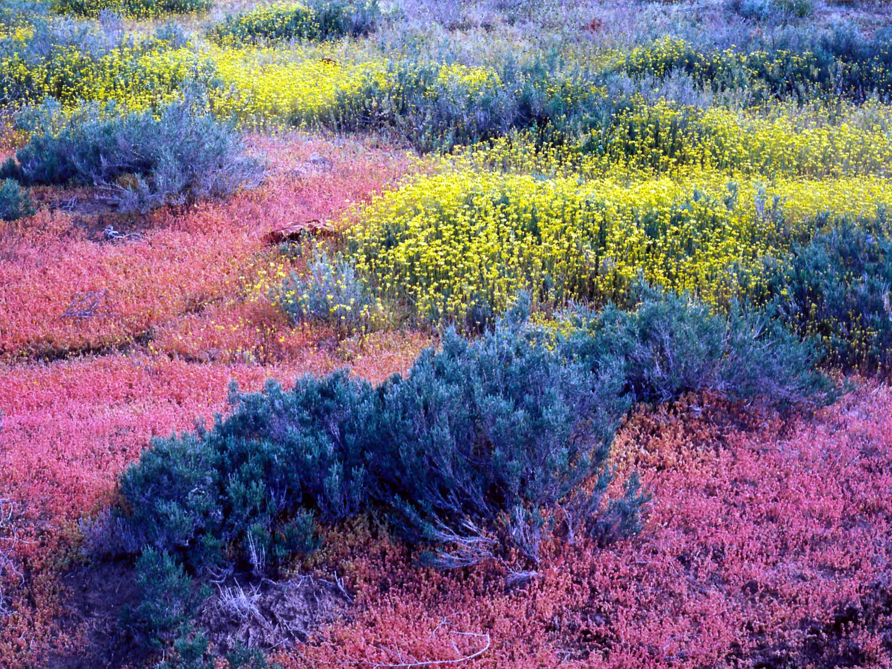
Figure 3.3.13 Community of annual and perennial saltworts in the Aktau-Buzachi Reserve
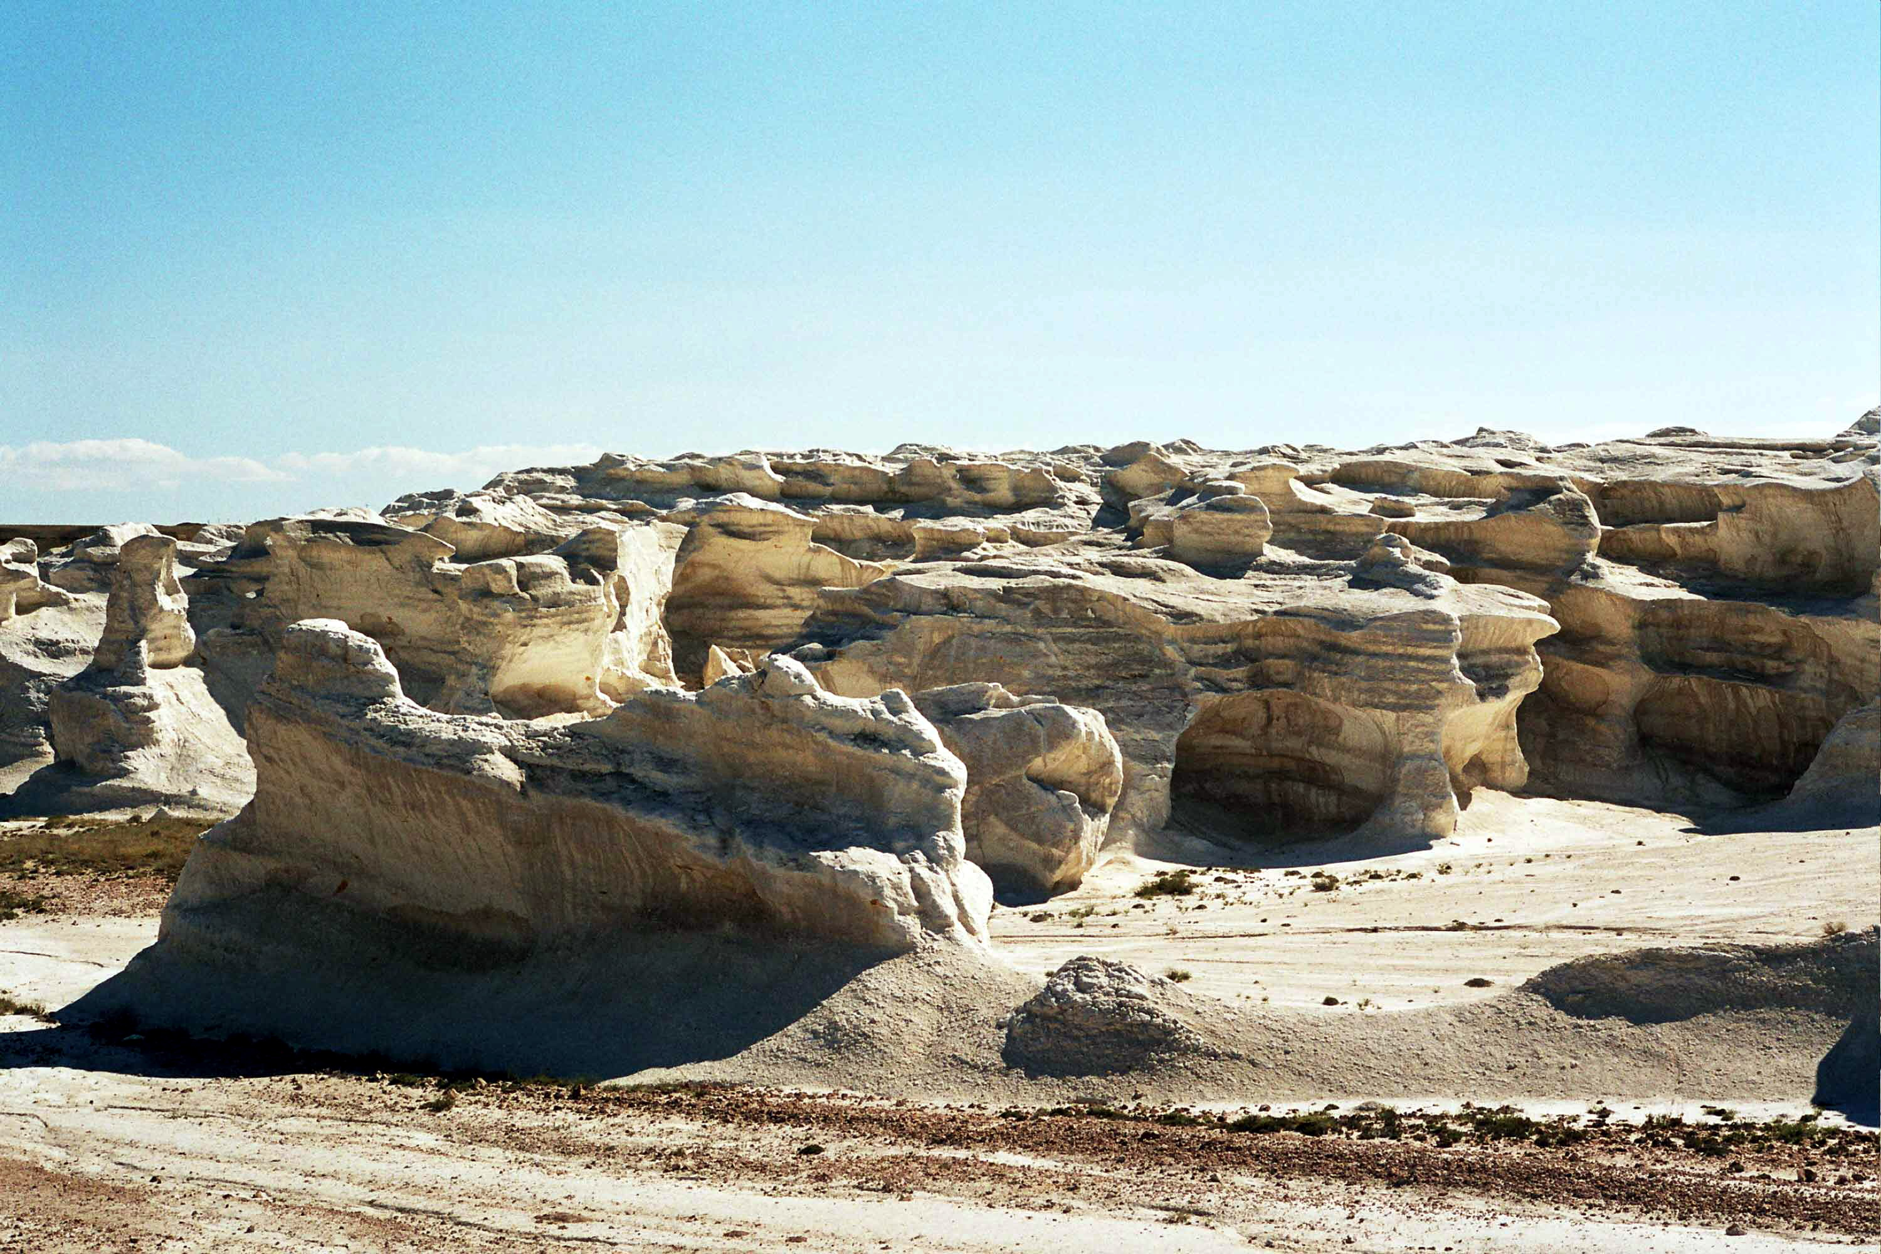
Figure 3.3.14 Aeolian forms of relief in the Aktau-Buzachi Reserve
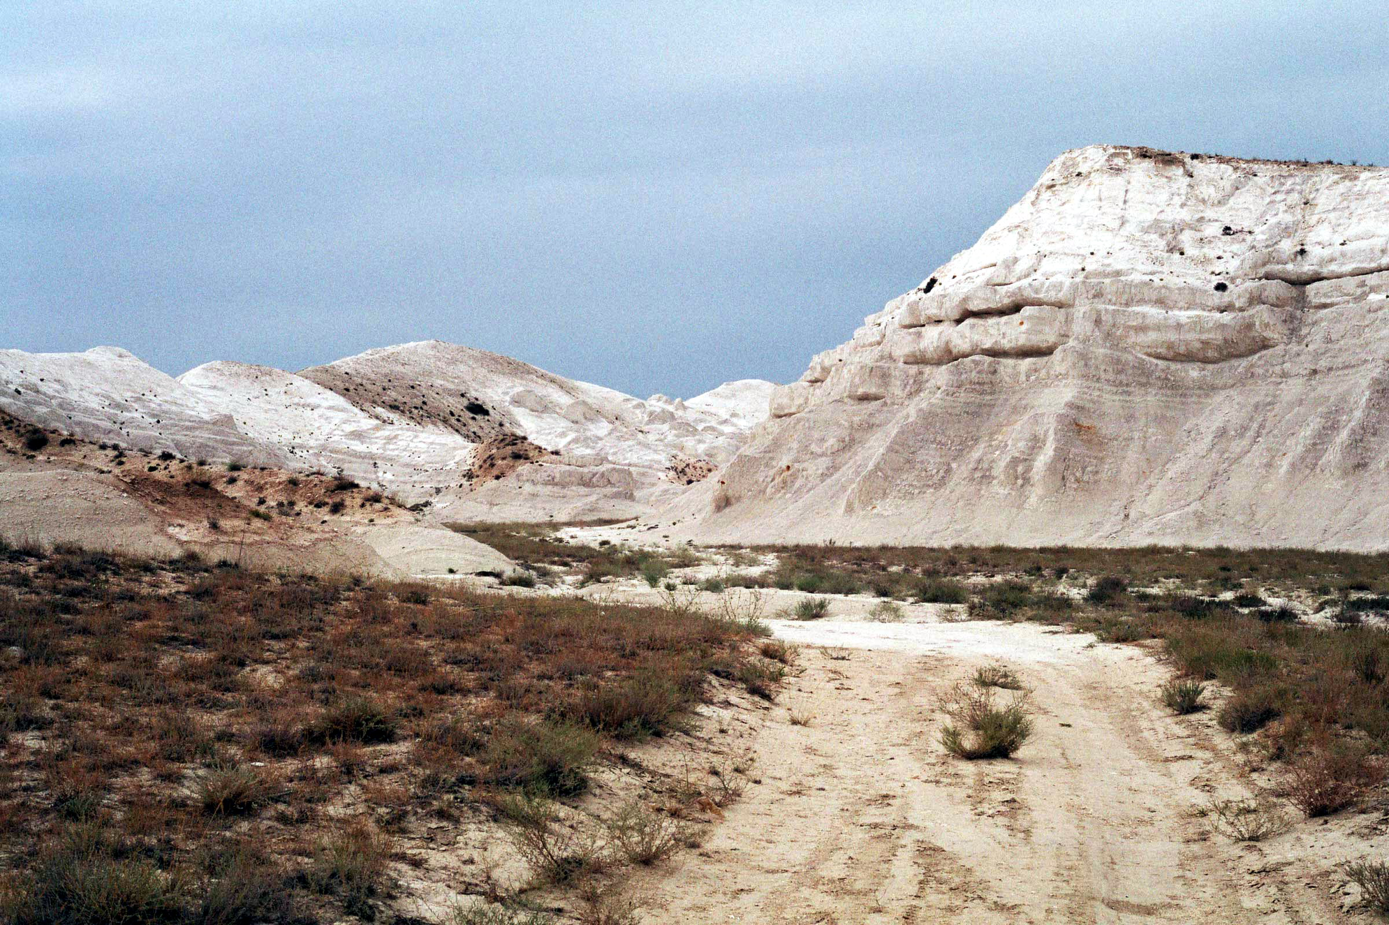
Figure 3.3.15 Mountains in the Aktau area
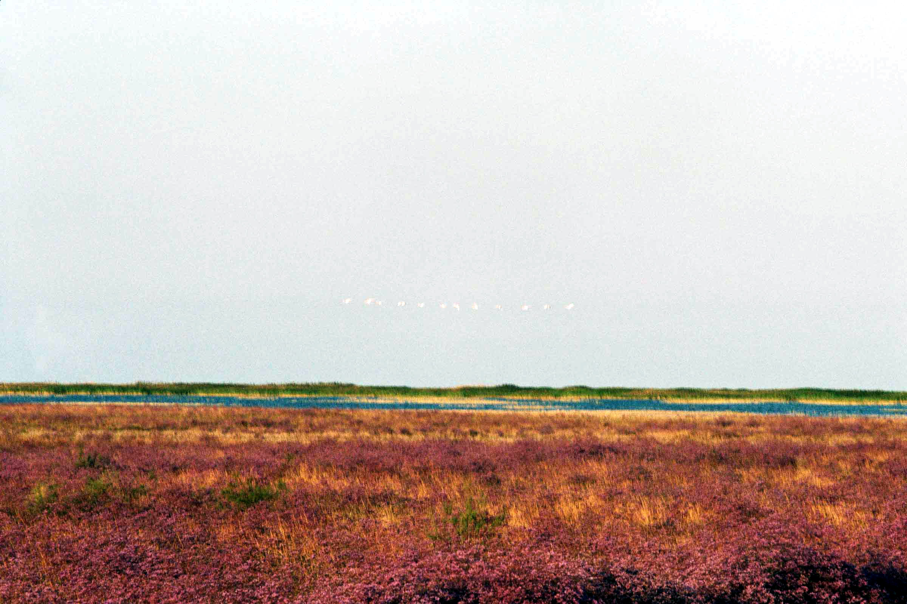
Figure 3.3.16 Sea lavender and sea spear grass meadow in the Aktau-Buzachi Reserve
Unloaded areas of the coast are occupied by sub-shrub communities with domination of kermek (Limonium suffruticosum), sarsazan (Halocnemum strobilaceum), and kalidium (Kalidium caspicum). Annual saltworts are abundant in the herb layer (Salicornia europaea, Suaeda linifolia, and Climacoptera crassa).
High relief forms of the salt marsh banks are occupied by communities of hyper-halophyte sub-shrub - sarsazan (Halocnemum strobilaceum). Projective cover of these communities is 20-40%. Vegetation here is often in depressed condition, because of frequent ecological changes (quick fluctuations of moisture regime).
Sarsazan communities on salt marshes are inhabited by annual saltworts: petrosimonia (Petrosimonia triandra), klimakoptera (Climacoptera crassa), and tumbleweed (Salsola nitraria). Species composition of sarsazan communities numbers not more than 6-10 species. Communities are dispersed. Total projective cover reaches 10-60%.
Elevated plains with zonal grey-brown soils are occupied with desert communities, formed by xerophytes, xero-halophytes shrubs, and sub-shrubs with participation of ephemerals and ephemeroids (Eremopyron orientalis, E. triticeum, Poa bulbosa, and Lepidium perfoliatum). Abundance of ephemerals and ephemeroids in plant communities in 2006 was inconspicuous because of unfavourable weather conditions in spring.
Heterogeneous vegetation cover is typical to hilly-wavy elevated plains. Most common is complex of keurek-biyurgun (Anabasis salsa, Salsola orientalis), keurek-sagebrush (Artemisia terrae-albae, Salsola orientalis), sagebrush-keurek and biyurgun communities on loamy sand and light-loamy saline soils on high relief forms. In some places, itsigek (Anabasis aphylla), participates in sagebrush and biyurgun communities, and on some plains, especially on trampled down areas, it becomes a landscape plant.
Biyurgun communities occupy low areas with dense soil. Other components of the complex have no definite connection to relief components and depend on soil salinity and density (Safronova, 1996). Keurek communities are always connected with most mellow soils, including soils disturbed by rodents. Biyurgun communities are connected with most dense soils. These communities include ephemerals and ephemeroids (Eremopyrum orientale, Catabrosella humilis, Alyssum turcestanicum, and Poa bulbosa) and perennial turf grasses (Agropyron desertorum, Stipa caspia). Projective cover in these complexes usually varies from 40 to 50% and reaches 70% in humid years (due to abundant development of ephemerals). Floristic composition of these communities is not rich and comprises about 10 species.
Large areas of loamy soils are occupied by complex of biyurgun (Anabasis salsa), keurek-sagebrush (Artemisia terrae-albae, Salsola orientalis) and itsigek-sagebrush (Artemisia gurganica, Anabasis aphylla) communities. In numerous salt marsh depressions very common are sarsazan communities, which surround pure salt marshes, and sarsazan-halophyte-kermek (Limonium suffruticosum, Artemisia halophila, Halocnemum strobilaceun), and kermek-halophyte-sagebrush (Artemisia halophila, Limonium suffruticosum) communities.
On tops and slopes of hilly plains with rubbly soils, develop perennial halophyte communities, referring to formations of tasbiyurgun (Nanophyn erinaceum) and biyurgun (Anabasis salsa, Anabasis brachiata).
On outcrops of chalk rocks, rather common are biyurgun-tasbiyurgun (Nanophyton erinaceum, Anabasis brachiata) communities with participation of boyalych (Salsola arbuscula). On slopes and tops, on rough rubbly soils dominant are solonchak-biyurgun-tasbiyurgun (Nanophyton erinaceum, Anabasis salsa) and sagebrush-tasbiyurgun (Nanophyton erinaceum, Artemisia terrae-albae) communities. These communities have low projective cover (10-20%).
The borderlands of the missives are covered with ridged and fixed sands with domination of grass-sagebrush communities (Artemisia lerchiana, Agropyron fragile), sometimes with participation of Artemisia tschernieviana. These communities also include Carex physodes, Alhagi pseudalhagi, and Euphorbia seguieriana. Deep depressions between hills and ridges with sor and takyr solonchaks are occupied by sarsazan communities (Halocnemum strobilaceum). In less dense depressions more common are halophyte-azhrek communities (Aeluropus littoralis, Artemisia halophilla) with kermek (Limonium suffruticosum) and kalidium (Kalidium caspicum).
Vegetation of littoral large-grained shelly salty sands is represented by communities with domination of sand sagebrush (Artemisia tschernieviana) and psammophillic shrubs and sub-shrubs – zhuzguns (Calligonum leucocladum, C. caput-medusae), astragalus (Astragalus karagugensis) and convolvulus (Convolvulus erinaceum). Among grasses, common are: Agropyron fragile, Aeluropus littoralis, Eragrostis minor, solitary Stipagrostis pennata, and Stipa caspica. Vegetation cover of these sands is in depressed condition because of excess pasturage. Vitality of all species is low. Animals eat around vegetative and young generative parts of plants. Projective cover is not more than 20-25%.
Red Book of the Republic of Kazakhstan (1981) includes 2 vascular plant species inhabiting the Aktau-Buzachi Reserve. These are:
- Salsola euryphylla (3), and
- Convolvulus persicus (3)
Biodiversity of plant species in general is assessed a decreasing one, this of and rare and endangered plants is assessed as stable.
Fauna of the terrestrial vertebrates of the site under consideration comprises 1 species of amphibians, 15 species of reptiles, 282 species of birds and 35 species of mammals (data on invertebrates are not available).
Amphibians are represented by one species – green toad (Bufo viridis), occurring near temporary, and artificial water reservoirs.
Reptiles are represented by 15 species from 7 families. Maximum frequency of occurrence of reptiles is registered in south-east and east of the territory.
Avifauna is most diverse in coastal stations, where about 40 wetland species are nesting. Most of the Red Book species concentrate in chink (ancient sea coastline) and near-chink zone, at the bottom of depressions in shrub massifs and floods of springs.
The order of Anserinae numbers more than 24 species. Among them are mute swan, whooper swan, red-breasted goose, pintail, mallard, shoveler, and goosander. Birds of prey number more than 30 species. Among them is white-tailed eagle, Egyptian vulture, black vulture, imperial eagle. Waterfowls, except some gulls and waders make a stopover near the Caspian shore and on Kochak Bay during their migration. Some of them (flamingo, swans, ducks, and herons) in spring and autumn can stay here for a month or more.
The reserve has all necessary conditions for nesting of 5 rare bird species, occurring in desert zone of Mangyshlak. Most numerous are two species – steppe eagle and Pallas sand grouse. Among rare migrant birds, most frequently met is Demoiselle crane and black bellied sand grouse. In the period of seasonal migrations, there are registered single individuals of short-toed eagle, golden eagle, saker falcon, and great bustard. The most valuable in faunal respect is coastal area with nesting places of birds, forage stations, and territory, used by birds for stopover during seasonal migrations. This territory lies on the migration routes on most of rare and valuable species.
Background mammals of the territory are rodents, Lagomorpha (hares) and predators (fox and corsac). About 200 foxes and the same number of corsacs occur on the territory of the reserve. Very rare are predators from the family of mustelids – marbled polecat and weasel. Steppe species are practically absent, except Siberian polecat. About 50 wolves live here and their number exceeds the norm, necessary for the region. Very common is tolai hare. Its number is unstable and depends on number of foxes and corsacs. Saiga often visits the territory of the reserve. In some years, herds of thousands of individuals pasture here. In 1995, 35 koulans were brought to the reserve. At present, the koulans are well acclimatized. The most valuable species of the reserve are goitered gazelle and Asiatic mouflon. Goitered gazelle occurs mostly on Buzachi, in difficult to access salt marshes, and mouflon lives only on the mountain ridge of northern Aktau.
Red List of IUCN and Red Book of Republic of Kazakhstan includes 1 species of reptiles, 39 species of birds and 7 species of mammals. They are represented by the following organisms:
Reptiles:
- Elaphe quatuorlineata - four-lined snake (4)
Birds:
- Pelecanus onocrotalus - great white pelican (1)
- P. crispus - Dalmatian pelican (2, 3)
- Phalacrocorax pygmaeus - pygmy cormorant (2, 5)
- Ardeola ralloides - squacco heron (2)
- Bubulcus ibis - cattle egret (3)
- Egretta garzetta - little egret (3)
- Platalea leucorodia - spoonbill (2)
- Plegadis falcinellus - glossy ibis (2)
- Ciconia nigra - black stork (3)
- Phoenicopterus roseus - greater flamingo (2)
- Rufidrenta ruficollis - red-breasted goose (2)
- Cygnus cygnus - mute swan (2)
- C. bewickii - Bewick’s swan (5)
- Anas angustirostris - marbled teal (1, 2)
- Aythya nyroca – white-eyed pochard (3, 5)
- Oxyura leucocephala - white-headed duck (1)
- Pandion haliaeetus – osprey (1)
- Circus macrourus - pallid harrier (2, 5)
- Circaetus ferox - short toed-eagle (2)
- Hieraaetus pennatus - booted eagle (3)
- Aquila rapax – steppe eagle (5)
- A. clanga - greater spotted eagle (2)
- A. heliaca – eastern imperial eagle (3)
- A. chrysaetos - golden eagle (3)
- Haliaeetus albicilla - white-tailed eagle (2, 5)
- Falco cherrug – saker falcon (1)
- F. peregrinus - peregrine falcon (1)
- F. naumanni - lesser kestrel (1)
- Grus leucogeranus - Siberian white crane (0-1)
- Anthropoides virgo - demoiselle crane (5)
- Porphyrio porphyrio – purple gallinule (2)
- Otis tarda - great bustard (1, 2)
- O. tetrax - little bustard (2, 5)
- Chlamydotis undulata - houbara bustard (2, 5)
- Chettusia gregaria – sociable plover (1)
- Larus ichthyaetus - great black-headed gull (2)
- Syrrhaptes paradoxus - Pallas’s sandgrouse (4)
- Pterocles orientalis - black-bellied sand-grouse (3)
- Bubo bubo - Eurasian eagle owl (2)
Mammals:
- Felis margarita – sand dune cat (3)
- Vormela peregusna - marbled polecat (3)
- Linx caracal – caracal (1)
- F. manul – Pallas's cat (3)
- Gazella subgutturosa - goitered gazelle (5)
- Ovis orientalis arkal - Asiatic mouflon (3)
- Equus hemionus - Asiatic wild ass (2)
Biodiversity of majority of the animal groups (amphibians, reptiles, and birds) is assessed as a stable one, while mammals (both all, rare and endangered species) demonstrate increasing of biodiversity and abundance.
Aquatic, coastal, and desert ecosystems, formed on the territory of Aktau-Busachi Reserve, are divided into four groups:
- Aquatic
- Coastal
- Halophytic(desert)
- Xerophytic(desert)
Aquatic ecosystems are represented by shallow water areas of less than 1 m deep with thickets of rush and reed (Phragmites australis, Scirpus tabernaemontani) and submerged aquatic macrophytes (Potamogeton pectinatus, Ceratophyllum submersum, Najas marina, and Caulinia minor). These ecosystems are valuable habitats of nesting wetland birds.
Coastal ecosystems, situated on low marks, were formed on late-new-Caspian plain, subjected to tidal phenomena. Characteristic vegetation consists of dispersed glasswort (Salicornia europaea) on salt marshes and coastal common reed thickets (Phragmites australis). Higher relief forms are occupied by coastal ecosystems on littoral salt marshes with domination of glasswort (Salicornia europaea), kalidium (Kalidium caspicum, Kalidium foliatum) combined with Aeluropus littoralis – Puccinellia distans communities with tamarisk (Puccinellia distans, Aeluropus littoralis, and Tamarix ramosissima) on littoral salt marshes. Another type of coastal ecosystem is a meadow with puccinellia and tamarisk (Puccinellia distans, Tamarix ramosissima, and Tamarix laxa) on meadow meadow-littoral solonchak soils, combined with sarsazan communities (Halocnemum strobilaceum) on littoral solonchaks.
Halophyte ecosystems are not subjected to tidal phenomena but they are in conditions of constant ground moistening. That is why salinization of soil is a widely spread process. The soil cover consists of meadow littoral saline soils, littoral solonchaks, and common and sor solonchaks. Important components of vegetation are annual halophytes: petrosimonia (Petrosimonia triandra), climacoptera (Climacoptera crassa), saltwort (Salsola nitraria), and also sarsazan (Halocnemum strobilaceum), kermek “sea-lavender” (Limonium suffruticosum), potashnik (Kalidium caspicum), and tamarix (Tamarix ramosissima). Halophyte ecosystems have little economical importance because of low productivity of vegetation cover and high soil salinity. Besides, they are vulnerable to human impacts.
Xerophyte ecosystems were formed in automorphic conditions, on different zonal soils (brown or grey-brown), sands, and outcrops of parental materials. Vegetation cover of ecosystems of high flat relief forms is characterized by domination of desert communities of xerophyte- and halo-xerophyte shrubs and sub-shrubs with participation of ephemerals and ephemeroids (Eremopyron orientalis, E. triticeum, Poa bulbosa, and Lepidium perfoliatum) on brown soils. Ecosystems with complex soil and vegetation cover formed in the denudation valleys – keurek-biyurgun (Anabasis salsa, Salsola orientalis), keurek-sagebrush (Artemisia terrae-albae, Salsola orientalis), and biyurgun – on brown solonetzic and solonetz soils. On the tops and slopes of denudation forms on brown immature soils, develop perennial halophyte communities of tasbiyurgun (Nanophyn erinaceum) and biyurgun (Anabasis salsa, Anabasis brachiata).
Sand ecosystems also refer to xerophytic type. Sand vegetation is represented by many species, with domination of sagebrush (Artemisia tschernieviana), zhuzgun (Calligonum leucocladum, C. caput-medusae), astragalus (Astragalus karagugensis) and convolvulvus (Convolvulus erinaceum). Most common among grasses are Agropyron fragile, Aeluropus littoralis, Eragrostis minor, Stipagrostis pennata, and Stipa caspica are met as single plants. Territories occupied by xerophyte ecosystems are used mostly as seasonal grasslands.
Human impact over the area is limited by its refuge status, which provides limitation of economic activity, affecting the animal world condition. At the same time, there is no necessary control and management of the reserve because of finance lack. The staff for territory protection is insufficient. Protection is poorly organized and protection objects are practically absent. That is why the reserve ecosystems are under human impact of different intensity. Their main types are cattle pasturage, man-caused effects, and recreation. All territory is subjected to pasturage, except difficult to access areas (chink slopes, ravines, flooded territories). Man-caused influence is connected with road network, construction and functioning of different objects. Attractive parts of the coast are under recreation impact. In these places, vegetation is damaged and destroyed, territory is piled with rubbish. Tamarisk and other bushes are used as firewood. Unapproved hunting is also quite usual.
3.3.6 Karakiya-Karakol Reserve
Karakiya-Karakol State Zoological Reserve of Republican significance (see Annex 2, Figures 3.3.17-3.3.20) was created on the square of 137.5 thousand hectares by the Resolution of the Council of Ministers of Kazakh SSR of April 13, 1986, No. 96. After liquidation, it was newly organized by the Resolution of RK Government of July 27, 2001, No. 877 with the status of refuge of Republican significance. The latest document, regulating the status of Aktau-Buzachi Reserve, is Resolution of RK Government of July 19, 2005, No. 746 “On ratification of the List of Protected Areas of Republican significance”.
The sanctuary was organized in Mangystau province, without withdrawal of land from land managers. The reference point is near the Karakol Lake. The Lake Karakol was formed in 1967 from the sewage of Nuclear Power Station of Kazatomprom. This is a vast flowing shallow water reservoir with the square of more than 5 000 hectares and numerous islands. Its depth is about 1 m, length – about 12 km. The lake is situated in the coastal zone of the Caspian Sea, in 10 km to the south-east of Aktau. In 1980s about 22-25 individuals of mute swan wintered on the lake. More than 80 species of birds, including 21 Red Book and IUCN Red List species, make a stopover on the lake. The lake is also included into the list of protected ornithological areas of Kazakhstan.

Flora of the Karakiya-Karakol Reserve numbers about 200 species of higher plants (data on other plant species are not available). Vegetation cover consists of perennial halophyte, mostly biyurgun (Anabasis salsa) deserts and sagebrush deserts (Artemisia terra-albae). Rarer are sagebrush (Artemisia lerchiana, Artemisia gurganica) deserts (Safronova, 1996).
Peculiarity of vegetation of the north-eastern part of the region is connected with saxaul (Arthrophytum lehmannianum) communities. Another peculiarity is wide distribution of azhrek (Aeluropus littolaris) and itsigek communities (Anabasis aphylla) with Salsola dendroides, connected with dry riverbeds in the valleys. Plains of different level have complex vegetation cover. Grass-sagebrush (Artemisia terra-albae, Agropyron desertorun var. dasyphyllum, and Stipa caspia) with Anabasis aphylla communities forms a complex with biyurgun communities on loamy solonetzic soils.
More diverse are complexes on loamy soils: biyurgun and itsigek-sagebrush, biyurgun and itsigek- sagebrush, biyurgun, sagebrush (Artemisia terra-albae and A.gurganica) and itsigek-sagebrush. Dominant in these communities are biyurgun and, sometimes, sagebrush representatives of flora.
Vegetation of salt marsh Karagiye is connected with its edges. Solonchaks are occupied with sarsazan (Halocnemum strobilaceum) and kalidium (Kalidium caspicum) communities. Rather common are azhrek (Aeluropus litorallis), kermek (Limonium suffruticosum), and halophyte-sagebrush communities (Artemisia halophila). There are thickets of Tamarix laxa. Also registered are Nitraria schoberi and Reaumuria fruticosa. Chalk rock takyrs are occupied with dispersed biyurgun, itsigek and itsigek-sagebrush communities.
Unique is the vegetation of rock outcrops. Limestone rocks are occupied by dispersed communities with well developed shrubs and sub-shrubs. Often equally abundant are Atraphaxis replicata, Caragana grandiflora, Rhamnus sintenisii, Salsola arbuscula, Astragalus turcomanicus, Krascheninnikovia ceratoides and Convolvulus fruticosus. Rare and not so abundant is black saxaul Haloxylon aphyllum.
Chalk outcrops are free from vegetation. Plants are connected with streams and gullies. Artraphaxis replicata, Caragana grandiflora, Salsola arbuscula, Anabasis aphylla, A. brachiata, A. salsa, Artemisia gurganica, Nanophyton erinaceum, Salsola orientalis are main species met here, which form disperse(with total projective cover from 5 to 20%) communities. There are anabasis, tasbiyurgun, biyurgun, and sagebrush communities with or without shrubs.
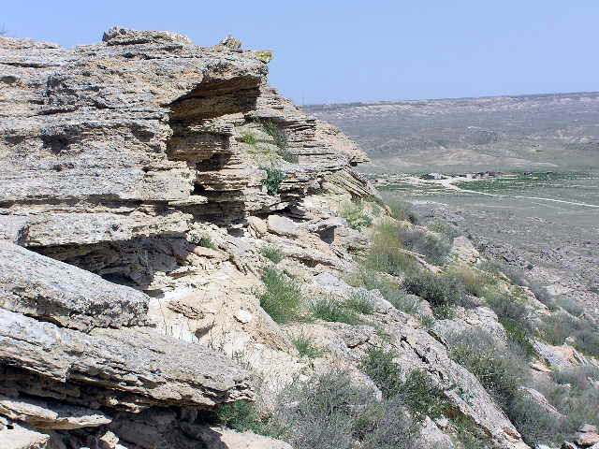
Figure 3.3.17 Mountains in the Karakiya area of the Karakiya-Karakol Reserve
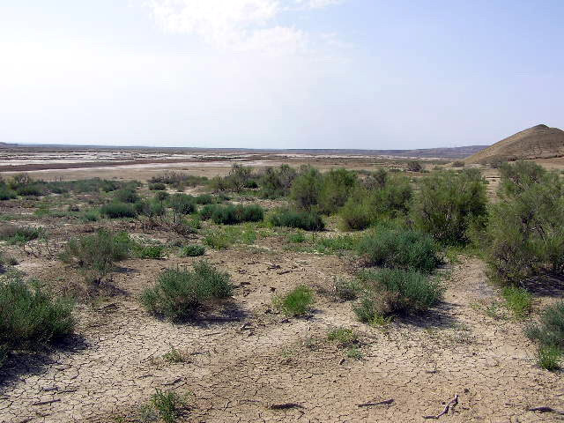
Figure 3.3.18 Sagebrush - tamarisk communities with camel's-torn in the Karakiya area of the Karakiya-Karakol Reserve
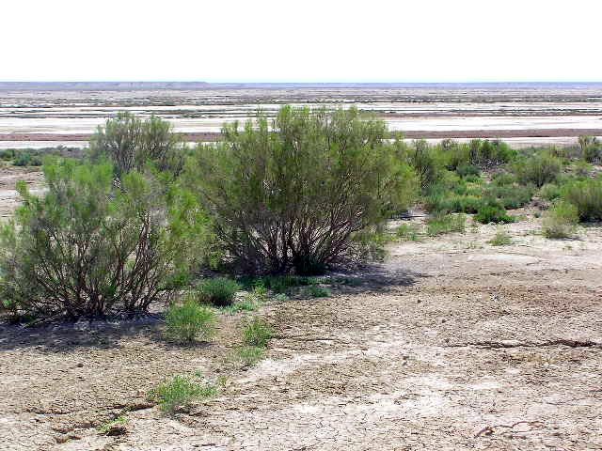
Figure 3.3.19 Tamarisk community in the Karakiya area of the Karakiya-Karakol Reserve
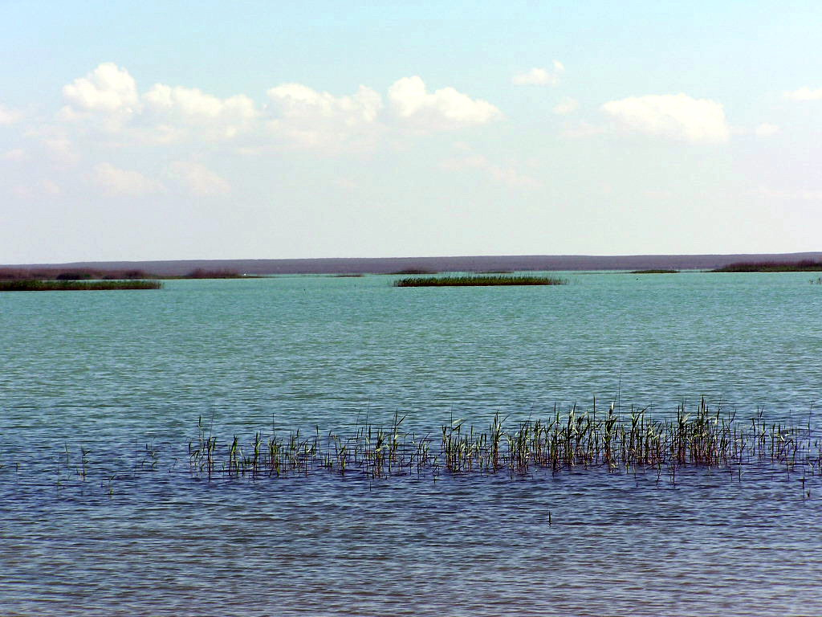
Figure 3.3.20 Reed islands formed by Phragmites australis in the Karakol area of the Karakiya-Karakol Reserve
Vegetation cover on clays and chalk is absent. Plants grow only in low relief forms. Shrubs and sub-shrubs are not met here. Gaps clays are occupied only by representatives of family Chenopodiaceae (Anabasis aphylla, A. salsa, Halimocnemis karelinii, Kalidium capsicum, Petrosimonia brachiata, Salsola dendroides, S. chiwensis, and Suaeda dendroides). Reaumurea fruticosa is also present here.
Rare and endangered species in the Karakiya-Karakol Reserve includes 2 vascular plant species:
- Malacocarpus crithmifolius (3), and
- Euphorbia sclerocyathium (3)
Biodiversity of all plant species is assessed as stable.
Fauna of the site comprises 1 species of amphibians, 17 species of reptiles, 282 species of birds and 43 species of mammals (data on invertebrates are not available).
Reptiles are represented by 17 species from 6 families. Representative of terrestrial tortoises is steppe tortoise (Agrionemys horsfieldi). It is not abundant and lives on sandy and loamy desertificated areas (Gvozdev E.V. et all., 1989.) Most common are species from the family of lizards (Lacertidae). For arid part of the territory background species are lizards ((Eremias arguta and Eremias velox), which can number about 10 individuals per hectare (Brushko, 1993).
Aviafauna of the area comprises about a half of the birds of Kazakhstan. Most of nesting and settled birds occur along the coast. Majority of birds included into the Red Book of Kazakhstan are registered here in the period of seasonal migrations (Gvozdev E.V. et all., 1989). One of the main routes of spring and autumn migrations of birds goes along the coast.
Among birds of prey of the family Accipitridae there are about 15species. Most common is black kite (Milvus migrans), pallid harrier (Circus macrourus), sparrow hawk (Accipiter nisus), and steppe eagle (Aquila rapax). Among 6 species of Falconidae most common is lesser kestrel (Falco naumanni) and kestrel (F. tinnunculus). Representatives of rare and endangered species of birds of prey are met at nesting. Houbara bustard (Chlamydotis undulata) and black-bellied sand grouse (Pterocles orientalis) also nest here.
Among nesting xerophillic species of the plain territory, background species are representatives of small larks and wheaters. Most common is short-toed lark (Calandrella cinerea) and lesser short-toed lark (Calandrella rufescens) and isabelline wheater (Oenanthe isabellina). On steep areas and rough relief places, there are nests of blue-cheeked beeeater (Merops superciliosus). Redheaded bunting (Emberizia bruniceps) and desert warbler (Sylvia nana) nest in reed and tamarisk thickets. On dry places, among bushes, there are nests of nightingale (Luscinia megarhynchos), scrub robin (Cercotrichas galactotes), and saxaul sparrow (Passer ammodendri). Here also occur great grey shrike (Lanius excubitor) and Turkestan shrike (Lanius phoenicuroides).
Red Books of IUCN and Republic of Kazakhstan includes 1 species of reptiles, 39 species of birds and 6 species of mammals. They are represented by the following organisms:
Reptiles:
- Elaphe quatuorlineata - four-lined snake (4)
Birds:
- Pelecanus onocrotalus - great white pelican (1)
- P. crispus - Dalmatian pelican (2, 3)
- Phalacrocorax pygmaeus - pygmy cormorant (2, 5)
- Ardeola ralloides - squacco heron (2)
- Bubulcus ibis - cattle egret (3)
- Egretta garzetta - little egret (3)
- Platalea leucorodia - spoonbill (2)
- Plegadis falcinellus - glossy ibis (2)
- Ciconia nigra - black stork (3)
- Phoenicopterus roseus - greater flamingo (2)
- Rufidrenta ruficollis - red-breasted goose (2)
- Cygnus cygnus - mute swan (2)
- C. bewickii - Bewick’s swan (5)
- Anas angustirostris - marbled teal (1, 2)
- Aythya nyroca – white-eyed pochard (3, 5)
- Oxyura leucocephala - white-headed duck (1)
- Pandion haliaeetus – osprey (1)
- Circus macrourus - pallid harrier (2, 5)
- Circaetus ferox - short toed-eagle (2)
- Hieraaetus pennatus - booted eagle (3)
- Aquila rapax – steppe eagle (5)
- A. clanga - greater spotted eagle (2)
- A. heliaca – eastern imperial eagle (3)
- A. chrysaetos - golden eagle (3)
- Haliaeetus albicilla - white-tailed eagle (2, 5)
- Falco cherrug – saker falcon (1)
- F. peregrinus - peregrine falcon (1)
- F. naumanni - lesser kestrel (2)
- Grus leucogeranus - Siberian white crane (0, 1)
- Anthropoides virgo - demoiselle crane (5)
- Porphyrio porphyrio – purple gallinule (2)
- Otis tarda - great bustard (1, 2)
- O. tetrax - little bustard (2, 5)
- Chlamydotis undulata - houbara bustard (2, 5)
- Chettusia gregaria – sociable plover (1, 2)
- Larus ichthyaetus - great black-headed gull (2)
- Syrrhaptes paradoxus - Pallas’s sandgrouse (4)
- Pterocles orientalis - black-bellied sand-grouse (3)
- Bubo bubo - Eurasian eagle owl (2)
Mammals:
- Vormela peregusna - marbled polecat (3)
- Felis manul – Pallas's cat (3)
- Linx caracal – caracal (1)
- Gazella subgutturosa - goitered gazelle (5)
- Ovis orientalis arkal - Asiatic mouflon (3)
Biodiversity of all animal species is assessed as stable.
Desert ecosystems. Main part of the described territory is within the zone of middle type desert on brown and greyish-brown soils. Ecosystems here are formed in severe natural conditions with low precipitation, sharp temperature changes, moisture deficit, and high soil salinity. Elements of meso- and microrelief play important role in formation of ecosystems.
Soil and vegetation cover is mosaic. This is connected with relief of the territory, chemical composition of the paternal rocks, differences in mechanical composition and salinity of soils, and also – with uneven distribution of moisture over relief elements. The largest area is occupied by zonal ecosystems. Their vegetation is represented by communities of north-turanic subshrubs – sagebrush (Artemisia terrae-albae), biyurgun, and solonchak anabasis (Anabasis salsa). Prevailing soils are grey-brown, often solonetzic and saline, and desert solonetz soils. Part of homogenous communities of this type is inconspicuous. They are most frequent in complex cover, where the ratio of biyurgun and sagebrush communities depends on soil salinity. According their mechanical composition, these soils are loamy and loamy sand. This feature defines the edaphic variant – pelitophytic or hemi-psammophytic.
Desert ecosystems vary in species richness of plants. Chalk and takyr soils are covered by monotype communities, but sand and stony-rubby soils – by communities of 60-70 species. Total projective cover is not more than 30-40%. In young communities on rock outcrops and overgrowing takyrs it comprises only 2-5%.
Steep slopes of denudation forms with immature soils and paternal rock outcrops are habitats of Atraphaxis replicata, Caragana grandiflora, Rhamnus sintenisii, Salsola arbuscula, Astragalus turcomanicus, Krascheninnikovia ceratoides and Convolvulus fruticosus. Rarer is black saxaul Haloxylon aphyllum. For salt marshes characteristic are ecosystems with additional surface and ground moistening. Dispersed halophytes dominate in their vegetation cover (Halocnemum strobilaceum and Kalidium caspicum). For salt marshes and solonchaks rather common are Aeluropus litorallis, Limonium suffruticosum, and bushes of Tamarix laxa. Along the old riverbeds, grow Artraphaxis replicata, Caragana grandiflora, Anabasis aphylla, A. brachiata, A. salsa, Artemisia gurganica, and Salsola orientalis on meadow-brown saline soils.
A shallow water reservoir was formed in the region of Karakol Lake because of sewage. Widely spread here is cane and reed (Phragmites australis and Scirpus tabernaemontani) and other aquatic vegetation. The lake is a wintering and nesting place for waterfowl.
Human impact. Desert ecosystems are very sensitive to human impact. The strongest human impact takes place in the territory adjacent to the Lake Karakol. Numerous dumps of rubbish and spills of combustive-lubricating materials are observed near the lake. Network of ground roads is developed around the lake. Traces of motor transport passages are observed everywhere except difficult to access parts of the reserve (salt marshes, solonchaks, steep slopes and depressions). Cattle pasturage occurs over the whole reserve. Cases of illegal hunting are also frequently registered. Meanwhile, the lake is a stopover place for 80 species of bids, including 21 Red Book of RK and IUCN species. However, the modern condition of the lake and its dynamics is not studied because of finance lack for scientific research.
3.3.7 Species dynamics and main features of human impacts
Analysis of vegetation dynamics on the territory of Novinskiy Reserve, in the Ural River delta, on Busachi and Mangyshlak Peninsulas shows, that during the last few years, areas occupied by Anabasis salsa, Artemisia, Poa bulbosa, Carex physodes, and Astragalus sp. have become smaller. Among the Red Book species, less abundant became Malacocarpus critlimiiolius and Convolvulus persica. Increased in their number some weeds (Peganum harmala, Anbasis aphylla, and Euphorbia seguieriana), and the Red Book species Malacocarpus eritmifolius. This is caused by misguided tourism, cattle pasturage, human impact and some natural factors (especially decrease of snow and rain precipitation).
Among animals, the most common for coastal zone is goitered gazelle, saiga, different rodents, wolf, fox, corsac, steppe polecat, marbled polecat, desert cat, caracal, ear shrew, and species of bats. All species, listed above, except rodents, demonstrate decrease in number. Among the Red Book species, goitered gazelle and Ustyurt mouflon are decreasing in number. The experts consider this to be the result of direct and indirect human impact (destruction of habitats, land ploughing up, infection diseases). Illegal hunting (poaching) is one of the most important negative factors. The most endangered in this respect is goitered gazelle, saiga and hare. According mass media data, number of saiga decreased to 20 thousand individuals. As important negative effects, specialists indicate also river pollution with sewage (plants and factories on the banks of the Volga and Ural Rivers, etc.). The specialists come up with an idea that human impact can reduce the number and diversity of animals to the point of complete disappearance, if they are not protected by creation of protected areas, reserves, etc.
Positive changes that are worth mentioning are acclimatization of koulans in Aktau-Buzachi Reserve and growth of marbled polecat population. A basis for these changes is rich forage reserve and absence of hunting the abovementioned animals. Growth of wolf population has been registered for the last few years. The reason is the absence of natural enemies and reduction of sanitary shooting.
Mass migration of birds in Kazakhstan sector of the Caspian Sea occurs in March-May, and in September - early November (depending on terms of cold season). Seasonal migration is more typical to mute swans and whooping swans. They appear in the late October - early November and leave to the north for summer. In general, about 3 million ducks, 500 thousand geese, 35 thousand flamingos, and 10 million waders pass through the Northern and North-eastern Caspian coast. About 20 thousand of swans and 100 thousand of ducks spend winter in the Kazakhstan part of the Caspian Sea. Fluctuations of number of birds depend not on human impact but on natural process of migration. At the same time, geese, and ducks hunting is continuing. Some poachers catch birds in order to sell them to other countries. However, this effect is inconspicuous.
Migration of mammals is usually local. For example, in autumn, goitered gazelles migrate from the coast into the sandy barkhan territories of Buzachi Peninsula. Wild boa and saiga migrations are also registered. In most cases, migrations are connected with reproduction and forage conditions. In winter, Caspian seals live on the ice of Northern Caspian Sea where they breed in February-March. In spring, they migrate to the south and spend summer in deeper and cooler waters of the Middle and South Caspian Sea. Mass death of seals was observed in 2000 (first in the North-eastern Caspian Sea, then – in the Middle and South Caspian Sea). More than 11 thousand animals died then. The laboratory research showed the presence of antigens of carnivore plague in the tissues of all dead seals and signs of toxicosis. At present, the number of seals is assessed as 400-420 thousand. Population of seals is now recovering in number because of absence of seal catch and hunting on a state scale.
Illegal hunting (in particular, catch of sturgeons) is very common in RK. In spite of total ban of sturgeons catch, this fish can be easily bought in shops and markets of the region. Specialists assess share of illegal fishing as 20-60% of state catch of fish (fishing cooperatives, artels, etc.).
The most dangerous types of human impact on the considered coast are intensification of economical activity in shelf zone of the Caspian Sea, environmental pollution by domestic sewage and industrial waste, destruction of surface ground layer by motor transport and other machinery, and poaching.
The following measures are considered to be the most important for improvement of the environment:
- Gain of control over nature protection laws observance in the Republic;
- Use of modern technology in economic activity;
- Liquidation of spontaneous damps (rise of cultural level and ecological education of local people);
- Decrease in amount of domestic sewage and other waste;
- Construction of landfill for hard domestic waste;
- Construction of nuclear-waste disposal station;
- Ban against driving outside existing motor ways;
- Toughening of measures against poaching;
- Creation of unified Rules for Fishing for all Caspian states;
- Adequate financial provision of science;
- Conducting of joint environment and biodiversity monitoring by all Caspian states;
- Organization of workshops on biodiversity control for all representative institutions according unified methods for all Caspian states.
In 2006-2015, exploration, construction, and infrastructure development of oil fields are being planned in many sites of the Kazakhstan sector of the Caspian Sea. This activity will definitely have negative effect on all components of the environment. Thereupon, very important is the assessment of ecological capacity of coastal ecosystems and their possibilities to bear increasing human impact.

