3.5 Turkmenistan
The total length of Turkmenian part of the Caspian Sea coast from north to south is about 600 km. The coastline is indented, with numerous bays and peninsulas. The coast represents saline sandy-clay plains with rather wide shelf zone. The region refers to the territories with strong shortage of fresh water. Once the fresh water was brought here in tankers from Baku, now it comes through the pipeline from the Karakum Canal. Mainly cattle breeding represent the agriculture of the region.
Turkmenian part of the Caspian Sea is the home of the State Reserve Khazar created to protect bird and fish fauna of the region. It consists of two parts: Turkmenbashinskiy sector (north) and Esenguliyskiy sector (south). It also includes Ogurchinskiy Reserve situated on the island of the same name.
Processes of natural and man-made desertification (land degradation) are widely spread in the coastal zone of the Turkmenian part of the Caspian Sea. In the coastal zone of about 100 km wide, desertification of strong and very strong degree (15.7%) occurs on 76.5% of the territory (Babayev, Shrader, 2003). Problems of biodiversity decrease and biodiversity conservation are closely connected with land degradation.
3.5.1 Main ecosystems
Turkmenian coast of the Caspian Sea, except its southern part, lies in the desert zone and is characterized by extreme soil and climatic conditions. The following three natural regions are marked out here (Babayev, 1984):
- Tuarkyr-Ustyurtskiy clay-detritus-erosion region;
- Caspian sand-solonchak region;
- Atrek delta region.
Short description of the regions is the following:
Tuarkyr-Ustyurtskiy clay-detritus-erosion region is situated in the extreme north-west of Turkmenistan. Mountains (kyry) with the maximum height of 400 m above the sea level are typical for the region. Plateau highlands are separated by narrow valleys, canyons, and depressions with solonchak soil. Sand missives are covered by grass and shrub vegetation. Mean annual temperature is about 15°C, absolute maximum is 43°C, absolute minimum is 30°C. Atmospheric precipitation is about 100 mm per year. Most common here are grey-brown, sandy-desert soils, in depressions – solonchak soils. Sub-shrub halophytes Salsola gemmascens, Anabasis salsa, and Artemisia santolina and ephemeral herbs dominate in the vegetation cover. The territory of the region is used as a whole-year grassland for camels.
Caspian sand-solonchak region occupies the middle part of the Turkmenian Caspian coast, which appears to be a low sand-solonchak and clay-solonchak plain. Quite common here are barhan and fixed sands as well as solonchak areas without any vegetation (Figure 3.5.1). Ground waters are close to the surface and strongly mineralized.
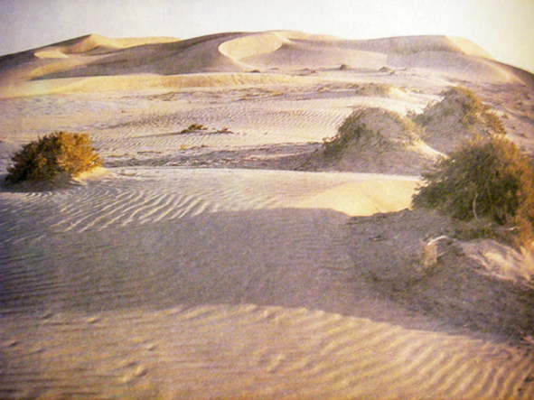
Figure 3.5.1 Landscape of running sands in the Caspian coastal zone of Turkmenistan
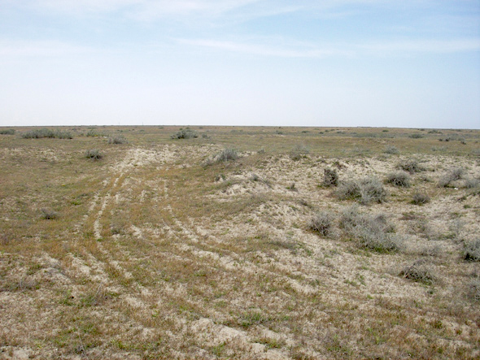
Figure 3.5.2 Flat landscape in the vicinity of Esenguly
Climate of the region is marine one. The mean annual temperature is 15.4°C, absolute maximum is 44°C, absolute minimum is 18°C. Annual precipitation is 150 mm. Sandy-desert and solonchak types of soil are most common here. Vegetation is represented by halophyte and psammophyte communities, which do not form a dense cover. The Ogurchinskiy Island with the similar natural conditions can also be referred to the region. Territory of the region is used as whole year grasslands for sheep, goats, and camels.
Atrek delta region includes southwestern part of Kopetdag Mountains. In the south, it borders with Kuyuki highland and in the north with Meshedkym sandy desert. In the west, it continues into the Caspian coastal plain. In the south-east it begins near the Chat settlement, where the Sumbar River runs into the Atrek River, and then gradually goes down to the west. The relief represents a low plain, built by ancient stratified sediments of the Atrek River (Figure 3.5.2).
Climate here is mild subtropical. Mean annual temperature is 17.1°C; annual precipitation is 188 mm per year. Ground waters are close to the surface and strongly mineralized. The Atrek River delta is the only region in Turkmenian Caspian coast where some limited areas are used for irrigated agriculture. In the modern Atrek River delta, with surface position of mineralized ground waters, solonchak and meadow soils are well developed. In the ancient delta plain of Atrek River, vast territories were used for ancient irrigated agriculture (Meshed-Messerian plain). Takyr and takyr-like soil are widely spread here. Land cultivation is limited by the absence of water resources. Vegetation of the modern delta is rather dense, represented by annual halophytes and tugay plants - Tamarix sp., Aeluropus littoralis and Phragmites australis. Territory of the region is used as whole-year grassland for sheep and goats.
In the 50 km wide coastal zone of the abovementioned region, the following ecosystems are present:
- Desert ecosystems (sandy, clay, solonchak, gypsum and kyr);
- Delta ecosystems;
- Wetland ecosystems;
- Marine ecosystems.
3.5.2 Geological structure and coastal relief
Turkmenian coast of the Caspian Sea was formed on the large tectonic structures that defined the development of coastal processes and relief. The coastal line is strongly incised with large (Kara-Bogaz-Gol, Turkmenbashinskiy and North-Cheleken) and small bays. There are two types of coast: platform type and geosyncline type. They have different geological structure, relief, and intensity of desertification. Platform coasts are dominant in the north of the Turkmenian coast, geosyncline – mostly in the south.
The northern part of the coast is a steep (chink) of 50-80 m high. Towards the sea, it continues into the beach zone with the width from 20 to 100 m. Such kind of coast with maximum height of 138 m is characteristic to the northern part of Kara-Bogaz-Gol Bay. Then it goes down and continues into the chink plateau Ustyurt where the marks are higher (up to 300 m). In the southeast of Kara-Bogaz-Gol coast, the relief is undulating with the height of some hills up to 60-80 m.
To the south of Dyuldyulata Mountain, quaternary deposits form the modern Caspian coast. Dense silty-clay deposits of Baku and Khazar age went under the water during the sea level rise and form underwater slopes (regions of Bekdash, Dzhapar and Kiyanly settlements, and Kara-Bogaz-Gol Straight). Open part of these deposits form bare stony beach, which is periodically affected by wind tide (regions of Karshi, Omchali, Aim villages to the south of Kulimayak settlement and others).
From Kara-Bogaz-Gol to Krasnovodsk the coast represents a flat solonchak plain lined with sandy and strongly salted dunes with the height of about 16 m above the sea level.
Rocky highlands Karadag and Shagadam (Figure 3.5.3) as well as the southern part of Krasnovodsk Plateau are situated on the northern rocky coast of Krasnovodsk Bay. They are formed by granite, granite-gneiss, and tuff. After this area, the coast continues into the vast plain formed by loose sand, siltstone and clay rocks of higher Pleistocene and Holocene.
In the region of base rock rise in the western part of Cheleken Peninsula, the coast is steep, formed by Pleistocene dark clay, strongly eroded by sea waves. Slough and caving processes are quite common here (Figure 3.5.4). Further, the coast continues into a plain, which stretches to the border with Iran.
Geosyncline coast is highly sensitive to every small change of the sea level. The 10 cm rise or fall of the sea level cause flood or drying of the coast for the distance of 200 m. On the anticlines coast this value is 10 times less. Sometimes during one hour of the wind tide, the coast territory can be flooded over the distance of 200 m.
Among the geosyncline coasts there are lateral and longitudinal ones. The former, situated between Turkmenbashi Bay and Turkmenskiy Bay, is strongly incised with numerous small bays. Within the region there are numerous mud volcanoes situated in the zones of large ruptures. From time to time, they become active, and ecologically dangerous mud and gas are thrown out of them (Figure 3.5.5).
In respect of presence of various coastal systems in Turkmenistan and human impacts on them, situation is presented in Table 3.5.1 (for designations refer to Sections 2.3 and 2.4). One can see that this littoral state has 70% of coastal systems known for the European seas.
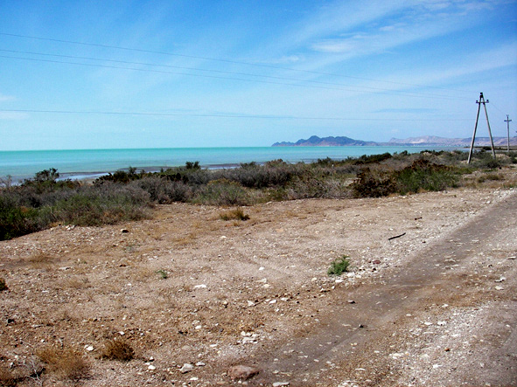
Figure 3.5.3 Mountains Shagadam and Karadag form stony coast of the Turkmenbashinskiy Bay
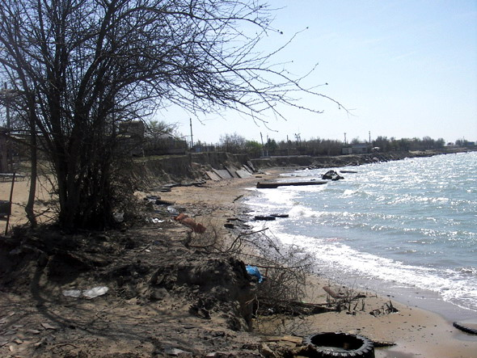
Figure 3.5.4 Landslip on the cliff of Cheleken Peninsula
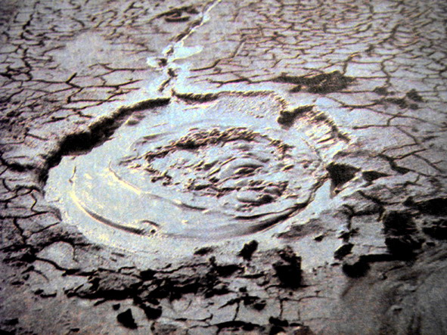
Figure 3.5.5 Mud volcano in the Cheleken Peninsula area
Table 3.5.1 Main types of the Caspian Sea coasts and human impacts on them in Turkmenistan
Code | Coastal site type | Presence | Human impacts
HRC | Hard rock cliffed coasts | + | CB, CP, CG
HRP | Hard rock coastal plains | - | -
SRC | Soft rock cliffed coasts | + | CB, CD, CG
SRP | Soft rock coastal plains | + | CA, CN, CM
SKC | Skerry coasts | - | -
SGS | Shingle / sandy spits | + | DR, CH
SSB | Shingle / sandy beaches | + | CH
COD | Coastal dunes | + | CA, CM
RRT | Reed & rush thickets | + | DF
MUF | Mud flats | - | -
WET | Wetlands | + | DF
SAM | Salt marshes | + | CM
OBA | Open bays | + | DR
SCB | Semi-closed bays | + | DR
LAG | Lagoons | + | DR
COL | Coastal lakes | - | -
RID | River deltas | + | CA
EST | Estuaries | - | -
SOI | Solitary islands | + | DB, CB
ARC | Archipelagos | - | -
ADM | Protective engineering structures / Dams | - | -
Analysis of the table shows that according to the frequency of occurrence the first place belongs to temporary recreational activities (DR), which are recorded in 4 types of coastal biotopes. Second place belongs to impact of agriculture (CA), construction, dredging and dumping (CB) and mineral extraction (CM), which are recorded in 3 types of coastal biotopes. Third place belongs to impact of wear (CG) and temporary fishing and hunting (DF), which are recorded in 2 types of coastal biotopes. Other types of human impact are recorded in one type of coastal biotope each. Theses are coastal defence (CD building activities in recreation purposes (CH), oil production, and transportation (CN), pollution (CP) and temporary construction (DB).
Climate of Turkmenian Caspian coast is continental and very dry, except very narrow coastal zone. This is caused by atmospheric circulation patterns, continental location of the territory, character of underlying surface and relief conditions. On condition of plain relief, influence of the Caspian Sea spreads over 50-80 km and on rugged terrain, it decreases to 20-30 km. In general, the narrow coastal zone appears to be a waterless plain with patches of sands and solonchak areas.
The weather of the region is changeable in cold season, hot, and dry in summer. Mean annual temperature at the seaside changes from 12.2°C in the north (Bekdash station) to 15.8°C in the south (Esenguli station). Annual precipitation in the region is very low: 70-200 mm. Minimum precipitation level is registered in the region of Kara-Bogaz-Gol Bay (70 mm per year). Number of sunshine hours is very high in the Caspian region and varies from 2600 to 2700 per year. Mean annual duration of warm period is about 260 days, in the south is 278 days.
3.5.3 Climate
Caspian region is the area of strong wind activity. Mean annual wind speed is not less than 6 m s⁻¹, and mean maximum wind speed is 8.7 m s⁻¹. Most active are winds in the northern half of the region where the mean perennial number of strong wind cases is 700-800, whereas in the south it is 400. Strong winds cause dust storms, which are most frequent in the region of Balkanbad (about 60-66 day in a year).
Subtropical climatic region occupies the southern part of the coast. It begins from Chekishlyar settlement, stretches along the narrow coastal zone, and includes the Atrek River delta and valley. Climate is milder here, mean annual temperature is 16.3°C, and mean temperature of January is 4.3°C, of August is 28.0°C. Sunshine duration is 2900 hours per year.
3.5.4 Soils and vegetation
In the northern part of the coastal zone, soils are grey-brown and sandy-desert; in the southern part dominant are takyr and takyr-like soils, meadow-takyr and meadow soils. Solonchak soils are present everywhere. Complex of grey-brown solonetzic clay gypsiferous soils covers almost all surface of Krasnovodsk Plateau. High content of broken stones and development of crystalline gypsum is characteristic to these soils. Sandy-desert soils develop on fixed sands of the coastal zone (Figure 3.5.6). These soils are weekly developed and sometimes primitive. Their surface layer is loose and sandy, than goes root horizon with week signs of structure formation. Solonchak soils together with salty and loose sands are spread in the narrow stripe of Caspian coast. Solonchak takyr, and swollen solonchak soils are spread in modern delta of the Atrek River.
Vegetation of the region is sparse, low and mosaic. Psammophyte vegetation represented by shrubs, subshrubs, and grasses (Haloxylon persicum, Ephedra strobilacea, Salsola richteri, Calligonum sp., Carex physodes and Anisantha tectorum) is characteristic for the sandy areas. Near wells and settlements sand plant vegetation strongly suffers from misguided pasturage.
Coastal running sands have some vegetation only in the lower parts of the sand formations. The usual sand plants here are Nitraria shoberi, N. komarovii and Aristida stipagrostis. Vegetation cover of sandy-shell new Caspian and modern deposits in the coastal zone is fragmentary. The most common plants of this area are Artemisia santolina, A. badhysi and A. kelleri.
On the modern deposits in the beach zone and also around coastal solonchak areas, the most common plants are Salicornia herbacea and Halocnemum strobilaceum with inconspicuous presence of annual halophytes and sand plants. Sagebrushes, Salsola arbuscula, Salsola gemmascens, Salsola rigida, Anabasis salsa, and ephemeral plants form vegetation of gypsum deserts. Vegetation of clay deserts consists of sparse groups of annual halophytes, patches of sagebrushes and Tamarix sp. bushes along temporary streams. Halophyte vegetation sometimes forms dense cover in solonchak desert meadows of the Atrek River delta. Bare solonchak (Figure 3.5.7) and running sands occupy large areas of Caspian coast of Turkmenistan.
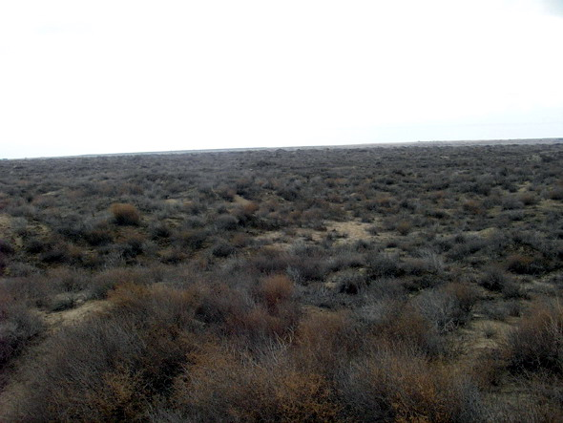
Figure 3.5.6 Sands consolidated by vegetation in the Krasnovodskoye plateau area
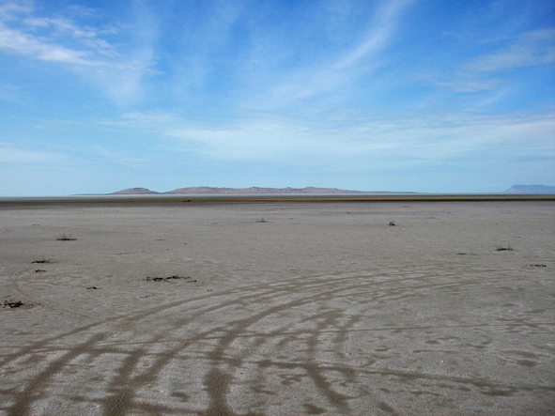
Figure 3.5.7 Landscape of pure salt marshes in the Balkhanskiy Bay area
3.5.5 Population and economy
Territory of the coast belongs to administrative division of Balkhanskiy Velayat. It includes 6 subdivisions (etraps): Turkmenbashinskiy, Bereketskiy, Garrygalynskiy, Serdarskiy, Esenguliyskiy and Etrekskiy. Besides, there are territories that belong to administrations of towns Khazar and Balkanabad. On the velayat territory there are 6 towns, 17 settlements of town type and 139 villages. The largest towns are Balkanbad, Khazar, Turkmenbashi and Serdar. Balkanskiy Velayat is the largest in Turkmenistan (136.3 thousand square km), but its population is one of the smallest (553.5 thousand people; 2005). The average density of the velayat population is 3.2 people per 1 square km, while the average population density in Turkmenistan is 10.6 people per square km.
Economy of the region is based on industrial sector, which includes industry and mining. Industry ratio in the total production of the country is 26%. Balkhanskiy Velayat produces 16% of electric energy of Turkmenistan, 91% of oil, 30% of gas, and 90% of oil products. All production volume of iodine, bromine, technical carbon, sodium sulphate, bischofite, epsomite, fish preserves and salt is concentrated in the region.
The main treasure of Balkhanskiy Velayat is oil, oil gas, and natural gas. Oil fields are concentrated in the regions Goturdepe, Bassa-Gel’mes, Cheeleken, Vyshka, Ekerem, Gumdag, Gamyshlydzha and in the water area of the Caspian Sea (banks: Lam or Dzheitun, Livanov, Gubkin, Zhdanov or Dzhigalybek). In 2003, oil production of the region grew considerably, up to 7.0 million of tons, including 900 thousand of tons produced with the participation of foreign capital. Explored oil reserves and new oil-field construction and operation will allow producing 35-40 million of tons of oil in the following 10 years. Most part of this amount will be produced in Balkhanskiy Velayat. At present Turkmenbashi oil-processing plant is under reconstruction and modernization.
Other minerals are extracted in the following minefields:
- Cheleken Peninsula, Boyadag, Gograndag, Garadashly, Goturdepe, and Gundag (iodine-bromine waters);
- Baba-Khodzha, Guvlymayak, Garashor, Zapadnyy Uzboy (salt);
- Kara-Bogaz-Gol (mirabolite, magnesium, iodine, cilium);
- Yagman and Chairli (bituminous and brown coal).
Square of the velayat land supply is 13.9 million hectares. More than 90% of these lands appear to be plain and mountain grasslands with different degree of water supply. Agriculture is poorly developed because of water shortage. Irrigated agriculture started developing in the eastern part of the velayat after the construction of Garacum canal. In the south of the region there are some small areas irrigated with waters of the rivers Atrek and Sumbar. Irrigated land square here is only 5.5 thousand hectares. For irrigation, mostly meadow soils are used. However, these lands are irrigated not every year. The reason is the lack of water. The Atrek River brings its waters to the Caspian Sea not every year (last time it was in 1998). The river can dry out and its water is used on Iran territory.
The south-western part of Turkmenistan has a lot of land suitable for agriculture. Solonchaks and salted mobile sands occupy the coastal zone of this territory. In the modern delta of the Atrek River, solonchak and meadow soils are well developed and the ground waters are close to the surface. Within the south-western region the most suitable for agriculture development is the Chogalinskiy massive of takyr soils (about 40 thousand hectares), Chatskiy massive of light grey soils and takyr soils (more than 100 thousand hectares) and ancient irrigated takyr-like and takyr soils of Messerian plain (about 200 thousand hectares).
Crop agriculture is concentrated in the eastern part of the velayat. Small crop areas are present in the Atrek delta. The total area of cropland of the velayat is 47 thousand hectares (1998), including 41.7 thousand hectares of grain culture and 3 thousand hectares of cotton.
Square of Esengulyiskiy etrap, including the territory of Khazarskiy reserve, is about 1 million 480 thousand hectares. Its population is 38 thousand of people. Square of agricultural land is 3.5 thousand hectares. In 2004, the Yun Taba water reservoir (40 million cubic meters) was created in the region.
A cattle breeding is the main field of agriculture in the region with its vast grasslands that occupy 8383.3 thousand hectares. In general, the grasslands of the region are rather poor. The annual pasturage normative for one sheep is 9.2 hectares.
On the territory of Balkhanskiy Velayat there are several types of lands according their use:
- Lands, used in the mining industry;
- Lands of active economic development, where centres of mining and processing industry are situated;
- Lands under reclamation for irrigation;
- Lands of dry subtropics with separate areas of irrigated land in Atrek and Sumbar river valleys;
- Available croplands;
- Grasslands of sandy, gypsum and solonchak deserts used for whole year pasturage;
- Mountain grasslands and hayfields;
- Lands used for recreation;
- Protected Areas (Reserves).
3.5.6 Transport
Transport is especially important in the region rich in natural resources. Main types of transport in the region are marine, railroad and pipeline. There are three ports on the Turkmenian coast: Turkmenbashi, Bekdash, and Alandzha. Ferry line has worked between Turkmenbashi and Bekdash and Bekdash – Baku since 1959. Turkmenbashi –Astrakhan’ ferry line has worked since 1998.
Railroad network is poorly developed. Density of railroad network in Balkhanskiy Velayat is 1.5 times less than average in the country. Under project are the following railroads: Turkmenbashi – Erashovo (Western Kazakhstan) 650 km long, Bereket – Etrek – Benderturkmen (Iran) 225 km long. Projected railroad Turkmenbashi – Dashoguz, 600 km long, will allow facilitating mining industry development in Western Turkmenistan.
The total length of motorways is 2 850 km, only half of them with dense cover. Per 1 000 square km of the territory there are 13.4 km of motorways. The urban motorway Ashghabat – Turkmenbashi, 600 km long, is being constructed at present.
Development of oil and gas industry, growth of urban population and increased requirement of drinkable water make pipelines especially important in the transport system. Turkmenbashi port receives oil through the pipeline of 475 km long. The total length of functioning pipelines Khazar – Belek – Turkmenbashi, Gumdag – Belek - Center, Korpedzhe – Kurtkui (Iran) is 4 000 km.
Water supply of industrial centres is achieved with the help of pipeline from the underground lake Jaskhan to Balkanabad and Dzhebel settlement, which has been working since 1961. Water pipeline Gaaragum – Bereket – Balkanabad – Turkmenbashi and Balkanabad – Khazar, built in 1984, allowed creating a zone of independent water supply to the coast of the Caspian Sea of the total length of 350 km.
3.5.7 Protected Areas
In the region of Turkmenian Caspian coast there is a unique State Nature Reserve Khazar, which is situated mostly in the bays of the Caspian Sea (Rustamov, Vasilyev, 1976; Nature Chronicle, 2004).
History of Khazar Nature Reserve began in 1932 from creation of Esenguliyskiy Ornithological Reserve, which included low current of the Atrek River and the Esenguliyskiy Bay. In 1968, it was reorganized into Krasnovodskiy Nature Reserve, which included the whole system of shallow sea bays called “Krasnovodskiy and North-Cheleken Bays”. In 1994 by the resolution of Turkmenistan government, it was renamed into State Nature Reserve Khazar, which included the Reserve “Ogurchinskiy Island”.
The reserve is situated at the border of typical desert, Caspian Sea water area, and subtropical province of Iran. Its territory includes three separate sectors: Khazar, Esenguli and Ogurchinskiy Reserve. The total square of Nature Reserve, including water area, is 278 hectares.
Khazar sector includes the water areas of Turkmenbashinsliy Bay, North-Cheleken, Balkhanskiy Bay, and Mikhailovskiy Bay, surrounded by protection zone 1 km wide. Its square is 192.3 thousand hectares. Among them 159.3 thousand hectares, belong to the water area of the bays and the least of the area – coastal solonchaks, sandy desert areas, islands, and spits.
Esenguli sector has a square of 69.7 thousand hectares, including the water area of 35.9 thousand hectares. The sector consists of four different landscape formations:
- coastal strip and shallow water area;
- territory of the former Esenguli Bay;
- freshwater lake Maloye Delili (now dry) and a bed of drying out lake Bolshoye Delili with thickets of reed, cane and tamarisk, with rich underwater vegetation;
- Karadegish terrestrial sector with typical meadow vegetation and tamarisk thickets.
Ogurchinskiy Reserve is situated on the island of the same name. Its square is about 7.0 thousand of hectares. It separates the Turkmenskiy Bay from the open sea and is situated at the distance of 40 km from the mainland shore. Relief of the island is plain, formed by fixed sands and solonchaks.
3.5.8 Sensitive sites, general biodiversity, rare and endangered species
Based on literature analysis, field research and discussion with specialists, the following sites of the Turkmenian Caspian coast were chosen as most sensitive and most important for the biodiversity conservation:
- Atrek River Delta and Gasankuli part of the State Nature Reserve Khazar (flora and fauna as a priority groups)
- Ogurchinskiy Island (fauna as a priority group)
- South-Cheleken Bay (fauna as a priority group)
- Turkmenbashinskiy, North-Cheleken, Balkhanskiy and Mikhailovskiy Bays (fauna as a priority group)
- Kiyanly Bay (fauna as a priority group)
Turkmenian coast of the Caspian Sea, except the most southern site (dry subtropics), is situated within the desert zone. It is indented by numerous large and small bays, straits, islands and floods (permanent and temporary), protected from the sea storms. There is a large coastal shallow water area. Because of hard climatic and soil conditions in the region and shortage of fresh water, the coastal zone is poorly developed and has little population. The main field of industry is oil and gas production and processing. The sea environment is weakly polluted with industrial waste and sewage.
Most of the habitats of the Turkmenian sector of the Caspian Sea are included in the List of Ramsar Convention as wetlands of international significance, important for waterfowls. These wetlands are situated within the State Reserve Khazar (Figure 3.5.8). Favourable natural conditions and strong protection create prerequisites for biodiversity conservation.
Flora and fauna of the Turkmenian sector of the Caspian Sea and its coast encounters 1 085 species. Among them there are:
- 40 species of algae;
- 5 species of aquatic higher plants;
- 528 species of vascular plants;
- 59 species of invertebrates;
- 45 species of fishes;
- 2 species of amphibians;
- 38 species of reptiles;
- 289 species of birds;
- 79 species of mammals.
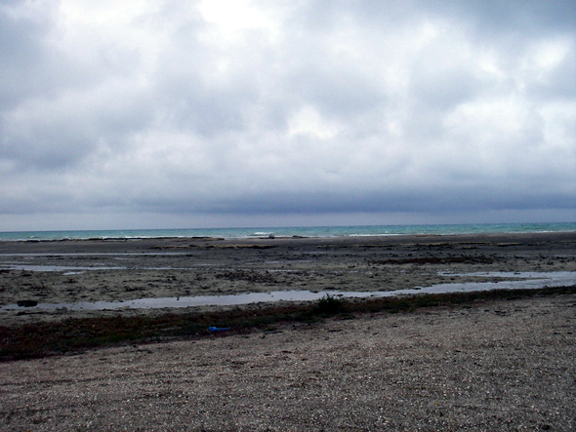
Figure 3.5.8 Wetlands of the Turkmenistan coast of the Caspian Sea
Species list of plants and animals included to the Red Book of Turkmenistan (1999) looks like follows:
Vascular plants:
- Tiloschistes lacunosus (1)
- Salsola chiwensis (2)
- S. transhyrcanica (2)
- Climacoptera czelekenica (2)
- Ammodendron eichwaldii (3)
- Jurinea karabugasica (2)
- Lasiopogon muscoides (3)
- Phagnalon androssovii (2)
Fishes:
- Acipenser nudiventris - ship sturgeon (1)
- Salmo trutta caspius - Caspian trout (1)
- Stenodus leucichthys leucichthys - Caspian inconnu (1)
- Alosa kessleri - blackback shad (5)
- Caspimyzon wagneri - Caspian lamprey (2)
Reptiles:
- Naja oxiana - oxus cobra (3)
- Varanus griseus - desert monitor (4)
Birds:
- Pelicanus crispus - Dalmatian pelican (1)
- P. onocrotalus - great white pelican (1)
- Ciconia nigra - black stork (1)
- Platalea leucorodia – Eurasian spoonbill (1)
- Phoenicopterus roseus – greater flamingo (2)
- Anser erythropus - lesser white-fronted goose (1)
- Marmaronetta angustirostris – marbled duck (1)
- Oxyura leucocephala - white-headed duck (1)
- Pandion haliaetus - osprey (3)
- Haliaeetus albicilla - white-tailed eagle (1)
- Haliaeetus leucoryphus - Pallas's sea eagle (3)
- Aquila rapax – steppe eagle (3)
- Aquila chrysaetos - golden eagle (3)
- Aquila heliaca – eastern imperial eagle (1)
- Falco peregrinus - peregrine falcon (3)
- Falco cherrug – saker falcon (3)
- Circaetus gallicus/ferox - short-toed eagle (3)
- Francolinus francolinus - black francolin (3)
- Anthropoides virgo - demoiselle crane (1)
- Porphyrio porphyrio – purple gallinule (3)
- Tetrax (Otis) tetrax - little bustard (3)
- Chlamidotis undulata - houbara bustard (2)
- Chettusia gregaria – sociable plover (3)
- Larus ichthyaetus - great black-headed gull (2)
- Passer simplex - desert sparrow (2)
Mammals:
- Gazella subgutturosa - goitered gazelle (5)
- Lutra lutra – common otter (3)
- Hystrix leucurus - porcupine (4?)
In general, diversity of rare and endangered species is assessed as stable with a small trend to decrease in density for single species.
Migration of birds is important factor of biodiversity in the Turkmenian sector of the Caspian Sea coast. According long-term observations, the number of birds comprises from 5 to 8 million of individuals. About 300 thousand of birds stay here for wintering period, which lasts for 4-5 months. The number of birds that nest in the region reaches 15-20 thousand of individuals (National Report, 2000).
According the data of Khazar State Reserve personnel, in 2006 the number of wintering birds was more than in previous years (in 2005 – about 250 thousand, in 2006 – about 300 thousand). Because of bird flu epidemics, since December 20, 2006, a ban on bird hunting was introduced in the Turkmenian coast of the Caspian Sea. This measure allowed birds to spend winter quietly. They swam and fed right near the coast adjacent to the Turkmenbashi City. However, January frost made the wintering conditions harder. Nevertheless, death of birds was not registered at the coast during spring fieldwork.
Dangerous tendency registered at Turkmenian coast is the appearance of alien species, such as jellyfish Mnemiopsis leidi. This species is present everywhere in the Turkmenian sector of the Caspian Sea. Number of jellyfishes in the waters of Turkmenbashi Bay reached 126 billion (Nature Chronicle, 2004).
All 5 sites, chosen for description and detailed research, has special importance for biodiversity conservation. Some of them underwent considerable degradation under the influence of natural factors and human impacts. They demand complex research and elaboration of measures on their recreation (low current and delta of the Atrek River). Others should be given a Protected Area status and included into the State Reserve Khazar (north-western part of Turkmenbashinskiy Bay) or should become refuges (South-Cheleken Bay and Kiyanly Bay).
The real situation in the chosen sensitive sites is described below.
3.5.9 Atrek River Delta and Gasankuli part of the State Nature Reserve Khazar
Atrek River Delta and Gasankuli part of the State Nature Reserve Khazar situated in the southern part of Turkmenian coast, nearer to the border with Iran (see Annex 2, Figures 3.5.9-3.5.10), have dry subtropical climate. The site includes vast shallow sea areas, floods, lakes, and streams of the Atrek River low current. In general, they form a peculiar kind of landscape with mild climatic conditions. Shallow water area is a transit and wintering zone for migrating birds. The main settlement of the region is the etrap centre Esenguly with 38.2 thousand of people (2005). Besides, there are some other large and small settlements: Adzhiyab, Chaloyuk and Karadegish. Traditional activities in the region are fishing, agriculture, and cattle breeding.
Fishing is the leading field of economy in the region. Once there were fishing collective farms and fish processing factories. Maximum catch was registered in 1934. In those times, they caught 107.2 thousand of centners of roach, and 21.0 thousand of centners of common carp. After 1940 the catch fell to 2 thousand of centners of roach and 0.5 thousand of centners of common carp. The reasons of catch decrease are the fall of sea level and river flow, development of irrigated agriculture, intensification of fishery and some others. At present, collective farms and enterprises are closed and the fishing fleet has become out of date. Illegal fishing is going on, but its volume is unknown.
Irrigated agriculture is limited and based on little water resource of rivers Atrek and Sumbar. At present, irrigation possibilities are not good because of Atrek current stoppage and weak current of Sumbar. In favourable years, the square of irrigated land was more than 5 thousand hectares, but at present, this number is becoming less. In the region mostly wheat, cotton, vegetables, and melons are cultivated. Cattle breeding are weakly developed, because grasslands are poor, and large territories are occupied by halophytes not suitable for cattle feeding.
In the Atrek low current, there are famous spawning grounds of roach and common carp, as well as zander and, in some years – sturgeon. They are situated near the sea (at the distance of 20-25 km). The square of Adzhiyab spawning grounds is 3 850 hectares, where the spawning substrate - Aeluropus littoralis occupies 50-60%. The spawning complex of Adzhiyab spawning grounds was built in 1973 for the growth of roach (Rutilus caspius) and common carp (Cyprinus carpio) population. To the east are Delili and Northern spawning grounds (at the distance of 40-60 km from the sea). Water regime of the spawning grounds depends on the Atrek River flow. However, water regulation on Iran territory led to the loss of spawning grounds. After 1998, the river waters did not reach the sea and the site was in critical condition. The buildings of the spawning grounds are in poor condition, canal is silted, and emergency disposal is not functioning. The spawning complex requires major repairs. The lake Maloye Delili has dried out, tugai forests in the flood-lands are degrading and disappearing. At the same time, this region is a nesting place of rare and valuable birds, such as purple gallinule (Porphyrio poliocephalus) and black francolin (Francolinus francolinus), included in the Red Book of Turkmenistan, and also the habitat of rare mammals, such as common otter (Lutra lutra) and porcupine (Hystrix leucurus).
At present, personnel of the reserve are working on the reproduction of black francolin in the open-air cages. There are now 14 black francolins in the open-air cage in Karadegish settlement. On the territory of the dry lake Maloye Delili there were registered voices of black francolins indicating some growth of population of this rare bird. Degradation of vegetation cover and land salination are quite common types of land degradation in the region. Critical condition of the site requires urgent measures on its recovery.
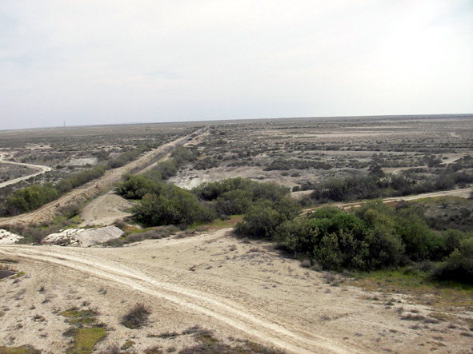
Figure 3.5.9 Landscape in the area of former Adzhiyabskoye spawning ground (dried)
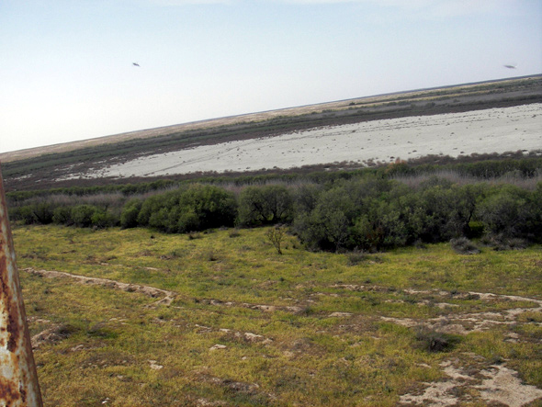
Figure 3.5.10 Lake Maloye Delili dried out after stopping of flow from the Atrek River
3.5.10 Ogurchinskiy Island
Ogurchinskiy Island (see Annex 2, Figure 3.5.11) is situated in 40 km from the coast and is characterized by desert conditions. The island stretches for 40 km in meridian direction; its width varies from 0.5 to 2.0 km. The landscape of the island is sandy-desert. Relief is of ridge-hillock type. The island is built of marine accumulative sandy and shell rocks. Sandy surfaces of the island are fixed by well-developed shrub-grass vegetation. There is no permanent population and agriculture on the island. There is a lighthouse and a base of frontier troops. A Reserve created on the island belongs to the State Reserve Khazar and has a square of 7.0 thousand hectares. The main purpose of the Reserve is introduction of goitered gazelle (Gazella subgutturosa), which was brought here in 1983 in a quantity of 13 adult individuals. There was time when goitered gazelle number was 1000 or even 1500 individuals. However, in recent years, because of weak protection measures and degradation of natural vegetation, the goitered gazelle population number fell to 700 individuals. According to the resort report, in recent years, the number of females has become more than mails and the animals have become smaller.
In spring and autumn, mass migration of birds takes place along the island coast. Numerous nesting colonies of gulls and terns are formed on sandy beaches. This area is important as a habitat of Caspian seal, endemic species, which forms permanent breeding grounds in the calm shallow places (northern and southern parts of the island). Once, about 500-600 individuals were registered on these breeding grounds. However, in recent years, strong human impact made the seals leave their habitats. In winter of 2005-2006 not a single seal was registered on the southern breeding ground and on the northern – only two individuals. The reason is the weakening of protection measures and growth of human impact. Degradation of vegetation and weathering of sand are characteristic processes in the area. It is explained by growth of goitered gazelle population, shortage of forage and cutting down trees.
3.5.11 South-Cheleken Bay
South-Cheleken Bay (see Annex 2, Figures 3.5.12-3.5.13) is situated in the southern part of Cheleken Peninsula (another name – Dervish Peninsula). South-Cheleken Spit that represents a narrow and low accumulative swell separates the bay from the sea. The spit consists from mellow accumulative sandy rock subjected to quick erosion, infiltration, and abrasion by the seawater. The bay stretches in meridian direction; its length is more than 20 km and width – from 0.8 to 6 km. Not far from the bay is the town Khazar with population of 16.2 thousand people (2005). The lower coastal part of the town is flooded and some buildings are destroyed. Khazar chemical plant is situated in the town. Because of shore destruction the seawater came close (20 m) to the plant. In the north-western corner of the bay, there are some small settlements: Karagel’ and port-quay Aladzha. Some parts of the settlements were flooded during the sea level rise; there are some deserted and destroyed buildings. A dam and a road from Karagel’ to Aladzha were reconstructed after the flood. Building materials and food products are unloaded here.
Small bays and straits cross the shores of the bay. It is very important for the wintering and stopover of migrating waterfowls and shorebirds. During the sea level rise there were formed large shallow areas where strong insolation favours algae development. The area is important as a buffer zone for conservation of wintering sites of birds during extreme weather conditions (cold, ice, storm, wind). In bad weather, wintering birds migrate here from the northern bays and find warmer water and shelters from the wind. The bay is a zone of high ecological risk, because of possible oil pollution from the oil production complex situated in the sea and in Cheleken Peninsula. Presence of settlements is a disturbance factor for birds. Illegal fishing is quite common here. Another problem is weathering and salinization of sand on the coast.
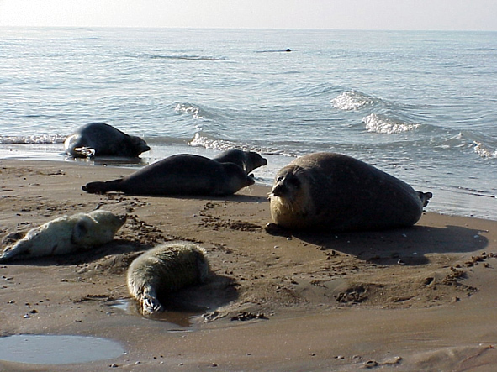
Figure 3.5.11 Seal haul-outs on the Ogurchinskiy Island
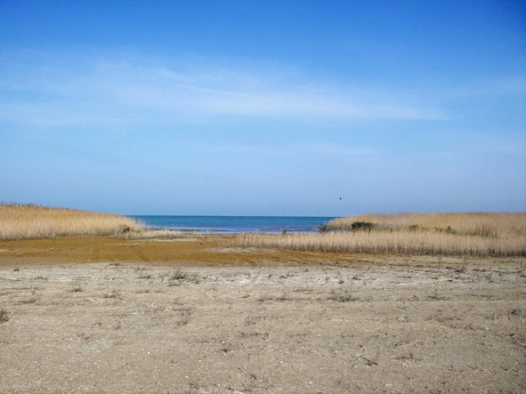
Figure 3.5.12 Reed coast of the North-Cheleken Bay
3.5.12 Turkmenbashinskiy, North-Cheleken, Balkhanskiy and Mikhailovskiy Bays
Sites named above are most important for migration and wintering of birds. Altogether, they form a nucleus of the State Reserve Khazar. The system of bays is included into the list of wetlands protected by Ramsar Convention. The site is comparatively small and is well protected from cold winter winds. The bays have rich and diverse forage resources for numerous birds and fishes. The site is a main wintering place for flamingo (Phoenicopterus roseus), swans (Cygnus cygnus and C. olor), coot (Fulica atra), little grebe (Podiceps ruficolis), white and grey egret (Ardea cinerea and Egretta alba), mallard (Anas platyrhyncha), pochard (Aythia ferina) and many other species of birds. Fattening of many valuable fish species, such as mullet (Liza auratus and L. saliyens) and herring (Alosa kessleri) occurs at the site. Sea level rise in 1979-1995 had a positive effect on environment of the bays. In particular, the square of some bays enlarged in 2.5-5 times and more. Consequently, the shallow water area with rich aquatic vegetation and the wintering capacity of the bays enlarged.
The region, where the site is situated, is one of the most densely populated on the Turkmenian coast. Turkmenbashi with the population of 90.2 thousand (2005) is one of the largest in the republic. It is a transport centre with the largest seaport, a railway station, and an airport. The region is also a centre of oil processing industry. There are also some smaller settlements, among them is Kenar (former Ufra), and several tourist centres (Avaza, Tarta and others). Towns and settlements have a negative effect on the environment. The sea and the coast are polluted with oil products and sewage. Soymonov Bay is strongly polluted with oil products from Turkmenbashi Oil Processing Complex. The complex is under reconstruction with introduction of modern environmentally clean technology, so the degree of pollution is becoming smaller (it is indicated by the development of Charophyta). However, the risk of oil spill is still high. On the suburb territory of the Caspian coast, misguided cattle pasturage is leading to vegetation degradation. Illegal fishing and uncontrolled hunting is widely spread in the region. Thus, the north-western part of Turkmenbashi Bay (with the square of 9 thousand hectares) belongs to the Turkmenbashi Society of Hunters and Anglers. More than 100 thousand of game birds are bagged here during the hunting season (National Report, 2000). Uncontrolled hunting and poaching leads to the loss of bird population and creates unfavourable ecological conditions in the whole region.
In winter of 2005-2006, in connection with bird flu epidemics, bird hunting was banned from December 20. This measure had a positive effect on the number of birds and conditions of their wintering. Strengthening of protection regime is essential for biodiversity conservation of the site.
3.5.13 Kiyanly Bay
Kiyanly Site (see Annex 2, Figure 3.5.14) is situated in 40 km to the north of the previous site and occupies a large bay of the same name. The bay is important for biodiversity conservation because it is well protected from the winds and storms by the rocky spit sometimes rising over the sea surface. There are small thickets of reed in the northern shallow part of the bay. Underwater sediments and diverse aquatic flora create rich forage resources for migrating birds and fishes. The site is the place of mass concentration of waterfowls and shorebirds in migration seasons. It is a wintering place for coot, scaup, tufted duck, grebe, and pochard. Breeding grounds of seals were registered on the stony spit. A small settlement Kiyanly is situated on the coast of the bay. Once there was a fishing collective farm but now it is closed. The economy fell into decay. There are destroyed buildings on the shore. The main activity of unemployed population is illegal fishing. In the southern part of the bay two industrial objects are being constructed – a marine gas terminal and a fish farm. If ecological requirements are followed, these objects will not be dangerous for migration and wintering of birds, fishes, and seals.
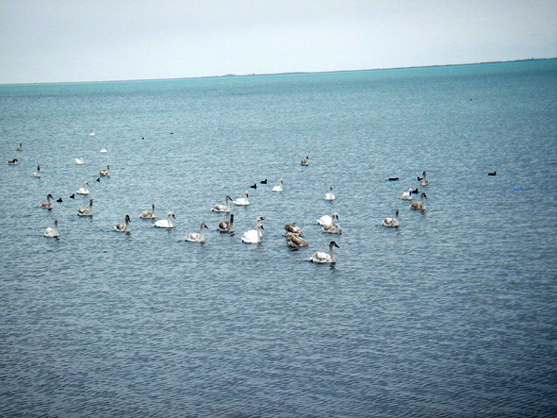
Figure 3.5.13 Swans are calmly feeding this year near the Turkmenbashi City
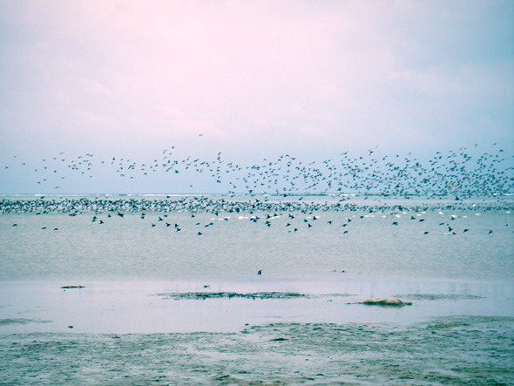
Figure 3.5.14 Wintering birds in the Kiyanly Bay
3.5.14 Species dynamics and main features of human impacts
Flora. Higher aquatic vegetation in the coastal zone of Turkmenistan is represented by several species of vascular plants. Among them is the sea weed (Zostera minor), pond-grass (Potamogeton pectinatis), ruppia (Ruppia spiraeis), naiad (Najas marina) and some others.
Coastal flora is represented by 357 species of higher plants from 185 genera and 35 families. Dominant are the families Asteraceae (65 species, 18% of the total number of species), Chenopodiaceae (48 species, 13%) and Fabaceae (40 species, 11%). Dominant living forms are i grasses which comprise 86% of the total species composition of plants. Shrubs and subshrubs comprise 6%, trees – 0.5% of all species. Thickets of reed are present at some sites of the coast. Natural vegetation of the coast is poor, of semi-desert and desert type. Most common are white saxaul (Haloxylon persicum), cherkez (Salsola richteri), selitryanka (Nitraria komarovii), kandym (Calligonum litvinovii), and sarsazan (Halocnemum strobilaceum).
During the recent years, the square of tugay vegetation in the Atrek flood-land became smaller because of river flow regulation on Iran territory. Two years after the beginning of the sea transgression, in Chikishlyar site population of Charophyte algae sharply decreased in number. It happened because the water area became deeper, insolation became worse, and roughness of the sea increased. However, in recent years, Charophyte algae are spreading towards the mainland shore with suitable depth for their development.
Because of the last transgression of the Caspian Sea, some of the coastal water reservoirs have recovered and restored their biological productivity. The wetland areas became larger in 65% in comparison to 1987. Quick development of macro- and microphyte algae occurred in Balkhanskiy Bay, which became 7 times larger after the Caspian Sea transgression. Blue-green and Charophyte algae intensely developed on the solonchak lowlands in the region of Okarem-Geokpatlauk and Kamyshlydzha.
Among 61 plant species growing on Turkmenian wetlands, 8 species are included in the Red Book. Increasing economic activity puts under threat the fate of the following endangered species included in the Red Book:
- Tiloschistes lacunosus (Avaza environs);
- Salsola chiwensis (northern coast of Kara-Bogaz-Gol);
- S. transhyranica (coast near Turkmenbashi and Khazar);
- Climacoptera chelekenica (coast near Khazar);
- Ammodendron eichwaldii (from Karabogas to Khazar);
- Jurinea karabugasica (coast of Kara-Bogaz-Gol);
- Lasiopogon muscoides (Turkmenbashi environs);
- Phagnalon androssovii (Turkmenbashi environs);
The most important types of human impact over the coastal vegetation are: (1) cattle pasturage, (2) construction of gas and oil pipelines and roads, (3) production of oil and gas, (4) cutting down shrubs, and (5) general pollution of marine environment from the coastal sources. Around the settlements, biodiversity and abundance of plants decreases on 50%. In the regions of oil and gas fields, biodiversity and abundance of plants decrease on 50-60%. According to the approach proposed for assessment of environmental changes (see Section 2.4) such a state of environment corresponds to “bad” (“poor”) quality. Oil field and gas field development lead to the decrease in the vegetation diversity and abundance by 50-60% (the same rank as for previous one).
Fauna of the coastal zone in Turkmenistan is irregularly studied.
The abundance of crustaceans is growing together with the growth of wetland area after the sea transgression. At present, this group has no economic significance.
Insect fauna is poorly studied. Background groups of insects are Odonata, Orthoptera, Homoptera, Coleoptera, Lepidoptera, Neuroptera and Diptera.
Fish fauna is represented by 45 species, among them there are sturgeons (5 species), sprats (3 species), herrings (11 species), salmons (2 species), pike (1 species), carps (8 species), perches (3 species), and gobies (8 species). Only one species represents catfish, Caspian needle-fish, southern stickleback and gambusia.
Endangered species are represented by lamprey (Caspiomyzon wagneri), Volga herring (Alosa kessleri), Caspian brown trout (Salmo trutta caspius), and Caspian inconnu (Stenodus leucichthys leucichthys). These species have always been rare. Caspian brown trout and Caspian inconnu, included in the Red Book, have practically disappeared. Sturgeons and pikeperch are quickly disappearing species. To the south of Turkmenbashinskiy Bay the pikeperch is practically absent, which is connected with oil pollution of the marine environment. The sprat catch has also decreased as well as amount of vobla and sazan. The main reason of this is the absence of water in the Atrek River delta in the spawning period. Additional press on fish abundance is poaching. For some species (salmon, inconnu) decrease in their number is caused by stoppage of fish farms situated on the banks of the Kura and Volga River.
Population of grey mullet at Turkmenian coast is in good condition. In winter, this fish used to concentrate in the southern part of the sea and then migrated in spring and autumn. Now this pattern has changed. During the year, grey mullet distributes along the whole coast and goes far to the north. In recent years, grey mullet migrates from the shallow areas to the deep ones and back. Changes in fish behaviour are probably connected with the end of acclimatization period and stabilization of behaviour stereotypes.
Fish industry in Turkmenistan has declined after disintegration of the USSR. Once the catch of sprat was 450-500 thousand of tons, in 1998 it was only 5 thousand of tons and in 1999 – 8 thousand of tons. Sturgeons comprise only 0.4% of the total catch, herrings – 0.7%. The main reason of the catch fall is ageing and disabling of ships and absence of scientific search for fish shoals.
Illegal fishing is beyond all calculation but according to the available data, it is well developed. In 1999, 20 tons of sturgeons were caught for the quota of research work in Turkmenian sector of the Caspian Sea. The enquiry established that, only in Ashghabad, private traders sell about 300 tons of sturgeons.
Most common among reptiles is aquatic grass snake (Natrix tessellata), which occurs in the North-Cheleken Bay near the water edge.
Among 289 bird species registered on Turkmenian coast, 144 species are not connected with wetlands. Most of them, as well as water birds, are migrant species, which appear on the coast during seasonal migrations, and wintering. Among them, there are such valuable species as great and little bustard. There are also some rare species among settled birds, such as black francolin, pheasant, and chukar. Most important species nesting in the Atrek River flood-lands and requiring protection are marbled teal, white-headed duck, saker falcon, eagle owl, purple gallinule, great black headed gull, Mediterranean gull, Caspian tern, and houbara.
Spring and autumn migrations of birds occur with minor fluctuations that depend mostly on climatic conditions of the year. Autumn migration usually begins in the end of September – beginning of October, migration peak is in the end of October –November, migration end is in December. Spring migration begins in the end of February – beginning of March; migration peak is in March, migration end is in April. The total migration flow on the Turkmenian coast varies from 5 to 8 million of individuals. About 600 thousand of birds stay here for wintering. In summer, reed thickets become nesting places for some migrant birds (ducks, coots, gulls, terns, etc.).
Analysis of long-term abundance dynamics of wintering and migrant waterfowls and shorebirds on the south-eastern coast of the Caspian Sea showed that during 20 years (from 1972 to 1990) the number of birds decreased in 2-2.5 times. Specialists explain this fact by growth of illegal hunting and fishing and possible worsening of ecological conditions in birds’ habitats. Beginning from 1991, there has been registered a slow but continuous growth of wintering and migrant birds’ number. At the same time, the species composition of birds has not changed. The reason of this growth is, probably, improvement of ecological conditions in permanent habitats and growth of wetland area of south-eastern Caspian coast after recent sea transgression.
According the data of Khazar State Reserve the number of wintering birds varies in the following limits:
- Flamingos: 1998 – 22 808, 2001 - 15 928, 2002 - 13 819;
- Swans: 1998 – 1 719, 2001 - 1 033, 2002 – 542;
- Coots: 1998 – 74 240, 2001 – 53 487, 2002 – 51 992.
Increase in number was registered for some species:
- Grebes: 2001 – 5 480, 2002 – 6 884;
- Dabbling ducks: 2001 - 22 402, 2002 – 30 541;
- Waders: 2001 – 27 722, 2002 - 34 766.
Fluctuations in bird’s number strongly depend on their original number in their permanent habitats. For the game birds, these fluctuations depend on their shooting along the migration ways. In the north-western area of Turkmenbashinskiy Bay, about 100 thousands of birds are shot during the game season and on the whole coast – about 280 thousand. These birds are mostly grebes and diving ducks. From 1990 to 1996, the amount of shooting grew in 3.5 times.
Among the species occurring on Turkmenian coast, 43 are rare. Among them, 24 species are included in the Red Book of Turkmenistan. The rest 19 species have decreased in number and become endangered because of human impact. The number of purple gallinule (Porphyrio porphyrio), included in the Red Book, continue decreasing, because of disturbance by people and direct extermination. At the same time, the Red Book species, great black-headed gull, in 2006 increased in its wintering density in 30 times compared to 1984. This is connected with the growth of wetland area and creation of favourable conditions in Balkhanskiy Bay after the sea transgression.
Rare mammals in the Caspian Sea are represented by Caspian seal (Pusa caspica), near water – by common otter (Lutra lutra), and in the desert – by goitered gazelle (Gazella subgutturosa). The number of seals is gradually growing. Every year, about 7-11 thousand of these animals stay at the places of their constant gathering (Ogurchinskiy Island, Osushnoy Island), in North-Cheleken Bay and Krasnovodsk Spit. During the last 6-8 years, hunting seals does not occur in the region and only small number of seals is killed during illegal hunting. Many dead seals were found in March of 2001 on Ogurchinskiy Island. In that year, dead seals were seen all over the coast. The reason of this sudden death of seals is not known yet. One of the possible reasons was warm winter and absence of floating ice in the northern Caspian Sea in winter. Seasonal migration of seals is observed in autumn (to the northern Caspian Sea) and in spring (backwards). In resent years, aggressive behaviour of seals towards people was observed on the beaches near Turkmenbashi and Khazar. Aggressiveness of seals is probably connected with growing disturbance and pollution of their habitats (Lam and Zhdanov Banks – places of oil production)
Otter is occasionally met on the Atrek River banks but its number goes down from year to year.
Goitered gazelle was once registered on Dardzha Peninsula. In 1983, 12 individuals were brought to Ogurchinskiy Island, and by 1997, there number reached 1500. However, in recent years, because of weak protection their number fell to several dozens of individuals. Additional burden for their population is growth of cattle pasturage, degradation of grasslands and illegal hunting.
Porcupine registered in the region of Delili Lake is also included into the Red Book of Turkmenistan.
The most important types of human impact on the animal world of the coast are: (1) changes of biotopes after sea level fluctuations, (2) growth of economic activity, (3) illegal fishing, and illegal (excessive) hunting, (4) intensification of oil and gas production, and (5) general pollution of the environment. Decrease in number of commercial species is connected mostly with excessive hunting.
For the improvement of ecological situation on the Turkmenian coast of the Caspian Sea the principal tasks are the following:
- improvement of social and economic condition of local population;
- conservation of wetlands in the natural condition, as one of the important regulators of water regime in the south-eastern Caspian Sea and as habitats for characteristic flora and fauna, first of all – waterfowls and shorebirds;
- conservation of waterfowls and shorebirds as international and national resource, taking into consideration international routes of birds’ migration;
- prevention and softening of human impact on highly sensitive wetlands;
- intensification of ecological monitoring research.
In future, it is important to pay special attention to the following questions:
- Social and economic conditions of local population, that determine intensification of illegal fishing and illegal hunting birds and mammals;
- Landscape diversity which underlies biological diversity and determine necessity of landscape research in the coastal zone;
- Influence of sea level fluctuations on wetlands (enlarging or diminishing of their square and, consequently, wintering area for birds);
- Growth of oil pollution of marine and terrestrial ecosystems;
- Desertification in coastal zone and marine environment.

