Annex 1
Meetings of the CCSI Project Coordinator and National Project Leaders with the CEP-PCU Managers, Experts, and National Teams
General Meetings
Meeting No. 1 (Inception Meeting; see Figure A-1.1)
Date and time (duration) of meeting: January12-13, 2006 (2 workdays)
Place where the meeting took place: Baku, Azerbaijan Office of CEP
Participants and their position:
Mr. Lev Neretin, CEP-PCU, Biodiversity Ex-Expert
Mr. Bakhtiyar Muradov, CEP–NFP, Azerbaijan
Mr. Ziyafet Kerimov, CEP–NFP, Azerbaijan
Mr. Elchin Iskenderov, CCSI Project Manager, Azerbaijan
Mr. Vladimir Pogrebov, CCSI Regional Coordinator, Russian Federation
Mr. Tofik Hasanov, CCSI National Project Leader, Azerbaijan
Mr. Manaf Suleymanov, CCSI Nature Conservation Expert, Azerbaijan
Ms. Natalie Nazarova, CCSI Information Expert, Azerbaijan
Mr. Omid Sedighi, CCSI National Project Leader, Islamic Republic of Iran
Mr. Vladimir Uvarov, CCSI National Project Leader, Kazakhstan
Mr. Serik Timirkhanov, CCSI Biodiversity Expert, Kazakhstan
Mr. Valery Svetlakov, CCSI Information Expert, Kazakhstan
Mr. Andrew Filippov, CCSI National Project Leader, Russian Federation
Mr. Aman Babayev, CCSI National Project Leader, Turkmenistan
Guests and representatives of other CEP projects
Theme of meeting: CCSI Project implementation.

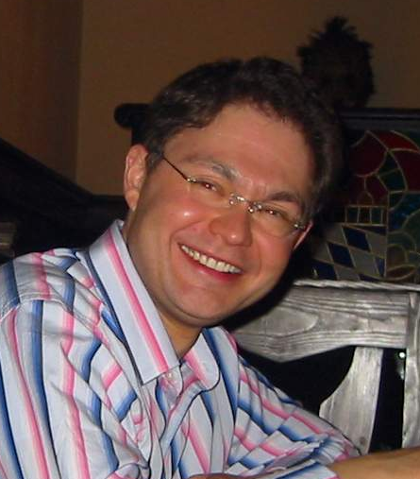 | 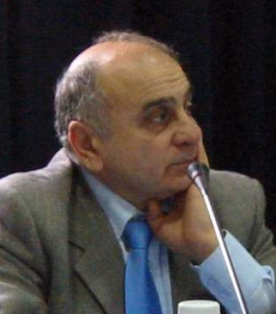 | 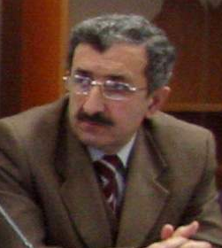 | 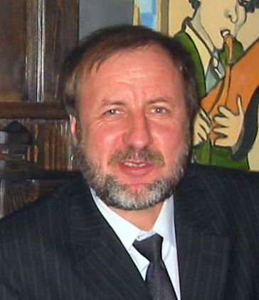
Lev Neretin, CEP | Bakhtiyar Muradov, CEP | Ziyafet Kerimov, CEP | Vladimir Belokopytov, ECS
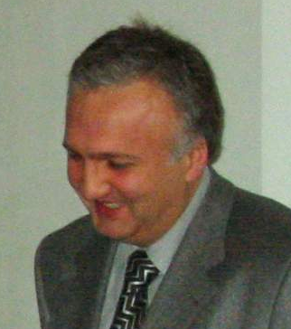 | 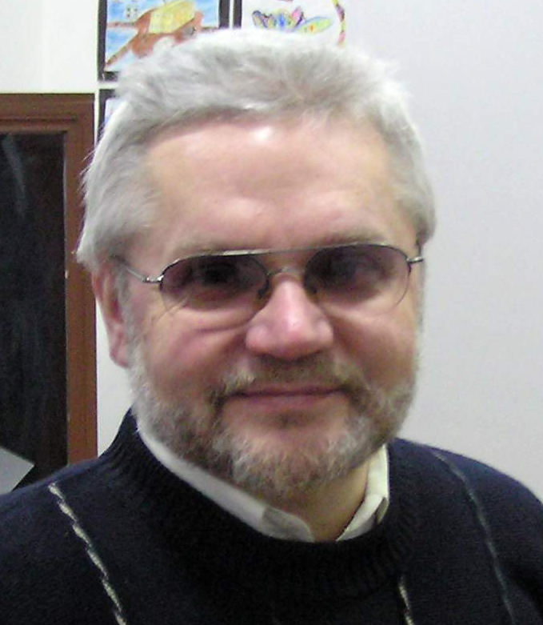 | 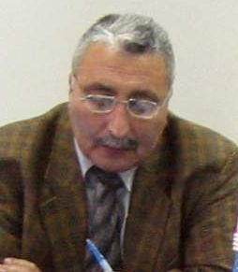 | 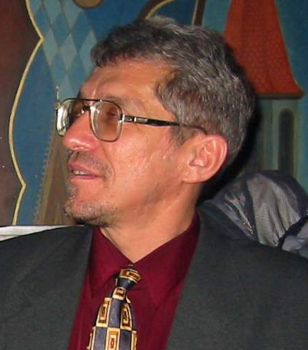
Elchin Iskenderov,  CCSI Project Manager | Vladimir B. Pogrebov,  CCSI Regional Coordinator | Tofik Hasanov,  CCSI National Leader in Azerbaijan | Vladimir Uvarov,  CCSI National Leader in Kazakhstan
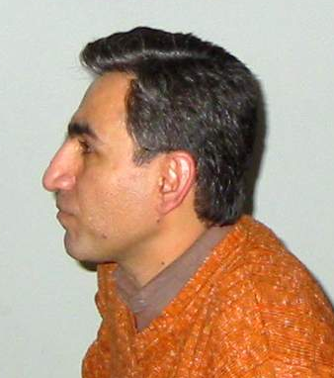 | 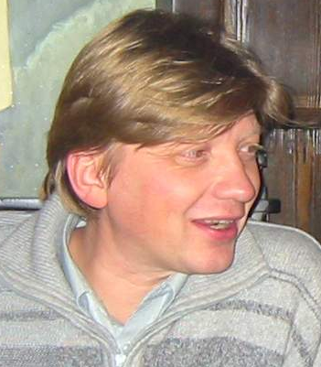 | 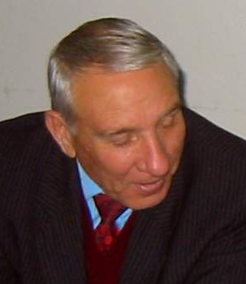 | 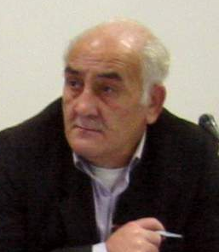
Omid Sedighi,  CCSI National Leader in Iran | Andrey Filippov,  CCSI National Leader in Russia | Aman Babayev,  CCSI National Leader in Turkmenistan | Manaf Suleymanov,  CCSI Azerbaijan Expert
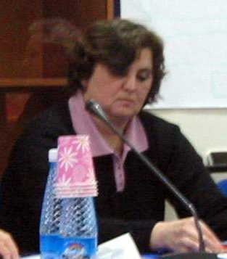 | 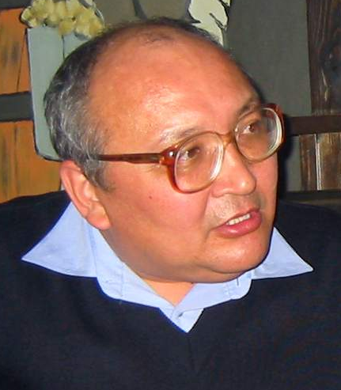 | 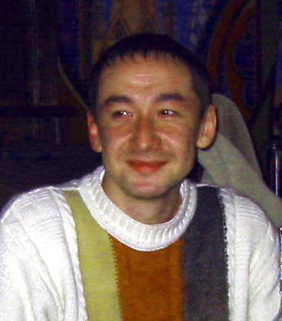 | 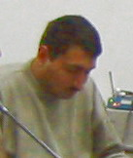
Natalie Nazarova,  CCSI Azerbaijan Expert | Serik Timirkhanov,  CCSI Kazakhstan Expert | Valery Svetlakov,  CCSI Kazakhstan Expert | CCSI Inception Meeting Technical Assistant
Figure A-1.1 Participants of the Inception Meeting (Baku, Azerbaijan, 12-13th January, 2006; see List of Abbreviations in the beginning of the Report)
Meeting No. 2 (within a framework of BISRAG Meeting)
Date and time (duration) of meeting: March 1-2, 2006 (2 workdays)
Place where the meeting took place: Baku, Azerbaijan Office of CEP
Participants and their position:
Mr. Hamidreza Ghaffarzadeh, CEP-PCU, Project Manager
Mr. Volodymyr Myroshnychenko, CEP-PCU, Data and Information Management Expert
Mr. Bakhtiyar Muradov, CEP–NFP, Azerbaijan
Ms. Parvin Farshchi, CEP–NFP, Islamic Republic of Iran
Mr. Serik Akhmetov, CEP–NFP, Kazakhstan
Ms. Tatyana Butylina, CEP–NFP, Russian Federation
Mr. Boris Morozov, CEP–NFP, Russian Federation
Mr. Vladimir Pogrebov, CCSI Regional Coordinator, Russian Federation
Ms. Nina Litvinova, CCSI Biodiversity Expert, Russian Federation
Mr. Manaf Suleymanov, CCSI Nature Conservation Expert, Azerbaijan
Other participants of BISRAG Meeting
Meeting No. 3 (within a framework of “Caspian Biodiversity Information System and Monitoring Training”)
Date and time (duration) of meeting: May 24-25, 2006 (2 workdays)
Place where the meeting took place: Baku, Azerbaijan Office of CEP, Office of ACEP
Participants and their position:
Mr. Hamidreza Ghaffarzadeh, CEP-PCU, Project Manager
Mr. Bakhtiyar Muradov, CEP–NFP, Azerbaijan
Mr. Igor Mitrofanov, CEP-PCU, Biodiversity Expert
Mr. Elchin Iskenderov, CCSI Project Manager, Azerbaijan
Mr. Vladimir Pogrebov, CCSI Regional Coordinator, Russian Federation
Mr. Manaf Suleymanov, CCSI Nature Conservation Expert, Azerbaijan
Ms. Natalie Nazarova, CCSI Information Expert, Azerbaijan
Mr. Omid Sedighi, CCSI National Project Leader, Islamic Republic of Iran
Ms. Maya Vinogradova, CCSI Biodiversity Expert, Kazakhstan
Mr. Andrew Filippov, CCSI National Project Leader, Russian Federation
Mr. Alexander Gorbunov, CCSI Biodiversity Expert, Russian Federation
Mr. Abdulgamid Teimurov, CCSI Biodiversity Expert, Russian Federation
Mr. Aman Babayev, CCSI National Project Leader, Turkmenistan
Other participants of “Caspian Biodiversity Information System and Monitoring Training”
Azerbaijan Republic
Meeting No. 1:
Date and time (duration) of meeting: January 25, 2006 (14:00-17:00)
Place where the meeting took place: Baku, ACEP Office
Participants and their position:
Mr. Elchin Iskenderov, Project Manager, ACEP
Mr. Tofik Hasanov, National Project Leader, ACEP
Mr. Manaf Suleymanov, Team Leader, Nature Conservation Expert, ACEP
Ms. Natalie Nazarova, Information Expert, АСЕР
Mr. Ilyas Babayev, Ornithologist, Institute of Zoology, NAS RA
Ms. Elena Tagiyeva, Botanist, Institute of Geography, NAS RA
Mr. Tavakkul’ Iskenderov, Zoologist, JSC “Zootoxin”
Mr. Aftandil Abbasov, Ichthyologist, Protected Area “Gyzyl-Agach”
Mr. Gadzhiaga Safarov, Biologist, National Park “Girkan”
Mr. Ali Orudjev, Forest Conservation Expert, NGO “Biodiversity Centre”
Theme of meeting: Plans of work on the CCSI Project: Two separate field activities (Ground-Truthing exercises and initiation on a one-year Biodiversity Monitoring Programme)
Islamic Republic of Iran
Meeting No. 1
Date and time of meeting: February 25, 2006 (9:00-14:00)
Place where the meeting took place: Tehran, DOE office
Participants and their position:
Mr. Omid Sedighi, CCSI National Project Leader, Iran
Dr. Parvin Farshchi, CEP–SAPIC, Iran
Dr. Jamshid Mansoori, CCSI Biodiversity Expert (Ornithologist)
Mr. Zahra Alavian, CCSI Biodiversity Expert
Theme of meeting: Sensible areas, objectives, TOR of project, tasks in proposed sites, technical problems, available fund for GT and BMP.
Meeting No. 2
Date and time of meeting: March 7, 2006 (one workday)
Place where the meeting took place: Tehran, DOE office
Participants and their position:
Mr. Omid Sedighi, CCSI National Project Leader, Iran
Dr. S.M.B. Nabavi, (Macrofauna expert), NFP-CEP (Iran)
Mr. Kurosh Kavoosi, CCSI Biodiversity Expert (Botanist)
Mr. Johar Kammi, CCSI Biodiversity Expert (Amphibians and Reptiles)
Mrs. Mehri Moddarres, CCSI Biodiversity Expert
Mr. Jahangir Chaboksavar, CCSI Biodiversity Expert
Mrs. Farnaz Shoaee, CCSI Biodiversity Expert
Mrs. Katayoon Rafitabar, CCSI Biodiversity Expert
Theme of meeting: tasks at proposed sites, technical problems, available fund for GT and BMP, compromising project with available fund, lack of information and gaps. Replacement of Almagol-Agigol-Alagol wetland by Lavandevil wildlife refuge.
Meeting No. 3
Date and time of meeting: April 10, 2006 (one workday)
Place where the meeting took place: Anzali, DOE office
Participants and their position:
Mr. Omid Sedighi, CCSI National Project Leader, Iran
Mr. Kurosh Kavoosi, CCSI Biodiversity Expert (Botanist)
Mr. Johar Kammi, CCSI Biodiversity Expert (Amphibians and Reptiles)
Mrs. Mehri Moddarres, CCSI Biodiversity Expert
Dr. Jamshid Mansoori, CCSI Biodiversity Expert
Mrs. Farnaz Shoaee, CCSI Biodiversity Expert
Mrs. Katayoon Rafitabar, CCSI Biodiversity Expert
Mr. Asan Bagherzadeh, Guilan Local Biodiversity Expert
Mr. Ali Fallah, Guilan Local Biodiversity Expert
Theme of meeting: Technical problems and available funds for GT and BMP. Gaps and lack of data for assessment of species dynamic and degree of threat and human impact. Uniformity of methods in data collection and monitoring. National reporting on GT and content of the Report.
Republic of Kazakhstan
Meeting No. 1
Date and time (duration) of meeting: February 8, 2006 (10:00-12:00)
Place where the meeting took place: Almaty, KAAE Office
Participants and their position:
Mr. Vladimir Uvarov, CCSI National Project Leader, Kazakhstan
Mr. Serik Timirkhanov, CCSI Biodiversity Expert, Kazakhstan
Ms. Maya Vinogradova, CCSI Biodiversity Expert, Kazakhstan
Ms. Oksana Marynych, CCSI Biodiversity Expert, Kazakhstan
Mr. Anatoliy Gistsov, CCSI Biodiversity Expert, Kazakhstan
Theme of meeting: Aim and tasks of studies in Novinskiy Reserve, signing of Contracts with recruited specialists.
Meeting No. 2
Date and time (duration) of meeting: February 15, 2006 (15:00-18:00)
Place where the meeting took place: Aktau, KAAE office
Participants and their position:
Mr. Vladimir Uvarov, CCSI National Project Leader, Kazakhstan
Mr. Rakhat Kozhakmetov, CCSI Biodiversity Expert, Kazakhstan
Mr. Kurish Tasbolatov, CCSI Biodiversity Expert, Kazakhstan
Mr. Kikbay Rzakhanov, CCSI Biodiversity Expert, Kazakhstan
Theme of meeting: Aim and tasks of studies in Komsomolets Bay, Aktau-Buzachi Reserve and Karagiye-Karakol Reserve, signing of Contracts with recruited specialists.
Meeting No. 3
Date and time (duration) of meeting: February 17, 2006 (12:00-13:00)
Place where the meeting took place: Atyrau, KAAE office
Participants and their position:
Mr. Vladimir Uvarov, CCSI National Project Leader, Kazakhstan
Mr. Yuriy Kim, CCSI Biodiversity Expert, Kazakhstan
Local (Atyrau) representatives of KAAE
Theme of meeting: Discussion on national reporting on GT phase of the CCSI Project.
Russian Federation
Meeting No. 1
Date and time (duration) of meeting: February 17-18, 2006 (2 workdays)
Place where the meeting took place: Astrakhan
Participants and their position:
Mr. Andrew Filippov, CCSI National Project Leader, Russian Federation
Ms. Nina Litvinova, CCSI Biodiversity Expert, Russian Federation
Mr. Alexander Gorbunov, CCSI Biodiversity Expert, Russian Federation
Theme of meeting: Sensible areas in Astrakhan region, technical problems, available funds for GT and BMP.
Meeting No. 2
Date and time (duration) of meeting: February 17-18, 2006 (1 workday)
Place where the meeting took place: Moscow
Participants and their position:
Mr. Andrew Filippov, CCSI National Project Leader, Russian Federation
Ms. Tatyana Butylina, CEP–NFP, Russian Federation
Mr. Boris Morozov, CEP–NFP, Russian Federation
Theme of meeting: National Expert appointment, Project budget, Project Coordination.
Meeting No. 3
Date and time (duration) of meeting: March 06-10, 2006 (5 workdays)
Place where the meeting took place: Makhachkala
Participants and their position:
Mr. Andrew Filippov, CCSI National Project Leader, Russian Federation
Mr. Gayirbeg Abdurakhmanov, CCSI Biodiversity Expert, Russian Federation
Mr. Abdulgamid Teimurov, CCSI Biodiversity Expert, Russian Federation
Mr. Gadzhibek Dzhamirzoyev, CCSI Biodiversity Expert, Russian Federation
Theme of meeting: Sensitive Sites in Dagestan, technical problems, available funds for GT and BMP, GT and BMP accomplishment.
Meeting No. 4
Date and time (duration) of meeting: March 12, 2006 (1 workday)
Place where the meeting took place: Astrakhan
Participants and their position:
Mr. Andrew Filippov, CCSI National Project Leader, Russian Federation
Ms. Nina Litvinova, CCSI Biodiversity Expert, Russian Federation
Mr. Alexander Gorbunov, CCSI Biodiversity Expert, Russian Federation
Theme of meeting: Technical problems, available funds for GT and BMP, GT and BMP accomplishment.
Turkmenistan
Meeting No. 1
Date and time (duration) of meeting: January 23, 2006 (15:00-16:00)
Place where the meeting took place: Ashgabat
Participants and their position:
Mr. P. Esenov, Director of National Institute for Deserts, Flora and Fauna, Turkmenistan
Mr. J. Saparmuradov, National Coordinator for Biodiversity Convention, Turkmenistan
Ms. G. Orazdurdyeva, CEP/SPD Coordinator, Turkmenistan
Mr. Aman Babayev, CCSI National Project Leader, Turkmenistan
Theme of meeting: Aim and tasks of the CCSI, Project Coordination.
Meeting No. 2
Date and time (duration) of meeting: February 17, 2006 (15:00-18:00)
Place where the meeting took place: Turkmenbashi City
Participants and their position:
Mr. Aman Babayev, CCSI National Project Leader, Turkmenistan
Mr. B. Bairammamedov Head of the Caspian Ecological Control, Turkmenistan
Mr. Yu. Gurbantuvakov, Director of Khazar Reserve, Turkmenistan
Mr. B. Berdiev, Deputy Director of Khazar Reserve, Turkmenistan
Ms. S. Zakaryaeva, Senior Researcher of Khazar Reserve, Turkmenistan
Theme of meeting: Aim and tasks of the CCSI, Sensitive Sites, expert appointment, technical problems, GT and BMP carrying out.
Meeting No. 3
Date and time (duration) of meeting: March 09, 2006 (11:00-13:00)
Place where the meeting took place: Ashgabat
Participants and their position:
Mr. Aman Babayev, CCSI National Project Leader, Turkmenistan
Mr. E. Rustamov, CCSI Biodiversity Expert, Turkmenistan
Mr. T. Berkeliev, CCSI Biodiversity Expert, Turkmenistan
Mr. K. Atayev, Ornithologist, Turkmenistan
Mr. B. Ivakhov, CCSI Information Expert, Turkmenistan
Theme of meeting: Aim and tasks of the CCSI, Sensitive Sites, technical problems, GT and BMP carrying out, mapping.
Meeting No. 4
Date and time (duration) of meeting: March 15, 2006 (15:00-18:00)
Place where the meeting took place: Ashgabat
Participants and their position:
Mr. V.Glazovskiy, Head of Department, Ministry for Nature Protection (MNP) of Turkmenistan, CCSI Information Expert, Turkmenistan
Mr. Aman Babayev, CCSI National Project Leader, Turkmenistan
Theme of meeting: Discussion on Sensitive Sites, their approval by MNP
Meeting No. 5
Date and time (duration) of meeting: April 19, 2006 (1 workday)
Place where the meeting took place: Turkmenbashy City
Participants and their position:
Mr. Aman Babayev, CCSI National Project Leader, Turkmenistan
Mr. Yu. Gurbantuvakov, Director of Khazar Reserve, Turkmenistan
Mr. B. Berdiev, Deputy Director of Khazar Reserve, Turkmenistan
Ms. S. Zakaryaeva, Senior Researcher of Khazar Reserve, Turkmenistan
Mr. V. Gayzer, Ornithologist, Turkmenistan
Mr. A. Sherbina, Ecologist, Turkmenistan
Theme of meeting: Expert appointment, BMP, fieldwork, technical problems.

