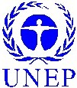
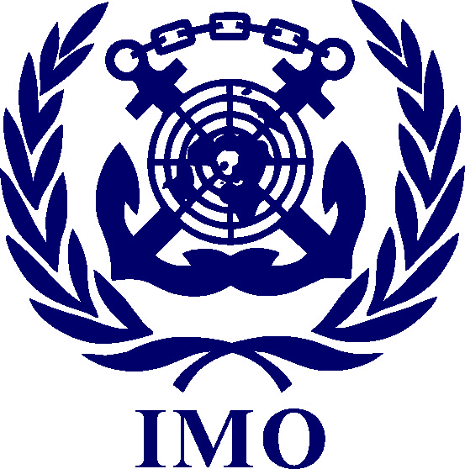

FINAL PROGRAMME
2006 IMO/UNEP Forum on Regional Co-operation in Combating Marine Pollution
2 - 5 May 2006, IMO Headquarters, London

 |  | Tuesday – 2 May 2006
 | Opening Session
09.00-09.30 |  | Opening remarks by IMO  Jean-Claude Sainlos, Director, Marine Environment Division, IMO
 |  | David Edwards, Director, Technical Co-operation Division, IMO
09.30-10.00 |  | Regional Co-operation for the response to marine pollution incidents  Miguel Palomares, IMO
10.00-10.30 |  | The new strategy of the Regional Seas Programme  Ellik Adler, UNEP
10.30-11.00 |  | Coffee/Tea
11.00-11.30 |  | Role of industry  Rob Cox, International Petroleum Industry Environmental Conservation Association (IPIECA)
11.30-12.00 |  | National-level perspectives on regional co-operation  Klaus Essig, Venezuela
 | Frameworks and Instruments for Co-operation
12.00-12.30 |  | The OPRC Convention as a basis for regional co-operation in response to marine oil spills  Patricia Charlebois, IMO
12.30-14.00 |  | Lunch
14.00-14.30 |  |  | IMO/UNEP MAP cooperation for achieving sustainable development in the Mediterranean sea and coastal areas  Paul Mifsud, Mediterranean Action Plan (MAP)
14.30-15.00 |  |  | Caspian initiative on Oil Spills Response Protocol  Hamidreza Ghaffarzadeh, Caspian Action Plan (CAP)
15.00-15.30 |  |  | New protocols and equipment register for SPREP region  Sefanaia Nawadra, South Pacific Regional Environment Programme (SPREP )
15.30-16.00 |  |  | Break out session – Requirements for creating and sustaining strong regional  co-operation
16.00-16.30 |  |  | Coffee/Tea
16.30-17.30 |  |  | Break out session – cont’d
17.30-18.00 |  |  | Reports from Groups
18.00 |  |  | End of Session

 |  | Wednesday – 3 May 2006
 | Frameworks and Instruments for Co-operation cont’d
09.00-9.30 |  | Oil spill contingency plan of South Asia  Arvind Boaz, South Asian Seas Environment Programme
09.30-10.00 |  | Addressing environmental challenges of shipping - Baltic experience  Tadas Navickas, Helsinki Commission (HELCOM)
10.00-10.30 |  | PEMSEA and the Implementation of the Sustainable Development Strategy of the Seas of East Asia  James Paw, IMO
 | Regional Activity Centres – Advantages and Challenges
10.30-11.00 |  | Coffee/Tea
11.00-11.30 |  | MERRAC's Activities and New Directions  KANG Chang-Gu, Marine Environmental Emergency Preparedness and Response Regional Activity Center of the Northwest Pacific Action Plan (NOWPAP MERRAC)
11.30-12.00 |  | REMPEITC and the Caribbean region  Brian Peter, Regional Marine Pollution Emergency, Information and Training Centre of the Wider Caribbean Sea (RAC/REMPEITC-Carib)
12.00-12.30 |  | From preparedness and response to prevention: the Mediterranean strategy as a tool for achieving sustainable development  Frédéric Hébert, Regional Marine Pollution Emergency Response Centre for the Mediterranean Sea (REMPEC)
12.30-14.00 |  | Lunch
14.00-14.30 |  | Introduction to the new Marine Emergency Mutual Aid Centre for the Red Sea and Gulf of Aden  Ziad H.Abu Ghararah, Regional Organisation for the Conservation of the Environment of the Red Sea and Gulf of Aden (PERSGA)
 | Response and Co-operation: Case Studies
14.30-15.15 |  | The importance of regional co-operation in responding to the Prestige incident  Francisco Alonso, Technical Counsellor to the Spanish Maritime Directorate
15.15-16.00 |  | Break out session – Structures and platforms for the implementation of regional co-operation
16.00-16.30 |  | Coffee/Tea
16.30-17.30 |  | Break out session – cont’d
17.30 |  | Reports from Groups
18.00 |  | End of Session

 |  | Thursday – 4 May 2006
 | Emerging Topics & New Challenges
09.00-9.30 |  | Results of the work undertaken to digitise global tanker routes  Colleen O’Hagan, International Tanker Owners Pollution Federation Ltd. (ITOPF)
09.30-10.00 |  | Economic instruments, sustainable financing and ecosystem valuation for the protection of the marine environment  Ulrik Weuder, UNEP
10.00-10.30 |  | HNS: A new challenge  Patricia Charlebois, IMO
10.30-11.00 |  | Coffee/Tea
11.00-11.30 |  | International regime for nuclear/radiological emergencies including incidents in ports and at sea  Carlos Nogueira de Oliveira, International Atomic Energy Agency (IAEA)
11.30-12.00 |  | EMSA role in the field of marine pollution preparedness and response  Fionn Molloy, European Maritime Safety Agency (EMSA)
12.00-12.30 |  | The West and Central Africa (WACAF) Global Initiative Project  Richard Santner, Oil Spill Response Limited (OSRL)
12.30-14.30 |  | Lunch
14.30-15.00 |  | Compensation and Liability - recent developments  Joe Nichols, International Oil Pollution Compensation Funds (IOPC)
 | Other topics
15.00-15.30 |  | UNEP’s Global Initiative on Marine Litter  Ellik Adler, UNEP
15.30-16.00 |  | London Convention 1972/1996 Protocol: Achievements and Value for Marine Pollution Prevention and Management  Rene Coenen, IMO
16.00-16.30 |  | Coffee/Tea
16.30-17.00 |  | Prevention of pollution from leisure crafts  Lilia Khodjet el Khil, REMPEC
17.00-17.30 |  | Summary of results
17.30 |  | End of session

 |  | Friday – 5 May 2006
 | Other topics cont’d
09.00-09.30 |  | Invasive species and ballast water
- Perspectives on Marine Invasive Species
Sean Murphy, Global Invasive Species Programme (GISP)

09.30-10.00 |  | - The Globallast Progamme  Jose Matheickal, IMO
10.00-10.30 |  | Discussion
10.30-11.00 |  | Coffee/Tea
11.00-12.00 |  | Conclusions & Recommendations
12.00-12.30 |  | Closing Remarks
13.00 |  | End of forum

_________________

