Chronic Disease Prevention & Control in the Americas

Monthly Newsletter of the PAHO/WHO Chronic Disease Program
Pan American Health Organization
Regional Office of the World Health Organization
Vol. 1, No. 8, August 2007

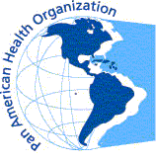
Editors: James Hospedales Copy Editor: Donna Eberwine Production Staff: Pilar Fano, Enrique Pérez-Flores, Maria Pico, Suzanna Stephens

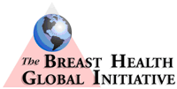
Regional Developments
Breat Cancer Guidelines Now Available in Spanish
BHGI, PAHO Partnership Advances Global Dissemination of Clinical Guidelines for Low- and Middle-Income Countries
The Breast Health Global Initiative’s (BHGI) Guidelines for International Breast Health and Cancer Control are now available in Spanish through a collaboration with the Pan American Health Organization’s (PAHO) Noncommunicable Disease Unit. PAHO’s sponsorship of the translation of the guidelines has made the BHGI evidence-based “best practices with limited resources” freely available for downloading via their websites.

The Spanish publication presents an overview of the guidelines first published in English in 2006 and addresses the issues of early detection and access to care, diagnosis and pathology, treatment and allocation of resources, and health systems and public policy to effectively combat the burden of breast cancer in low-and middle-income countries.

Translation of the Guidelines for International Breast Health and Cancer Control into the world’s major languages is a long-standing goal of BHGI, and future plans include translation into Russian, Chinese, and Arabic. The partnership with PAHO grew out of discussion at the International Union Against Cancer Conference in Washington in July 2006.


“The availability of these guidelines in Spanish is a major leap forward in reaching ministries of health, health care providers, and policymakers in Spanish-speaking countries,” said Dr. Benjamin O. Anderson, chairman and director of BHGI. “We are tremendously grateful to PAHO for their partnership in this endeavor to improve breast health and cancer treatment for medically underserved Spanish-speaking countries around the world.”
Contents
- Regional Developments 1
  - Breast Cancer Guidelines Now Available in Spanish 1
- Progress in the Countries 2
  - Policy Recommendations on Tobacco Control for CARICOM Countries 2
  - USA: New Guidelines for Physical Activity 6
  - Trinidad and Tobago NCD Programs 6
  - Follow-Up on Nicaragua Meetings 6
- Upcoming Events
  - CARICOM Summit on CNCDs 7
  - Call for Abstracts, Biennial CARMEN Meeting 7

“Breast cancer is a growing problem in Latin America, with some 90,000 cases reported every year, many of them at advanced stages because of poor access to preventive and curative services,” said PAHO Director, Dr. Mirta Roses. “The availability of these guidelines in Spanish will be an important contribution for those interested in expanding health services to reach Latin American women early and to improve their quality of life.”

Breast cancer is newly diagnosed in more than 1 million women each year and is the most common cause of cancer-related deaths among women worldwide. Women in low-and middle-income countries are more likely to die of the disease than women in richer countries, in part because their cancers are commonly detected and treated in advanced stages, when treatment is more expensive and least successful.

Major scientific advances in detection and management of breast cancer have improved outcomes in developed countries, but health care providers in low- and middle-income countries face resource constraints that limit their ability to apply these advances to improve breast cancer care. The Guidelines

for International Breast Health and Cancer Control address this problem by recommending the most appropriate and applicable “best practices” for countries with limited resources.

The guidelines recommend a stepwise system of resource allocation on four levels—basic, limited, enhanced and maximal—depending on the availability of resources. In the areas of detection and access to care, for example, they recommend that countries with very basic health systems educate women about performing breast self-examination to detect lumps. For countries with more but still limited resources, they recommend targeted outreach and education on clinical breast examination to women in at-risk groups, followed by ultrasound or mammography to confirm the discovery of suspected lumps.

The guidelines call for additional research to assess how these recommendations can be best implemented in limited-resource settings.

The BHGI is an international alliance of organizations and individuals around the world devoted to medically underserved women sponsored by the Fred Hutchinson Cancer Research Center and Susan G. Komen for the Cure.

Source: Leslie Sullivan, Senior Program Manager, Public Health Sciences Division of the The Breast Health Global Initiative (BHGI) at the Fred Hutchinson Cancer Research Center.

Progress in the Countries
PAHO Advises CARICOM on FCTC
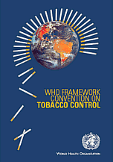
PAHO is supporting the WHO Framework Convention on Tobacco Control (WHO FCTC) by promoting and monitoring compliance among member states in Latin America and the Caribbean. As part of this work, PAHO's tobacco control team has developed policy recommendations for Caribbean Community (CARICOM) countries to help Parties advance toward full compliance and non-parties to consider implementing policies concordant with the treaty provisions. The recommendations, which will be shared at a Sept. 14 meeting of Caribbean heads of state in Trinidad and Tobago, are presented below, along with data on FCTC status and tobacco use in CARICOM countries.
PAHO Policy Recommendations on Tobacco Control for CARICOM Countries
1. Enact national legislation to comply with the provisions of the WHO FCTC for CARICOM members that are Parties to WHO FCTC and consequently are required to move forward on implementing the WHO FCTC mandates (see Table 1 for specific mandates and implementation deadlines).

2. Ratify the WHO FCTC for CARICOM Member States that have not ratified it. Signature indicates a good-faith intention by the country to ratify the convention and a political commitment not to undermine the objectives of the treaty, but it does not bind countries to the obligations of the WHO FCTC. Should ratification not be a feasible goal within the political context of a country, the WHO FCTC should be used as a roadmap for implementing effective tobacco control measures based on scientific evidence. (see Table 1 for CARICOM countries pending ratification)

3. Adopt policies, including passing of legislation, on protection from exposure to tobacco smoke (ETS) through the creation of 100% Smoke Free-Environments. ETS among children is unacceptably high in all CARICOM countries, especially in public places (ranging from 35%–65%) (Graph 1; all graphs are PowerPoint objects and can be viewed by clicking on them). The only way to provide protection from second-hand smoke (SHS) is to make all indoor environments (and in some cases, outdoor environments) 100% smoke-free. Shared smoking and non-smoking areas, or smoking rooms in buildings with a common ventilation system, contaminate clean air with polluted air. These policies are usually proposed by the tobacco industry.

4. Enact legislation on tobacco product packaging and labeling, specifically banning the use of misleading and false terms such as “low tar,” “light,” “ultra-light” or “mild” and approving large, clear and visible health warnings that cover 50% or more of the principal display area (see example from Brazil on next page). Health warnings are very effective in providing information to the public. For the eight WHO FCTC Parties in CARICOM, the deadline for implementing this measure is three years after the Convention’s entry into force date in the correspondent country (Table 1).

Table 1: WHO FCTC Ratification Status in CARICOM

Country |  | WHO FCTC Ratification Status |  | Has the Party approved appropriate legislation on health warnings complying with Art 11 of the WHO FCTC?  (Date indicates either deadline for Party to pass legislation or date legislation was passed complying with Art 11) |  | Has the Party approved appropriate legislation on banning direct and indirect advertising complying with Art 13 of the WHO FCTC?  (Date indicates either deadline for Party to pass legislation or date legislation was passed complying with Art 13) |  | Is there legislation in place in the Party banning smoking in health and educational facilities?  (Date corresponds to when legislation was passed)
- Trinidad & Tobago | Ratified |  | No, 27 Feb 2008 |  | No, 27 Feb 2010 |  | No
- Jamaica | Ratified |  | No, 05 Oct 2008 |  | No, 05 Oct 2010 |  | Not available
- Guyana | Ratified |  | No, 14 Dec 2008 |  | No, 14 Dec 2010 |  | No
- Barbados | Ratified |  | No, 01 Feb 2009 |  | No, 01 Feb 2011 |  | Not available
- Saint Lucia | Ratified |  | No, 05 Feb 2009 |  | No, 05 Feb 2011 |  | Not available
- Belize | Ratified |  | No, 15 Mar 2009 |  | No, 15 Mar 2011 |  | No
- Antigua & Barbuda | Ratified |  | No, 03 Sep 2009 |  | No, 03 Sep 2011 |  | Not available
- Dominica | Ratified |  | No, 22 Oct 2009 |  | No, 22 Oct 2011 |  | Not available
- Grenada | Ratified |  | No, 14 Nov 2010 |  | No, 14 Nov 2012 |  | Not available
- Bahamas | Signed but not yet ratified |  | -- |  | -- |  | --
- Haiti | Signed but not yet ratified |  | -- |  | -- |  | --
- Saint Kitts & Nevis | Signed but not yet ratified |  | -- |  | -- |  | --
- Saint Vincent & the Grenadines | Signed but not yet ratified |  | -- |  | -- |  | --
- Suriname | Have not ratified |  | -- |  | -- |  | --
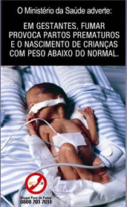

5. Adopt a comprehensive ban of all tobacco advertising, promotion and sponsorship. Exposure to tobacco advertising on billboards in CARICOM countries ranges between 50% and 85% (Graph 2). In addition, a high percentage of children (around 10%) have been offered free cigarette samples by tobacco industry representatives. For the eight WHO FCTC Parties in CARICOM, the deadline for implementing this measure is five years after the Convention’s entry into force for the corresponding country (Table 1).

6. Increase tobacco taxes and prices recognizing that price and tax measures are an effective means to reduce tobacco consumption by various segments of the population, in particular young persons. Tobacco taxes in Latin America and the Caribbean account for approximately 50% of the price; while in countries where tobacco taxes are part of comprehensive tobacco control measures, this percentage accounts for about 75% (see graph p. 5).

7. Monitor the tobacco industry. While developing and implementing tobacco control policies, countries shall act to protect these policies from commercial and other direct and indirect interests of the tobacco industry, including tobacco industry front groups. This includes, but is not limited to, protecting tobacco control policies against industry-funded youth smoking programs and industry-
proposed ventilation systems, and monitoring the lobbying and advocacy efforts of the tobacco industry and front groups.

8. Establish a surveillance system for monitoring the tobacco epidemic at the country level. There is little comparable information on adult smoking prevalence in CARICOM countries (see Graph 3). Countries should establish and maintain a national system for epidemiological surveillance of tobacco consumption and related social, economic and health indicators.
- Available data show that smoking prevalence is higher among men than women and
that there was no significant change in smoking prevalence between 2002 and 2005.
- For the youth population, data show that smoking prevalence is relatively high, taking into account the age of the group in the survey (13–15 years) (Graph 4) and that children at this age are susceptible to taking up smoking. Efforts by the tobacco industry to target children through tobacco advertising and promotion must be countered to prevent smoking prevalence from rising.

9. Establish or reinforce a national program for tobacco control and an intergovernmental national coordinating mechanism with the participation of key decision-makers. Most CARICOM countries do not have tobacco control programs within their ministries of health. As a first goal, designation of a public official as a tobacco control focal point at each ministry of health is recommended. As a second goal, because of the multisectoral characteristics of tobacco control, members of an intergovernmental commission should be identified and convoked officially.

Source: Vera Luiza da Costa e Silva, Kerstin Schotte, Adriana Blanco, Rosa Sandoval and Erika Tang, PAHO Regional Program on Tobacco Control and Consumers’ Health.

USA: New Guidelines for Physical Activity
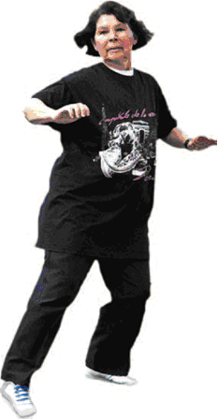
The American College of Sports Medicine (ACSM) and the American Heart Association (AHA) released their first guidelines for physical activity in adults in August.

According to the new guidelines, all healthy adults ages 18–65 years need to engage in moderately intensive aerobic physical activity for at least 30 minutes five days a week or vigorous aerobic physical activity for at least 20 minutes three days each week.

Further, adults will benefit from performing activities that maintain or increase muscular strength and endurance at least two days each week. The guidelines recommend that adults perform 8–10 exercises using the major muscle groups on two non-consecutive days each week. To maximize strength development, a resistance (weight) should be used for 8–12 repetitions of each exercise resulting in willful fatigue.

The prevention-oriented recommendations emphasize how adults, by engaging in regular physical activity, can promote and maintain health and reduce their risk of chronic disease and premature death.

A companion set of recommendations is also provided for adults ages 65 and older and adults ages 50-64 with chronic conditions or physical functional limitations (e.g. arthritis) that affect movement ability or physical fitness.

Source: Excerpts from press release on the ACSM website.
Trinidad and Tobago NCD Programs
For the Biannual Meeting of the CARMEN Network scheduled to take place in November in Port-of-Spain, Trinidad, PAHO has received the following three abstracts of presentations, which provide useful information on national activities to prevent and control chronic disease:
- National Plan for Risk Factor Reduction in NCD Prevention and Control
- Diabetic Foot Care Management Programme in County St. George Central
- Wellness Programme for Risk Factor Reduction in NCD Prevention and Control.

Follow-Up on Nicaragua Meetings
I. Consultation for the National Plan
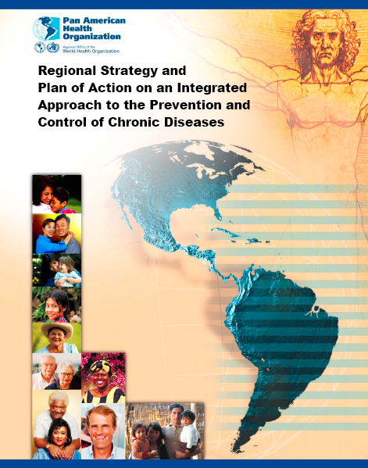
Last month’s newsletter covered the national consultation of PAHO and Nicaraguan authorities to implement the plan of execution for the four lines of action of the Regional Strategy on an Integrated Approach to the Prevention and Control of Chronic Diseases Including Diet, Physical Activity, and Health. Participants in the consultation identified priorities for continued collaboration with PAHO in the area of chronic noncommunicable diseases. A more detailed description of the meeting, the agenda, and all PowerPoint presentations can now be viewed on the meeting website.
II. CAMDI: First Learning Session, 3–4 July 2007
Last month’s issue covered the second stage of development of the Central American Diabetes Initiative (CAMDI) to improve care for people with diabetes, by applying the Breakthrough Series Methodology. A more detailed description, the agenda, plus all presentations can now be found on the meeting website.

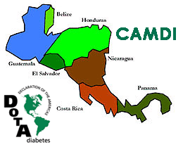
Upcoming Events
CARICOM Summit on CNCDs
The Caribbean Community (CARICOM) will hold its Regional Summit on CNCDs in Port-of-Spain, Trinidad, on 15 September 2007. The theme will be
“Uniting against Noncommunicable Diseases—Stop the Epidemic.”
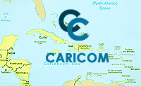
Objectives
- Establish and agree on a regional approach to the prevention and control of noncommunicable diseases and, in this regard, evaluate the Caribbean situation within the global context;
- Examine the burden of the main diseases and the evidence for the application of interventions; and
- Propose solutions at the level of the health sector and examine those with major policy implications that fall within the purview of Heads of Government.
Expected Results
- A clear appreciation of the real and present problems posed by noncommunicable diseases in the Caribbean in terms of health and development.
- A clear understanding of the modifiable risk factors for the noncommunicable diseases that can be addressed in the current environment.
- Information on the interventions that can be taken to modify those risk factors.
- An understanding of the insufficiency of the measures usually taken to modify individual behavior and a real appreciation of the policy decisions that lie uniquely at the level of Heads
of Government, which need to be taken to address the problem through application of those interventions and change of the enabling environment.
The PAHO/WHO Chronic Disease Program invites the readers of this newsletter to submit contributions of interest for the Americas. Send contributions (1–3 paragraphs) to Dr. James Hospedales (hospedaj@paho.org) with copy to Pilar Fano (fanopili@paho.org) and Suzanna Stephens (stephens@paho.org). Your feedback on this newsletter would be appreciated. Instructions and criteria can be found on the homepage for this newsletter at the web link below:
- Collective decisions on steps to be taken and monitoring mechanisms necessary for follow up.
Immediately following the conclusion of the summit, a Town Hall Meeting will be held by the summit’s Steering Committee, to facilitate an engagement of Heads of Government with a wide cross-section of stakeholders across the Caribbean Region and internationally. This meeting will be facilitated through simulcast. In addition, ministries of health are preparing national posters outlining country situations and interventions, which will be displayed at the summit venue.

There will also be a number of regional and international partner institutions and donors attending the summit, with the hope of fostering meaningful collaboration in the follow-up activities to this event.

Source: CARICOM Savingram No. 596/2007.

Call for Abstracts, Biennial CARMEN Meeting
The CARMEN Network for the Integrated Prevention and Control of Noncommunicable Disease in the Americas will hold its biennial meeting in Port-of-Spain, Trinidad and Tobago, from 4 to 8 November 2007. The theme is Sharing, Learning, Imagining, Planning and Partnering to Implement the Chronic Disease Regional Strategy within the CARMEN Network. Following a closed session on 4 November for CARMEN members, the other days will be devoted to the areas of policy & advocacy, surveillance & research, health promotion & disease prevention, and integrated management of diseases and their risk factors. To submit abstracts, see the guidelines (deadline: 27 September). For more information and documentation, see the conference page.

