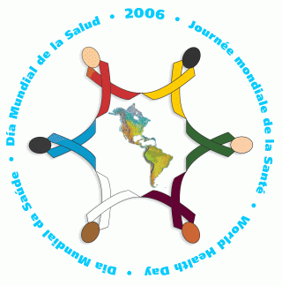
World Health Day
7 April 2006
Celebrate Our
Health Workers in
the Americas!

This year, WHO’s Annual World Health Day will honor Health Workers – the most important resources that we have for our health.

The Region of the Americas will hold activities on World Health Day (7 April) and throughout that week (April 3-7) to celebrate health workers across the Americas. Each country will honor selected teams of Everyday Heroes in health who have demonstrated exceptional efforts and outreach in their service to others.

This year is particularly important for the Americas as we hope to promote a Decade for Human Resources in Health. During the next 10 years, we urge governments and stakeholders to make human resource development a priority in the health strategies, and to commit political will, intervention activities and financial resources to provide what our health workers need most:
Academic Education
Professional Training
Fair Compensation
Safe and Healthy Working Conditions
Supportive Policies
Join us during in pledging our commitment to protect and care for this precious resource – as they work every day to protect and care for us.

