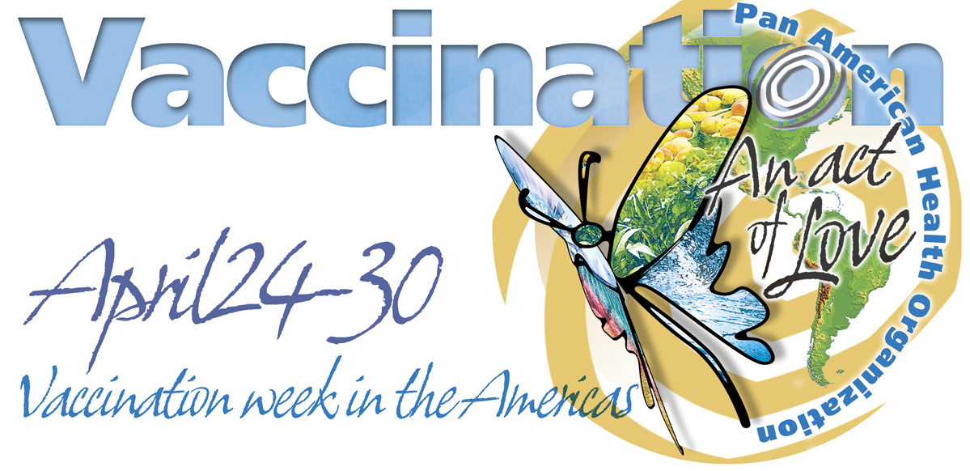

_____________________________________________________________

Communications and Advocacy Plan

Vaccination Week in the Americas 2004

Country Focus

Prepared by the Area of Public Information

Pan American Health Organization (PAHO)

Updated April 1, 2004

I:\2004VaccinationWeek\engmediaproposal.doc

Executive Summary

All the countries in the Americas have committed to Vaccination Week in the Americas, set for April 24-30, 2004. This will be a week in which all the countries will work together to immunize mostly children, concentrating on those in hard-to-reach urban areas, isolated border communities, and areas with low coverage. The goals are to reach all those children who typically are left behind and those who have not been vaccinated with the full complement of vaccines.

Enthusiasm is high because of the success of the 2003 vaccination week, evaluated as an effective communications campaign in which 95 percent of people surveyed heard about the vaccinations through television or radio, even in remote border areas. In 2003, 19 countries took part, which resulted in some 14 million immunizations. Several of the countries also immunized women of childbearing age. The outstanding results stemmed from the political commitment by the countries, interagency coordination, social mobilization and the technical support from Pan American Health Organization (PAHO), UNICEF, the CDC, International Federation of Red Cross and Red Crescent Societies, and others.

PAHO is coordinating the 2004 activities with all the countries in the region for the first-ever Vaccination Week in the Americas in which all 35 nations will participate. Preliminary figures indicate that some 40 million people will receive vaccinations, while tens of thousands more in the United States and Canada will benefit from public awareness campaigns about immunizations. The challenge this year is the same as the one outlined last year by Dr. Mirta Roses Periago, PAHO’s director, who said each country should set its own goals, reaching out to the most vulnerable, the most isolated. The Vaccination Week in the Americas is an unprecedented show of Pan Americanism that should be seen not as “another campaign” but rather as “another opportunity” to promote the importance of routine vaccinations.

To ensure the success of this and future vaccination efforts, strong communication components are needed to spread the word on the vaccination drive, building on the success of the 2003 week and laying the foundation for stronger ongoing and routine immunization programs.

Target Audiences and Activities
To inform as many people as possible about vaccination opportunities in April, the plan’s primary target audiences in North and South America and the Caribbean are:

Print and television journalists and media owners as the gateway to all our important audiences: mothers, fathers and children, indigenous and community leaders, government officials (mayors, ministers of health, social services, etc.), religious leaders, and the general public.

Suggested activities at the national level could include the following:

- Media Briefings: National health officials, with support from PAHO, UNICEF, and others, will bring together journalists to disseminate information about the April Vaccination Week and about immunization in general. These briefings will run from February through April. Each country should secure high-level participation at launches and activities.

- Social Marketing Campaign: a marketing outreach campaign starting in February-March and running through May 2004, designed to raise awareness of the importance of vaccination and Vaccination Week, targeted to all audiences. This will include public service announcements, posters, stickers, and news releases. Special “Champions of Health” will share the message. PAHO and UNICEF will utilize all its country offices and the communicators in those offices to promote and advocate for community and official participation.

- Mayor’s Initiative: National health officials, with support from PAHO, will make special efforts to provide mayors with practical information that will help them support vaccination programs for their municipalities. Activities could include special material for mayors, a best practices document, and mayoral visits to vaccination programs. In the United States, the CDC will prepare a special proclamation for communities in the U.S.

- Religious Initiative: Outreach to prominent religious leaders from different denominations to explain vaccination strategies.

- Business Leaders Outreach: Special efforts directed at prominent business leaders, entrepreneurs, philanthropists, and others to explain vaccination strategies and solicit their support.

- Community Workshops: community workshops targeted to residents to address importance of vaccination.

Evaluation
Specific measurement criteria used to evaluate progress could include:

- Increase in general public awareness levels of the need for vaccination
- Number of government leaders initiating new vaccination measures
- Number of vaccination messages incorporated in mass media
- Total number of people reached with messages through all outreach activities
- Total number of people within each target audience reached (mayors, business leaders, etc.)
- Quality of materials and activities
- Volume and type of hits on web site

Communications/public relations campaign and targeted materials

Purpose and Objectives

Overall goals of the Vaccination Week in the Americas
  - Communication of immunization benefits
  - Immunization delivery

Purpose
- Target isolated and difficult to reach groups
- Promote equity and access to vaccination
- Consolidate measles eradication efforts
- Continue Rubella elimination plan
- Encourage communication and cooperation
- Promote Pan Americanism

Goals
- To have all countries in the Americas participate
- To be the first measles-free region in the world
- To lead the way for a global vaccination week

Purpose on the National Levels

- Combine global, state and local programs into one effort
- Highlight idea that diseases don’t recognize borders
- Sustain and maintain the success of measles elimination efforts
- Promote national efforts
- Promote/launch new materials for year-round use

Suggested Components for campaign

Target: Raise awareness of immunization throughout the Americas

Messages:
- Vaccination: An Act of Love (PAHO slogan)
- Love Them. Protect Them. Immunize Them (CDC slogan)

• Immunizations are one of the most important ways parents can protect their children against serious diseases.

• We can now prevent more diseases than ever before. Because we can prevent more diseases, parents are often not aware of what it takes to fully immunize a child.

• Infants and young children are particularly vulnerable to infectious diseases; that is why it is critical that they are protected through immunization.

• Parents and caregivers need to take responsibility for their child’s vaccinations. They are encouraged to become informed consumers and keep a record of each immunization visit.

• Immunization protects families and communities. Children who are not immunized increase the chance that others will get the disease.

• Immunizations are extremely safe thanks to advancements in medical research and ongoing review by doctors, researchers, and public health officials.

• Children are far more likely to be harmed by serious infectious diseases than by immunization.

Activities and events could be co-branded, that is, shared logos with PAHO, UNICEF, national governments and/or partners.
  - Messages
  - Identifier/Logo
  - Materials
  - Television and radio shows (Spanish and English)
    - Top-level spokespersons
    - National spokespersons could work with local media
    - CNN Spanish was very supportive of Health Week in the Americas in 2003
    - Call on celebrities for support (Don Francisco, Jon Secada, Gloria Estefan, “Monica,” etc.)
  - Newspaper supplements
  - PSAs (PAHO received wide distribution of radio/television PSA in 2003.) There was no paid media placement in 2003.

Some products for the communications campaign:
- Posters
- PSA-co-branded (in house)
- Radio Spots
- Press Releases
- Magazine ads
- Special plans for launches and kickoffs with health officials, celebrities, and other Champions of Health. Dedicated Website and links
- Identify additional partners, such as:
  - Canadian Pediatric Society
  - Pediatric groups
  - Vaccine manufactures
  - National Council of La Raza
  - Hispanic Alliance
  - Univision: (just began wellness campaign)
  - United Nations Association
  - United Nations Foundation
  - Telemundo

Description of Activities

1) Media Outreach

Purpose: To inform media, including media owners from the region, as the gateway to reach all important audiences including mothers, fathers, grandparents, doctors, mayors, community groups, and others, about local and regional vaccination initiatives and vaccination social marketing efforts.
.
Audience: Through the media (print and electronic), all key audiences

Objectives:
- Showcase exemplary practices in vaccination.
- Encourage collaboration by the media, civil society and governmental organizations in promoting Vaccination Week in the Americas.
- Contribute to the development of a media framework for leadership and engagement in vaccination work.

Activities:
Two types of activities are envisaged:
- A series of briefings on the vaccination programs in each country by national health leaders, including technical staff.
- Leadership discussions for authorities and media owners, perhaps with a focus on the Inter-American Press Association.

2) Business Leaders Outreach

Purpose: To involve business leaders from the region in local and regional vaccination initiatives and in guiding and supporting the overall plan.

Participants: Business people, entrepreneurs, engaged philanthropists from the private sector, representatives of organizations, civil society and Ministry of Health staff in each country.

Objectives:
- Educate business leaders about human and financial costs of failure to vaccinate and cost benefit of engaging in vaccination work.
- Showcase exemplary practices as well as health workers in vaccination initiatives.
- Encourage partnerships between the business sector, other civil society and governmental organizations in multi-sectoral efforts to achieve high vaccination coverage.
- Consider selecting members for an Advisory Board to guide overall vaccination efforts in the region and help plan financing of expansion of national immunization programs to include new vaccines.
- Contribute to the social marketing of vaccination programs in the region.

Events:
National leadership meetings and Ministry of Health staff with invited business leaders to brief them on immunization programs and ask for their collaboration in social marketing, communication support for vaccination days, and possible vaccine purchase collaboration.

3) Mayors Outreach

Purpose: To promote mayoral and municipal support for vaccination initiatives in the region.

Partners: Explore with funding agencies, other organizations.

Objective: Provide mayors of the region with practical information that will help them support effective vaccination programs for their cities.

4) Religious Meetings

Purpose: To involve religious leaders from the region in local and regional vaccination initiatives and obtain their support.

Participants: Could include religious and spiritual leaders of different denominations, from the Catholic Church to ECLAM (Conferencia Episcopal Latino Americana), Latin American representatives of the World Jewish Congress, and Protestant, Pentecostal, Mennonite and Muslim associations.

Objectives:
- Encourage collaboration between the religious, other civil society and governmental organizations in multi-sectoral efforts in vaccination.
- Consider members for an Advisory Board to support overall efforts in the region
- Contribute to the development of an inter-denominational religious and philosophical framework for leadership and engagement in vaccination work.
- Lay the groundwork for an Interfaith Council on Vaccination in the Americas
- Showcase religious led regional “best practices” to promote vaccination.

Event:
- Meetings in the countries with religious leaders and letter-writing campaign.

5) Web Site: PAHO/Vaccination Week in the Americas

Purpose: To establish a virtual presence for Vaccination Week in the Americas, a new effort to attract interest in and support for the promotion and dissemination of vaccination information, increasing awareness and knowledge transfers throughout the region.

Objectives:
1. Establish a virtual framework for communication and coordination of programs and activities underway in the region that have similar objectives.
2. Promote understanding of exemplary practices in vaccination as the leading edge and most cost efficient health intervention.

3. Attract donor interest, serve as a means to procure funds and mobilize resources at the regional, national and local levels for vaccine initiatives.
.
Web Design Content and Features:
- The page is envisioned as a portal linked to other web sites dealing with the Vaccination Week of the Americas. It should feature a clear and concise explanation of the events and activities in all the countries as well as a cost-benefit of vaccination, a brief history of success in polio and measles elimination, and downloadable fact sheets in various formats on immunization schedules and vaccines. It should feature recent media coverage, success stories and accomplishments very prominently (“Vaccines in the News”).

Standards for Corporate Partnerships

All Relationships Must:
- Preserve the general public’s trust in immunization programs
- Maintain or enhance the reputation of national immunization programs
- Uphold PAHO’s mission (or appropriate partner or country).

All Corporations Must:
- Produce quality products (no tobacco/alcohol)
- Not exert influence or control over immunization programs
- Adhere to ethical business practices
- Maintain a positive image/reputation
- Reach targeted audiences

