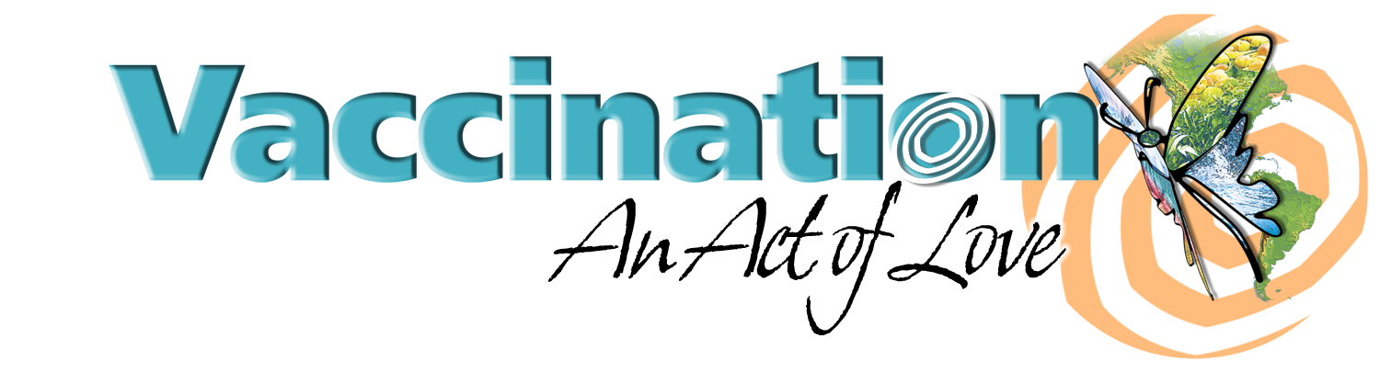
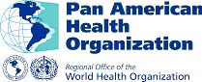
Background Information

Vaccination Week in the Americas 2005 April 2005

Vaccination Week in the Americas is a regional initiative to strengthen regular vaccination programs through the identification of populations without access to immunization located in remote or urban fringe areas, and indigenous communities and other ethnic minorities. The principles of Vaccination Week in the Americas are equity, access, and Pan Americanism.

Each country sets its own priorities based on specific population targets, with support from the Pan American Health Organization, and national goals vary throughout the Region. For the vaccination initiative, some of the specific goals include:

- Over 44 million people of all ages will be vaccinated throughout the Region.
- Country plans include immunization of 20.9 million children under five years old, 1.5 million women of child-bearing age, 12 million persons over 60 years of age, 7.1 million adults, 242,000 indigenous persons, and 2.2 million persons in other risk groups.
- The elimination of rubella and congenital rubella syndrome (CRS) is a regional priority, and many countries are using Vaccination Week in the Americas as an opportunity to vaccinate against rubella. Paraguay will vaccinate 3.5 million people between the ages of 5 and 39 against the disease;
- High-risk and hard-to-reach populations are also an important priority during Vaccination Week in the Americas. Brazil plans to vaccinate almost 200,000 people in indigenous communities and more than 12 million adults over 60 years old against influenza.
- Argentina aims to vaccinate 3.5 million children
- Chile is vaccinating 1.1 million children aged 1 to 4 years.
- Colombia has targeted 228,775 children for vaccination.
- Guatemala will introduce in its schedule the Pentavalent vaccine, already in use in most countries of the region, which protects children against diphtheria, whooping cough, tetanus, hepatitis B, and meningitis. The country will vaccinate 255,000 children under five years old, of which 55,000 will be vaccinated with the Pentavalent vaccine.
- Peru will vaccinate almost 3 million people aged 2 years and older against yellow fever.
- The United States is promoting vaccination activities on the U.S.-Mexico border and elsewher4e as part of National Infant Immunization Week.
- Other public health activities have been integrated into vaccination week. Honduras will provide 885,880 people with Vitamin A supplements, especially children under five years old and women post-partum. Nicaragua will provide Vitamin A supplements to more than 900,000 children under five years of age and anti-parasitic drugs to children between 2 and 12 years old.

- Prior vaccination efforts reached 43 million children, women of childbearing age, and older adults, many in high-risk and difficult to reach areas and resulted in reduction of inequities in vaccination. Among the 15 million children under five years old who were vaccinated during Vaccination Week in the Americas lat year, over 3 million had not received any doses of DTP/Pentavalent previously. Approximately 1.5 million women of childbearing age received their first doses of Td in municipalities at high risk for neonatal tetanus;
- Trans-border coordination, a tool to promote Pan Americanism and establish permanent relationships between leaders and border communities. Twenty-two bi-national and tri-national border events took place throughout the Region;
- Regional commitment, demonstrated by the participation of five Presidents, several First Ladies, Ministers of Health, and representatives of international organizations in the launching events of the Vaccination Week in the Americas;
- Inter-agency cooperation and mobilization of resources. All countries made contributions from their national budgets, and approximately $1.5 million was mobilized from external sources to support Vaccination Week in the Americas activities. These financial resources were allocated mainly to the Pan American Health Organization (PAHO) priority countries: Bolivia, Guyana, Haiti, Honduras, and Nicaragua.

For more information please contact Daniel Epstein, Public Information, Tel. 202 974 3459, email: epsteind@paho.org – www.paho.org

23-30 of April
Vaccination Week in the Americas
National Infant Immunization Week

