Module 5: Planning for Change: Project planning

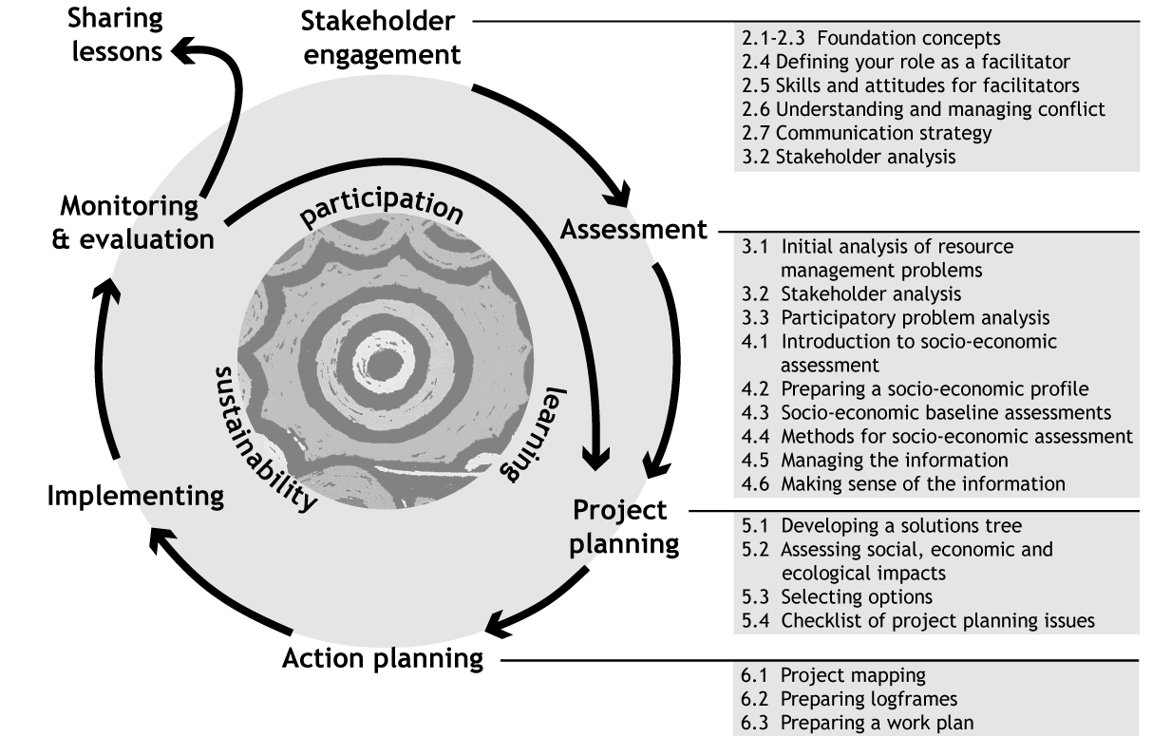

Module aims
This module will help you facilitate stakeholders to work from an understanding of resource management issues to a project design. Specifically, it covers how to facilitate a:
- Solutions tree activity.
- Participatory impact assessment activity.
- Discussion of project options.

Topics
  - Developing a solutions tree
  - Assessing social, economic and ecological impacts
  - Selecting options
  - Checklist of project planning issues

Introduction
The previous modules have taken project staff and stakeholders through a process of understanding resource management issues, and their social and economic context. The next stage in a participatory resource management program is planning. During this stage, facilitators working with the project can use the activities in this module involve stakeholders to develop potential solutions and selection appropriate options for development into a project plan.

Topic 5.1 Developing a solutions tree
Once the causes of resource management issues have been analysed, stakeholders are in a better position to develop targeted strategies to address some of the ‘root causes’. The solutions tree activity that follows works with the outputs of the Participatory Problem Analysis (Topic 3.3) to develop potential solutions to the identified causes of the resource management problems.
It is important to clarify that not all of the solutions identified in a solutions tree would be picked up in a project plan. In any event, time, skill and money constraints are likely to limit the ability of projects to tackle a problem from every possible angle. Therefore, the solution tree activity discussed overleaf aims to provide a logical basis for considering alternative solutions and planning for the implementation of the solutions selected. After the potential solutions have been identified, stakeholders can discuss criteria for choosing between alternative strategies to develop into a project map (see Module 6). The activities solutions tree activity can also identify potential areas for action that stakeholders may be able to work on outside of the project framework.

Activity: Developing a “Solutions tree”
Purpose
To show stakeholders how the problem analysis can be used to identify solutions and possible activities for the pilot project.
To better understand what stakeholders believe are possible solutions and valid activities for the pilot project.
The identification of solutions at this stage is not final. The options are assessed and discussed. A ‘project map’ is later developed for the set of objectives and actions that are likely to gain the greatest benefit with the least negative consequences (the greatest ‘net’ benefit).
Participants:
Stakeholders who have worked on the participatory problem analysis process follow on to this activity.
Materials:
Flip-chart paper
Post-it notes
Coloured marker pens.
Preparation:
Organise the workspace to enable groups of up to 5-6 to work on the task.
Time:
1 ½ to 2 hours
Steps:
1. Ask participants to review their problem tree and make any needed revisions based on further thoughts and discussions on possible underlying causes.
2. When they are finished with revisions, invite participants to construct a Solutions Tree by converting each ‘problem’ (the negative statement) into a future positive action. For example, the negative statement ‘lack of public awareness of the impact of waste on water quality’ may be converted to a positive action such as ‘increase public awareness of the impact of waste on water quality’.
3. As participants work, ask them to keep checking the logic of the relationship between different levels to ensure that activities clearly address the problem. Do this by asking IF…THEN as you move up the chart (see figure below on “checking the logic of the solutions tree”). They could do this by asking IF we do the positive action, THEN will the specific problem to which the action is related be alleviated? This is sometimes known as the IF … THEN test. An example would be the question: IF we increase public awareness of the impact of waste on water quality THEN will we reduce ignorance of the impact of waste on water quality? If the answer is ‘yes’, the logic of the solutions tree holds firm.
Think creatively and holistically about the solution!
4. If there is any problem with the logic of the solutions tree, you may need to rephrase the positive action. There could be an error in the logic in the Problem Tree so check this also.
5. Check the solutions tree to see if the solutions that may have come up in earlier discussions by participants are represented. If they are not, ask why not? Was the problem tree correct? Perhaps the problem tree needs further revisions? Go back and make more changes to the problem tree if necessary.
- Ask each group to present their work to the others.

Checking the Logic of Solutions Tree
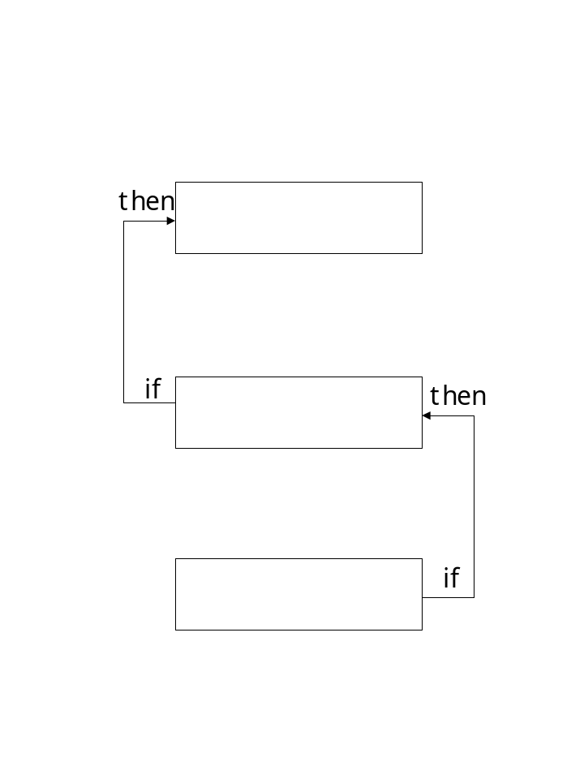
Check that the lower box will lead to what is written at the box on the next level, and so on. This will help to make sure that the actions on the solutions tree flow logically.

Source: (adapted from Worah et al., 1999)

Example: Solutions tree to address chemical pollution of coastal waters from Niue
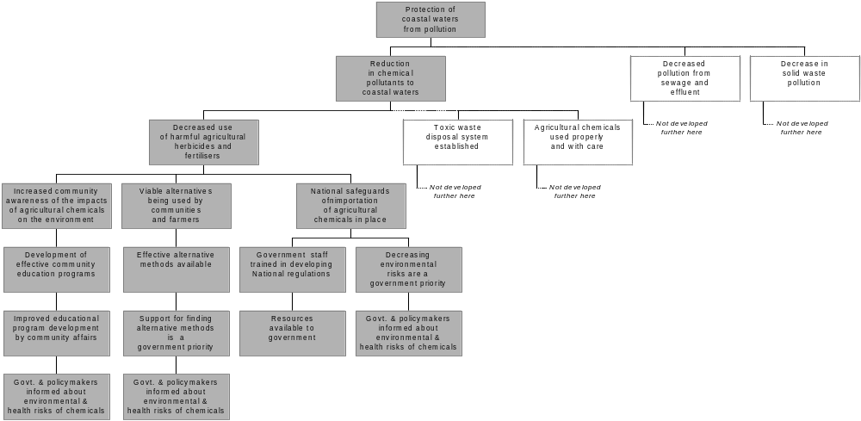
Note:
- All lines represent downward arrows
- Refer back to the problem tree in Module 3.2 (Example 2)to see the relationship between problems and solutions.

Topic 5.2 Assessing the social, economic and ecological impacts of possible solutions
Any potential solution is likely to have ecological, social and economic impacts. It will, for instance, have intended ecological impacts because the objective of the project will be to alter resource management practices. The solution would also have economic and social impacts because it involves changing behaviour and thereby changing people’s access to wealth and resources. At the same time the project may also generate unanticipated ecological, social and economic impacts.
To select the ‘best’ option to address the environmental problem, project staff will need to work with stakeholders to consider the social, economic and ecological impacts of alternative options. This is because negative impacts on any option may jeopardise the success of the project. For instance, there would be no point in pursuing an option that offers positive ecological benefits if the social and economic impacts of this are so damaging to stakeholders that compliance would be impossible. In fact, severe social and economic implications are a warning sign that an option will ultimately be unsustainable or unviable.
One way of conceptualizing the relationships between the economic, social and ecological is as an ‘egg’ (see Figure 9), where economic and social actions are nested within the biophysical environment. Action in one area will ripple through the others. Impact assessment helps us to work out what these connections are, so that we can maximise outcomes across these three dimensions and develop more sustainable resource management activities (Lal and Keen, 2002).
Figure 9: Three dimensions of sustainability
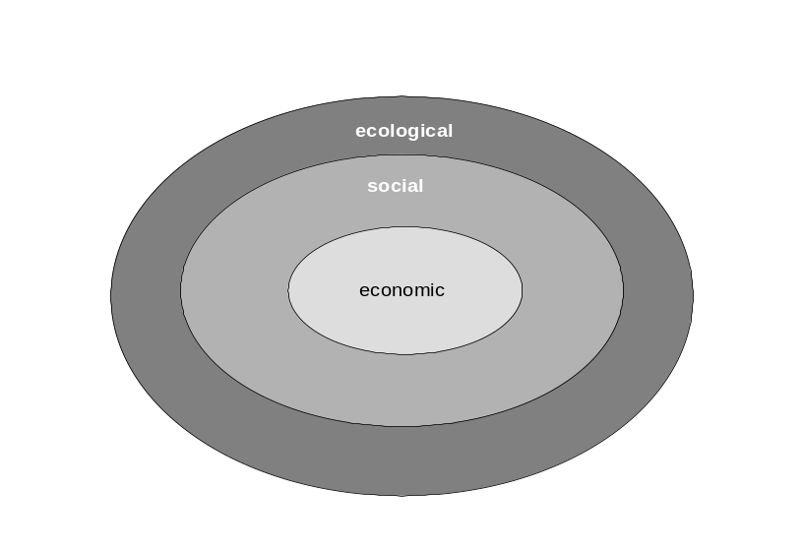
Source: (Lal and Keen, 2002)

Environmental impact assessment
Environmental impact assessment (EIA) is a process to support planning and decision-making. It is based on the identification, prediction and evaluation of the potential environmental impacts of about projects, plans and policies. Impact assessments can involve very detailed technical examinations of the environmental impacts in policies and projects, particularly where projects are likely to have significant negative environmental impacts (Modak and Biswas 1999). The scale of the impact assessment can and should be matched to the project. However, the steps are broadly similar, and aim to integrate consideration of the economic, social and economic impacts of an intervention.
In this section, we will focus of the social impacts of alternative solutions and will only consider economic and ecological impacts as they relate to these. Project managers would need to consider all these sets of impacts – social, economic and ecological – in practice. Information on the economic aspects of solutions is discussed in detail in Lal and Holland (2004).

Social Impact assessment
Social impact assessment is a specialised form of impact assessment. It focuses on:
- The likely social impacts of what is planned;
- The likely consequences for various stakeholders (eg improvement or deterioration in people’s well-being); and
- How to improve positive benefits or minimize negative impacts.
Social impact assessment, like EIA, can be a relatively large and complex process. However, the scale of the impact assessment can and should be matched to the project (Goldman, 2000).
Impact assessment can be done when consensus has been reached on the viability of two or three main options. Alternatively, it can begin in the early stages of stakeholder consideration of problems and with information about likely social impacts being collected and analysed as part of the baseline assessment.
Social impact assessment is linked to stakeholder analysis because it involves considering how stakeholder interests would be affected by different options to solve the problem. A stakeholder analysis in relation to potential solutions (see Topic 3.2) can be used to help identify these impacts. Subsequently, actions can be refined to increase any positive effects on stakeholder interests and or reduce or avoid any negative effects from alternative solutions. The information collected during preliminary community profile and baseline assessments are also important inputs to the impact assessment process.

Who assesses impacts and when?
Project staff may carry out a preliminary assessment of potential social, economic and environmental implications of a project on their own or in consultation with government in the process of determining where to locate projects. This preliminary assessment can help avoid the strategic mistake of selecting a project site that is unlikely to have viable or politically acceptable solutions. It is not wise politically to go through all the public stakeholder activities leading up to the preliminary assessments only to conclude that “Do Nothing Different” is the best option. Project managers and other project staff might also begin thinking about environmental impacts in the early stages of stakeholder consideration of problems and information about likely impacts being collected and analysed as part of the baseline assessment.
Stakeholders are likely to raise issues of concern or risks early in the process of consultations—even during the first round of stakeholder meetings. Project staff needs to think about potential social impacts and need to assure stakeholders that possible impacts will be considered in the decision-making process.
EIA is thus central to the selection of social, economically and ecologically viable options. A participatory activity to assess the environmental impacts of options is outlined in Topic 5.4.

Topic 5.3 Selecting Options
Before assessing impacts, it is important to select two to three options from the wider set of potential solutions developed in workshops. This is necessary because of time constraints, and also because it is unlikely that one project will be able to accommodate the full range of activities.
The topics in this module are intended to support stakeholders to take a considered decision on which options for action they will pursue. The solutions tree Activity (Topic 5.1) will have assisted them to identify potential solutions (options). The impact assessment below will help them consider the likely positive and negative impacts of certain options, including the option of taking no action.
In this topic, we look at the decision-making process and your role in it as a facilitator or manager of a project. We also look at some criteria and techniques that can help stakeholders to assess the costs and benefits of options and choose the actions that are likely to bring the greatest overall benefit in social, economic and ecological terms.

Decision-making in groups: processes and issues
Before moving on to the specifics of selecting options, lets pause and consider the decision-making processes involved. The selection of options for action on a resource management issue is a key decision-point for stakeholders. Your facilitation role at this stage is crucial, and it is important for you to have an understanding the group dynamics of decision-making.
Groups can arrive at a decision on an issue in many different ways. Some common rules that you may have come across are shown in Figure 10.
Figure 10: Common decision-making rules.
Consensus agreement
‘Flip a coin’
Delegation
Majority vote
Chairman decides without discussion
Chairman decides after discussion
Common
Decision
Rules

(Braakman and Edwards, 2002)

Looking at these ‘common decision rules’, you will see that some rules are more consistent with a participatory program than others. For example, a chairman deciding after discussion is a very limited form of participation. In contrast, decision through consensus can allow broad participation, as long as rules are followed to ensure participation in the discussion process. Without explicit ground rules to guide the discussion, those with power, influence, and confidence are likely to hold sway, or the process can get bogged down and issues are not considered fully or systematically. The decision-making scenario may then look more like Figure 11 below.

Figure 11: Decision making without rules

The most talkative/ powerful/ confident get they want

After the meeting ends without agreement, a few people meet behind closed doors and make the real decision
Some people hold on to rigid, fixed positions and try to sabotage the discussions

Decision-making without ground rules

The person who has most at stake makes an independent decision
The meeting goes overtime; the discussion drags on and on…

Just as time runs out, someone makes a new suggestion. This becomes the decision
Some members stall the discussion by vetoing it. Thus no decision becomes a decision not to act.

(Braakman and Edwards, 2002)

To avoid these problems, it is important for facilitators to discuss and establish decision-making rules with the group. You may even find it useful to use these diagrams in your discussions.
Another important aspect of the facilitator’s role is the need to encourage the group to look broadly at issues before moving towards a decision-point. Such an approach challenges the group to move beyond ‘business as usual’ discussions to look at new ideas and angles. As a facilitator, you can help this process along to broaden discussion and then move back to a decision point (See Figure 12 and Issue 15 below on how to promote divergent thinking).
Figure 12: Divergent and Convergent thinking
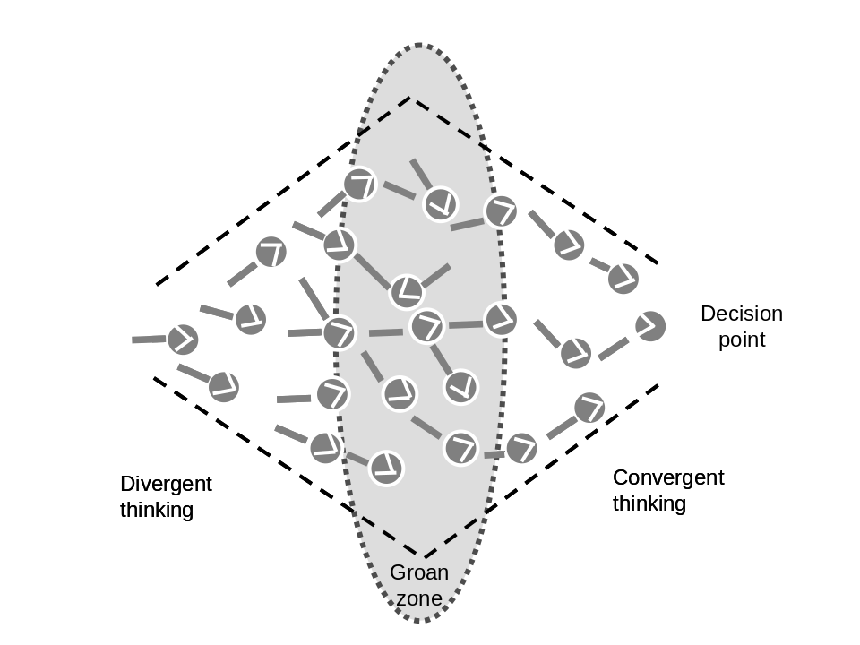
Source: Braakman and Edwards, 2002: 47
As the group explores ideas a further challenge for the facilitator is to help them find the point at which free ranging discussion can be focused back to a decision point. This transition point is sometimes called the ‘groan zone’ because it can be a confusing time for the group as it struggles to find a shared framework. Your facilitation skills are crucial in helping a group move through the ‘groan zone’ towards a decision point (See Issue 16 below on getting through the ‘groan zone’).
Issue 15: How to promote divergent thinking
- Alert the group of ‘business as usual’ discussions.
- Help the group avoid making decisions too quickly by pointing out how limited their input is.
- Encourage everyone to contribute.
- Think about the tools and skills needed to learn about other diverse points of view.
- Suggest ways to structure thinking activities.
- Respect other people’s point of view.
- Don’t ask people to revise or reconsider their opinions.
- Encourage people to raise difficult issues or challenges.
Source: Braakman and Edwards, 2002: 52

Issue 16: Getting through the ‘groan zone’
- Sharpen your listening skills.
- Encourage the group to keep struggling, and assure them that this struggle is part of the normal process.
- Encourage the group to share perspectives.
- Honour objections and ask for suggestions.
- Be patient.
- Be tolerant.
- Be flexible.
- Above all show trust and confidence in the group.
Source: Braakman and Edwards, 2002: 63

Developing criteria for making decisions
Decision-making criteria are factors or qualities of an option that you may use to work out the desirability of particular options for action. Some commonly used criteria in resource management programs are included in the box below (see Issue 17). Explicitly considering criteria is helpful because it allows stakeholders to discuss what factors are important to them in making a choice. If the criteria are hidden or not discussed, factors that are very important to particular stakeholders or have a big influence on the viability of an option may be left out of the decision.

Issue 17: Useful criteria for selecting resource management options
Experience shows that in projects dealing with participatory resource management, it is important to assess options for action against criteria to help select the most efficient, effective and equitable ones. Some useful criteria include that the action or strategy :-
- Increases environmental quality rather than having negative environmental impacts.
- Maintains social cohesion and responsibility to take joint action (otherwise the activity will not last).
- Creates incentives for sustainable resource use.
- Is not so risky as to be unrealistic;
- Has manageable and realistic financial costs (is financially feasible).
- Is culturally acceptable.
- Is equitable in sharing the costs and benefits

These kinds of criteria can be introduced to discussions with stakeholders if key areas have been left out of their discussions, or if they are having trouble getting started on identifying criteria that are important to them. It is not necessary to address all these criteria in decision-making. However, some criteria should always be considered (for example feasibility criteria – see Issue 18 below).
The criteria that come out of stakeholder discussions can be used in a number of ways to assess project options or solutions. The activities outlined in this module include:
- Impacts tree.
- SWOT analysis.
- Matrix ranking.
These three activities can be used to help stakeholders systematically consider the options against the various criteria that are important to them.
Issue 18: Are the options feasible?
Quite often, projects that seem to be built around ‘good ideas’ appear to fail. Many of the projects supported in the SPBCP and BCN did not achieve their goals because the planned activities were not feasible in the long term. They therefore did not generate the benefits that were anticipated (Hunnam et al., 2003).
Financial feasibility focuses on the revenues, costs and or profitability of an activity. This is critical for financial planning (ensuring sufficient flow of money) and for assessing the profitability of any income generating activities. Revenues are receipts earned for goods or services sold. They also include any financial subsidies from governments or NGOs. Costs are all financial costs (such as salaries, rent, inputs, electricity, taxes and so on), Financial feasibility assessments should also reflect the operational viability of an activity. This may include practical considerations in implementation such as whether staff are adequately trained to do the job, climate or infrastructure and risks (such as strikes, loss of power etc.) (Lal and Holland, 2004).
Economic feasibility assesses the economic benefits and costs of activities. These are the benefits and costs to society of using resources in an activity. These include the value of environment impacts on resources and changes in environmental quality, the efficiency with which resources are used and the distribution of benefits and costs of an activity across the community concerned. These issues are critical because a financially viable activity may be economically unviable. For example, an ecotourism enterprise may generate profits for a community, thereby assisting it to reduce fishing an area heavily. Yet if the pollution arising from the hotel is significant, the community may be worse off than they were before the activity began (Lal and Holland, 2004).
Social feasibility considers such issues as: the degree of stakeholder support for an action, compatibility with the cultural and institutional context, the level of equity in the distribution of benefits and costs amongst stakeholders, and risks in the social environment (e.g. conflict, rapid social change processes such as migration). This is important because factors such as inequitable distribution of benefits or high levels of conflict in a community can make a project unfeasible (see for instance McCallum and Sekhran, 1997 on the importance of considering the social viability of an integrated conservation and development projects in PNG).

The “Impacts tree” and “Swot analysis” activities that follow can be useful in analysing the costs and benefits of various options. The SWOT analysis can be used to analyse the strengths and weaknesses of specific options. The matrix ranking activity can be used as an alternative to SWOT analysis to evaluate a number of options against agreed criteria. Once the range of options has been narrowed down to two or three, the impacts tree activity (the final one in Activity 5.3) can be undertaken.

Activity: SWOT Analysis

Purpose
To assist stakeholders to make an informed decision about which potential solution to adopt. This activity assists them to do this by getting them to focus on the relative strengths and weaknesses, opportunities and threats related to particular project options.
SWOT Analysis can also be used to assess the strengths and weaknesses of an organization or partnership in relation to a project or managing a resource management issue.
Note: The criteria discussed earlier in this topic may help to identify specific strengths and weaknesses, opportunities and threats. Eg. A weakness may be that the option is culturally unsuitable (for example, composting toilets are an option to address pollution from human waste, but the handling of human waste may be considered tabu in the target community).

Participants:
Small groups of stakeholders in a workshop.

Materials:
Flip-chart paper
Coloured marker pens.

Preparation:
Organise the workspace to enable groups of up to 5-6 to work on the task.

Time:
1 ½ to 2 hours

Steps:
- Explain the purpose of the activity.
- Invite the groups to work with one option each. Try and arrange things so that all the options under discussion are covered by the mix of groups.
- Invite the group to identify strengths, weaknesses, opportunities and threats associated their option. Opportunities include favourable conditions and possibilities for partnering or extending the initiative. Threats include risks that might diminish the viability or effectiveness of an option.
- After 45 minutes, invite groups to present their findings to the larger group and to clarify any questions raised.

Activity: Matrix Ranking

Purpose
To allow stakeholders to prioritise possible solutions on the basis of specific criteria. This can be used following the SWOT activity preceding, or as an alternative to the activity.

Participants:
Small groups of stakeholders in a workshop.

Materials:
Flip-chart paper
Coloured marker pens.

Preparation:
Organise the workspace to enable groups of up to 5-6 to work on the task.

Time:
2 hours

Steps:
- The activity can start by inviting stakeholders to review any criteria that have been developed in previous discussions. If criteria have not previously been developed by the group, allow stakeholders to discuss criteria that are important to them in considering whether a solution is appropriate or not, and likely to succeed or not. You can use the ‘common criteria’ box (Issue 13) and the likely impacts tree (outlined earlier in this topic) to stimulate discussion on criteria.
- Once stakeholders have a set of agreed criteria, invite them to enter the criteria on the left hand column of the matrix ranking worksheet included below.
- Get stakeholders to enter each project option along the top row.
- Ask the groups to work down the column for each option, giving it a ranking from 1-5 on how well it meets each criterion (1 = does not meet the criterion, 5 = perfect match).
- Calculate an overall score for each option by summing the rankings for each potential solution. Get stakeholders to compare the scores for each option.
- VARIATION: If participants want to place a weighting on criteria they feel are particularly important, they can rank their importance from 1-5. If the criteria are weighted, the ranking given in step 4 will need to be multiplied by this weighting. These optional variations are shown in grey columns on the activity sheet below.
Note: the process of assessment is more important than the numerical score. For example, a group may find that the option scoring highest is still not desirable on some other grounds they had not considered yet. The score should not lock them into pursuing particular options.
Source: adapted from (Pretty et al., 1995)

Activity Sheet: Matrix Ranking
 | Weighting (optional) | Option 1 |  | Option 2 | Option 3 | Option 4
Criterion 1 |  |  | Rank  x weight  -ing
Criterion 2
Criterion 3
Criterion 4
Criterion 5
Criterion 6
Criterion 7
Criterion 8
Total

Matrix Ranking Example: Matrix ranking of adaptation options for Saoluafata Village (for Climate Change Vulnerability and Adaptation Assessment, Samoa)

 |  | Adaptation options
Criteria | Weighting (optional) | Planting trees | Sea walls | Reclaim land | Relocation of houses | Option 5
Cost | 4 | 5 (20) | 1 (4) | 1 (4) | 1 (4)
Community benefits other than climate change adaptation | 5 | 5 (25)  (fuel and building materials) | 2 (10) | 2 (10) | 5 (25)  (access to new housing)
Ease of implementation | 3 | 5 (15) | 2 (6) | 2 (6) | 1 (3)
Environmental benefits | 4 | 5 (20) | 1 (4) | 1 (4) | 2 (8)
Political support | 3 | 5 (15) | 5 (15) | 5 (15) | 5 (15)
Total |  | 95 | 39 | 39 | 55
Source: Example from Samoa Capacity Building for the Development of Adaptation Measures in Pacific Island Countries Project, 2003

Activity: Likely Impacts Tree

Background
The ‘likely impacts tree’ activity can be done with stakeholders when they have identified two or two or three main options or areas of action. Involving stakeholders directly in an assessment process allows them to raise their concerns, and to participate in informed decisions based on an understanding of the consequences of particular courses of action.
The example provided with this activity is of a ‘no-action’ option. This is sometimes referred to as ‘do-nothing’ option. No action’ refers to no action or direct intervention by the project. Analysing this gives stakeholders a reference point from which to consider impacts. The ‘no action’ option also has positive and negative impacts on stakeholders. When developing a No Action option, recognise that some actions may occur by other stakeholders.

Purpose
To involve stakeholders in analysing the impacts of various options to deal with resource management issues.
To better understand what stakeholders believe are possible impacts.
The identification of impacts helps stakeholders to clarify the consequences of various actions so that they can eventually select those actions that are likely to gain the greatest benefit with the least negative consequences (the greatest ‘net’ benefit).

Participants:
Small groups of stakeholders in a workshop setting.

Materials:
Flip-chart paper
Post-it notes
Coloured marker pens.

Preparation:
Organise the workspace to enable groups of up to 5-6 to work on the task.

Time:
1 ½ to 2 hours
Steps:
- Ask the group to review the Solutions Tree (See Topic 5.1) and other sources of information on possible solutions. Invite them to Identify 2-3 of the potential options that the community project may undertake. Add to this the option of ‘No Action’.
‘No action’ refers to no action or direct intervention by the project. Analysing this gives the group a reference point from which to consider impacts. The ‘no action’ option also has positive and negative impacts on stakeholders. When developing a ‘No Action’ option, recognise that some actions may occur by other stakeholders.
- For each of the options selected, invite the group to examine what is likely to happen as a consequence of that action being taken. Start with ‘No Action’ option – ‘If you don’t do anything, what will happen?’ Identify the changes that will result – including social, political, cultural, institutional or economic.
- For each of the likely effects or impacts (positive and negative) decide which stakeholders are affected.
- Invite the groups to examine ‘what needs to happen?’. For each of the options identified, invite the groups to consider how the negative impacts of alternative options could be reduced or avoided. Invite them also to consider how any positive effects of an option could be increased.
The diagram below can help the groups clarify the main steps in this process.

Key steps in developing an impacts tree:

Step 1: What is planned to Happen? (work with 2-3 options for action, including a ‘no action’ option)

Step2: What is likely to Happen? (identify the social, economic and environmental impacts of each option in a tree diagram)

For each impact think about whether they are:
POSITIVE
NEGATIVE

TO WHOM?
TO WHOM?

Step 3: What needs to happen?

What steps need to be taken to:
MAXIMISE POSITIVE IMPACTS?
MINIMISE NEGATIVE IMPACTS?

Example: A Likely Consequences Tree for ‘no action’ on marine resource degradation
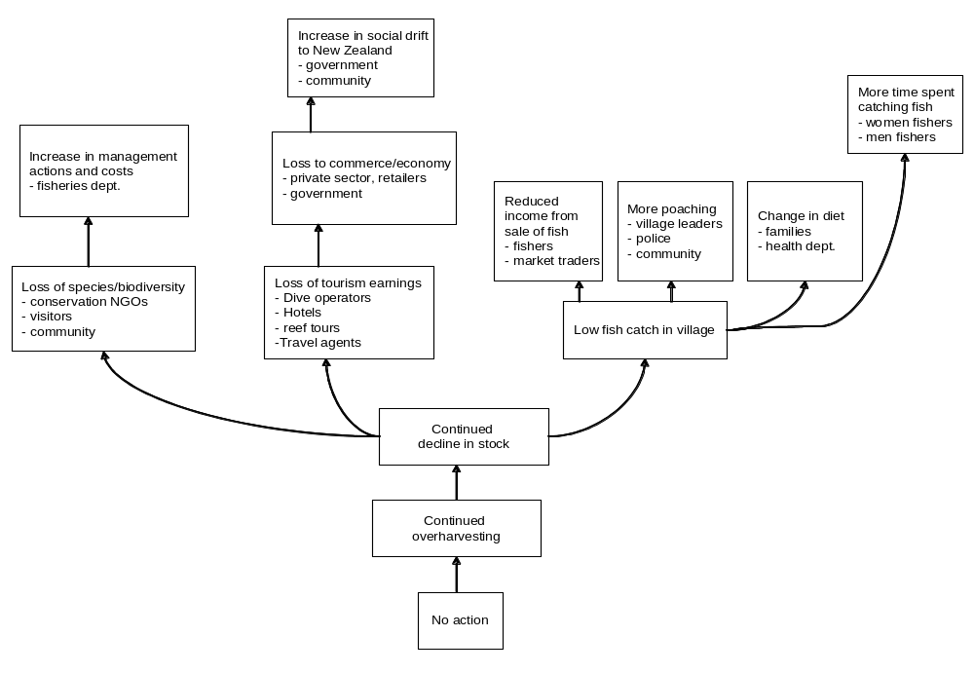Source: Solomon Islands group work; IWP Train the Trainer workshop, Vanuatu, 2003

Topic 5.4 Checklist of project planning issues
Once stakeholders have selected an option or options, you can reflect with them on the project planning issues covered in Topic 1.2. Reflecting on these issues prior to developing a more detailed project plan with specific goals, objectives and activities will help to produce a more considered and logical project plan. These project planning issues are summarised below (see Topic 1.2 for a more detailed outline of the associated issues).

Administrative requirements

Financial:
- Identify resource needs.
- Establish accounting and reporting systems.
- Determine who is accountable for use of funds.
- Develop project guidelines on the use of funds.

Personnel:
- Identify staffing needs.
- Develop recruitment procedures.
- Work out salary ranges and costs.
- Clarify roles, responsibilities and workloads of staff.
- Identifying staff training and development needs.
- Encourage staff retention by appropriate recruitment and good working conditions.

Reporting schedules and responsibilities
- Check reporting requirements of the funding body.
- Decide who will prepare reports and liaise with funders.

Equipment needs
- Identify equipment needs.
- Check any restrictions on use of funds for equipment.

Timelines
- Check that project timelines are realistic and allow time and space to work with stakeholders.

Communication strategy
- Develop a communication strategy for ongoing communication with project stakeholders, which covers:
  - Objectives of the communications activity
  - Target groups
  - Messages/Content
  - Communication techniques
  - Schedule, timing
  - Budget
  - Who is responsible
  - Monitoring
- Is social marketing a relevant approach to consider? Consider this option if behavioural change is one of the proposed outputs for a project. A more detailed resource on this approach is available through SPREP.
- Is community education relevant?

Governance and Institutional strengthening
- Check that any critical issues relating to governance and institutional ‘fit’ are being considered, including:
  - Relationships between local, provincial, national and international rules and systems for decision-making (these are represented in Figure 13 below).
  - Definition of property rights (ownership of and access to resources)
  - Clear definition of management responsibilities across levels.
  - Organisational constraints faced by government agencies and others) in their role.

Figure 13: Strengthening linkages for effective governance
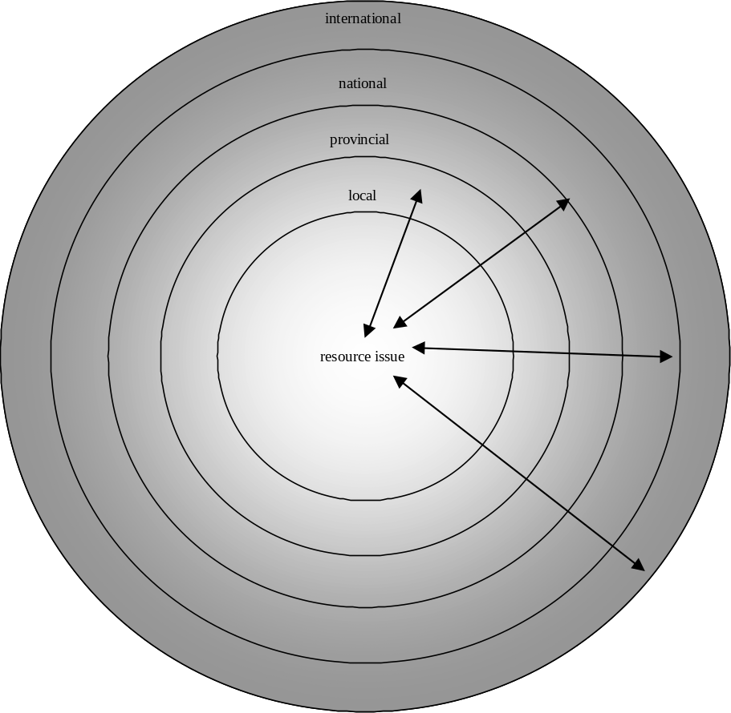

Partnerships and coordination arrangements
- Determine which stakeholders to engage in partnership and coordination arrangements with others, and what kind of arrangement is suitable (e.g. informal networks, formal agreements, consortiums and alliances).
- Ensure that partners have a common, clear understanding of their obligations, responsibilities and commitments to the project.
- Have an agreed plan for managing any disputes between partners

Stakeholder Participation
Develop a stakeholder participation plan that considers:
- Which stakeholders will be encouraged to participate in the project and why.
- Where you will you meet with these groups.
- When – at what stages in the process their involvement will be sought.
- How they will they be encouraged to participate in the project.
- Whether there are any difficulties anticipated in promoting participation by certain groups
Case 23 shows how one project approached its participation plan.
Case 23: Stakeholder Participation Plan for Milne Bay Project, PNG
The stakeholder participation plan for the Milne Bay marine conservation project in PNG covered these topics:
1. How the plan was prepared.
2. Stakeholder identification (primary and secondary stakeholders, and relevant organisations).
3. Information dissemination and awareness raising activities.
4. Social Mobilisation (how stakeholders will be consulted and engaged in the project).
5. Conservation Planning and Enforcement (and how stakeholders will be involved in developing planning and enforcement systems).
6. Monitoring and Evaluation systems (and how stakeholders will be involved in these).
7. Social and Participation Issues (including conflict resolution, creation of incentives for conservation, the role of external actors, how to ensure accountability).
A different way of writing up a stakeholder participation is shown in Case 24 (see Annex 3), which summarises stakeholders and the nature of their potential involvement.

Capacity building and Training
- Can the project improve the capacity of individuals and organisations to work effectively towards sustainable resource management? Keep in mind broad areas such facilitations skills, management skills, and knowledge about the resource and socio-economic environment.
- Consider techniques such as mentoring, reflective practice, on-the-job training, and opportunities for sharing experience with other facilitators in your area, country, region and beyond. Training courses can be used in a targeted way for areas that cannot be addressed through such programs.
- Remember to factor capacity building into your budget.

Monitoring and evaluation
- Develop a plan for project monitoring and evaluation to assess how well the project objectives are being met, and impacts on stakeholders.
- Budget for M&E, including knowledge and skills as well as financial resources and personnel
- Consider how M&E findings will be used in decision making and who will use it, bearing in mind that the purpose of M&E is to learn and modify actions.
See Bunce and Pomeroy (2003) for more information on designing monitoring programs.

Replicability
- Think about opportunities for replication, including:
  - Which groups and areas may be able to learn from your experiences and adapt approaches and concepts used in your project.
  - How you can promote the sharing of lessons from your project with other practitioners and communities.

Sustainability
- Develop a ‘succession plan’ (a transition plan that outlines how project activities will be resourced and managed when the funding cycle for the project ends).
- Consider other sustainability issues including:
  - Whether project activities will be supported by policies and rules at various levels of government, and by key organisations.
  - Whether stakeholders will have sufficient ownership and capacity to take on the activities initiated in the project.

References for Module 5
Braakman, L. and Edwards, K. (2002) The Art of Building Facilitation Capacities: a training manual, Regional Community Forestry Training Centre for Asia and the Pacific, Bangkok.
Bunce, L. and Pomeroy, B. (2003) Socioeconomic Monitoring Guidelines for Coastal Managers in Southeast Asia (SocMon SEA), World Commission on Protected Areas and Australian Institute of Marine Science, Townsville.
Goldman, L. (Ed.) (2000) Social Impact Analysis: an applied anthropology manual, Berg, Oxford.
Lal, P. and Keen, M. (2002) 'Economic Considerations in Community Based Resource Use and Management', Development Bulletin, 58, 68-71.
McCallum, R. and Sekhran, N. (1997) Race for the Rainforest: Evaluating Lessons from an Integrated Conservation and Development "Experiment" in New Ireland, Papua New Guinea, Department of Environment and Conservation, United Nations Development Programme/Global Environment Facility, Port Moresby.
Pretty, J., Guijt, I., Thompson, J. and Scoones, I. (1995) Participatory Learning and Action: a trainer's guide, IIED, London.
Worah, S., Svedsen, D. S. and Ongleo, C. (1999) Integrated Conservation and Development: a trainer's manual, WWF and Asian Institute of Technology, Khlong Luang, Thailand.

